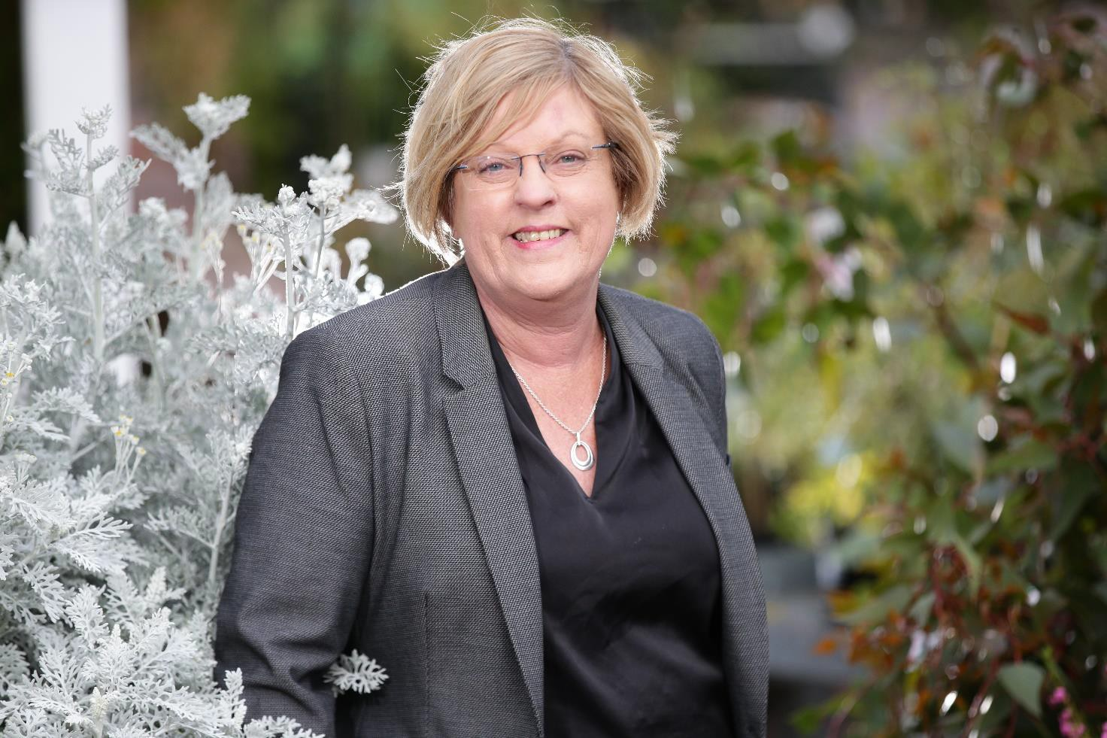
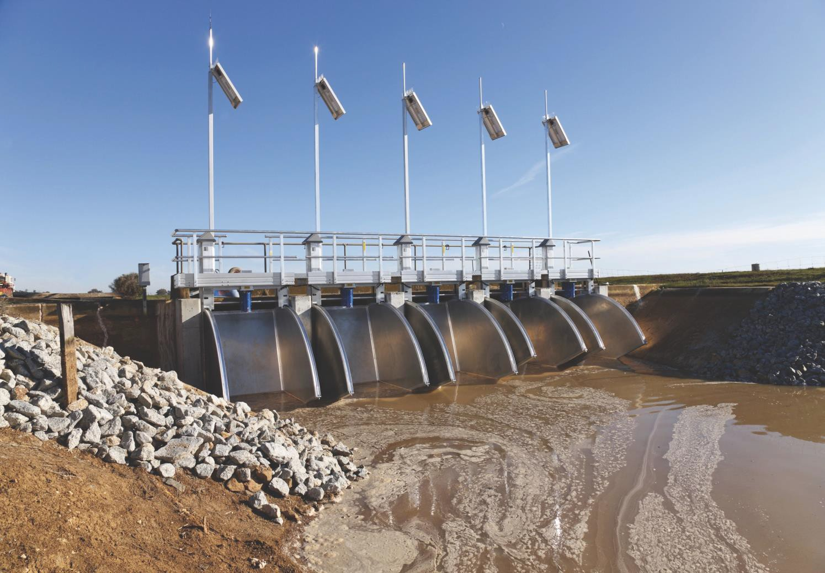
Goulburn Murray Water Transformation Process Achievements Snapshot
2017 - 2020

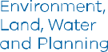

Acknowledgment
We acknowledge and respect Victorian Traditional Owners as the original custodians of Victoria's land and waters, their unique ability to care for Country and deep spiritual connection to it. We honour Elders past and present whose knowledge and wisdom has ensured the continuation of culture and traditional practices.
We are committed to genuinely partner, and meaningfully engage, with Victoria's Traditional Owners and Aboriginal communities to support the protection of Country, the maintenance of spiritual and cultural practices and their broader aspirations in the 21st century and beyond.
© The State of Victoria Department of Environment, Land, Water and Planning 2021
This work is licensed under a Creative Commons Attribution 4.0 International licence. You are free to re-use the work under that licence, on the condition that you credit the State of Victoria as author. The licence does not apply to any images, photographs or branding, including the Victorian Coat of Arms, the Victorian Government logo and the
Department of Environment, Land, Water and Planning (DELWP) logo. To view a copy of this licence, visit http://creativecommons.org/licenses/by/4.0/

Disclaimer
This publication may be of assistance to you but the State of Victoria and its employees do not guarantee that the publication is without flaw of any kind or is wholly appropriate for your particular purposes and therefore disclaims all liability for any error, loss or other consequence which may arise from you relying on any information in this publication.

Accessibility
If you would like to receive this publication in an alternative format, please telephone the DELWP Customer Service Centre on 136186, email customer.service@delwp.vic.gov.au or via the National Relay Service on 133 677 www.relayservice.com.au. This document is
also available on the internet at www.delwp.vic.gov.au.

Contents

Minister’s Foreword 2
GMW Transformation Process 3
Overview of Strategic Advisory Panel recommendations 3
Auditing Progress 3
- Improving financial sustainability 5
Implementation progress 5
- Transforming GMW’s business 7
Implementation progress 7
- Improving asset management 8
- Improving customer & stakeholder engagement 9
- Improving how GMW delivers 11
Implementation progress 11
Summary of Strategic Advisory Panel Recommendation Implementation 12

Minister’s Foreword
Goulburn Murray Water Transformation Process Achievements Snapshot 2017 - 2020

Over the past three years Goulburn Murray Water (GMW) has been transforming how it operates as the largest rural water corporation in Australia servicing more than 20,000 customers and managing assets valued at approximately $5 billion.
In 2017 I established an independent Strategic Advisory Panel to review GMW and set transformative actions so that GMW can viably support productive agriculture and communities in the Goulburn-Murray Irrigation District (GMID) well into the future.
The panel’s recommended actions to streamline GMW’s organisation and business include reducing operating and capital costs, strengthening its financial position to maintain affordable water prices for customers, improving asset management and renewing customer engagement.
This snapshot shows there have been significant improvements in GMW’s organisation and services. An independent audit of progress confirms that between 2018 and 2020, GMW has successfully addressed all of the panel’s 30 recommendations, with 25 now complete and 5 embedded into GMW’s ongoing business practices.
GMW’s review of capital and operational expenditure identified major cost savings achieved beyond the recommendations for financial sustainability. It led to a forecast reduction in revenue requirements of $64 million over the 2020-24 period and more affordable water prices, with most customers benefitting from a drop in fixed charges of around 10 per cent.
Many customers and stakeholders were consulted for GMW’s submission to the Essential Services Commission (ESC) on water pricing for 2022- 2024. This was approved in June 2020 with savings for customers now and in the future.
The Victorian and Australian Governments’ $2 billion investment in modernising GMID irrigation infrastructure over the last decade has
strengthened the GMID’s resilience by creating a more efficient delivery system. The Connections

project was completed in October 2020 with the benefit of the irrigators share being provided to eligible delivery shareholders in October 2021.
The transformation process has involved a channel-by-channel assessment covering all 5,780 kilometres of GMW’s channel and pipe network. Advanced data from this process is informing a new investment tool for GMW to make decisions about asset maintenance and adjustments to meet service requirements and customer demands.
I thank all who were involved in the intensive consultation and work to find cost savings and lower water prices, understand the impacts on services and bills and improve how GMW provides services to the community.
The intention behind this transformation process is for GMW’s business and services to continue improving beyond 2021, with plans and progress to be monitored through corporate reporting.
We look forward to supporting GMW’s continued initiatives for providing fair, affordable and efficient water services and maintaining the GMID with modern, efficient and well-operated infrastructure.

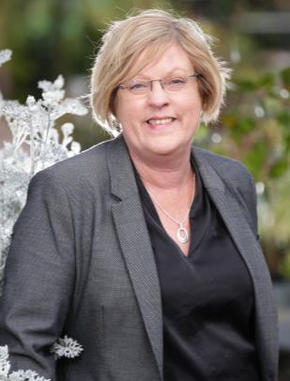

The Hon. Lisa Neville MP
Minister for Water

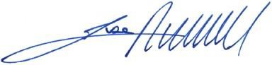

GMW Transformation Process

The GMW Transformation Process has reset the shape and direction of Goulburn Murray Water’s organisation and how it delivers services.

The Victorian Government is supporting GMW as it navigates the challenges of reduced water availability, climate change, National Water Initiative obligations, a changing customer base and irrigation infrastructure upgrades. The Victorian and Australian Governments have invested more than $2 billion to modernise GMW’s infrastructure and build a sustainable future for productive agriculture and communities in the Goulburn-Murray Irrigation District (GMID).
In October 2017 the Minister for Water announced the establishment of a Strategic Advisory Panel to support GMW and make recommendations to respond to these challenges.
The Minister received the panel’s independent report in January 2018. This made 30 recommendations for GMW to transform its core business over the short, medium and long term, along with two recommendations for the Department of Environment, Land, Water and Planning (DELWP).
The recommendations were to be put into action from 2018 to 2020.

Overview of Strategic Advisory Panel recommendations
The panel’s recommendations for GMW cover five areas to:
- Improve financial sustainability
- Transform GMW’s business
- Improve asset management
- Improve customer and stakeholder engagement
- Improve how GMW delivers, including a review of its business functions and development of a reporting framework across the organisation.
The recommendations for DELWP cover two areas to:
- Reflect GMW’s transformation outcomes in the Minister’s Letter of Expectations to outline performance improvement in priority policy areas
- Make sure the Strategic Advisory Panel’s recommendations about delivery share inform the Victorian Government’s delivery share review.

Auditing Progress

In February 2021 Ernst and Young’s audit of the implementation of the Strategic Advisory Panel’s recommendations confirms that all 30 recommendations have been addressed - 25 of the 30 recommendations are complete. Five are embedded as part of GMW’s ongoing business practices and will inform key GMW organisational strategies. Progress on delivering these actions will be reflected in the Corporate Plan.

The two recommendations for DELWP were completed in 2018.

KEY HIGHLIGHTS
Significant GMW cost savings
- Improvement in GMW’s financial position through a review of its capital and operational expenditure requirements – GMW achieved beyond the Strategic Advisory Panel’s recommendations for GMW’s financial sustainability.
More affordable customer services
- Reduced water prices for most of GMW’s 21,000 customers who are mainly irrigators. Fixed charges reduced by 10 per cent on average in 2020-21 and almost 1 per cent for the next three years.
Channel-by-channel assessment
- Combined all 5,870 kilometres of GMW’s channel and pipe network to inform part of a single database, adding advanced data to inform GMW’s medium and long-term investment decisions.
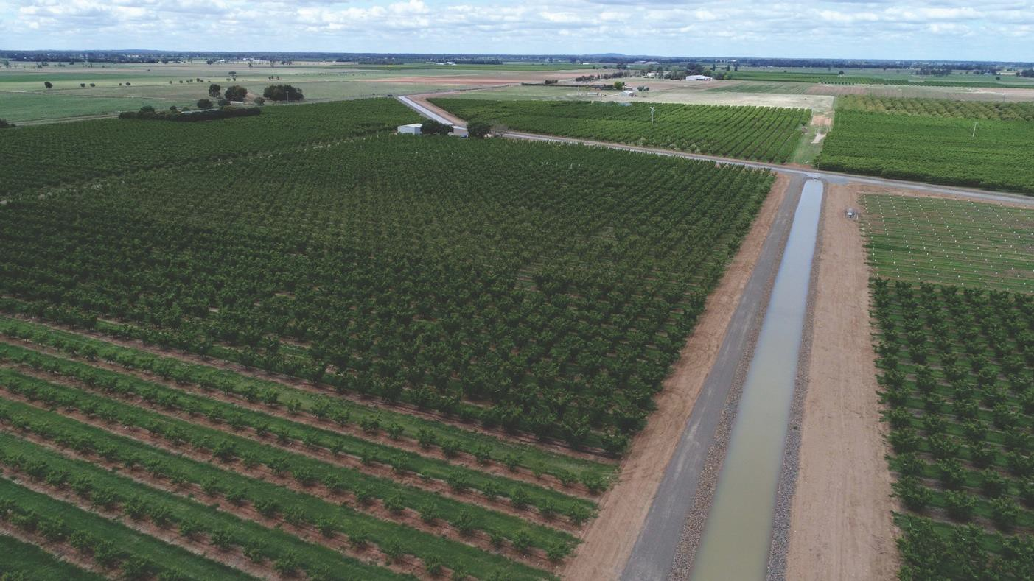

Improving financial sustainability

The Strategic Advisory Panel identified that for GMW to maintain its overall financial sustainability, it had to achieve significant annual savings in operating and capital expenditure, especially in the gravity irrigation business.

GMW’s overall business is made up of the irrigation business and non-irrigation business, which includes non-regulated, bulk water, surface diversions and groundwater.
Marsden Jacob Associates developed a 50-year financial model for the panel that focused on each business area. This was to assess GMW’s long-term financial sustainability, the business lines it operates, and the level of change required.
The intended outcomes of recommendations 1 to 4 included lower prices for customers and a sustainable GMW, established as a regional leader, better positioned to meet community expectations, with strong business practice and prudent and efficient financial management.

Implementation progress
Two recommendations have been completed:
- Recommendation 1 – short-term operating and capital expenditure target (2018–2024): a further 10 per cent efficiency in both operating and capital expenditure for gravity irrigation, plus 29 per cent for pumped irrigation, drainage, water districts and fee-for-service businesses from 2019-20.

A new era for GMW and its customers
- A landmark $64m reduction in GMW’s revenue requirement from the previous pricing period, enabling it to reduce costs and implement several important changes to its tariff structure.
- Reduced water prices for most customers from July 2020.
- A common water delivery charge introduced across GMW’s six irrigation districts.
- Recommendation 4 – confirmation of savings targets following further modelling work in 2018.
The original wording for Recommendation 1 reflected savings targets subject to further modelling work and validation under Recommendation 4. Once Recommendation 4 was completed, the focus of Recommendation 1 was adjusted. Final savings targets adopted are outlined in the table below.

 | Short term (2018 to  2024)  $million | Medium term (2025 to  2040)  $million | Long term (2041 to  2067)  $million
Average annual savings | 19.4 | 45.0 | 32.6
Cumulative savings | 19.4 | 64.4 | 97.0

Recommendations 2 and 3 involving medium and long-term targets for operating and capital expenditure have been embedded in GMW’s ongoing business practices. These will be delivered through GMW’s Service Strategy and Financial Sustainability Strategy. GMW’s Board, Service Planning Committee and Risk and Finance Committee will monitor progress, and this will be reported in the Corporate Plan.

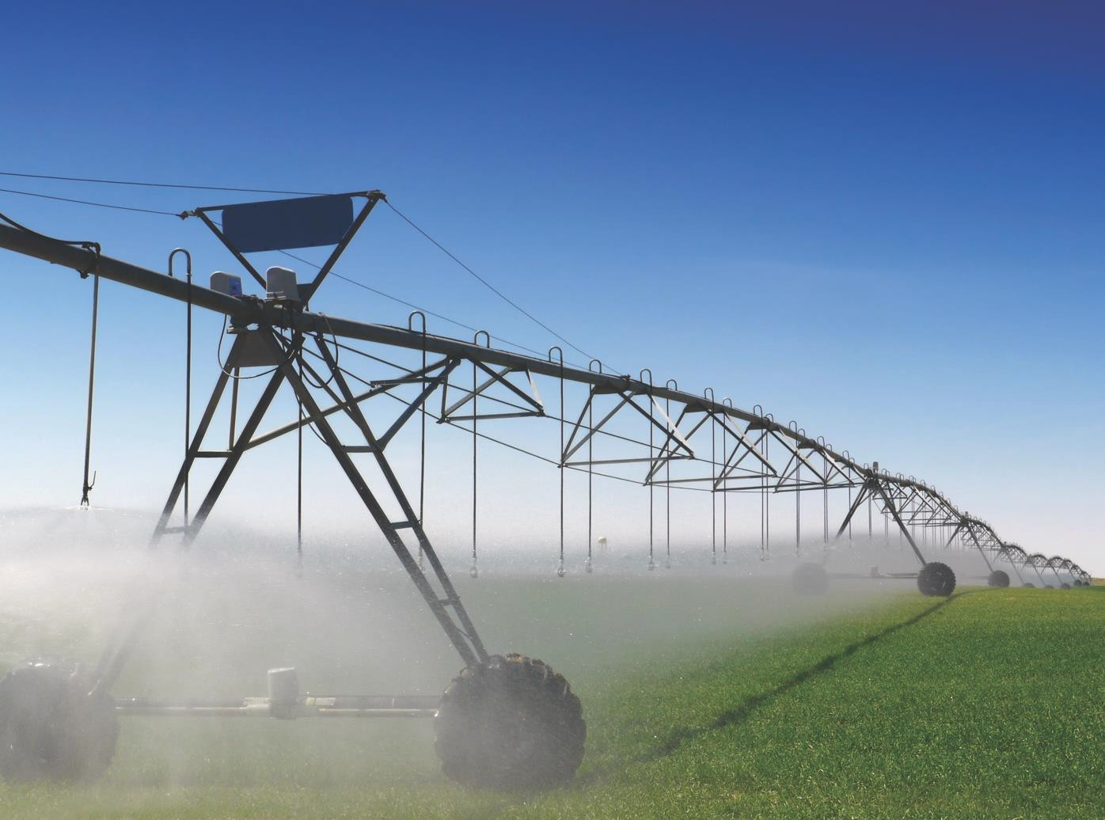

Case Study: GMW Pricing Submission 2020-24 – a pricing reset

The Essential Services Commission (ESC) price submission process requires water corporations to prepare a pricing submission for the forward four-year regulatory period for approval by the ESC.
In June 2020, the ESC approved GMW’s price submission for the 2020-24 pricing period. It set out the prices GMW customers pay, the services they receive from 1July 2020 to 30 June 2024 and how the savings identified through the Strategic Advisory Panel review will be achieved.
The price submission led to a forecast reduction in GMW’s revenue requirements of $64 million over the 202-24 period and more affordable water prices, with most customers benefitting from a drop in fixed charges of around 10 per cent.

Transforming GMW’s business

The Strategic Advisory Panel reported that GMW’s business and its way of operating needed an urgent and significant transformation.
This required GMW to go beyond ‘business as usual’ operations and take a ‘step change’ approach to major changes resulting in improvement.
Actions to bring about change were aimed at GMW’s organisational structure, executive leadership, transformation resourcing and organisational capacity.

The seven recommendations 5 – 11 focused on guiding the transformation process to instil strong leadership and governance, dedicated resources, robust project evaluation processes and information flows across the business. The intention behind the transformation is to produce continuing improvements to GMW’s business beyond 2020.

KEY HIGHLIGHTS
- Introduction of a new Leadership Team.
- Organisational transformation achievements signal that GMW is a renewed and resilient business.
- The process was achieved through extensive implementation planning, dedicated resources identifying champions of transformation teams among staff and establishing targeted project work.
- Organisational transformation was encouraged and supported at all levels of the organisation.

Implementation progress
Recommendations 5 – 11 are all complete, achieving major organisational change to support GMW’s transformation.
These actions cover short-term initiatives in planning, resourcing and implementation,
as well as improvements to GMW’s business structures, governance, reporting, processes and Board processes.

f

Improving asset management

The Strategic Advisory Panel recommended a stocktake of GMW’s critical irrigation infrastructure, asset maintenance requirements and timing and opportunities for future rationalisation. There was also a focus on developing a more efficient asset investment and replacement strategy.

GMW is Australia’s largest rural water corporation, with an asset base valued at approximately $5 billion. It is responsible for irrigation infrastructure servicing a region covering 68,000 square kilometres.
Decisions about the maintenance, replacement and adjustment of GMID assets have to be made by factoring in many strategic challenges. These include reduced water availability, climate change, National Water Initiative obligations, a changing customer base and irrigation infrastructure upgrades through the $2 billion Connections Project carried out from 2008 to 2020.
Five recommendations focus on asset management.
Implementation progress
Recommendations 12, 13, 15 and 16 are complete. These focus on a full review of assets and asset management performance, lessons learned from the Connections Project and an updated investment framework.
The fourth recommendation 14 has been embedded in GMW’s ongoing practices for future delivery. This involves developing a 50-year asset management plan to address the potential reduction in the GMID’s footprint over the next 50 years from changing environmental, market and cost challenges. The GMW Board and Service Planning Committee will monitor delivery progress and report this in the Corporate Plan.
Looking ahead, GMW’s focus is on:
- A targeted, risk-based approach to identifying priority asset maintenance and replacement works.
- Making sure the asset base reflects service requirements and demand from customers.

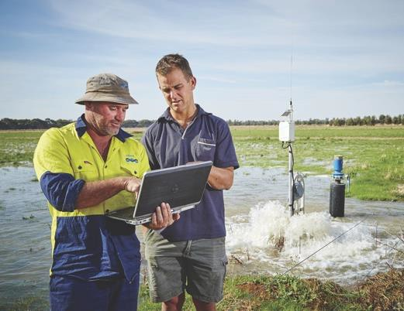
Case Study: Channel-by-channel assessment – All 5,870km of channel/pipe network

The channel-by-channel assessment involved GMW developing a framework to assist with asset management and rationalisation. GMW now has up-to-date data on the condition and use of every GMW channel, divided into 213 ‘pods’ or subsections of channels. This supports a more strategic approach to asset management, maintenance and replacement planning.
In 2017 the unequal distribution of water delivery across the network and the question of future planning was the reason for developing a more intelligent channel-by-channel asset management approach.

Improving customer & stakeholder engagement

The Strategic Advisory Panel’s report highlighted priority actions for GMW to improve the way it engages with its GMID customers and stakeholders.
The focus was on developing better planned engagement and adopting a ‘partnership approach’, so that community members can be involved in decision-making about their services.

GMW has more than 20,000 customers and
a diverse range of stakeholders, spread across 68,000 kilometres.
The quality of GMW’s customer and stakeholder engagement is vitally important to inform decisions about how to continuously support the region and provide efficient, affordable, cost-effective and reliable water supplies.
Five recommendations focus on improving customer and stakeholder engagement and GMW’s role in helping to promote future investment opportunities within the region.

KEY HIGHLIGHTS
- The 2019-2020 Essential Services Commission (ESC) price submission process gave GMW the opportunity to explore and integrate new ways of engaging with customers and stakeholders.
- 10 per cent of GMW’s customer base contributed to the development of GMW’s 2020 ESC price submission.
- GMW has introduced modernised online customer services and single- point-of-contact customer support.
- There is now more flexibility for customer contact through an online booking system and a new contact model for GMW’s regional offices.

Implementation progress
Recommendations 17, 20 and 21 are complete. These involve designing a customer and stakeholder engagement program, consulting customers on pricing and a review of the Customer Charter.
Two recommendations have been embedded in GMW’s ongoing practices for future delivery:
  - Recommendation 18: Reviewing operating rules for GMW’s Water Services and Customer Committees to improve the value provided by these groups.
  - Recommendation 19: Developing policies and economic tools for deciding when and where to attract new customers across the GMID.

Progress with the review of the operating rules for the GMW Water Services and Customer
Committees will be reported to the GMW Board and Customer and Stakeholder Committee and DELWP.

Implementation of Recommendation 19 is occurring through GMW’s participation in the Agricultural Redevelopment Committee (ARC), which includes partner agencies GBCMA, NCCMA, Agriculture Victoria and DELWP. The ARC is established as part of the Goulburn Murray Resilience Strategy with an objective focusing on a Regional Investment Prospectus to provide branding of the region and
its significant relative advantages. Through this process, information on land, water and infrastructure assets is intended to be made available to potential investors.

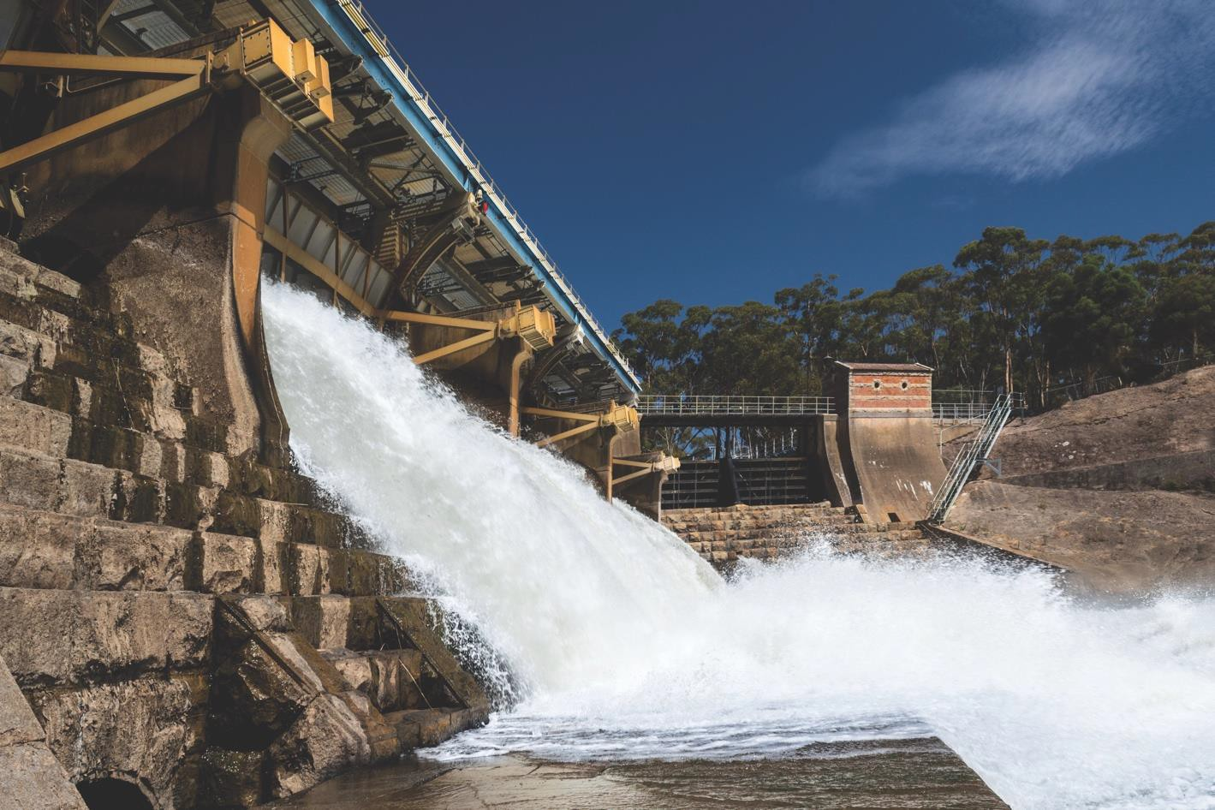

Case Study: GMW 2020 Essential Services Commission Pricing Submission

GMW consulted widely to develop the submission over a two-year period. This enabled customers to get involved in deciding how to achieve cost savings and understand impacts on their services and bills through:

- Over 1000 face-to-face conversations
- 3000 online visits to GMW’s ‘Your Say’ website
- 1300 customer conversations
- 36 customer forum participants, 18 customer workshops, three major customer events and 34 drop-in days
- Contributions from 75 Water Services Committee members
- A service standard summit day and two pricing and tariff summit days.

Improving how GMW delivers

The Strategic Advisory Panel identified the need for GMW to review all its business operations and activities to align strategic priorities and improve the organisation’s monitoring and reporting.

GMW’s operations and activities are delivered through different business units focused on regulatory and non-regulatory functions.

KEY HIGHLIGHTS
- GMW completed a full review of its business functions, including finance, IT, risk, human resources, legal, billing and technical services.
- Monthly reporting to the GMW Board has been improved to clearly communicate the status of actions and point to broader strategic outcomes.
- GMW’s strategic and corporate structure now lines up with the aims and results of the transformation process.
The panel made nine recommendations that focused on reviewing all business functions and priorities, aligning planning and processes, and establishing better structures for monitoring and reporting.

Implementation progress
All nine recommendations from 22 to 30 are complete and involve:
  - A full review of GMW’s business functions, core and non-core activities, decision-making and Board processes and performance reporting arrangements.
  - Development of consistent reporting across the organisation for informed decision making
and to align with GMW’s strategic and corporate
planning documents.

Summary of Strategic Advisory Panel Recommendation Implementation
Complete Embedded in GMW’s ongoing business practices

Recommendations to Goulburn Murray Water (GMW)
1: Improving financial sustainability
Recommendation 1 (as stated in the Strategic Advisory Panel Report noting adjustments were made following completion of Recommendation 4): | Status:
In the short term (2018 to 2024), identify and achieve a further 10 per cent efficiency in both operating and capital expenditure across its regulated core businesses of gravity irrigation and 29 per cent in the pumped irrigation, drainage, water districts and fee for service businesses from 2019/20.
The short-term savings required are estimated at $1.4 million in capital expenditure and $8.3 million in total operating expenditure (operations, maintenance and overheads). If more capital savings are achievable, then the estimated operating cost savings could be reduced accordingly. This also applies for the medium and long-term estimates.
- In the gravity irrigation business, this is equivalent to an average annual saving of $1.4 million in capital expenditure and $4.8 million in total operating expenditure (labour, operations, maintenance and overheads). These amounts are additional to the share of the efficiencies that GMW has already identified through its asset initiatives ($474 million) and efficiencies measures ($15.2 million by 2022) and incorporated in the revised base case scenario.
- In the non-gravity irrigation (pumped irrigation, drainage, water districts and fee for service) businesses, this amount is equivalent to average annual savings of $3.5 million in operating expenditure, in addition to the efficiency measures already incorporated into the revised base case.
Recommendation 2: | Status:
In the medium term (2025 to 2040), identify and achieve further efficiencies in the gravity irrigation business of around 15 per cent in 2024/25, and additional efficiencies of 5 per cent
in 2029/30:
- This amounts to additional average annual savings of around $7.9 million in capital expenditure and $10.1 million in operating expenditure on top of the 10 per cent savings assumed for 2019/20.
- In addition, GMW should consider whether it may be appropriate to moderate the magnitude of savings required in 2029/30 by increasing prices in real terms by 0.75 per cent over the five-year period from 2024/25 to 2029/30.
Recommendation 3: | Status:
In the long term (2041 to 2067), identify additional five per cent efficiencies in operating and capital expenditures in 2039/40 in the gravity irrigation business, and apply these with a one
per cent per annum price increase over the 10-year period 2029/30 to 2038/39. The estimated savings amount to an additional average annual savings of around $5.2 million in capital expenditure and $2.4 million in operating expenditure.
Recommendation 4: | Status:
GMW should confirm the savings targets by undertaking further modelling work in 2018 once it has validated the capital and maintenance cost inputs.

2: Transforming GMW’s business
Recommendation 5: | Status:
Adopt the GMW Transformation Implementation Plan.
Recommendation 6: | Status:
Establish a Transformation Panel to focus and drive the necessary structural and cultural change in the business, and to ensure that GMW is supported with specialist advice to transition and transform the business.
Recommendation 7: | Status:
To avoid delay in commencing the transformation, establish a dedicated Transition Panel by February/March 2018. The Transition Panel will translate the findings and recommendations of this report into GMW and draft a preliminary transformation delivery plan. It will also set up transformation project teams, conduct Connections Project lessons learnt workshops, plan for the GMW business unit restructure, and commence planning for the irrigation asset review work
(eg. channel by channel assessments).
Recommendation 8: | Status:
Form lead project teams to assist in creating a vision for the future and, integrate and communicate transformation throughout the organisation.
Recommendation 9: | Status:
Establish a Transformation Manager as the ‘change agent’ to lead the transformation within the business until December 2019.
Recommendation 10: | Status:
Employ a Chief Operating Officer to initially focus on delivering the transformation plan with the Managing Director.
Recommendation 11: | Status:
Establish a new business structure (individual business units) to successfully deliver GMW’s services reliably to customers at efficient prices over the short, medium and long term.
3: Improving asset management
Recommendation 12: | Status:
In the context of the transformation activities, including channel by channel assessments, review latest asset management performance against the benchmark ISO 55000 standard and Asset Management Accountability Framework requirements, and use this to develop a comprehensive action plan to address any systemic and ongoing issues.
Recommendation 13: | Status:
Undertake a full review of Connections Project’s activities to identify opportunities to improve GMW’s asset management practices, including conducting workshops.
Recommendation 14: | Status:
Develop a plan to address the potential reduction in GMID’s footprint over the next 50 years due to changing environmental, market and cost challenges.
Recommendation 15: | Status:
Review and consolidate the improvement opportunities identified in the Capital Investment Framework review and the Connections Project lessons learnt review.

Recommendation 16: | Status:
After reviewing the Connections Project lessons learnt, develop a detailed implementation plan that assigns clear timeframes and staff accountabilities to deliver all activities, including assigning an overall project leader with full authority to deliver.
4: Improving customer and stakeholder engagement
Recommendation 17: | Status:
Design a customer and stakeholder engagement program to improve trust and respect of GMW’s customers and stakeholders by:
- communicating the need, process, and outcomes of the transformation particularly as it relates to the services and prices to customers.
- listening to customers and stakeholders about their needs and develop shared values including future footprint rules which will attract and retain investment.
- eliciting preferences for policies, processes, and programs.
- informing customers and stakeholders about what is to occur and when.
- communicating and inform customers and the community of investment opportunities to enhance regional development.
Recommendation 18: | Status:
Review the Water Services Committees’ and Customer Committees’ Terms of Reference, membership and outcomes to enhance their contribution to GMW and ensure that they better reflect the customer and community base and transformation requirements.
Recommendation 19: | Status:
Develop policies and economic tools for deciding when and where to attract new customers across the GMID. This should include GMW publishing a Statement of Opportunities which would provide potential customers with valuable feasibility information relating to land.
Recommendation 20: | Status:
Consult with customers about their willingness to reduce the extent of any price increases by accepting a different level of service. Reflect the outcomes of this consultation in its September 2019 pricing submission for the 2020 regulatory period. This would include adopting the Connections Project bottom-up processes and principles approach of channel inspections
and information on individual’s future business intentions to assist in reconciling local and whole of GMID outcomes.
Recommendation 21: | Status:
Review its Customer Charter to ensure that it:
- correctly reports its two service standards (flow rate and supply level) and reviews these standards annually;
- enables WSC’s to consider information and reviews of its performance against service targets;
- reflects its customer segmentation.
5: Improving how GMW delivers
Recommendation 22: | Status:
Develop a reporting framework that is consistent and accurate across the organisation to ensure informed decision making. This needs to include key performance indicators (KPIs), timeframes and strategic initiatives that align with GMW’s strategy and transformation. The reporting framework should not be outsourced to large consulting firms if they do not fully understand the business.

Recommendation 23: | Status:
Ensure the Board has directives in place to ensure the Managing Director can provide necessary leadership, strategic direction, communication and the resources to ensure business transformation is successful and enduring.
Recommendation 24: | Status:
Review all committees to ensure they are effective, necessary and consistent with a transformed GMW. Each committee should have clear objectives and accountabilities, through well focused charters or terms of reference and report their outcomes, recommendations and minutes to the Board.
Recommendation 25: | Status:
Review its Board attendance to ensure it is a meeting of directors and not management. Management should not attend Board meetings except to deliver and discuss specific papers.
Recommendation 26: | Status:
Review the quality and coverage of Board papers to ensure that they properly inform the Board and assist members in decision making. The Managing Director should be able to understand and respond with enough detail on papers presented to the Board.
Recommendation 27: | Status:
Review performance reporting arrangements to ensure that they are clearly aligned to strategic and corporate planning documents and are informative about the evidence or reasons for any assessment of performance.
Recommendation 28: | Status:
Review decision making processes to eliminate additional processes that slow decision making and are inconsistent with delegated authorities.
Recommendation 29: | Status:
Review the operation of all its business functions including finance (eg. separate regulatory and non-regulatory business unit reporting, borrowings profile), IT (eg. the Enterprise Information Management System), risk, human resources, legal, billing, technical services.
The review should include staffing, output, reporting and value add to the business.
Recommendation 30: | Status:
Review its non-core activities, including the fledgling commercial activity, given its additional cost and diversion of management time and attention. The review should include developing overarching principles that would determine initially if assessments of any commercial opportunities proceed, and risk assessed business plans and Profit & Loss accounts applying SMART principles (specific, measurable, attributable, relevant and time-bound) to each activity. These measures would determine whether those activities continue within GMW or could be divested by the end of 2019.
Recommendations to the Department of Environment, Land, Water and Planning (DELWP):
Recommendation 1: | Status:
The Minister’s Letter of Expectations should be updated to reflect the transformation outcomes as outlined in this report.
Recommendation 2: | Status:
The current DELWP delivery share review should have regard to the Panel’s recommendations related to delivery shares as set out in this report.

delwp.vic.gov.au
16 Goulburn Murray Water Transformation Process OFFICIAL
Achievements Snapshot 2017 - 2020

