
Waterways of the West Action Plan
  - Annual Report 2025






deeca.vic.gov.au


We acknowledge and respect Victorian Traditional Owners as the original custodians of Victoria’s land and waters, their unique ability to care for Country and deep spiritual connection to it.
We honour Elders past and present whose knowledge and wisdom
has ensured the continuation of culture and traditional practices.
DEECA is committed to genuinely partnering with Victorian Traditional Owners and Victoria’s Aboriginal community to progress their aspirations.
© The State of Victoria Department of Energy, Environment and Climate Action September 2026
Creative Commons
This work is licensed under a Creative Commons Attribution 4.0 International licence, visit the Creative Commons website (http://creativecommons.org/licenses/by/4.0/).
You are free to re-use the work under that licence, on the condition that you credit the State of Victoria as author. The licence does not apply to any images, photographs or branding, including the Victorian Coat of Arms, and the Victorian Government and Department logos.
ISSN 2653-746X - Online (pdf/word)
Disclaimer
This publication may be of assistance to you but the State of Victoria and its employees do not guarantee that the publication is without flaw of any kind or is wholly appropriate for your particular purposes and therefore disclaims all liability for any error, loss or other consequence which may arise from you relying on any information in this publication.
Accessibility
To receive this document in an alternative format, phone the Customer Contact Centre on 136 186, email customer.service@deeca.vic.gov.au, or contact National Relay Service on 133 677. Available at the Water website (www.water.vic.gov.au).

Contents
Context 2
Overview of progress in 2025 3
Looking ahead 4
Action plan implementation case studies 5
Strengthening planning protections for Waterways of the West 5
Community-led restoration along Kororoit Creek 6
Action tracker 7

Context
The Victorian Government released the Waterways of the West Action Plan in late 2021 to ensure Melbourne’s western waterways are healthy and thriving for future generations.
The Waterways of the West Action Plan is a 5-year plan that identifies 9 directions and 40 actions. This Waterways of the West Annual Report outlines some key highlights from 2025 implementation and the status of actions and delivers on the Victorian Government’s commitment to update the community annually on implementation of the Action Plan.
The Bunurong, Wadawurrung and Wurundjeri Woi Wurrung peoples have cared for this Country and its integrated waterways for millennia. The Action Plan recognises the waterways of the west as living and integrated natural entities, and Traditional Owners as having a unique role as a voice of the living entities on their Country.
A new community-led approach, the Action Plan is guided by the 50-year Waterways of the West Community Vision. The vision encourages agencies and community to walk together with the Traditional Owners of Melbourne’s West.
By bringing everyone throughout the region together, we move closer to realising the Community Vision and delivering the beneficial outcomes we are collectively seeking for the health of our waterways.
How the 5-year Action Plan builds on the vision for the Waterways of the West
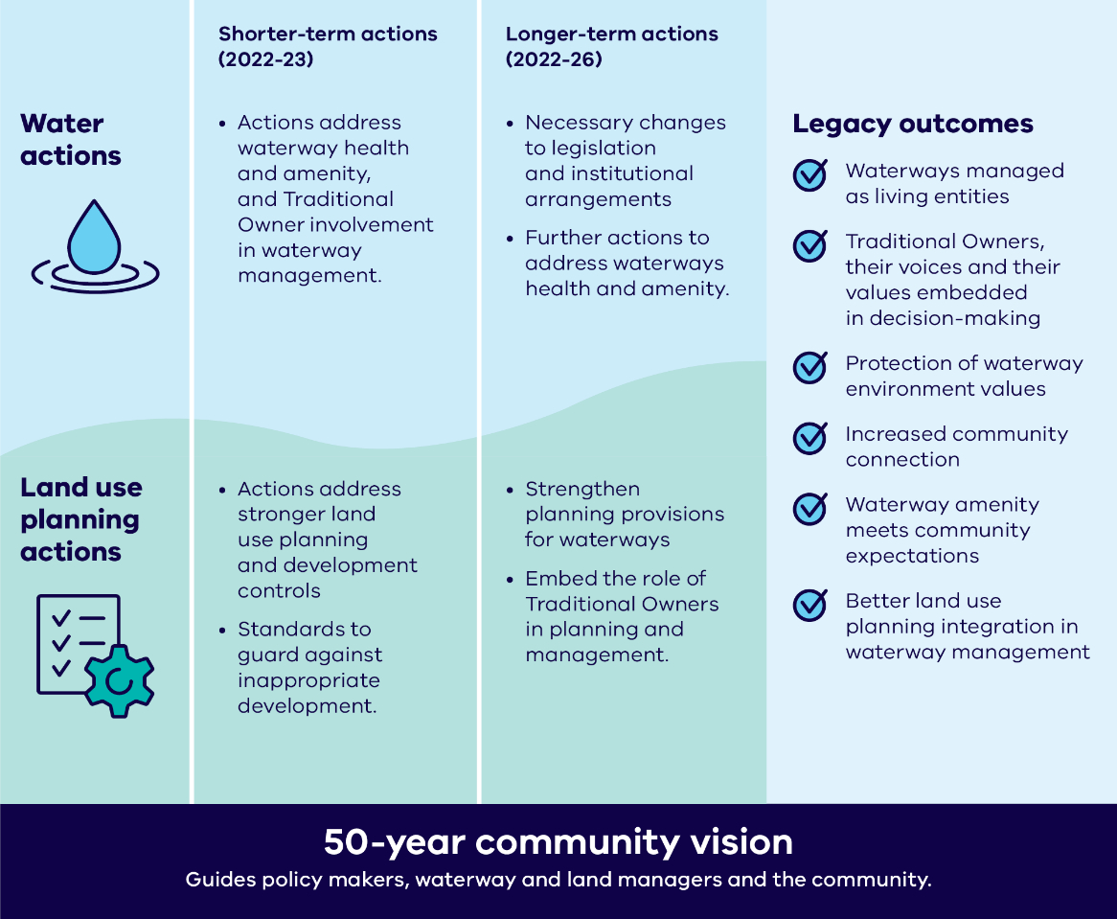
Figure 1: Waterways of the West implementation framework

Overview of progress in 2025
Highlights of 2025 include:
- In late 2025 the Government approved Planning Scheme Amendment VC278 which put in place planning controls to protect Skeleton, Stony and Jacksons Creeks (among other waterways), and made existing planning controls for Waterways of the West permanent. See Actions 3.4 & 3.5.
- During 2025 DEECA undertook engagement with Traditional Owner groups across Victoria on Outcome 1 of Water is Life, Traditional Owner Access to Water Roadmap, seeking input into the development of a law proposal to recognise all Victorian waterways as living. A 'What We Heard' Report summarising the findings of the engagement was provided to participating Traditional Owner groups in December 2025.
- City of Wyndham completed the Davis Creek feasibility study. The study, funded by DEECA, gathered information and assessed the feasibility of a new pedestrian bridge, river access, and improved local play at the Davis Creek and Wirribi Yaluk/Werribee River confluence in Tarneit. The location was identified as a priority due to its proximity with the future Werribee Township Regional Park. This will be an ongoing project driven by the Lower Werribee Waterway Amenity Action Plan.
- Melbourne Water, funded by DEECA, is working to develop a new waterway collaboration, and Strategic Plan for the Maribyrnong River, its tributaries and catchment. This work drives co-delivery of outcomes for the Maribyrnong as guided by the 50-year Community Vision for the Waterways of the West, as well as supporting key actions and outcomes under the Healthy Waterways and Port Phillip and Western Port Regional Catchment Strategies. Gaining the self-determined participation of Traditional Owners Wurundjeri Woi-wurrung Cultural Heritage Aboriginal Corporation and buy-in from the catchment’s community and agency stakeholders has been a focus of the initial stages of implementation. See Directions 2, 4, and 8.
- The Adapt West project completed and released a series of reports to support project planning and delivery. A Stage 2 Summary Report highlighted outcomes from three studies investigating the community and social, ecological, and cultural values of Port Phillip Bay’s western shoreline. It also outlined the project’s key adaption objectives and strategic vision. An assessment of coastal hazard exposure (Stage 3) was also completed with a summary of the work published. See Action 5.3.
- Work started on a new pollution prevention program that focuses on industrial areas in the Maribyrnong catchment. The program will strengthen pollution monitoring, grow analytical capacity and support businesses to manage their environmental risk. It will also support aligned communication to businesses and the community about the importance of protecting the Waterways of the West from pollution. See Action 7.2
For more detailed information on delivery of actions in the Waterways of the West Action Plan, please see the Action tracker section of the report.

Table 1: Status of actions across Action Plan directions
Direction | Number of actions | Delivered/ Superseded | Ongoing | In progress | Planning
Direction 1: Recognise the Waterways of the West as living and integrated natural entities and the Traditional Owners as the ‘voice of these living entities’ | 6 | 5* | 1 | 0 | 0
Direction 2: Embed Traditional Owners’ values in planning and decision-making for waterways | 7 | 2 | 2 | 1 | 2
Direction 3: Strengthen planning policy and controls for waterways | 5 | 5 | 0 | 0 | 0
Direction 4: Improve waterway amenity to meet community expectations | 5 | 2 | 1 | 2 | 0
Direction 5: Better protection of the region’s wetland values | 4 | 2 | 0 | 1 | 1
Direction 6: Identify opportunities to meet environmental and cultural water needs | 2 | 1 | 0 | 1 | 0
Direction 7: Protect the Waterways of the West from pollution | 3 | 1 | 0 | 2 | 0
Direction 8: Increase community connection, education and participation | 5 | 4 | 0 | 1 | 0
Direction 9: Ensure accountability and transparency for Action Plan delivery | 3 | 0 | 1 | 2 | 0
Total | 40 | 22 | 5 | 10 | 3
*includes items that have been superseded as they are considered to have been delivered

Looking ahead
The Waterways of the West Action Plan is entering the final year of its five-year implementation timeframe in 2026. Some actions for 2026 include:
- Following public consultation, DEECA will continue work to finalise the Third Victorian Waterway Management Strategy. The strategy includes an increased focus on urban waterways and their importance for community including amenity, health and environmental outcomes (Direction 4).
- Melbourne Water will continue to lead the Maribyrnong Collaboration in 2026, working with Traditional Owners, agencies and community stakeholders to support coordinated planning for the Maribyrnong River, its tributaries and catchment, including preparation of a strategic plan for the waterway corridor.
- 7 Greenlinks grant projects in the Waterways of the West are concluding with final plantings and maintenance activities underway. City of Wyndham and the Werribee River Association adding 25,000 new plants along the Lower Wirribi Yaluk/Werribee River. While projects along the Maribyrnong River and Steele, Stony, Kororoit and Moonee Ponds Creeks will collectively deliver over 40 hectares of works along inner west waterways for both wildlife and community benefit.
- Development of a Coastal Hazard Adaptation and Resilience Plan for the coastline between Hobsons Bay and Geelong as part of the Adapt West project. The plan will identify adaptation pathways, funding, roles and responsibilities, change management, triggers for review and a monitoring plan. In 2026 the project will be developing its priorities for adaptation and planning for Stage 5 of the project (Direction 5).
- Launch of the implementation of the Pollution Prevention in Waterways of the West program that focuses on industrial areas in the Maribyrnong catchment. See Action 7.2
- Ongoing statewide engagement with Traditional Owners to develop and test legislative and policy approaches to recognise waterways as living entities and Traditional Owners as a unique voice of those entities (Water is Life: Traditional Owner Access to Water Roadmap, Outcome 1).

Action plan implementation case studies

Strengthening planning protections for Waterways of the West
The Waterways of the West Action Plan includes several planning actions to strengthen planning controls and policies for waterway protection. In 2022, a planning scheme amendment introduced updates to State Planning Policy, established a new regional planning policy, and applied Significant Landscape Overlays to the Mirrangbamurn/Maribyrnong River, Moonee Moonee/Moonee Ponds Creek and Wirribi Yaluk/Werribee River. This delivered several short-term actions in the Action Plan, while longer-term actions to expand and finalise protections remained to be completed.
This staged approach meant that early policy reforms could be built on through more detailed strategic planning, allowing protections to be extended to additional waterways and existing interim controls to be reviewed before being made permanent.
In 2023, the Department of Transport and Planning’s Planning Controls for Waterways program undertook further strategic planning work for Cherry Creek, Emu Creek, Jacksons Creek (biik wurrdha), Kororoit Creek, Deep Creek, Skeleton Creek, Steele Creek and Stony Creek. This work supported the implementation of additional planning controls and delivered Action 3.2 of the Action Plan.
The Planning Controls for Waterways program also reviewed the existing planning controls for the Mirrangbamurn/Maribyrnong River, Moonee Moonee/Moonee Ponds Creek and Wirribi Yaluk/Werribee River. In 2025, Planning Scheme Amendment VC278 expanded these controls within and beyond the urban growth boundary and made the interim controls permanent. This delivered Actions 3.5 and 3.6 of the Action Plan.
Together, these changes strengthen the planning framework for Waterways of the West by extending protections to additional waterways and providing greater certainty for the long-term management of river and creek corridors across Melbourne’s west.

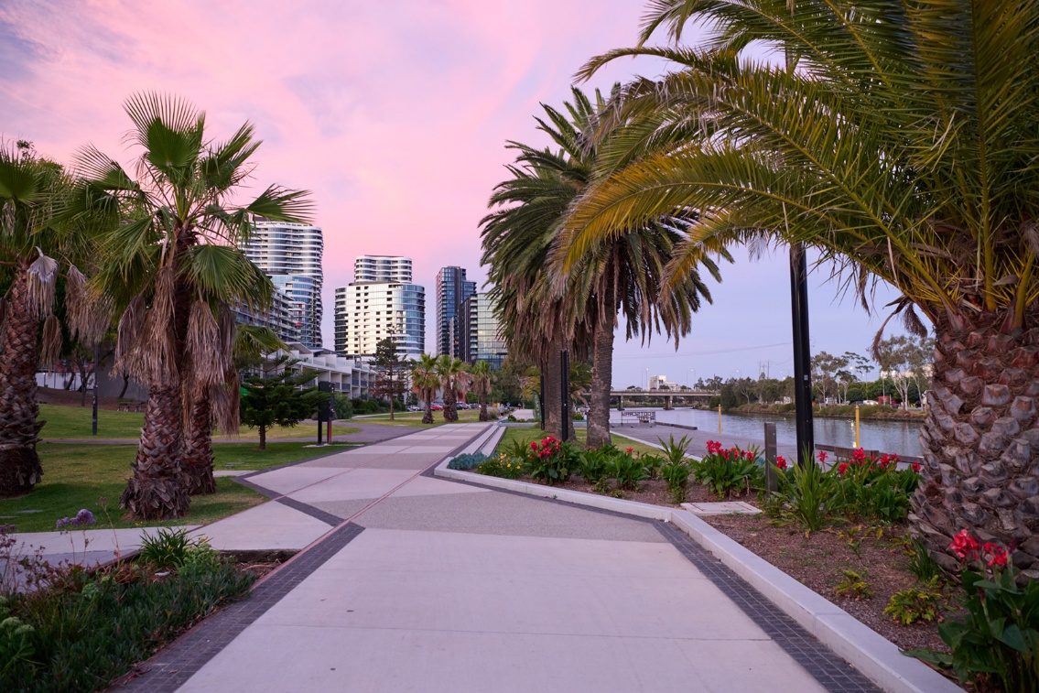
Image: Maribyrnong River, Footscray Rd Area (Supplied by DTP).

Community-led restoration along Kororoit Creek
The Kororoit Creek: Slice of Haven in Suburbia Green Links project has led to habitat improvement and increased community connection along a valued section of Kororoit Creek in Sunshine West.
Delivered by the Friends of Kororoit Creek (FoKC), the project extends on an established regeneration area with 6,500 new plants, direct seeding, mulching and new habitat structures with the placement of rocks and logs. These works are creating valuable space for local wildlife to thrive, while also contributing to a cooler, more welcoming green haven for the community to enjoy.
The project was driven by the passion and commitment of the local community. Volunteers contributed many hours of collective effort, learning new skills and discovering more about the wildlife around them.
Brimbank City Council, also a Green Links grant recipient, partnered with FoKC to hold a beneficial pollinator survey and a ‘Moths After Dark’ moth and nocturnal insect survey. These activities were supported by expert entomologist Luis Mata. Hundreds of species were recorded the event, improving understanding of the range of local biodiversity along the creek. FoKC has also documented all the species found to date along the creek: https://www.inaturalist.org/projects/wildlife-of-kororoit-creek-friends-of-kororoit-creek-project
This project demonstrates the strength of collaboration and combining resources to achieve bigger results for nature and the community.
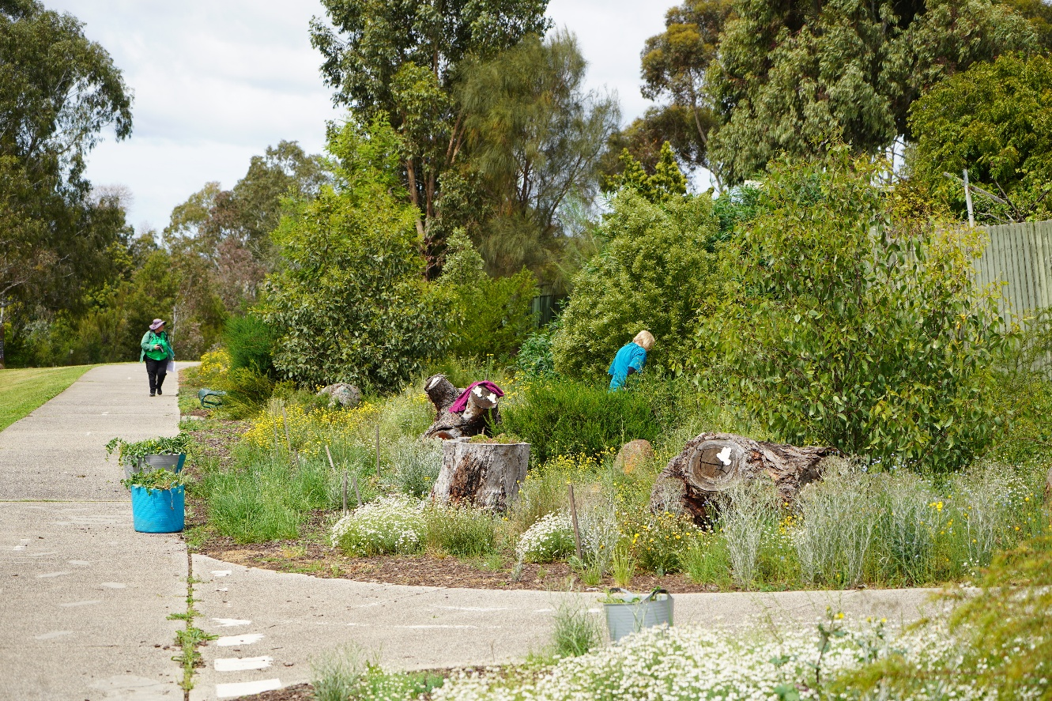
Image: Fenceline planting along Kororoit Creek (Source: FoKC)
‘The creek now looks healthier, more resilient and more inviting. Millions of seeds are being produced by the thriving plants, creating a great foundation for ongoing care and future growth’ Kororoit Creek: Slice of Haven in Suburbia Final Report

Action tracker
The Waterways of the West Action Plan sets out 9 directions and 40 short and long-term actions to be undertaken over a 5-year implementation period. All short-term actions have now been completed, with the exception of part of Action 4.3, with most outcomes reported in the 2022, 2023 and 2024 annual reports.
The majority of long-term actions are expected to be delivered by the end of 2026, where they are not ongoing in nature, or have not been superseded by related policy or program delivery. The 2025 Action Tracker below provides point-in-time summary of action progress and implementation status during the reporting year (to December 2025), including ongoing actions that have no fixed delivery date.
While each action below lists a responsible lead organisation, the delivery of the Action Plan is only achievable through extensive collaboration across agency/organisation boundaries.
A detailed explanation of all deliverables and actions, including background, can be found in the Waterways of the West Action Plan.

Action | Status at Dec 2025 | Timeframe | Lead agency | Comment
Direction 1: Recognise the Waterways of the West as living and integrated natural entities and the Traditional Owners as the ‘voice of these living entities’
1.1 ‘Living entity’ and ‘voice’ for Regional Catchment Strategy (RCS) | Delivered | Short-term | Melbourne Water | Delivered in 2022 – refer to the Waterways of the West Action Plan Annual Report 2022
1.2 Bunurong, Wadawurrung and Wurundjeri aspirations in RCS planning | Delivered | Short-term | Melbourne Water | Delivered in 2022 – refer to the Waterways of the West Action Plan Annual Report 2022
1.3 Support for Bunurong, Wadawurrung and Wurundjeri to express ‘voice of living entities’ | Ongoing | Short-term | Department of Energy, Environment and Climate Action (DEECA) | DEECA continued to support Bunurong, Wadawurrung and Wurundjeri Woi Wurrung Traditional Owners in exploring how the concept of being the 'voice of living entities' could be reflected in policy and legislation.  During 2025, this work included informing living entity policy development for the draft Third Victorian Waterway Management Strategy, progressing Outcome 1 of the Water is Life: Traditional Owner Access to Water Roadmap, and enabling Traditional Owner participation in the design of initiatives such as the Waterways of the West Pollution Prevention Program.  DEECA also funded Melbourne Water to support Traditional Owner participation in the Maribyrnong Collaboration.
1.4 Wider engagement with Traditional Owners about ‘living entity’ and ‘voice’ | Superseded | Long-term | DEECA | Actions 1.4-1.6 are now being delivered through Outcome 1 of Water is Life.  The Victorian Government is working with Traditional Owners to increase their access to water and their involvement in water management. Outcome 1 in Water is Life commits DEECA to working with Traditional Owners across Victoria to develop a law proposal to recognise all waterways as living entities and Traditional Owners as having a unique voice to speak for those living entities.  Extensive work was undertaken during 2025 to develop the proposal and undertake consultation with Traditional Owners across Victoria to input into this law proposal. While Outcome 1 was originally expected to be completed by the end of 2025, the timeline has been extended to enable further engagement and ensure meaningful, ongoing collaboration with Traditional Owners.  To support this next phase of work, DEECA is offering grants of up to $20,000 (excluding GST) to interested Traditional Owner groups for Outcome 1 engagement activities and collaboration with DEECA. Several Learning by Doing projects will commence in August 2026, supporting Traditional Owners to develop their positions on Outcome 1. The outcomes of these projects will help inform any future law reform proposals and related policy development.  Water is Life Progress reporting is published annually.
1.5 Investigate legislation for ‘living entity’ and ‘voice’ concepts | Superseded | Long-term | DEECA | Outcomes from engagement with stakeholders in 2025 as well as legal advice is guiding ongoing investigation into developing legislative mechanisms for Outcome 1 in Water is Life.
1.6 Traditional Owner preamble for possible legislation | Superseded | Long-term | DEECA | Subject to Actions 1.4 and 1.5, ongoing engagement with relevant Traditional Owners and preparation of an engagement summary report on this matter is planned.
Direction 2: Embed Traditional Owners’ values in planning and decision-making for waterways
2.1 Embed connections to Country in RCS | Delivered | Short-term | Melbourne Water | Delivered in 2022 – refer to the Waterways of the West Action Plan Annual Report 2022
2.2 Partnerships to implement ‘voice’ on Country | Ongoing | Short-term | Melbourne Water | Melbourne Water is supporting Traditional Owner leadership in Waterways of the West planning, governance and on-ground activities through dedicated funding, while partnering to explore recognition of waterways as living entities and the application of emerging policy approaches.
2.3 Support for Jacksons Creek Regional Parklands cultural values study | Delivered | Short-term | DEECA | Delivered in 2022 – refer to the Waterways of the West Action Plan Annual Report 2022
2.4 Jacksons Creek Planning Partnership | Ongoing | Long-term | Department of Transport and Planning (DTP) and DEECA | DEECA partnered with local land manager organisations to establish and develop the Jacksons Creek biik wurrdha Partnership Group (Jacksons Creek Planning Partnership) to implement the Jacksons Creek biik wurrdha Regional Parklands Future Directions Plan (2022). The Future Directions Plan sets out a vision, principles and directions for progressive parkland establishment, expansion and management by 2040. The Partnership has resulted in the delivery of projects supporting access to the parklands and protecting its environmental and cultural values. The continuation of the Partnership is subject to funding.  The Future Directions Plan will continue to be implemented by Partnership organisations, including Wurundjeri Woi-wurrung Cultural Heritage Corporation, which is leading a parkwide archaeological survey to inform future land use planning, protection, and management of the Jacksons Creek biik wurrdha Regional Parklands. This project is expected to be completed by January 2027.
2.5 Traditional Owner values and knowledge in land use planning | Ongoing | Long-term | DTP and DEECA | In 2025, DTP progressed updates to the Planning and Environment Act, which were passed by Parliament and received Royal Assent in February 2026. Although not specifically focused on Traditional Owner-related amendments, the work provided an opportunity to strengthen the recognition of Traditional Owner values and act on recommendations made in the Yoorrook Justice Commission's report, Yoorrook Truth be Told. Including ensuring that Registered Aboriginal Parties are invited to participate in strategic planning on Country and are given early notification of proposed development on land that has been prescribed to be culturally sensitive.  The Planning Controls for Waterways Program within DTP is also exploring how planning schemes can better reflect these values.
2.6 RCS reporting Traditional Owner aspirations | Planned | Long-term | Melbourne Water | Melbourne Water completed a mid-term review of their Regional Catchment Strategy (RCS) in 2025. The review includes an assessment of development of the RCS and to what extent self-determined Traditional Owner priorities are reflected. The review also includes an assessment of implementation of the RCS, including to what extent self-determined Traditional Owner priorities are included in sub-strategies under the RCS.
2.7 Bunurong, Wadawurrung and Wurundjeri Healthy Waterway Strategy partnership | In progress | Long-term | Melbourne Water | Recommendations from the Healthy Waterways Strategy mid-term review has resulted in engagement with Traditional Owners being strengthened with more information sharing and collaborative projects supporting self-determined caring for Country. Further information is available in the HWS 2025 reporting at: https://healthywaterways.com.au/annual-summaries/2025
Direction 3: Strengthen planning policy and controls for waterways
3.1 Stronger planning policy and guidance | Delivered | Short-term | DTP | Delivered in 2022 – refer to the Waterways of the West Action Plan Annual Report 2022
3.2 Interim landscape and environmental controls for key waterways | Delivered | Short-term | DTP | Delivered in 2022 – refer to the Waterways of the West Action Plan Annual Report 2022
3.3 Interim built-form controls for key waterways | Delivered | Long-term | DTP | In 2025 landscape controls were expanded, and made permanent, for key waterways in urban areas via Planning Scheme Amendment VC278. VC278 allows for better management of the interface and amenity between private land holdings with waterways.  Practice Notes 97 and 98 outline how to identify, plan for and consider planning applications to protect the values of waterways.
3.4 Planning controls for additional waterways | Delivered | Long-term | DTP | In late 2025 the Government approved Planning Scheme Amendment VC278 which delivered planning controls to protect Skeleton Creek, Stony Creek and Jacksons Creek (among other waterways).
3.5 Review of interim planning controls | Delivered | Long-term | DTP | In late 2025 the Government approved Planning Scheme Amendment VC278 making existing planning controls for Waterways of the West permanent.
Direction 4: Improve waterway amenity to meet community expectations
4.1 Waterway amenity values in RCS | Delivered | Short-term | Melbourne Water | Delivered in 2022 – refer to the Waterways of the West Action Plan Annual Report 2022
4.2 Develop a Lower Wirribi Yaluk/Werribee Waterway Amenity Action Plan | Delivered | Short-term | Melbourne Water | Delivered in 2022 – refer to the Waterways of the West Action Plan Annual Report 2022
4.3 Waterway amenity advocacy | In progress | Short-term | Melbourne Water | Draft Urban Waterways Planning Guidelines have been produced, as an extension of DTP’s planning for waterways program. Further stakeholder and government review is expected in 2026.  Other components of this action have been delivered - refer to the Waterways of the West Action Plan Annual Report 2022.
4.4 Melbourne Water statement of obligations to reflect amenity role | Ongoing | Long-term | DEECA | The Statement of Obligations for water corporations including Melbourne Water is being reviewed, pending Ministerial approval. The Statement outlines the obligations and guiding principles that are applicable to all water corporations.  Melbourne Water, along with DEECA, continue to collaborate on initiatives that champion the amenity values of urban waterways, beyond statutory obligations.
4.5 Victorian Waterway Management Strategy – urban waterway values | In progress | Long-term | DEECA | An Urban Waterways chapter has been drafted for the Third Victorian Waterway Management Strategy, and work to finalise the strategy will continue in 2026.
Direction 5: Better protection of the region’s wetland values
5.1 Wetland mapping data update | Delivered | Short-term | DEECA | Delivered in 2022 – refer to the Waterways of the West Action Plan Annual Report 2022
5.2 RCS wetland mapping | Delivered | Short-term | Melbourne Water | Delivered in 2022 – refer to the Waterways of the West Action Plan Annual Report 2022
5.3 Adaptation strategies for western shoreline wetlands of Port Phillip Bay | In progress | Long-term | DEECA | The Adapt West project completed and released a series of reports that support project planning and delivery of a strategic plan to manage coastal hazards and future resilience for the western shoreline of Port Phillip Bay.  A Stage 2 Summary report was released which reported on the outcomes from three value studies (community and social, ecological, and cultural) and outlined the key adaption objectives and strategic vision of the project. An assessment of coastal hazard exposures (Stage 3) was also completed with a summary of the work published.  Risk and vulnerability work (Stage 4) progressed throughout 2025, including completion of an economic base case and a risk and vulnerability assessment. In 2026, development of adaptation pathways will take into consideration of various adaptation actions and pathways to protect the values identified in Stage 2 and respond to the risks highlighted in Stages 3 and 4.
5.4 Western shoreline wetlands master plan | Planned | Long-term | DEECA | Master Plan dependent on Action 5.3.
Direction 6: Identify opportunities to meet environmental and cultural water needs
6.1 Funding for Traditional Owner cultural water assessment priorities | Delivered | Short-term | DEECA | Delivered in 2022 – refer to the Waterways of the West Action Plan Annual Report 2022
6.2 Central and Gippsland Region Sustainable Water Strategy water options for environment and culture | In progress | Long-term | DEECA | Short-term environmental water commitments for Wirribi Yaluk/Werribee River have been progressed through water savings from the Bacchus Marsh Irrigation District project. Long-term commitments are dependent on the Werribee system reconfiguration. Feasibility studies, water resource modelling, and a preliminary business case concluded in 2024.  Initial investigations are underway regarding use and/or trade of unused water in the Maribyrnong system for use as environmental water.  Catchment-scale Integrated Water Management (IWM) Plans for the Wirribi Yaluk/Werribee and Maribyrnong catchments to increase use of recycled water, treated stormwater and rainwater, and associated Action Plans were released in April 2024. All plans are available online at IWM forums.
Direction 7: Protect the Waterways of the West from pollution
7.1 Pollution prevention taskforce | Delivered | Short-term | DEECA and Environment Protection Authority (EPA) Victoria | Delivered in 2023 – refer to the Waterways of the West Action Plan Annual Report 2023
7.2 Priority pollution prevention projects | In progress | Long-term | DEECA and EPA Victoria | Funding has been secured to implement priority recommendations of the Taskforce (Action 7.1).  A new Pollution Prevention in Waterways of the West Program is being developed, with a focus on industrial areas in the Maribyrnong catchment. The program will strengthen pollution monitoring and analytical capacity and support businesses to manage their environmental risk. It will also support communication with industry and the community around pollution prevention opportunities.
7.3 Implementation of place-based stormwater objectives | In progress | Long-term | Melbourne Water | Melbourne Water is collaborating with industry partners to implement place-based stormwater performance objectives as part of implementation of the Healthy Waterways Strategy. Plans for major stormwater schemes in Toolern and Sunbury, which can make substantial contributions, are also being progressed.
Direction 8: Increase community connection, education and participation
8.1 Community engagement about Traditional Owner culture and values | Delivered | Short-term | Melbourne Water | Delivered in 2024 – refer to the Waterways of the West Action Plan Annual Report 2024
8.2 Community engagement strategy, including culturally and linguistically diverse (CALD) | Delivered | Short-term | Melbourne Water | Delivered in 2023 – refer to the Waterways of the West Action Plan Annual Report 2023
8.3 CALD engagement toolkit | Delivered | Short-term | DEECA | Delivered in 2022 – refer to the Waterways of the West Action Plan Annual Report 2022
8.4 Community Vision inclusion in RCS | Delivered | Short-term | Melbourne Water | Delivered in 2022 – refer to the Waterways of the West Action Plan Annual Report 2022
8.5 Community Vision inclusion in Healthy Waterway Strategy programs | In progress | Long-term | Melbourne Water | The mid-term review of the Healthy Waterways Strategy was completed in June 2024. Addendums for the Werribee and Maribyrnong catchment programs are being prepared and will include the Waterways of the West Community vision.
Direction 9: Ensure accountability and transparency for Action Plan delivery
9.1 Annual implementation report | Ongoing | Short-term | DEECA | This report is for the fourth year of annual reporting on the Action Plan and covers the period from January – December 2025.
9.2 Final review of implementation | In progress | Long-term | DEECA | A review of implementation of the Action Plan has commenced and will inform delivery of the Action Plans with a final review expected in 2027/28.
9.3 Waterway condition reporting through Healthy Waterways Strategy | In progress | Long-term | Melbourne Water | Melbourne Water prepares annual reports on progress towards the Performance Objectives of the Healthy Waterways Strategy https://healthywaterways.com.au/report-card

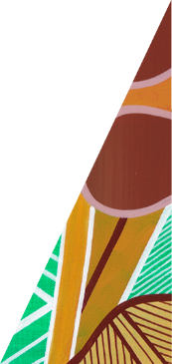






deeca.vic.gov.au

