Rivers of the Barwon (Barre Warre Yulluk) Action Plan Annual Report 2024

Table of Contents

Context 3

How the 5-year Action Plan builds on the vision for the Rivers of the Barwon (Barre Warre Yulluk) 4

Overview of progress in 2024 4

Looking ahead 6

Action plan implementation case studies 7

Supporting Integrated Water Management planning for Bannockburn and Geelong Growth Areas 7

Early headway in delivering three priority projects identified in the Kitjarra-dja-bul Bullarto langi-ut Masterplan 8

Upgrading recreational access and safety – West Fyans Park boat ramp 9

Action tracker 11

Direction 1: Recognise the Rivers of the Barwon (Barre Warre Yulluk) as a living and integrated natural entity and the Traditional Owners as the ‘voice of this living entity’ 12

Direction 2: Embed Traditional Owners’ values in planning and decision making for waterways 15

Direction 3: Strengthen planning policy and controls for waterways 17

Direction 4: Improve waterway amenity to meet community expectations 18

Direction 5: Identify opportunities to meet environmental and cultural water needs 20

Direction 6: Strengthen stormwater management to build resilience 22

Direction 7: Ensure accountability and transparency for Action Plan delivery 23

Publication information 24

Acknowledgements 24

Copyright 24

Creative Commons 24

Disclaimer 24

Accessibility 25

# Context

The Victorian Government released the [Rivers of the Barwon (Barre Warre Yulluk) Action Plan](https://www.water.vic.gov.au/waterways/rivers-of-the-barwon-barre-warre-yulluk-action-plan) in late 2021 to ensure this iconic catchment thrives and is enjoyed for years to come.

The Rivers of the Barwon (Barre Warre Yulluk) Annual Reports provide an update on progress towards delivering the 7 Directions and 30 Actions that make up the Action Plan. This report outlines some key highlights from 2024 implementation and the status of actions, and delivers on the Victorian Government’s commitment to update the community annually on implementation of the 5-year Action Plan.

The Eastern Maar and Wadawurrung peoples have cared for this Country and its integrated waterways for millennia. The Action Plan recognises the waterways as living and integrated natural entities, and the unique role that Traditional Owners have as knowledge holders and custodians to be a voice of these living entities.

A new community-led approach, the Action Plan is guided by a 50-year Community Vision. The vision encourages agencies and community to walk together with the Traditional Owners of Barre Warre Yulluk. The vision is part of the [action plan](https://www.water.vic.gov.au/waterways/rivers-of-the-barwon-barre-warre-yulluk-action-plan).

By bringing everyone throughout the region together, we move closer to realising the 50-year Rivers of the Barwon community vision and delivering the beneficial outcomes we are collectively seeking for the health of our waterways.

## How the 5-year Action Plan builds on the vision for the Rivers of the Barwon (Barre Warre Yulluk)

Figure 1: Rivers of the Barwon (Barre Warre Yulluk) implementation framework

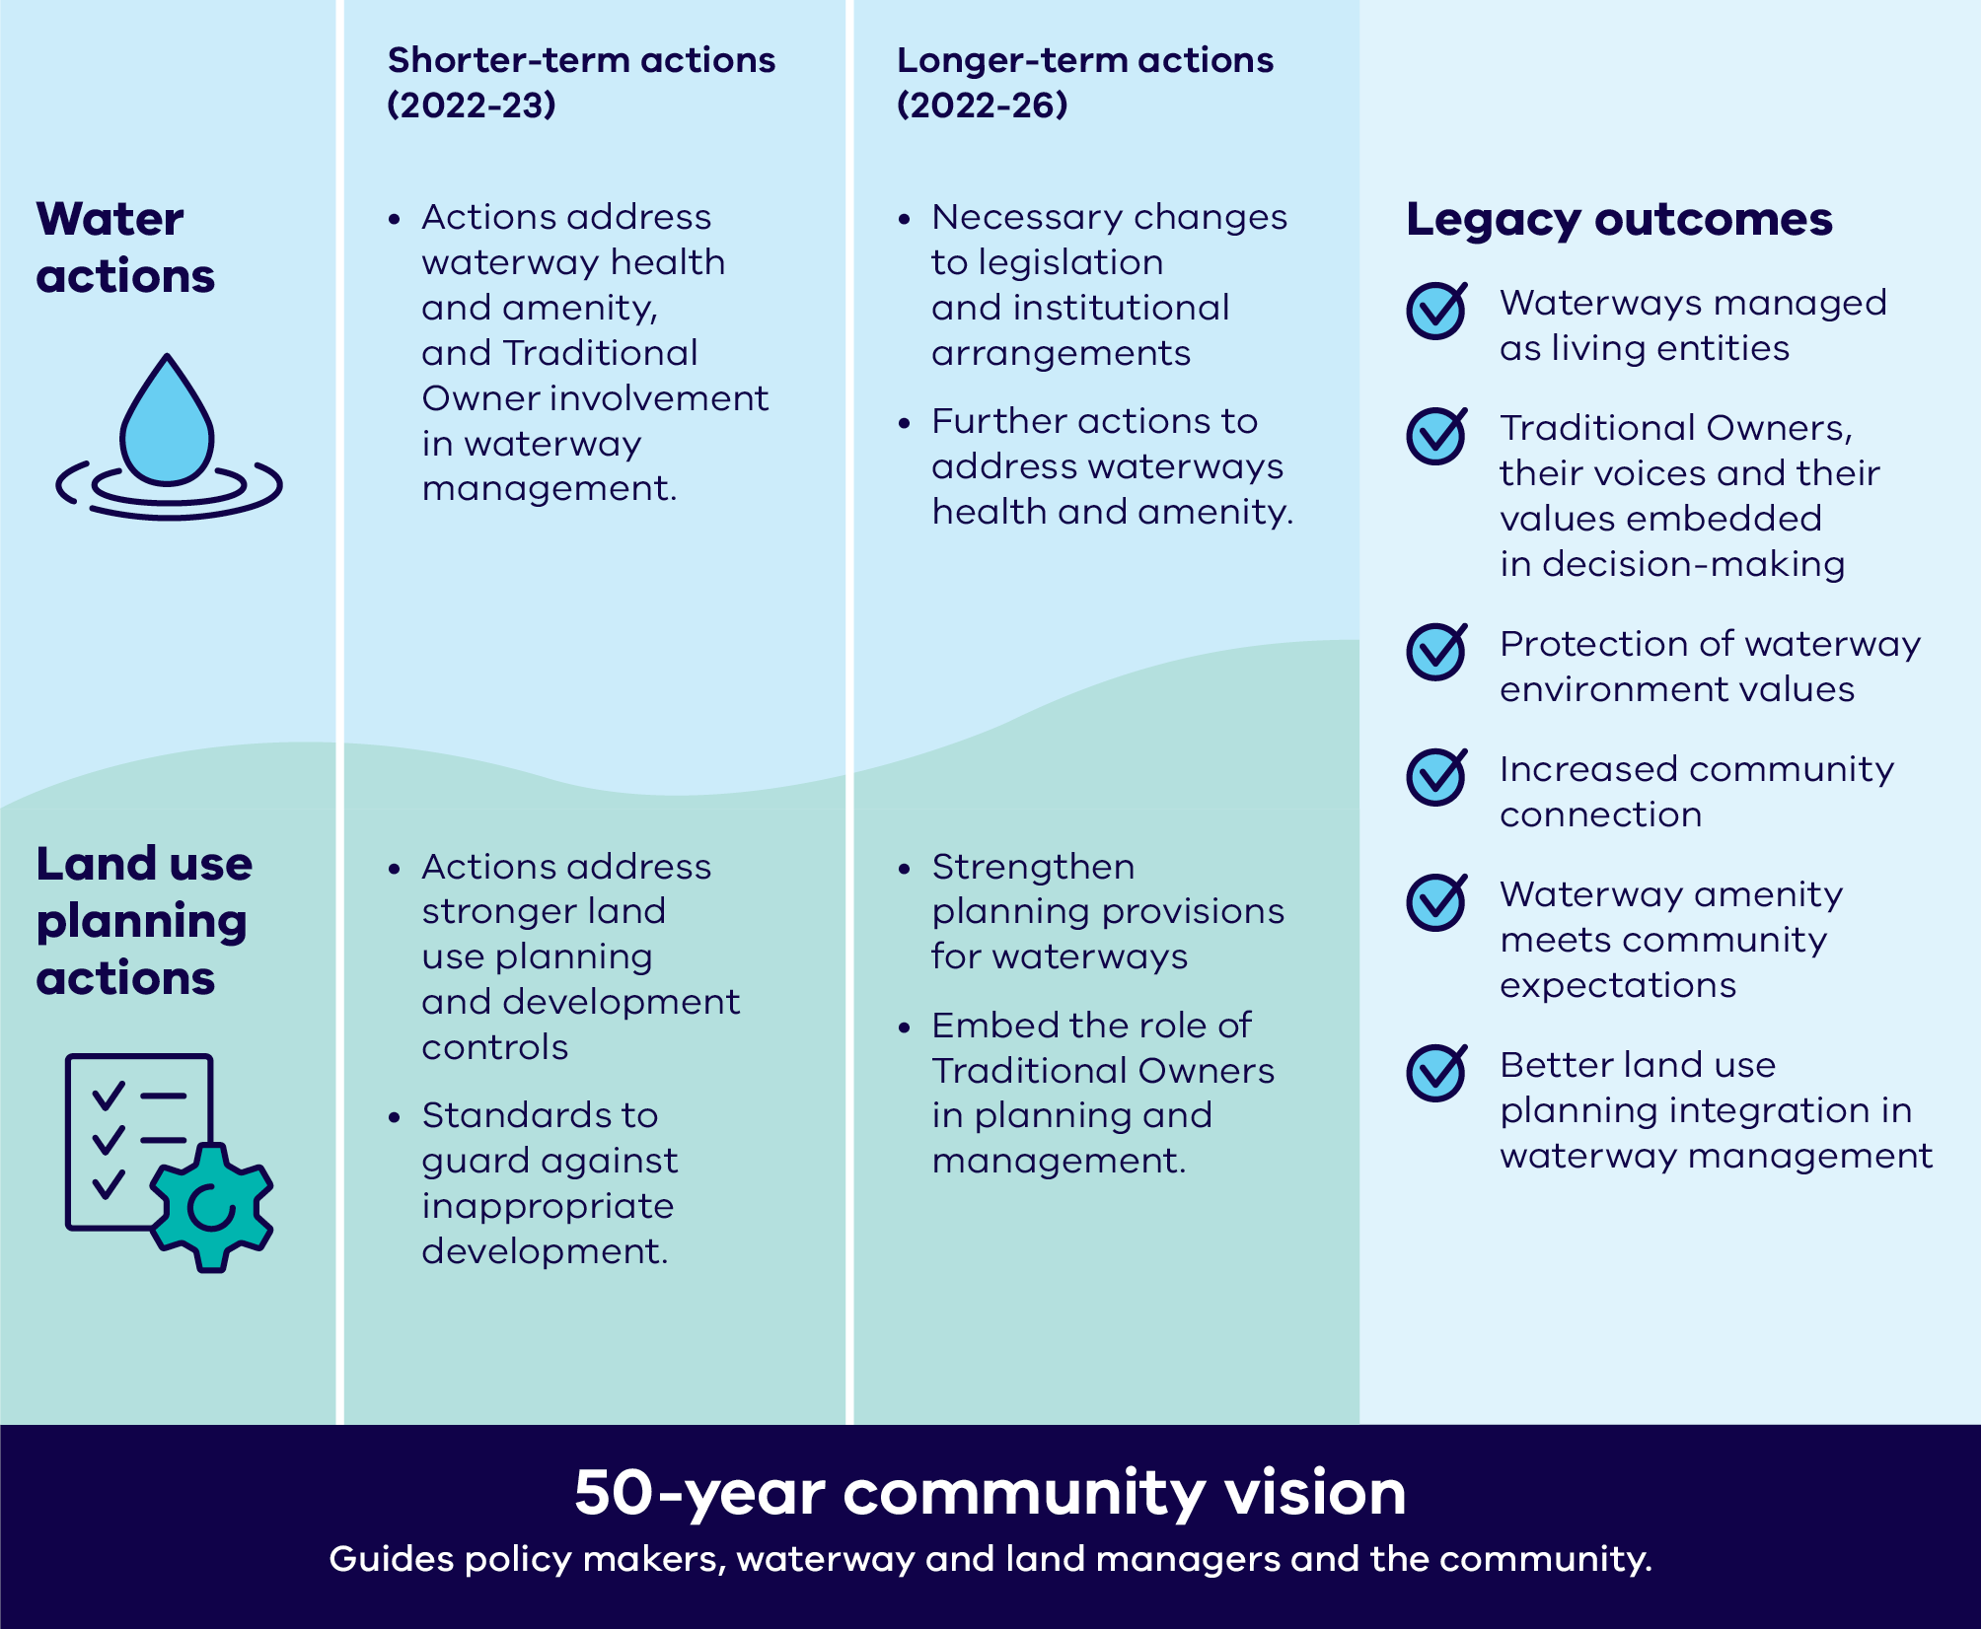

# Overview of progress in 2024

Highlights of 2024 include:

* Beginning of the [Kitjarra-dja-bul Bullarto langi-ut Masterplan](https://ccma.vic.gov.au/projects/barwon-river-parklands/) 10-year implementation phase, starting the work to deliver new recreational and amenity benefits to the community. Finalised and launched in February 2024, the [Kitjarra-dja-bul Bullarto langi-ut Masterplan](https://ccma.vic.gov.au/projects/barwon-river-parklands/) will drive important regional outcomes for the Moorabool Yaluk/Moorabool River and Parwan/Barwon River from Meredith through to Barwon Heads. *See Action 4.5.*
* Support of the implementation of *Kitjarra-dja-bul Bullarto langi-ut* including funding a coordinator role at Corangamite Catchment Management Authority (CMA), as well as funding to resource Wadawurrung Traditional Owner Aboriginal Corporation to support and participate in implementation over this period. *See Action 4.5.*
* The West Fyans Street Boat Ramp upgrade was finished and opened by Corangamite CMA, creating safer and improved river access for unpowered watercraft to explore the river. This project was funded through an Iconic Urban Rivers of the Barwon 2022/23 grant. *See Direction 4.*
* Supporting collaborative integrated water management planning for Bannockburn and Geelong growth areas, with a focus on investigating the management options for stormwater. *See Direction 6.*

For more detailed information on delivery of actions in the Rivers of the Barwon (Barre Warre Yulluk) Action Plan, please see the Action tracker section of the report.

**Table 1: Status of actions across Action Plan directions**

|  |  |  |  |  |  |
| --- | --- | --- | --- | --- | --- |
| **Direction** | **Number of actions** | **Delivered** | **Ongoing** | **In progress** | **Planning** |
| Direction 1: Recognise the Rivers of the Barwon (Barre Warre Yulluk) as a living and integrated natural entity and the Traditional Owners as the ‘voice of this living entity’ | 6 | 2 | 1 | 1 | 2 |
| Direction 2: Embed Traditional Owners’ values in planning and decision-making for waterways | 5 | 2 | 1 | 1 | 1 |
| Direction 3: Strengthen planning policy and controls for waterways | 6 | 2 | 0 | 0 | 4 |
| Direction 4: Improve waterway amenity to meet community expectations | 6 | 4 | 0 | 2 | 0 |
| Direction 5: Identify opportunities to meet environmental and cultural water needs | 2 | 1 | 0 | 1 | 0 |
| Direction 6: Strengthen stormwater management to build resilience | 3 | 1 | 0 | 2 | 0 |
| Direction 7: Ensure accountability and transparency for Action Plan delivery | 2 | 1 | 0 | 1 | 0 |
| **Total** | **30** | **13** | **2** | **8** | **7** |

# Looking ahead

The Rivers of the Barwon (Barre Warre Yulluk) Action Plan enters the third year of its   
5-year implementation timeframe in 2025. Some actions for 2025 include:

* Statewide engagement with Traditional Owners to develop and test legislative and policy approaches to recognise waterways as ‘living entities’ and their Traditional Owners as a unique ‘voice’ of those entities (Direction 1).
* Corangamite CMA will start development of its next regional waterway strategy, including engagement with Eastern Maar and Wadawurrung Traditional Owners on their priorities for the waterways as a living entity (Action 2.5).
* Corangamite CMA will begin planning and design of the fishways on the Parwan/Barwon River at Buckley Falls and Moorabool Yaluk/Moorabool River at Batesford Weir, as well as engagement with stakeholders to develop a conceptual design of a new fishway at Baums Weir on the Parwan/Barwon River (Action 4.5).
* The development of a new Victorian Waterway Management Strategy is underway in partnership with Traditional Owners, catchment management authorities and other partners, with input from key stakeholder groups and the broader Victorian community (Action 4.6).
* Ongoing investment in Victoria’s urban waterway habitat through the $10 million [Green Links Grants Program](https://www.water.vic.gov.au/our-programs/green-links), including a new Round 2 project between City of Greater Geelong and Corangamite CMA (Direction 4).
* Engagement with industry on stormwater licensing reform options as part of implementation of the Central and Gippsland Region Sustainable Water Strategy 2022 (Action 6.3).

# Action plan implementation case studies

## Supporting Integrated Water Management planning for Bannockburn and Geelong Growth Areas

### Direction 6: Strengthen stormwater management to build resilience

Upcoming strategic planning projects for Bannockburn and the growth areas of Geelong’s west and north will be examining the potential impact of development on waterways such as Parwan/Barwon River, Moorabool Yaluk/Moorabool River, and Bruce Creek. Stormwater management is a critical consideration to manage the potential development impacts.

A range of projects are being undertaken to inform the planning processes and address collective stormwater challenges in the region. To coordinate planning and implementation of these projects, a steering committee of key agencies has been meeting regularly. The participating organisations are the Department of Energy, Environment and Climate Action (DEECA), Barwon Water, City of Greater Geelong, Golden Plains Shire, Corangamite CMA and Wadawurrung Traditional Owners Aboriginal Corporation.

The collaboration between these organisations is growing their understanding of how to manage long-term impacts of development on waterways and delivering more effective integrated water management.

## Early headway in delivering three priority projects identified in the Kitjarra-dja-bul Bullarto langi-ut Masterplan

### Action 4.5 Support for Kitjarra-dja-bul Bullarto langi-ut priority projects

**Moorabool River Reserve**

Golden Plains Shire is leading on consultation and master planning for a new public park along the west bank of the Lower Moorabool Yaluk/Moorabool River at Batesford. The park will have a strong focus on protection of environmental and Traditional Owner cultural values. Planning for the park has been supported by funding from DEECA.

To date, a detailed [masterplan](https://www.goldenplains.vic.gov.au/sites/default/files/2023-10/Moorabool_River_Reserve_Masterplan_Adopted_23-33.pdf) has been developed for the site following engagement with Wadawurrung Traditional Owners and the local community.

A consultant has been engaged to develop a Traditional Owner Cultural Narrative to guide infrastructure design for amenity elements such as walking trails, pedestrian bridges and cultural signage. Further engagement will be undertaken in 2025 to develop concepts and Wadawurrung design elements.

**Bukareeyoo/Ocean Grove sand spit sewerage works**

Funding from DEECA is supporting the re-development of four public toilet blocks on the Bukareeyoo/Ocean Grove sand spit including connection to reticulated sewerage to replace existing septic tanks.

This work is also supporting an outcome identified under the Barwon Coast Caravan and Camping Masterplan.

Key design elements of the project are now underway, including design of four amenity blocks, a Cultural Heritage Management Plan, and the detailed design of sewerage works. Construction is expected to be tendered in the second half of 2025 and commence in the second quarter of 2026.

**Parwan/Barwon River Loop Trail – City of Greater Geelong**

Supported by funding from DEECA, once completed this project will connect walking trails on the north and south sides of the Parwan/Barwon River in the Fyansford and Mt Brandon area of Geelong. A new pedestrian bridge across the river near the Geelong Ring Road is also planned.

Initial conceptual designs are being reviewed and refined with Corangamite CMA to take flooding and other operational considerations into account. Conceptual design is expected to be complete by late 2025, followed by procurement of detailed design of the pedestrian bridge and connecting walking tracks (subject to funding).

## Upgrading recreational access and safety – West Fyans Park boat ramp

### Direction 4: Improve waterway amenity to meet community expectations

The West Fyans Park boat ramp, identified as needing safety and access upgrades, was reopened to the public following improvement works in mid-2024.

The boat ramp is a popular site to access the Parwan/Barwon River for unpowered watercraft such as kayaks, however the concrete ramp had become unsafe due to algae build-up creating a highly slippery entry point. The adjoining river platform also lacked functional mooring points or options for safe access from the water’s edge.

The new launching facility was able to utilise the existing solid foundations which reduced disturbance and costs during the works. The project has significantly improved the amenity of the site, prioritised public safety and ensures easy and secure access for recreational activities along this stretch of the river.

Stakeholder engagement helped to inform the design of the boat ramp, with feedback such as the inclusion of ladders at the river’s edge to assist people in exiting the water, incorporated into the final design.

The boat ramp now features anti-slip fibre reinforced plastic mini mesh which has enhanced its safety. The river decking area has also been reconstructed with longer-lasting anti-slip materials, including recycled plastic planks for the top of the deck and new barge boards along the front of the decking. These improvements provide a resting point for watercraft and prevent damage, ensuring a safer and more enjoyable environment for river-based activities.

Photo 1: (West Fyans Park boat ramp. Credit: Corangamite Catchment Management Authority)

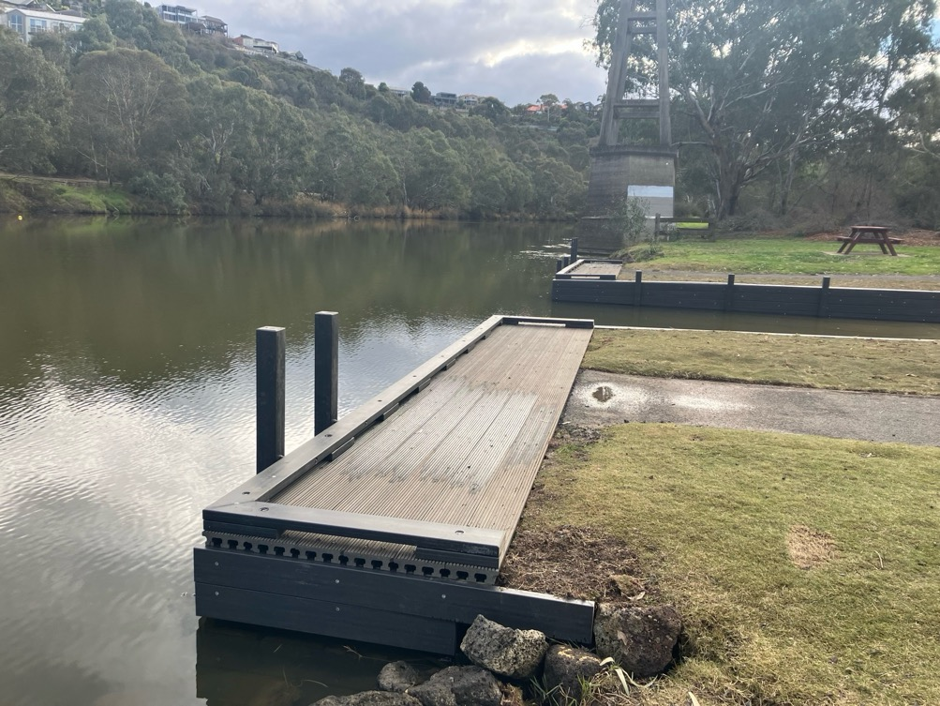

# Action tracker

The Action Plan outlines 7 Directions and 30 Actions that aim to deliver results across a   
5-year period. All short-term actions have now been completed. Many short-term actions were delivered and reported on in the 2022 and 2023 annual reports. Long-term actions are planned for delivery by the end of 2026, dependent on the availability of funding.

The 2024 reporting below provides detail on the progress of actions in 2024, including ongoing actions that have no fixed delivery date and are continuing.

While each action below lists a responsible lead organisation, the delivery of the Action Plan is only achievable through extensive collaboration across agency/organisation boundaries. This is most apparent in working to deliver ‘living entity’ and ‘voice’ outcomes, which will involve partnerships with Traditional Owners and other agencies.

A full explanation of all deliverables and actions, including background, can be found in the [Rivers of the Barwon (Barre Warre Yulluk) Action Plan](https://www.water.vic.gov.au/waterways/rivers-of-the-barwon-barre-warre-yulluk-action-plan).

## Direction 1: Recognise the Rivers of the Barwon (Barre Warre Yulluk) as a living and integrated natural entity and the Traditional Owners as the ‘voice of this living entity’

### Short-term

#### Action 1.1 ‘Living entity’ and ‘voice’ for Regional Catchment Strategy (RCS)

**Status:** Delivered in 2022 – refer to the [Rivers of the Barwon (Barre Warre Yulluk) Action Plan Annual Report 2022](https://www.water.vic.gov.au/__data/assets/pdf_file/0022/661234/rivers-of-the-barwon-action-plan-annual-report.pdf)

**Led by:** Corangamite Catchment Management Authority (CMA)

#### Action 1.2 Eastern Maar and Wadawurrung aspirations in Corangamite RCS planning

**Status:** Delivered in 2022 – refer to the [Rivers of the Barwon (Barre Warre Yulluk) Action Plan Annual Report 2022](https://www.water.vic.gov.au/__data/assets/pdf_file/0022/661234/rivers-of-the-barwon-action-plan-annual-report.pdf)

**Led by:** Corangamite CMA

#### Action 1.3 Support for Eastern Maar and Wadawurrung to express ‘voice of living entities’

**Status:** Ongoing

Continuing support for Eastern Maar and Wadawurrung Traditional Owners to express what being 'the voice of the living entities' is to them through policy and legislation. This includes work on living entity policy to support the new Victorian Waterway Management Strategy (VWMS), as well as engagement on Outcome 1 of [Water is Life, Traditional Owner Access to Water Roadmap](https://www.water.vic.gov.au/our-programs/aboriginal-water-program/water-is-life-roadmap).

### Long-term

#### Action 1.4 Wider engagement with Traditional Owners about ‘living entity’ and ‘voice’

**Status:** In progress

**Led by:** DEECA

Preparation for broader statewide engagement with stakeholders as part of the delivery of Outcome 1 of Water is Life, Traditional Owner Access to Water Roadmap.

Photo 2: Water is Life Aboriginal artwork



#### Action 1.5 Investigate legislation for ‘living entity’ and ‘voice’ concepts

**Status:** Planned

**Led by:** DEECA

Subject to engagement outcomes (see Action 1.4) and consistent with the commitments in Water is Life, Traditional Owner access to Water Roadmap, consultation will be held on proposed legislative mechanisms.

#### Action 1.6 Traditional Owner preamble for possible legislation

**Status:** Planned

**Led by:** DEECA

Subject to Actions 1.4 and 1.5.

## Direction 2: Embed Traditional Owners’ values in planning and decision making for waterways

### Short-term

#### Action 2.1 Embed connections to Country in Corangamite RCS

**Status:** Delivered in 2022 – refer to the [Rivers of the Barwon (Barre Warre Yulluk) Action Plan Annual Report 2022](https://www.water.vic.gov.au/__data/assets/pdf_file/0022/661234/rivers-of-the-barwon-action-plan-annual-report.pdf)

**Led by:** Corangamite CMA

#### Action 2.2 Partnerships to implement ‘voice’ on Country

**Status:** Delivered in 2022 – refer to the [Rivers of the Barwon (Barre Warre Yulluk) Action Plan Annual Report 2022](https://www.water.vic.gov.au/__data/assets/pdf_file/0022/661234/rivers-of-the-barwon-action-plan-annual-report.pdf)

**Led by:** Corangamite CMA

### Long-term

#### Action 2.3 Traditional Owner values and knowledge in land use planning

**Status:** Ongoing

**Led by:** Department of Transport and Planning (DTP) and DEECA

This action will be delivered beyond the Action Plan framework. The Department of Transport and Planning (DTP) is reviewing the *Planning and Environment Act* *1987*. Although the review is not focused on Traditional Owner-related amendments, it provides an opportunity to strengthen the recognition of Traditional Owner values. The Planning Controls for Waterways Program, within DTP, is also exploring how planning schemes can better reflect these values.

#### Action 2.4 Regional Catchment Strategy (RCS) reporting Traditional Owner aspirations

**Status:** Planned

**Led by:** Corangamite CMA

Corangamite CMA will include in its RCS reporting an assessment by the Traditional Owners of RCS activities that give effect to Traditional Owners’ aspirations and Country plans.

The RCS mid-term review (in 2025) will provide the opportunity to engage the Eastern Maar Aboriginal Corporation and Wadawurrung Traditional Owner Aboriginal Corporation to assess the effect of their actions in delivering against the outcomes identified within their country plans that support the delivery of the RCS. More information on the identified outcomes is available at: [Traditional Owners | Corangamite Regional Catchment Strategy](https://corangamite.rcs.vic.gov.au/themes/communities/traditional-owners-in-icm/)

#### Action 2.5 Eastern Maar and Wadawurrung regional waterway strategy partnership

**Status:** In progress

**Led by:** Corangamite CMA

This action is expected to be delivered during 2025 when drafting of the new Corangamite Waterway Strategy formally commences. Funding provided by the Department of Energy, Environment and Climate Action will support engagement with this process for both Eastern Maar and Wadawurrung Traditional Owners. A process for this will be developed that is both suitable and culturally safe enabling both Traditional Owner organisations to provide valuable input into the new regional waterway strategy.

## Direction 3: Strengthen planning policy and controls for waterways

### Short-term

#### Action 3.1 Stronger planning policy and guidance

**Status:** Delivered in 2022 – refer to the [Rivers of the Barwon (Barre Warre Yulluk) Action Plan Annual Report 2022](https://www.water.vic.gov.au/__data/assets/pdf_file/0022/661234/rivers-of-the-barwon-action-plan-annual-report.pdf)

**Led by:** DTP

#### Action 3.2 Interim landscape and environmental controls for key waterways

**Status:** Delivered in 2022 – refer to the [Rivers of the Barwon (Barre Warre Yulluk) Action Plan Annual Report 2022](https://www.water.vic.gov.au/__data/assets/pdf_file/0022/661234/rivers-of-the-barwon-action-plan-annual-report.pdf)

**Led by:** DTP

### Long-term

#### Action 3.3 Interim built-form controls for key waterways

**Status:** Planned

**Led by:** DTP

Subject to funding, DTP will undertake background studies and investigate implementation options to support stronger built-form planning controls for the Parwan/Barwon, Moorabool Yaluk/Moorabool, Waywatcurtan/Leigh and Yarrowee Rivers. Subject to funding, further work is required to review and consider their potential implementation.

#### Action 3.4 Integrated regional strategic land use plan for Rivers of the Barwon (Barre Warre Yulluk)

**Status:** Planned

**Led by:** DTP

Initial investigations are underway to scope the project, however development and implementation is subject to funding.

#### Action 3.5 Structure plan to integrate Geelong’s centre with Parwan/ Barwon River

**Status:** Planned

**Led by:** DTP

The DTP consultation on the draft Central Geelong Framework Plan is complete and a planning scheme amendment to implement the plan has been prepared. Work to prepare a Structure Plan for the city centre to the Parwan/Barwon River will be considered once the Framework Plan is finalised.

#### Action 3.6 Review of interim planning controls

**Status:** Planned

**Led by:** DTP

Review to occur in 2025-26.

## Direction 4: Improve waterway amenity to meet community expectations

### Short-term

#### Action 4.1 Waterway amenity values in RCS

**Status:** Delivered in 2022 – refer to the [Rivers of the Barwon (Barre Warre Yulluk) Action Plan Annual Report 2022](https://www.water.vic.gov.au/__data/assets/pdf_file/0022/661234/rivers-of-the-barwon-action-plan-annual-report.pdf)

**Led by:** Corangamite CMA

#### Action 4.2 Barwon and Moorabool flagship programs

**Status:** Delivered in 2022 – refer to the [Rivers of the Barwon (Barre Warre Yulluk) Action Plan Annual Report 2022](https://www.water.vic.gov.au/__data/assets/pdf_file/0022/661234/rivers-of-the-barwon-action-plan-annual-report.pdf)

**Led by:** Corangamite CMA

#### Action 4.3 Develop Kitjarra-dja-bul Bullarto langi-ut/ Barwon Rivers Parklands Masterplan

**Status:** Delivered in 2023 – refer to the [Rivers of the Barwon (Barre Warre Yulluk) Action Plan Annual Report 2023](https://www.water.vic.gov.au/__data/assets/pdf_file/0026/716507/rivers-of-the-barwon-action-plan-annual-report-2023.pdf)

**Led by:** Corangamite CMA

#### Action 4.4 Funding for Yarrowee Masterplan parkland priority projects

**Status:** Delivered in 2023 – refer to the [Rivers of the Barwon (Barre Warre Yulluk) Action Plan Annual Report 2023](https://www.water.vic.gov.au/__data/assets/pdf_file/0026/716507/rivers-of-the-barwon-action-plan-annual-report-2023.pdf)

**Led by:** DEECA

### Long-term

#### Action 4.5 Support for Kitjarra-dja-bul Bullarto Langi-ut priority projects

**Status:** In progress

**Led by:** Corangamite CMA

Investment has been secured through Round 1 of the Green Links Program and the Federal Government’s [Urban Rivers and Catchment Program](https://www.dcceew.gov.au/environment/biodiversity/conservation/urban-rivers-catchments-program) (URCP) to advance works aligned with the Kitjarra-dja-bul Bullarto Langi-ut Masterplan:

$1.22 million of the Green Links Rivers of the Barwon Revegetation Works Project will be used to revegetate sections of the Parwan/Barwon, Moorabool Yaluk/Moorabool, and along waterways in highly urbanised areas of Geelong including Waurn Ponds.

$1.67 million in Federal funding through the URCP will support fishway projects near Buckley Falls on the Parwan/ Barwon River and at Batesford Weir on the Moorabool Yaluk/Moorabool River, a key project identified under the Masterplan.

Additionally, $533,500 in funding was provided in 2024 by DEECA to the leads of three high priority Masterplan projects via the Corangamite CMA.

#### Action 4.6 Victorian Waterway Management Strategy – urban waterway values

**Status:** In progress

**Led by:** DEECA

The new Victorian Waterway Management Strategy is due to be released in the next year. Work is underway on this, including updated policies about planning for urban waterway values and threats.

## Direction 5: Identify opportunities to meet environmental and cultural water needs

### Short-term

#### Action 5.1 Funding for Traditional Owner cultural water assessment priorities

**Status:** Delivered in 2022 – refer to the [Rivers of the Barwon (Barre Warre Yulluk) Action Plan Annual Report 2022](https://www.water.vic.gov.au/__data/assets/pdf_file/0022/661234/rivers-of-the-barwon-action-plan-annual-report.pdf)

**Led by:** DEECA

### Long-term

#### Action 5.2 Central and Gippsland Region Sustainable Water Strategy (CGRSWS) water options for environment and culture

**Status:** In progress

**Led by:** DEECA

The CGRSWS (2022) includes policies to return up to 6,500 megalitres to Moorabool Yaluk/Moorabool River west branch and 700 megalitres to the river’s east branch over the next 10 years. Action 4-3 and 4-4 of the CGRSWS will contribute to this commitment through returning 3,000 megalitres to the Moorabool Yaluk/Moorabool River west branch and 700 megalitres to the east branch.

Project implementation has commenced including discussion of entitlement options, water resource modelling and a separate project led by the Wadawurrung Traditional Owners Aboriginal Corporation (WTOAC) trialling water delivery in the Moorabool Yaluk/Moorabool River. A video documenting WTOAC’s first self-determined trial water delivery to Wadawurrung Dja (Country) can be found here: [A Flowing Future: Water releases back to Wadawurrung Dja (Country)](https://www.youtube.com/watch?v=VsS9hDKQ4LE).

Additionally, discussions are well underway to determine how water returned in the Moorabool Yaluk/Moorabool River will be shared between WTOAC and the environment (Action 4-4). These discussions are being held in collaboration with WTOAC, the Victorian Environmental Water Holder and Corangamite CMA.

## Direction 6: Strengthen stormwater management to build resilience

### Short-term

#### Action 6.1 Framework for stormwater infrastructure collaboration

**Status:** Delivered in 2022 – refer to the [Rivers of the Barwon (Barre Warre Yulluk) Action Plan Annual Report 2022](https://www.water.vic.gov.au/__data/assets/pdf_file/0022/661234/rivers-of-the-barwon-action-plan-annual-report.pdf)

**Led by:** City of Greater Geelong

### Long-term

#### Action 6.2 Support for a pilot Geelong stormwater offsets program

**Status:** In progress

**Led by:** DEECA

An offsets scheme has been drafted by the City of Greater Geelong.

#### Action 6.3 Central and Gippsland Region Sustainable Water Strategy (CGRSWS) stormwater investigations

**Status:** In progress

**Led by:** DEECA

Action 3-12 of the CGRSWS, to improve stormwater regulations to support increased capture and use, has commenced, with working groups for Northern and Southern Victoria formed and Traditional Owner engagement being undertaken. The working groups have shortlisted options which will be consulted on more broadly in 2025.

DEECA, in conjunction with delivery partners, has commenced investigations into options to improve stormwater management arrangements (CGRSWS Action 3-14).

DEECA is also investigating the feasibility of mandating the Victorian Environmental Protection Authority’s urban stormwater flow reduction targets (CGRSWS Action 3-16). A preliminary cost benefit analysis has been developed which will inform further technical, economic and regulatory work currently being scoped to further understand the viability of different approaches.

## Direction 7: Ensure accountability and transparency for Action Plan delivery

### Short-term

#### Action 7.1 Annual implementation report

**Status:** Ongoing

**Led by:** DEECA

The first two annual reports were published in 2023 and 2024, respectively. This report is for the third year of implementation from January to December 2024.

### Long-term

#### Action 7.2 Final review of implementation

**Status:** In progress

**Led by:** DEECA

A Monitoring, Evaluation, Reporting and Implementation framework is in place and interim review of the Action Plan progress has commenced.

# Publication information

## Acknowledgements

We acknowledge and respect Victorian Traditional Owners as the original custodians of Victoria’s land and waters, their unique ability to care for Country and deep spiritual connection to it.

We honour Elders past and present whose knowledge and wisdom has ensured the continuation of culture and traditional practices.

DEECA is committed to genuinely partnering with Victorian Traditional Owners and Victoria’s Aboriginal community to progress their aspirations.

## Copyright

© The State of Victoria Department of Energy, Environment and Climate Action, June 2025.

## Creative Commons

This work is licensed under a Creative Commons Attribution 4.0 International licence, visit the [Creative Commons website](http://creativecommons.org/licenses/by/4.0/) (<http://creativecommons.org/licenses/by/4.0/>).

You are free to re-use the work under that licence, on the condition that you credit the State of Victoria as author. The licence does not apply to any images, photographs or branding, including the Victorian Coat of Arms, and the Victorian Government and Department logos.

**ISSN** 2653-7478 **- Online (pdf/word)**

## Disclaimer

This publication may be of assistance to you but the State of Victoria and its employees do not guarantee that the publication is without flaw of any kind or is wholly appropriate for your particular purposes and therefore disclaims all liability for any error, loss or other consequence which may arise from you relying on any information in this publication.

## Accessibility

To receive this document in an alternative format, phone the Customer Service Centre on 136 186, email [customer.service@delwp.vic.gov.au](mailto:customer.service@delwp.vic.gov.au), or contact National Relay Service on 133 677. Available at DEECA website ([www.deeca.vic.gov.au](http://www.deeca.vic.gov.au/)).

**End of document.**