Waterways of the West Annual Report 2024

Table of Contents

Overview 3

How the 5-year Action Plan builds on the vision for the Waterways of the West 4

Overview of progress in 2024 5

Looking ahead 8

Action plan implementation case studies 9

Collaboration delivers amenity outcomes along the Lower Wirribi Yaluk/Werribee River 9

Traditional Owner Engagement with community in the Maribyrnong and Werribee catchments 10

Action status update 12

Direction 1: Recognise the Waterways of the West as living and integrated natural entities and the Traditional Owners as the ‘voice of these living entities’ implementation to date 12

Direction 2: Embed Traditional Owners’ values in planning and decision-making for 15

Direction 3: Strengthen planning policy and controls for waterways 18

Direction 4: Improve waterway amenity to meet community expectations 19

Direction 5: Better protection of the region’s wetland values 21

Direction 6: Identify opportunities to meet environmental and cultural water needs 22

Direction 7: Protect the Waterways of the West from pollution 23

Direction 8: Increase community connection, education and participation 24

Direction 9: Ensure accountability and transparency for Action Plan delivery 25

Publication information 27

Acknowledgements 27

Copyright 27

Creative Commons 27

Disclaimer 27

Accessibility 28

# Overview

The Victorian Government released the [Waterways of the West Action Plan](https://www.water.vic.gov.au/waterways/waterways-of-the-west-action-plan/waterways-of-the-west-annual-report-2022) in late 2021 to ensure Melbourne’s western waterways are healthy and thriving for future generations.

The Waterways of the West Action Plan is a 5-year plan that identifies 9 Directions and 40 Actions. This Waterways of the West Annual Report outlines some key highlights from 2024 implementation and the status of actions, and delivers the Victorian Government’s commitment to update the community annually on implementation of the Action Plan.

The Bunurong, Wadawurrung and Wurundjeri Woi wurrung peoples have cared for this Country and its integrated waterways for millennia. The Action Plan recognises the waterways of the west as living and integrated natural entities, and Traditional Owners as having a unique role as a voice of the living entities on their Country.

A new community-led approach, the Action Plan is guided by the 50-year [Waterways of the West Community Vision](https://www.water.vic.gov.au/__data/assets/pdf_file/0031/661747/waterways-of-the-west-community-vision.pdf). The vision encourages agencies and community to walk together with the Traditional Owners of Melbourne’s West.

By bringing everyone through the region together, we move closer to realising the 50-year Waterways of the West community vision and delivering the beneficial outcomes we are collectively seeking for the health of our waterways.

## How the 5-year Action Plan builds on the vision for the Waterways of the West

Figure 1: Waterways of the West implementation framework

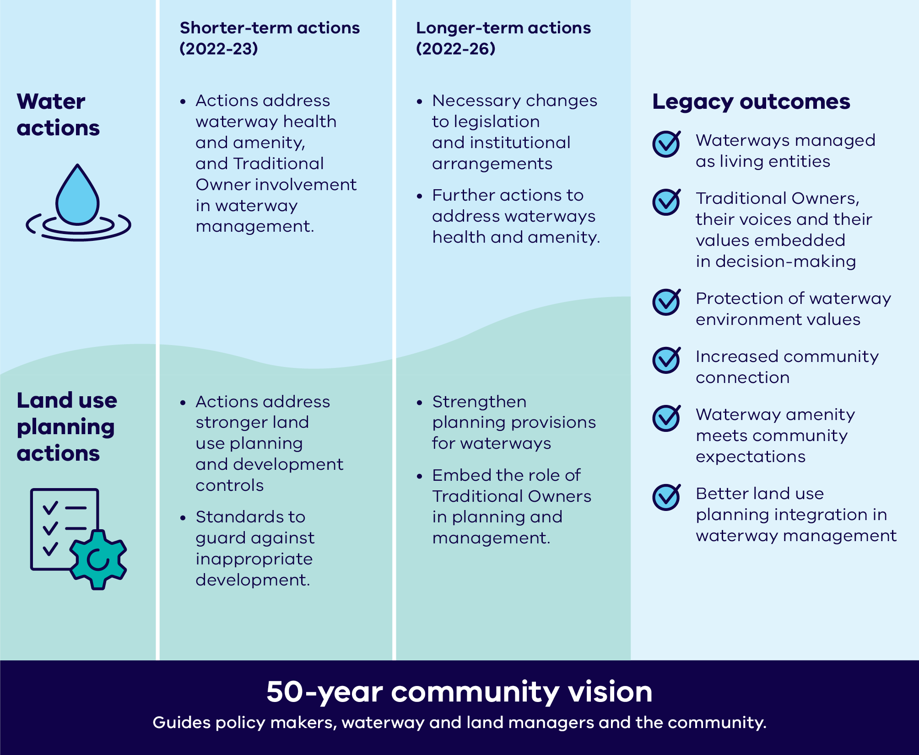

# Overview of progress in 2024

Highlights of 2024 include:

* Funding supported a First Nations resource to work with the Chain of Ponds Collaboration, to enhance cultural heritage values and Traditional Owner aspirations along Moonee Moonee/Moonee Ponds Creek. *See Action 2.2 of the* [*Waterways of the West Action Plan*](https://www.water.vic.gov.au/waterways/waterways-of-the-west-action-plan)*.*
* The Victorian Government supported the recently established Maribyrnong River and Waterways Association to build on community and Traditional Owner connection with the Maribyrnong catchment. This included rolling out the Water Think Tank Series and a collaboration with the Wurundjeri Woi-wurrung Cultural Heritage Corporation, via the Yiagilang Ngarrngatj Research Unit, to explore the tangible and intangible cultural heritage of waterways in the Maribyrnong catchment. *See Action 2.2.*
* The City of Wyndham, supported by a DEECA Iconic Urban Waterways grant, developed a concept design for improved landscape outcomes and on-water access at Bungies Hole, which is located in a bend of the Wirribi Yaluk/ Werribee River behind Chirnside Park. *See Action 4.2.*
* Commencement of the [Adapt West – Shaping our Shores](https://www.marineandcoasts.vic.gov.au/coastal-programs/adapt-west-shaping-our-shores) project, to deliver a Coastal Hazard Adaptation and Resilience Plan for the region, guided by the Port Phillip Bay Western Shoreline Regional and Strategic Partnership. *See Action 5.3.*
* Funding secured in the 2024-25 State Budget to progress pollution prevention initiatives. *See Action 7.2.*
* Targeted investment in community-driven collaborations and activities across the Waterways of the West, such as Melbourne Water’s Growing Waterway Knowledge and Engagement in the West project. This project resulted in 11 community engagement and capacity-building events between 2022 and 2024. Annual Grow West Community Planting Days attracted almost 300 volunteers and involved another 300 people in associated events and workshops, including those from culturally and linguistically diverse (CALD) communities and school groups. *See Actions 8.1 & 8.2.*

**Table 1: Status of actions across Action Plan directions**

|  |  |  |  |  |  |
| --- | --- | --- | --- | --- | --- |
| **Direction** | **Number of actions** | **Delivered** | **Ongoing** | **In progress** | **Planning** |
| Direction 1: Recognise the Waterways of the West as living and integrated natural entities and the Traditional Owners as the ‘voice of these living entities’ | 6 | 2 | 1 | 1 | 2 |
| Direction 2: Embed Traditional Owners’ values in planning and decision-making for waterways | 7 | 2 | 2 | 1 | 2 |
| Direction 3: Strengthen planning policy and controls for waterways | 5 | 2 | 0 | 2 | 1 |
| Direction 4: Improve waterway amenity to meet community expectations | 5 | 2 | 0 | 3 | 0 |
| Direction 5: Better protection of the region’s wetland values | 4 | 2 | 0 | 1 | 1 |
| Direction 6: Identify opportunities to meet environmental and cultural water needs | 2 | 1 | 0 | 1 | 0 |
| Direction 7: Protect the Waterways of the West from pollution | 3 | 1 | 0 | 2 | 0 |
| Direction 8: Increase community connection, education and participation | 5 | 4 | 0 | 1 | 0 |
| Direction 9: Ensure accountability and transparency for Action Plan delivery | 3 | 0 | 1 | 2 | 0 |
| **Total** | **40** | **16** | **4** | **14** | **6** |

# Looking ahead

The Waterways of the West Action Plan enters the fourth year of its five-year implementation timeframe in 2025. Some actions for the year ahead include:

* Statewide engagement with Traditional Owners to develop and test legislative and policy approaches to recognise waterways as ‘living entities’ and their Traditional Owners as a unique ‘voice’ of those entities (Direction 1).
* Development of a new Victorian Waterway Management Strategy is underway in partnership with Traditional Owners, catchment management authorities and other key stakeholders, with input from the broader Victorian community (Direction 4).
* Adapt West projects are undertaking further engagement with the community and partners as it progresses towards developing a Coastal Hazard Adaptation and Resilience Plan (Direction 5).
* Launching new potential pollution prevention initiatives, guided by analysis of existing projects and research on pollution and litter in our waterways (Direction 7).
* Further investment in Victoria’s urban waterway care and restoration through the $10 million [Green Links Grants Program](https://www.water.vic.gov.au/our-programs/green-links).

# Action plan implementation case studies

## Collaboration delivers amenity outcomes along the Lower Wirribi Yaluk/Werribee River

### **Direction 4: Improve waterway amenity to meet community expectations**

The Lower Werribee Waterway Amenity Action Plan continues delivering amenity improvements along the Wirribi Yaluk/Werribee River.

Opened in 2024, a new multi-use platform for recreational water activities on the Lower Wirribi/Werribee is a joint initiative of Melbourne Water, Wyndham City Council, Parks Victoria, Wadawurrung Traditional Owners Aboriginal Corporation and the Department of Energy, Environment and Climate Action (DEECA). The platform, a stepped rock terrace, is designed to be used for launching kayaks and fishing on the west bank of the river in the Werribee River Park, creating an additional launch place upstream of the mouth of the river.

The project provides a new access point to the River Red Gums Nature Walk which runs through the adjacent woodland, and is complemented by revegetation works funded under the Green Links program. These works improve visitor accessibility, experience and increase community connection and appreciation of the river and surrounds.

The project works recognise and celebrate the cultural values of the Lower Wirribi Yaluk/Werribee River for the Bunurong and Wadawurrung peoples. Work on an overarching experience framework and signage will also foster greater awareness of cultural knowledge and history.

Further upriver, Wyndham City Council will be undertaking a river access and crossing feasibility study at the Davis Creek Confluence. This work is funded by a grant from DEECA.

## Traditional Owner Engagement with community in the Maribyrnong and Werribee catchments

### **Action 8.1: Community engagement about Traditional Owner culture and values**

Landcare, environmental groups, school students and community members from the Maribyrnong and Werribee catchments have had a unique opportunity to join Traditional Owners on-Country as part of a DEECA funded program of cultural awareness education.

Highlights of the program over the last 2 years have included:

* Cultural heritage tours on-Country with Wadawurrung of Little River, the You Yangs and local urban waterways.
* Bunurong cultural safety sessions held at the Hobson Bay Wetlands Centre.
* A Wurundjeri-led cultural education session in Melbourne.
* Cultural events held by Landcare groups including Brisbane Ranges Landcare Group, Werribee River Association, Eynesbury Landcare Group, Little River Community Landcare and a walk and talk at Little River Primary School.
* A bus tour on International Rural Women’s Day visited Derrimut Grassland Reserve and Werribee Mansion to discuss indigenous management of Country and protecting small patches of remnant grasslands and wildflowers within an urban landscape.
* A tour of the Little River Catchment with Landcare leaders and Wadawurrung for scoping of future collaboration opportunities.

Feedback shows that participants grew their understanding of First Nations culture and their under-standing of the experience of First Nations peoples since colonisation. The funding also supported Wadawurrung Traditional Owners to produce a video to highlight and share cultural knowledge of waterways, biodiversity, and land (dja) and sea (warre) Country, that is being used at the Western Treatment Plant as an educational tool. More material on Wadawurrung cultural values and heritage is being developed to create a resource for agencies and community groups on the importance of cultural heritage assessments as part of natural resource management projects.

Photo 1: Wadawurrung tour of You Yangs November 2023 (source: Melbourne Water)

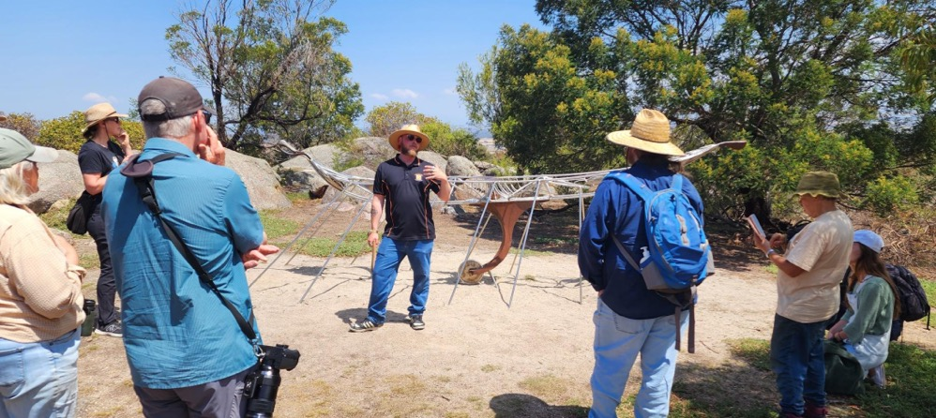

# Action status update

The Action Plan outlines 9 Directions and 40 Actions that aim to deliver results across a 5-year period. All short-term actions have been completed and reported on in the 2022 and 2023 annual reports, with the exception of part of Action 4.3. Long-term actions are planned for delivery by the end of 2026, dependent on the availability of funding.

The 2024 reporting below provides detail on the progress of actions in 2024, including ongoing actions that have no fixed delivery date and are continuing.

While each action below lists a responsible lead organisation, the delivery of the Action Plan is only achievable through extensive collaboration across agency/organisation boundaries. This is most apparent in working to deliver ‘living entity’ and ‘voice’ outcomes, where agencies and community walk together with Traditional Owners towards a shared future.

A detailed explanation of all deliverables and actions, including background, can be found in the [Waterways of the West Action Plan.](https://www.water.vic.gov.au/waterways/waterways-of-the-west-action-plan)

## Direction 1: Recognise the Waterways of the West as living and integrated natural entities and the Traditional Owners as the ‘voice of these living entities’ implementation to date

### Short-term

#### Action 1.1 ‘Living entity’ and ‘voice’ for Regional Catchment Strategy (RCS)

**Status:** Delivered in 2022 – refer to the [Waterways of the West Action Plan Annual Report 2022](https://www.water.vic.gov.au/__data/assets/word_doc/0028/661492/waterways-of-the-west-action-plan-annual-report.docx)

**Led by:** Melbourne Water

#### Action 1.2 Bunurong, Wadawurrung and Wurundjeri aspirations in RCS planning

**Status:** Delivered in 2022 – refer to the [Waterways of the West Action Plan Annual Report 2022](https://www.water.vic.gov.au/__data/assets/word_doc/0028/661492/waterways-of-the-west-action-plan-annual-report.docx)

**Led by:** Melbourne Water

#### Action 1.3 Support for Bunurong, Wadawurrung and Wurundjeri to express ‘voice of living entities’

**Status:** Ongoing

**Led by:** Department of Energy, Environment and Climate Action (DEECA)

Continuing support of Bunurong, Wadawurrung and Wurundjeri Woi Wurrung Traditional Owners to express what being 'the voice of the living entities' is to them through policy and legislation. This includes work on living entity policy to support the new Victorian Waterway Management Strategy (VWMS), as well as engagement on Outcome 1 of [Water is Life, Traditional Owner Access to Water Roadmap](https://www.water.vic.gov.au/our-programs/aboriginal-water-program/water-is-life-roadmap).

### Long-term

#### Action 1.4 Wider engagement with Traditional Owners about ‘living entity’ and ‘voice’

**Status:** In progress

**Led by:** DEECA

Preparation for broader statewide engagement with stakeholders as part of the delivery of Outcome 1 of [Water is Life, Traditional Owner Access to Water Roadmap](https://www.water.vic.gov.au/our-programs/aboriginal-water-program/water-is-life-roadmap)

Photo 2: Water is life Aboriginal artwork



#### Action 1.5 Investigate legislation for ‘living entity’ and ‘voice’concepts

**Status:** Planned

**Led by:** DEECA

Subject to engagement outcomes (see Action 1.4) and consistent with the commitments in Water is Life, Traditional Owner Access to Water Roadmap, consultation will be held on proposed legislative mechanisms.

#### Action 1.6 Traditional Owner preamble for possible legislation

**Status:** Planned

**Led by:** DEECA

Subject to Actions 1.4 and 1.5.

Direction 2: Embed Traditional Owners’ values in planning and decision-making forwaterways

### Short-term

#### Action 2.1 Embed connections to Country in RCS

**Status:** Delivered in 2022 – refer to the [Waterways of the West Action Plan Annual Report 2022](https://www.water.vic.gov.au/__data/assets/word_doc/0028/661492/waterways-of-the-west-action-plan-annual-report.docx)

**Led by:** Melbourne Water

#### Action 2.2 Partnerships to implement ‘voice’ on Country

**Status:** Ongoing

**Led by:** Melbourne Water

Melbourne Water is undertaking work relevant to this action through its implementation of [Burndap Birrarung burndap umarkoo, the Yarra Strategic Plan](https://www.melbournewater.com.au/about/what-we-do/publications/burndap-birrarung-burndap-umarkoo-yarra-strategic-plan). The outcomes from this are being monitored for application to the Waterways of the West. Melbourne Water is also supporting the Department of Energy, Environment and Climate statewide policy focus on waterways as living entities.

DEECA also partnered with Maribyrnong River and Waterways Association to support the Wurundjeri Woi Wurrung Cultural Heritage Aboriginal Corporation to explore the tangible and intangible cultural heritage of waterways in the Maribyrnong catchment, and with the Chain of Ponds Collaboration to enhance cultural heritage values and Traditional Owner aspirations along Moonee Moonee/Moonee Ponds Creek.

#### Action 2.3 Support for Jacksons Creek Regional Parklands cultural values study

**Status:** Delivered in 2022 – refer to the [Waterways of the West Action Plan Annual Report 2022](https://www.water.vic.gov.au/__data/assets/word_doc/0028/661492/waterways-of-the-west-action-plan-annual-report.docx)

**Led by:** DEECA

### Long-term

#### Action 2.4 Jacksons Creek Planning Partnership

**Status:** Planned

**Led by:** Department of Transport and Planning (DTP) and DEECA

DEECA is working with partners, including the Wurundjeri Woi Wurrung Cultural Heritage Aboriginal Corporation to progress initial actions to support the delivery of a pilot Jacksons Creek Planning Partnership. Delivery of the pilot is subject to longer-term funding. The project will embed cultural mapping values that inform broader planning in the Jacksons Creek biik wurrdha Regional Parklands.

#### Action 2.5 Traditional Owner values and knowledge in land use planning

**Status:** Ongoing

**Led by:** DEECA & DTP

This action will be delivered beyond the Action Plan framework.

DTP is reviewing the *Planning and Environment Act* *1987*. Although the review is not focused on Traditional Owner-related amendments, it provides an opportunity to strengthen the recognition of Traditional Owner values. The Planning Controls for Waterways Program within DTP is also exploring how planning schemes can better reflect these values.

#### Action 2.6 RCS reporting Traditional Owner aspirations

**Status:** Planned

**Led by:** Melbourne Water

Melbourne Water is undertaking a mid-term review of the Regional Catchment Strategy (RCS). The review includes an assessment of development of the RCS and to what extent self-determined Traditional Owner priorities are reflected. The review also includes an assessment of implementation of the RCS, including to what extent are self-determined Traditional Owner priorities included in sub strategies under the RCS.

#### Action 2.7 Bunurong, Wadawurrung and Wurundjeri Healthy Waterway Strategy partnership

**Status:** In progress

**Led by:** Melbourne Water

Melbourne Water are holding regular discussions and on-Country meetings with Bunurong, Wadawurrung and Wurundjeri Woi Wurrung Traditional Owners**.**

The Healthy Waterways Strategy (HWS) mid-term review outlines a process for the assessment of the HWS progress towards cultural values objectives, which will be completed by Traditional Owners. This process aims to develop a path forward, supporting self-determination over the next four years of the Strategy and beyond. Resource and capacity support for Traditional Owners to partner on the HWS is being factored into Melbourne Water's Price Submission for 2026.

## Direction 3: Strengthen planning policy and controls for waterways

### Short-term

#### Action 3.1 Stronger planning policy and guidance

**Status:** Delivered in 2022 – refer to the [Waterways of the West Action Plan Annual Report 2022](https://www.water.vic.gov.au/__data/assets/word_doc/0028/661492/waterways-of-the-west-action-plan-annual-report.docx)

**Led by:** DTP

#### Action 3.2 Interim landscape and environmental controls for key waterways

**Status:** Delivered in 2022 – refer to the [Waterways of the West Action Plan Annual Report 2022](https://www.water.vic.gov.au/__data/assets/word_doc/0028/661492/waterways-of-the-west-action-plan-annual-report.docx)

**Led by:** DTP

### Long-term

#### Action 3.3 Interim built-form controls for key waterways

**Status:** Planned

**Led by:** DTP

DTP has conducted background studies to support stronger built-form planning controls for Mirrangbamurn/Maribyrnong River, Moonee Moonee/Moonee Ponds Creek and Wirribi Yaluk/Werribee River. Subject to funding, further work is required to review and consider their potential implementation.

#### Action 3.4 Planning controls for additional waterways

**Status:** In progress

**Led by:** DTP

DTP is implementing additional waterways planning controls for:

Mirrangbamurn/Maribyrnong River, Moonee Moonee/Moonee Ponds Creek, and Wirribi Yaluk/Werribee River beyond the urban growth boundary, and Cherry Creek, Stony Creek, Emu Creek, Deep Creek, Skelton Creek, and Jacksons Creek.

This now forms part of the Government’s commitment to establish planning controls across 14 waterways in Melbourne through the Planning Controls for Waterways Program.

#### Action 3.5 Review of interim planning controls

**Status:** In progress

**Led by:** DTP

As part of the Planning Controls for Waterways program, a review of the performance of existing interim controls for the Mirrangbamurn/Maribyrnong River, Moonee Moonee/Moonee Ponds Creek and Wirribi Yaluk/Werribee River is underway to support the transition to permanent controls.

## Direction 4: Improve waterway amenity to meet community expectations

### Short-term

#### Action 4.1 Waterway amenity values in RCS

**Status:** Delivered in 2022 – refer to the [Waterways of the West Action Plan Annual Report 2022](https://www.water.vic.gov.au/__data/assets/word_doc/0028/661492/waterways-of-the-west-action-plan-annual-report.docx)

**Led by:** Melbourne Water

#### Action 4.2 Develop a Lower Werribee Waterway Amenity Action Plan

**Status:** Delivered in 2022 – refer to the [Waterways of the West Action Plan Annual Report 2022](https://www.water.vic.gov.au/__data/assets/word_doc/0028/661492/waterways-of-the-west-action-plan-annual-report.docx)

**Led by:** Melbourne Water

The City of Wyndham also finalised a concept design for improved landscape outcomes and on-water access at Bungies Hole, located in a bend of the Wirribi Yaluk/Werribee River.

#### Action 4.3 Waterway amenity advocacy

**Status:** In progress

**Led by:** Melbourne Water

The Urban Waterways Planning Guidelines project has commenced to complement DTP’s planning for waterways work. Draft Guidelines are planned for the end of 2025 with statutory implementation for Government consideration in 2026.

Other components of this action have been delivered – refer to the [Waterways of the West Action Plan Annual Report 2022](https://www.water.vic.gov.au/__data/assets/word_doc/0028/661492/waterways-of-the-west-action-plan-annual-report.docx)

### Long-term.

#### Action 4.4 Melbourne Water statement of obligations to reflect amenity role

**Status:** In progress

**Led by:** DEECA

Melbourne Water is progressing the investigation of options for expanding its amenity advocacy role.

#### Action 4.5 Victorian Waterway Management Strategy – urban waterway values

**Status:** In progress

**Led by:** DEECA

The new Victorian Waterway Management Strategy is due to be released in the next year. Work is underway on this, including updated policies about planning for urban waterway values and threats.

## Direction 5: Better protection of the region’s wetland values

### Short-term

#### Action 5.1 Wetland mapping data update

**Status:** Delivered in 2022 – refer to the [Waterways of the West Action Plan Annual Report 2022](https://www.water.vic.gov.au/__data/assets/word_doc/0028/661492/waterways-of-the-west-action-plan-annual-report.docx)

**Led by:** DEECA

#### Action 5.2 RCS wetland mapping

**Status:** Delivered in 2022 – refer to the [Waterways of the West Action Plan Annual Report 2022](https://www.water.vic.gov.au/__data/assets/word_doc/0028/661492/waterways-of-the-west-action-plan-annual-report.docx)

**Led by:** Melbourne Water

### Long-term

#### Action 5.3 Adaptation strategies for western shoreline wetlands of Port Phillip Bay

**Status:** In progress

**Led by:** DEECA

The Port Phillip Bay Western Shoreline Regional and Strategic Partnership has been established to respond to current and future coastal hazard impacts across the region. Exploration of coastal hazard adaptation and community engagement occurred in 2024.

#### Action 5.4 Western shoreline wetlands master plan

**Status:** Planned

**Led by:** DEECA

Master Plan dependent on Action 5.3.

## Direction 6: Identify opportunities to meet environmental and cultural water needs

### Short-term

#### Action 6.1 Funding for Traditional Owner cultural water assessment priorities

**Status:** Delivered in 2022 – refer to the [Waterways of the West Action Plan Annual Report 2022](https://www.water.vic.gov.au/__data/assets/word_doc/0028/661492/waterways-of-the-west-action-plan-annual-report.docx)

**Led by:** DEECA

### Long-term

#### Action 6.2 Central and Gippsland Region Sustainable Water Strategy water options for environment and culture

**Status:** In progress

**Led by:** DEECA

Short-term environmental water commitments for Wirribi Yaluk/Werribee River have been progressed through water savings from the Bacchus Marsh Irrigation District project. Long-term commitments are dependent on the Werribee system reconfiguration. Feasibility studies, water resource modelling, and a preliminary business case concluded in 2024.

Initial investigations are underway regarding use and/or trade of unused water in the Maribyrnong system for use as environmental water.

Catchment-scale Integrated Water Management (IWM) Plans for the Werribee and Maribyrnong catchments to increase use of recycled water, treated stormwater and rainwater have been finalised, and associated Action Plans were released in April 2024. All Plans are available online at [IWM forums](https://www.water.vic.gov.au/our-programs/integrated-water-management/iwm-forums).

## Direction 7: Protect the Waterways of the West from pollution

### Short-term

#### Action 7.1 Pollution prevention taskforce

**Status:** Delivered in 2023 – refer to the [Waterways of the West Action Plan Annual Report 2023](https://www.water.vic.gov.au/__data/assets/word_doc/0020/716510/waterways-of-the-west-action-plan-annual-report-2023.docx)

**Led by:** DEECA & Environmental Protection Authority Victoria (EPA)

### Long-term

#### Action 7.2 Priority pollution prevention projects

**Status:** In progress

**Led by:** DEECA & EPA Victoria

Review and planning of the next stages is underway, guided by the recommendations of the Pollution Prevention Taskforce. DEECA is looking to better understand how to complement broader work on pollution and litter projects, including those undertaken in the Yarra Catchment and as part of the Healthy Waterways Strategy. Funding was secured in the 2024/25 budget to progress this work.

#### Action 7.3 Implementation of place-based stormwater objectives

**Status:** In progress

**Led by:** Melbourne Water

As part of the Healthy Waterways Strategy mid-term review a review of the stormwater performance objectives was undertaken. The review outlined several recommendations that will seek to support achievement of the stormwater objectives. Further information is available online at: <https://healthywaterways.com.au/resources/mid-term-review>

## Direction 8: Increase community connection, education and participation

### Short-term

#### Action 8.1 Community engagement about Traditional Owner culture and values

**Status:** Delivered

**Led by:** Melbourne Water

Community engagement and cultural awareness programs for community groups with Bunurong, Wadawurrung and Wurundjeri Woi wurrung Traditional Owners were held across 2024. The program included cultural heritage training and on-Country site visits with all Traditional Owners, as well as the production of a Wadawurrung specific cultural heritage and values film.

See Traditional Owner engagement with community in the Maribyrnong and Werribee catchments case study on page 10.

#### Action 8.2 Community engagement strategy, including culturally and linguistically diverse (CALD)

**Status:** Delivered in 2023 – refer to the [Waterways of the West Action Plan Annual Report 2023](https://www.water.vic.gov.au/__data/assets/word_doc/0020/716510/waterways-of-the-west-action-plan-annual-report-2023.docx)

**Led by:** Melbourne Water

#### Action 8.3 CALD engagement toolkit

**Status:** Delivered in 2022 – refer to the [Waterways of the West Action Plan Annual Report 2022](https://www.water.vic.gov.au/__data/assets/word_doc/0028/661492/waterways-of-the-west-action-plan-annual-report.docx)

**Led by:** DEECA

#### Action 8.4 Community Vision inclusion in RCS

**Status:** Delivered in 2022 – refer to the [Waterways of the West Action Plan Annual Report 2022](https://www.water.vic.gov.au/__data/assets/word_doc/0028/661492/waterways-of-the-west-action-plan-annual-report.docx)

**Led by:** Melbourne Water

### Long-term

#### Action 8.5 Community Vision inclusion in Healthy Waterway Strategy programs

**Status:** In progress

**Led by:** Melbourne Water

The mid-term review of the Healthy Waterways Strategy was completed in June 2024. Addendums for the Werribee and Maribyrnong catchment programs are being prepared and will include the Waterways of the West Community vision.

## Direction 9: Ensure accountability and transparency for Action Plan delivery

### Short-term

#### Action 9.1 Annual implementation report

**Status:** Ongoing

**Led by:** DEECA

The first two annual reports were published in 2023 and 2024, respectively. This report is for the third year of implementation January – December 2024.

### Long-term

#### Action 9.2 Final review of implementation

**Status:** In progress

**Led by:** DEECA

A Monitoring, Evaluation, Reporting and Implementation framework is in place and interim reviews of the Action Plan progress has commenced.

#### Action 9.3 Waterway condition reporting through Healthy Waterways Strategy

**Status:** In progress

**Led by:** Melbourne Water

In June 2024, Melbourne Water released its mid-term review of the Healthy Waterways Strategy. The review assessed how the Strategy is tracking and informed priorities for the remainder of the Strategy.

The mid-term review findings and recommendations were shared with the Waterways of the West communities through online and in person events (June-Oct 2024). The mid-term review summary and reports can be found here: <https://healthywaterways.com.au/resources/mid-term-review>.

In addition, Melbourne water continues to [report annually](https://healthywaterways.com.au/report-card) on progress towards the Performance Objectives of the Healthy Waterways Strategy. Community participation is on track in both the Werribee and Maribyrnong catchments.

# Publication information

## Acknowledgements

We acknowledge and respect Victorian Traditional Owners as the original custodians of Victoria’s land and waters, their unique ability to care for Country and deep spiritual connection to it.

We honour Elders past and present whose knowledge and wisdom has ensured the continuation of culture and traditional practices.

DEECA is committed to genuinely partnering with Victorian Traditional Owners and Victoria’s Aboriginal community to progress their aspirations.

## Copyright

© The State of Victoria Department of Energy, Environment and Climate Action, June 2025.

## Creative Commons

This work is licensed under a Creative Commons Attribution 4.0 International licence, visit the [Creative Commons website](http://creativecommons.org/licenses/by/4.0/) (<http://creativecommons.org/licenses/by/4.0/>).

You are free to re-use the work under that licence, on the condition that you credit the State of Victoria as author. The licence does not apply to any images, photographs or branding, including the Victorian Coat of Arms, and the Victorian Government and Department logos.

**ISSN** 2653-746X **- Online (pdf/word)**

## Disclaimer

This publication may be of assistance to you, but the State of Victoria and its employees do not guarantee that the publication is without flaw of any kind or is wholly appropriate for your particular purposes and therefore disclaims all liability for any error, loss or other consequence which may arise from you relying on any information in this publication.

## Accessibility

To receive this document in an alternative format, phone the Customer Service Centre on 136 186, email [customer.service@delwp.vic.gov.au](mailto:customer.service@delwp.vic.gov.au), or contact National Relay Service on 133 677. Available at DEECA website ([www.deeca.vic.gov.au](http://www.deeca.vic.gov.au/)).

**End of document.**