|  |
| --- |
| Managing willows in Victoria |
|  |

## What’s the issue?

**Exotic species such as ash, elm, poplar and particularly willows were historically planted along waterways for erosion control and aesthetic purposes. The spread of these species over time has degraded riparian environments[1]. Willows have now invaded thousands of kilometres of riparian environments in south eastern Australia.**

Consequently, over the last 20 years or so, catchment management authorities (CMAs) have been removing willows along many Victorian waterways.

These willow management programs have sometimes caused concern with the public, particularly landholders and recreational fishers, who have a strong interest in the health of our waterways. Concerns have been raised about the location and extent of willow control, the management techniques used, the timing of revegetation efforts after willow control and the limited consultation with the public about willow control projects.

This brochure has been developed to acknowledge those concerns, improve communication and raise awareness of the ‘why, what and how’ about willow management in Victoria.

## The problem with willows

Willows are recognised as one of the most serious riparian weeds in temperate Australia and most types   
of willows are considered Weeds of National Significance (WoNS)[2].

There are numerous scientific studies which have demonstrated that:

* **Willows degrade the condition of rivers** **and riparian land** – Willows crowd out or exclude native plants, they reduce native biodiversity especially by providing less hollows for native birds and animals, and their massed autumn leaf fall can deplete oxygen levels in waterways.
* **Willows are highly invasive** – Several varieties of willows produce huge quantities of seeds and most varieties are able to spread from broken twigs and branches.
* **Willows can initiate erosion and channel widening** – Extensive willow root mats extend into the channel bed and trap sediment, multi stem trunks catch more debris, and trees and limbs fall instream and continue to grow, all contributing to raising the bed level and diverting flows into and over the bank. This results in bank erosion and causes the river to widen out around the willow.

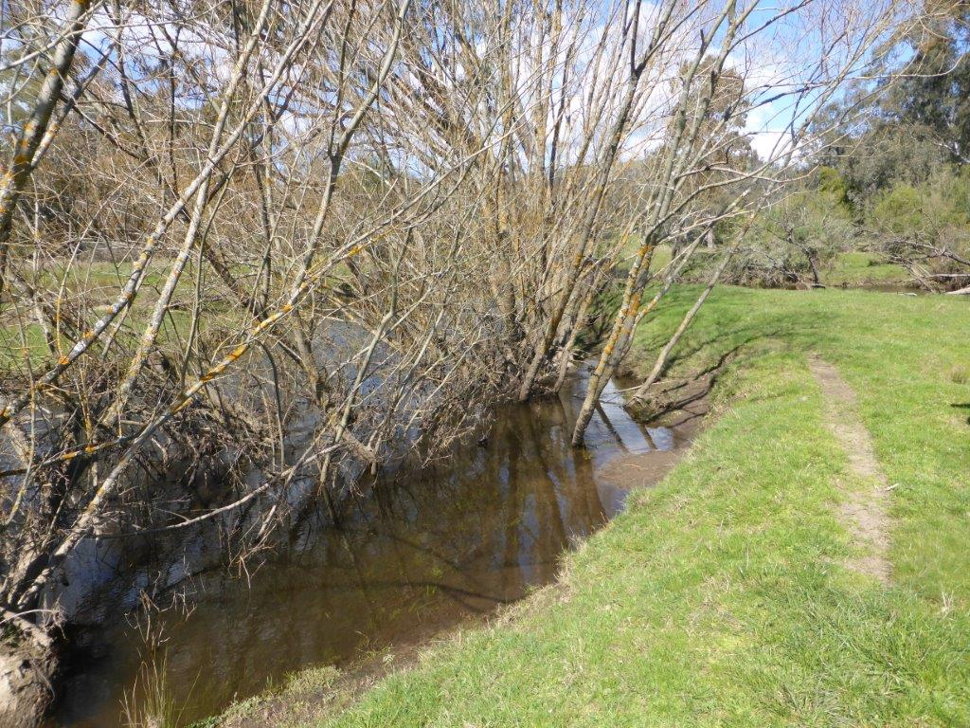

Rubicon River, Thornton, showing the river widening out behind the willows. Photo courtesy Goulburn Broken CMA

* **Willows reduce the supply of habitat and food for fish** – Willow root mats can create uniform stream channels with reduced fish habitat diversity. Willows also support fewer terrestrial bugs than native plants, reducing the number of bugs falling into rivers as a possible source of food for fish.
* **Willows growing instream are big water users** – When willows extend their roots into a waterway, they can consume significant amounts of water and dry out small streams and swamps.
* **Willows can restrict recreational access** – Dense stands of willows reduce access for fishing, walking and can be dangerous for canoeists who may become trapped.

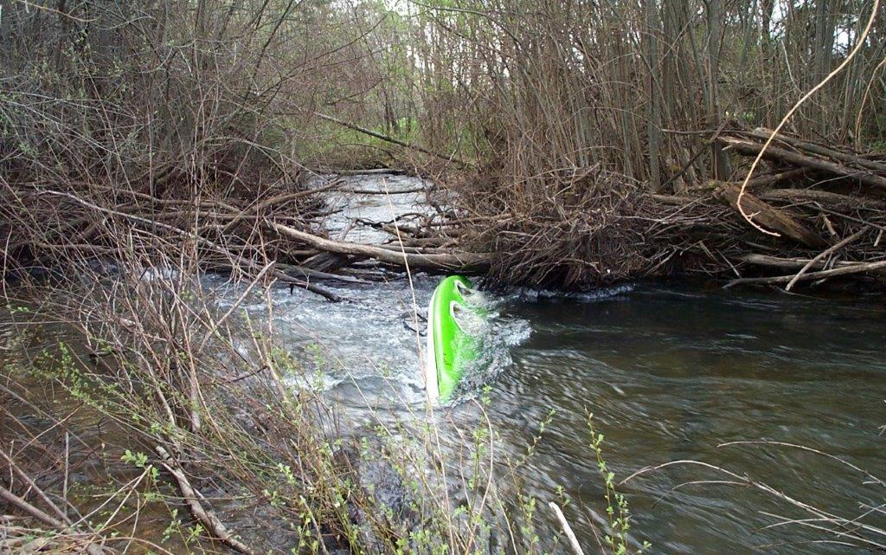

Willow blockage on the Ovens River near Bright causing obstructions for recreational activity. Photo courtesy North   
East CMA

* **Willows can create a threat to public and private infrastructure** –Dense colonisation of waterways can restrict flows to such an extent that waterways can change course completely (“avulse”). When this occurs there are frequently significant risks to public infrastructure such as roads and bridges, as well as private property. Floating rafts of willow debris also create issues for infrastructure where they jam up against bridge pylons, fences and other assets.

## Legislation and policy

The Victorian *Catchment and Land Protection Act 1994* has declared most willow species[3] as noxious weeds   
in Victoria. These willows are further categorised as ‘restricted’ weeds[4] that pose an unacceptable risk of spreading in Victoria and are a serious threat to another state or territory of Australia. They cannot be legally sold or traded within Victoria. However, there is no   
legal obligation upon landholders to manage willows   
on their properties.

## Willow management principles, priorities and implementation

### Managing willows as part of a broader waterway health program

Catchment management authorities address the impacts of willows and other key threats to waterway health through their regional waterway strategies. This enables them to integrate willow management with other waterway management activities such as establishing instream habitat, managing stock access, replanting the site with native plants or managing for natural regeneration. Consideration is also given to the risks willows present to public infrastructure.

### Setting willow management priorities at the regional level

Willows are present throughout Victoria in varying densities depending on environmental conditions and previous introduction and management practices. Some willow taxa also pose more of a threat to waterway health than others. Therefore, management of willow control across a region should be prioritised as follows:

* **First priority** – Protect the best waterways. A high quality riparian environment with native vegetation is not easily replaced once lost.
* **Second priority** – Prevent the spread of highly invasive *seeding* willow species wherever they are located. These include black willow, grey sallow and types of pussy willow. These species have the potential to spread long distances and can quickly become a serious problem.
* **Third priority** – Prevent the spread of highly invasive *brittle* willow species. These include crack willow and crack willow hybrids that spread vegetatively.

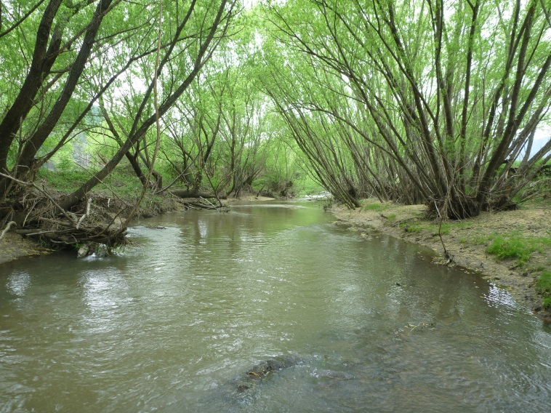

Crack willow (*Salix fragilis*), a type of highly invasive brittle willow, on the Happy Valley Creek, Ovens. Photo courtesy   
Paul McInerny.

### Implementing willow management at the site level

At the site level, the following factors should be considered when managing willows:

* Brittle willows that spread by broken twigs and branches should ideally be controlled starting at the upstream end and working downstream to limit reinvasion. However, in open farmland it may be better to focus on sparse rather than dense willow populations first, to minimise spread downstream. This approach creates a mosaic of treated areas along the river that can be joined over time.
* Where infestations are significant i.e. along several kilometres, willow control should be staged over several years.
* Selective control of willows may be required in sensitive areas such as:
  + vulnerable banks that may require additional stabilisation before removing willows to prevent bank erosion e.g. with rock beaching.
  + willow dominated reaches where social values exist that rely on willows e.g. shading of swimming or fishing holes.
  + near built assets e.g. bridges, pump sites, power poles, roads.
  + where landholder or stakeholder concern is   
    high, including concerns from local recreational fishing groups.
* Circumstances such as:
  + the stream type (e.g. is the stream bed gravel,   
    clay etc.),
  + the waterway’s location (e.g. urban, agricultural, recreational site etc.) and
  + where the willows occur (are they instream, on the face or toe of the bank, or on the riparian land?),

will determine the best willow control method (e.g. pre poison then cut, cut and paint stump etc.).

* Willows may be retained if they do not have a propensity to spread (e.g. weeping willows) and are   
  in isolated occurrences with minimal impact on waterway condition.

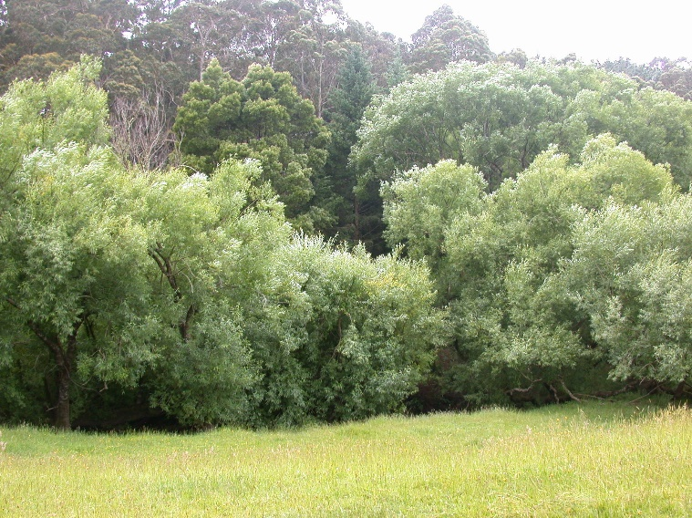

Gellibrand River – pre willow control (2002). Photos courtesy Corangamite CMA

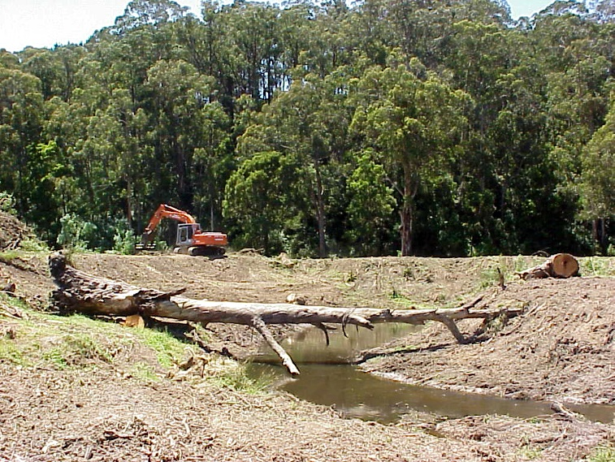

Gellibrand River – post willow control (2002)

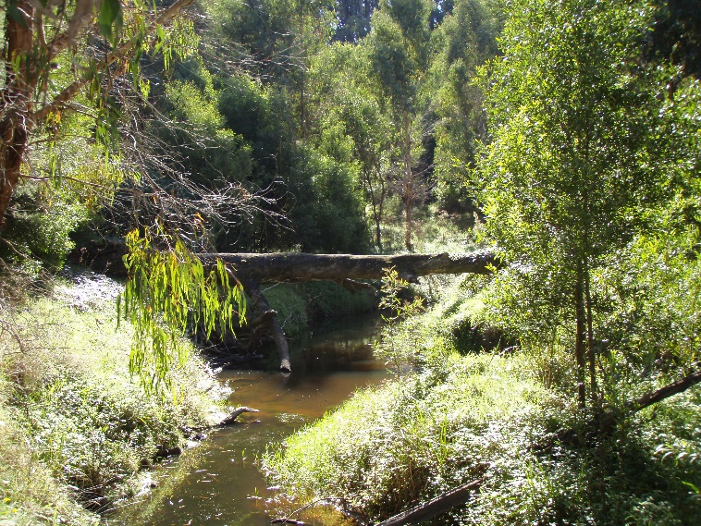

Gellibrand River – following revegetation and natural regeneration (2010)

* Follow up revegetation with indigenous plants should occur in treated areas as soon as possible after willow removal taking seasonal factors into consideration. The biodiversity and erosion control value of the indigenous vegetation will be low while it is establishing then increase over time until it is fully established, which could take many years. These site level willow management factors are considered in the context of:
  + the objectives for the management of the waterway,
  + site constraints such as stream type, form   
    and condition,
  + the existing riparian condition,
  + community attitudes towards willow management,
  + the ecological or infrastructure assets at risk from willows and
  + available funding.

## Engaging the community

To ensure a successful willow control program, CMAs will improve their community engagement and provide landholders, communities and key stakeholders such as recreational fishers with meaningful opportunities to get involved in willow removal and riparian management projects. This engagement will begin early in the planning process before detailed site or reach-scale project plans are made.

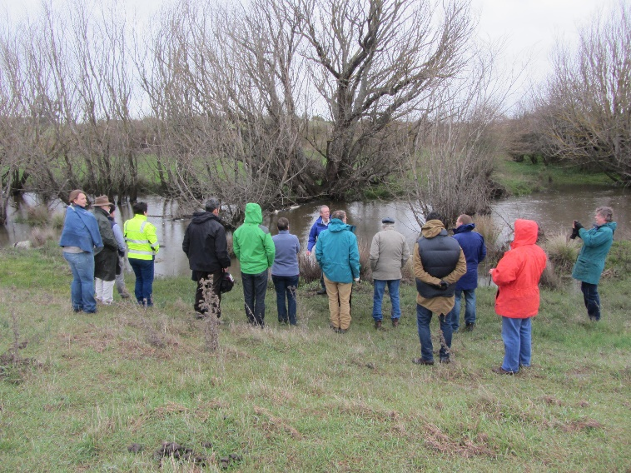

Caring for the Campaspe Project Reference Group discussing willow management at Langley on the Campaspe River. Photo courtesy North Central CMA

## Further information

More information about willows and their management can be found on the WoNS website at: <http://weeds.ala.org.au/WoNS/willows/>.

More information about waterway management programs in your region, including willow management, can be obtained from your CMA.

Want to get involved and help improve riparian land? We would love to hear from you:

East Gippsland CMA 5152 0600

West Gippsland CMA 1300 094 262

Corangamite CMA 5232 9100

Glenelg Hopkins CMA 5571 2526

Wimmera CMA 5382 1544

Mallee CMA 5051 4377

North Central CMA 5448 7124

Goulburn Broken CMA 5822 7700

North East CMA 1300 216 513

Melbourne Water* 131 722

* Melbourne Water is the waterway manager for the Port Phillip region

## Acknowledgements

This fact sheet was prepared with assistance from Riverness and in consultation with CMAs, Fisheries Victoria (Department of Economic Development, Jobs, Transport and Resources), VRFish (Victorian Recreational Fishing Peak Body) and the Australian Trout Foundation.

|  |  |
| --- | --- |
| © The State of Victoria Department of Environment, Land, Water and Planning 2023  LogoThis work is licensed under a Creative Commons Attribution 4.0 International licence. You are free to re-use the work under that licence, on the condition that you credit the State of Victoria as author. The licence does not apply to any images, photographs or branding, including the Victorian Coat of Arms, the Victorian Government logo and the Department of Environment, Land, Water and Planning (DELWP) logo. To view a copy of this licence, visit http://creativecommons.org/licenses/by/4.0/  ISBN 978-1-76047-236-8 (pdf/online)  Disclaimer  This publication may be of assistance to you but the State of Victoria and its  employees do not guarantee that the publication is without flaw of any kind or is  wholly appropriate for your particular purposes and therefore disclaims all liability  for any error, loss or other consequence which may arise from you relying on any information in this publication. | Accessibility  If you would like to receive this publication in an alternative format, please telephone the DELWP Customer Service Centre on 136186, email [customer.service@delwp.vic.gov.au](mailto:customer.service@delwp.vic.gov.au), or via the National Relay Service on 133 677 [www.relayservice.com.au](http://www.relayservice.com.au). This document is also available on the internet at [www.delwp.vic.gov.au](http://www.delwp.vic.gov.au). |

1. Riparian land is land that runs along rivers, creeks and wetlands.
2. Excluding weeping willow (*Salix babylonica*) and two species of hybrid pussy willow (*Salix x calodendron* and *Salix x reichardtii*).
3. excluding cricket bat willow (*Salix alba var. caerulea*), New Zealand hybrid willow (*Salix alba x matsudana*), weeping willow (*Salix babylonica*), pussy willow (*Salix x calodendron*), goat willow (*Salix caprea ‘Pendula*)’, Salix matsudana ‘Aurea’, tortured or twisted willow (*Salix matsudana ‘Tortuosa’*), dark-leaved willow (*Salix myrsinifolia*) and pussy willow (*Salix x reichardtii*).
4. meaning they cannot be bought or sold within Victoria. “Restricted’ does not refer to their distribution but is a formal category of noxious weeds.