delwp.vic.gov.au

|  |
| --- |
| Guidance Note on Setbacks near Dams |
|  |
|  |

|  |  |
| --- | --- |
|  |  |

|  |  |  |  |
| --- | --- | --- | --- |
|  |  |  |  |
|  |  |  |  |

Photo credit

Southern Rural Water

|  |
| --- |
| Acknowledgment  We acknowledge and respect Victorian Traditional Owners as the original custodians of Victoria's land and waters, their unique ability to care for Country and deep spiritual connection to it. We honour Elders past and present whose knowledge and wisdom has ensured the continuation of culture and traditional practices.  We are committed to genuinely partner, and meaningfully engage, with Victoria's Traditional Owners and Aboriginal communities to support the protection of Country, the maintenance of spiritual and cultural practices and their broader aspirations in the 21st century and beyond. |
| © The State of Victoria Department of Environment, Land, Water and Planning 2022  LogoThis work is licensed under a Creative Commons Attribution 4.0 International licence. You are free to re-use the work under that licence, on the condition that you credit the State of Victoria as author. The licence does not apply to any images, photographs or branding, including the Victorian Coat of Arms, the Victorian Government logo and the Department of Environment, Land, Water and Planning (DELWP) logo. To view a copy of this licence, visit <http://creativecommons.org/licenses/by/4.0/>  ISBN 978-1-76136-044-2 (pdf)  Disclaimer  This publication may be of assistance to you but the State of Victoria and its employees do not guarantee that the publication is without flaw of any kind or is wholly appropriate for your particular purposes and therefore disclaims all liability for any error, loss or other consequence which may arise from you relying on any information in this publication.  Accessibility  If you would like to receive this publication in an alternative format, please telephone the DELWP Customer Service Centre on 136186, email [customer.service@delwp.vic.gov.au](mailto:customer.service@delwp.vic.gov.au), or via the National Relay Service on 133 677 [www.relayservice.com.au](http://www.relayservice.com.au). This document is also available on the internet at [www.delwp.vic.gov.au](http://www.delwp.vic.gov.au). |

|  |
| --- |
| Guidance Note on Setbacks near Dams |

Document history

|  |
| --- |
| Department of Environment, Land, Water and Planning  8 Nicholson Street,  East Melbourne, Victoria 3002 |

|  |  |  |  |
| --- | --- | --- | --- |
| **Version** | **Date** | **Author** | **Summary of changes** |
| 1.0 | July 2022 | DELWP | Original created |
|  |  |  |  |

Acknowledgements

|  |  |  |  |
| --- | --- | --- | --- |
|  |  |  |  |

This guideline was prepared based on work done by Hydrology and Risk Consulting (HARC) and Hunter Geotechnical for the Department of Environment, Water, Land and Planning.

The assistance of the following organisations in providing thoughtful comment and review during the preparation of the guideline is acknowledged:

* Dam Safety Advisory Committee
* Goulburn Murray Water
* Grampians Wimmera Mallee Water
* Lower Murray Water
* Melbourne Water
* Southern Rural Water
* Municipal Association of Victoria

# **Contents**

Introduction 1

1. When does a setback distance apply for a dam? 2

2. What are the exclusions and limitations from application of the setback guidance? 2

2.1 How to calculate minimum setback distance? 3

3. Consideration of Dams and Property Boundaries 5

3.1 Where to find location of your dams? 5

3.2 Existing Dams 5

3.3 New Dams 9

4. Application of setback distance 10

4.1 Example Application 11

4.1.1 How to Identify Dam Embankment, Crest and Toe? 11

4.1.2 How to Determine Dam Height? 12

4.1.3 How to calculate the Downstream Slope? 12

4.1.4 How to Lookup the Minimum Setback Distance? 13

5. References 15

**List of tables**

**Table 1: Toe Method Calculation Slope Categories** 3

**Table 2: Recommended Minimum Setback Distance (metres) from the Downstream Toe of the Existing Embankment** 4

List of figures

**Figure 1: Required Dam Measurements** 3

**Figure 2: Setback application, single parcel contains entire setback** 6

**Figure 3: Setback application, multiple parcels in single ownership** 7

**Figure 4: Setback application, multiple parcels in different ownership** 8

**Figure 5: Setback application (Shown in green), On-stream Storage** 10

**Figure 6: Setback application (Shown in green), Off-stream Storage** 11

**Figure 7: Example Dam, Identification of Crest and Toe of Embankment** 12

**Figure 8: Example Dam, Measurements and Levels** 12

**Figure 9: Downstream Slope** 13

**Figure 10: Example Calculated Minimum Setback Distance** 14

Any dam that falls within the limitations and exclusions criteria of this guidance note must be treated as a special case and have an appropriate setback distance determined through an alternate pathway. For enquiries related to the regulatory process and alternate pathways in these rare situations, please contact the Water and Catchments Group (Dam Safety and Regulation Team) in the Department of Environment, Land, Water and Planning on 136 186.

# Introduction

This document provides guidance for setbacks of all dams, except for those that exclusions apply to, from property boundaries and proposed developments. The purpose of the setback is to provide an accessible zone from the dam in the event of a dam safety incident or emergency, ongoing maintenance and safety management and space to implement dam safety upgrade works.

A dam safety incident in 2020, where residential development was built up to the toe of the dam embankment, highlighted the potential difficulties for emergency operations and remediation works where no setback was allowed for.

In the development of this guideline, a key consideration has been to provide a simple approach that can be applied by dam owners/proponents, regulators, planning practitioners and developers.

The setback distance, measured from the toe of the embankment to any development is to allow for:

* Access so that dam safety management operations can be effectively undertaken (e.g., inspections and surveillance).
* Access so that emergency management can be effectively deployed.
* Space for dam safety upgrade works to be undertaken to the dam to meet regulatory requirements.

The setback does not provide protection to or significantly reduce the consequences for persons and properties immediately or further downstream from the dam should a dam failure occur. Dam safety is regulated through the Water Act 1989. The owner of the dam has an obligation to comply with the relevant legislative and regulatory requirements in managing dams. These requirements may require the completion of dam safety upgrade works.

This guideline does not override regulatory requirements for dams or any setback distances or other constraints that are required by water authorities, public utilities and other relevant entities that may be required through other mechanisms, such as referrals under the Planning and Environment Act 1987. This setback is not a replacement for any setbacks or corridors required to appropriately manage dambreak flooding.

The setback distance is consistent with the So Far As Is Reasonably Practical (SFAIRP) approach to dam safety and management.

# **When does a setback distance apply for a dam?**

This guidance is intended to apply to dams with the following characteristics:

* Earthfill dams with an embankment height of between 0.5 and 15 metres.
* This guidance applies to private dams, council owned dams, dams on commercial properties and some drainage retarding basins.
* Sloping land downstream of the dam of up to 10 degrees.
* A dam as defined in the [Water Act 1989](https://content.legislation.vic.gov.au/sites/default/files/2022-03/89-80aa136%20authorised.pdf).

Dams with an embankment height of less than 5 metres and an embankment slope shallower than 5H:1V can adopt a minimum setback distance of 10m, subject to an assessment by a suitably qualified dams engineer.

The setback distances do not provide mitigation against dambreak flooding and do not replace or absolve a Dam Owner of their obligations under the Water Act 1989 and common law to maintain a safe dam structure and to plan for and mitigate the risk of failure. The owner of the dam has an obligation to comply with regulatory requirements (refer Section 5) in managing dams and this may require dam safety upgrade works be undertaken to manage dam safety risks, which are to be undertaken in a timely manner. The owner also has obligations of dam surveillance and having a Dam Safety Emergency Plan (DSEP) in place. A sample DSEP template can be found [here](https://www.water.vic.gov.au/__data/assets/pdf_file/0017/54242/DamSafetyEmergencyPlan.pdf).

The application of this guideline is intended to be through a range of pathways including dam licencing, strategic planning, and statutory planning.

# **What are the exclusions and limitations from application of the setback guidance?**

The guideline is not intended to apply to all dam types and constructions. The limitations and exclusions from the application of the setback guidance include:

* Earthfill dams with an embankment height of greater than 15 metres.
* Concrete dams.
* Dams where slopes downstream of the toe is steeper than 10 degrees.
* Dams that have a consequence category of High A or Extreme in accordance with the Australian National Committee on Large Dams (ANCOLD) guidelines (ANCOLD 2012) given the high population at risk and high potential life loss in the inundation zone for dam breach in consideration of the proposed development.
* Specific Drainage Retarding Basins that have been designed in compliance with Melbourne Water guidelines (Melbourne Water, 2016) and have embankment slopes at or flatter than 5H to 1V.

Any dam that falls within these limitations and exclusions criteria must be treated as a special case and have an appropriate setback distance determined through an alternate pathway. In these rare cases, larger setback distances for these dams should be considered, based on the dam risk as determined by a suitably qualified dams engineer and the dam Licencing Authority. The process and decision criteria for setting setbacks for these dams is not considered by this guideline.

Drainage retarding basins that have been specifically designed, approved and constructed in accordance with the Guidelines for the Development and Assessment of Retarding Basins (Melbourne Water, 2016) with an embankment at a grade of 5H:1V or less are also excluded from this guidance. They have been designed through an appropriate risk management pathway to meet the objectives of this guideline.

## **How to calculate minimum setback distance?**

To calculate the minimum setback distance, only two measurements are required, as shown in **Figure 1**. These are:

* HD = Height of the dam embankment in metres, measured from the lowest elevation at the toe of the embankment to the highest elevation of the dam crest.
* Downstream Slope (S) = natural slope of the land downstream of the embankment. This can be measured in degrees, fall (-m/m) or percentage. This is the average slope measured at the lowest elevation at the embankment toe over a distance equivalent to the dam height plus 10 m (HD + 10 m), or minimum of 10 m (whichever is the greater).

The minimum setback distance takes into consideration the height of the dam embankment and the slope of the ground downstream from the dam. The guidance applies to dams where dam height (HD) is between 0.5 and 15 metres.

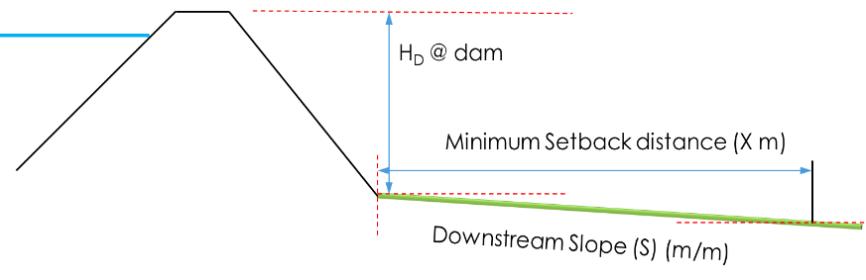

Figure 1: Required Dam Measurements

The maximum downstream slope is categorised into four ranges of downstream slope from flat to up to gradients of -0.16 m/m (1 in 6 or 10°). Where slopes are uphill away from the dam, the setback distance for flat ground conditions should been adopted. These slope categories are shown in **Table 1**. The downstream slope is to be measured from the lowest elevation along the downstream dam embankment toe.

Table 1: Toe Method Calculation Slope Categories

| Description | Range (m/m) | Range (degree) | Range (1 in X) |
| --- | --- | --- | --- |
| Uphill/Flat/Minor Downhill | Any uphill slope, downhill slope <-0.02 m/m (-2%) | <1° | <1 in 50 |
| Downhill slope | -0.02 m/m to -0.05 m/m  (-2% to -5%) | 1° to 3° | 1 in 50 to 1 in 20 |
| Downhill slope | -0.05 m/m to -0.1 m/m  (-5% to -10%) | 3° to ~6° | 1 in 20 to 1 in 10 |
| Downhill slope | -0.1 m/m to -0.16 m/m (-10% to -16%) | ~6° to ~10° | 1 in 10 to 1 in 6 |

The minimum setback distance is from the downstream toe of the existing embankment and is applied along the full length of the embankment. In the case of a turkey’s nest type dam, this would be applied around the full perimeter of the dam (refer Section 4).

Table 2: Recommended Minimum Setback Distance (metres) from the Downstream Toe of the Existing Embankment

|  |  |  |  |  |
| --- | --- | --- | --- | --- |
| **Maximum Dam Height (H**D**)** | **Minimum Setback Distance (metres)  (Measured from the Downstream Toe of the Existing Embankment)** | | | |
| Any uphill slope, downhill slope  <-0.02 m/m  (<-2%, <1°) | Downhill Slope -0.02 to -0.05 m/m  (-2% to -5%,  1° to 3°) | Downhill Slope -0.05 to -0.1 m/m  (-5% to -10%,  3° to 6°) | Downhill Slope -0.1 to -0.16 m/m (-10% to -16%,  6° to 10°) |
| 0.5 to 2 | 10 | 11 | 12 | 13 |
| > 2 to 3 | 12 | 13 | 14 | 15 |
| > 3 to 4 | 14 | 15 | 16 | 17 |
| > 4 to 5 | 15 | 16 | 17 | 18 |
| > 5 to 6 | 16 | 17 | 18 | 20 |
| > 6 to 7 | 17 | 18 | 19 | 21 |
| > 7 to 8 | 18 | 19 | 20 | 22 |
| > 8 to 9 | 19 | 20 | 22 | 23 |
| > 9 to 11 | 21 | 23 | 24 | 26 |
| > 11 to 13 | 23 | 25 | 26 | 28 |
| > 13 to 15 | 25 | 27 | 28 | 30 |

# **Consideration of Dams and Property Boundaries**

This section provides guidance on application of the setback distance under a range of circumstances.

The focus of this guideline is for existing dams. However, refer section 3.3 for new dams. New dams should comply with ANCOLD and regulatory requirements in consideration of future planning in proximity to and downstream of the dam.

## **Where to find location of your dams?**

Information about location of dams can be found by contacting your local water corporation. The following link provides an interactive map which can be used to find water information, including the location of water storages and contact details of local water corporations.

[Water in your region](https://www.water.vic.gov.au/water-reporting/water-in-your-region)

## **Existing Dams**

For existing dams, there are three general cases for how the setback distance can be applied, dependent on the location of the dam with regard to existing property boundaries. The intention of the setback distance is to ensure at the planning stages of a development that the appropriate property and land-use boundaries are set. The time at which this occurs will depend on the planning or subdivisional process that is being undertaken.

As an example, in the development of a precinct structure plan or overall development plan, the location of existing dams can be noted with appropriate setback distances included in the future planning arrangements, especially during the transitional development period.

All cases assume that the dam is required to operate during/or and post the development period. If the dam is decommissioned as part of the development process, then the setbacks would no longer be required.

There are effectively three ways an existing dam could interact with a proposed development, based on property boundaries that exist at the time and the ownership of the land:

1. Where the land at which the dam is located is being subdivided and there is no property boundary within the minimum setback distance. In this case any new cadastral boundary must be at or further from the dam than the minimum setback distance specified in this guideline.

This is shown in Figure 2**.** The blue circle represents the setback distance (indicative only), which is within the overall property boundary. Any new cadastral boundaries created as part of the subdivision must be outside this area.

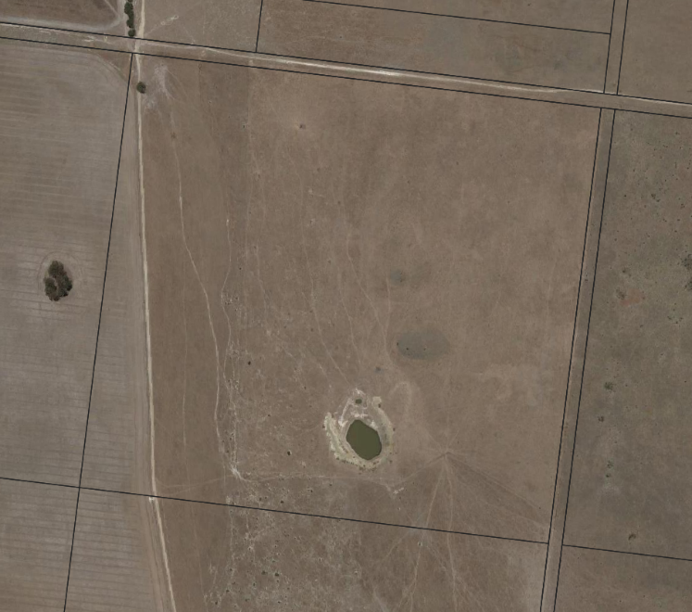

No new cadastral boundaries within blue area.

Figure 2: Setback application, single parcel contains entire setback

1. Where the dam is located near a cadastral boundary and the neighbouring lots are in the same ownership. If subdivision of one of the lots is to occur, the subdivision must amend the lot boundaries to meet the minimum setback requirements of this guideline. This is shown in Figure 3.  
     
   The blue area is the indicative setback distance. There should be no new cadastral boundaries within the blue area and the existing boundaries must be adjusted to provide the setback. This is intended to ensure that the owner of the dam is in control of all land within the setback distance.

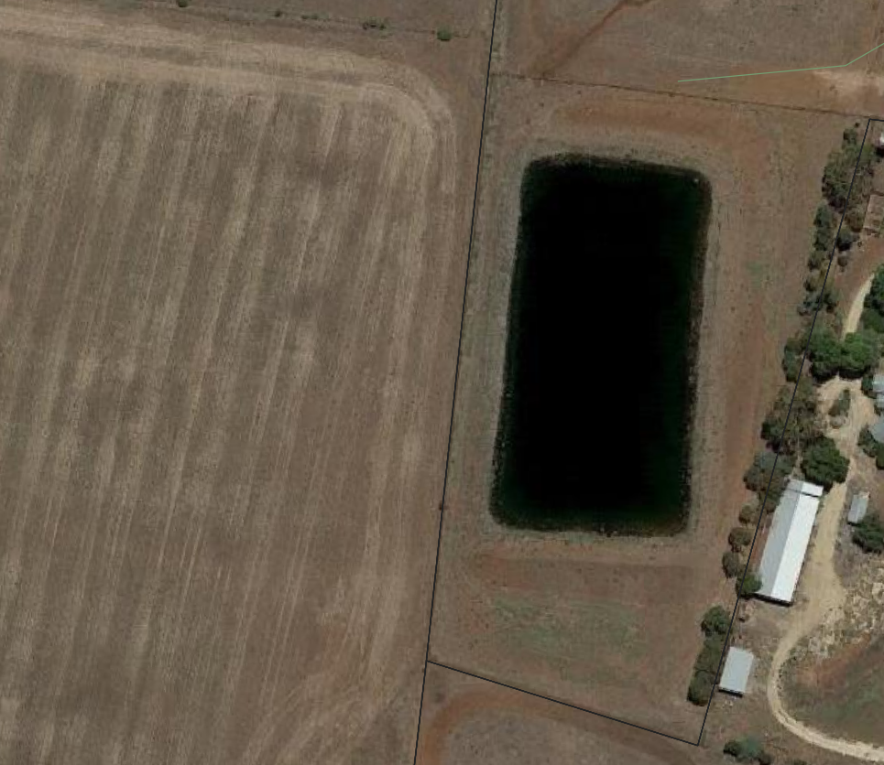

Owner A

Owner A

Realign existing boundaries along orange lines to provide setback.

Figure 3: Setback application, multiple parcels in single ownership

1. Where the dam is on a neighbouring property and the ownership of the lots are different. In this case, the setback distance will need to be accommodated across both land holdings. This is shown in **Figure 4**.  
     
   In Figure 4, the development is to occur on Owner A’s land, with the existing dam on Owner B’s land that is not subject to development. The setback distance is indicated by the blue perimeter line (including both the orange and blue shaded areas). The orange area indicates the area on the developing property where the setback applies. There must be no development associated with residential, industrial, or commercial uses within this area.   
     
   A desirable outcome would be for the orange area to be acquired by the Dam Owner (Owner B). If this is not possible, maintenance access to the embankment must be provided, either through an easement or other negotiated agreement.



Setback provided on both properties.

Owner B

Owner A

Figure 4: Setback application, multiple parcels in different ownership

In the third case, the setback distance would apply to land in rural, urban, and identified growth areas.

For existing dams that have been built to cadastral boundaries, roads abutting the dam can be included within the 5 metres of setback distance required for access for inspections and maintenance activities. This is subject to the required permissions being obtained where disruption to the normal operation of roads for these purposes is anticipated. This is provided that the roadway is the furthest part of the setback away from the dam embankment. For new roads, the setback distance should be applied such that the roadway is not within the minimum setback distance.

Strategic planning investigations should consider the location of dams together with the setback distances recommended in these guidelines.

In all three scenarios discussed in 3.2 above, no new buildings or other critical infrastructure should be constructed within the proposed setbacks, regardless of land use and zoning.

## **New Dams**

Where new dams or retarding basins are part of a proposed development they must be designed and constructed to comply with ANCOLD and regulatory requirements. This includes consideration of the population at risk associated with the development (and potential further development in the future) and meeting the requirements of So Far As Is Reasonably Practicable (SFAIRP) for managing dam safety. The dam must be designed by a qualified dam engineer and should include (but not be limited to) defensive design measures against piping (e.g., installation of filters) where appropriate, meet fallback requirements for flood retention, have a spillway designed to safely pass the design flood, consider dambreak flooding and meet the requirements for stability.

A setback distance from property boundaries for maintenance activities and dam safety inspections must be maintained for all new dams, whether licenced or not. This distance must be developed by a suitably qualified dams engineer and/or the dam licencing authority and may be larger than the minimum specified below. As an indication, the minimum setback distance for new dams should be:

* For dams up to 5 m in height (HD), the minimum setback should be 5 m.
* For dams greater than 5 m and up to 10 m in height (HD), the minimum setback should be 10 m.

New dams greater than 10 m in height and that fall within the limitations and exclusions criteria must be treated as special cases and have appropriate setback distances determined through an alternate pathway. In these rare cases, the Dam Safety and Regulation Team at Department of Environment, Land, Water and Planning should be contacted on 136 186 for guidance on an alternate pathway. However, it is unlikely that a new dam of greater than 10m in height will be constructed in close proximity to existing development.

For new dams in rural areas, the dam owner must adopt a setback from property boundaries. The setback distances in the guideline may be used as a starting point for that determination.

# **A****pplication of setback distance**

The setback distances are intended to apply to both on-stream and off-stream storages, as defined in DELWP’s publication [Your Dam Your Responsibility](https://www.water.vic.gov.au/__data/assets/pdf_file/0017/54251/Your-dam-Your-Responsibility-2018-05-19-digital-version-.pdf). The setback is intended to apply for its full width where there is any formed embankment. The application is shown in **Figure 5** and **Figure 6**.

X

X

X

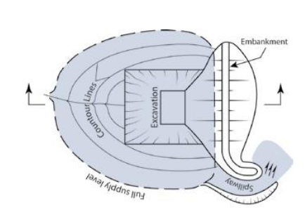

Figure 5: Setback application (Shown in green), On-stream Storage.

For on-stream dams, as per **Figure 5**, the setback applies to the downstream face of the full embankment. The setback distance is a constant value from the downstream toe of the embankment (shown on **Figure 5** as X).

For off-stream dams that are ring dams or turkey nest dams, the setback would be applicable for the entire perimeter of the dam embankment as shown in **Figure 6**.

X

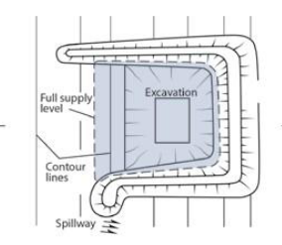

X

X

X

X

X

Figure 6: Setback application (Shown in green), Off-stream Storage

## **Example Application**

This section provides a step-by-step example application for the calculation of the minimum setback distance. The steps involved in determining the setback are:

1. Identify the dam embankment crest and toe.
2. Calculate the maximum height of the dam, HD, measured from the lowest elevation at the toe of the embankment to the highest elevation of the dam crest.
3. Determine the slope of the land away from the embankment (typically in m/m or degrees). This is the average slope measured at the lowest elevation at the embankment toe over a distance equivalent to the dam height plus 10 m (HD + 10 m), or minimum of 10 m (whichever is the greater).
4. Look at the minimum setback distance from **Table 2**.

The embankment data and pictures used in the example below have been modified for the purposes of the example calculation and are not intended to represent any particular dam.

### **How to Identify Dam Embankment, Crest and Toe?**

The crest and toe of the embankment must be defined spatially. This can be done through site survey, assessment of LIDAR topographic data or contour data, if the resolution is sufficient. If using contour data, it is recommended to allow for some conservativeness in the assessment of the embankment height. Figure 7 and Figure 8 show an example dam, with the toe and crest of the embankment defined. The proposed new General Residential Zone and property boundaries are indicated in orange on Figure 7.

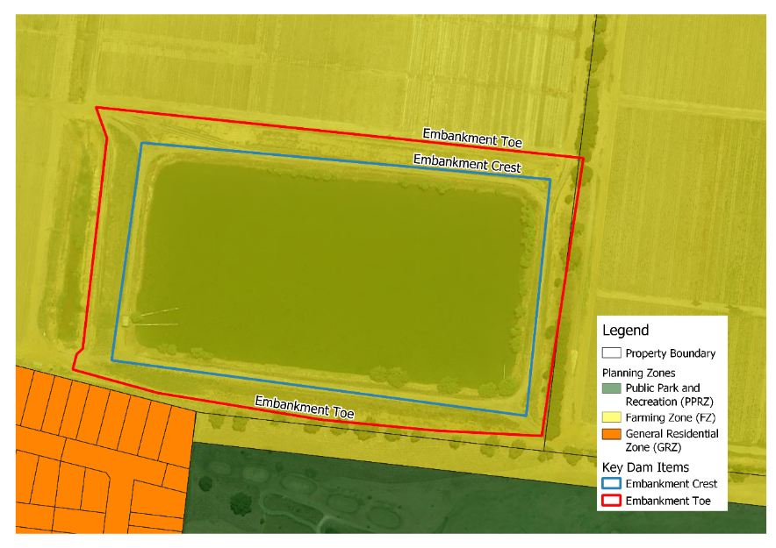

Figure 7: Example Dam, Identification of Crest and Toe of Embankment

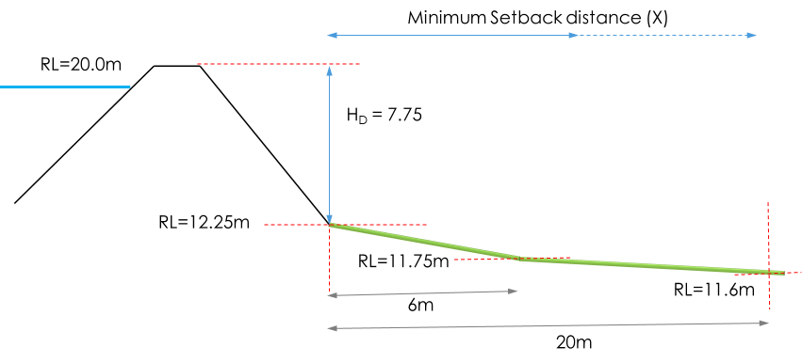

Figure 8: Example Dam, Measurements and Levels

### **How to Determine Dam Height?**

From Figure 8, the dam height is 7.75 metres.

### **How to calculate the Downstream Slope?**

The maximum land slope downstream of the dam can be either uphill, downhill, or flat. This slope should be measured as the steepest downhill grade from the toe of the dam embankment. Figure 9 indicates these slopes.

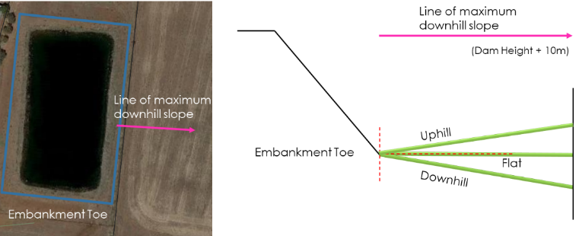

Figure 9: Downstream Slope

In the example, as shown in Figure 8, the land slopes away from the dam at a steeper grade to 6 m from the embankment and then at shallower grade from there to 20 metres from the toe of the embankment.

To calculate the average slope, the change in elevation from the toe of the dam to a point 18 metres (dam height plus 10 metres) from the embankment toe is measured. This difference is 0.63 metres. The slope is therefore -0.032 m/m (calculated by -0.63/18).

### How to Lookup the Minimum Setback Distance?

|  |  |  |  |  |
| --- | --- | --- | --- | --- |
| Maximum Dam Height (HD) | Minimum Setback Distance (metres)  (Measured from the Downstream Toe of the Existing Embankment) | | | |
| Any uphill slope, downhill slope  <-0.02 m/m  (<-2%, <1°) | Downhill Slope -0.02 to -0.05 m/m  (-2% to -5%,  1° to 3°) | Downhill Slope -0.05 to -0.1 m/m  (-5% to -10%,  3° to 6°) | Downhill Slope -0.1 to -0.16 m/m (-10% to -16%,  6° to 10°) |
| 0.5 to 2 | 10 | 11 | 12 | 13 |
| > 2 to 3 | 12 | 13 | 14 | 15 |
| > 3 to 4 | 14 | 15 | 16 | 17 |
| > 4 to 5 | 15 | 16 | 17 | 18 |
| > 5 to 6 | 16 | 17 | 18 | 20 |
| > 6 to 7 | 17 | 18 | 19 | 21 |
| > 7 to 8 | 18 | 19 | 20 | 22 |
| > 8 to 9 | 19 | 20 | 22 | 23 |
| > 9 to 11 | 21 | 23 | 24 | 26 |
| > 11 to 13 | 23 | 25 | 26 | 28 |
| > 13 to 15 | 25 | 27 | 28 | 30 |
|  |  |  |  |  |

Once the dam height and downstream slope are determined, **Table 2** can be used to look up the minimum setback distance as shown.

From **Table 2**, the minimum setback distance for this dam is 19 metres. This is plotted in **Figure 10**.

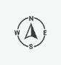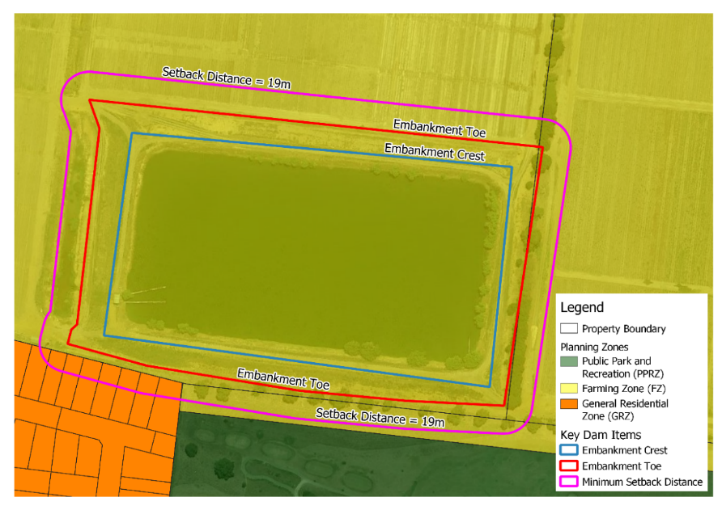

Figure 10: Example Calculated Minimum Setback Distance

From Figure 10, the proposed residential property boundary is within the minimum setback distance as shown by the orange area. The layout for the residential subdivision would require a change to comply with the setback distance, such that the proposed residential area was not within the magenta line. Where the setback is within the Farming Zone, south-east of the dam, changing the boundary is encouraged but not mandatory, provided access is maintained.

# **References**

1. For more information and guidance on good practice in design, construction and management of dams, as well as the responsibilities for both new and existing dam owners, see DELWP’s guide to managing safety of small dams [Your Dam Your Responsibility](https://www.water.vic.gov.au/__data/assets/pdf_file/0017/54251/Your-dam-Your-Responsibility-2018-05-19-digital-version-.pdf).

2. Regulatory requirements, information, and guidance on making an application to construct and operate a dam can be found from your local Licensing Authority (water corporation):

[Melbourne Water](https://www.melbournewater.com.au/water-data-and-education/waterway-diversions/dam-safety-licences-and-registration)

[Southern Rural Water](http://www.srw.com.au/water-systems/dams-private-property/)

[Goulburn Murray Water](https://www.g-mwater.com.au/water-resources/diversions/farm-dams)

[Grampians Wimmera Mallee Water](https://www.gwmwater.org.au/connecting-services/surface-water-diversion/construct-a-farm-or-household-dam)

[Lower Murray Water](https://www.lmw.vic.gov.au/for-irrigators/water-licences-entitlements/)

3. For general information and guidance on planning processes, including subdivision, development applications, and planning scheme amendments, see DELWP’s guide on [Using Victoria's Planning System](https://www.planning.vic.gov.au/guide-home/using-victorias-planning-system%20).

4. For specific advice about planning approvals required for subdividing property or building close to dams please contact your local council. You can look up who your local council is by visiting [Know Your Council.](https://knowyourcouncil.vic.gov.au/%20%20%20%20%20%20%20%20%20%20%20%20%20%20)

delwp.vic.gov.au