Guidance Note: Floodplain management responsibilities
October 2026









deeca.vic.gov.au

This guidance note sets out responsibilities for flood mapping and related development controls in Victoria. It also explains the transition arrangements for current projects, including flood studies.

The shared role to manage flood risk
Victoria's State Emergency Management Plan recognises that flood emergency management is a shared responsibility.
The Victorian State Emergency Service (VICSES) leads and coordinates flood response activities, including warnings, evacuations and emergency assistance during flood events. Floodplain management authorities, local councils and other agencies support flood preparedness, risk management and recovery.
More broadly, managing flood risk is a shared responsibility between government, responsible authorities, communities, landholders and businesses.
Government provides the legislative framework, policy and strategic direction for floodplain management, while responsible authorities provide flood information, technical advice and services to help communities understand and manage risk.
Communities, landholders and businesses also play an important role by:
- understanding and acting on flood risk using available information, warnings and advice
- preparing for flood emergencies and responding to official warnings
- making informed decisions about development, land use and property in flood-prone areas
- contributing local knowledge and participating in consultation on flood studies, mapping and planning.
Together, these roles support coordinated flood risk management before, during and after flood events.
Flood mapping arrangements
Floodplain management authorities—including Melbourne Water and the nine regional catchment management authorities—are responsible for leading flood modelling and associated community engagement to support:
- flood-related planning scheme amendments led by the Minister for Planning
- flood-related building control designations by the Minister for Housing, Building and Precincts
Other authorities may continue to undertake local flood investigations and modelling to support specific projects or programs they invest in, such as stormwater drainage, flood mitigation infrastructure or precinct structure plans.

Previous flood mapping arrangements
State-funded flood studies in Victoria have historically been delivered with flood modelling, community engagement and implementation led by local councils.
There are several active projects with varied status, mapping, funding arrangements and delivery schedules through these previous arrangements. This includes active flood studies, flood-related planning scheme amendments as well as completed flood studies that have not been implemented as development controls.
These active state-funded projects may continue under previous local agreements, responsibilities and agreed processes for a transitional period of two-years.
Transitional principles have been established to support consistency in approaches statewide to support fair and orderly transition.
Floodplain management responsibilities
The Water Act 1989 establishes the floodplain management functions in Victoria.
Floodplain management authorities are responsible for providing the best-available technical flood advice to responsible authorities, emergency services, and communities. This includes:
- Leading preparation, review and endorsement of best-available flood mapping with flood risk ratings.
- Providing advice, informed by flood mapping, to support local flood mitigation planning and decision-making by councils and other relevant authorities.
- Integrating engagement on flood mapping and planning and building controls.
- Providing strategic advice on flood-related planning and building controls.
- Providing statutory planning and building advice.
- Engaging with stakeholders to determine regional priorities to maintain and update flood mapping to support timely and robust decisions.
- Developing and overseeing implementation of regional floodplain management strategies.
The Catchment and Land Protection Act 1994 establishes catchment management authorities and provides the framework for integrated catchment management across Victoria. Catchment management authorities are responsible for:
- Coordinating catchment planning
- Integrating floodplain management with land, water and biodiversity objectives
- Supporting regional partnerships and strategic planning activities
The Statement of Obligations issued by the Minister for Water specifies obligations for regional catchment management authorities and Melbourne Water in relation to performing their floodplain management functions. These support:
- The Water Act 1989 functions by establishing performance expectations and service delivery responsibilities for floodplain management authorities
- Integration of floodplain management into planning and emergency management systems.
Active flood studies may continue under previous arrangements, subject to funding agreement, statutory requirements and decisions by the relevant authority.
Planning and Building responsibilities
The Planning and Environment Act 1987 establishes Victoria's planning system and provides the mechanism for implementing flood-related planning controls.
Minister for Planning is responsible for:
- Administering the Planning and Environment Act 1987 and the Victoria Planning Provisions.
- Preparing, adopting and approving implementation of flood planning scheme amendments in moderate to extreme risk areas, on the advice of floodplain management authorities. This includes coastal, drainage and riverine flooding.
- Ensuring flood-related planning controls are applied consistently and in a timely way to support safe and appropriate land use and development decisions.
Local councils are generally responsible for:
- Providing local knowledge, data, and information to inform flood mapping and local flood mitigation feasibility assessments.
- Making decisions on local flood mitigation measures and priorities, including consideration of feasibility, costs, benefits and community needs.
- Managing, operating and maintaining local flood mitigation and drainage infrastructure.
- Assessing planning permit applications
- Integrating flood information into strategic planning processes
- Developing and maintaining municipal emergency planning, preparedness and recovery
- Enforcing the planning and building systems
- Supporting community engagement and responding to public enquiries relating to flood management.
The Building Act 1993 establishes Victoria's building regulatory framework and provides mechanisms for managing development in flood-prone areas.
Minister for Housing, Building and Precincts is responsible for:
- Administering the building regulatory framework relating to construction in flood-prone areas.
- Making flood-prone area building designations within the applicable 1% AEP flood extent to apply minimum construction standards, on the advice of floodplain management authorities. This includes coastal, drainage and riverine flooding.
Building surveyors are responsible for:
- Assessing compliance with building requirements.
- Applying minimum construction standards.
- Considering flood-prone area requirements.

Transition Arrangements
Existing flood planning controls remain in place on affected land. Approved planning permits and previous statutory processes can continue to operate to support a fair and orderly transition.
New flood planning controls will generally apply to new flood studies.
Relevant authorities will continue to work together to support timely implementation of the best available flood information into development controls.
Active flood studies and related planning scheme amendments should generally continue through established pathways unless applying the new controls or changing delivery responsibilities would provide a clear benefit.
Any decision to vary active flood study scope, delivery pathways, engagement or implementation mechanisms should be assessed against the below principles.
Public Safety
The timely availability of robust flood information to support land use planning, community awareness and emergency management is the primary consideration.
Decisions should not create unreasonable delays in making flood risk information available to decision-makers, emergency services or affected communities.
Amendment Readiness
Greatest weight should be given to the current status of implementation activities.
Consideration should be given to:
- whether a planning scheme amendment has commenced;
- whether consultation has already occurred;
- whether amendment documentation has been prepared;
- whether exhibition has occurred; and
- whether implementation funding arrangements are already established.
Where an amendment has been exhibited, the implementation pathway should generally not change.
Mapping Readiness
Consideration should be given to:
- the maturity of flood investigation outputs;
- whether mapping has been prepared to contemporary standards;
- whether information required to support implementation is available; and
- whether significant additional technical work would be required.
Community and Stakeholder Readiness
Consideration should be given to consultation already undertaken through the flood investigation process.
Where appropriate, opportunities should be identified to align flood investigation engagement and planning implementation activities to reduce duplication and support efficient delivery.
Changes later in the project lifecycle should only occur where there is a clear implementation benefit.
Funding and Delivery Impacts
Projects should be delivered within existing funding arrangements wherever practicable.
Variations that create additional costs or unfunded obligations should only proceed with agreement from relevant funding partners.

Planning Control Transition
Two implementation pathways may be used during the transition period:
- application of existing flood planning controls (UFZ, FO, LSIO and SBO); or
- application of the new flood planning controls.
Projects are not required to continue with a particular planning control approach where assessment against the transitional arrangements demonstrates a clear implementation benefit.
Flood investigations that have substantially progressed through amendment processes will generally continue using existing flood planning controls.
Newly funded flood investigations will generally implement the new flood planning controls.
Existing flood planning controls may continue to be applied during the transition period where amendment processes have already substantially progressed or where implementation under those controls provides the most practical and efficient pathway to planning scheme implementation.
Local councils may continue to progress, adopt and implement state funded flood studies and flood-related planning scheme amendment to 1 October 2028, provided they were approved for funding before 3 October 2025.

Figure 1: Floodplain management statutory framework
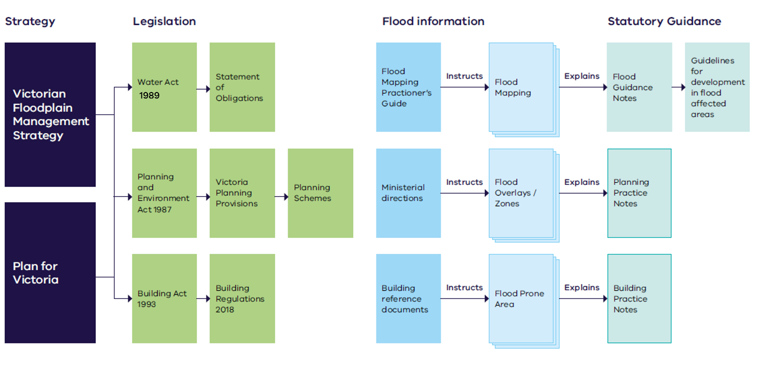


Image: Marram baba Merri Creek Regional Park (2022)

© The State of Victoria Department of Energy, Environment and Climate Action October 2026 Creative Commons This work is licensed under a Creative Commons Attribution 4.0 International licence, visit the Creative Commons website (http://creativecommons.org/ licenses/by/4.0/). You are free to re-use the work under that licence, on the condition that you credit the State of Victoria as author. The licence does not apply to any images, photographs or branding, including the Victorian Coat of Arms, and the Victorian Government and Department logos.
ISBN 978-1-86520-051-4 (pdf/online/MS word)
Disclaimer ISBN to be provided This publication may be of assistance to you but the State of Victoria and its employees do not guarantee that the publication is without flaw of any kind or is wholly appropriate for your particular purposes and therefore disclaims all liability for any error, loss or other consequence which may arise from you relying on any information in this publication
Accessibility To receive this document in an alternative format, phone the Customer Contact Centre on 136 186, email customer.service@deeca.vic.gov.au, or contact National Relay Service (www.accesshub.gov.au/) on 133 677. Available at DEECA website (www.deeca.vic.gov.au)

