How the Sustainable Yield Assessment will be used
  - Sustainable Yield Assessment Fact Sheet
The Sustainable Yield Assessment provides a new information source that will support the next evolution in groundwater management, including in managing risks from climate change, now and into the future.
This is the first time DEECA has done an assessment of the impact of extraction on groundwater levels across all of Victoria and it has included assessment of over 1000 groundwater systems.
When we combine the Sustainable Yield Assessment with other sources of information, we improve our shared understanding of groundwater and how groundwater management can be improved (Figure 1).
Figure 1: Information sources used to manage groundwater in Victoria
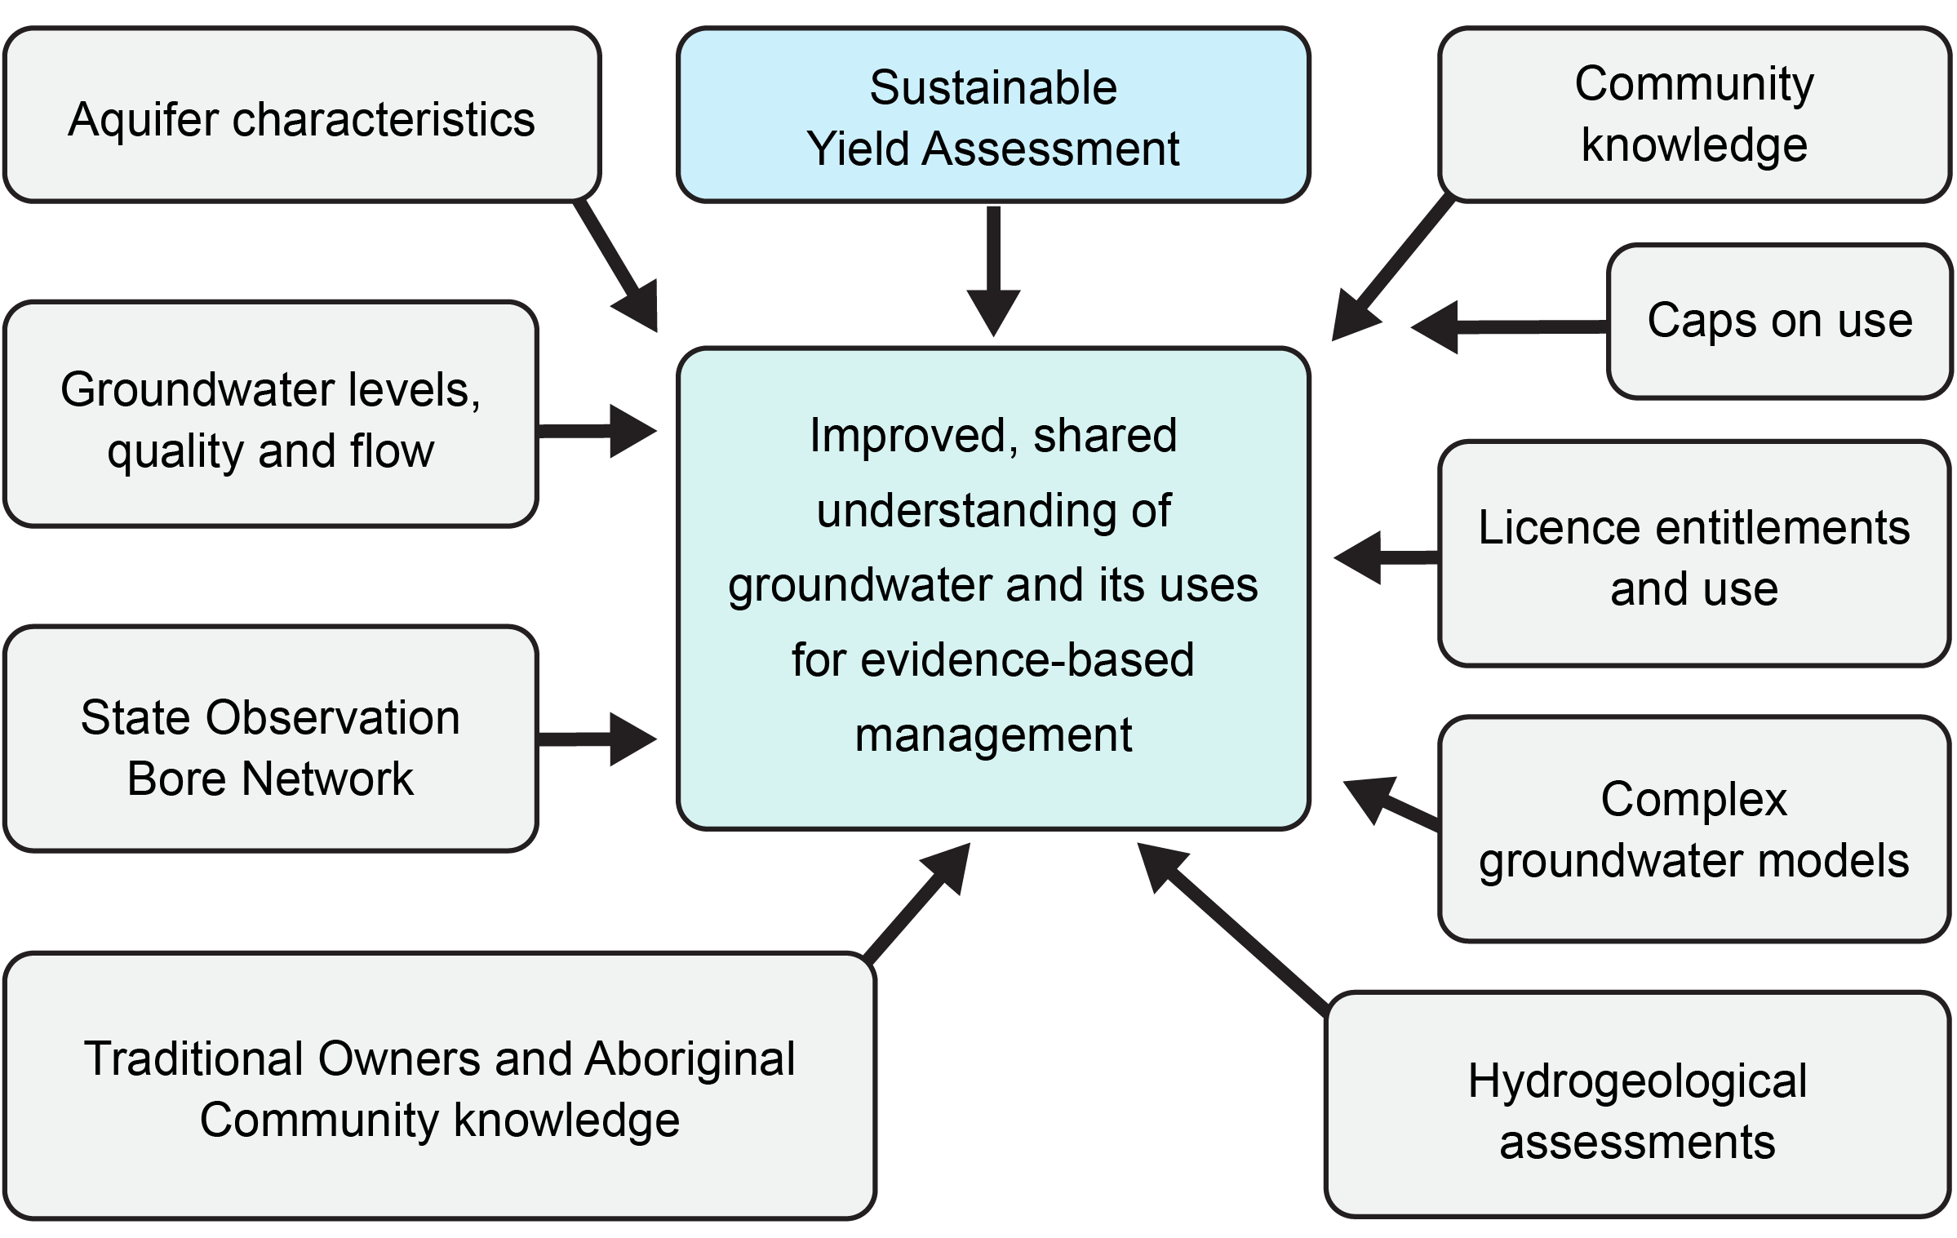
Improved, shared understanding of groundwater and its uses for evidence-based management is informed by the following inputs:
- Sustainable Yield Assessment
- Aquifer characteristics
- Groundwater levels, quality and flow
- State Observation Bore Network
- Traditional Owners and Aboriginal community knowledge
- Community knowledge
- Caps on use
- Licence entitlements and use
- Complex groundwater models
Hydrogeological assessments
For some groundwater systems, such as low-use unincorporated areas, where often less is known about the resource, the Sustainable Yield Assessment will be especially valuable in providing more insight and informing management. For other systems, the Sustainable Yield Assessment may be one input amongst many, which will help to validate or refine what is already known.

How will the Sustainable Yield Assessment be used?
Most systems are being managed effectively according to the current level of risk without the need for changes to local management. Rural Water Corporations already monitor groundwater condition, use a robust range of management tools and work closely with the community, especially in higher use systems, to manage risks.
The Sustainable Yield Assessment has not indicated that there is a need to make any immediate changes to local management. Importantly, all entitlements will remain secure. However, we need to look at our tools for monitoring and managing future risks under our caps, before we see unacceptable levels of drawdown.

Groundwater Management 2030
The Sustainable Yields Assessment has been undertaken as a foundational, technical piece of work under Groundwater Management 2030 (GM2030). GM2030 aims to improve the groundwater licensing and management framework so that it can better adjust to meet future opportunities and challenges and make the best, sustainable use of available water in a drying climate.
The Sustainable Yield Assessment will be used to inform work under the GM2030 program, including:
- Setting and amending caps where appropriate and meaningful to do so, including exploring caps in unincorporated areas where caps do not currently exist and considering opportunities to make more groundwater available in areas where the sustainable yield is higher than existing caps.
- Managing groundwater use within entitlement caps by monitoring and responding to observed groundwater levels
- A state-wide 10-year monitoring strategy focussing on continued metering and improved monitoring of our two key management parameters, use and groundwater levels, and introducing water level resource condition reporting.
The re-assessment over the next 6-12 months of a small number of systems where a sustainable yield estimate could not be derived. The details of these systems are provided in the Sustainable Yield Assessment Overview Report.
At a local level, rural water corporations will continue to manage groundwater in consultation with licence holders and the community. These activities include implementing and regularly reviewing management plans. Rural Water Corporations will use the Sustainable Yield Assessment to help prioritise and inform reviews of local management, alongside the other available information they currently consider in making management decisions.
Importantly, entitlements will remain secure and there will be no immediate changes to local management. Stakeholders and communities will be consulted on any options to improve management in the future.

How will the community and stakeholders be consulted?
DEECA will engage with stakeholders and Traditional Owners about the Sustainable Yield Assessment and how the results will inform future management improvements as part of the ongoing GM2030 work program.
As part of their normal program of activities, rural water corporations will continue to work with stakeholders on any reviews of local management.

How are cultural values being considered in the Sustainable Yield Assessment?
The Sustainable Yield Assessment is a technical assessment that develops a relationship between groundwater use, drawdown and climate. More work needs to be done to understand the sustainable yield estimates in the context of all groundwater values, including environmental, social and cultural values.
With the release of the Sustainable Yield Assessment and ongoing policy work under the wider GM2030 work program, DEECA will be working with Traditional Owners to understand how the Sustainable Yield Assessment can be used to support the cultural values of groundwater and Traditional Owner self-determined objectives relating to groundwater.

Additional information:
- Sustainable Yield Assessment Overview Report
- Fact Sheet: What is the Sustainable Yield Assessment?
- Fact Sheet: How the Sustainable Yield Assessment be calculated
- Fact Sheet: How is groundwater is managed?

Publication information

Acknowledgements
We acknowledge and respect Victorian Traditional Owners as the original custodians of Victoria’s land and waters, their unique ability to care for Country and deep spiritual connection to it.
We honour Elders past and present whose knowledge and wisdom has ensured the continuation of culture and traditional practices.
DEECA is committed to genuinely partnering with Victorian Traditional Owners and Victoria’s Aboriginal community to progress their aspirations.

Copyright
© The State of Victoria Department of Energy, Environment and Climate Action, 2026.

Creative Commons
This work is licensed under a Creative Commons Attribution 4.0 International licence, visit the Creative Commons website (http://creativecommons.org/licenses/by/4.0/).
You are free to re-use the work under that licence, on the condition that you credit the State of Victoria as author. The licence does not apply to any images, photographs or branding, including the Victorian Coat of Arms, and the Victorian Government and Department logos.
ISBN 978-76176-763-0 (pdf/online/MS word)

Disclaimer
This publication may be of assistance to you but the State of Victoria and its employees do not guarantee that the publication is without flaw of any kind or is wholly appropriate for your particular purposes and therefore disclaims all liability for any error, loss or other consequence which may arise from you relying on any information in this publication.

Accessibility
To receive this document in an alternative format, phone the Customer Service Centre on 136 186, email customer.service@delwp.vic.gov.au, or contact National Relay Service on 133 677 or visit http://www.accesshub.gov.au/. Available at DEECA website (www.deeca.vic.gov.au).
End of document.

