Western Region Sustainable Water Strategy
Developing a new strategy for the sustainable use of water resources across western Victoria
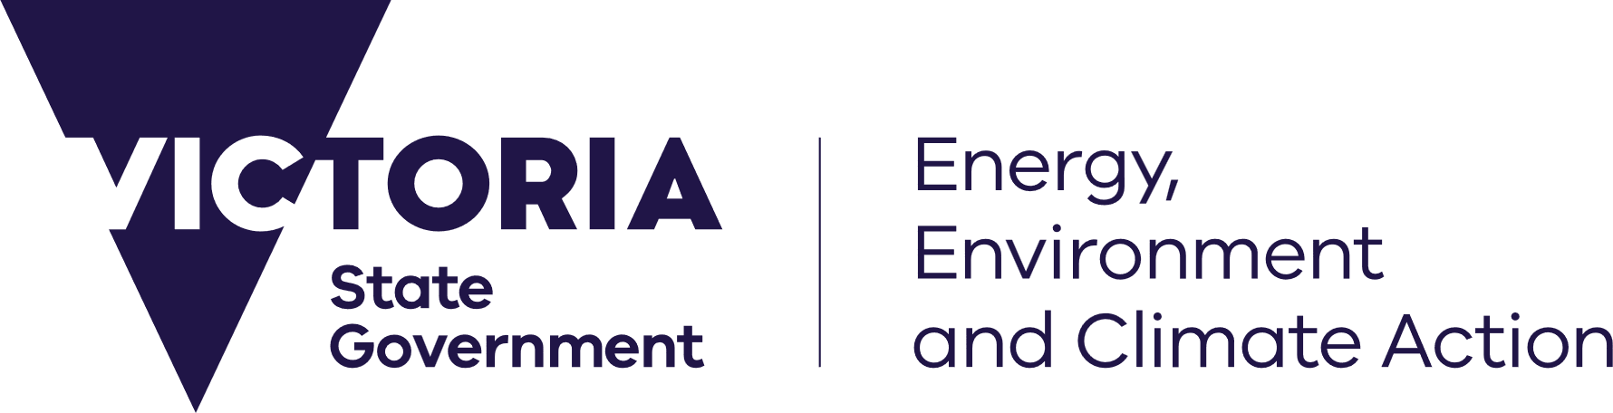
deeca.vic.gov.au


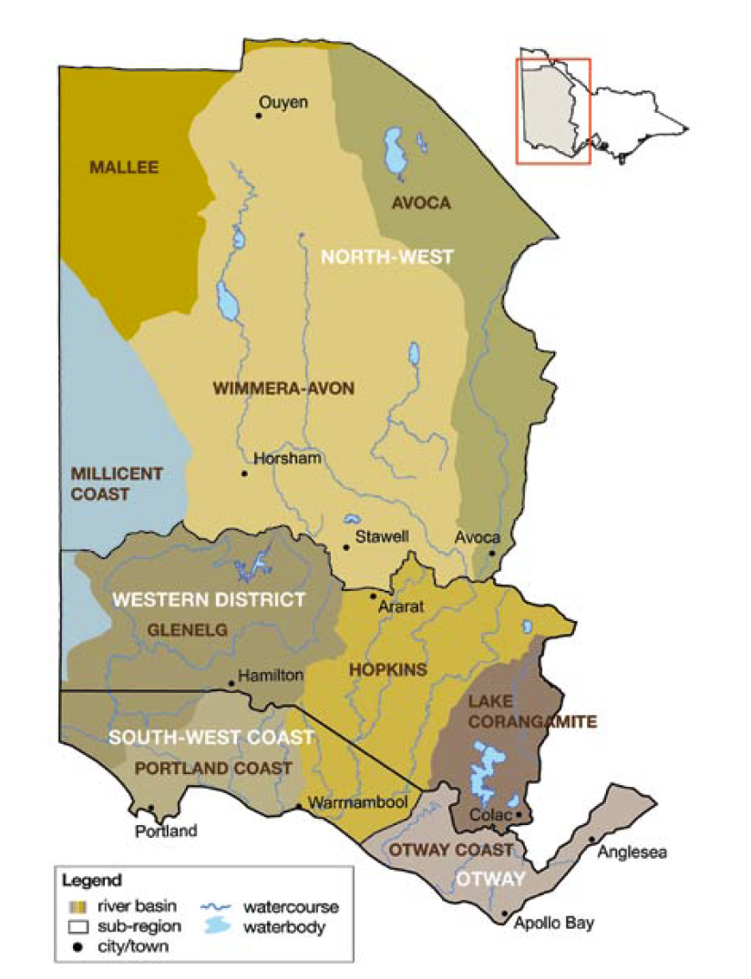

What is a sustainable water strategy?
A reliable and safe water supply is essential for the wellbeing and prosperity of all Victorians. Our waterways also provide an enormous range of economic, cultural, environmental and social values.
Changes to our climate, landscape and community can impact on water supplies and water quality for many water users. So there is a need to plan for these changes and respond through improving water policy, management and infrastructure.
The development of sustainable water strategies (SWSs) are an important way that water agencies, partners, Traditional Owners, stakeholders and the community can consider and shape plans to manage our water supplies into a drier and warmer future. They are a statutory requirement under the Water Act 1989 and endorsed by the Minister for Water.

What is the area of the Western Region SWS?
The Western Region (Figure 1) extends from the southern Mallee in the north to the south-west coast, and from the Victoria/South Australia border in the west to the Avoca, Woady Yaloak and Gellibrand rivers to the east.
Figure 1: Map of Western Region SWS area

It includes the extensive Wimmera plains, the Grampians Ranges (Gariwerd), the Western District plains and the coastal draining section of the Otway Ranges.

Why is the new Western Region SWS being developed now?
The first Western Region SWS was finalised in 2011 following the Millennium Drought and completion of the Wimmera Mallee Pipeline Project.
In the years since then there’s been periodic impacts from drought conditions across much of the region, including the current drought affecting the south-west. The region’s community and economy is also changing, reflecting shifts in agriculture, population and industries.
There’s been significant progress in water policy such as in supporting integrated water management and increasing Traditional Owner partnerships in water and waterway management. Our understanding of future threats to water supplies from droughts, climate and land use change has improved, informed by additional monitoring and modelling data.
We have also seen advances in water infrastructure in parts of western Victoria such as roof water harvesting and reuse schemes and new pipelines supplying water for stock and domestic use. A new Western Region SWS provides the opportunity to consider these changes and other new information sources to set clear long-term direction for water policy and infrastructure across the region.

What are some of the issues the new Western Region SWS is likely to consider?

Given the factors described previously, some of the issues likely to be considered in a new Western Region SWS include:
- water supplies for livestock farms (including dairy industry) during droughts.
- access to water for Traditional Owners.
- alternative water supplies such as stormwater and recycled wastewater.
- flows for waterways during dry conditions.
- efficient water infrastructure to reduce losses from seepage and evaporation.
- trends in water availability and likely water demands.
- water licencing and trade.

What is the process to develop a new Western Region SWS?
There are statutory requirements to develop a SWS under the Water Act 1989 such as having:
- a consultative committee representing water-sector and Traditional Owner interests to provide guidance at key points of the process.
- a draft SWS that is open for public feedback for at least two months.
- an independent panel to provide advice to the Minister for Water on feedback on the draft SWS.
The SWS development process involves several steps (Figure 2) and will also include the establishment of working groups to provide technical and policy input as well as providing other avenues for groups and individuals to contribute to the new Western Region SWS.

Figure 2: Indicative timeline of key steps in the Western Region SWS process

What has the 2011 Western Region SWS led to?
Reporting on the implementation of the 2011 Western Region SWS is available at water.vic.gov.au. It identified that 55 of the 69 actions within it have been achieved and this has led outcomes such as:
- revising groundwater management units
- developing Ministerial guidelines for groundwater-dependent ecosystems
- updating the operating rules of the Wimmera Mallee headworks system.
- developing rules to divert river flows for recreation in wet years
- revising urban water demand strategies
- protecting flows in the Millicent Coast Basin and Merri River.
There were also lessons learnt through the implementation process such as identifying remaining challenges not considered in the Western Region SWS and providing additional guidance on the suggested process to deliver actions so that they effectively meet their original intent.
Overall the Western Region SWS was an important step for the management of western Victoria’s water resources, helping to build knowledge and understanding and improving clarity of policy and management.
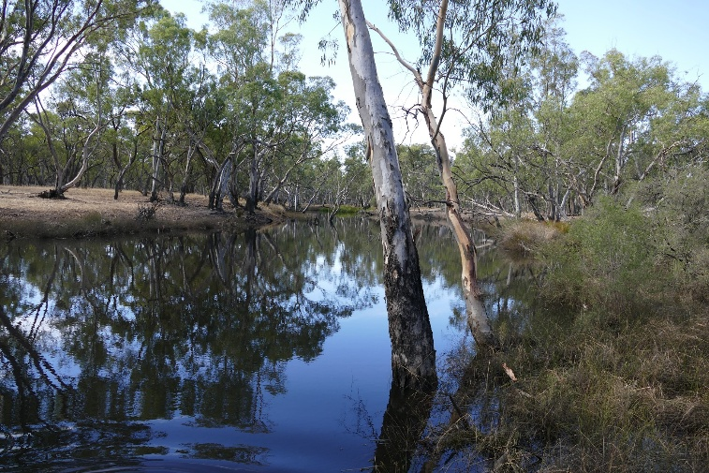
Who is involved in developing a SWS?
There is a wide range of groups involved in developing a SWS to help understand local issues and propose solutions from a range of perspectives. They include representatives from:
- Key agencies with roles in managing water and waterways such as water corporations and catchment management authorities
- Traditional Owner groups.
- Farming and other relevant industry groups.
- Environmental groups.
- Recreational groups focused on waterways (e.g. recreational fishing).
- Local governments and regional development bodies.
Interested in updates on the Western Region SWS and having your say?
Contact the Western Region SWS team at sws.team@deeca.vic.gov.au or 136 186 to be registered for updates on key milestones on the Western Region SWS.


We acknowledge Victorian Traditional Owners and their Elders past and present as the original custodians of Victoria’s land and waters and commit to genuinely partnering with them and Victoria’s Aboriginal community to progress their aspirations.
© The State of Victoria Department of Energy, Environment and Climate Action, November 2025.
Creative Commons
This work is licensed under a Creative Commons Attribution 4.0 International licence, visit the Creative Commons website (http://creativecommons.org/licenses/by/4.0/).
You are free to re-use the work under that licence, on the condition that you credit the State of Victoria as author. The licence does not apply to any images, photographs or branding, including the Victorian Coat of Arms, and the Victorian Government and Department logos.
Disclaimer
This publication may be of assistance to you but the State of Victoria and its employees do not guarantee that the publication is without flaw of any kind or is wholly appropriate for your particular purposes and therefore disclaims all liability for any error, loss or other consequence which may arise from you relying on any information in this publication.
Accessibility
To receive this document in an alternative format, phone the Customer Service Centre on 136 186, email customer.service@delwp.vic.gov.au, or contact National Relay Service on 133 677. Available at DEECA website (www.deeca.vic.gov.au).

