Rivers and Riparian Action Plan 2021

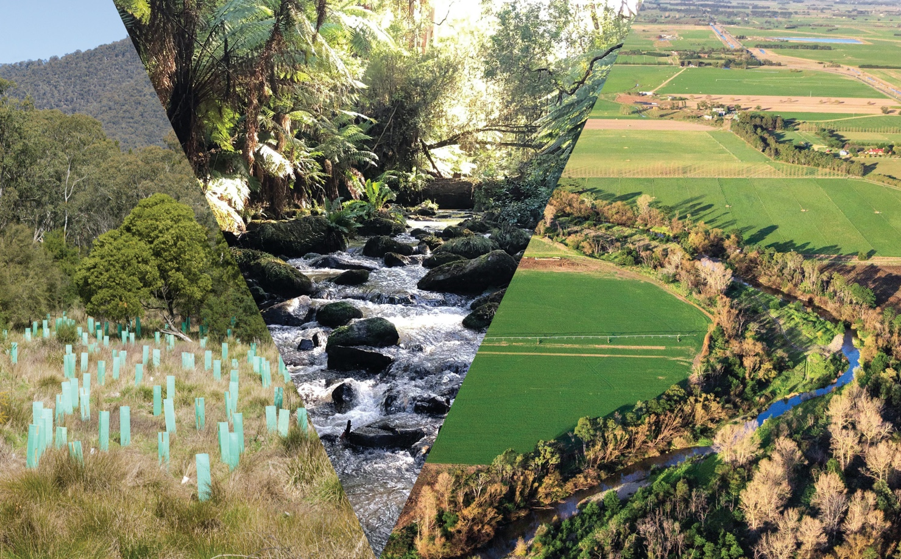

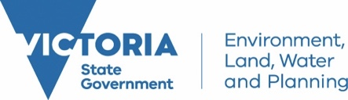

Table of Contents

Minister’s Foreword 3
Purpose of this Action Plan 4
Strategic planning framework for waterway management in Victoria 5
Traditional owners and waterway management 6
Key Waterway Management Initiatives 8
INITIATIVE 1 – Flagship Waterway Projects 9
Current flagship waterway projects 9
New flagship waterway projects 10
INITIATIVE 2 – Gippsland Lakes 12
INITIATIVE 3 – Ramsar Wetlands 13
INITIATIVE 4 – Major environmental water works in northern Victoria 14
INITIATIVE 5 – Iconic Urban Waterways 15
INITIATIVE 6 – Bushfire Recovery 16
INITIATIVE 7 – Water for the environment 17
INITIATIVE 8 – Catchment management authority water statutory functions 18
INITIATIVE 9 – Citizen Science 19
Monitoring and Reporting 21

Acknowledgment
We acknowledge and respect Victorian Traditional Owners as the original custodians of Victoria’s land and waters, their unique ability to care for Country and deep spiritual connection to it. We honour Elders past and present whose knowledge and wisdom has ensured the continuation of culture and traditional practices.

We are committed to genuinely partner, and meaningfully engage, with Victoria’s Traditional Owners and Aboriginal communities to support the protection of Country, the maintenance of spiritual and cultural practices and their broader aspirations in the 21st century and beyond.

Minister’s Foreword
The health, wellbeing and prosperity of Victorian communities depend on healthy rivers, wetlands, floodplains and estuaries. Traditional Owners have strong connections to Country, especially waterways. Waterways provide many of the areas we love to go to swim, camp, fish, walk, ride or just relax and enjoy the scenery.

Healthy waterways make our cities and towns liveable and provide a variety of opportunities for recreation. We rely on healthy rivers and water storages for our drinking water, and for other purposes such as farming and industry. Healthy waterways support a diverse range of native plants and animals. The land that runs along rivers, creeks and wetlands – riparian land – provides important ecosystem services and many other benefits.

This Rivers and Riparian Action Plan outlines what government is doing to manage Victoria’s waterways over the next four years. It encapsulates a range of programs – improving critical waterways, internationally recognised wetlands, regional environments and iconic urban waterways.

Government investment in this range of initiatives is also great news for regional communities and especially regional jobs. People will be employed by catchment management authorities, other regional agencies and industries supplying services like fencing contractors, plant nurseries and construction contractors.

We know with climate change it will be even more important to have healthy green spaces to support community health and well-being – and by improving the health of our waterways the Plan will also support economic activity in our regions particularly tourism – which is even more important given the economic impacts of COVID.

I look forward to continuing to achieve healthier waterways for the benefit of all Victorians.

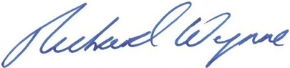
The Hon Richard Wynne MP
Acting Minister for Water

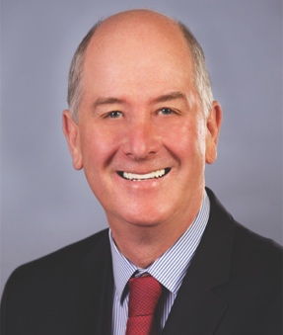

Purpose of this Action Plan
This Rivers and Riparian Action Plan outlines what government is doing to manage Victoria’s waterways over the next four years. It spans the period 2020-21 to 2023-24 and continues the government’s key commitment to improve the health of waterways and riparian land in Victoria.

The Action Plan includes a package of key initiatives to improve the health of waterways across Victoria. Undertaking the initiatives continues implementation of many important Victorian Government commitments in Victoria’s Water Plan – Water for Victoria – and is consistent with the Victorian Waterway Management Strategy, government’s framework for managing the health of Victoria’s waterways. This Action Plan follows on from the previous Regional Riparian Action Plan but is broader and encapsulates a range of programs.

The Rivers and Riparian Action Plan will continue to build on the government’s existing approach to managing waterways including:
- government and agencies like catchment management authorities (CMAs) and Melbourne Water working with Traditional Owners, local communities and landholders to deliver programs,
- focussing on the multiple benefits of managing waterways in particular environmental, social and cultural benefits – from managing habitat to protect threatened species to providing recreational benefits and opportunities to improve the wellbeing and self-determination of Victoria’s Traditional Owners, and
- ensuring monitoring, evaluation, reporting and improvement (known as MERI) will be a focus so that we learn from our work and continue to improve and get better waterway outcomes for the community.

The Rivers and Riparian Action Plan includes a stronger emphasis on climate change impacts on waterways – recognising that reduced flows in waterways, higher water temperatures and more intense rainfall when it does rain impacts the health of our waterways.

Traditional Owner involvement in waterway management will also be a strong focus of this Action Plan.

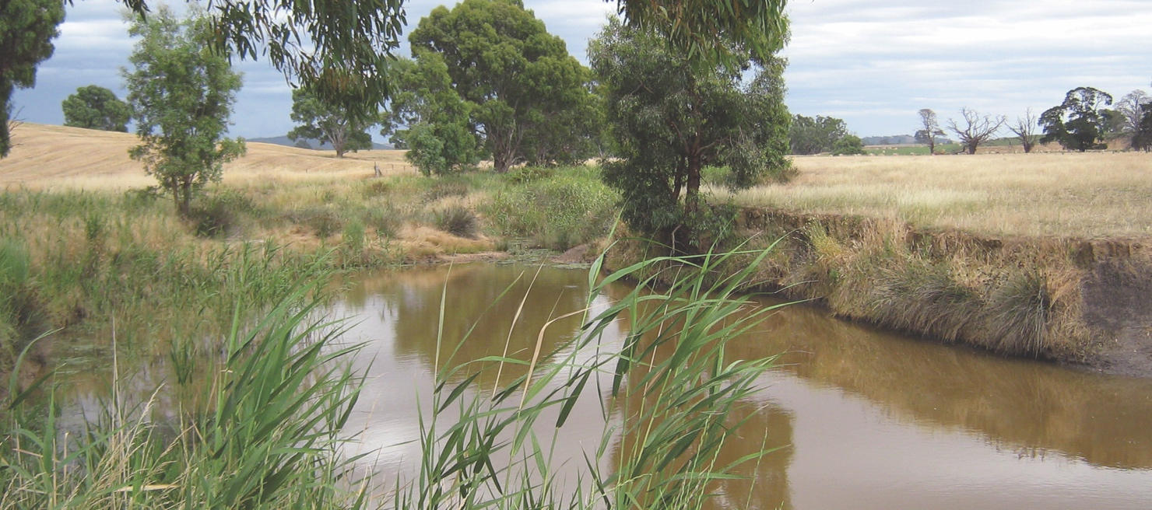
Pictured above: Cann River. Courtesy East Gippsland CMA.

Strategic planning framework for waterway management in Victoria
The Victorian Waterway Management Strategy (2013) provides the framework for government, in partnership with the community, to maintain and improve the condition of Victoria’s waterways. It establishes a clear vision and includes policies, principles and actions related to the integrated management of waterways. The Strategy is currently under review with a new Strategy proposed for release in 2023.

Water for Victoria (2016) is the government’s broader policy agenda for managing water resources. It builds on waterway management policy settings from the Victorian Waterway Management Strategy and includes the need for improved management of waterways for community needs such as recreation and places more emphasis on major urban waterways such as those in Melbourne and Geelong.

Catchment management authorities are responsible for waterway management across regional Victoria. In the Melbourne and metropolitan area and across the Port Phillip and Westernport region, the waterway management role is undertaken by Melbourne Water. Each region has a regional waterway strategy developed by CMAs and Melbourne Water in partnership with regional stakeholders, embracing community values and building priorities for waterway management and investment in each region for eight to ten years. They include a work program of management activities for priority waterways.

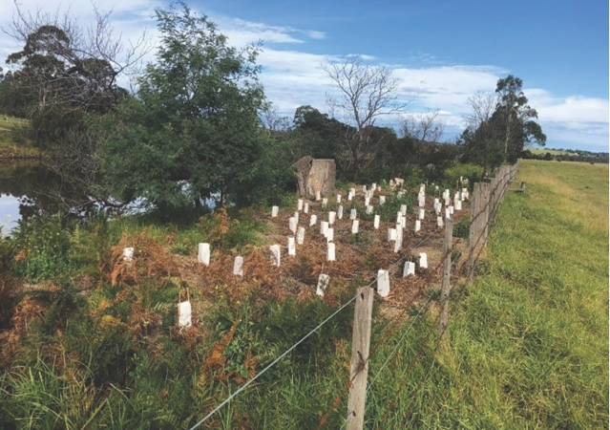
Pictured above: Revegetation on the Tambo River. Courtesy East Gippsland CMA.

The Regional Riparian Action Plan was a five-year plan running from 2015 to 2020 to accelerate on-ground riparian management works to improve the health of riparian land along Victoria’s regional rivers, estuaries and wetlands. An additional $40 million was provided by the state government for riparian works during this period. It was part of the broader $222 million initiative to improve the health of waterways and catchments across regional Victoria over that period.

The Regional Riparian Action Plan addressed priorities outlined in regional waterway strategies and was a key commitment in Water for Victoria.

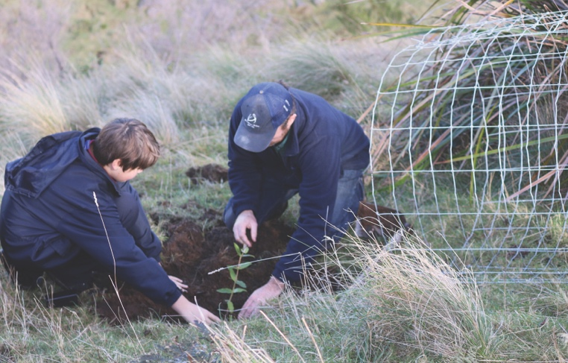
Pictured above: Planting day on the Agnes River. Courtesy West Gippsland CMA.

Traditional owners and waterway management
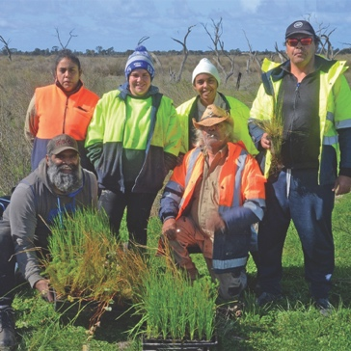
Pictured above: Barapa Barapa crew at Johnson Swamp, near Kerang. Courtesy Damien Cook.

Water has cultural importance for Traditional Owners and Aboriginal people. In particular, Traditional Owners have a strong connection to waterways as the lifeblood for Country – a sacred, living entity. The vast majority of Aboriginal places and significant sites recorded on the Victorian Aboriginal Heritage Register occur within one kilometre of a waterway or water body. These can include sites such as middens, scar trees and fish traps,as well as places with spiritual and ceremonial significance.

The Victorian Government is committed to providing opportunities for greater Aboriginal participation in waterway planning and management, consistent with its commitments to self-determination and Treaty.

This approach strengthens partnerships and creates more efficient, mutual and respectful relationships between Traditional Owners, CMAs, landholders and the broader community, with everyone contributing to improving landscapes and implementing works on Country.

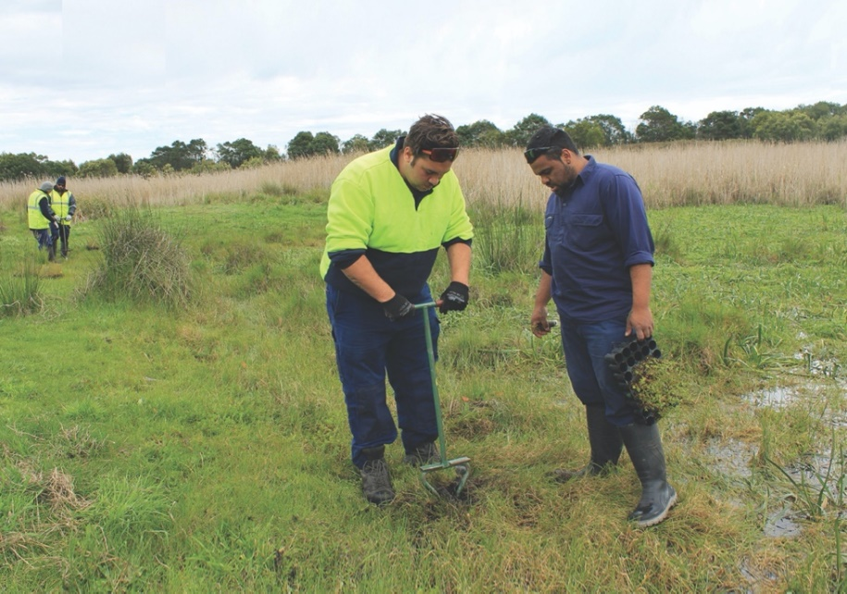
Pictured above: Budj Bim rangers at work at Tyrendarra Indigenous Protected Area, south west Victoria. Courtesy Glenelg Hopkins CMA.

Through these partnerships, the government’s waterway management programs support Traditional Owners to care for Country and engage communities in waterway projects. Traditional Owners also bring their traditional ecological knowledge and experience to improve and care for waterways and Country.

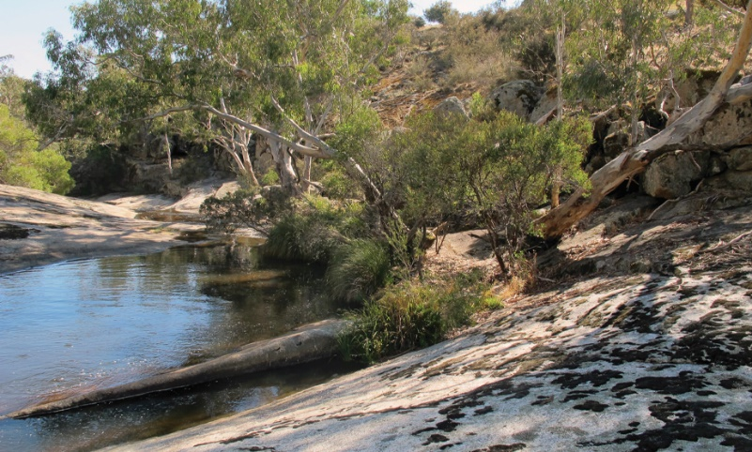
Below: Hughes Creek, a tributary of the Goulburn River. Courtesy Goulburn Broken CMA.

Key Waterway Management Initiatives
This section outlines the key initiatives in which government is investing as part of this Action Plan to maintain and improve Victoria’s waterways from 2020 to 2024. These initiatives are funded as part of the Government’s investment in:

- waterway and catchment health in the face of escalating climate change,
- supporting regional communities and economic recovery through healthy waterways,
- major environmental water works in northern Victoria,
- protecting iconic urban waterways, and
- bushfire waterway recovery.

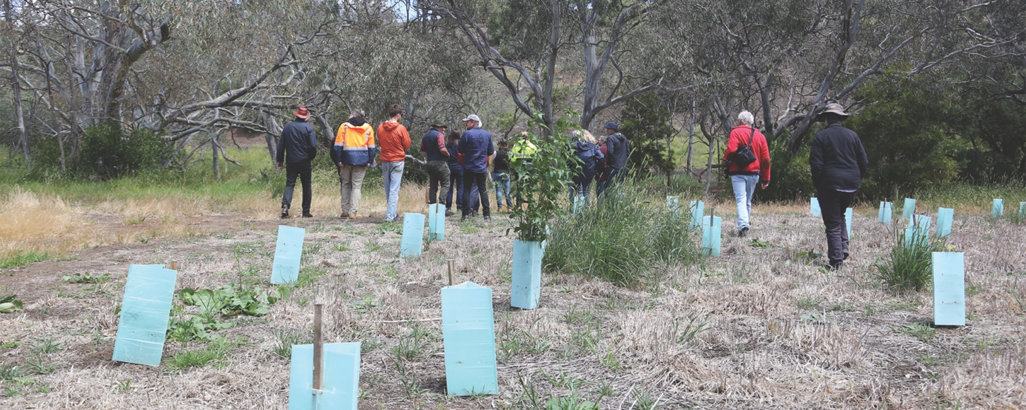
Pictured above: Revegetation on the Moorabool River. Courtesy Corangamite CMA.

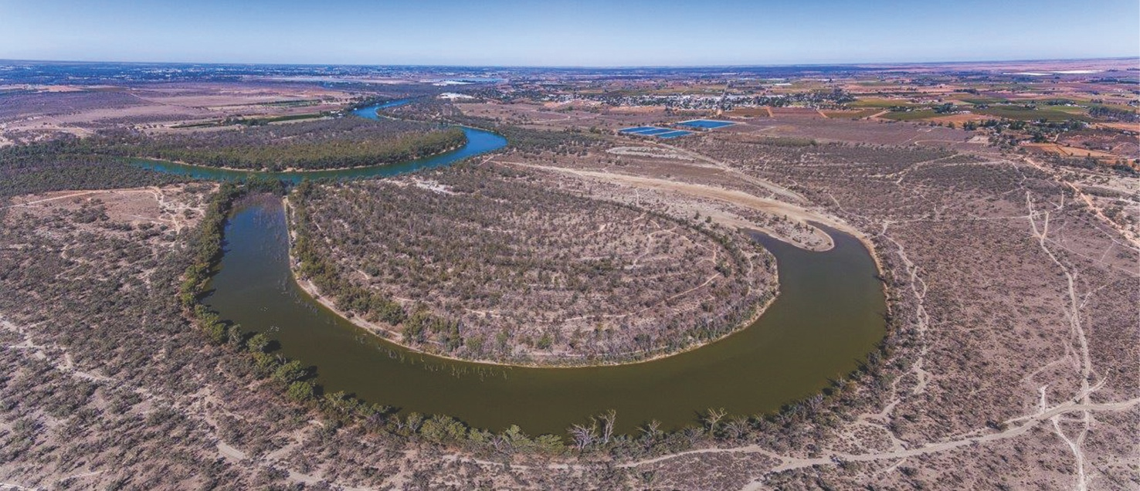
Pictured above: Catfish Billabong within Merbein Common, north west Victoria. Courtesy Mallee CMA.

INITIATIVE 1 – Flagship Waterway Projects
The government is investing in on-ground environmental works to protect and restore the rivers and landscapes that people love and use. This includes funding long-term, large scale restoration projects at 18 flagship waterways across regional Victoria. An important element of the flagship waterways approach is to better demonstrate the social and cultural benefits of investment in waterways and catchments.

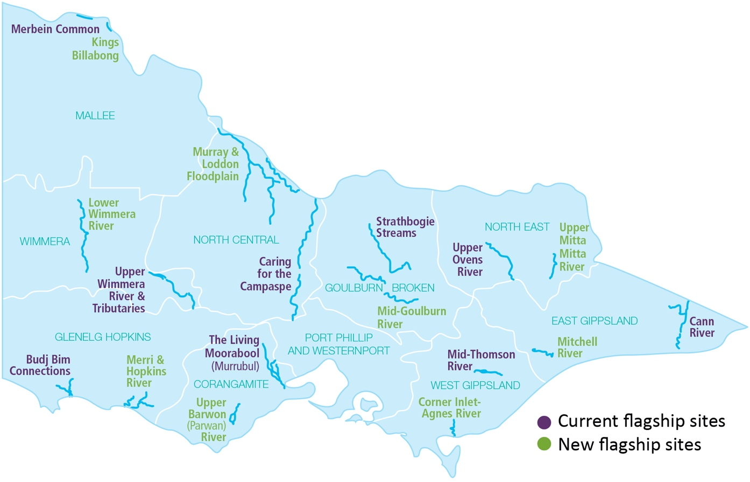

Current flagship waterway projects
The nine current flagship waterway projects are:

Corangamite CMA - The Living Moorabool (Murrubul): Improving the health of the river and connection to the community by improving riparian vegetation, water quality, and better engagement and awareness.

East Gippsland CMA - Cann River: Consolidating the intensive on-ground effort of previous years by partnering with landholders and Landcare groups to maintain and improve the riparian environment.

Goulburn Broken CMA - Strathbogie Streams: Improving stream health and riparian vegetation, raising community awareness of the endangered Macquarie perch, and improving opportunities for Traditional Owners to work on Country.

Glenelg Hopkins CMA - Budj Bim Connections: Improving native vegetation and aquatic habitats, increasing the understanding of flow pathways and wetland hydrology, and fostering the sharing and integration of Aboriginal knowledge in the Budj Bim National Heritage Landscape.

Mallee CMA - Merbein Common: Building on the success of providing water for the environment across the Merbein Common - a floodplain reserve nestled in a bend of the Murray River near Mildura with nationally significant wetlands. Current investment is focused on enhancing recreation facilities for bushwalking, cycling and canoeing.

North Central CMA - Caring for the Campaspe: Improving the health and resilience of the river through bank stabilisation and revegetation, and fostering widespread community involvement and stewardship.
North East CMA - Upper Ovens River: Improving riparian vegetation, channel and bank stability, water quality, habitat for aquatic animals and access to the river for recreation, in partnership with the local community.

Wimmera CMA - Upper Wimmera River: Improving riparian vegetation and bed and bank stability to protect downstream ecosystems and improve water quality, and raising landholder awareness of river health issues and community participation in best management practices.

West Gippsland CMA - Mid Thomson River: Increasing the number and diversity of native fish, and improving the stability of the river channel and riparian vegetation to reduce impacts from flooding, including engaging and informing communities that participate in waterway management decisions.

More information about these projects is available on the flagship waterways website.

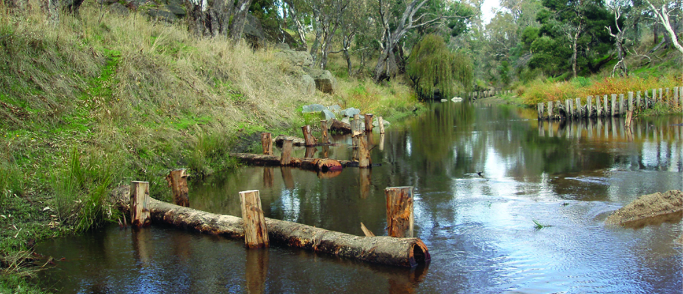
Pictured above: Woody habitat reintroduction on Seven Creeks, a tributary of the Goulburn River. Courtesy Goulburn Broken CMA.

New flagship waterway projects
Nine new flagship waterway projects commencing in 2021 will focus on improving riparian and aquatic habitats of nine additional key waterways across Victoria. The new flagship projects will emphasise partnerships with Traditional Owners and community engagement.

Continued investment in flagship waterways directly supports regional tourism through increased opportunities for recreational activity on waterways, including boating and fishing, and helps to maintain critical government service delivery and expertise in regional hubs to drive faster recovery of local economies.
The new flagship waterway projects are:

Corangamite CMA - Upper Barwon (Parwan) River: Improving riparian management practices and monitoring in the Barwon River through collaborative planning and community engagement.

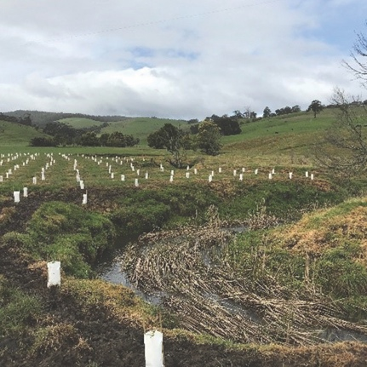
Pictured above: Revegetation on Dewing Creek, a tributary of the Upper Barwon. Courtesy Corangamite CMA.

East Gippsland CMA - Mitchell River: Replacing a willow-dominated river with a continuous corridor of native vegetation and improving community access and flood resilience.

Goulburn Broken CMA - Mid-Goulburn River: Developing a plan to manage competing needs in the waterway, with implementation of key activities such as riparian and instream works.

Glenelg Hopkins CMA - Merri & Hopkins rivers: Addressing threats and challenges associated with agriculture and an increasing population in Warrnambool, involving riparian works, citizen science and community engagement.

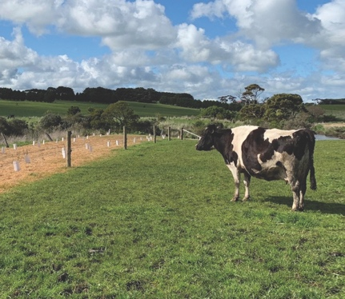
Pictured left: Fencing and revegetation on the Merri River. Courtesy Glenelg Hopkins CMA.

Mallee CMA - Kings Billabong: Involving on-ground management activities, protection of cultural sites and community engagement.

North Central CMA - Murray & Loddon floodplain: Improving waterway health to support recovery of threatened fish species.

North East CMA - Upper Mitta Mitta River: Addressing priority threats and enhancing access to key recreational areas through on-ground works and citizen science monitoring.

Wimmera CMA - Lower Wimmera River: Mitigating erosion, enhancing riparian vegetation and improving water quality through revegetation and bank stabilisation.

West Gippsland CMA - Corner Inlet and tributaries: Improving riparian connectivity along the Agnes River and addressing water quality risks to beneficial uses of the Corner Inlet Ramsar site and its inflowing tributaries.

In addition to these flagship projects, CMAs will undertake critical on ground waterway and riparian management activities, such as fencing, revegetation with native species and removing weeds, along other priority waterways as described in regional waterway strategies.

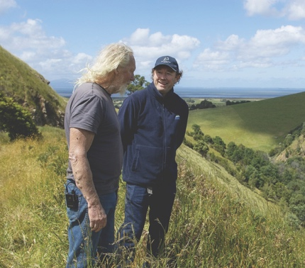
Pictured left: Landholder talking to CMA staff member on the Agnes River. Courtesy West Gippsland CMA.

INITIATIVE 2 – Gippsland Lakes
The Gippsland Lakes are a highly valued area for Traditional Owners, the environment, the local community and the economy. The Lakes include the Gippsland Lakes Ramsar site, and important land and waters for the Gunaikurnai people.

Government investment will support a new term of the Gippsland Lakes Coordinating Committee, and funding to continue on-ground works by East and West Gippsland CMAs and the Gunaikurnai Land and Waters Aboriginal Corporation.

This will support implementation of the Gippsland Lakes Ramsar Management Plan and the Gunaikurnai Whole-of-Country Plan for Tatungalung Country.

Funding also supports the implementation of recommendations for the Gippsland Lakes Priority Plan. This priority plan aligns with monitoring required to track ecological character status and inform management decisions for the Ramsar site. The Committee will also allocate funding to specific environmental priorities for the Gippsland Lakes and focus investment on maintaining the site’s ecological character, in line with Ramsar obligations. Projects previously funded include a range of community group initiatives to restore habitat for native species by reducing sediment and nutrient loads in the Lakes, protecting native animals and improving understanding of plants and animals. These projects can be seen on the Love Our Lakes website.

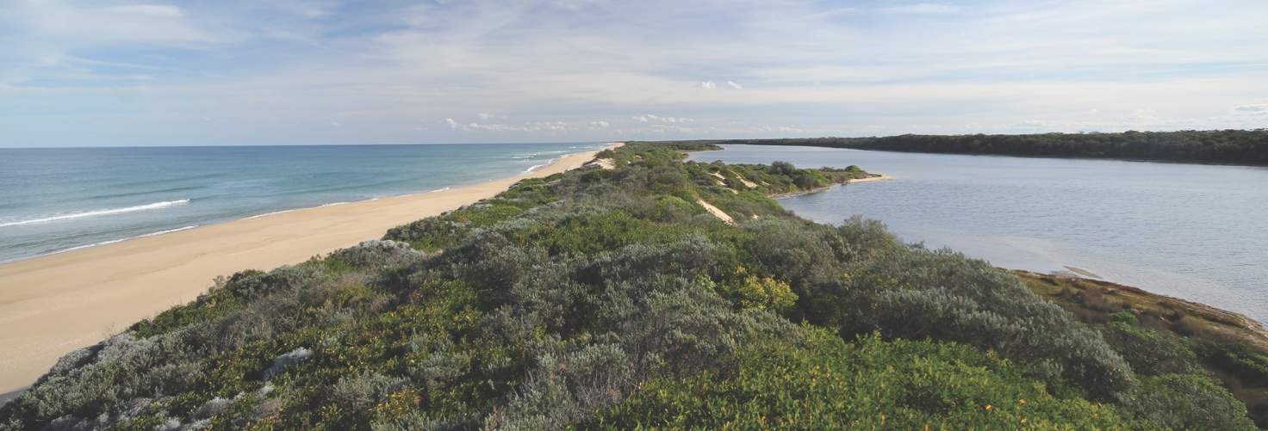
Pictured above: Gippsland Lakes Ramsar site. Courtesy East Gippsland CMA.

INITIATIVE 3 – Ramsar Wetlands
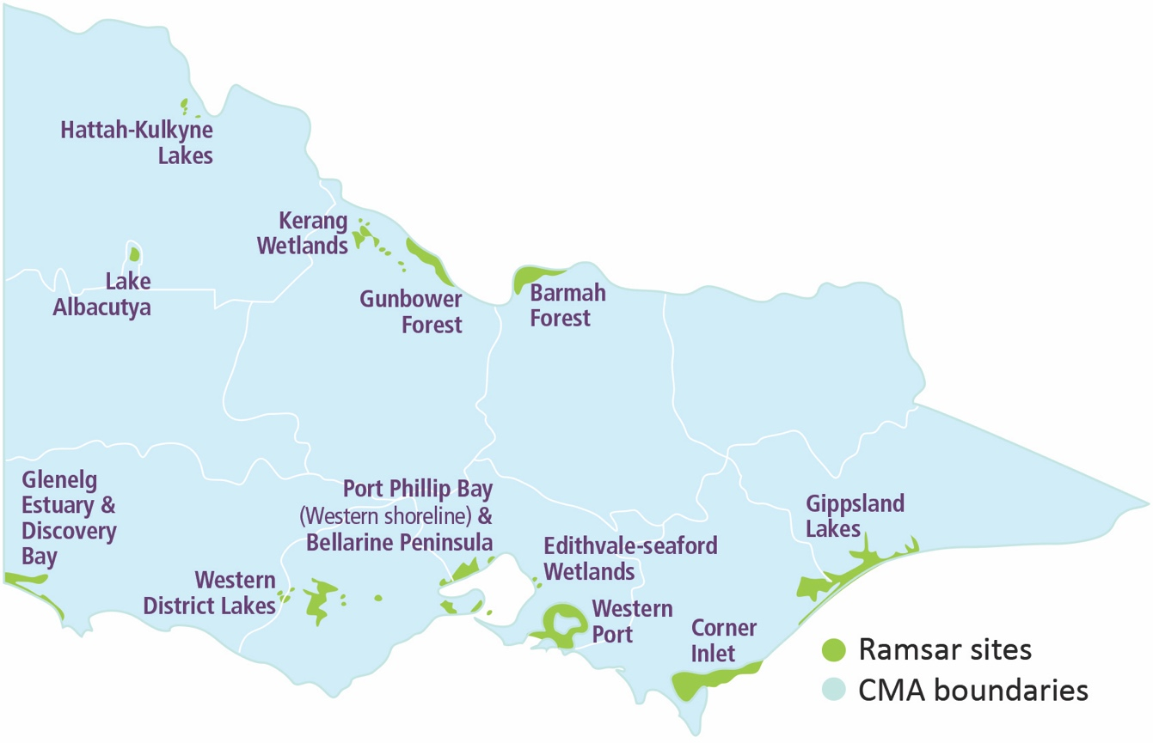

Victoria has 12 of Australia’s 66 wetlands of international significance listed under the Ramsar Convention on Wetlands. These wetlands are known as Ramsar wetlands and are recognised globally as representative, rare or unique, or are important for conserving biological diversity.
The Victorian Government has an obligation to maintain or improve the ecological character of Ramsar wetlands (at the time of their listing). Consequently, Government will fund partners including Parks Victoria, catchment management authorities, local councils and Traditional Owners to undertake management activities from Ramsar management plans such as pest plant and animal control, revegetation, and other wetland restoration activities, and monitoring to track ecological character.

More information about wetland management in Victoria can be found at Wetlands (water.vic.gov.au)

The map above shows the location of Victoria’s Ramsar sites.

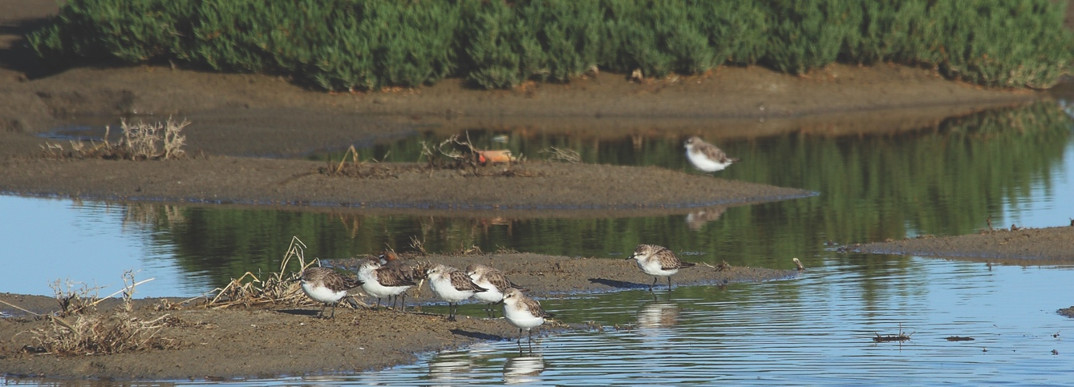
Pictured above: Cullen Waders at Kerang Wetlands. Courtesy North Central CMA.

INITIATIVE 4 – Major environmental water works in northern Victoria
The Victorian government will fund construction projects to support native fish and high value wetlands in collaboration with four CMAs:

- Construction of a fishway on Bright Weir on the Ovens River to allow fish to move upstream to access the headwaters of the river and 120 kilometres of tributaries (North East CMA).
- Construction of a rock-ramp style fishway at Tea Garden Creek on the Ovens River near Wangaratta to allow fish access to over 270 kilometres of additional important riverine and refuge habitat along the Ovens and major tributaries (North East CMA).
- Infrastructure works to improve fish passage in the Gunbower and lower Loddon systems linking over 500 kilometres of the Murray River to the lower Loddon River and Gunbower Creek, and high-quality nursery habitat in Ghow (Kow) Swamp, and preventing the loss of fish into irrigation channels (North Central CMA).
- Construction of a regulator on Kynmer Creek in the Barmah National Park to restore a more natural hydrological regime to the creek. The regulator will allow lower flows from the Murray River into the Barmah Forest, a Ramsar-listed wetland and Living Murray icon site (Goulburn Broken CMA).
- Construction of an environmental regulator at Catfish Billabong near Mildura to restore a more natural wetting and drying regime, which will improve water quality and the health of aquatic and fringing vegetation (Mallee CMA).
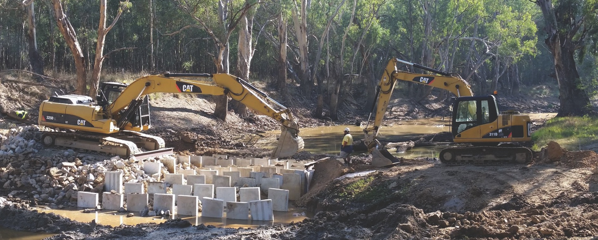
Pictured above: Frosts crossing on the Ovens River under construction. Courtesy North East CMA.

INITIATIVE 5 – Iconic Urban Waterways
Government investment into the iconic urban waterways program will continue to improve the way we manage the Yarra River (Birrarung), the Rivers of the Barwon (Barre Warre Yaluk), the Maribyrnong (Mirrangbamurn) and Werribee rivers (Wirribi Yaluk), and other urban waterways and their parklands in the west of Melbourne.

This program will:
- launch the first Yarra Strategic Plan, and the Rivers of the Barwon (Barre Warre Yaluk) and the Waterways of the West action plans by late 2021,
- implement the Yarra Strategic Plan, the Rivers of the Barwon (Barre Warre Yaluk) and the Waterways of the West action plans including immediate actions to provide benefit for these waterways,
- support the Birrarung Council as an independent voice for the Yarra River, and
- enable Traditional Owner self-determined participation in urban waterway planning and management.

The program is leading a new approach in how we look after urban waterways in a holistic and integrated way that embeds Traditional Owner values, knowledge and culture in decision-making. The plans will emphasise the importance of liveable cities, of protecting waterways and of enhancing their associated parklands. They will include broader issues such as landscape amenity, and land use planning and development controls and standards that are suited to the unique features of these waterways while supporting growth and development.

Further information on these projects can be found at the Waterways of the West Action Plan, Yarra Strategic Plan and Barwon River Action Plan websites.

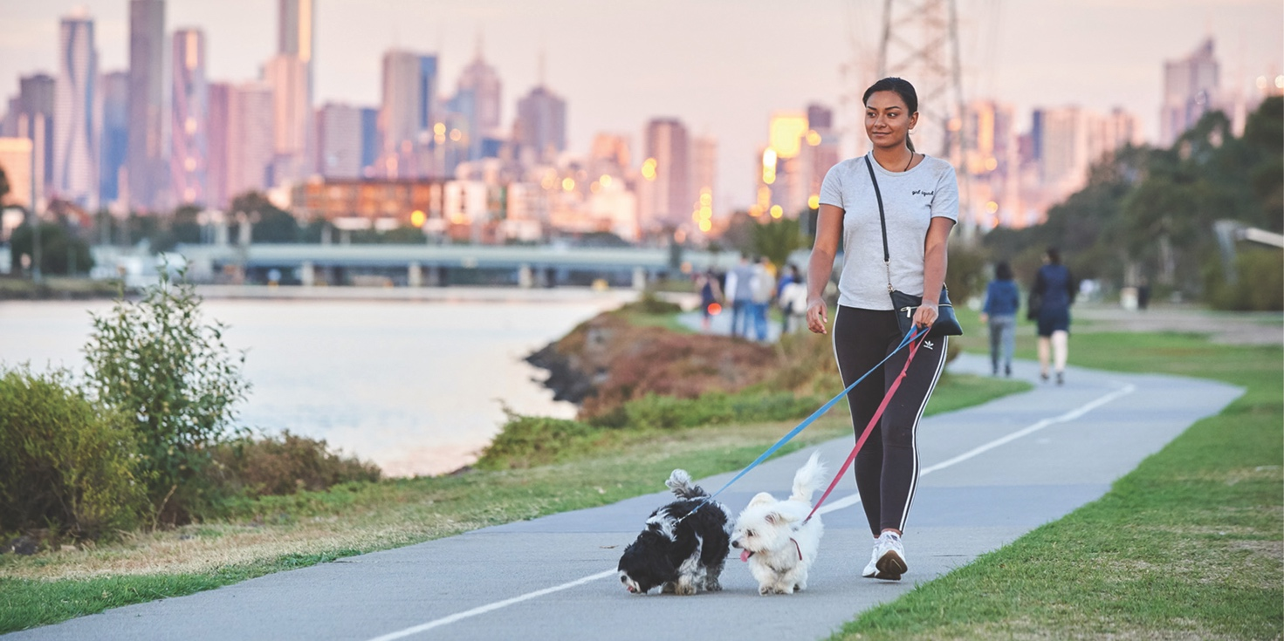
Pictured above: Footscray Park on the Maribyrnong River.

INITIATIVE 6 – Bushfire Recovery
The Black Summer bushfires in 2019-2020 extensively damaged and destroyed waterway assets in Gippsland and North East Victoria, especially riparian fencing and erosion control structures. The communities in these areas depend on waterways for business, agriculture, tourism and recreational use.

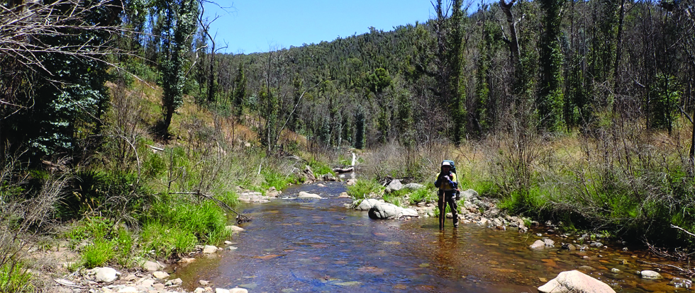
Pictured top: Weed control being undertaken in the Buchan catchment as part of bushfire recovery. Courtesy East Gippsland CMA.

Government’s bushfire recovery funding to East Gippsland CMA and North East CMA will enable restoration of waterway and catchment assets. These include repairing riparian fencing and off-stream watering systems, controlling weeds and tackling priority risks from erosion, debris and degraded water quality; facilitating community engagement events that will provide genuine opportunities for communities to get involved; and to undertake strategic coordination, design and planning of the community recovery program in collaboration with local contractors, Traditional Owners and Landcare groups.

Further information can be found on the East Gippsland and North East CMAs’ bushfire recovery webpages.

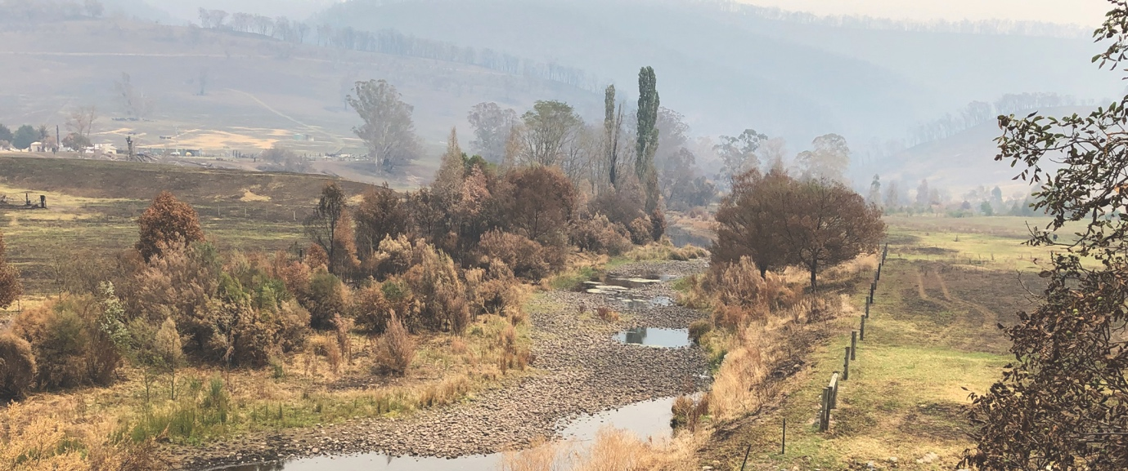
Pictured above: Buchan River after the Black Summer bushfires of 2019-2020. Courtesy East Gippsland CMA.

INITIATIVE 7 – Water for the environment
Water for the environment is water that maintains the health of rivers, estuaries and wetlands. It is critical to protect the plants, animals and overall health of rivers, wetlands, floodplains and estuaries. For example, environmental water stimulates native fish to breed; triggers and promotes riparian plant seeding, germination and growth; flushes out salt; moves organic matter onto the floodplain and allows fish to move freely in the river. It can also provide social, cultural and economic benefits such as opportunities for boating and canoeing and improved fishing, and benefits for the regional economies which rely on these recreational activities.

In Victoria more than 650 gigalitres of water (just over 400 times the volume of the MCG; long-term annual average) for the environment is set aside in storages like reservoirs and dams as formal environmental water entitlements. The Victorian Environmental Water Holder (VEWH) is the independent statutory body responsible for holding and managing Victoria’s environmental water entitlements. Managing water for the environment in Victoria is a partnership between DELWP, the VEWH, CMAs, Melbourne Water, land managers, Traditional Owners and interstate agencies including the Commonwealth Environmental Water Holder and the Murray Darling Basin Authority.

More information about environmental water can be found on the Environmental Water and Victorian Environmental Water Holder websites.
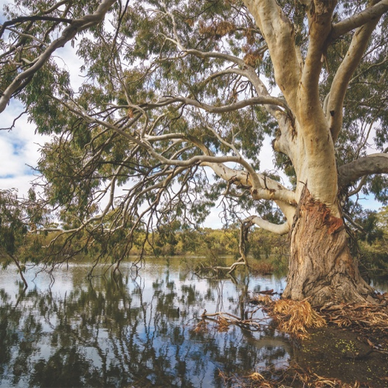
Pictured above: Environmental watering of Ned’s Corner on the Murray River, far north west Victoria. Courtesy Mallee CMA.

INITIATIVE 8 – Catchment management authority water statutory functions
The statutory functions of CMAs are crucial to protect and maintain the health of our waterways. Activities include providing statutory advice to protect waterways from inappropriate works and developments, and processing permits and licences to support the community and industry when building or working on floodplains and waterways.

Under these obligations, CMAs provide direct support to local government as planning referral authorities, as well as direct customer service to the general public by processing around 5,000 waterway permits, licences and planning advice/approval actions per annum. This reduces the Victorian public’s financial exposure to flooding by hundreds of millions of dollars each year, by ensuring that planning applications consider local flood level and stormwater data. It also protects waterway health by preventing inappropriate works and activities on waterways.

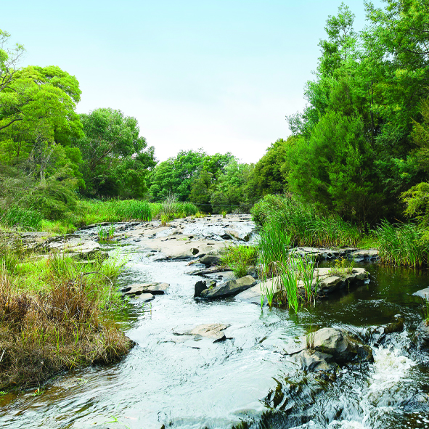
Pictured above: Franklin River after riparian works. Courtesy West Gippsland CMA.

INITIATIVE 9 – Citizen Science
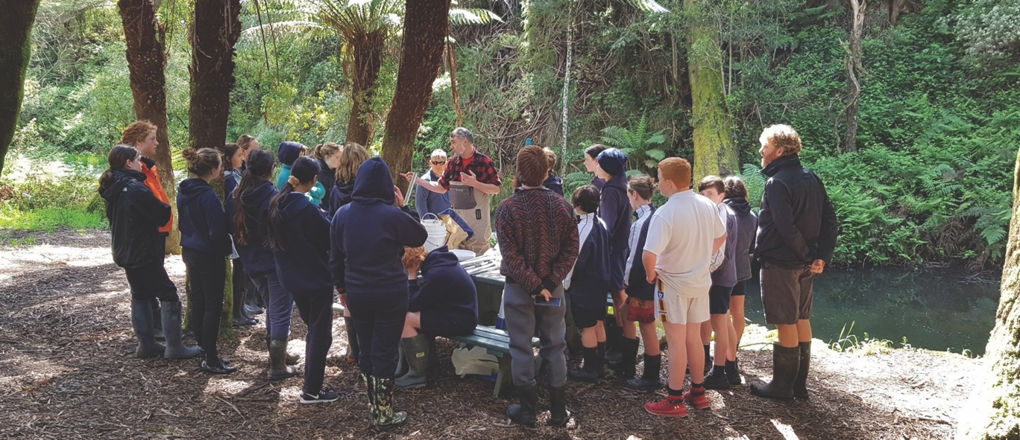
Pictured above: Primary school students participating in the National Waterbug Blitz at Apollo Bay. Courtesy Corangamite CMA.

Citizen science will continue to be a key element for supporting waterway health across the state. Improving waterway and catchment health requires community support, particularly in the face of climate change. The government is supporting community partnerships such as Waterwatch, EstuaryWatch, and other citizen science initiatives to address local waterway priorities. These programs are used to inform waterway management decisions while strengthening community engagement and participation in waterways. They achieve environmental outcomes and significant social and economic benefits for individuals and communities.

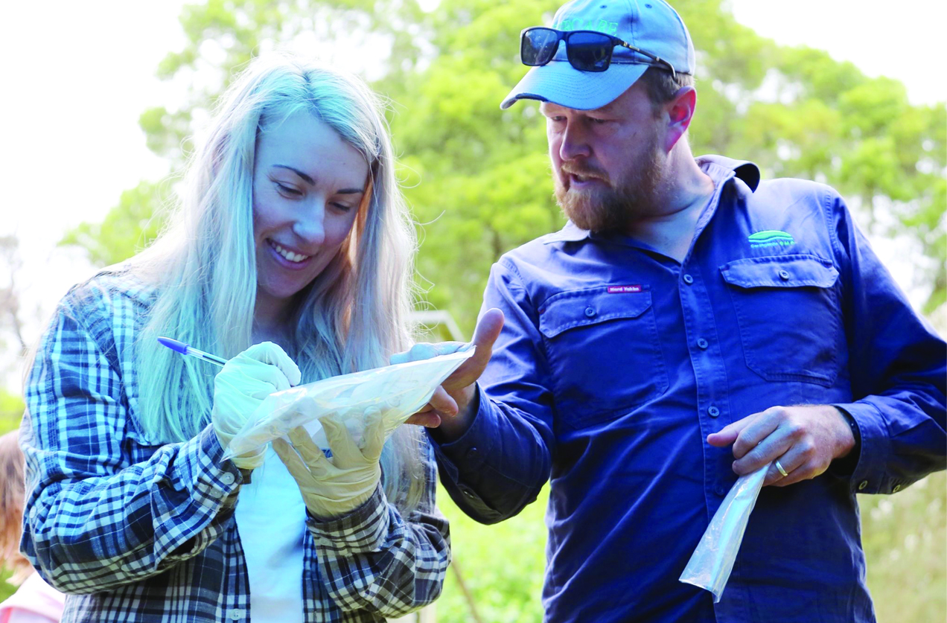
Above: Citizen Scientist working with the Corangamite CMA on the Curdies Perch Search Project. Courtesy Corangamite CMA.

Monitoring and Reporting
Accountability for the initiatives outlined in the Action Plan is provided under a governance framework which utilises Key Performance Indictors (KPIs) aligned to Water for Victoria, including performance measures that are publicly reported in the government’s annual Budget Papers. An evaluation plan is also created and followed for each initiative, and achievements against each plan are reported annually on the government’s water.vic.gov.au website and in the Department of Environment, Land, Water and Planning’s annual reports.

Furthermore, the many initiatives that are part of the Action Plan will continue to invest in a range of programs aimed at evaluating and reporting back to communities on the benefits of waterway management and the outcomes achieved by the initiatives. This includes:
- evaluating the effectiveness of key management efforts such as fencing and replanting of riparian areas and wetlands as well as the delivery of environmental water to rivers and wetlands,
- monitoring the management of Victoria’s Ramsar sites which tracks and reports on the status of priority critical components, processes and services,
- underpinning the 18 flagship waterways projects with MERI plans which track progress towards objectives and regularly report back to government and communities, and
- broad surveillance monitoring programs to gather information on the status of key waterway values and assets, such as the Native Fish Report Card and Statewide Wetland Condition Report.

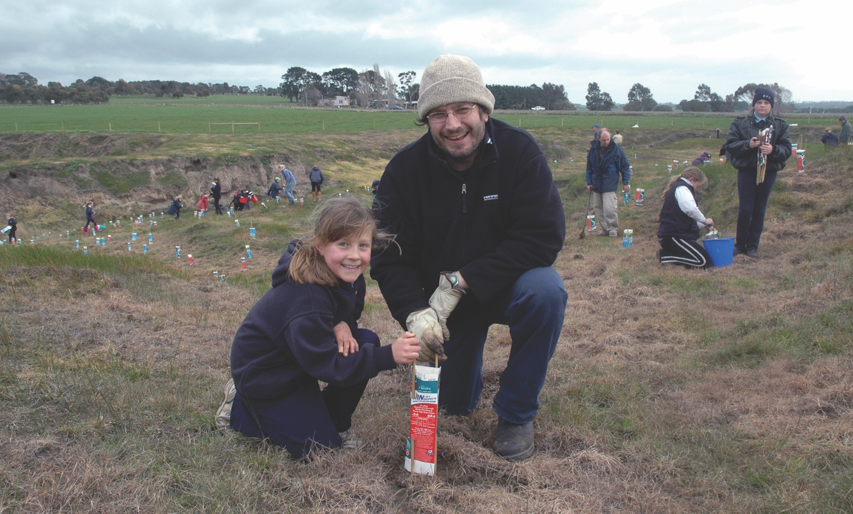
Pictured above: Primary school students planting trees on Deans Creek, Lake Colac catchment. Courtesy Corangamite CMA.

© The State of Victoria Department of Environment, Land, Water and Planning 2021

This work is licensed under a Creative Commons Attribution 4.0 International licence. You are free to re-use the work under that licence, on the condition that you credit the State of Victoria as author. The licence does not apply to any images, photographs or branding, including the Victorian Coat of Arms, the Victorian Government logo and the Department of Environment, Land, Water and Planning (DELWP) logo. To view a copy of this licence, visit http://creativecommons.org/licenses/by/4.0/

Disclaimer
This publication may be of assistance to you but the State of Victoria and its employees do not guarantee that the publication is without flaw of any kind or is wholly appropriate for your particular purposes and therefore disclaims all liability for any error, loss or other consequence which may arise from you relying on any information in this publication.

ISBN 978-1-76105-576-8 (pdf/online/MS word)

For further information visit water.vic.gov.au

Accessibility
If you would like to receive this publication in an alternative format, please telephone the DELWP Customer Service Centre on 136186, email customer.service@delwp.vic.gov.au, or via the National Relay Service on 133 677 or relayservice.com.au.

This document is also available on the internet at www.delwp.vic.gov.au.

