Guidelines for assessing the impact of climate change on water availability in Victoria
  - 2025

Acknowledgements
DEECA acknowledges the contributions of a range of researchers and water sector participants, including:
- Water sector representatives who participated in the workshops that informed the development of the guidelines and provided valuable feedback on the draft version.
- Climate and hydrology researchers from the Bureau of Meteorology, Monash University and the University of Melbourne, who contributed a range of background material for the guidelines.
- Researchers from CSIRO, particularly Anjana Devanand and Zaved Khan, for developing the hydroclimate projections.
- Consultants from Hydrology and Risk Consulting, Streamology, and Patrick Russell, who contributed to the drafting of the guidelines.
- Various reviewers who provided valuable comments and suggestions for different components of the guidelines, including the Water Resilience and Science Team at Hunter Water, Francis Chiew from CSIRO, Murray Peel and Keirnan Fowler from the University of Melbourne.
Any questions on these guidelines should be directed to the Hydrology, Climate and Energy team, Water Access and Planning Branch, Water Resource Division, Water and Catchments Group, Victorian Department of Energy, Environment and Climate Action. Email the team at HCS.team@deeca.vic.gov.au
Acknowledgement to Country
We acknowledge and respect Victorian Traditional Owners as the original custodians of Victoria’s land and waters, their unique ability to care for Country and deep spiritual connection to it.
We honour Elders past and present whose knowledge and wisdom
has ensured the continuation of culture and traditional practices.
DEECA is committed to genuinely partnering with Victorian Traditional Owners and Victoria’s Aboriginal community to progress their aspirations.
Copyright notice
© The State of Victoria Department of Energy, Environment and Climate Action, 2025.
Creative Commons
This work is licensed under a Creative Commons Attribution 4.0 International licence; visit the Creative Commons website (http://creativecommons.org/licenses/by/4.0/).
You are free to reuse the work under that licence, on the condition that you credit the State of Victoria as author. The licence does not apply to any images, photographs or branding, including the Victorian Coat of Arms, and the Victorian Government and Department logos.
ISBN 978-1-76176-665-7 (pdf/word/online)
Disclaimer
This publication may be of assistance to you but the State of Victoria and its employees do not guarantee that the publication is without flaw of any kind or is wholly appropriate for your particular purposes and therefore disclaims all liability for any error, loss or other consequence which may arise from you relying on any information in this publication.
Accessibility
To receive this document in an alternative format, phone the Customer Service Centre on 136 186, email customer.service@delwp.vic.gov.au or contact National Relay Service on 133 677. An accessible version is available at Water availability climate change guidelines (https://www.water.vic.gov.au/our-programs/climate-change-and-victorias-water-sector/climate-change-water-resources/water-availability-climate-change-guidelines)

Summary
Victoria’s water resources under a changing climate
Water is critical to our economy, environment and communities. A healthy environment with safe, affordable, and reliable water supplies is essential for the wellbeing and livelihood of Victorians.
Climate change is already affecting Victoria’s water availability. Victoria’s climate has become warmer and drier in the last few decades, resulting in reduced water availability for communities, industries, and cultural and environmental uses.
On average, Victoria has experienced unusually dry conditions since the start of the 21st century, which may signal a shift in the state’s rainfall patterns. Rainfall declines have been observed during the cooler period of the year, with a more rapid decline in recent decades. At the same time, the frequency of high-intensity rainfall events has increased.
During the Millennium Drought from 1997 to 2009, the runoff reductions observed in many Victorian catchments were much larger than was expected for the reduction in rainfall. Despite some recent wet years, this drought-like, low runoff state persists in about one-third of the assessed catchments, particularly in central and western Victoria. In these catchments, less annual runoff continues to be generated from a given amount of annual rainfall compared to the period prior to the Millenium Drought.
Climate change projections developed by CSIRO for Victoria are presented in these guidelines and show that changes in climate and runoff are likely to continue into the future. For example, an increase of 1.5°C in the average global temperature relative to the year 2000, projected to occur between 2050 and 2065, means Victoria is expected to experience:
- A decrease in the cool-season rainfall (May to October), which has been projected by the majority of global climate models, with a median projected decrease of 4.6%.
- An increase in average annual potential evapotranspiration of 4.4% (median projection), with a plausible range of increase from 3.7% to 5.6%.
- A decrease in average annual runoff of 15% (median projection), with a plausible range decrease from 4% to 26%.
Finer scale projections are also available for each river basin in Victoria.
Assessing climate change impacts on Victoria’s water resources
As our climate continues to change and extreme weather events increase, there is a greater need to understand how this impacts water availability so this knowledge can be incorporated into water planning and management decisions.
These guidelines provide advice for how the impacts of climate change on water resources across Victoria can be assessed in a consistent way, using robust approaches informed by the latest science. The guidelines provide pragmatic approaches that can be readily applied by practitioners, in a way that suits the water assessment tools, processes and decision-making frameworks across Victoria.
The guidelines support the technical assessment of climate change impacts on water availability and provide the flexibility to tailor the approach, including the level of effort to the context and objective of the particular application.
Scope of the guidelines
These guidelines have been developed by the Victorian Department of Energy, Environment, and Climate Action to support climate change assessments of water availability across Victoria.
The guidelines support planning, impact and risk assessment, policy development and decision making by providing a clear framework that applies the latest science and techniques for undertaking assessments of water availability, including surface water and groundwater. The primary audience for these guidelines is Victoria’s water corporations, catchment management authorities, storage managers and water policy makers.
Assessing the impact of climate change on water availability as described in these guidelines may also be of interest to other stakeholders, such as Traditional Owners, the agricultural sector, water-dependent industries, local government, research bodies, or groups which manage water resources.
The guidelines can be used to assess climate change impact on water availability for various planning horizons: near, medium and long term.
The guidelines directly support water corporations discharging their responsibilities under the Statement of Obligations (General) to ‘comply with any guidelines for forecasting the impact of climate change on water supplies’ issued by the Victorian Minister for Water. The guidelines can also be applied to assessments of future water availability for integrated water cycle management, environmental water assessments and other purposes.
What is in the guidelines?
The guidelines provide information on what to consider prior to undertaking an assessment of climate change impact, technical guidance on how to perform the assessment, and how to interpret and communicate assessment results.
A summary of the guidelines is shown in the figure below.
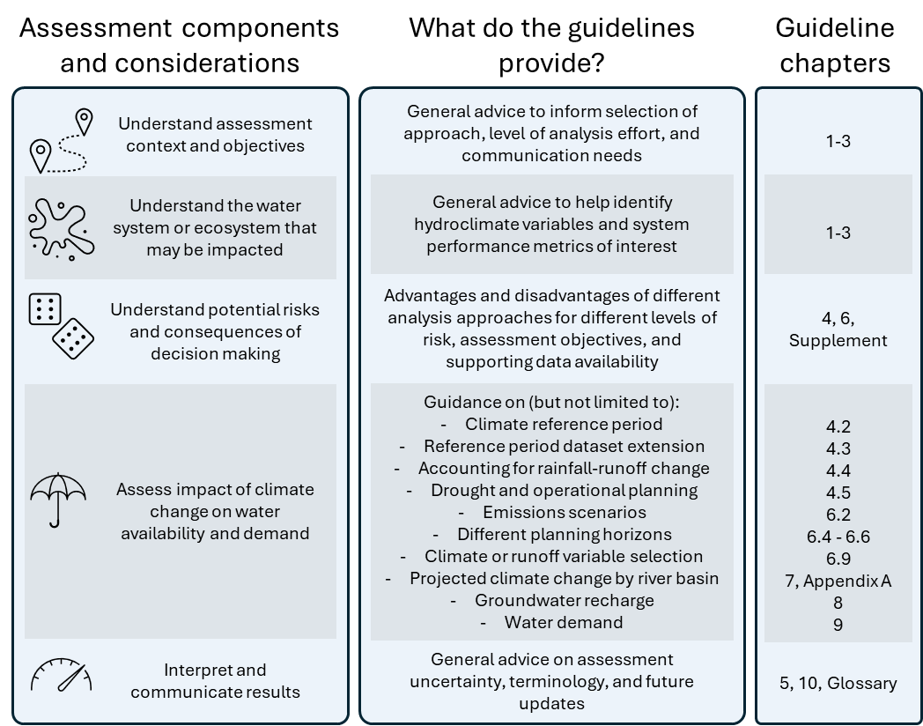

Key improvements in this update
Developed in consultation with water sector stakeholders and hydrology and climate researchers, this most recent update to the guidelines builds upon the previous 2020 edition. Key changes from the previous 2020 version of the guidelines include:
- A new approach for assessing and representing the step-change in hydrologic response seen in parts of Victoria during and after the Millennium Drought. This includes a method to detect whether a persistent shift in rainfall‒runoff response has occurred in a catchment, and how to represent this change when projecting future water availability. This is a significant advance on the approach used for many years in Victoria, which had used a simpler scenario based on a one-off step change in climate from 1997.
- Updated CSIRO climate change projections for water availability, based on models from the Intergovernmental Panel on Climate Change’s most recent Coupled Model Intercomparison Project 6. The method used by the CSIRO to generate the updated projections produces a narrower range of future rainfall and runoff projections that provides a cleaner climate change signal with less noise. The updated projections have a generally similar “medium impact” rainfall and runoff projection when compared to the previous projections, but the “high impact” projection is typically less dry, and the “low impact” projection is typically less wet.
- Projections now extended to 2085, can be applied to any year over a planning horizon up to 2085, and include seasonality. Warm season (November to April) and cool season (May to October) projections are available for rainfall and runoff. Projected changes can be obtained for two emissions scenarios for different years, or relative to projected global warming levels.
- Improvements to usability. Clearer advice is provided to help practitioners navigate the different assessment approaches, which supports users in tailoring assessments to their specific context and objective.
The 2025 update to the guidelines is part of a continuous cycle of refining guidance and approaches in response to changes including more data, advances in analysis methods and tools, advances in the science, and evolving user needs. These changes are generally incremental, so the guidelines and projections do not invalidate earlier assessments or necessarily require past analysis to be redone.

Table of Contents

1. Introduction 1
2. How to assess climate change impact 4
3. Observed climate change to date 9
4. Preparing a hydroclimate dataset 12
5. How the future climate projections were developed 31
6. Applying climate change projections 36
7. Projections by river basin 51
8. Changes to water availability – groundwater recharge 60
9. Changes to water demands 64
10. Assessment uncertainty 68
11. Future updates 70
Glossary 71
References 75
Appendices 83
Appendix A. Victorian climate change projections for water availability applications 84
Appendix B. Additional information and guidance 122

Introduction
At a glance
- Victoria’s climate has changed and continues to change – with a likely drier climate future for Victoria, affecting water availability for communities, industries and the environment.
- These guidelines support the assessment of water availability under a changing climate, now and into the future.
Climate change is already affecting Victoria’s water availability. Victoria’s climate has become warmer and drier, with reduced water availability for communities, industries, and cultural and environmental uses. As the climate continues to change and extreme weather events increase, there is a greater need to understand how this will impact water availability for water planning and management.
The Victorian Department of Energy, Environment and Climate Action (DEECA) is committed to ensuring that Victoria is well placed to provide reliable and secure water sources now and into the future. These Guidelines for Assessing the Impact of Climate Change on Water Availability in Victoria (the guidelines) are a key tool developed by the department to help achieve that goal. Since 2016 the guidelines have supported the Victorian water sector when undertaking assessments of current and future water availability.
The guidelines offer a consistent framework to assess climate change impact on water availability across shared water resources and a range of applications, including water security planning, environmental water management, integrated water cycle management, and to inform water resource policy and decision making.
The guidelines have been developed by incorporating the latest scientific research and in consultation with water sector stakeholders. This has resulted in practical and scientifically robust guidance, which helps navigate an area of complex science. The guidelines continue to support a contemporary understanding of how climate change impacts may manifest in water systems. Outcomes from the latest Victorian Water and Climate Initiative (VicWaCI) research program (DEECA, 2025a) found Victoria’s climate is continuing to warm, with changes to when and how much rain is falling across seasons and years. More key findings on observed changes are presented in chapter 3.
New hydroclimate projections have been developed for these updated guidelines, which include the following features:
- Developed for water availability assessment from the 6th phase of Coupled Model Intercomparison Project (CMIP6) global climate models. The shared socio-economic pathways (SSP) that describe emissions trajectories used in the CMIP6 models have also been adopted.
- Better estimates of climate change impact on climate variables and runoff (i.e. better representation of climate change signal and reducing random variability) – resulting in a narrower range of project water availability outcomes. This includes generally similar “medium impact” rainfall and runoff projections, but the “high impact” projection is typically less dry, and the “low impact” projection is typically less wet.
- Extend out to the year 2085, with a method to determine projection factors for intermediate years.
- As well as annual projections, the guidance now also differentiates between projected behaviour in different seasons with cool (May-Oct) and warm (Nov-May) seasonal projections.
The breadth of climate change impact assessments continues to grow, and there is no single approach for all applications. The guidance offers flexibility to apply different assessment methodologies that are tailored to the specific context - expanding the potential use of the Guidance for a broad range of applications.
Additional information on a range of climate assessment methods and approaches to support adaptive planning has been provided in the Guidelines for Assessing the Impact of Climate Change on Water Availability in Victoria – Supplementary Materials.
Future water availability will depend on the greenhouse gas emissions trajectory influencing global warming and the physical responses (such as changes to rainfall) to that projected warming in climate models. There is a range of possible climate futures, including those that are similar to recent decades, drier or much drier than has been observed in the instrumental records over the last 130 years. This uncertainty requires adaptive planning based on the careful consideration of water system or ecosystem risks and vulnerabilities. The guidelines support this by providing robust approaches for planning over different time horizons (near term to long term) and guidance on how to interpret and communicate assessment results.
Finally, the 2025 update to the guidelines is part of a continuous cycle of refining guidance and approaches in response to changes including more data, advances in analysis methods and tools, advances in the science, and evolving user needs. These changes are generally incremental, and they do not invalidate earlier assessments or necessarily require past analysis to be redone.

Who are these guidelines for?
These guidelines have been developed to support planning, impact and risk assessment, policy development and decision making. They do so by providing a clear framework that applies the latest science and techniques for undertaking assessments of water availability, including surface water and groundwater. The primary audience for these guidelines is Victoria’s water corporations, catchment management authorities, storage managers and water policy makers.
Assessing the impacts of climate change on water availability as described in these guidelines may also be of interest to other stakeholders, such as Traditional Owners, the agricultural sector, water-dependent industries, Local Government, research bodies, or groups which manage water resources.
The guidelines directly support water corporations to discharge their responsibilities under the Statement of Obligations (General) that requires them to ‘comply with any guidelines for forecasting the impact of climate change on water supplies’ issued by DEECA (Minister for Environment, Climate Change and Water, 2015).
The guidelines complement and support a range of other programs of work including:
- Complementing the Guidelines for the development of Urban Water Strategies & Drought Preparedness Plans (DEECA, 2025b) and Guidelines for the Adaptive Management of Wastewater Systems Under Climate Change in Victoria (DELWP, 2022b).
- Informing the Victorian Waterway Management Strategy and Regional Waterway Strategies through the use of the methods and concepts described in the guidelines.
- Supporting integrated water cycle management feasibility and design applications.
- Helping to better understand the impact of climate change on water quality and associated risk assessments, as there is often a relationship between water quality and availability.
- As a resource, supporting implementation of Water is Life (DELWP, 2022a), Victoria’s roadmap to Traditional Owner access to water, including Outcomes 2 and 3.
- Supporting consideration of existing and projected water availability here the Minister for Water or the delegated authority is required to make a determination under section 40 of the Water Act.

Climate change impact assessment to inform decision making and risk assessment
Assessing the impact of climate change on water availability can be part of a broader risk assessment or decision-making process (Figure 1), such as water security planning, statutory decision-making processes when considering water access applications under the Water Act 1989, water resource or waterway policy development.
Risks in these assessments may originate from climatic and non-climatic factors. Furthermore, the requirements to undertake climate risk assessment and reporting have increased to ensure that risks are mitigated and adaptation strategies are in place. For example, Victorian government entities are required to report their potential exposure and planned responses to climate-related risks (Financial Reporting Direction 24). The Public Administration Act 2004 (Vic) requires directors to consider climate-related risks as part of their duty of care, diligence and skill.
The guidelines support the technical assessment of water availability under climate change, which can be tailored to different contexts and inform different types of risk analyses. Guidance is also provided to interpret and communicate results, including uncertainties, so that they can be considered appropriately in the broader risk assessment and decision-making process.
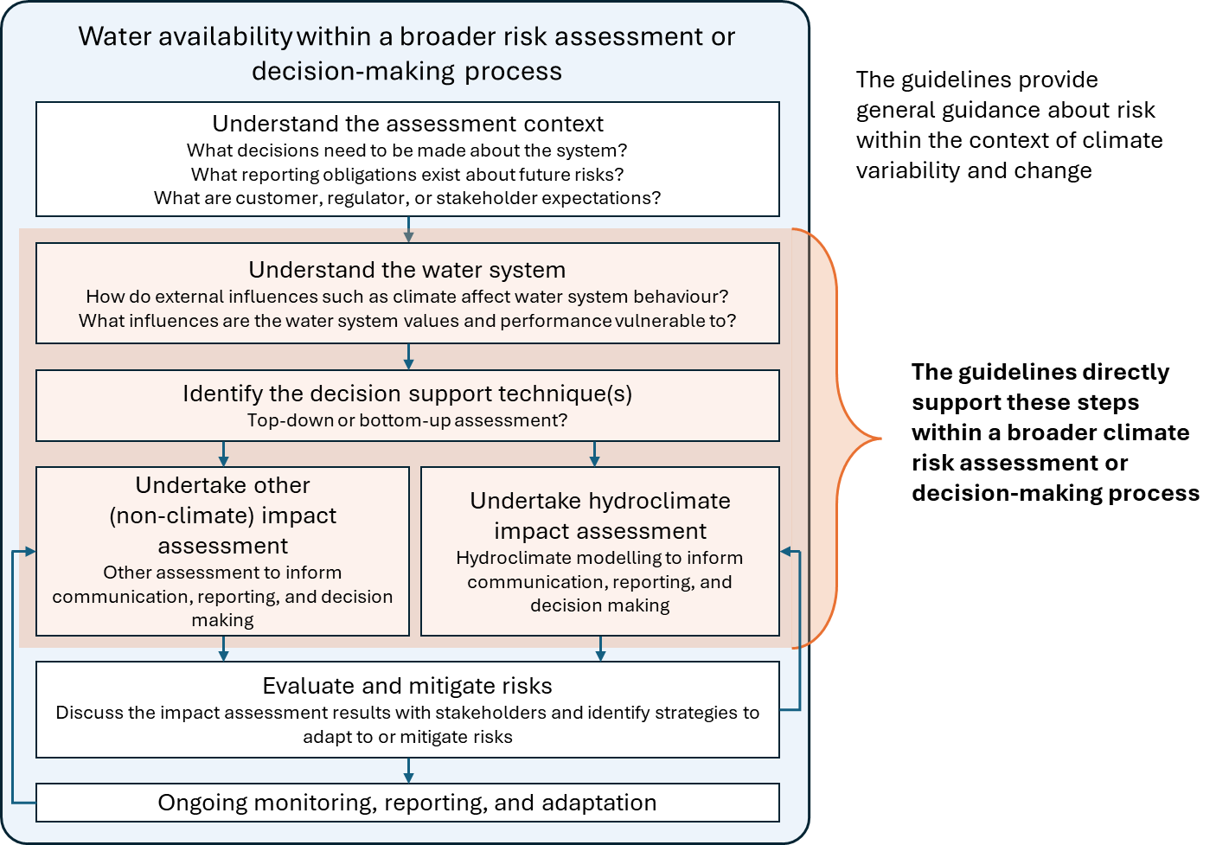
Figure 1: Water availability assessment phases within a broader risk assessment or decision-making process.

How to assess climate change impact
At a glance
- Robust assessment of climate change requires an understanding of the context and objective of assessment, along with understanding how the system behaves, and the potential risks and consequences of decisions.
- This chapter outlines some of the considerations that are necessary to consider when deciding how to go about assessing climate change impact on water availability.
- The context and objective of the assessment should guide the approach used in the assessment, the level of effort expended, and interpretation and communication of the results.
Assessment of climate change on water availability is generally undertaken in a broad context, such as long-term water resource security or sharing assessments, environmental assessments or infrastructure investments. Understanding of this context and objectives, the behaviour of the system or ecosystem being assessed, and the decision consequences and risks can guide the approach and methods used in this assessment. In addition to undertaking a technical assessment of how climate change affects water availability, it is also important to understand the uncertainties and limitations of the assessment, so that the results can be interpreted and communicated appropriately.
This chapter outlines a workflow to assess climate change impact and communicate the results, as summarised in Figure 2. These steps are discussed in more detail in subsequent chapters.

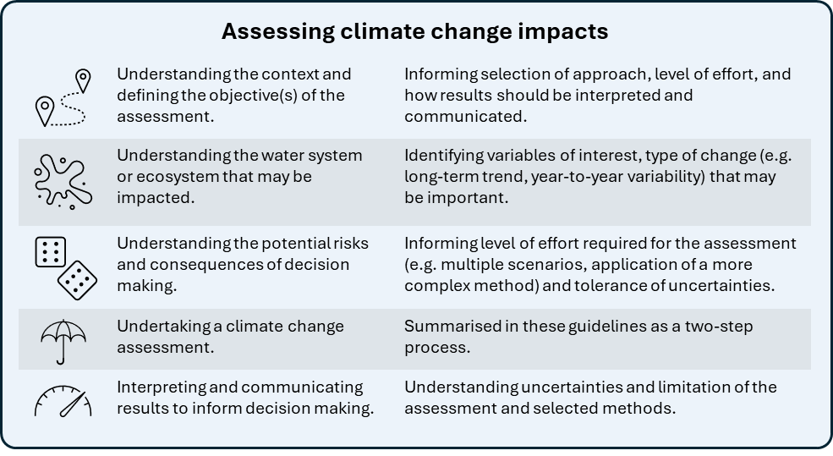
Figure 2: Summary of components and considerations for assessing climate change impacts on water availability.

Context and objective of the assessment
The context and objective of the assessment should guide the approach used in the assessment, the level of effort expended, and interpretation and communication of the results. The context can be application-specific or reflect the decision that is being made. The objective can determine the indicators/metrics that are required, which method may be suitable to conduct the assessment, and how results should be interpreted. For examples:
- a scenario-based analysis may be appropriate and practical to assess climate change risks in the context of long-term water security planning, including decisions for a near-term augmentation with a long design life,
- a stochastic analysis of water availability based on recent climate may be beneficial for short term water security planning where the consequences of low water availability are very high,
- a vulnerability assessment may be required to identify risks to ecological values in streams under climate change.

Understanding the water system or ecosystem that may be impacted
Understanding the system behaviour informs which climate variables, type of change (e.g. long-term average, variability, sequencing of events), temporal and spatial scales are important for the assessment. The availability and quality of both historical and projected data need to be considered in the selection of assessment methods and interpretation of the results.

Understanding the potential risks and consequences of decision making
The level of effort expended in the climate change impact assessment should take into consideration the potential consequences of the decision and level of risk that may be acceptable to the decision maker – with the level of effort typically commensurate with the level of risk (Figure 3).
Additional information on uncertainties of the assessment, for a system that may be vulnerable to climate variability or change, can support a decision that has material consequences. This can include presenting the range of uncertainties embedded in climate change projections, uncertainties due to climate variability, or the limitations in methods used to assess the impact of climate change. For example, applying multiple climate change projections can capture a fuller range of plausible average annual water availability over the long-term, whereas modelling many variations of potential climate sequences (e.g. stochastic generated input) can provide a fuller range of system performance due to climate variability. The process for determining the level effort or complexity of assessment can also be iterative if the results from an initial assessment expose greater system vulnerability than anticipated.
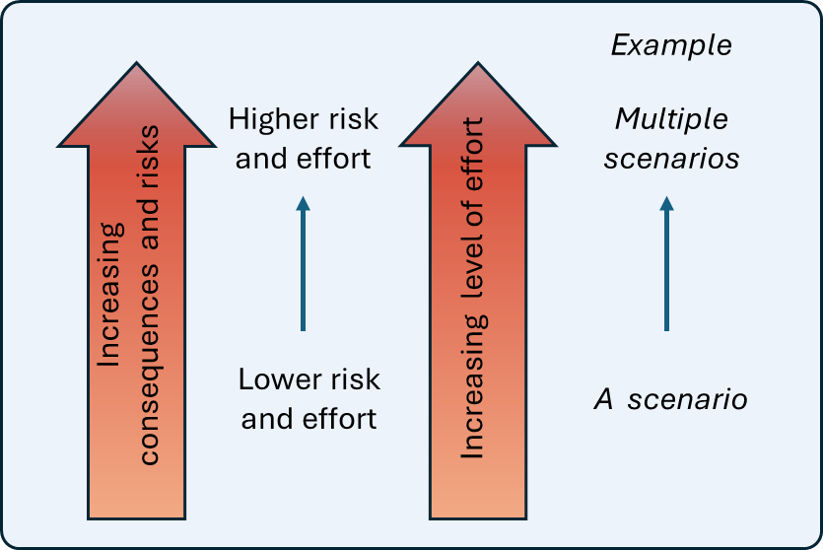
Figure 3: Example of how understanding system behaviour, potential consequences and system risk can guide the effort and complexity of assessment.

Undertaking a climate change assessment
Climate change impact assessments on water availability can be summarised into two steps:
- preparing a hydroclimate dataset that reflects the characteristics of the recent climate and represents long- a wide range of climate variability for that system (Figure 4)
- projecting climate change impact on the hydroclimate dataset (Figure 5).
These steps are broadly similar whether using a scenario-based approach (also referred to as ‘top-down’) or a sensitivity approach (also referred to as ‘bottom-up’, ‘scenario neutral‘ or ‘decision scaling’). For more on these two approaches see chapter 6.10.
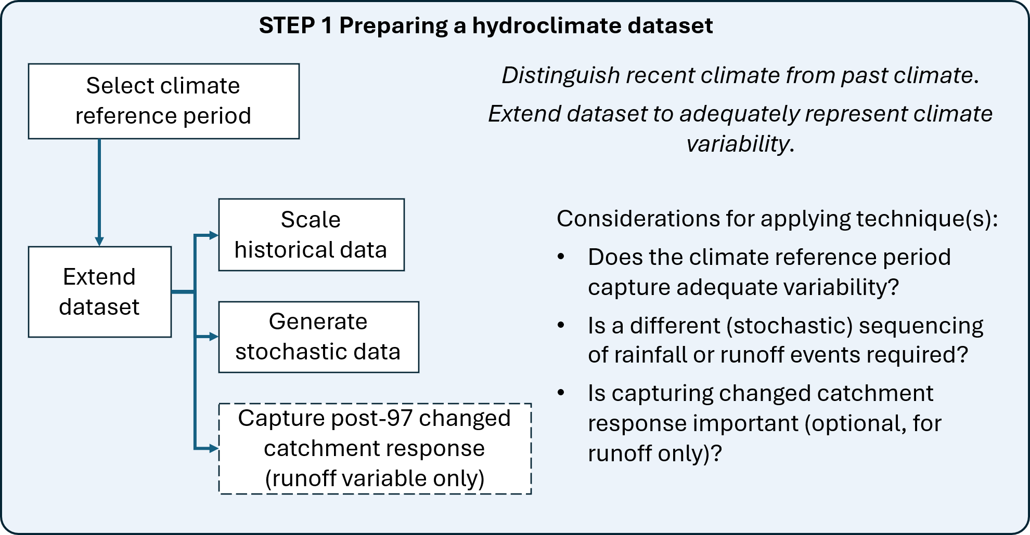
Figure 4: The first step is to prepare a hydroclimate dataset that reflects the characteristics of the recent climate and represents longer-term climate variability.

Step 1 recognises amplification of the warming trend during recent decades (e.g. from the 1970s) compared with the earlier parts of observational records (DEECA, 2025a). The selected climate reference period represents the characteristics of this recent time that may include the impact of climate change. The length of climate reference period can be relatively short for sampling rare (extreme) events. As Victoria’s climate is highly variable (DEECA, 2025a), there may be a need to represent a greater range of variability than what has been captured in the climate reference period for long-term assessments of water availability. If this is the case, dataset from the climate reference period can be extended through scaling historical data, generating stochastic data or other methods (chapter 4.3). See chapter 4 for more detail.

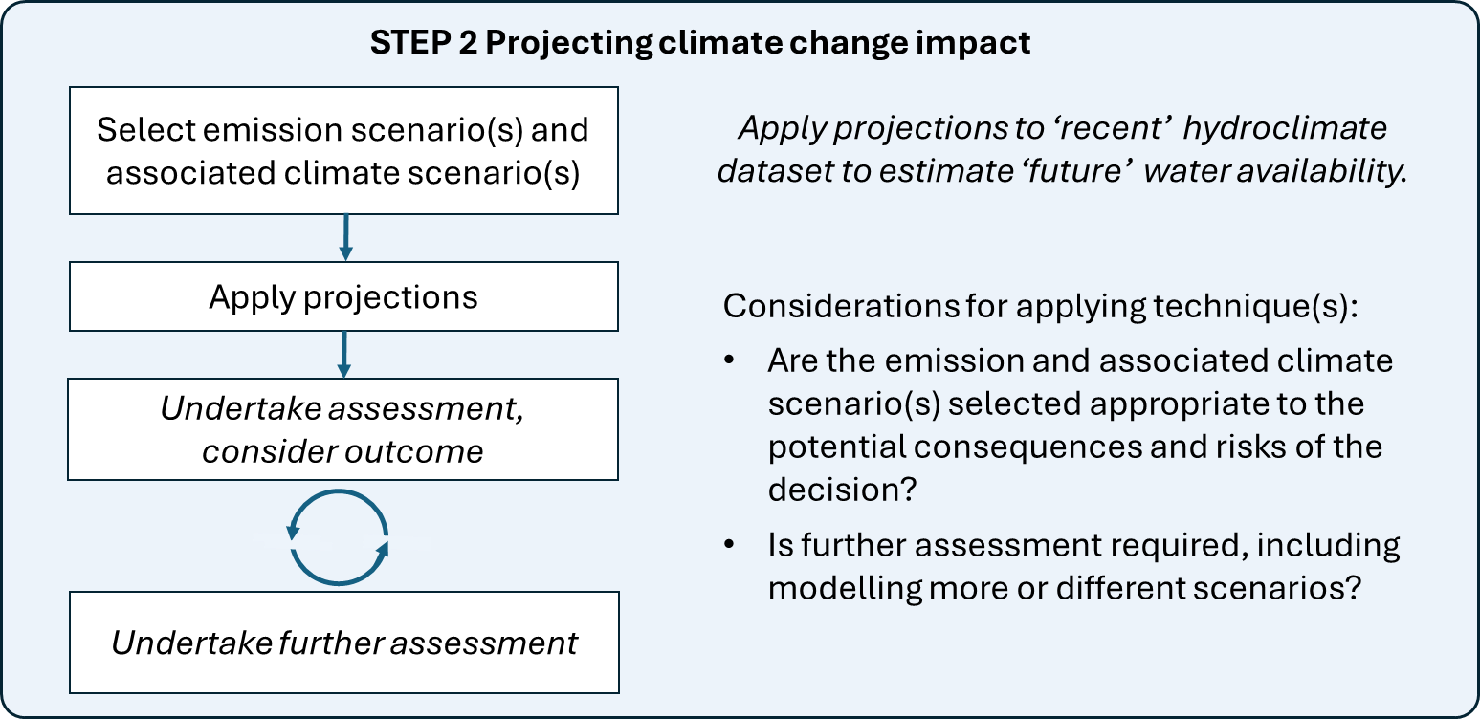
Figure 5: The second step is to project climate change impact on the hydroclimate dataset to estimate future water availability.

Step 2 projects climate change impact on the extended hydroclimate dataset developed in Step 1.
In a top-down scenario-based assessment, future water availability is estimated for each climate scenario by applying projected changes from that scenario to the hydroclimate dataset. Multiple scenarios that represent emission trajectories (e.g. Shared Socio-Economic Pathways or Global Warming Levels) and the range of output from global climate models (e.g. 10th percentile, 50th percentile, 90th percentile) can be selected to produce a range of plausible future water availabilities. This enables uncertainties from future rate of global warming, and climate system response to that warming to be accounted for.
In a bottom-up sensitivity assessment, future water availability is estimated for a range of plausible changes to hydroclimate variables (such as temperature and rainfall) independently of emission and climate scenarios (also see Supplementary Materials chapters 3.3 and 3.4). However, projected changes to those variables from various emission and climate scenarios are generally overlaid with the output of bottom-up sensitivity assessment to indicate which climate futures may be physically plausible based on global climate models.
Projections have been developed for temperature, potential evapotranspiration (PET), rainfall and runoff (see chapter 7 and Appendix A) under different emission and climate scenarios. Runoff projections are also applicable to groundwater recharge (chapter 8). These projections can be used to estimate future water availability and demand.
See chapters 6‒9 of these guidelines for more detail, with information on how the climate change projections were developed in chapter 5. Other supporting information can be found in the Appendices.

Interpreting and communicating the results to inform decision making
Potential climate and water futures are influenced by a range of factors, including greenhouse gas concentrations and the Earth’s climate responses to those concentrations.
To appropriately inform policy, planning and decision making, the impact of climate change on water availability should be considered in the context of its inherent uncertainties. These uncertainties should be acknowledged, interpreted and communicated to decision-makers and stakeholders, to enable them to make informed risk-based decisions.

Observed climate change to date
At a glance
- This chapter describes some of the key observed changes in climate and streamflow, because it provides context for understanding future changes. Further information about observed changes is available in Victoria’s Water Resources Under a Changing Climate and Victoria’s Climate Science Report 2024.
- Over recent decades, Victoria’s climate has become hotter and drier, with higher potential evapotranspiration, lower cool-season (April to October) rainfall and lower streamflow.
- The frequency of extreme rainfall events has also increased.
- These changes have potential implications for water availability and environmental water management, including changes to streamflow magnitudes and seasonality, as well as changes to the frequency and duration of cease-to-flow or high flow events.

Observed changes in climate and streamflow across Victoria
Observed historical changes in Victoria’s climate and streamflow can provide some insights for understanding how climate change may continue to unfold. These historical changes were explored as part of the VicWaCI research partnership, with outcomes presented in Victoria’s Water Resources Under a Changing Climate – Insights from phase 2 of the Victorian Climate and Water Initiative (DEECA, 2025a). Similar insights are also presented in Victoria’s Climate Science Report 2024 (DEECA, 2024).
The following highlights from the VicWaCI research are of direct relevance to the guidelines:
- Victoria’s climate continues to warm.
- There is large natural variability in rainfall between seasons, years and locations across the state.
- Cool-season (April to October) rainfall continues to decline, particularly on the northern slopes of the Great Dividing Range and in parts of the Otway and Colac regions (Figure 6). Multiple lines of evidence suggest that the recent reduction in cool-season rainfall is partly attributable to global warming. This has resulted in a reduction in annual runoff, because most of Victoria’s runoff is typically generated during the cool season.
- There has been no significant trend in warm-season (November to March)¹ rainfall during recent decades due to its high natural variability. Very little (if any) additional runoff is likely to be generated from an increase in warm-season rainfall, as high evapotranspiration is expected to offset the increased rainfall.
- There has been a decrease in the frequency of light to moderate rainfall events, but an increase in very heavy to extreme rainfall events.
- About one-third of catchments (particularly in central and western Victoria) have not fully recovered from the Millennium Drought and still generate less annual runoff for a given annual rainfall than they did prior to the Millennium Drought.
- The Millennium Drought has also resulted in persistent changes in streamflow characteristics, such as changes to the frequency and duration of days with no flow.
- Groundwater sensitivity to rainfall and potential evapotranspiration varies across Victoria, which suggests a complex relationship between climate, local geology and groundwater.
These changes have potential implications for water availability and demand. Lower cool-season rainfall translates into reduced groundwater recharge and streamflow, which reduce the reliability of these sources of water. Changes to frequency and duration of cease-to-flow and high flow events may change environmental flow requirements.
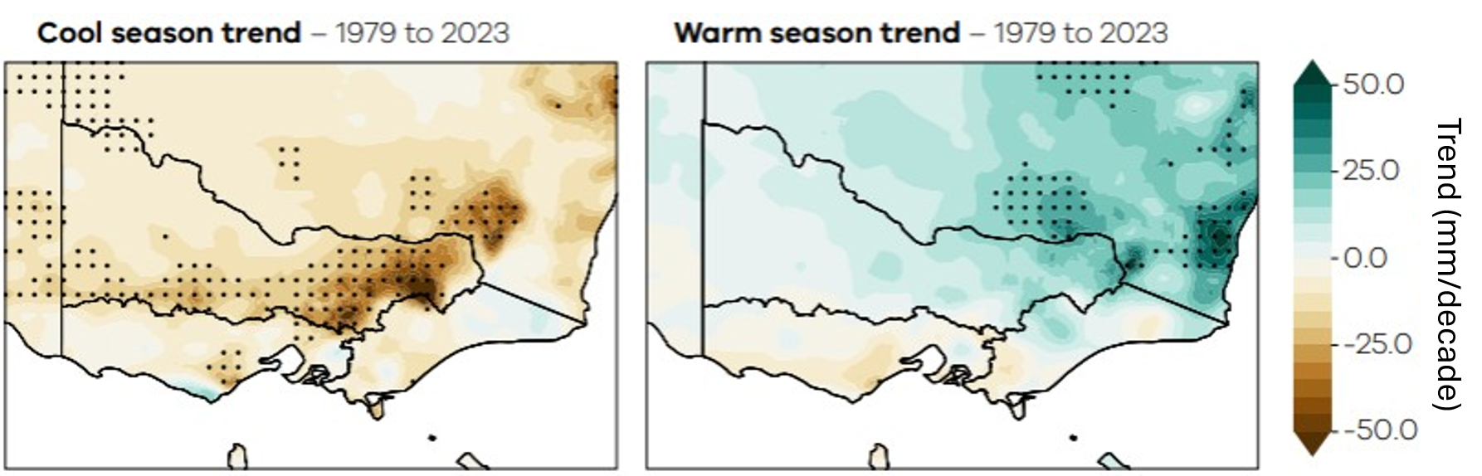
Figure 6: Rainfall trends (1979‒2023, mm/decade) during cool (April to October) and warm (November to March) seasons. Stippling indicates areas where the trends are statistically significant (at the 90% confidence interval). Data sourced from the Australian Gridded Climate Data, Bureau of Meteorology. Source: Adapted from DEECA 2025a.

Assessing local changes in climate and hydrology
The maps and figures presented in Victoria’s Water Resources Under a Changing Climate – Insights from phase 2 of the Victorian Climate and Water Initiative (DEECA, 2025a) and Victoria’s Climate Science Report 2024 (DEECA, 2024) provide an overview of climate change to date in three broad regions and at some specific locations.
Additional information on local changes in climate and hydrology may be required to provide additional context for a climate change impact assessment. This could include reporting on historical changes in:
- climate variables or runoff at a very local scale, and/or
- performance indicators that are unique to the water system being considered, such as water yield, reliability of entitlement or supply.
Changes in mean conditions are often used as a measure of change. Other metrics can also provide insight into changes in the variability or characteristics of the data, including:
- Changes in the probability of exceedance (e.g. changes in high or low flows of a given exceedance percentile).
- Changes in intervals between events.
- Changes in the frequency or duration of events.
- Changes in accumulated value over time.
Comparison of the rainfall‒runoff relationship before and after the Millennium Drought can be used to assess whether a shift has occurred, and this is discussed further in chapter 4.4.

The following factors should be considered when assessing the robustness and confidence of the assessment results:
- how sensitive the observed changes are to the start and end date of the assessed change
- whether the quality of data over different time periods affects the observed changes
- whether the observed changes are statistically significant (i.e. discernible from the noise in the data at a given level of confidence)
- whether the observed changes are linear, non-linear or step-changes
- the time step (sub-daily, daily, monthly, seasonal, annual) at which the observed changes are more likely to be evident and of relevance to a local water system.
When communicating assessment results, information on data quality and confidence of the assessment can be used to demonstrate the robustness of the assessed changes. For example, assessments with statistically significant changes (i.e. changes are unlikely to have occurred by chance) derived from high-quality observed data will be more robust than assessments where this is not the case.
Changes to observed data can also be influenced by non-climatic factors, such as changes in upstream land use or water diversion (e.g. water extracted from a waterway for consumptive use). It is important to account for this if the assessment requires drivers of change to be identified. Some climate datasets can exhibit non-climate trends that can confound the identification of historical changes.
See Appendix B.4 for further information on high-quality climate and streamflow datasets that have been subjected to more rigorous quality control for the purpose of detecting long-term trends.

Preparing a hydroclimate dataset

At a glance
- Climate change projections require a reference period from which to project climate change impacts. The climate reference period is used to characterise climate variability and distinguish recent climate from earlier climate periods.
- The post-1975 climate reference period is recommended as being suitable for providing a representative sample of recent climate variability for the purpose of projecting future climate change.
- This period can be supplemented with additional data to extend the dataset so that it represents a larger sample of variability, which can make the assessment more robust.
- In catchments where a change in the rainfall‒runoff response has persisted after the Millennium Drought, the pre-1997 historical runoff data can be adjusted so that it is representative of the changed rainfall‒runoff response.
- Different techniques and methods are presented in this chapter for analysing and adjusting datasets.

Introduction
Victoria has a highly variable climate. This climate variability is represented by fluctuations in temperature, evapotranspiration, rainfall and other climate variables on sub-daily, daily, seasonal, annual and decadal timescales. It includes both the variance (e.g. the distribution of low to high rainfall conditions) and the sequencing of climate events. Climate variability consists of random and periodic variations. The observed climate over recent decades includes changes in climate variability in Victoria (e.g. declines in cool-season rainfall and extreme rainfall events becoming more intense, as discussed in chapter 3) relative to the climate in earlier decades of the 19th and 20th centuries.
Climate change projections require a reference period from which to project climate change impacts. These guidelines recommend selecting a representative historical reference period that is long enough to characterise year-to-year climate variability, but the climate should not change so much across the whole period (i.e. the climate is largely stationary) as a result of changes in greenhouse gas concentrations.
This chapter of the guidelines presents:
- The concept of the climate reference period to characterise climate variability from the recent climate period.
- How data from the climate reference period can be supplemented to achieve (1) an extension of the dataset to allow a more robust analysis of water availability, and (2) greater variability while still maintaining the characteristics of the defined climate reference period.
- Consideration of sample events for drought, extreme events and operational planning.
- How some parts of the state have experienced a changed rainfall‒runoff relationship and options for including this in the characterisation and representation of current runoff variability.

Climate reference period
These guidelines adopt a climate reference period that distinguishes recent climate from past climate. Greater warming has occurred in recent decades compared with the first half of the 20th century, with an accelerated decline in cool-season rainfall and increased intensity of very heavy rainfall. For this reason, the climate reference period spans July 1975 to June of the most recent year of available data (July to June correlates with the water year in Victoria). This represents a ‘recent’ climatic and hydrological period, which contains annual/seasonal variability from approximately the past 50 years, as well as the impact of global warming.
The recommended climate reference period is from July 1975 to June of the most recent year of available records; that is, the ‘post-1975’ climate reference period.
The post-1975 climate reference period incorporates a large range of climate variability, including the dry periods of the Millennium Drought, the Tinderbox Drought (2017‒19) and the 1982‒83 drought, and wetter years in the late 1970s, the early to mid-1990s and the sequential La Niña years from 2010‒12 and 2021‒23. This period is considered to be representative of a recent climate and its variability. Further information about the considerations behind selecting a post-1975 climate reference period can be found in Appendix B.2.
Ideally, up to the most recent year of available records would be used to characterise the post-1975 climate reference period. Although no minimum length of data for the post-1975 climate reference period has been specified, longer and good quality data can improve the robustness of a water availability assessment. For example, adding 3 years of data to a climate reference period that spans 45 years (1975–2020) did not significantly alter water yield compared to adding the same data to a climate reference period that spans 23 years (1997–2020) (HARC, 2025a).
For catchments where the rainfall‒runoff response has changed since the Millennium Drought, a further adjustment can be made to the post-1975 climate reference period dataset to reflect changes to local hydrology within this period.

Supplementing the climate reference period datasets to represent a greater range of climate variability

Introduction
Extending the range of climate variability beyond what is represented in the post-1975 climate reference period is important for a long-term water availability assessment. Using the data from only the climate reference period may result in an underestimation or overestimation of long-term water availability (HARC 2025a, summarised in Appendix B.10. It is important to represent a greater range of climate variability by extending the climate reference period.
Water availability assessments based on historical records from only the post-1975 climate reference period have a limited range of climate variability. A broader range of climate variability is likely to have occurred in Victoria’s past, and may also occur in the future. Events that are wetter or drier than those experienced in the post-1975 reference period could occur, even without the influence of climate change.
Two commonly used methods for extending information about climate variability in water availability assessments are historical data scaling and stochastic data generation:
- Historical data scaling requires relatively low effort, is often fit-for-purpose, and is supported by a water resource modelling tool developed by DEECA to streamline the scaling process.
- Stochastic data generation requires a higher level of effort and skill due to the number of parameters and the selection of models that are involved. Stochastic techniques also produce large amounts of data that requires analysis or modelling. However, assessing water availability with stochastic data enables the uncertainties from a large range of possible climate sequences to be represented and made transparent. In addition, system performance can be assessed against low-likelihood but high-impact events (such as a 1-in-200 annual exceedance probability drought event).
Some considerations that can guide which method to use include:
- the potential consequences of the decision
- the vulnerability of system performance to climate variability, particularly variation in climate sequences
- the cost of potential management options, such as water supply augmentation options.
In addition to these methods, covariate analysis and palaeoclimate reconstructions can also be used to characterise climate variability with varying levels of effort and complexity (Figure 7). Brief descriptions of covariate analysis and palaeoclimate reconstructions are provided here, with more discussions provided in the Supplementary Materials.

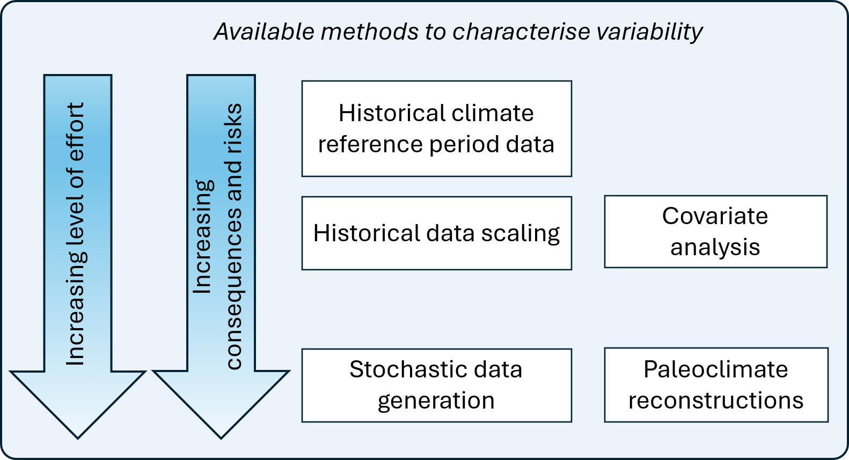
Figure 7: Methods to characterising climate variability. Source: Adapted from WSAA (2024).

Covariate analysis is an emerging technique that offers an alternative to historical data scaling. The approach is being tested in a growing number of applications so its use may become more prevalent. Paleoclimate proxy records are another means to obtain more information about climate variability beyond that available from the instrumental climate record (observed data recorded via weather instruments). Paleoclimate reconstructions for rainfall and streamflow have been used in other states to extend reference climate and streamflow datasets with additional climate variability. For Victoria, it is recommended that ‘high-skill paleoclimate reconstructions, likely based on new local proxy records, be developed before they are directly used in water sector applications’ (DEECA, 2025a).

Historical data scaling
Historical data scaling is a simple technique to adjust historical data so that the data have similar exceedance properties to a reference period, such as the post-1975 climate reference period. The recommended approach for these guidelines involves deriving average values for each interval (decile) of probability exceedance for both the reference period and the earlier historical data. The historical record prior to the reference period is then factored by the ratio of the average values in each period (e.g. post- and pre-1975) for the decile in which each value is located (Figure 8). DEECA’s Hydroclimate Data Transformation Tool for the eWater Source modelling platform automates this calculation (DEECA, 2026) and is available through the eWater Source community plugin library. This scaling can be applied to streamflow, rainfall, evaporation or temperature.
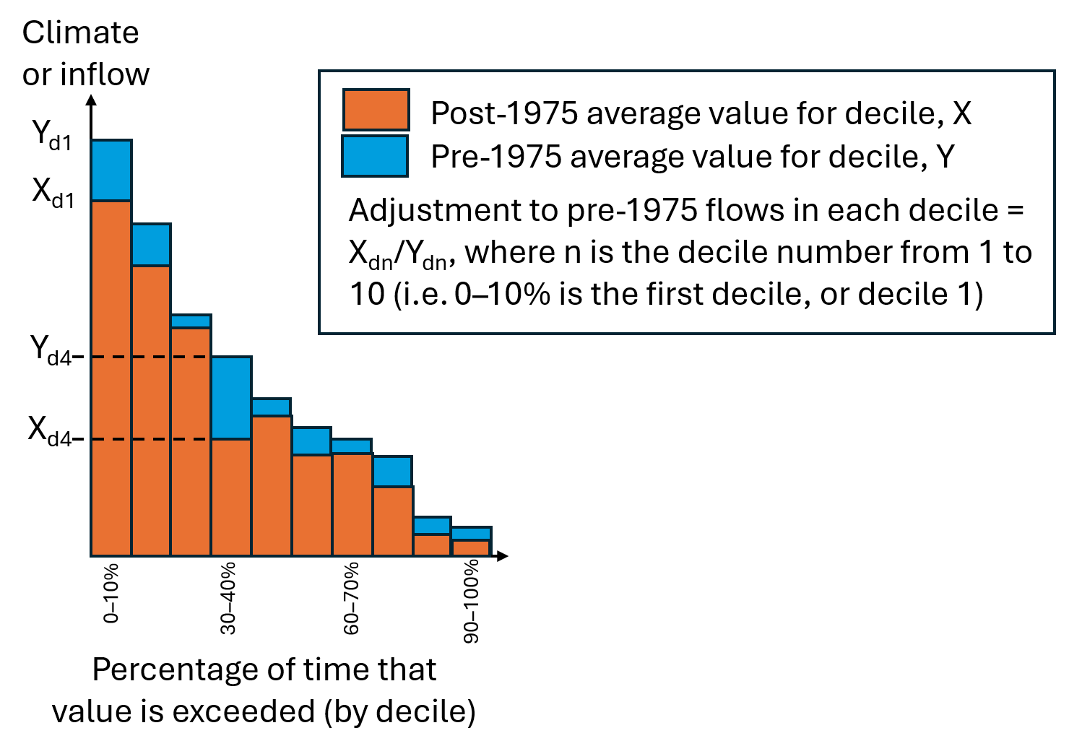
Figure 8: Illustration of historical data scaling by decile in the pre-1975 period.

Scaling can be undertaken either annually or seasonally (based on two or four seasons). In water resource assessments, seasonal scaling is typically defined by splitting the year into a cool season and a warm season. Seasonal scaling can produce different urban system yield estimates to annual scaling in average-to-drier climates in Victoria, which indicates the sensitivity of these systems to the seasonal timing of inflows (HARC, 2025a, summarised in Appendix B.10). Given the change in historical cool-season rainfall is more significant compared to warm-season rainfall, it is appropriate to scale the historical data for these two seasons separately. Two-season scaling is more robust than four-season scaling because sample sizes can be too small when using four seasons.
Seasonal (cool and warm) historical data scaling is preferred over annual or four seasons. Cool season spans May to October, while warm season spans November to April.
Any historical data scaling technique has the potential to create discontinuities in daily time series data. When applying the scaling to deciles using all months of data, discontinuities can occur at the boundary of each decile. For example, with respect to streamflow data, if a baseflow recession passes through a decile boundary it could result in a step jump up or down for daily flows either side of that boundary.
Similarly, when undertaking streamflow analysis and applying decile scaling for each season, there is potential for discontinuity from one season to the next (e.g. from the last day of the warm season to the first day of the cool season). The implications of adopting flow duration curve scaling for particular applications should therefore be checked by examining the factored time series output relative to the intended use of that output. This issue is unlikely to arise for monthly time step data, where discontinuities from month to month are unlikely to be evident. See Appendix B.3 for examples of anomalous exceedance curve scaling.
When applying historical data scaling to match flow exceedance curve behaviour, always check the consistency of the scaling factors across adjacent deciles and seasons.
If anomalies are identified in the historical data scaling process and they can be attributed to the scaling process (rather than the quality of the input data), a simpler scaling approach may be warranted. This could involve the use of a single set of decile scaling factors across all months and seasons in a year.
Another alternative to decile scaling is matching reference period average seasonal/annual values instead of deciles. However, this approach is less preferred compared to decile scaling because it does not allow for the different changes to observed climate/streamflow under wet and dry conditions (i.e. that differently affect the high and low end of climate and streamflow exceedance curves).
Alternatively, if needed for a given application, data smoothing could be applied to average values across time steps at the decile and seasonal boundaries, to remove obvious discontinuities. Some lessons from historical data scaling are discussed further in Appendix B.3.
Historical data scaling cannot fully apply changes to the variability of rainfall or streamflow from the climate reference period to the pre-reference period, regardless of which historical data scaling method is applied. For example, a shift in the seasonal timing of a peak flow event or a change in the pattern of wet and dry years will not be represented in the scaled pre-reference period data. This is because the sequencing of historical events is preserved and only their magnitude is adjusted. If water system performance or values are sensitive or vulnerable to these types of changes, stochastic data generation can be an alternative option. The stochastic model can be parameterised to better represent hydroclimate behaviour of the climate reference period.

Stochastic data generation
The instrumental climate record has captured one realisation of many possible realisations of climate that could occur should the sequencing of that climate unfold differently. Stochastic models are typically used to generate alternative sequencing of data, such as for climate, streamflow and/or water demand. Stochastic data are random numbers that are generated and, importantly, modified so that they have the same statistical characteristics (in terms of mean, variance, skew, long-term persistency, etc.) as the reference period data on which they are based (Srikanthan et al., 2007).
Stochastic data generation can be applied to assess uncertainty in water system behaviour due to climate sequencing, where the sequencing of observed data alone may not offer enough variation. For example, a recent study to assess Maryborough’s supply system yield with stochastic data has demonstrated (DEECA, 2025a):
- One benefit of stochastic data is understanding the uncertainty in water system performance due to climate variability, as indicated by the range of yields shown in Figure 9. In contrast, the single value of performance from the observed climate records provides no indication of uncertainty around that single estimate.
- Climate aspects that are important for assessing water system performance need to be replicated in the stochastic data. The stochastic model form that was adopted in this study generated few long-duration droughts (i.e. of similar duration to the Millennium Drought) to which the supply system was most vulnerable. As a result, the yield estimated from stochastic data is mostly higher than the yield estimated from observed climate data (Figure 9). A different model form capable of generating more long-duration droughts may have resulted in a yield distribution that was more evenly spread around the single yield estimate from the instrumental climate record.
- Results are sensitive to the climate reference period used to define the statistical properties of the stochastic model. The stochastic data generated from the post-1975 and post-1993 periods produced a lower range of water yields than the (unscaled) full historical period. It is therefore highly important to consider the climate reference period chosen when developing a stochastic model.
Stochastic data generation requires careful consideration of model parameters, including model time step and observed data used for training the model, to ensure the climate variability is appropriately represented to inform water system performance.

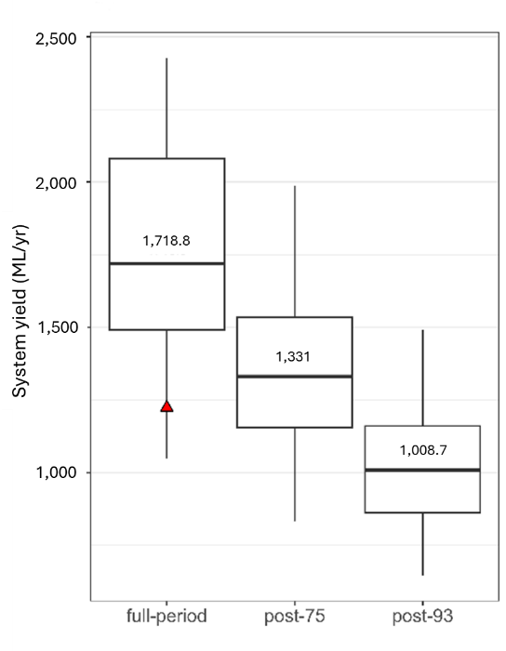
Figure 9: System yield of the Maryborough water supply system using stochastic data based on the full historical period, the post-1975 period and the post-1993 period. Box plots indicate the 2.5, 25, median, 75 and 97.5 percentile values from 1000 stochastic replicates. The red triangle indicates average annual yield using observed climate records only. Source: DEECA (2025a).

HARC (2025a) reviewed the use of stochastic data generation and associated guidance for its use in water availability assessments in Australia and found that:
- Stochastic data are increasingly being used around Australia for water resources planning, including more applications outside of academic research. The tools available to generate stochastic data are becoming more accessible than in the past.
- The use of stochastic data has benefits over the use of cycled reference data (which cycles the last year of a dataset to the start of a record to create a new dataset), providing different sequencing from the instrumental climate record and producing statistically independent sequences.
- The most common reason for using stochastic data is to inform water availability risks due to climate sequencing beyond that observed over the instrumental climate record, particularly for risks associated with the representation of multi-year droughts. This is because there is limited information about multi-year droughts within the instrumental climate record.
- Stochastic data are of limited to no value for hydroclimate data, which are relatively invariable.
- The value of stochastic data for representing additional within-year climate variability is lower than for multi-year periods, because more information about within-year climate variability is already available from the instrumental record.
- Stochastic data generation can be used to estimate hydroclimate information for very low-likelihood events (i.e. for events with likelihoods well beyond that which can be estimated using the instrumental/reconstructed climate records). However, such events might not be physically plausible. Stochastic models are mathematical models, not physical process-based models.
- There are different methods and tools available to generate stochastic data sets, which can in turn generate different water availability estimates. The choice of stochastic model and model settings can be particularly important when representing multi-year persistence in climate behaviour, and when considering perturbations to stochastic model parameters under climate change projections or as part of climate stress testing. The quality of stochastic data produced is only as good as the quality of the input data used.
Further discussion of stochastic data generation procedures and tools is provided in Appendix B.5.

Additional analysis to identify and represent changing rainfall‒runoff behaviour in the post-1997 period

Introduction
During the Millennium Drought, the runoff reductions observed in many Victorian catchments were much larger than was expected for the reduction in rainfall. In these catchments, less annual runoff was generated from a given amount of annual rainfall during the drought than when compared to the period prior to the drought (Figure 10). The reduction is experienced across the flow range, with the largest amount observed in the low to extreme-low flows.
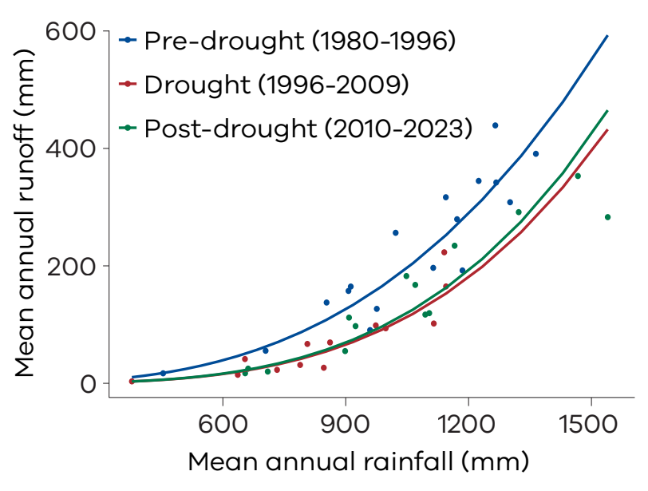
Figure 10: Comparison of the annual rainfall‒runoff relationship between pre-drought (blue), during the drought (red) and post-drought (green) for the Holland Creek catchment (404207) in north central Victoria. Source: DEECA (2025a).

Since the end of the Millennium Drought, the relationship between rainfall and runoff has recovered in some catchments, however in other catchments the reduced runoff response, or shift in rainfall‒runoff relationship, persists.
For catchments where the shift in the rainfall‒runoff relationship persists, an additional hydroclimate dataset that represents the hydrological shift can be developed, which allows the projected future climate change impacts to be assessed based on the assumption that the shift continues to persist into the future. This chapter of the guidelines describes how the additional hydroclimate dataset can be developed.
In previous versions of this guidance, a scenario called the ‘post-1997 step climate change scenario’ was recommended. With the benefit of additional observed data and recent science findings, it is apparent that in impacted catchments this previous scenario was representing a shift in hydrology more than a shift in climate. The latest research in this topic is summarised in Box 1. A new approach of directly representing the shift in hydrology in the post-1975 climate reference period is recommended in place of the previous ‘post-1997 step climate change scenario’.
For catchments where a shift in the rainfall‒runoff response has persisted since the Millennium Drought, an additional hydroclimate dataset that represents this hydrological shift can be developed to inform assessments of projected climate change impact to water availability.

Box 1: Findings from the research into shifting rainfall‒runoff relationships
Research by Monash University through VicWaCI observed that a shift in the rainfall‒runoff response since the Millennium Drought has persisted for approximately one-third of catchments studied in Victoria (Peterson et al. 2021; Zahedi et al. in review).
This shift in the catchment runoff response due to severe or prolonged drought has been described in terms of runoff states. Catchments can be described as having one or multiple states based on their runoff response to rainfall. For example:
- Catchments that did not experience a shift in the rainfall‒runoff relationship have one runoff state.
- Catchments that did experience a shift have multiple states, switching from a normal runoff state into a low runoff state (where less runoff is generated for a given amount of rainfall) during a very dry period, including the Millennium Drought.
Of the 158 catchments explored in this study using observed datasets up to 2021, 51 were found to remain in a low runoff state in 2020. Figure 11 illustrates the evolution of annual catchment response from 1995 to 2020 throughout Victoria. Catchments in blue are in a normal runoff state and those in orange are in a low runoff state. Catchment response was increasingly impacted across the state as the Millennium Drought progressed, with 88 of the 158 catchments in a low runoff state in 2010. This had reduced to 51 catchments by 2020. The variable spatial distribution of these catchments is illustrated in Figure 11, with catchments exhibiting a low runoff state found across Victoria.
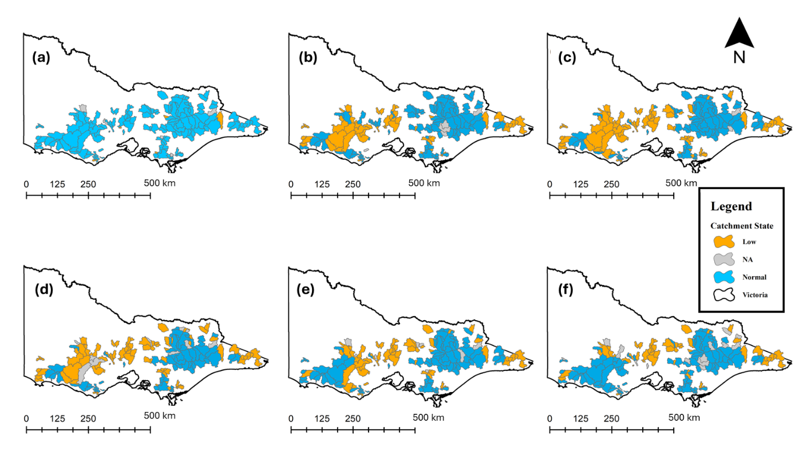
Figure 11: Shifts in catchment hydrological response across Victorian catchments over 25 years: (a) 1995, (b) 2000, (c) 2005, (d) 2010, (e) 2015, (f) 2020. Source: Zahedi et. al (in review).

The return of catchments with multiple states, to a pre-Millennium Drought runoff state, may require an extended wet period to recover. Three consecutive La Niña years from 2021 to 2023 may have seen the recovery of further catchments that had shifted to a low runoff state, but this has not yet been clearly observed and documented.
To better understand the shift in the rainfall‒runoff response, unregulated gauged catchments were analysed. In these catchments streamflow can more readily be attributed to shifts in key catchment processes. Extrapolating these findings with confidence to other parts of the state with regulated or otherwise impacted catchments requires further analysis.
Practitioners are encouraged to make their own assessment on whether their catchment has experienced a shift in rainfall‒runoff response. Sections 4.4.2-4.4.5 describe the approaches practitioners can take to detect whether a shift has occurred and represent this in an additional hydroclimate dataset if necessary.
Since the Millennium Drought, persisting shifts in rainfall‒runoff response have been observed in catchments throughout the state, particularly in central‒west Victoria and east Gippsland. Practitioners are encouraged to use these guidelines to make their own assessment on whether their catchment has experienced a shift in rainfall‒runoff response.

Identifying a change in the rainfall‒runoff response
To detect whether a change in the rainfall‒runoff response has occurred and continues to persist, DEECA recommends a method that compares the relationship between annual rainfall and runoff pre-, during and post-drought. The recommended method is largely based on Saft et al. (2015) with some minor adjustments. This method was adopted because it is rigorous, largely unambiguous and easy to apply (with supporting tools). It can also be used to inform any subsequent adjustments to pre-1997 data that may be required to represent the shift in rainfall‒runoff response.
Practitioners can assess whether a catchment is experiencing a persisting shift in the rainfall‒runoff response using DEECA’s Hydroclimate Data Transformation Tool (2026 version) Source plugin. In addition to assessing whether a shift has persisted, the plugin can also adjust the historical runoff data prior to 1997 to reflect the shift.
The steps that can be used to detect whether a change in the rainfall‒runoff response has occurred and continues to persist are summarised below.
DEECA has developed a tool to support this analysis i.e. the unit conversion in step 1 below, then steps 3‒5. This tool is available through DEECA’s Hydroclimate Data Transformation Tool for the eWater Source modelling platform in the eWater Source community plugin library. A standalone version of the tool can also be accessed by contacting DEECA’s Hydrology, Climate and Energy team at HCS.Team@deeca.vic.gov.au.
The steps in the recommended process for identifying a change in the rainfall‒runoff response are as follows (see also Figure 12):
- Collate annual rainfall and annual runoff data. The runoff data are preferentially converted to units of mm/year by dividing the runoff in ML/year by the catchment area in km². This conversion is a step of convenience to allow any changes in runoff to be more readily compared with the input annual rainfall, and to more readily allow comparisons between catchments. However, the analysis can still be undertaken using input annual runoff in other units such as ML/year or GL/year, if a reliable estimate of the catchment area is not available.
- Check the quality of the rainfall and runoff data. The quality of the rainfall and runoff data used in the analysis can affect the level of confidence in the analysis outputs. Many studies use gauged runoff data from the Bureau of Meteorology’s Hydrologic Reference Stations, which are higher-quality streamflow gauges located in largely natural catchments with low levels of upstream water use or flow regulation. Gauged runoff data from other sites can also be used. Where there is significant upstream water use or flow regulation, the data can be adjusted for the effects of that historical water use, as is typically done when preparing 'unimpacted’ water resource model inputs.
Ideally, rainfall and runoff data should be available from at least 1982 onwards, so that at least one drought in the pre-1997 period (i.e. in 1982/83) can be included in the analysis.
The presence of outliers that are known to be of poorer quality can influence the level of confidence in the analysis outputs, as can the quality of any infilling or extension of the available gauged data. For example, extending or infilling streamflow data using outputs from rainfall‒runoff may make detecting a shift in response less likely. See Appendix B.4 for further information on high-quality climate and streamflow datasets that have been subjected to more rigorous quality control for the purpose of detecting shifts and trends.
- Test whether there has been a shift in rainfall‒runoff behaviour in the post-1997 period. This can be undertaken using DEECA’s Hydroclimate Data Transformation Tool.
- If no shift is detected, no adjustment of pre-1997 runoff data is required. Extended hydroclimate data based on the post-1975 climate reference period can be prepared as described in chapter 4.3.
- If a shift is detected, proceed to the next step.
- Test whether a shift in rainfall‒runoff behaviour persists in the post-2010 period. This can be undertaken using DEECA’s Hydroclimate Data Transformation Tool.
- If the detected shift did not persist in the post-2010 period, no adjustment of pre-1997 runoff data is required. Extended hydroclimate data based on the post-1975 climate reference period can be prepared as described in chapter 4.3.
- If a shift is detected, the pre-1997 runoff can be adjusted as outlined in chapter 4.4.3.
- Check statistical assumptions for change detection. Using the diagnostic information in DEECA’s Hydroclimate Data Transformation Tool, confirm that the linear regression model residuals are:
  - randomly distributed over time and over the range of observed flows
  - normally distributed
  - not serially correlated.
If any of these assumptions are invalid, the level of statistical significance of the change may be overstated (i.e. a higher risk of detecting a change where none exists). Options that can be taken when those assumptions are invalid are presented in Appendix B.11.
The consistency of the slope of the relationship between rainfall and (the transformed) runoff between the pre-1997, post-1997 and post-2010 periods can be checked, using the diagnostic plots in DEECA’s Hydroclimate Data Transformation Tool. Where the slope of this relationship is not consistent over different periods, a statistically significant shift in rainfall‒runoff behaviour is less likely to be detected. If a shift is detected, this could result in under- or overestimation of the shift in years of either lower or higher rainfall (depending on the direction of the difference in slope). Practitioners should consider the implications of this result for their given application.

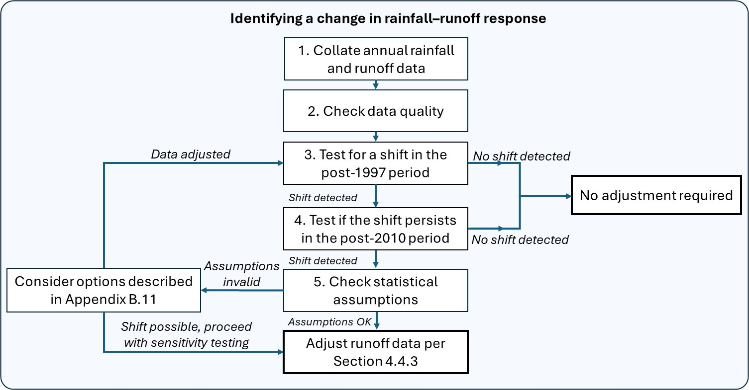
Figure 12: The process for identifying a change in the rainfall‒runoff response.

Further technical details around the method and an example case study are provided in Appendix B.11.
Practitioners can choose to develop their own assessment tools, rather than relying on DEECA’s Source modelling platform plugin tool, recognising that there are other ways to detect changes in rainfall‒runoff behaviour than the approach recommended in these guidelines.
If a shift in the rainfall‒runoff response in the post-1997 period cannot be detected (e.g. due to poor data availability or quality) but it is considered likely to have occurred (e.g. as observed in a neighbouring catchment that has better data availability and quality with similar catchment and hydroclimate characteristics), practitioners may still wish to create an additional hydroclimate dataset using the adjustments described below, as a precautionary sensitivity test on water availability.

Adjusting runoff data where a change in the rainfall‒runoff response has been identified
Practitioners working with catchments that have experienced a change to their historical rainfall‒runoff relationship can explicitly account for this shift to ensure that future water availability projections account for this change and are more robust to the range of plausible future water availabilities. It is recommended that this adjustment, when required, is applied prior to any pre-1975 historical data scaling or stochastic data generation using post-1975 reference period data.
Adjustments to the pre-1997 period of the streamflow dataset to represent a shift in the rainfall-runoff response should be made prior to any pre-1975 historical data scaling.
Adjusting for changes in rainfall‒runoff behaviour in the post-1997 period (and any subsequent pre-1975 historical data scaling) will create an additional dataset, to which the runoff change factors under projected climate change can be applied. Consequently, the plausible range of future water availability is broadened by considering the impact of a shift in the rainfall‒runoff response persisting into the future. Given the possibility of a catchment recovering to its pre-1997 rainfall‒runoff state in the future, the use of both datasets is recommended.
The process of extending the post-1997 rainfall‒runoff response and extending the post-1975 climate characteristics are conceptualised as two steps in Figure 13. Figure 14 illustrates how these adjustments may affect the streamflow dataset.
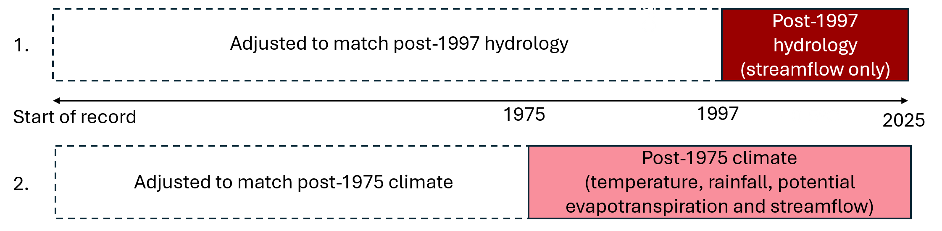
Figure 13: Adjustments to the pre-1997 period of the streamflow dataset to represent a shift in rainfall‒runoff response (#1) are made in addition to extending the post-1975 climate characteristics to the pre-1975 period (#2).

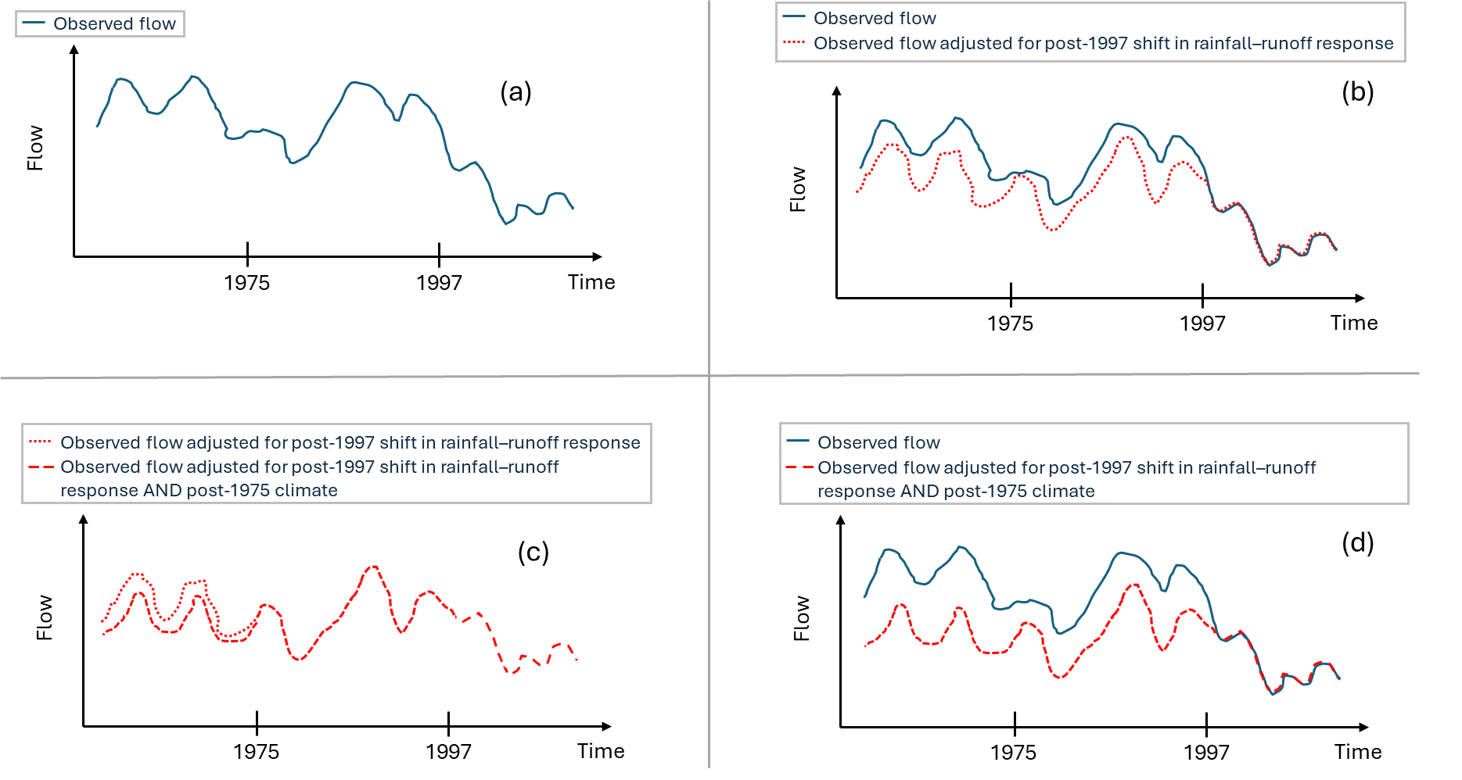
Figure 14: Example of how a catchment's observed streamflow record can be adjusted to represent post-1975 climate conditions and post-1997 catchment conditions: (a) observed flow, (b) adjusting for post-1997 rainfall-runoff shift, (c) adjusting to post-1975 climate, and (d) observed flow and final adjusted dataset.

The process adopted for adjusting the pre-1997 data depends on the availability and suitability of tools to support the analysis:
- A rainfall‒runoff model can be applied directly to generate estimated runoff in the pre-1997 period under post-1997 catchment response conditions. This is appropriate if the rainfall‒runoff model has been well calibrated to all of the post-1997 period, but poorly calibrated to all of the pre-1997 period because it is underestimating runoff. That is, the model outputs pre-1997 reflect the shifted rainfall‒runoff response from the post-1997 period. A general discussion of the advantages and disadvantages of using rainfall‒runoff models is provided in Section 6.8 of the guidelines. In this application, the use of a rainfall‒runoff model is likely to improve the representation of changes in sub-annual runoff in the pre-1997 period, relative to the alternative approach below.
- When using a rainfall‒runoff model is not practical (e.g. no model exists for the catchment, or the model calibration is poor), the estimated shift in annual rainfall‒runoff response detected in the process outlined in chapter 4.4.2 can be applied to the annual (transformed) runoff data in the pre-1997 period. This can be done by back-transforming the shifted data and then disaggregating the adjusted annual data to be consistent with the time step of the original dataset (usually daily or monthly) using the sub-annual flow pattern in the original dataset. The resulting shift in runoff, relative to the unshifted value, will be non-linear. This means the shift in runoff will be greater at higher flows than at lower flows (but may be similar in percentage terms). In years with very low runoff, this adjustment process can result in zero runoff in those years. The adjustment process is automated in DEECA’s Hydroclimate Data Transformation Tool and is presented in more detail in Appendix B.11.
DEECA’s Hydroclimate Data Transformation Plugin (2026 version) is well suited to adjusting streamflow datasets where understanding runoff changes at a sub-annual time step is not critical. For applications that have a strong focus on assessing daily or seasonal changes to the flow regime, the use of a rainfall‒runoff model is preferred.

Using adjusted streamflow data to generate future runoff projections
Where a persisting statistically significant shift in rainfall‒runoff response has been detected, practitioners can represent this change in an additional hydroclimate dataset for the purpose of generating future runoff projections. To do so, practitioners should in sequential order complete all of the following steps:
- Use post-1997 streamflow data directly and adjust pre-1997 streamflow data so that the pre-1997 data is representative of the shifted rainfall‒runoff response (see chapter 4.4.3)
- Further adjust any pre-1975 streamflow data by using decile scaling to ensure that it is representative of the post-1975 climate reference period (see chapter 4.3.2).
- Apply the runoff projections (scaling factors) for the desired future climate scenario (see chapter 6 & 7).
Assuming that shifted catchments remain in their recent low runoff state could potentially underestimate future runoff in some catchments. Persisting shifts in rainfall‒runoff response post-drought are observable for many catchments; however, the threshold at which these catchments may recover is not well understood. It is plausible that more catchments may return to a normal runoff state in future years after an extended wet period. Consequently, if the catchment response shifts back to a normal state during the planning horizon, the projected reductions in runoff may be overestimated.
The analysis described in chapter 4.4 can be used as a complement to the primary post-1975 hydroclimate reference period dataset to assess the full range of plausible future water availabilities in catchments where a shift in rainfall–runoff response has been detected. Figure 15 illustrates how the post-1975 hydroclimate reference period (applicable to all catchments across Victoria) and the data set representing a persistent post-1997 hydrological shift (applicable to catchments where a persistent shift in rainfall – runoff response has been detected) could be presented to inform future water availability projections.

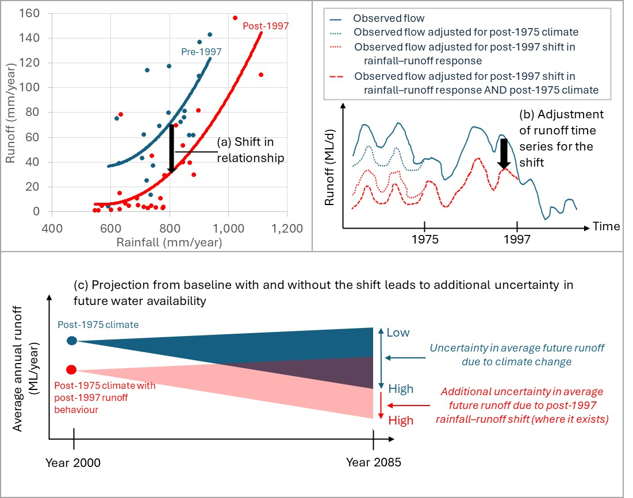
Figure 15: Example application of the representation of shifted catchment response in future water availability projections.

When referring to analysis that is based on the adjusted streamflow data, the use of the term ‘post-1975 climate with post-1997 runoff behaviour’ is suggested.

Applying the post-1997 runoff behaviour in water availability assessments
As discussed in chapter 2, when considering how to apply the post-1997 rainfall–runoff analysis, practitioners should consider the:
- context and objective of the assessment (chapter 2.1)
- behaviour of the particular water system (chapter 2.2)
- potential risks and consequences of decision making (chapter 2.3).
The approach to identify and represent the post-1997 rainfall–runoff behaviour in the hydroclimate dataset described in these guidelines is new. It has been successfully tested on a limited range of applications. Given the approach is novel, unique, and applications to date have been limited, there may be unexpected challenges encountered for some applications.
Where a shift in rainfall–runoff behaviour is identified, practitioners will need to consider how best to present the range of uncertainty in future water availability projections. This uncertainty includes whether the shift continues in the future as well as the range of climate change scenarios due to climate model uncertainty. For example, rather using all low, medium and high climate change scenarios applied to both runoff datasets, practitioners may choose to present a subset of scenarios that are considered suitable for that application.
In some instances, the impact of accounting for the post-1997 runoff behaviour on projected water availability may be small relative to the range of uncertainties in future climate, which may limit the value of representing post-1997 rainfall–runoff behaviour for the particular application.
When assessing sub-catchments within a larger water system, or nested catchments, in some cases a shift may be identified in only a proportion of catchments. In general, it is recommended that the post-1997 rainfall–runoff shift is applied uniquely to runoff datasets in individual catchments, as supported by the test results, rather than being applied uniformly to a region. However, if only a small proportion of the total water resource being assessed exhibits a shift in rainfall–runoff behaviour, then this shift may be immaterial across the broader water system.
If a seemingly anomalous test result appears for a catchment within a region, practitioners should confirm, where possible, that this is not due to poorer quality of the input data for the particular catchment.
In some cases, the result of the test for detecting the post-1997 rainfall–runoff shift may be ambiguous because the test assumptions are not satisfied (see Appendix B.11). In this situation, practitioners can choose to take no further action (i.e. proceeding with the assessment using the extended post-1975 dataset only) or proceed to generate this additional dataset using rainfall–runoff models (as described previously in chapter 4.4.3) as a precautionary approach to better understand the impacts on water availability from this source of uncertainty.
Where the complexity in applying the approaches to represent the shift in rainfall‒runoff response described here is prohibitive from either an analysis or communication perspective, the use of the post-1997 climate reference period (as described in previous guidance (DEECA 2020) could be considered. However, although this earlier approach provides a representation of the post-1997 rainfall–runoff behaviour, it has some significant limitations (see Box 2).

Box 2: Post-1997 step climate change scenario
In earlier editions of these guidelines, a step or ‘return-to-dry’ climate change scenario was used to represent the significant change in average rainfall (and average runoff) between the post-1997 period and earlier periods. The post-1997 period was considered as a climate reference period in addition to the post-1975 climate reference period. This was a precautionary scenario emerging from the experience of the Millennium Drought and was derived from hydroclimate observations that were independent of the global climate model projections. Following the Millennium Drought, it was uncertain whether a permanent shift to a much drier climate state had occurred, one that was drier than any of the global climate model projections over the next one to two decades.
Since the previous version of the guidelines was issued in 2020, Victoria has experienced three successive wetter years. This has broadened the range of rainfall variability within the post-1997 period. The average rainfall in the post-1997 period is generally higher than previously estimated in 2020 and is now no longer as dry relative to the pre-1997 period. This has reduced the relevance of a post-1997 step climate change scenario as a precautionary scenario. In this context, this scenario may underestimate longer-term future risks because it assumes no change to future water availability beyond the step change that has occurred.
With respect to climate variability, the post-1997 climate reference period is shorter (~30 years) than the post-1975 climate reference period (~50 years), so it is less representative of broader climate variability. Being more recent, it is more likely to be representative of behaviour under current levels of greenhouse gas concentrations. Despite the recent wetter years, the period has also largely been dominated by a long duration, low-likelihood drought event (i.e. the Millennium Drought spanning approximately one-third of the post-1997 period).
HARC (2025a) found that adopting a post-1997 climate reference period (relative to adopting post-1975) typically resulted in less stable estimates of long-term water availability. This is an indicator of the limitations of a post-1997 climate reference period, which is yet to reasonably characterise the fuller range of climate variability. Hence, the post-1975 climate reference period is more suitable for characterising recent climate variability for long-term assessments. The key findings from HARC (2025a) are summarised in Appendix B.10.
Instead of using a post-1997 climate reference period, these guidelines recommend using a post-1975 climate reference period, plus testing to identify whether a local shift in rainfall‒runoff response in the post-1997 period has occurred and persisted since the end of the Millennium Drought (as explained further in this chapter). Like the post-1997 climate change scenario, allowing for a local shift in the rainfall‒runoff response recognises that catchment hydrology has changed in some (but not all) catchments within Victoria and that surface water availability would be lower if that shift persists into the future.
The use of post-1997 as a reference period may, however, still be relevant for some applications. These may include:
- comparisons of historical water availability over different decades, due to both historical climate change and historical climate variability
- where there is stakeholder desire to compare water availability in the post-1997 period with previous estimates derived using the 2020 guidelines
- where the complexity in applying the approaches to represent the shift in rainfall‒runoff response is prohibitive from an analysis or communication perspective.

Wet, dry and drought event sampling from the climate reference period
Operational planning decisions and near-term adaptive drought responses relating to water availability utilise streamflow characteristics and water system performance over the following week through to the following season or year (e.g. Annual Water Outlook) and, for some systems, up to the next few years (e.g. the desalinated water order advice technical analysis in Melbourne Water (2025)). These type of decisions and actions can be tested using a sample of climate and runoff events from the post-1975 historical reference period (without any adjustment for historical climate change within that reference period). The decision to sample from all of the post-1975 period (reasonably representative of the likely future range of climate variability) or a subset of years within that period (such as the Millennium Drought) may be based on the type of event and desirable range of climate conditions under which decisions are to be tested.
The historical instrumental record is quite short when considering events of low likelihood. For example, it is possible that a drought could occur over the coming months or years that is more severe (in terms of the magnitude of the rainfall deficit and/or its duration) than that which has occurred historically (Verdon-Kidd & Kiem, 2009), irrespective of whether this is driven by increased greenhouse gas concentrations or natural climate variability. This situation occurred during the Millennium Drought.
There are various techniques available to generate synthetic droughts (i.e. data that is not observed, but constructed to represent a potential drought) that are more severe than the worst drought on record. This may include:
- Stochastic data generation, as applied for setting very high levels of security for water supplies in some of Australia’s capital cities (e.g. Seqwater, 2023).
- Using samples from the historical record. This is a simpler approach currently adopted and recommended for use when stress testing urban water supply system security (DEECA, 2025b). It involves scenarios such as running the 2006–07 drought year back-to-back or the three driest years from the Millennium Drought back-to-back. This approach preserves the within-year characteristics of a real drought event but rearranges each year to meet the scenario objectives of generating a hypothetical multi-year event that is less likely (but more severe) than the Millennium Drought. The extent to which different drought events are sampled and reshuffled should reflect the organisation’s risk appetite for the given application.
The suggested hierarchy of approaches for event sampling for drought preparedness and other operational planning is shown in Figure 16.
There may be exceptions to this process for smaller water systems with less than 12 months of available storage capacity. For these supply systems, changes to within-year drought duration (and severity) are more important for testing supply system resilience than changes to multi-year drought duration. In this case, scaling or otherwise extending within-year historical drought events, including years in the Millennium Drought, is considered appropriate if the higher degree of uncertainty in this process is acknowledged. This form of sensitivity testing is discussed in further detail in the Supplementary Materials.

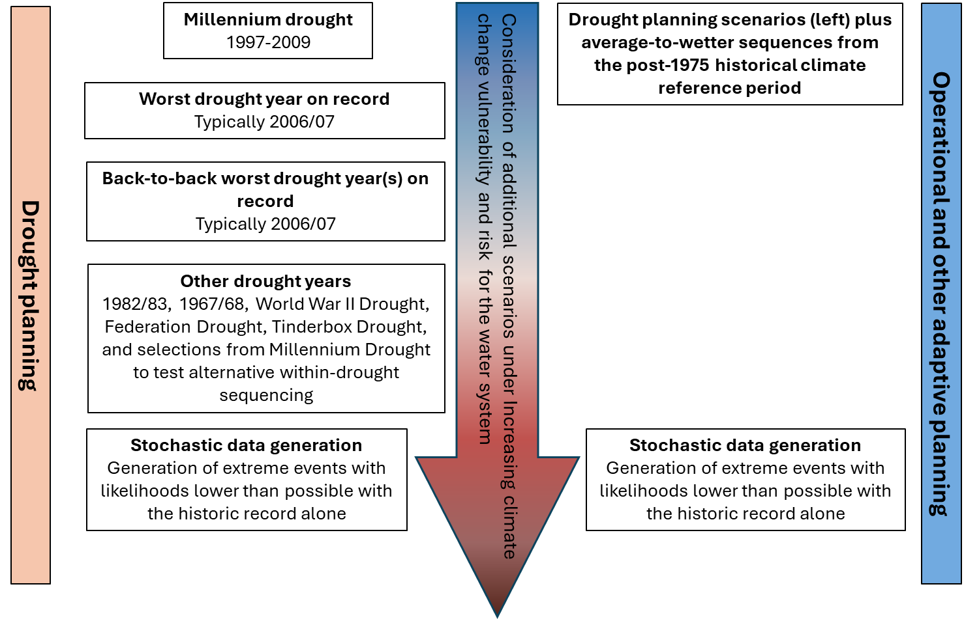
Figure 16: Example of event sampling consistent with the climate change guidance.

For near-term applications (~5 years), climate variability considerations are expected to be of greater importance than projected long-term change. Most of the observed records in the post-1975 historical climate reference period, particularly after 1990, have already been impacted by climate change. Adjusting for climate change impacts that have occurred since 2000 (the midpoint of the 1975–2025 period) is likely to produce a drier climate sequence than the post-1975 period due to the observed global warming. However, this adjustment factor will be derived from global climate models where projection uncertainty between models is likely to be greater than the projected climate change impact over the past 25 years. A drought that is more severe than the adjusted historical droughts can still occur due to climate variability. Stress testing the water system as part of drought preparedness planning can address this risk.
On balance, sampling from the extended dataset based on post-1975 climate reference period is adequate for a near-term assessment up to 5 years. For an assessment period longer than this, including near-term assessments where the outcomes could have long-term consequences, it would be prudent to adjust the post-1975 climate reference period with the projected climate change impact that has occurred since 2000. This adjustment for historical climate change for long-term applications, and the situations to which it would apply, is discussed further in chapter 6.4.
For near-term applications (up to a ~5-year planning horizon, without long-term consequences), stress testing the water system using the extended post-1975 dataset is considered sufficient.
In catchments where a persistent shift in rainfall–runoff response has been detected, the extended post-1975 dataset can be adjusted to reflect post-1997 rainfall‒runoff behaviour (consistent with chapter 4.4) to inform planning decisions and adaptive drought responses. This could include, for example, where non-zero inflows are assumed as part of drought preparedness trigger design. An allowance for a rainfall‒runoff shift could also include situations where the catchment has recovered to the pre-1997 rainfall‒runoff state since the Millennium Drought, but the water system is being designed or tested under severe drought conditions.

Characterising ‘current’ hydroclimate and water availability
The post-1975 climate reference period captures the climate conditions of recent decades. Hydroclimate characteristics and measures of water availability (such as average, maximum, minimum) of this period may differ from those derived from the full instrumental record.
Some applications require hydroclimate characteristics or an estimate of water availability under ‘current’ climate conditions. These include reporting of annual water resources, short-term outlooks, and long-term assessments that track changes over time. Hydroclimate data from this ‘recent’ (post-1975) climate can pragmatically be used to estimate ‘current’ water availability for most near-term applications (also see chapter 6.4).
For long-term applications, including where estimates of current water availability are compared with estimates of future water availability over many decades, data from this recent climate period can be adjusted to represent current conditions. This is achieved by allowing for incremental climate change within the climate reference period, up to the current year.

How the future climate projections were developed
At a glance
- Updated water availability projections, derived from the Coupled Model Intercomparison Project phase 6 (CMIP6) global climate models, have been developed by CSIRO for Victoria.
- The updated climate projections are available for changes in temperature, rainfall and potential evapotranspiration (PET). Changes in runoff resulting from the projected changes in the climate variables were developed using rainfall‒runoff models.
- The rate of change in each climate variable was estimated per degree of global warming. The approach adopted to develop the projections provides a narrower range compared to the previous 2020 guidelines, in addition to enabling the projections to be calculated for any individual year (up to 2085).

The method used to develop hydroclimate projections
Development of hydroclimate projections consisted of three stages:
- Estimating the climate change signal in climate variables.
- Developing future daily climate time series for rainfall‒runoff modelling.
- Rainfall‒runoff modelling to simulate historical and future runoff.
The generation of hydroclimate projections for these guidelines was undertaken by CSIRO. These three stages are discussed below.

Estimating the climate change signal in climate variables
The raw climate projections data come from the Coupled Model Intercomparison Project phase 6 (CMIP6) global climate models (GCMs) (Eyring et al., 2016), which were used in the Intergovernmental Panel on Climate Change (IPCC) Sixth Assessment Report (IPCC, 2023). A total of 120 GCM simulations were included in the analysis to generate projections in these guidelines, with the simulations selected based on the inclusion of relevant climate variables where available from three emissions scenarios (Shared Socioeconomic Pathways SSP 2-4.5, 3-7.0 and 5-8.5)). The three emission scenarios have been selected as their projected increase in global average temperature is largely aligned with the current trajectory of global warming up to 2050.
The climate projections in these guidelines have been developed using a method that estimates the rate of change in climate variables for increases in global average temperature from the year 1990 onwards. This ‘pattern scaling’ method produces a rate of change for each climate variable (temperature, rainfall, and PET) per degree of global warming for each GCM simulation. More detail of the method can be found in Appendix A.31 and Supplementary Materials - chapter 2. The projected changes in climate variables are presented relative to the year 2000, which is the midpoint of the 1975‒2025 historical reference period. As the projected changes have been expressed per degree of global warming, they can be used to estimate changes relative to a different starting point (see chapter 6).
The climate projections have been developed for the following variables:
- mean annual temperature, rainfall and PET
- mean cool-season (May–Oct) and warm-season (Nov–Apr) temperature, PET and rainfall
- very heavy daily rainfall (>P99.5 daily rainfall, i.e. daily rainfall that is exceeded 0.5% of the time or on average 1.8 times per year).

Developing future daily climate time series for rainfall‒runoff modelling
The rainfall‒runoff modelling was carried out using daily rainfall and PET data from 1975 to 2023. The daily rainfall series comes from the SILO gridded (0.05°, ~5 km cells) daily climate series (SILO, 2024). Daily PET was calculated using Morton’s wet environmental evapotranspiration algorithm (Morton, 1983; Chiew & McMahon, 1991) and the FAO24 net radiation algorithm (Allen et al., 1998), using the SILO daily data for temperature, relative humidity and solar radiation.
To reflect a future climate, historical daily climate series from the 1975‒2023 climate period were scaled by the climate change signal developed as described in chapter 5.1.1. There are two steps in the scaling of rainfall:
- All the daily rainfalls above the 99.5th percentile value (P_{99.5}, a very heavy daily rainfall value) are scaled by the corresponding change signal in P_{99.5}.
- All other daily rainfalls are then scaled by seasonal factors such that the future rainfall series reflects the seasonal rainfall change signals.
The PET series are scaled by the seasonal PET change signals. The results are projected daily climate series that reflect the projected changes in very heavy daily rainfall, seasonal rainfall and PET.

Rainfall‒runoff modelling to simulate historical and future runoff
Daily runoff was modelled for each of the ~10,000 grid cells across Victoria using the GR4J conceptual daily rainfall‒runoff model (Perrin et al., 2003). A regional calibration was used to determine the four parameter values in GR4J for each of the four regions across Victoria (see the Supplementary Materials). The GR4J model was calibrated against 1997–2023 observed daily streamflow data from 127 catchments (39 in north-west Victoria, 15 in south-west Victoria, 37 in north-east Victoria and 36 in south-east Victoria). The historical streamflow data were obtained from the Bureau of Meteorology’s Hydrologic Reference Stations (Zhang et al., 2016) and represent high-quality streamflow data from largely unregulated catchments with minimal human impact (unimpaired catchments).
Historical and future runoff were simulated using observed climate data from the 1975‒2023 period and future climate data (as described in chapter 5.1.2) respectively. A comparison of the two runoff simulations (historical and future) provided projected change in runoff over the 1975–2023 period under an assumed increase in global warming. These were represented as changes per degree of global warming for:
- mean annual runoff
- mean cool-season (May–Oct) and warm-season (Nov–Apr) runoff.

Summary of future hydroclimate projections
The future hydroclimate projections were developed for each of the ~10,000 0.05° grid cells as well as for aggregations over the 29 river basins across Victoria. The spatial aggregations were based on the volumetric values (i.e. rainfall or runoff volume across the river basin). Projections that fall within the 10th and 90th percentiles from the distribution of 120 GCM simulations are considered to represent a plausible range of climate futures. This range excludes potential outlying projections or unlikely scenarios. These guidelines present projections that correspond to the 10th, 50th and 90th of the distribution to represent the plausible range.
Note that the aggregation of the seasonal 10th or 90th percentile projections can be wider than the 10th or 90th percentile projections at the annual scale, although testing for sample grid cells indicated that this effect was negligible, relative to the difference between the 10th and 90th percentile projections. Likewise, the 10th and 90th percentile projections from any individual grid cell within a river basin can exhibit a wider range than the 10th or 90th percentile projections for the river basin.
The median and 10th and 90th percentile projections (from the distribution of 120 GCM simulations) for 1.5°C global warming scenario have been presented for annual and cool- and warm-season PET, rainfall and runoff, respectively, across Victoria (Figure 17, Figure 18 and Figure 19). The scenario of 1.5°C global warming represents an increase in average global temperature relative to the year 2000, which is the mid-point of the post-1975 climate reference period. This level of warming may occur between 2050 and 2065 depending on the emissions scenario.
There is strong agreement between the PET projections from the 120 GCM simulations with the 10th to 90th percentile projected increase in PET ranging from 3.5% to 6.0%. The PET projections for the different seasons and across Victoria are relatively similar (Figure 17).
The GCM simulations indicate that very heavy daily rainfall will become more intense, with a median projection of daily rainfall above P_{99.5} (daily rainfall that is exceeded 0.5% of the time, or on average 1.8 days per year) increasing by about 5%, and ranging (10th to 90th percentile) from 0% to 10% (not shown here).
The large majority of GCM simulations indicate that cool-season rainfall will decrease, with a median projection of a 4.6% decrease averaged across Victoria, with the 10th to 90th percentile projection ranging from +0.2% to -9.5% (middle row of Figure 18). There is less agreement in the projection of warm-season rainfall, with the 10th to 90th percentile projection ranging from +5.7% to -8.9% (bottom row of Figure 18). The spatial differences in the projections across Victoria are relatively small.
Runoff across Victoria is mostly projected to decrease, driven by the reduction in cool-season rainfall (when most of the runoff occurs) and increase in PET. Averaged across Victoria, the median projection is for mean annual runoff (or water availability) to decrease by 15%, with the 10th to 90th projection ranging from a decrease of 4% to a decrease of 26% (Figure 19). The range in the projected change is slightly greater for the drier region in north-west Victoria. With the projected decrease in mean runoff, hydrological droughts will also become more frequent and severe.
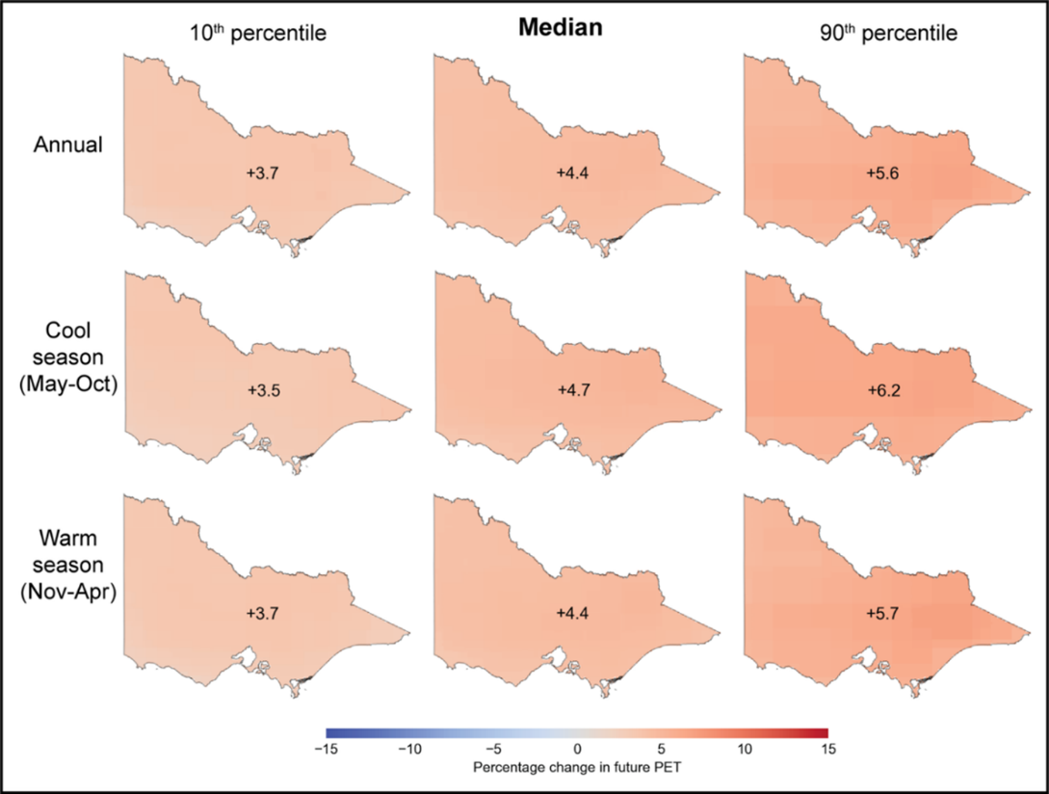
Figure 17: Projected change in mean annual, cool-season and warm-season PET across Victoria under 1.5°C average global warming from 2000.

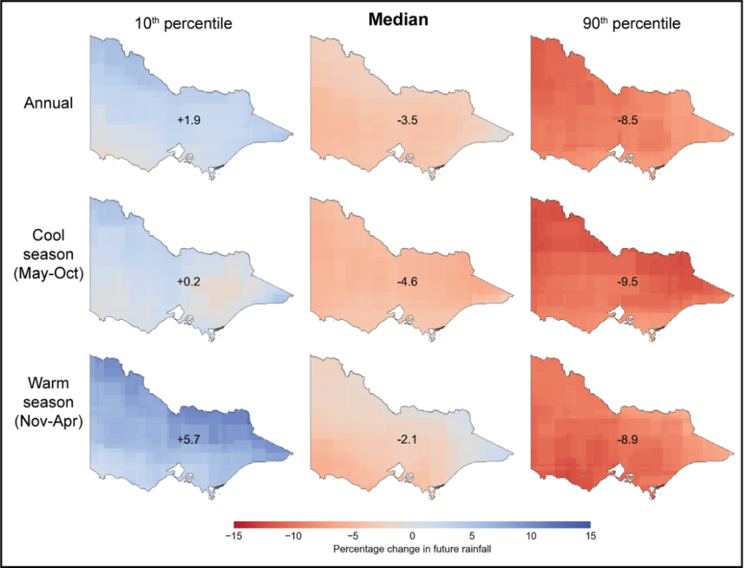
Figure 18: Projected change in mean annual, cool-season and warm-season rainfall across Victoria under 1.5°C average global warming from 2000.

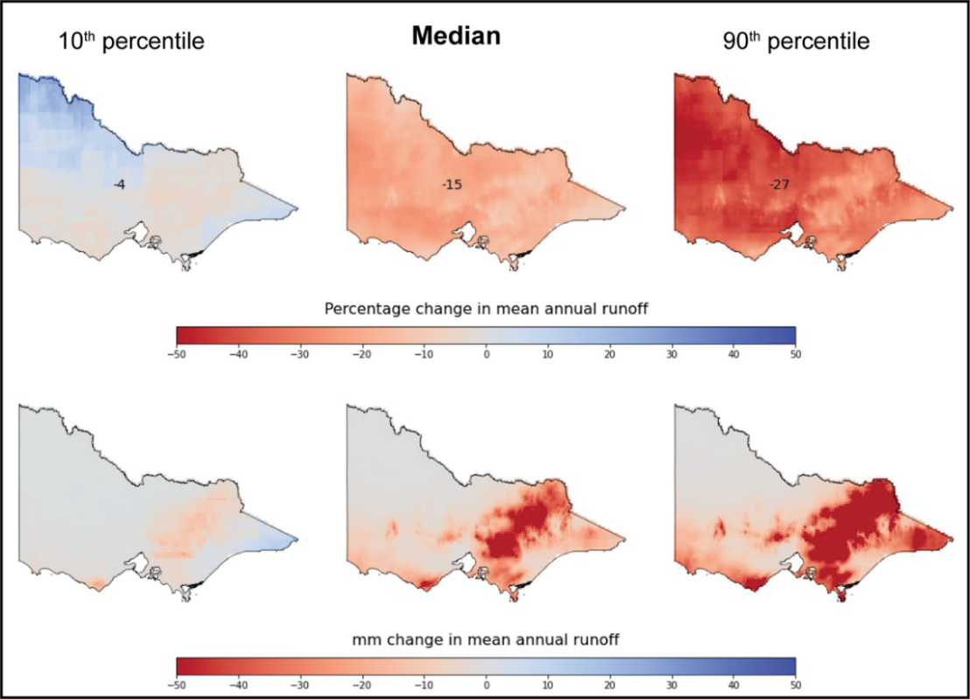
Figure 19: Projected percentage and volumetric (mm) changes in mean annual runoff across Victoria under 1.5°C average global warming from 2000.

Robustness of hydroclimate projections and limitations of method used to develop the projections
The methods adopted to derive hydroclimate projections take advantage of available climate and hydrological science, but as with any method, are subject to some uncertainties and limitations. These are outlined in further detail in the Supplementary Materials and are summarised as follows:
- Projected changes for climate variables and runoff can be estimated linearly up to ~2.5°C above the level of warming from the year 2000 (the midpoint of the post-1975 period). This is approximately equivalent to 0.7°C from the pre-industrial period. Estimation of projected changes at a greater global warming level would require reassessment of the relationships between warming and changes to climate variables.
- Rainfall‒runoff models were applied to conditions outside of the range of observed values over which the models were calibrated. This includes higher air temperature, higher PET and higher atmospheric CO₂ concentration. There are conflicting views on how vegetation will respond to these changes, but their net impact on runoff in water-limited areas like Victoria is likely to be relatively small (compared with uncertainty in future rainfall projections) and cannot yet be observed in global streamflow data (Wei et al., 2024).
- The empirical scaling method uses historical rainfall sequences to create future daily rainfall sequences.
- Chiew et al. (2022) compared runoff projections developed for south-east Australia using different hydrological impact modelling methods (different methods used to generate future climate series, different rainfall‒runoff models and model calibration) and climate projection data sources and concluded that they all indicate a likely hotter and drier future in south-east Australia, with similar values and range in the runoff projections.

Applying climate change projections
At a glance
- This chapter provides advice on how the climate change projections can be applied to different applications.
- The climate change projections are expressed relative to the year 2000 and can be directly applied to the post-1975 climate reference period datasets developed using the approaches described in chapter 4.
- In addition to annual average projections of change, cool and warm season projections are also available. Selection of which hydroclimate variables to use – e.g. average annual or seasonal, in the climate change impact assessment, should be informed by considering the application and the vulnerability of the water system to seasonal changes.
- Projections are available for both the Intergovernmental Panel on Climate Change’s (IPCC) Shared Socioeconomic Pathways (SSP) scenarios SSP2-4.5 and SSP3-7.0. The intermediate greenhouse gas emissions scenario SSP2-4.5 is recommended as suitable for most applications related to water availability, and the high greenhouse gas emissions scenario SSP3-7.0 is suitable for higher risk applications that affect water system performance later this century.

Introduction
When using the guideline projections in any climate change impact assessment, practitioners need to consider:
- the emissions scenario(s) or increase in global warming to be applied
- how uncertainty in the climate model response to global warming is represented
- the time frame over which the impact is to be assessed
- the reference period and increase in global warming to which the projections are compared
- specific points in time for which the projections are required
- the spatial resolution of the projections
- the data and tools available to assist with the assessment (e.g. rainfall‒runoff models, climate-dependent demand models, water resource models, ecological response models)
- the vulnerability of the water system to climate variability and climate change (if known)
- the changes to hydroclimate that the water system is likely to be most vulnerable to (if known).
Each of these considerations are discussed below for the purpose of assessing the impact of climate change on water availability across Victoria. Where application-specific guidance has been provided elsewhere (e.g. through other state government guidance, such as the sea level rise considerations in Victoria’s Resilient Coast guidelines (DEECA, 2023), the practitioner should defer to the assessment specifications in that guidance.

The emissions scenario or increase in global warming to be applied

Emissions scenario
Climate projections have been derived based on greenhouse gas emissions scenarios that provide a range of possible futures. In the IPCC’s Sixth Assessment Report (2023), Shared Socioeconomic Pathways (SSPs) have been used to represent future scenarios instead of Representative Concentration Pathways (RCPs). RCPs described possible trajectories of future emissions and how much extra energy would be trapped by greenhouse gases (referred to as radiative forcing) by 2100. SSPs further refine those scenarios by considering social changes or policies ‒ such as different types of energy generation, rates of population growth, economic development and land uses ‒ that contribute to different levels of greenhouse gas emissions over time (IPCC, 2023). The SSP scenarios may be similar to the RCP scenarios, but they are not identical due to differences in concentration trajectories and overall effective radiative forcing.
There are five SSP scenarios that comprise:
- two very low and low greenhouse gas emissions scenarios (SSP1-1.9 and SSP1-2.6) that have CO2 emissions declining to net zero around 2050 and 2070, respectively, followed by varying levels of net negative CO2 emissions
- one intermediate greenhouse gas emissions scenario (SSP2-4.5) that has CO2 emissions remaining around current levels until 2050
- two very high and high greenhouse gas emissions scenarios (SSP5-8.5 and SSP3-7.0) that have roughly double CO2 emissions from current levels by 2050 and 2100, respectively. SSP5-8.5 also assumes fossil-fuelled development and unconstrained growth with no CO2 removal (IPCC, 2023; NESP, 2024).
Projected global greenhouse gas emissions in 2030 show that global warming is likely to exceed 1.5°C relative to the pre-industrial period, while there are significant emissions gaps to limit warming below 2°C. This suggest that the SSP1-1.9 and SSP1-2.6 scenarios are less plausible. Very high emissions scenario SSP5-8.5 has become less likely based on current and projected global greenhouse gas emissions, although it cannot be ruled out. Global warming levels that exceed 4°C relative to the pre-industrial period could occur from lower emissions scenarios if climate sensitivity or carbon cycle feedback is higher than the best estimate.
Projections in these guidelines have been provided for the SSP2-4.5 and SSP3-7.0 emissions scenarios for the years 2025, 2050 and 2075. When considering which emissions scenario(s) to adopt for assessing the climate change impact on water availability:
- up to 2050, either SSP is suitable ‒ the level of global warming for the two emissions scenarios is similar up to 2050, so the choice of scenario has very little influence on assessment outcomes; both emissions scenarios (as presented in the modelled projections in IPCC [2023] from 2015) follow the observed rate of global warming to 2025
- beyond 2050:
- SSP2-4.5 is appropriate for most applications as the projected warming in this scenario is most similar to the current trajectory based on tracking of emissions reduction pledges, targets, policies and actions of governments around the world (e.g. UNEP, 2025; Climate Analytics and New Climate Institute, 2024)
- SSP3-7.0 is a high emissions scenario that is appropriate for water availability decisions that meet the following criteria:
  - have uncertain outcomes due to climate uncertainty
  - affect system values/performance after 2050
  - are irreversible (i.e. the decision or the associated water system cannot readily be adapted if higher warming were to eventuate)
  - have high consequences.
The SSP2-4.5 emissions scenario is suitable for most applications related to water availability. SSP3-7.0 is suitable for higher risk applications that affect water system performance after 2050. Using both SSPs could illustrate different outcomes over the long term when exploring different levels of adaptability.

Increase in global warming since 2000
These guidelines enable projected changes to climate variables and runoff to be estimated for an increase in global warming (e.g. 1.5°C) relative to the year 2000, which is the mid-point of the post-1975 climate reference period. The projections are presented as a rate of change per degree of global warming so that they can be scaled linearly. For example, if the projected change in rainfall is for a 10% change per degree of global warming from 2000 (i.e. applicable to the post-1975 climate reference period), the projected change would be 15% for a 1.5°C increase in global warming from that year.

Uncertainty in climate model response to global warming
The uncertainty in climate model response to the emissions scenarios is represented by 10th, 50th and 90th percentile projections. This reflects the distribution of projections from the range of 120 GCM simulations.
In these guidelines, this range is also referred to as the ‘high’, ‘medium’ and ‘low’ impact projections, which is a short-hand label based on their anticipated impact for most applications. The high-impact projection is associated with greater rainfall reduction and higher impacts on water availability. The low-impact projection is associated with lower rainfall reductions (or in some instances a small increase in rainfall), and therefore lower impacts on water availability.
The projections are also labelled descriptively as three distinct climate futures:
- a ‘warmer climate change projection with little change in rainfall’
- a ‘warmer and drier climate change projection’
- a ‘warmer and much drier climate change projection’.
All three projections are labelled as ‘warmer’ to emphasise the consistently projected increases in temperature and, by association, increases in potential evaporation. These labels are suggested descriptors only. They include the words ‘climate change projection’ to avoid any confusion with short-term outlook scenarios used in urban water corporation annual water outlooks. The labels can be shortened (e.g. to ‘warmer and drier’) where the risk of confusion with the labelling of short-term forecasts is low.
Other uncertainties in the climate response to global warming (e.g. potential changes in climate sequencing under projected climate change, climate futures outside of the range represented by the low- to high-impact projections) are summarised in chapter 10.

The time horizon of impact assessment
These guidelines provide projections from 2025 to 2085. Projections for a 50-year planning horizon to 2075 can be readily extracted from a table (Appendix A), while projections for other years can be derived using the per degree of global warming scaling factors (as described in chapter 6.6). The guidelines refer to near-term and long-term applications, which are broadly defined below, for the purposes of applying the guidelines.

Near-term applications
Near-term applications are those with a planning horizon of up to ~5 years, without long-term consequences. For examples:
- an urban water corporation’s annual water outlook (for projections up to ~5 years)
- a resource manager’s seasonal determination and outlook (for the coming season)
- an annual seasonal watering proposal or plan, or a drought preparedness plan with a ~5-year design life.
For near-term applications, climate variability considerations (i.e. whether it is likely to be a wet, average or dry year) will typically be of much greater significance to assessment outcomes than climate change considerations. Using data from the extended climate reference period (i.e. the ‘recent’ post-1975 climate reference period) for this analysis is adequate. This will generate a single estimate of ‘current’ water availability with respect to climate change (for a given post-1997 rainfall‒runoff response).
For near-term applications (up to ~5-year planning horizon) without long-term consequences, using data from the extended climate reference period (post-1975) is adequate.
The use of global climate models to undertake multi-year or decadal climate forecasting to help assess water availability for near-term applications is an emerging area of applied science (see Appendix B.3). However, uncertainties in these forecasts remain high at present, and their use is not recommended other than for their potential to provide additional context when interpreting water availability over multi-year periods in the near-term (within 5 years). Changes to policies or regulations that have a design life of less than 5 years (e.g. a temporary change to a bulk entitlement that has a sunset clause to cease effect after 2 years) can be considered a near-term application.

Long-term applications
Long-term applications are those with a planning horizon of beyond ~5 years. For example:
- a 50-year water resource strategy
- a near-term decision that could influence water availability over coming decades (e.g. building and commissioning a new permanent water supply asset in the next 2 years that has a design life of several decades).
For long-term applications, climate change considerations will be of increasing significance to assessment outcomes relative to climate variability considerations. Most changes to policies or regulations, such as a permanent change to a bulk entitlement, will have long-term consequences for water availability and can be considered a long-term application.
The range of climate model uncertainty (low, medium, high) for a given emissions scenario should be considered over the whole planning horizon. Practitioners may choose to emphasise or use a particular projection, depending on the level of risk and vulnerability to climate change for their given application. However, informing decision makers and stakeholders about the range of projections due to climate model uncertainty, as presented in these guidelines, will ensure awareness of and the range of plausible future water availability conditions, rather than focusing on one possible climate future to the exclusion of all others.
For long-term applications beyond a 5-year planning horizon, the range of climate model uncertainty (low, medium, high impact) for a given emissions scenario should be considered over the whole planning horizon.
Understanding the range of climate futures can also be important for identifying triggers and thresholds for adaptation pathway planning. Any comparisons between current (~2025) estimates of water availability and estimates of water availability over future decades should be on a like-for-like basis with regards to emissions scenarios and uncertainty in the climate model response to global warming. The estimate of ‘current’ water availability should be a range with respect to climate change (reflecting climate change uncertainty over the ‘recent’ (post-1975) climate reference period), when comparing that estimate against long-term water availability in future decades.

The reference period and increase in global warming
The level of global warming refers to the projected increase in global average near-surface temperature relative to a historical reference period. For example, the goal of the Paris Agreement is to limit the increase in global warming to well below 2°C relative to the levels during the pre-industrial period (1850–1900). In these guidelines, the hydroclimate projections are presented as changes relative to the post-1975 climate reference period, with future increases in global warming expressed relative to the year 2000 (the midpoint between 1975 and 2025).
To obtain projections under an increase in global warming relative to a climate reference period other than the post-1975 period, the historical increase in global warming between the two reference periods would need to be considered. In the case of estimating projected hydroclimate changes for a 2°C increase in global warming relative to pre-industrial levels, projections for climate variables or runoff from the guidelines would need to be calculated for a 1.3°C increase to account for the 0.7°C of warming that has already occurred from pre-industrial times to the year 2000 (Figure 20). Refer to chapter 6.6 for more detail.
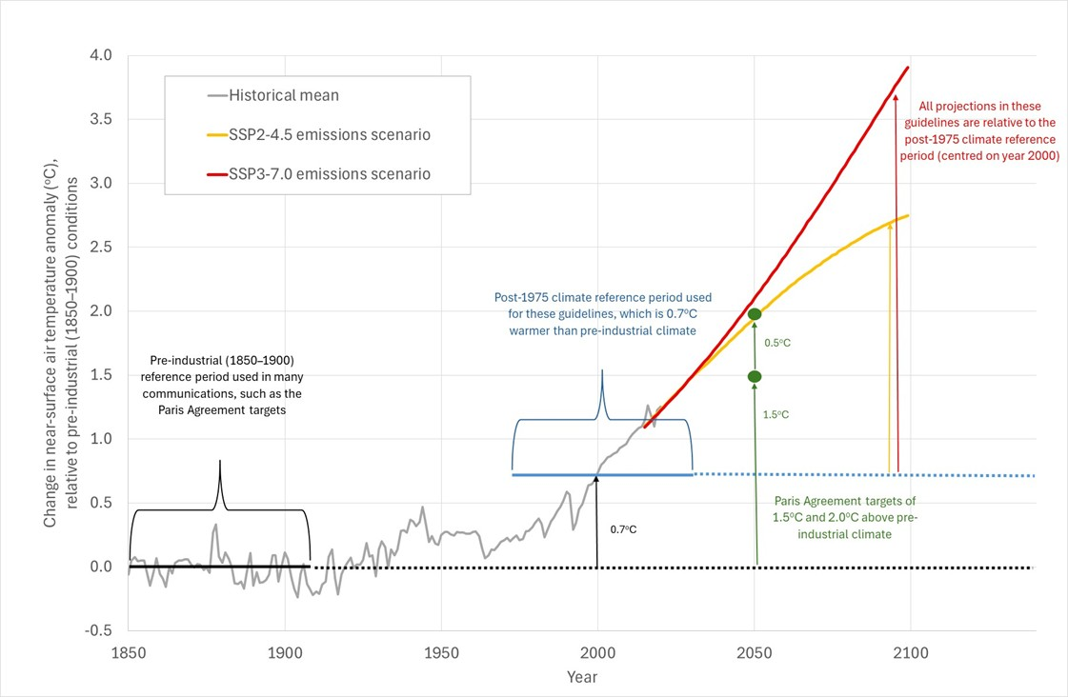
Figure 20: The global warming baseline (year 2000) for the climate change projections in these guidelines relative to pre-industrial near surface temperatures.

All climate change projections in these guidelines are expressed relative to the year 2000 and can be directly applied to the post-1975 reference climate period datasets.

Obtaining projections for a specific time horizon or increase in global warming
If projections are required for years other than 2025, 2050 and 2075, these can be generated using the projected global warming, relative to the year 2000, for the given emissions scenario. The process for doing this is illustrated in Figure 21 and comprises:
- looking up the projected mean level of global warming for the year of interest from the IPCC’s Sixth Assessment Report for the given emissions scenario (reproduced in Table 1 for SSP2-4.5 and Table 2 for SSP3-7.0)
- applying that level of global warming to the rate of climate or runoff change per degree of global warming (Δ/ºC of GW) from the climate and runoff projection tables in Appendix A in these guidelines.
For example, if a projected change in annual runoff were required for SSP2-4.5 for the East Gippsland Basin for the year 2060, relative to the post-1975 climate reference period (year 2000):
- the projected increase in global warming (from Table 1) is 1.43°C
- the projected change in annual runoff per degree of global warming (from Appendix A) ranges from +2.0% (low) to -6.0% (medium) to -15.3% (high)
- therefore, the projected change in annual runoff for the year 2060 for the East Gippsland Basin (Appendix A.1) for the SSP2-4.5 emissions scenario would range from an increase of 1.43 × 2.0 = 2.9% (low) to a decrease of 1.43 × 6.0 = 8.6% (medium) and 1.43 × 15.3 = 21.9% (high).
The mean change in global warming is used to distinguish between levels of global warming in emissions scenarios. Only the mean change is used because uncertainty in the projected climate (including local temperature) due to climate model uncertainty is already reflected in the range of projections (10th, 50th and 90th) presented in Appendix A.31.

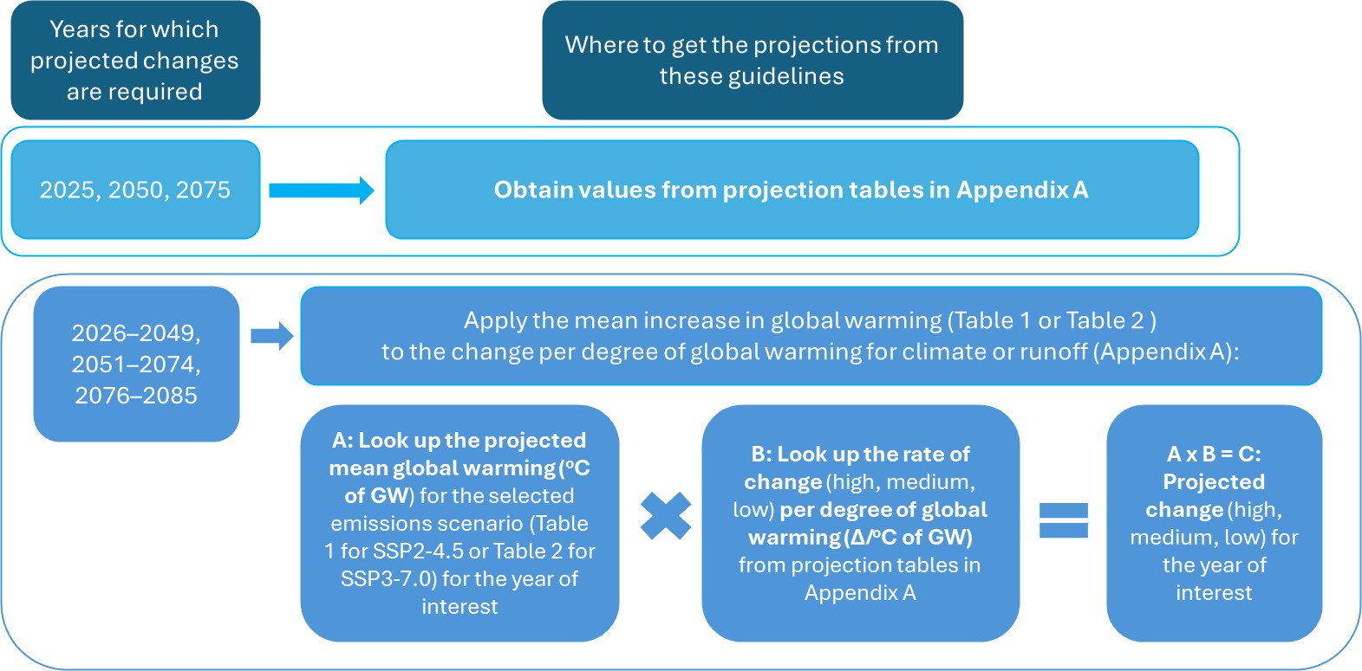
Figure 21: Projecting climate change in individual years for future planning.

Table 1: Projected change in mean global near-surface air temperature for SSP2-4.5 to apply to the post-1975 climate reference period (relative to the year 2000). Source: Adapted from IPCC (2021)
Year | Global temperature change  (°C) | Year | Global temperature change  (°C) | Year | Global temperature change  (°C)
2025 | 0.62 | 2050 | 1.21 | 2075 | 1.70
2026 | 0.65 | 2051 | 1.24 | 2076 | 1.71
2027 | 0.67 | 2052 | 1.26 | 2077 | 1.73
2028 | 0.70 | 2053 | 1.28 | 2078 | 1.75
2029 | 0.72 | 2054 | 1.30 | 2079 | 1.76
2030 | 0.75 | 2055 | 1.33 | 2080 | 1.78
2031 | 0.77 | 2056 | 1.35 | 2081 | 1.79
2032 | 0.79 | 2057 | 1.37 | 2082 | 1.81
2033 | 0.82 | 2058 | 1.39 | 2083 | 1.82
2034 | 0.84 | 2059 | 1.41 | 2084 | 1.84
2035 | 0.86 | 2060 | 1.43 | 2085 | 1.85
2036 | 0.88 | 2061 | 1.45
2037 | 0.91 | 2062 | 1.47
2038 | 0.93 | 2063 | 1.49
2039 | 0.95 | 2064 | 1.51
2040 | 0.98 | 2065 | 1.53
2041 | 1.00 | 2066 | 1.55
2042 | 1.03 | 2067 | 1.56
2043 | 1.05 | 2068 | 1.58
2044 | 1.07 | 2069 | 1.60
2045 | 1.10 | 2070 | 1.61
2046 | 1.12 | 2071 | 1.63
2047 | 1.14 | 2072 | 1.65
2048 | 1.17 | 2073 | 1.67
2049 | 1.19 | 2074 | 1.69

Table 2: Projected change in mean global near-surface air temperature for SSP3-7.0 to apply to the post-1975 climate reference period (relative to the year 2000). Source: Adapted from IPCC (2021)
Year | Global temperature change  (°C) | Year | Global temperature change  (°C) | Year | Global temperature change  (°C)
2025 | 0.61 | 2050 | 1.37 | 2075 | 2.25
2026 | 0.64 | 2051 | 1.40 | 2076 | 2.29
2027 | 0.67 | 2052 | 1.43 | 2077 | 2.33
2028 | 0.70 | 2053 | 1.47 | 2078 | 2.37
2029 | 0.72 | 2054 | 1.50 | 2079 | 2.41
2030 | 0.75 | 2055 | 1.53 | 2080 | 2.45
2031 | 0.78 | 2056 | 1.57 | 2081 | 2.48
2032 | 0.81 | 2057 | 1.60 | 2082 | 2.52
2033 | 0.84 | 2058 | 1.63 | 2083 | 2.56
2034 | 0.87 | 2059 | 1.67 | 2084 | 2.60
2035 | 0.89 | 2060 | 1.70 | 2085 | 2.64
2036 | 0.92 | 2061 | 1.74
2037 | 0.96 | 2062 | 1.77
2038 | 0.99 | 2063 | 1.81
2039 | 1.01 | 2064 | 1.85
2040 | 1.05 | 2065 | 1.89
2041 | 1.08 | 2066 | 1.92
2042 | 1.11 | 2067 | 1.96
2043 | 1.14 | 2068 | 1.99
2044 | 1.17 | 2069 | 2.03
2045 | 1.21 | 2070 | 2.06
2046 | 1.24 | 2071 | 2.10
2047 | 1.27 | 2072 | 2.14
2048 | 1.30 | 2073 | 2.18
2049 | 1.33 | 2074 | 2.21

The spatial resolution of projections
The projections in these guidelines are presented by river basin and are applicable to all locations within a river basin, which are considered appropriate for most water availabilities applications.
For finer scale climate change projections:
- Change factors are available for download in gridded NetCDF format (Hydroclimate projections for Victoria). These are presented for 5 × 5 km² grids and are based on GCM projections generated at a much coarser scale (in the order of 100 × 100 km² grids). These finer scale climate change projections do not necessarily contain more information, because they are spatially disaggregated without any consideration of local climate processes at this finer spatial scale. This information is recommended primarily for research applications due to the data format and size.
- Victoria’s Future Climate Tool (DEECA, 2025c) presents the VCP19 and VCP24 regional climate model projections for Victoria, which are provided for 5 × 5 km² grids. The tool explains the differences between the VCP19 and VCP24 projections and allows users to interrogate both datasets. Note that different emissions scenarios (SSP1-2.6 and SSP3-7.0 for VCP24; RCP4.5 and RCP8.5 for VCP19) and a smaller subset of input global climate models have been used for the VCP projections, relative to projections in these guidelines. The VCP19 projections provide information about the relative spatial differences in climate system response, but have several limitations, such as a significant warm bias along the east coast of Victoria, poorer representation of mean sea level pressures than their host GCMs, and an overestimation of wind speeds in winter for a given level of pressure (Clarke et al., 2019).
Projections in these guidelines are presented by river basin and applicable to all locations within a river basin. In most cases these projections are considered appropriate.
Practitioners can use the VCP24 climate change projections from Victoria’s Future Climate Tool for fine scale applications that may benefit from exploring the impact of high-resolution projections from a smaller subset of climate models.

The data and tools available for the assessment
The quality and extent of data available climate change impact assessments will influence the approach taken. Where data quality and extent are poor, the application of more complex climate change impact assessment methods may be unwarranted, and could suggest a level of precision in outcomes that is not commensurate with the uncertainty in the hydroclimate information.
Models and tools can be used to assist with climate change impact assessments, such as rainfall‒runoff models, climate-dependent demand models, water resource models, ecological response models and water quality models. Their input requirements (e.g. time step, input variable type) can influence the type of projection information drawn from the guidelines. For example, for an environmental flow assessment that has different seasonal objectives, the projected change in seasonal climate and runoff would be more likely to be suitable to apply than the projected annual changes.

Rainfall‒runoff models
Projections are available for both rainfall and runoff. For those with access to a well-calibrated rainfall‒runoff model, there may be advantages in using rainfall projections as an input, to account for local changes in soil moisture accumulation. Using the rainfall projections from these guidelines, the rainfall‒runoff model can be applied to generate changes in runoff sequencing, such as changes in the proportion of time with cease-to-flow conditions due to changing soil moisture conditions. These changes are not represented when applying the runoff projections from these guidelines.
A summary of the strengths and challenges of the two different approaches (i.e. using the runoff projections or using the rainfall projections plus a rainfall‒runoff model) for generating projected changes in runoff, adapted from an assessment by CSIRO, is provided in Table 3. Rainfall‒runoff models are simple representations of complex hydrological processes and can perform poorly in a drying climate (Fowler et al., 2020), so they must be demonstrated to have an acceptable goodness-of-fit for any given application before being applied.
Table 3: Use of runoff projections versus rainfall projections for projecting future changes in runoff.
 | Use of runoff projections from these guidelines | Use of rainfall projections from these guidelines
Input | - Projected runoff change factor | - Projected rainfall and PET change factors, rainfall‒runoff model
Output | - Scaled historical runoff | - Projected runoff from rainfall‒runoff model
Best used | - When estimating changes to average annual or average seasonal system performance  - Water system with large storage capacity and low variability in inflows | - When estimating changes to flow distribution  - Water system with high variability in inflows, or intermittent flow
Strengths | - Easy to apply | - Better representation of non-linear hydrological processes (e.g. changes to cease-to-flow, length of spells)
Challenges | - May overestimate or underestimate the impact of climate change on runoff at a local scale | - Requires a well-calibrated rainfall‒runoff model, which can be difficult in a drying climate  - More time-consuming, particularly for water systems with many sub-catchment inflows

Rainfall‒runoff model calibration
When calibrating a rainfall‒runoff model in a drying climate, Fowler et al. (2018) recommend using objective functions for calibration that are not unduly biased towards high flows. One suggested approach is to combine measures of model performance corresponding to separate and distinct calibration periods. This could include, for example, using a single objective function that evenly weights calibration metrics (e.g. the Kling Gupta Efficiency, or KGE) for the pre-1997 period, the Millennium Drought (1997‒2009) and the post-Millennium Drought period. Such an approach biases the calibration to the post-1997 period (by weighting two-thirds of the overall goodness-of-fit measure to the post-1997 period) but also considers calibration performance in wetter sequences such as those seen in the pre-1997 period.
A suitable approach could also include the use of a staged calibration process that considers multiple objective functions (e.g. the sum/log/power daily exceedance curve and bias) targeting performance for different aspects of the flow regime.
As part of its rainfall‒runoff model calibration, DEECA undertakes rainfall‒runoff modelling using FORS calibration (Egan, 2024) that also spatially weights rainfall data as part of the calibration process.

The vulnerability of the water system to climate variability and climate change
The vulnerability of the water system to climate variability should inform the selection of hydroclimate variables to use in the climate change impact assessment. This vulnerability can be assessed based on an understanding of historical water system behaviour under climate variability, previous modelling or assessment of the system, or potentially a stress test.
The selection of variables from the climate change projections in these guidelines will primarily be based on the vulnerability of the water system.

Choosing rainfall variables
When considering changes in future rainfall:
- For an application with low vulnerability to climate variability and change, the average annual rainfall projections in the guidelines can be applied. An example application could be future inflow estimation for a water system with a very large storage capacity, where any future seasonal changes in inflow are buffered when storing the water for several years.
- For most applications in climate-dependent water systems, the seasonal rainfall projections in the guidelines, in combination with the guideline changes in very heavy daily rainfall, can be applied. This option is consistent with current climate science, which anticipates likely cool-season rainfall decline in Victoria, and increases in rainfall intensity on days of very heavy rainfall. This approach requires only marginally more effort than applying annual rainfall projections.
- If the water system is highly vulnerable to changes in rainfall sequencing, rather than just changes in mean rainfall, alternative approaches such as using stochastic data or applying stress testing should be considered. These approaches range from requiring low effort (e.g. stress testing based on rearranging the Millennium Drought) to much higher effort (e.g. stochastic data generation).
A summary of the various rainfall projection parameters that can be selected for the climate change impact assessment, informed by system vulnerability to climate variability and change is provided in Figure 22.

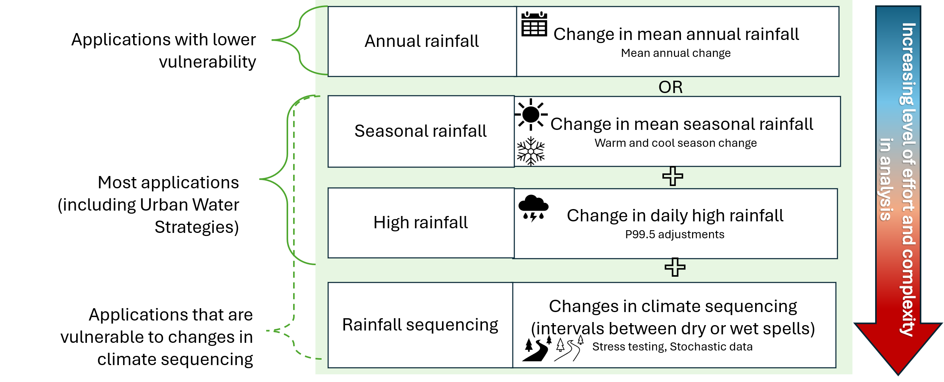
Figure 22: Rainfall projection parameter selection and approach, with increasing vulnerability (and risk) to climate variability and change.

Choosing runoff variables
The same concept applies to the selection of runoff projection parameters (Figure 23). When considering changes in future runoff:
- For an application with low vulnerability to climate variability and change (and hence lower risk), the average annual runoff projections in the guidelines can be applied. An example application could be future inflow estimation for a water system with a very large storage capacity, where any future seasonal changes in inflow are buffered when storing the water for several years.
- For most applications in climate-dependent water systems, the seasonal runoff projections in the guidelines can be applied. This is consistent with current climate science, which anticipates likely cool-season rainfall decline in Victoria. This approach requires only marginally more effort than applying annual runoff projections.
- If the water system is highly vulnerable to changes in runoff sequencing rather than just changes in mean runoff, alternative approaches such as using stochastic data or applying stress testing may need to be considered. These approaches require much higher effort.

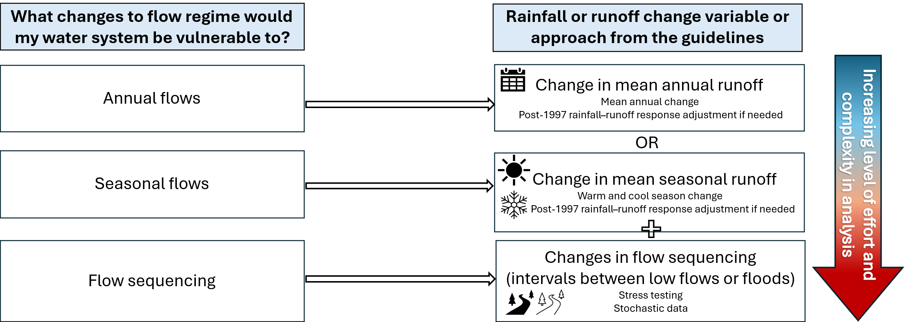
Figure 23: Runoff projection parameter selection and approach, with increasing vulnerability (and risk) to climate variability and change.

As noted in chapter 6.8, a well-calibrated rainfall‒runoff model can be used to route rainfall through soil moisture storage, to provide additional insights about changes in non-linear hydrological processes, such as changes in cease-to-flow conditions and length of spells due to the interaction of rainfall with the landscape, soil profile and water table of aquifers.
When considering changes in future runoff via a rainfall‒runoff model (Figure 24):
- For an application with low vulnerability to climate variability and change (and hence lower risk), the average annual rainfall projections can be applied. This is the lowest effort option that is suitable when climate-related risks to water availability are low.
- For most applications in climate-dependent water systems, the seasonal rainfall projections in combination with changes in very heavy daily rainfall can be applied. This option is consistent with current climate science, which anticipates likely cool-season rainfall decline in Victoria, and increases in rainfall intensity on days of very heavy rainfall. This approach requires only marginally more effort than applying annual rainfall projections.
- If the water system is highly vulnerable to changes in rainfall sequencing rather than just changes in mean rainfall, alternative approaches such as using stochastic data or applying stress testing may need to be considered. These approaches range from requiring low effort (e.g. stress testing based on rearranging the Millennium Drought) to much higher effort (e.g. stochastic data generation).
The runoff projections made using the rainfall projections together with a local rainfall‒runoff model can be checked against the mean annual runoff projections in these guidelines for a sample point in time (e.g. 2050 or 2075). This could be used to confirm that the rainfall‒runoff model is behaving within reasonable expectations, based on the knowledge of the local catchment and its likely hydrological response in a drying climate, relative to the rainfall‒runoff response averaged across the river basin.

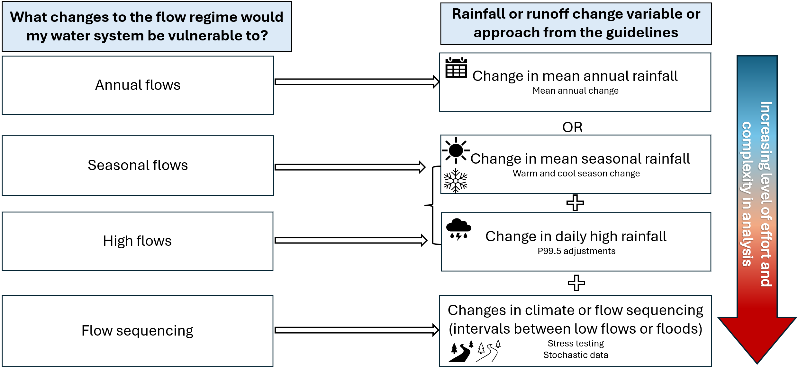
Figure 24: Rainfall projection parameter selection and approach when using a rainfall‒runoff model.

A post-1975 reference period streamflow dataset can sometimes include a mix of observed data and data simulated using a rainfall‒runoff model. When this occurs, a decision must consider whether to apply the projected runoff changes to this composite time series or replace the observed runoff data with the simulated runoff data. When only simulated runoff data are used, the projected changes in rainfall can be applied to the rainfall‒runoff model inputs to generate projected runoff using the model. As discussed previously in chapter 6.8, this choice will depend on the quality of the rainfall‒runoff model, particularly its goodness-of-fit to post-1997 observed flow behaviour. It may also be useful to test the sensitivity of system performance to both approaches if there is uncertainty about the potential benefits or otherwise of using a rainfall‒runoff model.

Applying the climate change projections to different impact assessment types
There are different ways in which a climate change impact assessment can be undertaken to support different planning decisions. Impact assessment techniques are typically categorised into either ‘top-down’ or ‘bottom-up’ approaches, or a combination of the two. The broad process for these two approaches (Figure 25: Top-down and bottom-up approaches to climate change impact assessments.) can be described as:
- A top-down approach uses climate change projections from climate models as scenarios. The climate change impact assessment identifies changes in system performance or values under these scenarios. The scenarios are based on a set of input assumptions, generating outputs that can be used for multiple purposes and water system types.
- A bottom-up approach involves stressing the system systematically to identify the magnitude of future change in climate input that would result in unsatisfactory performance or loss of values. This approach is sometimes referred to as ‘scenario neutral’ because it does not rely on any particular greenhouse gas emissions scenario. A bottom-up approach often starts with co-design with stakeholders for an individual water system to identify what type of climate change impacts are of most relevance to system performance and values.
In practice, a bottom-up approach is usually coupled with a top-down assessment to place any stress test results in the context of plausible future climate change.
Applying the projections in these guidelines at different points in time over a long planning horizon also allows adaptation pathways to be explored, which can reduce the potential for maladaptation.

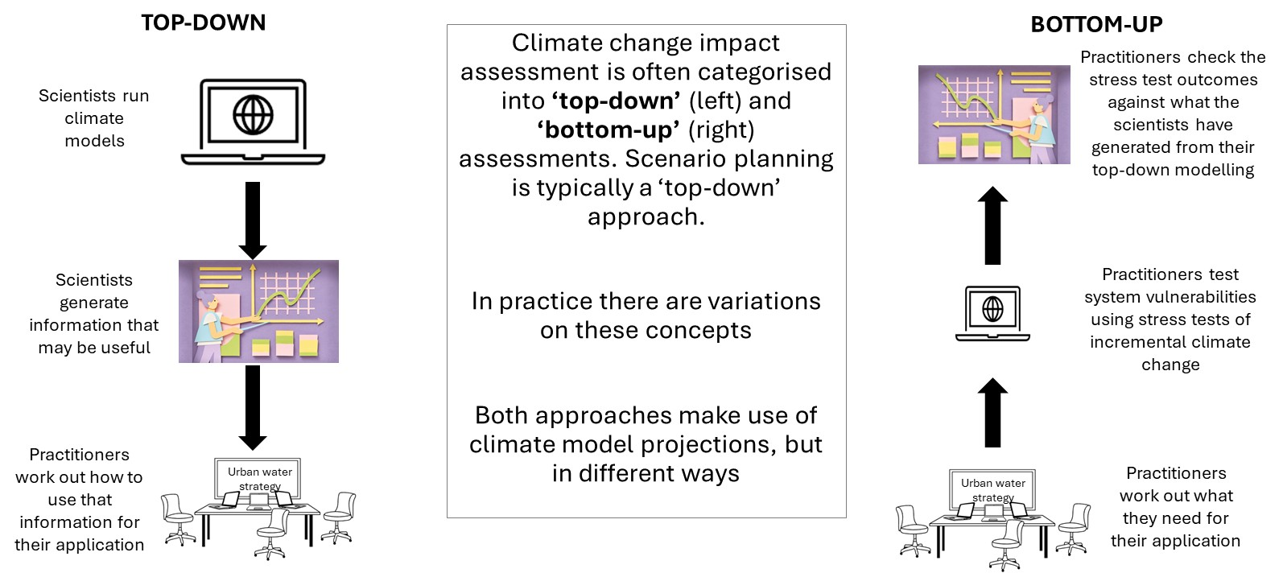
Figure 25: Top-down and bottom-up approaches to climate change impact assessments.
The projections in these guidelines can be used to support either a top-down or a bottom-up approach to climate change impact assessment.
Further information about the benefits and limitations of the various approaches to impact assessment to support decision-making processes in different situations can be found in Supplementary Materials - chapter 2. Water resource analysis to support bottom-up approaches typically requires more computing effort. Potential adjustments to water resource modelling setup to reduce this effort during climate change scenario exploration are discussed in the Supplementary Materials.
The hydroclimate projections in these guidelines are presented as projections from the global climate models, for a defined set of hydroclimate variables, at a given point in time (2025, 2050 and 2075) or as a rate of change per degree of global warming that can be applied at any point in time. While there was some co-design of output variable selection with stakeholders during development of these guidelines to maximise their utility, these output variables are not specifically tailored to any individual application.
These guideline projections can directly support top-down assessments (e.g. scenario planning with adaptive management) or can be used to place bottom-up assessments in the context of plausible future climate change. To support bottom-up impact assessments, typically the projections from all available emissions scenarios at a given point in time (or for a given level of global warming) are overlain onto the stress-test results. In these guidelines, projections are available for SSP2-4.5 and SSP3-7.0 emissions scenarios.

Changes to water availability: Performance metrics
If a performance metric is required at a specific point in time (or global warming level), it is better to estimate that performance from projected climate inputs at that point in time, rather than interpolating between estimates of performance from other points in time, unless that performance is demonstrated to respond linearly with changes in climate.
This chapter provides guidance on applying climate projections to water system performance metrics that can vary with climate, such as supply system yield, supply system reliability, environmental flow compliance, and cost. A performance metric may also potentially be a trigger within an adaptive pathway. These performance metrics are typically calculated by running hydroclimate inputs through a water system response model. Where the performance metrics respond linearly to climate change, the performance at relatively few points in time over a planning horizon can be used to infer performance over the whole planning horizon by linearly interpolating. Similarly, if any non-linearity in performance is of negligible consequence to subsequent decision making or reporting, linear interpolation of performance under projected climate change may be suitable.
Sometimes performance metrics may exhibit threshold behaviour with respect to climate change, whereby a small incremental change in climate results in either no change in performance or a rapid (step or steep) change in performance, or both. Sensitivity testing (see the Supplementary Materials) can help identify non-linear responses in performance to changes in climate. Where performance is demonstrated or considered likely to be non-linear with respect to changes in climate, linear interpolation of performance outcomes may no longer be appropriate, and performance may need to be estimated at a greater number of points along the planning horizon. The level of effort needed will be higher than simple linear interpolation, with the number of points required along the planning horizon being a trade-off between level of effort and improvement in knowledge about any non-linearity of performance. This is demonstrated with two theoretical cases in Figure 26.
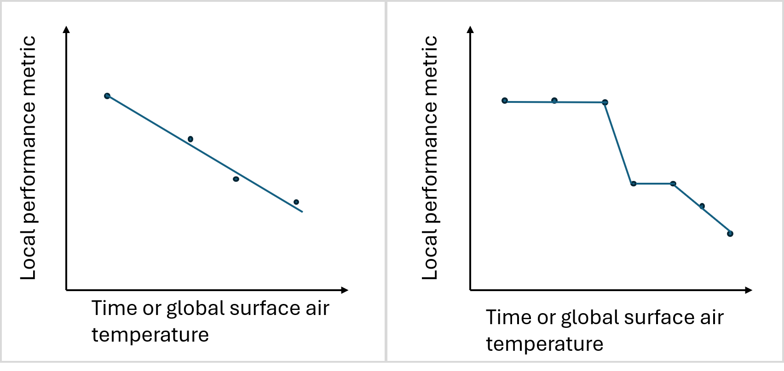
Figure 26: An example of the linear (left) and non-linear (right) response of a performance metric to global warming.
The pattern scaling approach for generating the hydroclimate projections in these guidelines assumes a linear change in hydroclimate (i.e. local temperature, evapotranspiration, rainfall and runoff) with changes in global warming. While this is a reasonable assumption over a multi-decadal timescale, this may not necessarily be the case over a shorter single period or multi-year periods. There is the potential for rapid changes in local hydroclimate, interspersed by short periods of stable climate, in response to global warming, as has occurred historically. This uncertainty in the trajectory of climate variables due to global warming in individual years or sub-decadal multi-year periods is discussed in chapter 10.

Projections by river basin
At a glance
- Projected changes in climate variables and runoff are available for each river basin in Victoria (see Appendix A).
- The projections averaged across Victoria are presented in this chapter, including average annual, warm season and cool-season rainfall and runoff projections.
- Examples of how to apply the projections are also provided.

Introduction
Climate change projections for Victoria are presented by river basin in Appendix A. The statewide projections in Table 4 are presented here as an example – a copy of one of the 30 data tables are in Appendix A. These projection data tables are applicable for water availability and water demand estimation. Definitions, assumptions and exclusions that will help to interpret the projections have also been provided.

Definitions
The following definitions apply when interpreting these tables:
- All projections are relative to the year 2000, which is the approximate midpoint of the post-1975 climate reference period (1975‒2025). They can be directly applied to the post-1975 climate reference period hydroclimate datasets.
- The uncertainty in climate model response to the emissions scenarios is labelled in three ways:
- 10th, 50th and 90th percentile projections, reflecting the plausible range of projections from the global climate model ensemble
- high, medium and low impact, which is a short-hand label based on their anticipated impact for most applications ‒ the high impact scenario (90th percentile projection) is associated with greater reduction in rainfall, greater increase in PET and higher impacts on water availability; the low impact scenario (10th percentile projection) is associated with lower reduction in rainfall (or in some instances a small increase in rainfall), lower increase in PET and therefore lower impacts on water availability
- as labels that describe three distinct climate futures based on projected rainfall, relative to the year 2000 ‒ these are a ‘warmer climate change projection with little change in rainfall’ (10th percentile projection), a ‘warmer and drier climate change projection’ (50th percentile projection) and a ‘warmer and much drier climate change projection’ (90th percentile projection). All three projections are labelled as ‘warmer’ to emphasise the consistently projected increases in temperature and, by association, increases in potential evaporation. These labels are suggested descriptors only. They include the words ‘climate change projection’ to avoid any confusion with short-term outlook scenarios used in urban water corporation annual water outlooks. These labels can be shortened (e.g. to ‘warmer and drier’) where the risk of confusion with the labelling of short-term forecasts is low.
Δ/°C of GW represents the projected change in a climate variable or runoff per degree of global warming, for use when estimating projected changes between 2025, 2050 and 2075, or from 2076 to 2099. The level of global warming for the two SSPs for each year from 2025 to 2099 is presented in
Table 1
- Table 1 and Table 2Table 2 in chapter 6.
- Temp indicates the projected change in average daily temperature for each river basin. It can be applied to daily maximum, daily average and daily minimum temperatures. Note that this is presented as a range and is different from the average level of global warming for each SSP. This is because it reflects the local air temperature response to global warming (rather than a global average) and incorporates the uncertainty in climate model response to global warming on local air temperature. As discussed in chapter 9, if an air temperature input is required for demand modelling, the 50th percentile projection in the ‘Temp’ variable would typically be used.
- PET is potential evapotranspiration and is applicable to the various indicators of PET (e.g. pan evaporation, Morton’s shallow lake evaporation).
- 99.5th percentile precipitation corresponds to days of very heavy rainfall (exceeded on 0.5% of days, or 1.8 days per year on average or a 1.8 EY event). This threshold for applying changes to rainfall intensity under projected climate change is broadly consistent with the guidance in Australian Rainfall and Runoff (Wasko et al., 2024). The rainfall change factors for this variable can be applied to all daily rainfall values above the 99.5th percentile rainfall value, as calculated from the post-1975 climate reference period dataset. Daily rainfall values that are exceeded more frequently (e.g. on 10% or 20% of days) are not scaled for changes in rainfall intensity, consistent with the guidance in Wasko et al. (2024).
- The cool season covers the months May to October inclusive, and the warm season covers the months November to April inclusive. Differences in seasonal rainfall and runoff projections are supported by the available science outlined in chapter 3.1. The seasonal projections for local temperature and PET were not significantly different from the annual projections for these climate variables. The annual projections for these two variables are therefore representative of changes that would be expected seasonally. The aggregation of the seasonal 10th or 90th percentile projections can be wider than the 10th or 90th percentile projections at the annual scale.
- River basins are defined by the Australian Water Resources Management Committee boundaries. These boundaries are the same as those used by Victoria’s Water Measurement Information System (DEECA, 2025d) and Victorian Water Accounts (DEECA, 2025e). A statewide average is also presented, which is the average of the individual grid cells used to generate the projections across the state, and will not be equal to the average of the river basin projections.

Assumptions
Note that the range of projections (the 10th, 50th and 90th percentile) are derived for each climate variable from the available GCM simulations. To create and apply a climate scenario consistently in an assessment, hydroclimate variables that correspond to the same percentile (e.g. 90th percentile) can be selected to represent the same impact of climate change (e.g. high impact). For example, a high impact scenario that represents a drier and warmer climate can be created using the 90th percentile projections of various hydroclimate variables, which comprises of greater reduction in rainfall, greater increases in air temperature and PET, greater reduction in runoff.

Exclusions
The projections in these guidelines are designed to meet the needs of practitioners for a wide range of water availability assessments. Projections for some climate change impacts that are less directly related to water availability have not been provided. These include projections for sea level rise, and changes in days or nights of extreme temperature, both of which may be relevant for integrated water cycle management applications, for example. Alternative sources for these climate change projections are listed and discussed in further detail in the Supplementary Materials.
Projections for changes in sub-daily rainfall time series are not provided, as there are currently no reliable projections for time series rainfall changes at these short time steps (e.g. for 6-minute rainfall data). This is consistent with the guidance in Australian Rainfall and Runoff (Wasko et al., 2024) and is further discussed in Appendix B.7. Stochastic data approaches could potentially be used if understanding sub-daily rainfall variability beyond that available from historical observations is important for a given application.
Projected changes in rainfall (and runoff) variability have not been presented due to the difficulties in characterising changes in rainfall variability, independent of changes in mean conditions, in a way that is meaningful to practitioners. There is also lower confidence in information about changes to rainfall variability from climate models (e.g. changes in drought severity or duration), relative to projected changes in mean rainfall behaviour. GCM outputs post-processed by CSIRO indicated that the coefficient of variation of annual rainfall is likely to increase under projected climate change across all of Victoria (see chapter 5 for more information). This is consistent with the key messages from the climate science research available for these guidelines, which indicates likely increased rainfall variability due to the combination of a drier climate on average (reducing rainfall in dry periods) and increased rainfall intensity on days of very heavy rainfall (increasing rainfall in very wet periods).
Projected changes in runoff due to changes in snow cover are potentially relevant to alpine areas of Victoria and are discussed in Appendix B.8.

Table 4: Climate change projections to apply to the post-1975 reference period for Victoria.*
 |  |  |  |  | Precipitation (%) |  |  |  | Runoff (%)
Emissions scenario | Climate model response to emissions scenario | Year | Annual temp (°C) | Annual PET (%) | 99.5th percentile | Annual | Cool season (May‒Oct) | Warm season (Nov‒Apr) | Annual | Cool season (May‒Oct) | Warm season (Nov‒Apr)
SSP2-4.5 | Low: 10th percentile  ‘Warmer climate change projection with little change in rainfall’ | 2025 | 0.5 | 1.5 | 4.1 | 0.8 | 0.1 | 2.4 | -1.6 | -1.2 | -1.4
SSP2-4.5 |  | 2050 | 1.0 | 3.0 | 8.0 | 1.6 | 0.1 | 4.7 | -3.0 | -2.3 | -2.8
SSP2-4.5 |  | 2075 | 1.4 | 4.2 | 11.2 | 2.2 | 0.2 | 6.6 | -4.2 | -3.3 | -3.9
SSP2-4.5 |  | Δ/ºC of GW | 0.8 | 2.5 | 6.6 | 1.3 | 0.1 | 3.9 | -2.5 | -1.9 | -2.3
SSP2-4.5 | Medium: 50th percentile  ‘Warmer and drier climate change projection’ | 2025 | 0.6 | 1.8 | 2.3 | -1.4 | -1.9 | -0.9 | -6.0 | -6.0 | -6.3
SSP2-4.5 |  | 2050 | 1.1 | 3.6 | 4.5 | -2.8 | -3.7 | -1.7 | -11.6 | -11.7 | -12.2
SSP2-4.5 |  | 2075 | 1.6 | 5.0 | 6.4 | -4.0 | -5.2 | -2.3 | -16.3 | -16.4 | -17.1
SSP2-4.5 |  | Δ/ºC of GW | 0.9 | 3.0 | 3.8 | -2.3 | -3.1 | -1.4 | -9.6 | -9.6 | -10.1
SSP2-4.5 | High: 90th percentile  ‘Warmer and much drier climate change projection’ | 2025 | 0.7 | 2.3 | 0.1 | -3.5 | -3.9 | -3.7 | -10.9 | -10.7 | -11.4
SSP2-4.5 |  | 2050 | 1.3 | 4.6 | 0.3 | -6.9 | -7.6 | -7.2 | -21.3 | -20.9 | -22.2
SSP2-4.5 |  | 2075 | 1.8 | 6.4 | 0.4 | -9.7 | -10.7 | -10.1 | -29.9 | -29.3 | -31.2
SSP2-4.5 |  | Δ/ºC of GW | 1.1 | 3.8 | 0.2 | -5.7 | -6.3 | -5.9 | -17.6 | -17.2 | -18.3
SSP3-7.0 | Low: 10th percentile  ‘Warmer climate change projection with little change in rainfall’ | 2025 | 0.5 | 1.5 | 4.1 | 0.8 | 0.1 | 2.4 | -1.5 | -1.2 | -1.4
SSP3-7.0 |  | 2050 | 1.1 | 3.4 | 9.0 | 1.8 | 0.2 | 5.3 | -3.4 | -2.6 | -3.1
SSP3-7.0 |  | 2075 | 1.8 | 5.6 | 14.9 | 2.9 | 0.3 | 8.8 | -5.6 | -4.4 | -5.1
SSP3-7.0 |  | Δ/ºC of GW | 0.8 | 2.5 | 6.6 | 1.3 | 0.1 | 3.9 | -2.5 | -1.9 | -2.3
SSP3-7.0 | Medium: 50th percentile  ‘Warmer and drier climate change projection’ | 2025 | 0.6 | 1.8 | 2.3 | -1.4 | -1.9 | -0.8 | -5.9 | -5.9 | -6.2
SSP3-7.0 |  | 2050 | 1.3 | 4.0 | 5.1 | -3.2 | -4.2 | -1.9 | -13.1 | -13.2 | -13.7
SSP3-7.0 |  | 2075 | 2.1 | 6.7 | 8.4 | -5.2 | -6.9 | -3.1 | -21.6 | -21.7 | -22.7
SSP3-7.0 |  | Δ/ºC of GW | 0.9 | 3.0 | 3.8 | -2.3 | -3.1 | -1.4 | -9.6 | -9.6 | -10.1
SSP3-7.0 | High: 90th percentile  ‘Warmer and much drier climate change projection’ | 2025 | 0.6 | 2.3 | 0.1 | -3.5 | -3.9 | -3.6 | -10.8 | -10.6 | -11.3
SSP3-7.0 |  | 2050 | 1.4 | 5.1 | 0.3 | -7.8 | -8.6 | -8.1 | -24.0 | -23.5 | -25.0
SSP3-7.0 |  | 2075 | 2.4 | 8.5 | 0.5 | -12.8 | -14.2 | -13.3 | -39.6 | -38.8 | -41.3
SSP3-7.0 |  | Δ/ºC of GW | 1.1 | 3.8 | 0.2 | -5.7 | -6.3 | -5.9 | -17.6 | -17.2 | -18.3
*The statewide change is not an average of the changes for each river basin. This is because the river basins vary in size and some basins include areas that fall within New South Wales.

Case study examples
The following three case studies illustrate how the guidelines could be applied to different situations. These case studies are hypothetical and generic in nature, and the is some subjectivity when deciding levels of risk and vulnerability, and the suitability of available tools (e.g. rainfall‒runoff model) to support the assessment. As noted in chapter 6.1, where other guidance on the desired approach for undertaking a climate change impact assessment is available for the application, the practitioner should consider the suitability of the following case study examples within the context of that other guidance.

Case study 1: Near-term application without long-term consequences

Assessment context
This application is for an operational plan or forecast with a design life or outlook of less than 5 years. Over this time frame, climate variability considerations are expected to be of greater importance than climate change considerations. Any threat to this water system’s performance or values is likely to occur during summer/autumn low-flow periods. The consequences of poor performance or loss of values in this water system are low because of access to low-cost contingency measures.

Guideline step 1
Distinguish recent climate from past climate and extend the data to capture a greater range of climate variability:
- Establish the 1975‒2025 dataset using gauged data, supplemented by gauged transposition (chapter 4.2).
- Extend the information about climate variability by adjusting the gauged pre-1975 data by seasonal (cool/warm) decile scaling (chapter 4.3.2).
- Assess performance or changes to water system values using water resource models and system response models (if applicable).

Case study 2a: Near-term application with long-term consequences of low risk

Assessment context
This application is for a long-term strategy, prepared in 2025, with a planned life of approximately 5 years before it is next reviewed and updated. From a previous strategy for the same water system, undertaken 5 years ago, it is expected that an action will be required over the next 5 years (i.e. a near-term decision), but that decision is adaptable in subsequent 5-year periods due to the ability for stage implementation. Any threat to this water system’s performance or values is likely due to the failure of winter/spring rainfall followed by very low flow or cease-to-flow periods in summer/autumn. For this application, there is a well-calibrated rainfall‒runoff model available for inflows in the water system, which in this case was potentially useful for understanding low-flow behaviour over summer and autumn.

Guideline step 1
Distinguish recent climate from past climate and extend the data to capture a greater range of climate variability:
- Establish the 1975‒2025 dataset using a rainfall‒runoff model that has been demonstrated to perform well in the post-1997 period (chapter 4.2, 6.8).
- Extend the data to capture a greater range of climate variability by applying seasonal (cool/warm) decile scaling to the pre-1975 modelled data (chapter 4.3.2).
- Calculate the 99.5th percentile daily rainfall (i.e. the daily rainfall exceeded on 0.5% of days) using the extended dataset.

Guideline step 2
Project future climate change:
- Adopt the SSP2-4.5 emissions scenario only (see chapter 6.4 – it is a near-term decision without significant long-term consequences) and look up the projected changes in cool- and warm-season rainfall, 99.5th percentile rainfall and PET for the low (10th percentile), medium (50th percentile) and high (90th percentile) projections for 2025, 2050 and 2075 (chapter 7, Appendix A). The seasonal projections are preferred because of the risk during summer/autumn low-flow periods.
- Interpolate the projections for the years 2030 and 2035 using the rate of global warming for SSP2-4.5 to obtain more information about water availability around the time of the proposed action (chapter 6.6).
- Apply the projected changes in rainfall and PET to the post-1975 climate dataset for the years 2025, 2030, 2035, 2050 and 2075 (chapter 6.6).
- Run the rainfall‒runoff model to estimate runoff in 2025, 2030, 2035, 2050 and 2075. Check the projected change in runoff from the model against the runoff projections in the guidelines (chapter 7, Appendix A) for a sample point in time to confirm that they are reasonably similar, or that any major differences can be accounted for based on a conceptual understanding of the local rainfall‒runoff response relative to that for the river basin as a whole.
- Apply the projected medium (50th percentile) rainfall, PET or local temperature change for 2025, 2030, 2035, 2050 and 2075 to any climate-dependent demand models that use those climate inputs (chapter 9).
Assess performance or changes to water system values using water resource models and system response models (if applicable), with and without the proposed action.

Case study 2b: Near-term application with long-term consequences of low risk

Assessment context
This application is for assessments that can support the design of integrated water cycle management assets with time series behaviour analysis. In this context, the assessments could include:
- a rainwater tank reliability of supply assessment,
- estimation of the reliability of urban irrigation demand, or
- a reliability of supply assessment for a stormwater harvesting storage.
The water management assets being designed are typically for near-term implementation (e.g. a new housing estate to be built within the next 5 years) but would service the community or property owners for decades to come. The long-term consequences of the inaccurate estimation of water availability or demand would need to be considered on a case-by-case basis, but in this case are considered low because they can be mitigated through access to other water sources (e.g. the drinking water supply – see case study 3). Any threat to the performance of these water assets is likely to be due to the failure of winter/spring rainfall followed by periods of very low or no rainfall in summer/autumn.
For this application, there are simple time series analysis models of the water system that utilise either long-term continuous simulation or representative wet, average and dry climate years. Projections at a sub-daily timestep is not supported by these guidelines (refer to chapter 7.1.3).
For any water availability assessments for integrated water cycle management assets based on design event analysis (for water supply, water quality management, or other purposes, where water availability must be assessed for a design rainfall or flood event of a given likelihood), climate change considerations would be sourced from Australian Rainfall and Runoff (Wasko et al., 2024).

Guideline step 1
Distinguish recent climate from past climate and extend the data to capture a greater range of climate variability as per case study 2a. Where representative climate years are being used, these should be sourced from the post-1975 climate reference period datasets.

Guideline step 2
Assuming (for this case study only) a similar asset implementation timing to that in Case Study 2a, project future climate change as per case study 2a, using the relevant time series analysis models of the water system to assess the reliability of the integrated water management assets.

Case study 3: Long-term application with long-term consequences of high risk

Assessment context
This application is for a long-term strategy, prepared in 2025 with a planned life of approximately 5 years before it is next reviewed and updated. From a previous strategy for the same water system, undertaken 5 years ago, it is expected that a high-cost, irreversible action with a long design life and low adaptive capacity may be required around 2040. Any threat to this water system’s performance or values, if it were to emerge, would be due to low rainfall in successive years. The consequence of poor system performance or loss of values is very high. For this application there is a rainfall‒runoff model available, but a decision was made not to apply it for the purposes of generating future runoff changes, because seasonal low-flow behaviour or cease-to-flow conditions were not critical to understanding changes to water system performance or values.

Guideline step 1
Distinguish recent climate from past climate and extend the data to capture a greater range of climate variability:
- Establish the 1975‒2025 dataset using gauged data, supplemented by a combination of rainfall‒runoff modelling, gauged transposition, and reservoir water balances (chapters 4.2, 6.8).
- Extend the information about climate variability by generating stochastic streamflow, rainfall and PET data using a model trained on the 1975‒2025 dataset (chapter 4.3.3). The stochastic data generation model has been designed and demonstrated to perform well during multi-year droughts.

Guideline step 2
Project future climate change:
- Adopt both the SSP2-4.5 and SSP3-7.0 emissions scenarios (chapter 6.4 – it is a long-term decision with significant long-term consequence if that decision is not correct) and look up the projected changes in annual runoff, rainfall and PET for the low (10th percentile), medium (50th percentile) and high (90th percentile) projections for 2025, 2050 and 2075 (chapter 7, Appendix A). Either seasonal or annual projections could be used, but adopting the annual projections only is considered low risk for the reasons stated above. Changes to days of very heavy rainfall are also a low risk for the same reason.
- Interpolate the projections for the year 2040 using the rate of global warming for SSP2-4.5 and SSP3-7.0 to obtain more information about water availability around the time of the proposed action (chapter 6.6).
- Apply the projected changes in runoff, rainfall and PET to the stochastic model outputs to estimate runoff, rainfall and PET in 2025, 2040, 2050 and 2075 (chapter 6.6).
- Apply the projected medium (50th percentile) rainfall, PET or local temperature change for 2025, 2040, 2050 and 2075 to any climate-dependent demand models that use those climate inputs (chapter 9).
- Assess performance or changes to water system values using water resource models and system response models (if applicable), with and without the proposed action.

Changes to water availability – groundwater recharge
At a glance
This chapter helps to identify whether a given aquifer is sensitive to climate change or not, and if so, how aquifer recharge rates can be modified for projected climate change.
The main steps to determine climate change impact on groundwater recharge are:
- Identify whether a simple analytical approach or a more complex groundwater modelling approach is needed.
- Undertake analysis using the selected approach.
- Consider potential impacts and issues in determining supply and demand for groundwater-sourced urban water supplies.

Introduction
Groundwater trends (over 5 years or more) in Victoria vary across the state and between aquifers. While some areas have experienced declining levels, particularly southern Victoria, others are showing stable or rising trends, especially following recent heavy rainfall. These trends are influenced by a range of factors (such as climate, land use and extractions) and vary significantly across different regions and aquifers. A comparison of groundwater levels, metered use data and climate trends in unconfined aquifers across southern Victoria indicates that climate has a significant influence on groundwater levels (DELWP, 2020a). Groundwater levels in confined aquifers are primarily driven by groundwater extractions.
Recharge comes from rainfall (diffuse recharge), flooding (flood recharge) and/or irrigation accessions in irrigated areas. Some groundwater systems are also recharged from streams where they are highly connected or receive increased recharge from preferential pathways such as in basalt (via fractures) and limestone (karstic systems). These systems are generally more responsive to climate. Climate change may therefore affect rates of recharge and the future availability of groundwater.
To assess groundwater availability a conceptual model of the system is required, as well as an understanding of how the system is recharged. Some of the key concepts related to this conceptualisation are discussed in Appendix B.12.
Climate change may increase the frequency of high-intensity rain events that provide significant recharge opportunities for groundwater systems. It may also alter irrigation practices if summer rains increase and alter flood events and stream recharge events to groundwater systems. The variability and complexity of each system means that it is essential that a system’s recharge mechanism is understood prior to any assessment of the resource and the impact of climate change.
These guidelines provide advice only on how recharge rates should be estimated to consider climate change projections ‒ they do not provide advice on how to assess the resource, or to undertake groundwater modelling. Industry standards should be referred to for further information, including the Australian Groundwater Modelling guidelines (Barnett et al., 2012).
In Victoria, resource managers ‒ not the licensed user ‒ are responsible for licensing groundwater take up to prescribed limits, set by the permissible consumptive volume.

Groundwater resources that require assessment of climate change impacts
Some aquifers are more sensitive to changes in climate than others. The most vulnerable are those with shallow water tables and highly responsive systems.
The approach outlined in these guidelines is primarily for sedimentary aquifers that are unconfined with depths to the water table less than 20 m. For any other systems, local conditions should be considered and factored into any assessment of the resource. For highly responsive systems, the percentage change in runoff can be used instead of the percentage change in rainfall for that catchment to provide a more conservative estimate.
Before commencing a climate change impact assessment, practitioners are urged to consider the available information and data on the resource, its use and dependency, and any related factors such as dependent ecosystems. As outlined in chapter 2, the context of the application should inform the approach for that assessment, and the level of climate vulnerability of the resource should also be factored into the level of investment required to model the groundwater system.

Historical recharge rates for analytical modelling of groundwater systems in Victoria
Prior investigations in Victoria provide indicative recharge rates for the different aquifer systems defined by the Victorian Aquifer Framework (VAF). Using the reference in Table 5, recharge rates for the VAF aquifer systems can be searched for through the website discover.data.vic.gov.au. These investigations suggest bulk recharge rates that include all forms of recharge to the system. They were undertaken between 1970 and 2018 and are representative of rechange within the post-1975 climate reference period. The results represent the 25th, 50th (or median) and 75th percentile of estimated annual recharge rates (Table 5).
Due to the uncertainty in the recharge rates, it is recommended that all three percentiles are used, in conjunction with rainfall or runoff climate change projections, to determine the sensitivity of the resource to changes in recharge. If there are studies into recharge in the area and/or more recent investigations that provide alternative recharge rates, these can be used as the reference period recharge rate.
Table 5: Reference period recharge estimates for major aquifer systems in Victoria (1975 – 2018).
VAF name | VAF  reference | 1st quartile  (25th percentile)  (mm/yr) | Median  (50th percentile)  (mm/yr) | 4th quartile  (75th percentile)  (mm/yr)
Basement | BSE | 14 | 23 | 34
Lower Tertiary Basalt (LTBA) | LTBA | 37 | 54 | 74
Lower Tertiary Basalt (LTBB) | LTBB | 26 | 40 | 87
Lower Tertiary Aquifer | LTA | 13 | 17 | 48
Lower Mid-Tertiary Aquifer | LMTD | 16 | 26 | 34
Upper Mid-Tertiary Aquifer | UMTA | 21 | 34 | 60
Upper Tertiary Aquifer Fluvial | UTAF | 15 | 20 | 27
Upper Tertiary Aquifer Marine | UTAM | 9 | 17 | 40
Upper Tertiary Basalt | UTB | 22 | 30 | 39
Upper Tertiary Quaternary | UTQA | 14 | 22 | 35
Quaternary | QA | 12 | 24 | 43

When applying the values in Table 5, note that:
- Recharge rates in mm/yr are determined from prior assessments including field studies, investigations and, in some instances, groundwater models.
- These recharge rates include irrigation accessions and flood recharge in some cases and so should be used with caution for areas that are recharged solely by diffuse (rainfall-driven) recharge.
- Local conditions need to be considered when using these rates:
- fractured rocks (limestone, basalts) may have different (higher) recharge rates
- unconfined aquifers with greater depths to the water table may have much lower recharge rates
- aquifers that are highly connected to waterways may have much higher recharge rates.

Approach for including climate change in recharge assessments
Two levels of investigation are proposed here: a simple analytical approach and a more complex groundwater modelling approach. The method used to determine the recharge rates for both approaches is provided below as a three-step process (together comprising Figure 27). The best available data and information should be used to inform the assessment. Where recent studies have been undertaken into recharge or there is new advice on climate change impacts, these should be considered in the approach taken.
Note that recharge is only one aspect of assessing groundwater availability, and consideration also needs to be given to changes in flux (aquifer discharge), leakage between aquifers, and changes in aquifer storage, none of which are part of these guidelines.
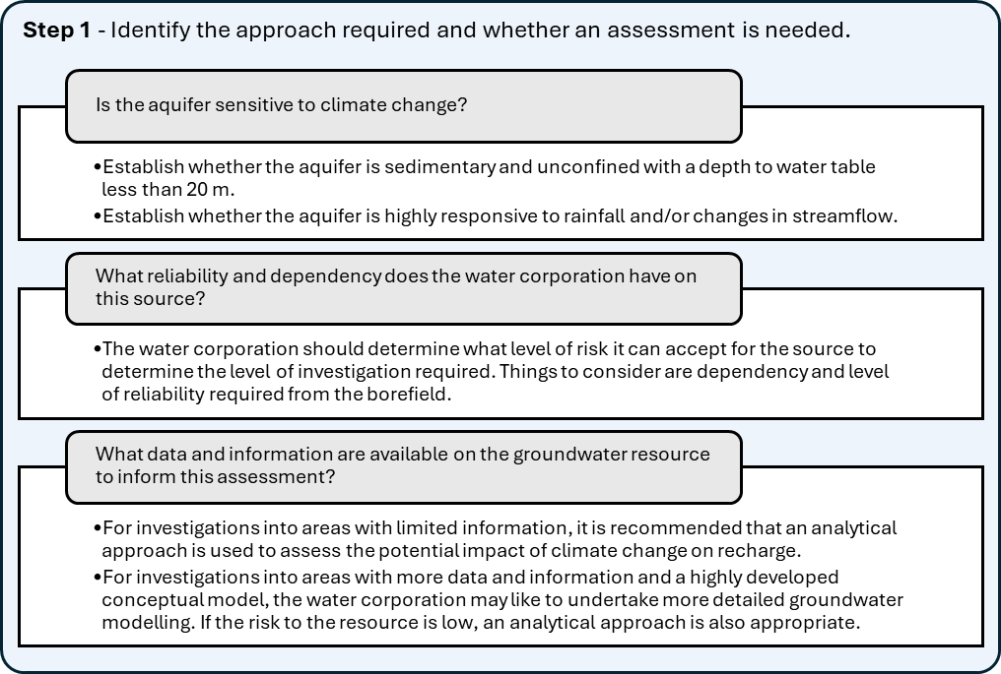

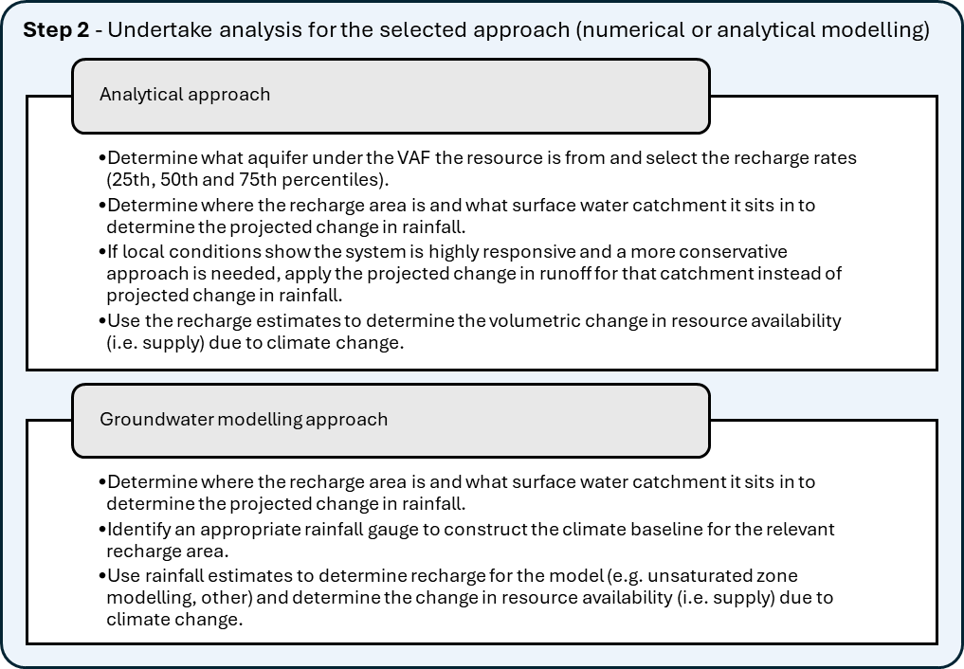
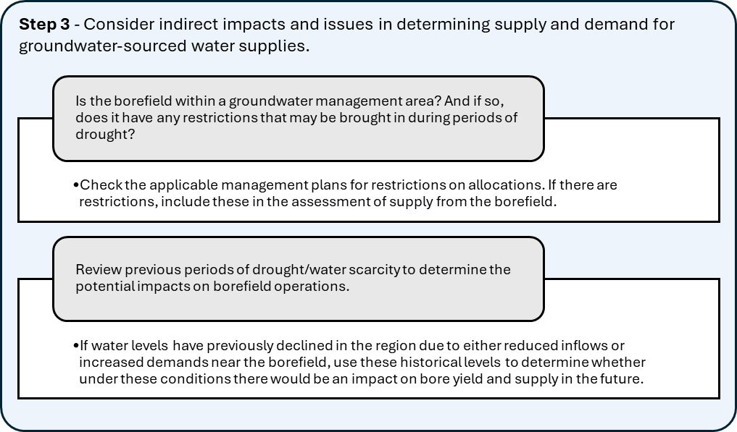
Figure 27: Three steps to consider climate change impact on groundwater recharge.

Changes to water demands
At a glance
Consumptive demand for water, and water losses, can increase under hotter and drier climate futures. Shifts in demand type and timing may also occur.
A four-step process is outlined to assess the impact of a changing climate on demand:
- Collect data on the variability of water use.
- Establish connection between climate and demand data (if possible).
- Model the connection and apply it under changed climate inputs.
- Query whether there are potential changes in demand due to climate that cannot readily be modelled.
Many demands for water will vary with climate. To assess the impact of climate change on water demand, follow the four steps outlined below and summarised in Figure 28. The same logic can be applied to water losses.
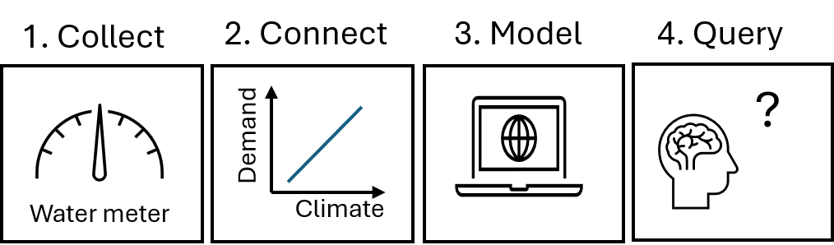
Figure 28: The process for assessing changes to water demands due to climate variability and climate change.

Step 1: Collect data on the variability of water use
Collecting water use data is a precursor to examining the connection between climate and demand (chapter 9.2) and/or modelling it (chapter 9.3). Calibration and verification of climate-dependent demand models is difficult to undertake without observed water use data.
The time step (or frequency) of water use data should consider the nature of the demand, its variability and its expected variance with climate:
- Where interannual variability is the main type of demand variance due to climate, only annual data need be collected.
- Where seasonal variability is the main type of demand variance, only seasonal (typically monthly) data need be collected.
- Where demands can vary significantly from day to day due to climate, or even during the day, continuously metered data will be more useful.
If data cannot be collected locally, use data from appropriately similar locations, or findings from reference literature.

Step 2: Connect climate and demand
The nature and extent of the variance of demand with climate can be understood using historical observations (e.g. does demand go up when it is hotter or drier, and down when it is cooler or wetter?). Where the extent of the relationship between the observed climate and a given demand is not well known, statistical correlations can be established to confirm it. This can be achieved using simple techniques, such as a scatter plot of the demand and a climate variable that is considered likely to influence that demand, such as temperature (Figure 29). More complex techniques can also be employed, such as a covariate analysis (examining correlations between many climate variables and demand) or stepwise regression (trialling different climate variables in a regression analysis of observed demand versus observed climate to achieve the best fit to the observed demand). If more than one climate variable is used, those variables should be independent of each other, with a clear incremental benefit in goodness-of-fit if additional variables are included.
Although relationships between demand and climate (typically temperature, evaporation or net evaporation) on the same time step are common, for some applications other accumulated variables may be more influential, such as heatwaves (consecutive days above a temperature threshold), dry spells (consecutive days of little or no rain) or soil moisture deficits. Regression analysis may also need to account for the influence of non-climate variables over the model fit period, such as changes in the number of water users associated with that demand.
While a linear relationship between climate and demand is illustrated in Figure 29, relationships between climate and demand may also be non-linear. An example of a non-linear response could be a disproportionately higher water demand when it is very hot.
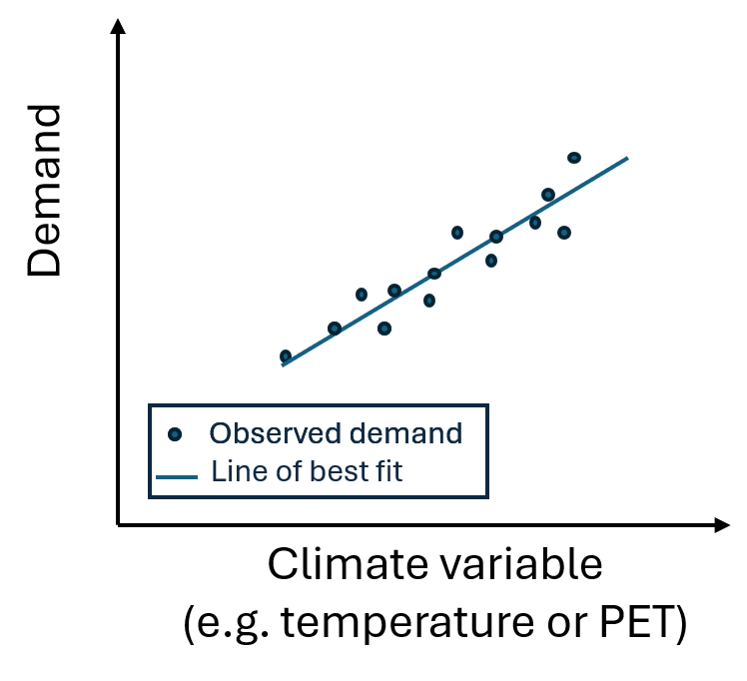
Figure 29: Example scatter plot showing an observed linear relationship between climate and demand.

The following demands and losses are likely to be climate dependent:
- Outdoor water use and irrigation.
- Some major industrial and commercial water uses (e.g. evaporative cooling towers for power generation, construction or mine site dust/fire suppression).
- Indoor water use in air-conditioners that use evaporative cooling.
- Evaporation from open water bodies including wetlands, lakes, reservoirs and small catchment dams.
- Evaporation and evapotranspiration from groundwater in shallow aquifers.
- Evapotranspiration from vegetation.
Demands that are less likely to vary appreciably with climate include most in-house water use, domestic and stock water use, and most major industrial and commercial uses. A previous end-use study of residential water demand for Melbourne identified differences in indoor water use seasonally (Redhead, 2013), but these differences were negligible, apart from the seasonal increase in the use of evaporative air-conditioners, and garden watering.

Step 3: Develop and apply a climate-dependent demand model
Where a relationship between demand and climate has been established or is known to exist, a climate-dependent demand model can be developed and applied. In some cases, off-the-shelf demand modelling software that includes climate dependency is available for this purpose, such as the irrigation demand models PRIDE and Irrigator. However, for most applications, simple bespoke regression models or lumped conceptual models are typically developed. There are two steps in this process:
  - Calibrate the model using observed climate inputs to replicate observed demand behaviour.
  - Apply the model with changed climate inputs under the projected climate change.
The input climate variables used in the demand model must be able to be adjusted under future climate conditions. Using climate variables for which there are no available climate projections in these guidelines (e.g. wind speed or solar radiation) will limit the ability to apply the model under climate change. Changes in mean annual, cool- and warm-season climate are provided in these guidelines and are likely to be suitable for most applications. Where changes in peak daily climate are required (e.g. changes in days of extreme heat), regional climate models such as VCP24 and VCP19 (see Appendix B.6) could be interrogated to support the application.
Models with inputs or parameters that assume fixed daily, seasonal or annual rates, or patterns of demand, which do not vary dynamically with climate in the model, may need to be manually adjusted if they are expected to vary under projected climate change. This can include end-use or agent-based models used in household or neighbourhood-scale urban demand modelling. Alternatively, the model form may need to be adjusted to incorporate climate variance.
When applying a demand model with changed climate inputs, it is assumed that the relationship between climate and demand will continue to hold under those changed conditions. Non-linear relationships between climate and demand are often more sensitive under changed climate inputs. Model outputs should be sanity checked when changing extreme input values, particularly when using non-linear relationships. Demand models developed using machine learning, which rely on historical patterns of water use to forecast future demand, may not be appropriate if patterns of water use are expected to diverge outside of historical observations under projected climate change.
For demand models that rely on correlations with temperature and/or PET, the medium temperature and medium PET projections for any given emissions scenario will be sufficient for most applications. Projected changes in rainfall and runoff in most water systems are expected to heavily influence the climate dependency of system performance or values. In contrast, the uncertainty in the projections for PET and temperature will contribute a much lower degree of uncertainty to system performance or values. Where water system performance is highly sensitive to changes in demand, and those demands are highly sensitive to changes in climate, the range of climate change projections can be used.
For demand modelling, the medium (50th percentile) projection for a given emissions scenario can be used, unless the demand model is highly sensitive to climate change.

Step 4: Query the possibility of other climate-related changes not represented in the demand model
Most demand models are a simple representation of change in demand under climate variability and climate change. Actual future demand may be affected by other factors that are indirectly related to climate change and that are not represented in the model. These could include:
- Land use changes in response to climate change – for example, could there be a shift in where certain crops are grown due to changes in temperature, frost or rainfall? This type of response is likely to be informed by historical observations of land and water use, regional trends in water entitlement transfers, and an understanding of agricultural and economic trends.
- Changes in demand on shorter time steps than were modelled ‒ for example, an increase in peak day demand due to increased temperature on days of extreme heat. Such a climate response might not be well replicated if using a monthly time step demand model.
- Changes in water user behaviour due to climate change ‒ for example, a reduction in tourist visits to bushfire-prone areas or ski fields, or an increase in water used for firefighting.
- Changes in biophysical responses to global warming and higher greenhouse gas concentrations in the atmosphere that are not currently incorporated into crop water demand or rainfall‒runoff models ‒ this includes increases in transpiration rates from vegetation due to increases in the vegetation leaf area under higher concentrations of CO₂ in the atmosphere (e.g. see Zhang et al., 2016).
- Decline in water quality due to climate hazard and climate change ‒ this can create additional demand, or change demand patterns.
These changes are often difficult to quantify. Nevertheless, asking what responses to climate a given demand model might not adequately represent is important for acknowledging any climate-related uncertainties in demand estimation due to the model structure.

Assessment uncertainty
At a glance
- Climate projections contain a range of uncertainties which include future greenhouse gas emissions and how the earth’s climate system responds to continued changes in greenhouse gas concentrations.
- Adaptive planning and complementary approaches will buffer against uncertainty in assessing the impact of future climate change on water availability.
There are numerous uncertainties around the climate change projections and related assumptions adopted in these guidelines. Some uncertainties are addressed explicitly in previous chapters. However, the possibility remains that future climate change and associated changes in runoff and recharge could manifest differently to those projected guidelines.
Key uncertainties in undertaking climate change impact assessments include the following:
- Not representing the full range of historical climate variability.
- The selection of a 50-year climate reference period, which includes both wet and dry periods, aims to represent the climate variability experienced in recent periods. Extending data through scaling of historical data outside the climate reference period or generating stochastic data can further reduce this uncertainty.
- Variability outside the instrumental period, such as extreme events with very low probability, can pose a risk as they are not represented in these datasets (see Supplementary Materials on Paleoclimate rainfall and streamflow reconstructions). The use of stress testing for very extreme events, such as drought that is more severe than historically observed, can help assess this risk.
- Uncertainty in future greenhouse gas emissions and rates of global warming, and the secondary impact on rainfall and PET over time. This is addressed through the provision of projections for two emissions scenarios. However, it is possible that global warming could be much lower or higher than currently anticipated ‒ for example, due to:
- Advancements in technology (to lower global warming).
- Changes in government policy and actions (that change the rate of global warming).
- Unforeseen feedback loops that are not reflected in any of the global climate models (e.g. the global tipping points discussed in Lenton et al., 2023).
- Rates of global warming can vary from year to year around the mean global warming projections in the guidelines (e.g. El Niño years are typically warmer on a global scale than La Niña years).
- Uncertainty in the physical processes, including representation in global climate models and the associated model response to global warming. This is addressed by presenting multiple scenarios (i.e. high-, medium- and low-impact projections) that cover the 10th to 90th percentile range of plausible futures from global climate models for each emissions scenario. However, it is possible that one of the climate models that falls outside of the 10th to 90th percentile range of results presented in these guidelines will most accurately forecast the rainfall and PET response to global warming.
Uncertainty in downscaled (local) output from global climate models. Projections have been developed based on empirical scaling to relate or downscale projected changes in global climate models to a local scale. Several alternative downscaling techniques also exist. Using a dynamical downscaling process, regional climate models can represent climate processes, such as thunderstorms, and local topography, such as mountains, at a finer scale than global climate models. This results in projections with a spatial resolution of 5 km or less for a limited area. However, these regional climate models rely on a small number of global climate models to provide input, so uncertainty in the source model is reflected in the dynamically scaled projection data. Projected changes from global climate models and regional climate models for a specific area may differ in magnitude, although they should show a similar direction of change (e.g. increase or decrease). Victoria’s Future Climate Tool (DEECA, 2025c) provides high spatial resolution projections from regional climate models, which can be used to explore projected changes at a local level.
- Uncertainty in future climate variability. Projected changes to seasonal rainfall patterns, such as decreasing average cool-season rainfall and increasing intensity of extreme rainfall, have been included in the projections in these guidelines. Meanwhile, interannual rainfall variability is projected to increase, which can result in increased frequencies of hydrological drought, fewer high flow days and more low flow days (Zheng et al., 2024).
Other future changes in rainfall variability may not be projected with high confidence as there are biases in the simulation of some climate processes (DEECA, 2025a). For example, changes to daily rainfall time series or annual sequences can be highly uncertain. Regardless of the confidence of the projections, some changes in variability may be difficult to practically apply to time series analysis. The approach adopted in these guidelines assumes no change in the number of rain days and no change in the sequencing of climate events under projected climate change. This also includes no change in the number of days with cease-to-flow conditions when using the runoff scaling factors. However, as previously mentioned, the projected change to the intensity of extreme rainfall can be incorporated into the assessment (also see chapter 6.9).
These guidelines propose stress testing where water systems are vulnerable to changes to climate variability that cannot be projected with confidence. Stress testing can also consider low-likelihood, high-impact events, such as droughts or floods more severe than those observed in the instrumental record.
- Uncertainty in the rainfall‒runoff response in a drying climate. Rainfall‒runoff models are simple representations of complex hydrological processes. They are subject to calibration uncertainty due to input data uncertainty, with different runoff estimates possible using different calibration strategies and different model structures.
Runoff projections in these guidelines have been produced by calibrating rainfall‒runoff models to the post-1997 period. The guidelines also provide advice on how a post-1997 rainfall‒runoff shift can be estimated using historical observations. It is unknown when or whether the rainfall‒runoff response in those catchments will return to pre-drought behaviour.
- Hydrological processes that influence runoff generation, such as interception from farm dams and vegetation response to higher CO2, may change under climate change (DEECA, 2025a). These are not currently accounted for by the hydrological models used to develop the runoff projections.
- Other impacts of climate change that indirectly affect water availability. For example, the increased risk of bushfires that may change forest evapotranspiration and influence runoff during regrowth (DEECA 2024, also see Appendix B.9).
- Compounding effects from multiple drivers, accelerated changes due to tipping points or thresholds being exceeded, and other uncertainties.
For most applications, uncertainties in climate change impact assessments can be addressed through adaptive planning, such as a periodical update to water plans and strategies (e.g. 5-yearly updates to urban water strategies). The advice in these guidelines is also reviewed and updated periodically to incorporate emerging climate knowledge and assessment techniques. This will ensure that plans and strategies can be adapted to incorporate new knowledge about climate variability and climate change as it emerges. Where a decision needs to be made in the short term (i.e. within approximately the next 5 years) that will have long-term consequences for water availability, the value of adaptive, robust solutions increases.

Future updates
These guidelines will be updated as part of a continuous cycle of refining guidance and approaches.
These guidelines incorporate the latest information on climate change projections in 2025. Climate science, hydrology, hydrogeology and water planning are active areas of research and our knowledge of climate change and its impacts will continue to evolve over time. The actual trajectory of greenhouse gas emissions and mitigation policies are also expected to change over time.
To receive further information or updates to this guidance, contact DEECA’s Hydrology, Climate and Energy team at: HCS.Team@deeca.vic.gov.au
This email address can also be used to subscribe to the team newsletter, which periodically provides the latest information on research, publications and webinars.
Information can also be accessed via DEECA’s website: https://www.water.vic.gov.au/water-and-climate

Glossary
Adaptation | Changes made to natural or human systems to prepare for actual or expected changes in the climate in order to minimise harm, act on opportunities or cope with the consequences.
Anthropogenic climate change | Climate change attributable to anthropogenic forcing.
Anthropogenic forcing | Increases in energy in the world’s atmosphere associated with human activity.
Bottom-up assessment | A climate impact assessment that considers the vulnerabilities of a water system or its dependent values to changes in climate, and then tests those vulnerabilities using sensitivity tests or stress tests.
Carbon dioxide (CO₂) | A naturally occurring gas; also a by-product of human actions such as burning fossil fuels or land use changes. It is the main human-generated greenhouse gas that affects the Earth’s atmosphere.
Climate | The average weather experienced at a site or region over a period of at least 30 years.
Climate change | Changes in the state of the climate attributed directly or indirectly to human activity, including an increase in the occurrence of extreme weather events, long-term changes in weather patterns and sea level rise. Distinct from climate variability as the changes persist for an extended period, typically decades or longer.
Climate projection | Simulations of the climate system based on a scenario of future emissions or concentrations of greenhouse gases and aerosols, generally from climate models.
Climate variability | Variations in climate beyond those of individual weather events. Climate variability is typically characterised over long timescales of several decades or more. Climate can also vary spatially.
Coupled Model Intercomparison Project (CMIP) | A project that coordinates and archives climate model simulations from modelling groups around the world. Global climate models in the sixth phase of the project, CMIP6, were used to inform the IPCC’s Sixth Assessment Report.
Cool season | The projections in these guidelines are based on a May to October cool season.
Decile | One of a series of threshold values that divides a set of ordered data into 10 groups with an equal number of data points in each.
DEECA | Department of Energy, Environment and Climate Action
Downscaling | A method that produces local to regional-scale climate information from larger-scale models or data analyses. Different methods include dynamical, statistical and empirical downscaling.
Emissions scenario | A plausible representation of the future development of greenhouse gas emissions and aerosols. Scenarios are based on a set of assumptions, such as socioeconomic development and technological change. Examples include Shared Socioeconomic Pathways (SSPs; used in the IPCC’s Sixth Assessment Report) and Representative Concentration Pathways (RCPs; used in the IPCC’s Fifth Assessment Report).
El Niño Southern Oscillation (ENSO) | Year-to-year fluctuations in atmospheric pressure, ocean temperatures and rainfall associated with El Niño (warming of the oceans in the equatorial eastern and central Pacific) and its opposite, La Niña. El Niño usually brings below-average rainfall to much of Australia, and La Niña usually brings above-average rainfall.
External forcing | A forcing agent outside the climate system causing a change in the climate system, such as a volcanic eruption, solar variations, anthropogenic changes in the composition of the atmosphere and land-use change.
Extreme weather | A weather event that is rare at a particular place and time of year. Definitions of ‘rare’ vary, but an extreme weather event would normally occur less than 10% of the time.
Global climate model (GCM) | A numerical representation of the global climate system based on its physical, chemical and biological properties, their interactions and feedback processes. Also referred to as general circulation models. The resolution of global climate models usually ranges between 100 and 200 km.
Global warming | The increase, observed or projected, in global surface temperatures.
Global warming levels | The expected change that will be experienced at a specific location (such as Victoria) when the world reaches particular levels of global warming above pre-industrial levels.
Greenhouse gas | Natural and human-generated gases that trap heat in the atmosphere and warm the planet. Water vapour, carbon dioxide, nitrous oxide, methane and ozone are the primary greenhouse gases in the Earth’s atmosphere.
Hadley Cell | A large-scale atmospheric circulation pattern in which air rises at the Equator and sinks at about 30° latitude north or south. The Hadley Cell controls the position of the band of high-pressure systems (called the sub-tropical ridge).
Indian Ocean Dipole (IOD) | A climate driver defined by the difference in sea surface temperatures between the eastern and western tropical Indian Ocean. When positive, there is cooler than normal water in the tropical eastern Indian Ocean and warmer than normal water in the tropical western Indian Ocean.
Instrumental record | A direct measurement of a variable using an instrument. For example, an instrumental record of temperature is observed with a thermometer and officially recorded. This differentiates climate records based on paleoclimate proxies, which infer climate behaviour based on non-climate observations (coral growth rates, tree rings, ice core analysis, etc.) before direct measurement of climate began.
Inter-decadal Pacific Oscillation (IPO) | A fluctuation in the sea surface temperature and mean sea level pressure of both the north and south Pacific Ocean with a cycle of 15 to 30 years. Unlike ENSO, the IPO may not be a single physical ‘mode’ of variability, but be the result of a few processes with different origins. The IPO interacts with the ENSO to affect the climate variability over Australia
Intergovernmental Panel on Climate Change (IPCC) | The United Nations body for assessing climate change science. It provides regular assessments of the scientific basis of climate change, its impacts and future risks, and options for adaptation and mitigation.
Millennium Drought | Extreme dry climate that occurred during 1997–2009 in southern mainland Australia due to a combination of low rainfall and low river inflows.
Paleoclimate | Indirect measurements of climate from geological (e.g. sediment cores) and biological (e.g. tree rings) materials that preserve evidence of past changes in climate. Paleoclimate research looks at changes in climate beyond the timeline of instrumental records.
Percentile | A value on a scale of 100 that indicates the percentage of the dataset values that is equal to, or below, it. For example, the 90th (or 10th) percentile may be used to refer to the threshold for the upper (or lower) extremes.
Potential evapotranspiration (PET) | The rate of evapotranspiration from a limitless source of water. It is typically higher than actual evapotranspiration, which will be limited by water availability. Evapotranspiration includes transpiration from vegetation and evaporation from water bodies.
Pre-industrial | Prior to the industrial revolution (i.e. pre-1750), when human activities such as the burning of fossil fuels increased the concentration of greenhouse gases in the atmosphere. Consistent with the IPCC, this report uses 1850–1900 as the pre-industrial baseline, as it is the earliest period with near-global temperature observations.
Regional climate model (RCM) | A climate model used to generate higher-resolution results from a global climate model. Like a global climate model, a regional climate model is a numerical representation of the climate system based on its physical, chemical and biological properties, their interactions and feedback processes, but it produces results at a regional or local scale.
Representative Concentration Pathway (RCP) | An emissions scenario that includes changes in concentrations of greenhouse gases, aerosols and land use over time. These are used as inputs to climate models. RCPs were associated with the IPCC’s Fifth Assessment Report but have been replaced by Shared Socioeconomic Pathways (SSPs) for the IPCC’s Sixth Assessment Report.
Risk | The potential for consequences where something of value is at stake and where the outcome is uncertain. Risk is often represented as a probability of occurrence of hazardous events or trends, multiplied by the consequences if these events occur.
Runoff | The flow of water over land before reaching a stream, river or other watercourse. Once in a watercourse, runoff is referred to as streamflow. It is a major component of the hydrological cycle.
Shared Socioeconomic Pathway (SSP) | Each SSP outlines ways the world may change in future, including different types of energy generation, rates of population growth, economic development and land uses. These lead to different levels of greenhouse gas emissions over time.
Southern Annular Mode (SAM) | The north–south movement of the westerly wind belt that circles Antarctica. When positive, the jet is displaced poleward. The changing position of the westerly wind belt influences the strength and position of atmospheric fronts and mid-latitude weather systems, and is an important driver of rainfall variability in southern Australia.
Sub-tropical ridge | A belt of high-pressure that encircles the globe in the sub-tropical latitudes. It is part of the global circulation of the atmosphere. The exact latitude of the sub-tropical ridge changes between seasons and plays an important role in the way Australian weather varies from season to season.
Top-down assessment | A climate impact assessment that considers available climate model projections of future climate, then assesses water system performance, or changes to the system’s dependent values, using those projections.
Uncertainty | A state of incomplete knowledge that can result from a lack of information or from disagreement about what is known or even knowable. It may have many types of sources, from imprecision in the data to ambiguously defined concepts or terminology, or uncertain projections of human behaviour. Uncertainty can be represented by qualitative statements (e.g. reflecting the judgement of a team of experts).
Victorian Aquifer Framework (VAF) | The framework provides a consistent approach to defining aquifers across the state of Victoria. There are 15 aquifers represented in the framework, which occur at various depths and locations.
Victorian Water and Climate Initiative (VicWaCI) | A program of research that began in 2017, co-funded by the Victorian State Government and research partners, VicWaCI research sought to improve our understanding of past, current and future climate influences on water resources in Victoria.
Warm season | The projections in these guidelines are based on a November to April warm season.

References
Addor, N., & Seibert, J. (2014). Bias correction for hydrological impact studies – beyond the daily perspective. Hydrological Processes, 28(17), 4823–4828. https://doi.org/10.1002/hyp.10238
Allen, R.G., Pereira, L.S., Raes, D., & Smith, M. (1998). Crop evapotranspiration – guidelines for computing crop water requirements. FAO irrigation and drainage paper 56. Food and Agriculture Organization of the United Nations. https://www.fao.org/4/x0490e/x0490e00.htm
Ashcroft, L., Karoly, D. J., & Gergis, J. (2014). Southeastern Australian climate variability 1860–2009: A multivariate analysis. International Journal of Climatology, 34(6), 1928–1944. https://doi.org/10.1002/joc.3812
Ball, J., Babister, M., Nathan, R., Weeks, W., Weinmann, E., Retallick, M., & Testoni, I. (Eds.). (2019). Australian rainfall and runoff: A guide to flood estimation (Version 4.2). Commonwealth of Australia (Geoscience Australia). https://www.arr-software.org/pdfs/ARR_190514_Book1_V4.2.pdf
Barnett, B., Townley, L., Post, V., Evans, R. E., Hunt, R., Peeters, L., Richardson, S., Werner, A., Knapton, A., & Boronkay, A. (2012). Australian groundwater modelling guidelines. National Water Commission. https://euroaquae.tu-cottbus.de/Semester3/LectureNotes/Module31/FeFlow/Australian-groundwater-modelling-guidelines.pdf
Barron, O. V., Crosbie, R. S., Charles, S. P., Dawes, W. R., Ali, R., Evans, W. R., Cresswell, R., Pollock, D., Hodgson, G., Currie, D., Mpelasoka, F., Pickett, T., Aryal, S., Donn, M., & Wurcker, B. (2011). Climate change impact on groundwater resources in Australia (Waterlines report). National Water Commission. https://doi.org/10.4225/08/58542d915ec17
Bennett, B. (2019). foreSIGHT: Systems insights from generation of hydroclimatic timeseries. https://cran.r-project.org/web/packages/foreSIGHT/index.html
Bennett, B., Culley, S., Westra, S., Guo, D., & Maier, H. (2019a). Package foreSIGHT. https://cran.rproject.org/web/packages/foreSIGHT/index.html
Bennett, B., Culley, S., Westra, S., Guo, D., & Maier, H. (2019b). foreSIGHT vignettes. https://cran.rproject.org/web/packages/foreSIGHT/vignettes/Vignette.html
Bennett, B., Culley, S., Westra, S., & Maier, H. (2018). An R tool for scenario-neutral climate impact analysis of water resource systems. In 9th International Congress on Environmental Modelling and Software. https://scholarsarchive.byu.edu/cgi/viewcontent.cgi?article=4157&context=iemssconference
Berghout, B., Henley, B., & Kuczera, G. (2015). Impact of climate data uncertainty on estimated system yield. In 36th Hydrology and Water Resources Symposium: The Art and Science of Water (pp. 443–451). Engineers Australia. https://www.proceedings.com/content/030/030289webtoc.pdf
Bhend, J., Bathols, J., & Hennessy, K. (2012). Climate change impacts on snow in Victoria. CSIRO report for the Victorian Department of Sustainability and Environment. http://hdl.handle.net/102.100.100/106550?index=1
Blöschl, G., Bierkens, M. F. P., Chambel, A., Cudennec, C., Destouni, G., et al. (2020). Twenty-three unsolved problems in hydrology (UPH) – A community perspective. Hydrological Sciences Journal, 64(10), 1141–1158. https://doi.org/10.1080/02626667.2019.1620507
Blöschl, G., Sivapalan, M., Wagener, T., Viglione, A., & Savenije, H. (2013). Runoff prediction in ungauged basins: Synthesis across processes, places and scales. Cambridge University Press. https://doi.org/10.1002/2014EO020025
Box, G. E., & Cox, D. R. (1964). An analysis of transformations. Journal of the Royal Statistical Society: Series B (Methodological), 26(2), 211–252. https://doi.org/10.1111/j.2517-6161.1964.tb00553.x
Bureau of Meteorology & CSIRO. (2024). State of the climate 2024. https://www.csiro.au/en/research/environmental-impacts/climate-change/state-of-the-climate
Charles, S. P., Chiew, F. H. S., Potter, N. J., Zheng, H., Fu, G., & Zhang, L. (2020). Impact of downscaled rainfall biases on projected runoff changes. Hydrology and Earth System Sciences, 24, 2981–2997. https://hess.copernicus.org/articles/24/2981/2020/
Chiew, F. H. S., & McMahon, T. A. (1991). The applicability of Morton’s and Penman’s evapotranspiration estimates in rainfall‒runoff modelling. Water Resources Bulletin, 27(3), 505–522. https://doi.org/10.1111/j.1752-1688.1991.tb01462.x
Chiew, F. H. S., Devanand, A., Khan, Z., Zheng, H., Potter, N. J., et al. (2025). Hydroclimate projections for the Murray-Darling Basin (Report from Module 1 of the MDB Sustainable Yields Project). CSIRO.
Chiew, F. H. S., Teng, J., Vaze, J., Post, D. A., Perraud, J.-M., Kirono, D. G. C., & Viney, N. R. (2009). Estimating climate change impact on runoff across south-east Australia: Method, results and implications of modelling method. Water Resources Research, 45, W10414. https://doi.org/10.1029/2008WR007338
Chiew, F. H. S., Zheng, H., Potter, N. J., Charles, S. P., Thatcher, M., et al. (2022). Different hydroclimate modelling approaches can lead to a large range of streamflow projections under climate change: Implications for water resources management. Water, 14(9), 2730. https://doi.org/10.3390/w14172730
Clarke, J. M., Grose, M., Thatcher, M., Hernaman, V., Heady, C., Round, V., Rafter, T., Trenham, C., & Wilson, L. (2019). Victorian climate projections 2019 technical report. CSIRO. https://www.climatechange.vic.gov.au/victorias-changing-climate/Vic-Climate-Projections-2019-Technical-Report_1.pdf
Climate Analytics & New Climate Institute. (2024). Climate Action Tracker: Warming projections global update, November 2024. https://climateanalytics.org/publications/cat-global-update-as-the-climate-crisis-worsens-the-warming-outlook-stagnates
Cook, R. D. (1977). Detection of influential observations in linear regression. Technometrics, 19(1), 15–18. https://doi.org/10.1080/00401706.1977.10489493
Crosbie, R. S., Pickett, T., Mpelasoka, F. S., Hodgson, G., Charles, S. P., & Barron, O. V. (2013). An assessment of the climate change impacts on groundwater recharge at a continental scale using a probabilistic approach with an ensemble of GCMs. Climatic Change, 117, 41–53. https://doi.org/10.1007/s10584-012-0558-6
CSIRO, & Bureau of Meteorology. (2015). Climate change in Australia: Information for Australia’s natural resource management regions (Technical Report). https://www.climatechangeinaustralia.gov.au/media/ccia/2.2/cms_page_media/168/CCIA_2015_NRM_TechnicalReport_WEB.pdf
Culley, S., Bennett, B., Westra, S., & Maier, H. R. (2019). Generating realistic perturbed hydrometeorological time series to inform scenario-neutral climate impact assessments. Journal of Hydrology, 576, 111–122. https://doi.org/10.1016/j.jhydrol.2019.06.005
DEECA. (2023). Victoria’s resilient coast: Adapting for 2100+ — Framework and guidelines. https://www.marineandcoasts.vic.gov.au/marine-coastal-management/victorias-resilient-coast-adapting-for-2100
DEECA. (2024). Victoria’s Climate Science Report 2024. https://www.climatechange.vic.gov.au/victorias-changing-climate/Victorias-Climate-Science-Report-2024.pdf
DEECA. (2025a). Victoria’s water resources under a changing climate: Insights from phase 2 of the Victorian Climate and Water Initiative. https://www.water.vic.gov.au/__data/assets/pdf_file/0037/729928/Victorias-water-resources-under-a-changing-climate.pdf
DEECA. (2025b). Guidelines for the development of Urban Water Strategies & Drought Preparedness Plans.
DEECA. (2025c). Victoria’s Future Climate Tool. https://vicfutureclimatetool.indraweb.io/cmip6/
DEECA. (2025d). Victoria’s Water Measurement Information System. https://data.water.vic.gov.au/
DEECA. (2025e). Victorian Water Accounts. https://accounts.water.vic.gov.au/
DEECA. (2026, under preparation). Hydroclimate data transformation plugin for the Source modelling platform: User manual.
DELWP. (2018). Pilot water sector climate change adaptation action plan. https://www.water.vic.gov.au/__data/assets/pdf_file/0040/669388/Pilot-water-sector-climate-change-adaptation-action-plan.pdf
DELWP. (2019). Managing climate change risk: Guidance for board members and executives of water corporations and catchment management authorities. https://www.water.vic.gov.au/__data/assets/pdf_file/0034/663568/managing-climate-change-risk-guidance-note-for-water-entities.pdf
DELWP, Bureau of Meteorology, CSIRO, & The University of Melbourne. (2020a). Victoria’s water in a changing climate. https://www.water.vic.gov.au/__data/assets/pdf_file/0026/664145/victorias-water-in-a-changing-climate.pdf
DELWP. (2020a). Long-term water resource assessment for southern Victoria. Department of Environment, Land, Water and Planning. https://www.water.vic.gov.au/__data/assets/pdf_file/0019/664210/long-term-water-resource-assessment-for-southern-victoria.pdf
DELWP. (2020b). Guidelines for assessing the impact of climate change on water availability in Victoria (Final). https://www.water.vic.gov.au/__data/assets/pdf_file/0027/663327/guidelines-for-assessing-the-impact-of-climate-change-on-water-availability-in-victoria-2020-edition.pdf
DELWP. (2022a). Water is life: Traditional Owner access to water roadmap — Section A: Victorian Government policy. https://www.water.vic.gov.au/__data/assets/pdf_file/0029/658523/water-is-life-traditional-owner-access-to-water-roadmap-section-a-victorian-government-policy.pdf
DELWP. (2022b). Guidelines for the adaptive management of wastewater systems under climate change in Victoria (Final). https://www.water.vic.gov.au/__data/assets/pdf_file/0027/663561/guidelines-for-the-adaptive-management-of-wastewater-systems-under-climate-change-in-victoria.pdf
Devanand, A., Chiew, F. H. S., Post, D. A., Robertson, D. E., Grose, M. G. R., et al. (2025). Partitioning uncertainty in climate projections in the Murray-Darling Basin. Submitted journal paper under review
Egan, C. A. (2024). Fors – rapid hydrologic flow calibration suite. In 2024 Hydrology and Water Resources Symposium (HWRS 2024). Engineers Australia. https://www.proceedings.com/80092.html
Eyring, V., Bony, S., Meehl, G. A., Senior, C. A., Stevens, B., et al. (2016). Overview of the Coupled Model Intercomparison Project Phase 6 (CMIP6) experimental design and organization. Geoscientific Model Development, 9, 1937–1958. https://doi.org/10.5194/gmd-9-1937-2016
Fowler, K., Peel, M., Western, A., & Zhang, L. (2018). Improved rainfall‒runoff calibration for drying climate: Choice of objective function. Water Resources Research, 54, 3392–3408. https://doi.org/10.1029/2017WR022466
Fowler, K., Knoben, W., Peel, M., Peterson, T., Ryu, D., Saft, M., Seo, K.-W., & Western, A. (2020). Many commonly used rainfall‒runoff models lack long, slow dynamics: Implications for runoff projections. Water Resources Research, 56, e2019WR025286. https://doi.org/10.1029/2019WR025286
Fowler, K. J. A., Peel, M. C., Saft, M., Peterson, T. J., Western, A., et al. (2022b). Explaining changes in rainfall‒runoff relationships during and after Australia’s Millennium Drought: A community perspective. Hydrology and Earth System Sciences, 26, 6073–6120. https://doi.org/10.5194/hess-26-6073-2022
Frost, A., Srikanthan, R., & Cowertwait, P. (2004). Stochastic generation of point rainfall data at subdaily timescales: A comparison of DRIP and NRSP. https://www.mssanz.org.au/modsim05/papers/frost.pdf
Frost, A. J., & Shokri, A. (2021). The Australian Landscape Water Balance model (ARWA-L v7): Technical description of the Australian Water Resources Assessment Landscape model version 7 (Technical Report, Version 1.0.6). Bureau of Meteorology. https://awo.bom.gov.au/assets/notes/publications/AWRA-Lv7_Model_Description_Report.pdf
Fu, G., Chiew, F., & Shi, X. (2018). Generation of multi-site stochastic daily rainfall with four weather generators: A case study of a small catchment in Australia. Theoretical and Applied Climatology, 134(3-4), 1027–1046. https://doi.org/10.1007/s00704-017-2306-3
Gibbs, M., Alcorn, M., & Vaze, J. (2024). The SWTools R package for SILO data acquisition, homogeneity testing and correction. Australasian Journal of Water Resources, 28(1), 123–135. https://doi.org/10.1080/13241583.2023.2214989
Gippsland Water. (2017). 2017 Urban Water Strategy. Gippsland Water.
Grose, M. R., Narsey, S., Trancoso, R., Mackallah, C., Delage, F., et al. (2023). A CMIP6-based multi-model downscaling ensemble to underpin climate change services in Australia. Climate Services, 30, 100368. https://doi.org/10.1016/j.cliser.2023.100368
Guo, D., Westra, S., & Maier, H. R. (2018). An inverse approach to perturb historical rainfall data for scenario-neutral climate impact studies. Journal of Hydrology, 556, 877–890. https://doi.org/10.1016/j.jhydrol.2016.03.025
HARC. (2020a). Investigation in anomalies resulting from decile scaling [File note, 13 February 2020].
HARC. (2020b). Derivation of daily inputs to the Ovens Source model: Technical report.
HARC. (2025a). Water resource modelling sensitivities to climate change: Technical report (Draft, March 2025).
HARC. (2025b). Rainfall‒runoff modelling in Northern Victoria Valleys of the Murray Darling Basin: Investigations into non-climatic trends (Memorandum, 28 January 2025).
Harris, R. M. B., Remenyi, T., & Bindoff, N. L. (2016). The potential impacts of climate change on Victorian alpine resorts: A report for the Alpine Resorts Co-ordinating Council. Antarctic Climate & Ecosystems CRC. https://swift.rc.nectar.org.au/v1/AUTH_4a33cd0edb47438ca9029479f143496b/rd-rocftr/CFA_-_Alpine_Resorts_Study.pdf
Harrison, R. G., & Burt, S. D. (2024). Accuracy of daily extreme air temperatures under natural variations in thermometer screen ventilation. Atmospheric Science Letters, 25(10). https://doi.org/10.1002/asl.1256
Hatterman, F. F., Vetter, T., Breuer, L., Su, B., Daggupati, P., et al. (2018). Sources of uncertainty in hydrological impact assessment in a cross-scale study. Environmental Research Letters, 13, 015006. https://pure.iiasa.ac.at/14999
Heneker, T. M., Lambert, M. F., & Kuczera, G. (2001). A point rainfall model for risk-based design. Journal of Hydrology, 247(1–2), 54–71. https://doi.org/10.1016/S0022-1694(01)00361-4
Henley, B. J., Peel, M. C., Nathan, R., King, A. D., Ukkola, A. M., Karoly, D., & Tan, K. S. (2019). Amplification of risks to water supply at 1.5 °C and 2 °C in drying climates: A case study for Melbourne, Australia. Environmental Research Letters, 14, 084028. https://iopscience.iop.org/article/10.1088/1748-9326/ab26ef
Hope, P., Timbal, B., Hendon, H., Ekström, M., & Potter, N. (2017). A synthesis of findings from the Victorian Climate Initiative (VicCI). Bureau of Meteorology. https://www.bom.gov.au/research/projects/vicci/docs/2017/VicCI-SynR-MR.pdf
IPCC. (2021). Climate Change 2021: The Physical Science Basis. Contribution of Working Group I to the Sixth Assessment Report of the Intergovernmental Panel on Climate Change. Cambridge University Press. https://www.ipcc.ch/report/ar6/wg1/
IPCC. (2023). Climate Change 2023: Synthesis Report. Contribution of Working Groups I, II and III to the Sixth Assessment Report of the Intergovernmental Panel on Climate Change. https://doi.org/10.59327/IPCC/AR6-9789291691647
Jayaweera, L., Wasko, C., Nathan, R., & Johnson, F. (2023). Non-stationarity in extreme rainfalls across Australia. Journal of Hydrology, 624. https://doi.org/10.1016/j.jhydrol.2023.129872
Jeffrey, S., Carter, J., Moodie, K., & Beswick, A. (2001). Using spatial interpolation to construct comprehensive archive of Australian climate data. Environmental Modelling & Software, 16(4), 309–330. https://doi.org/10.1016/S1364-8152(01)00008-1
Jones, D., Wang, W., & Fawcett, R. (2009). High-quality spatial climate data-sets for Australia. Australian Meteorological and Oceanographic Journal, 58(4), 233–248. https://www.publish.csiro.au/MO/ES09032
Joseph, J., Ghosh, S., Pathak, A., & Sahai, A. K. (2018). Hydrologic impacts of climate change: Comparisons between hydrological parameter uncertainty and climate model uncertainty. Journal of Hydrology, 566, 1–22. https://doi.org/10.1016/j.jhydrol.2018.08.080
Kuczera, G. (2020). Multi-site multi-season multi-state contemporaneous auto-regressive model (MSSSCAR). In WATHNET5 user manual.
Kwon, H., Lall, U., & Khalil, A. F. (2007). Stochastic simulation model for nonstationary time series using an autoregressive wavelet decomposition: Applications to rainfall and temperature. Water Resources Research, 43(5). https://doi.org/10.1029/2006WR005258
Lane, P. N. J., Benyon, R. G., Nolan, R. H., Keenan, R. J., & Zhang, L. (2023). Forests, fire and vegetation change impacts on Murray-Darling Basin water resources. Australian Journal of Water Resources, 27, 68–84. https://doi.org/10.1080/13241583.2023.2179555
Lavery, B., Kariko, A., & Nicholls, N. (1992). A historical rainfall data set for Australia. Australian Meteorological Magazine, 40(1), 33–39. https://www.bom.gov.au/climate/change/acorn-rainfall/docs/lavery1992.pdf
Lenton, T. M., Laybourn, L., Armstrong McKay, D. I., Loriani, S., Abrams, J. F., Lade, S. J., Donges, J. F., Milkoreit, M., Smith, S. R., Bailey, E., Powell, T., Fesenfeld, L., Zimm, C., Boulton, C. A., Buxton, J. E., Dyke, J. G., Ghadiali, A. (2023). Global Tipping Points Report 2023: Summary report. University of Exeter. https://report-2023.global-tipping-points.org/summary-report/narrative-summary/
Martinec, J., Rango, A., & Roberts, R. (2008). Snowmelt Runoff Model (SRM) user’s manual. New Mexico State University. https://ntrs.nasa.gov/citations/19830015389
McMahon, T. A., Kiem, A. S., Peel, M. C., Jordan, P. W., & Pegram, G. G. S. (2008). A new approach to stochastically generating six-monthly rainfall sequences based on empirical mode decomposition. Journal of Hydrometeorology, 9(6), 1377–1389. https://journals.ametsoc.org/view/journals/hydr/9/6/2008jhm991_1.pdf
Melbourne Water. (2025). 2025/26 Desalinated Water Order Advice. Technical Analysis. https://www.melbournewater.com.au/media/eyJtZWRpYSI6IjI4MjA2In0%253D/downloads
Morton, F. I. (1983). Operational estimates of areal evapotranspiration and their significance to the science and practice of hydrology. Journal of Hydrology, 66, 1–76. https://doi.org/10.1016/0022-1694(83)90177-4
Minister for Environment, Climate Change and Water. (2015, December 20). Statement of obligations (general). https://www.water.vic.gov.au/__data/assets/pdf_file/0042/677697/general-statement-of-obligations.pdf
Nash, J. E., & Sutcliffe, J. V. (1970). River flow forecasting through conceptual models. Part I — A discussion of principles. Journal of Hydrology, 3, 282–290. https://doi.org/10.1016/0022-1694(70)90255-6
NESP. (2024). Understanding SSPs: Fact sheet. https://nesp2climate.com.au/resource/understanding-ssps/
NSW DCCEEW. (2025). NARCliM generations and parameters. https://www.climatechange.environment.nsw.gov.au/narclim/using-narclim-data/narclim-generations-and-parameters
Peel, M. C., Srikanthan, R., McMahon, T. A., & Karoly, D. J. (2011). Ensemble empirical mode decomposition of monthly climatic indices relevant to Australian hydroclimatology. In Proceedings of the 19th International Congress on Modelling and Simulation. https://www.mssanz.org.au/modsim2011/I6/peel.pdf
Peel, M. C., Srikanthan, R., McMahon, T. A., & Karoly, D. J. (2015). Approximating uncertainty of annual runoff and reservoir yield using stochastic replicates of global climate model data. Hydrology and Earth System Sciences, 19, 1615–1639. https://doi.org/10.5194/hess-19-1615-2015
Perrin, C., Michel, C., & Andréassian, V. (2003). Improvement of a parsimonious model for streamflow simulations. Journal of Hydrology, 279, 275–289. https://doi.org/10.1016/S0022-1694(03)00225-7
Peterson, T. J., Saft, M., Peel, M. C., & John, A. (2021). Watersheds may not recover from drought. Science, 372(6541). https://www.science.org/doi/10.1126/science.abd5085
Potter, N. J., Chiew, F. H. S., Charles, S. P., Fu, G., Zheng, H., & Zhang, L. (2020). Bias in dynamically downscaled rainfall characteristics for hydroclimate projections. Hydrology and Earth System Sciences, 24, 2963–2979. https://doi.org/10.5194/hess-24-2963-2020
Redhead, (2013). Melbourne residential water end uses winter 2020 / summer 2012: Final report (Report No. 10TR-001). Smart Water Fund. https://water360.com.au/wp-content/uploads/2022/10/10tr5---001-melbourne-residential-water-use_final_report.pdf
Richardson, C.W. (1981). Stochastic simulation of daily precipitation, temperature, and solar radiation. Water Resources Research, 17, 1, 182–190. https://doi.org/10.1029/WR017i001p00182
Robertson, D. E., Chiew, F. H. S., Zheng, H., Peña-Arancibia, J., Shrestha, D. L., & Post, D. A. (2024). How do hydrological non-stationarities impact future runoff projections? In Hydrology and Water Resources Symposium (pp. 1209–1218). Engineers Australia. https://search.informit.org/doi/abs/10.3316/informit.T2025050600026800139050769
Robertson, D. E., Zheng, H., Peña-Arancibia, J. L., Chiew, F. H. S., Aryal, S., et al. (2023). How sensitive are catchment runoff estimates to on-farm storages under current and future climates. Journal of Hydrology, 626, 130185. https://doi.org/10.1016/j.jhydrol.2023.130185
Round, V., Grose, M., Macadam, I., Bodman, R., King, M., Truong, S., Heady, C., Thatcher, M., & Clarke, J. M. (2024). Victorian Climate Projections 2024 Technical Report. CSIRO. https://www.climatechange.vic.gov.au/victorias-changing-climate/Victorian-climate-projections-2024-CSIRO.pdf
Saft, M., Western, A. W., Zhang, L., Peel, M. C., & Potter, N. J. (2015). The influence of multiyear drought on the annual rainfall‒runoff relationship: An Australian experience. Water Resources Research, 51, 2444–2463. https://doi.org/10.1002/2014WR015348
Satheesh, A. (2017). Stochastic analysis tool. In eWater Source User Guide 5.0. https://ewater.atlassian.net/wiki/spaces/SD50/pages/50135685/Stochastic+Analysis+Tool
Searcy, J. K., & Hardison, C. H. (1960). Manual of hydrology: Part 1, general surface-water techniques — double-mass curves (U.S. Geological Survey Water-Supply Paper 1541-B).
Seqwater. (2023). South-East Queensland’s Water Security Program 2023. https://www.seqwater.com.au/water-security
Shapiro, S. S., & Wilk, M. B. (1965). An analysis of variance test for normality (complete samples). Biometrika, 52(3–4), 591–611. https://doi.org/10.1093/biomet/52.3-4.591
SILO. (2024). SILO gridded climate data. https://www.longpaddock.qld.gov.au/silo/gridded-data/
Siriwardena, L., Srikanthan, R., & McMahon, T. A. (2002). Evaluation of two daily rainfall data generation models (Technical Report 02/14). Cooperative Research Centre for Catchment Hydrology. https://toolkit.ewater.org.au/Tools/PublicationDetail.aspx?id=1000018&publicationID=1000014
Srikanthan, R. (2005). Stochastic generation of daily rainfall data using a nested transition probability matrix model. In Proceedings of the 29th Hydrology and Water Resources Symposium: Water Capital (pp. 26–33). Engineers Australia. https://mssanz.org.au/modsim05/papers/srikanthan.pdf
Srikanthan, R. (2006). Stochastic generation of spatially consistent daily rainfall at multiple sites. In Proceedings of the 30th Hydrology & Water Resources Symposium: Past, Present & Future (pp. 408–413). Engineers Australia.
Srikanthan R., Kuczera G., Thyer M., McMahon T.A. (2002a). Stochastic Generation of Annual Rainfall Data. (Technical Report 02/6). Cooperative Research Centre for Catchment Hydrology.
Srikanthan, R., McMahon, T. A., & Sharma, A. (2002b). Stochastic generation of monthly rainfall data (Technical Report 02/08). Cooperative Research Centre for Catchment Hydrology.
Srikanthan, R., & Zhou, S. L. (2003). Stochastic generation of climate data. https://ewater.org.au/archive/crcch/archive/pdfs/technical200016.pdf
Srikanthan, R., Chiew, F., & Frost, A. (2007). SCL Stochastic Climate Library: User manual. https://toolkit.ewater.org.au/Tools/DownloadDocumentation.aspx?id=1000251
Steinschneider, S., & Brown, C. (2013). A semiparametric multivariate, multisite weather generator with low-frequency variability for use in climate risk assessments. Water Resources Research, 49(11), 7205–7220. https://doi.org/10.1002/wrcr.20528
Teng, J., Vaze, J., Chiew, F. H. S., Wang, B., & Perraud, J.-M. (2012). Estimating the relative uncertainties sourced from GCMs and hydrological models in modelling climate change impact on runoff. Journal of Hydrometeorology, 13(1), 122–139. https://doi.org/10.1175/JHM-D-11-058.1
Thyer, M., Frost, A., Kuczera, G., & Srikanthan, R. (2006). Stochastic modelling of (not-so) long-term hydrological data: Current status and future research. In 30th Hydrology & Water Resources Symposium: Past, Present and Future (pp. 321–326). Engineers Australia. https://search.informit.org/doi/10.3316/INFORMIT.502003232661455
UNEP. (2025). Emissions gap report 2024. Third edition. https://www.unep.org/resources/emissions-gap-report-2024
United States National Severe Storm Laboratory. (2020). Severe weather 101 – Winter weather. https://www.nssl.noaa.gov/education/svrwx101/winter/
Verdon-Kidd, D. C., & Kiem, A. S. (2009). Nature and causes of protracted droughts in southeast Australia: Comparison between the Federation, WWII, and Big Dry droughts. Geophysical Research Letters, 36, L22707. https://doi.org/10.1029/2009GL041067
Viney, N. R., Perraud, J., Vaze, J., Chiew, F. H. S., Post, D. A., & Yang, A. (2009). The usefulness of bias constraints in model calibration for regionalisation to ungauged catchments. In Proceedings of the 18th World IMACS / MODSIM Congress (pp. 3421–3427). https://mssanz.org.au/modsim09/I7/viney_I7a.pdf
Wasko, C., Westra, S., Nathan, R., Jakob, D., Nielson, C., Evans, J., Rodgers, S., Ho, M., Babister, M., Dowdy, A., & Sharples, W. (2024). Climate change considerations. In J. Ball et al. (Eds.), Australian Rainfall and Runoff (Update 27 August 2024). http://book.arr.org.au.s3-website-ap-southeast-2.amazonaws.com/
Wei, H., Zhang, Y., Huang, Q., Chiew, F. H. S., Luan, J., et al. (2024). Direct vegetation response to recent CO₂ rise shows limited effect on global streamflow. Nature Communications, 15, 9423. https://doi.org/10.1038/s41467-024-53879-x
WMO. (2024). WMO global annual to decadal climate update: 2024–2028. https://wmo.int/publication-series/wmo-global-annual-decadal-climate-update-2024-2028
WSAA. (2016). Climate change adaptation guidelines (WSA 303–2016 v1.2). https://www.wsaa.asn.au/Common/Uploaded%20files/library/resource/WSAA_%20Climate_%20Change_%20Adaptation_%20Guidelines_202016.pdf
WSAA. (2024). Urban water resources planning framework: Guideline. March 2024. https://wsaa.asn.au/Common/Uploaded files/library/resource/Urban_ Water_ Resources_ Planning_ Framework_ March_202024.pdf
Wu, Z., & Huang, N. E. (2004). A study of the characteristics of white noise using the empirical mode decomposition method. Proceedings of the Royal Society A: Mathematical, Physical and Engineering Sciences, 460(2046), 1597–1611. https://doi.org/10.1098/rspa.2003.1221
Wu, Z., & Huang, N. E. (2009). Ensemble empirical mode decomposition: A noise-assisted data analysis method. Advances in Adaptive Data Analysis, 1(1), 1–41. https://doi.org/10.1142/S1793536909000047
Zahedi, S., Peterson, T.J., & Peel, M.C. (in review). Does antecedent catchment wetness explain the timing of rainfall–runoff relationship shifts? Water Resources Research.
Zhang, Y., & Chiew, F. H. S. (2009). Relative merits of different methods for runoff predictions in ungauged catchments. Water Resources Research, 45, W07412. https://doi.org/10.1029/2008WR007504
Zhang, Y., Peña-Arancibia, J. L., McVicar, T. R., Chiew, F. H. S., Vaze, J., Liu, C., Lu, X., Zheng, H., Wang, Y., Liu, Y. Y., Miralles, D. G., & Pan, M. (2016). Multi-decadal trends in global terrestrial evapotranspiration and its components. Scientific Reports, 6, 19124. https://doi.org/10.1038/srep19124
Zheng, H., Chiew, F. H. S., Post, D. A., Robertson, D. E., Charles, S. P., et al. (2024). Projections of future streamflow for Australia informed by CMIP6 and previous generations of global climate models. Journal of Hydrology, 636, 131286. https://doi.org/10.1016/j.jhydrol.2024.131286

Appendices

- Victorian climate change projections for water availability applications
This appendix presents climate change projections for Victoria by river basin that are applicable for water availability and water demand estimation. Additional information on how the projections have been derived is also included. The full report on the method can be found in the Supplementary Materials.

Definitions
The following definitions apply when interpreting these tables:
- All projections are relative to the year 2000, which is the approximate midpoint of the post-1975 climate reference period (1975‒2025). They can be directly applied to the post-1975 climate reference period hydroclimate datasets.
- The uncertainty in climate model response to the emissions scenarios is labelled in three ways:
- 10th, 50th and 90th percentile projections, reflecting the plausible range of projections from the global climate model ensemble
- high, medium and low impact, which is a short-hand label based on their anticipated impact for most applications ‒ the high impact scenario (90th percentile projection) is associated with greater reduction in rainfall, greater increase in PET and higher impacts on water availability; the low impact scenario (10th percentile projection) is associated with lower reduction in rainfall (or in some instances a small increase in rainfall), lower increase in PET and therefore lower impacts on water availability
- as labels that describe three distinct climate futures based on projected rainfall, relative to the year 2000 ‒ these are a ‘warmer climate change projection with little change in rainfall’ (10th percentile projection), a ‘warmer and drier climate change projection’ (50th percentile projection) and a ‘warmer and much drier climate change projection’ (90th percentile projection). All three projections are labelled as ‘warmer’ to emphasise the consistently projected increases in temperature and, by association, increases in potential evaporation. These labels are suggested descriptors only. They include the words ‘climate change projection’ to avoid any confusion with short-term outlook scenarios used in urban water corporation annual water outlooks. These labels can be shortened (e.g. to ‘warmer and drier’) where the risk of confusion with the labelling of short-term forecasts is low.
Δ/°C of GW represents the projected change in a climate variable or runoff per degree of global warming, for use when estimating projected changes between 2025, 2050 and 2075 as per the below tables, or from 2076 to 2085. The level of global warming for the two SSPs for each year from 2025 to 2085 is presented in
- Table 1 and Table 2 in chapter 6.6.
- Temp indicates the projected change in average daily temperature for each river basin. It can be applied to daily maximum, daily average and daily minimum temperatures. Note that this is presented as a range and is different from the average level of global warming for each SSP. This is because it reflects the local air temperature response to global warming (rather than a global average) and incorporates the uncertainty in climate model response to global warming on local air temperature. As discussed in chapter 9, if an air temperature input is required for demand modelling, the 50th percentile projection in the ‘Temp’ variable would typically be used.
- PET is potential evapotranspiration and is applicable to the various indicators of PET (e.g. pan evaporation, Morton’s shallow lake evaporation).
- 99.5th percentile precipitation corresponds to days of very heavy rainfall (exceeded on 0.5% of days, or 1.8 days per year on average or a 1.8 EY event). This threshold for applying changes to rainfall intensity under projected climate change is broadly consistent with the guidance in Australian Rainfall and Runoff (Wasko et al., 2024). The rainfall change factors for this variable can be applied to all daily rainfall values above the 99.5th percentile rainfall value, as calculated from the post-1975 climate reference period dataset. Daily rainfall values that are exceeded more frequently (e.g. on 10% or 20% of days) are not scaled for changes in rainfall intensity, consistent with the guidance in Wasko et al. (2024).
- The cool season covers the months May to October inclusive, and the warm season covers the months November to April inclusive. Differences in seasonal rainfall and runoff projections are supported by the available science outlined in chapter 3.1. The seasonal projections for local temperature and PET were not significantly different from the annual projections for these climate variables. The annual projections for these two variables are therefore representative of changes that would be expected seasonally. The aggregation of the seasonal 10th or 90th percentile projections can be wider than the 10th or 90th percentile projections at the annual scale.
- River basins are defined by the Australian Water Resources Management Committee boundaries. These boundaries are the same as those used by Victoria’s Water Measurement Information System and Victorian Water Accounts . A statewide average is also presented, which is the average of the individual grid cells used to generate the projections across the state, and will not be equal to the average of the river basin projections.

Assumptions
Note that the range of projections (the 10th, 50th and 90th percentile) are derived for each climate variable from the available GCM simulations. To create and apply a climate scenario consistently in an assessment, hydroclimate variables that correspond to the same percentile (e.g. 90th percentile) can be selected to represent the same impact of climate change (e.g. high impact). For example, a high impact scenario that represents a drier and warmer climate can be created using the 90th percentile projections of various hydroclimate variables, which comprises of greater reduction in rainfall, greater increases in air temperature and PET, greater reduction in runoff.

Exclusions
The projections in these guidelines are designed to meet the needs of practitioners for a wide range of water availability assessments. Projections for some climate change impacts that are less directly related to water availability have not been provided. These include projections for sea level rise, and changes in days or nights of extreme temperature, both of which may be relevant for integrated water cycle management applications, for example. Alternative sources for these climate change projections are listed and discussed in further detail in the Supplementary Materials.
Projections for changes in sub-daily rainfall time series are not provided, as there are currently no reliable projections for time series rainfall changes at these short time steps (e.g. for 6-minute rainfall data). This is consistent with the guidance in Australian Rainfall and Runoff, and is further discussed in Appendix B.7. Stochastic data approaches could potentially be used if understanding sub-daily rainfall variability beyond that available from historical observations is important for a given application.
Projected changes in rainfall (and runoff) variability have not been presented due to the difficulties in characterising changes in rainfall variability, independent of changes in mean conditions, in a way that is meaningful to practitioners. There is also lower confidence in information about changes to rainfall variability from climate models (e.g. changes in drought severity or duration), relative to projected changes in mean rainfall behaviour. Global climate model outputs post-processed by CSIRO indicated that the coefficient of variation of annual rainfall is likely to increase under projected climate change across all of Victoria (see chapter 5 for more information). This is consistent with the key messages from the climate science research available for these guidelines, which indicates likely increased rainfall variability due to the combination of a drier climate (reducing rainfall in dry periods) and increased rainfall intensity on days of very heavy rainfall (increasing rainfall in very wet periods).
Projected changes in runoff due to changes in snow cover are potentially relevant to alpine areas of Victoria, and are discussed in Appendix B.8.

- East Gippsland Basin (basin number 221)
Table 6: Projected climate change to apply to the post-1975 reference period for the East Gippsland Basin.
 |  |  |  |  | Precipitation (%) |  |  |  | Runoff (%)
Emissions scenario | Climate model response to emissions scenario | Year | Annual temp (°C) | Annual PET (%) | 99.5th percentile | Annual | Cool season (May–Oct) | Warm season (Nov–Apr) | Annual | Cool season (May–Oct) | Warm season (Nov–Apr)
SSP2-4.5 | Low: 10th percentile  ‘Warmer climate change projection with little change in rainfall’ | 2025 | 0.5 | 1.4 | 6.1 | 1.4 | 1.0 | 3.3 | 1.2 | 1.0 | 3.0
SSP2-4.5 |  | 2050 | 1.0 | 2.7 | 11.9 | 2.8 | 2.0 | 6.5 | 2.4 | 1.9 | 5.8
SSP2-4.5 |  | 2075 | 1.4 | 3.8 | 16.7 | 4.0 | 2.9 | 9.1 | 3.4 | 2.7 | 8.1
SSP2-4.5 |  | Δ/°C of GW | 0.8 | 2.3 | 9.8 | 2.3 | 1.7 | 5.4 | 2.0 | 1.6 | 4.8
SSP2-4.5 | Medium: 50th percentile  ‘Warmer and drier climate change projection’ | 2025 | 0.6 | 1.9 | 2.5 | -0.2 | -1.8 | 0.5 | -3.7 | -4.0 | -3.1
SSP2-4.5 |  | 2050 | 1.2 | 3.6 | 4.8 | -0.4 | -3.5 | 1.0 | -7.2 | -7.7 | -5.9
SSP2-4.5 |  | 2075 | 1.6 | 5.1 | 6.8 | -0.6 | -4.9 | 1.4 | -10.1 | -10.9 | -8.3
SSP2-4.5 |  | Δ/°C of GW | 1.0 | 3.0 | 4.0 | -0.3 | -2.9 | 0.9 | -6.0 | -6.4 | -4.9
SSP2-4.5 | High: 90th percentile  ‘Warmer and much drier climate change projection’ | 2025 | 0.7 | 2.4 | 0.2 | -2.8 | -3.9 | -2.7 | -9.5 | -9.6 | -10.5
SSP2-4.5 |  | 2050 | 1.4 | 4.6 | 0.4 | -5.5 | -7.5 | -5.2 | -18.5 | -18.6 | -20.4
SSP2-4.5 |  | 2075 | 2.0 | 6.5 | 0.6 | -7.7 | -10.6 | -7.3 | -26.0 | -26.2 | -28.7
SSP2-4.5 |  | Δ/°C of GW | 1.1 | 3.8 | 0.4 | -4.5 | -6.2 | -4.3 | -15.3 | -15.4 | -16.8
SSP3-7.0 | Low: 10th percentile  ‘Warmer climate change projection with little change in rainfall’ | 2025 | 0.5 | 1.4 | 6.0 | 1.4 | 1.0 | 3.3 | 1.2 | 1.0 | 2.9
SSP3-7.0 |  | 2050 | 1.1 | 3.1 | 13.4 | 3.2 | 2.3 | 7.3 | 2.7 | 2.2 | 6.5
SSP3-7.0 |  | 2075 | 1.9 | 5.1 | 22.1 | 5.2 | 3.8 | 12.1 | 4.5 | 3.6 | 10.8
SSP3-7.0 |  | Δ/°C of GW | 0.8 | 2.3 | 9.8 | 2.3 | 1.7 | 5.4 | 2.0 | 1.6 | 4.8
SSP3-7.0 | Medium: 50th percentile  ‘Warmer and drier climate change projection’ | 2025 | 0.6 | 1.8 | 2.4 | -0.2 | -1.8 | 0.5 | -3.7 | -3.9 | -3.0
SSP3-7.0 |  | 2050 | 1.3 | 4.1 | 5.4 | -0.5 | -4.0 | 1.2 | -8.1 | -8.7 | -6.7
SSP3-7.0 |  | 2075 | 2.2 | 6.7 | 9.0 | -0.8 | -6.5 | 1.9 | -13.4 | -14.4 | -11.0
SSP3-7.0 |  | Δ/°C of GW | 1.0 | 3.0 | 4.0 | -0.3 | -2.9 | 0.9 | -6.0 | -6.4 | -4.9
SSP3-7.0 | High: 90th percentile  ‘Warmer and much drier climate change projection’ | 2025 | 0.7 | 2.4 | 0.2 | -2.8 | -3.8 | -2.6 | -9.4 | -9.4 | -10.3
SSP3-7.0 |  | 2050 | 1.6 | 5.2 | 0.5 | -6.2 | -8.5 | -5.9 | -20.9 | -21.0 | -23.0
SSP3-7.0 |  | 2075 | 2.6 | 8.6 | 0.8 | -10.2 | -14.0 | -9.7 | -34.4 | -34.7 | -37.9
SSP3-7.0 |  | Δ/°C of GW | 1.1 | 3.8 | 0.4 | -4.5 | -6.2 | -4.3 | -15.3 | -15.4 | -16.8
- Snowy Basin (basin number 222)
Table 7: Projected climate change to apply to the post-1975 reference period for the Snowy Basin.
 |  |  |  |  | Precipitation (%) |  |  |  | Runoff (%)
Emissions scenario | Climate model response to emissions scenario | Year | Annual temp (°C) | Annual PET (%) | 99.5th percentile | Annual | Cool season (May–Oct) | Warm season (Nov–Apr) | Annual | Cool season (May–Oct) | Warm season (Nov–Apr)
SSP2-4.5 | Low: 10th percentile  ‘Warmer climate change projection with little change in rainfall’ | 2025 | 0.5 | 1.5 | 5.4 | 1.2 | -0.1 | 3.6 | 0.2 | 0.2 | 0.4
SSP2-4.5 |  | 2050 | 1.0 | 2.9 | 10.6 | 2.4 | -0.3 | 6.9 | 0.3 | 0.4 | 0.8
SSP2-4.5 |  | 2075 | 1.4 | 4.1 | 14.9 | 3.3 | -0.4 | 9.7 | 0.5 | 0.6 | 1.1
SSP2-4.5 |  | Δ/°C of GW | 0.8 | 2.4 | 8.7 | 1.9 | -0.2 | 5.7 | 0.3 | 0.3 | 0.7
SSP2-4.5 | Medium: 50th percentile  ‘Warmer and drier climate change projection’ | 2025 | 0.6 | 1.9 | 2.9 | -0.8 | -2.4 | 0.2 | -5.3 | -5.7 | -5.3
SSP2-4.5 |  | 2050 | 1.2 | 3.7 | 5.6 | -1.5 | -4.6 | 0.4 | -10.4 | -11.0 | -10.3
SSP2-4.5 |  | 2075 | 1.7 | 5.3 | 7.9 | -2.1 | -6.5 | 0.6 | -14.6 | -15.5 | -14.5
SSP2-4.5 |  | Δ/°C of GW | 1.0 | 3.1 | 4.6 | -1.2 | -3.8 | 0.4 | -8.6 | -9.1 | -8.5
SSP2-4.5 | High: 90th percentile  ‘Warmer and much drier climate change projection’ | 2025 | 0.7 | 2.5 | -0.1 | -2.8 | -4.1 | -3.1 | -11.3 | -10.9 | -12.7
SSP2-4.5 |  | 2050 | 1.4 | 4.9 | -0.1 | -5.4 | -8.0 | -6.1 | -22.0 | -21.1 | -24.8
SSP2-4.5 |  | 2075 | 1.9 | 6.9 | -0.1 | -7.6 | -11.2 | -8.5 | -31.0 | -29.7 | -34.8
SSP2-4.5 |  | Δ/°C of GW | 1.1 | 4.0 | -0.1 | -4.5 | -6.6 | -5.0 | -18.2 | -17.5 | -20.4
SSP3-7.0 | Low: 10th percentile  ‘Warmer climate change projection with little change in rainfall’ | 2025 | 0.5 | 1.5 | 5.4 | 1.2 | -0.1 | 3.5 | 0.2 | 0.2 | 0.4
SSP3-7.0 |  | 2050 | 1.1 | 3.3 | 11.9 | 2.7 | -0.3 | 7.8 | 0.4 | 0.5 | 0.9
SSP3-7.0 |  | 2075 | 1.9 | 5.4 | 19.7 | 4.4 | -0.5 | 12.9 | 0.6 | 0.8 | 1.5
SSP3-7.0 |  | Δ/°C of GW | 0.8 | 2.4 | 8.7 | 1.9 | -0.2 | 5.7 | 0.3 | 0.3 | 0.7
SSP3-7.0 | Medium: 50th percentile  ‘Warmer and drier climate change projection’ | 2025 | 0.6 | 1.9 | 2.8 | -0.8 | -2.3 | 0.2 | -5.3 | -5.6 | -5.2
SSP3-7.0 |  | 2050 | 1.3 | 4.2 | 6.3 | -1.7 | -5.2 | 0.5 | -11.7 | -12.4 | -11.6
SSP3-7.0 |  | 2075 | 2.2 | 7.0 | 10.4 | -2.8 | -8.6 | 0.8 | -19.3 | -20.5 | -19.2
SSP3-7.0 |  | Δ/°C of GW | 1.0 | 3.1 | 4.6 | -1.2 | -3.8 | 0.4 | -8.6 | -9.1 | -8.5
SSP3-7.0 | High: 90th percentile  ‘Warmer and much drier climate change projection’ | 2025 | 0.7 | 2.5 | -0.1 | -2.8 | -4.1 | -3.1 | -11.2 | -10.7 | -12.6
SSP3-7.0 |  | 2050 | 1.5 | 5.5 | -0.1 | -6.1 | -9.0 | -6.8 | -24.9 | -23.8 | -27.9
SSP3-7.0 |  | 2075 | 2.5 | 9.1 | -0.2 | -10.1 | -14.9 | -11.3 | -41.0 | -39.3 | -46.1
SSP3-7.0 |  | Δ/°C of GW | 1.1 | 4.0 | -0.1 | -4.5 | -6.6 | -5.0 | -18.2 | -17.5 | -20.4
- Tambo Basin (basin number 223)
Table 8: Projected climate change to apply to the post-1975 reference period for the Tambo Basin.
 |  |  |  |  | Precipitation (%) |  |  |  | Runoff (%)
Emissions scenario | Climate model response to emissions scenario | Year | Annual temp (°C) | Annual PET (%) | 99.5th percentile | Annual | Cool season (May–Oct) | Warm season (Nov–Apr) | Annual | Cool season (May–Oct) | Warm season (Nov–Apr)
SSP2-4.5 | Low: 10th percentile  ‘Warmer climate change projection with little change in rainfall’ | 2025 | 0.5 | 1.5 | 5.5 | 1.1 | 0.0 | 3.0 | -0.3 | -0.1 | -1.5
SSP2-4.5 |  | 2050 | 1.0 | 2.9 | 10.7 | 2.2 | -0.1 | 5.9 | -0.6 | -0.1 | -2.9
SSP2-4.5 |  | 2075 | 1.4 | 4.1 | 15.1 | 3.1 | -0.1 | 8.2 | -0.9 | -0.2 | -4.1
SSP2-4.5 |  | Δ/°C of GW | 0.8 | 2.4 | 8.9 | 1.8 | -0.1 | 4.8 | -0.5 | -0.1 | -2.4
SSP2-4.5 | Medium: 50th percentile  ‘Warmer and drier climate change projection’ | 2025 | 0.6 | 2.0 | 2.7 | -1.1 | -2.4 | -0.1 | -6.7 | -6.6 | -7.1
SSP2-4.5 |  | 2050 | 1.2 | 3.8 | 5.3 | -2.1 | -4.6 | -0.3 | -12.9 | -12.7 | -13.8
SSP2-4.5 |  | 2075 | 1.6 | 5.3 | 7.5 | -3.0 | -6.5 | -0.4 | -18.2 | -17.9 | -19.4
SSP2-4.5 |  | Δ/°C of GW | 1.0 | 3.1 | 4.4 | -1.8 | -3.8 | -0.2 | -10.7 | -10.5 | -11.4
SSP2-4.5 | High: 90th percentile  ‘Warmer and much drier climate change projection’ | 2025 | 0.7 | 2.7 | 0.1 | -3.1 | -4.3 | -3.4 | -11.9 | -11.9 | -13.5
SSP2-4.5 |  | 2050 | 1.3 | 5.2 | 0.2 | -6.0 | -8.4 | -6.6 | -23.1 | -23.2 | -26.2
SSP2-4.5 |  | 2075 | 1.9 | 7.4 | 0.3 | -8.4 | -11.8 | -9.2 | -32.4 | -32.6 | -36.9
SSP2-4.5 |  | Δ/°C of GW | 1.1 | 4.3 | 0.2 | -5.0 | -7.0 | -5.4 | -19.0 | -19.2 | -21.7
SSP3-7.0 | Low: 10th percentile  ‘Warmer climate change projection with little change in rainfall’ | 2025 | 0.5 | 1.5 | 5.4 | 1.1 | 0.0 | 3.0 | -0.3 | -0.1 | -1.5
SSP3-7.0 |  | 2050 | 1.1 | 3.3 | 12.1 | 2.5 | -0.1 | 6.6 | -0.7 | -0.2 | -3.3
SSP3-7.0 |  | 2075 | 1.9 | 5.4 | 20.0 | 4.1 | -0.1 | 10.9 | -1.2 | -0.3 | -5.4
SSP3-7.0 |  | Δ/°C of GW | 0.8 | 2.4 | 8.9 | 1.8 | -0.1 | 4.8 | -0.5 | -0.1 | -2.4
SSP3-7.0 | Medium: 50th percentile  ‘Warmer and drier climate change projection’ | 2025 | 0.6 | 1.9 | 2.7 | -1.1 | -2.3 | -0.1 | -6.6 | -6.5 | -7.0
SSP3-7.0 |  | 2050 | 1.3 | 4.3 | 6.0 | -2.4 | -5.2 | -0.3 | -14.6 | -14.4 | -15.6
SSP3-7.0 |  | 2075 | 2.2 | 7.1 | 9.9 | -4.0 | -8.6 | -0.5 | -24.1 | -23.7 | -25.7
SSP3-7.0 |  | Δ/°C of GW | 1.0 | 3.1 | 4.4 | -1.8 | -3.8 | -0.2 | -10.7 | -10.5 | -11.4
SSP3-7.0 | High: 90th percentile  ‘Warmer and much drier climate change projection’ | 2025 | 0.7 | 2.7 | 0.1 | -3.0 | -4.3 | -3.3 | -11.7 | -11.8 | -13.3
SSP3-7.0 |  | 2050 | 1.5 | 5.9 | 0.2 | -6.8 | -9.5 | -7.4 | -26.0 | -26.2 | -29.6
SSP3-7.0 |  | 2075 | 2.5 | 9.7 | 0.4 | -11.2 | -15.7 | -12.2 | -42.9 | -43.2 | -48.8
SSP3-7.0 |  | Δ/°C of GW | 1.1 | 4.3 | 0.2 | -5.0 | -7.0 | -5.4 | -19.0 | -19.2 | -21.7
- Mitchell Basin (basin number 224)
Table 9: Projected climate change to apply to the post-1975 reference period for the Mitchell Basin.
 |  |  |  |  | Precipitation (%) |  |  |  | Runoff (%)
Emissions scenario | Climate model response to emissions scenario | Year | Annual temp (°C) | Annual PET (%) | 99.5th percentile | Annual | Cool season (May–Oct) | Warm season (Nov–Apr) | Annual | Cool season (May–Oct) | Warm season (Nov–Apr)
SSP2-4.5 | Low: 10th percentile  ‘Warmer climate change projection with little change in rainfall’ | 2025 | 0.5 | 1.6 | 5.2 | 0.8 | -0.3 | 3.0 | -1.7 | -1.2 | -1.8
SSP2-4.5 |  | 2050 | 1.0 | 3.1 | 10.2 | 1.5 | -0.6 | 5.9 | -3.4 | -2.3 | -3.6
SSP2-4.5 |  | 2075 | 1.4 | 4.3 | 14.3 | 2.1 | -0.8 | 8.2 | -4.8 | -3.2 | -5.0
SSP2-4.5 |  | Δ/°C of GW | 0.8 | 2.6 | 8.4 | 1.2 | -0.5 | 4.8 | -2.8 | -1.9 | -2.9
SSP2-4.5 | Medium: 50th percentile  ‘Warmer and drier climate change projection’ | 2025 | 0.6 | 1.9 | 2.7 | -1.4 | -2.1 | -0.8 | -6.3 | -6.2 | -6.6
SSP2-4.5 |  | 2050 | 1.2 | 3.8 | 5.3 | -2.8 | -4.1 | -1.5 | -12.2 | -12.1 | -12.8
SSP2-4.5 |  | 2075 | 1.6 | 5.3 | 7.5 | -3.9 | -5.8 | -2.1 | -17.1 | -17.0 | -18.0
SSP2-4.5 |  | Δ/°C of GW | 1.0 | 3.1 | 4.4 | -2.3 | -3.4 | -1.2 | -10.1 | -10.0 | -10.6
SSP2-4.5 | High: 90th percentile  ‘Warmer and much drier climate change projection’ | 2025 | 0.7 | 2.7 | 0.0 | -3.2 | -4.4 | -3.8 | -11.5 | -11.1 | -12.3
SSP2-4.5 |  | 2050 | 1.3 | 5.2 | 0.1 | -6.3 | -8.6 | -7.3 | -22.4 | -21.6 | -24.0
SSP2-4.5 |  | 2075 | 1.9 | 7.3 | 0.1 | -8.9 | -12.1 | -10.3 | -31.6 | -30.4 | -33.8
SSP2-4.5 |  | Δ/°C of GW | 1.1 | 4.3 | 0.1 | -5.2 | -7.1 | -6.1 | -18.5 | -17.9 | -19.8
SSP3-7.0 | Low: 10th percentile  ‘Warmer climate change projection with little change in rainfall’ | 2025 | 0.5 | 1.6 | 5.2 | 0.7 | -0.3 | 3.0 | -1.7 | -1.2 | -1.8
SSP3-7.0 |  | 2050 | 1.1 | 3.5 | 11.5 | 1.7 | -0.7 | 6.6 | -3.8 | -2.6 | -4.0
SSP3-7.0 |  | 2075 | 1.9 | 5.8 | 18.9 | 2.7 | -1.1 | 10.9 | -6.3 | -4.3 | -6.6
SSP3-7.0 |  | Δ/°C of GW | 0.8 | 2.6 | 8.4 | 1.2 | -0.5 | 4.8 | -2.8 | -1.9 | -2.9
SSP3-7.0 | Medium: 50th percentile  ‘Warmer and drier climate change projection’ | 2025 | 0.6 | 1.9 | 2.7 | -1.4 | -2.1 | -0.8 | -6.2 | -6.1 | -6.5
SSP3-7.0 |  | 2050 | 1.3 | 4.3 | 6.0 | -3.2 | -4.6 | -1.7 | -13.7 | -13.6 | -14.4
SSP3-7.0 |  | 2075 | 2.2 | 7.0 | 9.9 | -5.2 | -7.6 | -2.8 | -22.7 | -22.4 | -23.8
SSP3-7.0 |  | Δ/°C of GW | 1.0 | 3.1 | 4.4 | -2.3 | -3.4 | -1.2 | -10.1 | -10.0 | -10.6
SSP3-7.0 | High: 90th percentile  ‘Warmer and much drier climate change projection’ | 2025 | 0.7 | 2.6 | 0.0 | -3.2 | -4.3 | -3.7 | -11.4 | -11.0 | -12.2
SSP3-7.0 |  | 2050 | 1.5 | 5.8 | 0.1 | -7.1 | -9.7 | -8.3 | -25.3 | -24.4 | -27.1
SSP3-7.0 |  | 2075 | 2.5 | 9.6 | 0.2 | -11.8 | -16.0 | -13.7 | -41.8 | -40.2 | -44.7
SSP3-7.0 |  | Δ/°C of GW | 1.1 | 4.3 | 0.1 | -5.2 | -7.1 | -6.1 | -18.5 | -17.9 | -19.8
- Thomson Basin (basin number 225)
Table 10: Projected climate change to apply to the post-1975 reference period for the Thomson Basin.
 |  |  |  |  | Precipitation (%) |  |  |  | Runoff (%)
Emissions scenario | Climate model response to emissions scenario | Year | Annual temp (°C) | Annual PET (%) | 99.5th percentile | Annual | Cool season (May–Oct) | Warm season (Nov–Apr) | Annual | Cool season (May–Oct) | Warm season (Nov–Apr)
SSP2-4.5 | Low: 10th percentile  ‘Warmer climate change projection with little change in rainfall’ | 2025 | 0.5 | 1.5 | 5.0 | 0.9 | -0.4 | 2.4 | -1.4 | -0.7 | -1.4
SSP2-4.5 |  | 2050 | 1.0 | 3.0 | 9.7 | 1.7 | -0.7 | 4.6 | -2.7 | -1.3 | -2.7
SSP2-4.5 |  | 2075 | 1.4 | 4.2 | 13.6 | 2.4 | -1.0 | 6.5 | -3.7 | -1.9 | -3.8
SSP2-4.5 |  | Δ/°C of GW | 0.8 | 2.5 | 8.0 | 1.4 | -0.6 | 3.8 | -2.2 | -1.1 | -2.2
SSP2-4.5 | Medium: 50th percentile  ‘Warmer and drier climate change projection’ | 2025 | 0.6 | 1.9 | 2.6 | -1.5 | -2.0 | -1.1 | -5.9 | -5.4 | -6.9
SSP2-4.5 |  | 2050 | 1.1 | 3.7 | 5.0 | -2.9 | -3.8 | -2.1 | -11.5 | -10.5 | -13.4
SSP2-4.5 |  | 2075 | 1.6 | 5.3 | 7.0 | -4.1 | -5.4 | -3.0 | -16.2 | -14.7 | -18.8
SSP2-4.5 |  | Δ/°C of GW | 0.9 | 3.1 | 4.1 | -2.4 | -3.1 | -1.8 | -9.5 | -8.6 | -11.1
SSP2-4.5 | High: 90th percentile  ‘Warmer and much drier climate change projection’ | 2025 | 0.7 | 2.6 | -0.1 | -3.7 | -4.3 | -4.3 | -10.9 | -10.1 | -12.6
SSP2-4.5 |  | 2050 | 1.3 | 5.0 | -0.1 | -7.1 | -8.4 | -8.3 | -21.3 | -19.7 | -24.4
SSP2-4.5 |  | 2075 | 1.8 | 7.0 | -0.2 | -10.1 | -11.8 | -11.7 | -29.9 | -27.7 | -34.4
SSP2-4.5 |  | Δ/°C of GW | 1.1 | 4.1 | -0.1 | -5.9 | -6.9 | -6.9 | -17.6 | -16.3 | -20.2
SSP3-7.0 | Low: 10th percentile  ‘Warmer climate change projection with little change in rainfall’ | 2025 | 0.5 | 1.5 | 4.9 | 0.9 | -0.4 | 2.3 | -1.3 | -0.7 | -1.4
SSP3-7.0 |  | 2050 | 1.1 | 3.4 | 10.9 | 1.9 | -0.8 | 5.2 | -3.0 | -1.5 | -3.1
SSP3-7.0 |  | 2075 | 1.9 | 5.6 | 18.0 | 3.2 | -1.3 | 8.6 | -4.9 | -2.5 | -5.0
SSP3-7.0 |  | Δ/°C of GW | 0.8 | 2.5 | 8.0 | 1.4 | -0.6 | 3.8 | -2.2 | -1.1 | -2.2
SSP3-7.0 | Medium: 50th percentile  ‘Warmer and drier climate change projection’ | 2025 | 0.6 | 1.9 | 2.5 | -1.5 | -1.9 | -1.1 | -5.8 | -5.3 | -6.8
SSP3-7.0 |  | 2050 | 1.3 | 4.2 | 5.6 | -3.3 | -4.3 | -2.4 | -13.0 | -11.8 | -15.1
SSP3-7.0 |  | 2075 | 2.1 | 7.0 | 9.3 | -5.4 | -7.1 | -4.0 | -21.4 | -19.5 | -24.9
SSP3-7.0 |  | Δ/°C of GW | 0.9 | 3.1 | 4.1 | -2.4 | -3.1 | -1.8 | -9.5 | -8.6 | -11.1
SSP3-7.0 | High: 90th percentile  ‘Warmer and much drier climate change projection’ | 2025 | 0.7 | 2.5 | -0.1 | -3.6 | -4.2 | -4.2 | -10.8 | -10.0 | -12.4
SSP3-7.0 |  | 2050 | 1.5 | 5.6 | -0.1 | -8.1 | -9.4 | -9.4 | -24.0 | -22.3 | -27.6
SSP3-7.0 |  | 2075 | 2.4 | 9.2 | -0.2 | -13.3 | -15.6 | -15.4 | -39.6 | -36.7 | -45.5
SSP3-7.0 |  | Δ/°C of GW | 1.1 | 4.1 | -0.1 | -5.9 | -6.9 | -6.9 | -17.6 | -16.3 | -20.2
- Latrobe Basin (basin number 226)
Table 11: Projected climate change to apply to the post-1975 reference period for the Latrobe Basin.
 |  |  |  |  | Precipitation (%) |  |  |  | Runoff (%)
Emissions scenario | Climate model response to emissions scenario | Year | Annual temp (°C) | Annual PET (%) | 99.5th percentile | Annual | Cool season (May–Oct) | Warm season (Nov–Apr) | Annual | Cool season (May–Oct) | Warm season (Nov–Apr)
SSP2-4.5 | Low: 10th percentile  ‘Warmer climate change projection with little change in rainfall’ | 2025 | 0.5 | 1.5 | 4.9 | 0.7 | -0.2 | 1.9 | -0.7 | -0.4 | -1.7
SSP2-4.5 |  | 2050 | 0.9 | 2.9 | 9.5 | 1.5 | -0.4 | 3.7 | -1.3 | -0.9 | -3.4
SSP2-4.5 |  | 2075 | 1.3 | 4.0 | 13.4 | 2.0 | -0.5 | 5.3 | -1.9 | -1.2 | -4.7
SSP2-4.5 |  | Δ/°C of GW | 0.7 | 2.4 | 7.9 | 1.2 | -0.3 | 3.1 | -1.1 | -0.7 | -2.8
SSP2-4.5 | Medium: 50th percentile  ‘Warmer and drier climate change projection’ | 2025 | 0.6 | 1.8 | 2.5 | -1.5 | -1.6 | -1.2 | -5.7 | -5.1 | -7.6
SSP2-4.5 |  | 2050 | 1.1 | 3.5 | 4.8 | -3.0 | -3.2 | -2.4 | -11.2 | -9.9 | -14.9
SSP2-4.5 |  | 2075 | 1.5 | 5.0 | 6.8 | -4.2 | -4.5 | -3.3 | -15.7 | -13.9 | -20.9
SSP2-4.5 |  | Δ/°C of GW | 0.9 | 2.9 | 4.0 | -2.5 | -2.6 | -2.0 | -9.2 | -8.2 | -12.3
SSP2-4.5 | High: 90th percentile  ‘Warmer and much drier climate change projection’ | 2025 | 0.6 | 2.5 | -0.6 | -3.5 | -3.9 | -4.4 | -9.8 | -8.9 | -12.1
SSP2-4.5 |  | 2050 | 1.3 | 4.8 | -1.3 | -6.9 | -7.6 | -8.5 | -19.1 | -17.2 | -23.6
SSP2-4.5 |  | 2075 | 1.8 | 6.8 | -1.8 | -9.6 | -10.7 | -12.0 | -26.9 | -24.2 | -33.1
SSP2-4.5 |  | Δ/°C of GW | 1.0 | 4.0 | -1.0 | -5.7 | -6.3 | -7.0 | -15.8 | -14.2 | -19.5
SSP3-7.0 | Low: 10th percentile  ‘Warmer climate change projection with little change in rainfall’ | 2025 | 0.5 | 1.4 | 4.8 | 0.7 | -0.2 | 1.9 | -0.7 | -0.4 | -1.7
SSP3-7.0 |  | 2050 | 1.0 | 3.2 | 10.8 | 1.6 | -0.4 | 4.2 | -1.5 | -1.0 | -3.8
SSP3-7.0 |  | 2075 | 1.7 | 5.3 | 17.8 | 2.7 | -0.7 | 6.9 | -2.5 | -1.6 | -6.3
SSP3-7.0 |  | Δ/°C of GW | 0.7 | 2.4 | 7.9 | 1.2 | -0.3 | 3.1 | -1.1 | -0.7 | -2.8
SSP3-7.0 | Medium: 50th percentile  ‘Warmer and drier climate change projection’ | 2025 | 0.5 | 1.8 | 2.5 | -1.5 | -1.6 | -1.2 | -5.7 | -5.0 | -7.5
SSP3-7.0 |  | 2050 | 1.2 | 4.0 | 5.5 | -3.3 | -3.6 | -2.7 | -12.6 | -11.2 | -16.8
SSP3-7.0 |  | 2075 | 2.0 | 6.6 | 9.0 | -5.5 | -5.9 | -4.4 | -20.8 | -18.4 | -27.7
SSP3-7.0 |  | Δ/°C of GW | 0.9 | 2.9 | 4.0 | -2.5 | -2.6 | -2.0 | -9.2 | -8.2 | -12.3
SSP3-7.0 | High: 90th percentile  ‘Warmer and much drier climate change projection’ | 2025 | 0.6 | 2.5 | -0.6 | -3.5 | -3.9 | -4.3 | -9.7 | -8.7 | -11.9
SSP3-7.0 |  | 2050 | 1.4 | 5.5 | -1.4 | -7.7 | -8.6 | -9.6 | -21.6 | -19.4 | -26.6
SSP3-7.0 |  | 2075 | 2.3 | 9.0 | -2.3 | -12.8 | -14.2 | -15.9 | -35.6 | -32.1 | -43.8
SSP3-7.0 |  | Δ/°C of GW | 1.0 | 4.0 | -1.0 | -5.7 | -6.3 | -7.0 | -15.8 | -14.2 | -19.5
- South Gippsland Basin (basin number 227)
Table 12: Projected climate change to apply to the post-1975 reference period for the South Gippsland Basin.
 |  |  |  |  | Precipitation (%) |  |  |  | Runoff (%)
Emissions scenario | Climate model response to emissions scenario | Year | Annual temp (°C) | Annual PET (%) | 99.5th percentile | Annual | Cool season (May–Oct) | Warm season (Nov–Apr) | Annual | Cool season (May–Oct) | Warm season (Nov–Apr)
SSP2-4.5 | Low: 10th percentile  ‘Warmer climate change projection with little change in rainfall’ | 2025 | 0.4 | 1.4 | 4.9 | 0.6 | 0.2 | 1.5 | -0.5 | 0.2 | -2.1
SSP2-4.5 |  | 2050 | 0.9 | 2.7 | 9.5 | 1.1 | 0.5 | 3.0 | -1.0 | 0.4 | -4.1
SSP2-4.5 |  | 2075 | 1.2 | 3.8 | 13.4 | 1.5 | 0.7 | 4.2 | -1.4 | 0.6 | -5.8
SSP2-4.5 |  | Δ/°C of GW | 0.7 | 2.2 | 7.9 | 0.9 | 0.4 | 2.5 | -0.8 | 0.4 | -3.4
SSP2-4.5 | Medium: 50th percentile  ‘Warmer and drier climate change projection’ | 2025 | 0.5 | 1.7 | 2.4 | -1.4 | -1.5 | -1.4 | -5.7 | -5.3 | -7.7
SSP2-4.5 |  | 2050 | 1.0 | 3.4 | 4.7 | -2.7 | -2.9 | -2.7 | -11.2 | -10.4 | -14.9
SSP2-4.5 |  | 2075 | 1.5 | 4.7 | 6.5 | -3.8 | -4.1 | -3.8 | -15.7 | -14.6 | -21.0
SSP2-4.5 |  | Δ/°C of GW | 0.9 | 2.8 | 3.8 | -2.2 | -2.4 | -2.2 | -9.2 | -8.6 | -12.3
SSP2-4.5 | High: 90th percentile  ‘Warmer and much drier climate change projection’ | 2025 | 0.6 | 2.3 | -0.4 | -3.0 | -3.2 | -4.0 | -9.8 | -9.5 | -11.6
SSP2-4.5 |  | 2050 | 1.3 | 4.5 | -0.8 | -5.9 | -6.2 | -7.8 | -19.1 | -18.4 | -22.5
SSP2-4.5 |  | 2075 | 1.8 | 6.3 | -1.1 | -8.3 | -8.7 | -10.9 | -26.8 | -25.9 | -31.7
SSP2-4.5 |  | Δ/°C of GW | 1.0 | 3.7 | -0.6 | -4.9 | -5.1 | -6.4 | -15.7 | -15.2 | -18.6
SSP3-7.0 | Low: 10th percentile  ‘Warmer climate change projection with little change in rainfall’ | 2025 | 0.4 | 1.4 | 4.8 | 0.5 | 0.2 | 1.5 | -0.5 | 0.2 | -2.1
SSP3-7.0 |  | 2050 | 1.0 | 3.0 | 10.8 | 1.2 | 0.5 | 3.4 | -1.1 | 0.5 | -4.6
SSP3-7.0 |  | 2075 | 1.6 | 5.0 | 17.7 | 2.0 | 0.9 | 5.5 | -1.8 | 0.8 | -7.7
SSP3-7.0 |  | Δ/°C of GW | 0.7 | 2.2 | 7.9 | 0.9 | 0.4 | 2.5 | -0.8 | 0.4 | -3.4
SSP3-7.0 | Medium: 50th percentile  ‘Warmer and drier climate change projection’ | 2025 | 0.5 | 1.7 | 2.4 | -1.4 | -1.5 | -1.4 | -5.7 | -5.3 | -7.6
SSP3-7.0 |  | 2050 | 1.2 | 3.8 | 5.2 | -3.0 | -3.3 | -3.0 | -12.6 | -11.7 | -16.9
SSP3-7.0 |  | 2075 | 1.9 | 6.2 | 8.7 | -5.0 | -5.4 | -5.0 | -20.8 | -19.3 | -27.8
SSP3-7.0 |  | Δ/°C of GW | 0.9 | 2.8 | 3.8 | -2.2 | -2.4 | -2.2 | -9.2 | -8.6 | -12.3
SSP3-7.0 | High: 90th percentile  ‘Warmer and much drier climate change projection’ | 2025 | 0.6 | 2.3 | -0.4 | -3.0 | -3.1 | -3.9 | -9.7 | -9.3 | -11.4
SSP3-7.0 |  | 2050 | 1.4 | 5.1 | -0.9 | -6.7 | -7.0 | -8.7 | -21.5 | -20.7 | -25.4
SSP3-7.0 |  | 2075 | 2.3 | 8.4 | -1.4 | -11.0 | -11.5 | -14.4 | -35.5 | -34.2 | -42.0
SSP3-7.0 |  | Δ/°C of GW | 1.0 | 3.7 | -0.6 | -4.9 | -5.1 | -6.4 | -15.7 | -15.2 | -18.6
- Bunyip Basin (basin number 228)
Table 13: Projected climate change to apply to the post-1975 reference period for the Bunyip Basin.
 |  |  |  |  | Precipitation (%) |  |  |  | Runoff (%)
Emissions scenario | Climate model response to emissions scenario | Year | Annual temp (°C) | Annual PET (%) | 99.5th percentile | Annual | Cool season (May–Oct) | Warm season (Nov–Apr) | Annual | Cool season (May–Oct) | Warm season (Nov–Apr)
SSP2-4.5 | Low: 10th percentile  ‘Warmer climate change projection with little change in rainfall’ | 2025 | 0.5 | 1.5 | 5.0 | 0.4 | 0.0 | 1.4 | -1.3 | -0.7 | -2.5
SSP2-4.5 |  | 2050 | 0.9 | 2.8 | 9.8 | 0.7 | 0.0 | 2.7 | -2.6 | -1.4 | -4.9
SSP2-4.5 |  | 2075 | 1.2 | 4.0 | 13.7 | 1.0 | 0.0 | 3.8 | -3.7 | -2.0 | -6.9
SSP2-4.5 |  | Δ/°C of GW | 0.7 | 2.4 | 8.1 | 0.6 | 0.0 | 2.2 | -2.2 | -1.2 | -4.0
SSP2-4.5 | Medium: 50th percentile  ‘Warmer and drier climate change projection’ | 2025 | 0.5 | 1.8 | 2.2 | -1.6 | -1.6 | -1.4 | -6.6 | -6.3 | -8.2
SSP2-4.5 |  | 2050 | 1.1 | 3.5 | 4.3 | -3.1 | -3.1 | -2.6 | -12.9 | -12.3 | -16.0
SSP2-4.5 |  | 2075 | 1.5 | 4.9 | 6.0 | -4.4 | -4.4 | -3.7 | -18.1 | -17.3 | -22.5
SSP2-4.5 |  | Δ/°C of GW | 0.9 | 2.9 | 3.5 | -2.6 | -2.6 | -2.2 | -10.6 | -10.2 | -13.2
SSP2-4.5 | High: 90th percentile  ‘Warmer and much drier climate change projection’ | 2025 | 0.6 | 2.4 | -0.9 | -3.4 | -3.8 | -4.3 | -11.8 | -11.0 | -12.6
SSP2-4.5 |  | 2050 | 1.2 | 4.8 | -1.7 | -6.7 | -7.3 | -8.4 | -22.9 | -21.4 | -24.5
SSP2-4.5 |  | 2075 | 1.7 | 6.7 | -2.4 | -9.4 | -10.3 | -11.8 | -32.2 | -30.0 | -34.4
SSP2-4.5 |  | Δ/°C of GW | 1.0 | 3.9 | -1.4 | -5.5 | -6.0 | -6.9 | -18.9 | -17.6 | -20.2
SSP3-7.0 | Low: 10th percentile  ‘Warmer climate change projection with little change in rainfall’ | 2025 | 0.4 | 1.4 | 4.9 | 0.4 | 0.0 | 1.4 | -1.3 | -0.7 | -2.5
SSP3-7.0 |  | 2050 | 1.0 | 3.2 | 11.0 | 0.8 | 0.0 | 3.1 | -2.9 | -1.6 | -5.5
SSP3-7.0 |  | 2075 | 1.6 | 5.3 | 18.1 | 1.4 | 0.0 | 5.1 | -4.9 | -2.7 | -9.1
SSP3-7.0 |  | Δ/°C of GW | 0.7 | 2.4 | 8.1 | 0.6 | 0.0 | 2.2 | -2.2 | -1.2 | -4.0
SSP3-7.0 | Medium: 50th percentile  ‘Warmer and drier climate change projection’ | 2025 | 0.5 | 1.8 | 2.2 | -1.6 | -1.6 | -1.3 | -6.5 | -6.2 | -8.1
SSP3-7.0 |  | 2050 | 1.2 | 3.9 | 4.8 | -3.5 | -3.5 | -3.0 | -14.5 | -13.9 | -18.1
SSP3-7.0 |  | 2075 | 2.0 | 6.5 | 8.0 | -5.8 | -5.8 | -4.9 | -23.9 | -22.9 | -29.8
SSP3-7.0 |  | Δ/°C of GW | 0.9 | 2.9 | 3.5 | -2.6 | -2.6 | -2.2 | -10.6 | -10.2 | -13.2
SSP3-7.0 | High: 90th percentile  ‘Warmer and much drier climate change projection’ | 2025 | 0.6 | 2.4 | -0.9 | -3.4 | -3.7 | -4.3 | -11.6 | -10.8 | -12.4
SSP3-7.0 |  | 2050 | 1.4 | 5.4 | -1.9 | -7.6 | -8.2 | -9.5 | -25.9 | -24.1 | -27.6
SSP3-7.0 |  | 2075 | 2.3 | 8.9 | -3.1 | -12.5 | -13.6 | -15.6 | -42.7 | -39.7 | -45.5
SSP3-7.0 |  | Δ/°C of GW | 1.0 | 3.9 | -1.4 | -5.5 | -6.0 | -6.9 | -18.9 | -17.6 | -20.2
- Yarra Basin (basin number 229)
Table 14: Projected climate change to apply to the post-1975 reference period for the Yarra Basin.
 |  |  |  |  | Precipitation (%) |  |  |  | Runoff (%)
Emissions scenario | Climate model response to emissions scenario | Year | Annual temp (°C) | Annual PET (%) | 99.5th percentile | Annual | Cool season (May–Oct) | Warm season (Nov–Apr) | Annual | Cool season (May–Oct) | Warm season (Nov–Apr)
SSP2-4.5 | Low: 10th percentile  ‘Warmer climate change projection with little change in rainfall’ | 2025 | 0.5 | 1.6 | 4.6 | 0.8 | 0.0 | 2.0 | -1.0 | -0.2 | -2.0
SSP2-4.5 |  | 2050 | 1.0 | 3.0 | 9.0 | 1.6 | 0.0 | 3.8 | -2.0 | -0.5 | -4.0
SSP2-4.5 |  | 2075 | 1.4 | 4.2 | 12.7 | 2.2 | -0.1 | 5.4 | -2.8 | -0.7 | -5.6
SSP2-4.5 |  | Δ/°C of GW | 0.8 | 2.5 | 7.4 | 1.3 | 0.0 | 3.1 | -1.7 | -0.4 | -3.3
SSP2-4.5 | Medium: 50th percentile  ‘Warmer and drier climate change projection’ | 2025 | 0.6 | 1.9 | 2.3 | -1.7 | -1.9 | -1.1 | -5.5 | -5.0 | -7.8
SSP2-4.5 |  | 2050 | 1.1 | 3.7 | 4.4 | -3.2 | -3.6 | -2.1 | -10.7 | -9.8 | -15.1
SSP2-4.5 |  | 2075 | 1.6 | 5.2 | 6.2 | -4.5 | -5.1 | -3.0 | -15.1 | -13.8 | -21.2
SSP2-4.5 |  | Δ/°C of GW | 0.9 | 3.0 | 3.6 | -2.7 | -3.0 | -1.8 | -8.9 | -8.1 | -12.5
SSP2-4.5 | High: 90th percentile  ‘Warmer and much drier climate change projection’ | 2025 | 0.7 | 2.5 | -1.5 | -3.6 | -4.3 | -4.3 | -10.3 | -9.7 | -12.2
SSP2-4.5 |  | 2050 | 1.3 | 4.9 | -2.8 | -7.1 | -8.4 | -8.4 | -20.0 | -18.8 | -23.8
SSP2-4.5 |  | 2075 | 1.8 | 6.9 | -4.0 | -9.9 | -11.8 | -11.8 | -28.2 | -26.4 | -33.5
SSP2-4.5 |  | Δ/°C of GW | 1.1 | 4.0 | -2.3 | -5.8 | -6.9 | -6.9 | -16.6 | -15.5 | -19.7
SSP3-7.0 | Low: 10th percentile  ‘Warmer climate change projection with little change in rainfall’ | 2025 | 0.5 | 1.5 | 4.6 | 0.8 | 0.0 | 1.9 | -1.0 | -0.2 | -2.0
SSP3-7.0 |  | 2050 | 1.1 | 3.4 | 10.2 | 1.8 | 0.0 | 4.3 | -2.3 | -0.5 | -4.5
SSP3-7.0 |  | 2075 | 1.8 | 5.6 | 16.8 | 2.9 | -0.1 | 7.1 | -3.8 | -0.9 | -7.4
SSP3-7.0 |  | Δ/°C of GW | 0.8 | 2.5 | 7.4 | 1.3 | 0.0 | 3.1 | -1.7 | -0.4 | -3.3
SSP3-7.0 | Medium: 50th percentile  ‘Warmer and drier climate change projection’ | 2025 | 0.6 | 1.9 | 2.2 | -1.6 | -1.8 | -1.1 | -5.4 | -5.0 | -7.7
SSP3-7.0 |  | 2050 | 1.3 | 4.1 | 5.0 | -3.6 | -4.1 | -2.4 | -12.1 | -11.1 | -17.0
SSP3-7.0 |  | 2075 | 2.1 | 6.8 | 8.2 | -6.0 | -6.7 | -4.0 | -20.0 | -18.2 | -28.1
SSP3-7.0 |  | Δ/°C of GW | 0.9 | 3.0 | 3.6 | -2.7 | -3.0 | -1.8 | -8.9 | -8.1 | -12.5
SSP3-7.0 | High: 90th percentile  ‘Warmer and much drier climate change projection’ | 2025 | 0.7 | 2.5 | -1.4 | -3.6 | -4.3 | -4.3 | -10.2 | -9.5 | -12.1
SSP3-7.0 |  | 2050 | 1.5 | 5.5 | -3.2 | -8.0 | -9.5 | -9.5 | -22.6 | -21.2 | -26.9
SSP3-7.0 |  | 2075 | 2.4 | 9.1 | -5.3 | -13.2 | -15.6 | -15.6 | -37.3 | -35.0 | -44.3
SSP3-7.0 |  | Δ/°C of GW | 1.1 | 4.0 | -2.3 | -5.8 | -6.9 | -6.9 | -16.6 | -15.5 | -19.7
- Maribyrnong Basin (basin number 230)
Table 15: Projected climate change to apply to the post-1975 reference period for the Maribyrnong Basin.
 |  |  |  |  | Precipitation (%) |  |  |  | Runoff (%)
Emissions scenario | Climate model response to emissions scenario | Year | Annual temp (°C) | Annual PET (%) | 99.5th percentile | Annual | Cool season (May–Oct) | Warm season (Nov–Apr) | Annual | Cool season (May–Oct) | Warm season (Nov–Apr)
SSP2-4.5 | Low: 10th percentile  ‘Warmer climate change projection with little change in rainfall’ | 2025 | 0.5 | 1.6 | 4.4 | 1.1 | 0.6 | 2.5 | -0.5 | -0.1 | 0.4
SSP2-4.5 |  | 2050 | 0.9 | 3.0 | 8.6 | 2.1 | 1.2 | 4.8 | -1.0 | -0.2 | 0.7
SSP2-4.5 |  | 2075 | 1.3 | 4.3 | 12.0 | 2.9 | 1.7 | 6.7 | -1.5 | -0.3 | 1.0
SSP2-4.5 |  | Δ/°C of GW | 0.8 | 2.5 | 7.1 | 1.7 | 1.0 | 3.9 | -0.9 | -0.2 | 0.6
SSP2-4.5 | Medium: 50th percentile  ‘Warmer and drier climate change projection’ | 2025 | 0.6 | 1.9 | 2.1 | -1.5 | -1.8 | -1.2 | -7.6 | -7.3 | -8.9
SSP2-4.5 |  | 2050 | 1.1 | 3.7 | 4.2 | -2.9 | -3.5 | -2.3 | -14.8 | -14.2 | -17.4
SSP2-4.5 |  | 2075 | 1.6 | 5.2 | 5.9 | -4.1 | -4.9 | -3.2 | -20.8 | -19.9 | -24.5
SSP2-4.5 |  | Δ/°C of GW | 0.9 | 3.0 | 3.4 | -2.4 | -2.9 | -1.9 | -12.2 | -11.7 | -14.4
SSP2-4.5 | High: 90th percentile  ‘Warmer and much drier climate change projection’ | 2025 | 0.7 | 2.5 | -1.8 | -3.7 | -4.0 | -4.4 | -14.4 | -14.5 | -15.7
SSP2-4.5 |  | 2050 | 1.3 | 4.9 | -3.5 | -7.2 | -7.7 | -8.5 | -28.0 | -28.2 | -30.5
SSP2-4.5 |  | 2075 | 1.8 | 6.9 | -4.9 | -10.2 | -10.8 | -11.9 | -39.4 | -39.7 | -42.9
SSP2-4.5 |  | Δ/°C of GW | 1.1 | 4.1 | -2.9 | -6.0 | -6.4 | -7.0 | -23.1 | -23.3 | -25.2
SSP3-7.0 | Low: 10th percentile  ‘Warmer climate change projection with little change in rainfall’ | 2025 | 0.5 | 1.5 | 4.3 | 1.1 | 0.6 | 2.4 | -0.5 | -0.1 | 0.4
SSP3-7.0 |  | 2050 | 1.1 | 3.4 | 9.7 | 2.3 | 1.4 | 5.4 | -1.2 | -0.2 | 0.8
SSP3-7.0 |  | 2075 | 1.8 | 5.6 | 15.9 | 3.9 | 2.3 | 8.9 | -1.9 | -0.4 | 1.4
SSP3-7.0 |  | Δ/°C of GW | 0.8 | 2.5 | 7.1 | 1.7 | 1.0 | 3.9 | -0.9 | -0.2 | 0.6
SSP3-7.0 | Medium: 50th percentile  ‘Warmer and drier climate change projection’ | 2025 | 0.6 | 1.9 | 2.1 | -1.5 | -1.8 | -1.2 | -7.5 | -7.2 | -8.8
SSP3-7.0 |  | 2050 | 1.3 | 4.1 | 4.7 | -3.3 | -3.9 | -2.6 | -16.7 | -16.0 | -19.6
SSP3-7.0 |  | 2075 | 2.1 | 6.8 | 7.7 | -5.4 | -6.4 | -4.3 | -27.6 | -26.4 | -32.4
SSP3-7.0 |  | Δ/°C of GW | 0.9 | 3.0 | 3.4 | -2.4 | -2.9 | -1.9 | -12.2 | -11.7 | -14.4
SSP3-7.0 | High: 90th percentile  ‘Warmer and much drier climate change projection’ | 2025 | 0.6 | 2.5 | -1.8 | -3.7 | -3.9 | -4.3 | -14.2 | -14.3 | -15.5
SSP3-7.0 |  | 2050 | 1.4 | 5.6 | -3.9 | -8.2 | -8.7 | -9.6 | -31.6 | -31.9 | -34.5
SSP3-7.0 |  | 2075 | 2.4 | 9.2 | -6.5 | -13.5 | -14.3 | -15.8 | -52.1 | -52.6 | -56.8
SSP3-7.0 |  | Δ/°C of GW | 1.1 | 4.1 | -2.9 | -6.0 | -6.4 | -7.0 | -23.1 | -23.3 | -25.2
- Werribee Basin (basin number 231)
Table 16: Projected climate change to apply to the post-1975 reference period for the Werribee Basin.
 |  |  |  |  | Precipitation (%) |  |  |  | Runoff (%)
Emissions scenario | Climate model response to emissions scenario | Year | Annual temp (°C) | Annual PET (%) | 99.5th percentile | Annual | Cool season (May–Oct) | Warm season (Nov–Apr) | Annual | Cool season (May–Oct) | Warm season (Nov–Apr)
SSP2-4.5 | Low: 10th percentile  ‘Warmer climate change projection with little change in rainfall’ | 2025 | 0.5 | 1.5 | 4.4 | 0.9 | 0.8 | 2.2 | -0.3 | 0.5 | -0.6
SSP2-4.5 |  | 2050 | 0.9 | 3.0 | 8.6 | 1.8 | 1.6 | 4.3 | -0.5 | 1.0 | -1.1
SSP2-4.5 |  | 2075 | 1.3 | 4.2 | 12.1 | 2.5 | 2.3 | 6.0 | -0.8 | 1.4 | -1.6
SSP2-4.5 |  | Δ/°C of GW | 0.8 | 2.5 | 7.1 | 1.5 | 1.4 | 3.5 | -0.4 | 0.8 | -0.9
SSP2-4.5 | Medium: 50th percentile  ‘Warmer and drier climate change projection’ | 2025 | 0.6 | 1.8 | 2.3 | -1.6 | -1.7 | -1.2 | -7.1 | -6.8 | -9.1
SSP2-4.5 |  | 2050 | 1.1 | 3.6 | 4.4 | -3.0 | -3.3 | -2.4 | -13.8 | -13.2 | -17.7
SSP2-4.5 |  | 2075 | 1.5 | 5.0 | 6.2 | -4.3 | -4.7 | -3.4 | -19.5 | -18.5 | -24.9
SSP2-4.5 |  | Δ/°C of GW | 0.9 | 2.9 | 3.7 | -2.5 | -2.7 | -2.0 | -11.4 | -10.9 | -14.6
SSP2-4.5 | High: 90th percentile  ‘Warmer and much drier climate change projection’ | 2025 | 0.6 | 2.5 | -1.6 | -3.7 | -4.0 | -4.5 | -13.2 | -13.0 | -16.3
SSP2-4.5 |  | 2050 | 1.3 | 4.8 | -3.1 | -7.2 | -7.8 | -8.8 | -25.7 | -25.2 | -31.7
SSP2-4.5 |  | 2075 | 1.8 | 6.8 | -4.4 | -10.2 | -10.9 | -12.3 | -36.1 | -35.5 | -44.5
SSP2-4.5 |  | Δ/°C of GW | 1.0 | 4.0 | -2.6 | -6.0 | -6.4 | -7.3 | -21.2 | -20.9 | -26.2
SSP3-7.0 | Low: 10th percentile  ‘Warmer climate change projection with little change in rainfall’ | 2025 | 0.5 | 1.5 | 4.4 | 0.9 | 0.8 | 2.2 | -0.3 | 0.5 | -0.6
SSP3-7.0 |  | 2050 | 1.0 | 3.4 | 9.7 | 2.0 | 1.8 | 4.8 | -0.6 | 1.1 | -1.3
SSP3-7.0 |  | 2075 | 1.7 | 5.5 | 16.0 | 3.4 | 3.0 | 7.9 | -1.0 | 1.8 | -2.1
SSP3-7.0 |  | Δ/°C of GW | 0.8 | 2.5 | 7.1 | 1.5 | 1.4 | 3.5 | -0.4 | 0.8 | -0.9
SSP3-7.0 | Medium: 50th percentile  ‘Warmer and drier climate change projection’ | 2025 | 0.5 | 1.8 | 2.2 | -1.5 | -1.7 | -1.2 | -7.0 | -6.7 | -9.0
SSP3-7.0 |  | 2050 | 1.2 | 4.0 | 5.0 | -3.4 | -3.8 | -2.7 | -15.6 | -14.8 | -20.0
SSP3-7.0 |  | 2075 | 2.0 | 6.6 | 8.2 | -5.7 | -6.2 | -4.5 | -25.8 | -24.5 | -33.0
SSP3-7.0 |  | Δ/°C of GW | 0.9 | 2.9 | 3.7 | -2.5 | -2.7 | -2.0 | -11.4 | -10.9 | -14.6
SSP3-7.0 | High: 90th percentile  ‘Warmer and much drier climate change projection’ | 2025 | 0.6 | 2.4 | -1.6 | -3.7 | -4.0 | -4.5 | -13.0 | -12.8 | -16.1
SSP3-7.0 |  | 2050 | 1.4 | 5.4 | -3.5 | -8.2 | -8.8 | -9.9 | -29.0 | -28.5 | -35.7
SSP3-7.0 |  | 2075 | 2.3 | 8.9 | -5.8 | -13.5 | -14.5 | -16.3 | -47.8 | -47.0 | -59.0
SSP3-7.0 |  | Δ/°C of GW | 1.0 | 4.0 | -2.6 | -6.0 | -6.4 | -7.3 | -21.2 | -20.9 | -26.2
- Moorabool Basin (basin number 232)
Table 17: Projected climate change to apply to the post-1975 reference period for the Moorabool Basin.
 |  |  |  |  | Precipitation (%) |  |  |  | Runoff (%)
Emissions scenario | Climate model response to emissions scenario | Year | Annual temp (°C) | Annual PET (%) | 99.5th percentile | Annual | Cool season (May–Oct) | Warm season (Nov–Apr) | Annual | Cool season (May–Oct) | Warm season (Nov–Apr)
SSP2-4.5 | Low: 10th percentile  ‘Warmer climate change projection with little change in rainfall’ | 2025 | 0.5 | 1.5 | 4.6 | 0.6 | 0.6 | 2.0 | -0.4 | 0.3 | -0.5
SSP2-4.5 |  | 2050 | 0.9 | 2.9 | 8.9 | 1.1 | 1.1 | 3.9 | -0.8 | 0.5 | -0.9
SSP2-4.5 |  | 2075 | 1.3 | 4.1 | 12.5 | 1.6 | 1.5 | 5.5 | -1.2 | 0.7 | -1.3
SSP2-4.5 |  | Δ/°C of GW | 0.7 | 2.4 | 7.4 | 0.9 | 0.9 | 3.2 | -0.7 | 0.4 | -0.8
SSP2-4.5 | Medium: 50th percentile  ‘Warmer and drier climate change projection’ | 2025 | 0.5 | 1.8 | 2.1 | -1.6 | -1.8 | -1.3 | -8.6 | -8.6 | -9.8
SSP2-4.5 |  | 2050 | 1.1 | 3.5 | 4.0 | -3.2 | -3.4 | -2.6 | -16.8 | -16.7 | -19.1
SSP2-4.5 |  | 2075 | 1.5 | 4.9 | 5.6 | -4.5 | -4.8 | -3.6 | -23.6 | -23.5 | -26.8
SSP2-4.5 |  | Δ/°C of GW | 0.9 | 2.9 | 3.3 | -2.6 | -2.8 | -2.1 | -13.9 | -13.8 | -15.7
SSP2-4.5 | High: 90th percentile  ‘Warmer and much drier climate change projection’ | 2025 | 0.6 | 2.4 | -1.4 | -3.6 | -3.5 | -4.7 | -15.2 | -15.3 | -16.8
SSP2-4.5 |  | 2050 | 1.2 | 4.6 | -2.7 | -7.0 | -6.8 | -9.1 | -29.6 | -29.8 | -32.7
SSP2-4.5 |  | 2075 | 1.7 | 6.5 | -3.8 | -9.8 | -9.5 | -12.7 | -41.7 | -41.9 | -46.0
SSP2-4.5 |  | Δ/°C of GW | 1.0 | 3.8 | -2.3 | -5.8 | -5.6 | -7.5 | -24.5 | -24.6 | -27.0
SSP3-7.0 | Low: 10th percentile  ‘Warmer climate change projection with little change in rainfall’ | 2025 | 0.5 | 1.5 | 4.5 | 0.6 | 0.6 | 2.0 | -0.4 | 0.3 | -0.5
SSP3-7.0 |  | 2050 | 1.0 | 3.3 | 10.0 | 1.3 | 1.2 | 4.4 | -0.9 | 0.6 | -1.0
SSP3-7.0 |  | 2075 | 1.7 | 5.4 | 16.6 | 2.1 | 2.0 | 7.2 | -1.5 | 1.0 | -1.7
SSP3-7.0 |  | Δ/°C of GW | 0.7 | 2.4 | 7.4 | 0.9 | 0.9 | 3.2 | -0.7 | 0.4 | -0.8
SSP3-7.0 | Medium: 50th percentile  ‘Warmer and drier climate change projection’ | 2025 | 0.5 | 1.8 | 2.0 | -1.6 | -1.7 | -1.3 | -8.5 | -8.5 | -9.7
SSP3-7.0 |  | 2050 | 1.2 | 3.9 | 4.5 | -3.6 | -3.9 | -2.9 | -18.9 | -18.8 | -21.5
SSP3-7.0 |  | 2075 | 2.0 | 6.5 | 7.5 | -5.9 | -6.4 | -4.8 | -31.2 | -31.1 | -35.5
SSP3-7.0 |  | Δ/°C of GW | 0.9 | 2.9 | 3.3 | -2.6 | -2.8 | -2.1 | -13.9 | -13.8 | -15.7
SSP3-7.0 | High: 90th percentile  ‘Warmer and much drier climate change projection’ | 2025 | 0.6 | 2.3 | -1.4 | -3.5 | -3.4 | -4.6 | -15.0 | -15.1 | -16.6
SSP3-7.0 |  | 2050 | 1.4 | 5.2 | -3.1 | -7.9 | -7.6 | -10.2 | -33.4 | -33.6 | -36.9
SSP3-7.0 |  | 2075 | 2.3 | 8.6 | -5.1 | -13.0 | -12.6 | -16.9 | -55.1 | -55.4 | -60.9
SSP3-7.0 |  | Δ/°C of GW | 1.0 | 3.8 | -2.3 | -5.8 | -5.6 | -7.5 | -24.5 | -24.6 | -27.0
- Barwon Basin (basin number 233)
Table 18: Projected climate change to apply to the post-1975 reference period for the Barwon Basin.
 |  |  |  |  | Precipitation (%) |  |  |  | Runoff (%)
Emissions scenario | Climate model response to emissions scenario | Year | Annual temp (°C) | Annual PET (%) | 99.5th percentile | Annual | Cool season (May–Oct) | Warm season (Nov–Apr) | Annual | Cool season (May–Oct) | Warm season (Nov–Apr)
SSP2-4.5 | Low: 10th percentile  ‘Warmer climate change projection with little change in rainfall’ | 2025 | 0.4 | 1.4 | 4.8 | 0.5 | 0.5 | 1.8 | -0.9 | -0.6 | -2.3
SSP2-4.5 |  | 2050 | 0.8 | 2.7 | 9.3 | 1.0 | 1.0 | 3.5 | -1.7 | -1.2 | -4.5
SSP2-4.5 |  | 2075 | 1.2 | 3.8 | 13.1 | 1.4 | 1.5 | 4.9 | -2.3 | -1.7 | -6.3
SSP2-4.5 |  | Δ/°C of GW | 0.7 | 2.2 | 7.7 | 0.8 | 0.9 | 2.9 | -1.4 | -1.0 | -3.7
SSP2-4.5 | Medium: 50th percentile  ‘Warmer and drier climate change projection’ | 2025 | 0.5 | 1.7 | 2.2 | -1.6 | -1.6 | -1.5 | -7.3 | -6.7 | -8.8
SSP2-4.5 |  | 2050 | 1.0 | 3.3 | 4.3 | -3.2 | -3.1 | -2.9 | -14.3 | -13.1 | -17.1
SSP2-4.5 |  | 2075 | 1.4 | 4.6 | 6.1 | -4.5 | -4.4 | -4.1 | -20.1 | -18.4 | -24.1
SSP2-4.5 |  | Δ/°C of GW | 0.8 | 2.7 | 3.6 | -2.6 | -2.6 | -2.4 | -11.8 | -10.8 | -14.2
SSP2-4.5 | High: 90th percentile  ‘Warmer and much drier climate change projection’ | 2025 | 0.6 | 2.3 | -1.4 | -3.3 | -3.5 | -4.4 | -12.1 | -11.8 | -13.2
SSP2-4.5 |  | 2050 | 1.2 | 4.5 | -2.7 | -6.4 | -6.7 | -8.6 | -23.5 | -23.0 | -25.8
SSP2-4.5 |  | 2075 | 1.6 | 6.3 | -3.8 | -9.1 | -9.5 | -12.1 | -33.1 | -32.4 | -36.2
SSP2-4.5 |  | Δ/°C of GW | 1.0 | 3.7 | -2.2 | -5.3 | -5.6 | -7.1 | -19.5 | -19.0 | -21.3
SSP3-7.0 | Low: 10th percentile  ‘Warmer climate change projection with little change in rainfall’ | 2025 | 0.4 | 1.4 | 4.7 | 0.5 | 0.5 | 1.8 | -0.8 | -0.6 | -2.3
SSP3-7.0 |  | 2050 | 0.9 | 3.1 | 10.5 | 1.2 | 1.2 | 3.9 | -1.9 | -1.4 | -5.0
SSP3-7.0 |  | 2075 | 1.5 | 5.1 | 17.3 | 1.9 | 1.9 | 6.5 | -3.1 | -2.3 | -8.3
SSP3-7.0 |  | Δ/°C of GW | 0.7 | 2.2 | 7.7 | 0.8 | 0.9 | 2.9 | -1.4 | -1.0 | -3.7
SSP3-7.0 | Medium: 50th percentile  ‘Warmer and drier climate change projection’ | 2025 | 0.5 | 1.7 | 2.2 | -1.6 | -1.6 | -1.5 | -7.2 | -6.6 | -8.7
SSP3-7.0 |  | 2050 | 1.1 | 3.7 | 4.9 | -3.6 | -3.5 | -3.3 | -16.1 | -14.8 | -19.3
SSP3-7.0 |  | 2075 | 1.9 | 6.1 | 8.1 | -6.0 | -5.8 | -5.4 | -26.6 | -24.4 | -31.9
SSP3-7.0 |  | Δ/°C of GW | 0.8 | 2.7 | 3.6 | -2.6 | -2.6 | -2.4 | -11.8 | -10.8 | -14.2
SSP3-7.0 | High: 90th percentile  ‘Warmer and much drier climate change projection’ | 2025 | 0.6 | 2.3 | -1.4 | -3.3 | -3.4 | -4.4 | -11.9 | -11.7 | -13.1
SSP3-7.0 |  | 2050 | 1.3 | 5.1 | -3.0 | -7.3 | -7.6 | -9.7 | -26.6 | -26.0 | -29.1
SSP3-7.0 |  | 2075 | 2.1 | 8.4 | -5.0 | -12.0 | -12.5 | -16.0 | -43.8 | -42.8 | -47.9
SSP3-7.0 |  | Δ/°C of GW | 1.0 | 3.7 | -2.2 | -5.3 | -5.6 | -7.1 | -19.5 | -19.0 | -21.3
- Lake Corangamite Basin (basin number 234)
Table 19: Projected climate change to apply to the post-1975 reference period for the Lake Corangamite Basin.
 |  |  |  |  | Precipitation (%) |  |  |  | Runoff (%)
Emissions scenario | Climate model response to emissions scenario | Year | Annual temp (°C) | Annual PET (%) | 99.5th percentile | Annual | Cool season (May–Oct) | Warm season (Nov–Apr) | Annual | Cool season (May–Oct) | Warm season (Nov–Apr)
SSP2-4.5 | Low: 10th percentile  ‘Warmer climate change projection with little change in rainfall’ | 2025 | 0.4 | 1.4 | 4.9 | 0.3 | 0.1 | 1.5 | -0.9 | -0.5 | -3.0
SSP2-4.5 |  | 2050 | 0.9 | 2.7 | 9.6 | 0.7 | 0.2 | 2.8 | -1.7 | -1.1 | -5.8
SSP2-4.5 |  | 2075 | 1.2 | 3.8 | 13.5 | 0.9 | 0.3 | 4.0 | -2.5 | -1.5 | -8.1
SSP2-4.5 |  | Δ/°C of GW | 0.7 | 2.2 | 8.0 | 0.5 | 0.2 | 2.3 | -1.4 | -0.9 | -4.8
SSP2-4.5 | Medium: 50th percentile  ‘Warmer and drier climate change projection’ | 2025 | 0.5 | 1.7 | 2.6 | -1.7 | -1.6 | -1.6 | -8.8 | -8.4 | -9.8
SSP2-4.5 |  | 2050 | 1.0 | 3.4 | 5.1 | -3.3 | -3.2 | -3.2 | -17.2 | -16.4 | -19.1
SSP2-4.5 |  | 2075 | 1.4 | 4.7 | 7.1 | -4.6 | -4.4 | -4.5 | -24.1 | -23.0 | -26.8
SSP2-4.5 |  | Δ/°C of GW | 0.8 | 2.8 | 4.2 | -2.7 | -2.6 | -2.6 | -14.2 | -13.5 | -15.8
SSP2-4.5 | High: 90th percentile  ‘Warmer and much drier climate change projection’ | 2025 | 0.6 | 2.3 | -0.9 | -3.5 | -3.7 | -4.5 | -14.8 | -14.9 | -14.4
SSP2-4.5 |  | 2050 | 1.1 | 4.5 | -1.7 | -6.8 | -7.3 | -8.8 | -28.7 | -29.0 | -28.1
SSP2-4.5 |  | 2075 | 1.6 | 6.3 | -2.4 | -9.5 | -10.2 | -12.4 | -40.4 | -40.7 | -39.5
SSP2-4.5 |  | Δ/°C of GW | 0.9 | 3.7 | -1.4 | -5.6 | -6.0 | -7.3 | -23.7 | -23.9 | -23.2
SSP3-7.0 | Low: 10th percentile  ‘Warmer climate change projection with little change in rainfall’ | 2025 | 0.4 | 1.4 | 4.9 | 0.3 | 0.1 | 1.4 | -0.9 | -0.5 | -2.9
SSP3-7.0 |  | 2050 | 1.0 | 3.0 | 10.9 | 0.7 | 0.2 | 3.2 | -2.0 | -1.2 | -6.5
SSP3-7.0 |  | 2075 | 1.6 | 5.0 | 17.9 | 1.2 | 0.4 | 5.3 | -3.3 | -2.0 | -10.7
SSP3-7.0 |  | Δ/°C of GW | 0.7 | 2.2 | 8.0 | 0.5 | 0.2 | 2.3 | -1.4 | -0.9 | -4.8
SSP3-7.0 | Medium: 50th percentile  ‘Warmer and drier climate change projection’ | 2025 | 0.5 | 1.7 | 2.6 | -1.6 | -1.6 | -1.6 | -8.7 | -8.3 | -9.7
SSP3-7.0 |  | 2050 | 1.2 | 3.8 | 5.7 | -3.7 | -3.6 | -3.6 | -19.3 | -18.5 | -21.5
SSP3-7.0 |  | 2075 | 1.9 | 6.3 | 9.4 | -6.1 | -5.9 | -6.0 | -31.9 | -30.5 | -35.5
SSP3-7.0 |  | Δ/°C of GW | 0.8 | 2.8 | 4.2 | -2.7 | -2.6 | -2.6 | -14.2 | -13.5 | -15.8
SSP3-7.0 | High: 90th percentile  ‘Warmer and much drier climate change projection’ | 2025 | 0.6 | 2.3 | -0.9 | -3.4 | -3.7 | -4.5 | -14.6 | -14.7 | -14.2
SSP3-7.0 |  | 2050 | 1.3 | 5.0 | -1.9 | -7.6 | -8.2 | -9.9 | -32.4 | -32.7 | -31.7
SSP3-7.0 |  | 2075 | 2.1 | 8.3 | -3.1 | -12.6 | -13.5 | -16.4 | -53.4 | -53.9 | -52.3
SSP3-7.0 |  | Δ/°C of GW | 0.9 | 3.7 | -1.4 | -5.6 | -6.0 | -7.3 | -23.7 | -23.9 | -23.2
- Otway Coast Basin (basin number 235)
Table 20: Projected climate change to apply to the post-1975 reference period for the Otway Coast Basin.
 |  |  |  |  | Precipitation (%) |  |  |  | Runoff (%)
Emissions scenario | Climate model response to emissions scenario | Year | Annual temp (°C) | Annual PET (%) | 99.5th percentile | Annual | Cool season (May–Oct) | Warm season (Nov–Apr) | Annual | Cool season (May–Oct) | Warm season (Nov–Apr)
SSP2-4.5 | Low: 10th percentile  ‘Warmer climate change projection with little change in rainfall’ | 2025 | 0.4 | 1.1 | 4.5 | 0.1 | 0.3 | 1.3 | -1.4 | -1.4 | -2.6
SSP2-4.5 |  | 2050 | 0.7 | 2.2 | 8.8 | 0.1 | 0.5 | 2.4 | -2.8 | -2.7 | -5.0
SSP2-4.5 |  | 2075 | 1.0 | 3.0 | 12.3 | 0.2 | 0.7 | 3.4 | -3.9 | -3.7 | -7.0
SSP2-4.5 |  | Δ/°C of GW | 0.6 | 1.8 | 7.3 | 0.1 | 0.4 | 2.0 | -2.3 | -2.2 | -4.1
SSP2-4.5 | Medium: 50th percentile  ‘Warmer and drier climate change projection’ | 2025 | 0.5 | 1.6 | 2.6 | -1.6 | -1.5 | -1.9 | -5.2 | -4.9 | -7.7
SSP2-4.5 |  | 2050 | 0.9 | 3.1 | 5.1 | -3.1 | -3.0 | -3.7 | -10.1 | -9.5 | -15.0
SSP2-4.5 |  | 2075 | 1.3 | 4.4 | 7.1 | -4.4 | -4.2 | -5.2 | -14.2 | -13.4 | -21.1
SSP2-4.5 |  | Δ/°C of GW | 0.8 | 2.6 | 4.2 | -2.6 | -2.5 | -3.1 | -8.3 | -7.9 | -12.4
SSP2-4.5 | High: 90th percentile  ‘Warmer and much drier climate change projection’ | 2025 | 0.6 | 2.1 | -0.7 | -3.2 | -3.4 | -4.8 | -9.6 | -9.4 | -11.6
SSP2-4.5 |  | 2050 | 1.1 | 4.2 | -1.3 | -6.2 | -6.7 | -9.4 | -18.7 | -18.2 | -22.5
SSP2-4.5 |  | 2075 | 1.5 | 5.9 | -1.8 | -8.6 | -9.4 | -13.2 | -26.3 | -25.6 | -31.6
SSP2-4.5 |  | Δ/°C of GW | 0.9 | 3.5 | -1.1 | -5.1 | -5.5 | -7.7 | -15.4 | -15.0 | -18.6
SSP3-7.0 | Low: 10th percentile  ‘Warmer climate change projection with little change in rainfall’ | 2025 | 0.4 | 1.1 | 4.5 | 0.1 | 0.3 | 1.2 | -1.4 | -1.3 | -2.5
SSP3-7.0 |  | 2050 | 0.8 | 2.4 | 9.9 | 0.2 | 0.6 | 2.8 | -3.1 | -3.0 | -5.6
SSP3-7.0 |  | 2075 | 1.4 | 4.0 | 16.3 | 0.3 | 0.9 | 4.5 | -5.1 | -4.9 | -9.3
SSP3-7.0 |  | Δ/°C of GW | 0.6 | 1.8 | 7.3 | 0.1 | 0.4 | 2.0 | -2.3 | -2.2 | -4.1
SSP3-7.0 | Medium: 50th percentile  ‘Warmer and drier climate change projection’ | 2025 | 0.5 | 1.6 | 2.6 | -1.6 | -1.5 | -1.9 | -5.1 | -4.8 | -7.6
SSP3-7.0 |  | 2050 | 1.1 | 3.5 | 5.7 | -3.5 | -3.3 | -4.2 | -11.4 | -10.7 | -16.9
SSP3-7.0 |  | 2075 | 1.8 | 5.8 | 9.5 | -5.8 | -5.5 | -6.9 | -18.7 | -17.7 | -27.9
SSP3-7.0 |  | Δ/°C of GW | 0.8 | 2.6 | 4.2 | -2.6 | -2.5 | -3.1 | -8.3 | -7.9 | -12.4
SSP3-7.0 | High: 90th percentile  ‘Warmer and much drier climate change projection’ | 2025 | 0.6 | 2.1 | -0.6 | -3.1 | -3.4 | -4.8 | -9.5 | -9.2 | -11.4
SSP3-7.0 |  | 2050 | 1.2 | 4.7 | -1.4 | -6.9 | -7.5 | -10.6 | -21.1 | -20.5 | -25.4
SSP3-7.0 |  | 2075 | 2.0 | 7.8 | -2.4 | -11.4 | -12.4 | -17.4 | -34.8 | -33.8 | -41.9
SSP3-7.0 |  | Δ/°C of GW | 0.9 | 3.5 | -1.1 | -5.1 | -5.5 | -7.7 | -15.4 | -15.0 | -18.6
- Hopkins Basin (basin number 236)
Table 21: Projected climate change to apply to the post-1975 reference period for the Hopkins Basin.
 |  |  |  |  | Precipitation (%) |  |  |  | Runoff (%)
Emissions scenario | Climate model response to emissions scenario | Year | Annual temp (°C) | Annual PET (%) | 99.5th percentile | Annual | Cool season (May–Oct) | Warm season (Nov–Apr) | Annual | Cool season (May–Oct) | Warm season (Nov–Apr)
SSP2-4.5 | Low: 10th percentile  ‘Warmer climate change projection with little change in rainfall’ | 2025 | 0.4 | 1.5 | 4.8 | 0.4 | 0.3 | 1.4 | -1.4 | -1.1 | -3.0
SSP2-4.5 |  | 2050 | 0.8 | 2.8 | 9.3 | 0.7 | 0.6 | 2.7 | -2.6 | -2.1 | -5.9
SSP2-4.5 |  | 2075 | 1.2 | 4.0 | 13.1 | 1.0 | 0.9 | 3.9 | -3.7 | -3.0 | -8.3
SSP2-4.5 |  | Δ/°C of GW | 0.7 | 2.3 | 7.7 | 0.6 | 0.5 | 2.3 | -2.2 | -1.8 | -4.9
SSP2-4.5 | Medium: 50th percentile  ‘Warmer and drier climate change projection’ | 2025 | 0.5 | 1.7 | 2.5 | -1.8 | -1.7 | -1.9 | -9.2 | -9.0 | -10.1
SSP2-4.5 |  | 2050 | 1.0 | 3.3 | 4.8 | -3.6 | -3.2 | -3.7 | -17.9 | -17.5 | -19.6
SSP2-4.5 |  | 2075 | 1.5 | 4.7 | 6.7 | -5.0 | -4.6 | -5.2 | -25.1 | -24.6 | -27.6
SSP2-4.5 |  | Δ/°C of GW | 0.9 | 2.7 | 3.9 | -2.9 | -2.7 | -3.0 | -14.8 | -14.5 | -16.2
SSP2-4.5 | High: 90th percentile  ‘Warmer and much drier climate change projection’ | 2025 | 0.6 | 2.3 | -1.0 | -3.8 | -4.0 | -4.7 | -15.7 | -15.6 | -14.6
SSP2-4.5 |  | 2050 | 1.2 | 4.5 | -1.9 | -7.4 | -7.8 | -9.2 | -30.5 | -30.3 | -28.4
SSP2-4.5 |  | 2075 | 1.6 | 6.4 | -2.7 | -10.3 | -11.0 | -12.9 | -42.9 | -42.5 | -40.0
SSP2-4.5 |  | Δ/°C of GW | 1.0 | 3.7 | -1.6 | -6.1 | -6.5 | -7.6 | -25.2 | -25.0 | -23.5
SSP3-7.0 | Low: 10th percentile  ‘Warmer climate change projection with little change in rainfall’ | 2025 | 0.4 | 1.4 | 4.7 | 0.3 | 0.3 | 1.4 | -1.3 | -1.1 | -3.0
SSP3-7.0 |  | 2050 | 0.9 | 3.2 | 10.5 | 0.8 | 0.7 | 3.1 | -3.0 | -2.4 | -6.7
SSP3-7.0 |  | 2075 | 1.6 | 5.3 | 17.4 | 1.3 | 1.2 | 5.1 | -4.9 | -3.9 | -11.0
SSP3-7.0 |  | Δ/°C of GW | 0.7 | 2.3 | 7.7 | 0.6 | 0.5 | 2.3 | -2.2 | -1.8 | -4.9
SSP3-7.0 | Medium: 50th percentile  ‘Warmer and drier climate change projection’ | 2025 | 0.5 | 1.7 | 2.4 | -1.8 | -1.6 | -1.9 | -9.1 | -8.9 | -9.9
SSP3-7.0 |  | 2050 | 1.2 | 3.7 | 5.4 | -4.0 | -3.7 | -4.2 | -20.2 | -19.7 | -22.1
SSP3-7.0 |  | 2075 | 1.9 | 6.2 | 8.9 | -6.6 | -6.0 | -6.9 | -33.2 | -32.5 | -36.5
SSP3-7.0 |  | Δ/°C of GW | 0.9 | 2.7 | 3.9 | -2.9 | -2.7 | -3.0 | -14.8 | -14.5 | -16.2
SSP3-7.0 | High: 90th percentile  ‘Warmer and much drier climate change projection’ | 2025 | 0.6 | 2.3 | -1.0 | -3.7 | -4.0 | -4.7 | -15.5 | -15.3 | -14.4
SSP3-7.0 |  | 2050 | 1.3 | 5.1 | -2.1 | -8.3 | -8.8 | -10.4 | -34.4 | -34.1 | -32.1
SSP3-7.0 |  | 2075 | 2.2 | 8.4 | -3.5 | -13.7 | -14.5 | -17.1 | -56.8 | -56.3 | -52.9
SSP3-7.0 |  | Δ/°C of GW | 1.0 | 3.7 | -1.6 | -6.1 | -6.5 | -7.6 | -25.2 | -25.0 | -23.5
- Portland Coast Basin (basin number 237)
Table 22: Projected climate change to apply to the post-1975 reference period for the Portland Coast Basin.
 |  |  |  |  | Precipitation (%) |  |  |  | Runoff (%)
Emissions scenario | Climate model response to emissions scenario | Year | Annual temp (°C) | Annual PET (%) | 99.5th percentile | Annual | Cool season (May–Oct) | Warm season (Nov–Apr) | Annual | Cool season (May–Oct) | Warm season (Nov–Apr)
SSP2-4.5 | Low: 10th percentile  ‘Warmer climate change projection with little change in rainfall’ | 2025 | 0.4 | 1.2 | 5.1 | -0.1 | 0.3 | 0.6 | -1.0 | -0.2 | -4.2
SSP2-4.5 |  | 2050 | 0.7 | 2.3 | 9.8 | -0.1 | 0.6 | 1.2 | -1.8 | -0.4 | -8.2
SSP2-4.5 |  | 2075 | 1.0 | 3.2 | 13.8 | -0.2 | 0.8 | 1.7 | -2.6 | -0.6 | -11.5
SSP2-4.5 |  | Δ/°C of GW | 0.6 | 1.9 | 8.1 | -0.1 | 0.5 | 1.0 | -1.5 | -0.3 | -6.7
SSP2-4.5 | Medium: 50th percentile  ‘Warmer and drier climate change projection’ | 2025 | 0.5 | 1.5 | 2.3 | -1.8 | -1.6 | -2.2 | -7.7 | -7.5 | -9.1
SSP2-4.5 |  | 2050 | 0.9 | 3.0 | 4.5 | -3.5 | -3.2 | -4.2 | -15.0 | -14.7 | -17.7
SSP2-4.5 |  | 2075 | 1.3 | 4.2 | 6.3 | -5.0 | -4.5 | -6.0 | -21.1 | -20.6 | -24.9
SSP2-4.5 |  | Δ/°C of GW | 0.8 | 2.5 | 3.7 | -2.9 | -2.6 | -3.5 | -12.4 | -12.1 | -14.7
SSP2-4.5 | High: 90th percentile  ‘Warmer and much drier climate change projection’ | 2025 | 0.6 | 2.1 | -0.2 | -3.6 | -3.8 | -4.9 | -14.3 | -14.3 | -13.9
SSP2-4.5 |  | 2050 | 1.1 | 4.1 | -0.4 | -6.9 | -7.3 | -9.6 | -27.9 | -27.9 | -27.0
SSP2-4.5 |  | 2075 | 1.5 | 5.8 | -0.6 | -9.8 | -10.3 | -13.5 | -39.2 | -39.2 | -38.0
SSP2-4.5 |  | Δ/°C of GW | 0.9 | 3.4 | -0.4 | -5.7 | -6.1 | -7.9 | -23.0 | -23.0 | -22.3
SSP3-7.0 | Low: 10th percentile  ‘Warmer climate change projection with little change in rainfall’ | 2025 | 0.4 | 1.2 | 5.0 | -0.1 | 0.3 | 0.6 | -0.9 | -0.2 | -4.1
SSP3-7.0 |  | 2050 | 0.8 | 2.6 | 11.1 | -0.2 | 0.6 | 1.3 | -2.1 | -0.5 | -9.2
SSP3-7.0 |  | 2075 | 1.3 | 4.3 | 18.3 | -0.3 | 1.0 | 2.2 | -3.4 | -0.8 | -15.2
SSP3-7.0 |  | Δ/°C of GW | 0.6 | 1.9 | 8.1 | -0.1 | 0.5 | 1.0 | -1.5 | -0.3 | -6.7
SSP3-7.0 | Medium: 50th percentile  ‘Warmer and drier climate change projection’ | 2025 | 0.5 | 1.5 | 2.3 | -1.8 | -1.6 | -2.2 | -7.6 | -7.4 | -9.0
SSP3-7.0 |  | 2050 | 1.0 | 3.4 | 5.1 | -4.0 | -3.6 | -4.8 | -16.9 | -16.5 | -20.0
SSP3-7.0 |  | 2075 | 1.7 | 5.6 | 8.4 | -6.6 | -5.9 | -7.9 | -27.9 | -27.3 | -33.0
SSP3-7.0 |  | Δ/°C of GW | 0.8 | 2.5 | 3.7 | -2.9 | -2.6 | -3.5 | -12.4 | -12.1 | -14.7
SSP3-7.0 | High: 90th percentile  ‘Warmer and much drier climate change projection’ | 2025 | 0.5 | 2.1 | -0.2 | -3.5 | -3.7 | -4.9 | -14.1 | -14.1 | -13.7
SSP3-7.0 |  | 2050 | 1.2 | 4.6 | -0.5 | -7.8 | -8.3 | -10.8 | -31.4 | -31.5 | -30.5
SSP3-7.0 |  | 2075 | 2.0 | 7.6 | -0.8 | -12.9 | -13.7 | -17.9 | -51.8 | -51.9 | -50.3
SSP3-7.0 |  | Δ/°C of GW | 0.9 | 3.4 | -0.4 | -5.7 | -6.1 | -7.9 | -23.0 | -23.0 | -22.3

- Glenelg Basin (basin number 238)
Table 23: Projected climate change to apply to the post-1975 reference period for the Glenelg Basin.
 |  |  |  |  | Precipitation (%) |  |  |  | Runoff (%)
Emissions scenario | Climate model response to emissions scenario | Year | Annual temp (°C) | Annual PET (%) | 99.5th percentile | Annual | Cool season (May–Oct) | Warm season (Nov–Apr) | Annual | Cool season (May–Oct) | Warm season (Nov–Apr)
SSP2-4.5 | Low: 10th percentile  ‘Warmer climate change projection with little change in rainfall’ | 2025 | 0.4 | 1.4 | 5.0 | 0.3 | 0.2 | 1.0 | -0.9 | -0.2 | -3.8
SSP2-4.5 |  | 2050 | 0.8 | 2.8 | 9.7 | 0.6 | 0.3 | 2.0 | -1.8 | -0.4 | -7.3
SSP2-4.5 |  | 2075 | 1.2 | 3.9 | 13.7 | 0.8 | 0.4 | 2.9 | -2.5 | -0.5 | -10.3
SSP2-4.5 |  | Δ/°C of GW | 0.7 | 2.3 | 8.0 | 0.5 | 0.3 | 1.7 | -1.5 | -0.3 | -6.1
SSP2-4.5 | Medium: 50th percentile  ‘Warmer and drier climate change projection’ | 2025 | 0.5 | 1.7 | 2.3 | -1.9 | -1.9 | -2.2 | -8.4 | -8.3 | -10.8
SSP2-4.5 |  | 2050 | 1.0 | 3.2 | 4.4 | -3.8 | -3.7 | -4.2 | -16.3 | -16.1 | -21.0
SSP2-4.5 |  | 2075 | 1.4 | 4.5 | 6.2 | -5.3 | -5.1 | -5.9 | -22.9 | -22.7 | -29.6
SSP2-4.5 |  | Δ/°C of GW | 0.8 | 2.7 | 3.6 | -3.1 | -3.0 | -3.5 | -13.4 | -13.3 | -17.4
SSP2-4.5 | High: 90th percentile  ‘Warmer and much drier climate change projection’ | 2025 | 0.6 | 2.3 | -0.7 | -3.9 | -4.3 | -4.6 | -14.8 | -14.7 | -16.1
SSP2-4.5 |  | 2050 | 1.2 | 4.4 | -1.3 | -7.6 | -8.4 | -9.0 | -28.7 | -28.6 | -31.3
SSP2-4.5 |  | 2075 | 1.6 | 6.3 | -1.8 | -10.6 | -11.8 | -12.6 | -40.4 | -40.3 | -44.1
SSP2-4.5 |  | Δ/°C of GW | 1.0 | 3.7 | -1.0 | -6.3 | -6.9 | -7.4 | -23.7 | -23.7 | -25.9
SSP3-7.0 | Low: 10th percentile  ‘Warmer climate change projection with little change in rainfall’ | 2025 | 0.4 | 1.4 | 4.9 | 0.3 | 0.2 | 1.0 | -0.9 | -0.2 | -3.7
SSP3-7.0 |  | 2050 | 0.9 | 3.1 | 11.0 | 0.7 | 0.3 | 2.3 | -2.0 | -0.4 | -8.3
SSP3-7.0 |  | 2075 | 1.5 | 5.1 | 18.1 | 1.1 | 0.6 | 3.8 | -3.3 | -0.7 | -13.6
SSP3-7.0 |  | Δ/°C of GW | 0.7 | 2.3 | 8.0 | 0.5 | 0.3 | 1.7 | -1.5 | -0.3 | -6.1
SSP3-7.0 | Medium: 50th percentile  ‘Warmer and drier climate change projection’ | 2025 | 0.5 | 1.6 | 2.2 | -1.9 | -1.9 | -2.1 | -8.3 | -8.2 | -10.7
SSP3-7.0 |  | 2050 | 1.1 | 3.6 | 5.0 | -4.3 | -4.1 | -4.8 | -18.4 | -18.2 | -23.7
SSP3-7.0 |  | 2075 | 1.9 | 6.0 | 8.2 | -7.0 | -6.8 | -7.9 | -30.3 | -30.0 | -39.1
SSP3-7.0 |  | Δ/°C of GW | 0.8 | 2.7 | 3.6 | -3.1 | -3.0 | -3.5 | -13.4 | -13.3 | -17.4
SSP3-7.0 | High: 90th percentile  ‘Warmer and much drier climate change projection’ | 2025 | 0.6 | 2.3 | -0.6 | -3.8 | -4.3 | -4.5 | -14.6 | -14.5 | -15.9
SSP3-7.0 |  | 2050 | 1.3 | 5.0 | -1.4 | -8.5 | -9.5 | -10.1 | -32.4 | -32.3 | -35.4
SSP3-7.0 |  | 2075 | 2.1 | 8.3 | -2.4 | -14.1 | -15.6 | -16.7 | -53.4 | -53.3 | -58.3
SSP3-7.0 |  | Δ/°C of GW | 1.0 | 3.7 | -1.0 | -6.3 | -6.9 | -7.4 | -23.7 | -23.7 | -25.9
- Millicent Coast Basin (basin number 239)
Table 24: Projected climate change to apply to the post-1975 reference period for the Millicent Coast Basin.
 |  |  |  |  | Precipitation (%) |  |  |  | Runoff (%)
Emissions scenario | Climate model response to emissions scenario | Year | Annual temp (°C) | Annual PET (%) | 99.5th percentile | Annual | Cool season (May–Oct) | Warm season (Nov–Apr) | Annual | Cool season (May–Oct) | Warm season (Nov–Apr)
SSP2-4.5 | Low: 10th percentile  ‘Warmer climate change projection with little change in rainfall’ | 2025 | 0.4 | 1.4 | 5.6 | 0.5 | 0.2 | 2.1 | -1.3 | -1.1 | -2.4
SSP2-4.5 |  | 2050 | 0.9 | 2.8 | 10.8 | 1.0 | 0.4 | 4.1 | -2.5 | -2.2 | -4.6
SSP2-4.5 |  | 2075 | 1.2 | 3.9 | 15.2 | 1.4 | 0.5 | 5.7 | -3.5 | -3.1 | -6.5
SSP2-4.5 |  | Δ/°C of GW | 0.7 | 2.3 | 8.9 | 0.8 | 0.3 | 3.4 | -2.1 | -1.8 | -3.8
SSP2-4.5 | Medium: 50th percentile  ‘Warmer and drier climate change projection’ | 2025 | 0.6 | 1.7 | 2.1 | -1.9 | -2.2 | -1.4 | -9.1 | -9.1 | -10.7
SSP2-4.5 |  | 2050 | 1.1 | 3.3 | 4.1 | -3.8 | -4.3 | -2.7 | -17.6 | -17.8 | -20.7
SSP2-4.5 |  | 2075 | 1.5 | 4.6 | 5.8 | -5.3 | -6.0 | -3.8 | -24.8 | -25.0 | -29.1
SSP2-4.5 |  | Δ/°C of GW | 0.9 | 2.7 | 3.4 | -3.1 | -3.6 | -2.2 | -14.6 | -14.7 | -17.1
SSP2-4.5 | High: 90th percentile  ‘Warmer and much drier climate change projection’ | 2025 | 0.6 | 2.2 | -0.7 | -4.2 | -4.5 | -4.3 | -17.8 | -18.1 | -16.7
SSP2-4.5 |  | 2050 | 1.2 | 4.3 | -1.4 | -8.1 | -8.7 | -8.3 | -34.6 | -35.3 | -32.5
SSP2-4.5 |  | 2075 | 1.7 | 6.0 | -2.0 | -11.4 | -12.3 | -11.6 | -48.6 | -49.6 | -45.6
SSP2-4.5 |  | Δ/°C of GW | 1.0 | 3.5 | -1.2 | -6.7 | -7.2 | -6.8 | -28.6 | -29.2 | -26.8
SSP3-7.0 | Low: 10th percentile  ‘Warmer climate change projection with little change in rainfall’ | 2025 | 0.4 | 1.4 | 5.5 | 0.5 | 0.2 | 2.1 | -1.3 | -1.1 | -2.4
SSP3-7.0 |  | 2050 | 1.0 | 3.1 | 12.2 | 1.1 | 0.4 | 4.6 | -2.8 | -2.5 | -5.2
SSP3-7.0 |  | 2075 | 1.6 | 5.1 | 20.1 | 1.8 | 0.7 | 7.6 | -4.6 | -4.0 | -8.6
SSP3-7.0 |  | Δ/°C of GW | 0.7 | 2.3 | 8.9 | 0.8 | 0.3 | 3.4 | -2.1 | -1.8 | -3.8
SSP3-7.0 | Medium: 50th percentile  ‘Warmer and drier climate change projection’ | 2025 | 0.5 | 1.7 | 2.1 | -1.9 | -2.2 | -1.4 | -8.9 | -9.0 | -10.5
SSP3-7.0 |  | 2050 | 1.2 | 3.7 | 4.6 | -4.3 | -4.8 | -3.0 | -19.9 | -20.0 | -23.4
SSP3-7.0 |  | 2075 | 2.0 | 6.1 | 7.7 | -7.1 | -8.0 | -5.0 | -32.8 | -33.1 | -38.6
SSP3-7.0 |  | Δ/°C of GW | 0.9 | 2.7 | 3.4 | -3.1 | -3.6 | -2.2 | -14.6 | -14.7 | -17.1
SSP3-7.0 | High: 90th percentile  ‘Warmer and much drier climate change projection’ | 2025 | 0.6 | 2.2 | -0.7 | -4.1 | -4.4 | -4.2 | -17.5 | -17.9 | -16.5
SSP3-7.0 |  | 2050 | 1.3 | 4.8 | -1.6 | -9.1 | -9.8 | -9.3 | -39.0 | -39.8 | -36.6
SSP3-7.0 |  | 2075 | 2.2 | 7.9 | -2.6 | -15.0 | -16.2 | -15.4 | -64.3 | -65.7 | -60.4
SSP3-7.0 |  | Δ/°C of GW | 1.0 | 3.5 | -1.2 | -6.7 | -7.2 | -6.8 | -28.6 | -29.2 | -26.8

- Upper Murray Basin (basin number 401)
Table 25: Projected climate change to apply to the post-1975 reference period for the Upper Murray Basin.
 |  |  |  |  | Precipitation (%) |  |  |  | Runoff (%)
Emissions scenario | Climate model response to emissions scenario | Year | Annual temp (°C) | Annual PET (%) | 99.5th percentile | Annual | Cool season (May–Oct) | Warm season (Nov–Apr) | Annual | Cool season (May–Oct) | Warm season (Nov–Apr)
SSP2-4.5 | Low: 10th percentile  ‘Warmer climate change projection with little change in rainfall’ | 2025 | 0.5 | 1.6 | 4.9 | 0.9 | 0.2 | 4.1 | -1.3 | -0.7 | -0.7
SSP2-4.5 |  | 2050 | 1.0 | 3.1 | 9.5 | 1.8 | 0.4 | 7.9 | -2.5 | -1.4 | -1.3
SSP2-4.5 |  | 2075 | 1.4 | 4.3 | 13.3 | 2.5 | 0.5 | 11.2 | -3.5 | -2.0 | -1.9
SSP2-4.5 |  | Δ/°C of GW | 0.8 | 2.5 | 7.8 | 1.5 | 0.3 | 6.6 | -2.1 | -1.2 | -1.1
SSP2-4.5 | Medium: 50th percentile  ‘Warmer and drier climate change projection’ | 2025 | 0.6 | 2.1 | 2.9 | -1.3 | -2.4 | 0.0 | -6.1 | -6.6 | -5.8
SSP2-4.5 |  | 2050 | 1.2 | 4.0 | 5.7 | -2.6 | -4.7 | 0.1 | -11.8 | -12.9 | -11.3
SSP2-4.5 |  | 2075 | 1.7 | 5.6 | 8.1 | -3.6 | -6.6 | 0.1 | -16.6 | -18.1 | -15.9
SSP2-4.5 |  | Δ/°C of GW | 1.0 | 3.3 | 4.7 | -2.1 | -3.9 | 0.1 | -9.8 | -10.6 | -9.3
SSP2-4.5 | High: 90th percentile  ‘Warmer and much drier climate change projection’ | 2025 | 0.7 | 2.6 | 0.1 | -2.9 | -4.9 | -2.9 | -11.3 | -11.7 | -10.4
SSP2-4.5 |  | 2050 | 1.4 | 5.1 | 0.1 | -5.5 | -9.5 | -5.7 | -22.0 | -22.8 | -20.2
SSP2-4.5 |  | 2075 | 2.0 | 7.2 | 0.2 | -7.8 | -13.3 | -8.0 | -30.9 | -32.1 | -28.4
SSP2-4.5 |  | Δ/°C of GW | 1.2 | 4.2 | 0.1 | -4.6 | -7.8 | -4.7 | -18.2 | -18.9 | -16.7
SSP3-7.0 | Low: 10th percentile  ‘Warmer climate change projection with little change in rainfall’ | 2025 | 0.5 | 1.6 | 4.8 | 0.9 | 0.2 | 4.0 | -1.3 | -0.7 | -0.7
SSP3-7.0 |  | 2050 | 1.1 | 3.5 | 10.7 | 2.0 | 0.4 | 9.0 | -2.8 | -1.6 | -1.5
SSP3-7.0 |  | 2075 | 1.9 | 5.7 | 17.6 | 3.3 | 0.7 | 14.8 | -4.7 | -2.7 | -2.5
SSP3-7.0 |  | Δ/°C of GW | 0.8 | 2.5 | 7.8 | 1.5 | 0.3 | 6.6 | -2.1 | -1.2 | -1.1
SSP3-7.0 | Medium: 50th percentile  ‘Warmer and drier climate change projection’ | 2025 | 0.6 | 2.0 | 2.9 | -1.3 | -2.4 | 0.0 | -6.0 | -6.5 | -5.7
SSP3-7.0 |  | 2050 | 1.4 | 4.5 | 6.5 | -2.9 | -5.3 | 0.1 | -13.3 | -14.5 | -12.7
SSP3-7.0 |  | 2075 | 2.3 | 7.4 | 10.7 | -4.8 | -8.7 | 0.1 | -22.0 | -23.9 | -21.0
SSP3-7.0 |  | Δ/°C of GW | 1.0 | 3.3 | 4.7 | -2.1 | -3.9 | 0.1 | -9.8 | -10.6 | -9.3
SSP3-7.0 | High: 90th percentile  ‘Warmer and much drier climate change projection’ | 2025 | 0.7 | 2.6 | 0.1 | -2.8 | -4.8 | -2.9 | -11.2 | -11.6 | -10.3
SSP3-7.0 |  | 2050 | 1.6 | 5.8 | 0.1 | -6.3 | -10.7 | -6.4 | -24.8 | -25.8 | -22.8
SSP3-7.0 |  | 2075 | 2.6 | 9.6 | 0.2 | -10.3 | -17.6 | -10.5 | -40.9 | -42.5 | -37.6
SSP3-7.0 |  | Δ/°C of GW | 1.2 | 4.2 | 0.1 | -4.6 | -7.8 | -4.7 | -18.2 | -18.9 | -16.7

- Kiewa Basin (basin number 402)
Table 26: Projected climate change to apply to the post-1975 reference period for the Kiewa Basin.
 |  |  |  |  | Precipitation (%) |  |  |  | Runoff (%)
Emissions scenario | Climate model response to emissions scenario | Year | Annual temp (°C) | Annual PET (%) | 99.5th percentile | Annual | Cool season (May–Oct) | Warm season (Nov–Apr) | Annual | Cool season (May–Oct) | Warm season (Nov–Apr)
SSP2-4.5 | Low: 10th percentile  ‘Warmer climate change projection with little change in rainfall’ | 2025 | 0.5 | 1.6 | 5.3 | 0.9 | 0.0 | 4.1 | -0.9 | -0.8 | 0.2
SSP2-4.5 |  | 2050 | 1.0 | 3.2 | 10.3 | 1.8 | -0.1 | 7.9 | -1.8 | -1.6 | 0.4
SSP2-4.5 |  | 2075 | 1.4 | 4.5 | 14.5 | 2.5 | -0.1 | 11.2 | -2.5 | -2.3 | 0.5
SSP2-4.5 |  | Δ/°C of GW | 0.9 | 2.6 | 8.5 | 1.5 | 0.0 | 6.6 | -1.5 | -1.3 | 0.3
SSP2-4.5 | Medium: 50th percentile  ‘Warmer and drier climate change projection’ | 2025 | 0.6 | 2.0 | 3.0 | -1.3 | -2.3 | -0.2 | -5.2 | -5.6 | -5.4
SSP2-4.5 |  | 2050 | 1.2 | 4.0 | 5.8 | -2.5 | -4.4 | -0.4 | -10.2 | -10.8 | -10.5
SSP2-4.5 |  | 2075 | 1.7 | 5.6 | 8.2 | -3.6 | -6.2 | -0.6 | -14.3 | -15.2 | -14.7
SSP2-4.5 |  | Δ/°C of GW | 1.0 | 3.3 | 4.8 | -2.1 | -3.7 | -0.4 | -8.4 | -8.9 | -8.6
SSP2-4.5 | High: 90th percentile  ‘Warmer and much drier climate change projection’ | 2025 | 0.7 | 2.6 | -0.3 | -3.0 | -4.9 | -3.1 | -9.8 | -10.0 | -9.4
SSP2-4.5 |  | 2050 | 1.4 | 5.1 | -0.5 | -5.9 | -9.5 | -5.9 | -19.1 | -19.4 | -18.3
SSP2-4.5 |  | 2075 | 1.9 | 7.2 | -0.8 | -8.3 | -13.4 | -8.4 | -26.8 | -27.2 | -25.8
SSP2-4.5 |  | Δ/°C of GW | 1.1 | 4.2 | -0.5 | -4.9 | -7.9 | -4.9 | -15.7 | -16.0 | -15.1
SSP3-7.0 | Low: 10th percentile  ‘Warmer climate change projection with little change in rainfall’ | 2025 | 0.5 | 1.6 | 5.2 | 0.9 | 0.0 | 4.0 | -0.9 | -0.8 | 0.2
SSP3-7.0 |  | 2050 | 1.2 | 3.6 | 11.7 | 2.0 | -0.1 | 9.0 | -2.0 | -1.8 | 0.4
SSP3-7.0 |  | 2075 | 1.9 | 6.0 | 19.2 | 3.3 | -0.1 | 14.8 | -3.3 | -3.0 | 0.7
SSP3-7.0 |  | Δ/°C of GW | 0.9 | 2.6 | 8.5 | 1.5 | 0.0 | 6.6 | -1.5 | -1.3 | 0.3
SSP3-7.0 | Medium: 50th percentile  ‘Warmer and drier climate change projection’ | 2025 | 0.6 | 2.0 | 3.0 | -1.3 | -2.2 | -0.2 | -5.2 | -5.5 | -5.3
SSP3-7.0 |  | 2050 | 1.4 | 4.5 | 6.6 | -2.9 | -5.0 | -0.5 | -11.5 | -12.2 | -11.8
SSP3-7.0 |  | 2075 | 2.3 | 7.4 | 10.9 | -4.7 | -8.2 | -0.8 | -18.9 | -20.1 | -19.4
SSP3-7.0 |  | Δ/°C of GW | 1.0 | 3.3 | 4.8 | -2.1 | -3.7 | -0.4 | -8.4 | -8.9 | -8.6
SSP3-7.0 | High: 90th percentile  ‘Warmer and much drier climate change projection’ | 2025 | 0.7 | 2.6 | -0.3 | -3.0 | -4.8 | -3.0 | -9.7 | -9.8 | -9.3
SSP3-7.0 |  | 2050 | 1.6 | 5.8 | -0.6 | -6.6 | -10.7 | -6.7 | -21.5 | -21.8 | -20.7
SSP3-7.0 |  | 2075 | 2.6 | 9.5 | -1.0 | -10.9 | -17.7 | -11.1 | -35.5 | -36.0 | -34.1
SSP3-7.0 |  | Δ/°C of GW | 1.1 | 4.2 | -0.5 | -4.9 | -7.9 | -4.9 | -15.7 | -16.0 | -15.1

- Ovens Basin (basin number 403)
Table 27: Projected climate change to apply to the post-1975 reference period for the Ovens Basin.
 |  |  |  |  | Precipitation (%) |  |  |  | Runoff (%)
Emissions scenario | Climate model response to emissions scenario | Year | Annual temp (°C) | Annual PET (%) | 99.5th percentile | Annual | Cool season (May–Oct) | Warm season (Nov–Apr) | Annual | Cool season (May–Oct) | Warm season (Nov–Apr)
SSP2-4.5 | Low: 10th percentile  ‘Warmer climate change projection with little change in rainfall’ | 2025 | 0.5 | 1.6 | 5.7 | 1.1 | -0.1 | 3.9 | -0.9 | -1.1 | -0.2
SSP2-4.5 |  | 2050 | 1.0 | 3.1 | 11.0 | 2.2 | -0.3 | 7.5 | -1.8 | -2.2 | -0.3
SSP2-4.5 |  | 2075 | 1.5 | 4.3 | 15.5 | 3.0 | -0.4 | 10.6 | -2.5 | -3.1 | -0.4
SSP2-4.5 |  | Δ/°C of GW | 0.9 | 2.5 | 9.1 | 1.8 | -0.2 | 6.2 | -1.5 | -1.8 | -0.3
SSP2-4.5 | Medium: 50th percentile  ‘Warmer and drier climate change projection’ | 2025 | 0.6 | 2.0 | 2.5 | -1.5 | -2.2 | -0.7 | -5.6 | -5.6 | -5.7
SSP2-4.5 |  | 2050 | 1.2 | 3.9 | 5.0 | -2.9 | -4.2 | -1.3 | -10.9 | -10.9 | -11.1
SSP2-4.5 |  | 2075 | 1.7 | 5.5 | 7.0 | -4.0 | -5.9 | -1.9 | -15.3 | -15.4 | -15.6
SSP2-4.5 |  | Δ/°C of GW | 1.0 | 3.2 | 4.1 | -2.4 | -3.5 | -1.1 | -9.0 | -9.0 | -9.2
SSP2-4.5 | High: 90th percentile  ‘Warmer and much drier climate change projection’ | 2025 | 0.7 | 2.6 | -0.4 | -3.3 | -4.8 | -3.2 | -10.4 | -10.5 | -10.1
SSP2-4.5 |  | 2050 | 1.4 | 5.1 | -0.7 | -6.4 | -9.2 | -6.2 | -20.2 | -20.5 | -19.7
SSP2-4.5 |  | 2075 | 1.9 | 7.1 | -1.0 | -9.0 | -13.0 | -8.7 | -28.4 | -28.8 | -27.7
SSP2-4.5 |  | Δ/°C of GW | 1.1 | 4.2 | -0.6 | -5.3 | -7.6 | -5.1 | -16.7 | -16.9 | -16.3
SSP3-7.0 | Low: 10th percentile  ‘Warmer climate change projection with little change in rainfall’ | 2025 | 0.5 | 1.6 | 5.6 | 1.1 | -0.1 | 3.8 | -0.9 | -1.1 | -0.2
SSP3-7.0 |  | 2050 | 1.2 | 3.5 | 12.4 | 2.4 | -0.3 | 8.5 | -2.0 | -2.5 | -0.4
SSP3-7.0 |  | 2075 | 1.9 | 5.7 | 20.5 | 4.0 | -0.5 | 14.0 | -3.3 | -4.2 | -0.6
SSP3-7.0 |  | Δ/°C of GW | 0.9 | 2.5 | 9.1 | 1.8 | -0.2 | 6.2 | -1.5 | -1.8 | -0.3
SSP3-7.0 | Medium: 50th percentile  ‘Warmer and drier climate change projection’ | 2025 | 0.6 | 2.0 | 2.5 | -1.4 | -2.1 | -0.7 | -5.5 | -5.5 | -5.6
SSP3-7.0 |  | 2050 | 1.4 | 4.4 | 5.6 | -3.2 | -4.7 | -1.5 | -12.3 | -12.3 | -12.5
SSP3-7.0 |  | 2075 | 2.3 | 7.3 | 9.2 | -5.3 | -7.8 | -2.5 | -20.2 | -20.3 | -20.7
SSP3-7.0 |  | Δ/°C of GW | 1.0 | 3.2 | 4.1 | -2.4 | -3.5 | -1.1 | -9.0 | -9.0 | -9.2
SSP3-7.0 | High: 90th percentile  ‘Warmer and much drier climate change projection’ | 2025 | 0.7 | 2.6 | -0.3 | -3.2 | -4.7 | -3.1 | -10.3 | -10.4 | -10.0
SSP3-7.0 |  | 2050 | 1.5 | 5.7 | -0.8 | -7.2 | -10.4 | -7.0 | -22.8 | -23.1 | -22.2
SSP3-7.0 |  | 2075 | 2.5 | 9.5 | -1.3 | -11.9 | -17.2 | -11.5 | -37.6 | -38.1 | -36.6
SSP3-7.0 |  | Δ/°C of GW | 1.1 | 4.2 | -0.6 | -5.3 | -7.6 | -5.1 | -16.7 | -16.9 | -16.3

- Broken Basin (basin number 404)
Table 28: Projected climate change to apply to the post-1975 reference period for the Broken Basin.
 |  |  |  |  | Precipitation (%) |  |  |  | Runoff (%)
Emissions scenario | Climate model response to emissions scenario | Year | Annual temp (°C) | Annual PET (%) | 99.5th percentile | Annual | Cool season (May–Oct) | Warm season (Nov–Apr) | Annual | Cool season (May–Oct) | Warm season (Nov–Apr)
SSP2-4.5 | Low: 10th percentile  ‘Warmer climate change projection with little change in rainfall’ | 2025 | 0.5 | 1.6 | 5.8 | 1.4 | 0.4 | 3.9 | -0.9 | -1.0 | -1.1
SSP2-4.5 |  | 2050 | 1.0 | 3.1 | 11.2 | 2.7 | 0.9 | 7.6 | -1.8 | -2.0 | -2.2
SSP2-4.5 |  | 2075 | 1.4 | 4.3 | 15.8 | 3.8 | 1.2 | 10.6 | -2.6 | -2.8 | -3.1
SSP2-4.5 |  | Δ/°C of GW | 0.8 | 2.5 | 9.3 | 2.2 | 0.7 | 6.3 | -1.5 | -1.6 | -1.8
SSP2-4.5 | Medium: 50th percentile  ‘Warmer and drier climate change projection’ | 2025 | 0.6 | 2.0 | 2.2 | -1.3 | -2.2 | -0.6 | -6.8 | -6.7 | -6.7
SSP2-4.5 |  | 2050 | 1.2 | 3.8 | 4.3 | -2.5 | -4.2 | -1.2 | -13.2 | -13.0 | -13.1
SSP2-4.5 |  | 2075 | 1.7 | 5.4 | 6.0 | -3.5 | -5.9 | -1.7 | -18.5 | -18.3 | -18.4
SSP2-4.5 |  | Δ/°C of GW | 1.0 | 3.2 | 3.5 | -2.0 | -3.5 | -1.0 | -10.9 | -10.7 | -10.8
SSP2-4.5 | High: 90th percentile  ‘Warmer and much drier climate change projection’ | 2025 | 0.7 | 2.5 | -0.2 | -3.4 | -4.6 | -3.3 | -12.6 | -12.3 | -11.6
SSP2-4.5 |  | 2050 | 1.4 | 4.8 | -0.3 | -6.7 | -9.0 | -6.4 | -24.4 | -23.9 | -22.6
SSP2-4.5 |  | 2075 | 1.9 | 6.8 | -0.5 | -9.4 | -12.6 | -8.9 | -34.4 | -33.5 | -31.8
SSP2-4.5 |  | Δ/°C of GW | 1.1 | 4.0 | -0.3 | -5.5 | -7.4 | -5.3 | -20.2 | -19.7 | -18.7
SSP3-7.0 | Low: 10th percentile  ‘Warmer climate change projection with little change in rainfall’ | 2025 | 0.5 | 1.6 | 5.7 | 1.4 | 0.4 | 3.8 | -0.9 | -1.0 | -1.1
SSP3-7.0 |  | 2050 | 1.1 | 3.5 | 12.7 | 3.0 | 1.0 | 8.5 | -2.1 | -2.2 | -2.5
SSP3-7.0 |  | 2075 | 1.9 | 5.7 | 20.9 | 5.0 | 1.6 | 14.1 | -3.4 | -3.7 | -4.1
SSP3-7.0 |  | Δ/°C of GW | 0.8 | 2.5 | 9.3 | 2.2 | 0.7 | 6.3 | -1.5 | -1.6 | -1.8
SSP3-7.0 | Medium: 50th percentile  ‘Warmer and drier climate change projection’ | 2025 | 0.6 | 1.9 | 2.2 | -1.3 | -2.1 | -0.6 | -6.7 | -6.6 | -6.6
SSP3-7.0 |  | 2050 | 1.4 | 4.3 | 4.8 | -2.8 | -4.8 | -1.3 | -14.9 | -14.7 | -14.7
SSP3-7.0 |  | 2075 | 2.2 | 7.1 | 7.9 | -4.6 | -7.9 | -2.2 | -24.5 | -24.2 | -24.3
SSP3-7.0 |  | Δ/°C of GW | 1.0 | 3.2 | 3.5 | -2.0 | -3.5 | -1.0 | -10.9 | -10.7 | -10.8
SSP3-7.0 | High: 90th percentile  ‘Warmer and much drier climate change projection’ | 2025 | 0.7 | 2.4 | -0.2 | -3.4 | -4.6 | -3.2 | -12.4 | -12.1 | -11.5
SSP3-7.0 |  | 2050 | 1.5 | 5.4 | -0.4 | -7.5 | -10.1 | -7.2 | -27.6 | -26.9 | -25.5
SSP3-7.0 |  | 2075 | 2.5 | 8.9 | -0.6 | -12.4 | -16.7 | -11.8 | -45.5 | -44.4 | -42.1
SSP3-7.0 |  | Δ/°C of GW | 1.1 | 4.0 | -0.3 | -5.5 | -7.4 | -5.3 | -20.2 | -19.7 | -18.7
- Goulburn Basin (basin number 405)
Table 29: Projected climate change to apply to the post-1975 reference period for the Goulburn Basin.
 |  |  |  |  | Precipitation (%) |  |  |  | Runoff (%)
Emissions scenario | Climate model response to emissions scenario | Year | Annual temp (°C) | Annual PET (%) | 99.5th percentile | Annual | Cool season (May–Oct) | Warm season (Nov–Apr) | Annual | Cool season (May–Oct) | Warm season (Nov–Apr)
SSP2-4.5 | Low: 10th percentile  ‘Warmer climate change projection with little change in rainfall’ | 2025 | 0.5 | 1.6 | 5.0 | 0.8 | -0.1 | 3.3 | -1.1 | -0.9 | -1.5
SSP2-4.5 |  | 2050 | 1.0 | 3.1 | 9.7 | 1.5 | -0.2 | 6.4 | -2.2 | -1.8 | -3.0
SSP2-4.5 |  | 2075 | 1.4 | 4.4 | 13.6 | 2.1 | -0.3 | 8.9 | -3.1 | -2.5 | -4.2
SSP2-4.5 |  | Δ/°C of GW | 0.8 | 2.6 | 8.0 | 1.2 | -0.1 | 5.3 | -1.8 | -1.5 | -2.5
SSP2-4.5 | Medium: 50th percentile  ‘Warmer and drier climate change projection’ | 2025 | 0.6 | 1.9 | 2.4 | -1.6 | -2.0 | -0.9 | -6.3 | -6.1 | -6.8
SSP2-4.5 |  | 2050 | 1.2 | 3.8 | 4.7 | -3.1 | -3.9 | -1.7 | -12.2 | -11.8 | -13.3
SSP2-4.5 |  | 2075 | 1.6 | 5.3 | 6.6 | -4.3 | -5.5 | -2.4 | -17.2 | -16.6 | -18.7
SSP2-4.5 |  | Δ/°C of GW | 1.0 | 3.1 | 3.9 | -2.6 | -3.2 | -1.4 | -10.1 | -9.7 | -11.0
SSP2-4.5 | High: 90th percentile  ‘Warmer and much drier climate change projection’ | 2025 | 0.7 | 2.5 | -0.4 | -3.9 | -4.2 | -3.8 | -11.6 | -11.4 | -11.4
SSP2-4.5 |  | 2050 | 1.3 | 4.9 | -0.8 | -7.5 | -8.1 | -7.5 | -22.6 | -22.1 | -22.2
SSP2-4.5 |  | 2075 | 1.8 | 6.9 | -1.1 | -10.6 | -11.4 | -10.5 | -31.8 | -31.1 | -31.3
SSP2-4.5 |  | Δ/°C of GW | 1.1 | 4.1 | -0.6 | -6.2 | -6.7 | -6.2 | -18.7 | -18.3 | -18.4
SSP3-7.0 | Low: 10th percentile  ‘Warmer climate change projection with little change in rainfall’ | 2025 | 0.5 | 1.6 | 4.9 | 0.7 | -0.1 | 3.2 | -1.1 | -0.9 | -1.5
SSP3-7.0 |  | 2050 | 1.1 | 3.5 | 10.9 | 1.6 | -0.2 | 7.2 | -2.5 | -2.0 | -3.4
SSP3-7.0 |  | 2075 | 1.9 | 5.8 | 18.1 | 2.7 | -0.3 | 11.8 | -4.1 | -3.3 | -5.6
SSP3-7.0 |  | Δ/°C of GW | 0.8 | 2.6 | 8.0 | 1.2 | -0.1 | 5.3 | -1.8 | -1.5 | -2.5
SSP3-7.0 | Medium: 50th percentile  ‘Warmer and drier climate change projection’ | 2025 | 0.6 | 1.9 | 2.4 | -1.6 | -2.0 | -0.9 | -6.2 | -6.0 | -6.8
SSP3-7.0 |  | 2050 | 1.3 | 4.3 | 5.3 | -3.5 | -4.4 | -1.9 | -13.8 | -13.3 | -15.0
SSP3-7.0 |  | 2075 | 2.2 | 7.0 | 8.7 | -5.7 | -7.3 | -3.2 | -22.7 | -21.9 | -24.8
SSP3-7.0 |  | Δ/°C of GW | 1.0 | 3.1 | 3.9 | -2.6 | -3.2 | -1.4 | -10.1 | -9.7 | -11.0
SSP3-7.0 | High: 90th percentile  ‘Warmer and much drier climate change projection’ | 2025 | 0.7 | 2.5 | -0.4 | -3.8 | -4.1 | -3.8 | -11.5 | -11.2 | -11.3
SSP3-7.0 |  | 2050 | 1.5 | 5.6 | -0.9 | -8.5 | -9.1 | -8.4 | -25.5 | -24.9 | -25.1
SSP3-7.0 |  | 2075 | 2.4 | 9.2 | -1.4 | -14.0 | -15.1 | -13.9 | -42.1 | -41.1 | -41.4
SSP3-7.0 |  | Δ/°C of GW | 1.1 | 4.1 | -0.6 | -6.2 | -6.7 | -6.2 | -18.7 | -18.3 | -18.4

- Campaspe Basin (basin number 406)
Table 30: Projected climate change to apply to the post-1975 reference period for the Campaspe Basin
 |  |  |  |  | Precipitation (%) |  |  |  | Runoff (%)
Emissions scenario | Climate model response to emissions scenario | Year | Annual temp (°C) | Annual PET (%) | 99.5th percentile | Annual | Cool season (May–Oct) | Warm season (Nov–Apr) | Annual | Cool season (May–Oct) | Warm season (Nov–Apr)
SSP2-4.5 | Low: 10th percentile  ‘Warmer climate change projection with little change in rainfall’ | 2025 | 0.5 | 1.5 | 4.7 | 1.3 | 0.9 | 3.4 | 0.2 | 0.3 | 0.3
SSP2-4.5 |  | 2050 | 1.0 | 2.9 | 9.2 | 2.5 | 1.7 | 6.6 | 0.5 | 0.6 | 0.7
SSP2-4.5 |  | 2075 | 1.4 | 4.1 | 12.9 | 3.5 | 2.5 | 9.3 | 0.7 | 0.8 | 0.9
SSP2-4.5 |  | Δ/°C of GW | 0.8 | 2.4 | 7.6 | 2.1 | 1.4 | 5.4 | 0.4 | 0.5 | 0.5
SSP2-4.5 | Medium: 50th percentile  ‘Warmer and drier climate change projection’ | 2025 | 0.6 | 1.9 | 2.2 | -1.4 | -2.0 | -1.0 | -7.4 | -7.1 | -7.4
SSP2-4.5 |  | 2050 | 1.2 | 3.7 | 4.3 | -2.8 | -3.9 | -1.9 | -14.4 | -13.8 | -14.4
SSP2-4.5 |  | 2075 | 1.6 | 5.2 | 6.0 | -3.9 | -5.4 | -2.7 | -20.2 | -19.3 | -20.3
SSP2-4.5 |  | Δ/°C of GW | 1.0 | 3.1 | 3.5 | -2.3 | -3.2 | -1.6 | -11.9 | -11.4 | -11.9
SSP2-4.5 | High: 90th percentile  ‘Warmer and much drier climate change projection’ | 2025 | 0.7 | 2.5 | -1.1 | -3.9 | -4.1 | -4.2 | -14.1 | -14.3 | -14.7
SSP2-4.5 |  | 2050 | 1.3 | 4.8 | -2.1 | -7.6 | -8.0 | -8.1 | -27.5 | -27.7 | -28.5
SSP2-4.5 |  | 2075 | 1.8 | 6.7 | -2.9 | -10.6 | -11.2 | -11.4 | -38.7 | -39.0 | -40.1
SSP2-4.5 |  | Δ/°C of GW | 1.1 | 4.0 | -1.7 | -6.3 | -6.6 | -6.7 | -22.7 | -22.9 | -23.6
SSP3-7.0 | Low: 10th percentile  ‘Warmer climate change projection with little change in rainfall’ | 2025 | 0.5 | 1.5 | 4.7 | 1.3 | 0.9 | 3.3 | 0.2 | 0.3 | 0.3
SSP3-7.0 |  | 2050 | 1.1 | 3.3 | 10.4 | 2.8 | 2.0 | 7.4 | 0.5 | 0.7 | 0.7
SSP3-7.0 |  | 2075 | 1.8 | 5.5 | 17.1 | 4.7 | 3.2 | 12.3 | 0.9 | 1.1 | 1.2
SSP3-7.0 |  | Δ/°C of GW | 0.8 | 2.4 | 7.6 | 2.1 | 1.4 | 5.4 | 0.4 | 0.5 | 0.5
SSP3-7.0 | Medium: 50th percentile  ‘Warmer and drier climate change projection’ | 2025 | 0.6 | 1.9 | 2.2 | -1.4 | -2.0 | -1.0 | -7.3 | -7.0 | -7.3
SSP3-7.0 |  | 2050 | 1.3 | 4.2 | 4.8 | -3.2 | -4.3 | -2.2 | -16.2 | -15.5 | -16.3
SSP3-7.0 |  | 2075 | 2.1 | 6.9 | 7.9 | -5.2 | -7.2 | -3.6 | -26.7 | -25.6 | -26.9
SSP3-7.0 |  | Δ/°C of GW | 1.0 | 3.1 | 3.5 | -2.3 | -3.2 | -1.6 | -11.9 | -11.4 | -11.9
SSP3-7.0 | High: 90th percentile  ‘Warmer and much drier climate change projection’ | 2025 | 0.7 | 2.4 | -1.1 | -3.8 | -4.0 | -4.1 | -14.0 | -14.1 | -14.5
SSP3-7.0 |  | 2050 | 1.5 | 5.4 | -2.3 | -8.5 | -9.0 | -9.1 | -31.0 | -31.3 | -32.2
SSP3-7.0 |  | 2075 | 2.4 | 8.9 | -3.9 | -14.1 | -14.8 | -15.1 | -51.2 | -51.6 | -53.1
SSP3-7.0 |  | Δ/°C of GW | 1.1 | 4.0 | -1.7 | -6.3 | -6.6 | -6.7 | -22.7 | -22.9 | -23.6

- Loddon Basin (basin number 407)
Table 31: Projected climate change to apply to the post-1975 reference period for the Loddon Basin.
 |  |  |  |  | Precipitation (%) |  |  |  | Runoff (%)
Emissions scenario | Climate model response to emissions scenario | Year | Annual temp (°C) | Annual PET (%) | 99.5th percentile | Annual | Cool season (May–Oct) | Warm season (Nov–Apr) | Annual | Cool season (May–Oct) | Warm season (Nov–Apr)
SSP2-4.5 | Low: 10th percentile  ‘Warmer climate change projection with little change in rainfall’ | 2025 | 0.5 | 1.5 | 4.5 | 1.2 | 0.8 | 3.1 | 0.3 | 0.2 | 0.3
SSP2-4.5 |  | 2050 | 1.0 | 2.9 | 8.8 | 2.4 | 1.6 | 6.0 | 0.5 | 0.4 | 0.6
SSP2-4.5 |  | 2075 | 1.4 | 4.1 | 12.4 | 3.3 | 2.3 | 8.5 | 0.7 | 0.6 | 0.8
SSP2-4.5 |  | Δ/°C of GW | 0.8 | 2.4 | 7.3 | 2.0 | 1.4 | 5.0 | 0.4 | 0.4 | 0.5
SSP2-4.5 | Medium: 50th percentile  ‘Warmer and drier climate change projection’ | 2025 | 0.6 | 1.9 | 2.1 | -1.4 | -2.0 | -1.0 | -7.7 | -7.7 | -7.1
SSP2-4.5 |  | 2050 | 1.2 | 3.6 | 4.1 | -2.8 | -3.8 | -1.9 | -14.9 | -15.0 | -13.8
SSP2-4.5 |  | 2075 | 1.6 | 5.1 | 5.8 | -3.9 | -5.4 | -2.6 | -21.0 | -21.1 | -19.4
SSP2-4.5 |  | Δ/°C of GW | 1.0 | 3.0 | 3.4 | -2.3 | -3.2 | -1.5 | -12.3 | -12.4 | -11.4
SSP2-4.5 | High: 90th percentile  ‘Warmer and much drier climate change projection’ | 2025 | 0.7 | 2.3 | -1.0 | -3.8 | -4.3 | -4.0 | -14.9 | -15.5 | -14.3
SSP2-4.5 |  | 2050 | 1.3 | 4.5 | -2.0 | -7.3 | -8.3 | -7.9 | -29.0 | -30.2 | -27.8
SSP2-4.5 |  | 2075 | 1.8 | 6.4 | -2.9 | -10.3 | -11.6 | -11.0 | -40.8 | -42.4 | -39.0
SSP2-4.5 |  | Δ/°C of GW | 1.1 | 3.7 | -1.7 | -6.0 | -6.8 | -6.5 | -24.0 | -24.9 | -22.9
SSP3-7.0 | Low: 10th percentile  ‘Warmer climate change projection with little change in rainfall’ | 2025 | 0.5 | 1.5 | 4.5 | 1.2 | 0.8 | 3.1 | 0.3 | 0.2 | 0.3
SSP3-7.0 |  | 2050 | 1.1 | 3.3 | 10.0 | 2.7 | 1.9 | 6.8 | 0.6 | 0.5 | 0.7
SSP3-7.0 |  | 2075 | 1.8 | 5.4 | 16.4 | 4.4 | 3.1 | 11.2 | 0.9 | 0.8 | 1.1
SSP3-7.0 |  | Δ/°C of GW | 0.8 | 2.4 | 7.3 | 2.0 | 1.4 | 5.0 | 0.4 | 0.4 | 0.5
SSP3-7.0 | Medium: 50th percentile  ‘Warmer and drier climate change projection’ | 2025 | 0.6 | 1.8 | 2.1 | -1.4 | -1.9 | -1.0 | -7.6 | -7.6 | -7.0
SSP3-7.0 |  | 2050 | 1.3 | 4.1 | 4.7 | -3.1 | -4.3 | -2.1 | -16.8 | -17.0 | -15.6
SSP3-7.0 |  | 2075 | 2.1 | 6.8 | 7.7 | -5.2 | -7.1 | -3.5 | -27.7 | -28.0 | -25.7
SSP3-7.0 |  | Δ/°C of GW | 1.0 | 3.0 | 3.4 | -2.3 | -3.2 | -1.5 | -12.3 | -12.4 | -11.4
SSP3-7.0 | High: 90th percentile  ‘Warmer and much drier climate change projection’ | 2025 | 0.7 | 2.3 | -1.0 | -3.7 | -4.2 | -4.0 | -14.7 | -15.3 | -14.1
SSP3-7.0 |  | 2050 | 1.5 | 5.1 | -2.3 | -8.2 | -9.3 | -8.9 | -32.8 | -34.0 | -31.3
SSP3-7.0 |  | 2075 | 2.4 | 8.4 | -3.8 | -13.6 | -15.4 | -14.6 | -54.0 | -56.1 | -51.6
SSP3-7.0 |  | Δ/°C of GW | 1.1 | 3.7 | -1.7 | -6.0 | -6.8 | -6.5 | -24.0 | -24.9 | -22.9

- Avoca Basin (basin number 408)
Table 32: Projected climate change to apply to the post-1975 reference period for the Avoca Basin.
 |  |  |  |  | Precipitation (%) |  |  |  | Runoff (%)
Emissions scenario | Climate model response to emissions scenario | Year | Annual temp (°C) | Annual PET (%) | 99.5th percentile | Annual | Cool season (May–Oct) | Warm season (Nov–Apr) | Annual | Cool season (May–Oct) | Warm season (Nov–Apr)
SSP2-4.5 | Low: 10th percentile  ‘Warmer climate change projection with little change in rainfall’ | 2025 | 0.5 | 1.5 | 4.6 | 1.3 | 0.8 | 3.2 | 0.8 | 1.2 | 2.3
SSP2-4.5 |  | 2050 | 1.0 | 2.9 | 9.0 | 2.5 | 1.5 | 6.2 | 1.5 | 2.3 | 4.4
SSP2-4.5 |  | 2075 | 1.4 | 4.0 | 12.7 | 3.6 | 2.1 | 8.7 | 2.1 | 3.3 | 6.2
SSP2-4.5 |  | Δ/°C of GW | 0.8 | 2.4 | 7.5 | 2.1 | 1.2 | 5.1 | 1.2 | 1.9 | 3.6
SSP2-4.5 | Medium: 50th percentile  ‘Warmer and drier climate change projection’ | 2025 | 0.6 | 1.8 | 2.0 | -1.3 | -1.8 | -0.7 | -7.3 | -8.0 | -5.7
SSP2-4.5 |  | 2050 | 1.2 | 3.6 | 3.8 | -2.4 | -3.6 | -1.4 | -14.3 | -15.6 | -11.0
SSP2-4.5 |  | 2075 | 1.7 | 5.0 | 5.4 | -3.4 | -5.0 | -2.0 | -20.1 | -22.0 | -15.5
SSP2-4.5 |  | Δ/°C of GW | 1.0 | 3.0 | 3.2 | -2.0 | -3.0 | -1.2 | -11.8 | -12.9 | -9.1
SSP2-4.5 | High: 90th percentile  ‘Warmer and much drier climate change projection’ | 2025 | 0.7 | 2.2 | -0.9 | -4.0 | -4.4 | -3.8 | -16.0 | -16.9 | -14.3
SSP2-4.5 |  | 2050 | 1.3 | 4.2 | -1.8 | -7.7 | -8.5 | -7.3 | -31.1 | -32.9 | -27.8
SSP2-4.5 |  | 2075 | 1.9 | 5.9 | -2.5 | -10.8 | -11.9 | -10.3 | -43.7 | -46.2 | -39.1
SSP2-4.5 |  | Δ/°C of GW | 1.1 | 3.5 | -1.4 | -6.4 | -7.0 | -6.0 | -25.7 | -27.1 | -23.0
SSP3-7.0 | Low: 10th percentile  ‘Warmer climate change projection with little change in rainfall’ | 2025 | 0.5 | 1.5 | 4.6 | 1.3 | 0.8 | 3.1 | 0.8 | 1.2 | 2.2
SSP3-7.0 |  | 2050 | 1.1 | 3.2 | 10.2 | 2.9 | 1.7 | 7.0 | 1.7 | 2.6 | 5.0
SSP3-7.0 |  | 2075 | 1.8 | 5.3 | 16.8 | 4.7 | 2.8 | 11.5 | 2.8 | 4.4 | 8.2
SSP3-7.0 |  | Δ/°C of GW | 0.8 | 2.4 | 7.5 | 2.1 | 1.2 | 5.1 | 1.2 | 1.9 | 3.6
SSP3-7.0 | Medium: 50th percentile  ‘Warmer and drier climate change projection’ | 2025 | 0.6 | 1.8 | 1.9 | -1.2 | -1.8 | -0.7 | -7.2 | -7.9 | -5.6
SSP3-7.0 |  | 2050 | 1.3 | 4.0 | 4.3 | -2.7 | -4.0 | -1.6 | -16.1 | -17.6 | -12.4
SSP3-7.0 |  | 2075 | 2.2 | 6.6 | 7.1 | -4.5 | -6.7 | -2.6 | -26.5 | -29.1 | -20.5
SSP3-7.0 |  | Δ/°C of GW | 1.0 | 3.0 | 3.2 | -2.0 | -3.0 | -1.2 | -11.8 | -12.9 | -9.1
SSP3-7.0 | High: 90th percentile  ‘Warmer and much drier climate change projection’ | 2025 | 0.7 | 2.1 | -0.9 | -3.9 | -4.3 | -3.7 | -15.7 | -16.7 | -14.1
SSP3-7.0 |  | 2050 | 1.5 | 4.8 | -2.0 | -8.7 | -9.5 | -8.2 | -35.0 | -37.1 | -31.4
SSP3-7.0 |  | 2075 | 2.5 | 7.9 | -3.3 | -14.4 | -15.7 | -13.6 | -57.8 | -61.1 | -51.8
SSP3-7.0 |  | Δ/°C of GW | 1.1 | 3.5 | -1.4 | -6.4 | -7.0 | -6.0 | -25.7 | -27.1 | -23.0

- Mallee Basin (basin number 414)
Table 33: Projected climate change to apply to the post-1975 reference period for the Mallee Basin.
 |  |  |  |  | Precipitation (%) |  |  |  | Runoff (%)
Emissions scenario | Climate model response to emissions scenario | Year | Annual temp (°C) | Annual PET (%) | 99.5th percentile | Annual | Cool season (May–Oct) | Warm season (Nov–Apr) | Annual | Cool season (May–Oct) | Warm season (Nov–Apr)
SSP2-4.5 | Low: 10th percentile  ‘Warmer climate change projection with little change in rainfall’ | 2025 | 0.5 | 1.5 | 4.5 | 1.9 | 1.4 | 3.5 | 4.3 | 3.1 | 6.0
SSP2-4.5 |  | 2050 | 1.0 | 2.8 | 8.7 | 3.6 | 2.7 | 6.9 | 8.4 | 6.0 | 11.6
SSP2-4.5 |  | 2075 | 1.4 | 4.0 | 12.2 | 5.1 | 3.8 | 9.7 | 11.8 | 8.5 | 16.4
SSP2-4.5 |  | Δ/°C of GW | 0.8 | 2.3 | 7.2 | 3.0 | 2.2 | 5.7 | 6.9 | 5.0 | 9.6
SSP2-4.5 | Medium: 50th percentile  ‘Warmer and drier climate change projection’ | 2025 | 0.6 | 1.8 | 1.4 | -1.2 | -2.1 | -0.7 | -6.9 | -9.3 | -4.4
SSP2-4.5 |  | 2050 | 1.2 | 3.4 | 2.7 | -2.4 | -4.0 | -1.3 | -13.4 | -18.1 | -8.6
SSP2-4.5 |  | 2075 | 1.7 | 4.8 | 3.8 | -3.3 | -5.6 | -1.9 | -18.9 | -25.5 | -12.0
SSP2-4.5 |  | Δ/°C of GW | 1.0 | 2.8 | 2.2 | -1.9 | -3.3 | -1.1 | -11.1 | -15.0 | -7.1
SSP2-4.5 | High: 90th percentile  ‘Warmer and much drier climate change projection’ | 2025 | 0.7 | 2.1 | -1.1 | -4.6 | -4.9 | -3.9 | -17.9 | -21.0 | -14.0
SSP2-4.5 |  | 2050 | 1.3 | 4.0 | -2.1 | -8.9 | -9.6 | -7.6 | -34.8 | -40.9 | -27.3
SSP2-4.5 |  | 2075 | 1.9 | 5.6 | -2.9 | -12.4 | -13.4 | -10.7 | -48.9 | -57.5 | -38.3
SSP2-4.5 |  | Δ/°C of GW | 1.1 | 3.3 | -1.7 | -7.3 | -7.9 | -6.3 | -28.7 | -33.8 | -22.5
SSP3-7.0 | Low: 10th percentile  ‘Warmer climate change projection with little change in rainfall’ | 2025 | 0.5 | 1.4 | 4.4 | 1.8 | 1.4 | 3.5 | 4.2 | 3.1 | 5.9
SSP3-7.0 |  | 2050 | 1.1 | 3.2 | 9.8 | 4.1 | 3.1 | 7.8 | 9.4 | 6.8 | 13.1
SSP3-7.0 |  | 2075 | 1.8 | 5.3 | 16.1 | 6.7 | 5.0 | 12.8 | 15.6 | 11.2 | 21.7
SSP3-7.0 |  | Δ/°C of GW | 0.8 | 2.3 | 7.2 | 3.0 | 2.2 | 5.7 | 6.9 | 5.0 | 9.6
SSP3-7.0 | Medium: 50th percentile  ‘Warmer and drier climate change projection’ | 2025 | 0.6 | 1.7 | 1.4 | -1.2 | -2.0 | -0.7 | -6.8 | -9.2 | -4.3
SSP3-7.0 |  | 2050 | 1.3 | 3.9 | 3.0 | -2.7 | -4.5 | -1.5 | -15.1 | -20.4 | -9.7
SSP3-7.0 |  | 2075 | 2.2 | 6.4 | 5.0 | -4.4 | -7.5 | -2.5 | -25.0 | -33.7 | -15.9
SSP3-7.0 |  | Δ/°C of GW | 1.0 | 2.8 | 2.2 | -1.9 | -3.3 | -1.1 | -11.1 | -15.0 | -7.1
SSP3-7.0 | High: 90th percentile  ‘Warmer and much drier climate change projection’ | 2025 | 0.7 | 2.0 | -1.1 | -4.5 | -4.8 | -3.9 | -17.6 | -20.7 | -13.8
SSP3-7.0 |  | 2050 | 1.5 | 4.5 | -2.3 | -10.0 | -10.8 | -8.6 | -39.2 | -46.1 | -30.7
SSP3-7.0 |  | 2075 | 2.5 | 7.4 | -3.9 | -16.5 | -17.8 | -14.2 | -64.7 | -76.1 | -50.7
SSP3-7.0 |  | Δ/°C of GW | 1.1 | 3.3 | -1.7 | -7.3 | -7.9 | -6.3 | -28.7 | -33.8 | -22.5

- Wimmera–Avon Basin (basin number 415)
Table 34: Projected climate change to apply to the post-1975 reference period for the Wimmera–Avon Basin.
 |  |  |  |  | Precipitation (%) |  |  |  | Runoff (%)
Emissions scenario | Climate model response to emissions scenario | Year | Annual temp (°C) | Annual PET (%) | 99.5th percentile | Annual | Cool season (May–Oct) | Warm season (Nov–Apr) | Annual | Cool season (May–Oct) | Warm season (Nov–Apr)
SSP2-4.5 | Low: 10th percentile  ‘Warmer climate change projection with little change in rainfall’ | 2025 | 0.5 | 1.5 | 5.2 | 1.1 | 0.7 | 2.8 | 0.5 | 0.6 | 0.9
SSP2-4.5 |  | 2050 | 0.9 | 2.9 | 10.1 | 2.1 | 1.5 | 5.4 | 0.9 | 1.2 | 1.7
SSP2-4.5 |  | 2075 | 1.3 | 4.1 | 14.2 | 2.9 | 2.0 | 7.7 | 1.3 | 1.7 | 2.4
SSP2-4.5 |  | Δ/°C of GW | 0.8 | 2.4 | 8.3 | 1.7 | 1.2 | 4.5 | 0.8 | 1.0 | 1.4
SSP2-4.5 | Medium: 50th percentile  ‘Warmer and drier climate change projection’ | 2025 | 0.6 | 1.8 | 2.3 | -1.7 | -2.1 | -1.0 | -7.8 | -8.0 | -8.5
SSP2-4.5 |  | 2050 | 1.1 | 3.5 | 4.4 | -3.3 | -4.1 | -2.0 | -15.2 | -15.5 | -16.5
SSP2-4.5 |  | 2075 | 1.6 | 4.9 | 6.2 | -4.6 | -5.7 | -2.8 | -21.4 | -21.8 | -23.3
SSP2-4.5 |  | Δ/°C of GW | 0.9 | 2.9 | 3.6 | -2.7 | -3.4 | -1.7 | -12.6 | -12.8 | -13.7
SSP2-4.5 | High: 90th percentile  ‘Warmer and much drier climate change projection’ | 2025 | 0.7 | 2.3 | -0.9 | -4.1 | -4.2 | -4.0 | -14.2 | -14.3 | -15.1
SSP2-4.5 |  | 2050 | 1.3 | 4.4 | -1.7 | -8.0 | -8.2 | -7.7 | -27.6 | -27.9 | -29.5
SSP2-4.5 |  | 2075 | 1.8 | 6.2 | -2.4 | -11.2 | -11.5 | -10.9 | -38.9 | -39.2 | -41.4
SSP2-4.5 |  | Δ/°C of GW | 1.0 | 3.7 | -1.4 | -6.6 | -6.8 | -6.4 | -22.8 | -23.0 | -24.3
SSP3-7.0 | Low: 10th percentile  ‘Warmer climate change projection with little change in rainfall’ | 2025 | 0.5 | 1.5 | 5.1 | 1.1 | 0.7 | 2.8 | 0.5 | 0.6 | 0.9
SSP3-7.0 |  | 2050 | 1.1 | 3.3 | 11.4 | 2.3 | 1.6 | 6.1 | 1.1 | 1.4 | 2.0
SSP3-7.0 |  | 2075 | 1.8 | 5.4 | 18.7 | 3.9 | 2.7 | 10.1 | 1.8 | 2.3 | 3.2
SSP3-7.0 |  | Δ/°C of GW | 0.8 | 2.4 | 8.3 | 1.7 | 1.2 | 4.5 | 0.8 | 1.0 | 1.4
SSP3-7.0 | Medium: 50th percentile  ‘Warmer and drier climate change projection’ | 2025 | 0.6 | 1.8 | 2.2 | -1.7 | -2.1 | -1.0 | -7.7 | -7.9 | -8.4
SSP3-7.0 |  | 2050 | 1.3 | 3.9 | 5.0 | -3.7 | -4.6 | -2.3 | -17.2 | -17.5 | -18.7
SSP3-7.0 |  | 2075 | 2.1 | 6.5 | 8.2 | -6.1 | -7.6 | -3.8 | -28.4 | -28.9 | -30.8
SSP3-7.0 |  | Δ/°C of GW | 0.9 | 2.9 | 3.6 | -2.7 | -3.4 | -1.7 | -12.6 | -12.8 | -13.7
SSP3-7.0 | High: 90th percentile  ‘Warmer and much drier climate change projection’ | 2025 | 0.6 | 2.2 | -0.9 | -4.0 | -4.2 | -3.9 | -14.0 | -14.1 | -14.9
SSP3-7.0 |  | 2050 | 1.4 | 5.0 | -2.0 | -9.0 | -9.2 | -8.7 | -31.2 | -31.5 | -33.2
SSP3-7.0 |  | 2075 | 2.4 | 8.2 | -3.2 | -14.9 | -15.2 | -14.4 | -51.4 | -51.9 | -54.8
SSP3-7.0 |  | Δ/°C of GW | 1.0 | 3.7 | -1.4 | -6.6 | -6.8 | -6.4 | -22.8 | -23.0 | -24.3

- Victoria
Table 35: Projected climate change to apply to the post-1975 reference period for Victoria. Note that this statewide change is not an average of the changes for each river basin. This is because the river basins vary in size and some basins include areas that fall within New South Wales.
 |  |  |  |  | Precipitation (%) |  |  |  | Runoff (%)
Emissions scenario | Climate model response to emissions scenario | Year | Annual temp (°C) | Annual PET (%) | 99.5th percentile | Annual | Cool season (May–Oct) | Warm season (Nov–Apr) | Annual | Cool season (May–Oct) | Warm season (Nov–Apr)
SSP2-4.5 | Low: 10th percentile  ‘Warmer climate change projection with little change in rainfall’ | 2025 | 0.5 | 1.5 | 4.1 | 0.8 | 0.1 | 2.4 | -1.6 | -1.2 | -1.4
SSP2-4.5 |  | 2050 | 1.0 | 3.0 | 8.0 | 1.6 | 0.1 | 4.7 | -3.0 | -2.3 | -2.8
SSP2-4.5 |  | 2075 | 1.4 | 4.2 | 11.2 | 2.2 | 0.2 | 6.6 | -4.2 | -3.3 | -3.9
SSP2-4.5 |  | Δ/°C of GW | 0.8 | 2.5 | 6.6 | 1.3 | 0.1 | 3.9 | -2.5 | -1.9 | -2.3
SSP2-4.5 | Medium: 50th percentile  ‘Warmer and drier climate change projection’ | 2025 | 0.6 | 1.8 | 2.3 | -1.4 | -1.9 | -0.9 | -6.0 | -6.0 | -6.3
SSP2-4.5 |  | 2050 | 1.1 | 3.6 | 4.5 | -2.8 | -3.7 | -1.7 | -11.6 | -11.7 | -12.2
SSP2-4.5 |  | 2075 | 1.6 | 5.0 | 6.4 | -4.0 | -5.2 | -2.3 | -16.3 | -16.4 | -17.1
SSP2-4.5 |  | Δ/°C of GW | 0.9 | 3.0 | 3.8 | -2.3 | -3.1 | -1.4 | -9.6 | -9.6 | -10.1
SSP2-4.5 | High: 90th percentile  ‘Warmer and much drier climate change projection’ | 2025 | 0.7 | 2.3 | 0.1 | -3.5 | -3.9 | -3.7 | -10.9 | -10.7 | -11.4
SSP2-4.5 |  | 2050 | 1.3 | 4.6 | 0.3 | -6.9 | -7.6 | -7.2 | -21.3 | -20.9 | -22.2
SSP2-4.5 |  | 2075 | 1.8 | 6.4 | 0.4 | -9.7 | -10.7 | -10.1 | -29.9 | -29.3 | -31.2
SSP2-4.5 |  | Δ/°C of GW | 1.1 | 3.8 | 0.2 | -5.7 | -6.3 | -5.9 | -17.6 | -17.2 | -18.3
SSP3-7.0 | Low: 10th percentile  ‘Warmer climate change projection with little change in rainfall’ | 2025 | 0.5 | 1.5 | 4.1 | 0.8 | 0.1 | 2.4 | -1.5 | -1.2 | -1.4
SSP3-7.0 |  | 2050 | 1.1 | 3.4 | 9.0 | 1.8 | 0.2 | 5.3 | -3.4 | -2.6 | -3.1
SSP3-7.0 |  | 2075 | 1.8 | 5.6 | 14.9 | 2.9 | 0.3 | 8.8 | -5.6 | -4.4 | -5.1
SSP3-7.0 |  | Δ/°C of GW | 0.8 | 2.5 | 6.6 | 1.3 | 0.1 | 3.9 | -2.5 | -1.9 | -2.3
SSP3-7.0 | Medium: 50th percentile  ‘Warmer and drier climate change projection’ | 2025 | 0.6 | 1.8 | 2.3 | -1.4 | -1.9 | -0.8 | -5.9 | -5.9 | -6.2
SSP3-7.0 |  | 2050 | 1.3 | 4.0 | 5.1 | -3.2 | -4.2 | -1.9 | -13.1 | -13.2 | -13.7
SSP3-7.0 |  | 2075 | 2.1 | 6.7 | 8.4 | -5.2 | -6.9 | -3.1 | -21.6 | -21.7 | -22.7
SSP3-7.0 |  | Δ/°C of GW | 0.9 | 3.0 | 3.8 | -2.3 | -3.1 | -1.4 | -9.6 | -9.6 | -10.1
SSP3-7.0 | High: 90th percentile  ‘Warmer and much drier climate change projection’ | 2025 | 0.6 | 2.3 | 0.1 | -3.5 | -3.9 | -3.6 | -10.8 | -10.6 | -11.3
SSP3-7.0 |  | 2050 | 1.4 | 5.1 | 0.3 | -7.8 | -8.6 | -8.1 | -24.0 | -23.5 | -25.0
SSP3-7.0 |  | 2075 | 2.4 | 8.5 | 0.5 | -12.8 | -14.2 | -13.3 | -39.6 | -38.8 | -41.3
SSP3-7.0 |  | Δ/°C of GW | 1.1 | 3.8 | 0.2 | -5.7 | -6.3 | -5.9 | -17.6 | -17.2 | -18.3

- Additional information on CSIRO methods used to develop the projections
The methods used in these guidelines to develop the projections are similar to those used in the Murray‒Darling Basin Sustainable Yields assessment for the Basin Plan Review, which is described in detail in Chiew et al. (2025), including the merits and limitations of the method. The projections were developed for each of the ~10,000 0.05° (~5 km) grid cells across Victoria. The spatial resolutions of the various GCMs are different (generally more than 100 km) and their grids do not necessarily align, and for the analysis here, the GCM simulations were mapped across Victoria and analysed at 0.05° (~ 5 km) grid cells.
To generate the projections, CSIRO applied a ‘pattern scaling’ approach. This is illustrated in Figure 30 for a sample 0.05° (~5 km) grid cell for annual rainfall from one of the 120 GCM simulations:
- The top panel shows the GCM simulation of annual rainfall.
- The middle panel shows the GCM simulation of global temperature. The annual values are plotted as the change or difference relative to the average value over 1976‒2005 (a 30-year period centred on 1990).
- The bottom panel shows the pattern scaling method, where the simulated/projected annual rainfall is plotted against the simulated/projected global temperature, and the linear slope (orange line) passing through the origin at 1990 is the estimated/projected change in mean annual rainfall per degree of global warming since 1990 from that GCM simulation for that grid cell.
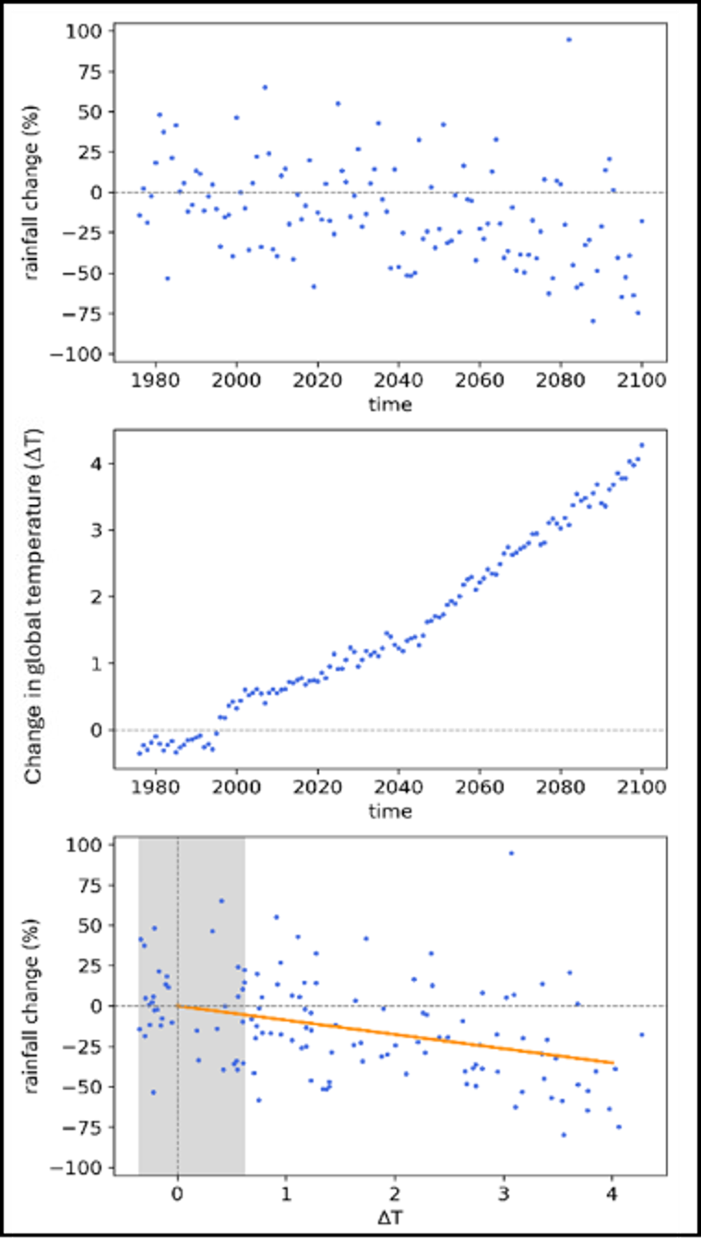
Figure 30: Illustration of the pattern scaling method for one GCM simulation for a 0.05° grid cell, with the slope of the orange line in the bottom panel indicating the percentage change in mean annual rainfall per degree of global warming since 1990.
Analyses in Murray‒Darling Basin Sustainable Yields assessment (Chiew et al., 2025; Devanand et al., 2025) indicate that projections from all 120 simulations from the different SSPs (41 from SSP2-4.5, 37 from SSP3-7.0 and 42 from SSP5-8.5), expressed as a change in the climate variable per degree of global warming, can be considered together to provide 120 estimates of projected change in each climate variable. The end result is therefore 120 plausible projections for each climate variable analysed, expressed as a change in the climate variable per degree of global warming, for each of the ~10,000 0.05° (~5 km) grid cells across Victoria.
To produce a runoff projection, a complete set of temperature, PET and daily rainfall data is required as input. However, they are not always available as a set from the 120 GCM simulations. In these instances:
- the projected change in PET can be adopted from the GCM simulation that has the closest projected change in temperature averaged across Victoria
- the projected change in very heavy daily rainfall, above P_{99.5}, can be adopted from the GCM simulation that has the closest projected change in annual rainfall averaged across Victoria.
The pattern scaling results can be scaled to provide projections for any global warming level associated with any emissions scenario and future time period over the 21st century.
To estimate future runoff, the GR4J model was calibrated regionally to four regions of Victoria, shown in Figure 31 along with the Bureau of Meteorology’s Hydrologic Reference Stations. A single set of parameter values (for each region) was then used to model historical and future runoff for all the 0.05° grid cells in each region. The four regions were arbitrarily defined, guided by cluster analysis of observed annual streamflow series, mean annual streamflow, and runoff coefficient in the 127 catchments across Victoria.
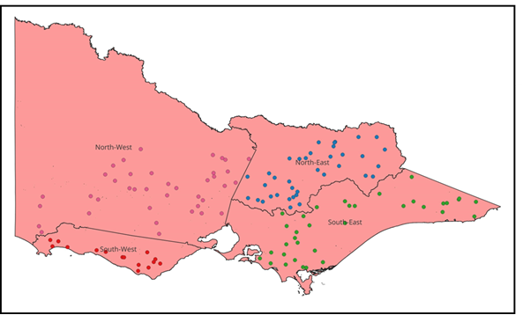
Figure 31: Location of the 127 Hydrologic Reference Station catchments and four hydrological modelling regions in Victoria.
In the regional calibration, a single set of parameter values was used to model runoff across each of the four regions, with the model calibrated to maximise the sum of NSE bias (Viney et al., 2009) in all catchments in each region. The Nash‒Sutcliffe efficiency (NSE) (Nash & Sutcliffe, 1970) minimises the sum of squares of the difference between the modelled and observed daily streamflows, and the bias ensures that the difference between the total modelled streamflow and the observed streamflow is small. In the regional calibration, where the NSE bias in a catchment is less than 0.2, it is set to 0.2. This is to avoid the regional calibration attempting to simulate streamflow in a couple of very poor-performing catchments (with a very low or meaningless negative NSE value) at the expense of the other catchments in the region. In these poor-performing catchments, there may be issues with the climate inputs or streamflow data or the rainfall‒runoff model simply not being able to reproduce the observed streamflow.
Using the same parameter values to model runoff across large regions with similar hydroclimates can potentially provide a more robust estimation of changes in future runoff across the region. Other methods that are commonly used to predict runoff in ungauged catchments ‒ such as using parameter values from the nearest calibration catchment or from physically similar catchments ‒ were also explored (Zhang & Chiew, 2009; Bloschl et al., 2013), with the regional calibration showing similar or better calibration results.
The methods adopted take advantage of available climate and hydrological science but, as with any method, are subject to some uncertainties, which are discussed further below.

Uncertainties in the pattern scaling method
There are several appealing features in the pattern scaling method used to estimate the change signal in the climate variables. The pattern scaling method considers the trend in the climate variable (e.g. rainfall) over more than 100 years, unlike the traditional time slice method, which compares the rainfall over a future time window versus a historical period (e.g. Zheng et al., 2024). Any method used will reflect both the uncertainty in the climate change signal simulated by the different climate models as well as the internal climate variability or stochasticity arising from initial conditions in the climate models. By considering the rainfall trend over 100+ years, the pattern scaling method more robustly captures the range in the climate change signal, whereas the time slice method inevitably also accounts for a large proportion of the internal climate variability, more so when a shorter time slice or window is used (Devanand et al., 2025). As a result, the range in the climate projections developed using the pattern scaling method for these guidelines is smaller than the range in the climate projections in the 2020 guidelines (DELWP, 2020b), which were developed using the time slice method.
The pattern scaling method easily enables the climate projections to be expressed as a change per degree of global warming. The analysis in Chiew et al. (2025) and Devanand et al. (2025) indicates that the change signal per degree of global warming can then be linearly scaled to obtain projections for any global warming level. The analysis also shows that GCM simulations for the different emissions scenarios can be pooled together (120 GCM simulations are considered in these guidelines) to estimate the distribution (median and range) in the future climate projections. The analysis also indicates that the runoff projections per degree of global warming can generally be linearly scaled to estimate the change in runoff for global warming levels up to 2.5°C above the baseline level of warming.

Uncertainty in hydroclimate projections
The largest uncertainty in the runoff projection comes from the uncertainty in the rainfall projection. The differences in the runoff projections developed using different rainfall‒runoff models for changes in the climate inputs are relatively small compared with the range in the rainfall projections from the different GCMs (Teng et al., 2012; Joseph et al., 2018; Hatterman et al., 2018; Chiew et al., 2025).
The use of climate projections from a sub-set of ‘better performing’ GCMs, as well as from four higher-resolution dynamical downscaling or regional climate model products in the Coordinated Regional Downscaling Experiment (CORDEX) (Grose et al., 2023), was also investigated. The results show that the median and the range of projections for these are similar to those developed for the guidelines (Chiew et al., 2025).

Hydrological non-stationarity
A limitation in the hydrological impact modelling is the use of the same model parameter values obtained through model calibration against historical data to model the future under climate change. The modelling therefore considers the changes in the climate inputs (climate non-stationarity) but not the potential changes in the climate‒runoff relationship or dominant hydrological processes (hydrological non-stationarity).
Many catchments in Victoria exhibit non-stationarity in the rainfall‒runoff relationship where less annual streamflow was generated during the Millennium Drought for the same amount of rainfall compared with pre-drought conditions (Saft et al., 2015; DEECA, 2025a). The shift in hydrological response and recovery following the drought can vary in the different catchments, and many catchments in the state, particularly in western Victoria, have not fully recovered from the Millennium Drought (Peterson et al., 2021).
There have been extensive studies in the VicWaCI and elsewhere attempting to understand the causality and to adapt models to account for hydrological non-stationarity (DEECA, 2025a; Fowler et al., 2022b). However, this is a complex problem that has been identified as one of the 23 key research challenges by the international hydrological community (Bloschl et al., 2020), and research in this area continues. Existing modelling approaches, such as the modelling adopted in these guidelines, tend to overestimate runoff during dry periods, and this in turn tends to lead to an underestimation of the reduction in future runoff under a drying climate (DEECA, 2025a).
By using the same parameter values to model both the historical baseline and the future, the model output is also being extrapolated to predict a future under conditions not seen in the past, such as higher temperature, PET and atmospheric CO₂ concentration. There are conflicting views on how vegetation will respond to these changes, but their net impact on runoff in water-limited areas such as Victoria is likely to be relatively small (compared with uncertainty in future rainfall projections) and cannot yet be observed in global streamflow data (Wei et al., 2024).
Also not modelled in these guidelines are the potential changes in future catchment conditions ‒ for example, the impact of farm dams (not accounting for this will underestimate the reduction in total runoff volume by up to 10%; see Robertson et al., 2023), fires (the net impact on total runoff is likely to be relatively small; see Lane et al., 2023; Robertson et al., 2024) and snow hydrology (higher temperatures will affect the seasonality of alpine runoff but have a relatively smaller impact on total runoff volume, particularly when aggregated over a large area).

Hydrological impact modelling method
The empirical scaling method used in these guidelines assumes that the future daily rainfall sequence is the same (but with different daily values) as the historical rainfall sequence. Methods such as direct bias correction of climate model simulations can overcome this limitation but are likely to also introduce more uncertainties (Potter et al., 2020; Charles et al., 2020; Addor & Siebert, 2014). The empirical scaling method was adopted because it:
- is fit-for-purpose to assess climate change impact on runoff
- provides consistent projections that are relatively easy to interpret and communicate
- is simple and can be applied with future projections from all available and appropriate climate models to reflect a fuller range of uncertainty
- is commonly used for climate change impact assessment globally and is similar to methods used in previous and recent studies in this region (Chiew et al., 2009; Zheng et al., 2024).
Nevertheless, Chiew et al. (2022) compared runoff projections developed for south-east Australia using different hydrological impact modelling methods (different methods used to generate future climate series, different rainfall‒runoff models and model calibration) and climate projection data sources and concluded that they all indicate a hotter and drier future in south-east Australia, with similar values and range in the runoff projections.

Additional information and guidance
This appendix includes additional information and guidance on water availability impact assessment techniques and assumptions, and the reasons for their adoption in these guidelines. It also includes some sample applications of aspects of the guideline methods.
  - Complementary references
A full list is provided in References. Some of the most relevant complementary references to guidelines and technical reports are provided in Table 36Table . This list is by no means exhaustive.

Table 36: Complementary references.
Reference | Potential complementary uses
Water planning guidance and other climate change guidance
DELWP. (2022). Guidelines for the adaptive management of wastewater systems under climate change in Victoria. | Complementary climate change impact assessment guidance specific to sewerage planning
DEECA. (2025b). Guidelines for the development of Urban Water Strategies & Drought Preparedness Plans | Guidelines for how Victoria’s water corporations should undertake long-term and short-term urban water resource planning
DELWP. (2018). Pilot water sector climate change adaptation action plan | The climate change adaptation strategy for the water sector
DELWP. (2019). Managing climate change risk: Guidance for board members and executives of water corporations and catchment management authorities | Guidance on how to integrate climate change impact assessments on water supplies into decision making
WSAA. (2016). Climate change adaptation guidelines | Illustrates how climate change impact assessment on water supplies fits in with broader climate change adaptation and mitigation measures by water corporations
WSAA. (2024). Urban water resource planning framework | Water resource planning principles on a wide range of water resource planning topics, including climate change and climate variability
Climate science
DEECA. (2024). Victoria’s climate science report 2024 | An overview of the latest findings from scientific research into climate change in Victoria
DELWP et al. (2020a) Victoria’s water in a changing climate. | An overview of the scientific findings from the VicWaCI research program from 2017 to 2020
DEECA. (2025a). Victoria’s water resources under a changing climate – Insights from phase 2 of the Victorian Climate and Water Initiative | An overview of the scientific findings from phase 2 of the VicWaCI research program from 2021 to 2024
Round, V., et al. (2024). Victorian climate projections 2024 technical report | Technical report that presents VCP24 projections based on global and regional climate modelling simulations.
Adapt NSW. About NARCliM. https://www.climatechange.environment.nsw.gov.au/ narclim/about-narclim | Information about the NSW and ACT Regional Climate Modelling (NARCliM) projections that extend into Victoria
Design flood estimation
Ball, J., et al. (Eds.). (2019). Australian rainfall and runoff: A guide to flood estimation | The national guideline for design flood estimation, including climate change considerations in chapter 6 from Wasko et al. (2024)

  - Climate reference periods
Climate reference periods provide a reference point from which to project climate change impacts. Climate reference periods are required to present an understanding of water system behaviour. They are also important for accounting purposes when comparing available resources over time, across different climate change scenarios and across different parts of Victoria.
The selection of a suitable climate reference period is a trade-off between the period being long enough to capture natural climate variability (droughts, floods and everything in between), but short enough to avoid the confounding effects of trends over the reference period, such as those driven by changes in greenhouse gas concentrations. The desired characteristics of a climate reference period are that it:
- includes a wide range of natural climate variability
- is reasonably stationary with respect to greenhouse gas‒induced climate change, such as the observed decline in cool-season rainfall and increases in very heavy rainfall intensity
- is comparable across supply systems and river basins.
A range of factors were considered when selecting climate reference periods. These included the availability of observed climate and hydrology data, the variability of that observed data, the presence of trends and steps in the observed data, the availability of suitable paleoclimate information, and the likely minimum requirements for procedures that could extend the reference period to incorporate more climate variability. DEECA also consulted with water corporations and research scientists on this issue.

  - Historical data scaling examples
Historical data scaling is a simple technique to adjust historical data so that the data have similar exceedance properties to a reference period, such as the post-1975 reference period. The recommended approach for these guidelines involved deriving average values for each interval (decile) of probability exceedance for both the reference period and the earlier historical data. The historical record prior to the reference period (e.g. pre-1975 flow) was then factored by the ratio of the average values in each period (e.g. post- and pre-1975) for the decile in which each value was located (see Figure 8).
Historical data scaling has the potential to create discontinuities in daily time series data. When applying the scaling to deciles using all months of data, discontinuities can occur at the boundary of each decile. When applying historical data scaling to match exceedance curve behaviour, it is necessary to check the consistency of the scaling factors across adjacent deciles and seasons.
HARC (2020a) undertook an analysis of the potential for historical data scaling to introduce data anomalies in 150 datasets across Victoria. From this analysis it was concluded that:
- inconsistent scaling factors across adjacent deciles occurred in less than 5% of datasets
- it was not uncommon for high, low or the majority of historical streamflows to increase after scaling (e.g. low flows increased in 26% of datasets). Understanding the quality of the reference period data is important for interpreting the validity of the historical data scaling.
HARC (2020a) also investigated some of the potential causes of anomalies introduced by historical data scaling. These included examining differences in a sample of wet and dry catchments, differences when analysing the dataset on different time steps, differences when using a shorter period of record in the historical (pre-reference) period, differences when applying annual or seasonal scaling, differences due to changes in the method of streamflow derivation and differences in the observed flows over time (e.g. due to changes in gauging practices). This analysis did not identify any conclusive patterns for the drivers of potential data anomalies introduced by historical data scaling, with anomalies likely to be unique to individual datasets associated with local quality control or water management issues. Where potential anomalies were identified, an examination of the stationarity of gauged water levels was shown to help identify whether poor quality of raw data was a cause of the anomaly.
When comparing seasonal versus annual scaling factors, HARC (2020a) noted with a sample dataset that scaling factors over the cool season typically resulted in flow reductions in the historical period, while in the warm season, flow increases occurred.
Some examples of historical data scaling are shown in the following graphs. The flow exceedance curve is plotted as 10 points, with 1 point for the average flow within each decile. The scaling conversion factor is the factor that would be applied to the historical data for that decile.
Figure 32 illustrates the historical data scaling that would typically be expected in a drying climate, namely that the reference period flows are below the historical flows for all deciles, and the scaling factors are therefore all less than 100%.
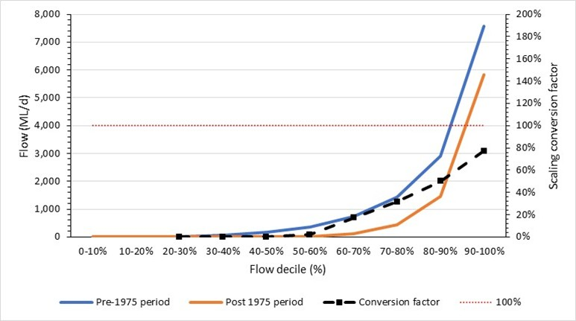
Figure 32: Example of expected historical data scaling, with post-1975 flows lower than pre-1975 flows in all deciles. Source: HARC (2020a).

Figure 33 shows an example of potentially anomalous scaling factors, with an unusually high scaling factor of 220% in the third decile. In this example, after investigating the data, it might be more appropriate to adopt the scaling factor for the fourth decile for application in the third decile. It is likely that the third decile is unduly influenced by a small number of data points within the decile, due to the presence of zero flows within this decile.
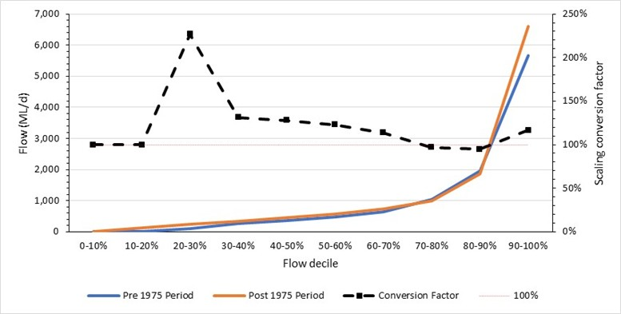
Figure 33: Example of anomalies in the historical data scaling factors. Source: HARC (2020a).

Figure 34 shows an example of flow increases in the reference period in both the low-flow (first to third deciles) and high-flow (top decile) range. It is not unusual for the top decile flows to be higher in the reference period than in the historical (pre-reference) period, because flows in this decile will be influenced by relatively rare high-flow events. This observation is also consistent with the increases in rainfall intensity that are expected under global warming. However, increases in streamflow in the lowest three deciles are unexpected, and would be a trigger to investigate this dataset further, to understand whether flow regulation, drainage or wastewater treatment plant discharge may account for this behaviour.
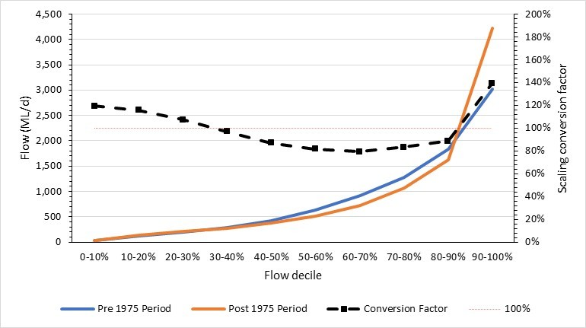
Figure 34: Example of low-flow and high-flow increases under historical data scaling. Source: HARC (2020a).

  - Non-climatic trends in the climate data
Non-climatic trends can sometimes be present in recorded climate data. These may occur because of poor infilling and data extension, or when different collection methods are used ‒ such as changes in instrumentation, gauge location or surrounding vegetation cover that cause interference with the gauge (Lavery et al., 1992).
Higher-quality raw hydroclimate datasets are designated by the Bureau of Meteorology such as the:
- Australian climate change site networks which include the ACORN-SAT temperature observations, rainfall, pan evaporation and cloud amount
- Hydrologic Reference Stations for detecting long-term variability and changes in streamflow.
The sites for these datasets have been quality controlled to ensure that they are comparable through time and free of spurious non-climate influences that might otherwise mask real trends. South Eastern Australian Recent Climate Historic (SEARCH) temperature data (Ashcroft et al., 2014) extend further back in time than the ACORN-SAT dataset and HARC (2025b) has shown the two datasets to be well correlated for the Melbourne air temperature data.
The continuously infilled daily climate products currently available in Australia are the Scientific Information for Land Owners (SILO) database (Jeffrey et.al., 2001) and the Australian Water Availability Project (AWAP) datasets (Jones et al., 2009). These datasets are available at gauged locations (infilled over time) or as a gridded product (infilled over time and across ungauged locations). HARC (2020b) found that AWAP gridded rainfall data underestimate rainfall peaks compared with the at-site data and overestimate lower rainfall, likely due to smoothing effects. The SILO gridded data are a closer match than the AWAP gridded data to the at-site rainfall records due to differences in interpolation of the gridded surfaces in the two products. However, both gridded datasets underestimate the peaks of the at-site data. For these reasons, at-site rainfall data are considered more reliable than the equivalent gridded data at the same or adjacent locations.
The correlations used to infill at-site data in the SILO database are regularly updated, which means that infilled SILO data may differ between downloads. These correlations are typically less stable when infilling missing data from very recent periods. Gibbs et al. (2024) noted that adopting at-site rainfall data from the SILO database often includes extrapolation to extend the dataset after the relevant rainfall station is closed or before it opens. This can introduce non-climatic trends in the data when compared with adjacent continuous sites.
Although pan evaporation is recorded, other estimates of PET that are typically used in water availability assessments are derived from theoretical relationships that rely on recorded input sunshine hours, temperature, relative humidity, wind speed, elevation, latitude, mean annual rainfall, and/or salinity. Non-climatic trends can also be present in some of these climate records (HARC, 2025b). These datasets are available from both SILO and the Australian Water Resources Assessment Landscape (AWRA-L) water balance model (Frost & Shokri, 2021).
Searcy and Hardison (1960) noted that longer periods of records have a greater chance of there being a change in physical conditions at the gauge site or in methods of data collection. These can include:
- the growth of vegetation over the gauge, or the construction of buildings that cast shade, intercept rainfall or block wind
- the installation of Stevenson screens at climate stations, which allow air flow but shelter the thermometer from direct sunlight and rain. These screens were installed at different locations in south-east Australia throughout the 20th century, and may affect non-climate trends in air temperature, depending on the site. ACORN-SAT temperature data are unaffected by the installation of Stevenson screens. More recently developed aspirated thermometers, which force air flow through the Stevenson screen, can also result in a difference in recorded air temperature during calm (no wind) conditions, but the differences found are smaller than those arising from the installation of the Stevenson screens (Harrison & Burt, 2024)
- changes in the method of recording solar radiation, from a sparse network of ground-based stations prior to 1957, to a denser network of ground-based stations from 1957 to 1989, to the use of satellite observations from 1990 onwards. The accuracy of these solar radiation networks has increased with each change in recording method.
Double-mass curves of climate data at the site of interest against a known high-quality dataset (e.g. from the Bureau of Meteorology’s climate change site network) can be used to identify any anomalous climate data behaviour. Where anomalous climate data are identified, a nearby alternative site can be used or the climate data can be de-trended until the double-mass curve against the high-quality dataset returns to a straight line. This requires the identification of breakpoints in the double-mass curve, with adjustments applied to individual segments of the curve between each breakpoint.

  - Stochastic data generation
To produce useful stochastic simulations, the most important statistics derived from the stochastic replicates must be consistent with the statistics of the underlying data. Data from a reference period ‒ such as measured rainfall, streamflow, evaporation or temperature ‒ are normally used as the baseline for preparing the statistics. In this case, ‘(e)ach stochastic replicate (sequence) is different and has different characteristics compared to the historical data, but the average of each characteristic from all the stochastic replicates is the same as the historical data’ (Srikanthan et al., 2007). Recent examples have adjusted the underlying statistics, which are to be matched by the stochastic replicates, to allow for projected climate change (Peel et al., 2015; Henley et al., 2019). For example, the stochastic rainfall replicates might be modified to preserve some statistics from the observed historical rainfall data (e.g. correlation in annual rainfall totals) but with the mean annual rainfall statistic modified to match a climate change projection. The underlying reference period series, as input to the stochastic data generation process, may also be adjusted to be consistent with the statistics from the post-1975 period.
For the generation of stochastic data consistent with these climate change guidelines, stochastic data generation can be undertaken directly on the post-1975 historical climate reference period. When generating stochastic data for use with GCM-based projections, the adjustment of those data for projected peak (if applicable) and average annual historical climate change can be undertaken either before or after generating the stochastic data. However, due to the level of effort in generating and checking stochastic data, it is suggested that the data be generated only once (using the post-1975 historical climate reference period). The adjustment for projected historical low, medium and high climate change can then be applied to the stochastic dataset.
This chapter briefly summarises the features of stochastic simulation models and issues to consider when selecting a stochastic data generation model for application. It also provides information on specific stochastic data simulation methods for use in water resources modelling, concentrating on methods and tools that are readily available to Australian modellers.

Features of stochastic simulation models
Stochastic data simulation methods can be applied to simulate:
- precipitation
- evaporation and evapotranspiration
- streamflow
- temperature.
Stochastic models can be used to generate data on several different timescales, including:
- annual
- seasonal (where the number of seasons and even the length of seasons can vary)
- monthly
- weekly
- daily
- sub-daily (e.g. hourly, or even down to 5-minute resolution).
The variables to be simulated and the time step required for the model will vary, according to the:
- underlying structure of the water resources model
- computing infrastructure required to run the model for many replicates
- metrics that are to be analysed from the model.
Stochastic data are produced by a statistical model. This model often has its own parameters, such as the mean and variance for each variable and the cross-correlations between the variables. These parameters should be calibrated to improve the model’s ability to accurately reproduce the most important statistical properties of the underlying (normally historical) data.
- Calibration is an important step in the process and should demonstrate that the statistics of the stochastic replicates are sufficiently close to the statistics in the underlying data sequence.
- Calibration should normally be tested by generating replicates that are the same length as the underlying (reference period) data series. For example, if the reference period rainfall sequence at a site is 47 years long, during calibration stochastic replicates should be generated that are also 47 years long.
- Once an acceptable model calibration has been demonstrated using replicates that are the same length as the reference period data, the calibrated statistical model may then be applied to generate any number of replicates, of any length that is required for simulation.
Some stochastic data simulation models can incorporate uncertainty in the model parameters into the data generation process. Allowing for parameter uncertainty will normally increase the variability between the stochastic data replicates that are produced. Consequently, allowing for parameter uncertainty has been demonstrated to increase the probability (and hence the risk) posed by extreme droughts in some systems (Thyer et al., 2006; Berghout et al., 2015).
Several stochastic data generation models follow a two-step approach:
- produce stochastic data at an annual or seasonal time step
- downscale, or disaggregate, the annual/seasonal generated data to a finer time step (monthly, weekly, daily or sub-daily).
The practical advantage of this two-step approach is that the annual/seasonal totals are closer to normal distribution and therefore may be generated using a parametric model, which is better able to represent years/seasons that are outside of the range of the underlying (historical) data. A parametric approach may then be applied to the second step (disaggregation or downscaling) and still allow the multi-year dynamics of the system to be appropriately captured (Peel et al., 2011; Steinschneider and Brown, 2013; Kuczera, 2020).

Selection of a stochastic data generation model
At least three tools are readily available to Australian practitioners for generating stochastic climate data: SCL, foreSIGHT and MSSSCAR (in WATHNET5). Within each of these tools, there are several options to generate stochastic data for a system.
In selecting a stochastic data generation method, modellers should consider the following:
- the variables (e.g. rainfall, streamflow, evaporation) that are required to run the water resources model
- the variables that might be required to generate inputs to the water resources model (e.g. temperature may be required to generate a time series of demand)
- the time step of the water resources model
- the time step of models that might be required to generate inputs (e.g. rainfall‒runoff models may run on a daily time step, in order to generate a weekly or monthly flow series, as input to the water resources system model)
- the overall number of sites and variables to be generated
- the importance of seasonality as a driver of the response of the system and, if seasonality is important, how many seasons and the start and end months for the seasons
- the importance of long-term climate drivers on climate in the study area.
Modellers should consider making simplifications to the structure of the water resources model, to reduce the effort that may otherwise be required to calibrate the stochastic data model and to generate the stochastic data. Stochastic data should always be calibrated to the underlying (historical) data. If stochastic data are required for a large number of sites and/or variables, there may be considerable effort required to demonstrate that the stochastic data generation model is well calibrated for all these sites and variables.
For example, it may be desirable to increase the time step of the underlying model (from daily to monthly) or to reduce the spatial detail in the model, by combining several catchments together or only representing the largest reservoirs in the system. A relevant recent example of this is the simulation of a simplified representation of the Melbourne water supply system (Henley et al., 2019), which generated inflows using a monthly time-step model and only modelled the four largest reservoirs in the system. The model used had considerably less spatial resolution than the REALM or eWater Source models that might normally be used for water resources planning and that would typically run on a finer time step (e.g. daily) and typically represent the smaller storage and management rules for many more stream reaches in the system.
In some cases, the only means of testing the sensitivity of outcomes to the stochastic data generation approach may be to apply a few different approaches. To test the sensitivity of the yield of a water resources system to ENSO, it would probably be best to first generate the stochastic data with ENSO as the state driver and then run this through the system, before repeating the process again without using the state driver. Fu et al. (2018) found that applying four different weather generators for stochastic data generation allowed for a broader representation of the influence of climate variability and climate change on outcomes from water resources models.
In summary, stochastic simulation in water resources models often requires trade-offs to be made in what spatial details or features are represented in the model and the model time step. For example, it may be that explicit modelling of farm dam impacts or modelling environmental flow releases on a daily time step are traded off against a model that is better able to capture the probability of extreme multi-year drought events that cause severe restrictions. The modelling team should use their experience in modelling the system with historical data series to make informed choices about simplifications that are likely to deliver the most value from stochastically generated data. Improved understanding of probabilities and risks for extreme events may come at the expense of loss of some detail in modelling finer-scale spatial and temporal features.

Stochastic weather generators
A range of different approaches have been developed and tested in the literature for the generation of stochastic climate or weather data, and these can be grouped into two broad categories:
- short to long timescale methods generate stochastic data at short timescales (daily or sub-daily), in a manner that aims to replicate the statistics for the short timescale the data are generated at, and typically rely on scaling relationships to reproduce the statistics at longer timescales (e.g. multi-day, seasonal and annual timescales)
- long to short timescale methods first generate stochastic data at long timescales (seasonal, annual or multi-year), generally using a parametric stochastic generator, with generated data then stochastically disaggregated to shorter timescales (monthly, daily or sub-daily), normally using a non-parametric approach.
Short to long timescale methods have typically been applied to systems where outcomes are more strongly driven by events that occur at shorter timescales, such as floods or runoff events into systems with relatively small storage (e.g. household rainwater tanks). Conversely, long to short timescale methods have typically been applied to systems where outcomes are driven by longer-term conditions, such as water resources planning for urban water supply systems, which typically have very large multi-year reservoirs.

Stochastic Climate Library (SCL)
The Stochastic Climate Library (SCL) software was first released in 2005, with only minor updates in 2006 and 2007. The SCL was originally produced by the Cooperative Research Centre for Catchment Hydrology and is still available via the eWater toolkit.
The SCL contains the following options for stochastic models:
- annual rainfall: first-order autoregressive model with parameter uncertainty (Srikanthan et al., 2002a)
- monthly rainfall: modified method of fragments (with annual data generated using the above annual rainfall model) (long to short timescale generator) (Srikanthan et al., 2002b)
- daily rainfall: transition probability matrix (with Boughton’s correction) (short to long timescale generator) (Siriwardena et al., 2002; Srikanthan, 2005)
- sub-daily rainfall: DRIP model (short to long timescale generator) (Heneker et al., 2001; Frost et al., 2004)
- annual climate: first-order autoregressive multivariate model (Srikanthan & Zhou, 2003)
- monthly climate: modified method of fragments (long to short timescale generator) (Srikanthan & Zhou, 2003)
- daily climate: first-order autoregressive multivariate model conditioned on rainfall state and nested in monthly and annual models (long to short timescale generator) (Srikanthan & Zhou, 2003)
- multi-site daily rainfall: multi-site two-part model nested in monthly and annual models (long to short timescale generator) (Srikanthan, 2006).
Full descriptions of each model are provided in Srikanthan et al. (2007) and the references therein.
The SCL user interface contains tools that enable the user to calibrate a stochastic data generation model and then generate stochastic replicates. The SCL user interface contains features that allow the key statistics from the underlying (historical) data to be readily compared against the generated replicates, which is a particularly useful feature during model calibration.
The multi-site daily rainfall (long to short timescale) generator has also been implemented in eWater Source (Satheesh, 2017).

Multi-Site, Multi-Season, Multi-State Contemporaneous Auto-Regressive (MSSSCAR) model
The Multi-Site, Multi-Season, Multi-State Contemporaneous Auto-Regressive (MSSSCAR) model is a tool that is provided in WATHNET5 (Kuczera, 2020). These are the key features of MSSSCAR:
- multi-site: it may be applied across many different sites in a system or catchment – these sites may have precipitation, evaporation/evapotranspiration, temperature and/or streamflow data
- multi-season: it may be applied to first generate annual data, or to first generate data for any number of seasons within a year (although between two and four seasons would be typical)
- multi-state: the annual/seasonal generation model may (or may not) be conditioned according to one underlying climatic driver variable, such as El-Niño Southern Oscillation (ENSO) or the Interdecadal Pacific Oscillation (IPO)
- auto-regressive: the annual/seasonal generation model preserves the autocorrelation structure of the annual or seasonal totals (i.e. the extent to which a wet or dry season/year is followed by further wet or dry seasons/years)
- produces outputs at daily, monthly, seasonal or annual time steps, by disaggregating the generated seasonal or annual totals using the method of fragments, with fragments selected using a kernel nearest neighbour approach.
Full details on the MSSSCAR model are provided in Kuczera (2020).
The MSSSCAR model has several features that advance it beyond the models that are available in SCL:
- Its multi-season feature may be particularly useful for systems where there are clear shifts between wet and dry seasons (compared with the SCL models, which first generate data on an annual time step only).
- The multi-state feature allows for conditioning of the stochastic data generation process using an underlying climate driver, which is not available in any of the SCL models.
- The kernel nearest neighbour approach permits considerably more within-season (or within-year) variability in patterns than the disaggregation approach that is applied in most of the SCL models.
Although the MSSSCAR model could probably be used to produce sub-daily data, it is unlikely that it has actually been applied in practice to generate data at time steps that are shorter than daily. Indeed, most of the applications of WATHNET and the MSSSCAR model have probably been in water supply systems with large multi-year storages, so the emphasis in testing the stochastic data generation processes has probably been on monthly, seasonal and annual statistics. For generating sub-daily rainfall data, the DRIP model (Heneker et al., 2001; Frost et al., 2004) (contained in the SCL) is probably a more appropriate model, at least until further testing is carried out on the MSSSCAR model at sub-daily time steps.

foreSIGHT package in R
The Systems Insights from Generation of Hydroclimatic Timeseries (foreSIGHT) package has been developed in the R statistical analysis system (Bennett et al., 2018, 2019a; Bennett, 2019; Culley et al., 2019). foreSIGHT implements the stochastic data generation approach from Richardson (1981), which is a short to long timescale generator, generating daily rainfall occurrence and amount.
foreSIGHT can be configured to undertake water resources modelling, as well as generating the stochastic climate data for the simulations (Bennett et al., 2018, 2019a, 2019b; Culley et al., 2019). For example, the foreSIGHT documentation contains a package for simulation of a domestic rainwater tank system.
foreSIGHT has been developed to undertake scenario-based planning approaches, sometimes referred to as the ‘inverse approach’, whereby stochastic replicates are generated to sample the full plausible range of potential future exposure (Guo et al., 2018; Henley et al., 2019). For example, foreSIGHT may be used to test replicates that are generated for each combination of projected changes in mean annual rainfall and mean annual temperature, under projected climate change.

Generators applying Wavelet or Empirical Mode Decomposition
Wavelet Decomposition (WD) (Kwon et al., 2007; Steinschneider & Brown, 2013), Empirical Mode Decomposition (EMD) and Ensemble Empirical Mode Decomposition (EEMD) (Wu & Huang, 2004; 2009) are all long to short timescale stochastic generating approaches that have been applied to separate out lower-frequency (multi-decadal) fluctuations in climate or streamflow data from higher-frequency (seasonal to multi-year) fluctuations. The statistical features of these lower- and higher-frequency variations can be used to drive stochastic data generation processes. Examples of applications of EMD and EEMD approaches to stochastic data generation for Australian water resources systems include McMahon et al. (2008) and Peel et al. (2011). WD has been applied to analysis of a water resources system in the United States of America by Kwon et al. (2007) and Steinschneider and Brown (2013).
Using WD, EEMD or EMD to separate out the multi-decadal from the annual to multi-year signals allows the generated stochastic replicates to better capture long-term drivers of climate variability than alternative simpler approaches, such as auto-regressive models. They can be considered as an alternative approach to the multi-state component of the MSSSCAR model. It may be that WD, EEMD or EMD is better at reproducing the longer-term variability in Victorian climate, which is subject to several different long-term drivers, than a multi-state model that is only tied to one driver (such as IPO or ENSO). Further research would be required to resolve this issue.
To date, there is no software that can be readily accessed by water resources modellers to implement WD, EMD or EEMD methods. The algorithms for EEMD are set out in several journal publications (Wu & Huang, 2004, 2009; Peel et al., 2015). Similarly, the algorithms for implementation of WD are set out in Kwon et al. (2007) and Steinschneider and Brown (2013).

  - Other climate change projections
The climate projections presented in these guidelines are sourced from the CMIP6 GCM suite, downscaled using empirical scaling (i.e. scaling a local climate dataset based on the modelled rate of change of those climate variables under projected global warming). Other climate change projections that cover Victoria are available, and can be used as part of a multiple lines of evidence approach to understanding projected climate change. Key advantages of the projections in these guidelines, relative to some of these other available projections, are that they:
- Use the latest IPCC GCM suite (CMIP6).
- Span a wide range of plausible future rainfall projections, from ‘warmer and wetter’ to ‘warmer and drier’ to ‘warmer and much drier’.
- Provide projected changes in variables of direct relevance to the water sector, including runoff.
- Presented at a convenient spatial scale and in a format that can readily be used with low effort.
When considering the use of other projections it is important that the underlying assumptions are well understood, including:
- what generation of the CMIP modelling suite was used to derive the projections
- what emissions scenarios they assume
- how many GCMs have been used and what range of climate futures they represent, relative to the full CMIP model ensemble
- whether the datasets have been bias-corrected in the downscaling process to account for any significant biases in the climate modelling process
- the method by which fine-scale (in the order of 2‒20 km² grids) projections were derived, noting that some projections can involve coarse interpolation that does not necessarily generate additional information at a finer scale
- for projections using a time-slice method, what baseline they are projected from.

Projections from regional climate models (RCMs)
Regional climate models (RCMs) have the advantage over GCMs of including the effects of coastlines and mountain ranges that can influence weather locally. However, they can also introduce significant bias and additional uncertainties during the modelling process and sometimes only cover a narrower range of plausible climate futures because they use relatively few host GCMs.
Two iterations of the Victorian Climate Projections (VCP19 and VCP24) have been generated using RCMs with a focus on Victoria. Both sets of projections are available in Victoria’s Future Climate Tool (DEECA, 2025c). These products provide climate projections that are relevant to a diverse range of Victorian stakeholders with an acknowledgement that bespoke projections may be relevant for specific sectors to address their needs and applications.
The VCP19 and VCP24 projections include additional climate variables. These projections represent changes in climate behaviour and variability at finer spatial and temporal resolutions than the projections provided in these guidelines, However, some of these outputs have limited applicability to water availability assessments. For example, the VCP projections do not include projections for runoff.
The methods and assumptions used to develop these projection products are outlined below:
- The VCP19 projections (Clarke et al., 2019) were developed by CSIRO for Victoria’s Climate Science Report 2019. They were generated using the Conformal Cubic Atmospheric Model (CCAM) RCM, drawing on 6 host GCMs from the 2014 CMIP-5 modelling suite of 42 models, with projections available for RCP4.5 and RCP8.5. The VCP19 projections have a significant warm bias along the east coast of Victoria, poorer representation of mean sea level pressures than their host GCMs, and an overestimation of wind speeds in winter for a given level of pressure (Clarke et al., 2019).
- The VCP24 projections (Round et al., 2024) were developed by CSIRO for Victoria’s Climate Science Report 2024 for the SSP1-2.6 and SSP3-7.0 emissions scenarios. VCP24 builds on but does not supersede VCP19. The suite of downscaled projection metrics within VCP24 draw on results from several modelling simulations:
- NARCliM2.0, which is based on the Weather Research and Forecasting (WRF) RCM, was used to downscale 5 GCMs from the CMIP6 modelling suite across the south-east corner of Australia. These projections are based on the third generation of the NARCliM RCM. The latest NARCliM has improved model accuracy, but the three NARCliM generations should be used together to capture a more comprehensive range of plausible climate futures (DCCEEW, 2025).
- Projections downscaled from 7 CMIP6 GCMs using CCAM by CSIRO for the Australian Climate Service (ACS). A method was employed that encourages CCAM to more closely resemble the host GCM but also inherit some of the errors in the GCM to generate a set of nationally consistent downscaled simulations.
- Eight CMIP6 GCMs were downscaled using CCAM by the Queensland Department of Environment and Science to generate another set of nationally consistent downscaled simulations. These projections were generated using an approach where GCM biases are reduced but there is increased reliance on the CCAM physics and dynamics for predicting changes in regional climate. This is a similar concept to that used in VCP19.
- The Bureau of Meteorology Atmospheric Regional Projections for Australia (BARPA) project generated another set of nationally consistent simulations by downscaling 7 CMIP6 GCMs using the unified model (UM) for the ACS.

Other available projections from GCMs
There are several other GCM-based projections that cover Victoria beyond those presented in these guidelines, including:
- Hydroclimate Projections for the Murray‒Darling Basin to support the Murray‒Darling Basin Authority’s Basin Plan Review, which covers northern Victoria ‒ the projections were derived using the same climate models and post-processing methods as adopted for these guidelines.
- the Bureau of Meteorology’s Australian Water Outlook, which includes climate and water availability projections ‒ the climate projections are based on downscaled and bias-corrected outputs from 4 CMIP-5 GCMs, and they are run through the AWRA-L hydrological model to produce daily soil moisture, actual and potential evapotranspiration and runoff at approximately 5 km grids.
- Climate Change in Australia, a hub for a range of climate change projection datasets ‒ this includes CMIP-5 projections for natural resource management regions, of which there are 3 covering Victoria.

Multi-year global climate outlook
Short-term weather forecasting and seasonal climate outlooks rely on climate models. These models can also be used for extended outlooks of up to several years, but the accuracy from any single climate model will be very low. To work around this limitation, the World Meteorological Organization (WMO) has adopted an approach that uses a climate model ensemble to ‘forecast’ climate conditions over the next few years. This is presented in its Global Annual to Decadal Climate Update, which provides a synthesis of climate model ‘predictions’ over the coming 5-year period. The update is produced annually, with the most recent update (referred to by the WMO as the 2024‒2028 update) released in June 2024 (WMO, 2024). It includes a single year outlook covering the calendar year (January to December) 2024 and a 5-year outlook covering May 2024 to March 2029 for the May to September and November to March seasons (noting that the April and October shoulder months between each season are not reported on).
The update includes predictions of near-surface temperature, sea level pressure, and precipitation from the climate model ensemble, initialised from current conditions. These forecasts are expressed as:
- anomalies of the ensemble mean from reference historical average climate conditions
- the ‘likelihood’ of above or below reference historical average climate conditions based on the proportion of the model ensemble that is in agreement on the direction of the anomaly.
These results are presented in global maps (Figure 35) in a format that can be interpreted at a continental scale, but are difficult to read at a local scale. As such, the WMO update provides fairly coarse information spatially, temporally and in terms of the parameters it reports on. However, the update has the potential to indicate areas of the globe where significant anomalies from reference climate conditions are predicted. For example, the model ensemble confidently predicts global warming (rather than global cooling or no change) over the coming 5 years, as a deviation from historical mean temperatures with >90% agreement on the predicted direction of change across the model ensemble (Figure 36). By its own self-assessment, the updates are less certain for precipitation, and review of previous forecasts indicates that the approach performed poorly over Victoria during the back-to-back La Niña years of the early 2020s. It is unknown how well the approach would perform locally in very dry years.
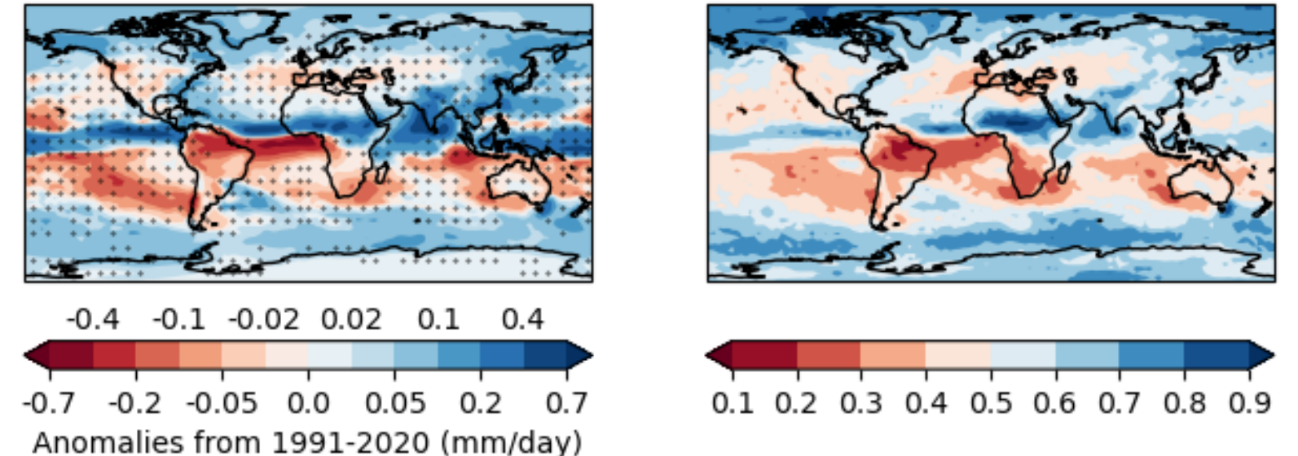
Figure 35: Predictions for 2024‒2028 May to September precipitation anomalies relative to 1991‒2020. Ensemble mean anomalies are shown on the left, stippled where more than one-third of models disagree on the sign of the anomaly, and the probability of above-average precipitation is shown on the right. Source: World Meteorological Organization (2024).

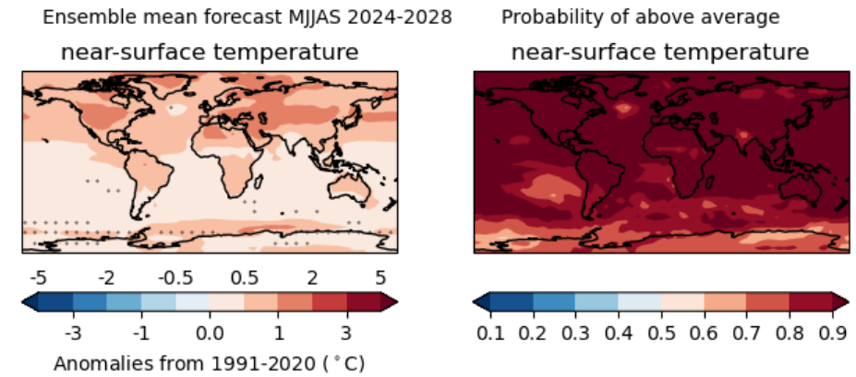
Figure 36: Predictions for 2024‒2028 May to September near-surface temperature anomalies relative to 1991‒2020. Ensemble mean anomalies are shown on the left, stippled where more than one-third of models disagree on the sign of the anomaly, and the probability of above-average near-surface temperature is shown on the right. Source: World Meteorological Organization (2024).

This approach is attractive due to the longer lead times for upcoming rainfall conditions for adaptive planning decisions. However, rainfall forecast accuracy is likely to remain very low for the foreseeable future. For water availability assessments associated with response actions that have lead times of several years, the WMO update (or similar forecasts that have been rigorously reviewed) may nevertheless still have value as supporting information as part of a multiple lines of evidence approach to decision making, when the same direction of the climate anomaly is projected by a strong majority (> 66%) of climate models.

  - Supplementary guidance on sub-daily rainfall and very heavy rainfall events
These guidelines propose a simple adjustment to very heavy rainfall events, whereby all daily rainfall above the 99.5th percentile is increased in response to global warming. This approach does not consider changes in very heavy rainfall events of different durations or rainfall magnitudes above the 99.5th percentile. Australian Rainfall and Runoff’s climate change guidance indicates a higher increase in design rainfall per degree of global warming for durations less than 24 hours (Wasko et al., 2024). Jayaweera et al. (2023) also found that the increase in high rainfall intensity across Australia over recent decades, concurrent with global warming, was higher for rare to extreme rainfall (lower likelihood) events up to the 1-in-100 AEP event. While Australian Rainfall and Runoff provides specific climate change advice for design event analysis, it notes that for continuous simulation using time series analysis ‘there is no clear consensus on how such methods should be adjusted to account for climate change’ (Wasko et al., 2024).
The projections provided by CSIRO do not include projected changes to sub-daily rainfall events of different durations and intensities. Options for adjusting sub-daily rainfall data include:
- Identifying days with rainfall totals above the 99.5th percentile and then adjusting all sub-daily rainfall on that day by CSIRO’s projected change ‒ this approach is likely to underestimate changes to peak sub-daily rainfall, particularly for event durations of less than 1 hour.
- Classifying time series rainfall events by their duration, identifying the 1 EY (1 exceedance per year) event for those durations and then adjusting those events per degree of warming as per the guidance in Australian Rainfall and Runoff for design events of different duration (i.e. greater increases for high rainfall events of shorter duration).
- Stress testing the water system with what-if scenarios that consider unique changes to sub-daily rainfall events of a given intensity.
After making the adjustment to high rainfall events, all remaining sub-daily rainfall can be adjusted by the residual change in mean seasonal rainfall, regardless of the event duration (as per the advice in these guidelines for daily rainfall).
Changes to sub-daily rainfall time series under projected climate change is an area of ongoing research and further improvement in methods is desirable to meet stakeholder needs.

  - Supplementary guidance on changes in runoff due to changes in snow cover under climate change

Background
While the alpine areas of Victoria subject to snowfall are relatively small, the headwaters of many catchments lie in these areas, providing important water resources and supporting environmental values.
Precipitation falling as snow that melts shortly after reaching the ground generates runoff in a similar manner to rainfall. In such cases, the runoff projections presented in these guidelines remain applicable.
However, if that snow accumulates on the ground as a snowpack, runoff will be delayed until such time as the snowpack melts. This shifts the seasonality of runoff from winter months (when air temperatures in alpine regions are often below 0°C) to spring (when air temperatures are sufficiently above 0°C to melt the snowpack). Essentially, the snowpack acts as a temporary storage of winter precipitation, which can be important both environmentally and for water supply in terms of buffering streamflow and improving the persistence and reliability of base flow.
Rainfall projections in these guidelines come from global climate models, which have grid sizes that are larger than Victoria’s snow fields. This results in the average elevation of every model grid cell being lower than that required to generate snow. The rainfall‒runoff model used to generate runoff projections also does not explicitly model Victoria’s snowpack. Snowmelt is implicitly embedded in the streamflow records to which the rainfall‒runoff model is calibrated. However, shifts in the volume of the snowpack under projected climate change, and associated shifts in runoff seasonality, will not be reflected in the runoff projections in these guidelines. This could potentially affect the projected reliability of supply for supply systems that are at risk from changes in seasonal streamflow behaviour.
In contrast, RCMs (ie. climate models used in VCP19 or VCP24) operate at a finer scale and therefore do model changes in snow cover in Victoria. However, these changes have not been analysed. Only a descriptive overview from a preliminary analysis of changes in snow cover was presented in the VCP19 technical report (Clarke et al., 2019), which concluded that modelled changes were similar to those previously assessed in greater detail, such as in Bhend et al. (2012). Future changes to snow cover for Victoria were not updated (using VCP24 projections) for Victoria’s Climate Science Report 2024 (DEECA, 2024), which relied on the conclusions drawn from the VCP19 technical report.
The spatial extent of snow cover in Victoria varies seasonally and from year to year, based on prevailing weather conditions. Snow formation requires both precipitation and sub-zero air temperatures. While snow can occasionally occur at very low altitudes, a snowpack lasting several weeks or more occurs only in alpine regions of north-east Victoria. All of Victoria’s ski resorts have ski fields at elevations higher than ~1300 m above sea level (based on Harris et al., 2016). This can be regarded as an indicative elevation below which snow is unlikely to aggregate into a snowpack for several weeks or more. The following advice is therefore only applicable to catchments higher than ~1300 m above sea level.
A range of studies have estimated both historical and projected changes in snowfall, snowpack and snowmelt in Australia’s alpine regions. Some of these studies have used a purpose-built model that assigns precipitation to either snow or rainfall based on local temperature information, or they have used RCMs that operate on a fine grid scale. As noted in the technical report for the VCP19 (Clarke et al., 2019), the findings from these studies have been generally consistent and were broadly re-stated in the latest State of the Climate 2024 report (Bureau of Meteorology and CSIRO, 2024). In Victoria’s alpine regions, under increased global warming:
- Victoria’s climate is drying and is projected to continue to become drier under most GCM projections (Hope et al., 2017).
- Maximum snow depths have declined over recent decades and the snow season is on average finishing earlier (Bhend et al., 2012).
- There is a very high confidence that there will be a decrease in snowfall, an increase in the rate of snowmelt and thus reduced snow cover in future decades (CSIRO and Bureau of Meteorology, 2015).
- These future trends will be large compared to natural variability and most evident at low elevations (CSIRO and Bureau of Meteorology, 2015).
- Snowmaking activities at alpine resorts may partially offset these climate trends; however, opportunities for snowmaking are expected to reduce significantly due to warmer air temperatures (Harris et al., 2016).

Technical guidance
The following guidance is based on considering the potential risk posed from changes to seasonal streamflow behaviour associated with changes in accumulated snow depth. This approach draws on the approach adopted by Gippsland Water in its 2017 Urban Water Strategy (Gippsland Water, 2017). While this approach was initially developed for urban supplies, it could equally be applied to rural supply systems or environmental water management. The proposed decision process is shown in Figure 37.
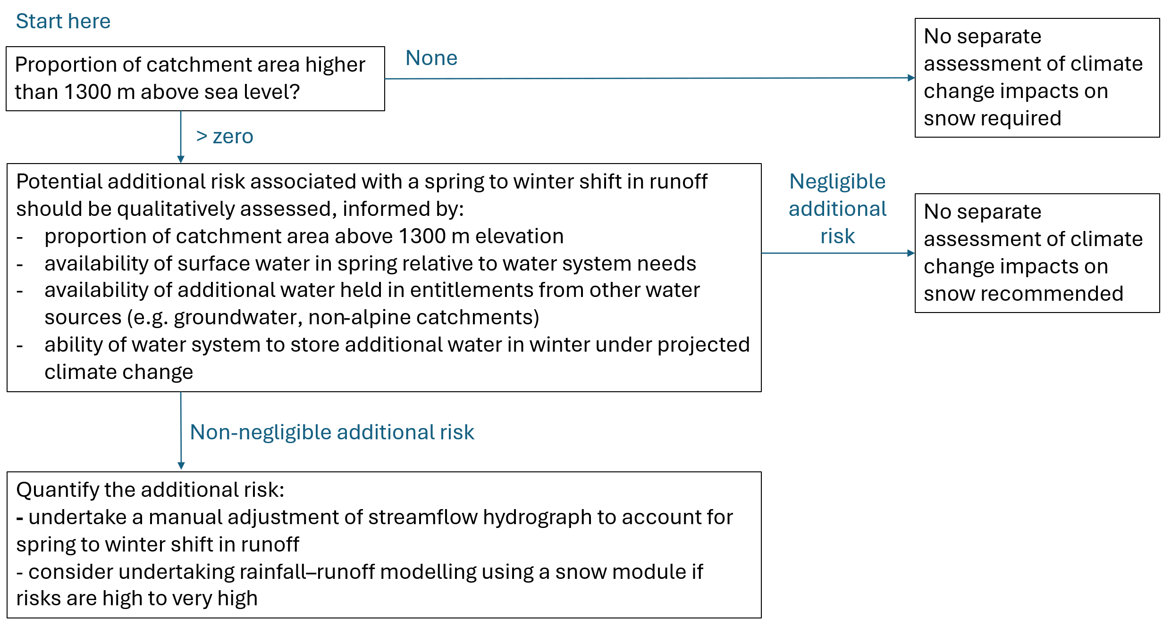
Figure 37: Decision process for assessing the potential risk associated with projected changes in snow cover.

In this decision process, where a catchment includes areas higher than ~1300 m elevation, a qualitative assessment of the additional risk associated with changes in the snowpack can be undertaken. This additional risk is due only to the seasonal shift in runoff from spring to winter associated with changes in the snowpack volume. This risk is over and above any risk attributable to projected changes in total precipitation (i.e. rainfall plus snow) under climate change.
In almost all catchments, this additional risk is expected to be negligible because:
- the contributing catchment area covered by snow is small
- the projected available surface water in spring under climate change may be in excess of system needs
- underutilised water entitlements from other sources may be available
- the duration of periods of continuous snowpack accumulation is short
- snow depth is already naturally lower and non-existent at lower elevations in drought years
- more airspace in storage may become available in winter in a drying climate.
If a non-negligible additional risk is identified for a water system, a manual adjustment of baseline water system inflows is recommended to quantify this risk. This adjustment process can be informed by hydrological advice specific to the location of interest, provided that it is transparently undertaken and reported. As a suggestion, DEECA offers the following process in the absence of specific local and informed hydrologic advice:
- Step 1: Factor water system inflows for projected changes in runoff (as is done for all surface water systems based on the factors provided in these guidelines) to assess changes in water system performance under climate change without considering changes in the snowpack.
- Step 2: Download historical snow depth information from Data Victoria using ‘Victorian alpine resorts’ in the search window, then select the resort area that is likely to be representative of changes in snow depth within the catchment, based on its proximity and elevation.
- Step 3: Identify historical days of snowpack accumulation and depletion over the available period of record. Snow depth data associated with snowmaking are likely to only cover a small area of the natural snowpack extent and can be ignored for the purposes of water supply impact assessment.
- Step 4: Based on Bhend et al. (2012), it is plausible that snowpack could be non-existent at lower-elevation snowfields in Victoria and reduced by 80–95% at higher-elevation snowfields by 2050. For this analysis it can therefore be conservatively assumed that no snow accumulates in Victoria from 2050 onwards, acknowledging that this is a likely upper bound on projected impacts. In practice, in future decades some snow will continue to fall, and snowmaking will continue for as long as it is commercially viable to do so.
- On days of historical snowpack accumulation over the historical climate reference period, assume that all accumulated snow on that day runs off immediately. The rate of snow to equivalent rainfall can be assumed to be a notional 8% (due to the uncompressed nature of snow) (e.g. from United States Severe Storm Laboratory, 2020). The rate of runoff (as a proportion of precipitation) can be based on historical runoff rates for the streamflow gauge nearest the snowfield of interest. This additional runoff can then be added to the projected streamflow time series.
- On days of historical snowpack depletion over the historical climate reference period, assume that runoff generated from that depletion is no longer available to run off. These runoff volumes (again assuming a rate of runoff based on historical observations) can then be subtracted from the projected streamflow sequence.
- Step 5: Reassess the reliability of supply with the adjusted streamflow sequence to quantify an upper bound on the likely additional risk associated with changes to snowfall, snowpack and snowmelt due to climate change.
- Step 6: Undertake sensitivity testing on the runoff coefficient and rainfall to snow conversion if desired.
It is acknowledged that the period of available snow depth data may not fully cover the historical climate reference period (or its extended climate sequence), in which case the analysis can be conducted using a shorter period of analysis. Even an analysis in a representative year (Figure 38) can provide insights about the level of additional risk posed by changes in snow cover.
Where water system risks are estimated to be high to very high, the option exists to estimate changes in runoff using a rainfall‒runoff model that contains a dedicated snow module. There are several such models, including the Snowmelt Runoff Model (Martinec et al., 2008), which links temperature to precipitation and runoff behaviour. This approach is likely to be more accurate than the approach described above, but it requires additional effort that would only be warranted in supply systems identified as likely to be at high to very high risk from changes in snow behaviour.
Step 1
Factor supply system inflows for projected changes in runoff
 | Step 2  Download historical snow depth information |  |  | 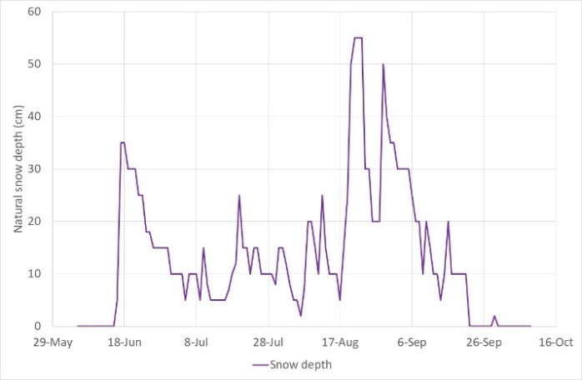
 |  | Step 3  Identify historical days of snowpack accumulation and depletion |  |  | 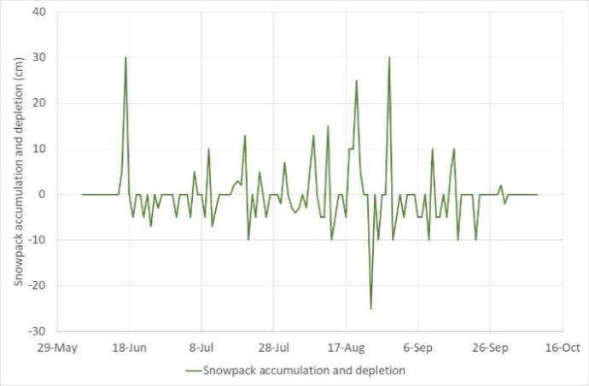
 |  |  | Step 4  Adjust projected streamflow based on the assumption that snowpack accumulation no longer occurs |  |  | 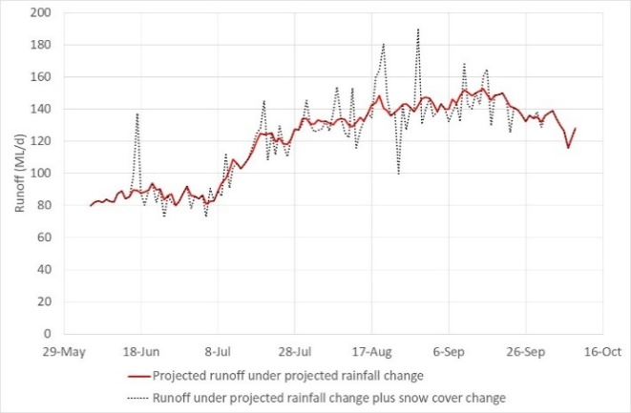
Figure 38: Example adjustment of runoff due to projected climate change in rainfall and snow depth.

  - Supplementary guidance on changes in runoff due to changes in bushfire risk under climate change
Information about the historical incidence of bushfires in Victoria, and changes to bushfire risk over recent decades and under projected climate change, are available from Victoria’s Climate Science Report 2024 (DEECA, 2024). In summary, the incidence of major bushfires in Victoria has increased over recent decades and bushfire risk is projected to increase in a hotter and drier climate.
Changes in vegetation cover from bushfires can impact runoff and recharge over time. After initial increases in runoff from bushfire-affected areas – typically in the first few years following a bushfire – runoff may decrease as the forest regrows over the following years and decades. The precise nature of the interaction between bushfires and runoff/recharge is difficult to predict and can depend on the spatial extent and severity of the fire, the species and age of the vegetation burnt, as well as changes in species composition following the fire.
Reliably quantifying projected changes in runoff and recharge due to projected changes in future bushfire risk is extremely difficult. For any given application, the extent to which the impacts of future changes in bushfire risk on water availability can be quantitatively estimated will depend on the ability to model the impact of fire on vegetation mortality, as well as the interaction between climate change and post-fire ecosystem responses. This is not only due to the complex relationship between bushfire and hydrological response, but also the unknown timing, spatial extent and intensity of future bushfires.
Post-fire mortality in forests with mixed Eucalyptus species, which cover a large proportion of Victorian catchments, are likely to be lower than mortality in wet Eucalyptus forests. This results in relatively modest and short-term changes in post-fire runoff, as vegetation recovers rather than regenerates in mixed species forests. Shorter intervals between bushfires may inhibit regeneration of some Eucalyptus species (such as E. regnans and E. delegatensis) and potentially shift vegetation composition to species with lower water use (such as Acacia species). Projected rainfall reduction under drier climate change projections is likely to limit vegetation water use, while projected increases in temperature can increase drought stress.

  - Water resource modelling sensitivities to climate change
HARC (2025b) investigated various water resource modelling sensitivities to climate change for DEECA in preparation for the update of these guidelines. It used 6 case studies around Victoria covering different types of urban supply systems located in different climate regions (i.e. in wetter, average or drier parts of the state) and with different storage capacities (i.e. run-of-river systems, seasonal/annual storage capacity, or storage with multi-year carryover). The study tested the sensitivity of historical streamflow metrics and urban supply system yield to the climate reference period and the pre-reference period scaling method used, and tested changes in urban supply system yield to potential changes in within-year climate variability.
There were 4 key findings of relevance to these guidelines:
- Data collected in the recent, wetter years from back-to-back La Niña years in 2021‒23 typically increased water availability, relative to estimates made using data up to 2020. This was due to the influence of those 3 years on pre-reference period scaling factors. The change in water availability was most evident when using a post-1997 climate reference period, rather than a post-1975 climate reference period. This highlights the lower stability in water availability estimates when using a shorter climate reference period. The additional 3 years of wetter data changed the scaling factors used to adjust moderate to higher flow events in the pre-reference period. Multi-year and larger annual storage systems were able take advantage of this to increase supply system yield, with yield from run-of-river systems largely unaffected.
- Long-term water availability assessments should be based on a data sequence that sufficiently captures a large range of variability over time. This aspect of the study tested the use of a post-1975 (truncated) dataset relative to the use of a longer dataset. It was found that when truncating the data period, there was the potential to exclude events that are critical for assessing water system performance (e.g. for supply systems where the 1967‒68 drought generated supply shortfalls). There was also the potential to exclude events that can influence performance measures based on long-term likelihoods (e.g. missing periods with and without restrictions in the pre-1975 period that influence water supply system reliability and can influence yield).
- In drier parts of Victoria, seasonal scaling of pre-reference period data is preferred over annual scaling, if those scaling factors are robust. Urban supply system yields were found to be lower when using seasonal scaling rather than annual scaling, but this was a lower-order impact than the influence of the climate reference period on yield. Seasonal scaling picks up the cool-season rainfall reduction in alignment with VicWaCI research outcomes. Sensitivities to scaling approach were higher in average to drier regions of Victoria, with low or no sensitivity in wetter regions.
- Water systems with no appreciable storage, or only seasonal storage capacity, are susceptible to future changes in within-year climate variability (while systems with multi-year storage capacity are less susceptible). For run-of-river systems, preserving the variance (with a reduction in mean), or increasing the variance (with or without a reduction in mean), reduces water availability to a much greater extent than reducing the mean of the inflows alone. This outcome for run-of-river systems is likely to also be applicable to rural and environmental performance assessments on unregulated rivers. For systems with multi-year storage capacity, increases in above-mean flows can be captured to offset reductions in below-mean flows, so changes in variance are not as influential on supply system performance.

  - Estimating historical rainfall‒runoff shift in the post-1997 and post-2010 periods

Shift detection
The analysis method to determine whether a shift has occurred in the post-1997 period firstly involves fitting a multi-linear regression relationship to annual rainfall and annual runoff, as in Equation 1 as per the method in Saft et al. (2015):
Q = a₀ + (a₁ × I) + (a₃ × P)
Equation 1
where:
Q is the annual runoff (in mm/year prior to transformation) from July to June, which has been Box-Cox transformed
I is the post-1997 indicator (0 for the pre-1997 period up to June 1997, 1 for the post-1997 period from July 1997 onwards)
P is the annual precipitation (mm/year) from July to June
a₀, a₁, and a₃ are coefficients.
The annual runoff can be converted to units of mm/year by dividing the runoff in ML/year by the catchment area in km². This conversion is a step of convenience to allow any changes in runoff to be more readily compared with the input annual rainfall, and to more readily allow comparisons between catchments; however, the analysis can still be undertaken using input annual runoff in other units such as ML/year or GL/year. The runoff is transformed into the Box-Cox domain so that the non-linear relationship between rainfall and runoff can be represented as a linear relationship. The Box-Cox transformation is (based on Box & Cox, 1964):
Q = (q^{λ}-1)/λ, if λ ≠ 0
Q = log q, if λ = 0
Equation 2
where:
Q is the annual runoff from July to June, which has been Box-Cox transformed
q is the annual runoff in mm/year from July to June
λ is an exponent that can range from -5 to +5, which is optimised such that the distribution of the runoff approximates a normal distribution. This parameter is optimised by maximising the log-likelihood that the transformed values are normally distributed.
A shift in rainfall‒runoff behaviour is deemed to occur if the post-1997 indicator, I, is a statistically significant variable in the multiple linear regression. If I is not statistically significant, then no shift has been detected. The statistical significance of the shift can be determined by looking at the p-value of the a₁ coefficient, where the shift is significant at either the 5% (p<0.05) or 10% (p<0.10) level of significance, which are commonly adopted as thresholds for strong and moderate statistical significance, respectively. If p>0.1, then no shift has occurred and no adjustment of pre-1997 data is required.
If a statistically significant shift in rainfall‒runoff behaviour has been detected, a further test is applied to assess whether a statistically significant difference in rainfall‒runoff behaviour has occurred post-2010, relative to the pre-1997 period. To undertake this test, the following multiple linear regression is undertaken:
Q = a₀ + (a₁ × I_{1997‒2009}) + (a₂ × I_{2010‒date}) + (a₃ * P)
Equation 3
where:
Q, P and a are as described in Equation 1
I_{1997‒2009} is the Millennium Drought indicator (1 for July 1997 to June 2010, 0 otherwise)
I_{2010‒date} is the post-2010 indicator (1 for July 2010 onwards, 0 otherwise).
A shift in rainfall‒runoff is assessed as having persisted since 2010 if the p-value of the a₂ coefficient is significant at either the 5% (p<0.05) or 10% (p<0.10) level of significance. If p>0.1, then no shift has occurred in the post-2010 period, relative to the pre-1997 period. This would mean that a shift occurred during the Millennium Drought, but the catchment has since recovered to its pre-1997 rainfall‒runoff behaviour. In this case, no adjustment of pre-1997 runoff data would be required.
The Millennium Drought ended at slightly different times across Victoria. For this analysis, the post-2010 period is designated as commencing in July 2010, to ensure that the start of this period occurs after the end of the Millennium Drought across all of the state.
The test applied assumes that the magnitude of the shift in the rainfall‒runoff relationship is uniform over the range of input rainfall data such that the fitted linear relationships between rainfall and the Box-Cox transformed runoff for different periods (the pre-1997, post-1997 and post-2010) are parallel. Where this is not the case, greater (or lesser) shifts in the Box-Cox transformed runoff may be observed in years of either low rainfall or high rainfall. This can result in an overestimation (or under-estimation) of runoff reduction in low or high rainfall years. A statistically significant shift is also less likely to be detected using the detection method from these guidelines in this situation.
The validity of a test of statistical significance using a multiple linear regression is dependent on several assumptions that the residuals of the regression model are:
- randomly distributed over time and over the range of observed flows
- normally distributed
- not serially correlated.
The distribution of residuals over time and over the range of observed flows can be assessed using plots of the model residuals. The normality of the residuals can be assessed visually using a histogram of model residuals or a quantile-quantile plot, or applying a statistical test such as a Shapiro-Wilk test for normality (Shapiro & Wilk, 1965). Outliers that may have high leverage in the dataset can be identified visually from the scatter plot of rainfall against runoff or formally detected using the Cook’s distance statistic (Cook, 1977). The annual serial correlation of the residuals can be calculated and should be less than 0.3.
If any of these statistical test assumptions is invalid, then the linear regression model does not fit the data well and that the level of statistical significance of the shift using this technique may be overstated or the shift poorly characterised. The response to this conclusion could be to:
- Cease further analysis of the post-1997 rainfall-runoff shift and communicate that the analysis was inconclusive. Uncertainty from the post-1997 shift can still be acknowledged, but it is not explicitly represented in the modelled analysis.
- Try alternative assessment techniques outside of DEECA’s Hydroclimate Data Transformation Tool. These alternative assessment techniques require a good understanding of statistical analysis procedures and involve a much higher level of effort. For examples, this may involve:
- Manually adjusting the form of the linear regression model until the statistical test assumptions are satisfied ‒ this could include, for example, transforming the runoff or rainfall data in other ways (e.g. using a logarithmic or power transform, rather than a Box-Cox transformation) to address non-normality and non-random distribution of residuals, and/or introducing an auto-regressive term to reduce serial correlation of residuals.
- Detecting the shift in rainfall‒runoff relationship between different states over time (Peterson et al., 2021). The analysis can be performed using hydroState, a statistical package that provides methods to construct and evaluate hidden Markov models of runoff with rainfall as a predictor (Peterson et al., 2021). This technique was developed as part of VicWaCI research program so its application outside research is still evolving. Practitioners can contact DEECA’s Hydrology, Climate and Energy team if they would like to discuss this option further.

Pre-1997 runoff data adjustment
If a shift in the rainfall‒runoff response has been detected, the suggested process for adjusting the pre-1997 data is as outlined below. The option adopted depends on the availability and suitability of tools to support the analysis.

Option 1
Where a rainfall‒runoff model for the catchment exists that has been well calibrated in the post-1997 period, but poorly calibrated (i.e. underestimating runoff) in the pre-1997 period because of the rainfall‒runoff shift, then that rainfall‒runoff model can be applied directly to generate estimated runoff in the pre-1997 period under post-1997 catchment response conditions. A general discussion of the pros and cons of using rainfall‒runoff models is provided in chapter 6.8.
In this application, the use of a rainfall‒runoff model is likely to provide an improved representation of changes in sub-annual runoff in the pre-1997 period, relative to the alternative option below of adjusting a reference runoff dataset. Note:
- If the rainfall‒runoff model calibrates well to both the post-1997 and pre-1997 period, it should not be used for this purpose, because it will not represent behaviour in a low-runoff state in the pre-1997 period.
- If the rainfall‒runoff model calibrates poorly to the post-1997 period, it should not be used for this purpose, because it would misrepresent post-1997 runoff behaviour.

Option 2
The alternative option is to apply the shift that was identified as a result of the shift detection process based on Saft et al. (2015), as discussed in the earlier section of this chapter0. This adjustment process is automated in DEECA’s Hydroclimate Data Transformation Tool Source modelling platform plugin (DEECA 2026) for detecting and applying the post-1997 catchment response as follows:
- From the linear regression analysis, apply the shift (i.e. the a₁ coefficient in Equation 1) to the pre-1997 annual Box-Cox transformed runoff. This is the shift in the post-1997 data, not the shift in the post-2010 data. The post-2010 shift is only used to determine whether the post-1997 shift has persisted after the end of the Millennium Drought, not to adjust the data.
- Transform the annual runoff data back into their original (arithmetic) domain. If the adjusted transformed data become negative, the data cannot be transformed back into their original domain and are assumed to be zero. That is, a low-runoff value is shifted to zero, because the shift is greater than the runoff value. This will result in zero flow for the whole year. In practice, there could still be some runoff in these low-runoff years that have shifted to zero runoff years. However, in the absence of an understanding of the shift in the rainfall‒runoff response on a sub-annual time step (e.g. what happens to initial and continuing losses on days of high rainfall within low-rainfall years after the shift?), a shift to zero flows has been assumed.
- Disaggregate the adjusted annual data to the time step of the original dataset (usually daily or monthly) using the sub-annual flow pattern in the original dataset. This assumes no change to the sequencing of within-year runoff. In practice, the shift in rainfall‒runoff behaviour could result in disproportionate changes in sub-annual runoff, depending on the antecedent conditions prior to individual runoff events.
- Check the output sub-annual time series from the adjustment process, relative to the original unadjusted dataset, to confirm that the adjustment process has generated reasonable values that are suitable to use for the intended purpose. Some diagnostic plots (time series data and flow duration curves) are included in DEECA’s tool for this purpose.
This option has the advantage that it has been automated. It ensures consistency with the reference unadjusted runoff dataset, which can be valuable if that unadjusted dataset is of high quality. On a sub-annual time step, the representation of the shift is coarse in nature, and its usefulness may be limited for applications that have a strong focus on assessing daily or seasonal changes to the flow regime.

Case study examples
The following case studies illustrate the application of the above methods to detect any shift in rainfall‒runoff and (if detected) adjust the pre-1997 runoff data to reflect post-1997 catchment response. These case studies were prepared prior to the development of DEECA’s tool for detecting rainfall‒runoff shift, and hence the format of figures presented may vary from those in the tool.

Case study 1: Glenelg River at Big Cord
The first case study is the 57 km² catchment upstream of the Glenelg River at Big Cord in the Glenelg Basin. In this case study, two alternative runoff datasets were used: simulated runoff from a rainfall-runoff model and gauged data at streamflow gauge 238231. There are no significant diversions or flow regulations upstream of the catchment, and it is a largely undisturbed catchment.
For this analysis, continuous gauged streamflow data were available from 1979 to 2023 from Victoria’s Water Measurement Information System, and simulated streamflow data using a rainfall-runoff model were available back to 1891 from DEECA’s Wimmera-Glenelg Source model inputs. These streamflow data were converted to units of mm/year by dividing the flow data in ML/year by the catchment area above. An infilled and extended rainfall time series from Balmoral Post Office (089003) over the same period was obtained from DEECA’s Wimmera-Glenelg Source model inputs.
The quality of the rainfall and runoff data were checked. The rainfall data were checked for stationarity using a double-mass curve against a nearby rainfall gauge and were found to be stationary. A plot of annual rainfall against annual runoff did not identify any obvious data outliersFigure .
The statistical testing using the simulated rainfall-runoff model output data (1891-2023) indicated that there was no statistically significant shift in rainfall-runoff behaviour in the post-1997 period (at the 10% level of significance). This is confirmed visually in Figure 39Figure , where there is little difference between the line of best fit through the pre- and post-1997 data, relative to the noise in the data. Statistical assumptions for change detection were confirmed as valid, but in this case study have no bearing on the outcome of the statistical tests and have not been discussed further.

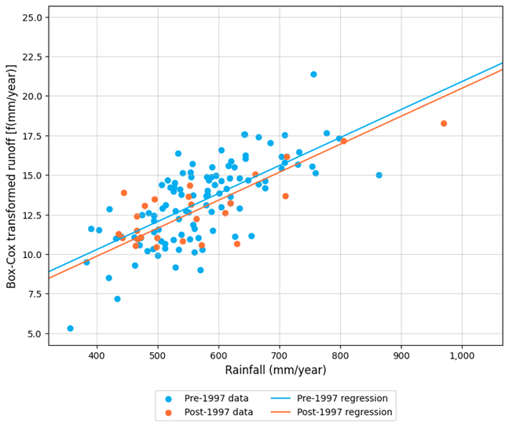
Figure 39: Scatter plot of rainfall versus (Box-Cox transformed) runoff for Glenelg River at Big Cord, 1891‒2023. Runoff data sourced from a rainfall-runoff model.
The absence of a statistically significant shift in rainfall-runoff behaviour would ordinarily mean no further consideration of a post-1997 rainfall-runoff shift scenario for this site. However, this test result was different to those for some nearby catchments that had been analysed (where a shift had been detected). As noted previously in chapter 4.4.2 of the guidelines, extending or infilling streamflow data using outputs from rainfall‒runoff models may make detecting a shift in response less likely. To investigate this, the case study analysis was also undertaken using only the gauged data (with minimal infilling as needed) from 1979-2023. The outcomes from that test are shown in Figure 40 for the post-1997 period and Figure 41 for the post-2010 period. The results indicated a statistically significant shift in rainfall-runoff behaviour in the post-1997 period (at the 5% level of significance) and that a shift had persisted in the post-2010 period (also at the 5% level of significance).
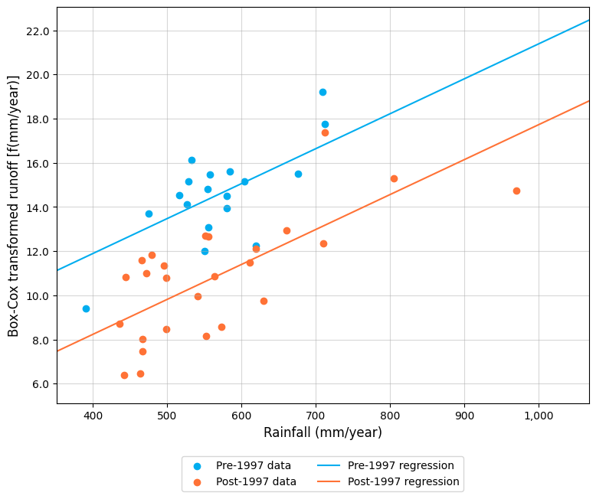
Figure 40: Scatter plot of rainfall versus (Box-Cox transformed) gauged runoff for Glenelg River at Big Cord, 1979‒2023.
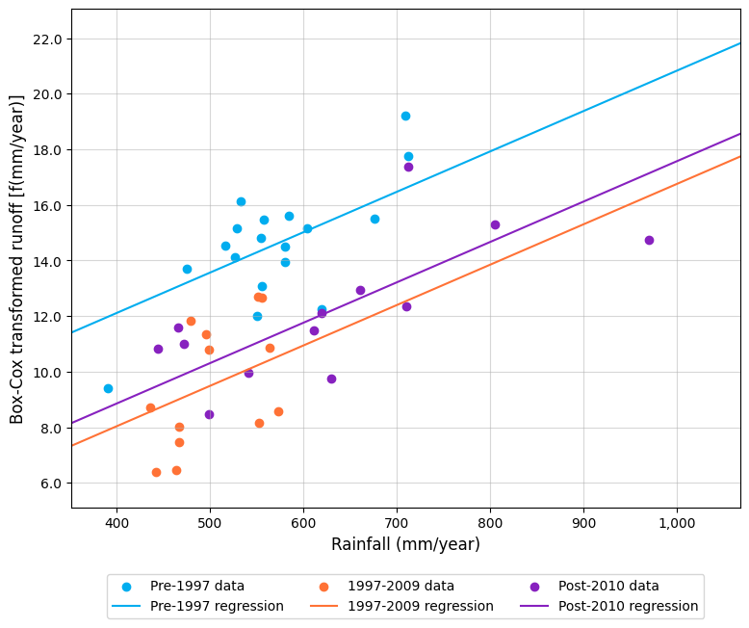
Figure 41: Scatter plot of rainfall versus (Box-Cox transformed) gauged runoff for Glenelg River at Big Cord, 1979‒2023, including post-2010 regression line of best fit.

The statistical test assumptions for both tests were assessed, with the diagnostic plots for the post-1997 test shown below as an example. In Figure 42 there is a fairly even scatter of residuals over the range of flow values. The residuals were not serially correlated (lag-1 annual serial correlation was +0.083, which was within of the threshold range of +0.3). A Shapiro-Wilk test indicated that the model residuals were approximately normally distributed (p-value for that test of non-normality > 0.05), which was confirmed visually using the histogram in Figure 43.
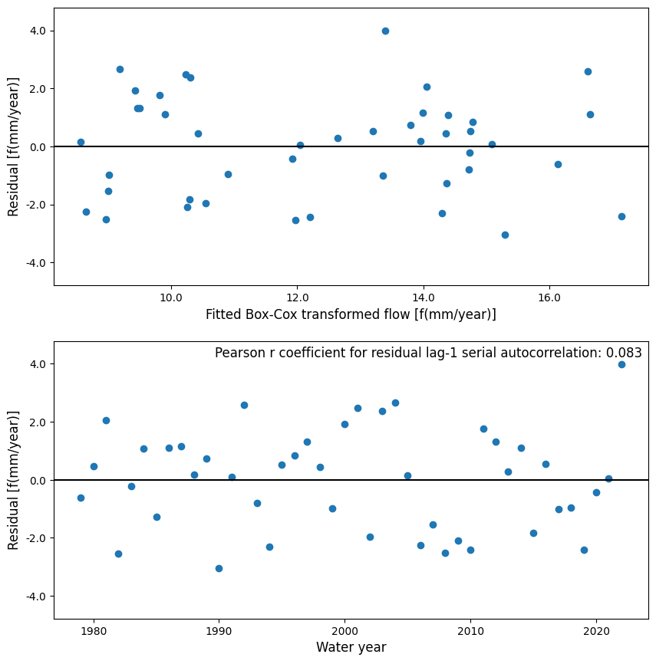
Figure 42: Regression model residuals for linear regression for detecting a post-1997 rainfall‒runoff shift in the Glenelg River at Big Cord, 1979‒2023.
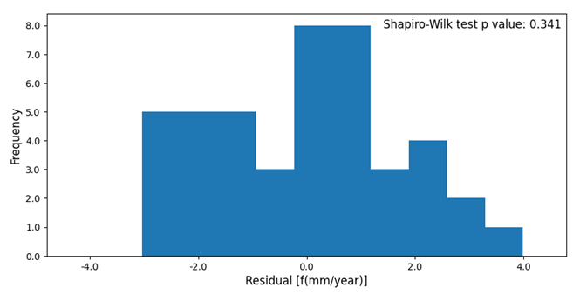
Figure 43: Histogram of model residuals indicating an approximate normal distribution.

The magnitude of the shift in runoff in the pre-1997 period was estimated using option 2. The outcome was an estimated 49% reduction in runoff on average in the pre-1997 period. The adjusted pre-1997 data relative to the unadjusted dataset are shown in Figure 44.
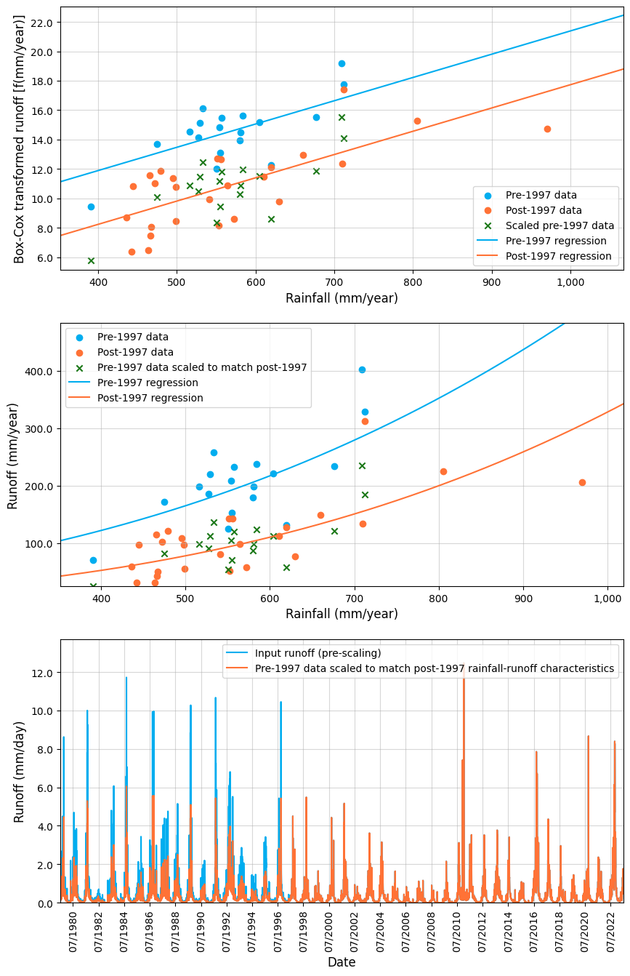
Figure 44: Adjusted annual and daily runoff in the Glenelg River at Big Cord, 1979‒2023.

When the gradient of the relationship between rainfall and runoff was allowed to change from the pre-1997 to the post-1997 period, the magnitude of the shift remained fairly consistent across all rainfall conditions, as shown in Figure 45. In this case study, the magnitude of the runoff shift (Box-Cox transformed) was slightly lower in low-rainfall years (possibly due to high leverage of the data point in the year of highest rainfall), but a shift was still visible. This confirmed that there was no appreciable bias in the magnitude of the shift under different rainfall conditions.
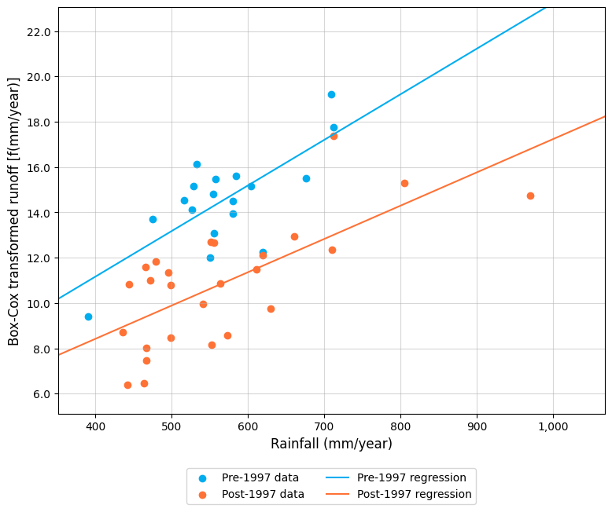
Figure 45: Scatter plot of rainfall versus (Box-Cox transformed) gauged runoff for Glenelg River at Big Cord, 1979‒2023, allowing a change in the gradient of the relationship.
The Glenelg River at Big Cord case study highlights the importance of understanding the nature of the runoff data being used in the analysis and confirms that the use of runoff data generated from rainfall-runoff models can reduce the likelihood of being able to detect a statistically significant shift in rainfall-runoff behaviour where it has occurred.

Case study 2: Latrobe River from Ada River junction to Noojee
The second case study is the 228 km² catchment in the Latrobe River between the Ada River junction and Noojee in the Latrobe Basin. In this case study, a reach water balance between two streamflow gauges (226205 and 226222) was used to prepare the data.
This reach balance generated an unimpacted flow time series that accounted for the influence of historical diversions from the river. The resulting runoff estimate was available over the period from 1957 to 2021. An infilled rainfall time series from Noojee (site 085277) over the same period was obtained from the SILO database. The rainfall data were checked for stationarity using a double-mass curve against a nearby rainfall gauge and were found to be stationary. A plot of annual rainfall against annual runoff did not identify any obvious data outliers (Figure 46Figure ).
The statistical testing indicated that there was a statistically significant shift in rainfall‒runoff behaviour in the post-1997 period (at the 5% level of significance). This is confirmed visually in Figure 46Figure 39, where there is a difference between the line of best fit through the pre- and post-1997 data, relative to the noise in the data (i.e. visually the blue dots are mostly plotting above the orange dots).
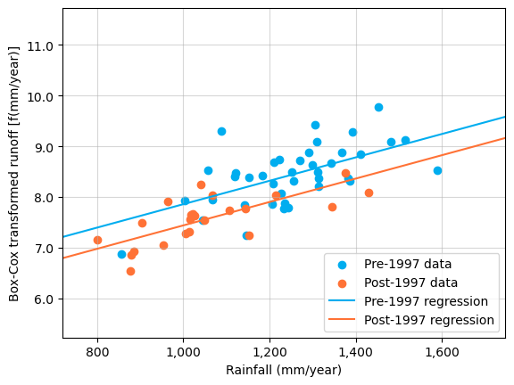
Figure 46: Scatter plot of rainfall versus (Box-Cox transformed) runoff for Latrobe River between Noojee and the Ada River junction, 1957‒2021.

As a result of this positive test for a rainfall‒runoff shift in the post-1997 period, the dataset was also tested and found to exhibit a statistically significant shift in rainfall‒runoff behaviour in the post-2010 period (at the 5% level of significance). This is illustrated in where the shift in the post-2010 data is near-identical to the shift over the Millennium Drought.
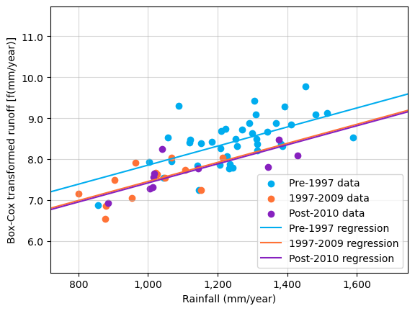
Figure 47: Scatter plot of rainfall versus (Box-Cox transformed) runoff for Latrobe River between Noojee and the Ada River junction, 1957‒2021, including post-2010 regression line of best fit.

The statistical test assumptions for both tests were assessed, with the diagnostic plots for the post-1997 test shown below as an example. In Figure 48 there is a fairly even scatter of residuals over the range of flow values. There appears to be some cyclical behaviour in the model residuals over time, but these are evenly distributed when the pre-1997, post-1997 and post-2010 periods are each considered collectively. The residuals were however serially correlated (lag-1 annual serial correlation was +0.479, which was outside of the threshold range of +0.3), which indicates that the level of statistical significance from the test result may be overstated. In this case, in the absence of further and more complex analysis (such as introducing an autoregressive term to reduce serial correlation), some user judgement would be required to decide whether to carry forward a post-1997 rainfall-runoff shift scenario in subsequent water resource assessments. This discretion is in line with the guidance provided in chapter 4.4.5. Given the strong evidence for shift in the test results, and the clear visual differences between the pre-1997 and post-1997 (including post-2010) period datasets in the previous Figure 46 and Figure 47, it would be reasonable for this catchment to consider post-1997 rainfall-runoff shift as part of sensitivity testing for potential uncertainties in water availability. In the absence of undertaking a Shapiro-Wilk test, the model residuals were considered to be approximately normally distributed using the histogram in Figure 49.
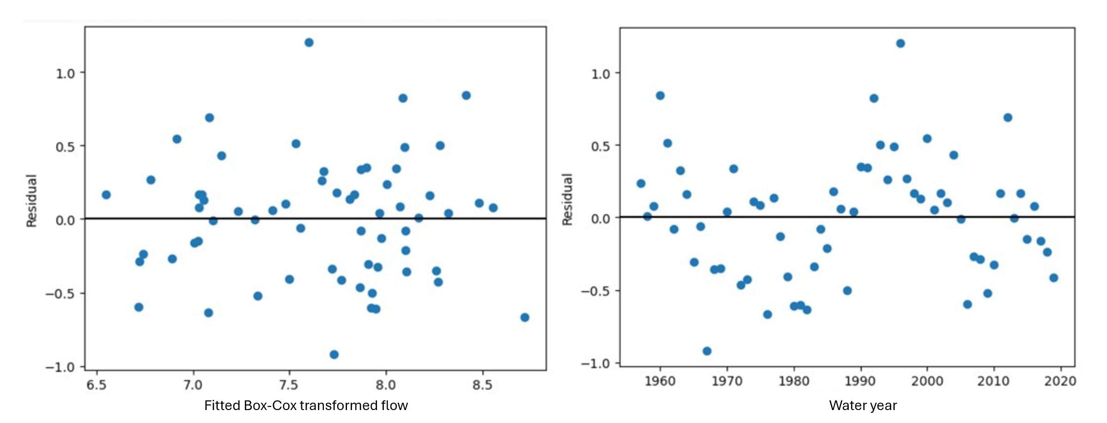
Figure 48: Regression model residuals for linear regression for detecting a post-1997 rainfall‒runoff shift in the Latrobe River between Noojee and the Ada River junction.
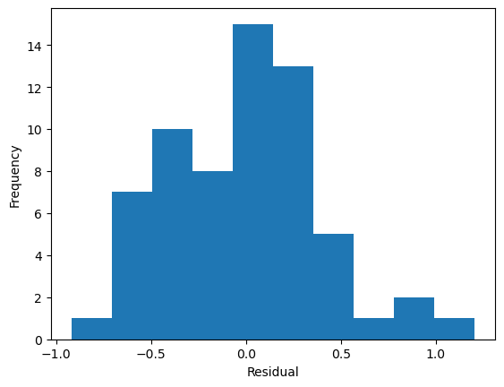
Figure 49: Histogram of model residuals indicating an approximate normal distribution.

The magnitude of the shift in runoff in the pre-1997 period was estimated using option 2. The outcome was an estimated 19% reduction in runoff on average in the pre-1997 period. The adjusted pre-1997 data relative to the unadjusted dataset are shown in Figure 50.

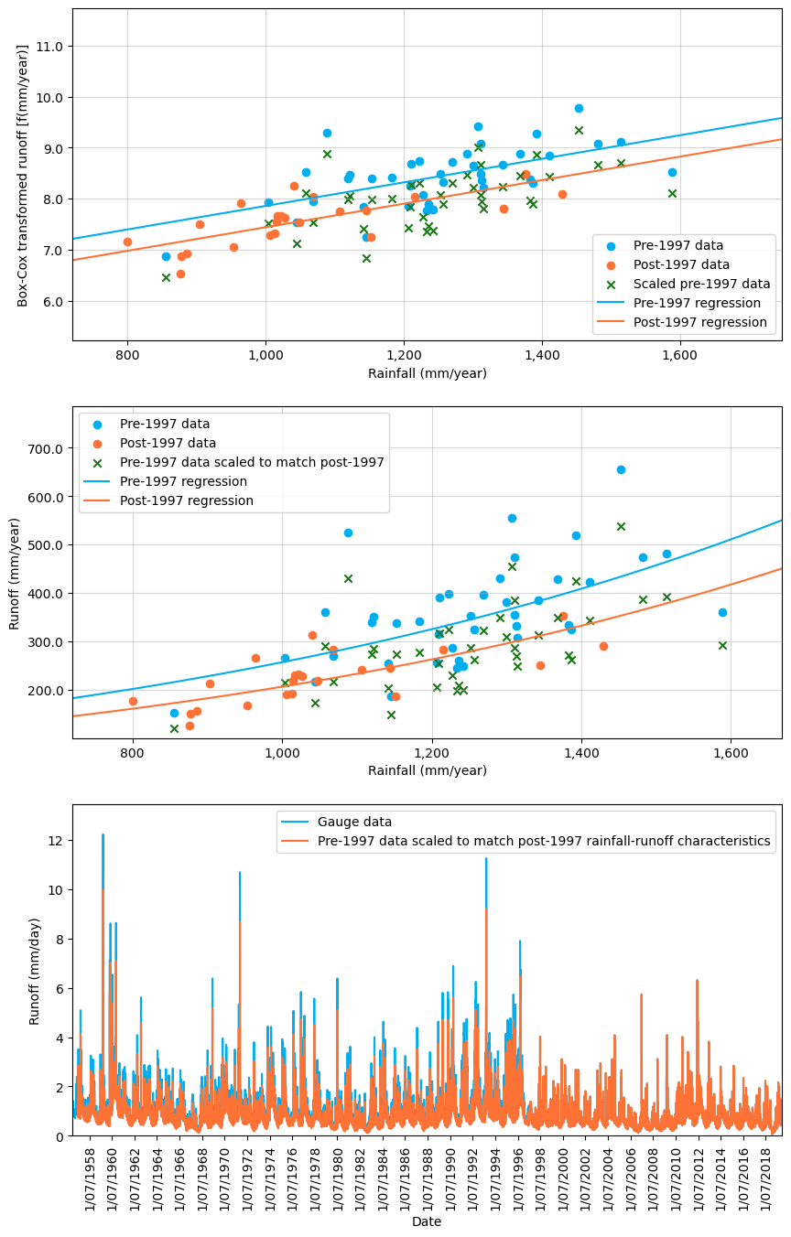
Figure 50: Adjusted annual and daily runoff in the Latrobe River between Noojee and the Ada River junction due to a post-1997 rainfall‒runoff shift.

When the gradient of the relationship between rainfall and runoff was allowed to change from the pre-1997 to the post-1997 period, the magnitude of the shift remained fairly consistent across all rainfall conditions, as shown in Figure 51. In this case study, the magnitude of the runoff shift (Box-Cox transformed) was slightly lower in low-rainfall years, but a shift was still visible. This confirmed that there was no appreciable bias in the magnitude of the shift under different rainfall conditions.
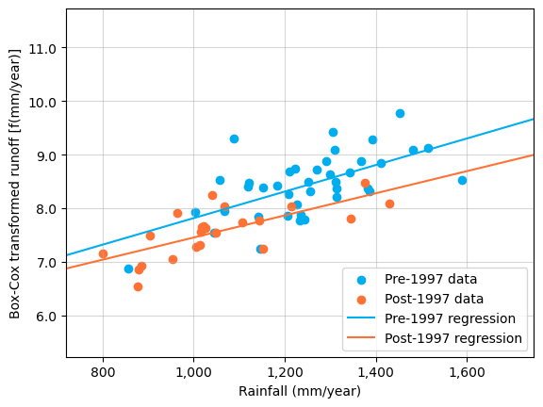
Figure 51: Scatter plot of rainfall versus (Box-Cox transformed) runoff for Latrobe River between Noojee and the Ada River junction, 1957‒2021, allowing a change in the gradient of the relationship.

  - Additional information on groundwater recharge processes

Influence of climate on groundwater resources
Climate change processes will affect groundwater resources through changes in the frequency, duration and quantity of rainfall and evapotranspiration. The combined impact of potential increased storm event intensity, altered seasonality of rainfall and reduced annual rainfall volumes affects groundwater resources differently, depending on the recharge mechanisms for the aquifer.
For water table aquifers dependent on diffuse recharge (from infiltration of rain through the unsaturated zone profile to the water table), the change in frequency, duration and seasonality of the rainfall will potentially reduce recharge rates. For confined aquifer systems, the recharge areas in outcropping aquifers will similarly be affected. Throughflow to the deep confined parts of the aquifers would obviously take much longer (hundreds to thousands of years) meaning changes in contemporary recharge would not be seen in these systems.
In some groundwater systems, such as in western Victoria, it is likely that the systems contain waters recharged millions of years ago, with little contemporary or recent recharge to the system. It is appropriate for systems such as these to assume either no contemporary recharge or very low recharge rates (<10 mm/year), where the groundwater response shows no response to recent (post-1975) climate conditions.

Dominant recharge mechanisms for Victoria’s groundwater systems
Recharge can occur through diffuse mechanisms (over large areas in response to rainfall infiltrating the soil) and focused mechanisms (the movement of water from surface water bodies such as lakes or streams to an underlying aquifer). Diffuse and focused recharge varies temporally and spatially, and systematic trends are often linked to climate, land use and geology (Figure 52).
Many groundwater systems have been assessed to determine the availability of the resource for use. These assessments have independently determined recharge for areas of intensive use. Some of these assessments include both diffuse recharge, and irrigation accessions and/or flood recharge, all of which influence the groundwater system response.
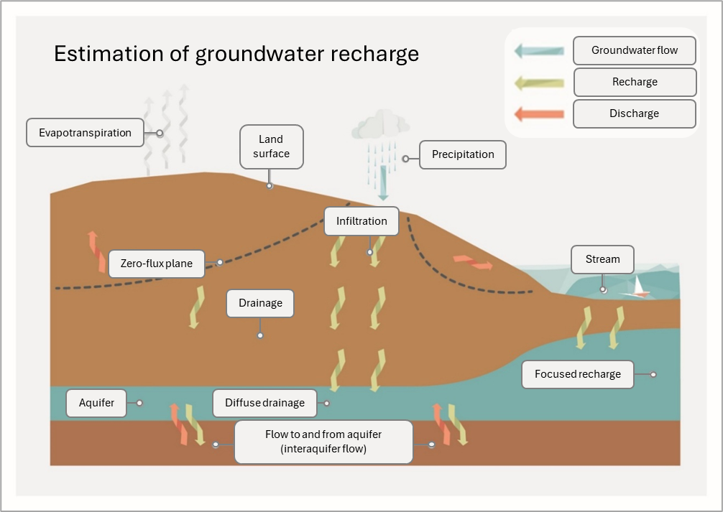
Figure 52: Conceptual diagram showing diffuse and focused recharge processes.

Influence of rainfall amount, intensity and timing
Groundwater recharge is a ‘threshold’ process with a minimum amount of rainfall required to generate any recharge. In Victoria, groundwater recharge is most significant during winter and spring. During these seasons, rainfall can maintain a higher moisture content in the soil profile to facilitate recharge to the water table. During summer and autumn, evaporation rates exceed precipitation and so do not generally facilitate recharge events.
In arid and semi-arid regions, such as in north-western Victoria, it is storm events that provide the driving force for recharge events. Some studies indicate that intense daily rainfall for a period of 100 days is required for recharge to occur (Crosbie et al., 2013), with a minimum daily threshold of 10 mm/day. Other studies indicate that 100 mm/month is required in arid regions. Most of the literature agrees that the annual rainfall total does not drive recharge, but the seasonality and intensity of it do.
Empirical evidence in some Victorian catchments indicates that approximately 350 mm/yr of rainfall is required for significant recharge to occur. This aligns with current knowledge about Victorian groundwater systems. There has not been any study into the influence of storm events on recharge to provide guidance on minimum rainfall within hourly or daily time periods to inform these guidelines (Barron et al., 2011).

Projected changes in recharge due to climate change
Reductions in winter rainfall when diffuse recharge occurs, will impact recharge in the longer term (hundreds of years).
Increased summer rainfall is unlikely to increase recharge but may reduce extraction rates in areas of groundwater use (i.e. in dryland agricultural areas or where farm dams are used), thereby reducing declines in groundwater levels.
Reductions in annual rainfall may affect groundwater recharge occurrence in those catchments with low annual rainfall where it may drop below the 350 mm/yr threshold.








VicWaCI report (DEECA, 2025a) defines cool season as April to October and warm season as November to March. Elsewhere in these guidelines, cool season spans May to October and warm season spans November to April as used in the development of projections by CSIRO.

