
Victoria’s Comprehensive Report 2025
  - Basin Salinity Management 2030

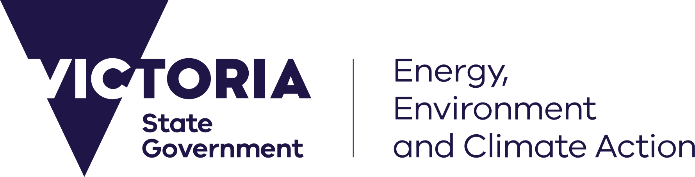




deeca.vic.gov.au

Acknowledgements
Helen Wilson, Lachlan Campbell – North East CMA
Carolyn Nigro, Jennifer Pagon and Megan McFarlane – Goulburn Broken CMA
Geoff Rix, Dan Beyer, Karuppan Sakadevan, Rebecca Willcock and Talitha Brits – Mallee CMA
Phil Dyson and Mandy Coulson – North Central CMA
Joel Boyd – Wimmera CMA
Mark Potter and Paul Saunders – Goulburn Murray Water
Dugal Wallace – Agriculture Victoria
Melissa Tylee, Lauren Lo, Amanda Gois Viana, Ella Jorgensen, Samira Akhavan – Department of Energy, Environment and Climate Action.
Photo credit
Samira Akhavan – Department of Energy, Environment and Climate Action

We acknowledge and respect Victorian Traditional Owners as the original custodians of Victoria’s land and waters, their unique ability to care for Country and deep spiritual connection to it.
We honour Elders past and present whose knowledge and wisdom
has ensured the continuation of culture and traditional practices.
DEECA is committed to genuinely partnering with Victorian Traditional Owners and Victoria’s Aboriginal community to progress their aspirations.
© The State of Victoria Department of Energy, Environment and Climate Action 2025.
Creative Commons
This work is licensed under a Creative Commons Attribution 4.0 International licence, visit the Creative Commons website (http://creativecommons.org/licenses/by/4.0/).
You are free to re-use the work under that licence, on the condition that you credit the State of Victoria as author. The licence does not apply to any images, photographs or branding, including the Victorian Coat of Arms, and the Victorian Government and Department logos.
Disclaimer
This publication may be of assistance to you but the State of Victoria and its employees do not guarantee that the publication is without flaw of any kind or is wholly appropriate for your particular purposes and therefore disclaims all liability for any error, loss or other consequence which may arise from you relying on any information in this publication.
Accessibility
To receive this document in an alternative format, phone the Customer Service Centre on 136 186, email customer.service@delwp.vic.gov.au, or contact National Relay Service on 133 677. Available at DEECA website (www.deeca.vic.gov.au).

Contents
Contents 1
Abbreviations 4
1. Executive summary 6
2. Introduction 9
3. Salinity accountability framework 11
3.1 Register position 11
3.1.1 Victorian Statement of Compliance 11
3.1.2 Credits 11
3.1.3 Debits 11
3.1.4 Net balance 11
3.2 Regional salinity registers 13
3.3 New accountable actions 14
3.3.1 Victorian Mid-Murray Storages Review 14
3.4 Salinity accountability for environmental water 15
3.4.1 Environmental watering of the Gunbower forested floodplain 15
3.4.2 Victorian Murray Floodplain Restoration Program 15
4. Management of salt interception schemes 15
4.1 SIS operations 16
4.2 SIS support and maintenance activities 16
5. Salinity management 18
5.1 Victorian salinity management 18
5.1.1 State-wide policies and actions 18
Water for Victoria 18
Sustainable Irrigation Program 18
Flow-based management and environmental water 19
Dryland salinity management 19
5.2 Regional salinity management 19
5.2.1 North East 19
5.2.2 Goulburn Broken 21
5.2.3 North Central 22
5.2.4 Mallee 23
5.2.5 Wimmera 24
5.3 Irrigation development 25
5.3.1 Regional Irrigated Land and Water Use Mapping 25
5.3.2 Mallee Horticulture Crop Report 25
5.3.3 Wimmera region 26
5.4 End-of-Valley Target evaluation 26
6. Efficient governance 26
6.1 BSM2030 Basin-wide Core Salinity Monitoring Network 27
6.1.1 Dryland salinity bore monitoring 27
6.1.2 North East 29
6.1.3 Goulburn Broken 29
6.1.4 North Central 29
6.1.5 Mallee 30
6.1.6 Wimmera 32
6.2 Register reviews of Victorian accountable actions 32
6.2.1 Summary 32
6.2.2 Goulburn Broken 32
Shepparton Irrigation Region Land and Water Management Plan 32
6.2.3 North Central 33
Barr Creek Catchment Strategy 33
Victorian Mid-Murray Storages 33
Kerang Lakes Swan Hill Salinity Management Plan 33
Woorinen Irrigation District Excision 34
6.2.4 Mallee 34
Nangiloc-Colignan Salinity Management Plan 34
6.3 Victorian response to IAG-Salinity audit recommendations 2021-2023 34
7. Strategic knowledge improvement 37
7.1 State-wide projects 37
7.1.1 BSM2030 Strategic Review 37
7.1.2 Contextual narratives of salinity risk for End-of-Valley Target sites 37
7.2 Regional projects 38
7.2.1 Goulburn Broken 38
Monument Cover Installation Project 38
Review of SIR Salinity Threat Status and Drivers 38
Shallow Groundwater in Shepparton Irrigation Region website 38
7.2.3 North Central 38
7.2.4 Mallee 39
Run of River Survey for salinity from Mallee Cliffs to Boundary Bend 39
Assessing landscape salinity impacts of cumulative irrigation development 40
Establishing hydrogeological processes in floodplains 40
Option analysis for irrigation drainage disposal basins 41
Options for reducing irrigation induced salinity impacts on Psyche Bend Lagoon 41
Airborne Electromagnetic Survey 41
7.2.5 Wimmera 42
8. Community engagement and communication 42
8.1 Community engagement and education activities 42
8.1.1 Dryland salinity management 42
8.1.2 North East 42
8.1.3 Goulburn Broken 42
8.1.4 North Central 43
8.1.5 Mallee 43
8.1.6 Wimmera 44
9. Priorities for future work 44
9.1 Statewide 44
9.2 North East 45
9.3 Goulburn Broken 45
9.4 North Central 45
9.5 Mallee 46
9.6 Wimmera 46
10. References 46
11. Appendix 48
11.1 End-of-Valley Target site flow and salinity outcomes 48
11.1.1 Wimmera at Horsham Weir (415200) EoVT site 48
11.1.2 Avoca at Quambatook (408203) EoVT site 51
11.1.3 Loddon at Laanecoorie (407203) EoVT site 53
11.1.4 Campaspe at Campaspe Weir (406218) EoVT site 55
11.1.5 Goulburn at Goulburn Weir (405259) EoVT site 57
11.1.6 Broken River at Casey's Weir (404217) EoVT site 59
11.1.7 Ovens at Peechelba-East (403241) EoVT site 61
11.1.8 Kiewa at Bandiana (402205) EoVT site 63

Abbreviations
AEM | Airborne Electromagnetic (Survey)
Ag Vic | Agriculture Victoria
AVR | Agriculture Victoria Research
BCS | Basin-wide Core Salinity (Monitoring Network)
BSM | Basin Salinity Management
BSM2030 | Basin Salinity Management 2030
BSMAP | Basin Salinity Management Advisory Panel
BSMS | Basin Salinity Management Strategy
CaLP Act | Catchment and Land Protection Act 1994 (Victoria)
CAT | Catchment Analysis Tool
CEWH | Commonwealth Environmental Water Holder
CMA | Catchment Management Authority
DEECA | Department of Energy, Environment and Climate Action
DCD | Drainage Course Declaration
EC | Electrical Conductivity (µS/cm)
EoVT | End-of-valley target
EWMP | Environmental Watering Management Plans
GMW | Goulburn-Murray Water
GMID | Goulburn Murray Irrigation District
IAAM | Integrated Accountable Action Model
IAG | Independent Audit Group (for Salinity)
KLM | Kerang Lakes Model
KLSHSMP | Kerang Lakes Swan Hill Salinity Management Plan
LCIR | Loddon Campaspe Irrigation Region
LMW | Lower Murray Water
LWMP | Land and Water Management Plan
MDBA | Murray-Darling Basin Authority (established Dec 2008)
ML | Megalitre
MSM-BIGMOD | MSM– BIGMOD, the daily flow and salinity model for the River Murray
N2SAB | Nyah to South Australin Border (Salinity Management Plan)
PBL | Psyche Bend Lagoon
RCS | Regional Catchment Strategy
REALM | Resource Allocation Model
RISI | Reduced Irrigation Salinity Impact
RILWUM | Regional Irrigation Land and Water Use Mapping
SDLAM | Sustainable Diversion Limit Adjustment Mechanism
SAF | Sustainable Agriculture Facilitator
SIP | Sustainable Irrigation Program
SIR | Shepparton Irrigation Region
SIRLWMP | Shepparton Irrigation Region Land and Water Management Plan
SIS | Salt Interception Scheme
SITWG | Salt Interception Technical Working Group
SMP | Salinity Management Plan
SRMZ | Salinity Risk Management Zones
TLM | The Living Murray (Program)
TWGSM | Technical Working Group for Salinity Modelling
VEWH | Victorian Environmental Water Holder
VMFRP | Victorian Murray Floodplain Restoration Program
VMMS | Victorian Mid-Murray Storage
VSDAG | Victorian Salt Disposal Advisory Group
VSDWG | Victorian Salt Disposal Working Group
WIDE | Woorinen Irrigation District Excision
WMIS | Victorian Water Measurement Information System

1. Executive summary
Victoria's Comprehensive Report 2025 presents Victoria’s accountability and achievements in implementing the Basin Salinity Management 2030 (BSM2030) strategy in 2024/25 and includes select highlights from 2023/24.
The Department of Energy, Environment and Climate Action (DEECA) takes the lead on reporting Victoria’s compliance under BSM2030, with support from Goulburn Broken Catchment Management Authority (CMA), North Central CMA, North East CMA, Mallee CMA, Wimmera CMA and Goulburn-Murray Water (GMW) and Agriculture Victoria (Ag Vic).
Salinity accountability framework
Victoria reconfirmed its commitment to salinity management in the Murray-Darling Basin through Water for Victoria (DELWP 2016). Water for Victoria is Victoria’s strategic plan for managing its water resources in the context of climate change and a growing population.
Victoria remains compliant with Schedule B to the Murray-Darling Basin Agreement (Schedule 1 to the Water Act 2007). Victoria’s net balance on the Murray-Darling Basin Salinity Register A in 2025 is -24.2 EC credits or $5.024 million/yr, which has been endorsed by the Basin Salinity Management Advisory Panel (BSMAP) in 2025.
Compared to Victoria’s Register A balance in 2024, the following key changes are observed:
- Victoria’s total credits in Register A increased by -2.09 EC credits.
- Victoria’s total debits in Register A did not change
During the reporting period, Victoria completed assessments of new and existing accountable actions including Barr Creek Catchment Strategy, Victorian Mid-Murray Storages (VMMS), Kerang Lakes Swan Hill Salinity Management Plan (KLSHSMP), Woorinen Irrigation District Excision (WIDE) and Nangiloc-Colignan Salinity Management Plan (SMP).
DEECA is continuing to monitor planning and delivery of Sustainable Diversion Limit Adjustment Mechanism (SDLAM) projects, including Victorian Murray Floodplain Restoration Program (VMFRP). Projects have not progressed to a point where salinity impact assessments for potential register entries could be commenced.
Management of salt interception schemes
A total of 86,886 and 86,389 tonnes of salt was diverted from the River Murray in 2023/24 and 2024/25, respectively. During this reporting period, the schemes remained at reduced operational levels after major flood events and damage in 2022. Works have begun for repairs and refurbishment to increase infrastructure resilience to flooding are ongoing.
Victoria continues to work with the Murray-Darling Basin Authority (MDBA) to refine the operation of the Salt Interception Schemes (SIS) in response to forecast river flow and salinity conditions, as part of the trial of responsive SIS management implemented under BSM2030.
Salinity management
Victoria continues to implement Land and Water Management Plans (LWMP) in irrigation areas. LMWPs provide the strategic framework and key actions for natural resource management in Victoria.
In addition, CMAs have long-term Environmental Water Management Plans (EWMP) to guide environmental watering activities across Victoria. EWMPs are developed under partnership arrangements with the community and government agencies, such as the Victorian and Commonwealth Environmental Water Holders and the MDBA which incorporate management of salinity impacts.
CMAs in partnership with Ag Vic, have also delivered a wide range of farm planning and on-farm works, including irrigation and dryland Whole Farm Plans, upgrades to irrigation systems for water use efficiency and salinity benefits, as well as education activities.
Salinity and salt loads at End-of-Valley-Target (EoVT) sites were monitored and evaluated over the reporting period for each End-of-Valley catchment. Salinity and salt load exceedance curves for Victorian EoVT sites are provided in this report.
Efficient governance
The Efficient Governance section of this report explores actions Victoria has taken to review its accountable actions, the ongoing status of its Basin-wide Core Salinity (BCS) Monitoring Network, and Victoria’s response to previous Independent Audit Group (IAG) recommendations.
Victoria’s CMAs, GMW and Ag Vic continued to support efficient Basin-wide governance of BSM2030 through monitoring, which informs the assessment of salinity impacts and periodic reviews of Victoria’s accountable actions.
Victoria actively participates in the biennial independent audit process, which tracks Basin-wide performance in implementing BSM2030 and identifies areas of improvement.
DEECA has worked closely with regional partners including CMAs, GMW and Ag Vic on the Victorian contribution to the BCS Monitoring Network which identifies all surface and groundwater sites used to monitor and review Victorian accountable actions.
Strategic knowledge improvement
DEECA, Ag Vic, water corporations and the CMAs continued to increase state-wide capacity for managing salinity in the Murray-Darling Basin in the reporting period by progressing several research and investigation projects:
- In collaboration with CMAs, water corporations and Ag Vic, DEECA explored possible futures for the next BSM strategy and prepared an advanced position for Victoria on key themes through which the BSM2030 Strategic Review could be framed and structured.
- Developed a set of contextual narratives and reporting tool to interpret the salinity risk of Victorian EoVT sites through a preliminary assessment of those sites. The contextual narratives concisely capture key salinity processes, landscape characteristics, climate drivers and risks unique to each catchment in Victoria.
- Goulburn Broken CMA, in collaboration with GMW, has enhanced protection for its monitoring bores, reviewed the salinity risk and drivers of risk in its Salinity Risk Management Zones, and upgraded their Shallow Groundwater in Shepparton Irrigation Region website that provides the public with key salinity and groundwater monitoring information.
- North Central CMA completed the Barr Creek Catchment Strategy accountable action review. They also investigated environmental watering and flood impacts on Murray-floodplain forests. The investigations found strong evidence that the trees and soil type of such forests prevent groundwater accession during environmental watering and flooding, thus significantly reducing the risk of inundation events raising saline groundwater tables.
- Mallee CMA collected Airbourne Electromagnetic (AEM) Survey data along the Victorian Mallee Murray corridor and progressed through its analysis, undertook a run of river survey through the River Murray to support data needs for accountable action reviews, and investigated risks of cumulative salinity impacts from irrigation developments and salinity impacts of inland irrigation drainage disposal basins. The CMA investigated hydrogeological processes on Murray-floodplains, finding similar results to North Central CMA’s Murray-floodplain Forest studies, and explored options to mitigate salinity impacts on Psyche Bend Lagoon.
- Ag Vic Research (AVR) continued to provide advice to CMAs, Landcare, community groups, rural water authorities and local governments on the management and avoidance of dryland salinity and rising groundwater levels in their area as well as provision of specific extension regarding the risks associated with the use of saline groundwater.
Community engagement and communication
Community engagement, education and communication are central to the implementation of Regional Catchment Strategies (RCS) and subordinate strategies and plans, including LWMPs and Waterway Strategies. Local ownership of the challenges and opportunities of salinity management has been a long-standing and successful approach in Victoria.
Engagement with Traditional Owners and Aboriginal Victorians is increasingly being prioritised, with two-way communications and learning.
Many CMA boards use community-based advisory groups to gain community and expert input into projects and strategies, and to help inform communities, agencies, and land managers about natural resource management in the region. These groups are central to effective management of salinity in Victoria, particularly in irrigation areas.
CMAs, GMW and Ag Vic continued to engage with local communities on salinity management over the reporting period, with a focus on communicating key salinity threats and mitigation options through watertable maps, Landcare groups, and field days.
Priorities for future work
Victoria will continue to implement BSM2030 in co-operation with the MDBA and Basin States. Key projects to complete include:
- Undertaking the BSM2030 Strategic Review to ensure the salinity management framework is fit-for-purpose and enables jurisdictions to address current and future salinity management challenges.
- Applying data collected through the AEM Survey in the Mallee and developed tools to salinity management for impacts to both the River Murray and landscape.
- Determining and supporting long-term salinity impact assessments for VMFRP and SDLAM projects in collaboration with BSMAP.
- Completing the Shepparton Irrigation Region Land and Water Management Plan (SIRLWMP), Tragowel Plains SMP 2002 Drains, and Nyah to South Australian Border (N2SAB) SMP accountable action reviews.
- Continuing to investigate salinity impacts directly or indirectly driven by climate change, such as high intensity rainfall and flood events, and irrigators adapting to climate change by increasing water application.
- Completing detailed assessments for EoVT sites identified as high risk.
- Reviewing and updating Victoria’s BCS Monitoring Network.
- Continuing implementation of regional LWMPs.

2. Introduction
Victoria's Comprehensive Report 2025 documents Victoria’s salinity accountability, management, and compliance under the Basin Salinity Management (BSM2030) Strategy (Schedule B of the Murray-Darling Basin Agreement in Schedule 1 of the Commonwealth Water Act 2007). Through BSM2030, partner governments are committed to the shared responsibility of actively managing salinity in the Murray-Darling Basin’s shared water resources. As a part of that commitment, partner governments complete status and comprehensive reporting in alternate years.
Comprehensive reports are subject to audit by the Independent Audit Group (IAG) for Salinity every two years. For this reason, this report includes key highlights from 2023/24 and 2024/25.
The report has been prepared and structured in accordance with Section 6.3.5 of the Basin Salinity Management Consolidated Procedures (MDBA 2025) and Audit and Reporting Plan for 2024/25 that was endorsed by the Basin Salinity Management Advisory Panel (BSMAP).
Key achievements and outcomes over the past two years have been summarised against the following key categories:
- Salinity accountability framework
- Management of salt interception schemes
- Salinity management
- Efficient governance
- Strategic knowledge improvement
- Community engagement and communication
- Priorities for future work.
Victoria delivers on its obligations under the BSM2030 as outlined in Manual for Victoria's Salinity Accountability in the Murray-Darling Basin (DELWP 2021). A core feature of Victoria’s salinity management is a partnership approach between the Department of Energy, Environment and Climate Action (DEECA), Agriculture Victoria (Ag Vic), the five northern Catchment Management Authorities (CMA) and Goulburn-Murray Water (GMW).

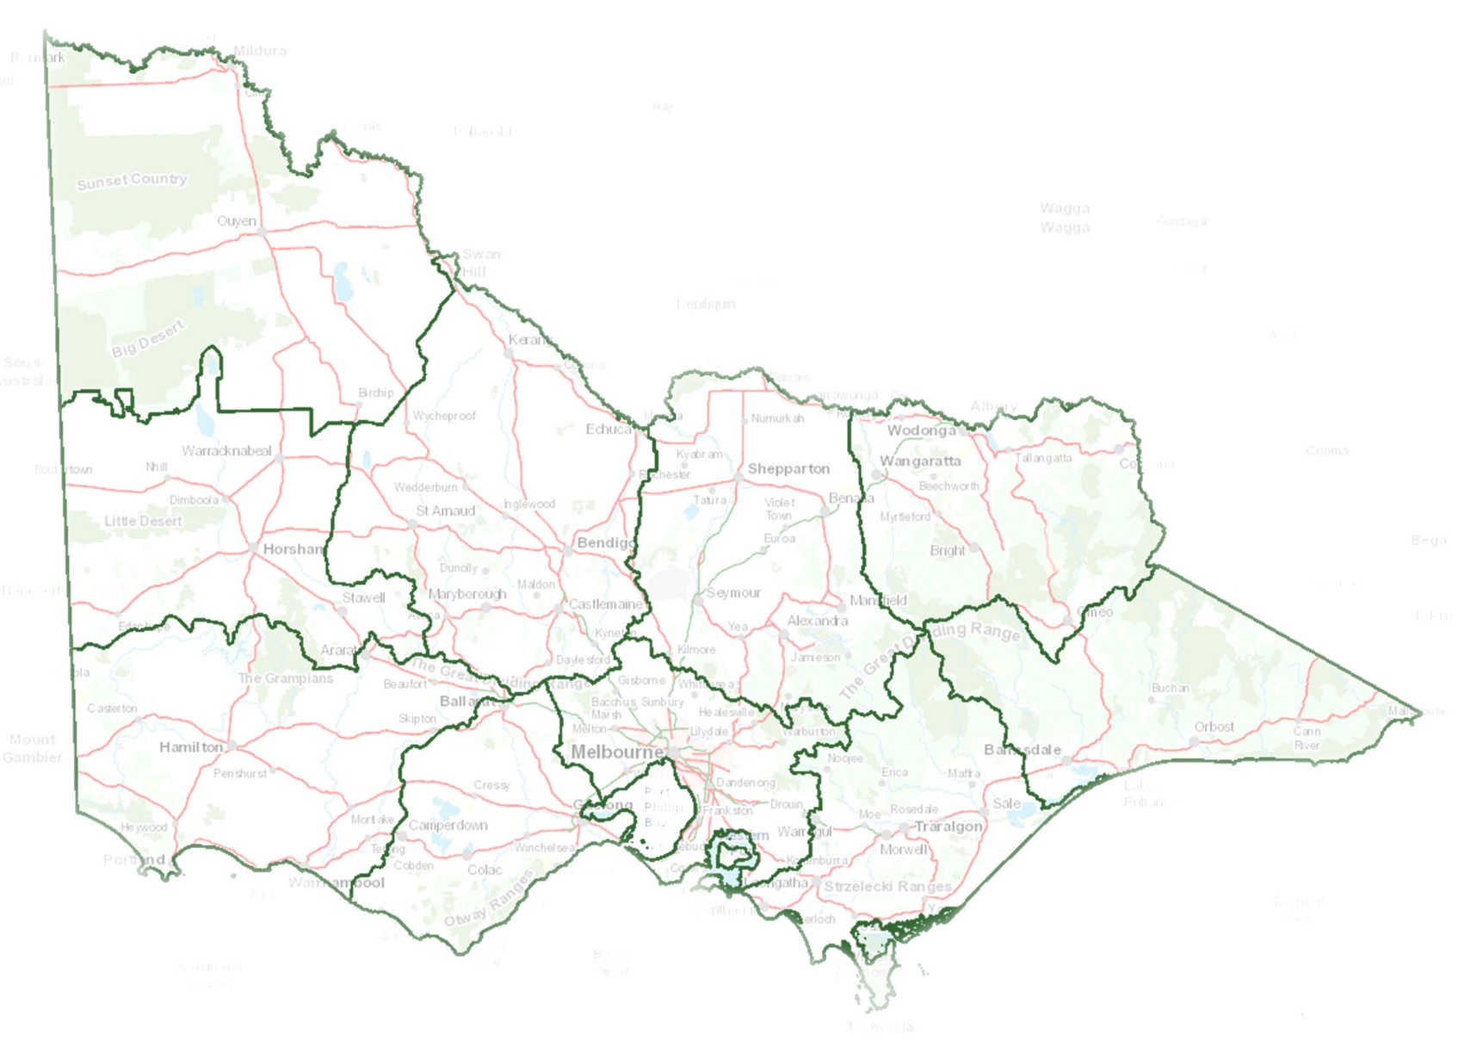
Wimmera
The Wimmera region spans approximately 2.3 million hectares—around 10% of Victoria—and is the fifth largest catchment management region in the State. Approximately 80% of the land is used for agriculture.
Dryland cropping and livestock grazing dominate the landscape, with wheat, canola, legumes, and pulses as key crops, and sheep raised for wool and meat. The upper Wimmera supports a growing viticulture sector, while groundwater-fed irrigation in West Wimmera sustains small seed, lucerne, and vegetable production.
Although the region is not connected to the River Murray via surface water, it is part of the Murray-Darling Basin and the BSM2030 due to its groundwater linkages. The Wimmera region is an important recharge area for the Parilla Sands aquifer which ultimately discharges to the River Murray. While the impact of salinity management in the Wimmera on River Murray salinity levels is minimal, salinity remains a significant local issue affecting land, water, biodiversity and infrastructure.
The region includes two Registered Aboriginal Parties that play an active role in natural resource management.

North Central
The North Central CMA region covers almost three million hectares and includes the Campaspe, Loddon, Avoca and Avon-Richardson River catchments. The area is dominated by agricultural landscapes which sustain the region’s economic and social prosperity.
The region’s waterways, which encompass more than 100,000 km of streams and 1,600 wetlands, have significant economic, environmental, cultural, and social values. The region is home to two internationally recognised Ramsar wetlands – Gunbower Forest and Kerang Wetlands – which support many migratory waterbirds. The region also includes five Registered Aboriginal Parties and several other groups with strong connections to Country that are involved in natural resource management.
Salinity risks are observed throughout the north central region. In a few places such as the salt lakes to the west of Donald, salinity is natural. This means it was there prior to colonisation. However, in most instances it is the result of changes in the hydrology of the land that can be attributed to the adoption of European agricultural practices.
Salinity is not restricted to agricultural land; it is also a substantive issue in terms of the water quality of the region’s rivers and streams. Salt loads within the Axe Creek catchment southeast of Bendigo, for example, range from 5,000 tonnes per annum to more than 10,000 tonnes depending on seasonal climatic conditions. Salinity is also an issue in urban areas where it typically referred to as ‘urban salinity’.
North East
Northeast Victoria has an agricultural production value of approximately $603 million/year across a range of industries including dairy, beef, wine, and horticulture. Approximately 650,000 hectares (ha) of land is used for agricultural production.
Approximately 55 per cent of the North East region consists of public land including National Parks, State Forests, wilderness areas, nature reserves, plantations, and plantation forests (on long-term lease for softwood production), crown land and Alpine resorts. The remaining land is largely privately owned, much of which is cleared of native vegetation and used for farmland.
Approximately 20% of all agricultural businesses in northeast Victoria use water from regulated and unregulated surface water, groundwater and farm dams to irrigate across 12,000 hectares.
Agricultural livelihoods, rural and peri-urban lifestyle and native vegetation are at some risk from salinity. This is more evident where land-use has been intensive and natural ecological processes disrupted or changed permanently.
The region also includes three Registered Aboriginal Parties involved in natural resource management.
Goulburn Broken
Covering 2.4 million hectares, or 10.5% of Victoria, the Goulburn Broken catchment consists of both dryland and irrigated agriculture. 460,000 hectares of highly productive irrigable land forms the Shepparton Irrigation Region (SIR). The SIR supports industries including dairy, horticulture and cropping and a large food processing sector with recent major investment in on-farm and off-farm irrigation infrastructure.
The catchment also includes two Registered Aboriginal Parties who represent the interests of First Nations people for their respective Country. This includes active involvement in natural resource management through joint management agreements and legislative rights to public land.
Representation and involvement on CMA groups and projects, and participation in the wider partnership of First Nations people is important given the impact that widespread salinity could have on landscape and the cultural value of Country.
Mallee
The Mallee region covers almost four million ha, around one-fifth of Victoria and is the largest catchment area in the State. It extends along the River Murray from Nyah to the South Australian Border and south through vast dryland cropping areas and public reserves. The region is recognised nationally and internationally for the diversity and uniqueness of its natural, cultural, and productive landscapes. The region also includes two Registered Aboriginal Parties and several other groups with strong connections to Country that play important roles in natural resource management.
Despite the semi-arid nature of the Mallee region, the predominance of effective winter rainfall and access to reliable water from the River Murray allows the Mallee region to be an agriculturally diverse and productive region. Total irrigable area in the region is 88,905 ha, of which 70,460 ha is actively irrigated (Mallee CMA 2024).
The gross value of irrigated horticultural production in the Mallee is more than $1.4 billion and it accounts for more than 30% of irrigated horticultural production in Victoria. In 2023-24, the region produced 70% of the nation’s table grapes, 45% of the nation’s almond, 13% of wine, 80% of dry grapes, and 20% of citrus. Majority of permanent horticultural plantings along the River Murray utilises the river as its irrigation water source.

3. Salinity accountability framework

3.1 Register position

3.1.1 Victorian Statement of Compliance
Under Schedule B of the Murray-Darling Basin Agreement, Victoria is accountable for actions changing salinity in the River Murray. Specifically, actions resulting in a modelled change of plus or minus 0.1 EC at Morgan, South Australia, must be reviewed and entered on the Murray-Darling Basin Authority (MDBA)-managed Basin Salinity Management (BSM) salinity registers. Actions increasing river salinity result in a debit on the salinity registers. Actions decreasing salinity impacts result in credits on the salinity registers. The salinity registers are updated annually in October upon endorsement at BSMAP.
Victoria remains compliant with Schedule B of the Murray-Darling Basin Agreement (Schedule 1 to the Commonwealth Water Act 2007).

3.1.2 Credits
Based on the 2024 MDBA Register A, Victoria’s salinity credits equalled a salinity effect of -44.7 EC and a salinity cost effect of $10.043 million/yr.
Based on the 2025 MDBA Register A, Victoria’s salinity credits are -46.8 EC or a salinity cost effect of $10.309 million/yr.

3.1.3 Debits
Based on the 2024 MDBA Register A, Victoria’s debits equalled a salinity effect of 22.6 EC and a salinity cost effect of -$5.278 million/yr.
Based on the 2025 MDBA Register A (current as of September 2025), Victoria’s salinity debits are 22.6 EC or a salinity cost effect of -5.285 million/yr.

3.1.4 Net balance
Victoria’s Salinity Register A for 2025 has a balance of -24.2 EC in net credits and a salinity cost effect of $5.024 million/yr (Table 1). Compared to Victoria’s balance in 2024, there has been a net -2.1 EC credit increase. The increase in net credits is mostly accounted for by revised credit estimates from the accountable action reviews of the Woolpunda Salt Interception Scheme (SIS) and Barr Creek Catchment Strategy in 2025.

Table 1: Victoria's Salinity Register A balance sheet summary
 | Balance in October 2024 |  | Change in 2024/25 reporting period |  | Balance in December 2025
 | Salinity effect (EC at Morgan) | Salinity cost effect ($/yr) | Salinity effect (EC at Morgan) | Salinity cost effect ($/yr) | Salinity effect (EC at Morgan) | Salinity cost effect ($/yr)
Credit | -44.73 | 10,043,000 | -2.08 | 266,000 | -46.81 | 10,309,000
Debit | 22.57 | -5,278,000 | 0.00 | -7,000 | 22.57 | -5,285,000
Total | -22.16 | 4,765,000 | -2.08 | 259,000 | -24.24 | 5,024,000

Table 2: Victoria's Credit Balance Sheet based on the 2025 Salinity Register A (current as of September 2025)
Register A entry | Physical impact  (EC) | Salinity cost effect  ($/yr)
Joint Works and Measures
Salinity and Drainage Strategy
Woolpunda Salt Interception Scheme (SIS) | -9.71 | 871,000
Improved Buronga and Mildura/Merbein SIS | -0.23 | 45,000
New Operating Rules for Barr Creek Pumps | -0.92 | 225,000
Waikerie Stage 1 SIS | -2.63 | 234,000
Changed MDBC River Operations 1988 to 2000 | -0.30 | 150,000
Mallee Cliffs SIS | -0.92 | 275,000
Changed MDBC River Operations 2000 to 2002 | -0.28 | -134,000
Waikerie SIS Phase 2A | -0.64 | 55,000
Sub-total Basin Salinity Management Strategy | -15.62 | 1,722,000
Basin Salinity Management Strategy
Changed MDBC River Operations after 2002 | -0.05 | 23,000
Pyramid Creek SIS | -0.57 | 135,000
Bookpurnong Joint SIS | -0.86 | 97,000
Improved Buronga SIS | -0.03 | 6,000
Loxton SIS | -1.16 | 136,000
Waikerie Lock 2 SIS | -1.00 | 68,000
Upper Darling SIS | -0.64 | 199,000
Joint Component of Murtho SIS | -0.66 | 123,000
Sub-total Basin Salinity Management Strategy | -4.97 | 787,000
BSM2030
MM SIS Refurbishment 2015 | -0.53 | 110,000
Sub-total BSM2030 | -0.53 | 110,000
Shared NSW & VIC Measures
Permanent Trade Accounting Adjustment - NSW to Victoria | -0.05 | 5,000
Barmah-Millewa Forest Operating Rules | -1.00 | 185,000
Sub-total NSW & VIC Measures | -1.05 | 190,000
Victorian Works and Measures
Barr Creek Catchment Strategy | -9.10 | 2,262,000
Psyche Bend – Sunraysia Drains Drying Up (combined) | -3.35 | 833,000
Permanent Trade Accounting Adjustment - Victoria to SA | -0.80 | 182,000
Lamberts Swamp | -2.70 | 528,000
Church's Cut Decommissioning | -0.20 | 47,000
Mallee Drainage Bore Decommissioning | -0.30 | 68,000
Reduced Irrigation Salinity Impact Victoria | -8.20 | 1,846,000
Victorian S&DS Commitment Adjustment | 0.00 | 1,600,000
Sub-total Victorian Measures | -24.65 | 7,366,000
Total credits | -46.81 | 10,309,000

Table 3: Victoria's Debit Balance Sheet based on the 2025 Salinity Register A (current as of September 2025)
Register A entry | Physical impact (EC) | Salinity cost effect ($/yr)
Joint Works and Measures
Salinity and Drainage Strategy
Changed Operation of Menindee and Lower Darling | 0.17 | -146,000
Sub-total Salinity and Drainage Strategy | 0.17 | -146,000
Basin Salinity Management Strategy
None | N/A | N/A
Sub-total Basin Salinity Management Strategy | 0 | 0
BSM2030
None | N/A | N/A
Sub-total BSM2030 | 0 | 0
State Works and Measures
Shared NSW and VIC Measures
None | N/A | N/A
Sub-total Shared Schemes | 0 | 0
Victorian Measures
Tragowel Plains Drains at 2002 level | 0.90 | -132,000
Shepparton SMP | 5.50 | -1,082,000
Nangiloc-Colignan SMP | 0.40 | -102,000
Nyah to SA Border SMP - Irrigation Development | 13.30 | -3,075,000
Kerang Lakes Swan Hill SMP | 1.50 | -341,000
Campaspe West SMP | 0.00 | -36,000
Woorinen Irrigation District Excision | 0.80 | -238,000
Sub-total Victorian Measures | 22.40 | -5,006,000
Total debits | 22.57 | -5,285,000

3.2 Regional salinity registers
Victoria manages its obligation to keep the total of salinity credits in excess of, or equal to, the total of any salinity debits attributed to it in Register A (Clause 16(1) (a) Schedule B) by allocating Victorian salinity credits to the CMAs. Salinity debits in each region depend on the accountable actions that are tied to each region. It is then the responsibility of the CMAs to ensure that the salinity debits in their region do not exceed their salinity credit allocation.
No additional salinity credits have been allocated to any CMAs during 2023/24 and 2024/25 as the assigned credits continued to be in excess of regional salinity debits. The salinity credit allocations to CMAs for accountable actions on the BSM Salinity Registers are provided in Table 4.
Victoria has allocated -39.62 EC to three CMAs, of which -16.68 EC have not been used to offset any regional debits. There are currently -5.11 EC salinity credits unallocated
Table 5). Salinity credits have not been allocated to Wimmera or North East CMA as they do not have any accountable actions. North East CMA has two Legacy of History register items, however offsetting credits for legacy of history items are managed through State credits.

Table 4: Victorian Register A salinity credit allocation and salinity debits for CMAs
 | Government allocation of salinity credits (EC) | Salinity debits by region in 2023/24 (EC) | Salinity debit change over 2024/25 reporting period (EC) | Salinity debits by region in 2024/25 (EC) | Allocated salinity credit balance for 2024/25 (EC)
Goulburn Broken | -8.9 | 6.0 | 0 | 6.0 | -2.9
North Central | -10.12 | 2.6 | 0 | 2.6 | -7.52
Mallee | -23.22 | 13.94 | 0.79 | 14.73 | -8.5
Total | -39.62 | 22.54 | 0.79 | 23.3 | -18.92

Table 5: Summary of Register A salinity credits for Victoria allocated to CMAs as of September 2025
Credits | Physical EC
Total available (Table 2) | -47.46
Total allocated (Table 4) | -39.62
Unallocated salinity credits | -7.84

3.3 New accountable actions

3.3.1 Victorian Mid-Murray Storages Review
The Victorian Mid-Murray Storages (VMMS) consist of four water bodies – Kow Swamp, Lake Charm, Lake Kangaroo and Lake Boga – which are also a part of the Kerang Lakes and the Torrumbarry system. The VMMS are operated to divert and store water from the River Murray during high flows, and release water for downstream Victorian users when required.
The VMMS was established in late 2009 through the decommissioning of Lake Mokoan on the Broken River and infrastructure constructed for the new operational arrangements. Both the decommissioning of Lake Mokoan and the operations of VMMS reduced water losses in storage and during delivery, which recovered 42.5 GL of environmental water entitlements for the River Murray and 14GL for the Snowy River. However, the diversion of flows from the River Murray and the re-release of those flows into the River Murray caused an increase in salt loads released.
Victoria completed a salinity impact assessment for the VMMS in January 2025. The VMMS accountable action was endorsed by BSMAP in May 2025 as a provisional entry of 5.6 EC debit on the BSM Salinity Register A with a ‘low’ confidence rating. The ‘low’ confidence rating and decision to record the VMMS as a provisional entry are due to the identification of complexities in modelling two-way flows between the VMMS and the River Murray. It is anticipated this will be resolved by simulating those flows in the Source Murray Model when the Source Murray Model is operationalised for the BSM Salinity Registers.
Responsibility of and ownership of the debits of the VMMS accountable action have not been determined and will be subject to further discussions at BSMAP.

3.4 Salinity accountability for environmental water
CMAs undertook environmental watering activities in accordance with their individual Environmental Water Management Plan (EWMP), which consider and manage the potential salinity impacts of proposed watering actions. A summary of current and potential future environmental water accountable actions is provided below.

3.4.1 Environmental watering of the Gunbower forested floodplain
Investigations supported by both the Living Murray Program (TLM) and the Victorian Murray Floodplain Restoration Project (VMFRP) have proceeded within the forested floodplain of the River Murray at Gunbower, Benwell and Guttrum.
Twenty-four bores fitted with electronic groundwater loggers in 2014 and 2021/22 were downloaded in October and December 2024. Groundwater hydrographs were plotted and the results interpreted. Data since 2021 demonstrates groundwater recharge on the floodplain during both flood and environmental watering inundation events is preventing by the presence of high shrink-swell clays acting together with trees behaving as phreatophytes (transpiring water from the capillary fringe above the watertable).
This means salinity risks resulting from flood or environmental water recharging deeper saline groundwater under these Murray floodplain forests are very low, and an accountable action is unlikely to be required for environmental watering of the Gunbower forested floodplain.

3.4.2 Victorian Murray Floodplain Restoration Program
Nine Victorian Sustainable Diversion Limit Adjustment Mechanism (SDLAM) projects were proposed as part of the package of 37 SDLAM measures agreed to by the Murray Darling Basin Ministerial Council in June 2017. This includes nine proposed sites under the VMFRP.
More detailed evaluation and modelling of long-term salinity impacts as managed under BSM2030 will become possible after approvals and design, construction and operation details are confirmed. Progress of the VMFRP is being continually monitored to ensure salinity accountability requirements under BSM2030 are adequately addressed.

4. Management of salt interception schemes
Salt interception schemes (SIS) reduce base salt loads as well as the magnitude and duration of episodic salinity peaks in the river. SIS are managed through the Joint Programs. Of the 14 SIS sites in the Murray-Darling Basin, three are in Victoria – Pyramid Creek Groundwater Interception Scheme, Barr Creek Drainage Diversion Scheme and Mildura-Merbein SIS.
Combined, the three schemes diverted 86,886 tonnes of salt in 2023/24 and 93,375 tonnes of salt in 2024/25 away from the River Murray (Table 6).
Table 6: Summary of Victorian salt interception scheme operations 2023/24 and 2024/25
 | 2023/24 |  |  | 2024/25
Salt interception scheme | Volume pumped (ML) | Salt load diverted (tonnes) | Average salinity (EC) | Volume pumped (ML) | Salt load diverted (tonnes) | Average salinity (EC)
Pyramid Creek | 504 | 12,983 | 42,910 | 766 | 19,730 | 42,910
Barr Creek | 1,584 | 7,297 | 5,722 | 987 | 6,993 | 6,448
Mildura-Merbein | 1,193 | 66,606 | 78,990 | 1,365 | 66,652 | 73,454
Total |  | 86,886 |  |  | 93,375

4.1 SIS operations

Pyramid Creek Groundwater Interception Scheme
The Scheme intercepts saline groundwater that would have otherwise discharged to Pyramid Creek. Prior to the scheme, saline groundwater caused significant negative impacts on the Torrumbarry Irrigation Area’s agricultural production, the environmental attributes of the Ramsar listed Kerang Lakes, and downstream River Murray water users.
In 2023/24, 504 ML of groundwater with an average salinity of 42,910 EC was intercepted, corresponding to a salt load of 12,983 tonnes diverted. In 2024/25, 766 ML of groundwater with the same average salinity was intercepted (Table 6). The diverted flows were delivered to constructed drainage basins, from which salt was harvested by a private operator.
The volumes of groundwater pumped in 2023/24 and 2024/25 were much lower than average as the major flooding event in October 2022 caused damage to the Scheme’s infrastructure and left the Scheme at only 42% operational availability. The Scheme met 29% of its operational target in 2023/24 and 79% of its operational target in 2024/25. Refurbishment is still in progress due to both budget constraints and a need to prevent future flood damage, but a small section of pumps has continued to operate since late January 2023 to meet minimal requirements of the private salt harvester.

Barr Creek Drainage Diversion Scheme
The Barr Creek Drainage Diversion Scheme has operated at 100% compliance to the operating rules over 2023/24 and 2024/25. It has been effective in reducing base salt loads entering the River Murray by intercepting drainage flows and saline groundwater from the Barr Creek catchment and diverting them to the Tutchewop Disposal Lakes.
In 2023/24, 1,584 ML of drainage water and intercepted groundwater at an average salinity of 5,722 EC was diverted to disposal lakes, which corresponded to a salt load of 7,297 tonnes. In 2024/25, 987 ML at an average salinity of 6,448 EC was diverted, which corresponded to a salt load of 6,993 tonnes. In 2024/25, operating rules required less diversion for the lower rainfall and reduced flows down Barr Creek. This resulted in lower diverted flows than 2023/24.
Mildura-Merbein Salt Interception Scheme
In 2023/24, the Scheme pumped 1,193 ML of groundwater at an average salinity of 78,900 EC and corresponding salt load of 66,606 tonnes diverted. In 2024/25, the scheme pumped 1,365 ML of groundwater at an average salinity of 73,454 EC and corresponding salt load of 66,652 tonnes diverted.
The Scheme operated to 50% of its operational target in 2023/24 and 79% in 2024/25. Due to maintenance requirements after the October 2022 flood event and sustained high river flows, the Scheme was unable to operate at 100% for most of 2023/24 and 2024/25.
Two of the pumps (MM8 and MM9) operated at a reduced level for most of each reporting period as a part of the Responsive Management Trial. Due to concerns with the rising salinity of the River Murray at Morgan, the pumps were operated for a short period of time in March and April 2025. By the end of June 2025, the Scheme was able to operate at 100% capacity but continued to operate at a lower level in accordance with the Responsive Management Trial operating rules.

4.2 SIS support and maintenance activities
Pyramid Creek Groundwater Interception Scheme
During the flood of October 2022, the Scheme experienced inundation similar to the 2011 flood event. Post-flood inspections showed that 92% of the pumps and 80% of the electrical cabinets were affected.
The Scheme has operated at a reduced level since then whilst investigations, designs and procurement were undertaken to replace the damaged electrical cabinets. To prevent future flood damage, detailed design for the new electrical cluster cabinets to be raised above the flood water level has been completed. The full scope of work exceeded the available budget, but a reduced scope of works is scheduled to be completed in 2025/26.
In April 2025, replacement of headworks connecting pumps to pipelines that have been damaged or reached end of life began (Figure 1). Replacing these headworks is crucial in preventing a headwork failure that could cause pumped saline groundwater to spill out onto the surface.
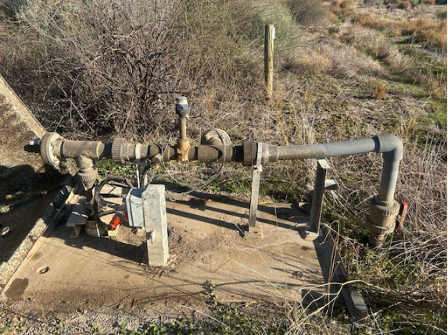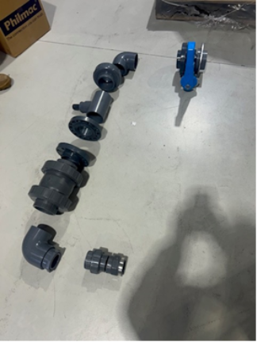
Figure 1: Previous condition of headworks prior to update works. Photo credit: GMW

Barr Creek Drainage Diversion Scheme
The Scheme was impacted by inundation due to the October 2022 flood. Permission was gained from the MDBA to use Lake Tutchewop for flood refuge, as it was in 2011. Lake Tutchewop did not fall below its Full Supply Level until April 2024; and then became serviceable as part of the Scheme operations. Despite the damage incurred from the flood event, the scheme was able to operate at 100% efficiency.
To meet updated electrical safety regulations, a new electrical switchboard was commissioned and became operational in March 2025, helping to ensure the Scheme can operate at 100% capacity.
Mildura-Merbein Salt Interception Scheme
In October 2024, pumps MM1 and MM2 were reinstated after being overhauled and are now running efficiently. Pump MM3 was then removed for repair and overhauled. It was reinstated in February 2025. A pipe cleaning procedure was developed for the Operations and Maintenance Manual, and cleaning of the Scheme was completed in December 2024. A project brief was developed for the scheduled 5-Year Review of the Scheme. It is expected that the project will be completed in 2026.

5. Salinity management

5.1 Victorian salinity management
DEECA is the delegated agency of the Victorian Government responsible for overseeing the implementation of salinity policy and accounting for Victoria’s obligations under BSM2030. Although DEECA coordinates the State’s implementation of BSM2030, the CMAs manage salinity impacts and most accountable action management activities as part of the implementation of their Land and Water Management Plans (LWMP) through Victoria’s Catchment and Land Protection Act 1994 (CaLP Act).
Victoria’s approach to meeting its Murray-Darling Basin salinity management obligations in partnership with CMAs and water corporations is set out in the Manual for Victoria’s Salinity Accountability in the Murray-Darling Basin (DELWP 2021).
Several state and interjurisdictional groups support and inform salinity management activity in Victoria; these include:
- Basin Salinity Management Advisory Panel (BSMAP)
- Salt Interception Technical Working Group (SITWG)
- Technical Working Group for Salinity Modelling (TWGSM)
- Victorian Salt Disposal Advisory Group (VSDAG)
- Victorian Salt Disposal Working Group (VSDWG)
- Various Project Steering Committees.

5.1.1 State-wide policies and actions

Water for Victoria
Water for Victoria (DELWP 2016) is the State’s strategic plan for managing water resources for a future with less water to share due to the impact of climate change and a growing population. The actions set out in the plan support a healthy environment, a prosperous economy with growing agricultural production, and thriving communities.
Through Water for Victoria, the State reconfirmed its commitment to salinity management in the Murray-Darling Basin with two key actions relating to salinity:
- managing salinity, water logging and water quality, including meeting compliance with BSM2030
- improving salinity management in the Mallee region, specifically in relation to irrigation development which represents Victoria’s largest salinity risk.

Sustainable Irrigation Program
Third-party impacts arising from irrigation, including salinity impacts, are managed through a well-established and evolving Sustainable Irrigation Program (SIP) delivered jointly by DEECA, Ag Vic and CMAs. SIP has driven Basin salinity outcomes in Victoria by:
- providing extension services to irrigators to encourage irrigation practices that reduce rootzone drainage or runoff
- providing incentives to maintain or upgrade irrigators’ on-farm irrigation systems to reduce rootzone drainage or runoff
- developing and coordinating Irrigation Development Guidelines processes to advise licensing authorities on matters relating to the Standard Water-Use Conditions and Water-Use Objectives when considering irrigation development proposals, including minimising salinity impacts by meeting industry best practice on limiting rootzone drainage and assessing likely off-site impacts
- monitoring surface water and groundwater in the Basin-wide Core Salinity (BCS) Monitoring network within Victoria
- undertaking activities to ensure Victoria meets the requirements of Schedule B of the Murray Darling Basin Agreement, such as completing accountable action reviews.
The program is supported by 4-year funding cycles ensuring stability of resourcing and enabling better strategic planning, especially for projects that require multiple years to complete.

Flow-based management and environmental water
Management of environmental water in Victoria is undertaken through a partnership between the Victorian Environmental Water Holder (VEWH), CMAs, DEECA, land managers including Parks Victoria and local councils, water corporations, Traditional Owner groups, and interjurisdictional agencies including the Commonwealth Environmental Water Holder (CEWH) and the MDBA.
In collaboration with communities and agencies, CMAs across Victoria have developed long-term EWMPs and Icon Site Operating Plans to guide environmental watering activities in rivers, wetlands and floodplains across the State. These plans outline the values, objectives, site watering requirements and operating strategies. They also summarise key risks that may impact on the ability to achieve objectives including risks to water quality.
EWMPs inform long-term watering plans and annual VEWH Seasonal Watering Plans for Northern Victoria, the Victorian Murray and the Wimmera-Mallee.

Dryland salinity management
Services addressing salinity on dryland farms across Victoria continue to be delivered by Ag Vic’s Resilience and Recovery Program within Ag Vic Services. The Resilience and Recovery Program delivers planning, ongoing management and mitigation advice through existing land management extension services such as farm planning courses with an emphasis on dryland farms with salinity risk.
Ag Vic Research (AVR) continues to engage with Landcare groups to educate them about dryland salinity management and other groundwater issues. This includes providing advice on groundwater level monitoring and dryland salinisation in their areas. Upon request from the public, AVR also test the salinity levels of farmers’ bore water to evaluate suitability for stock and domestic use.

5.2 Regional salinity management
This section describes the plans and strategies within each of Victoria’s Murray-Darling Basin-connected catchments that address the management of land and water salinity and the actions taken to implement these in 2023/24 and 2024/25.
Integrated catchment management underpins the sustainable management of land and water resources in Victoria. The Victorian Government and its partners seek to achieve sustainability and ensure the long-term viability of natural resource systems and human needs for both current and future generations with this approach.
In Victoria’s major irrigation districts, CMAs prepare and implement regional LWMPs to reduce the environmental and third-party impacts of irrigation and improve farm water use efficiency. Victorian LWMPs have evolved from Salinity Management Plans (SMP) developed in the late 1980s and 1990s to mitigate the impacts of salinity on agriculture, environments, and communities. Many of the objectives and tools implemented in the original SMPs are preserved in current LWMPs.

5.2.1 North East
The 2019-2024 North East Sustainable Irrigation Plan (North East CMA 2019) sets the strategic directions for and identifies activities to ensure sustainable irrigation in the region. The long-term outcomes sought from implementing the Plan are to maximise the regional productivity from available water and minimise adverse impacts on the environment, recreation, other land use and Traditional Owner values.
The Plan also focuses on minimising potential off-site impacts of agricultural land use and reducing the risk of salinity in waterways, including compliance with salinity obligations for the 5-year reviews of the Kiewa and King Valleys in accordance with BSM2030.
Over 2024/25, North East CMA worked in partnership with Ag Vic and GMW to develop the draft North East Victoria Sustainable Irrigation Plan 2025-2035 (North East CMA 2025).
The draft Strategy’s proposed medium-term outcomes are:
- regional productivity from available water and resources is improved
- irrigation enterprises are resilient to extreme climatic events/changes, dynamic rivers and emerging issues
- adverse impacts to the environment, recreation and cultural values from irrigation development and operation are minimised.
Flow-based salinity management
The North East CMA manage a small Commonwealth environmental water entitlement totalling 246 ML in the Ovens River and its tributaries. This entitlement has no identified salinity implications.
Land-based Salinity management
Irrigation-induced salinity across North East Victoria is managed through several different programs, including improved irrigation scheduling, improved irrigation system application rates, and ensuring new irrigation developments are undertaken according to best practice.
Education and financial incentives on irrigation scheduling were provided to irrigators across the region. This helped to avoid overwatering which can lead to salinity issues.
The farm works undertaken in the North East region during 2023/24 and 2024/25 are summarised in Table 7.
Table 7: Summary of farm works undertaken in the North East region during the reporting period
Item | Irrigation - works carried out 2023/24 | Irrigation - works carried out 2024/25
Irrigation system upgrades | - 5 new irrigation developments supported.  - 16 irrigation scheduling equipment grants covering over 300 ha.  - 8 irrigators supported to install irrigation scheduling equipment. | - 7 new soil moisture probes installed.  - 4 irrigators helped to understand the data from existing probes.  - 9 irrigators took up the financial incentive to purchase equipment to improve irrigation scheduling.
Education activities | - 6 field days and workshops supporting improved irrigation efficiency with over 90 attendees.  - 2 industry grants to support the nut and dairy industries adapt to climate change and a more variable water future, with over 25 attendees at the nut industry workshops.  - 8 cases studies developed to support dairy farmers adapt to climate change impacts.  - 39 Evapotranspiration newsletters circulated to 84 landholders over the irrigation season. | - 39 Evapotranspiration newsletters circulated.  - Tailored support to 29 irrigators with a focus on sustainable water use.
Other Achievements | - 26 one-on-one engagements with irrigations to improve irrigation system efficiency.  - 18 irrigation system checks to improve efficiencies across more than 300 ha.  - Production of the 2022/23 Technical Land and Water Use Mapping in Regulated Diversions Catchments of Northern Victoria (Goulburn Broken CMA 2024a). | - 1 irrigation field day held.  - 8 meetings held.  - 4 presentations made.  - 1 workshop held.  - 47 publications produced.  - 18 irrigation systems tested.
Reforestation works
In 2023/24, 460 ha of revegetation and vegetation enhancement projects were completed. An additional 70 ha was completed in 2024/25, totalling 530 ha over the two years. These projects were part of general catchment health and stewardship programs and are not directly related to salinity management but could help reduce saline groundwater accession.

5.2.2 Goulburn Broken
The Shepparton Irrigation Region Land and Water Management Plan (SIRLWMP) 2050 was launched in August 2024 (Goulburn Broken CMA 2024b). Building on the previous iteration of the SIRLWMP and work of communities, partners and governments, the Plan focuses on five critical attributes to guide community and agency actions in overcoming environmental, economic and social challenges. The critical attributes are:
- resilient community
- farm and regional prosperity
- water availability
- biodiversity
- drainage.
Meeting community expectations, regulatory standards and Murray Darling Basin salinity requirements is a key outcome under the drainage attribute.
Flow-based salinity management
In both 2023/24 and 2024/25, the Goulburn Broken CMA prepared 6 seasonal watering proposals covering the following waterways:
- Goulburn River
- Broken River
- Broken Creek
- Barmah-Millewa Forest
- Gaynor Swamp
- Kanyapella Basin
- Kinnairds Wetland
- Black Swamp
- Moodie Swamp
- Doctors Swamp
- Reedy Swamp
- Loch Garry
- Horseshoe Lagoon.
Salinity risk was not identified in these waterways or considered a risk in response to environmental water deliveries.
Land-based salinity management
The farm works undertaken in the Goulburn Broken region during 2023/24 and 2024/25 are summarised in Table 8.
Table 8: Summary of farm works undertaken in the Goulburn Broken region during the reporting period
Item | Irrigation - works carried out *  2023/24 | Irrigation - works carried out *  2024/25
Whole Farm Plans | 57 Whole Farm Plans completed in the SIR | 27 Whole Farm Plans completed in the SIR
Land forming | 2,641 ha laser levelled | 1373 ha laser levelled
Irrigation system upgrades | 2,641 ha of irrigation systems improved | 1371 ha of irrigation systems were improved
Other Achievements | 11 km of Drainage Course Declaration gazetted, servicing an area of 1,500 ha | -
*Note some activities are delivered by Ag Vic.
Groundwater investigation
Ag Vic and GMW staff worked together to investigate and monitor instances of localised perched watertables resulting in poor agricultural performance.

5.2.3 North Central
North Central continued to implement the Loddon-Campaspe Irrigation Region (LCIR) Land and Water Management Plan 2020-2030 (North Central CMA 2020) and the 2021-2027 Regional Catchment Strategy (RCS).
The LCIR LWMP and RCS provide direction and actions which guide sustainable irrigation development and management in the region. For example, proposed irrigation developments that require environmental assessment are now referred to an inter-agency Northern Victorian Irrigation Development Group, including providing advice to licencing authorities on salinity risks. The North Central CMA participates in this group through its Sustainable Agriculture program.
Flow-based salinity management
Extensive investigations and research have been conducted by North Central CMA regarding the potential for environmental water within the Gunbower, Guttrum and Benwell forested flood plains. The research involved collecting high-density groundwater data electronically over the past ten years within the Benwell and Guttrum forested floodplains and over the past five years for the Gunbower forested floodplain.
A technical and scientific guideline for salinity risk assessment was developed in 2023/24 for consideration in the environmental watering of wetlands and for the rehabilitation of wetlands.
Land-based salinity management
The farm works undertaken in the North Central region during 2023/24 and 2024/25 are summarised in Table 9.

Table 9: Summary of farm works undertaken in the North Central region during the reporting period
Item | Irrigation - works carried out *  2023/24 | Irrigation - works carried out *  2024/25
Whole Farm Plans | 27 Whole Farm Plan surveys over 3500 ha | 5 design plans over 508 ha completed
Land forming | - | -
Reuse systems | - | -
Soil salinity surveys | - | 5 surveys over 533 ha completed
Irrigation system upgrades | - | -
Education activities | - | -
Other Achievements | 1900 ha assessed for irrigation development | A drainage strategy developed for northern Victoria by the North Central CMA affords the opportunity to remove excess water that may contribute to salinity from the landscape
*Note some activities are delivered by Ag Vic.
Dryland salinity works
Dryland salinity is now managed through the North Central CMA’s Landcare program. Farming communities concerned with salinity undertake targeted tree planting, the adoption of deep-rooted perennial pastures and conservation tillage under programs that focus on improvements in soil health including the current State and Commonwealth climate change-focused carbon initiatives.
CMA projects supporting dryland salinity management include:
- Reporting and Accounting for Salinity
- Climate Positive Farming Initiative
- Carbon Farming Outreach Program
- Regional Drought Resilience Funding
- Sustainable Agriculture Facilitator.
Reforestation works
Ongoing groundwater monitoring in response to forestry plantations established with Landcare funding by the Northern United Forestry Group in 2004/05 continues through the Group’s volunteers. Electronic groundwater monitoring was established in 2024/25 by the North Central CMA in three of the Northern United Forestry Group bores. The CMA assisted with the construction of one additional well monitoring groundwater pressures below the 2024 Eucalypt plantation. The plantations have lowered the saline watertable beneath the plantations more than five metres since establishment in 2004.

5.2.4 Mallee
The Victorian Mallee Land and Water Management Plan 2020-29 provides the strategic framework for determining priority investment in works and measures to achieve the Plan’s vision and objectives (Mallee CMA 2020).
The Plan covers all irrigation area and areas potentially affected by irrigation. Within the Mallee, this covers a 25 km buffer along the River Murray from Nyah to the South Australian Border (Victorian side) and the Murrayville Groundwater Management Area.
The 2020-29 Victorian Mallee LWMP focuses on changes, challenges and opportunities that the Victorian Mallee irrigation region is likely to experience for the ten-year plan period. The Plan identifies issues in five major areas:
- low and variable water availability and deliverability
- sustainable water delivery methods
- uptake of best practice irrigation management
- regional water quality
- monitoring cumulative effects of irrigation water use.
Salinity management is a key underlying theme of the Plan, which sets out actions aimed at delivering salinity benefits and meeting MDB salinity requirements under BSM2030.
Flow-based salinity management
The Seasonal Watering Proposals for Hattah, Lindsay-Mulcra-Wallpolla, Murray Wetlands and Wimmera Mallee Pipeline were prepared in 2023/24 and 2024/25. Brickworks Billabong, Koorlong Lakes, and Lake Hawthorn were identified with a potential salinity risk resulting from environmental watering. However, no salinity risk was identified for the majority of planned environmental watering sites.
As part of Seasonal Water Proposal development, a risk assessment was undertaken through information contained within the EWMPs and as part of a stakeholder risk identification workshop facilitated by the VEWH. Risks were re-assessed during the development of the Delivery Plan and were an ongoing consideration during delivery. To ensure salinity remained within acceptable levels in the identified watering sites, active management strategies were implemented to mitigate the potential impacts of salinity.
In 2024/25, environmental watering was applied to 30 sites along the Murray River floodplains covering an area of 1,541 ha using 17,860 ML of environmental water.
There were no requirements for Basin Plan flow management reporting with reference to salinity management in 2023/24 or 2024/25.
Land-based salinity management
The farm works undertaken in the Mallee region during 2023/24 and 2024/25 are summarised in Table 10.
Table 10: Summary of farm works undertaken in the Mallee region during the reporting period
Item | Farm works carried out 2023/24* | Farm works carried out 2024/25*
Irrigation system upgrades | 10 properties received scheduling equipment (dendrometers). | -
Education activities | 22 irrigation-related workshops and  events delivered to Mallee irrigators. A total of 379 participants attended  educational events. | Workshops, field days, 19 forums and 16 publications delivered to facilitate the development of skills/knowledge required for implementation of improved land use options with salinity benefits (primarily secondary benefits such as increased groundcover).
Other Achievements | - | One property 4.02 ha surveyed for soil salinity.
*Note some activities are delivered by Ag Vic.
Reforestation works
No reforestation or revegetation works were carried out in 2023/24, but re-establishment of 40 ha of native vegetation was completed in 2024/25 using a combination of high-density seedling plantings and direct seeding.
A further 44 ha of previously revegetated areas was also maintained through supplementary (low density) planting to provide for seedling mortalities. A further 270 ha of revegetation works are scheduled to be undertaken in 2025/26. Long-term salinity benefits will be achieved through reduced groundwater recharge under established native vegetation.

5.2.5 Wimmera
The Regional Catchment Strategy 2021-27 (Wimmera CMA 2021) reaffirms how Wimmera land and soils are important natural assets that underpin the region’s agricultural industry and valued natural landscapes.
Outcomes to be achieved in 6 years under the RCS are:
- Ongoing collaboration and two-way learning in land planning and management by supporting and strengthening partnerships with First Nations people
- Maintain ground cover at 70% or greater, annually
- Farmers adapt practices to a changing climate
- Increase land managers’ knowledge of management practices that contribute to healthy productive soils.
Dryland salinity is identified by the RCS as a risk if waterlogging following drought years occurs.
Land-based salinity management
Wimmera CMA, in collaboration with Ag Vic, continued long-term monitoring activities through the Wimmera Land Use and Land Management Transect. This involves surveying agricultural land along strategic transects during both spring and autumn, capturing spatial and seasonal data on land cover and management practices that influence soil health.
On behalf of Victorian CMAs, Melbourne Water and Ag Vic, Wimmera CMA has also been leading the delivery of the Victorian component of the National Soil Monitoring Program. The program will monitor agreed national soil health indicators and use the data to help understand soil condition and trend. The data will support stakeholders to make evidence-based decisions to improve soil health including prevention of dryland salinity.
The farm works undertaken in the Wimmera region during 2023/24 and 2024/25 are summarised in Table 11.
Table 11: Summary of farm works undertaken in the Wimmera region during the reporting period
Item | Dryland - works carried out 2023/24 | Dryland - works carried out 2024/25
Education activities | The Sustainable Agriculture Facilitator supported maintenance of and ongoing data collection from 72 soil moisture probes, designed to increase the agriculture sector's resilience to climate variability, by providing a networked, catchment-wide soil moisture probe network.  Perennial Pasture Systems continued to conduct perennial pasture research and provide information to its members in the upper Wimmera catchment, engaging over 271 people. | The Sustainable Agriculture Facilitator supported maintenance of and ongoing data collection from 72 soil moisture probes.  Perennial Pasture Systems continued to conduct perennial pasture research and provide information to its members in the upper Wimmera catchment, engaging over 250 people.

Reforestation Works
The reforestation works undertaken in the Wimmera region during 2023/24 and 2024/25 are summarised in Table 12 .
Table 12: Reforestation and revegetation work carried out Wimmera during the reporting period
Low density tree establishment 2023/24 | Native vegetation protected 2023/24 | Low density tree establishment 2024/25 | Native vegetation protected 2024/25
> 39 ha | > 82 ha | > 88 ha | > 92 ha

5.3 Irrigation development
In Victoria, changes in irrigation development in the Murray Darling Basin are primarily monitored through two projects. They are the Regional Irrigated Land and Water Use Mapping (RILWUM) and Mallee Horticulture Crop Report.

5.3.1 Regional Irrigated Land and Water Use Mapping
In the North Central, Goulburn and North East regions, Ag Vic, DEECA, CMAs, GMW and industry groups collaborate to undertake the RILWUM program. The scope includes the Goulburn Murray Irrigation District (GMID) and river diverters from both regulated and unregulated systems. The RILWUM program utilises remote and on-ground land use surveys in irrigation areas matched with Victorian Water Register data to determine land use and seasonal water use by water use licences and industry.
For the GMID, land and water use data have been reported on since 2015, although farm survey data since 2004 have also been collated and made available on the Goulburn Broken website (Goulburn Broken CMA 2025a). The most recently published land and water use data from the 2021/22 irrigation season show a total of 843,445 ha of irrigation development in the GMID (Goulburn Broken CMA 2023). Total area of irrigated development had not changed significantly compared to previous years – for example, there was 829,382 ha of irrigation development in 2016 (Goulburn Broken CMA 2017).
Total water use in the GMID in 2021/22 was recorded as 932 GL, which was similar to previous years except for the exceptionally dry season of 2019/20 when only 513 GL was used.
For regulated diversions from Northern Victorian catchments, the most recently published data from the 2022/23 irrigation season show a total of 216,172 ha of irrigation development. Comparisons of irrigation development area to previous years are not available. Water use decreased from 60.6 GL in 2020/21 to 50.4 GL in 2022/23.
Survey, mapping and analysis of unregulated and groundwater diversions in the GMW area for 2023/24 have recently been completed. This report will show area and water use of irrigation developments using water from catchments without regulated storages and from groundwater systems. This data is expected to be published shortly.

5.3.2 Mallee Horticulture Crop Report
In the Mallee region, the Mallee CMA has produced a Mallee Horticulture Crop Report every three years since 1996. Since 2020, the Mallee Horticulture Crop Report has also included data from Murrayville in the southwestern part of the Mallee region, which is not connected to the Murray-Darling Basin.
The 2024 Crop Report tracks irrigation development from 1997 to the end of the 2023-24 irrigation season. The Report showed that irrigation in the Mallee along the River Murray has increased continuously since 1997, but has slowed in expansion since 2018.
The total irrigable area has increased from 40,940 ha in 1997 to 88,905 ha in 2024 as influenced by water price and improved economic returns for high value crops. Permanent plantings have increased from 32,010 ha to 59,970 ha in 2024 and now occupy 67% of the total irrigable area. Seasonal crops have decreased by 945 ha, with a total of 10,490 ha in 2024 and occupy 12% of the total irrigable area.
Dried-off areas – classified as areas dried-off for less than 10 years and able to be brought back into crop production – across the region increased from 3.3% in 1997 to 30.8% (18,445 ha) in 2024 (Mallee CMA, 2025).
The 2024 report is the first triennial crop report since 1997 that recorded a decrease in irrigated area. There was a reduction of 185 ha from a total of 70,645 ha to 70,460 ha from 2021 to 2024 report. The next report is expected to be produced in 2027.

5.3.3 Wimmera region
Based on the latest available data analysed by Ag Vic in 2020/21, the total irrigated area in the Wimmera region was approximately 6,706 ha, representing 1.4% of Victoria’s irrigated agricultural land. This includes irrigation for pasture, small seed production, lucerne, and vegetables, primarily supported by groundwater sources such as the Murray Group Limestone Aquifer (Ag Vic 2023).

5.4 End-of-Valley Target evaluation
End-of-Valley Target (EoVT) sites were introduced under the Basin Salinity Management Strategy (2001 – 2015) to serve as indicators of catchment health, and to help assess and manage the impacts of salt exports from tributary catchments to the shared water resources in the Murray-Darling Basin.
Under BSM2030, the role of EoVTs in supporting long-term salinity management across the Basin was adjusted to better reflect new knowledge. EoVTs now play an important role in building an understanding of salinity trends and risks to the shared water resource arising from tributary catchments. Figure 2 shows the location of Victoria’s EoVT sites.
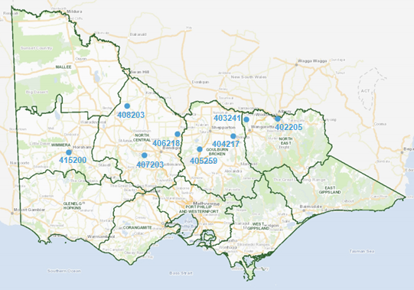
Figure 2: Victoria’s End-of-Valley Target sites
Salinity across the eight Victorian EoVT monitoring sites showed a slight increase at some locations compared to the previous reporting period. An increase in salt load (tonnes per day) was also observed at several sites. This is likely due to post-flood drainage and delayed flushing, which mobilised stored salts from floodplains and soils, increasing total salt export despite drier conditions after the flood. Salinity and salt loads remained below the benchmark period for the majority of Victoria’s EoVT sites. Detailed outcomes and a description of the EoVT sites are described in the Appendix (Section 11.1).

6. Efficient governance
The following section details arrangements and actions by Victoria to support efficient Basin-wide governance of BSM2030 and of Victoria’s salinity registers through monitoring and periodic accountable action reviews. Victoria actively participates in the BSM2030 audit process every two years, which tracks the performance of partner governments and the MDBA in implementing BSM2030 and identifies areas of improvement.
Victoria has a cross-borders approach to salinity management, with a strong focus on collaboration with interjurisdictional and regional partners. Basin CMAs, DEECA, Ag Vic and water corporations play a strong role in regional leadership and implementation of key salinity management actions including accountable action monitoring and reviews.

6.1 BSM2030 Basin-wide Core Salinity Monitoring Network
During 2022/23, DEECA with regional partners including Basin CMAs and Ag Vic, finalised the details of Victorian monitoring sites in the BCS Monitoring Network in line with BSM2030.
No updates to Victoria’s monitoring sites in the BCS Monitoring Network have been finalised during 2023/24 and 2024/25. However, CMAs and other responsible agencies have undertaken internal stocktakes of monitoring requirements for BSM2030, which have informed discussion of potential formal updates to the BCS Monitoring Network as a priority for future work now being considered.
In the past, strategic reviews of monitoring networks by CMAs have helped to inform the extent and number of monitoring sites within the network for Victoria. This has ensured resourcing is being directed to sites with the greatest benefit to salinity monitoring objectives.

6.1.1 Dryland salinity bore monitoring
Ag Vic Research (AVR) continues to oversee the monitoring of dryland salinity bores within the North Central CMA, Goulburn Broken CMA and North East CMA regions as part of Victoria’s “watching brief” on dryland salinity and saline groundwater trends in northern Victoria. This information is also used to determine likely emerging impact of dryland salinity on key environmental and productive assets.
In 2023/24, AVR reviewed its BCS Monitoring Network to identify current and emerging issues. During 2024/25, all bores in the core network were inspected. The review identified issues around the physical condition of the bores. This included bores reaching the end of their service life, damaged headworks, and bores becoming too shallow or dry to be monitored.
The review also identified bores that could no longer be monitored due to loss of access. Key issues include a loss of ability to monitor bores on private property and limitations due to occupational health and safety conditions such as hazardous ingress or dangerous livestock in the bore vicinity. Where available, additional bores were added to the monitoring runs to partially compensate for lapsed bores. AVR continues to discuss the future of the dryland salinity bore monitoring program with DEECA.
Table 13 describes changes to the dryland salinity bores in the BCS Monitoring Network identified by AVR in 2024/25. No changes were identified in 2023/24.
Table 13: Changes to Core Salinity Monitoring Network - AVR 2024/25
Bore ID or gauge number | Change year | What did it monitor? | Supporting which register entry or model? | Reason for change | Proposed action
11114  (Indigo area) | 2024/25 | Groundwater levels and salinity | Register B - Ovens | Bore destroyed by fire | Can not be replaced – 11156, 11172,11173 and 11159 have been added to the Indigo bore run to provide additional locational watertable data
11115  (Indigo area) | 2024/25 | Groundwater levels and salinity | Register B - Ovens | Bore destroyed by fire | Can not be replaced – 11156, 11172,11173 and 11159 have been added to the Indigo bore run to provide additional locational watertable data
11156  (Indigo area) | 2024/25 | Groundwater levels and salinity | Register B - Ovens | Added to network | Added to network to compensate for lapsed bores
11172  (Indigo area) | 2024/25 | Groundwater levels and salinity | Register B - Ovens | Added to network | Added to network to compensate for lapsed bores
11173  (Indigo area) | 2024/25 | Groundwater levels and salinity | Register B - Ovens | Added to network | Added to network to compensate for lapsed bores
11159  (Indigo area) | 2024/25 | Groundwater levels and salinity | Register B - Ovens | Added to network | Added to network to compensate for lapsed bores
11052  (Indigo area) | 2024/25 | Groundwater levels and salinity | Register B - Ovens | Not accessible due to declared noxious weed infestation | Monitoring is on-hold until weed free
11056  (Indigo area) | 2024/25 | Groundwater levels and salinity | Register B - Ovens | Not accessible due to declared noxious weed infestation | Monitoring is on-hold until weed free
Bore 189  (Dookie area) | 2024/25 | Groundwater levels and salinity | Register B – Goulburn Broken Dryland | No longer accessible | No suitable alternative bores available
8310  (Dookie area) | 2024/25 | Groundwater levels and salinity | Register B – Goulburn Broken Dryland | Bore destroyed | No suitable alternative bores available
8365  (Sheans Ck area) | 2024/25 | Groundwater levels and salinity | Register B – Goulburn Broken Dryland | Headworks repaired 2019 | Roadside bores in vicinity added to monitoring  (8360, 8364, 8368, 8369) to improve watertable data confidence
300  (Warrenbayne area) | 2024/25 | Groundwater levels and salinity | Register B – Goulburn Broken Dryland | No longer accessible (safety- decaying farm bridge) | The available roadside bores in the area continue to be monitored
8455  (Warrenbayne area) | 2024/25 | Groundwater levels and salinity | Register B – Goulburn Broken Dryland | No longer accessible (safety) | The available roadside bores in the area continue to be monitored
8420  (Warrenbayne area) | 2024/25 | Groundwater levels and salinity | Register B – Goulburn Broken Dryland | No longer accessible (safety) | Roadside bores 8418 and 8419 - headworks repaired 2019 and monitoring continued
175  (Axe Ck area) | 2024/25 | Groundwater levels and salinity | Register B - North-central Dryland | Blocked at 15m depth | No alternatives needed, still sufficient bores in area still monitored to cover for the loss
172  (Axe Ck area) | 2024/25 | Groundwater levels and salinity | Register B - North-central Dryland | Destroyed - in ploughed paddock | No alternatives needed, still sufficient bores in area still monitored to cover for the loss
6612  (Kamarooka area) | 2024/25 | Groundwater levels and salinity | Register B - North-central Dryland | Destroyed – in ploughed paddock | Not possible to continue monitoring in this vicinity
6206  (Serpentine area) | 2024/25 | Groundwater levels and salinity | Register B - North-central Dryland | Destroyed by roadside mowing | No serviceable DLS bores in vicinity

6.1.2 North East
There are 104 active groundwater monitoring bores in the North East CMA region forming part of the State Observation Bore Network. There has been no change to Victoria’s BCS Monitoring Network in the North East in 2023/24 and 2024/25 (outside dryland salinity bores monitored on the AVR network in the previous section).

6.1.3 Goulburn Broken
Surface water and groundwater monitoring has been undertaken as per the Goulburn Broken CMA’s component of the BCS Monitoring requirements.
Monthly monitoring of shallow observation bores enable the region to monitor change and identify salinisation risks. It is also used to produce community engagement tools such as groundwater level maps and salinity threat maps published on the Goulburn Broken CMA’s Shallow Groundwater in Shepparton Irrigation Region website (Goulburn Broken CMA 2025b). Additionally, the monitoring data dictates the operation of GMW’s Public Groundwater Pump Network through defined triggers.
Monitoring of the Goulburn Broken’s regional surface drains and rivers enables the CMA to identify changes in water quality such as salt loads, ensuring that new and emerging risks are being identified and could be input to BSM2030 accountable action reviews. Surface water monitoring also provides data to inform the annual SIR Surface Drain Water Quality Annual report.
Changes to the BCS Monitoring Network in 2023/24 and 2024/25 are presented in Table 14.
Table 14: Changes to Core Salinity Monitoring Network - Goulburn Broken CMA region 2023/24-2024/25
Bore ID or gauge number | Change year | What did it monitor? | Supporting which register entry or model? | Reason for change | Proposed action
23447 | 2023/24 | Groundwater levels | SIR Groundwater Trends to support Shepparton SMP Register A entry | Bore decommissioned at landholder’s request | No current action, but will identify replacement if required
43744 | 2023/24 | Groundwater levels | SIR Groundwater Trends to support Shepparton SMP Register A entry | Bore destroyed | No current action, but will identify replacement if required
112949 | 2024/25 | Groundwater levels and salinity | SIR LWMP | Bore added to network in 2024/25 | Bore added to network in 2024/25
110770 | 2024/25 | Groundwater levels and salinity | SIR LWMP | Bore destroyed | Bore decommissioned
113910 | 2024/25 | Groundwater levels and salinity | SIR LWMP | No safe access | Removed from network

6.1.4 North Central
In 2024/25 with support from the Victorian Flood Recovery Program, North Central CMA re-designed and repaired key monitoring infrastructure to support the salinity and groundwater monitoring program within the northern Riverine plains. The bore headworks of 100 damaged or degraded bores were replaced, 15 new bores were established, and 30 key bores were fitted with electronic instrumentation recording water levels at four-hourly intervals.
In total, 170 bores on the northern plains are now monitored jointly by the North Central CMA and Ag Vic. Additionally, 20 surface water hydrographic stations on stream networks are read by Ag Vic through the CMAs Regional Water Monitoring Program.
No change to Victoria’s BSC Monitoring Network was identified in the North Central region in 2023/24 or 2024/25.

6.1.5 Mallee
Flow and water quality of the River Murray and irrigation drainage were monitored during 2023/24 and 2024/25 to provide data and information for BSM2030 implementation.
River Murray flow and salinity were monitored in selective sites including Swan Hill, Colignan and Wentworth. In 2024/25, Wentworth had higher salinity compared to Swan Hill and Colignan, due in part to the additional salt contributed by Darling River inflows and in part to irrigation impacts from Victoria.
Monitoring of 29 drainage outfall sites for flow and salinity occurred during 2024/25. The data collected from the drainage network is useful for irrigation drainage basin performance assessment and the health of the surrounding landscapes. The flow and salinity data for all monitored drainage outfalls is available within the Victorian Water Measurement Information System (WMIS).
During 2024/25, 21 groundwater bores were assessed for condition and viability, 9 new bore locations were introduced to the network, and 5 locations had monitoring activities ceased. Changes occurred due to poor infrastructure conditions, location suitability and increased efficiency of monitoring (Table 15). There was no change to the BCS Monitoring Network in the Mallee in 2023/24.
Table 15: Changes to Core Salinity Monitoring Network - Mallee CMA region 2024/25
Bore ID or gauge number | Change year | What did it monitor? | Supporting which register entry or model? | Reason for change | Proposed action
6975 | 2024/25 | Groundwater  levels and  salinity | Mallee Drainage Bore Decommissioning Register A Entry | Ceased: screen fully blocked  poor aquifer connectivity | 26203  provides  coverage
6976 | 2024/25 | Groundwater  levels and  salinity | Mallee Drainage Bore Decommissioning Register A Entry | Ceased: screen fully blocked  poor aquifer connectivity substitute for bore 6999 | Substitute with 6999
6984 | 2024/25 | Groundwater  levels and  salinity | Mallee Drainage Bore Decommissioning Register A Entry | Ceased: another bore 6988  in better condition within 20 meters supported by Jacobs | Substitute with 6988
6985 | 2024/25 | Groundwater  levels and  salinity | Mallee Drainage Bore Decommissioning  Register A Entry | Ceased: another bore 6988 in better condition within 20 meters supported by Jacobs | Substitute with 6988
6987 | 2024/25 | Groundwater  levels and  salinity | Mallee Drainage Bore Decommissioning Register A Entry | Ceased: another bore 6988 in better condition within 20 meters supported by  Jacobs | Substitute with 6988
7656 | 2024/25 | Groundwater  levels and  salinity | Water Trade Model (Red Cliffs to Yelta) | Ceased: poor screen bore blocked, nearby 7697R in better condition | Substitute with 7697R
7685 | 2024/25 | Groundwater  levels and  salinity | Psyche Bend Register A entry and Water Trade Model  (Red Cliffs to Yelta) | Ceased: bore destroyed and  nearby bore provides  coverage | N/A
7735 | 2024/25 | Groundwater  levels and  salinity | Psyche Bend Register A entry | Ceased: located near other bores monitoring the same formation, retain bore 7734 as this site has the best monitoring record out of all 4 bores within 60 m of each other and monitoring the same aquifer supported by Jacobs | Substitute with 7734
7736 | 2024/25 | Groundwater  levels and  salinity | Psyche Bend Register A entry | Ceased: located near other bores monitoring the same formation, retain bore 7734 as this site has the best monitoring record out of all 4 bores within 60 m of each other and monitoring the same aquifer supported by Jacobs | Substitute with 7734
7737 | 2024/25 | Groundwater  levels and  salinity | Psyche Bend Register A entry | Ceased: located near other bores monitoring the same formation, retain bore 7734 as this site has the best monitoring record out of all 4 bores within 60 m of each other and monitoring the same aquifer supported by Jacobs | Substitute with 7734
7738 | 2024/25 | Groundwater  levels and  salinity | To support the Psyche  Bend Register A entry | Ceased: located near other bores monitoring the same formation, retain bore 7734 as this site has the best monitoring record out of all 4 bores within 60 m of each other and monitoring the same aquifer supported by Jacobs | Substitute with 7734
26208 | 2024/25 | Groundwater  levels and  salinity | To support Mallee  Drainage Bore  Decommissioning  Register A Entry | Ceased: near Manangatang 116622 is close by and monitoring same aquifer supported by Jacobs | Substitute with 116622
27012 | 2024/25 | Groundwater  levels and  salinity | To support Sunraysia  Drains Drying Up  Register A entry and the  RISI Stage 1 Register A  entry and RISI EM2.4  Model | Ceased: bore destroyed to  be replaced with MIL24_2 as part of the next drilling  program | New bore drilled
130547 | 2024/25 | Groundwater  levels and  salinity | To support the RISI  Stage 1 Register A entry and RISI EM2.4 Model | Ceased: destroyed by  vehicle. Can redrill but 7786 provides coverage
7905 | 2024/25 | Groundwater  levels and  salinity | Water Trade Model  (Yelta to SA) | Ceased: no access, private  property
7632 | 2024/25 | Groundwater  levels and  salinity | Victorian Mallee Legacy of History - Dryland & Irrigation EM1.2 Model | Ceased: cannot add as bore wasn’t found but nearby bore (7564) monitors the same aquifer | Substitute with 7564
7904 | 2024/25 | Groundwater  levels and  salinity | Water Trade Model  (Yelta to SA) | Ceased: no access, private property
7908 | 2024/25 | Groundwater  levels and  salinity | Water Trade Model  (Yelta to SA) | Ceased: no access, private property
7930 | 2024/25 | Groundwater  levels and  salinity | Water Trade Model  (Yelta to SA) | Cease: unreliable data  suggests no longer  connected to aquifer -7931  nearby in network | Substitute with 7931
26181 | 2024/25 | Groundwater  levels and  salinity | N2SAB SMP – Irrigation Development Register A entry and the Water Trade Numerical Groundwater Models  (Piambie to Nyah) | Ceased: close proximity to bore 26185 recorded
7912 | 2024/25 | Groundwater  levels and  salinity | Water Trade Model  (Yelta to SA) | Ceased: No access Private Property

6.1.6 Wimmera
Monitoring data were collected monthly at key surface water sites across the catchment, including the Wimmera River, MacKenzie River, Fyans Creek, Norton Creek, Mt William Creek, Glenlofty Creek, Concongella Creek, and Heifer Station Creek. Continuous water quality and flow data were also collected at permanent monitoring stations under the DEECA-managed Regional Water Monitoring Partnership.
Jeparit Waterwatch continued its long-term contribution to water quality monitoring, providing valuable historical context to current salinity and nutrient challenges.
There was no change to Victoria’s BSC Monitoring Network in the North East region in 2023/24 or 2024/25.

6.2 Register reviews of Victorian accountable actions

6.2.1 Summary
During 2023/24 and 2024/25 a range of projects were commenced, undertaken or completed to either review existing Victorian accountable actions or assess the salinity impacts of new accountable actions. These projects contributed to the management of eight Victorian Register A accountable actions listed in Table 16.
Table 16: Status of Victorian BSM2030 accountable action reviews in 2023/24 and 2024/25
In progress | Completed
Tragowel Plains Salinity Management Plan (SMP) 2022 Drains | Barr Creek Catchment Strategy
Shepparton Irrigation Region Land and Water Management Plan (LWMP) | Victorian Mid-Murray Storages (VMMS)
Nyah to South Australia Border (N2SAB) SMP | Kerang Lakes Swan Hill Salinity Management Plan (KLSHSMP)*
 | Woorinen Irrigation District Excision (WIDE)*
 | Nangiloc-Colignan SMP
*These accountable actions were reviewed together with the salinity impact assessment of the Victorian Mid-Murray Storages.

6.2.2 Goulburn Broken

Shepparton Irrigation Region Land and Water Management Plan
GMW, Goulburn Broken CMA and the VSDWG found that this accountable action represented a low biophysical risk based on current catchment observations, while appearing to be a large debit in the current register due to conservative modelling assumptions. Rather than undertaking expensive and detailed remodelling of a low biophysical risk, a review of the workplan led to a simple approach being chosen in line with the BSM2030 guiding principle of “effort commensurate with risk”.
Following this approach, the review of the register entry will be completed in 2025/26. Review recommendations are expected to be actioned by GMW after the review.
Opportunities and outcomes expected from the register entry review using this approach include:
- improved efficiency and cost-effective monitoring and measurement
- collaboration and alignment with other natural resource management objectives
- integrated monitoring framework to guide coordinated approach to Land and Water Management Plan monitoring, BSM2030 monitoring and groundwater resource monitoring and reporting.

6.2.3 North Central

Barr Creek Catchment Strategy
During 2024/25, North Central CMA completed an accountable action review for the Barr Creek Catchment. The review featured application of the new Integrated Accountable Action Model (IAAM) developed by the CMA over a period of several years. The IAAM afforded the opportunity to model the surface water hydrology of the catchments given its land use and land management. The surface water model, called Catchment Analysis Tool (CAT), addressed the surficial water balance affording the necessary inputs to a multi-aquifer groundwater model (MODFLOW). Parameters derived from both CAT and MODFOW allowed for the establishment of algorithms that were deployed to estimate flows and salinity from the catchment. These were provided to the MDBA for consideration in the Murray River model BIGMOD for the 2025 BSM salinity registers.
The 2024/25 Barr Creek accountable action review was endorsed by BSMAP in May 2025. The final assessment will increase the credit for the Barr Creek accountable action from -7.7 to -9.1 in the 2025 salinity registers, subject to BSMAP confirmation.

Victorian Mid-Murray Storages
In early 2010, the VMMS was formed by operationalising four separate storages in the Kerang Lakes system to harvest and store a portion of the increased unregulated Victorian tributary to the River Murray, resulting from the decommissioning of Lake Mokoan in the Broken River system. The objective was to create water savings for environmental watering through the reduction of evaporation losses by capturing, storing and releasing River Murray water for the benefit of Victorian Murray System users.
While the VMMS is located within the North Central region of Victoria, the salinity impact assessment of the VMMS was undertaken by DEECA and completed in January 2025. The assessment identified components of the Kerang Lakes Swan Hill Salinity Management Plan (KLSHSMP) and Woorinen Irrigation District Excision (WIDE) accountable actions that are superseded by the infrastructure and operating rules changes of the VMMS action.
The assessment resulted in a provisional entry of 5.6 EC debit placed under the Joint Works & Measures category for the 2025 Salinity Register A, with a confidence rating of “low”. Responsibility for and ownership of the debits of the VMMS have not yet been agreed on by BSMAP.
Progressing the VMMS provisional salinity entry to a “full” register entry will require final salinity impacts to be simulated via the Source Murray Model due to complexities in simulating two-way flows between the VMMS and the River Murray.

Kerang Lakes Swan Hill Salinity Management Plan
Victoria is accountable for the salinity impact of the Lake Charm Flushing component of the KLSHSMP accountable action. In 1997, the Lake Charm Outfall Channel works were commissioned to allow flushing of the lake to move the accumulated salinity from the lake into the River Murray.
As Lake Charm is one of the storages that make up the VMMS, the Lake Charm Outfall Channel operating rules became superseded when the VMMS was formed in 2010. This superseded portion of the KLSHSMP accountable action was determined in the VMMS salinity impact assessment completed in January 2025. As the VMMS was entered into Salinity Register A as a provisional entry and the final salinity impacts still need to be simulated via the Source Murray Model, the KLSHSMP register entry on Salinity Register A will not be updated until the VMMS register entry is assessed as a “full” entry, as agreed by BSMAP at meeting #72 on 15 May 2025.

Woorinen Irrigation District Excision
In 2003/04, part of the open channel system supplying the Woorinen Irrigation District was replaced with a piped system. This change resulted in a large portion of the irrigation district becoming supplied directly from the River Murray and a reduction in the volume of water supplied by the Torrumbarry Irrigation Area’s Channel No. 9. This in turn reduced flows through the Kerang Lakes. To protect the water quality of the Kerang Lakes, a throughflow requirement passing through the Kerang Lakes into the River Murray was added, which added a salt load to the River Murray. This created the WIDE accountable action debit.
The Kerang Lakes throughflow requirement became superseded when the VMMS was formed in 2010. This superseded portion of the WIDE accountable action was determined in the VMMS salinity impact assessment completed in January 2025. As the VMMS was entered into Salinity Register A as a provisional entry and the final salinity impacts still need to be simulated via the Source Murray Model, the WIDE register entry on Salinity Register A will not be updated until the VMMS register entry is assessed as a “full” entry, as agreed by BSMAP at meeting #72 on 15 May 2025.

6.2.4 Mallee

Nangiloc-Colignan Salinity Management Plan
The review assesses the salinity impact of drainage outfalls from irrigation on the River Murray. The Nangiloc-Colignan SMP accountable action review began in December 2023 and was completed in May 2024. The salinity impact of this accountable action is 0.4 EC, which remains unchanged after the review.
The flow and salt load assessment was carried out for sixteen identified drainage outfalls including:
- three drains discharging to Karadoc Swamp. Salt accumulates in the swamp and is flushed to the River Murray during flooding events
- nine drains discharging directly to the River Murray
- four drains discharging to inland basins of Forbes, Doering, Yatpool and Colignan.
Although not a requirement under BSM2030, the accountable action review included the assessment of drain flow and salt load to inland basins for the first time as the effects of inland disposal on the local environment have become more salient. Inland salt disposal may result in watertable rise and salt accumulation underneath the inland drainage basins and their immediate surrounding landscapes.

6.3 Victorian response to IAG-Salinity audit recommendations 2021-2023
Victoria’s progress and comments against the 2021-2023 IAG-Salinity’s recommendations are presented in Table 17 below.
Table 17: Victoria’s progress against the 2021-2023 IAG-Salinity’s recommendations
Recommendations from the 2021-2023 audit, in the order presented in the executive summary of the report | Victoria’s response (2023) |  | Victoria’s progress notes and comments as of September 2025
Recommendation 1:  The IAG-Salinity recommends that a focus of the 2026 review be to simplify the Registers and their presentation. | Victoria supports this recommendation and notes simplification of the register could align entries with contemporary salinity management and create long-term management efficiencies. | Victoria continues to support this recommendation in principle. It is important the BSM accountability framework identifies the appropriate salinity risks to account for and ensure the framework is fit-for-purpose.  Victoria has participated in BSM2030 Strategic Review workshops and provided feedback to the draft BSM2030 Strategic Review plan prepared by the MDBA. It is important a detailed workplan is finalised in in collaboration with BSMAP as soon as possible.
Recommendation 2:  The IAG-Salinity recommends that the MDBA in consultation with BSMAP develop a streamlined process for certifying that reviews and assessments have followed the BSM Procedures. | Victoria supports this recommendation in principle noting any process will need to be streamlined to avoid unintentional governance burdens on the MDBA and contracting governments. | The requirement to confirm that the relevant BSM procedures have been followed when completing a review or assessment of an accountable action has been incorporated into the Section 2.5.9 of the BSM Consolidated Procedures (MDBA 2025).  Victoria has followed this requirement by including this confirmation in the decision papers for accountable action reviews and assessments brought to BSMAP.
Recommendation 3:  The IAG recommends that future comprehensive reports include estimates of the area and locations of new irrigation developments and their potential salinity risks. | Victoria supports this recommendation in principle noting the Basin Salinity Management Advisory Panel would need to agree on a consistent reporting approach for new irrigation developments within a given reporting period. | Victoria has included in this comprehensive report.
Recommendation 4:  The IAG recommends that the BSM2030 strategic review consider replacing End of Valley Targets and Appendix 1 of Schedule B with an obligation to undertake simple risk reviews. | Victoria supports this recommendation in principle and notes the Basin Salinity Management Advisory Panel has commenced preliminary review work. | Victoria completed its End-of-Valley Targets Narratives Reporting and Risk Assessment (RMCG 2024). An internal check found that it remains in line with risk review requirements for End-of-Valley sites in the Consolidated BSM Procedures (MDBA 2025).
Recommendation 5:  The IAG recommends that the MDBA in consultation with BSMAP investigate the effects of climate change on the severity and frequency of extreme wet events and their salinity impacts. | Victoria supports this recommendation. | Victoria supports consideration of climate change as part of the BSM2030 Strategic Review and Basin Plan Water Quality Project.
Recommendation 6:  The IAG recommends that the 2023 draft Review Plan be adopted after confirming the costs of the proposed reviews can be funded. | Victoria supports this recommendation in-principle noting clarification on process to modify/revise the plan (if required) will need to be agreed. | Victoria notes the 2023 draft Review Plan was adopted in 2024 August by BSMAP.
Recommendation 7:  The IAG recommends that both the MDBA and the jurisdictions develop and prioritise indicative budgets for the tasks identified in the Roadmap. | Victoria supports this recommendation in principle noting Victoria’s funding beyond 30 June 2024 is subject to State Budget processes. | Victoria has completed all Victorian-led tasks within the timeframes set out in the Roadmap.  Outstanding Victorian-led Roadmap tasks are on track to be delivered, including the completion of the accountable action reviews of SIRLWMP, N2SAB SMP, and Tragowel Plains SMP within 2025/26. Budget has been committed for these actions.  Victoria continues to support the delivery of other Roadmap tasks such as providing input on the TLM works & measures and RMIF accountable actions and socio-economic & environmental benefits of salinity management narrative.
Recommendation 8:  The IAG recommends that the MDBA prepare adequate documentation for each Register entry following the transition to Source. | Victoria supports this recommendation in principle noting clarification on “adequate documentation” is required. | Victoria continues to support this recommendation in principle. Victoria is awaiting updates from TWGSM.
Recommendation 9:  The IAG recommends that the MDBA develop a Procedure to manage future updates of the Source model. | Victoria supports this recommendation noting the Source Model will be integral to future salinity management with good corporate knowledge management and transparency being essential. | Victoria continues to support this recommendation, noting the Transition to Source process is still underway.
Recommendation 10:  The IAG recommends that the Commonwealth salinity credits be used to offset changes to the jurisdictions’ balances caused by the transition to Source until the 2026 review. | Victoria supports this recommendation in principle, but notes contracting government are yet to be provide with details and justification for any changes. | Victorian continues to support this recommendation in principle.  Victoria is awaiting the Transition to Source process to produce a final salinity register to understand any changes and the drivers.
Recommendation 11:  The IAG recommends that Procedure 2.3.5 (Management of major shifts in the registers) be updated once the transition to Source is agreed and the approach to adjust the registers has been determined. | Victoria supports this recommendation. | Victoria continues to support this recommendation and is awaiting the Transition to Source process to be complete.
Recommendation 12:  The IAG recommends that, prior to the Authority approval of the salinity registers prepared using the Source Murray model, the Authority seeks the endorsement of BOC regarding changes to the register entries. | Victoria supports this recommendation. | Victoria continues to support this recommendation and is awaiting the Transition to Source process to be complete.
Recommendation 13:  The IAG recommends that the MDBA assign a high priority to repairing flood damaged salt interception schemes. | Victoria supports this recommendation. | Victoria continues to support this recommendation. Repair works to the Pyramid Creek Groundwater Interception Scheme are still under way as of June 2025/26.
Recommendation 14:  The IAG recommends that the management of salinity peaks be considered as part of the Enhanced Environmental Water Delivery project. | Victoria notes this recommendation and asks the recommendation to be discussed by BSMAP to clarify roles and responsibilities to implement this recommendation. | Victoria notes that the MDBA is planning to complete the Enhanced Environmental Water Delivery project in December 2026. Victoria will request the topic to be discussed by BSMAP.

7. Strategic knowledge improvement

7.1 State-wide projects
Over the last two years DEECA has progressed work in partnership with CMAs, water corporations, Ag Vic, other Basin States and MDBA in relation to salinity management.

7.1.1 BSM2030 Strategic Review
After completing an issues paper on the key governance, financial and physical risks faced by the salinity management program in Victoria in June 2023, DEECA and VSDWG continued to prepare for the coming BSM2030 Strategic Review. In May 2024, DEECA held a workshop with all VSDWG members including CMAs, water corporations and Ag Vic to explore potential futures of the Basin salinity management strategy and to inform Victoria’s position on how the coming BSM2030 Strategic Review would be best framed and scoped.
Victoria’s position from the resulting workshop was presented as Victoria’s key themes for framing the BSM2030 Strategic Review at BSMAP meeting #68 in August 2024:
- What are the right risks to account for?
- What are suitable accountability arrangements or approaches?
- What are the benefits and impacts of SIS operations?
- What are suitable governance arrangements for BSM?
- What BSM2030 elements will continue to be relevant in the future?
Collaboration between DEECA, CMAs, water corporations and Ag Vic through VSDWG continues to inform and provide confidence in Victoria’s positions on and contributions to the BSM2030 Strategic Review, including workshops and BSMAP discussions.

7.1.2 Contextual narratives of salinity risk for End-of-Valley Target sites
In 2023, DEECA engaged RMCG to develop a set of contextual narratives for Victorian EoVT sites. The contextual narratives concisely capture key salinity processes, landscape characteristics, climate drivers and risks unique to each catchment in Victoria. The narratives:
- provide guidance for future Basin Salinity Management (BSM) reporting and to support reporting teams to interpret the latest reporting data (part A)
- provide information to assist the Basin Salinity Management Advisory Panel (BSMAP) determine which EoVT sites require further investigation of salinity trends, predictions, and risks (part B).
The project resulted in the End-of-Valley Targets Narratives Reporting and Risk Assessment (RMCG 2024), which was completed in January 2024. Contextual narratives and a reporting tool were developed to aid in the interpretation of salinity and salt load exceedance curves for each EoVT catchment. Three high risk catchments requiring further detailed assessment were also identified:
- Loddon – due to major saline sub-catchments identified
- Campaspe – due to major saline sub-catchments identified
- Goulburn – due to very high baseline salt loads.
Victoria is committed to undertaking detailed risk assessments for the three high risk catchments. Initial scoping has been completed while the detailed approach to undertake the detailed assessments is being discussed in BSMAP.

7.2 Regional projects

7.2.1 Goulburn Broken

Monument Cover Installation Project
In partnership with the Goulburn Broken CMA, GMW has installed 127 monument covers at bore sites across the SIR. Monument covers help to protect monitoring bores from surface water intrusion and pest infestation (such as ants), protect bores from damage and provide monitoring efficiencies by making bore sites more visible. The SIR shallow groundwater monitoring bore network will be more resilient to future climate uncertainty including flood events as a result of this project.

Review of SIR Salinity Threat Status and Drivers
The Review of SIR Salinity Threat Status and Drivers Project is progressing the existing continuous improvement process to enhance the resilience of water resource use in the SIR. It ensures sustainable management for agricultural productivity and environmental health, and complementarity and efficiencies in monitoring and evaluating salinity related risks.
The project is reviewing key conclusions from an earlier SIR Salt and Water Balance Project in 2017 to determine if assumptions about watertable and salinity risk remain accurate in the current evolving climate conditions and other landscape factors that have changed since 2017.
Salinity Risk Management Zones (SRMZ) have been reviewed using recent groundwater monitoring data and some boundary changes have been recommended. Within the SRMZs, sub-zones have been established based on groundwater behaviour characteristics ranging from good, deep drainage to poor, deep drainage.
The project is considering the risk-to-asset classes in each sub-zone according to the drainage characteristics and asset types in the zone.
An initial review of the existing Salinity Threat Mapping Tool has determined that the basic aspects of the tool are still adequate. The review identified areas for further refinement where a detailed review is carried out.
After the evaluation of landscape salinity risk is completed, the project will evaluate management strategy change opportunities that can be explored through stakeholder engagement and implemented if further funding is secured.

Shallow Groundwater in Shepparton Irrigation Region website
The Shallow Groundwater in Shepparton Irrigation Region website was created to provide public access to information on the SIR shallow groundwater and salinity risks and opportunities (Goulburn Broken CMA 2025b). Two major features on the website are an SIR salinity threat map and an SIR groundwater levels map, which are periodically updated with current data.
In January 2025, the Shallow Groundwater in Shepparton Irrigation Region website was migrated from an external hosting service to the main Goulburn Broken CMA website, after a functionality and performance survey was conducted with members of the community.
Outcomes of the migration project have been very positive. Outdated formatting on the original website has been improved during transition, with website content now easier to view on both PC and mobile devices. Better security protection has also been applied to the new website.

7.2.3 North Central
Integrated Accountable Action Model
The development of the IAAM and its application to predictive analyses was used to complete the accountable action review of the Barr Creek Catchment Strategy. IAAM affords the opportunity to predict salinity outcomes for the River Murray based upon land and water management and the impact it has on groundwater behaviour, particularly the discharge of saline groundwater to the stream network.
Monitoring shallow and saline groundwater
The review of groundwater monitoring provided the opportunity to report more strategically on watertable elevation and salinity risk, particularly where data sets included continuous (four-hourly) monitoring in response to land management and climate.
Agency understanding of salinity risk continued to be improved through advising CMA staff and VSDWG members of the salinity risks attributable to elevated saline groundwater across the northern plains after the October 2022 floods (Figure 3).
Investigating inundation impacts on groundwater under Murray River forested floodplains
A decade of electronic monitoring of the Murray River forested floodplains has provided unprecedented records of watertable behaviour. This monitoring affirmed that neither floods nor environmental watering impact on saline groundwater elevation in these floodplains due to the presence of high shrink-swell clays acting together with trees transpiring water from the capillary fringe above the watertable.
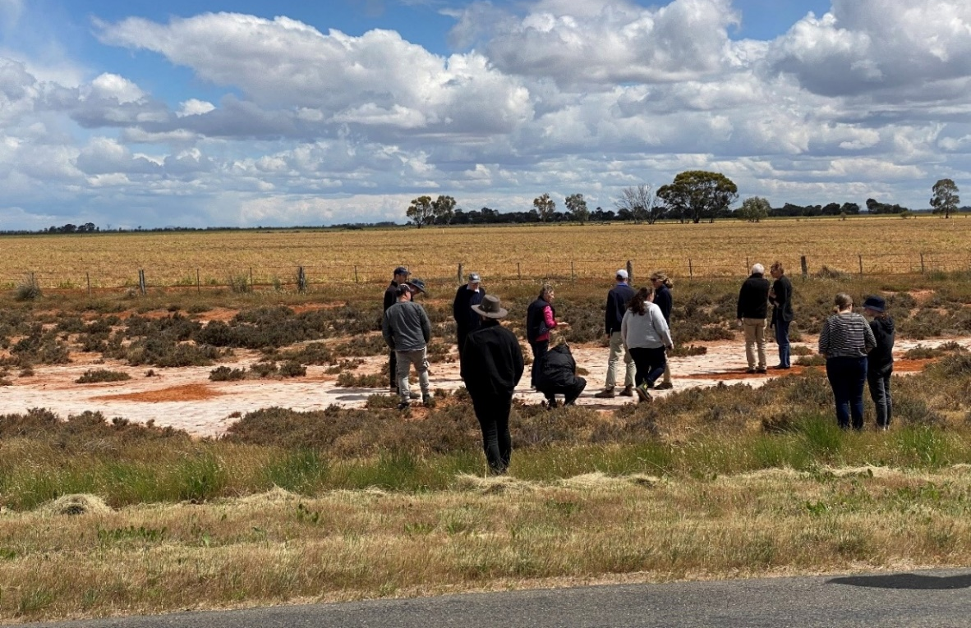
Figure 3: North Central CMA staff discussing salinity matters with VSDWG members on a northern Victorian floodplain. Photo credit: North Central CMA.

Guide for Salinity Risk Assessment in Wetland Management
The North Central CMA Guide for Salinity Risk Assessment in Wetland Management was completed in 2023/24, which was further updated in 2024/25. The Guide provides key information about hydrogeological processes in relation to wetlands and potential environmental watering sites in the North Central region. It also provides an approach to assessing salinity risk for the potential environmental watering of any wetland site in Victoria.

7.2.4 Mallee

Run of River Survey for salinity from Mallee Cliffs to Boundary Bend
A Run of River Survey for salinity was carried out by employing a combination of Global Positioning System, salinity sensors and bathymetric surveying techniques. The Survey was carried out over 310 km along the River Murray from Red Cliffs Pumping Station to Boundary Bend and was implemented when the River Murray flow was less than 10,000 ML across the survey distance.
The survey showed that the measured salinity from the near-surface salinity probe remained mostly between 210 and 240 EC. The mean average was 221 EC. Variability was relatively low with salinity ranging from as low as 170 EC and as high as 250 EC over the measured distance of the River Murray. The survey data is useful for salinity models (both surface and groundwater) and for estimating salinity impacts of accountable actions, including the N2SAB SMP accountable action.
The bathymetric survey provided a visual representation of the River Murray’s bed profile. This data can be instrumental in identifying variations in depth and potential areas where deeper pools might exist. These deeper areas are more likely to accumulate saline water. The integration and overlaying of salinity data with bathymetric data facilitated a clearer understanding of how salinity levels correspond to specific locations and depths within the River Murray.

Assessing landscape salinity impacts of cumulative irrigation development
The impact of cumulative irrigation on landscape salinity was investigated in six irrigation areas:
- Lake Cullulleraine
- Merbein West
- Nangiloc-Colignan
- Wemen
- Boundary Bend
- Kenley to Nyah.
Multiple lines of evidence were collected to assess whether irrigation-derived perched water was present in the boreholes adjacent to the irrigation properties. The results showed that the lateral movement of irrigation-derived root zone drainage as perched water beyond the irrigation property is not pervasive in the areas investigated. More than 50% of boreholes in each area had no evidence of existing or historic/intermittent perched water. Up to half the boreholes investigated in each area had a signature of possible historic/intermittent irrigation derived perched water.
These findings indicated that the migration of perched water at these locations is at most an intermittent process (for example, during periods of high rainfall and peak irrigation) or otherwise demonstrated a historic signature from previous irrigation practices.
A GIS-based salinity assessment tool was developed to consider both the regional watertable and the perched watertable processes to estimate landscape salinity. The assessment tool is now available for Mallee CMA to assess the impact of cumulative irrigation on landscape salinity to support the evaluation of irrigation development applications.

Establishing hydrogeological processes in floodplains
Field investigations were carried out in five floodplain areas from Nyah to South Australian Border along the River Murray, establishing hydrogeological processes to inform potential numerical groundwater models for assessing salinity impact of floodplain watering. The primary aim of the project was to improve understanding of water and salt dynamics in five priority floodplain regions including:
- Lindsay Island
- Mulcra Island
- Wallpolla Island
- Karadoc to Liparoo
- Wemen to Lake Powell.
Two sets of field activities were carried out in all floodplains, namely:
- surface geophysical survey to map floodplain conductivity with surface and groundwater sampling
- soil core sampling across all five floodplains.
Contemporary hydrogeological techniques, geophysical surveys and isotopic methods were used in the project to understand the interaction between surface and groundwater.
The field data showed a general distinction between surface water and groundwater. This suggests that vertical recharge from floodplain under environmental watering is limited to areas where vertosol soils (predominantly clays) are not present at the surface, and shallow alluvial groundwater is likely replenished outside the floodplain extent.

Option analysis for irrigation drainage disposal basins
Water and salt balances for five terminal irrigation drainage disposal basins (IDDB) receiving irrigation drainage water were investigated to identify salt storage, establish the relationship between irrigation drainage waters and perched and groundwaters, and identify potential leakage to surrounding areas. These basins are Doerings Basin, Karadoc Swamp, Lake Iraak, Woorlong Wetlands and Red Cliffs Southeast.
Preliminary community and stakeholder consultation was also completed for the management of these drainage basins.
The results showed that:
- Doerings and Karadoc basins were accumulating salt - 14,000 to 28,000 tonnes in Doerings and 98,000 to 637,000 tonnes in Karadoc respectively
- Lake Iraak, Woorlong and Red Cliffs Southeast drainage basins are not accumulating salt due to groundwater infiltration and periodic flushing from large flood events.
The relative management priorities for each disposal basin are summarised in Table 18.
Table 18: Mallee Region - Management priorities for disposal basins
IDDB | Management opportunities | Management priority
Doerings Basin | Manage increasing drainage flows | High
Karadoc Swamp | Support establishment of Swamp Sheoak (Casuarina obesa) | Medium
Lake Iraak | Manage odour issues | Medium
Woorlong Wetlands | Clearing of rush and reed growth and concentrate diversion of flows (stormwater and drainage) | High
Red Cliffs SE | Ensure natural rehabilitation is undisturbed | Low

Options for reducing irrigation induced salinity impacts on Psyche Bend Lagoon
This project aimed to identify feasible mitigation actions and required investigation and verification for those actions. In the first stage of the project, goals for Psyche Bend Lagoon (PBL) and its surrounding landscape were identified. These goals included:
- maintaining the salinity benefit of the accountable action
- preventing further degradation of PBL waterbody and the surrounding landscape
- improving ecological health, where possible
- increasing the overall attractiveness and amenity of the area.
For assessments, the floodplain landscapes surrounding PBL were assigned specific goals and options to achieve desired ecological and environmental outcomes. The following recommendations were made to achieve the goals, including:
- improved flushing mechanisms
- landscape watering in ecological significant areas
- depressurising groundwater underneath the PBL area in both Channel Sand Aquifer and Parilla Sand Aquifer.
To support mitigation actions, a vegetation assessment surrounding PBL was carried out and priority areas containing higher quality ecological values have been identified.

Airborne Electromagnetic Survey
An Airborne Electromagnetic (AEM) survey over the River Murray corridor in the Victorian Mallee was flown from March to May in 2024 to capture the spatial distribution of below-ground salinity. Data processing was undertaken in 2024/25. The second interim report was completed which covered data checks, preliminary processing and inversion, review of the final data set, AEM inversion methodology, and data processing.
The project is expected to be completed in July 2026.

7.2.5 Wimmera
Wimmera CMA continues foundational work and stakeholder engagement to support the renewal of the Wimmera Waterway Strategy. While still in its early stages, this process is helping to build regional capacity to manage salinity and other waterway issues by fostering collaboration, identifying shared priorities, and ensuring future planning reflects current environmental challenges and community values.
The strategy will provide a framework for future investigations and research efforts, including those relevant to salinity management within the Murray-Darling Basin.

8. Community engagement and communication
Community engagement, education and communication are central to the implementation of Victorian CMAs’ RCSs and subordinate strategies and plans including their LWMPs and Waterway Strategies. Many CMA boards use community-based advisory groups to gain community and expert input into projects and strategies, and to help inform communities, agencies, and land managers about natural resource management in the region. These groups are central to effective management of salinity in Victoria, particularly in irrigation areas, and have a long history of ownership and involvement in development and implementation of SMPs and LWMPs.

8.1 Community engagement and education activities

8.1.1 Dryland salinity management
Extension and testing services – Ag Vic undertakes a range of services that address land management and salinity issues on dryland farms. Ag Vic staff deliver planning, management and mitigation advice on dryland areas that have a salinity risk through existing on-farm land management and farm business resilience services such as farm business planning courses, workshops and on-farm field days.
Upon request from the public, AVR also tests the salinity levels of farmers’ bore water to evaluate suitability for stock and domestic use.
Landcare - AVR continues to engage with Landcare groups to educate them about dryland salinity management and other groundwater issues. Water salinity testing was provided for Donald Landcare group for their monitoring of the Richardson River salinity through the township, and bore hydrographs were provided for the Register B bore monitoring site they host on their property in the Seymour area.

8.1.2 North East
North East CMA continues to support communities across a range of projects to improve natural resource management and consider climate risks and adaptation needed.
Climate change adaptation for dairy and nut industries – In the last year, projects were undertaken to support two industries in identifying opportunities to adapt to the effects of climate change in a lower rainfall environment. The dairy and nut industries in the region identified water efficiencies and emissions as key themes for the projects. Growing more with less water is a key driver of reducing environmental issues (including preventing salinity impacts), emissions and increasing productivity through the investment in technology and smart application of water.

8.1.3 Goulburn Broken
Community committees – The Goulburn Broken CMA engages with local communities through Shepparton Irrigation Region (SIR) Drainage Working Group meetings, SIR People and Planning Integration Committee meetings (Figure 4), SIRLWMP community workshops and the Community Reference Group for the Girgarre Evaporation Basin Future Management Options Study.
Drainage Course Declarations – Direct landholder engagement was involved in the establishment of Drainage Course Declarations (DCD) for the Murray Valley West catchment and the Waranga Drainage Project, and the SIP Drainage Program Flood Recovery works such as catchment obstruction review, modification and removal.
Development of communication tools - Communication tools including the Murray Valley West Drainage Course Declaration Storymap, SIR watertable Study Maps, the SIR watertable Study Groundwater Segment Chart, SIR salinity monitoring bores groundwater level frequency curves and groundwater levels on Goulburn Broken CMA’s Shallow Groundwater in Shepparton Irrigation Region website were developed.
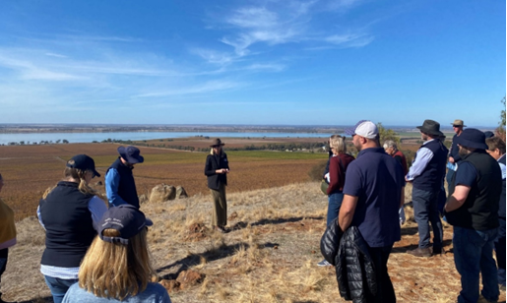
Figure 4: Shepparton Irrigation Region People and Planning Implementation Committee tour members hearing from a guest speaker and enjoying the view of the catchment from the top of the Mt Camel range, Victoria. (Photo credit: M. Potter, GMW).

8.1.4 North Central
Shallow watertable of saline groundwater – The North Central CMA published an article in the CMA Newsletter ‘The Chat’ about the post-October 2022 shallow watertable of saline groundwater in northern Victoria. Four presentations on dryland salinity and several on other salinity matters were made to Landcare groups, the Northern United Forestry Group (farm forestry group from northern Victoria comprising fifty farming families), and the Axe Creek Landcare Group. Support for the Axe Creek group extended to the installation of an electronic groundwater logger within a bore of interest to the group, and preparing the hydrograph for publication on the group’s Facebook page.
Regenerative Agriculture Project – Several hundred farmers participated in trialling alternative farming practices with the goal of improving water use efficiency and production. This work proceeded under the North Central CMA’s Regenerative Agriculture project supported by the National Landcare Program. Although the activities did not directly focus on salinity management, the hydrological outcomes sought are appropriate in dryland salinity management.

8.1.5 Mallee
A range of activities and material related to regional capacity development were completed during the reporting period.
Mildura Field Days - The agricultural, water management and salinity activities were displayed and explained to the community during the Mildura Field Days in May 2024. 750 people visited the Mallee CMA stall.
Irrigators shed meetings - Challenges and opportunities for irrigation including water conservation were discussed with irrigators in five locations: Mildura (including Merbein, Irymple & Red Cliffs), Nangiloc-Colignan, Boundary Bend, Lindsay Point and Robinvale. 30 irrigators and 14 agency partners participated in these meetings including Lower Murray Water (LMW), DEECA, The Victorian Northern Resource Manager, Ag Vic and the MDBA. Information on irrigation water delivery risks and shortfalls during the growing season in addition to salinity incentive grants available from Mallee CMA and the Victorian Government was provided.
Indigenous Water Literacy - A package of communication materials including information on salinity issues in the Mallee was developed for Traditional Owners and trialled with the Mallee CMA Aboriginal Reference Group (ARG). The material was refined following the feedback from ARG. Following the development of the communication material an engagement was organised for the First Peoples of the Millewa-Mallee.

8.1.6 Wimmera
Sustainable Agriculture Facilitator (SAF) program – Wimmera CMA continued its involvement in the SAF program. The program supports awareness and adoption of sustainable agricultural practices across the Wimmera, contributing to improved land management and salinity resilience.
Key activities included:
- coordinating and maintaining a soil moisture monitoring network across Wimmera farms to support informed decision-making
- strengthening partnerships, including cross-regional collaboration and engagement through the Wimmera Partnership Group involving key agricultural stakeholders
- supporting delivery of activities under locally led Natural Heritage Trust and Future Drought Fund projects
- sharing information and resources with farmers and stakeholders to build knowledge and capacity around sustainable land and water management.
The SAF’s efforts complement broader community engagement and capacity-building initiatives aimed at improving land management across the Murray-Darling Basin.

9. Priorities for future work
Victoria’s process for prioritising work is directed by the BSM2030 guiding principles of:
- accountability and transparency
- cost-efficient and cost-effective management
- risk-based approach
- adaptive management.
This results in investment of time and effort in projects which strategically improve and streamline our accountability processes. Victoria is focussing on areas where the real risk of salinity impact lies within the catchment, to ensure that the future risk to the River Murray and catchment is minimised.

9.1 Statewide
Victoria’s priorities over the next two years are summarised below.
- Undertaking the BSM2030 Strategic Review to ensure the salinity management framework is fit-for-purpose and enables jurisdictions to address current and future salinity management challenges.
- Applying the data collected through the AEM Survey in the Mallee and tools developed to manage salinity impacts to both the River Murray and landscape.
- Determining and supporting long-term salinity impact assessments for VMFRP and SDLAM projects in collaboration with BSMAP.
- Completing the SIRLWMP, Tragowel Plains SMP 2002 Drains, and N2SAB SMP accountable action reviews.
- Continuing to investigate salinity impacts directly or indirectly driven by climate change, such as high intensity rainfall and flood events, and irrigators adapting to climate change by increasing water application.
- Completing detailed assessments for EoVT sites identified as high risk.
- Reviewing and updating Victoria’s BCS monitoring network.
- Continuing implementation of regional LWMPs.

9.2 North East
Land and water management plan
- Finalise the North East Sustainable Irrigation (Land and Water Management) Plan in 2025/26 and commence implementation.
Extension services
- Provide extension services to improve water efficiency and drainage outcomes.
- Help landholders understand the risks of climate change and adapt to a more variable water future. This will focus on a broad range of natural resource management issues including salinity risks as required.
Revegetation
- Continue revegetation activities in conjunction with community.

9.3 Goulburn Broken
Salinity monitoring and impact management
- Complete the review of the SIRLWMP Register Entry.
- Assess the fit-for-purpose nature of the existing shallow observation bore network.
- Continue to develop the preferred option for the future management of the Girgarre Evaporation Basin.
Irrigation drainage
- Progress the Waranga Drainage Project Ecological Restoration Pilot.
- Continue to implement and adapt the GMID Drainage Management Strategy to ensure drainage adapts to regional changes and that its management matches current and future emerging needs.
- Develop a new urban-rural drainage agency planning framework to address escalating climate change stormwater risk to the region and the drainage network.
- Implement a DCD obstruction removal program in the Deakin Top Creek DCD (previously known as Old Deakin Drain 5 catchment).
- Plan and implement additional DCD-based hybrid surface drainage systems within the Surface Water Management Program, including the Murray Valley West Catchment DCD, funding dependent.
Land management
- Implement support structure following the launch of the SIRLWMP 2050.
Communication
- Review the Shallow Groundwater in Shepparton Irrigation Region website.
- Prepare the Shepparton Irrigation Region Watertable Study Map for August 2025.

9.4 North Central
- Complete the accountable action review for Tragowel Plains SMP 2002 Drains.
- Monitor and assess the potential impact of high intensity rainfall events driven by climate change on watertables and salinity throughout the Riverine Plains.
- Monitor and assess the impact of flooding on regional salinity risks.
- Monitor and assess the impact of environmental watering on watertable elevation within the forested floodplains of the River Murray.
- Support farming communities and other industry groups to understand and manage salinity risk.

9.5 Mallee
- Salinity impacts of floodplain watering – Investigate hydrological processes in floodplains receiving water (environmental and minor floods) to inform groundwater models for assessing salinity impact, particularly the wetting and drying cycles caused by floodplain watering. In 2025/26, the investigation will focus on Merbein Commons, Boundary Bend to Kenley, and Burra to Vinifera floodplain regions.
- Biodiversity corridors in irrigated landscapes - Assess the possible impacts of changed irrigation practices on native biodiversity at local and regional scales.
- Management plans for Irrigation Drainage Disposal Basins - Develop management plans for mitigating and rehabilitating potential impacts of Irrigation Drainage Disposal Basins and surrounding landscapes.
- Reducing irrigation-induced salinity impacts on Psyche Bend Lagoon and surrounds to offset salinity impacts of irrigation - Assess the feasibility of enhanced flushing and watering of PBL, develop a concept design for improved flushing and a monitoring program to assess the results and risks of the design.
- Managing impacts from increased water applications due to climate change – Undertake groundwater trend analysis with the incorporation of predicted increased water application as an adaptation to climate change, including developing spatial representation of where regional water may impact the growing zone in the ground of horticultural plants.

9.6 Wimmera
- With prevalent dry conditions and a low salinity risk to shared water resources of the Murray-Darling Basin, salinity management is not a priority. However, monitoring will continue.

10. References
ABS (2022). Value of Agricultural Commodities Produced, Australia and state/territory <https://www.abs.gov.au/statistics/industry/agriculture/value-agricultural-commodities-produced-australia/2020-21>, July 2022.
Ag Vic (2023). Victorian Irrigated Agriculture Industry – Fast Facts January 2023. <https://agriculture.vic.gov.au/about/agriculture-in-victoria/victorias-agriculture-and-food-industries/july-2024-update/Irrigated-Agriculture-Industry-Fast-Facts_January-2023.pdf>, Accessed 18/09/2025.
DELWP (2016). Water for Victoria: Water Plan. <https://www.water.vic.gov.au/__data/assets/pdf_file/0029/672446/water-for-victoria.pdf>, Accessed 17/09/2025.
DELWP (2021). Manual for Victoria’s Salinity Accountability in the Murray-Darling Basin.
Mallee CMA (2013). Mallee Regional Catchment Strategy 2013-19. Mallee CMA, Mildura.
Mallee CMA (2022). Mallee Horticulture Crop Report. Mallee CMA, February 2022
ABA (2025). Almond Insights 2023/2024. Australian Almond Board.
BOM (2025). Climate data online: Monthly rainfall – Mildura Airport. <http://www.bom.gov.au/watl/eto/>, Accessed 02/07/2025.
Mallee CMA (2013a). Mallee Regional Catchment Strategy 2013-19.
Mallee CMA (2025). 2024 Mallee Horticulture Crop Report.
Mallee CMA (2020). Victorian Mallee Irrigation Region Land and Water Management Plan 2020–29. < https://malleecma.com.au/wp-content/uploads/2021/01/MCMA_MalleeIrrigationRegionLWMP_2020-29_FINAL_B_web.pdf>, Accessed 18/09/2025.
MDBA (2025). Basin Salinity Management (BSM) Consolidated Procedures.
North Central CMA (2020). Loddon Campaspe Irrigation Region Land and Water Management Plan 2020-2030. < https://www.nccma.vic.gov.au/media/documents/nccma_land_and_water_management_plan_2020-2030_artwork_approved_delwp_septembe_O06aFyn.pdf>, Accessed 18/09/2025.
North Central CMA (2021). 2021-2027 North Central Regional Catchment Strategy.
North East CMA (2019). North East Victoria Sustainable Irrigation Plan 2019 – 2024: Land and Water Management Plan. <https://www.necma.vic.gov.au/Portals/0/files/Pdf/Sus%20Ag/FINAL_NECMA%20LWMP%2020190703.pdf?ver=usVi0IUpvHnoAVcFtRv8UQ%3d%3d>, Accessed 18/09/2025.
North East CMA (2025). Sustainable Irrigation Plan 2025-2035. <https://www.necma.vic.gov.au/Portals/0/files/Pdf/Plan%20Documents/NE%20SIP_NECMA_DRAFT_FINAL.pdf?ver=P_n9x7O0xoes7dqBTUr_kA%3d%3d>, Accessed 18/09/2025.
Goulburn Broken CMA (2017). Regional Irrigated Land and Water Use Mapping in the Goulburn Murray Irrigation District – Technical Report. < https://www.gbcma.vic.gov.au/downloads/GMID_studies/RILWUM_TechnicalReportFinal2017_LowRes_30_3_2017.pdf>, Accessed 18/09/2025.Executive Summary. <https://www.gbcma.vic.gov.au/downloads/GMID_studies/RILWUM_exec.pdf>, Accessed 18/09/2025.
Goulburn Broken CMA (2023). Regional Irrigated Land and Water Use Mapping in the Goulburn Murray Irrigation District - Fact Sheets - 2021/2022. <https://www.gbcma.vic.gov.au/downloads/CatchmentEconomy/2021-2022/2021-22%20Land%20Use%20Mapping%20Spatial%20-%20Summary.pdf>, Accessed 18/09/2025.
Goulburn-Broken CMA (2024a). Land and Water Use Mapping in Regulated Diversions Catchments of Northern Victoria – Technical Report 2022/23. <https://www.gbcma.vic.gov.au/downloads/Sustainable_Irrigation/2022_23%20Land%20and%20Water%20Use%20Mapping%20in%20Regulated%20Diversions%20Catchments%20of%20Northern%20Victoria%20Technical%20Report.pdf>, Accessed 23/09/2025.
Goulburn Broken CMA (2024b). Shepparton Irrigation Region Land and Water Management Plan 2050. < https://www.gbcma.vic.gov.au/downloads/Current_Issues/SIRLWMP_2050.pdf>, Accessed 18/09/2025.
Goulburn Broken CMA (2025a). Catchment Community and Economy. <https://www.gbcma.vic.gov.au/publications/published_documents/catchment_community_and_economy>, Accessed 18/09/2025.
Goulburn Broken CMA (2025b). Shallow Groundwater in Shepparton Irrigation Region, <https://www.gbcma.vic.gov.au/our-region/sustainable_irrigation/shallow-groundwater-in-shepparton-irrigation-region>, Accessed 16/09/2025.
RMCG (2024). Victorian End-of-Valley Targets narratives reporting and risk assessment.
Wimmera CMA (2021). Wimmera Regional Catchment Strategy 2021-2027. <https://wimmera.rcs.vic.gov.au/whole-strategy-download/#WimmeraRCS>, Accessed 18/09/2025.

11. Appendix

End-of-Valley Target site flow and salinity outcomes
The methodology set for EoVT site reporting is outlined in Section 5.2.6 and Section 5 Appendix 4 of the BSM Consolidated Procedures (MDBA 2025). It requires the preparation of five-year rolling salinity and salt load exceedance curves using continuous flow and salinity monitoring data. The exceedance curves are compared against an estimate of baseline conditions as represented by the Benchmark Period exceedance curve envelope.
The data reported cover the two-year period since the last comprehensive report. An exceedance curve for salinity and an exceedance curve for salt load frequency outcomes are generated for the five-year period preceding a given reporting year. For example, reporting years R2024 and R2025 correspond to the five-year period Jul 2019-Jun 2024 and Jul 2020-Jun 2025, respectively.
The Benchmark Period exceedance curve envelope is described by upper and lower bound exceedance curves. They are in turn determined by selecting the highest and lowest salinity and salt load values occurring at the 80th percentile over the benchmark period envelope (based on 1 July 1975 to 30 June 2000). The 80th percentile was selected to align with the salinity peak percentiles for reporting against the majority of EoVT target sites specified in Schedule B. This provides a measure for capturing the majority of events, whilst recognising the relatively small percentage of more extreme exceedance events in the system. The benchmark period envelope is shown as a grey band in each of the exceedance curve charts.

11.1.1 Wimmera at Horsham Weir (415200) EoVT site
The overall risk for Wimmera catchment was rated low in Victoria’s EoVT contextual narratives (RMCG 2024). Given the surface water system is terminal, the risk to shared water resources is considered minimal.
Figure 5 and Figure 6 show the salinity exceedance curve and salt load exceedance curve for the Wimmera at Horsham Weir site. Based on those figures, salinity and salt loads have increased since reporting period R2023 (Jul 2018-Jun 2023). The Residual Mass Rainfall chart (Figure 7) shows that the rainfall over the reporting periods is below average (the slope is negative).
No Benchmark Period exceedance curve envelope have been developed for the Wimmera catchment due to a lack of baseline data.
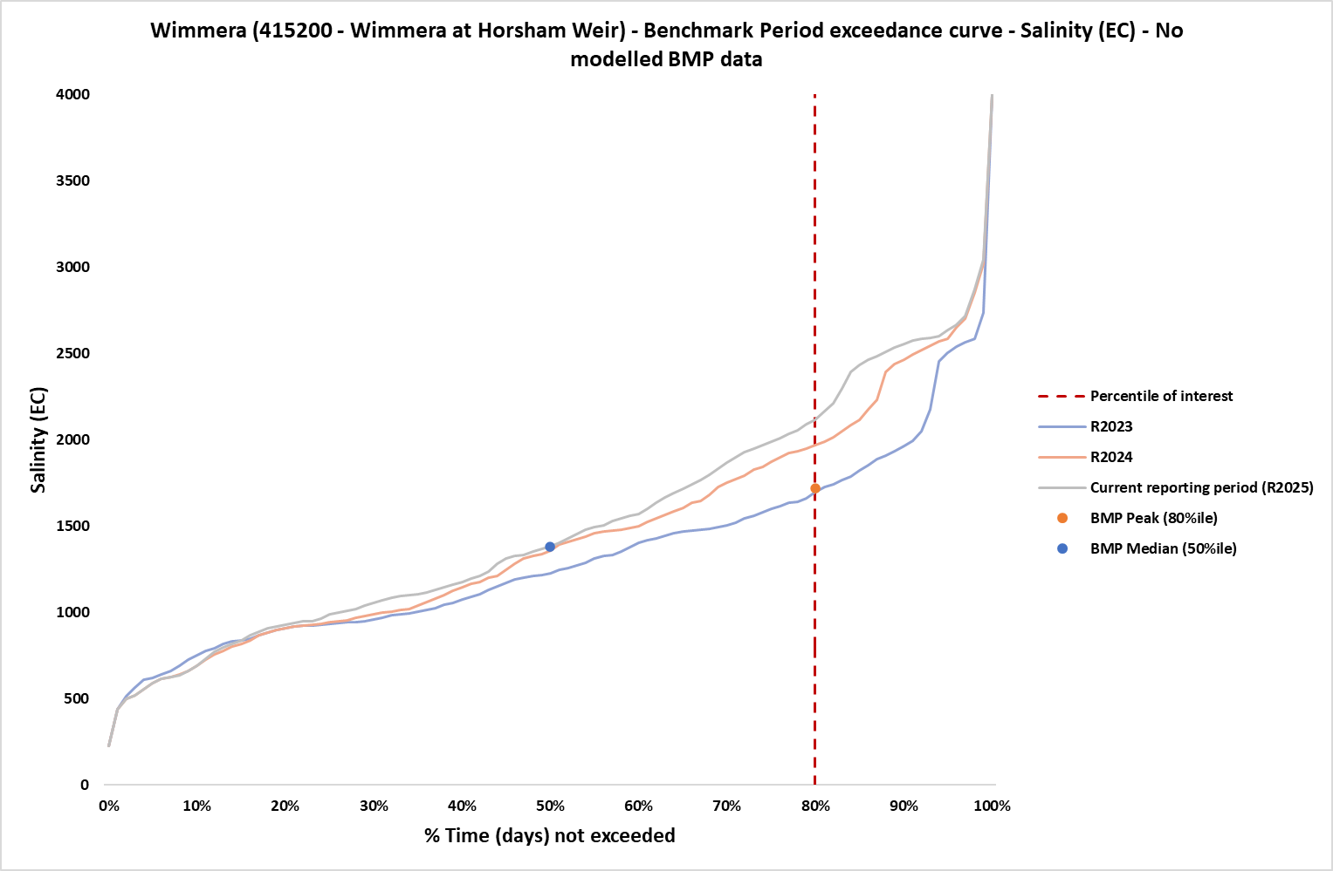
Figure 5: Salinity exceedance curve with benchmark period peak and median for reporting years, R2024 and R2025 corresponds to the five-year period Jul 2019-Jun 2024 and Jul 2020-Jun 2025, respectively, at Wimmera EoVT site
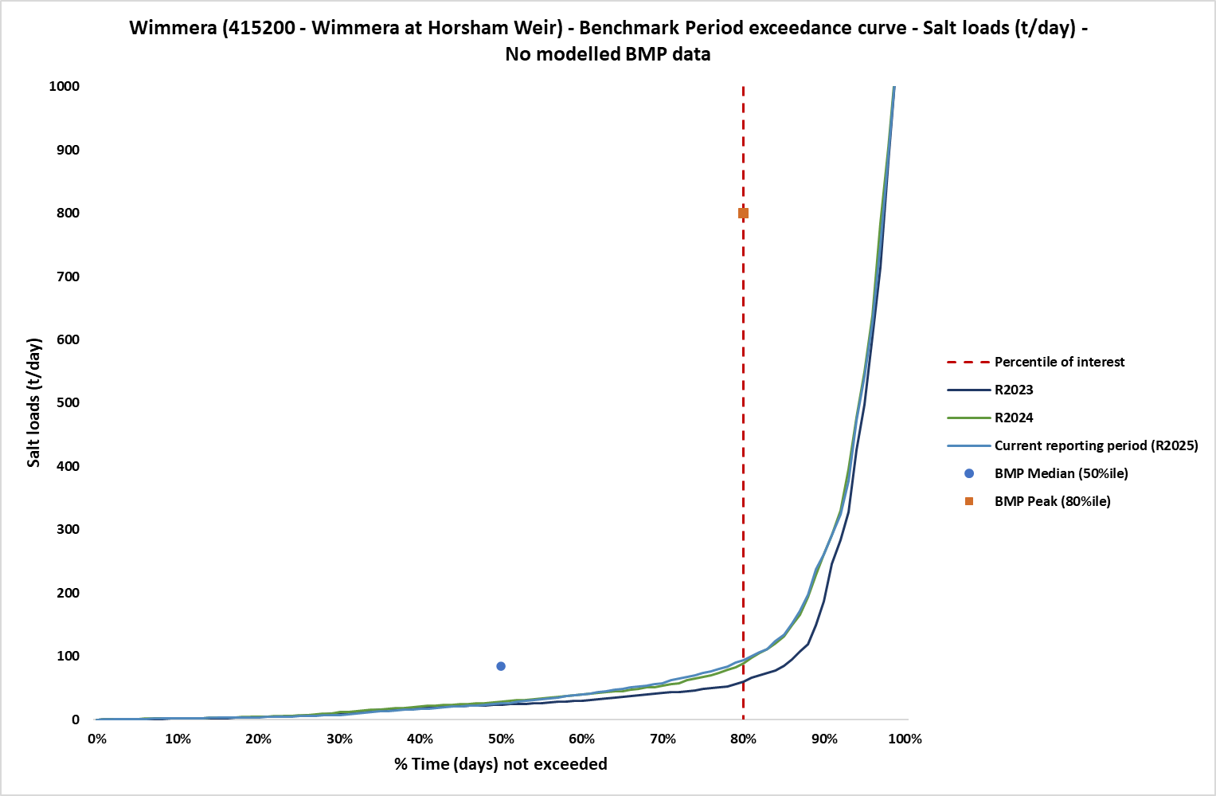
Figure 6: Salt load exceedance curve with Benchmark Period envelope and reporting years, R2024 and R2025 corresponds to the five-year period Jul 2019-Jun 2024 and Jul 2020-Jun 2025, respectively, at Wimmera EoVT site
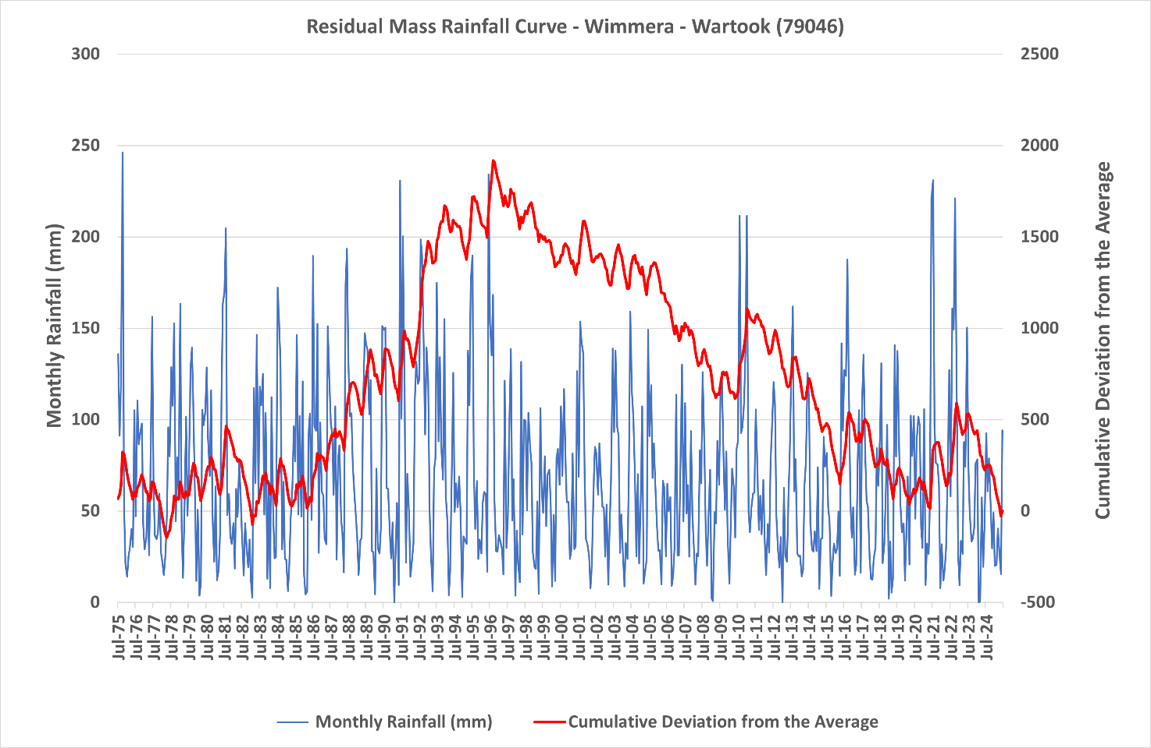
Figure 7: Residual mass rainfall curve for Wartook Reservoir (79046) 1975-2025

11.1.2 Avoca at Quambatook (408203) EoVT site
The overall risk for Avoca catchment was rated low in Victoria’s EoVT contextual narratives (RMCG 2024).
Figure 8 and Figure 9 show the salinity exceedance curve and salt load exceedance curve for the Avoca at Quambatook site. There have been no significant changes in salinity or salt loads since reporting period R2023 (Jul 2018-Jun 2023). The Residual Mass Rainfall chart (Figure 11) shows that the rainfall over the reporting periods is below average (the slope is negative).

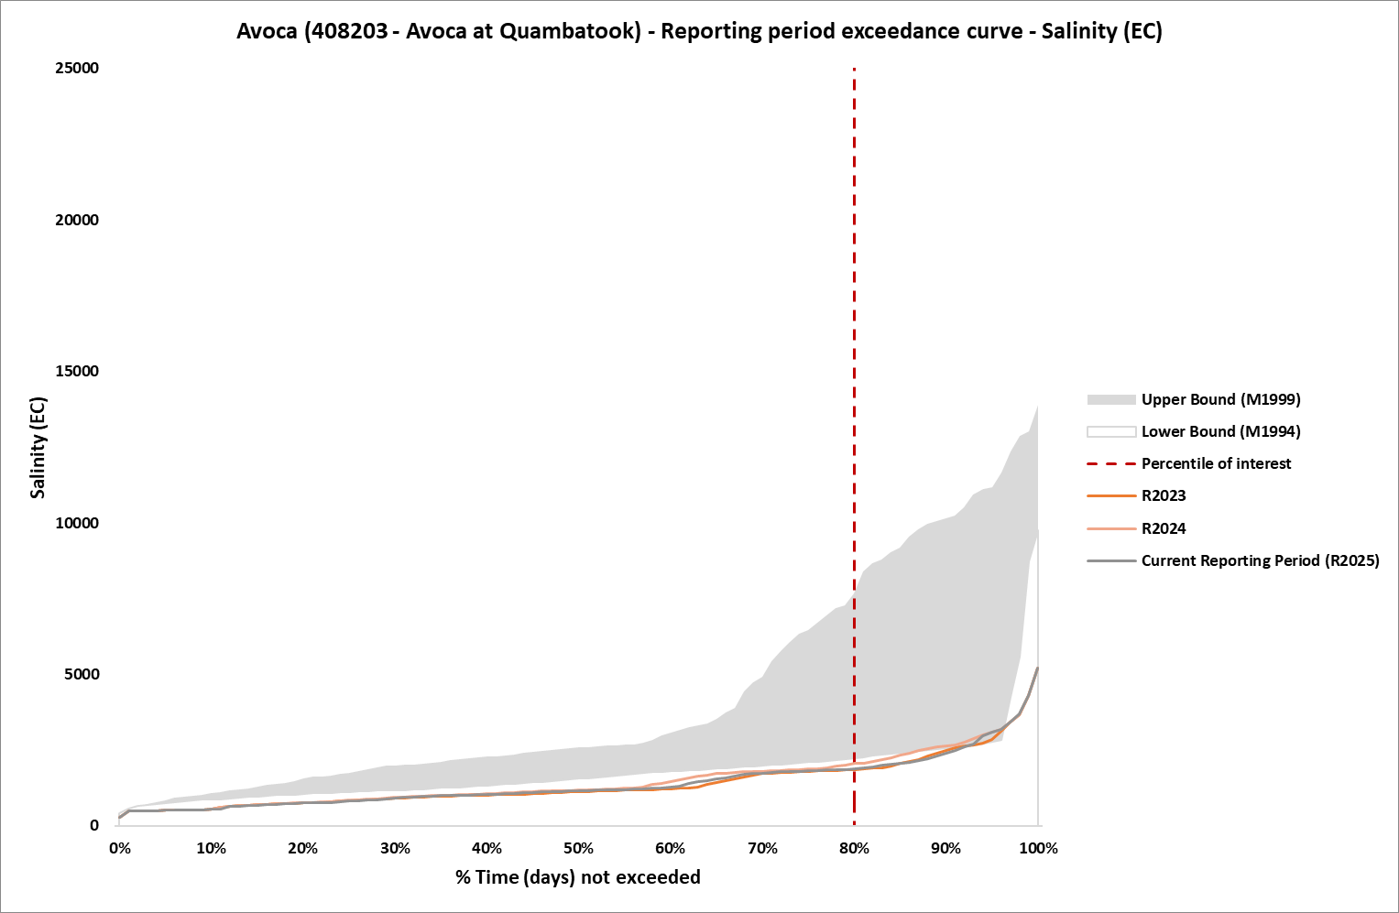
Figure 8: Salinity exceedance curve with Benchmark Period envelope and reporting years, R2024 and R2025 corresponds to the five-year period Jul 2019-Jun 2024 and Jul 2020-Jun 2025, respectively, at Avoca EoVT site
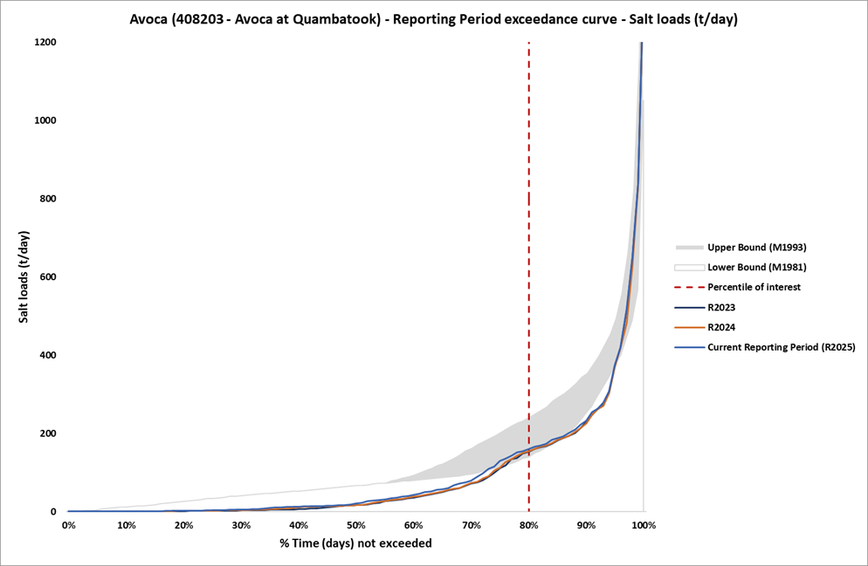
Figure 9: Salt load exceedance curve with Benchmark Period envelope and reporting years, R2024 and R2025 corresponds to the five-year period Jul 2019-Jun 2024 and Jul 2020-Jun 2025, respectively at Avoca EoVT site.

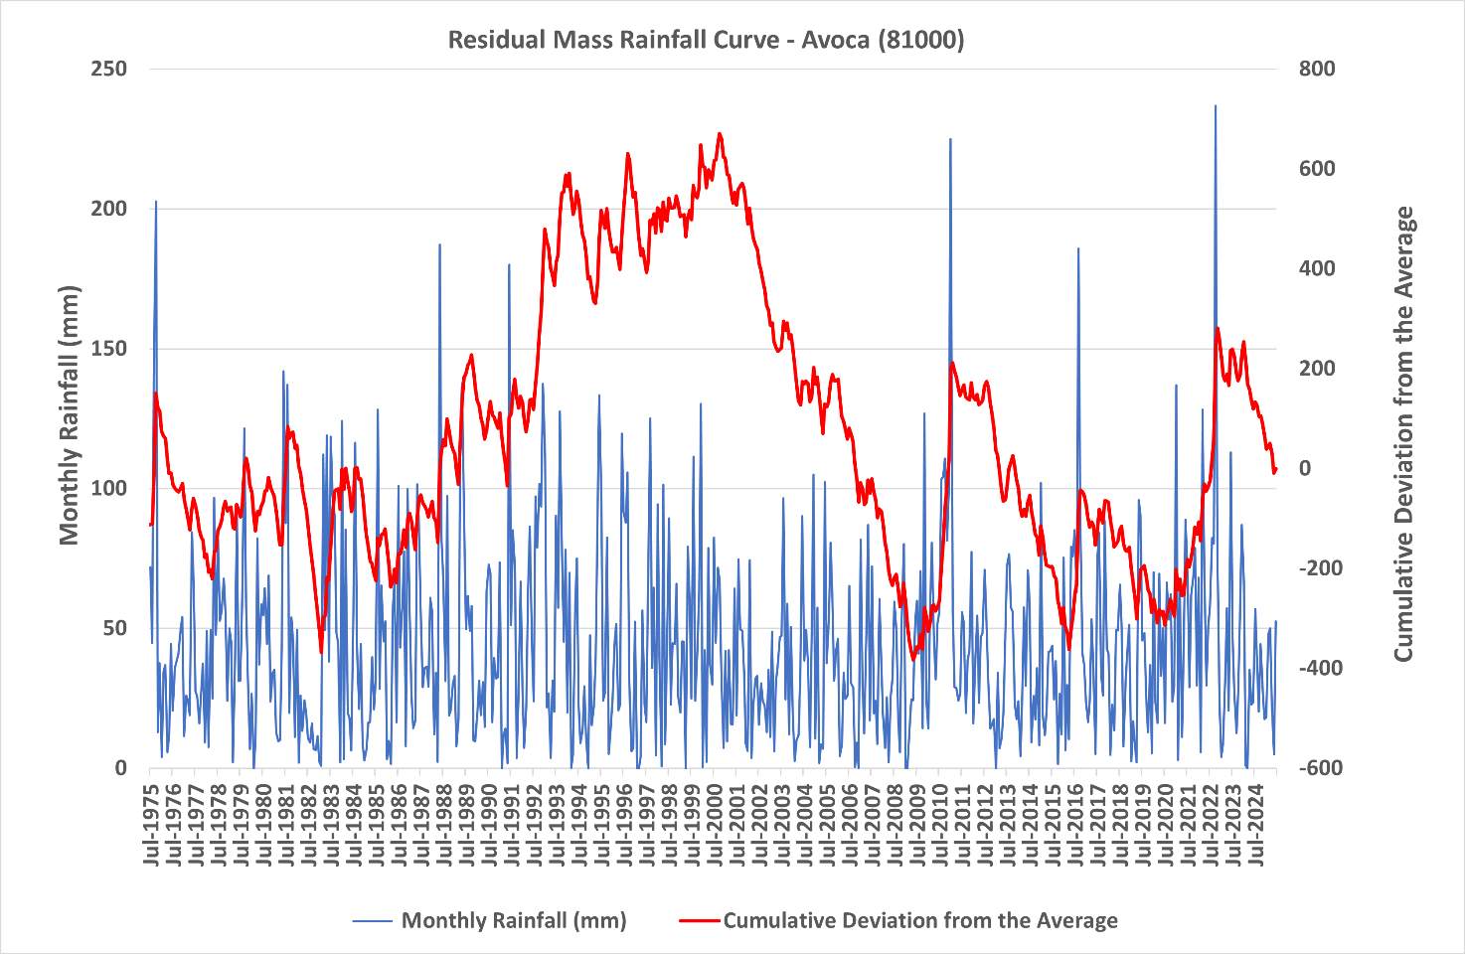
Figure 10: Residual mass rainfall curve for Avoca (10671) 1975-2025

11.1.3 Loddon at Laanecoorie (407203) EoVT site
The overall risk for Loddon catchment was rated high in Victoria’s EoVT contextual narratives due to the identification of major saline sub-catchments (RMCG 2024).
Figure 11 and Figure 12 show the salinity exceedance curve and salt load exceedance curve for the Loddon at Laanecoorie site. No change in salinity is evident, however salt loads have increased slightly since reporting period R2023 (Jul 2018-Jun 2023) but remained below the Benchmark Period envelope. The Residual Mass Rainfall chart (Figure 13) shows that the rainfall over the reporting periods is below average (the slope is negative).

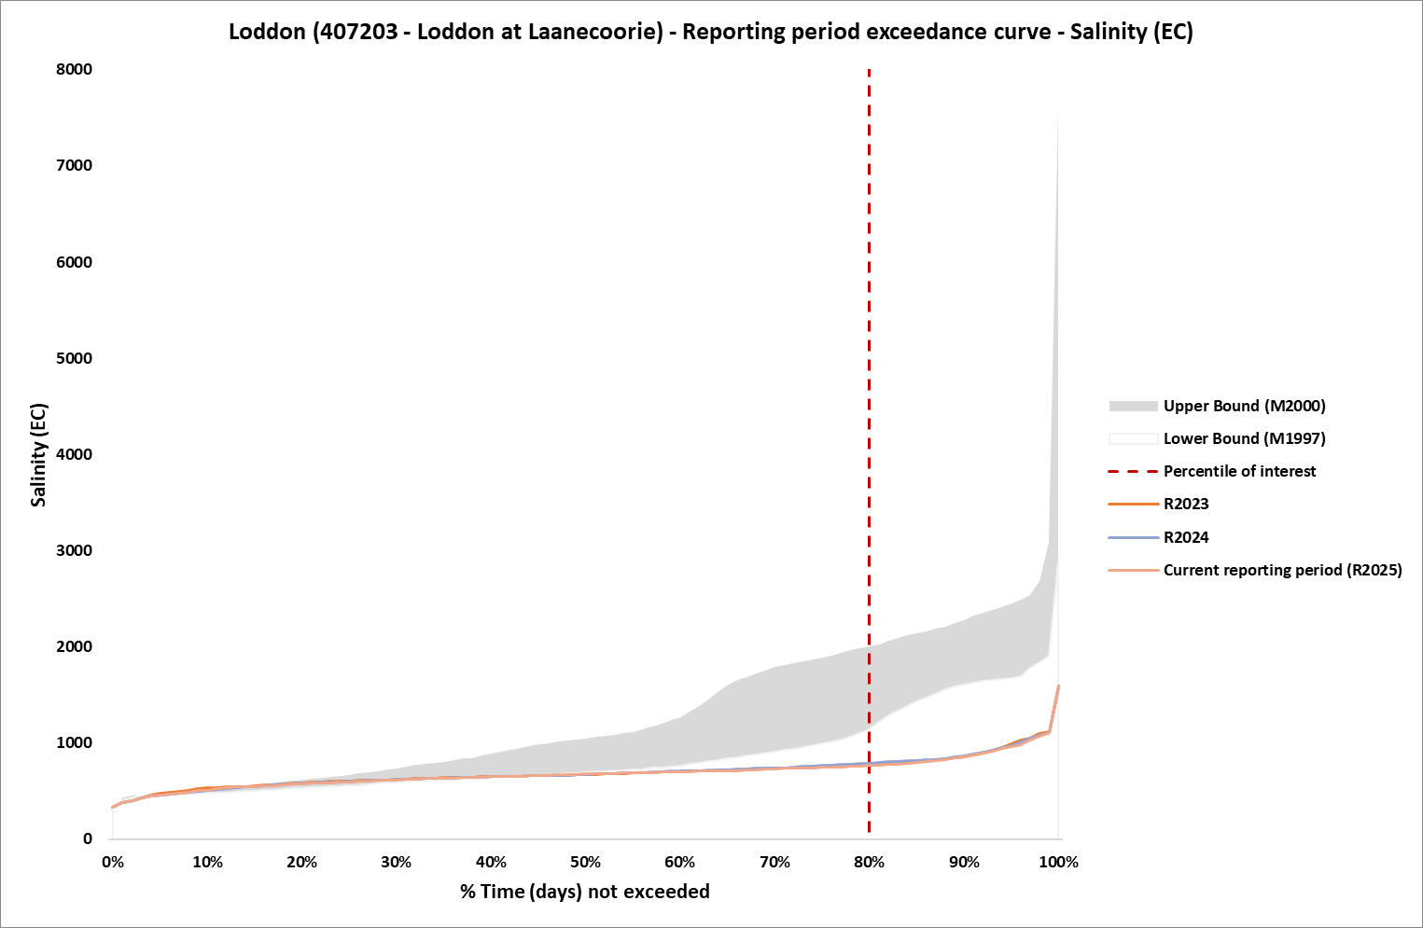
Figure 11: Salinity exceedance curve with Benchmark Period envelope and reporting years, R2024 and R2025 corresponds to the five-year period Jul 2019-Jun 2024 and Jul 2020-Jun 2025, respectively, at Loddon EoVT site

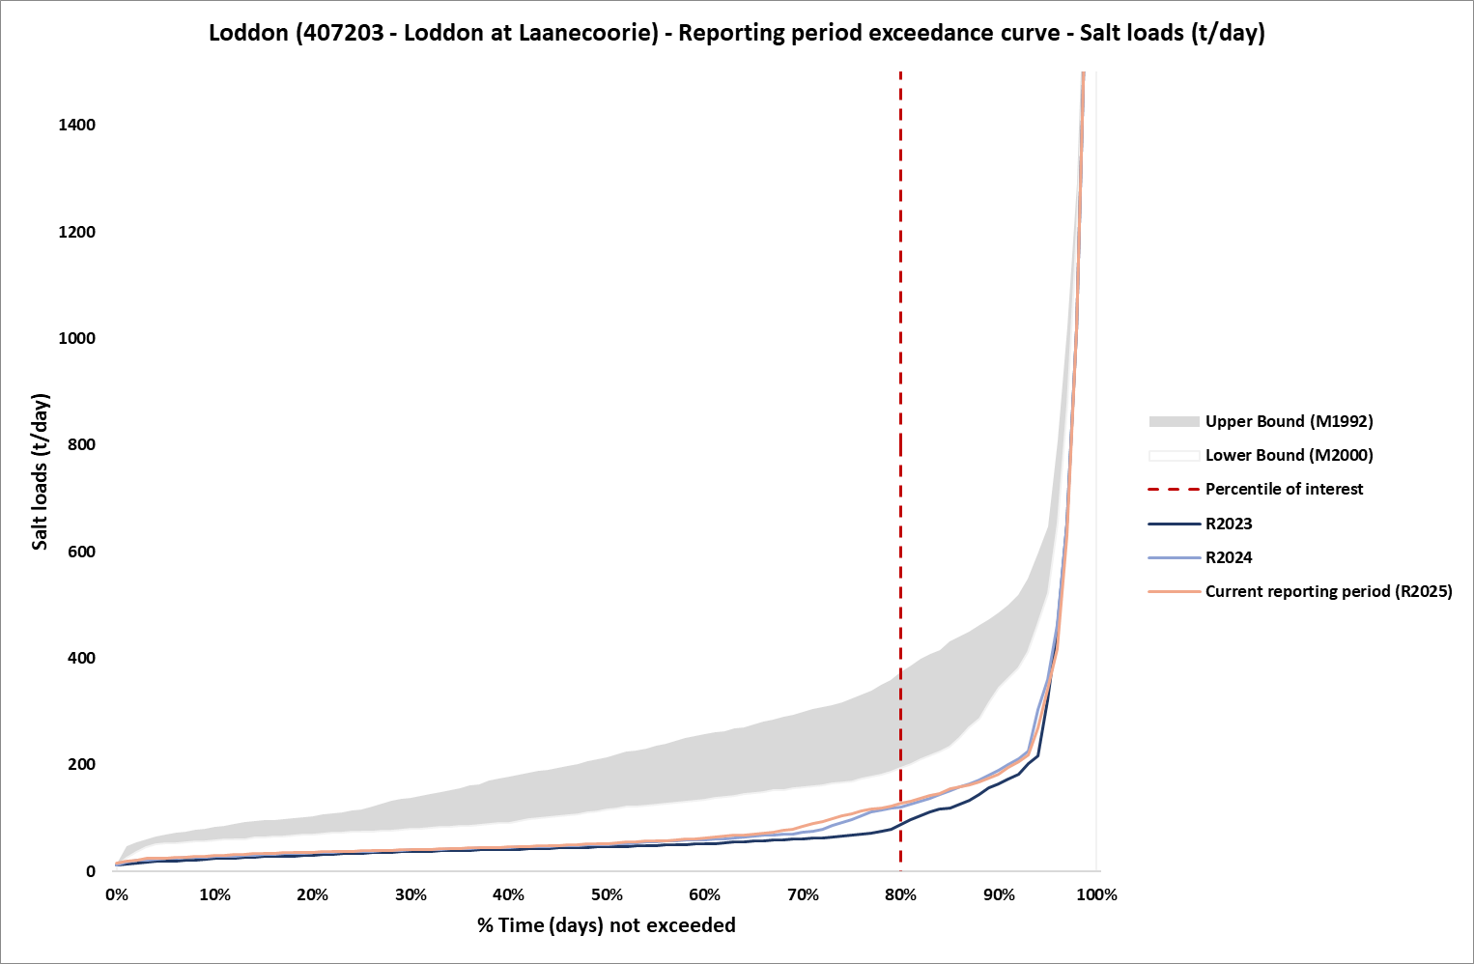
Figure 12: Salt load exceedance curve with Benchmark Period envelope and reporting years, R2024 and R2025 corresponds to the five-year period Jul 2019-Jun 2024 and Jul 2020-Jun 2025, respectively, at Loddon EoVT site

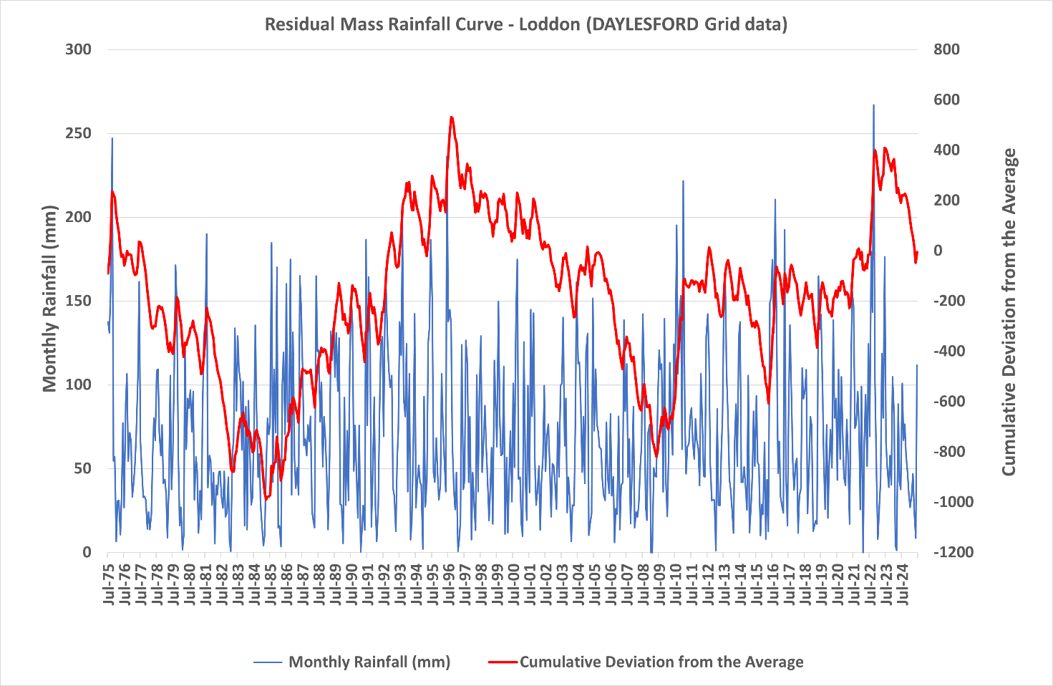
Figure 13: Residual mass rainfall curve for Daylesford (88020) 1975-2025

11.1.4 Campaspe at Campaspe Weir (406218) EoVT site
The overall risk for Campaspe catchment was rated high in Victoria’s EoVT contextual narratives due to the identification of major saline sub-catchments (RMCG 2024).
Figure 14 and Figure 15 show the salinity exceedance curve and salt load exceedance curve for the Campaspe at Campaspe Weir site. These figures show a marginal decrease in salinity and increase in salt loads. The Residual Mass Rainfall chart (Figure 16) shows that the rainfall over the reporting periods is below average (the slope is negative).

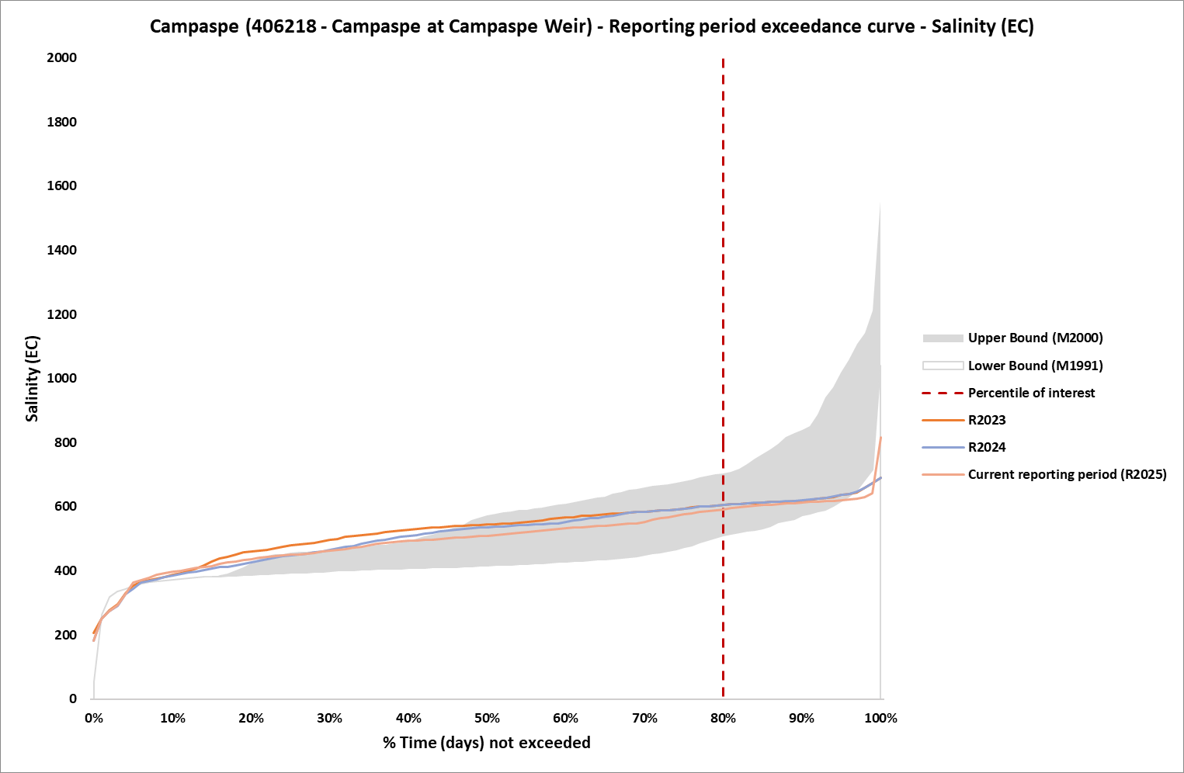
Figure 14: Salinity exceedance curve with Benchmark Period envelope and reporting years, R2024 and R2025 corresponds to the five-year period Jul 2019-Jun 2024 and Jul 2020-Jun 2025, respectively, at Campaspe EoVT site
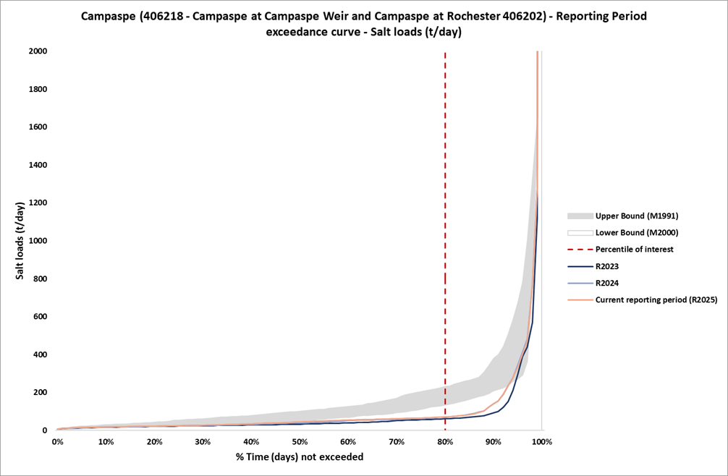
Figure 15: Salt load exceedance curve with Benchmark Period envelope and reporting years, R2024 and R2025 corresponds to the five-year period Jul 2019-Jun 2024 and Jul 2020-Jun 2025, respectively, at Campaspe EoVT site
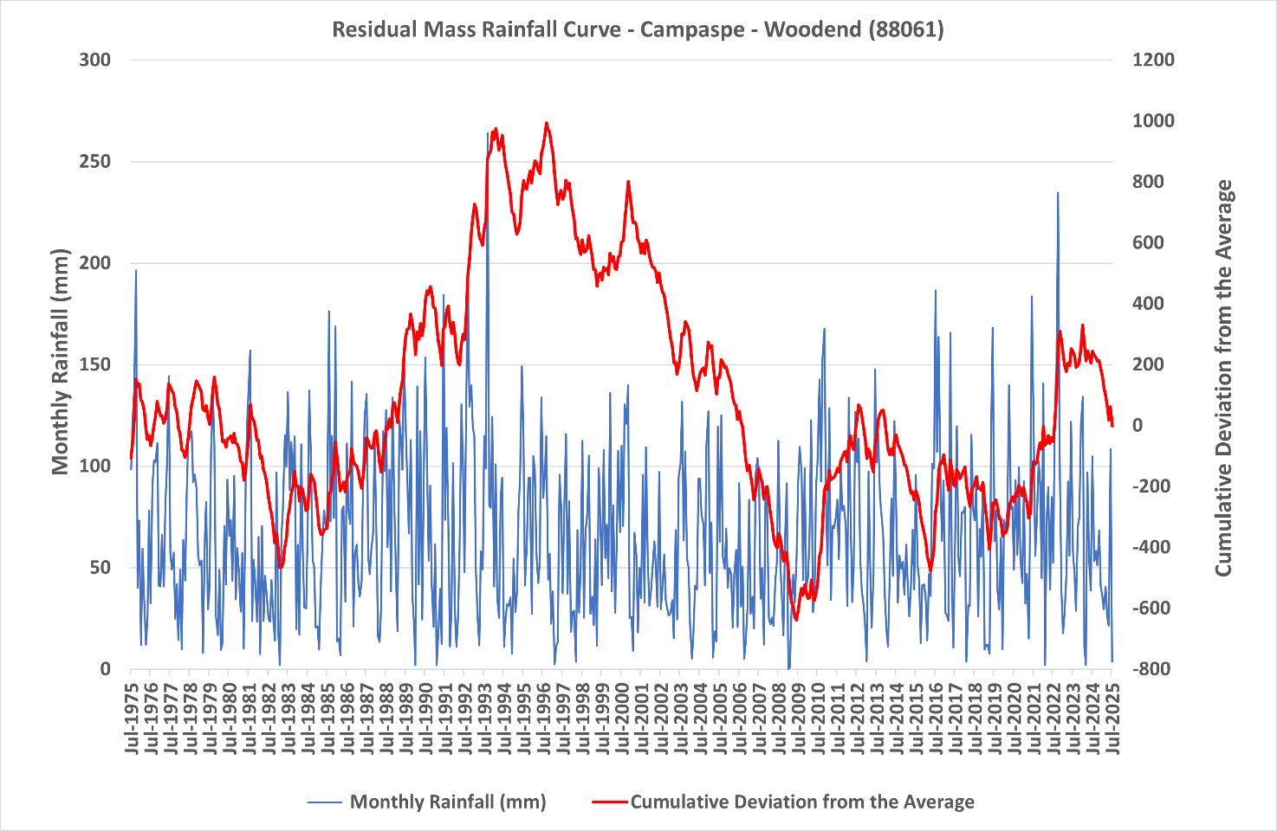
Figure 16: Residual mass rainfall curve for Woodend (88061) 1975-2025

11.1.5 Goulburn at Goulburn Weir (405259) EoVT site
The overall risk for Goulburn catchment was rated high in Victoria’s EoVT contextual narratives due to its baseline salt loads modelled over the Benchmark Period being very high (RMCG 2024).
Figure 17 and Figure 18 show the salinity exceedance curve and salt load exceedance curve for the Goulburn at Goulburn Weir site. No significant change in salinity is evident since reporting period R2023 (Jul 2018-Jun 2023), and levels remain below the Benchmark Period exceedance curve envelope. Salt loads have increased marginally, sitting close to the middle of the Benchmark Period exceedance curve envelope. The Residual Mass Rainfall chart (Figure 19) shows that the rainfall over the reporting periods is below average (the slope is negative).
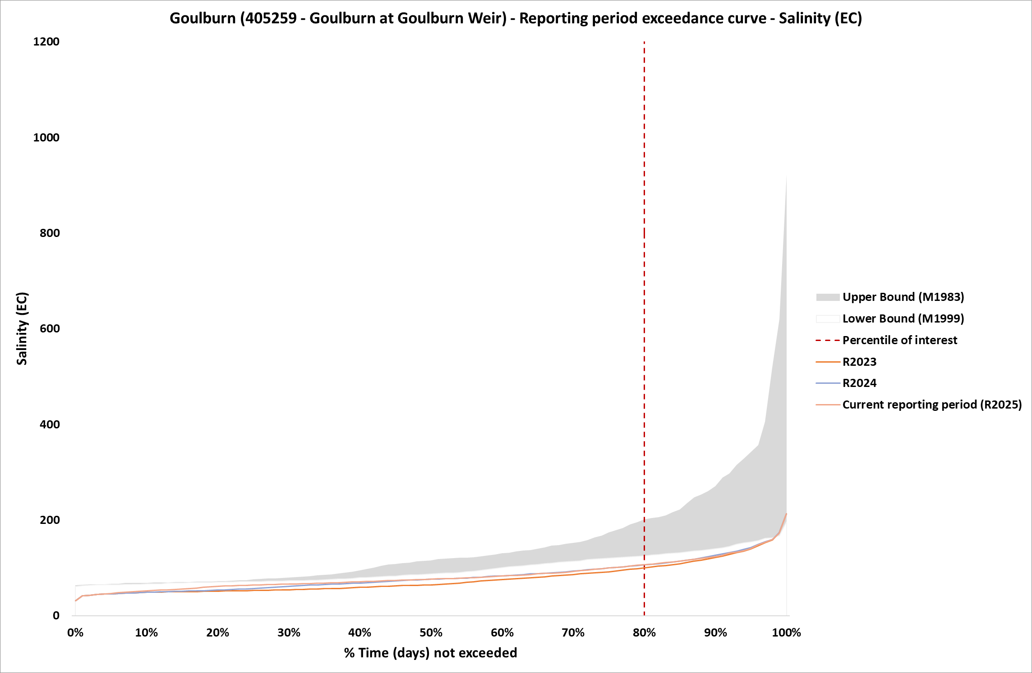
Figure 17: Salinity exceedance curve with Benchmark Period envelope and reporting years, R2024 and R2025 corresponds to the five-year period Jul 2019-Jun 2024 and Jul 2020-Jun 2025, respectively, at Goulburn EoVT site

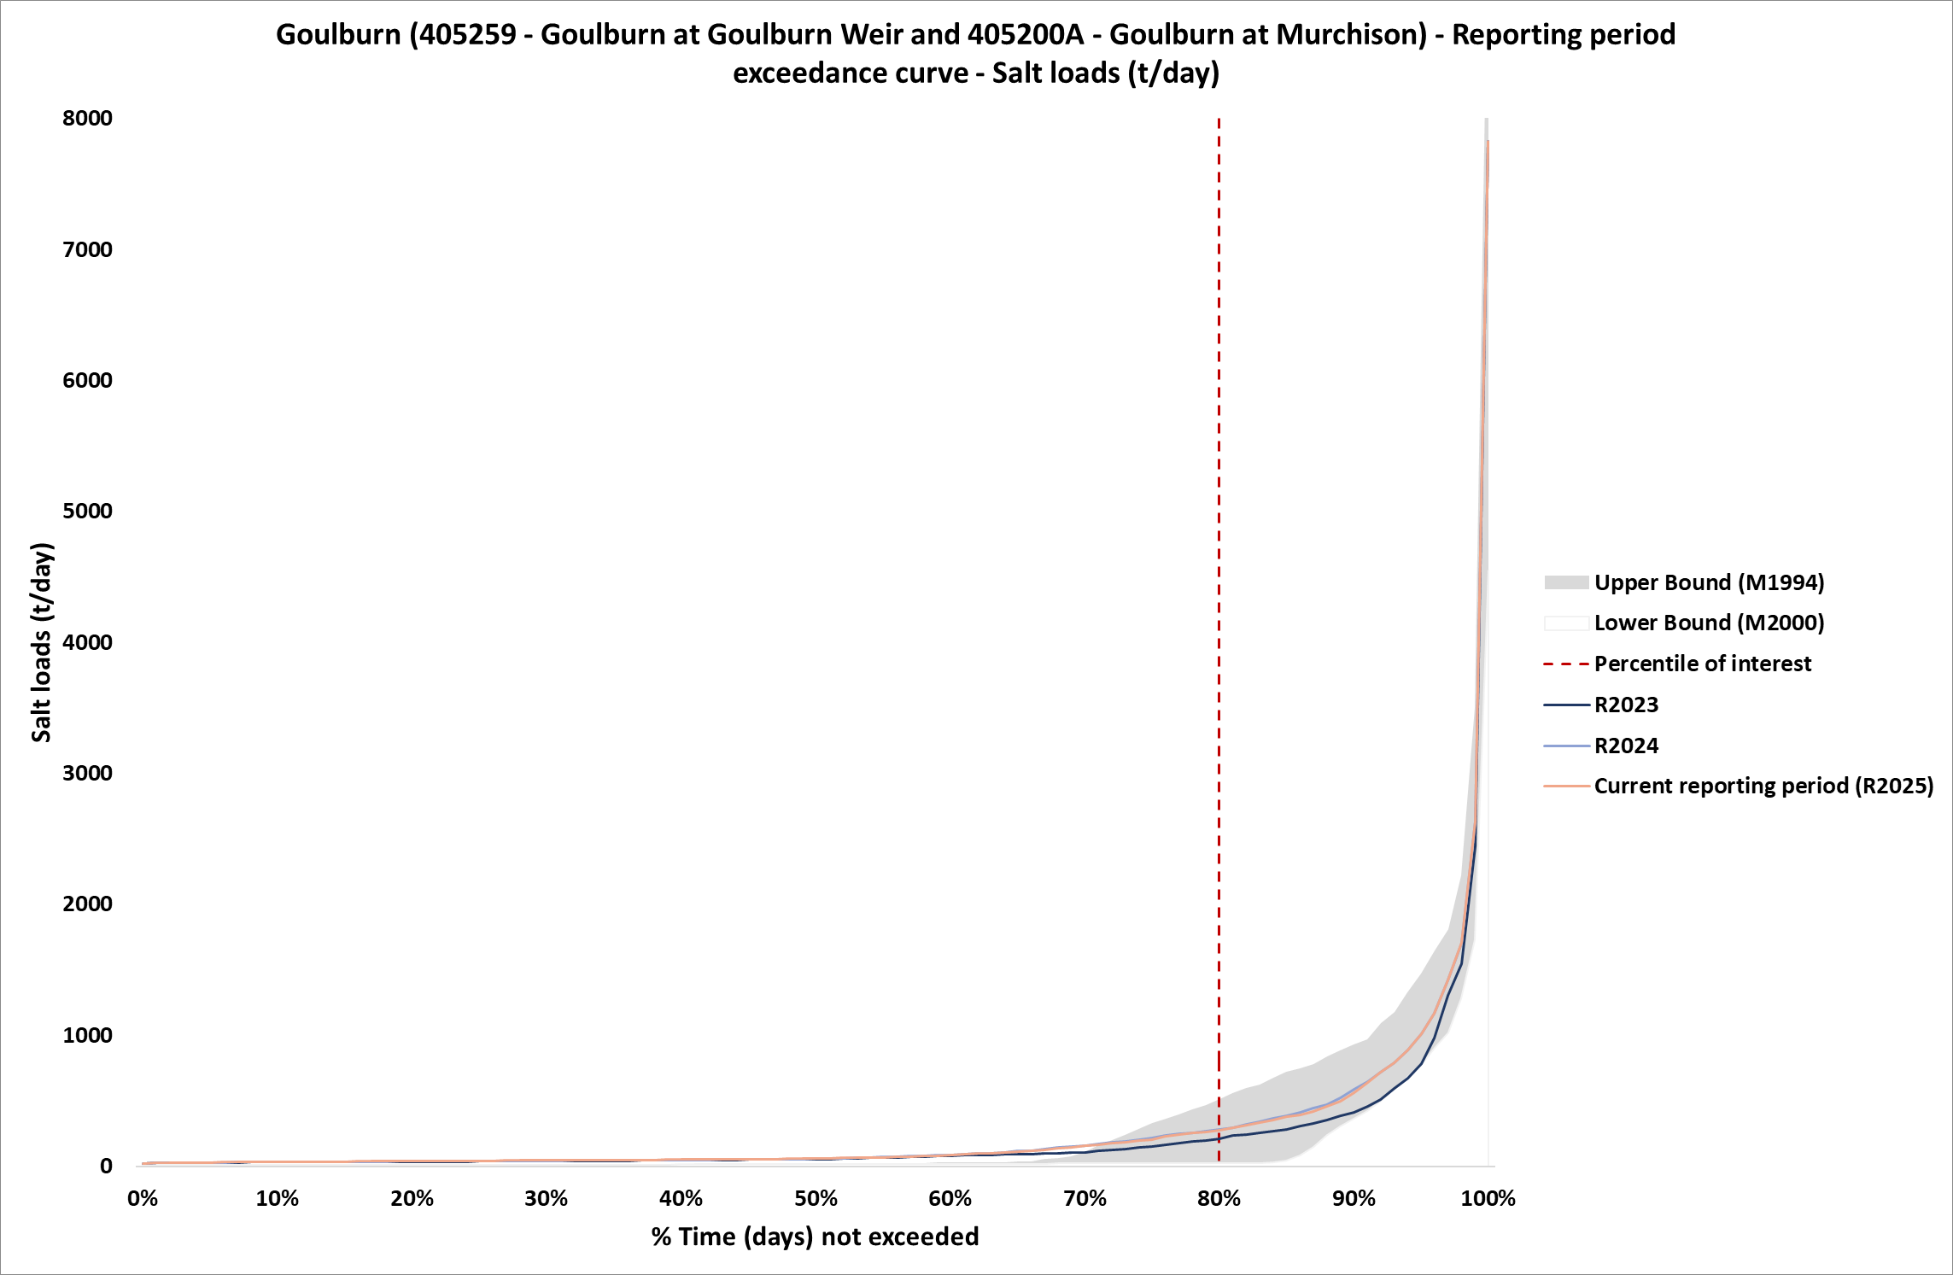
Figure 18: Salt load exceedance curve with Benchmark Period envelope and reporting years, R2024 and R2025 corresponds to the five-year period Jul 2019-Jun 2024 and Jul 2020-Jun 2025, respectively, at Goulburn EoVT site

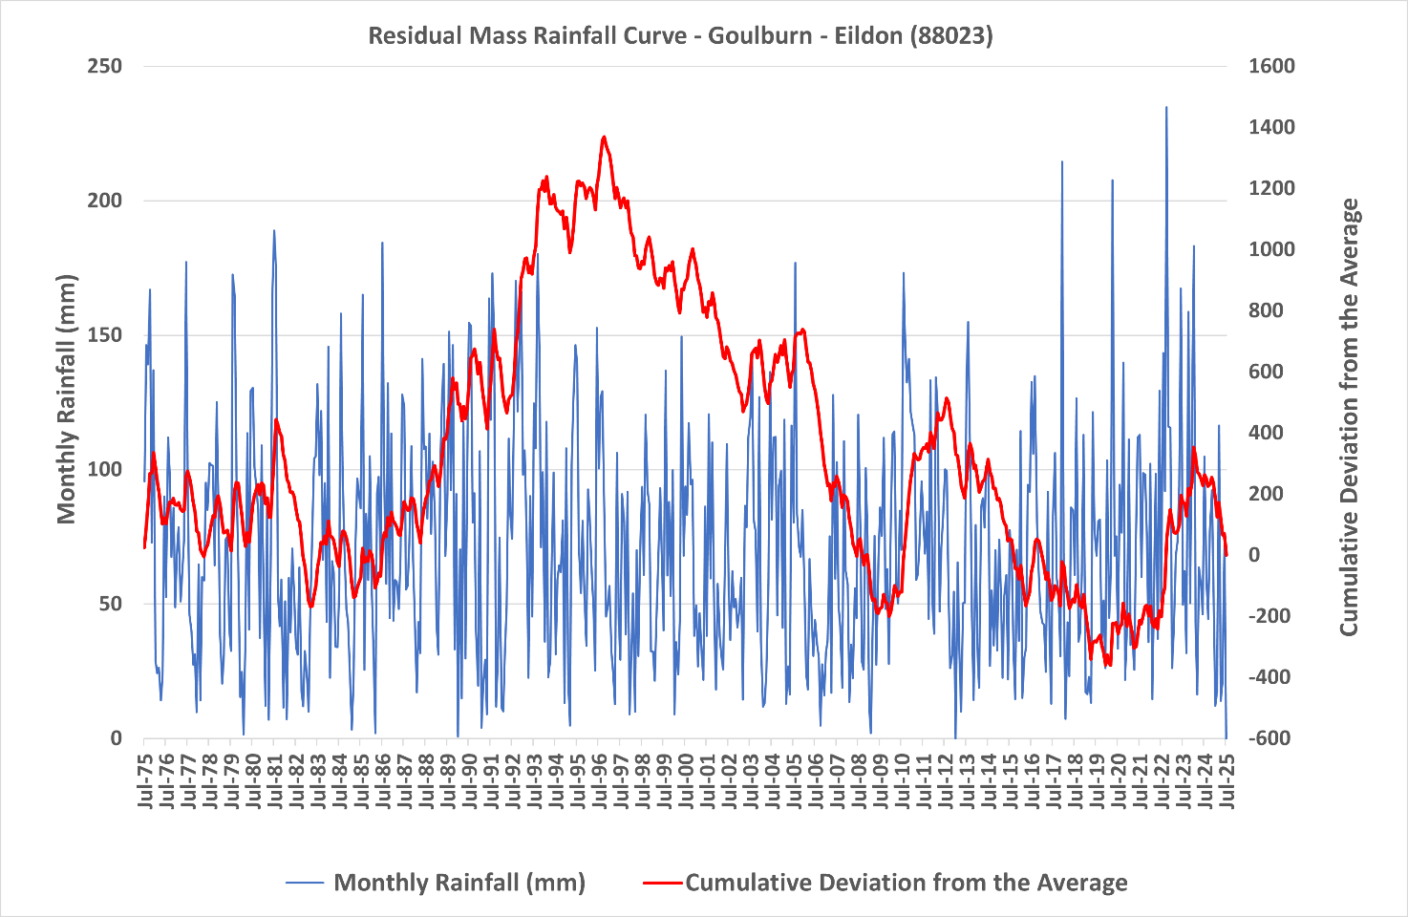Figure 19: Residual mass rainfall curve for Eildon (88023) 1975-2025

11.1.6 Broken River at Casey's Weir (404217) EoVT site
The overall risk for Broken catchment was rated low in Victoria’s EoVT contextual narratives (RMCG 2024).
Figure 20 and Figure 21 show the salinity exceedance curve and salt load exceedance curve for the Broken River at Casey's Weir site. These figures show a slight decrease in salinity and a large increase in salt loads. The Residual Mass Rainfall chart (Figure 22) shows that the rainfall over the reporting periods is below average (the slope is negative).
Salt loads have remained above the Benchmark Period exceedance curve envelope due to the decommissioning of Lake Mokoan in 2010 and continued Legacy of History Impacts.
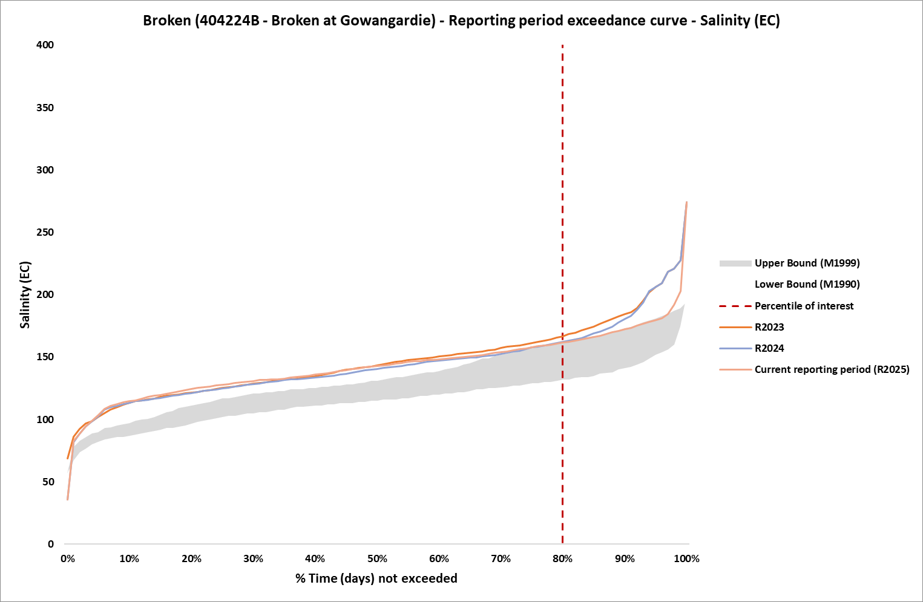
Figure 20: Salinity exceedance curve with Benchmark Period envelope and reporting years, R2024 and R2025 corresponds to the five-year period Jul 2019-Jun 2024 and Jul 2020-Jun 2025, respectively, at Broken EoVT site
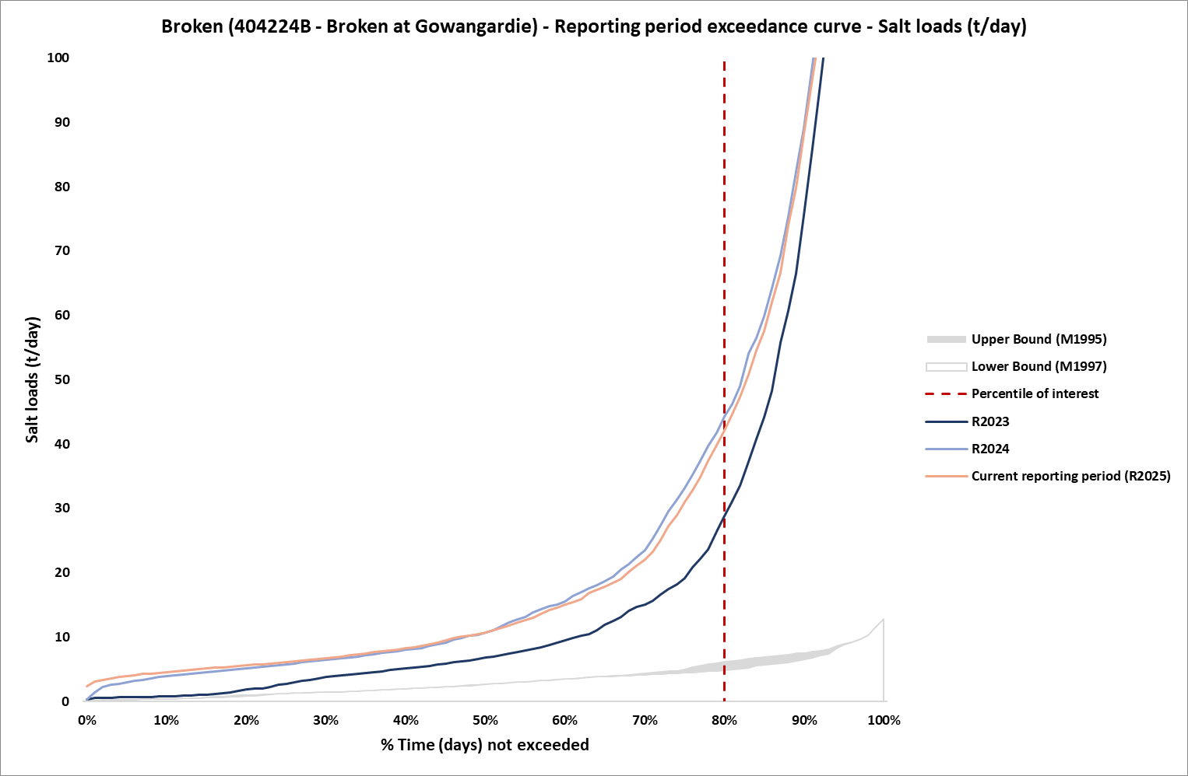Figure 21: Salt load exceedance curve with Benchmark Period envelope and reporting years, R2024 and R2025 corresponds to the five-year period Jul 2019-Jun 2024 and Jul 2020-Jun 2025, respectively, at Broken EoVT site

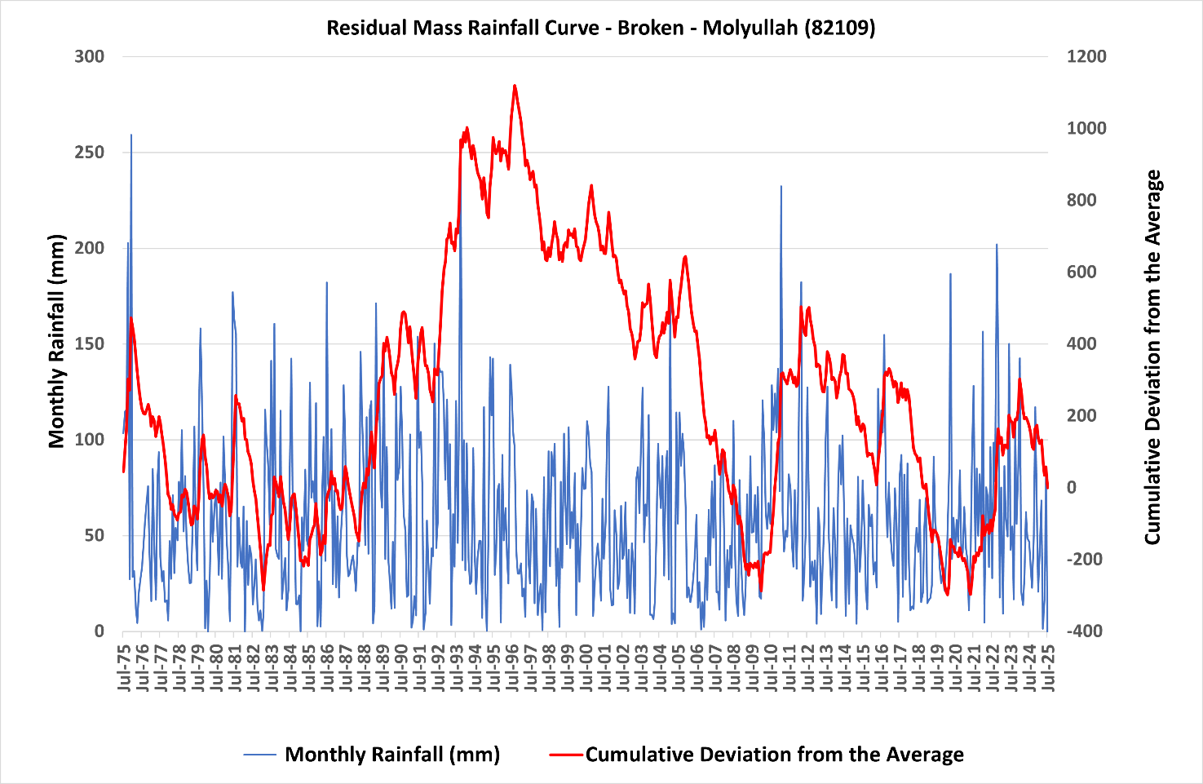
Figure 22: Residual mass rainfall curve for Molyullah (82109) 1975-2025

11.1.7 Ovens at Peechelba-East (403241) EoVT site
The overall risk for Ovens catchment was rated moderate in Victoria’s EoVT contextual narratives (RMCG 2024).
Figure 23 and Figure 24 show the salinity exceedance curve and salt load exceedance curve for the Ovens at Peechelba-East site. Salinity has increased marginally since reporting period R2023 (Jul 2018-Jun 2023) but remains well below the lower boundary of the Benchmark Period exceedance curve envelope. Salt loads have also increased marginally. The Residual Mass Rainfall chart (Figure 25) shows that the rainfall over the reporting periods is below average (the slope is negative).
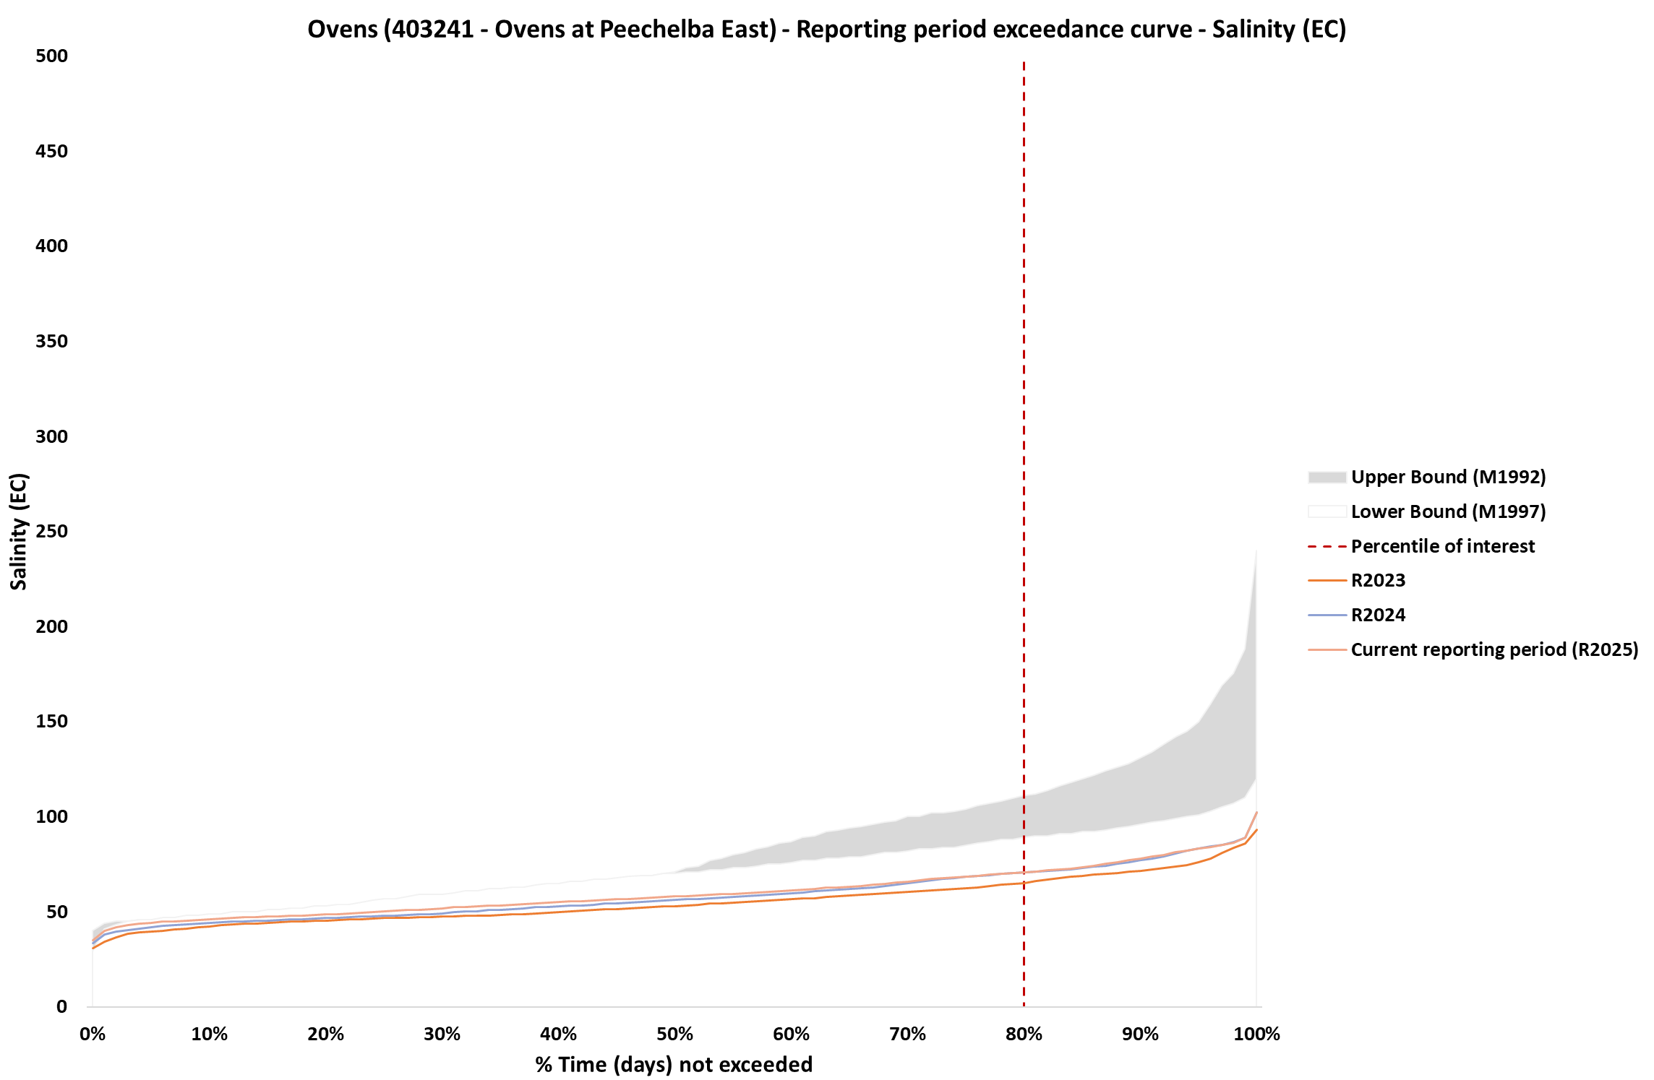
Figure 23: Salinity exceedance curve with Benchmark Period envelope and reporting years, R2024 and R2025 corresponds to the five-year period Jul 2019-Jun 2024 and Jul 2020-Jun 2025, respectively, at Ovens EoVT site

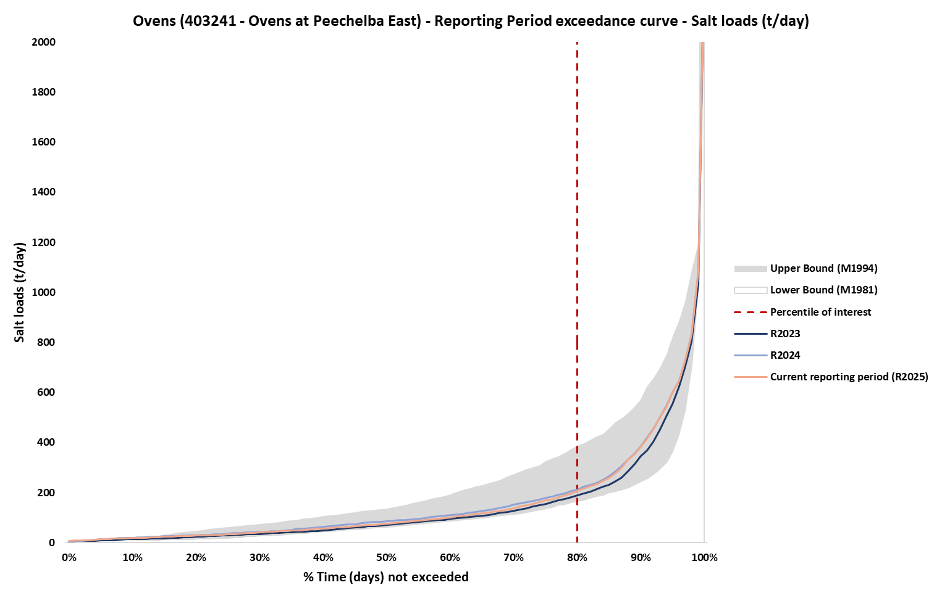
Figure 24: Salt load exceedance curve with Benchmark Period envelope and reporting years, R2024 and R2025 corresponds to the five-year period Jul 2019-Jun 2024 and Jul 2020-Jun 2025, respectively, at Ovens EoVT site

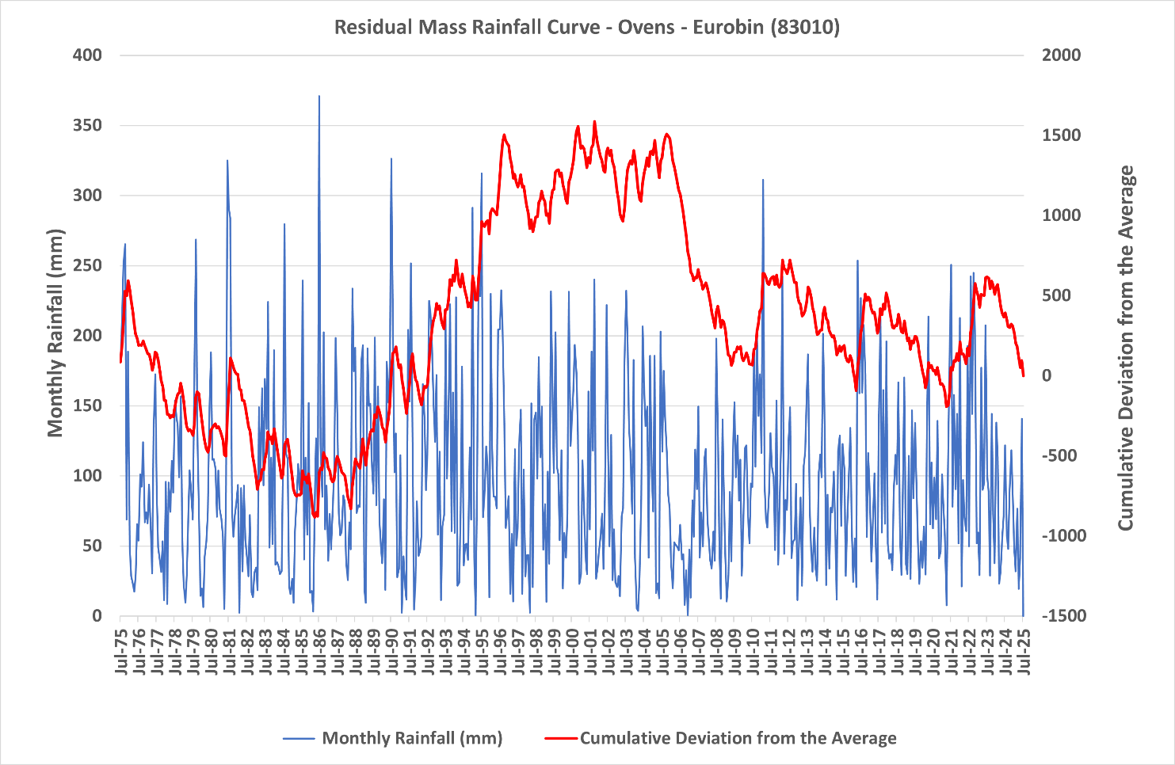
Figure 25: Residual mass rainfall curve for Eurobin (83010) 1975-2025

11.1.8 Kiewa at Bandiana (402205) EoVT site
The overall risk for Kiewa catchment was rated low in Victoria’s EoVT contextual narratives (RMCG 2024).
Figure 26 and Figure 27 show the salinity exceedance curve and salt load exceedance curve for the Kiewa at Bandiana site. A slight increase in salinity is evident since reporting period R2023 (Jul 2018-Jun 2023), while still remaining lower than the Benchmark Period exceedance curve envelope. Salt loads have also increased slightly. The Residual Mass Rainfall chart (Figure 28) shows that the rainfall over the reporting periods is below average (the slope is negative).
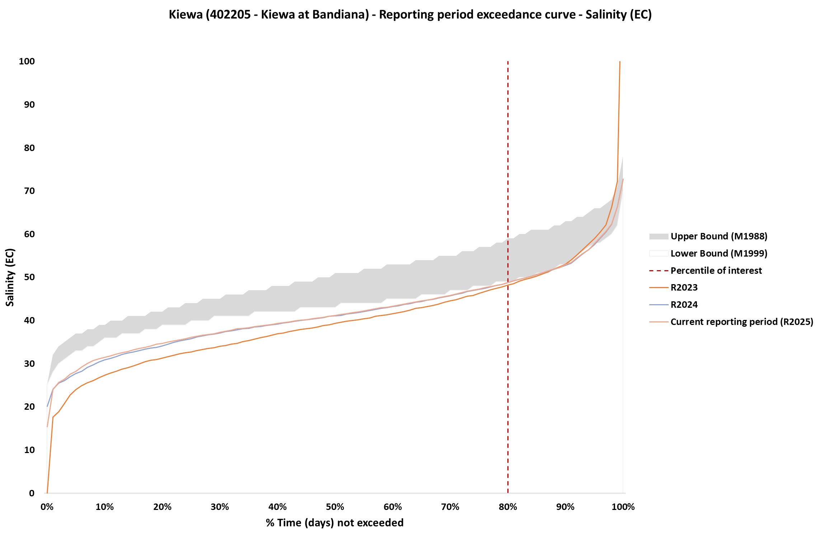
Figure 26: Salinity exceedance curve with Benchmark Period envelope and reporting years, R2024 and R2025 corresponds to the five-year period Jul 2019-Jun 2024 and Jul 2020-Jun 2025, respectively, at Kiewa EoVT site

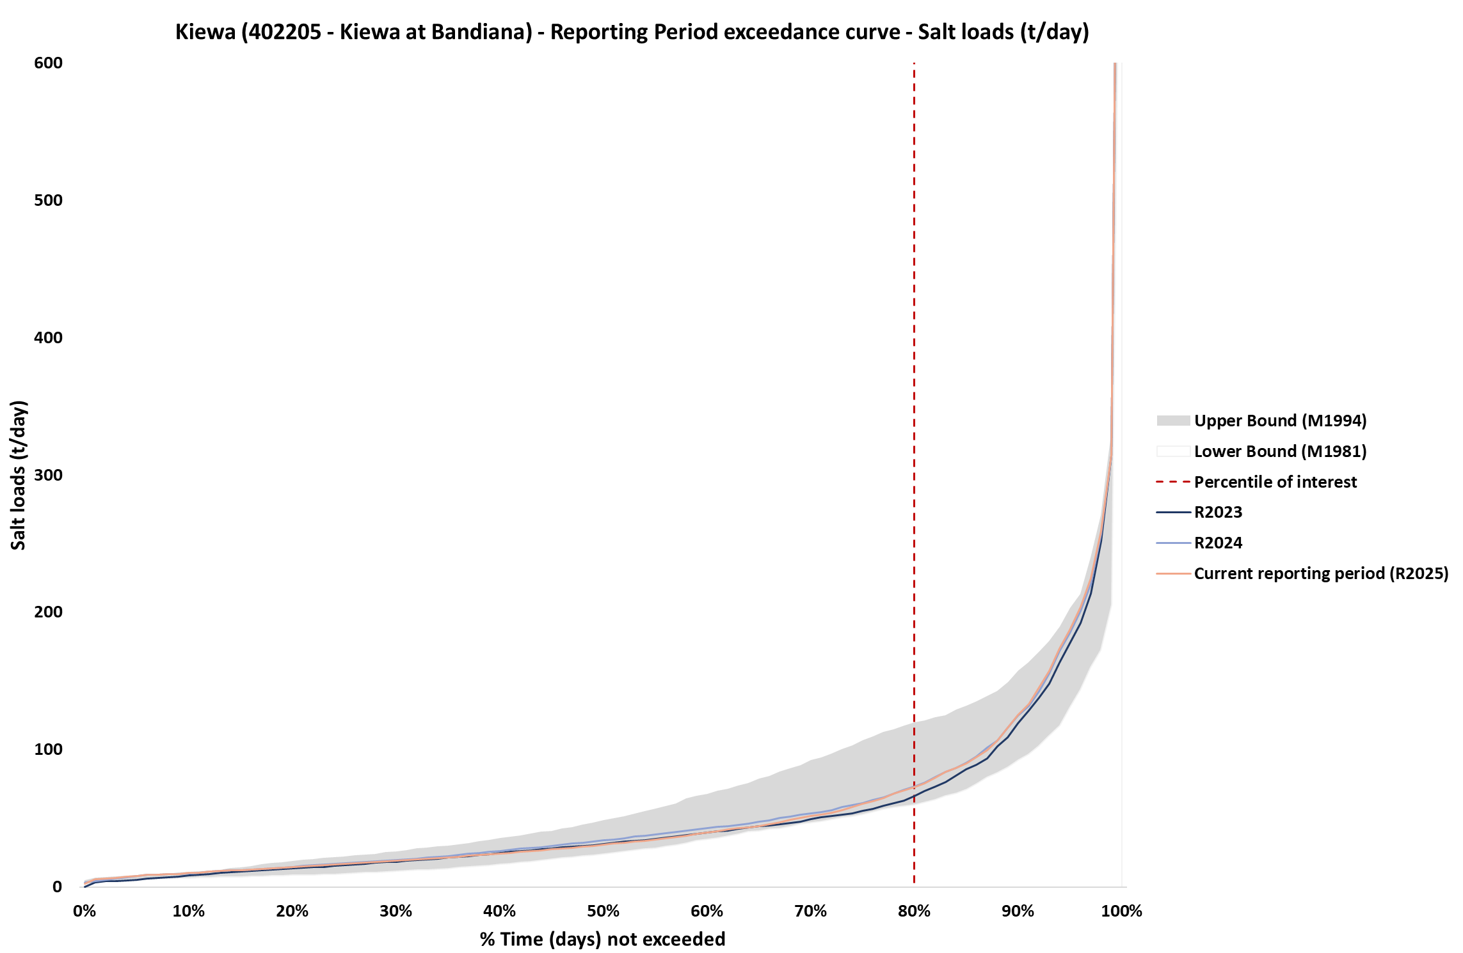
Figure 27: Salt load exceedance curve with Benchmark Period envelope and reporting years, R2024 and R2025 corresponds to the five-year period Jul 2019-Jun 2024 and Jul 2020-Jun 2025, respectively, at Kiewa EoVT site

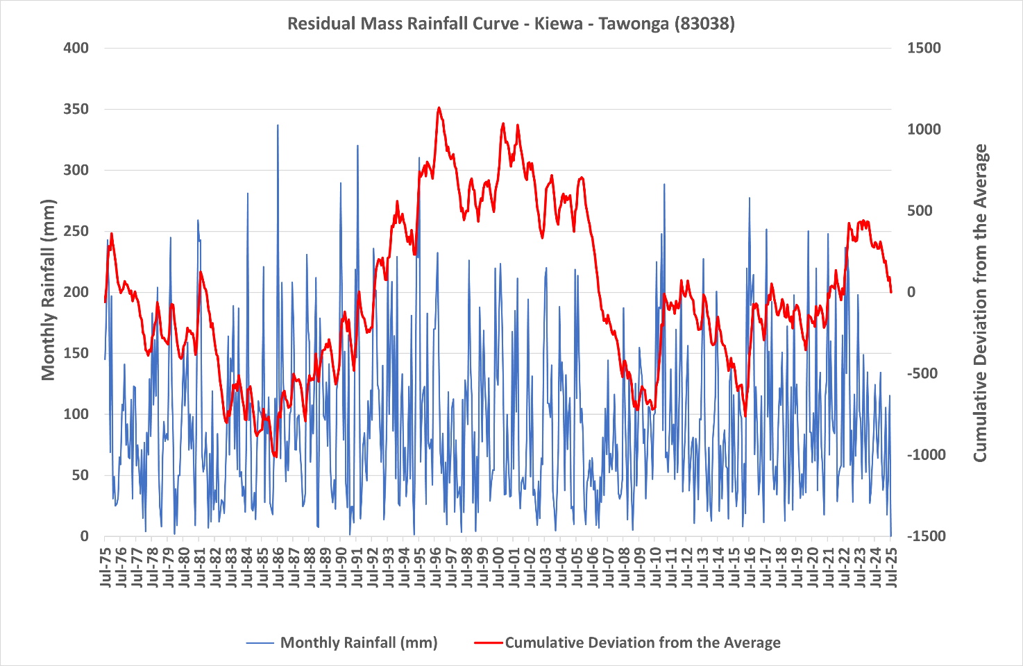
Figure 28: Residual mass rainfall curve for Tawonga (83038) 1975-2025

The Mallee regional debits are estimates performed by the Mallee CMA annually. They do not align with MDBA Register A as the corresponding entries on Register A will not be confirmed and updated until they are next reviewed (in 2026).

