Stormwater Quality Offset Schemes

Guidance for councils developing urban stormwater offsets in Victoria





[deeca.vic.gov.au](https://delwpvicgovau.sharepoint.com/Users/fionadurante/Downloads/deeca.vic.gov.au)



We acknowledge and respect Victorian Traditional Owners as the original custodians of Victoria’s land and waters, their unique ability to care for Country and deep spiritual connection to it.

We honour Elders past and present whose knowledge and wisdom   
has ensured the continuation of culture and traditional practices.

DEECA is committed to genuinely partnering with Victorian Traditional Owners and Victoria’s Aboriginal community to progress their aspirations.

© The State of Victoria Department of Energy, Environment and Climate Action February 2025.

Creative Commons

This work is licensed under a Creative Commons Attribution 4.0 International licence, visit the [Creative Commons website](http://creativecommons.org/licenses/by/4.0/) (<http://creativecommons.org/licenses/by/4.0/>).

You are free to re-use the work under that licence, on the condition that you credit the State of Victoria as author. The licence does not apply to any images, photographs or branding, including the Victorian Coat of Arms, and the Victorian Government and Department logos.

**ISBN** 978-1-76136-993-3 **(pdf/online/MS word)** Disclaimer

This publication may be of assistance to you but the State of Victoria and its employees do not guarantee that the publication is without flaw of any kind or is wholly appropriate for your particular purposes and therefore disclaims all liability for any error, loss or other consequence which may arise from you relying on any information in this publication.

Accessibility

To receive this document in an alternative format, phone the Customer Service Centre on 136 186, email [customer.service@delwp.vic.gov.au](mailto:customer.service@delwp.vic.gov.au), or contact National Relay Service on 133 677. Available at [DEECA website](http://www.deeca.vic.gov.au/) (www.deeca.vic.gov.au).

Contents

1. Introduction 2

2. Managing stormwater in urban areas 3

2.1 Statutory obligations 3

3. What are stormwater quality offsets? 5

3.1 What do stormwater offset schemes allow? 7

4. Setting up a stormwater offset scheme 8

5. Technical guidance on designing a stormwater offset scheme 9

Appendix 1: Steps in setting up stormwater offset schemes 21

Appendix 2: Frequently Asked Questions 29

Acronyms and abbreviations

|  |  |
| --- | --- |
| Acronym | Term |
| BAU | Business As Usual |
| BPEM | Urban Stormwater - Best Practice Environmental Management Guidelines |
| DSS | Development Services Scheme |
| IWM | Integrated Water Management |
| MERI | Monitoring, evaluation, reporting and improvement |
| MUSIC | Model for Urban Stormwater Improvement Conceptualisation |
| STORM score | BlueFactor STORM Calculator |
| SWQ | Stormwater Quality |
| TN | Total Nitrogen |
| TN kg | Kilograms of nitrogen |
| TP | Total Phosphorus load |
| TSS | Total Suspended Solids |
| TUIA | Total Untreated Impervious Area |
| VPP | Victoria Planning Provisions |
| WSUD | Water Sensitive Urban Design |

# Introduction

### This guidance aims to help Victorian Councils when establishing offset schemes for stormwater quality requirements and ensuring offset schemes are consistent across the state.

This document explains an urban stormwater offsetting approach that aligns with existing water and land planning processes across Victoria. Councils can use it to establish an offset scheme to provide flexibility to developers that cannot meet their stormwater quality requirements at the development site. The document aims to:

* Describe the role of the council in managing stormwater.
* Communicate what urban stormwater offsets are.
* Clarify the planning basis for stormwater offsets.
* Describe the steps for the establishment of an offsetting scheme, including establishing schemes and understanding what a council offset scheme should comprise.
* Provide direction on project identification and the relationship with strategic water planning at the municipal scale.
* Provide guidance on calculating a financial contribution rate.
* Provide guidance on fund administration reporting and governance, and monitoring and review processes.
* Provide direction on the grounds of refusal for an offset application that may be appropriate.

This guidance document has been prepared with input from representatives of organisations active in urban stormwater management and councils that have already established stormwater offset schemes. The Department acknowledges and thanks everyone who has contributed to this document’s development.

Where the term “must” is used in this document it is a requirement that councils follow the guidance. Where terms like “should” or “may” are used, it is the Victorian Government’s preference that councils follow the guidance, but councils ultimately have discretion on how they proceed.

# Managing stormwater in urban areas

Victorian councils play a significant role in urban stormwater management.

## Statutory obligations

In Victoria, councils have responsibilities for managing stormwater, including enforcing stormwater management through the planning scheme, in their municipality. In regional areas, councils are generally responsible for managing all urban stormwater as the relevant drainage authority. In Melbourne, councils are generally responsible for managing stormwater in catchments of 60 hectares or less.

Many development activities give rise to risk of harm from stormwater and there are obligations for managing stormwater under:

* [*Environment Protection Act 2017*](https://www.epa.vic.gov.au/about-epa/laws/new-laws)
* [*Local Government Act 1989*](https://www.legislation.vic.gov.au/in-force/acts/local-government-act-1989/161)
* [*Planning and Environment Act 1987*](https://content.legislation.vic.gov.au/sites/default/files/2023-06/87-45aa155-authorised.pdf)

We outline each of these obligations below, with respect to the role that councils play in stormwater management.

##### Environment Protection Act 2017

Stormwater management requirements under the *Environment Protection Act 2017* include:

* *G*[*eneral environmental duty*](https://www.epa.vic.gov.au/about-epa/laws/laws-and-your-business/general-environmental-duty-for-businesses)*(GED)*
* [[*Obligations of managers of land or infrastructure (urban stormwater management and on-site wastewater management)*](https://www.gazette.vic.gov.au/gazette/Gazettes2024/GG2024S226.pdf)](https://www.gazette.vic.gov.au/gazette/Gazettes2024/GG2024S226.pdf)*(OMLI)*

The GED requires all Victorians (including councils, developers, businesses and the community) to minimise risks from urban stormwater to human health and the environment from their activities. For example, this means eliminating risks from urban stormwater and designing and maintaining infrastructure to minimise risks from urban stormwater, so far as reasonably practicable.

If you’re a council developing an offset scheme, it is to support developers to meet stormwater quality objectives set out in planning requirements. The stormwater offset scheme does not offset other legal obligations, such as GED under the EP Act. It is strongly recommended that councils provide communication to the developers explaining that the offset allows them to meet their requirements under the *Planning and Environment Act*, and they must also remain compliant with the GED.

If reasonably practicable controls can be used onsite to minimise risk of harm to human health and the environment from stormwater – they must be installed. For example, if an EPA officer arrives at site, as part of their inspection they will assess if there are reasonably practicable controls in place to minimise all risks to human health and the environment from urban stormwater, regardless of whether a council stormwater offset agreement is in place.

Under the [OMLI](https://www.gazette.vic.gov.au/gazette/Gazettes2024/GG2024S226.pdf), councils are required to develop stormwater management plans in consultation with relevant stakeholders, and to review, update and report on the plan at least every five years.

Under the OMLIcouncils are required to develop stormwater management plans in consultation with relevant stakeholders. Councils must identify risks from urban stormwater and actions to minimise these risks. This strategic plan and understanding of risk can inform council making decisions around offset agreements. The plan can also be updated to reflect actions by the council to minimise risk.

##### Local Government Act 1989

Saved provisions in the *Local Government Act 1989* vests ownership of public stormwater drains in councils and gives them powers to manage and control this infrastructure.

Under the *Planning and Environment Act 1987* councils are also responsible for implementing the stormwater management provisions under the Victorian Planning Scheme. They do this through building and planning approvals. In addition, Clause 19.03-3S in the Planning Policy Framework requires councils adopt an integrated approach to the planning, design, assessment and approval of new developments which brings all the elements of the water cycle together, including sewage management, water supply, stormwater management and water treatment, to maximise community and environmental benefits.

|  |
| --- |
| **Box 1: Victoria Planning Provision (VPP) Planning Scheme Developer requirements (‘Stormwater obligations’)**  The [**Victoria Planning Provisions (VPP) Planning Scheme**](https://planning-schemes.api.delwp.vic.gov.au/__data/assets/pdf_file/0007/481723/VPPs_All_Clauses.pdf?_ga=2.71716243.1400613253.1623300239-1287828427.1621481968) requires that the following aspects meet best practice performance objectives for stormwater quality:   * all residential subdivisions (56.07) * apartment developments (less than 5 storeys 55.07-5 / 5 or more storeys 58.03-8) * residential multi-dwelling developments (55.03-4) * all non-residential commercial, industrial, and public land subdivision (53.18-4 W1) * all non-residential commercial, industrial, and public land building and works (53.18-4 W2)   The performance objectives are contained in the [Urban Stormwater – Best Practice Environmental Management Guidelines](https://www.epa.vic.gov.au/for-business/find-a-topic/prevent-water-pollution/urban-stormwater-management-guidance) (BPEM). The BPEM objectives (‘Stormwater obligations’) are:   * 70% reduction of typical urban annual litter load (Litter) * maintain flow discharges for the 1.5-year Average Recurrence Interval (ARI) at pre-development levels * 80% retention of typical urban annual suspended solids load (TSS) * 45% retention of typical urban annual total phosphorus (TP) load * 45% retention of typical urban annual total nitrogen (TN) load.   In addition to these common stormwater objectives, other planning requirements apply depending on the development type. Refer to the [Victorian planning requirements for stormwater management – Online Navigator Tool](https://clearwatervic.com.au/resource-library/toolkits/stormwater-planning/) for more information on these requirements. Councils are responsible for requiring compliance with these provisions through their local planning permit development application process. Councils may also have local planning policy requirements that exceed or complement the VPP and the construction code to adequately manage environmental and human health risks. |

# What are stormwater quality offsets?

Stormwater quality offsets can support developers to comply with their stormwater quality requirements under the VPP. When stormwater cannot be fully managed on-site, developers can opt to pay a fee to council to manage stormwater quality impacts offsite.

Most Victorian councils require developers to fully meet their stormwater quality obligations under the VPP on-site. [Planning Advisory Note 75](https://www.planning.vic.gov.au/__data/assets/pdf_file/0020/650711/PAN75-Amendment-VC154-Stormwater-Management.pdf) details how stormwater management systems must be designed and managed in accordance with the requirements of the relevant drainage authority.

Stormwater offsets allow developers to make a voluntary financial contribution to the council to help meet some of their stormwater quality obligations under the VPP. Council use the funds to construct and maintain stormwater management assets and works in another location within the municipality (not on the developer’s private land). These assets ‘offset’ the stormwater quality impacts from the development off-site.

Stormwater quality offsets can be used by developers to achieve the following stormwater requirements off-site, as a general principle:

* 80% retention of typical urban annual suspended solids load (TSS)
* 45% retention of typical urban annual total phosphorus (TP) load
* 45% retention of typical urban annual total nitrogen (TN) load.

The following stormwater requirements must be met on-site, as a general principle:

* maintain flow discharges for the 1.5-year Average Recurrence Interval (ARI) at pre-development levels
* minimise the impact of chemical pollutants and other toxicants in stormwater runoff (under 53.18-4 W1)
* other requirements defined by council within the planning permit.

Figure 1: Stormwater offset application process

**Figure 1** shows how the stormwater offset application process works in practice. Under the approach shown:

Applicants discuss their stormwater requirements with the council, as the relevant drainage authority.

Applicants can meet their stormwater quality requirements in one of the following ways:

**Option 1** – Install stormwater treatment measures on-site in that meet the stormwater requirement.

**Option 2** – Install some stormwater treatment measures on-site that meet stormwater requirements, partially or fully meeting the stormwater quality provisions. Additionally, provide a payment to the council’s offset scheme to make up the balance of the development’s stormwater quality provisions.

**Option 3** – Make a 100% payment to the council’s offset scheme if this option is provided by council.

Funds raised through the scheme are then used for council-managed projects that deliver equivalent or higher stormwater management benefits than those required by the VPP.

In Greater Melbourne, several councils (including the [City of Kingston](https://www.kingston.vic.gov.au/Property-and-Development/Stormwater/Water-Management), the [City of Moonee Valley](https://mvcc.vic.gov.au/work/my-development/sustainable-development/), and the [Mornington Peninsula Shire](https://shape.mornpen.vic.gov.au/Stormwater-Quality-In-Lieu-Contribution-Scheme?mc_cid=07f1e2e640&mc_eid=37a4e685de&utm_campaign=07f1e2e640-EMAIL_CAMPAIGN_2020_06_24_12_55_COPY_01&utm_medium=email&utm_source=Mornington%20Peninsula%20Shire&utm_term=0_e871850913-07f1e2e640-405343529)) have introduced stormwater offset schemes, and several other councils are in the process of establishing schemes. Melbourne Water also operates a [stormwater offset scheme](https://www.melbournewater.com.au/building-and-works/apply-to-build-or-develop/stormwater-quality-offset-contribution) which councils may refer development applications to, if they are within a Development Services Scheme and/or councils do not operate their own stormwater offset scheme.

## What do stormwater offset schemes allow?

It is important to be clear on what stormwater offsets let applicants and councils do, and what they don’t. General principles of stormwater offset schemes includethatthey:

|  |  |
| --- | --- |
| Badge Tick1 with solid fill | **Allow applicants to meet their stormwater obligations by making a payment to the offset scheme.** |
| Badge Tick1 with solid fill | **Allow councils discretion about how applicants meet their stormwater obligations.** As discussed later in this guidance, stormwater offsetting may not be appropriate in all applications. As the referral authority, councils retain the right to determine how applicants meet their stormwater obligations on-site and off-site through conditions within the planning permit. |
| Badge Tick1 with solid fill | **Allow councils to offer offsets to all development types.** The requirements apply to residential subdivision and apartment developments, all commercial and industrial subdivisions and developments, all public use developments, and all residential multi-dwelling developments. Exemptions are identified at VPP s53.18-1. |
| **Badge Cross with solid fill** | **Do not remove or reduce applicants’ stormwater obligations** as contained in Victoria Planning Provisions. Stormwater offsets simply provide another way for applicants to meet some of their obligations. This is an important point. Stormwater offsets are not a licence to pollute. |
| **Badge Cross with solid fill** | **Do not allow applicants to offset other compliance obligations off-site, including their GED.** Under the GED, developers are expected to reduce the risks of all potential stormwater pollutants including those in the BPEM, so far as reasonably practicable on-site. Stormwater requirements other than the stormwater quality obligations under BPEM, such as those to reduce the risk of flooding, or to minimise the impact of chemical pollutants and other toxicants in stormwater runoff, remain as per the conditions within the planning permit and must be met on-site. |
| **Badge Cross with solid fill** | **Do not allow applicants to offset site management compliance obligations during the construction stage.** These sedimentation and contamination obligations remain as per the conditions within the planning permit and other requirements and must be met on-site. |

# Setting up a stormwater offset scheme

The key steps in setting up a stormwater offset scheme are outlined in this section. Appendix 1 includes further detail and resources.

Key steps that will assist councils to establish a stormwater offset scheme are shown in **Figure 2**. Each step is explained in further detail in the technical guidance in **Appendix 1**.

The Victorian Government encourages councils that are establishing a stormwater offset scheme to use the processes and resources provided in this guidance document. This will ensure there is a consistent and transparent approach to stormwater offsets across councils in Victoria.

A good first step to setting up a scheme includes speaking with people from councils that already have established schemes. A key learning from the councils that have already implemented these schemes is that it is very important to involve the following people at every step along the way:

1. Council planners working with developers and granting permits
2. Council staff working in water sensitive urban design (WSUD) delivery
3. Councillors, particularly early in the planning process.

A collaborative approach ensures council officers and developers understand the detailed operational aspects and constraints of the scheme and have confidence in it. It also helps ensure the various planning, environmental, engineering, and administrative departments within each council have buy-in and can work together towards the same shared project outcomes.

**Figure** 2**: Key steps in setting up stormwater offset schemes in Victoria**

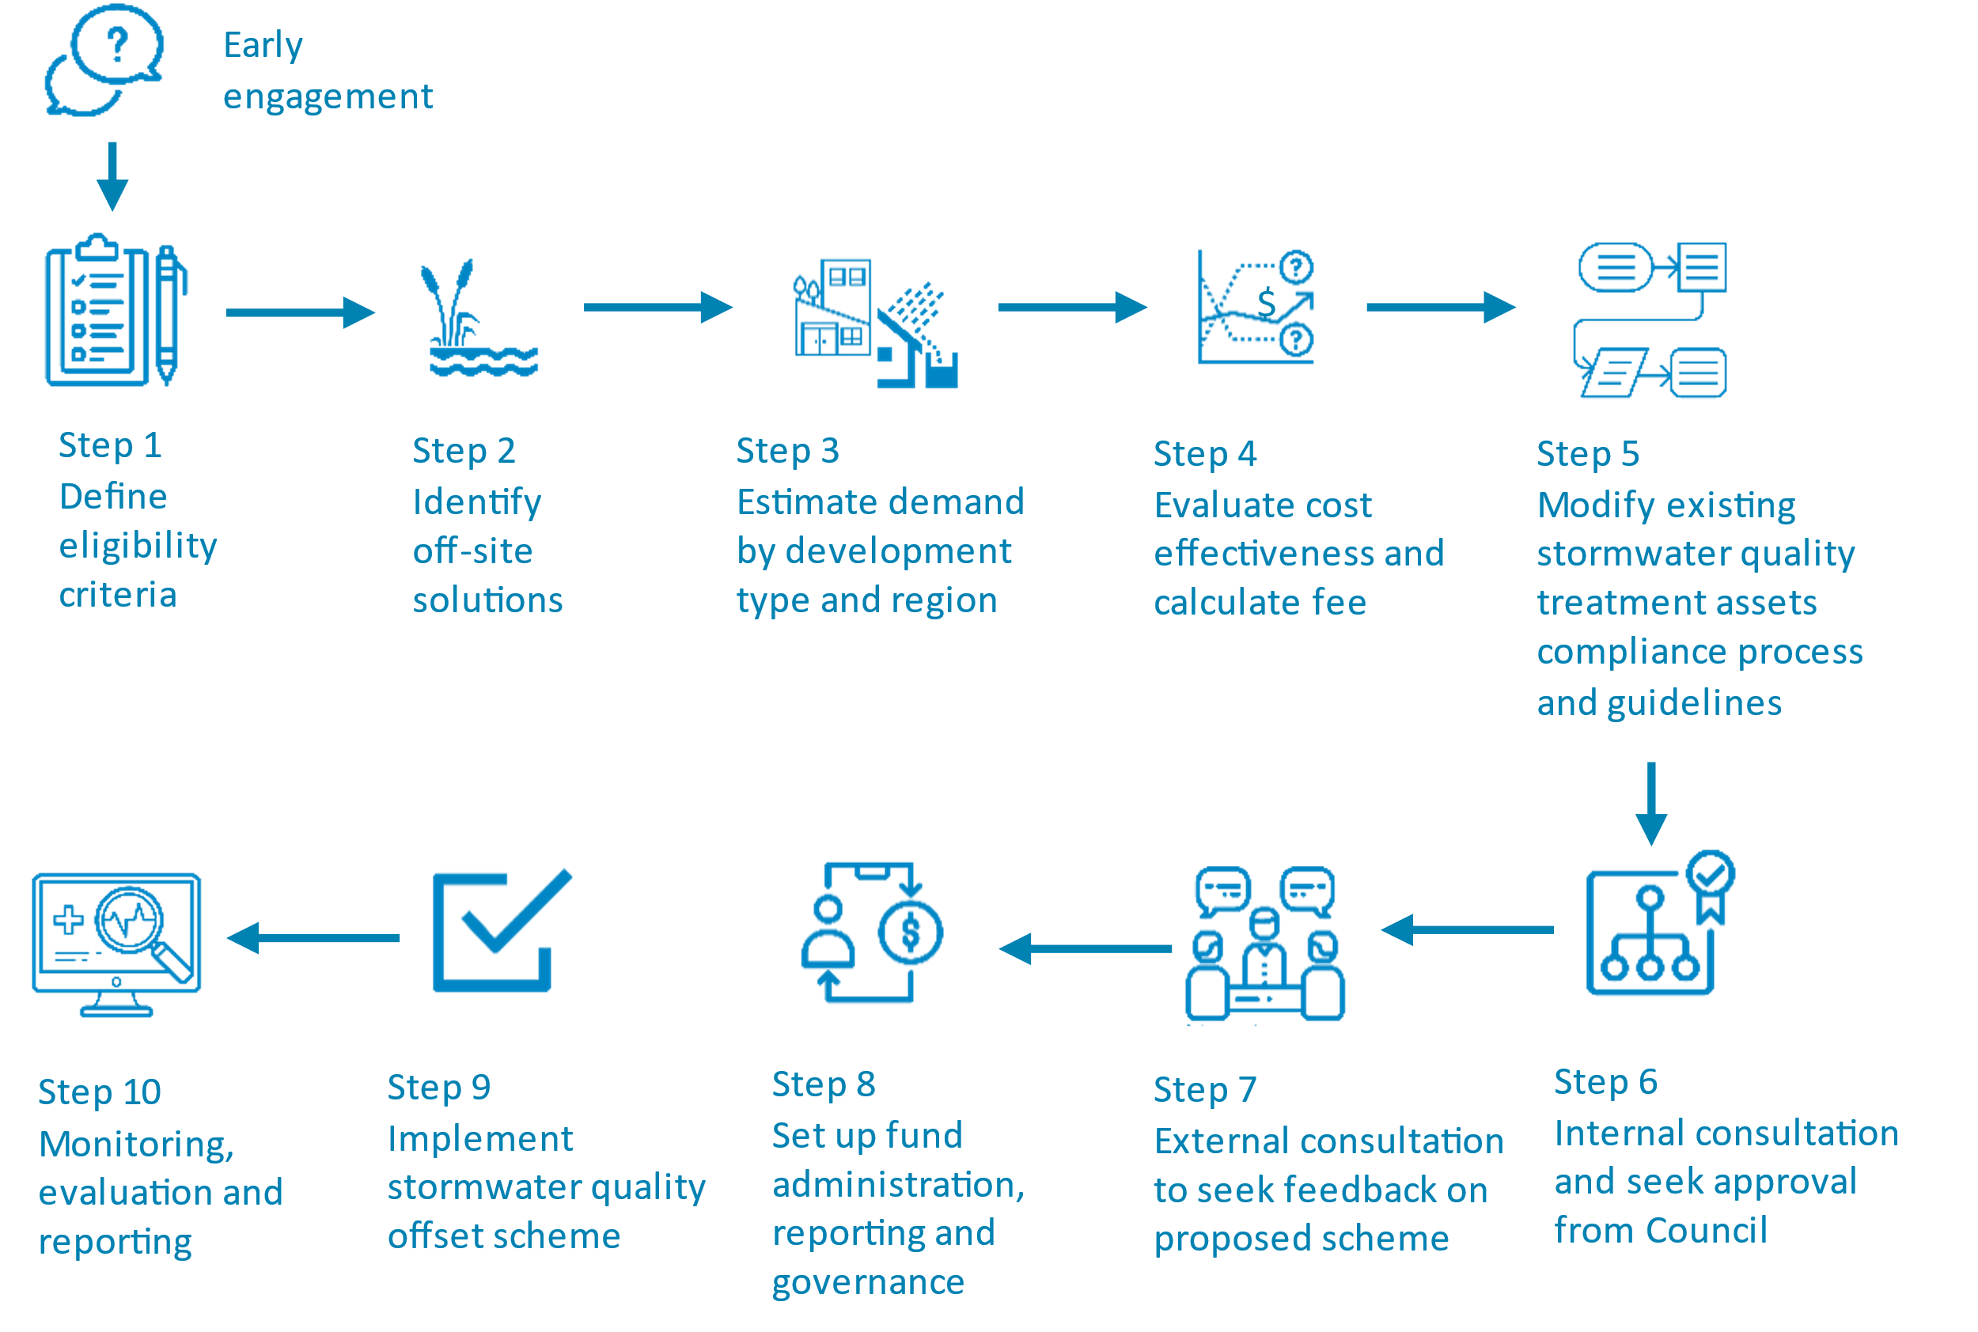

# Technical guidance on designing a stormwater offset scheme

Councils who follow the technical guidance in this section will find it easier to administer their schemes. Applicants who are engaging with different councils will find the consistency of approach beneficial. Following this guidance also means that councils can adapt their schemes in similar ways in line with any further regulatory developments.

The content of this section is technical and assumes some understanding of offsetting and offsetting principles. It is provided for council staff implementing stormwater offset schemes and those who may be supporting them.

## Eligibility

Eligibility defines who can apply for stormwater offsets, and what can be offset.

### Development applications that are eligible

All development applications required under the VPP must meet current best practice performance objectives for stormwater quality as contained in the BPEM. Those projects that are required to submit a planning application to council (as the referral authority) should be eligible to apply to council for stormwater offsets. These development applications include:

* residential subdivision (56.07)
* apartment (55.07-5)
* residential multi-dwelling (55.03-4)
* non-residential commercial, industrial, and public land subdivision (53.18-4 W1)
* non-residential commercial, industrial, and public land building and works (53.18-4 W2).

### Development applications that are ineligible

Developers are ineligible to apply for stormwater offsets in a council area if:

**Melbourne Water is the Referral Authority.** Councils may refer Section 52 and Section 55 applications to Melbourne Water if they are triggered by the relevant planning scheme, or if the development is part of a Melbourne Water drainage scheme – also sometimes referred to as a 'development scheme' or '*development services scheme*'. Councils can use Melbourne Water’s [drainage scheme map](https://www.melbournewater.com.au/building-and-works/developer-guides-and-resources/drainage-schemes-and-contribution-rates/find-your#/) to find out if a development is part of a Melbourne Water drainage scheme. If a development proposal falls within a Melbourne Water drainage scheme area, it will be subject to the conditions of that scheme. If that scheme includes Stormwater Quality (SWQ) contributions - and the developer meets those contributions or carries out equivalent works to the satisfaction of Melbourne Water - then the SWQ provisions in the Planning Scheme will be deemed to be met by council.

**The application is for a development outside of the council boundaries.** In this case the Referral Authority is the council where the proposed development is located.

**The developers want to offset stormwater impacts during construction.** Construction phase stormwater requirements cannot be offset. [Clause 65 (Decision Guidelines)](https://planning-schemes.delwp.vic.gov.au/schemes/vpps/65_01.pdf), [56.08-1 C26](https://planning-schemes.delwp.vic.gov.au/schemes/vpps/56_08.pdf), [53.18-3 W3](https://planning-schemes.delwp.vic.gov.au/schemes/vpps/53_18.pdf) provide requirements for managing stormwater during the construction phase.

### Development applications where offsets are not applicable

Stormwater quality offsets are not applicable for developments that are exempt from meeting BPEM requirements. These include:

**Vacant land subdivisions.** Vacant land subdivisions are currently not included within Clause 53.18. Therefore, vacant lot subdivisions are not automatically included within stormwater offset schemes. See Box 2: Vacant land subdivisions for more information.

**Single lot residential developments.**

**VicSmart applications.**

**An application to construct a building** with a gross floor area not exceeding 50 square meters.

**Applications to alter a building** resulting in an increase in impervious surface area of less than 50 square meters.

**An application lodged before** the approval date of Amendment VC154.

**Areas where it can be demonstrated that previous arrangements or contribution payments,** appropriate to the type of subdivision or development now taking place, have been made to council.

|  |
| --- |
| **Box 2: Vacant land subdivisions**  As noted above, vacant land subdivisions are currently not included within Clause 53.18 of the VPP. Therefore, vacant lot subdivisions are not automatically included within a council’s offset scheme.  Vacant lot subdivisions are currently covered under Clause 56. Under the current process, developers have the option to offset vacant lot subdivisions through the Melbourne Water in-lieu scheme if they are located within Melbourne Water’s area of operations.  Developers may also choose to provide stormwater treatment on site at the time of development if the type of development is known. If so, the proposed future stormwater quality treatment on lot is agreed with council through a Section 173 agreement. Through this agreement, the stormwater quality requirements that are to be built on site are included on the title as a condition.  The key issue arising from this is that development applications to construct a building, or construct or carry out works associated with one dwelling on a lot, are not included in Clause 53.18. This means that, after the subdivision application is approved, development applications for one dwelling on a lot will not be included within Clause 53.18 unless it is captured through Clause 56 at time of subdivision and included as a condition on the title.  The other challenge in including vacant lot subdivisions is that there is no certain way of knowing the planned development at time of subdivision and therefore no accurate indication of the additional impervious area.  Several Victorian councils have investigated approaches for including vacant lot subdivisions within their offset schemes. Options available to council include :   * Analysing the number of subdivision applications that result in development applications for one dwelling on a lot. This will inform whether there is merit in including vacant lot subdivisions within the in-lieu scheme and amending the process accordingly, or * If there is a significant number of these applications, councils could seek to establish a separate in-lieu fee. This fee could be based on the total area of subdivision and the relative density ratio of new subdivision developments in the council area. Melbourne Water also publishes [density ratios](https://www.melbournewater.com.au/building-and-works/developer-guides-and-resources/conditions-and-policies/contributions-16#Development_densities) used for calculating developer charges. These could be used by council if council density ratios are not available. |

### Council discretion

|  |
| --- |
| **Council discretion:** As a general principle, council retain the right to refuse applications for stormwater offsets. |
| **Council discretion, part offset**: As a general principle, council retain the right to offer developers a partial offset, i.e., developers must meet some stormwater quality compliance on-site and can offset the remaining part. |

Council can determine the extent of the offset offered to a development applicant. Council’s Statutory Planning Department should assess applications for stormwater offsets, taking into consideration a range of stormwater management requirements as part of the overall planning considerations.

Council can offer offsets up to a maximum amount of 100% of the stormwater compliance requirement in the Council Planning Permit conditions. Offsetting 100% of on-site obligations should only be approved by a council where it is considered appropriate. For instance, where on-site stormwater treatment measures are not possible due to on-site constraints such as insufficient land area, or there are insufficient demands available for rainwater tanks.

The maximum amount should be determined by the council based on the local context and it may differ across the municipality. These amounts should be clearly outlined as part of any relevant IWM Plan prepared for the municipality and, where possible, be identified through local planning policy and mapping within each municipal planning scheme.

In assessing applications for stormwater offsets councils should have regard to, as general principles:

* The EPA hierarchy for controlling hazards and risks for managing stormwater runoff under the [Urban Stormwater Management Guidance (2021)](https://www.epa.vic.gov.au/about-epa/publications/1739-1).
* Whether the offset application is for a development in an area of high environmental priority (see Box 3).
* Characteristics of the development site, such as:
  + the size of the development
  + whether on-site BPEM compliance is technically possible
  + the cost-effectiveness of on-site solutions, for example rainwater tanks (see Box 3)
  + evidence from relevant investigation reports, preliminary designs, engineering calculations and preliminary costings.
  + the likelihood that on-site measures will contribute to stormwater quality control over the full timeframe the developed impervious area will be in place.
* Opportunities for off-site council provision of stormwater offsets, and the equivalence of these (see section 5.2.3 for more details).

|  |
| --- |
| Box 3: Identifying the environmental priority of receiving waterways, and the appropriateness of offsets  In the Greater Melbourne area, Melbourne Water’s [Healthy Waterways Strategy 2018-28](https://healthywaterways.com.au/) identifies stormwater and other areas of higher environmental priority. Councils can use the [Healthy Waterways mapping tool](https://healthywaterways.com.au/map) to identify the environmental priority of receiving waters in a council area (see Figure 3: Healthy Waterways Strategy 2018-28 interactive mapping tool). Councils should consult with Melbourne Water when considering setting up stormwater offset sites or permitting stormwater offsetting in areas of high to very high ecological condition. Stormwater offsetting may be unsuitable for these areas.  In the rest of Victoria, consult with the local Catchment Management Authority to identify the environmental priority of receiving waters [using the map on this page](https://www.water.vic.gov.au/water-reporting/water-in-your-region). |

Figure 3: Healthy Waterways Strategy 2018-28 interactive mapping tool

|  |
| --- |
| Box 4: Rainwater tanks as cost-effective onsite solutions  For many residential developments, a rainwater tank is likely to be a feasible on-site solution that achieves a certain amount of the stormwater quality objectives by being plumbed to the garden, toilets and laundry. It will also achieve broader benefits than stormwater quality, including stormwater flow reduction and saving drinking water.  Rainwater tanks can provide greater security in times of water shortages and are exempt from the Victorian Government’s Permanent Water Use Rules. |

## Additionality, permanence and equivalence

The Victorian Government expects that councils will be able to show that their stormwater offset schemes are additional and achieve permanence and equivalence. What this means is councils should be able to:

* Demonstrate how the offset funds are used to invest in ways that are clearly additional to the business-as-usual level of investment in stormwater management that would have occurred if offset funds were not available. This is referred to as **additionality**.
* Demonstrate that the stormwater offsets will operate for at least as long as the stormwater impact lasts. This is referred to as **permanence**.
* Demonstrate that the target outcomes being managed through Stormwater offset schemes are equivalent to the obligations for managing nitrogen, phosphorus and suspended solids that councils take on by receiving stormwater offsets from applicants. This is referred to as **equivalence** and is explained in detail below.

We explain each of the main principles in detail below.

### Additionality

|  |
| --- |
| **Additionality:** as a principle, councils must be able to demonstrate how the offset funds are used to invest in ways that are clearly additional to the ‘BAU’ level of investment in stormwater management that would have occurred if offset funds were not available. |

Additionality is a key offsetting principle. Off-site stormwater assets provided through offsets must be additional to:

council’s business as usual (BAU) approaches

compliance with other statutory requirements and regulations, e.g. the general environmental duty (GED), and other planning regulations

agreed to under other schemes or land management obligations.

The Victorian Government recognises that offset schemes can be at risk of cost-shifting. Sometimes, funds originally targeted for stormwater management and WSUD investments are reallocated away from these investment areas in anticipation that stormwater offset money will be used instead.

The Victorian Government expects councils to demonstrate the Principle of Additionality and the ways that they are minimising risks of cost-shifting. Councils can use [tests to show that proposed](https://www.globalcarbonproject.org/global/pdf/WWF_2008_A%20comparison%20of%20C%20offset%20Standards.pdf) stormwater offset projects are additional.

|  |
| --- |
| **Box 5: Additionality test**  To be considered additional, an offset project must meet the legal and regulatory additionality test:  **Legal and Regulatory Additionality Test:** Does the stormwater management project need to be implemented to achieve compliance with environmental regulation, laws or other council compliance obligations? If so, it cannot be considered additional.  It must then meet at least one of these tests:  **Investment Test**: Would the project go ahead without the stormwater offset requirement or funds? If so, the project cannot be considered additional. The obligation taken on by council through receiving stormwater offset funds from applicants is a decisive reason for considering a project to be additional.  **OR**  **Barriers Test:** Are there any non-financial barriers to implementation, such as local resistance, lack of know-how or institutional barriers? If so, the project cannot be considered additional. To be considered additional, the stormwater project must succeed in overcoming the non-financial barriers that the BAU alternative would not have faced. |

Strategies for demonstrating additionality could include:

**Identifying a portfolio of WSUD investments that will only be invested in using stormwater offset funds.** This approach attaches the Principle of Additionality to a specific portfolio of projects and satisfies the investment test. These projects could be included in a council Integrated Water Management (IWM) Plan or similar document.

**Demonstrating how councils are meeting Legal and Regulatory requirements through projects not funded by offsets.** This approach includes showing a commitment to providing adequate funding of maintenance and renewal of compliance assets. This helps to show that offsets satisfy legal and regulatory additionality.

**Demonstrating how individual projects receive funding from multiple offset payments.** Councils can also show how each offset payment contributes towards compliance outcomes. This shows investment and legal and regulatory additionality.

Importantly:

**Councils can achieve additionality when they blend offset funds with other funding sources.** For example, if a council wants to build a large, constructed wetland in a council owned park, then the council can combine the offset payment with other funding sources.

To achieve additionality in this situation, councils need to show:

1. the amount of offset money that is going towards the development
2. how much BPEM compliance is being achieved through the offset contribution
3. that the wetland is additional to what would have happened under a BAU level of investment – i.e. the offsetting obligation and the offset funds were a decisive reason for implementing the stormwater management project.

**Councils can achieve additionality by investing in planned WSUD investments using offset funding.** For example, if a council has an IWM Plan with proposed capital works, it can use offset funds for these projects, so long as it shows that:

1. the offset is accelerating or bringing forward the planned WSUD investment, so that the offset funds and the offsetting obligation were a decisive reason for implementing the stormwater management project earlier than planned
2. council will construct additional stormwater treatment assets to what they had planned under the IWM Plan if the offsets were not being received. In this case, council must show the total investments that are in the IWM Plan plus the additional investment required for council to address offsetting the stormwater quality obligations that were unable to be delivered by the developer on-site.

### Permanence

|  |
| --- |
| **Permanence:** as a principle, stormwater offsets should operate for at least as long as the stormwater impact generated by the offset impervious area. Generally, this means assuming the stormwater impact is permanent. |

Permanence is a key offsetting principle. It describes the intention for an asset to last at least for as long as the stormwater quality impact it is offsetting. In most cases, the duration of a stormwater impact will be either permanent or not explicitly known. The default assumption is that stormwater impact is permanent, and therefore any stormwater offset provided should be permanent as well.

Note that an offset provided by council can be relocated to another site if needed. For example, a council may shift their offset from site A to site B if:

* site A is under-performing against expectations.
* site A needs to be retrofit.
* an alternate asset is constructed.

### Equivalence

|  |
| --- |
| **Equivalence:** as a principle, stormwater offsets should be at least environmentally equivalent to managing the stormwater quality impact where it occurs. |

Equivalence is a key offsetting principle. There are three key forms of equivalence, and the Victorian Government encourages councils to seek to achieve all three key forms when approving offsite offset projects.

The three forms of equivalence are:

**Outcomes.** The outcomes achieved from offsetting the impact of stormwater from a development site should be equal to or better than if the impact was managed at the development site.

**Location.** The amount of stormwater impact that is offset should include consideration of the different outcomes that are delivered by offsetting the impact in a different location to where it is created. This is particularly relevant in highly stormwater sensitive catchments (see Box 3).

**Timing.** Stormwater offset works delivering the required outcomes should be provided in advance of, or concurrently with, the impacts of increased stormwater runoff.

The Victorian Government does not expect offset schemes to use the equivalence ratios that are used in other jurisdictions for other schemes, such as wastewater offsets. If, over time, many Victorian councils start using offset schemes, this guidance may evolve into a more complex framework that uses equivalence ratios.

#### 5.2.3.1 Outcomes

The stormwater quality objectives specified in BPEM include:

* total suspended solids (TSS)
* total phosphorus (TP)
* total nitrogen (TN) loads.

The outcomes delivered via stormwater offset schemes should therefore reflect the TSS, TP, and TN obligations that councils take on by receiving stormwater offset contributions from applicants. To determine outcome and its equivalence, councils may consider modelling tools such as:

* the Model for Urban Stormwater Improvement Conceptualisation (MUSIC) software
* BlueFactor STORM calculator
* Melbourne Water’s STORM calculator.

Whatever tool is used, its results must assist the council to quantify the TSS, TP and TN runoff requirements that applicants need to mitigate to achieve compliance with the council’s stormwater objectives. These results can also provide the basis for councils to know what they need to offset to achieve outcome equivalence.

Outcomes considered when assessing the ‘outcomes equivalence’ should be broader than stormwater quality. For instance, a rainwater tank on a residential development will deliver stormwater flow reduction and drinking water savings for the catchment. If this residential development requests to completely offset their stormwater quality requirements, consideration should be given to if and how the stormwater flow and drinking water savings could be delivered as part of the offsetting arrangement. For example, could the offset contribution go towards a wetland (which offsets the stormwater quality objective) that is also used to irrigate open space (thereby providing stormwater flow and drinking water benefits)?

#### 5.2.3.2 Location

Where stormwater offsets are located is instrumental to the outcomes they deliver. In some catchments or sub-catchments, there will be an opportunity to deliver equivalent or better stormwater outcomes and co-benefits by locating offsets outside the area where the stormwater impact occurs. In other areas, equivalent or better stormwater outcomes and co-benefits may be best achieved by locating the council offsets close to where the stormwater impacts occur.

Some areas have a higher priority than others for improvement. The Victorian Government Guidance explains the way that councils should consider these priorities to achieve the Principle of Equivalence.

Councils can consider the way that offsetting stormwater catchments in lower priority areas could be shared across multiple catchments. Offsetting can occur in catchments of equivalent or higher waterway priority (so called ‘trading up’), or in the areas where the impacts and co-benefits of the offset investments are greatest.

#### 5.2.3.3 Timing

Stormwater offsets should be provided in advance of, or concurrently with, the impacts of increased stormwater runoff. This is to ensure that the offset provides the benefit at the time of additional stormwater runoff. Allowance must be made for establishment of planting post construction for an asset to become effective.

Councils can achieve timing equivalence by:

**Establishing a ‘bank’ of stormwater offsets by constructing one or more stormwater assets flagged as offset assets.** A council can make an upfront investment from its own funds to establish such a bank. Money could then be credited against the bank to pay back the original construction and operating costs.

**Rehabilitating or improving existing stormwater assets** for example, a wetland could be retrofit to improve stormwater quality treatment performance compared to its original design. This may result in lower investment costs than constructing new assets.

**Staging the delivery of offset projects** to reduce the time between when offset money is received and sufficient funds are available to construct the stormwater offsite assets. For example, a wetland development could be staged to scale up as funds are received over time.

## Implementation

This section outlines the key implementation principles the Victorian Government expects from a stormwater offset scheme.

### Offsetting works/assets

|  |
| --- |
| **Offsetting works/assets:** For all council stormwater offsetting works/assets, council must demonstrate an engineering approach for designing, constructing, evaluating, and monitoring the Council offset work/asset. |

Council stormwater offset projects must be designed and maintained to ensure there are no unintended consequences, such as increased flooding impacts. Councils must also have contingency plans in place in the case that an offset site fails. Design of stormwater offset assets should generally be in accordance with the following, as appropriate:

relevant local council WSUD Guidelines

Melbourne Water [standards and specifications](https://www.melbournewater.com.au/building-and-works/developer-guides-and-resources/standards-and-specifications) including for [constructed wetlands](https://www.melbournewater.com.au/planning-and-building/stormwater-management/options-treating-stormwater/constructed-wetlands), [biofiltration systems](https://www.melbournewater.com.au/building-and-works/developer-guides-and-resources/standards-and-specifications/biofiltration), and [constructed waterways](https://www.melbournewater.com.au/planning-and-building/developer-guides-and-resources/standards-and-specifications/constructed).

[MUSIC Modelling Guidelines](https://www.melbournewater.com.au/building-and-works/stormwater-management/storm-and-music-tools).

### Delivering broader benefits from offsetting works

Where possible, council offset schemes should aim to contribute to water outcomes broader than just the stormwater quality objectives. For instance, the [EPA Urban Stormwater Management Guidance](https://www.epa.vic.gov.au/about-epa/publications/1739-1) (2021) outlines the risk that stormwater volumes pose to the values of waterways and bays. While stormwater volume reduction is not expressly required under BPEM, the latest science clearly acknowledges the risk that stormwater volumes pose. Council scheme assets should therefore aim to reduce stormwater volumes where feasible. Council scheme assets should also aim to contribute to urban water security by reusing stormwater (e.g. for irrigation of public open spaces).

Figure 4 provides an example of a council asset which provides stormwater quality, stormwater volume, and water security benefits by treating stormwater in a sediment pond and wetland, which is harvested and reused to irrigate public open space.

|  |
| --- |
| **Broader benefits:** Councils should prioritise investments in offsetting assets that contribute to broader water related benefits, in particular water security and stormwater flow reduction. |

Figure 4: Stormwater harvesting for public open space irrigation

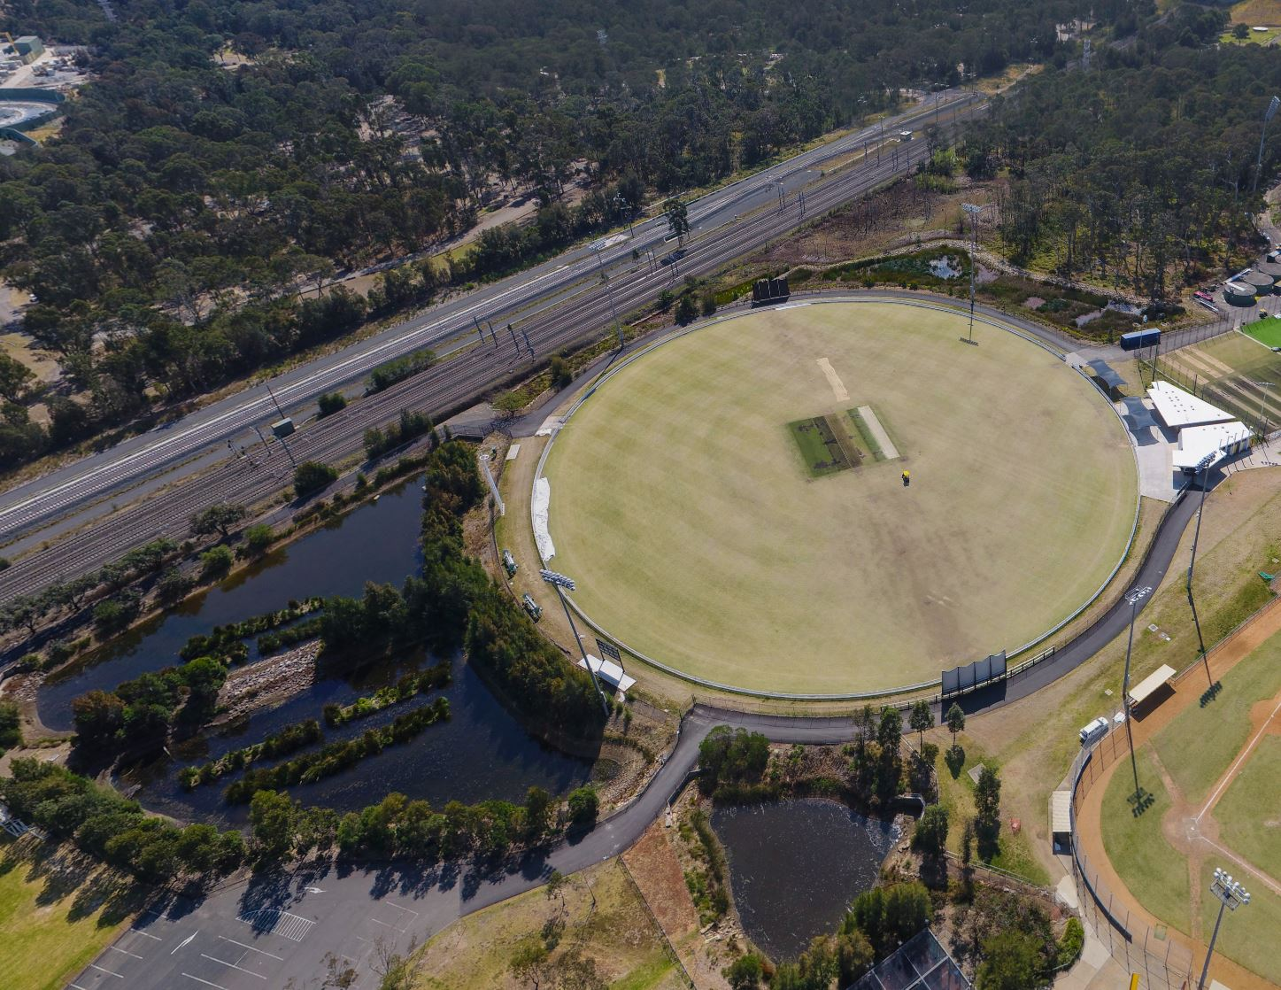

Source: Cooperative Research Centre for Water Sensitive Cities

### Funding policy

As stated in the *Victorian Guide to Regulation*,[1] general Victorian government policy is that fees and user charges should be set on a **full cost recovery basis** because it ensures that both efficiency and equity objectives are met.

|  |
| --- |
| **Full cost recovery:** Offsets should recover the full lifecycle cost of offsets provided, at a minimum. |

Full cost recovery means that stormwater offsets should recover, at a minimum:

* all development and construction costs incurred by council for the off-site project
* all ongoing maintenance and operation costs
* all additional costs to council associated with running the stormwater offset funding mechanism
* a rate of return of capital so this can be used for asset renewal and to cover risk, and to repay any debt financing costs.

Depending on the availability of alternative funding sources (such as the council budget or external funds), council stormwater offset projects may be partly or fully funded by the Offset scheme.

Full cost recovery promotes the efficient allocation of resources by sending the appropriate price signals about the value of all the resources being used in the provision of government goods, services and/or regulatory activity.

All Offset scheme now running in councils in Victoria are achieving full cost recovery. All council schemes are priced above the lifecycle cost to council to implement, and below the average cost to developers on-site. This pricing approach builds in a buffer for councils in case project budgets overrun, or if assets underperform and need to be modified. All council schemes also allow for periodic review.

### Offset financial contribution basis

The financial contribution basis is what the developer pays for when they pay an offset. The Victorian Government recommends Victorian councils use Total Untreated Impervious Area (TUIA) as the offset financial contribution basis.

Figure 5: shows how this is shown as impervious area on a STORM or MUSIC modelling report.

Figure 6: shows an example of how councils use the STORM and MUSIC rating to convert the total impervious area to TUIA to calculate offset payments.

|  |
| --- |
| **Offset financial contribution basis:** Total Untreated Impervious Area (TUIA) should be used as the basis of the offset fee. Using untreated impervious area means councils can change the underlying fee calculation without having to change the financial contribution basis. |
| **Offset financial contribution basis unit of measure:** Councils should have a single financial contribution basis unit of measure for all eligible developments, preferably per square meter. This reflects the principle that a square meter of impervious area has the same impact irrespective of the development type. |
| **Offset financial contribution basis uniform rate**: As part of developing the fee schedule, councils should determine whether a uniform per square meter financial contribution basis is appropriate, given it is simpler for developers to understand and for council to implement. |

Using TUIA, as compared to other metrics such as kilograms of nitrogen (TN kg), has several advantages for council, including:

**The basis of the calculation remains the same.** The basis of the financial contribution does not need to change if the underlying basis for calculating the contribution does. For example, if a council decides to change how it calculates the fee the financial contribution basis would not change – i.e. developers would continue to pay for TUIA.

**Consistency across councils can be achieved.** If all councils use a TUIA per square meter financial contribution basis – for example, using a consistent measurement basis from STORM and MUSIC reports – the approach is more accessible to developer applicants.

The toolkit of resources includes a calculator that councils can use to calculate Total Untreated Impervious Area (TUIA). Access the resources [here](https://marsdenjacob.sharepoint.com/:f:/r/sites/DEECAStormwaterOffsetGuideline/Shared%20Documents/Toolkit?csf=1&web=1&e=fGVxA0).

Figure 5: Example impervious area (m2) in a BlueFactor STORM Report

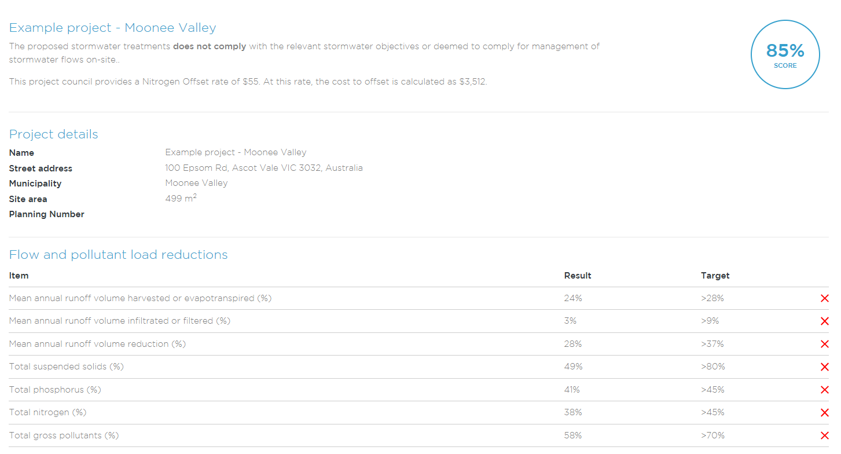

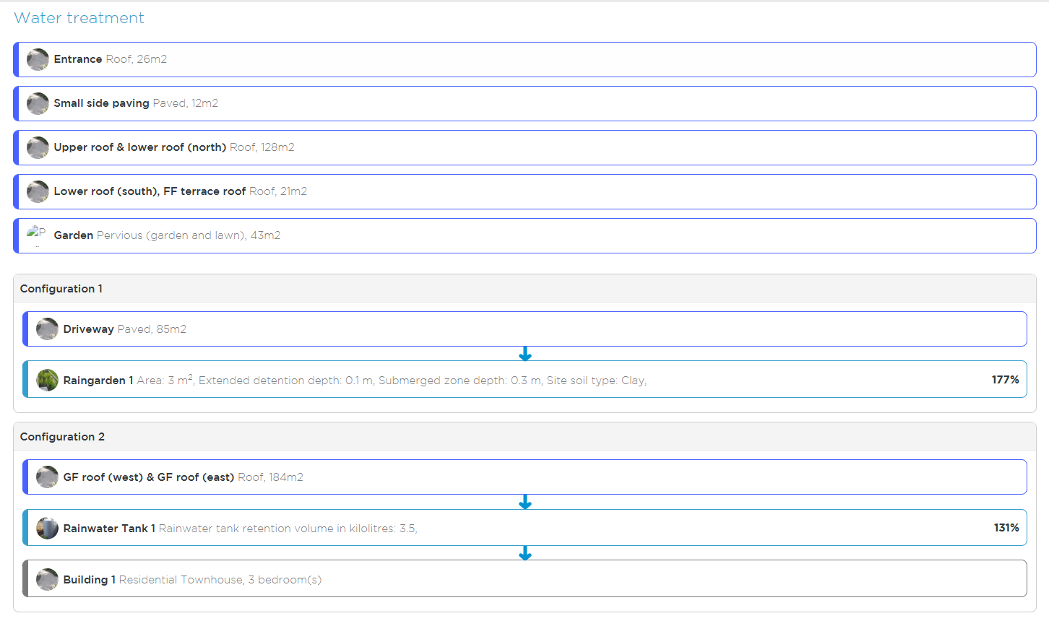

**Figure 6: Example of how untreated impervious area (m2) is used as the financial contribution basis for stormwater offset contribution by the City of Moonee Valley in their stormwater offset purchase agreement.**

The City of Moonee Valley stormwater offset purchase agreement is [available to download here](https://mvcc.vic.gov.au/wp-content/uploads/2020/03/WSUD-Voluntary-Contribution-Purchase-Agreement-Form-1.pdf).

### Offset fund management

|  |
| --- |
| **Offset fund management:** Funds collected and administered must be managed in accordance with financial management (Part 7) and planning and accountability (Part 3) requirements of the *Local Government Act 1989*. All money in the account must be used solely for the provision of WSUD infrastructure investments and maintenance assets.[2] |

All offset contributions received by council must be held in a specific interest-bearing reserve account. Funds collected and administered must be managed in accordance with the financial management (Part 7) and the planning and accountability (Part 3) requirements of the *Local Government Act 1989*.

All money in this account must be used solely for the provision of stormwater offset infrastructure investment, operation, and maintenance. Councils must establish an audit process to validate items that are being drawn from the reserve.

### Monitoring, evaluation, reporting and improvement framework

|  |
| --- |
| **MERI public disclosures:** Council schemes should develop public facing offset registers, showing offsets committed and delivered. Preferably this will be spatial data showing the location of offset projects, and the (approximate) location of the developments where offset payments have come from. |
| **Victorian Government Guidance, MERI performance verification:** As part of MERI, councils should undertake selected asset performance verification to show that the offset obligation is being delivered. This should be conducted by an independent third party. Since it is not practical or cost-effective for performance to be measured for all assets, the selected assets should be used as reference sites to demonstrate that, where assets are appropriately maintained, similar performance can be expected from other assets with similar design and construction. |
| **MERI offset review:** Councils should commit to a schedule for reviewing their offset mechanisms. |

Councils must report on stormwater offset expenditure and related activities and outcomes. Reporting will provide a valuable method of engaging with the community and other stakeholders on improvements made to local stormwater management.

As part of implementing Offset schemes, councils should set up quality assurance and reporting processes to demonstrate value for money and the achievement of objectives that could potentially link to existing performance monitoring processes.

All councils offering offsets should contribute towards a collective program of reference sites. This may be either through establishing and monitoring one or more sites or contributing towards a broader program to support other Councils providing reference sites.

Our recommendation is that councils review their offset scheme **every 18 months in the first three years of operation**. The review should include:

* offsets committed and achieved
* each offset’s performance against the Principle of Equivalence
* an evaluation of participation rates
* an evaluation of why applicants are participating and why they are not
* a review of constructed asset performance.

# Appendix 1: Steps in setting up stormwater offset schemes

There are 10 key steps to setting up a council run offset scheme. This section includes further detail on each of those key steps, as well as useful resources available.

This Appendix should be read in conjunction with the content of this document, particularly Chapters 4 and Chapter 5.

#### Early Engagement

|  |
| --- |
| Consult with a cross-section of the local development industry early to inform, clarify and manage expectations of the proposed scheme. It is also important to receive developer feedback on suggested contribution rates (and associated likely buy-in), to understand likely participation levels, and identify support needed for adoption. |
| If necessary, raise local community awareness about the importance of council projects to secure their willingness and acceptance. Large-scale council WSUD projects are usually more cost-effective for removing stormwater pollutants than small-scale on-site systems. The community receives the other benefits that WSUD assets provide including passive irrigation and urban cooling. Often, it’s easy to garner support if a community is closely connected to a significant waterbody such as a river, lake or the sea.[3] |

A key learning from Victorian councils that have implemented stormwater offsets is that it is very important to engage early with:

* council planners working with developers and granting permits
* council staff working in WSUD delivery
* councillors early in the process.

It is important that all these people are involved at all stages. A collaborative approach ensures council officers and developers understand detailed operational aspects and constraints of the scheme and have confidence in it. It also helps ensure the various planning, environmental, engineering, and administrative departments within council (as well as partner agencies, such as water corporations) have buy-in to the process and can work together towards the same project outcomes.[4]

Early engagement is fundamental to ensuring successful development of the offset scheme. Early internal and external engagement should be considered.

As an early step, council may consider consulting with developers and external stakeholders about introducing an offset scheme. This enables council to test initial appeal and confirm anecdotal information on whether an offset scheme would have appeal.

Consultation with Victorian councils that have established stormwater offset schemes already will also be of benefit. Information about suitable approaches and lessons learned can be incorporated into the process.

## Step 1: Define the eligibility criteria

|  |
| --- |
| **Eligibility criteria**: Refer to guidance in Section 5.1 (Eligibility) of the body of this document. |

Councils should develop draft eligibility criteria early on. Section 5.1 in the body of this document provides guidelines for determining eligibility.

## Step 2: Identify off-site solutions

|  |
| --- |
| **Identifying off-site solutions and cost effectiveness**: To develop an offset scheme, councils need to identify and prioritise council managed stormwater asset opportunities. This should ultimately be refined into a recommended program of works. The recommended assets must be supported by a concept design considering risks and constraints, MUSIC modelling and lifecycle costs. It is essential that councils invest adequate time, funds and research to determine the location of these assets. |

Strategic planning to identify the key stormwater treatment asset site opportunities across a municipality is an important step in setting up a council offset scheme.

Opportunity identification is based on site feasibility, with potential stormwater management sites prioritised accounting for the asset’s life cycle costs and their ability to deliver multiple beneficial outcomes (such as, waterway improvement, water supply security, urban greening, enhanced liveability, etc.).

This strategic planning is an important and robust method of estimating the financial costs to council of operating Offset scheme, as well as transparency on how the offsets will be invested to deliver enhanced community and urban design outcomes.

The prioritised stormwater management assets should be developed by assessing:

**Site identification:** Consider factors such as available treatment area, catchment flow volumes, proximity to drainage and site slope.

**Opportunity and feasibility assessment:** Include concept design of functional components considering optimal sizing to balance catchment yields, available treatment footprint and reuse demands. This assessment must also consider opportunities for integration, site constraints including contamination, services, flooding and competing demands.

**Screening of opportunities by council staff:** Take local knowledge and considerations into account.

**For screened-in options, evaluating the capital cost:** Include the cost of the land where applicable, along with annual operating and maintenance costs, and the useful life of the asset/s.

**For screened-in options, evaluating the stormwater metrics achieved:** Include flow volume, baseflow, the volume of stormwater harvested for reuse and, where applicable, the stormwater quality treatment metrics achieved (TSS, TP and TN).

**Review of screened-in projects by council and stakeholders:** Review for prioritisation and selection of projects to form the capital works program.

**Further development of priority projects to at least functional design:** Include further studies, such as survey and services proving geotechnical and cultural heritage aspects as well as community consultation.

Ideally the above approach should include iteration of the opportunities and priority projects through consultation with stakeholders.

As shown in Figure 7, the toolkit includes a sample spreadsheet for assessment of:

* council offset asset opportunities
* preliminary estimation of pollutant load
* reuse and cost assessments included in the toolkit.

Access the resource [here](https://www.water.vic.gov.au/water-sources/diverse-water-sources/improving-stormwater-management/council-stormwater-resources).

The box below lists principles that councils should adopt when identifying, designing and prioritising assets in a council offset works program.

|  |
| --- |
| Box 6: Principles that councils should adopt for identifying, designing, and prioritising assets in a council offset works program  All assets should be designed in accordance with water sensitive urban design (WSUD) principles (Victoria Stormwater Committee, 1999) and should aim to:   * Protect natural systems * Reduce runoff volumes and peak flows * Protect water quality * Reduce potable water demands * Integrate stormwater into the landscape * Add value while minimising costs to deliver the greatest overall benefit to the community.   Offset opportunities must be designed in accordance with relevant guidelines including:   * [Wetland Design Manual (Melbourne Water, 2018)](https://www.melbournewater.com.au/building-and-works/developer-guides-and-resources/standards-and-specifications/constructed-wetlands) * [Biofiltration systems in development services schemes guidelines (Melbourne Water, 2020)](https://www.melbournewater.com.au/building-and-works/developer-guides-and-resources/standards-and-specifications/biofiltration) * [MUSIC Modelling Guidelines (Melbourne Water, 2018)](https://www.melbournewater.com.au/building-and-works/developer-guides-and-resources/guidelines-drawings-and-checklists/guidelines)   A functional design including survey and services proving as well as appropriate geotechnical and other relevant studies is recommended for selected priority assets forming the adopted program of capital works.  Comparison should be made to identified ‘reference’ monitored sites to confirm likely performance outcomes of proposed council assets. Site constraints and risks must be assessed and considered. Where uncertainties exist, further investigation is recommended. Cost effectiveness assessment to follow best practice approaches including consideration of the full life cycle and application of an appropriate discount rate, span of analysis and expected lifespans of assets. |

Figure 7: Example council offset asset opportunity summary from prioritisation resource

## Step 3: Estimate demand by development type and region

|  |
| --- |
| **Estimating demand for offsets**: Forecast demand for offsets using a range of opt-in assumptions. This will allow councils to understand how quickly off-site measures may be constructed under a range of opt-in scenarios. |

The likely demand for an offset scheme can be estimated by developing a forecast of the expected new development within the council. Existing council strategies and Victorian Government information can be used to develop the forecast demand. These are listed below:

Council Development Contribution Plan

Council Housing and Settlement Strategy

[Victoria in Future](https://www.planning.vic.gov.au/land-use-and-population-research/victoria-in-future) – State Government of Victoria Land use and population research

Councils should conduct sensitivity analyses on demand forecasts to understand a range of possible offset compliance and fund inflow scenarios. As part of this, councils new to the process could consider speaking with councils who have already implemented Offset schemes to understand:

the demand forecasts they developed when planning the schemes

the actual take-up of offsets since the scheme started

what is driving demand.

Access the resource [here](https://www.water.vic.gov.au/water-sources/diverse-water-sources/improving-stormwater-management/council-stormwater-resources).

## Step 4: Evaluate cost effectiveness and calculate offset financial contribution price

|  |
| --- |
| **Financial contribution basis**: Refer to section 3.2 in the body of this document. Full cost recovery, offset financial contribution basis, set with regards to minimum. |

A basic premise of an offset scheme is that some applicants’ stormwater quality treatment obligations can be delivered more cost-effectively via off-site council assets than via on-site stormwater treatment.

Sections 5.3.3 and 5.3.4 in the body of this document set out the Victorian Government’s guidance on funding policies and the basis.

It is also prudent for councils to include contingency allowances in costing council assets, given council assets may not perform as expected, or may need rectification.

To set a price for offsets council needs to know:

1. What it will cost council to operate the scheme.
2. What the willingness to pay of applicants may be.

The offset price is then set with reference to these lower and upper bounds.

Key inputs to this activity are:

The prioritised off-site solutions identified through Step 2 (identify off-site solutions).

A representative sample of on-site development assets from development applications submitted to council. On-site cost reference points can be estimated from this sample.

**How to estimate the offset fee:**

The offset fee is estimated as a financial rate. The estimate is set with consideration of the range of cost for treatment where the cost of on-site treatment is the upper bound and the cost of council asset treatment is the lower bound.

In estimating the financial rate, the capital cost of on-site treatment assets is included and the annual operational cost is included as well.

For on- and off-site costs, include the cost of land.

Council should also include relevant overhead costs for scheme administration, and monitoring and reporting where costs are incurred over and above existing processes.

The toolkit includes a sample template that councils can use to estimate the offset fee called the Offset Calculation Tool.

## Scheme Payment Calculation for Developments:

Total impervious area of the site X

Percentage variance (100% - STORM Rating %) X

$XXXX (Stormwater offset scheme rate)

=

$ Stormwater offset scheme payment amount

Impervious areas include:

* roofs
* roads
* driveways
* sealed paths and patios
* swimming pools and sealed surrounds
* other sealed surfaces such as tennis courts etc.

## 

## Step 5: Draft new stormwater compliance process and guidelines

|  |
| --- |
| **Guidance for developers**: Guidance should be consistent with guidance from other councils already running schemes, where practicable. |

In Step 5, councils should prepare new draft compliance processes and developer guidelines. An example of the modified internal process based on the City of Darebin offset scheme study is provided in the Toolbox: [Example compliance process.](https://marsdenjacob-my.sharepoint.com/:p:/r/personal/jcheesman_marsdenjacob_com_au/Documents/DELWP%20stormwater%20offset%20guidance/Toolkit/2.4%20Darebin%20Process%20Map%20201223.pptx?d=wcd363bf202af4a65af19f2eb8c76f985&csf=1&web=1&e=1JTdbk)

This step enables the council project team to:

Investigate existing processes and identify the key point where the new offset scheme will be introduced to applicants.

Gain internal clarity and agreement on current processes and proposed changes. It is important to include council planners, engineers and compliance officers in this process.

Confirm and clarify where the council will initially communicate the options available to development applicants and confirm their approach to satisfying the stormwater quality treatment obligation.

Clearly identify the steps in the process where council can exercise their discretion in offering the Offset scheme to applicants.

***Based on the experience of councils already running offset schemes, it is recommended that discussion about the offset scheme and options available be held early in the application process.***

Once agreed, the revised internal process will be an input to designing the revised development application guidelines.

## Step 6: Undertake internal consultation and obtain approval from council to implement

|  |
| --- |
| A council resolution should be obtained to trial the offset scheme. Councils may choose to trial the offset mechanism for a certain period of time. |

A formal council resolution should be obtained for the Offset scheme. Several Victorian councils who have already established offset schemes have chosen to approve pilots first. These pilots typically run for 2-3 years. The completion of this step ensures that there is:

internal clarity in the proposed changes to be made by introducing the offset scheme, and

council approval is achieved in order to proceed with external consultation, with the intent to implement the scheme.

Internal consultation can be gained through the development of the offset scheme by including relevant council officers that interact with the scheme.

Established council processes may be followed to gain council approval. The content to be included in gaining council approval may be customised to suit. Key input elements include:

Legal basis (see Section 3)

Funding policy (5.3.3), offset financial contribution basis (5.3.4), and monitoring and evaluation (5.3.6)

## Step 7: Undertake external consultation to seek feedback on the proposed scheme

|  |
| --- |
| **Victorian Government Guidance:** This step is the culmination of steps 1 to 6 and enables council to communicate the proposed stormwater offset scheme with key external stakeholders. |

The Mornington Peninsula Shire stormwater [offset scheme consultation page](https://shape.mornpen.vic.gov.au/stormwater-lieu-contribution-scheme) is an excellent example of how councils can engage with stakeholders and seek feedback on a proposed scheme (Figure 6). Many Victorian councils who have successfully established Offset schemes have generously indicated they are willing to share samples of stakeholder engagement contents including briefing packs on the proposed scheme, feedback survey templates and other resources.

Relevant key stakeholders and input information is listed below.

#### Melbourne Water

For councils in Melbourne Water’s operating area, it is important that they inform Melbourne Water of the proposed Offset scheme and seek feedback. If the existing process referred development applications to the Melbourne Water offset scheme, then the introduction of a council scheme would mean that development applications would no longer be referred to Melbourne Water.

Melbourne Water may also be interested to confirm that the Offset scheme ensures that protection for priority catchments is maintained. This should be completed as outlined in Section 5.1 in the body of this document.

#### Councils with offset schemes

Consultation with other Victorian councils that have implemented Offset schemes may provide insights and lessons learned from their implementation that can be applied to new schemes.

#### Development community

The development community may include developers and development planning and design consultants. Consultation with these people is key to ensuring buy-in and interest in the proposed Offset scheme from the development community. It enables council to gain an understanding of the appeal of the proposed offset scheme, the fee and revised approach from the development community.

Key inputs to engaging with the development community include:

Rationale and alignment with Victorian Planning Policies

Eligibility (Section 5.1)

Core principles (Section 6.2)

Offset Financial contribution basis (Section 5.3.4)

Modified development application process (Step 5)

We also recommend including several worked-up examples of the stormwater quality treatment cost with and without the proposed scheme. This can be developed from past development applications.

## Step 8: Set up fund administration, reporting and governance

|  |
| --- |
| **Offset fund management:** Funds collected and administered will be managed in accordance with financial management (Part 7) and planning and accountability (Part 3) requirements of the *Local Government Act 1989*. All money in the account must be used solely for the provision of WSUD infrastructure investments and maintenance assets to meet or exceed offset stormwater obligations transferred to council. |

The contributions received by council should be held in a specific interest-bearing reserve account. When enough funds are accumulated in the reserve account, funds can be released to fund the next stormwater treatment asset. Maintenance funding will be deducted from the reserve. Council should establish an audit process to validate items are being drawn from the reserve.

Funds collected and administered must be managed in accordance with financial management (Part 7) and planning and accountability (Part 3) requirements of the *Local Government Act 1989*.

Figure 6: Stormwater offset key stakeholder consultation

All money in this account will be used solely for the provision of WSUD infrastructure investments and maintenance assets. Council may choose to implement the WSUD assets in order of priority. There is no specific requirement to deliver the assets in the prioritised order though. The key is to ensure that the funds allocated are utilised to develop council-owned stormwater treatment assets that meet the stormwater quality treatment obligation that has been transferred to council through the scheme.

Council will need to provide regular monitoring, reporting and review of the monies received and expended through a separate set of annual, audited financial statements. Council will determine the timing of these audits. These audits can occur as part of council’s other auditing requirements.

## Step 9: Develop a formal policy and implement the stormwater offset scheme

|  |
| --- |
| **Council stormwater offset policy:** councils should prepare a stormwater offset policy before they commence the stormwater offset scheme. |

Upon successfully completing steps 1 to 8, the offset scheme can be implemented.

**As a general principle,** Councils should establish a formal stormwater offset policy before commencing the stormwater offset scheme. The policy should describe the stormwater offset scheme’s intent, its scope, eligibility, charging basis, conditions, fund administration and expenditure, reporting and other matters.

Key considerations when implementing a stormwater offset scheme include:

**Trial or implement with review period:** As discussed at Step 6, council may wish to introduce the scheme as an initial trial with provision to review at a prescribed time. This enables council to test the initial acceptance of the scheme and review performance against modelled outcomes.

**Communication material and website content** will need to be developed as outlined in Step 5 and Step 7.

## Step 10: Monitor, evaluate and report

Councils should use a monitoring, evaluation and reporting framework, as outlined in Section 5.3.6 in the body of this document.

# Appendix 2: Frequently Asked Questions

### Q: Does opting into an offset scheme mean that my statutory obligations for stormwater management are met?

No, opting into an offset scheme does not offset other statutory obligations, such as GED under the EP Act. Under the GED, the expectation is that developers will reduce the risks of all potential stormwater pollutants, including those in the BPEM, so far as reasonably practicable on-site. See Section 2.1 Statutory Obligations.

Stormwater requirements other than the stormwater quality aspects of BPEM, such as those to reduce the risk of flooding, or to minimise the impact of chemical pollutants and other toxicants in stormwater runoff also remain.

### Q: Can stormwater offset funds collected be used to rectify or upgrade existing stormwater management assets?

Yes, but only if the rectification and/or upgrading of existing stormwater management assets creates stormwater quality treatment outcomes that are additional to the ‘business as usual’ level of investment in stormwater management that would have occurred if the offset funds were not available. See Section 5.2.1.

### Q: Can councils use funds raised from stormwater offsets to fund a compliance officer to resource activities not related to stormwater?

No, stormwater offset funds should not be used to invest in activities other than those related to stormwater quality treatment.

### Q: How is the offset calculated for a dual-use basin, that is, a basin which has the capacity to act as a stormwater detention basin as well as a stormwater quality improvement basin?

Stormwater offsets are calculated with reference to the lifecycle costs of the council providing stormwater quality treatment, and with reference to the costs developers would face if they achieved their stormwater quality compliance obligations at the development site (refer to Step 4). It is important to note that the offset is calculated based on a suite of stormwater quality treatment assets across the council. This considers assets that deliver stormwater quality treatment across multiple basins.

For multipurpose stormwater treatment assets, council should calculate the lifecycle cost on a ‘standalone basis.’ This means that council should calculate the cost of the stormwater detention basin as if it was only providing stormwater quality improvement. Doing this isolates the costs attributable to developers who have transferred their stormwater quality treatment obligation to council.

### Q: Can stormwater quality offsets only be used in areas where there is no Development Services Scheme (DSS). How can councils that have a DSS utilise the Offset scheme?

Council stormwater offset schemes only apply in areas where a DSS does not operate – see Section 5.1.2. Councils can still operate stormwater offsets in areas outside DSS within their council area.

### Q: There is a lot of vacant land subdivision occurring in some municipalities. How do councils include these developments in the Offset scheme?

Refer to Section 5.1.3. Vacant land subdivisions are currently not included within Clause 53.18 of the Victoria Planning Provision. Therefore, vacant lot subdivisions are not automatically included within stormwater offset schemes. Several Victorian councils have investigated approaches for vacant lot subdivisions within their offset schemes. Recommendations include:

* Councils first conduct analysis to quantify the number of subdivision applications that result in development applications for one dwelling on a lot. This will inform whether there is merit in including vacant lot subdivisions within the in-lieu scheme and amending the process accordingly.
* If there is a significant number of these applications, then councils can seek to establish a separate in-lieu fee. This fee could be based on the total area of subdivision and the relative density ratio of new subdivision developments in the council area. Melbourne Water also publishes density ratios used for calculating developer charges. These could be used by councils if council density ratios are not available.

### Q: What is the risk that a council-based stormwater offset scheme could be subject to challenge through VCAT or other avenues?

Some form of review at VCAT or appeal to the Supreme Court is unlikely due to stormwater offset schemes being voluntary. In addition, stormwater offsets do not constitute a development contribution of the type contemplated under the *Planning and Environment Act 1987*.

### Q: When and how should councils include planners and other people in council, and developers, when developing the scheme?

We discuss this under Early Engagement.

A collaborative approach ensures council officers and developers understand detailed operational aspects and constraints of the scheme and have confidence in it. It also helps ensure the various planning, environmental, engineering and administrative departments within council (as well as partner agencies, such as water corporations) have buy-in to the process and can work together towards the same project outcomes.

Early engagement is fundamental to ensuring successful development of the council stormwater offset scheme. Initial internal and external engagement should be considered.

As an initial step, council may consider consulting with developers and external stakeholders about introducing a stormwater offset scheme. This enables Council to test initial appeal and confirm anecdotal information on whether an offset scheme would have appeal.

Initial consultation with other Victorian councils that have already established stormwater offset schemes will also be of benefit as information about suitable approaches and lessons learned can be incorporated into the new process. Access examples of this material on the council sites – [Mornington Peninsula](https://www.mornpen.vic.gov.au/Environment/Water/Stormwater-Quality-in-lieu-Contribution-Scheme) and [Kingston](https://www.kingston.vic.gov.au/property/property-managment/drains-and-stormwater/stormwater-requirements-for-developers#section-2).

### Q: Are offsets required for volumetric objectives under EPA urban stormwater guidance?

[1739.1: Urban stormwater management guidance](https://www.epa.vic.gov.au/about-epa/publications/1739-1) is provided for developers who create new impervious surfaces, such as roads, subdivisions and other developments. It supports these parties to minimise the risks to human health and the environment from their design, planning and development activities, as the EPA [general environmental duty](https://www.epa.vic.gov.au/about-epa/laws/laws-and-your-business/general-environmental-duty-for-businesses) requires. It also supports those involved in the assessment of urban stormwater treatment proposals.

The guidance and the volumetric objectives in the guidance are not mandatory for developers. The volumetric objectives are not in the Victorian Planning Scheme or the *Planning and Environment Act 1987*.

Because of this, stormwater offsets have not been developed to meet volumetric objectives at this time. Councils may consider establishing stormwater volume targets in local planning policies, and offsets could be offered through this scheme. Councils seeking to do this are encouraged to discuss with DEECA, and to receive legal and planning advice in the first instance.

### Q: Can offset projects be in a different catchment to the development?

Yes. Victorian councils can set up schemes in a different catchment to the development if the offset is within the same municipality. When identifying where to locate offset projects, councils should have regard to the equivalence principles discussed in Section 5.2.3.

### Q: Can developers choose between the Melbourne Water and council offset rate?

No. Where a council stormwater offset scheme is operating, the Melbourne Water offset scheme is not available to developers (unless the proposal falls within a DSS). Melbourne Water will [direct developers to council as the referral authority](https://www.melbournewater.com.au/building-and-works/apply-to-build-or-develop/stormwater-quality-offset-contribution), and Councils will refer developers to the council offset scheme.

### Q: How does a local council offset scheme differ from the Melbourne Water offset scheme?

Historically, Melbourne Water’s offset scheme was established in the absence of local government offset schemes, providing a foundational framework for managing stormwater quality impacts (on nutrient levels in Port Phillip and Wester Port Bays) and where developments cannot meet BPEM on-site under Clause 56 of the VPPs.

A stormwater quality offset contribution is collected from developers by Melbourne Water after evaluation and approval by council to ensure developments meet best practice standards. This contribution is applicable to developments under 1 hectare and is contingent upon council assessment and Melbourne Water's approval, particularly when on-site Water Sensitive Urban Design (WSUD) is deemed impractical. The application process requires developers to submit council-certified development plans and stormwater assessments for review and endorsement. After review, Melbourne Water determines the contribution amount and issues an invoice outlining any conditions.

The contributions are used to build water quality treatment measures elsewhere in Port Phillip and Westernport catchments to ‘offset’ the impact of developments.

The stormwater quality offset contributions are determined based on rates derived from the volume of total annual nitrogen, as nitrogen is typically the limiting stormwater quality pollutant. This is based on the understanding that if nitrogen retention targets are achieved, then phosphorus and suspended solids objectives are also achieved.

Melbourne Water is currently reviewing its pricing of offsets, which do not include land or maintenance costs and are therefore substantially lower than local council schemes. The review of Melbourne Water’s offset scheme is likely to result in greater alignment and consistency with the processes and pricing associated with local government schemes. For instance, council offset scheme fees factor in the cost of land and maintenance (as well as capital costs) to ensure sufficient funds are collected to implement the scheme and offset impacts (from developments that have opted into the scheme) to build, operate and maintain the assets.

Melbourne Water collects/manages funding and construction of stormwater quality assets in some areas with Drainage Services Schemes (DSS). If a development proposal falls within a Melbourne Water DSS area, it will be subject to the conditions of that scheme. Alternatively, if a development proposal is not located within a DSS but within an area where a council stormwater quality offset scheme is in place, the developer will be referred to the council offset scheme.

Should a local stormwater quality offset not be accessible, developers are permitted to use Melbourne Water's offset scheme via their local council until they can create their own offset arrangements. It is highly recommended that all local governments establish their own stormwater quality offset schemes. Refer to Stormwater quality Offset Scheme Guidance (insert link) for more information.

### Q: How do offsets work in Melbourne Water Healthy Waterways Strategy stormwater priority areas?

Refer to Section 5.1.5. In the Greater Melbourne area, Melbourne Water’s [Healthy Watereways Strategy 2018-28](https://healthywaterways.com.au/) identifies stormwater and other areas of higher environmental priority. Councils can use the [Healthy Waterways mapping tool](https://healthywaterways.com.au/map) to identify the environmental priority of receiving waters in their council area. Councils should consult with Melbourne Water if they are considering setting up stormwater offset sites or permitting stormwater offsetting in high to very high stormwater condition areas. Stormwater offsetting may be unsuitable for high and very high stormwater condition areas.

1. See Section 3.2.13 of the Victorian Guide to Regulation.
2. Central and Gippsland Region Sustainable Water Strategy Actions 5.1 and 5.5.

   *Use diverse water sources to protect public spaces (5.1)* and *Improve stormwater management for greener environments and healthier waterways (5.2).*
3. <https://watersensitivecities.org.au/wp-content/uploads/2020/09/200917_V3_MVCC-Stormwater-Quality-1.pdf>
4. <https://watersensitivecities.org.au/wp-content/uploads/2020/09/200917_V3_MVCC-Stormwater-Quality-1.pdf>