Planning permit applications in special water supply catchment areas
deeca.vic.gov.au

We acknowledge and respect Victorian Traditional Owners as the original custodians of Victoria’s land and waters, their unique ability to care for Country and deep spiritual connection to it.
We honour Elders past and present whose knowledge and wisdom
has ensured the continuation of culture and traditional practices.
DEECA is committed to genuinely partnering with Victorian Traditional Owners and Victoria’s Aboriginal community to progress their aspirations.
© The State of Victoria Department of Energy, Environment and Climate Action February 2024.
Creative Commons
This work is licensed under a Creative Commons Attribution 4.0 International licence, visit the Creative Commons website (http://creativecommons.org/licenses/by/4.0/).
You are free to re-use the work under that licence, on the condition that you credit the State of Victoria as author. The licence does not apply to any images, photographs or branding, including the Victorian Coat of Arms, and the Victorian Government and Department logos.
ISBN 978-1-76136-506-5 (Print)
ISBN 978-1-76136-507-2 (pdf/online/MS word)
Disclaimer
This publication may be of assistance to you, but the State of Victoria and its employees do not guarantee that the publication is without flaw of any kind or is wholly appropriate for your particular purposes and therefore disclaims all liability for any error, loss or other consequence which may arise from you relying on any information in this publication.
Accessibility
To receive this document in an alternative format, phone the Customer Service Centre on 136 186, email customer.service@delwp.vic.gov.au, or contact National Relay Service on 133 677. Available at DEECA website (https://www.water.vic.gov.au/catchments/special-water-supply-catchment-areas).

Contents
Planning permit applications in open, special water supply catchment areas 2
Purpose of the Guidelines 2
Where do these Guidelines apply? 2
What is an open, special water supply catchment area? 3
Who should refer to the Guidelines? 3
What state planning and environmental policy applies to open, special water supply catchment areas? 4
Planning policy 4
Environment protection policy 5
Implementing the Guidelines 6
The Policies 6
Policy 1: Density of dwellings and other activities requiring onsite wastewater disposal 6
Policy 2: Effluent disposal and OWMS maintenance 8
Policy 3: Vegetated corridors and buffer zones along waterways 9
Policy 4: Buildings and works 9
Policy 5: Agricultural activities 9
Further information 10
Use and development referrals for planning permits 10
References 11
Appendix 12
Calculating dwelling density 12

Planning permit applications in open, special water supply catchment areas
Annotation from Minister for Water
As the Minister for Water and my responsibilities under the Water Act 1989, I issue the following guidelines to assist water corporations and other referral and responsible authorities in their assessment of planning permit applications for use and development of land within all open, special water supply catchment areas in Victoria. These guidelines have been adopted for the purposes of s.60(1A)(g) of the Planning and Environment Act 1987. This guidance document replacing Planning permit applications in open, potable water supply catchment areas, 2012, continues to ensure councils and water corporations align water quality considerations with the assessment and granting of planning permits. This guidance has also been incorporated into the OMLI (Urban stormwater management and onsite wastewater management) under the Environment Protection Act 2017 and is expected to be in effect by December 2023.
The Hon Harriet Shing MP
Minister for Water

Purpose of the Guidelines
The purpose of the guidelines is to protect the quality of source water for drinking water supplies, general domestic uses, and other beneficial uses, using a risk-based approach, whilst supporting appropriate development within special water supply catchment areas.
All land use requiring onsite wastewater disposal has the potential to generate cumulative impacts on water quality within open special water supply catchment areas. In acknowledgement of this, a guiding principle of the Guidelines is to minimise wastewater risks from dwellings and other waste generating uses within open special water supply catchment areas. Other wastewater generating uses may include, but are not limited to, animal production and intensive agricultural activities, as well as activities related to restaurants, wineries, hotels, group accommodation, host farms, camping and caravan parks.

Where do these Guidelines apply?
The Guidelines apply to all open water supply catchment areas declared to be special water supply catchment areas under Division 2 of Part 4 of the Catchment and Land Protection Act 1994. To find out all current declarations and which special water supply catchment areas (SWSCA) are open and their location, refer to Department of Energy, Environment and Climate Action (DEECA)’s MapshareVic tool at https://mapshare.vic.gov.au/mapsharevic/.
The Guidelines are a relevant consideration for all planning permit applications to use and/or develop land in special water supply catchment areas. Responsible authorities should consider the Guidelines as relevant when making decisions about applications in these declared catchment areas. Assessment of a planning permit application against relevant local policies and requirements of the Guidelines encourages water quality considerations are considered in planning decisions.
Where a planning permit is not triggered for a use and/or development, the policies and requirements outlined within the Guidelines can still be applied as a means of good practice relating to the land use and development within special water supply catchment areas. This would be in addition to ensuring compliance with any other relevant requirements under environment protection laws, agricultural sector legislation, policies, strategies, guidelines and/or best practice measures (such as individual farm management plans).

What is an open, special water supply catchment area?
A special water supply catchment area is a formally recognised and declared catchment that provides water resources for drinking water and domestic water supply purposes, under the Catchment and Land Protection Act 1994. There are two types of special water supply catchment areas. An ‘open’ catchment is where part or all the catchment area is in private ownership and is subject to various land uses and development. A ‘closed’ catchment means that the whole of the catchment area is land managed or owned by water corporations and public access is prohibited.
Protecting the quality of raw water is important as it is a key principle in safe drinking water risk management and is the regulatory responsibility of Water Corporations. Catchment Management Authorities may also play a role in protecting water quality in line with their Regional Waterway Strategy priorities and objectives. Maintaining water quality in rivers, lakes and reservoirs is the first step in the drinking water supply process. Most special water supply catchment areas have a long history of regulation aimed to protect public health by maintaining acceptable levels of water quality flowing into, and stored in, the water storage. This has protected communities from waterborne diseases and the need for excessive chemical treatment.
Water corporations do not have direct control over land in open, special water supply catchment areas, but may influence development and land use through the strategic and statutory planning process. However, because of the potential risks to public health, all use and development should be sited and managed appropriately by responsible entities to protect the quality of water collected from the catchment.
All land users within catchments need to be aware of the potential effect of their activities on water quality. Residential development and other waste producing land uses have the potential to impact adversely on water quality through the discharge of contaminated run-off and wastes, nutrient contributions, or sediment to waterways. These sources of pollutants present different levels of risk to catchments and are the focus of these guidelines.

Who should refer to the Guidelines?
The Guidelines are referenced in the Victoria Planning Provisions (VPP) and all planning schemes as policy documents, which include a range of requirements to protect the environment, human health, and amenity. These requirements include considering incompatible land uses, preventing harm to the environment, human health, and amenity, and addressing potential risks from contamination.
The Guidelines were prepared to assist responsible authorities, typically local government, and water corporations, when assessing a planning permit application for use and development of land within an open special water supply catchment area.
The Water Act 1989 provides the legal framework for managing water resources across Victoria, including catchment protection and effluent disposal. The Water Act 1989 confers powers on water corporations as referral authorities in the assessment of planning permit applications for onsite wastewater management systems (OWMS).
This works with section 55 of the Planning and Environment Act which requires that a responsible authority (usually a Council) provide a copy of an application to every person or body that the planning scheme specifies as a referral authority.
Referral authorities, for example a water corporation, are designated as either a ‘determining’ or ‘recommending’ referral authority. ‘Determining’ referral authorities can decide if the planning application should be granted and can require conditions to be included on planning permits to be issued. ‘Recommending’ referral authorities can make recommendations on a planning application, but a responsible authority (a Council) is not bound to comments or recommendations provided.
Clause 66.02-5 of the VPP however states that in special water supply catchment areas, water corporations are determining referral authorities.

What state planning and environmental policy applies to open, special water supply catchment areas?

Planning policy
The importance of catchment planning and management, water quality and integrated water management is specifically addressed in all planning schemes' Planning Policy Framework. A responsible authority must consider and give effect to the Planning Policy Framework when it makes a decision.
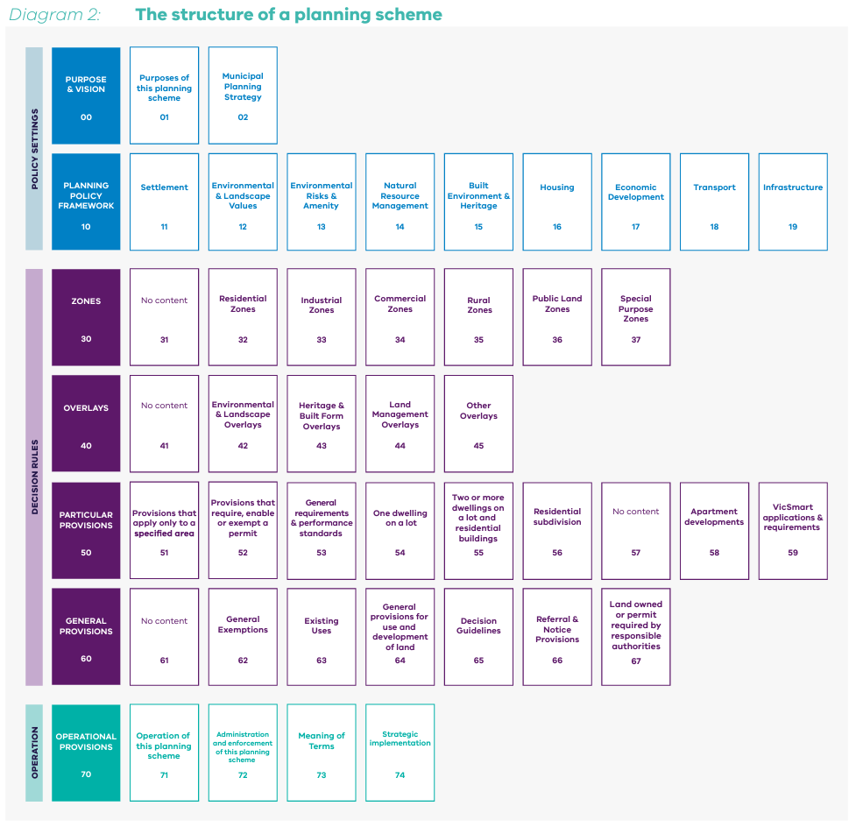
Rules
State Standard Referrals
66.02-3 Cattle feedlot
66.02-5 Special water supply catchment area
66.02-8 Extractive industry
Rules
Overlays
42.01 Environmental Significance Overlay
Policy clauses
14.02-1S Catchment planning management
14.02-2S Water Quality
19.03-3S Integrated water management
Source: Practitioners guide to Victoria’s planning schemes
The Guidelines have informed, can provide context to, or assist in the understanding of the following Planning Policy Framework clauses:
- Clause 14.02-1S (Catchment planning and management) sets out strategies to:
  - Ensure the continued availability of clean, high-quality drinking water by protecting water catchments and water supply facilities.
  - Retain natural drainage corridors with vegetated buffer zones at least 30 metres wide along each side of a waterway.
  - Require appropriate measures to restrict sediment discharges from construction sites.
  - Ensure planning is coordinated with the activities of catchment management authorities.
  - Planning authorities are required to have regard to relevant aspects of any regional catchment strategies approved under the Catchment and Land Protection Act 1994 and any associated implementation plan or strategy, including any regional river health and wetland strategies and any special area plans prepared under the Heritage Rivers Act 1992 and approved under the Catchment and Land Protection Act 1994

- Clause 14.02-2S (Water quality) sets out strategies to:
  - Protect reservoirs, water mains and local storage facilities from potential contamination.
  - Ensure that land use activities potentially discharging contaminated runoff or wastes to waterways are sited and managed to minimise such discharges and to protect the quality of surface water and groundwater resources, rivers, streams, wetlands, estuaries, and marine environments.
  - Discourage incompatible land use activities in areas subject to flooding, severe soil degradation, groundwater salinity or geotechnical hazards where the land cannot be sustainably managed to ensure minimum impact on downstream water quality or flow volumes.
- Clause 19.03-3S (Integrated water management)
  - The objective of the clause is to sustainably manage water supply and demand, water resources, wastewater, drainage, and stormwater through an integrated water management approach.
In consultation with local stakeholders, water corporations may also prepare catchment protection policies in the form of catchment management plans including water catchment risk assessments or similar, to address land use planning issues. The cumulative impact of OWMS in a special water supply catchment area may be captured in these plans. The local water corporation should be contacted for information about any catchment management plans.

Environment protection policy
The Environment Protection Act 2017 (EP Act) sets out the legislative framework for the protection of human health and the environment from pollution and waste as a responsibility shared by all levels of Government and industry, business, communities, and the people of Victoria.
The general environmental duty (GED) in section 25(1) of the EP Act establishes a prevention-based approach to environment protection and it requires a person who is engaging in an activity that may give rise to risks of harm to human health or the environment from pollution or waste must minimise those risks, so far as reasonably practicable.
The GED would require proactive consideration of the cumulative risk of existing and future OWMS on water quality, in open special water supply catchment areas, that can arise from increased dwelling density. This approach applies to all risks from development including the pathogenic risks from failing OWMS, increased nutrient and sediment loads from construction, and increased pesticides and fertilizers from agricultural activities.
The Environment Reference Standard (ERS) made under the EP Act, further identifies the environmental values that the Victorian community want to achieve and maintain, and it provides a way to assess those environmental values in locations across Victoria. Part 5 of the ERS sets out the environmental values relating to water, and it describes amongst other things, the indicators, and objectives for the protection of the water asset within specified catchment areas for its potable standard. This aligns with the Australian Drinking Water Guidelines which highlight the importance of a risk management approach in source water protection and establishes the precautionary approach as part of its guiding principles.
Orders made under section156 of the EP Act set obligations for managers of land and infrastructure in the management of infrastructure (OMLI) including OWMS. These obligations include a requirement for council areas with OWMS to develop and publish an Onsite Wastewater Management Plan (OWMP) to identify, assess and address the risks of harm to human health and the environment from these systems.
The Environment Protection Regulations 2021 (EP Regulations) are made under the EP Act and outline specific requirements for obtaining a permit to construct, install or alter an OWMS. The laws under the EP Act and EP Regulations relating to OWMS permits are administered and enforced by councils, who must refuse to issue a permit if it considers, amongst other things, that the activity specified in the application poses an unacceptable risk of harm to human health or the environment (Section 81(4)(b) of the EP Act).
The EPA provides further guidance in the Guideline for Onsite Wastewater Management Systems (in development), which outlines a risk-based approach to managing OWMS.

Implementing the Guidelines
The assessment of applications against the policies in the Guidelines (outlined below) should be appropriately considered on a site-by-site basis where a planning permit is required to use and/or develop the land for a dwelling or other activities requiring onsite wastewater disposal, or to subdivide land. The policies can assist in:
- guiding appropriate land use and development within a catchment area, including the location of and conditions on land use and development; and
- determining the areas where the management of existing onsite wastewater management systems requires additional focus.
Through strategic land use planning and with reference to catchment policies and onsite wastewater management plans, areas and causes of greatest risk can be identified and risk-based management responses determined.

The Policies
Each of the five policies under the Guidelines are set out below.
Where Policy 1 is identified to apply, Policies 2-5 should be addressed in support, to ensure that applications for dwellings which involve wastewater generating uses consider cumulative risk, broader onsite wastewater management planning, the protection of vegetated corridors and waterways, the potential impact of building and works and effluent disposal areas, and relevant agricultural activities.

Policy 1: Density of dwellings and other activities requiring onsite wastewater disposal
Where a planning permit is required to:
- use and/or develop land for a dwelling; or
- to subdivide land; or
- use and/or develop land pursuant to a schedule to an overlay specified in a planning scheme that has catchment or water quality protection as an objective:
  - the density of dwellings should be no greater than one dwelling per 40 hectares (1:40 ha); and
  - each lot created in the subdivision should be at least 40 hectares in area.
Where a planning permit is required for a use and/or development other than a dwelling which necessitates onsite wastewater disposal, the planning permit application for areas rated higher than low risk should provide the following information:
- A site-specific land capability assessment for the proposal which includes:
  - A plan which identifies all existing waste generating uses within a 1km radius of the proposal.
  - A statement on the potential cumulative impacts of the proposal and surrounding existing uses.
The above requirements for dwellings and other uses requiring onsite waste disposal does not apply under category 1 or 2 below.
Category 1
A planning permit is not required to use land for a dwelling, to subdivide land or to develop land pursuant to a schedule to an overlay specified in a planning scheme that has catchment or water quality protection as an objective.
Category 2
A permit is required to use land for a dwelling or other waste generating use, to subdivide land or to develop land pursuant to a schedule to an overlay specified in a planning scheme that has catchment and water quality protection as an objective, but the proposed development will be connected to reticulated sewerage.
Category 3
A catchment policy has been prepared for the catchment and endorsed by the relevant water corporation following consultation with relevant local governments, government agencies and affected persons. The proposed development must be consistent with the catchment policy.
Category 4
Where the existing development density exceeds or a proposal will result in a greater density then that of Policy 1, consideration of development will be given where all the following conditions in category 4 are met:
- the minimum lot size area specified in the zone for subdivision is met in respect of each lot.
- the water corporation is satisfied that the relevant Council has prepared, adopted, and is implementing an Onsite Wastewater Management Plan (OWMP) in accordance with the OWMP requirements (refer to requirements below); and
- the proposal does not present an unacceptable risk (i.e., cumulative risk) to the catchment having regard to:
- the proximity and connectivity of the proposal site to a waterway or a drinking water supply source (including reservoir).
- the existing condition of the catchment and evidence of unacceptable water quality impacts
- the quality of the soil.
- the slope of the land.
- the link between the proposal and the use of the land for a productive agricultural purpose.
- the existing lot and dwelling pattern in the vicinity of site.
- any site remediation and/or improvement works that form part of the application; and provide for the protection and restoration of catchments.
- the intensity or size of the development or use proposed and the amount of run-off that is likely to be generated.
A diagrammatic example of a method for calculating dwelling density is provided in the Appendix.
Onsite Wastewater Management Plan requirements
Councils are required to develop an onsite wastewater management plan (OWMP) which helps councils to:
- plan and manage onsite wastewater at a municipal level,
- document medium to long-term vision as a regulator for OWMS,
- understand the risks (including cumulative risks) from onsite wastewater,
- develop actions to manage risks from onsite wastewater systems.
The OMLI has specific requirements that councils need to satisfy when developing an OWMP. EPA has prepared guidance Guideline for developing onsite wastewater management plan (in development) which provides general advice to councils on how to develop, review and update an OWMP.
With respect to applying this Guideline in assessing planning permit applications under the VPP, implementing an OWMP will be considered an acceptable basis for a relaxation of Policy 1 (as set out above) where the following requirements (below) are satisfied.

- The OWMP satisfies the relevant requirements of the OMLI. Refer to the OMLI for specific relevant requirements.
- Council should be actively implementing the OWMP and be able to provide evidence of this implementation.
- When implementing the OWMP, the approach to compliance and enforcement should be reflected in the development of an action plan and be consistent with the priorities identified in the risk assessment.
- Implementing the OWMP includes reviewing controls put in place to assess how effective each control has been in reducing risk. For complex sites, an inspection program should be used to monitor risk management and control effectiveness.
OWMPs should not be static documents as risks from onsite wastewater can change rapidly. It is important that OWMPs are flexible to allow updated risk assessments when needed.
The frequency of reviewing risk assessments and action plans should be informed by the outcomes of the risk assessment process. Councils are required to review and update the OWMP and publish a report on implementation of the OWMP on its website at intervals of no more than 5 years.

Policy 2: Effluent disposal and OWMS maintenance
The Environment Protection Act 2017 sets out the legislative framework for the protection of human health and the environment from pollution and waste in Victoria. The EP Regulations specify requirements for matters relating to the operation and maintenance of OWMS. Part 5.7 of the EP Regulations also provides the ongoing obligations for a person in management or control of an OWMS. These include obligations to:
- operate and maintain OWMS in a way that minimises risks to human health and the environment (Reg 159 (1))
- take all reasonable steps to ensure the system is maintained in good working order (Reg 159(2))
- ensure the OWMS does not overflow (Reg 159(3))
- keep and hold maintenance records for a period of 5 years after each maintenance activity (and make them available to councils or EPA for inspection when requested) (Reg 162(1) & (2))
- notify the council as soon as practicable if the system poses a risk of harm to human health or the environment or is otherwise not in good working order (Reg 161(2))
The Guideline for Onsite Wastewater Management Systems (as updated or replaced), and other EPA publications related to onsite wastewater are reference documents that are designed to support Victoria’s environment protection regulatory framework. They outline a risk-based approach to managing OWMS and provide information on OWMS design and the operation and management of the overall system.
Any application for a planning permit must demonstrate that a proposed use, development, or subdivision of land to which these Guidelines apply will comply with all applicable laws, policies, and guidelines, including the requirement to obtain a permit under environment protection laws for the construction, installation or alteration of an onsite wastewater management system.

Policy 3: Vegetated corridors and buffer zones along waterways
Planning and responsible authorities should encourage the retention and restoration of natural drainage corridors with vegetated buffer zones at least 30 metres wide along waterways.
This will maintain the natural drainage function, minimise erosion of stream banks and verges and reduce polluted surface run-off from adjacent land uses. Applicable Catchment Management Authority Waterways Protection By-laws and the EPA provide further waterways protection guidance, in particular the EPA has published Managing soil disturbance and Working within or adjacent to waterways (as updated or replaced), which outline ways to eliminate or reduce the risk of harm from erosion, sediment and dust.

Policy 4: Buildings and works
Buildings and works (including earthworks and levee bank construction) should not be permitted to be located on effluent disposal areas, to retain full soil absorption and evaporation capabilities. All building and works, including effluent disposal areas, should be setback at least 30 metres from waterways to minimise erosion and sediment, nutrient and salinity-related impacts.
Appropriate measures should be used to restrict sediment discharges from construction sites in accordance with Civil construction, building and demolition guide, Publication 1834.1, EPA, 2023.

Policy 5: Agricultural activities
Where agricultural use and/or development requires a planning permit, Policy 5 seeks to prevent the pollution of waterways and damage to streamside vegetation (which contributes to bed and bank stability and filters overland flows entering the stream). Stock access to waterways should be minimized through paddock fencing (as relevant).
Stocking rates should consider the capabilities of the land to sustain grazing and the potential impact of overstocking on the catchment.
Reductions in agricultural and veterinary chemicals run-off should be encouraged by improved management of rates and frequencies of application.
The inappropriate disposal of fuel and fuel containers, the disposal of dead animals, the treatment and disposal of effluent from intensive agricultural industries, and the delivery and storage of chemicals are some of the other agricultural activities which can pose a risk to water quality
If a property owner proposes to build a farm dam for commercial or irrigation purposes in an open, special water supply catchment area, an application for a license must be made under s.51 of the Water Act 1989. The application for a license must be made to the relevant rural water corporation.

Further information

Use and development referrals for planning permits
Application to: | Referral Authority
Use or develop land for a cattle feedlot | Minister for Agriculture  Secretary to the Department (DEECA) and the relevant water corporation if the site is located within a special water supply catchment area under the Catchment and Land Protection Act 1994  Environment Protection Authority if the number of cattle is 5000 or more
Use subdivide or consolidate land.  To construct a building, construct or carry out works, demolish a building or undertake works that are within a Special water supply catchment area which provides water to a domestic water supply  (Excludes applications for signs, fences, roadworks, or unenclosed buildings/works ancillary to a dwelling) | The designated water corporation
Use or develop land for extractive industry  In special areas declared under section 27 of the Catchment and Land Protection Act 1994  - where the use/development involves removal/destruction of native vegetation if the area is > 9 hectares  - on land identified as high erosion risk or subject to salinity management | Secretary to the Department (DEECA)
Provisions in planning schemes may also require referrals for other reasons

References
AS/NZS 1547:2012, On-site domestic wastewater management
AS/NZS 1546.1:2008, On-site domestic wastewater treatment units – Septic tanks
AS/NZS 1546.2:2008, On-site domestic wastewater treatment units – Waterless composting toilets
AS/NZS 1546.3:2008, On–site domestic wastewater treatment units – Aerated wastewater treatment systems.
Department of Energy, Environment and Climate Change Find your water corporation (2023) https://www.water.vic.gov.au/for-households/find-your-water-corporation
Department of Energy, Environment and Climate Change Mapshare (2023) https://mapshare.vic.gov.au/mapsharevic/
Department of Energy, Environment and Climate Change Special water supply catchment areas (2023) https://www.water.vic.gov.au/catchments/special-water-supply-catchment-areas
Environment Protection Authority Victoria Civil construction, building and demolition guide, Publication 1834.1, 2023
Environment Protection Authority Victoria Managing soil disturbance, Publication 1894, 2020
Environment Protection Authority Victoria Regulating onsite wastewater management systems: local government toolkit (2021) https://www.epa.vic.gov.au/about-epa/publications/1974
Environment Protection Authority Victoria The Guideline for Onsite Wastewater Management Systems (in development) https://www.epa.vic.gov.au/
Environment Protection Authority Victoria The Guideline for developing onsite wastewater management plan (in development) https://www.epa.vic.gov.au/
Environment Protection Authority Victoria Working within or adjacent to waterways, Publication 1896, 2020
Municipal Association of Victoria Victorian land capability assessment framework (2014) https://www.mav.asn.au/
National Health and Medical Research Council Australian Drinking Water Guidelines (2011) Updated September 2022, Australian Drinking Water Guidelines Paper 6 National Water Quality Management Strategy, 2011
Planning practice note 42 Applying the rural zones (2023) https://www.planning.vic.gov.au/guides-and-resources/guides/planning-practice-notes/applying-the-rural-zones
Planning practice note 55 Planning in open drinking water catchments (2023) https://www.planning.vic.gov.au/guides-and-resources/guides/planning-practice-notes/planning-in-open-drinking-water-catchments

Appendix

Calculating dwelling density
The dwelling density requirement of 1:40 ha functions as a threshold which when exceeded requires a greater level of risk assessment.
The following guiding commentary is provided regarding calculating dwelling density:
- Unsewered dwelling density is calculated by counting the number of unsewered dwellings within a 1km radius (314 ha) of the site of the proposal.
- The density applies to unsewered developments.
- Public land should be included when calculating dwelling density unless there are catchment specific requirements relating to the land’s vulnerability which present circumstances where it may be appropriate to exclude the public land (such circumstances may include severe slopes, groundwater recharge areas).
- Areas of land and dwellings that are not within the same catchment as the proposed development should not be included when calculating dwelling density.
- Areas of land within the full supply level of a reservoir should not be included when calculating the dwelling density as this land will not be developed.
- Other point sources of wastewater discharge within the one-kilometre radius of the site of the proposed dwelling should also be considered when assessing the application as it increases the cumulative impact of development.
- The 1:40 ha density requirement is assessed by calculating the number of dwellings within a 1 km radius of the proposed development site. This results in an area of 314 ha, which is divided by the number of existing dwellings.
- To calculate an acceptable dwelling density in an area of 314 ha: 1: 40 ha = 314 / 40 which equals 7.85.
- When rounded up there should be no more than 8 unsewered dwellings within a 1 km radius from the proposed development.
- In all cases, other matters on a case-by-case basis will still need to be considered regarding the appropriateness of the application.
- It is recognised there may be circumstances when other methods are suitable such as the ‘average density’ or ‘polygon density’ methods. Where other methods are used, the justification is required to be clearly documented as part of the planning permit application.
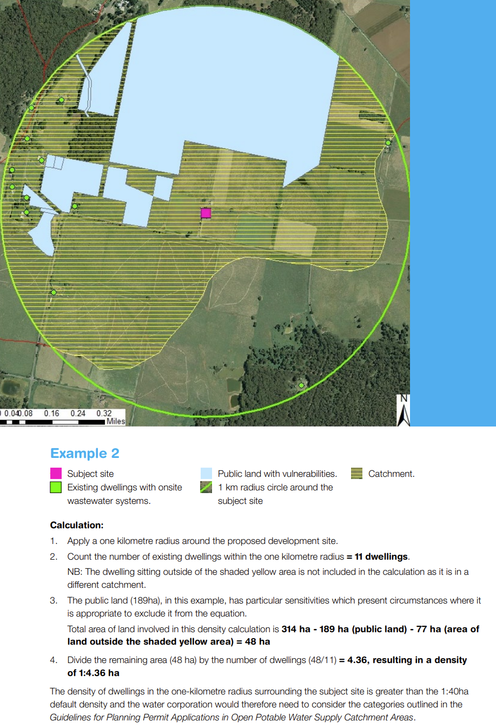
Source: Guidance-Note-for-Determining-Dwelling-Density-Vic-Water.pdf (sgwater.com.au)

The catchment and/or reservoir or water storage may also be used for irrigation purposes.
The importance of water catchments is also reflected in the Catchment Management Authority special area plans capability, under Division 2 of Part 4 of the Catchment and Land Protection Act 1994. These plans can be developed to assess the land and water resources of catchments in a region and identify objectives and strategies for improving the quality of those resources; they are also able to direct land use activities in a catchment
For an example of determining dwelling density see Appendix
The dwelling density requirement of 1:40 ha functions as a threshold which when exceeded requires a greater level of risk assessment.
Note the required assessment of cumulative risk to the catchment as outlined above, is in addition to a site-specific land capability assessment required pursuant to Policy 2
Waterways are defined in Section 3 of the Water Act 1989.

