
Wetland conceptual models: associations between wetland values, threats and management interventions
Version one
management interventions
Version One

Kay Morris and Phil Papas

September 2012
Arthur Rylah Institute for Environmental Research
Technical Report Series No. 237



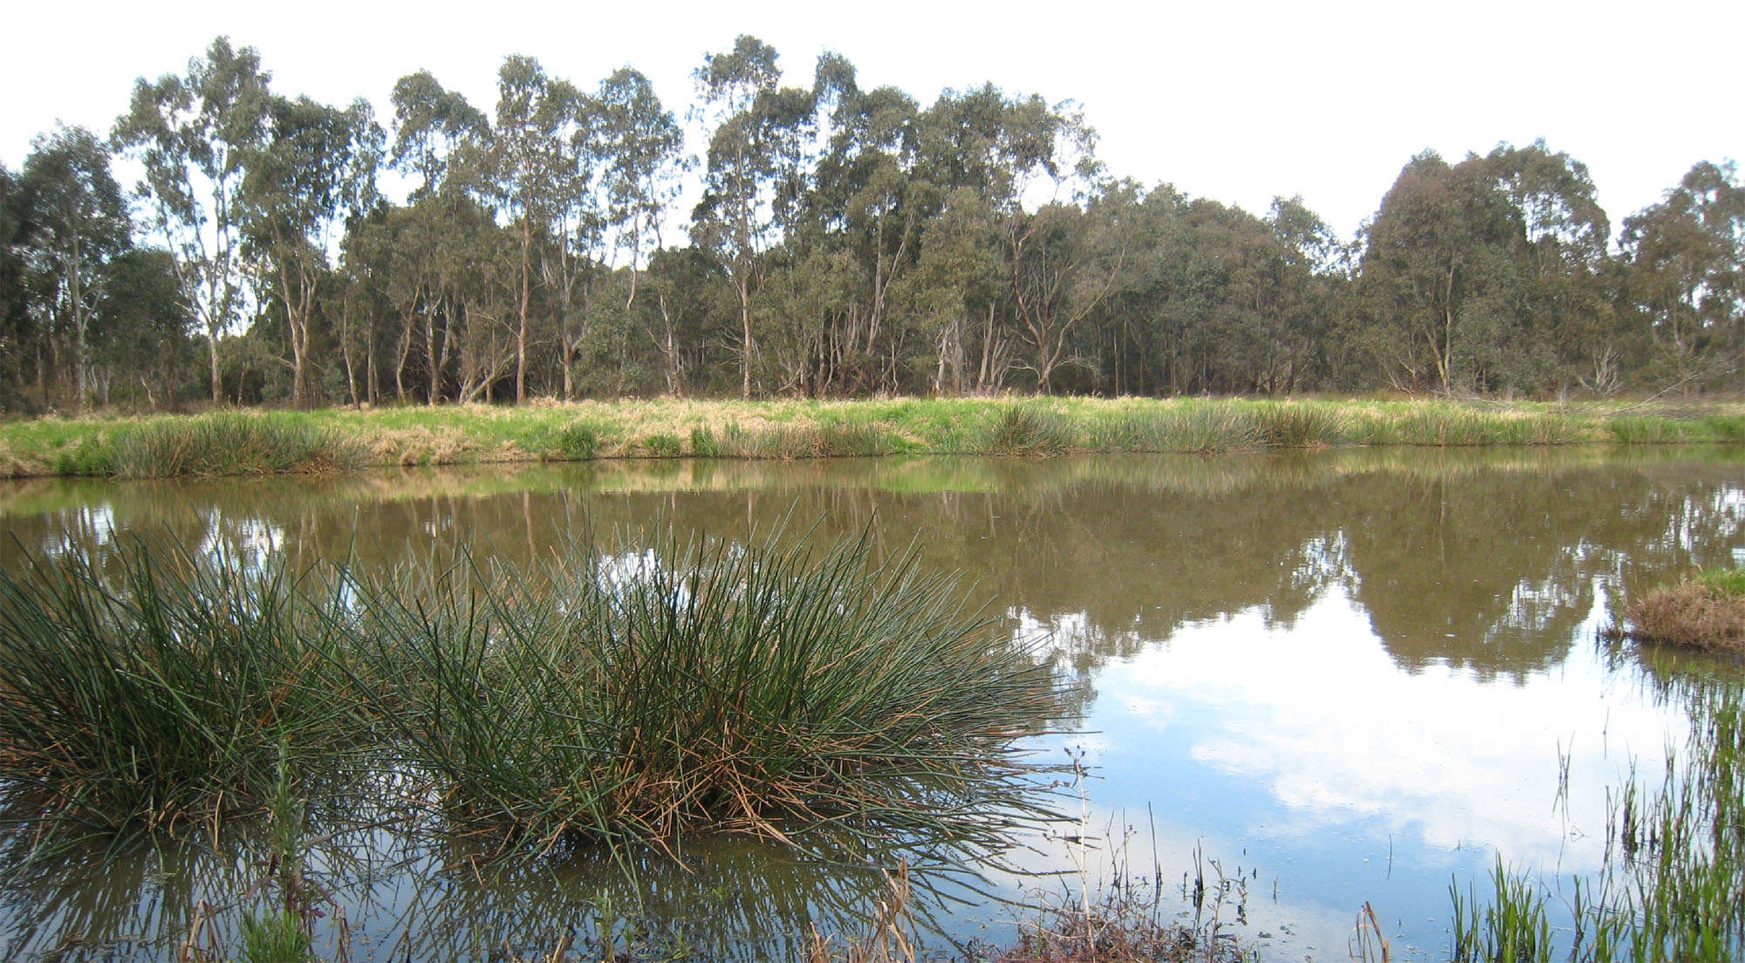



Wetland conceptual models: associations between wetland values, threats and management interventions. Version one
Kay Morris & Phil Papas
Arthur Rylah Institute for Environmental Research
123 Brown Street, Heidelberg, Victoria 3084
September 2012

Arthur Rylah Institute for Environmental Research
Department of Sustainability and Environment
Heidelberg, Victoria

Report produced by: Arthur Rylah Institute for Environmental Research
Department of Sustainability and Environment
PO Box 137
Heidelberg, Victoria 3084
Phone (03) 9450 8600
Website: www.dse.vic.gov.au/ari
© State of Victoria, Department of Sustainability and Environment 2012
This publication is copyright. Apart from fair dealing for the purposes of private study, research, criticism or review as permitted under the Copyright Act 1968, no part may be reproduced, copied, transmitted in any form or by any means (electronic, mechanical or graphic) without the prior written permission of the State of Victoria, Department of Sustainability and Environment. All requests and enquiries should be directed to the Customer Service Centre, 136 186 or email customer.service@dse.vic.gov.au
Citation: Morris, K. and Papas, P. (2012) Wetland conceptual models: associations between wetland values, threats and management interventions. Version one. Arthur Rylah Institute for Environmental Research Technical Report Series No. 237. Department of Sustainability and Environment, Heidelberg, Victoria

ISSN 1835-3835 (online)
ISBN 978-1-74287-643-6 (online)
Disclaimer: This publication may be of assistance to you but the State of Victoria and its employees do not guarantee that the publication is without flaw of any kind or is wholly appropriate for your particular purposes and therefore disclaims all liability for any error, loss or other consequence which may arise from you relying on any information in this publication.
Accessibility:
If you would like to receive this publication in an accessible format, such as large print or audio, please telephone
136 186, or through the National Relay Service (NRS) using a modem or textphone/teletypewriter (TTY) by dialling 1800 555 677, or email customer.service@dse.vic.gov.au
This document is also available in PDF format on the internet at www.dse.vic.gov.au
Front cover photo: Sale Common, a freshwater wetland in Gippsland, Victoria (Johanna Laurent).
Authorised by: Victorian Government, Melbourne

Contents

Acknowledgements iii
1 Background and objectives 3
2 Wetland value–threat associations 3
2.1 Method 3
2.2 Results 3
3 Threat-management intervention models and associations 3
3.1 Method 3
3.2 Models and descriptions 3
Management strategies and activities to reduce the threat of changed water regime (water excess) 3
Management strategies and activities to reduce the threat of changed water regime (water deficit) 3
Management strategies and activities to reduce the threat of changed water regime (changed seasonality) 3
Management strategies and activities to reduce the threat of invasive fauna: aquatic 3
Management strategies and activities to reduce the threat of invasive fauna: terrestrial 3
Management strategies and activities to reduce the threat of invasive flora: wetland 3
Management strategies and activities to reduce the threat of formation and activation of acid sulfate soils (ASS) 3
Management strategies and activities to reduce the threat of degraded water quality (salinity) 3
Management strategies and activities to reduce the threat of degraded water quality (turbidity) 3
Management strategies and activities to reduce the threat of degraded water quality (nutrients) 3
Management strategies and activities to reduce the threat of soil disturbance 3
Management strategies and activities to reduce the threat of degraded wetland vegetation 3
Management strategies and activities to reduce the threat of reduced wetland area 3
Management strategies and activities to reduce the threat of altered wetland form 3
3.3 Discussion 3
4 Recommendations 3
References 3
Appendix 1. Threat-value associations for wetlands 3
Appendix 2. List of management activities to reduce the level of wetland threats listed in AVIRA. 3

Acknowledgements
Guidance in developing this report was provided by Dr Andrea White, Dr Amber Clark and Janet Holmes from the Department of Sustainability and Environment, and by Greg Peters from Riverness, Protection and Restoration Services.

- Background and objectives
Background
The Victorian Waterway Health Program uses a risk-based approach to assist in setting priorities for the protection and restoration of Victoria’s aquatic ecosystems, namely river reaches, wetlands and estuaries. This risk-based approach is implemented through the Aquatic Value Identification and Risk Assessment (AVIRA). AVIRA stores information on the environmental, social and economic values of river, wetland and estuary assets. For each asset, AVIRA stores information on the threats to these values and conducts an automated risk assessment for every value/threat combination. AVIRA outputs inform a prioritisation process which identifies the values of river, estuary and wetland assets which have priority for management intervention. Once the risk assessment is completed, the possible management interventions are evaluated to assist in identifying priorities for investment. This forms the basis of strategic planning and investment for waterways at the regional level, ensuring that the most appropriate and cost-effective management interventions are implemented to protect, maintain or improve river, estuary and wetland values.
The steps involved in this process are illustrated in Figure 1 and listed below.
Step 1: assess the relationships between individual wetland values and threats.
Step 2: assess the relationships between management interventions and threats.
Step 3: assess how much of a management action is required to deliver a particular outcome.
These three steps will enable waterway managers, including the catchment management authorities (CMAs) and Melbourne Water, to achieve the outcomes described below (Peters 2009).
- a more evidence based decision-making and planning process
- improved capacity to identify threats to assets, and opportunities for asset protection
- a pro-active management approach
- more effective allocation and use of resources
- improved stakeholder confidence and trust.

Figure 1. The steps in the Victorian Waterway Health Program used to assess risks to waterway values and prioritise management interventions to deliver improved outcomes for community values.
Objectives
This report provides information to support Step 1 and Step 2 in this process. Information to support Step 3 is beyond the scope of this project. This report informs the following components of Step 1 and Step 2.
Step 1: Wetland Value-Threat Associations
- assesses the strength of association between a particular value and a particular threat
- provides confidence ratings for each value-threat association.
Step 2: Management Intervention - Threat Associations
- identifies management strategies and activities to reduce threats to wetland values
- assesses the effectiveness of particular management activities in addressing particular threats
- assigns expected time frame(s) over which a management activity is expected to reduce or eliminate a particular threat, and thus improve the condition of a particular value
- provides models that describe the management strategies and activities to reduce specific threats.

This report is the first account of this process. Model interrogation and evaluation should be ongoing and the models should be refined and updated as new information and knowledge is sourced and incorporated.

- Wetland value –threat associations
The strength of the association between wetland values and threats was assessed for 35 wetland values and nine wetland threats described in AVIRA (Tables 1 and 2; Peters 2009). In AVIRA reduced wetland connectivity is listed as a threatening process but has been excluded in this report because metrics to assess connectivity have not been developed. To align with AVIRA this report has used the term disturbance of acid sulfate soils in referring to threat-value associations but in the wetland management models this has been changed to formation and activation of acid sulfate soils as this captures more fully the scope of the threat. The threat degraded wetland vegetation is not included in AVIRA but impacts on many wetland values. To address this, a management intervention model is provided for degraded wetland vegetation.

Table 1. Wetland values listed in AVIRA (Peters 2009).
Broad Value Category | Value Category | Value
Environmental | Rare or threatened | Significant fauna: amphibians
 | species/communities | Significant fauna: birds
 |  | Significant fauna: fish
 |  | Significant fauna: invertebrates
 |  | Significant fauna: mammals
 |  | Significant fauna: aquatic reptiles
 |  | Significant fauna: riparian reptiles
 |  | Significant flora
 |  | Significant wetland EVCs
 | Naturalness | Wetland vegetation condition
 | Special Features | Drought refuges
 |  | Important bird habitats
Social | Activity | Recreational fishing
 |  | Non-motor boating
 |  | Motor boating
 |  | Camping
 |  | Swimming
 |  | Beside water activities (picnics & BBQs)
 |  | Beside water activities (sightseeing)
 |  | Beside water activities (tracks)
 |  | Game hunting
 | Place | Heritage (post-European)
 |  | Heritage (pre-European/indigenous)
 | People | Community Groups
 |  | Use of flagship species (wetland)
 |  | Landscape
Economic | Water | Urban or rural domestic water sources
 |  | Rural water sources for production
 |  | Water storages
 |  | Water carriers
 |  | Wastewater discharges
 | Power generation | Hydroelectricity
 | Other resources | Commercial fishing
 |  | Extractive industries
 |  | Timber harvesting and firewood collection

Table 2. List of wetland threats considered in this report. All threats are listed in AVIRA with the exception of degraded wetland vegetation. Degraded wetland vegetation has only been used in this report to develop threat-management intervention models.
Threat Category | Threat
Altered Water Regime | Changed water regime
Altered Physical Form | Reduced wetland area
 | Altered wetland form
Poor water quality | Degraded water quality
 | Disturbance of acid sulfate soils
Degraded Habitats | Soil disturbance
 | Degraded wetland vegetation
Invasive flora and fauna | Invasive flora (wetland)
 | Invasive fauna (aquatic)
 | Invasive fauna (terrestrial)

  - Method
Associations
The association rating is a key component of the risk assessment processes within AVIRA and represents the influence that a particular threat can have on a particular value (Doeg 2009). The strength of the association between values and threats has been determined by assessing the degree to which the level of a value will change in response to changes in the level of a threat. Associations are ranked as high, medium, low or none according to the definitions described in Table 3. For values such as significant flora which represent many species with different sensitivities to threats, the assigned association rating was based on the strongest reported association between a given species and a threat. This avoided under estimating the impact of a threat agent.

Table 3. Description of association ratings (taken from Peters et al. 2009)
Rating | Description
High | The threat always or often impacts the value
Medium | The threat may impact the value
Low | The threat does not impact the value but it is remotely possible
None | The threat does not impact the value

Confidence ratings
Confidence ratings represent the level of evidence that is available to support each threat-value association and are ranked as low, medium or high according to the definitions described in Table 4 (Doeg 2009). For environmental values, confidence ratings for threat-value associations have been based on the scientific literature and government and consultant reports obtained through on-line searches (e.g. Google Scholar, ProQuest, Google, government websites). For social and economic values, confidence ratings for threat-value associations were not investigated due to time constraints and are based on limited expert opinion. To reflect this, the level of confidence in the threat-value associations for these values is generally rated as low.

Table 4. Description of Confidence Rating (based on Doeg 2009)
Rating | Description
High | Where multiple peer reviewed research publications support the association assessment
Moderate | Where at least one peer reviewed research publications supports the association assessment
Low | Where the association is based only on expert opinion

  - Results
In total, 315 individual value-threat associations were assessed and are detailed in Appendix 1; 38% of threat-value associations were assessed as high, 28% as medium, 20% as low and 13% as having no association. Figures 2a and 2b summarise wetland threat-value associations that were ranked as high and medium, respectively. Table 5 provides a summary of the number of wetland values with a high or medium association with each threat.
Association ratings: Disturbance of ASS, reduced wetland area, and changed water regime may be considered the most significant threats to wetland values as they have high or medium associations with more than 85% of wetland values, encompassing environmental, social and economic values. The threat, soil disturbance affected the fewest number of wetland values, having a high or medium association with 37% of wetland values but affected all twelve environmental values.

Table 5. Number of wetland values with a high or medium association with each threat, as well as the total number of values with either a high or medium association with each threat. HA, High Association; MA, Medium Association.
 | Number of values with:
Threat | HA | MA | HA+MA
Disturbance of ASS | 34 | 1 | 35
Reduced wetland area | 23 | 11 | 34
Changed water regime | 21 | 9 | 30
Degraded water quality | 11 | 14 | 25
Altered wetland form | 8 | 16 | 24
Introduced flora (wetland) | 9 | 8 | 17
Introduced fauna (terrestrial) | 7 | 9 | 16
Introduced fauna (wetland) | 2 | 13 | 15
Soil disturbance | 6 | 7 | 13
TOTALS | 121 | 88 | 209

Confidence ratings: Associations that are ranked as high or medium but have low confidence (i.e. little evidence to support the association) represent significant knowledge gaps and warrant further research. A summary of the association-confidence assessment for environmental values are provided in Table 6. Although literature searches were not exhaustive, the association-confidence assessments reported provide an indication of where further research is most needed. Threats were found to have a high or medium association with at least eight (67%) of the 12 environmental values assessed - the majority of associations were ranked as high (Table 6). Threat-value associations that scored high also had stronger support (i.e. high confidence scores) compared with associations that were scored medium, which mostly had a low confidence rating. The pattern indicates that research effort has focused on threats that have the highest perceived impacts on wetland values. Even so, many high associations are inadequately supported by empirical data.

Table 6. Number of wetland environmental values (n=12) with a high or medium association (HA and MA, respectively) with each threat, and the number of values with a high and medium association with each threat that have a high, medium or low confidence rating. HA-HC, High Association and High Confidence; HA-MC, High Association and Moderate Confidence; High Association and Low Confidence; MA-HC, Medium Association and High Confidence; MA-MC, Medium Association and Medium Confidence; Medium Association and Low Confidence.
 |  | Number of values with:
Threat | HA |  | HA-HC | HA-MC | HA-LC | MA | MA-HC | MA-MC | MA-LC | HA+MA
Disturbance of ASS | 12 |  | 8 | 3 | 1 | 0 | 0 | 0 | 0 | 12
Reduced wetland area | 11 |  | 4 | 0 | 7 | 1 | 0 | 0 | 1 | 12
Changed water regime | 11 |  | 7 | 2 | 2 | 1 | 0 | 0 | 1 | 12
Degraded water quality | 7 |  | 6 | 0 | 1 | 3 | 0 | 0 | 3 | 10
Introduced fauna (terrestrial) | 7 |  | 2 | 2 | 3 | 3 | 0 | 0 | 3 | 10
Introduced fauna (wetland) | 2 |  | 2 | 0 | 0 | 8 | 0 | 4 | 4 | 10
Soil disturbance | 6 |  | 0 | 1 | 5 | 3 | 0 | 0 | 3 | 9
Altered wetland form | 7 |  | 1 | 1 | 5 | 3 | 0 | 0 | 3 | 10
Introduced flora (wetland) | 5 |  | 1 | 1 | 3 | 3 | 1 | 0 | 2 | 8
TOTALS | 68 |  | 31 | 10 | 27 | 25 | 1 | 4 | 20 | 93

Limitations: Assigning associations between broad wetland values and threats can be problematic as species associated with an environmental value (e.g. significant flora) exhibit a range of sensitivities to a particular threat. In this report the association was assigned based on the strongest reported association found between a species and the threat. As such, the variability in association ratings across significant species is not apparent. Similarly, some threats encompass a broad range of threat agents that are likely to exert different impacts on wetland values. For example, the threat of invasive terrestrial fauna will vary depending on the invasive species considered while the impact of degraded water quality will vary depending on the specific water quality variable considered (e.g. turbidity, nutrients, salinity, pH). The sensitivity of wetland values to threats also varies with wetland type, landscape context and the presence of other threatening processes; these are not considered in the current assessment. Confidence rating are also somewhat problematic as high confidence is assigned when several peer reviewed publications support the assigned association, but evidence may only be based on responses of a few species. As such, a high confidence rating should not be used to infer that there has been adequate research of the impacts of a threat on a specific wetland value.

- Threat-management intervention models and associations
Threat-management intervention models identify the management strategies and activities that may be undertaken to reduce the threats to wetlands listed in AVIRA. Management strategies and activities to mitigate threats to wetlands were identified based on a range of resources including: the Victorian Investment Framework (VIF) standard management outputs, expert opinion, the scientific literature and government and consultant reports. Due to time constraints investigation of the scientific literature and government and consultant reports was not exhaustive. The effectiveness of each management activity in reducing the level of a particular threat was also assessed. Where the effectiveness of a management activity was rated as moderate or high the expected response time for the management activity to reduce the level of the threat was also assessed.
  - Method
Model structure
Threat-management intervention models are presented as a hierarchical box and arrow type model with four key components identified:
- key threat
- management strategies to address the threat
- threat sources
- management activities associated with each strategy for which targets can be set.
For some models management approaches form an additional component in the model and are included to help guide the choice of management activities.
Each threat-management intervention model includes a general description of the threat and an explanatory table that describes the management activity and the rationale for implementing it. The table also provides an assessment of the effectiveness and the expected response time for the management activity to reduce the level of the threat.
When using threat-management intervention models the source(s) of the threat impacting the wetland must be known in order to select appropriate and effective management activities to reduce the threat level. For example, selecting appropriate management activities to reduce the threat of degraded water quality (nutrients) requires that the main source(s) of excess nutrient inputs to the wetland are known. In some cases additional information and/or monitoring may be needed to identify key sources of the threat. Prior to implementing any management activity a thorough assessment of potential risks must be undertaken. Key areas of risk that should be considered are outlined in the section on assessing risks.
Where a number of management activities could be implemented to reduce the level of a threat, selection should be based on careful consideration of the likely effectiveness, response time, costs, feasibility and risks associated with implementing the activity, as well as the level of community support. In some cases management activities will be complementary and implementing a suite of activities may prove the most effective approach to reduce the threat level.
Effectiveness
The effectiveness of a particular management activity to reduce the level of a threat was scored as high, medium, low or none according to the definitions described in Table 7. In most instances effectiveness ratings were assigned based on limited expert opinion due to time constraints. In some cases a key publication was available that provided guidelines for the management of specific threats and was used to inform the models.

Table. 7. Description of effectiveness ratings of management interventions to reduce threats to wetlands.
Effectiveness | Description
High | The management intervention will result in a significant and consistent reduction in the level of the threat
Moderate | The management intervention will result in a moderate reduction in the level of the threat but this will not always be consistent
Low | The management intervention will result in a small reduction in the level of the threat
Response times
Response times represent the period of time before a management activity is expected to eliminate or reduce the level of a threat. Response times do not represent the time frame over which the condition of a particular value will improve following the elimination or reduction of a threat. Management response times were scored as immediate, medium-term or long-term according to the criteria described in Table 8.
Table 8. Description of response time frames for management interventions
Rating | Description
Immediate | Less than one year
Medium-term | More than one year but less than six years
Long-term | More than six years

For some threat-management activities a range of response times were assigned to reflect variation that may occur depending on the type and amount of a management action that is carried out. For some management actions, such as those that enhance public awareness of invasive species, the effectiveness of the management action in reducing the threat will increase over time. In addition, differences in the magnitude and specific type of threat present will produce variation in response times to management activities. For example, the threat of invasive aquatic fauna encompasses a range of species that are likely to respond over different time frames to a management activity.
Confidence ratings
Due to time constraints, the management intervention-threat associations and response times have been based on expert opinion only and therefore have a low confidence rating. A robust search of the scientific and grey literature will be needed in the future to inform confidence in the assigned associations.
Assessing risks of implementing management activities
In assessing the risks of implementing a management activity three types of risk should be assessed, as described below. It should also be noted that approvals may be required for some management activities in certain circumstances and a risk assessment may be required as part of the approval process.
1. Will the management activity reduce the condition of any non-target wetland values?
In some cases implementing a management activity to reduce the level of a threat may not be beneficial to all values. For example, drying the wetland to restore the natural water regime may reduce the level of threat to some species but increase it for others; it may also impact on social values such as swimming and boating. Where the intervention will reduce the threat level to one or more values, but raise the level of a threat to other values, a consultation process should be undertaken involving community representatives to determine which values should be prioritised for management.
2. Will the management activity increase the level of other threats in the wetland?
A management activity that is carried out to reduce one threat may increase the level of another threat. For example, removing excess water to restore the natural water regime may be problematic where acid sulfate soils are present, as drying will result in the oxidation of the soil and in the production of acids. Where a management activity increases the level of another threat, the benefits of undertaking the management activity will need to be weighed up against the potential impacts of increasing the level of other threats.
3. Does the management intervention present risks to public health and safety, domestic animals or livestock?
Where management activities are hazardous to the public, domestic animals or livestock they may be unsuitable, or specific precautions may be needed before they can be implemented. Some activities (e.g. baiting programs) require approval from regulatory agencies.

  - Models and descriptions

Management strategies and activities to reduce the threat of changed water regime (water excess)

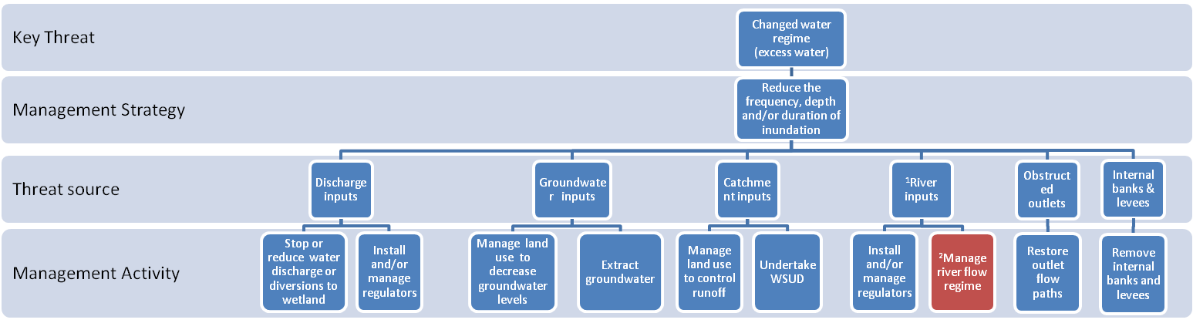
Text boxes coloured red indicate that the management strategies and activities are described in another model as indicated by the superscript.

¹Applies to floodplain wetlands only
²Refer to management strategies and activities to reduce the threat of altered flow regimes (river reaches)

Abbreviations:
WSUD= water-sensitive urban design

Description: changed water regime (water excess)
Wetland water regime describes the depth, duration, frequency, timing, rate and variability of wetting and drying cycles (Bunn et al. 1997). Changes to the water regime exert profound effects of wetland ecosystems and have the potential to alter the assemblage of plants and animals present as well as ecological processes such as dispersal, nutrient cycling and decomposition. The threat of changed water regimes due to excess water refers to changes in the natural water regime caused by an artificial increase in the frequency, duration and/or depth of wetland inundation.

KEY: Effectiveness is the expected level of threat reduction that will be achieved by a management intervention and is scored as: Low, a small reduction in the level of the threat; Med, a moderate reduction in the level of the threat which will not always be consistent; and high, a significant and consistent reduction in the level of the threat. Response times represent the period of time before a management activity is expected to eliminate or reduce the level of a threat and are scored as: 1, less than 1 year; 2, 1 -6 years; and 3, > 6 years.
Management Strategy | Management Activity | Effectiveness | Response Time | Rationale
Reduce the frequency, depth and/or duration of inundation | Stop or reduce water discharge or diversion to wetland | High | 1 | Water may be discharged or diverted to wetlands for flood mitigation, water storage or for water disposal. Water disposal can include: drainage water, stormwater, industrial, agricultural or domestic effluent, sewage treatment water, runoff from crop irrigation or the disposal of water from groundwater interception schemes. Stopping or reducing these inputs to the wetland will help to restore the water regime.
Reduce the frequency, depth and/or duration of inundation | Install and/or manage regulators | Med-High | 1 | Where too much water is delivered to wetlands regulators can be installed and/or managed to control water levels and prevent excess water inputs.
Reduce the frequency, depth and/or duration of inundation | Manage land use to decrease groundwater levels | Med | 2-3 | Changed land use practices such as irrigated agriculture and clearing of deep rooted native vegetation can cause groundwater tables to rise. This can cause excess groundwater recharge to wetlands with a connection to groundwater and a more permanent water regime. Facilitating efficient agricultural irrigation practices and revegetating areas with trees or other perennial deep rooted plants can help lower groundwater tables.
Reduce the frequency, depth and/or duration of inundation | Extract groundwater | Med-High | 1 | Changed land use practices such as irrigated agriculture and clearing of deep rooted native vegetation can cause groundwater tables to rise. This can cause excess groundwater recharge to wetlands with a connection to groundwater and a more permanent water regime. Pumping or draining groundwater to lower the groundwater table helps to restore natural drying cycles.
Reduce the frequency, depth and/or duration of inundation | Manage land use to control runoff | Med- | 1-3 | Reduced vegetation cover in the catchment increases surface water runoff to surface-fed wetlands. Revegetating cleared catchments can increase the retention of water in the catchment and reduce the amount and rate of water inflows to wetlands.
Reduce the frequency, depth and/or duration of inundation | Undertake water sensitive urban design (WSUD) | Med | 1-2 | Impervious surfaces in urban catchments increase surface runoff to surface-fed wetlands. Runoff can be reduced through water-sensitive urban design.
Reduce the frequency, depth and/or duration of inundation | Install and/or manage regulators (floodplain wetlands) | Med-High | 1 | In regulated rivers, high flows during irrigation releases or high water levels in instream storages can result in prolonged flooding in highly connected wetlands. Installing and managing regulators between regulated rivers and floodplain wetlands can prevent excess inundation.
(Continued on next page)
Description: changed water regime (water excess) (continued)
Management Strategy | Management Activity | Effectiveness | Response Time | Rationale
Reduce the frequency, depth and/or duration of inundation | Manage river flow regime (floodplain wetlands) | Med-High | 1 | The flow regime of a regulated river which is the source of water to the wetland may be altered in such a way that artificially high river levels are maintained which lead to constant or more frequent wetland inundation.  Refer to management strategies and activities to reduce the threat of altered river flow regimes (rivers) (GHD 2012).
Reduce the frequency, depth and/or duration of inundation | Restore outlet flow paths | High | 1 | In some wetlands natural outlets have been blocked to increase water storage capacity. These changes can increase the depth and duration of wetland inundation. Restoring outlet pathways can help to restore the nature water regime.
Reduce the frequency, depth and/or duration of inundation | Remove internal banks and levees | High | 1 | In some wetlands artificial levees may have been installed to prevent areas of the wetland becoming inundated. These changes can increase the depth and duration of water in areas of the wetland that continue to receive water. Removing internal barriers to water movement can help to restore the natural water regime.

Potential risks associated with management interventions
When assessing the suitability of a management activity to reduce the level of a threat to wetland values a thorough assessment of all potential risks associated with the management activity must be carried out. The types of risks that should be considered are described in the methods (see pages 10-11).

Management strategies and activities to reduce the threat of changed water regime (water deficit): Part A

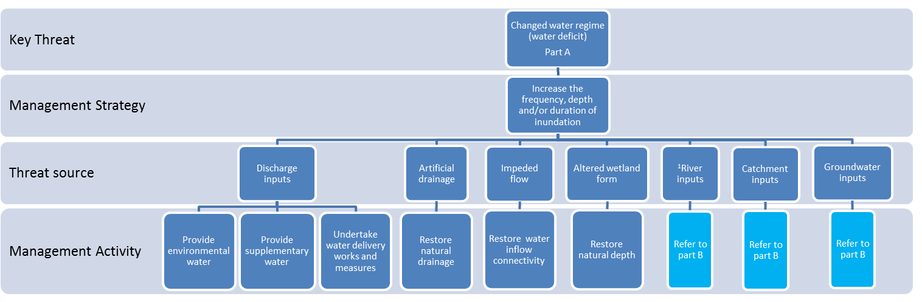

¹Applies to floodplain wetlands only

Management strategies and activities to reduce the threat of changed water regime (water deficit): Part B

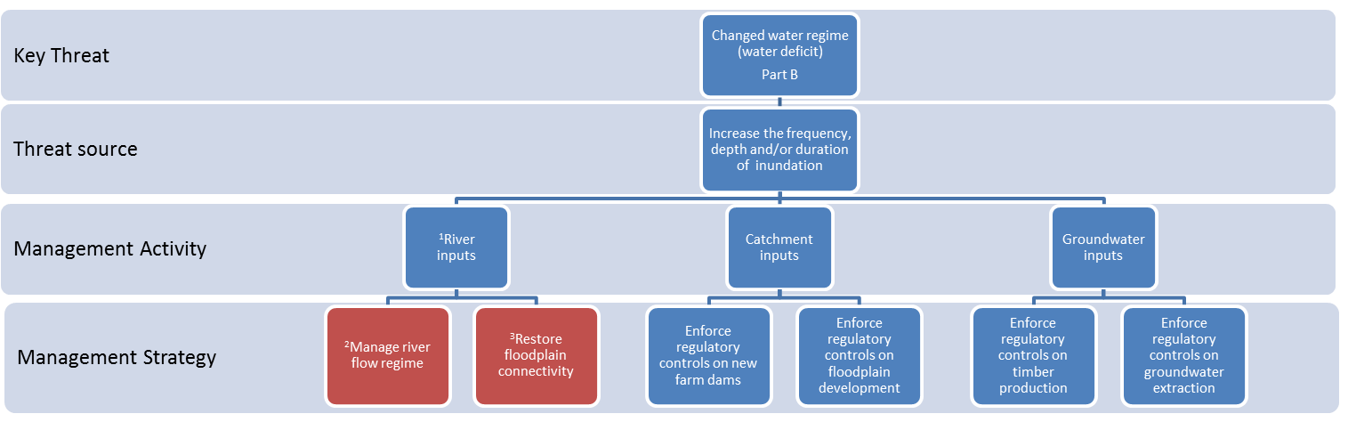

Text boxes coloured red indicate that the management activities are described in another model as indicated by the superscript.

¹Applies to floodplain wetlands only
²Refer to management strategies and activities to reduce the threat of altered flow regimes (river reaches)
³Refer to management strategies and activities to reduce the threat of altered floodplain connectivity (river reaches)

Description: changed water regime (water deficit)
Wetland water regime describes the depth, duration, frequency, timing, rate and variability of wetting and drying cycles (Bunn et al. 1997). Changes to the water regime exert profound effects of wetland ecosystems and may potentially alter the assemblage of plant and animals present as well as ecologic processes such as dispersal, nutrient cycling and decomposition. The threat of changed water regimes due to water deficit refers to changes in the natural water regime caused by a reduction in the frequency and/or duration of wetland inundation.

KEY: Effectiveness is the expected level of threat reduction that will be achieved by a management intervention and is scored as: Low, a small reduction in the level of the threat; Med, a moderate reduction in the level of the threat which will not always be consistent; and high, a significant and consistent reduction in the level of the threat. Response times represent the period of time before a management activity is expected to eliminate or reduce the level of a threat and are scored as: 1, less than 1 year; 2, 1 -6 years; and 3, > 6 years.
Management Strategy | Management Activity | Effectiveness | Response Time | Rationale
Increase the frequency, depth and/or duration of inundation | Provide environmental water | High | 1 | Diminished inflows reduce the frequency and duration of inundation. Providing environmental water will improve or restore the water regime.
Increase the frequency, depth and/or duration of inundation | Provide supplementary water (not environmental water) | High | 1 | Diminished inflows reduce the frequency and duration of inundation. Providing supplementary water from high quality wastewater from a source such as stormwater, agriculture or industry can improve or restore the water regime.
Increase the frequency, depth and/or duration of inundation | Undertake water delivery works and measures | High | 1 | Where the natural water sources are insufficient to maintain the required wetland water regime, environmental watering may be feasible if certain works (e.g. regulators and/or channels) and measures (e.g. pumping) are put in place. Undertaking required works and measures would enable supplementary water to be provided to improve or restore the water regime.
Increase the frequency, depth and/or duration of inundation | Restore natural drainage | High | 1 | Drainage of wetlands leads to reduced frequency and duration of inundation. Blocking outlet drains and restoring natural outlet levels can improve or restore the natural water regime.
Increase the frequency, depth and/or duration of inundation | Restore water inflow connectivity | Med-High | 1 | Inflows to the wetland can be blocked or impeded by infrastructure such as roads, levees, regulators, irrigation or floodplain development or by-pass channels. Removing the obstruction can restore inflow connectivity and improve or restore the water regime.
Increase the frequency, depth and/or duration of inundation | Restore natural depth | High | 1 | Deepening a wetland (e.g. by constructing a farm dam within the wetland) directs inflows to the deepened area and away from the rest of the wetland which will reduce the inundation duration for most of the wetland. See management strategies and activities to reduce the threat of altered wetland form.
Increase the frequency, depth and/or duration of inundation | Manage river flow regime (floodplain wetlands) | Med-High | 1 | The flow regime of a regulated river which is the source of water to the wetland may be altered in such a way that flood frequency is reduced and restoring the river flow regime can also restore the natural water regime of the wetland. Refer to management strategies and activities to reduce the threat of altered river flow regimes (river reaches) (GHD 2012).
(Continued on next page)
Description: changed water regime (water deficit) continued
Management Strategy | Management Activity | Effectiveness | Response Time | Rationale
Increase the frequency, depth and/or duration of inundation | Restore floodplain connectivity (floodplain wetlands) | Med-High | 1 | The flow of water from a regulated river which is the source of water to the wetland may be altered in such a way that the frequency, duration or depth of flooding is reduced. Restoring connectivity between the floodplain wetland and its source river can restore the natural water regime of the wetland. Refer to management strategies and activities to reduce the threat of altered floodplain connectivity (river reaches) (GHD 2012).
Increase the frequency, depth and/or duration of inundation | Enforce regulatory controls on new farm dams | High | 1 | Farm dams in the wetland catchment capture surface runoff that would otherwise flow to wetlands, reducing the frequency and duration of inundation. Enforcing existing regulatory controls on new farm dams can limit the amount of water diverted to farm dams.
Increase the frequency, depth and/or duration of inundation | Apply and enforce regulatory controls on floodplain development | High | 1 | Floodplain development has the potential to obstruct flow paths to wetlands. Applying and enforcing planning controls such as the Rural Flood Overlay, Land Subject to Inundation Overlay or Environmental Significance Overlay can ensure that flow paths are not obstructed by floodplain development.
Increase the frequency, depth and/or duration of inundation | Enforce regulatory controls on timber production | Med | 1-2 | Groundwater levels can be lowered in the vicinity of the wetland by certain land uses (e.g. plantation forestry). Enforcing existing regulatory controls on land use practices (e.g. Code of Practice for timber production) can reduce the threat of lowered groundwater tables.
Increase the frequency, depth and/or duration of inundation | Enforce regulatory controls on groundwater extraction | Med | 1-2 | The over extraction of groundwater resources for agriculture and human use can lead to lowering of the water table and the drying of groundwater dependent wetlands. Enforcing existing regulatory controls on groundwater extraction will help to restore groundwater tables to natural levels and improve or restore the water regime.

Potential risks associated with management interventions
When assessing the suitability of a management activity to reduce the level of a threat to wetland values a thorough assessment of all potential risks associated with the management activity must be carried out. The types of risks that should be considered are described in the methods (see pages 10-11).

Management strategies and activities to reduce the threat of changed water regime (changed seasonality)

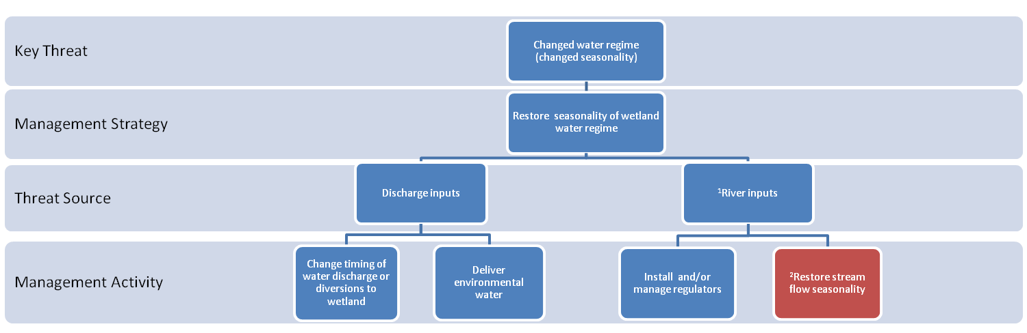

¹Applies to floodplain wetlands only
²Refer to management strategies and activities to reduce the threat of altered flow regimes (river reaches) (GHD 2012).

Key to abbreviations:
EW= environmental water
Description: changed water regime (changed seasonality)
Wetland water regime describes the depth, duration, frequency, timing, rate and variability of wetting and drying cycles (Bunn et al. 1997). The threat of changed water regime (altered seasonality) refers to unseasonal wetting and drying patterns. Changes to the seasonality of the water regime can alter the assemblage of plant and animals present as well as ecological processes such as breeding, dispersal, nutrient cycling and decomposition.

KEY: Effectiveness is the expected level of threat reduction that will be achieved by a management intervention and is scored as: Low, a small reduction in the level of the threat; Med, a moderate reduction in the level of the threat which will not always be consistent; and high, a significant and consistent reduction in the level of the threat. Response times represent the period of time before a management activity is expected to eliminate or reduce the level of a threat and are scored as: 1, less than 1 year; 2, 1 -6 years; and 3, > 6 years.
Management Strategy | Management Activity | Effectiveness | Response  Time | Rationale
Restore the natural seasonality of inundation | Change the timing of water discharge or diversion to wetland | High | 1 | Where water is discharged or diverted to a wetland, the timing of water inputs may not be in accord with the natural seasonal cycle of wetland inundation. Changing the timing of inputs to the wetland will help to restore the natural seasonality of the water regime.
Restore the natural seasonality of inundation | Deliver environmental water | High | 1 | Where drought or the over extraction of water for human use results in the premature drying of the wetland the delivery of environmental water can restore the natural seasonal pattern of wetland inundation.
Restore the natural seasonality of inundation | Install and/or manage regulators (floodplain wetlands) | Med-High | 1 | In regulated rivers the natural flow pattern may be reversed causing unseasonal summer/autumn flooding and a lack of the normal winter/spring flooding in connected wetlands. The installation and/or management of water regulators between the river and the wetland can prevent water entering the wetland in summer and autumn or enable flows to be delivered in winter and spring.
Restore the natural seasonality of inundation | Restore stream flow seasonality | Med-High | 1 | In regulated rivers the natural flow patterns may be reversed causing unseasonal summer/autumn flooding and a lack of the normal winter/spring flooding in connected wetlands. Re-instating more natural seasonal flow patterns in regulated rivers can help to restore the natural seasonal pattern of inundation in floodplain wetlands. Refer to management strategies and activities to reduce the threat of altered streamflow seasonality (river reaches) (GHD 2012).

Potential risks associated with management interventions
When assessing the suitability of a management activity to reduce the level of a threat to wetland values a thorough assessment of all potential risks associated with the management activity must be carried out. The types of risks that should be considered are described in the methods (see pages 10-11).

Management strategies and activities to reduce the threat of invasive fauna: aquatic (Part A)

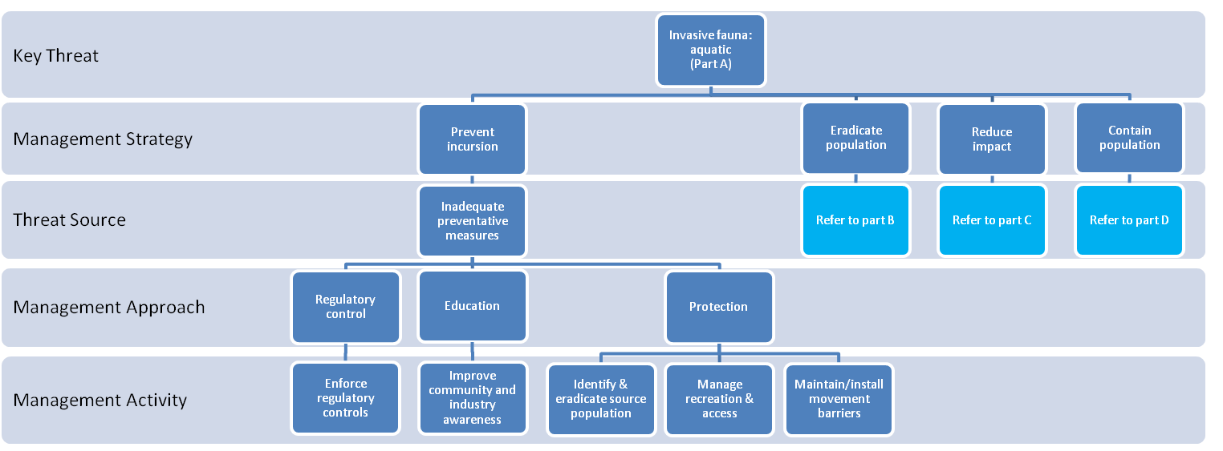

Management strategies and activities to reduce the threat of invasive fauna: aquatic (Part B)

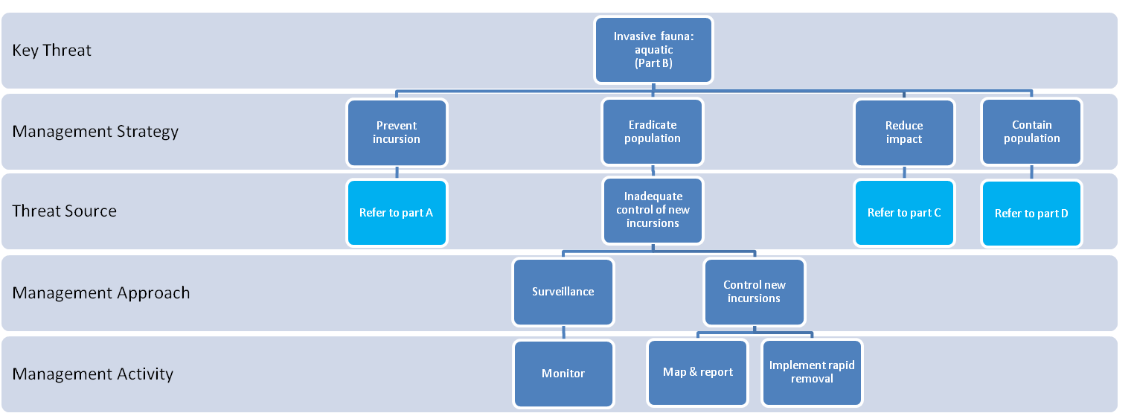

Management strategies and activities to reduce the threat of invasive fauna: aquatic (Part C)

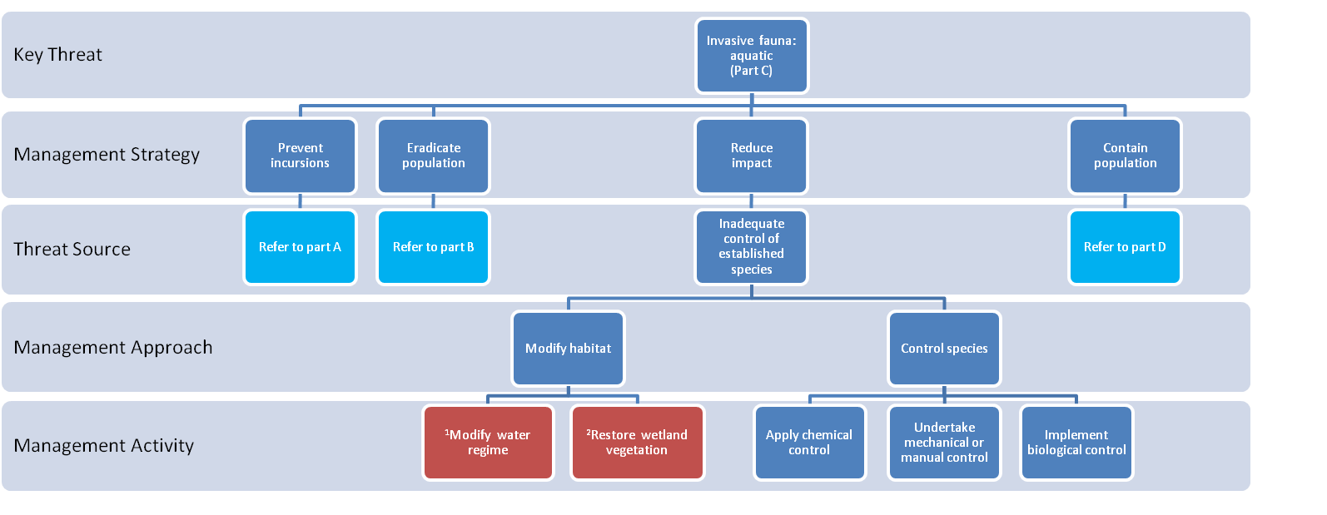
Text boxes coloured red indicate that the management activities are described in another model as indicated by the superscript.

¹Refer to management strategies and actions to reduce the threat of changed water regimes
²Refer to management strategies and actions for degraded wetland vegetation

Management strategies and activities to reduce the threat of invasive fauna: aquatic (Part D)

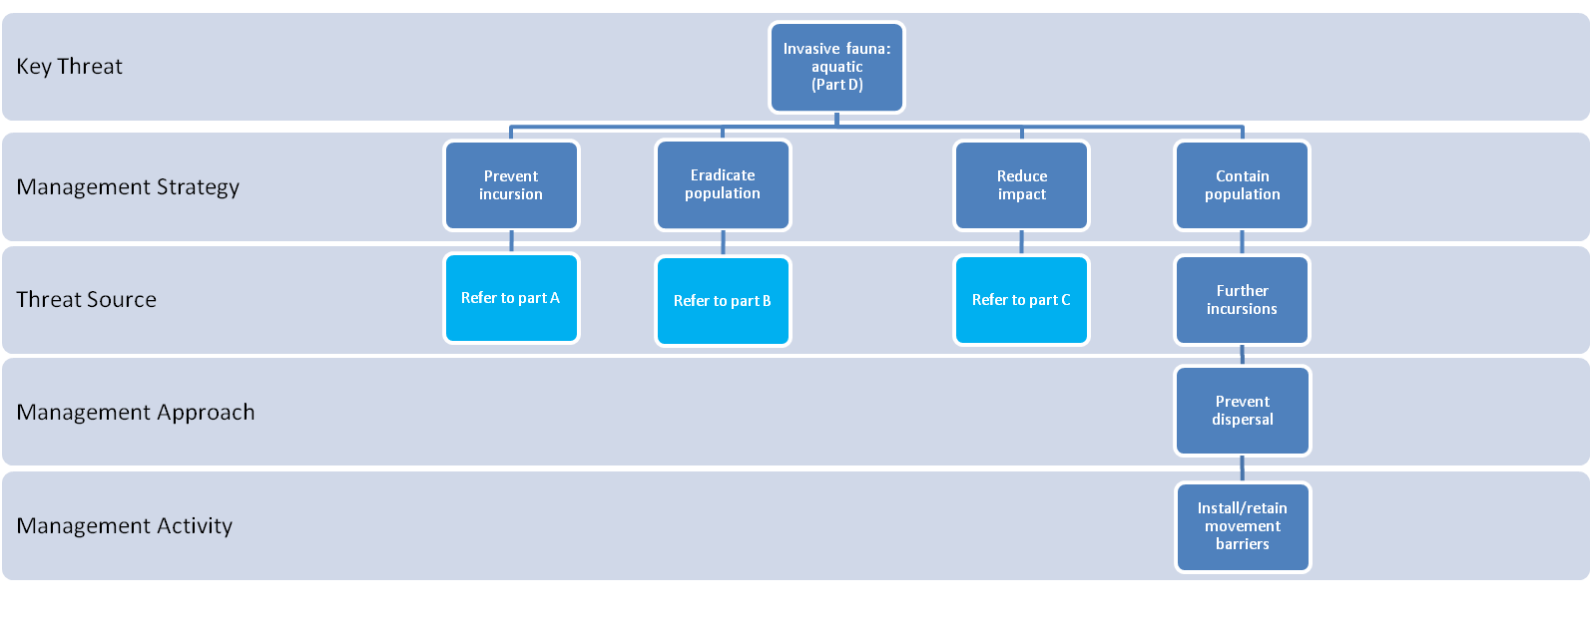

Description: invasive fauna (aquatic)
A range of invasive aquatic fauna impact on wetland values. Invasive fauna may predate on native species, compete for resources, modify habitat structure, degrade water quality and/or introduce disease or parasites (Crowl et al. 1992, Rowe et al. 2008). In Victoria, a number of invasive fish species utilise wetland habitats, including Common Carp (Cyprinus carpio), Goldfish (Carassius auratus), Weather Loach (Misgurnus angullicaudatus), Mosquitofish (Gambusia holbrooki), Redfin Perch (Perca fluviatilis) and Tench (Inca tinca). Brown Trout (Salmo trutta) and Rainbow Trout (Oncorhynchus mykiss) are introduced species that mainly occur in lakes and farm dams. Other aquatic fauna that are invasive in Victoria include two species of freshwater crayfish: Marron, Cherax cainii (Austin 2002) endemic to the south-west of Western Australia and Redclaw, Cherax quadricarinatus, native to tropical Queensland and the Northern Territory, both species are declared noxious in Victoria. Several freshwater introduced snails have establish populations in Victorian waterways including the American ribbed fluke snail (Pseudosuccinea columella) and European physa, Physa acuta (Ponder et al. 2000; Zukowski and Walker 2009). The Asian freshwater leech Barbronia weberi and the freshwater jellyfish Craspedacusta sowebyi, are also known to occur in Victoria (Govedich et al. 2002, Williams 1980).

KEY: Effectiveness is the expected level of threat reduction that will be achieved by a management intervention and is scored as: Low, a small reduction in the level of the threat; Med, a moderate reduction in the level of the threat which will not always be consistent; and high, a significant and consistent reduction in the level of the threat. Response times represent the period of time before a management activity is expected to eliminate or reduce the level of a threat and are scored as: 1, less than 1 year; 2, 1 -6 years; and 3, > 6 years.
Management Strategy | Management  Activity | Effectiveness | Response Time | Rationale
Prevent incursion | Enforce regulatory controls | Med | 1 | Lack of compliance with existing regulatory requirements to control invasive species can increase the risk of invasive species establishing in a wetland. In Victoria the Catchment and Land Protection Act 1994 (CaLP Act) covers the classification and control of pest animals and regulates their importation, possession, sale or release. The Fisheries Act 1995 provides for the declaration of noxious aquatic species. Species listed as noxious under the Section 75 of the Fisheries Act 1995 must be reported and are subject to regulations that restrict their use and spread. The translocation (or stocking) of fish for recreational fishing or conservation purposes is regulated to reduce the risk of feral populations establishing, the introduction of parasites and disease, and genetic shifts in wild populations (DPI 2005a). Protocols for the translocation of fish are available through DPI.
Prevent incursion | Improve community and industry awareness | Med | 1-2 | Lack of awareness by the community or industry (e.g. recreational anglers, commercial fisheries, aquaculture industry, aquarium industry) can lead to the unintentional introduction of invasive aquatic fauna such as the release of aquarium species or pets into waterways. Improving community and industry awareness of the risks presented by invasive species, how to identify and report them, and how to prevent their dispersal to new sites will reduce new incursions, facilitate the early detection and eradication of new incursions, and reduce the risk of human mediated dispersal.
Prevent incursion | Identify and eradicate source population | Med-High | 1 | If source populations of invasive aquatic fauna species are not eradicated, a wetland will be subject to ongoing incursions. Eradicating source populations of invasive species from which individuals are able to disperse and colonise the wetland will prevent new incursions and re-introductions.
(continued on next page)
Description: invasive fauna (aquatic) (continued)
Management Strategy | Management Activity | Effectiveness | Response Time | Rationale
Prevent incursion | Manage recreation and access | Med | 1 | Introduced aquatic fauna can be spread unintentionally by people who access the wetland for recreation or other activities. In some instances it may be necessary to close access to sites to minimise the risk of introducing or spreading high impact invasive species.
Prevent incursion | Maintain/install movement barriers | Med-High | 1 | Invasive aquatic fauna species that are established outside the wetland may reach the wetland by dispersing along permeable routes in the landscape. Installing barriers to movement along these routes can prevent invasive species reaching the wetland. The exclusion of invasive fish from wetlands can be achieved by creating vertical drops that the species is unable to negotiate or by installing physical or behavioural barriers. Physical barriers are mesh screens that are placed across channels or culverts that exclude fish of a particular size class. Behavioural barriers generate noise, electricity or flows that deter movement in a particular direction.
Eradicate population | Monitor | Med | 1 | Unless new incursions of invasive species are detected and controlled at an early stage they are likely to quickly establish and become much more difficult to control. Establishing monitoring programs to detect the occurrence of invasive species will enable the early detection of new incursions. Populations that are detected early are likely to be small and this enhances the likelihood of successful eradication and reduces the risk of dispersal to other sites. The effectiveness of monitoring programs is dependent on their frequency, areal extent and rigour.
Eradicate population | Map and report | Med | 1 | When new incursions have been detected they should be reported and their location and extent mapped so the effectiveness of eradication or control measures can be assessed.
Eradicate population | Implement rapid removal | Med-High | 1 | Unless new incursions of invasive species are eradicated at an early stage they are likely to quickly establish and become much more difficult to control. Eradication success is more likely while the population is small. Eradication techniques include physical control, chemical control or habitat manipulation. The most suitable approach will depend on the traits of the species, the nature of the site and the risks associated with each control technique.
Reduce impact | Modify water regime | Med | 1 | There is a high likelihood that the invasive aquatic fauna species could be controlled by manipulating the water regime of the wetland. Partially or completely drying the wetland can be effective in reducing populations of invasive aquatic fauna that are intolerant of drying. However non-target organisms will also be affected. Partially drying the wetland coupled with chemical control can be effective in some instances (Ayres and Clunie 2010).  Refer to management strategies and activities to reduce the threat of changed water regimes.
Reduce impact | Restore wetland vegetation | High | 1-2 | Wetland vegetation can provide important food and habitat for native aquatic fauna and degradation of wetland vegetation can therefore impact on native aquatic fauna populations and increases the likelihood of invasions occurring. Restoring wetland vegetation can increase the resilience of native aquatic fauna communities and decrease the likelihood of invasive species becoming established.  Refer to management strategies and activities to reduce the threat of degraded wetland vegetation and invasive flora (wetlands).
(continued on next page)
Description: invasive fauna (aquatic) (continued)
Management Strategy | Management Activity | Effectiveness | Response Time | Rationale
Reduce impact | Apply chemical control | Med-High | 1 | Chemicals such as lime, chlorine or a piscicide can be effective in reducing numbers of an invasive aquatic fauna species in certain situations. Chemicals used to control invasive fauna must be registered for use in Australia and permits for their use must be acquired. Chemical treatment can achieve eradication of invasive species in some cases but is generally only suitable in small shallow wetlands. Partially drying the wetland coupled with chemical control can be effective in some instances (Ayres and Clunie 2010). Chemical control techniques will impact on non-target species and result in the temporary loss of the water body for recreation and as a water supply.
Reduce impact | Undertake mechanical or manual control | Low-Med | 1 | There is a high likelihood that capturing the invasive aquatic fauna species would be effective in reducing numbers. Capture techniques for invasive fish include electro-fishing, netting, traps, cages and angling. Angling is probably the least effective technique but also raises public awareness (for a review of these techniques see Ayres and Clunie 2010).
Reduce impact | Implement biological control | Med-High | 1-2 | The principle of biological control is to use one organism to control another by restoring an ecological process (e.g. herbivory or disease) that limits the competitive ability of the invasive species. For example, stocking wetlands with native species that are known predators of the target invasive species may reduce or eliminate populations within the wetland. Thorough testing is needed to ensure that native species are not impacted. Biological control should only be carried out as part of an approved, co-ordinated biological control program.
Contain population | Install or maintain dispersal barriers | High | 1 | An invasive species that is established in the wetland may disperse to other wetlands resulting in new incursions. Installing barriers to movement along dispersal routes can prevent the invasive species reaching new wetlands. Restricting the movement of invasive fish to new sites can be achieved by creating vertical drops that the species is unable to negotiate or by installing physical or behavioural barriers. Physical barriers are mesh screens that are placed across channels or culverts that exclude fish of a particular size class. Behavioural barriers generate noise, electricity or flows that deter movement in a particular direction.
Potential risks associated with management interventions
When assessing the suitability of a management activity to reduce the level of a threat to wetland values a thorough assessment of all potential risks associated with the management activity must be carried out. The types of risks that should be considered are described in the methods (see pages 10-11).

Management strategies and activities to reduce the threat of invasive fauna: terrestrial (Part A)

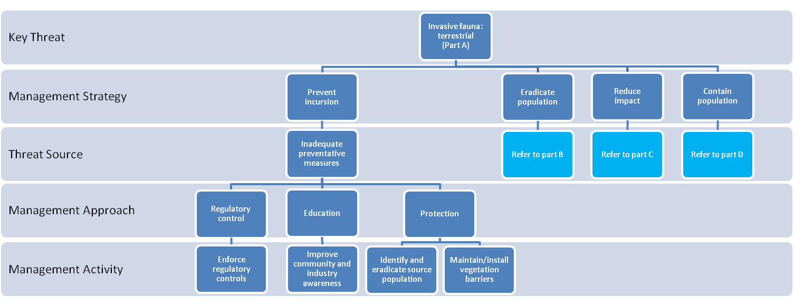
Management strategies and activities to reduce the threat of invasive fauna: terrestrial (Part B)

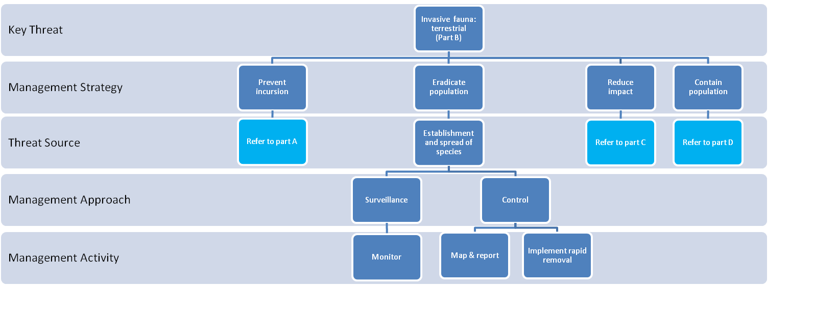

Management strategies and activities to reduce the threat of invasive fauna: terrestrial (Part C)

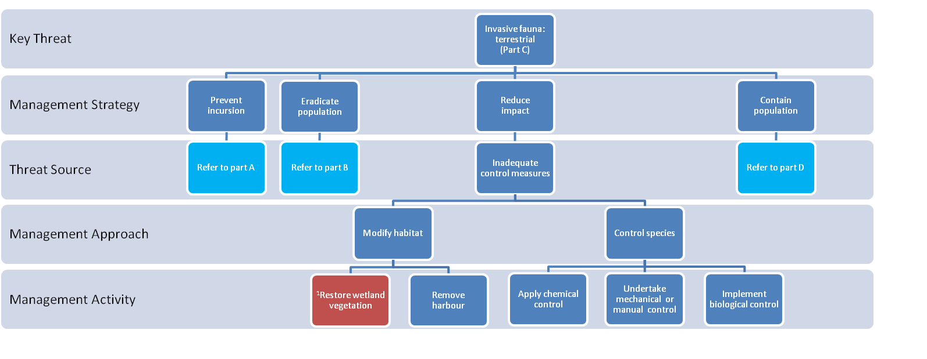
Text boxes coloured red indicate that the management strategies and activities are described in another model as indicated by the superscript.

¹Refer to management strategies and activities for degraded wetland vegetation
Management strategies and activities to reduce the threat of invasive fauna: terrestrial (Part D)

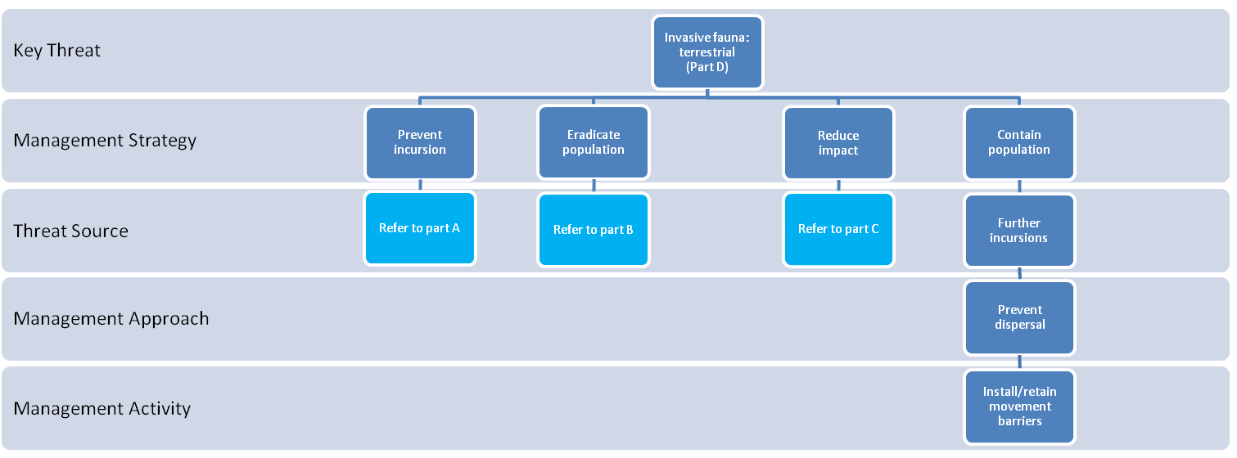

Description: invasive fauna (terrestrial)
Invasive animals are non-native species that are, or have the potential to become, established in the wild. Wild populations establish when species escape from captivity and domestication, are deliberately or accidentally released, or are accidentally or illegally imported. A range of invasive terrestrial fauna impact on wetland values by predating on native aquatic fauna, competing for resources, destroying or damaging vegetation, transporting invasive plants, modifying habitat structure, degrading water quality and/or introducing disease or parasites (Crowl et al. 1992, Rowe et al. 2008). Invasive terrestrial fauna that can occur in Victorian wetlands include: Capra hirus (Feral goat), Equus caballus (Feral horse), Felis catus (Feral cat), Oryctolagus cuniculus (European wild rabbit), Sus scrofa (Feral pig), Vulpes vulpes (European red fox) and Cervidae (Feral deer).
Management Strategy | Management Activity | Effectiveness | Response Time | Rationale
Prevent incursions | Enforce regulatory controls for invasive species | Med | 1 | Lack of compliance with existing regulatory requirements to control invasive species can increase the risk of invasive species establishing in a wetland. In Victoria the Catchment and Land Protection Act 1994 (CaLP Act) covers the classification and control of pest animals and regulates their importation, possession, sale or release.
Prevent incursions | Improve community and industry awareness | Med | 1-2 | Lack of awareness by the community or industry can lead to the unintentional introduction of invasive terrestrial fauna. Improving community and industry awareness of the risks presented by invasive species, how to identify and report them and how to prevent their dispersal to new sites will reduce new incursions, facilitate the early detection and eradication of new incursions and reduce the risk of human mediated dispersal.
Prevent incursions | Identify and eradicate source population | Med-High | 1 | The wetland can be protected from new incursions of invasive terrestrial fauna by identifying and eradicating populations that lie outside the wetland but have the potential to reach and establish in the wetland.  The most suitable eradication technique will depend on the traits of the species and the nature of the site.
Prevent incursions | Maintain or install vegetation barriers | Low-Med | 1-3 | A dense band of vegetation around the perimeter of the wetland may help to limit some invasive terrestrial fauna accessing the wetland.
Eradicate population | Monitor | High |  | Unless new incursions of invasive species are detected at an early stage they are likely to establish and become much more difficult to control. Establishing surveillance and reporting programs to detect the occurrence of invasive species will enable the early detection of new incursions. Populations that are detected early are likely to be small and this enhances the likelihood of successful eradication and reduces the risk of dispersal to other sites. Surveillance and reporting programs can also be implemented to assess the success of management activities to control established populations. The effectiveness of surveillance programs is dependant on their frequency, areal extent and rigour.
Eradicate population | Map and report | High | 1 | When new incursions have been detected they should be reported and their location and extent mapped so the effectiveness of eradication or control measures can be assessed.
Eradicate population | Implement rapid removal | High | 1 | Unless new incursions of invasive species are controlled at an early stage, they are likely to establish and become much more difficult to control. New incursions require rapid eradication as success is more likely while the population is small. The most suitable eradication technique will depend on the traits of the species and the nature of the site.
KEY: Effectiveness is the expected level of threat reduction that will be achieved by a management intervention and is scored as: Low, a small reduction in the level of the threat; Med, a moderate reduction in the level of the threat which will not always be consistent; and high, a significant and consistent reduction in the level of the threat. Response times represent the period of time before a management activity is expected to eliminate or reduce the level of a threat and are scored as: 1, less than 1 year; 2, 1 -6 years; and 3, > 6 years.
(continued on next page)
Description: invasive fauna (terrestrial) (continued)
Management Strategy | Management Activity | Effectiveness | Response Time | Rationale
Reduce impact | Restore wetland vegetation | High | 1-3 | Although reducing the threat of invasive terrestrial fauna will prevent further loss or damage to native wetland vegetation, where significant degradation has already occurred additional management activities will be needed to restore wetland vegetation. Refer to management actions and strategies to reduce the threat of degraded wetland vegetation condition.
Reduce impact | Remove harbour | Med | 1-2 | In newly colonised areas rabbits will temporarily use above-ground harbours for protection until warrens are completed. These harbours include dense thickets of blackberry or lantana. Removing these harbours may help to prevent colonisation. Once rabbits have established warrens in or near the wetland they are likely to breed, increasing the level of threat. Warren-ripping is used to destroy warrens (and rabbits). Without the protection of warrens breeding success is reduced.
Reduce impact | Apply chemical control | Med-High | 1 | For some terrestrial fauna species such as European red fox there is a high likelihood that baiting will be effective in reducing population size. The pesticide 1080 is used extensively in Australia to reduce fox populations. Fumigation of rabbit warrens uses poisons which kill rabbits in their burrows. Chemical control programs usually require permits and strict measures must be in place to protect the community and non-target organisms. These measures may include public notices and bait exclusion zones to protect the public, waterways, livestock and domestic animals.
Reduce impact | Undertake mechanical or manual control | Med-High | 1 | There is a high likelihood that capturing the invasive terrestrial fauna species would be effective in reducing numbers. Capture programs include trapping, hunting and mustering. Bounty programs offer a monetary reward to eligible hunters for contributing to the control of invasive animals. In Victoria bounty programs are used in conjunction with baiting programs to control foxes and wild dogs.
Reduce impact | Implement biological control | Med | 2-3 | In certain cases an invasive terrestrial species may be effectively controlled by implementing a biological control program. The principle of biological control is to use one organism to control another by restoring an ecological processes (e.g. herbivory or disease) that limits the competitive ability of the invasive species. Thorough testing is needed to ensure that the control agent does not impact non-target species. Biological control should only be carried out as part of an approved, co-ordinated biological control program.
Contain population | Install or maintain dispersal barriers | High | 1 | An invasive terrestrial fauna species could reach the wetland by moving through the landscape. Erecting barrier fencing can prevent invasive terrestrial species accessing the wetland but can also exclude native species. Cost will usually limit the application of this approach to high value assets that are at high risk or to smaller wetlands.
Potential risks associated with management interventions
When assessing the suitability of a management activity to reduce the level of a threat to wetland values a thorough assessment of all potential risks associated with the management activity must be carried out. The types of risks that should be considered are described in the methods (see pages 10-11).

Management strategies and activities to reduce the threat of invasive flora: wetland (Part A)

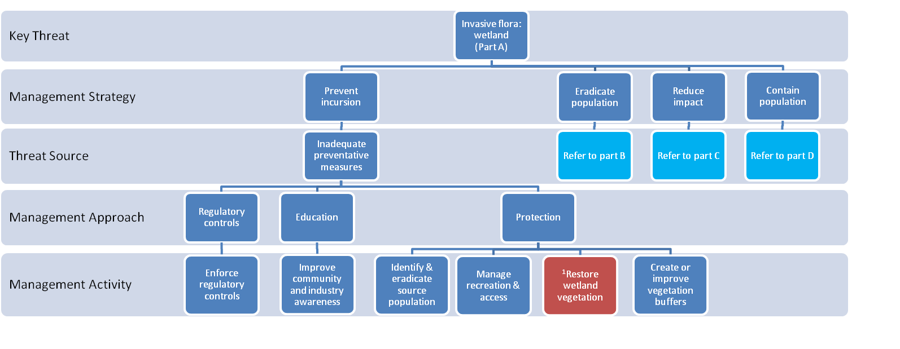
Text boxes coloured red indicate that the management strategies and activities are described in another model as indicated by the superscript.

¹Refer to management strategies and activities for degraded wetland vegetation
Management strategies and activities to reduce the threat of invasive flora: wetland (Part B)

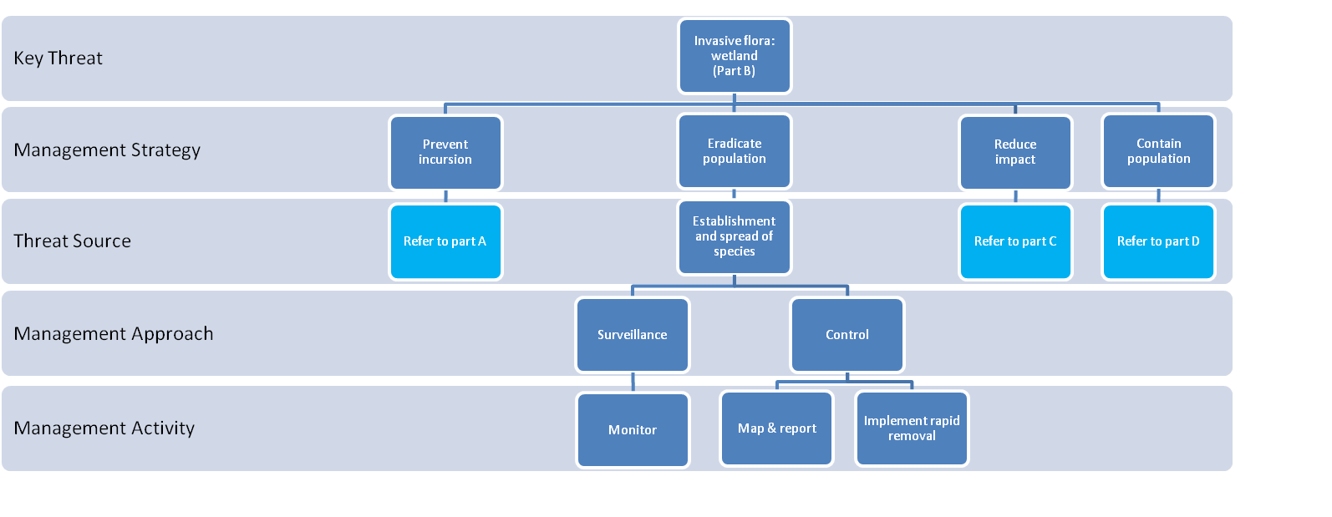

Management strategies and activities to reduce the threat of invasive flora: wetland (Part C)

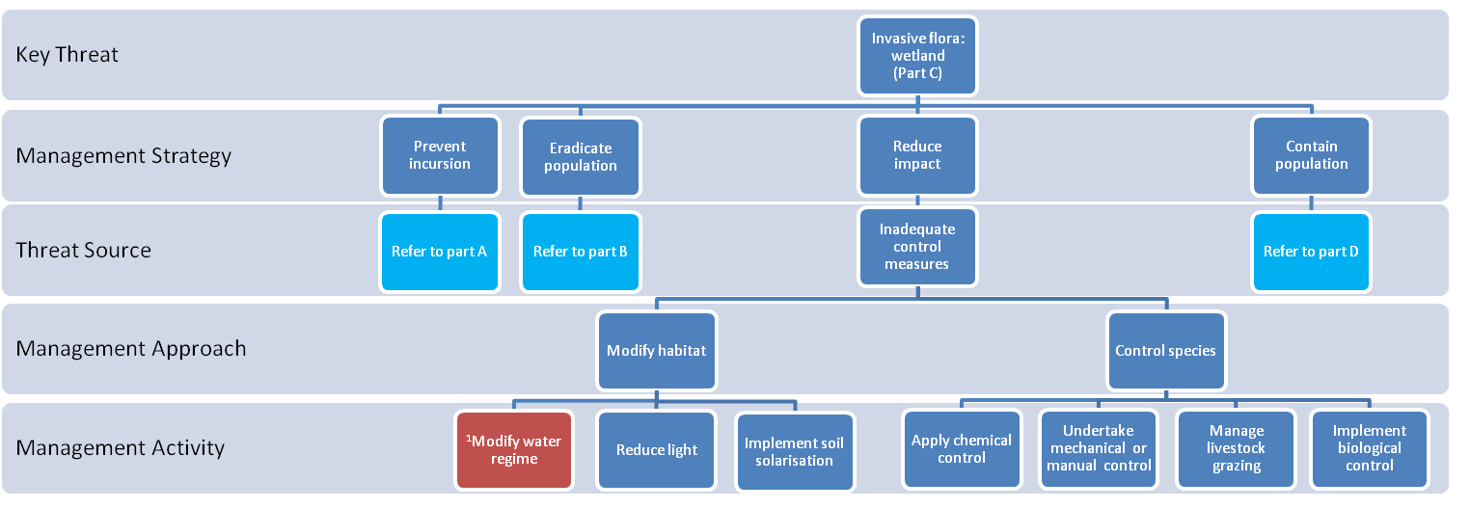
Text boxes coloured red indicate that the management strategies and activities are described in another model as indicated by the superscript.

¹Refer to management strategies and activities to reduce the threat of changed water regime

Management strategies and activities to reduce the threat of invasive flora: wetland (Part D)

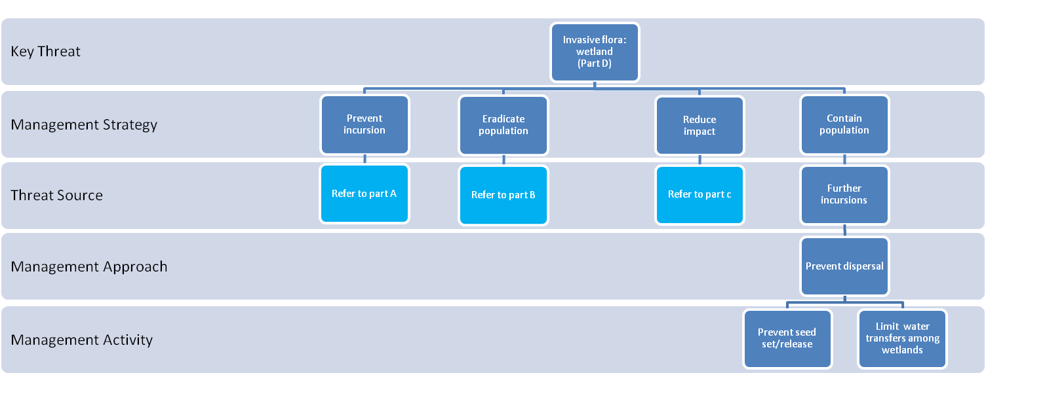

Description: invasive flora (wetlands)
Globally invasive plants are considered the second most important threat to biodiversity (DSE 2009). Invasive plants exert significant impacts on biodiversity as they can displace native flora that provide food resources and/or habitat for native fauna. Invasive plants usually have fast growth rates and outcompete native plants for water, nutrients, light and/or space. Certain types of invasive plants can choke waterways and reduce water quality, flow velocities and flow paths. The threat of invasive plants in Victorian wetlands is measured in the Index of Wetland Condition (IWC) through assessing the percentage cover of environmental weeds, and the proportion that are classified as high threat weeds (DSE 2006). High threat weeds are those that are have a comparatively high potential to outcompete native species. They may include native species outside their normal range. High threat species are specific to different EVC types and are identified in wetland EVC benchmarks (DSE 2006).
KEY: Effectiveness is the expected level of threat reduction that will be achieved by a management intervention and is scored as: Low, a small reduction in the level of the threat; Med, a moderate reduction in the level of the threat which will not always be consistent; and high, a significant and consistent reduction in the level of the threat. Response times represent the period of time before a management activity is expected to eliminate or reduce the level of a threat and are scored as: 1, less than 1 year; 2, 1 -6 years; and 3, > 6 years.
Management Strategy | Management Activity | Effectiveness | Response Time | Rationale
Prevent incursions | Enforce regulatory controls | Med | 1 | The Quarantine Act 1908 and the Environment Protection and Biodiversity Conservation Act 1999 are national legislation that serve to prevent the entry and spread of invasive species and the protection of the environment once they are present. Species listed as Noxious Weeds, Weeds of National Significance or on the National Alert List are subject to regulations that control there use and spread (Petroeschevsky et al 2006). Legislation and policy related to the management of invasive flora in Victoria can be found in EWWG (2007).
Prevent incursions | Improve community and industry awareness | Med | 1-2 | Lack of awareness by the community or industry can lead to the unintentional introduction of invasive wetland flora. Improving community and industry awareness of the risks presented by invasive species, how to identify and report them and how to prevent their dispersal to new sites will reduce new incursions, facilitate the early detection and eradication of new incursions and reduce the risk of human mediated dispersal (EWWG 2007, NRMMC 2007). The WeedStop Vehicle Hygiene program offered by DPI is a example of an education program that improves awareness of landowners, contractors and the community of practical ways to reduce the spread of invasive species (see http://www.dpi.vic.gov.au/agriculture/pests-diseases-and-weeds/weeds/weedstop).
Prevent incursions | Identify and eradicate source population | High | 1-2 | Invasive plant species may arrive in the wetland when their seeds or vegetative fragments are carried from populations outside the wetland by wind, water or animals. Eradicating these source populations will reduce the likelihood of invasive species arriving in the wetland.
Prevent incursions | Manage recreation and access | High | 1 | Providing walking tracks, board walks, boating ramps, parking bays and vehicle tracks help to reduce the introduction of invasive species carried on shoes, clothing, boats and vehicles. Where there is a high risk of introducing or spreading a highly invasive species site access may be restricted.
(continued on next page)

Description: invasive flora: wetland (continued)
Management Strategy | Management Activity | Effectiveness | Response Time | Rationale
Prevent incursions (cont.) | Restore wetland vegetation | High | 2-3 | There is an increased risk of incursions of invasive flora species where the wetland vegetation has been removed or highly degraded. Re-establishing native vegetation can assist in minimising the impact of invasive flora by out-competing the invasive species and changing the habitat to make it less suitable for the establishment or growth of the invasive species (e.g. by creating a more shaded environment). Refer to management strategies and activities to restore wetland vegetation.
Prevent incursions (cont.) | Create or improve vegetation buffer | Med | 1-3 | Native vegetation around the perimeter of the wetland can stop seeds carried in surface water flows reaching the wetland, and can act as a barrier for the dispersal of wind dispersed seed. Intact native vegetation around the perimeter of the wetland will reduce opportunities for invasive species to establish and enhances competitive exclusions by native species.
Eradicate  population | Monitor | High | 1 | Establishing surveillance and reporting programs to detect the occurrence of invasive species will enable the early detection of new incursions (EWWG 2007). Populations that are detected early are likely to be small which increases the chances of successful eradication and reduces the risk of dispersal to other sites. The effectiveness of surveillance programs is dependant on their frequency, areal extent and rigour.
Eradicate  population | Map and report | High | 1 | When new incursions have been detected they must be reported and their location and extent mapped so the effectiveness of eradication or control measures can be assessed.
Eradicate  population | Implement rapid removal | Med-High | 1 | New incursions require rapid eradication as success is more likely while the population is small and before seeds are produced. The most suitable eradication technique will depend on the traits of the species (e.g. woody or herbaceous, seedling or adult, submerged or emergent), whether the area is inundated or not, and whether other threats are present as this may preclude some control measures (e.g. hoeing is problematic where there are acid sulfate soils (ASS).
Reduce impact | Modify water regime | Med- High | 1 | Where growth and/or reproduction of an invasive wetland plant species is reduced by a specific water regime, modifying the water regime can help to eliminate or reduce the size of populations of invasive species. For example, long periods of complete submergence will reduce the growth of emergent invasive species that may have established under drier conditions. Refer to management strategies and activities to reduce the threat of changed water regime.
Reduce impact | Reduce light | Med-High | 1 | Covering low growing invasive plants or seedlings with mulch, plastic sheeting or shade cloth can be used to suppress their growth by reducing light required for photosynthesis. Death will only be achieved if enough light is excluded for a sufficient period of time. Plants with underground storage structures can prove difficult to eliminate with this method. Shading plants with plastic sheeting or shade cloth can not easily be applied to large incursions or tall vegetation.
Reduce impact | Implement soil solarisation | Med- High | 1 | Soil solarisation involves covering damp soil with plastic to raise the soil temperature sufficient to kill the plants present. This can not be applied easily to large incursions or tall vegetation.
(continued on next page)
Description: invasive flora: wetland (continued)
Management Strategy | Management Activity | Effectiveness | Response Time | Rationale
Reduce impact | Apply chemical control | Med-High | 1 | Only a few herbicides are registered for use in aquatic areas in Australia and include several glyphosphate-based products that do not contain surfactants (surfactants are known to be harmful to aquatic organisms). The use of herbicides in Victorian waters is tightly regulated and permits must be obtained prior to their application near a waterway. Guidance should be obtained in selecting the best herbicide, application technique and appropriate timing of application to best manage a particular invasive species. All herbicides must be used with care and measures taken to minimise adverse effects on non-target organism and risks to public health and safety.
Reduce impact | Undertake mechanical or manual control | Med- High | 1 | Mechanical measures include hoeing, harvesting machines and bulldozing. These measures may be problematic in sites with ASS or potential ASS, or when there is a risk of penetrating a saline groundwater table.  Manual control measures include hand removal, slashing and ring barking and are suited to managing small populations.
Reduce impact | Manage livestock grazing | Med | 1-2 | Livestock consume some invasive species and can help to suppress the growth and spread of invasive flora. The timing and intensity of grazing is used to optimise invasive plant control and minimise adverse effects associated with livestock grazing (includes impacts on water quality, soils and native vegetation).
Reduce impact | Implement biological control | High | 1-3 | The principle of biological control is to use one organism to control another by restoring an ecological processes (e.g. herbivory or disease) that limits the competitive ability of the invasive species. Thorough testing is needed to ensure that the control agent does not attack native species or valuable plants (CRC for Weed Management 2003). Biological controls are usually developed for large chronic infestations. Blackberry leaf rust fungus is a biological control agent used to control blackberries in Australia. Biological control should only be carried out as part of an approved, co-ordinated biological control program. Control agents for invasive plants are actively being researched and guidance on biological control approaches for particular invasive species should be obtained from DPI.
Contain population | Prevent seed set/release | High | 1 | Seeds and vegetative fragments of invasive wetland flora that have established in a wetland may disperse to other wetlands via wind, water or animal vectors. Measures to limit dispersal will help contain the spread of invasive species. Harvesting invasive plants prior to seed set or release can help limit both the expansion of the population within the wetland and dispersal to new sites.
 | Limit water transfers among wetlands | High | 1 | Seeds and vegetative fragments of invasive wetland flora that have established in a wetland may disperse to other wetlands via wind, water or animal vectors. The transfer of water among wetlands where invasive species are present has the potential to disperse buoyant seeds and vegetative fragments to new sites. Avoiding the transfer of water from a wetland where invasive species are present to other sites will help to contain the incursion.
Potential risks associated with management interventions
When assessing the suitability of a management activity to reduce the level of a threat to wetland values a thorough assessment of all potential risks associated with the management activity must be carried out. The types of risks that should be considered are described in the methods (see pages 10-11).

Management strategies and activities to reduce the threat of formation and activation of acid sulfate soils (ASS)

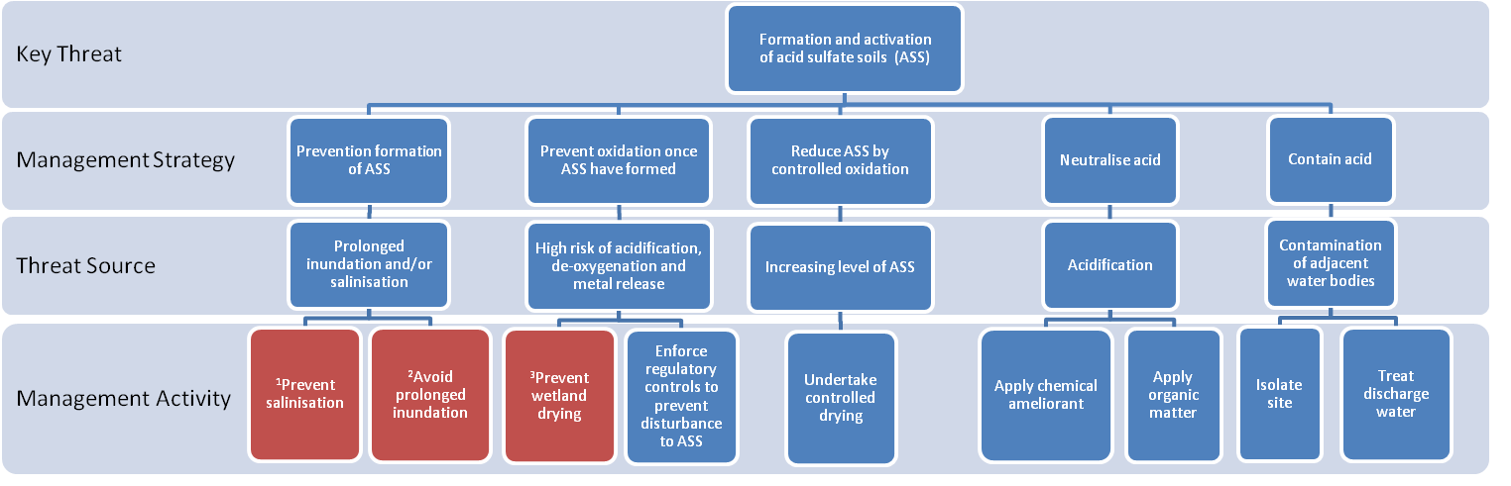
Text boxes coloured red indicate that the management activities are described in another model as indicated by the superscript.

¹Refer to management strategies and activities to reduce the threat of degraded water quality (salinity)
²Refer to management strategies and activities to reduce the threat of changed water regime (water excess)
³Refer to management strategies and activities to reduce the threat of changed water regime (water deficit)
Key to abbreviations:
ASS= acid sulfate soils
Arrows indicate order of management actions
Description: acid sulfate soils
Acid sulfate soils (ASS) refers to soils or sediment that contains reduced inorganic sulfur. Exposure of ASS to the air will result in a chemical reaction that produces sulfuric acid (H₂SO₄). Acid sulfate soils were previously only recognised as a threat in coastal regions but are now considered an emerging issue of inland aquatic ecosystems (EPHC and NRMMC 2011). The activation of ASS is detrimental to aquatic ecosystems as it can result in: acidification, de-oxygenation and/or metal mobilisation in the soil/sediment and water column. The management activities described in this model are based on the recommendations described in the Environmental Protection and Heritage Council and the Natural Resource Management Ministerial Council report (EPHC and NRMMC 2011).
KEY: Effectiveness is the expected level of threat reduction that will be achieved by a management intervention and is scored as: Low, a small reduction in the level of the threat; Med, a moderate reduction in the level of the threat which will not always be consistent; and high, a significant and consistent reduction in the level of the threat. Response times represent the period of time before a management activity is expected to eliminate or reduce the level of a threat and are scored as: 1, less than 1 year; 2, 1 -6 years; and 3, > 6 years.
Management Strategy | Management Activity | Effectiveness | Response Time | Rationale
Prevention formation | Prevent salinisation | Med | 1-3 | Secondary salinisation contributes to the formation of ASS at susceptible sites as it provides a source of sulfate needed for their formation. Reducing the risk of secondary salinisation can minimise the threat of ASS forming or worsening. Refer to management strategies and activities to reduce the threat of degraded water quality (salinity).
Prevention formation | Avoid prolonged inundation | Med | 1 | In sites susceptible to the formation of ASS sediment, anoxia produced by prolonged periods of inundation can contribute to the formation of ASS. Changing the water regime to include regular periods of drying can reduce the risk of ASS forming or worsening. Refer to management strategies and activities to reduce the threat of change water regime (water excess).
Prevent oxidation | Prevent wetland from drying | High | 1 | Where ASS are present, there is a risk of oxidation if they are exposed to the air which can result in acidification, de-oxygenation and/or metal mobilisation in the soil and water column. Maintaining a layer of water over the sediments will reduce this threat. Refer to management strategies and activities to reduce the threat of change water regime (water deficit).
Prevent oxidation | Enforce regulatory controls to prevent disturbance to ASS | High | 1 | Soil disturbances such as excavation or drainage increase the risk of exposure of ASS to the air which causes oxidation and can result in acidification, de-oxygenation and/or metal mobilisation in the soil and water column. The risk of the disturbance of ASS can be reduced by enforcing any existing regulatory controls.
Reduce ASS by controlled oxidation | Undertake controlled drying | Med-High | 1 | Where ASS have formed in the wetland, they may be reduced by controlled oxidation, i.e. by drying the sediments and allowing oxidation to occur in a controlled manner. However, there is a risk that this could cause excessive acid production and this risk needs to be assessed prior to undertaking controlled oxidation. Controlled oxidation is only possible if the system is found to have a high capacity to neutralise the acid that will be produced during oxidation. To manage the risk of acidification during controlled oxidation a carefully planned contingency strategy is needed and close monitoring of the level of acid production is required during drying. Contingency strategies may include the addition of chemical ameliorants and/or re-flooding.
(continued on next page)

Management Strategy | Management Activity | Effectiveness | Response Time | Rationale
Neutralise acid | Apply chemical ameliorant | Med-High | 1 | There is a high likelihood that applying a chemical ameliorant would be effective in neutralising acid in a wetland where ASS have been activated. A comprehensive list of suitable ameliorants is provided in EPHC & NRMMC (2011).
Neutralise acid | Apply organic matter | Med- | 1 | The addition of organic matter (such as a thick layer of mulch) increases microbial activity which produces anoxic condition (through microbial respiration) and this prevents further oxidation and acid production. Under anoxic conditions organic matter also fuels the reduction of iron and sulfur by micro-organisms which generates alkalinity, and this helps to neutralise acids already present (EPHC & NRMMC 2011). Although organic matter may help manage acidity in the short term, it also generates sulphide and therefore the potential for future acid production. Applying organic matter can be effective in treating the wetland where ASS have been activated, but success is variable and it is only recommended as a stop-gap measure until other measures can be implemented (EPHC & NRMMC 2011).
Contain acid | Isolate wetland | Med-High | 1 | Wetlands in which ASS have been activated and the resulting acidification can not be ameliorated present a risk to aquatic systems downstream if acid water is discharged. When this occurs the wetland should be isolated and downstream discharges prevented.
Contain acid | Treat discharge water | Med-High | 1 | Wetlands in which ASS have been activated and the resulting acidification can not be ameliorated present a risk to aquatic systems downstream if acid water is discharged. If discharges from the wetland cannot be prevented the water discharged from the wetland should be treated to reduce impacts on receiving areas. Treatment of water discharges can include chemical or biological amelioration and dilution.
Description: acid sulfate soils (continued)

Potential risks associated with management interventions
When assessing the suitability of a management activity to reduce the level of a threat to wetland values a thorough assessment of all potential risks associated with the management activity must be carried out. The types of risks that should be considered are described in the methods (see pages 10-11).

Management strategies and activities to reduce the threat of degraded water quality (salinity)

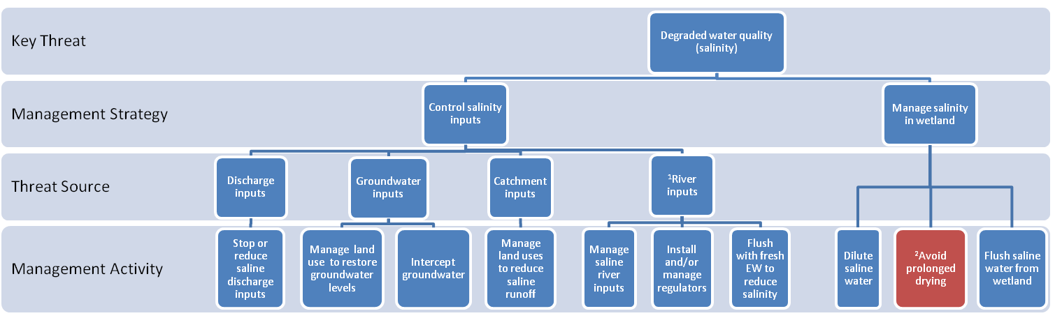
Text boxes coloured red indicate that the management strategies and activities are described in another model as indicated by the superscript.

¹ River inputs only apply to floodplain wetlands
² Refer to management strategies and activities to reduce the threat of changed water regimes (water deficit).

Abbreviations:
EW= environmental water

Description: degraded water quality (salinity)
Salinisation is a major threat to aquatic habitats throughout Australia (Hart et al. 1991). Salinisation due to human disturbance (secondary salinisation) results mainly from landscape changes that cause saline groundwater tables to rise. These include the clearing of deep rooted native vegetation (dryland salinity) and irrigated agriculture in poorly drained land, which both increase groundwater recharge. Increased groundwater recharge promotes the seepage of saline groundwater directly into watercourses and wetlands. Elevated groundwater tables also increase the surface expression of salts resulting in land salinisation. Surface runoff from salinised land then carries salts to watercourse and wetlands (Peck et al. 1983). Salinity exerts multiple impacts on aquatic systems including direct effects of aquatic fauna and flora and altered chemical processes, as well as the degradation of habitat and damage to infrastructure.
KEY: Effectiveness is the expected level of threat reduction that will be achieved by a management intervention and is scored as: Low, a small reduction in the level of the threat; Med, a moderate reduction in the level of the threat which will not always be consistent; and high, a significant and consistent reduction in the level of the threat. Response times represent the period of time before a management activity is expected to eliminate or reduce the level of a threat and are scored as: 1, less than 1 year; 2, 1 -6 years; and 3, > 6 years.
Management Strategy | Management Activity | Effectiveness | Response Time | Rationale
Control salinity inputs | Stop or reduce saline discharge inputs | High | 1 | Water may be discharged to wetlands to dispose of drainage water, industrial, agricultural or sewage treatment water, irrigation tailwater, or the water from groundwater interception schemes. Where these discharges are saline they should be stopped, reduced or diverted to other storages to prevent further increases in wetland salinity.
Control salinity inputs | Manage land use to restore groundwater levels | Low-Med | 2-3 | Land use changes can cause saline groundwater tables to rise and increase the salinity of wetlands that have a connection to the groundwater. Groundwater levels can be reduced by: (1) revegetating groundwater recharge and transmission zones with trees and other salt-tolerant perennial, high water use vegetation; (2) ensuring efficient water irrigation practices are in place and (3) preventing water seepage from water supply channels.
Control salinity inputs | Intercept groundwater | Med-High | 1-2 | Where high saline groundwater tables cannot be lowered by managing land use, groundwater interception works may be necessary to protect wetlands. Groundwater should be disposed in purpose-built disposal basins.
Control salinity inputs | Manage land uses to reduce saline runoff | Low-Med | 2-3 | Salts can enter wetlands from diffuse sources through salt wash-off from salinised land or when low quality irrigation water is used in the local catchment. Reducing salt wash–off from salinised land involves revegetating bare areas to reduce erosion and lowering the groundwater table to reduce the expression of salts at the soil surface.
Control salinity inputs | Miminise impacts from saline river inputs | High | 1 | Saline water inputs to freshwater wetlands from rivers can be avoided by ensuring off-takes are placed above stratified saline layers or impacts reduced by ensuring adequate fresh flows to dilute/flush salts.
(continued on next page)

Description: degraded water quality (salinity) (continued)
Management Strategy | Management Activity | Effectiveness | Response Time | Rationale
Control salinity inputs | Install and /or manage regulators (floodplain wetlands) | High | 1 | For lower river reaches affect by salt water intrusions the installations and/or management of regulators can help to prevent water entry into naturally freshwater wetlands during periods of high river salinity. Bottom-gated regulators should be avoided as they limit the capacity to deliver freshwater to wetlands (salt water is denser than freshwater and the most saline water sits at the bottom of the water column).
Control salinity inputs | Flush with fresh environmental water to reduce intrusion | Med-High | 1 | When river flows are substantially reduced by river regulation, a saline intrusion in the lower river reaches can move further upstream, this increases the salinity of water supplied to floodplain wetlands. The release of water from storages can reduce the upstream extent of saline intrusion and freshen the top layers of the water column improving the quality of river inputs to floodplain wetlands.
Manage salinity in wetland | Dilute saline water | Med-High | 1 | The concentration of salts present in the wetland can be diluted by the addition of fresh water. However, dilution may exert negative impacts if the depth or duration of inundation is increased for long periods. Other measures to address salinity will also be needed in the long-term.
Manage salinity in wetland | Flush saline water from wetland | Med-High | 1 | During periods of high water availability, draining saline water from the wetland and replacing it with fresh water can reduce the salt load in the wetland.
Manage salinity in wetland | Avoid prolonged drying | Med | 1 | When wetlands with a shallow saline groundwater table are dry capillary action will deliver saline groundwater to the soil surface where it evaporates and deposits salt. This process can result in a persistent increase in salinity unless salts are adequately flushed from the wetland. Unnaturally long periods of drying should therefore be avoided in wetlands where the main source of salinity is due to a shallow saline groundwater.
Potential risks associated with management interventions
When assessing the suitability of a management activity to reduce the level of a threat to wetland values a thorough assessment of all potential risks associated with the management activity must be carried out. The types of risks that should be considered are described in the methods (see pages 10-11).

Management strategies and activities to reduce the threat of degraded water quality (turbidity)

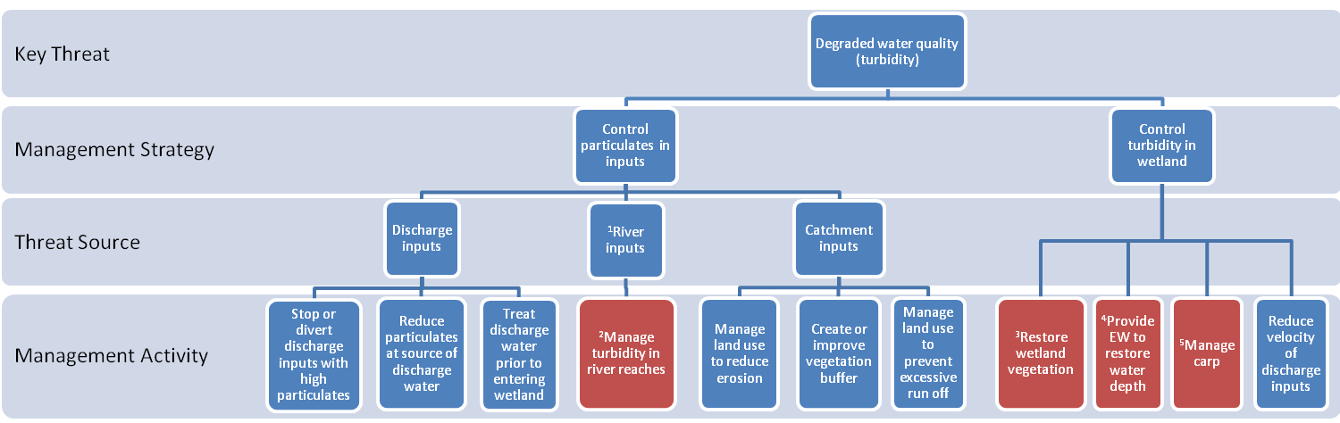

Text boxes coloured red indicate that the management activities are described in another model as indicated by the superscript.

¹River inputs only apply to floodplain wetlands
²Refer to management strategies and activities to reduce the threat of degraded water quality: turbidity (river reaches) (GHD 2012).
³Refer to management strategies and activities to reduce the threat of degraded wetland vegetation
⁴Refer to management strategies and activities to reduce the threat of changed water regime
⁵Refer to management strategies and activities to reduce the threat of invasive aquatic fauna

Abbreviations: EW= environmental water
Description: degraded water quality (turbidity)
Turbidity refers to the suspension of particles in the water column that reduce its clarity. Turbidity can be caused either by the suspension of soil particles in the water column or by the growth of phytoplankton. This threat-management intervention model only examines the threat of turbidity that results from increasing levels of suspended soil particles in the water column. High levels of soil particulates in the water column can result from soil erosion or construction activity in the catchment, discharge inputs to the wetland that are high in particulates, or by soil disturbance within the wetland created by livestock or invasive fauna (e.g. Common Carp, feral pigs). High levels of turbidity in wetlands exert negative impacts on submerged aquatic plants by reducing light needed for growth. Turbidity due to suspended sediments also impacts on fish and invertebrates by clogging gills, reducing feeding efficiency of visual feeders and through loss of habitat.
Management Strategy | Management Activity | Effectiveness | Response Time | Rationale
Control particulate inputs | Stop or divert discharge inputs with high particulates | High | 1 | Where discharge inputs are high in suspended soil particles, this can cause high levels of turbidity in the wetland. Stopping or reducing discharge inputs high in suspended soil particles will reduce the threat level in the wetland.
Control particulate inputs | Reduce particulates at source of discharge inputs | High | 1 | Where discharge inputs are high in suspended soil particles, this can cause high levels of turbidity in the wetland. Reducing the amount of suspended soil particles in the source water can reduce the threat level in the wetland.
Control particulate inputs | Treat discharge inputs prior to entering wetland | High | 1 | Where the turbidity of the discharge inputs cannot be reduced at the source, the water could be treated en route to the wetland. Artificial wetlands reduce particulate loads by slowing the flow of water and using vegetation filters to trap particulates.
Control particulate inputs | Manage degraded water quality (turbidity) in river reach | Med-High | 1-2 | Turbidity levels in floodplain wetlands can be increased when turbidity levels of their source rivers are high. Addressing high levels of turbidity in river reaches can therefore help to reduce the threat level in floodplain wetlands. Refer to management strategies and activities to reduce the threat of degraded water quality turbidity (river reaches) (GHD 2012).
Control particulate inputs | Manage land use to reduce erosion | Low-Med | 2-3 | Runoff from eroded areas carries high levels of suspended soil particles. Agricultural and construction activities require sediment and erosion controls to minimise particulates in stormwater runoff.
Control particulate inputs | Create or improve vegetation buffer | Med | 1-2 | Vegetation around the perimeter of the wetland acts as a filter and lowers particulate inputs from catchment sources. Creating riparian buffers along the lower reaches of streams and along drainage lines that flow into wetlands, as well as the wetland itself, can reduce particulates carried in water inflows.
KEY: Effectiveness is the expected level of threat reduction that will be achieved by a management intervention and is scored as: Low, a small reduction in the level of the threat; Med, a moderate reduction in the level of the threat which will not always be consistent; and high, a significant and consistent reduction in the level of the threat. Response times represent the period of time before a management activity is expected to eliminate or reduce the level of a threat and are scored as: 1, less than 1 year; 2, 1 -6 years; and 3, > 6 years.
(continued on next page)
Description: degraded water quality (turbidity) continued
Management Strategy | Management Activity | Effectiveness | Response Time | Rationale
Control particulate inputs (continued) | Manage land use to prevent excessive runoff | Low-Med | 2-3 | Surface water runoff from eroded areas or in catchment where soil disturbance has occurred carries particulates to wetlands. The greater the volume of surface water runoff reaching the wetland the greater the total amount of sediment that reaches the wetland. Reducing excessive surface water runoff will therefore reduce the particulate load to wetlands
Control turbidity in wetland | Restore wetland vegetation | Med | 1-3 | Aquatic plants reduce sediment re-suspension as they stabilise the sediment and reduce flow velocity. Restoring wetland vegetation can therefore reduce the threat level. Refer to management strategies and activities to reduce the threat of degraded wetland vegetation.
Control turbidity in wetland | Deliver environmental water to restore/maintain water depth | Med | 1 | Wind action on the surface of open water can create turbulent mixing of the water column and the re-suspension of soil particles. Sediments are less likely to be re-suspended by this process in deeper water and restoring or maintaining the natural filling depth can help reduce sediment re-suspension. Refer to management strategies and activities to reduce the threat of changed water regime.
Control turbidity in wetland | Manage carp | Med | 1-2 | The invasive freshwater fish, Common Carp (Cyprinus carpio) are sediment feeders. These disturb the sediments, uproot plants and destabilise banks. Managing carp populations can help reduce turbidity. Refer to management strategies and activities to reduce the threat of invasive aquatic fauna.
Control turbidity in wetland | Reduce velocity of discharge inputs | High | 1-2 | Reducing the velocity of water flowing into the wetland reduces sediment re-suspension and allows particles carried in the water to settle out. Reducing flow velocity may be achieved by creating a vegetation filter at the point of water entry.
Potential risks associated with management interventions
When assessing the suitability of a management activity to reduce the level of a threat to wetland values a thorough assessment of all potential risks associated with the management activity must be carried out. The types of risks that should be considered are described in the methods (see pages 10-11).

Management strategies and activities to reduce the threat of degraded water quality (nutrients)
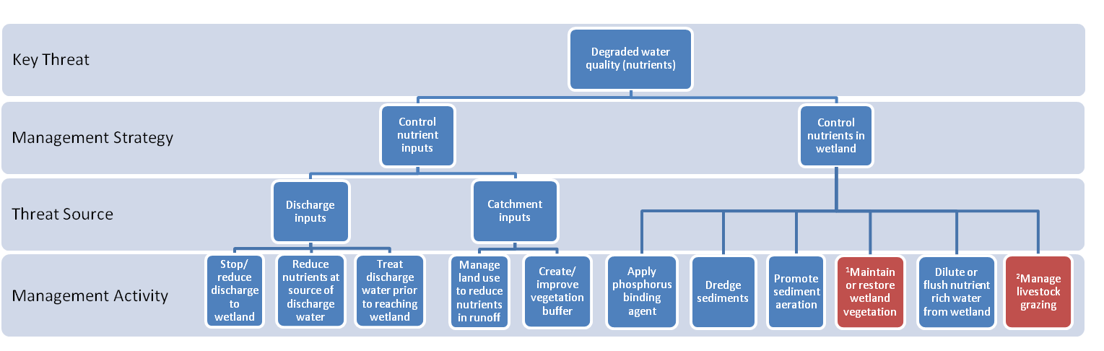

Text boxes coloured red indicate that the management activities are described in another model as indicated by the superscript.

¹Refer to management strategies and activities to reduce the threat of degraded wetland vegetation.
²Refer to management strategies and activities to reduce the threat of soil disturbance.
Description: degraded water quality (nutrients)
The nutrient content of natural wetlands is highly variable from bogs that are naturally very low in nutrients to marshes that are fed by surface or groundwater inputs and have naturally higher levels of nutrients (Sorrell 2010). Excessive levels of nutrients cause adverse effects of wetland values. Signs of excessive nutrients in a wetland can include high levels of primary productivity and litter accumulation, proliferation of plant species with high growth rates, increased algal abundance, and low levels of oxygen. These changes ultimately can result in algal blooms, fish deaths and impact on a wide range of wetland values.
KEY: Effectiveness is the expected level of threat reduction that will be achieved by a management intervention and is scored as: Low, a small reduction in the level of the threat; Med, a moderate reduction in the level of the threat which will not always be consistent; and high, a significant and consistent reduction in the level of the threat. Response times represent the period of time before a management activity is expected to eliminate or reduce the level of a threat and are scored as: 1, less than 1 year; 2, 1 -6 years; and 3, > 6 years.
Management Strategy | Management Activity | Effectiveness | Response Time | Rationale
Control nutrient inputs | Stop or reduce discharge inputs with high nutrient levels | High | 1 | Discharge inputs such as agricultural and domestic wastewater can contain high levels of nutrients and should be stopped, reduced or diverted to a treatment wetland to prevent further increases of nutrients in the wetland.
Control nutrient inputs | Reduce nutrients at source of discharge water | High | 1-2 | The nutrient level of water discharges can be reduced by treating agricultural or industrial wastewater at their source..
Control nutrient inputs | Treat discharge water prior to reaching wetland | High | 1-2 | Diverting wastewater into artificial wetlands designed to reduce nutrients can reduce the level of nutrients reaching natural wetlands.
Control nutrient inputs | Manage land use to reduce nutrients in runoff | Med-high | 1-3 | Diffuse nutrient runoff from agricultural land can be reduced by managing the use of fertilisers, controlling wastewater discharge, trapping sediment in streams that flow into wetland, vegetating drainage networks on farms to act as filters and by excluding livestock and establishing riparian vegetation along streams that run into wetlands (Sorrell 2010).
Control nutrient inputs | Create or improve vegetation buffer | Low-Med | 1-3 | A wetland is more susceptible to nutrient inputs where there is no vegetation around the perimeter of the wetland to act as a filter and lower nutrient inputs from catchment sources. Creating riparian buffers along the lower reaches of streams and drainage lines that flow into wetlands and around the wetland itself can reduce nutrients in inflow. Fencing vegetation buffers may be needed to reduce disturbance and nutrient inputs from livestock.
Control nutrients in wetland | Apply phosphorus (P) binding agent | Med | 1 | Phosphorus inactivation aims to lower the P content of the water and retard the release of P from the sediment. It involves the addition of compounds that bind P (e.g. aluminium salts, clay material) (Cooke et al. 2005). This management activity is more common in lakes and reservoirs that provide water for human consumption or are used for recreation (e.g. swimming) because it helps to control toxic blue green algae by limiting the availability of P.
Control nutrients in wetland | Dredge sediments | Med | 1 | Nutrients, particularly P, are stored in wetland sediments. Where high concentrations have been reached sediment removal may be appropriate. However, dredging the sediments will have adverse effects on other wetland values and these should be weighed up against the benefits. Dredging is also costly and dredge material needs appropriate disposal (Cooke et al. 2005).
(continued next page)
Description: degraded water quality (nutrients) (continued)

Management Strategy | Management Activity | Effectiveness | Response Time | Rationale
Control nutrients in wetland (cont.) | Promote sediment aeration | Med | 1 | De-oxygenation of the sediments can result in the release of sediment bound P into the water column which may cause blue-green algal blooms. Stands of some emergent plants such as Phragmites and Typha can aerate the root zone through a process called convective gas flow. Aeration of the root zone contributes to nutrient reduction by: i) promoting the binding of P to the sediments and ii) creating aerated zones adjacent to anaerobic zones that favour nitrification-denitrification by soil bacteria. In deep water bodies such as lakes and reservoirs that have a high levels of P bound in the sediments, mechanical aeration may be needed to limit P availability and control algal blooms (Cooke et al. 2005). Mechanical aeration is usually only applied to deep lakes, as these water bodies can become thermally stratified producing anoxic sediments. Aeration is usually achieved by pumps that deliver air/oxygen to the bottom of the lake through perforated tubes. Aeration techniques that result in the mixing of the water column are often not suitable because mixing delivers nutrient rich water from the lake bottom to surface waters where they can promote algal growth.
Control nutrients in wetland (cont.) | Maintain or restore wetland vegetation | Med | 1-3 | Aquatic vegetation is important in controlling nutrients in wetlands through uptake, facilitating nitrification-denitrification and promoting the binding of P to sediments (see row above). Aquatic plants help control algal blooms by competing with algae for light and nutrients and in some cases producing chemicals that inhibit algal growth. At high nutrient levels submerged plants can be lost with a shift to phytoplankton dominance. When this occurs it can be very difficult to re-establish submerged aquatic plants. Refer to management strategies and activities to reduce the threat of degraded wetland vegetation.
Control nutrients in wetland (cont.) | Dilute/ flush nutrients in water column | Med | 1 | Diluting nutrients with low nutrient water can help reduce nutrient concentrations and limit phytoplankton abundance. During periods of high water availability, draining nutrient rich water from the wetland and replacing it with low nutrient water can help remove nutrients from the system. Where there is a large store of nutrients in the sediment this may only produce a short-term reduction in the level of nutrients in the water column.
Control nutrients in wetland (cont.) | Manage livestock grazing | High | 1 | Livestock increase nutrients in the wetland through faecal inputs and when carcasses are left to decompose in the wetland. Refer to management strategies and activities to reduce the threat of soil disturbance.
Potential risks associated with management interventions
When assessing the suitability of a management activity to reduce the level of a threat to wetland values a thorough assessment of all potential risks associated with the management activity must be carried out. The types of risks that should be considered are described in the methods (see pages 10-11).

Management strategies and activities to reduce the threat of soil disturbance

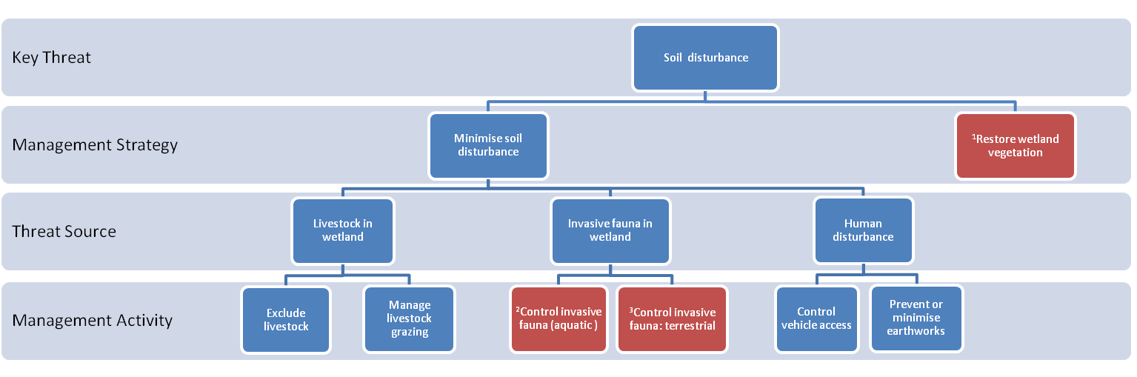Text boxes coloured red indicate that the management activities are described in another model as indicated by the superscript.
¹Refer to management strategies and activities to reduce the threat of degraded wetland vegetation
²Refer to management strategies and activities to reduce the threat of invasive fauna: aquatic
³Refer to management strategies and activities to reduce the threat of invasive fauna: terrestrial

Description: soil disturbance
Soil disturbance can alter the structural complexity of vegetation, disrupt soil based eggs and seed banks, increase turbidity and change the form of the wetland. Soil disturbance may be caused by earthworks, vehicle access, invasive terrestrial or aquatic fauna, and/or livestock.
KEY: Effectiveness is the expected level of threat reduction that will be achieved by a management intervention and is scored as: Low, a small reduction in the level of the threat; Med, a moderate reduction in the level of the threat which will not always be consistent; and high, a significant and consistent reduction in the level of the threat. Response times represent the period of time before a management activity is expected to eliminate or reduce the level of a threat and are scored as: 1, less than 1 year; 2, 1 -6 years; and 3, > 6 years.
Management Strategy | Management Activity | Effectiveness | Response Time | Rationale
Prevent soil disturbance | Exclude livestock access | High | 1 | Livestock cause soil disturbance which reduces the abundance, diversity and structure of wetland vegetation. It also disrupts soil based egg and seed banks, creates gaps in native vegetation cover in which invasive species may establish and changes the microtopography of the wetland. Excluding livestock will prevent these impacts. However, where significant soil disturbance has already occurred, the exclusion of livestock may not be sufficient to restore wetland vegetation and additional management interventions may be required.
Prevent soil disturbance | Manage livestock grazing | Med | 1 | Livestock cause soil disturbance which reduces the abundance, diversity and structure of wetland vegetation. It also disrupts soil based egg and seed banks, creates opportunities for invasive species to establish and changes the microtopography of the wetland. Managing livestock by restricting the area, timing, frequency and/or intensity of grazing can minimise adverse effects on the wetland. As soil disturbance is greatest when the soil is wet livestock access to the wetland should be avoided during these periods. To promote the regeneration of native aquatic flora, livestock access should be avoided when species are flowering and setting seed. Soil disturbance by livestock can also be limited by restricting access to specific watering points in the wetland. This can be achieved by installing fencing, or by placing watering troughs on higher ground. Reducing the number of livestock in the wetland will reduce the level of soil disturbance. Stocking rates can be manipulated by varying the number, duration and frequency that livestock access the wetland.
Prevent soil disturbance | Manage carp | Med-High | 1-2 | The invasive freshwater fish, Common Carp (Cyprinus carpio) are sediment feeders. They disturb sediments, uproot plants and destabilise banks. Managing carp populations can reduce the threat of soil disturbance. Refer to management strategies and actions to reduce the threat of invasive fauna (aquatic).
Prevent soil disturbance | Control invasive fauna (terrestrial) | Med-High | 1-3 | Several invasive terrestrial species can create significant soil disturbance. Eradicating or reducing populations of invasive terrestrial fauna will help prevent soil disturbance in the wetland. Refer to management strategies and activities to reduce the threat of invasive fauna (terrestrial).
Prevent soil disturbance | Control human access | High | 1 | Driving vehicles or walking in the wetland, particularly when the soil is wet can cause significant soil disturbance. Providing board walks, boat ramps, vehicle tracks, and access paths can limit soil disturbance created by human access for recreational purposes.
Prevent soil disturbance | Prevent or minimise earthworks | High | 1 | Earthworks create significant soil disturbance in the wetland. Where earthworks must be carried out in the wetland the impacted area should be minimised as much as practical and where ever possible the work should be undertaken when the sediments are dry.
(continued next page)
Description: soil disturbance (continued)

Management Strategy | Management Activity | Effectiveness | Response Time | Rationale
Restore wetland vegetation | Restore wetland vegetation | Low-High | 1-3 | Where soil disturbance has significantly degraded wetland vegetation, then revegetation may be required. Further disturbance to the soil should be prevented or minimised, other processes that degrade wetland vegetation managed, and/or direct seeding or planting undertaken. Refer to management strategies and activities to reduce the threat of degraded wetland vegetation.
Potential risks associated with management interventions
When assessing the suitability of a management activity to reduce the level of a threat to wetland values a thorough assessment of all potential risks associated with the management activity must be carried out. The types of risks that should be considered are described in the methods (see pages 10-11).

Management strategies and activities to reduce the threat of degraded wetland vegetation

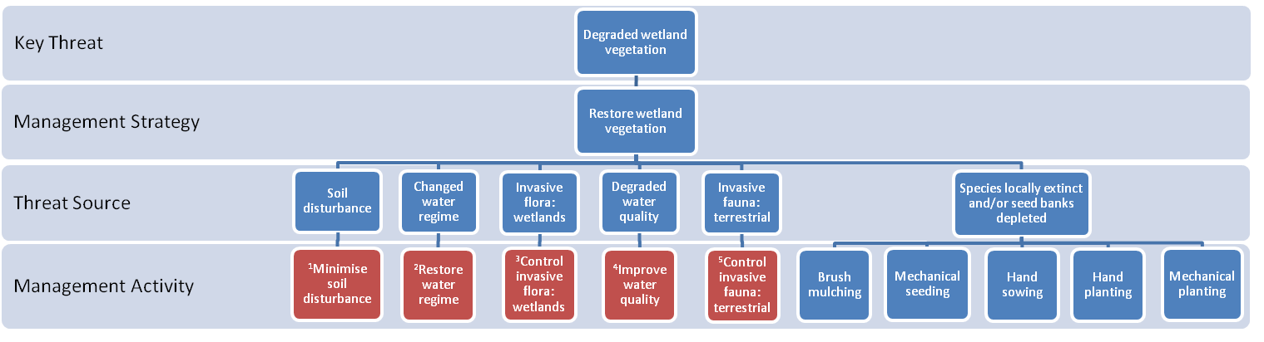

Text boxes coloured red indicate that the management activities are described in another model as indicated by the superscript.
¹Refer to management strategies and activities to reduce the threat of soil disturbance
²Refer to management strategies and activities to reduce the threat of changed water regime
³Refer to management strategies and activities to reduce the threat of invasive flora: wetlands
⁴Refer to management strategies and activities to reduce the threat of degraded water quality: salinity, nutrients, turbidity, acid sulfate soils
⁵Refer to management strategies and activities to reduce the threat of invasive faunal: terrestrial
Description: degraded wetland vegetation
Degraded wetland vegetation refers to a reduction in the condition of vegetation compared with an undisturbed system of the same vegetation type (IWC 2010). The condition of vegetation is described in terms of critical life form grouping, weeds, indicators of altered processes and vegetation structure and health. Changes in these attributes may be caused by changed water regime, degraded water quality, soil disturbance and invasive species. Reducing these threats can enable wetland vegetation to recover, but where species have become local extinct, or the seed bank is depleted revegetation will be needed.
KEY: Effectiveness is the expected level of threat reduction that will be achieved by a management intervention and is scored as: Low, a small reduction in the level of the threat; Med, a moderate reduction in the level of the threat which will not always be consistent; and high, a significant and consistent reduction in the level of the threat. Response times represent the period of time before a management activity is expected to eliminate or reduce the level of a threat and are scored as: 1, less than 1 year; 2, 1 -6 years; and 3, > 6 years.
Management Strategy | Management Activity | Effectiveness | Response Time | Rationale
Restore wetland vegetation | Minimise soil disturbance | Med-High | 1-2 | Natural regeneration is likely to be impaired when soil disturbance occurs. Refer to management strategies and actions to reduce the threat of soil disturbance.
Restore wetland vegetation | Manage livestock grazing | Med | 1 | Livestock can potentially degrade native wetland vegetation by: (1) consuming and trampling native plants; (2) creating soil disturbance which disrupts soil seed banks and alters the microtopography of the wetland; (3) increasing nutrient levels in the wetland (through inputs of dung and urine) which can alter competitive interactions among species and lead to compositional change; (4) transporting seeds and vegetative fragments of invasive species into the wetland and creating gaps in vegetation cover which increase the likelihood that invasive species will establish in the wetland. Managing livestock grazing by restricting the area, timing, frequency and/or intensity of livestock can minimise adverse effects on the wetland vegetation. As soil disturbance is greatest when the soil is wet livestock access to the wetland should be avoided during these periods. To promote the regeneration of native aquatic flora, livestock access should be avoided when native species are flowering and setting seed. Soil disturbance by livestock can also be limited by restricting access to specific watering points in the wetland. This can be achieved by installing fencing, or by placing watering troughs on higher ground. Reducing the number of livestock in the wetland will reduce the level of soil disturbance. Stocking rates can be manipulated by varying the number, duration and frequency that livestock access the wetland.
Restore wetland vegetation | Restore water regime | Med-High | 1-3 | Natural regeneration is likely to be impaired when the natural water regime is not maintained. Refer to management strategies and actions to reduce the threat of changed water regime.
Restore wetland vegetation | Control invasive flora: wetland | Med-High | 1-2 | Natural regeneration is likely to be impaired when invasive flora are not controlled. Refer to management strategies and actions to reduce the threat of invasive flora (wetland).
Restore wetland vegetation | Improve water quality | Med-High | 1-2 | Natural regeneration of is likely to be impaired by poor water quality such as high levels of salinity, nutrient, turbidity and/or acidification. Refer to management strategies and activities to reduce the threat of degraded water quality (salinity, nutrients, turbidity) and to formation and activation of acid sulfate soils.
Restore wetland vegetation | Control invasive fauna: terrestrial | Med-High | 1-3 | Natural regeneration will be impaired when invasive terrestrial fauna are not controlled. Refer to management strategies and activities to reduce the threat of invasive fauna (terrestrial).

Management Strategy | Management Activity | Effectiveness | Response Time | Rationale
Restore wetland vegetation | Brush mulching | Med | 1 | Brush mulching involves placing cut branches of trees and shrubs with ripe fruit on the revegetation site. Cut branches and shrubs improve establishment success as they help to reduce erosion and trap sediment, litter and seed. The approach is best suited to revegetating small patches within a site.
Restore wetland vegetation | Hand sowing | Low-Med | 1 | Two hand sowing approaches are used: (i) broadcast seeding and (ii) niche seeding. Broadcast seeding is used to distribute seeds over large areas and involves throwing seeds over prepared soil. Niche seeding is used to seed small areas under existing vegetation and involves placing seeds on prepared soil¹.
Restore wetland vegetation | Mechanical seeding | Low-Med | 1 | Mechanical seeders are used for sowing seed over large areas. A variety of seeding machines are available. Mechanical seeders scrape the soil to remove weed seeds in the soil before cutting a slot in the soil in which seeds are deposited. Some mechanical seeders also deliver water and fertilisers¹.
Restore wetland vegetation | Hydro mulching | Med-High | 1 | Hydro-mulching is where seeds are mixed with mulch, water and fertiliser to form slurry which is sprayed on the area¹.
Restore wetland vegetation | Hand planting | Med-High | 1 | Hand planting is where tube stock is planted by hand or with simple instruments (e.g. mattock, hamilton planter)¹
Restore wetland vegetation | Mechanical planting | Med-High | 1 | Mechanical planters are used for planting tube stock over large areas¹
¹A comprehensive account of planting methods can be found at http://www.florabank.org.au/
Potential risks associated with management interventions
When assessing the suitability of a management activity to reduce the level of a threat to wetland values a thorough assessment of all potential risks associated with the management activity must be carried out. The types of risks that should be considered are described in the methods (see pages 10-11).

Management strategies and activities to reduce the threat of reduced wetland area

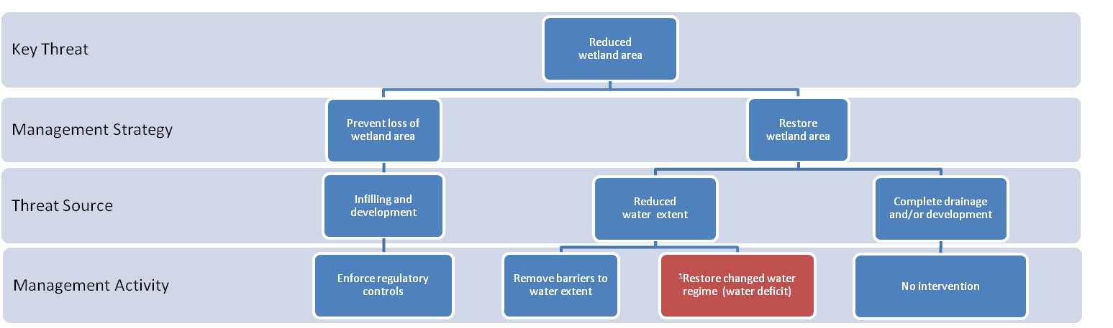
Text boxes coloured red indicate that the management activities are described in another model as indicated by the superscript.

¹Refer to management strategies and activities to reduce the threat of changed water regime (water deficit)

Description: reduced wetland area
Wetland area can be reduced when it is completely or partially converted to dry land through infilling or drainage, or when levee banks or water diversions prevent water reaching areas of the wetland that would normally experience inundation. A reduction in the area of a wetland reduces the availability of habitat for aquatic organisms and can lead to a reduction in population size or in the local extinction of species. Reduced wetland area can also alter the water regime (unless there is a comparable reduction in water inputs) and this can drive changes in wetland biota and alter ecological processes such as nutrient cycling and decomposition.
KEY: Effectiveness is the expected level of threat reduction that will be achieved by a management intervention and is scored as: Low, a small reduction in the level of the threat; Med, a moderate reduction in the level of the threat which will not always be consistent; and high, a significant and consistent reduction in the level of the threat. Response times represent the period of time before a management activity is expected to eliminate or reduce the level of a threat and are scored as: 1, less than 1 year; 2, 1 -6 years; and 3, > 6 years.
Management Strategy | Management Activity | Effectiveness | Response Time | Rationale
Prevent loss of wetland area | Apply and enforce regulatory controls | High | 1 | Wetland area can be lost by infilling and/or drainage for development or agriculture production. Preventing a reduction in wetland area can be achieved by applying planning controls such as new schedules to the Environmental Significance Overlay (ES0) and by enforcing existing regulatory controls (e.g. existing schedules to the ESO or the Ministerial guidelines for assessment of environmental effects under the Environmental Effects Act 1978).
Restore wetland area | Remove barriers to water extent | High | 1 | Remove channels, drains or levees that prevent water reaching areas of the wetland that would normally be inundated. Controlling invasive plants that obstruct and/alter the natural flow of water into and within the wetland.
Restore wetland area | Restore changed water regime (water deficit) | Med-High | 1-2 | A change in the water regime caused by a reduction in water inputs can reduce the functional area of the wetlands when water no longer reaches areas of the wetland that would normally be inundated. Refer to management strategies and action to reduce the threat of changed water regime (water deficit).
Restore wetland area | No intervention | None | Not applicable | In cases where the wetland has been permanently drained and the land developed it may not be possible to restore the natural wetland area.

Potential risks associated with management interventions
When assessing the suitability of a management activity to reduce the level of a threat to wetland values a thorough assessment of all potential risks associated with the management activity must be carried out. The types of risks that should be considered are described in the methods (see pages 10-11).

Management strategies and activities to reduce the threat of altered wetland form

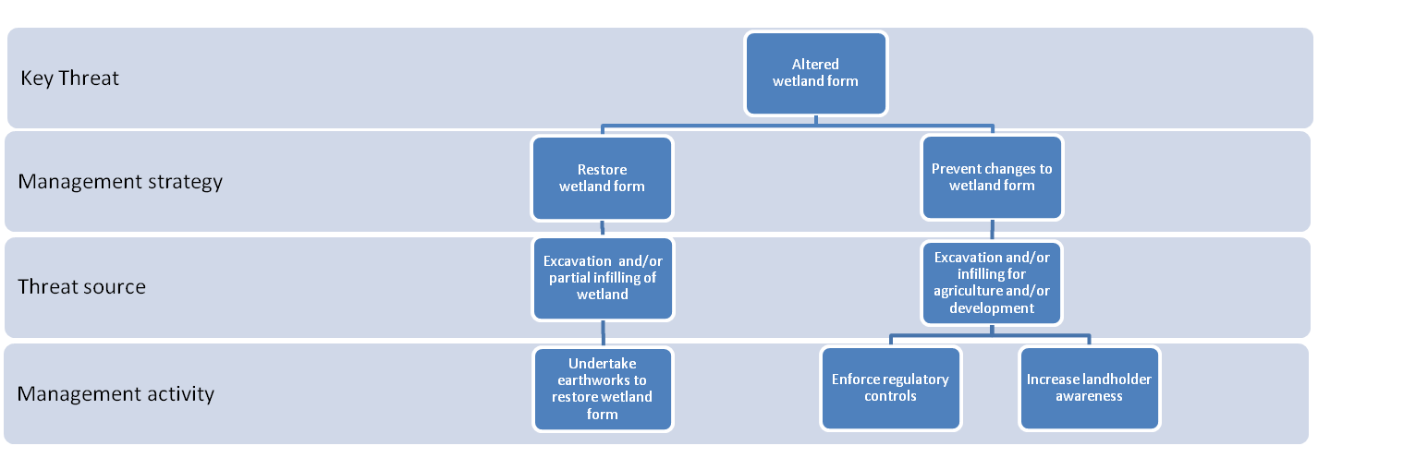
Description: altered wetland form
Altered wetland form is where the natural bathymetry (underwater topography), depth, shape and/or size of the wetland is altered (DSE 2006). These physical attributes of the wetland influence the depth and duration of inundation which in turn influence the flora and fauna communities present and biological processes (e.g. nutrient cycling and decomposition).
KEY: Effectiveness is the expected level of threat reduction that will be achieved by a management intervention and is scored as: Low, a small reduction in the level of the threat; Med, a moderate reduction in the level of the threat which will not always be consistent; and high, a significant and consistent reduction in the level of the threat. Response times represent the period of time before a management activity is expected to eliminate or reduce the level of a threat and are scored as: 1, less than 1 year; 2, 1 -6 years; and 3, > 6 years.
Management Strategy | Management Activity | Effectiveness | Response Time | Rationale
Restore wetland form | Undertake earthworks to restore natural bathymetry | High | 1 | Where wetlands have been deepened for water storage, earthworks may be needed to restore the natural bathymetry of the wetland.
Prevent further changes to wetland form | Enforce regulatory controls | High | 1 | Wetland form may be altered to permit agriculture. Preventing changes to the natural form of the wetland can be achieved by applying planning controls such as new schedules to the Environmental Significance Overlay (ES0) and by enforcing existing regulatory controls (e.g. existing schedules to the ESO or the Ministerial guidelines for assessment of environmental effects under the Environmental Effects Act 1978).
Prevent further changes to wetland form | Increase landholder awareness | Med-High | 1-2 | Landowners may deepen the wetland to improve water storage or they may divert water from areas of the wetland to permit grazing or agricultural production. Landowners that understand the value of wetlands and the impact of altered wetland form on wetland value may be less likely to change the form of the wetland.
Potential risks associated with management interventions
When assessing the suitability of a management activity to reduce the level of a threat to wetland values a thorough assessment of all potential risks associated with the management activity must be carried out. The types of risks that should be considered are described in the methods (see pages 10-11).

  - Discussion

All management activities to reduce wetland threats that are identified in the models are also listed in Appendix 2. Management activities were developed to address individual threats, and as such few are applicable across multiple threats. The effectiveness of most management activities were scored as moderate to high (Appendix 2). The least effective included activities to control invasive species or restore vegetation. Management activities that were considered most effective generally had short response times. Activities with long response times (> 6 yrs) included catchment scale initiatives, managing groundwater and activities to raise public awareness.
Limitations: Assessments of the effectiveness of management interventions to reduce the level of a threat, and response times, have been based on limited expert opinion. A robust examination of the scientific literature and government and consultant reports, as well as a more comprehensive evaluation by natural resource managers is need to increase confidence in the current assessments. Assessing the effectiveness of management interventions and response times proved difficult, and in many cases a range of values were assigned. This was necessary to reflect either the spectrum of threat agents represented by a threat category (e.g. invasive flora encompasses a large number of species with differing responses to management activities) or variation in the level of the threat. Although it is expected that management activities directed at mitigating a threat will improve wetland values (based on threat-value associations), this may not be sufficient in systems where the threat has already caused significant impacts. At these sites active restoration of the site may be needed in addition to threat mitigation to improve wetland values.

- Recommendations
This report represents the first attempt to document the strength of association between wetland threats and values and to provide a framework for identifying management activities to reduce threats. While this report provides a valuable resource to managers, there are a number of limitations to the current approach and it is anticipated that they will be addressed in future revisions to this document. Current limitations include the following.
- Confidence in the association between threats and social and economic values were not evaluated; this work will need to be undertaken in the future.
- Confidence in the effectiveness of management activities to mitigate threats has not been assessed and this should be prioritised in subsequent revisions.
- The threats and values indentified in AVIRA may warrant revision in the future to address the following points.
  - Some threats and values are too broad to provide meaningful association and confidence ratings. For example, significant flora and fauna, and invasive flora and fauna encompass a diverse range of taxa. Similarly, degraded water quality represents a range of water quality variables (nutrients, salinity, turbidity, pH, phytoplankton, dissolved oxygen, heavy metals, pesticides, herbicides and other contaminants). In future revisions, threat-value associations for the values, significant flora and fauna, and for the threats, invasive fauna (aquatic, and terrestrial) and flora (wetland) should be assessed using key species and species groupings (based on similar habitat requirements and water regimes). Similarly, threat-value assessments should be made for each water quality variable.
  - Wetland vegetation condition is not appropriate terminology for a wetland value. The value of naturalness should represent all aspects of wetland condition not just vegetation.
  - The threat disturbance of acid sulfate soils is an inappropriate term as there are two threats association with ASS: formation and activation. A more appropriate term would be formation and activation of ASS as adopted in the threat-management intervention models.
- The potential risks associated with implementing management activities to reduce the level of a threat are not described and will need to be developed in the future.
- Selecting effective management activities using the threat-management intervention models rely on the accurate identification of the source(s) of a particular threat. There is currently no guidance on how to identify the source(s) of a particular threat and this should be addressed in subsequent revisions.
- The AVIRA process is based on the premise that a reduction in the level of a threat will improve wetland values impacted by the threat. Although this is true, there may be cases where the condition of the wetland component is improved (threat level reduced) by the management activity but this does not result in the improvement in the value. For example, management activities may improve degraded wetland vegetation but significant fauna species that depend on this improved vegetation may have become locally extinct and fail to re-colonise the wetland. Where this occurs additional management activities may need to be directed at restoring the values rather than reducing the threat. These have not been covered in the threat-management intervention models and should be considered in future work.

References
Arthington, A.H., Milton, D.A. and McKay R.J. (1983). Effects of urban development and habitat alteration on the distribution and abundance of native and exotic freshwater fish in the Brisbane region, Queensland. Australian Journal of Ecology 8: 87-101.
Arthington, A.H.and McKenzie, F. (1997). Review of impacts of displaced/introduced fauna associated with inland waters. State of the Environment, Technical Paper Series.
Austin, C.M. and Ryan, S.G. (2002). Allozyme evidence for a new species of freshwater crayfish of the genus Cherax Erichson (Decapoda : Parastacidae) from the south-west of Western Australia. Invertebrate Systematics 16: 357-367.
Ayres, R. and Clunie, P. (2010). Management of freshwater fish incursions: a review. PestSmart Toolkit publication. Invasive Animals Cooperative Research Centre, Canberra, Australia.
Baber, M.J., Childers, D.L., Babbitt, K.J. and Anderson, D.H. (2002). Controls on fish distribution and abundance in temporary wetlands. Canadian Journal of Fisheries and Aquatic Sciences. 59: 1441-1450.
Backhouse, G., Lyon, J. and Cant, B. (2008). National recovery plan for the Murray Hardyhead Craterocephalus fluviatilis. Department of Sustainability and Environment, Melbourne, Victoria.
Baldassarre, G.A. and Bolen, E.G. (1994). Waterfowl Ecology and Management. John Wiley & Sons, Inc., New York.
Barbour, C.D. and Brown, J.H. (1974). Fish species diversity in lakes. The American Naturalist 108: 473-489.
Beesley L, Price A, King A, Gawne B, Nielsen D, Koehn J, Meredith S, Vilizzi L, Ning, N. and Hladyz, S. (2011). Watering floodplain wetlands in the Murray–Darling Basin for native fish, Waterlines report, National Water Commission, Canberra.
Bloomfield, C. and Coulter, J.K. (1973). Genesis and management of acid sulfate soils. Pp 296-307 In Brady (eds) Advances in Agronomy Academic Press, New York.
Boyer, R. and Grue, C.E. (1995) The need for water quality criteria for frogs. Environmental Health Perspectives 103: 352-357.
Braithwaite, R.W., Lonsdale, W.M. and Estbergs, J.A. (1989). Alien vegetation and native biota in tropical Australia: the impact of Mimosa pigra. Biological Conservation 48: 189-210.
Britton, J.R., Boar, R.R., Grey, J., Foster, J., Lugonzo, J. and Harper, D.M. (2007) From introduction to fishery dominance: the initial impacts of the invasive carp Cyprinus carpio in Lake Naivasha, Kenya, 1999 to 2006. Journal of Fish Biology 71: 239 – 257.
Brock, M. A. (1981). The ecology of halophytes of the south-east of South Australia. Hydrobiologia 81: 23-32.
Brock, M. A., and Lane, J. A. K. (1983). The aquatic macrophyte flora of saline wetlands in Western Australia in relation to salinity and permanence. Hydrobiologia 105: 63-76.
Brock, M. A. and Shiel, R. J. (1983). The composition of aquatic communities on saline wetlands in Western Australia. Hydrobiologia 105: 77-84.
Brock, M.A. and Casanova, M.T. (1997). Plant life at the edge of wetlands: ecological responses to wetting and drying patterns. Pp 181-192 In Klomp, N. and Lunt, I. (eds) Frontiers in ecology: building the links. Elsevier, Oxford, UK.
Brock, M.A., Nielsen, D.G., and Crosslé (2005). Changes in biotic communities developing from freshwater wetland sediments under experimental salinity and water regimes. Freshwater Biology 50: 1376-1390.
Brown, M. and Dinsmore, J.J. (1986). Implications of marsh size and isolation for marsh bird management. Journal of Wildlife Management 50: 392-397.
Bunn S.E., Boon P.I., Brock M.A. & Schofield N.J. (1997). National wetlands R&D Program scoping review. Occasional Paper 01 ⁄ 97. Land and Water Resources Research and Development Corporation, Canberra, ACT.
Cadwallader, P.L. (1977). J.O. Langtry’s 1949–50 Murray River investigations. Fisheries and Wildlife Paper, Victoria Number 13, Ministry for Conservation, Fisheries and Wildlife Division, East Melbourne, Australia.
Callinan,R.B., Sammut, J. and Fraser, G.C. (2005). Dermatitis, bronchitis and mortality in empire gudgeon Hypseleotris compressa exposed naturally to runoff form acid sulfate soils. Diseases of Aquatic Organisms 63: 247-253.
Casanova, M.T. and Brock, M.A. (2000). How do depth, duration and frequency of flooding influence the establishment of wetland plant communities? Plant Ecology 147: 237-250.
Celada, C. and Bogliani, G. (1993). Breeding bird communities in fragmented wetlands. Italian Journal of Zoology 60: 73-80.
Clarke, A., Lake, P.S. and O’Dowd, D.J. (2004). Ecological impacts on aquatic macroinvertebrates following upland stream invasion by a ponded pasture grass (Glyceria maxima) in southern Australia. Marine and Freshwater Research 55: 709-713.
Clemann, N. and Gillespie, G.R. (2010). National Recovery Plan for the Growling Grass Frog Litoria raniformis. Department of Sustainability and Environment, Melbourne.
Closs G.P., Balcombe, S.R., Driver, P., McNeil, D.G. and Shirley, M.J. (2006). The importance of floodplain wetlands to Murray–Darling fish: What’s there? What do we know? What do we need to know?’ Pp 14-28 In Phillips B (eds) Native fish and wetlands in the Murray–Darling Basin: action plan, knowledge gaps and supporting papers. Proceedings of a workshop held in Canberra, ACT. 7-8 June 2005. Murray-Darling Basin Commission, Canberra..
Clunie, P. and Koehn, J. (2001). Freshwater Catfish. A resource document. Volume 2. Arthur Rylah Institute for Environmental Research, Department of Natural Resources and Environment, Heidelberg, Victoria.
Cooke, C.D., Welch, E.B., Peterson, S.A. and Nichols, S.A. (2005). Restoration and management of lakes and reservoirs. 3rd edition. CRC Press, Taylor and Francis Group Boca Raton, Florida.
Crowl, T.A., Townsend, C.R. and Mcintosh, A.R. (1992). The impact of brown and rainbow trout on native fish: the case of Australasia. Reviews in Fish Biology and Fisheries 2: 217-241.
Davies, P.E., Cook, L.S.J. and Goenarso, D. (1994). Sublethal responses to pesticides of several species of Australian freshwater fish and crustaceans and rainbow trout. Environmental Toxicology and Chemistry 13: 1341-1354.
DEWHA (2008a). Threat abatement plan for predation by feral cats, Department of the Environmental, Water, Heritage and the Arts, Canberra.
DEWHA (2008b). Threat abatement plan for predation by the European red fox, Department of the Environmental, Water, Heritage and the Arts, Canberra.
DPI (2005a). Protocols for the Translocation of Fish in Victorian Inland Public Waters. Fisheries Victoria Management Report Series No. 24. Department of Primary Industries, Victoria.
DPI (2005b). Acid Soils (Agnote 1182). http://new.dpi.vic.gov.au/agriculture/farming-management/soil-water/soil/acid-soils. Department of Primary Industries, Victoria.
DSE. (2003a). Action Statement Flora and Fauna Guarantee Act 1988 No. 119. Brolga Gruss rubicunda. Department of Sustainability and Environment, Melbourne, Victoria.
DSE. (2003b). Flora and fauna guarantee action statement Western Swamp Crayfish Gramastacus insolitus. Department of Sustainability and Environment, Melbourne, Victoria.
DSE. (2003c). Flora and fauna guarantee action statement # 46. Hemiphlebia damselfly Hemiphlebia mirabilis. Department of Sustainability and Environment, Melbourne, Victoria.
DSE. (2003d). Flora and fauna guarantee action statement # 175. Inland carpet python Morelia spilota metcalfei. Department of Sustainability and Environment, Melbourne, Victoria.
DSE. (2006). Index of wetland condition conceptual framework and selection of measures. Victorian Government Department of Sustainability and Environment, Melbourne, Victoria.
DSE. (2009). Advisory list of environmental weeds of the aquatic habitats of Victoria, Victorian Government, Department of Sustainability and Environment, Melbourne, Victoria.
Dickman, C. (1996) Overview of the impacts of feral cats on Australian native fauna. Australian Nature Conservation Agency, Canberra.
Doeg, T. (2009). Confidence levels for the AVIRA association values. Prepared for Sustainable water, Environment & Innovation Division, Department of Sustainability and Environment, Victoria.
Doran, N. & Richards, K. (1996) Management requirements for rare and threatened burrowing crayfish in Tasmania. Unpublished Report to the Tasmanian RFA Environment and Heritage Technical Committee.
Drew, M. M. (2008). A guide to the management of native fish: Victorian coastal rivers, estuaries and wetlands. Department of Sustainability and Environment and Corangamite Catchment Management Authority, Victoria. Victorian Government Department of Sustainability and Environment, Melbourne.
Driscoll, C.T., Baker, J.P., Bisogni, J.R. Jr. and Schofield, C.L. (1980). Effect of aluminium speciation on fish in dilute acidified waters. Nature 284: 161-164.
EPHC and NRMMC (2011). National guidance for the management of acid sulfate soils in inland aquatic ecosystems. Environment Protection and Heritage Council and the Natural Resource Management Ministerial Council, Canberra, ACT.
Environmental Weeds Working Group (2007). Guidelines and procedures for managing the environmental impacts of weeds on public land in Victoria. Department of Sustainability and Environmental, Melbourne, Vicotria.
Ficetola, G.F. and Bernardi, F.D. (2004). Amphibians in a human-dominated landscape: the community structure is related to habitat features and isolation. Biological Conservation 119: 219-230.
GHD (2012). Conceptual Models to Support Target Setting in Regional Waterway Strategies, Unpublished Client Report. GHD, Melbourne, Victoria.
Gillespie, G.R. (2001). The role of introduced trout in the decline of the spotted tree frog (Litoria spenceri) in south-eastern Australia. Biological Conservation 100: 187-198.
Goldingay, R.L. (2008). Conservation of the endangered Green and Golden Bell Frog: what contributions has ecological research made since 1996. Australian Zoologist 34: 334-349.
Govedich, F.R., Bain, B.A., Burd, M. and Davies, R.W. (2003). Reproductiv biology of the invasive Asian freshwater leech Barbronia weberi (Blanchard, 1897). Hydrobiologia 510: 125-129.
Harris, K. (1995). Is there a negative relationship between Gambusia and tadpoles on the Northern Tablelands? B.Sc. (Hons). The University of New England: Armidale. New South Wales.
Hart B. T., Bailey P., Edwards R., Hortle, K., James K., McMahon A., Meredith C. and Swadling K. (1991) A review of the salt sensitivity of the Australian freshwater biota. Hydrobiology 210: 105-144.
Hazell, D., Cunningham, R., Lindenmayer, D., Mackey, B. and Osborne, W. (2001). Use of farm dams as frog habitat in an Australian agricultural landscape: factors affecting species richness and distrubution. Biological Consevation 102: 155-169.
Hazell, D., Hero, J.-M., Lindenmayer, D. and Cunningham, R. (2004). A comparison of constructed and natural habitat for frog conservtion in an Australian agricultural landscape. Biological Conservation 119: 61-71.
Healey, M.R. (1998). The impact of native and exotic fish on the early life history stages of frogs in wetlands. B App Sc (Hons) thesis, School of Science and Technology, Charles Sturt University, Wagga Wagga, NSW.
Hecnar, S.J. and M'Closkey, T.M. (1997). The effects of predatory fish on amphibian species richness and distribution. Biological Conservation 79: 123-131.
Houston, W.A. and Duivenvoorden, L.J. (2002). Replacement of littoral native vegetation with the ponded pasture grass Hymenachne amplexicaulis: effects on plants, macroinvertebrates and fish biodiversity in the Fitzroy River, Central Queensland, Australia. Marine and Freshwater Research 53: 1235-1244.
Howard-Williams, C. and Davies, J. (1988). The invasion of Lake Taupo by the submerged water weed Lagarosiphon major and its impact on the native flora. New Zealand Journal of Ecology 11: 13-19.
Hoyer, M.V. and Canfield, D.E.J. (1990). Limnological factors influencing bird abundance and species richness on Florida lakes. Lakes and Reservoir Management 6: 133-141.
Hoyer, M.V. and Canfield, D.E.J. (1994). Bird abundance and species richness on Florida lakes: influence of trophic status, lake morphology, and aquatic macrophytes. Hydrobiologia 297-280: 107-119.
Janes, R.A., Eaton, J.W. and Hardwick, K. (1996). The effects of floating mats of Azolla filiculoides Lam. and Lemna minuta Kunth on the growth of submerged macrophytes. Hydrobiologia 340: 23-26.
Jansen, A. and Healey, M. (2003). Frog communities and wetland condition: relationships with grazing by domestic livestock along an Australian floodplain river. Biological Conservation 109: 207-219.
Keast, A. (1984). The introduced aquatic macrophyte, Myriophyllum spicatum, as habitat for fish and their invertebrate prey. Canadian Journal of Zoology 62: 1289-1303.
Killgore, K.J. and Hoover, J.J. (2001). Effects of hypoxia on fish assemblages in a vegetated waterbody. Journal of Aquatic Plant Management 39: 40-44.
King, A.J., Tonkin, Z. and Lieschke, J. (2011). Short-term impacts of hypoxic blackwater on fish and crustaceans in the Barmah-Millewa Region 2010/2011. Arthur Rylah Institute for Environmental Research, unpublished client report. Department of Sustainability and Environment, Heidelberg, Victoria.
Kingsford, R.T. and Auld, K.M. (2005). Waterbird breeding and environmental flow management in the Macquarie Marshes, arid Australia. River Research and Applications 21: 187-200.
Kingsford, R.T. and Norman, F.I. (2002). Australian waterbirds - products of the continent's ecology. Emu 102: 47-69.
Kingsford, R. T., Walker, K. F., Lester, R. E., Young, W. J., Fairweather, P. G., Sammut, J. and Geddes, C. (2011). A Ramsar wetland in crisis – the Coorong, Lower Lakes and Murray Mouth, Australia. Marine and Freshwater Research 62: 255–265.
Knapp, R.A., Boiano, D.M. and Verdenburg, V.T. (2007). Removal of non native fish results in population expansion of a declining amphibian (mountain yellow-legged frog, Rana muscosa). Biological Conservation 135: 11-20.
Koehn, J.D. and O’Connor, W.G. (1990). Biological information for management of native freshwater fish in Victoria. Department of Conservation and Environment, Melbourne.
Komak, S. and Crossland, M.R. (2000). An assessment of the introduced mosquitofish (Gambusia affinis holbrooki) as a predator of eggs, hatchlings and tadpoles of native and non-native anurans. Wildlife Research 27: 185-189.
Lucus, M. and Baras, E. (2001). Migration of freshwater fishes. Blackwell Science, Oxford, UK.
Macek, P. and Rejmánková, E. (2007). Response of emergent macrophytes to experimental nutrient and salinity additions. Functional Ecology 21: 478-488.
Mayence, C.E., Marshal, D.J. and Godfree, R.C. (2010). Hydrologic and mechanical control for an invasive wetland plant, Juncus ingens, and implications for rehabilitating and managing Murray River floodplain wetlands, Australia. Wetlands Ecology and Management 18: 717-730.
McCarthy B, Conalin, A., D’Santos, P. and Baldwin D.S. (2006). Acidification, salinisation and fish kills at an inland wetland in south-eastern Australia following partial drying. Ecological Management and Restoration 7:218–223.
McKinnon, L.J. (1995). Emersion of Murray crayfish, Euastacus armatus (Decapoda: Parastacidae), from the Murray River due to post-flood water quality. Proceedings of the Royal Society of Victoria 107: 31-37.
Metzeling, L., Doeg, T. and O'Conner, W. (1995). The impact of salinization and sedimentation on aquatic biota. . In Bradstock, R.A., Auld, T.D., Keith, D.A., Kingsford, R.T., Lunney, D. and Sivertsen, D.P. (eds) Conserving Biodiversity: Threats and Solutions. Surrey Beatty and Sons, Sydney, Australia.
Morgan, L.A and Buttemer,W.A. (1996). Predation by the non-native fish Gambusia holbrooki on small Litoria aurea and L. dentate tadpoles. Australian Zoologist 30: 143-149.
Morris, K., Bailey, P.C.E., Boon, P.I. and Hughes, L. (2003). Alternative stable states in the aquatic vegetation of shallow urban lakes: II. Catastrophic loss of aquatic plants consequent to nutrient enrichment. Marine and Freshwater Research 54: 201-215.
NRMMC. (2007). Australian Weeds Strategy – A national strategy for weed management in Australia. National Resource Management Ministerial Council,Commonwealth of Australia, Canberra ACT.
Nielsen, D. L., Brock, M. A., Crosslé, K., Harris, K., Healey, M. and Jarosinski, I. (2003). The effects of salinity on aquatic plant germination and zooplankton hatching from two wetland sediments. Freshwater Biology 48: 2214-2223.
Nielsen, D. L., Brock, M. A. and Vogel, M. (2008). From fresh to saline: a comparison of zooplankton and plant communities developing under a gradient of salinity with communities developing under constant salinity levels. Marine and Freshwater Research 59: 549-559.
Papas (2007). Effect of macrophytes on aquatic invertebrates- a literature review. Freshwater Ecology, Arthur Rylah Institute of Environmental Research, Technical Report Series No. 158. Department of Sustainability and Environment, Melbourne, Melbourne Water, Melbourne, Victoria.
Peck, A. J., Thomas, J. F. and Williamson D. R. (1983). Salinity Issues: Effects of man on salinity in Australia. Water 2000. Australian Government Publishing Service, Canberra.
Peters, G. (2009). Aquatic value identification and risk assessment (AVIRA). Environmental, social and economic values and threats. Report for the Department of Sustainability and Environment. Riverness Protection and Restoration Services, Belmont Victoria.
Peters, G., Doeg, T. and Heron, S. (2009). Aquatic value identification and risk assessment (AVIRA) risk assessment process. Report for the Department of Sustainability and Environment. Riverness Protection and Restoration Services, Belmont Victoria.
Petroeschevsky, A., Lartlett-Taylor, J. and McPherson, F. (2006). Recognising weeds in our waters. Features of some of the most serious water weeds threatening Australia. Participant Workbook. The State of New South Wales NSW Department of Primary Industries.
Ponder, W. F., Clark, S. A., and Dallwitz, M. J. (2000). Freshwater and estuarine molluscs. An interactive key illustrated for New South Wales. (CD-ROM) (CSIRO Publishing: Collingwood.)
Raulings, E.J., Morris, K., Roache, M. and Boon, P.I. (2010). The importance of water regimes operating at small spatial scales for the diversity and structure of wetland vegetation. Freshwater Biology 55: 701-715.
Raulings, E.J., Morris, K., Roache, M.C. and Boon, P.I. (2011). Is hydrological manipulation an effective management tool for rehabilitating chronically flooded, brackish water wetlands? Freshwater Biology 56:369.
Relyea, R.A. (2005). The lethal impact of roundup on aquatic and terrestrial amphibians. Ecological Applications 15: 1118-1124.
Relyea, R.A. (2009). A cocktail of contaminants: how mixtures of pesticides at low concentrations affect aquatic communities. Oecologia 159:363-376.
Roberts, J. and Tilzey, R. (1997) Controlling carp: exploring the options for Australia. CSIRO Land and Water, Griffith.
Roberts, J., Chick, A., Oswald, L. and Thompson, P. (1995). Effect of carp Cyprinus carpio L., and exotic benthivorous fish, on aquatic plants and water quality in experimental ponds. Marine and Freshwater Research 46: 1171-1180.
Rocke, T.E. (1999) Water and sediment characteristics associated with avian botulism outbreaks in wetlands. Journal of Wildlife Management 53: 1249-1260.
Rosicky, M.A., Slavich, P., Sullivan, L.A. and Hughes, M (2006). Techniques for revegetation of acid sulfate soil scalds in the coastal floodplains of New South Wales, Australia: ridging, mulching and liming in the absence of stock grazing. Australian Journal of Experimental Agriculture 46: 1589-1600.
Rowe, D., Morre, A., Giogetti, A., Maclean, C., Grace, P., Wadhwa, S. and Cooke, J. (2008). Review of the impacts of gambusia, redfin perch, tench, roach, yellowfin goby and streaked goby in Australia. Prepared for the Australian Government Department of the Environment, Water, Heritage, and the Arts.
Sainty, G.R. and Jacobs, S.W.L. (2003). Waterplants in Australia. Sainty and Associates Pty, Ltd, Potts Point, NSW.
Sammut, J., Melville M.D., Callinan R.B., and Fraser G.C. (1995). Estuarine acidification: impacts on aquatic biota of draining acid sulfate soils. Australian Geographical Studies 33:89–100.
Sammut, J., White, I. and Melville, M.D. (1996) Acidification of an estuarine tributary in eastern Australia due to drainage of acid sulfate soils. Marine and Freshwater Research 47:669–684.
Scheffer, M., Carpenter, S., Foley, J.A., Folke, C. and Walker, B. (2001). Catastrophic shifts in ecosystems. Nature 413: 591-596.
Scott, A. (1997). Relationship between waterbird ecology and river flows in the Murray Darling Basin. Land and Water, CSIRO Australia, Canberra.
Smith, M.J., Scroggie, M.P., Schreiber, E.S.G., McNabb, E., Cheer, G., Macak, P., Loyn, R. and Ough, K. (2009). Associations between salinity and use of non-riverine wetland habitats by diurnal birds. Emu 109: 252-259.
Snodgrass, J.W., Bryan, A.L., Jr, Lide, R.F. and Smith, G.M. (1996). Factors influencing the occurrence and structure of fish assemblages in isolated wetlands of the upper coastal plain, USA. Canadian Journal of Fisheries and Aquatic Sciences 53: 443-454.
Snodgrass, J.W., Komoroski, M.J., Bryan Jr., A.L. and Burger, J. (2000). Relationship among isolated wetland size, hydroperiod, and amphibian species richness: Implication for wetland regulations. Conservation Biology 14: 414-419.
Sorrell, B. (2010). Nutrients. Pp 102-121 In Peters, M. and Clarkson, B. (eds) Restoration: A handbook for New Zealand freshwater systems. Manaaki Whenau Press, Lincoln, New Zealand.
Spencer, R.-J. (2002). Experimentally testing nest site selection: fitness tradeoffs and predation risk in turtles. Ecology 83: 2136-2144.
Spencer, R.-J. and Thompson, M.B. (2004). Experimental analysis of the impact of foxes on freshwater turtle populations. Conservation Biology 19: 845-854.
Suren, A.M., Martin, M.L. and Smith, B.J. (2005). Short-term effects of high suspended sediments on six common New Zealand stream invertebrates. Hydrobiologia 548: 67-74.
Toft, J.D., Simenstad, C.A., Cordell, J.R. and Grimaldo, L.F. (2003). The effects of introduced water hyacinth on habitat structure, invertebrate assemblages, and fish diets. Estuaries 26: 746-758.
van Holst AF, Westerveld G.J.W. (1973). Corrosion of concrete foundations in (potential) acid sulphate soils and subsoils in the Netherlands. Pp. 373–382 In Dost, H. (ed) Proceedings of the international symposium on acid sulphate soils. International Institute for Land Reclamation and Improvement: Wageningen.
Watson, J.W., McAllister, K.R .and Pierce, D.J. (2003). Home ranges, movements, and habitat selection of Oregon Spotted Frogs (Rana pretiosa). Journal of Herpetology 37: 292-300.
Webb, C. and Joss, J. (1997). Does predation by the fish Gambusia holbrooki (Atheriniformes: Poeciliidae) contribute to declining frog populations? Australian Zoologist 30: 316–324.
Wetzel, P.R. and van der Valk, A.G. (1998). Effects of nutrient and soil moisture on competition between Carex stricta, Phalaris arundinacea, and Typha latifolia. Plant Ecology 138: 179-190.
Williams, W.D. (1980) Australian Freshwater Life (2nd edn). Macmillan, Melbourne.
Zukowski, S and Walter, K.F. (2009) Freshwater snails in competition: alien Physa acuta (Physidae) and native Glyptophysa gibbosa (Planorbidae) in the River Murray, South Australia. Marine and Freshwater Research 60: 999-1005

Appendix 1. Threat-value associations for wetlands
KEY: The association represents the influence that a threat has on a value and is scored as follows: Low, the threat does not impact the value but it is remotely possible; Medium, the threat may impact the value; High, the threat always or often impacts the value. Confidence represents the level of evidence that is available to support the association rating and is scored as follows: Low, the association is based only on expert opinion; Moderate, at least one peer reviewed research publications supports the association assessment; High, multiple peer reviewed research publications support the association assessment.
Attribute | Threat | Association | Confidence | Explanation
Significant fauna (fish) | Changed water regime | High | High | The frequency of drying influences the probability of fish being present (Baber et al. 2002). Fish require a minimum water depth 1.5 times their body depth to swim and therefore water depth will influence the suitability of a wetland for large fish (Lucus and Baras 2001). Water regime can influence spawning in some fish species (Drew 2008). Beesley et al. 2011 "Environmental watering increases the abundance of the total fish community (all species considered together) within wetlands, by increasing the abundance of fish in their first year of life (larval and recruit fish)." The greatest threat to Murray Hardyhead (Craterocephalus fluviatilis) population are reduced water levels (Backhouse et al. 2008)
Significant fauna (fish) | Reduced wetland area | High | High | Direct effects through loss of habitat (Drew 2008). The key threat to Murray Hardyhead (Craterocephalus fluviatilis) is habitat loss due to lack of water (Backhouse et al. 2008). Snodgrass et al. (1996) found no correlation between wetland size and fish in coastal plains wetlands and attributed this to the system being subject to frequent disturbances. When the level of disturbance is high, rates of colonisation are the dominant influence on fish community assemblages. In contrast, in more stable systems biotic interaction shape community assemblages and habitat complexity and hence size is more strongly correlated with community assemblages. Lakes are hydrologically more stable and size is correlated with species richness (Barbour and Brown 1974). A reduction in total wetland area across the landscape will likely have an effect on fish.
Significant fauna (fish) | Altered wetland form | High | High | Assessment based on the impact of altered wetland form on water regime. The association rating is therefore the same as reported for altered water regime.
Significant fauna (fish) | Degraded water quality | High | High | Numerous reports on the impact of water quality on individual species, including some significant species (see reviews by Koehn and O’Connor, 1990; Drew 2008). "Reduced abundance of large-bodied native species, such as Murray Cod, Trout Cod, Silver Perch and Golden Perch at sites affected by blackwater compared to unaffected sites." (King et al. 2011).
(continued on next page)
Appendix 1 (continued)
Attribute | Threat | Association | Confidence | Explanation
Significant fauna (fish) | Disturbance of acid sulfate soils | High | High | "Acidified waters injure or kill aquatic organisms by causing lesions in gills and skin, disrupting gas exchange as well as acid-base and osmoregulatory mechanisms” (Kingsford et al. 2011, Callinan et al. 2005, Sammut et al. 1995). Low-pH waters and metals can also disrupt calcium mineralisation (Kingsford et al. 2011). High concentrations of monomeric aluminium produced by acidification is a major cause of fish injury or death (Driscoll et al. 1980, Sammut et al. 1995). Multiple reports of fish kills due to stream acidification resulting from drainage from oxidised sulfidic sediment (Sammut et al. 1996 and references within). Acidification, high metal concentration and salinity were associated with a large carp kill (Cyprinus carpio) and a pronounced reduction in fish diversity in Bottle Bend Lagoon (McCarthy et al. 2006).
Significant fauna (fish) | Soil disturbance | Medium | Low | Soil disturbance can affect fish populations when it suspends sediment particles or when sediments settle and coat benthic organisms and surfaces. While there is little evidence of direct effects of increased sediments on fish populations, negative effects are likely to occur by: i) clogging gills and limiting oxygen uptake; ii) loss of suitable habitat for spawning in fish that need silt free surfaces to attach adhesive eggs , iii) coating of fish eggs may reduce oxygen exchange and affect viability or development; iii) reduced feeding efficiency in visual feeders; iii) limiting diet by impact of sediments on algae, macrophytes and benthic invertebrate (Metzeling et al. 1995, Clunie and Koehn 2001). Soil disturbance in wetlands during the drying phase may destroy desiccation resistant eggs.
Significant fauna (fish) | Invasive flora (wetland) | High | High | Arthington et al. (1983) found native fish species with a preferences for open water and aquatic macrophyte beds declined in creeks overgrown by floating plants and para grass (Urochloamutica (Forssk.), an exotic perennial grass. Species affected included Melanotaenia fluviatis and Craterocephalus stercusmuscarum. Drew (2008) identifies aquatic weeds as a threat to the quality of fish habitats. High algal biomass and/or thick mats of floating plants (native and exotic) that cover a high proportion of the water surface can lower dissolved oxygen levels in the water column, particularly in productive systems (Janes et al. 1996, Morris et al. 2003) with potential impacts on fish populations. The abundance, diversity and size of fish were found to be reduced in a hypoxic wetland reach with high cover of floating plants compared with a more oxygenated wetland reach with lower vegetation cover (Killgore and Hoover 2000).
Significant fauna (fish) | Invasive fauna (terrestrial) | Medium | Low | Association rating based on impact of threat on water quality and habitat through physical disturbance and faecal inputs.
(continued on next page)
Appendix 1 (continued)
Attribute | Threat | Association | Confidence | Explanation
Significant fauna (fish)  (cont.) | Invasive fauna (aquatic) | High | High | Multiple reports and reviews demonstrate that exotic fish impact on native fish populations (including significant species) through predation or competition for food and space (Arthington and McKenzie 1997, Rowe et al. 2008; Closs et al. 2006, Drew 2008). Negative impacts of exotic redfin perch and tench in billabongs of Murray Darling Basin (Cadwallader 1977) and carp and goldfish in permanent billabongs (Closs et al. 2006 and refs within).
Significant fauna (birds) | Changed water regime | High | High | Floods trigger breeding in many species and wetland systems that are flooded after a dry period support high numbers of waterbirds compared to permanently flooded sites (Kingsford and Norman 2002, Kingsford and Auld 2005, Scott 1997). A review by Scott (1997) reports that Ciconiiformes and Pelecaniformes require spring-summer floods of 5-7 months for successful breeding. Colonial nesting waterbirds including Egrets and Ibis abandon nest sites in response to sudden falls in water level (Scott 1997). Significant species occur in each of these groups.
Significant fauna (birds) | Reduced wetland area | High | High | Direct effects through habitat loss. Negative effects will also occur through reduction in size of individual wetlands as there is good evidence of a positive relationship between wetland or lake area and waterbird species richness (Brown and Dinsmore 1986, Hoyer and Canfield 1990, Celada and Bogliani 1993, Baldassarre and Bolen 1994, Hoyer and Canfield 1994). A reduction in total wetland area across the landscape will likely have an effect on birds.
Significant fauna (birds) | Altered wetland form | Medium | Low | Association rating based on the impact of the threat on food resources
Significant fauna (birds) | Degraded water quality | Low | Medium | Avian botulism can kill thousands of birds, Rocke (1999) found that the risk of botulism outbreaks in North American wetlands declined when redox potential increased (>100), water temperature decreased (10-15˚C), pH was <7.5 or >9.0, or salinity was low (<2.0 ppt). Poor water quality may impact on waterbirds indirectly by affecting their food resources.
Significant fauna (birds) | Disturbance of acid sulfate soils | High | High | Association rating based on the expected impact of the threat on food resources and the quality of water for consumption. Confidence ratings are based on evidence for the effect of the threat on food resources (fish, vegetation) and water quality. Increases in salinity associated with the development of acid sulfate soils reduced populations of waterbirds (Kingsford et al. 2011)
Significant fauna (birds) | Soil disturbance | Low | Low | Association rating based on the impact of the threat on food resources.
Significant fauna (birds) | Invasive flora (wetland) | Low | Low | Association rating based on the impact of the threat on food resources and habitat
(continued on next page)
Appendix 1 (continued)
Attribute | Threat | Association | Confidence | Explanation
Significant fauna (birds) | Invasive fauna (terrestrial) | High | Medium | Several waterbird species may be adversely affected by European red fox (Vulpes vulpes) some of which are listed at threatened in Victoria including: Australasian bittern (Botaurus poiciloptilus), Lesser sand plover (Charadrius mongolus), Lathan's snipe (Gallinago hardwickii), White-bellied sea eagle (Haliaeetus leucogaster), Black faced cormorant (Phalacrocorax fuscescens), Hooded plover (Thinornis rubricollis) (DEWHA 2008a). Predation of Brolga (Grus rubicundus) eggs and chicks by European red fox (Vulpes vulpes) also been reported (DSE 2003a FFG Action Statement 119). Feral cats are known to adversely affect a large number of birds and although there are no threatened Victorian waterbirds currently listed as threatened by feral cats the list is not considered comprehensive (DEWHA 2008b). Bird species most susceptible to predation by feral cats are those that are: < 200 g body weight, utilise habitats with open vegetation, aggregate in large groups for feeding or reproduction and produce <1 young per female per year (Dickman 1996).
Significant fauna (birds) | Invasive fauna (aquatic) | Medium | Low | Association rating based on the effect exotic wetland fauna may have on food resources. Braithwaite et al. (1989) reports that weed invasion in northern Australian sedgelands had a negative impact on birds.
Significant fauna (amphibians) | Changed water regime | High | High | Snodgrass et al. (2000) found a significant positive relationship between amphibian diversity and duration of inundation. The relationship between duration of inundation and diversity was not linear as several wetlands with long hydro-period also contained fish populations and had lower amphibian species richness. Species showed preferences for different hydro-periods indicating the importance of preserving wetlands representing the entire spectrum of the hydroperiods.
Significant fauna (amphibians) | Reduced wetland area | High | High | Hecnar and M'Closky (1997) found no relationship between pond size and amphibian species richness among 97 Canadian ponds. Similarly Snodgrass et al. (2000) found no relationship found between wetland size and amphibian species richness in 22 U.S. coastal plains wetlands. Although the size of individual wetlands has minimal effect of amphibian species richness a reduction in wetland area is likely to reduce abundance with implications for population persistence. A reduction in total wetland area across the landscape is likely to have a strong negative effect on amphibian diversity, abundance and regional population persistence.
(continued on next page)

Appendix 1 (continued)
Attribute | Threat | Association | Confidence | Explanation
Significant fauna (amphibians) | Altered wetland form | High | Low | Amphibians utilise a range of microhabitats, from deep water areas to shallow vegetated zones (Watson et al. 2003). Areas of deep water enable frogs to avoid avian predators, and shallow vegetated areas provide foraging sites and refuge from predatory fish. Changes to wetland form that results in a loss in these microhabitats will impact on amphibian populations.
Significant fauna (amphibians) | Degraded water quality | High | High | Numerous studies and reviews show impacts of degraded water quality on a range of frog species (see review by Boyer and Grue 1995) and responses are likely to extend to significant frog species. Surveys conducted in north-west Victoria indicate low probability of frogs in wetland where salinities are >2400 mg/L (Smith et al. 2009). Low concentration of insecticides and pesticides can impact on amphibians (Relyea 2005 2009).
Significant fauna (amphibians) | Disturbance of acid sulfate soils | High | Medium | Direct impacts expected due to effects of low pH, increased metal concentration, salinity and depletion of dissolved oxygen in the water column. Indirect effect due to impact on food resources and vegetation structure.
Significant fauna (amphibians) | Soil disturbance | High | Medium | Jansen and Healey (2003) report a decline in species richness and populations of some species with increasing grazing intensity, probably mediated through reduced condition of wetland vegetation. Vegetation influences the abundance of prey species and help amphibians to maintain thermal regulation and avoid predation. A high proportion of vegetation cover has been associated with high amphibian species diversity (Ficetola and Bernardi 2004, Hazell et al. 2004, Hazell et al. 2001). Growling Grass Frogs favour sites with a high proportion of emergent vegetation (Clemann and Gillespie 2010). Green and Golden Bell Frogs prefer sites with certain plant species that are used for basking and foraging (e.g. Juncus krasussi) (Goldingay 2008). These studies suggest that soil disturbance that results in changes in the cover of aquatic and/or adjacent terrestrial vegetation cover will exert negative impacts on amphibian populations.
Significant fauna (amphibians) | Invasive flora (wetland) | Medium | Low | Exotic wetland flora will exert adverse effect when invasions reduce habitat complexity or the abundance of key native species. Habitat complexity can assist amphibians to thermoregulate by providing basking spots and shaded area as well as cover from predators. Green and Golden Bell Frogs prefer sites with certain plant species that are used for basking and foraging (e.g. Juncus kraussii) (Goldingay 2008).
(continued on next page)
Appendix 1 (continued)
Attribute | Threat | Association | Confidence | Explanation
Significant fauna (amphibians) | Invasive fauna (terrestrial) | High | Medium | Feral cats (Felis catus) and European red fox (Vulpes vulpes) adversely affect several significant amphibian species. Feral cats adversely affect: Giant Burrowing Frog (Heleioporus australiacus), Green and Golden Bell Frog (Litoria aurea) and Baw Baw Frog (Philoria frosti) (DEWHA 2008b). European red fox adversely affects Giant Burrowing Frog (Heleioporus australiacus) and Green and Golden Bell Frog (Litoria aurea) (DEWHA 2008a). Deer and pigs impact on fringing vegetation which provide shelter and over winter sites for amphibians.
Significant fauna (amphibians) | Invasive fauna (aquatic) | High | High | Both Australian native and invasive fish species predate amphibian larvae and tadpoles (Gillespie 2001). Susceptibility to predation by Gambusia (Gambusia holbrooki) has been reported for a range of amphibians (Harris 1995, Morgan and Buttemer 1996, Komak and Crossland 2000, and reviewed by Rowe et al. 2008). In Australia, Trout (Gillespie 2001) and Gambusia (Webb and Joss 1997, Healey 1998) are documented to predate tadpoles. Predation by Gambusia can be selective with tadpoles of Limnodynastes ornatus preferred over those of the introduced Bufo-marinus. Regression analysis showed a negative relationship between the density of Gambusia and frogs abundance (Webb and Joss 1997). A US study found numbers of the amphibian Rana muscosa to increase significantly following removal of non-native fish compared with populations in fishless lakes (Knapp et al. 2007). It is unclear if predation by invasive fish species is greater than by native fish.
Significant fauna (invertebrates) | Changed water regime | High | Medium | Western swamp crayfish (Gramastacus insolitus) is confined to permanent freshwater swamps and will be impacted by changes to the permanency of water bodies (DSE 2003b, FFG Action Statement). Hemiphlebia damselfly (Hemiphlebia mirabilis) are thought to insert their eggs inside aquatic vegetation (DSE 2003c, FFG Action Statement 46) and changes in the water regime that reduce the prevalence of vegetation may impact on this species.
Significant fauna (invertebrates) | Reduced wetland area | High | Low | Direct effects through habitat loss.
Significant fauna (invertebrates) | Altered wetland form | High | Medium | Assessment based on the impact of altered wetland form on water regime, and the association rating is therefore the same as reported for altered water regime.
(continued on next page)
Appendix 1 (continued)
Attribute | Threat | Association | Confidence | Explanation
Significant fauna (invertebrates) | Degraded water quality | High | High | Low concentrations of insecticides and pesticides can impact on invertebrates (Relyea 2009). Decapod crustaceans are very sensitivity to certain pesticides (Davies et al. 1994) and it is expected that the Western Swamp Crayfish (Gramastacus insolitus) which doesn't burrow would be very vulnerable to exposure to pesticides (Doran and Richards 1996, DSE 2003b Action Statement). Invertebrates are among the most sensitive biota to increasing salinity and adverse effects are expected when salinities reach around 1000 mg/L (Hart et al. 1991). Sub-lethal and indirect effects however may occur at lower levels of salinity (Hart et al. 1991). Emergence from the water and death of some crustaceans has been reported in response to extremely low dissolved oxygen levels in the water column (King et al. 2011, McKinnon 1995). Field based studies demonstrate that high levels of suspended sediments (SS) reduce the density of sensitive taxa such as mayflies and caddisflies (Suren et al. 2005). High levels of SS can reduce invertebrate populations by: abrading gill structures, reducing feeding efficiency, smothering food sources and reducing habitat availability by filling in interstitial spaces (see references in Suren et al. 2005). Short-term experimental exposure to SS did not alter mortality of five New Zealand invertebrate species and one crayfish species suggesting that the key effects of SS on invertebrates may be indirect through modification of habitat and effects of food resources (Suren et al. 2005).
Significant fauna (invertebrates) | Disturbance of acid sulfate soils | High | High | "Acidified waters kill aquatic organisms by damaging their gills and disrupting gas exchange and osmoregulatory processes. Low pH waters and higher metal levels also disrupt calcium mineralisation (Kingsford et al. 2011). Oxygen depletion and increased salinity associated with acid sulfate soils will also exert negative impact on invertebrates. Confidence ratings based on reports of the effect of acid sulfate soils on habitat and food resources, other aquatic organisms and water quality.
Significant fauna (invertebrates) | Soil disturbance | High | Low | Trampling by grazing animals may damage or disturb soil based propagule banks.
(continued on next page)
Appendix 1 (continued)
Attribute | Threat | Association | Confidence | Explanation
Significant fauna (invertebrates) | Invasive flora (wetland) | Medium | Medium | The invasive ponded pasture grass Olive Hymenachne (Hymenachne amplexicaulis) was found to reduce the abundance of Ephemeroptera (mayflies), Hemiptera (true bugs) and Odonata (dragonflies and damselflies) but to increase the abundance of Coleoptera (beetles and weevils) (Houston and Duivenvoorden, 2002). Reed sweet-grass Glyceria maxima), also a ponded pasture grass, was found to reduce macroinvertebrate diversity and functional feeding groups (Clarke et al. 2004). A U.S study by Toft et al. (2003) found invertebrate community assemblages to differ between Water Hyacinth (Echhornia crassapes) an introduced floating plant, and the native pennywort (Hydrocotyle umbellata) which occupy similar niches. A native amphipod prevalent in the diet of native fish was abundant on the native pennywort, whereas a non-indigenous amphipod which was not preyed upon by native fish was abundant on Water Hyacinth. These studies demonstrate the weed invasion can exert effect on invertebrate assemblages that have implications for food web dynamics. Some studies have failed to identify differences in invertebrate abundance or diversity between native and exotic macrophytes (Papas 2007).
Significant fauna (invertebrates) | Invasive fauna (terrestrial) | Low | Low | Feral pigs, deer and rabbits are likely to impact on water quality and/or create habitat disturbance with secondary impacts on invertebrates.
Significant fauna (invertebrates) | Invasive fauna (aquatic) | Medium | Medium | Aquatic invertebrates are the principal food source for Gambusia (Rowe et al. 2008). Carp impacts will be associated with habitat disturbance (disturbance of soil and removal of aquatic vegetation) with secondary impacts on invertebrates.
Significant aquatic fauna (reptiles) | Changed water regime | High | Low | Altered water regimes may adversely affect population of Broad-shelled turtles by reducing the abundance of key prey species (fish and amphibians).
Significant aquatic fauna (reptiles) | Reduced wetland area | High | Low | Direct effects through habitat loss. A reduction in total wetland area across the landscape will likely have an effect on aquatic reptile populations.
Significant aquatic fauna (reptiles) | Altered wetland form | Medium | Low | Rating based on the impact of the threat on their prey.
Significant aquatic fauna (reptiles) | Degraded water quality | Medium | Low | High level of suspended-sediments may reduce the ability of Broad-shelled turtles (Chelodina expansa) to visually detect prey. Reduced water quality may also alter food web structure and limit the abundance of preferred prey species.
Significant aquatic fauna (reptiles) | Disturbance of acid sulfate soils | High | High | Direct impacts expected through exposure to hazardous substances (low pH, metals, salinity, hydrogen sulfide gas) depleted dissolved oxygen levels and hydrogen sulfide gas. Indirect effects through impact on food resources (invertebrates, amphibians) and changes in habitat structure through loss of vegetation.
(continued on next page)
Appendix 1 (continued)
Attribute | Threat | Association | Confidence | Explanation
Significant aquatic fauna (reptiles)  (cont.) | Soil disturbance | Medium | Low | Soil disturbance may affect the Broad-shelled turtle (Chelodina expansa) when it suspends sediment particles which can reduce water clarity and lower predation success. Soil disturbance by livestock may damage buried eggs or compact the soil making it difficult for hatchlings to emerge.
Significant aquatic fauna (reptiles)  (cont.) | Invasive flora (wetland) | Low | Low | Exotic wetland flora will exert adverse effect when it displaces a significant amount of native wetland flora which is important for the persistence of prey species (e.g. amphibians, fish, insects).
Significant aquatic fauna (reptiles)  (cont.) | Invasive fauna (terrestrial) | High | High | Significant levels of nest predation on Australian freshwater turtles by the introduced European red fox (Vulpes vulpes) have been experimentally demonstrated through fox exclusion studies (Spencer 2002, Spencer and Thompson 2004). Predation on Broad-shelled turtle (Chelodina expansa) nests varied from 50-70% in sites with foxes but fell to 18-38% after foxes were removed (Spencer and Thompson 2004).
Significant aquatic fauna (reptiles)  (cont.) | Invasive fauna (aquatic) | Medium | Low | Carp suspend sediment which may affect the ability of Broad-shelled turtles to visually detect prey. Increases in the population of introduced fish which results in the decline of preferred prey species may also affect populations.
Significant riparian fauna (reptiles) | Changed water regime | High | Medium | Negative impacts may be mediated through effects of altered water regime on habitat availability and food resources. River Red Gum forests provide key habitat for the threatened Inland Carpet Python (Morelia spilota metcalfei) (DSE 203d, FFG Action Statement 175).
Significant riparian fauna (reptiles) | Reduced wetland area | High | Low | Direct effects through loss of habitat.
Significant riparian fauna (reptiles) | Altered wetland form | Low | Low | Assessment rating based on impact of threat on food resources (invertebrates, amphibians). See associations for invertebrates and amphibians.
Significant riparian fauna (reptiles) | Degraded water quality | Medium | Low | Assessment rating based on impact of threat on food resources (invertebrates, amphibians). See associations for invertebrates and amphibians.
Significant riparian fauna (reptiles) | Disturbance of acid sulfate soils | High | Medium | Assessment rating based on impact of threat on food resources (invertebrates, amphibians), changes in habitat structure through loss of vegetation, and direct effects through exposure to hazardous substances (low pH , metals, hydrogen sulfide gas), increases in salinity or depleted levels of dissolved oxygen.
Significant riparian fauna (reptiles) | Soil disturbance | High | Low | Soil disturbance created by pigs and deer can exert strong effects when it results in a significant loss of vegetation and or habitat complexity which reptiles rely on for thermoregulation and prey avoidance. Where the capacity to thermoregulate is compromised, breeding, foraging and prey avoidance capacity will be impacted.
(continued on next page)
Appendix 1 (continued)
Attribute | Threat | Association | Confidence | Explanation
Significant riparian fauna (reptiles)  (cont.) | Invasive flora (wetland) | High | Medium | Braithwaite et al. (1989) reports that weed invasion of northern Australian sedgelands exert negative effects on lizards. Exotic flora may exert adverse effects when it displaces wetland flora that provide habitat for prey species (e.g. amphibians and insects). Where exotic flora reduces habitat heterogeneity it will impact on the capacity of reptiles to thermoregulate with consequences for breeding, foraging and prey avoidance.
Significant riparian fauna (reptiles)  (cont.) | Invasive fauna (terrestrial) | High | High | European red fox (Vulpes vulpes) and feral cats (Felis catus) prey on the threatened Inland Carpet Python (Morelia spilota metcalfei) as they are slow moving and non-venomous (DSE 2003d, FFG Action Statement 175) as well as the Corangamite water skink (Eulamprus tympanum marnieae) (DEWHA 2008a,b) In contrast, rabbits are an important prey item for the Inland Carpet Python, comprising 50-80 % of their diet in Victoria (DSE 2003d, FFG Action Statement 175).
Significant riparian fauna (reptiles)  (cont.) | Invasive fauna (aquatic) | None | Low
Significant fauna (mammals) | Changed water regime | Medium | Low | Association rating based on impact of threat on food resources (fish and invertebrates) and roosting habitat (e.g. tree hollows).
Significant fauna (mammals) | Reduced wetland area | Medium | Low | Association rating based on impact of threat on food resources (fish and invertebrates) and roosting habitat (e.g. tree hollows).
Significant fauna (mammals) | Altered wetland form | Low | Low | Association rating based on impact of threat on food resources (fish and invertebrates) and roosting habitat (e.g. tree hollows).
Significant fauna (mammals) | Degraded water quality | Medium | Low | Association rating based on impact of threat on food resources (fish and invertebrates) and roosting habitat (e.g. tree hollows).
Significant fauna (mammals) | Disturbance of acid sulfate soils | High | Low | Association rating based on impact of threat on food resources (fish and invertebrates) and roosting habitat (e.g. tree hollows) and direct effects through exposure to low pH and metals.
Significant fauna (mammals) | Soil disturbance | Low | Low | Association rating based on impact of threat on food resources (fish and invertebrates) and roosting habitat (e.g. tree hollows).
Significant fauna (mammals) | Invasive flora (wetland) | Low | Low | Association rating based on impact of threat on food resources (fish and invertebrates) and roosting habitat (e.g. tree hollows).
Significant fauna (mammals) | Invasive fauna (terrestrial) | Low | Low | Association rating based on impact of threat on food resources (fish and invertebrates) and roosting habitat (e.g. tree hollows).
Significant fauna (mammals) | Invasive fauna (aquatic) | Low | Low |  | Association rating based on impact of threat on food resources (fish and invertebrates) and roosting habitat (e.g. tree hollows).
(continued on next page)
Appendix 1 (continued)
Attribute |  | Threat | Association |  | Confidence |  |  | Explanation
Significant flora (wetland)  (cont.) | Changed water regime |  |  | High |  | High |  |  | Water regime is a key driver of wetland vegetation community structure influencing: i) germination from the soil seed bank; ii) oxygen levels in the soil which inturn influence the concentration of nutrients and toxins; iii) light available to submerged plants for photosynthesis; iv) desiccation of aquatic plants and iv) inundation of emergent or terrestrial plants which limits gas exchange and photosynthesis (Brock and Casanova 1997, Casanova and Brock 2000). Effects on community assemblage have been reported by Mayence et al. 2010, Raulings et al. 2010, Raulings et al. 2011).
Significant flora (wetland)  (cont.) | Reduced wetland area |  |  | High |  | Low |  |  | Direct effects on significant flora through habitat destruction.
Significant flora (wetland) | Altered wetland form |  |  | High |  |  | Low |  | Altered wetland form is likely to alter water regime and exert strong effects on flora (see effects of altered water regime).
Significant flora (wetland) | Degraded water quality |  |  | High |  |  | High |  | Multiple studies demonstrating effects of salinity. Many freshwater plants absent when salinities are > 4000 mg/L and at 10000 mg/L only halophytic species are likely to occur (Brock 1981, Brock and Shiel 1983, Brock and Lane 1983). The emergence and survival of plants from soil seed banks show similar sensitivities to salinity (Nielsen et al. 2003, Nielsen et al. 2008, Brock et al. 2005). In Victoria, Smith et al. (2009) report a 40-50% decline in species number in wetlands at salinities of 1000 mg/L and a 60-70% decline at 4000 mg/L. Multiple studies demonstrate the impact of nutrient enrichment, including shifts from plant to phytoplankton dominance in shallow lakes (Scheffer et al. 2001, Morris et al. 2003) and dominance by competitive species is favoured by enrichment (Wetzel and van der Valk 1998, Macek and Rejmánková 2007).
Significant flora (wetland) | Disturbance of acid sulfate soils |  |  | High |  |  | High |  | Several studies report chronic exclusion of vegetation due to acid sulfate soils (Rosicky et al. 2006 and references within) As soil pH falls (i.e. more acidic) the solubility of a several toxic metal ions (Al, Mn and Fe) increase with potentially adverse effects on plants. Low pH can also inhibit the uptake of Ca and N leading to nutrient deficiencies (Bloomfield and Coulter 1973). Very low soil pH can also damage soil structure (DPI 2005b). Acid sulfate soils are also associated with oxygen depletion and increased salinity; both have adverse affects on plants.
Significant flora (wetland) | Soil disturbance |  |  | High |  |  | Low |  | Negative impacts via dislodgement or trampling of plants and increased turbidity.
Significant flora (wetland) | Invasive flora (wetland) |  |  | High |  |  | Low |  | Invasive species can outcompete native species and result in major changes in vegetation structure. Infestations can choke waterways (Sainty and Jacobs 2003). Wetland invasion by the ponded pasture grass Hymenachne. amplexicaulis displaces floating-attached/submerged native aquatic plants beds and reduces plant species richness (Houston and Duivenvoorden 2002).
(continued on next page)
Appendix 1 (continued)
Attribute |  | Threat | Association | Confidence | Explanation
Significant flora (wetland)  (cont.) | Invasive fauna (terrestrial) |  | High | Low | Grazing by invasive terrestrial fauna can directly impact on plants through trampling and consumption. Trampling by invasive terrestrial fauna can also damage/disturb soils based regenerative structures such as rhizomes, tubers and seed bank.
Significant flora (wetland)  (cont.) | Invasive fauna (aquatic) |  | Medium | Medium | Carp reported to uproot plants and increase turbidity (Roberts et al. 1995, Roberts and Tilzey 1997) but evidence is equivocal (see Arthington and Mackenzie 1997). Britton et al. (2007) found that macrophyte regeneration in littoral areas occurred despite increasing carp abundance.
Significant EVCs | Changed water regime |  | High | High | Water regime is a key driver of wetland vegetation community structure influencing: i) germination from the soil seed bank; ii) oxygen levels in the soil which inturn influence the concentration of nutrients and toxins; iii) light available to submerged plants for photosynthesis; iv) desiccation of aquatic plants and iv) inundation of emergent or terrestrial plants which limits gas exchange and photosynthesis (Brock and Casanova 1997, Casanova and Brock 2000). Effects on community assemblage have been reported by Mayence et al. 2010, Raulings et al. 2010, Raulings et al. 2011).
Significant EVCs | Reduced wetland area |  | High | Low | Direct effects on significant flora through habitat destruction.
Significant EVCs | Altered wetland form |  | High | Low | Altered wetland form is likely to alter water regime and exert strong effects of flora (see effects of altered water regime).
Significant EVCs | Degraded water quality |  | High | High | Multiple studies demonstrating effects of salinity. Many freshwater plants absent when salinities >4000 mg/L and at 10000 mg/L only halophytic species are likely to occur (Brock 1981; Brock and Shiel 1983; Brock and Lane 1983). The emergence and survival of plants from soil seed banks show similar sensitivities to salinity (Nielsen et al. 2003; Nielsen et al. 2008; Brock et al. 2005). In Victoria, Smith et al. (2009) report a 40-50% decline in species number in wetlands at salinities of 1000 mg/L and 60-70% at 4000 mg/L. Multiple studies demonstrate the impact of nutrient enrichment, including shifts from plant to phytoplankton dominance in shallow lakes (Scheffer et al. 2001, Morris et al. 2003) and dominance by competitive species is favoured by enrichment (Wetzel and van der Valk 1998, Macek and Rejmánková 2007).
Significant EVCs | Disturbance of acid sulfate soils |  | High | High | Several studies report chronic exclusion of vegetation due to acid sulfate soils (Rosicky et al. 2006 and references within) As soil pH falls (i.e. more acidic) the solubility of a several toxic metal ions (Al, Mn and Fe) increase with potentially adverse effects on plants. Low pH can also inhibit the uptake of Ca and N leading to nutrient deficiencies (Bloomfield and Coulter 1973). Very low soil pH can also damage soil structure (DPI 2005b). Acid sulfate soils are also associated with oxygen depletion and increased salinity; both have adverse affects on plants.
(continued on next page)
Appendix 1 (continued)
Attribute | Threat | Association |  | Confidence | Explanation
Significant EVCs (cont.) | Soil disturbance | High |  | Low | Negative impacts via dislodgement or trampling of plants and increases in suspended-sediments.
Significant EVCs (cont.) | Invasive flora (wetland) | High |  | Low | Invasive species can outcompete native species. Infestations can choke waterways.
Significant EVCs (cont.) | Invasive fauna (terrestrial) | High |  | Low | Grazing by invasive terrestrial fauna can directly impact on plants through trampling and consumption. Trampling by invasive terrestrial fauna can also damage/disturb soils based regenerative structures such as rhizomes, tubers and seed bank.
Significant EVCs (cont.) | Invasive fauna (aquatic) | Medium |  | Medium | Carp reported to uproot plants and increase turbidity (Roberts and Tilzey 1997) but evidence is equivocal (see Arthington and Mackenzie 1997). Britton et al. 2007 macrophyte regeneration in littoral areas occurred despite increasing carp abundance.
Wetland vegetation condition | Changed water regime |  | High | High | Water regime is a key driver of wetland vegetation community structure influencing: i) germination from the soil seed bank; ii) oxygen levels in the soil which inturn influence the concentration of nutrients and toxins; iii) light available to submerged plants for photosynthesis; iv) desiccation of aquatic plants and iv) inundation of emergent or terrestrial plants which limits gas exchange and photosynthesis (Brock and Casanova 1997, Casanova and Brock 2000). Effects on community assemblage have been reported by Mayence et al. 2010, Raulings et al. 2010, Raulings et al. 2011).
Wetland vegetation condition | Reduced wetland area |  | High | Low | Direct effects on significant flora through habitat destruction.
Wetland vegetation condition | Altered wetland form |  | High | Low | Altered wetland form is likely to alter water regime and exert strong effects of flora (see effects of altered water regime).
Wetland vegetation condition | Degraded water quality |  | High | High | Multiple studies demonstrating effects of salinity. Many freshwater plants absent when salinities > 4000 mg/L and at 10000 mg/L only halophytic species are likely to occur (Brock 1981, Brock and Shiel 1983, Brock and Lane 1983). The emergence and survival of plants from soil seed banks show similar sensitivities to salinity (Nielsen et al. 2003, Nielsen et al. 2008, Brock et al. 2005). In Victoria, Smith et al. (2009) report a 40-50% decline in species number in wetlands at salinities of 1000 mg/L and 60-70% at 4000 mg/L. Multiple studies demonstrate the impact of nutrient enrichment, including shifts from plant to phytoplankton dominance in shallow lakes (Scheffer et al. 2001, Morris et al. 2003) and dominance by competitive species is favoured by enrichment (Wetzel and van der Valk 1998, Macek and Rejmánková 2007).
(continued on next page)
Appendix 1 (continued)
Attribute | Threat | Association | Confidence | Explanation
Wetland vegetation condition  (cont.) | Disturbance of acid sulfate soils | High | High | Several studies report chronic exclusion of vegetation due to acid sulftate soils (Rosicky et al. 2006 and references within) As soil pH falls (i.e. more acidic) the solubility of a several toxic metal ions (Al, Mn and Fe) increase with potentially adverse effects on plants. Low pH can also inhibit the uptake of Ca and Nitrogen leading to nutrient deficiencies (Bloomfield and Coulter 1973). Very low soil pH can also damage soil structure (DPI 2005b). Acid sulfate soils are also associated with oxygen depletion and increased salinity; both have adverse affects on plants.
Wetland vegetation condition  (cont.) | Soil disturbance | High | Low | Negative impacts via dislodgement of plants and increases in suspended-sediments.
Wetland vegetation condition  (cont.) | Invasive flora (wetland) | High | Low | Invasive species can outcompete native species and result in major changes in vegetation structure. Infestation can choke waterways (Sainty and Jacobs 2003). Invasion of wetlands by the ponded pasture grass Olive Hymenachne (Hymenachne amplexicaulis) displaces floating-attached/submerged native aquatic plants beds and reduces plant species richness (Houston and Duivenvoorden 2002).
Wetland vegetation condition  (cont.) | Invasive fauna (terrestrial) | High | Low | Grazing can directly impact on plants through trampling and consumption. Trampling can also damage/disturb soils based regenerative structures such as rhizomes and tubers and seed bank.
Wetland vegetation condition  (cont.) | Invasive fauna (aquatic) | Medium | Medium | Carp reported to uproot plants and increase turbidity (Roberts and Tilzey 1997) but evidence is equivocal (see Arthington and Mackenzie 1997). Britton et al. 2007 macrophyte regeneration in littoral areas occurred despite increasing carp abundance.
Drought refuges | Changed water regime | High | Low | Association based on the impact of the threat on persistence of water in refuge wetland.
Drought refuges | Reduced wetland area | High | Low | Association based on the impact of the threat on persistence of water in refuge wetland.
Drought refuges | Altered wetland form | High | Low | May increase or decrease persistence of water in refuge wetland.
Drought refuges | Degraded water quality | High | Low | Persistence of wetland species in drought refuges will depend on suitable water quality within refuge wetlands.
Drought refuges | Disturbance of acid sulfate soils | High | High | Based on the effect of the threat on habitat and on the suitability of water for consumption. Confidence rating based on evidence of the effect of the threat on vegetation, aquatic fauna and water quality.
Drought refuges | Soil disturbance | Medium | Low | Association rating based on the impact of the threat on water quality of wetland refuge.
Drought refuges | Invasive flora (wetland) | Medium | Low | Association rating based on impact of threat on habitat quality and food resources for wetland taxa.
(continued on next page)
Appendix 1 (continued)
Attribute | Threat | Association | Confidence | Explanation
Drought refuges  (cont.) | Invasive fauna (terrestrial) | Medium | Low | Association rating based on impact of threat on habitat quality and food resources for wetland taxa.
Drought refuges  (cont.) | Invasive fauna (aquatic) | Medium | Low | Association rating based on impact of threat on habitat quality and food resources for wetland taxa.
Important bird habitats | Changed water regime | High | High | Floods trigger breeding in many species and wetland systems that are flooded after a dry period support high numbers of waterbirds compared to permanently flooded sites (Kingsford and Norman, 2002; Kingsford and Auld 2005). A review by Scott (1997) reports that Cicconiformes and Pelecaniformes require spring-summer floods of 5-7 months for successful breeding. Colonial nesting waterbirds including Egrets and Ibis abandon nest sites in response to sudden falls in water level (Scott 1997). Significant species occur in each of these groups.
Important bird habitats | Reduced wetland area | High | High | Direct effects through habitat loss. Negative effects will also occur through reduction in size of individual wetland as there is good evidence of a positive relationship between wetland or lake area and waterbird species richness (Brown and Dinsmore 1986, Hoyer and Canfield 1990, Celada and Bogliani 1993, Baldassarre and Bolen 1994, Hoyer and Canfield 1994).
Important bird habitats | Altered wetland form | Medium | Low | Association rating based on the impact of the threat on food resources.
Important bird habitats | Degraded water quality | Low | Medium | High waterbird abundance and diversity can occur in saline wetlands but many species will require a nearby source of freshwater. Avian botulism can kill thousands of birds; Rocke (1999) found that the risk of botulism outbreaks in North American wetlands declined when redox potential increased (>100), water temperature decreased (10-15˚C), pH was <7.5 or >9.0, or salinity was low (<2.0 ppt). Poor water quality may impact on waterbirds indirectly by affecting their food resources.
Important bird habitats | Disturbance of acid sulfate soils | High | Medium | Association rating based on the impact of the threat on food resources and water quality. Expect direct negative effects on birds through exposure to low pH, high metal concentrations or hydrogen sulfide gas. Confidence ratings are based on evidence for the effect of the threat on food resources (fish, vegetation) and water quality. Increases in salinity associated with the development of acid sulfate soils reduced populations of waterbirds (Kingsford et al. 2011).
Important bird habitats | Soil disturbance | Low | Low | Association rating based on the impact of the threat on food resources.
(continued on next page)
Appendix 1 (continued)
Attribute | Threat | Association | Confidence | Explanation
Important bird habitats  (cont.) | Invasive flora (wetland) | Low | Low | Association rating based on the impact of the threat on food resources and habitat. Studies of weed impacts in aquatic systems have found that the composition of a wide range of faunal groups can be altered, with negative effects on some species and positive effects on others (Houston and Duivenvoorden 2002, Keast 1984, Howard-Williams and Davies 1988, Braithwaite et al. 1989, Arthington et al.1983). Howard-Williams and Davies (1988) demonstrated that the invasion of New Zealand lakes by the submerged macrophyte Lagarosiphon major favoured herbivorous waterbirds.
Important bird habitats  (cont.) | Invasive fauna (terrestrial) | Medium | Low | Association rating based on the effect exotic wetland fauna may have on food resources.
Important bird habitats  (cont.) | Invasive fauna (aquatic) | Medium | Low | Association rating based on the impact of the threat on food resources and habitat.
Recreational fishing | Changed water regime | High | High | Association based on impact of threat on fish stocks. Confidence of associated based on evidence cited for significant fish which is likely to hold for recreational fish (particularly native species).
Recreational fishing | Reduced wetland area | High | High | Association based on impact of threat on fish stocks. Confidence of associated based on evidence cited for significant fish which is likely to hold for recreational fish (particularly native species).
Recreational fishing | Altered wetland form | High | High | Association based on impact of threat on fish stocks. Confidence of associated based on evidence cited for significant fish which is likely to hold for recreational fish (particularly native species).
Recreational fishing | Degraded water quality | High | High | Association based on impact of threat on fish stocks. Confidence of associated based on evidence cited for significant fish which is likely to hold for recreational fish (particularly native species).
Recreational fishing | Disturbance of Acid Sulfate Soils | High | High | Multiple reports of fish kills due to stream acidification resulting from drainage from oxidised sulfidic sediment (Sammut et al. 1996). For more information see association for significant fish.
Recreational fishing | Soil disturbance | Medium | Low | Association based on impact of threat on fish stocks. Confidence of associated based on evidence cited for significant fish which is likely to hold for recreational fish (particularly native species).
Recreational fishing | Invasive flora (wetland) | High | High | Association based on impact of threat on fish stocks. Confidence of associated based on evidence cited for significant fish which is likely to hold for recreational fish (particularly native species).
(continued on next page)
Appendix 1 (continued)
Attribute | Threat | Association | Confidence | Explanation
Recreational fishing (cont.) | Invasive fauna (terrestrial) | Medium | Low | Association based on impact of threat on fish stocks. Confidence of associated based on evidence cited for significant fish which is likely to hold for recreational fish (particularly native species).
Recreational fishing (cont.) | Invasive fauna (aquatic) | Medium | Low | Association based on impact of threat on fish stocks. Confidence of associated based on evidence cited for significant fish which is likely to hold for recreational fish (particularly native species).
Non-motor boating | Changed water regime | Medium | Low | Association rating based on impact of threat on likelihood of non-motor boating.
Non-motor boating | Reduced wetland area | High | Low | Association rating based on impact of threat on likelihood of non-motor boating.
Non-motor boating | Altered wetland form | Medium | Low | Association rating based on impact of threat on likelihood of non-motor boating.
Non-motor boating | Degraded water quality | Medium | Low | Association rating based on impact of threat on likelihood of non-motor boating.
Non-motor boating | Disturbance of Acid Sulfate Soils | High | High | Association based on public health risks of water with low pH and high metal concentrations (EPHC & NRMMC 2011).
Non-motor boating | Soil disturbance | None | Low
Non-motor boating | Invasive flora (wetland) | High | Low | Association rating based on impact of threat on likelihood of non-motor boating.
Non-motor boating | Invasive fauna (terrestrial) | None | Low
Non-motor boating | Invasive fauna (aquatic) | None | Low
Motor boating | Changed water regime | High | Low | Association rating based on impact of threat on likelihood of motor boating.
Motor boating | Reduced wetland area | High | Low | Association rating based on impact of threat on likelihood of motor boating.
Motor boating | Altered wetland form | Medium | Low | Association rating based on impact of threat on likelihood of motor boating.
Motor boating | Degraded water quality | Medium | Low | Association rating based on impact of threat on likelihood of motor boating.
Motor boating | Disturbance of Acid Sulfate Soils | High | High | Association based on public health risks of water with low pH and high metal concentrations (EPHC & NRMMC 2011).
Motor boating | Soil disturbance | None | Low
Motor boating | Invasive flora (wetland) | High | Low | Association rating based on impact of threat on likelihood of motor boating.
Motor boating | Invasive fauna (terrestrial) | None | Low
Motor boating | Invasive fauna (aquatic) | Low | Low | Association rating based on impact of threat on likelihood of motor boating.
(continued on next page)
Appendix 1 (continued)
Attribute |  | Threat | Association | Confidence | Explanation
Camping | Changed water regime |  | Medium | Low |  | Association rating based on impact of threat on likelihood of camping.
Camping | Reduced wetland area |  | High | Low |  | Association rating based on impact of threat on likelihood of camping.
Camping | Altered wetland form |  | None | Low
Camping | Degraded water quality |  | Medium | Low |  | Association rating based on impact of threat on likelihood of camping.
Camping | Disturbance of Acid Sulfate Soils |  | High | High |  | Association based on public health risks of coming into contact with hazardous materials (low pH and high metal concentrations and hydrogen sulfide gas). When the wetland dries contaminated wind borne dusts also present health risk (EPHC & NRMMC 2011).
Camping | Soil disturbance |  | Low | Low |  | Association rating based on impact of threat on likelihood of camping.
Camping | Invasive flora (wetland) |  | Low | Low |  | Association rating based on impact of threat on likelihood of camping.
Camping | Invasive fauna (terrestrial) |  | Low | Low |  | Association rating based on impact of threat on likelihood of camping.
Camping | Invasive fauna (aquatic) |  | Low | Low |  | Association rating based on impact of threat on likelihood of camping.
Swimming | Changed water regime |  | High | Low |  | Association rating based on impact of threat on likelihood of swimming.
Swimming | Reduced wetland area |  | High | Low |  | Association rating based on impact of threat on likelihood of swimming.
Swimming | Altered wetland form |  | Medium | Low |  | Association rating based on impact of threat on likelihood of swimming.
Swimming | Degraded water quality |  | High | Low |  | Association rating based on impact of threat on likelihood of swimming.
Swimming | Disturbance of Acid Sulfate Soils |  | High | High |  | Association based on public health risks of coming into contact with hazardous materials (low pH, high metal concentrations and hydrogen sulfide gas (EPHC & NRMMC 2011).
Swimming | Soil disturbance |  | Low | Low |  | Association rating based on impact of threat on likelihood of swimming.
Swimming | Invasive flora (wetland) |  | High | Low |  | Association rating based on impact of threat on likelihood of swimming.
Swimming | Invasive fauna (terrestrial) |  | None | Low
Swimming | Invasive fauna (aquatic) |  | Low | Low |  | Association rating based on impact of threat on likelihood of swimming.
Beside Water Activities (Tracks) | Changed water regime |  | Medium | Low |  | Association rating based on impact of threat on walking tracks.
Beside Water Activities (Tracks) | Reduced wetland area |  | High | Low |  | Association rating based on impact of threat on walking tracks.
Beside Water Activities (Tracks) | Altered wetland form |  | None | Low
Beside Water Activities (Tracks) | Degraded water quality |  | Medium | Low |  | Association rating based on impact of threat on walking tracks.
(continued on next page)
Appendix 1 (continued)
Attribute |  | Threat | Association |  | Confidence | Explanation
Beside Water Activities (Tracks)  (cont.) | Disturbance of acid sulfate soils |  | High |  | High |  |  | Association based on public health risks of coming into contact with hazardous materials (low pH and high metal concentrations and hydrogen sulfide gas). When the wetland dries contaminated wind borne dusts also present health risk (EPHC & NRMMC 2011).
Beside Water Activities (Tracks)  (cont.) | Soil disturbance |  | Low |  | Low |  |  | Association rating based on impact of threat on walking tracks.
Beside Water Activities (Tracks)  (cont.) | Exotic flora (wetland) |  | Low |  | Low |  |  | Association rating based on impact of threat on walking tracks.
Beside Water Activities (Tracks)  (cont.) | Exotic fauna (terrestrial) |  | Low |  | Low |  |  | Association rating based on impact of threat on walking tracks.
Beside Water Activities (Tracks)  (cont.) | Exotic fauna (aquatic) |  | None |  | Low
Beside Water Activities (Sightseeing) | Changed water regime |  | Low |  | Low |  |  | Association rating based on impact of threat on quality of sightseeing.
Beside Water Activities (Sightseeing) | Reduced wetland area |  | Medium |  | Low |  |  | Association rating based on impact of threat on quality of sightseeing.
Beside Water Activities (Sightseeing) | Altered wetland form |  | None |  | Low
Beside Water Activities (Sightseeing) | Degraded water quality |  | Medium |  | Low |  |  | Association rating based on impact of threat on quality of sightseeing.
Beside Water Activities (Sightseeing) | Disturbance of acid sulfate soils |  | High |  | High |  |  | Association based on public health risks of coming into contact with hazardous materials (low pH and high metal concentrations and hydrogen sulfide gas). When the wetland dries contaminated wind borne dusts also present health risk (EPHC & NRMMC 2011).
Beside Water Activities (Sightseeing) | Soil disturbance |  | Low |  | Low |  |  | Association rating based on impact of threat on quality of sightseeing.
Beside Water Activities (Sightseeing) | Invasive flora (wetland) |  | Low |  | Low |  |  | Association rating based on impact of threat on quality of sightseeing.
Beside Water Activities (Sightseeing) | Invasive fauna (terrestrial) |  | Low |  | Low |  |  | Association rating based on impact of threat on quality of sightseeing.
Beside Water Activities (Sightseeing) | Invasive fauna (aquatic) |  | None |  | Low
Beside Water Activities (Picnics and Barbecues) | Changed water regime |  | None |  | Low
Beside Water Activities (Picnics and Barbecues) | Reduced wetland area |  | Medium |  | Low |  |  | Association rating based on impact of threat on decision to picnic and BBQs at the site.
Beside Water Activities (Picnics and Barbecues) | Altered wetland form |  | None |  | Low
Beside Water Activities (Picnics and Barbecues) | Degraded water quality |  | Medium |  | Low |  |  | Association rating based on impact of threat on decision to picnic and BBQs at the site.
Beside Water Activities (Picnics and Barbecues) | Disturbance of acid sulfate soils |  | High | High |  |  | Association based on public health risks of coming into contact with hazardous materials (low pH and high metal concentrations and hydrogen sulfide gas. When the wetland dries contaminated wind borne dusts also present health risk (EPHC & NRMMC 2011).
Beside Water Activities (Picnics and Barbecues) | Soil disturbance |  | Low | Low |  |  | Association rating based on impact of threat on decision to picnic and BBQs at the site.
Beside Water Activities (Picnics and Barbecues) | Exotic flora (wetland) |  | Low | Low |  |  | Association rating based on impact of threat on decision to picnic and BBQs at the site.
(continued on next page)
Appendix 1 (continued)
Attribute | Threat | Association | Confidence | Explanation
Beside Water Activities (cont.) | Exotic fauna (terrestrial) | Low | Low | Association rating based on impact of threat on decision to picnic and BBQs at the site.
Beside Water Activities (cont.) | Exotic fauna (aquatic) | None | Low
Game hunting | Changed water regime | Medium | Low | Association assessment based on impact of threat on hunting experience.
Game hunting | Reduced wetland area | Medium | Low | Association assessment based on impact of threat on hunting experience.
Game hunting | Altered wetland form | Low | Low | Association assessment based on impact of threat on hunting experience.
Game hunting | Degraded water quality | Medium | Low | Association assessment based on impact of threat on hunting experience.
Game hunting | Disturbance of acid sulfate soils | High | High | Association based on public health risks of coming into contact with hazardous substances (low pH and high metal concentrations and hydrogen sulfide gas). When the wetland dries contaminated wind borne dusts also present health risk (EPHC & NRMMC 2011).
Game hunting | Soil disturbance | Low | Low | Association assessment based on impact of threat on hunting experience
Game hunting | Invasive flora (wetland) | Medium | Low | Association assessment based on impact of threat on hunting experience
Game hunting | Invasive fauna (terrestrial) | Low | Low | Association assessment based on impact of threat on hunting experience
Game hunting | Invasive fauna (aquatic) | Low | Low | Association assessment based on impact of threat on hunting experience
Pre-European Heritage | Changed water regime | High | Low | Association assessment rating based on impact of threat on cultural and spiritual values (e.g. dreamtime stories, artefacts and resources).
Pre-European Heritage | Reduced wetland area | High | Low | Association assessment rating based on impact of threat on cultural and spiritual values (e.g. dreamtime stories, artefacts and resources).
Pre-European Heritage | Altered wetland form | Medium | Low | Association assessment rating based on impact of threat on cultural and spiritual values (e.g. dreamtime stories, artefacts and resources).
Pre-European Heritage | Degraded water quality | High | Low | Association assessment rating based on impact of threat on cultural and spiritual values (e.g. dreamtime stories, artefacts and resources).
Pre-European Heritage | Disturbance of acid sulfate soils | High | Low | Association assessment rating based on impact of threat on cultural and spiritual values (e.g. dreamtime stories, artefacts and resources).
Pre-European Heritage | Soil disturbance | Medium | Low | Association assessment rating based on impact of threat on cultural and spiritual values (e.g. dreamtime stories, artefacts and resources).
Pre-European Heritage | Invasive flora (wetland) | Medium | Medium |  | Association assessment rating based on impact of threat on cultural and spiritual values (e.g. dreamtime stories, artefacts and resources).
Pre-European Heritage | Invasive fauna (terrestrial) | Medium | Medium |  | Association assessment rating based on impact of threat on cultural and spiritual values (e.g. dreamtime stories, artefacts and resources).
Pre-European Heritage | Invasive fauna (aquatic) | Medium | Low |  | Association assessment rating based on impact of threat on cultural and spiritual values (e.g. dreamtime stories, artefacts and resources).
(continued on next page)
Appendix 1 (continued)
Attribute | Threat | Association | Confidence | Explanation
Post-European Heritage  (cont.) | Changed water regime | Low | Low | Association assessment rating based on impact of threat on aesthetic, historic, scientific or social significance, or other significance, for current and future generations.
Post-European Heritage  (cont.) | Reduced wetland area | Low | Low | Association assessment rating based on impact of threat on aesthetic, historic, scientific or social significance, or other significance, for current and future generations.
Post-European Heritage  (cont.) | Altered wetland form | Low | Low | Association assessment rating based on impact of threat on aesthetic, historic, scientific or social significance, or other significance, for current and future generations.
Post-European Heritage  (cont.) | Degraded water quality | Low | Low | Association assessment rating based on impact of threat on aesthetic, historic, scientific or social significance, or other significance, for current and future generations.
Post-European Heritage  (cont.) | Disturbance of acid sulfate soils | High | Low | Association assessment rating based on impact of threat on aesthetic, historic, scientific or social significance, or other significance, for current and future generations.
Post-European Heritage  (cont.) | Soil disturbance | Low | Low | Association assessment rating based on impact of threat on aesthetic, historic, scientific or social significance, or other significance, for current and future generations.
Post-European Heritage  (cont.) | Invasive flora (wetland) | Low | Low | Association assessment rating based on impact of threat on aesthetic, historic, scientific or social significance, or other significance, for current and future generations.
Post-European Heritage  (cont.) | Invasive fauna (terrestrial) | Low | Low | Association assessment rating based on impact of threat on aesthetic, historic, scientific or social significance, or other significance, for current and future generations.
Post-European Heritage  (cont.) | Invasive fauna (aquatic) | Low | Low | Association assessment rating based on impact of threat on aesthetic, historic, scientific or social significance, or other significance, for current and future generations.
Landscape | Changed water regime | Medium | Low | Association assessment rating based on impact of threat on scenic values.
Landscape | Reduced wetland area | Medium | Low | Association assessment rating based on impact of threat on scenic values.
Landscape | Altered wetland form | Low | Low | Association assessment rating based on impact of threat on scenic values.
Landscape | Degraded water quality | None | Low
(continued on next page)
Appendix 1 (continued)
Attribute | Threat | Association | Confidence | Explanation
Landscape  (cont.) | Disturbance of Acid Sulfate Soils | High | Medium | Association assessment rating based on impact of threat on scenic values (EPHC & NRMMC 2011).
Landscape  (cont.) | Soil disturbance | None | Low
Landscape  (cont.) | Invasive flora (wetland) | Medium | Low | Association assessment rating based on impact of threat on scenic values (e.g. willows).
Landscape  (cont.) | Invasive fauna (terrestrial) | Low | Low | Association assessment rating based on impact of threat on scenic values.
Landscape  (cont.) | Invasive fauna (aquatic) | None | Low
Use of flagship species | Changed water regime | Medium | Low | Association assessment rating based on impact of threat on waterbirds especially brolgas, swans, egrets, ducks.
Use of flagship species | Reduced wetland area | Medium | Low | Association assessment rating based on impact of threat on waterbirds especially brolgas, swans, egrets, ducks.
Use of flagship species | Altered wetland form | Low | Low | Association assessment rating based on impact of threat on waterbirds especially brolgas, swans, egrets, ducks.
Use of flagship species | Degraded water quality | Medium | Low | Association assessment rating based on impact of threat on waterbirds especially brolgas, swans, egrets, ducks.
Use of flagship species | Disturbance of acid sulfate soils | High | High | Association rating based on the expected impact of the threat on food resources and the quality of water for consumption for waterbirds, specially brolgas, swans, egrets, ducks. Confidence ratings are based on evidence for the effect of the threat on food resources (fish, vegetation) and water quality. Increases in salinity associated with the development of acid sulfate soils reduced populations of waterbirds (Kingsford et al. 2011).
Use of flagship species | Soil disturbance | Low | Low | Association assessment rating based on impact of threat on waterbirds especially brolgas, swans, egrets, ducks.
Use of flagship species | Invasive flora (wetland) | Medium | Low | Association assessment rating based on impact of threat on waterbirds especially brolgas, swans, egrets, ducks.
Use of flagship species | Invasive fauna (terrestrial) | Medium | Low | Association assessment rating based on impact of threat on waterbirds especially brolgas, swans, egrets, ducks.
Use of flagship species | Invasive fauna (aquatic) | Low | Low | Association assessment rating based on impact of threat on waterbirds especially brolgas, swans, egrets, ducks.
(continued on next page)
Appendix 1 (continued)
Attribute | Threat | Association | Confidence | Explanation
Urban/rural township water sources | Changed water regime | High | Low | Association rating based on the impact of the threat on the quality and quantity of the water for domestic use.
Urban/rural township water sources | Reduced wetland area | Medium | Low | Association rating based on the impact of the threat on the quality and quantity of the water for domestic use.
Urban/rural township water sources | Altered wetland form | Medium | Low | Association rating based on the impact of the threat on the quality and quantity of the water for domestic use.
Urban/rural township water sources | Degraded water quality | High | Low | Association rating based on the impact of the threat on the quality and quantity of the water for domestic use.
Urban/rural township water sources | Disturbance of acid sulfate soils | High | Low | Association rating based on the impact of the threat on the quality and quantity of the water for domestic use. Association also based on public health risks of coming into contact with hazardous materials (low pH, high metal concentrations and hydrogen sulfide gas) . When the wetland dries contaminated wind borne dusts also present health risk (EPHC & NRMMC 2011).
Urban/rural township water sources | Soil disturbance | Low | Low | Association rating based on the impact of the threat on the quality and quantity of the water for domestic use.
Urban/rural township water sources | Invasive flora (wetland) | Low | Low | Association rating based on the impact of the threat on the quality and quantity of the water for domestic use.
Urban/rural township water sources | Invasive fauna (terrestrial) | Medium | Low | Association rating based on the impact of the threat on the quality and quantity of the water for domestic use.
Urban/rural township water sources | Invasive fauna (aquatic) | Low | Low | Association rating based on the impact of the threat on the quality and quantity of the water for domestic use.
Rural water sources for production | Changed water regime | High | Low | Association rating based on the impact of the threat on the quality and quantity of the water for production.
Rural water sources for production | Reduced wetland area | Medium | Low | Association rating based on the impact of the threat on the quality and quantity of the water for production.
Rural water sources for production | Altered wetland form | Medium | Low | Association rating based on the impact of the threat on the quality and quantity of the water for production.
Rural water sources for production | Degraded water quality | Medium | Low | Association rating based on the impact of the threat on the quality and quantity of the water for production.
(continued on next page)
Appendix 1 (continued)
Attribute | Threat | Association | Confidence | Explanation
Rural water sources for production | Disturbance of acid sulfate soils | High | Low | Association rating based on the impact of the threat on the quality and quantity of the water for production. Association also based on public health risks of coming into contact with hazardous substances (low pH, high metal concentrations and hydrogen sulfide gas). When the wetland dries contaminated wind borne dusts also present health risk (EPHC & NRMMC 2011).
Rural water sources for production | Soil disturbance | Low | Low | Association rating based on the impact of the threat on the quality and quantity of the water for production.
Rural water sources for production | Invasive flora (wetland) | Low | Low | Association rating based on the impact of the threat on the quality and quantity of the water for production.
Rural water sources for production | Invasive fauna (terrestrial) | None | Low
Rural water sources for production | Invasive fauna (aquatic) | Medium | Medium | The introduced aquatic gastropod Lymnaea columella is an intermediate host of the mammalian liver fluke (Faxiola heptica) which can parasite sheep and cattle with significant economic impact in many countries (Arthington and McKenzie 1997).
Water storages | Changed water regime | Low | Low | Associations based on the value of the physical structure and not the resource.
Water storages | Reduced wetland area | High | Low | Associations based on the value of the physical structure and not the resource.
Water storages | Altered wetland form | Medium | Low | Associations based on the value of the physical structure and not the resource.
Water storages | Degraded water quality | Low | Low | Associations based on the value of the physical structure and not the resource.
Water storages | Disturbance of acid sulfate soils | High | High | Association based on public health risks of coming into contact with hazardous substances (low pH, high metal concentrations and hydrogen sulfide gas). When the wetland dries contaminated wind borne dusts also present health risk (EPHC & NRMMC 2011). Concrete and other irrigation infrastructure can be damaged by acid sulfate soils (van Holst and Westerveld 1973).
Water storages | Soil disturbance | Low | Low | Associations based on the value of the physical structure and not the resource.
Water storages | Invasive flora (wetland) | Low | Low | Associations based on the value of the physical structure and not the resource.
Water storages | Invasive fauna (terrestrial) | None | Low
Water storages | Invasive fauna (aquatic) | Low | Low | Associations based on the value of the physical structure and not the resource.
(continued on next page)
Appendix 1 (continued)
Attribute | Threat | Association | Confidence | Explanation
Wastewater discharges | Changed water regime | Low | Low | Association rating based on the impact of threat on the capacity to hold waste water.
Wastewater discharges | Reduced wetland area | High | Low | Association rating based on the impact of threat on the capacity to hold waste water.
Wastewater discharges | Altered wetland form | Medium | Low | Association rating based on the impact of threat on the capacity to hold waste water.
Wastewater discharges | Degraded water quality | Low | Low | Association rating based on the impact of threat on the capacity to hold waste water.
Wastewater discharges | Disturbance of acid sulfate soils | High | High | Association based on public health risks of coming into contact with hazardous substances (low pH, high metal concentrations and hydrogen sulfide gas). When the wetland dries contaminated wind borne dusts also present health risk (EPHC & NRMMC 2011).
Wastewater discharges | Soil disturbance | None | Low
Wastewater discharges | Invasive flora (wetland) | None | Low
Wastewater discharges | Invasive fauna (terrestrial) | None | Low
Wastewater discharges | Invasive fauna (aquatic) | None | Low
Commercial fishing | Changed water regime | High | Low
Commercial fishing | Reduced wetland area | Medium | Low | Association rating based on impact of threat on commercial fishing viability. Fishery includes eels and yabbies.
Commercial fishing | Altered wetland form | Medium | Low | Association rating based on impact of threat on commercial fishing viability. Fishery includes eels and yabbies.
Commercial fishing | Degraded water quality | Medium | Low | Association rating based on impact of threat on commercial fishing viability. Fishery includes eels and yabbies.
Commercial fishing | Disturbance of acid sulfate soils | High | High | Multiple reports of fish kills due to stream acidification resulting from drainage from oxidised sulfidic sediment (Sammut et al. 1996 and references within). Acidification, high metal concentration and salinity were associated with a large carp kill (Cyprinus carpio) and a pronounced reduction in fish diversity (McCarthy et al. 2006). See association for significant fish for more information. Association also based on health risks of coming into contact with hazardous substances (low pH, metals and hydrogen sulfide gas) (EPHC & NRMMC 2011).
Commercial fishing | Soil disturbance | Medium | Low | Association rating based on impact of threat on commercial fishing viability. Fishery includes eels and yabbies.
(continued on next page)
Appendix 1 (continued)
Attribute | Threat | Association | Confidence | Explanation
Commercial fishing (cont.) | Invasive flora (wetland) | Low | Low | Association rating based on impact of threat on commercial fishing viability. Fishery includes eels and yabbies.
Commercial fishing (cont.) | Invasive fauna (terrestrial) | Medium | Low | Association rating based on impact of threat on commercial fishing viability. Fishery includes eels and yabbies.
Commercial fishing (cont.) | Invasive fauna (aquatic) | Medium | Low | Association rating based on impact of threat on commercial fishing viability. Fishery includes eels and yabbies.
Extractive industries | Changed water regime | Medium | Low | Association rating based on impact of threat on viability of extractive industry.
Extractive industries | Reduced wetland area | Medium | Low | Association rating based on impact of threat on viability of extractive industry.
Extractive industries | Altered wetland form | Low | Low | Association rating based on impact of threat on viability of extractive industry.
Extractive industries | Degraded water quality | Low | Low | Association rating based on impact of threat on viability of extractive industry.
Extractive industries | Disturbance of acid sulfate soils | High | Low | Association rating based on impact of threat on viability of extractive industry and health risks of coming into contact with hazardous substances (low pH, metals and hydrogen sulfide gas) (EPHC & NRMMC 2011).
Extractive industries | Soil disturbance | Low | Low | Association rating based on impact of threat on viability of extractive industry.
Extractive industries | Invasive flora (wetland) | None | Low
Extractive industries | Invasive fauna (terrestrial) | None | Low
Extractive industries | Invasive fauna (aquatic) | None | Low
Timber harvesting and firewood collection | Changed water regime | High | Low | Association based on impact of threat on quality and quantity of timber for timber harvesting and firewood collection.
Timber harvesting and firewood collection | Reduced wetland area | High | Low | Association based on impact of threat on quality and quantity of timber for timber harvesting and firewood collection.
Timber harvesting and firewood collection | Altered wetland form | Medium | Low | Association based on impact of threat on quality and quantity of timber for timber harvesting and firewood collection.
Timber harvesting and firewood collection | Degraded water quality | None | Low | Association based on impact of threat on quality and quantity of timber for timber harvesting and firewood collection.
Timber harvesting and firewood collection | Disturbance of acid sulfate soils | High | Low | Association based on impact of threat on quality and quantity of timber for timber harvesting and firewood collection and health risks of coming into contact with hazardous substances (low pH, metals and hydrogen sulfide gas) (EPHC & NRMMC 2011).
(continued on next page)
Appendix 1 (continued)
Attribute | Threat | Association | Confidence | Explanation
Timber harvesting and firewood collection  (cont.) | Soil disturbance | None | Low
Timber harvesting and firewood collection  (cont.) | Invasive flora (wetland) | None | Low
Timber harvesting and firewood collection  (cont.) | Invasive fauna (terrestrial) | None | Low
Timber harvesting and firewood collection  (cont.) | Invasive fauna (aquatic) | None | Low
Community groups | Changed water regime | Medium | Low | Association could be positive or negative.
Community groups | Reduced wetland area | Medium | Low | Association could be positive or negative.
Community groups | Altered wetland form | Medium | Low | Association could be positive or negative.
Community groups | Degraded water quality | Medium | Low | Association could be positive or negative
Community groups | Disturbance of acid sulfate soils | Medium | Low | Association could be positive or negative.
Community groups | Soil disturbance | Medium | Low | Association could be positive or negative.
Community groups | Invasive flora (wetland) | Medium | Low | Association could be positive or negative.
Community groups | Invasive fauna (terrestrial) | Medium | Low | Association could be positive or negative.
Community groups | Invasive fauna (aquatic) | Medium | Low | Association could be positive or negative.
Water carriers | Changed water regime | High | Low
Water carriers | Reduced wetland area | High | Low
Water carriers | Altered wetland form | Medium | Low
Water carriers | Degraded water quality | None | Low
Water carriers | Disturbance of acid sulfate soils | High | High |  | Association rating based on the effect of the threat on water quality and the health risks of coming into contact with hazardous substances (low pH, metals and hydrogen sulfide gas) (EPHC & NRMMC 2011) as well as the corrosive effects of acid sulfate soils on concrete and other irrigation infrastructure (van Holst and Westerveld 1973).
Water carriers | Soil disturbance | None | Low
Water carriers | Invasive flora (wetland) | None | Low
Water carriers | Invasive fauna (terrestrial) | None | Low
Water carriers | Invasive fauna (aquatic) | None | Low
(continued on next page)
Appendix 1 (continued)
Attribute | Threat | Association | Confidence | Explanation
Hydro-electricity | Changed water regime | High | Low |  | Changes to the depth, duration, frequency or seasonality of wetland inundation may impact on the capacity of the wetland to hold water discharges associated with hydroelectricity generation.
Hydro-electricity | Reduced wetland area | High | Low |  | Changes to the areas of wetland may impact on capacity of the wetland to hold water discharges associated with hydroelectricity generation.
Hydro-electricity | Altered wetland form | Medium | Low |  | Changes to the bathymetry of the wetland may impact on capacity of the wetland to hold water discharges associated with hydroelectricity generation.
Hydro-electricity | Degraded water quality | None | Low
Hydro-electricity | Disturbance of acid sulfate soils | High | High |  | Association rating based on the effect of the threat on water quality and the health risks of coming into contact with hazardous substances (low pH, metals and hydrogen sulfide gas) (EPHC & NRMMC 2011)as well as the corrosive effects of acid sulfate soils on concrete and other irrigation infrastructure (van Holst and Westerveld 1973).
Hydro-electricity | Soil disturbance | None | Low
Hydro-electricity | Invasive flora (wetland) | None | Low
Hydro-electricity | Invasive fauna (terrestrial) | None | Low
Hydro-electricity | Invasive fauna (aquatic) | None | Low

Appendix 2. List of management activities to reduce the level of wetland threats listed in AVIRA.
KEY: Effectiveness is the expected level of threat reduction that will be achieved by a management intervention and is scored as: Low, a small reduction in the level of the threat; Med, a moderate reduction in the level of the threat which will not always be consistent; and high, a significant and consistent reduction in the level of the threat. Response times represent the period of time before a management activity is expected to eliminate or reduce the level of a threat and are scored as: 1, less than 1 year; 2, 1 -6 years; and 3, > 6 years.
Management Activity | Effectiveness | Response Time
Changed water regime (water excess)
Stop or reduce water discharge or diversion to wetland | High | 1
Install and/or manage regulators | Med-High | 1
Manage land use to decrease groundwater levels | Med | 2-3
Extract groundwater | Med-High | 1
Manage land use to control runoff | Med- | 1-3
Undertake water-sensitive urban design (WSUD) | Med | 1-2
Install and/or manage regulators (floodplain wetlands) | Med-High | 1
Manage river flow regime (floodplain wetlands) | Med-High | 1
Restore outlet flow paths | High | 1
Remove internal banks and levees | High | 1
Changed water regime (water deficit)
Provide environmental water | High | 1
Provide supplementary water (not environmental water) | High | 1
Undertake water delivery works and measures | High | 1
Restore natural drainage | High | 1
Restore water inflow connectivity | Med-High | 1
Restore natural depth | High | 1
Manage river flow regime (floodplain wetlands) | Med-High | 1
Restore floodplain connectivity (floodplain wetlands) | Med-High | 1
Enforce regulatory controls on new farm dams | High | 1
Apply and enforce regulatory controls on floodplain development | High | 1
Enforce regulatory controls on timber production | Med | 1-2
Enforce regulatory controls on groundwater extraction | Med | 1-2
Changed water regime (seasonality)
Change the timing of water discharge or diversion to wetland | High | 1
Deliver environmental water | High | 1
Install and/or manage regulators (floodplain wetlands) | Med-High | 1
Restore stream flow seasonality | Med-High | 1
Invasive fauna (aquatic)
Enforce regulatory controls | Med | 1
Improve community and industry awareness | Med | 1-2
Identify and eradicate source population | Med-High | 1
Manage recreation and access | Med | 1
Maintain/install movement barriers | Med-High | 1
Monitor | Med | 1
Map and report | Med | 1
Implement rapid removal | Med-High | 1
Modify water regime | Med | 1
Restore wetland vegetation | High | 1-2
Apply chemical control | Med-High | 1
Undertake mechanical or manual control | Low-Med | 1
Implement biological control | Med-High | 1-2
Install or maintain dispersal barriers | High | 1

(continued on next page)
Appendix 2 (continued)
Management Activity | Effectiveness | Response Time
Invasive fauna (terrestrial)
Enforce regulatory controls for invasive species | Med | 1
Improve community and industry awareness | Med | 1-2
Identify and eradicate source population | Med-High | 1
Maintain or install vegetation barriers | Low-Med | 1-3
Monitor | High
Map and report | High | 1
Implement rapid removal | High | 1
Restore wetland vegetation | High | 1-3
Remove harbour | Med | 1-2
Apply chemical control | Med-High | 1
Undertake mechanical or manual control | Med-High | 1
Implement biological control | Med | 2-3
Install or maintain dispersal barriers | High | 1
Invasive flora (wetlands)
Enforce regulatory controls | Med | 1
Improve community and industry awareness | Med | 1-2
Identify and eradicate source population | High | 1-2
Manage recreation and access | High | 1
Restore wetland vegetation | High | 2-3
Create or improve vegetation buffer | Med | 1-3
Monitor | High | 1
Map and report | High | 1
Implement rapid removal | Med-High | 1
Modify water regime | Med- High | 1
Reduce light | Med-High | 1
Implement soil solarisation | Med- High | 1
Apply chemical control | Med-High | 1
Undertake mechanical or manual control | Med- High | 1
Manage livestock grazing | Med | 1-2
Implement biological control | High | 1-3
Prevent seed set/release | High | 1
Limit water transfers among wetlands | High | 1
Formation and acitivation of acid sulfate soils
Prevent salinisation | Med | 1-3
Avoid prolonged inundation | Med | 1
Prevent wetland from drying | High | 1
Enforce regulatory controls to prevent disturbance to ASS | High | 1
Undertake controlled drying | Med-High | 1
Apply chemical ameliorant | Med-High | 1
Apply organic matter | Med- | 1
Isolate wetland | Med-High | 1
Treat discharge water | Med-High | 1
Degraded water quality (salinity)
Stop or reduce saline discharge inputs | High | 1
Manage land use to restore groundwater levels | Low-Med | 2-3
Intercept groundwater | Med-High | 1-2
Manage land uses to reduce saline runoff | Low-Med | 2-3
Minimise impacts from saline river inputs | High | 1
Install and /or manage regulators (floodplain wetlands) | High | 1
Flush with fresh environmental water to reduce intrusion | Med-High | 1
Dilute saline water | Med-High | 1
Flush saline water from wetland | Med-High | 1
Avoid prolonged drying | Med | 1

(continued on next page)
Appendix 2 (continued)
Management Activity | Effectiveness | Response Time
Degraded water quality (turbidity)
Stop or divert discharge inputs with high particulates | High | 1
Reduce particulates at source of discharge inputs | High | 1
Treat discharge inputs prior to entering wetland | High | 1
Manage degraded water quality (turbidity) in river reach | Med-High | 1-2
Manage land use to reduce erosion | Low-Med | 2-3
Create or improve vegetation buffer | Med | 1-2
Manage land use to prevent excessive runoff | Low-Med | 2-3
Restore wetland vegetation | Med | 1-3
Deliver environmental water to restore/maintain water depth | Med | 1
Manage carp | Med | 1-2
Reduce velocity of discharge inputs | High | 1-2
Degraded water quality (nutrients)
Stop or reduce discharge inputs with high nutrient levels | High | 1
Reduce nutrients at source of discharge water | High | 1-2
Treat discharge water prior to reaching wetland | High | 1-2
Manage land use to reduce nutrients in runoff | Med-high | 1-3
Create or improve vegetation buffer | Low-Med | 1-3
Apply phosphorus (P) binding agent | Med | 1
Dredge sediments | Med | 1
Promote sediment aeration | Med | 1
Maintain or restore wetland vegetation | Med | 1-3
Dilute or flush nutrients in water column | Med | 1
Manage livestock grazing | High | 1
Soil disturbance
Exclude livestock access | High | 1
Manage livestock grazing | Med | 1
Manage carp | Med-High | 1-2
Control invasive fauna (terrestrial) | Med-High | 1-3
Control human access | High | 1
Prevent or minimise earthworks | High | 1
Degraded wetland vegetation
Minimise soil disturbance | Med-High | 1-2
Manage livestock grazing | Med | 1
Restore water regime | Med-High | 1-3
Control invasive flora: wetland | Med-High | 1-2
Improve water quality | Med-High | 1-2
Control invasive fauna: terrestrial | Med-High | 1-3
Brush mulching | Med | 1
Hand sowing | Low-Med | 1
Mechanical seeding | Low-Med | 1
Hydro mulching | Med-High | 1
Hand planting | Med-High | 1
Mechanical planting | Med-High | 1
Reduced wetland area
Apply and enforce regulatory controls | High | 1
Remove barriers to water extent | High | 1
Restore changed water regime (water deficit) | Med-High | 1-2
No intervention | None
Altered wetland form
Undertake earthworks to restore natural bathymetry | High | 1
Enforce regulatory controls | High | 1
Increase landholder awareness | Med-High | 1-2


ISSN 1835-3835 (online)
ISBN 978-1-74287-643-6 (online)

