Dam Safety in Victoria

Role Overview / DEECA Water and Catchments Group 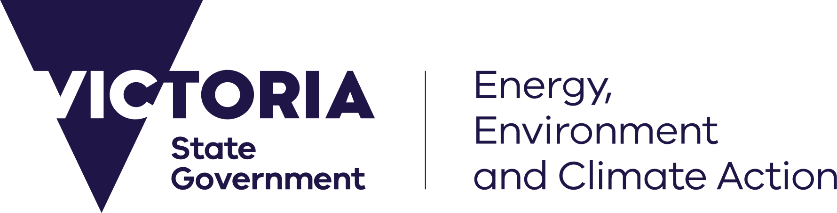

Overview
The Department of Energy, Environment and Climate Action (DEECA) helps support the safe management of dams across Victoria.
Dam safety is important because dams can affect people, homes, businesses, essential services and the environment. In Victoria, dam owners are responsible for operating and maintaining their dams safely. DEECA supports this through policy, oversight and emergency preparedness arrangements.
Victoria’s dam safety framework is supported by legislation, including the Water Act 1989 (Vic) and the Water Industry Act 1994 (Vic) Statement of Obligations (General), which set out responsibilities for dam safety management and reporting.
Our role
Our role is to help provide confidence to government and the community that dam safety risks to people, property and the environment are being identified, managed and reduced as ”so far as is reasonably practicable” (SFAIRP)
DEECA manages its role in dam safety through three pillars:
Risk
Identify significant dam safety risks and support arrangements to manage them, especially where there may be consequences for people, property or the environment.
Policy
Develop and maintain dam safety policy, guidance and frameworks that support consistent and effective dam safety management across Victoria.
Assurance
Provide oversight of key dam safety responsibilities and arrangements to support confidence that the dam safety framework is working effectively.

Emergency Response and Resilience
DEECA supports emergency preparedness and response arrangements for dam safety incidents.
Our role as Control Agency under the State Emergency Management Plan and Dam Safety Response Plan includes:
- coordinating access to technical advice and specialist capability during serious emergency events
- helping arrange access to suitably qualified technical experts to assess dam safety conditions during escalated incidents
- contributing to incident response planning and review
DEECA also:
- participates in emergency exercises and post-incident reviews to support continuous improvement
- maintains dam inundation mapping in the Victorian Government’s flood intelligence platform (FloodZoom) for large dams

Stakeholder engagement
DEECA works with a range of partners to support dam safety across Victoria. This includes:
- contributing to dam safety response and operational planning
- working with water corporations and industry to support coordinated emergency arrangements
- maintaining dam safety forums and professional networks
- consulting with internal and external stakeholders to inform strategic advice on dam safety.
What we do
DEECA:
- develops dam safety policy, regulatory frameworks and guidance
- supports oversight of dam safety responsibilities under the Water Act 1989 and the Statement of Obligations for water corporations
- identifies state-significant dam safety risks and works with stakeholders to support risk management by dam owners
- coordinates arrangements for escalated responses to dam safety incidents to help reduce impacts on communities, property and the environment
- provides advice to government on Victoria’s dam safety framework, incidents and emerging risks.
What we do not do
DEECA does not:
- advise on, design or approve dam works
- carry out compliance or enforcement activity for public or private dams
- manage risk management plans or escalated response activities for mining and quarrying tailings and slimes dams, which are managed by Resources Victoria under the Mineral Resources (Sustainable Development) Act 1990 (Vic).
Our commitment
DEECA is committed to working with partners across government and industry to support strong dam safety arrangements that help protect Victorian communities, infrastructure and the environment.

We acknowledge Victorian Traditional Owners and their Elders past and present as the original custodians of Victoria’s land and waters and commit to genuinely partnering with them and Victoria’s Aboriginal community to progress their aspirations.
© The State of Victoria Department of Energy, Environment and Climate Action, May 2026
Creative Commons
This work is licensed under a Creative Commons Attribution 4.0 International licence, visit the Creative Commons website (http://creativecommons.org/licenses/by/4.0/).
You are free to re-use the work under that licence, on the condition that you credit the State of Victoria as author. The licence does not apply to any images, photographs or branding, including the Victorian Coat of Arms, and the Victorian Government and Department logos.
ISBN 978-1-76176-908-5 (pdf/online/MS word)
Disclaimer
This publication may be of assistance to you but the State of Victoria and its employees do not guarantee that the publication is without flaw of any kind or is wholly appropriate for your particular purposes and therefore disclaims all liability for any error, loss or other consequence which may arise from you relying on any information in this publication.
Accessibility
To receive this document in an alternative format, phone the Customer Service Centre on 136 186, email customer.service@delwp.vic.gov.au, or contact National Relay Service on 133 677.
Available at DEECA website https://www.water.vic.gov.au/water-sources/victorias-dams/dam-safety-management

