Victoria’s Comprehensive Report 2023
  - Basin Salinity Management 2030
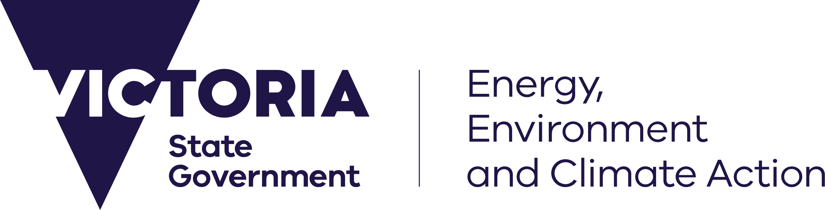
deeca.vic.gov.au
Acknowledgements
Scott McDonald – North East CMA, James Burkitt, Carl Walters, Rebecca Caldwell and Megan McFarlane – Goulburn Broken CMA, Geoff Rix and Karuppan Sakadevan – Mallee CMA, Joel Boyd – Wimmera CMA, Mark Potter and Paul Saunders – Goulburn Murray Water, Dugal Wallace, Samira Akhavan, Steve Wickson, Lewis Lo, Melissa Tylee, Ella Jorgensen, Lakshmi Haleyur – Department of Energy, Environment and Climate Action.
Author
Photo credit
Melissa Tylee (DEECA)
We acknowledge and respect Victorian Traditional Owners as the original custodians of Victoria’s land and waters, their unique ability to care for Country and deep spiritual connection to it.
We honour Elders past and present whose knowledge and wisdom
has ensured the continuation of culture and traditional practices.
DEECA is committed to genuinely partnering with Victorian Traditional Owners and Victoria’s Aboriginal community to progress their aspirations.
© The State of Victoria Department of Energy, Environment and Climate Action .
Creative Commons
This work is licensed under a Creative Commons Attribution 4.0 International licence, visit the Creative Commons website (http://creativecommons.org/licenses/by/4.0/).
You are free to re-use the work under that licence, on the condition that you credit the State of Victoria as author. The licence does not apply to any images, photographs or branding, including the Victorian Coat of Arms, and the Victorian Government and Department logos.
Disclaimer
This publication may be of assistance to you but the State of Victoria and its employees do not guarantee that the publication is without flaw of any kind or is wholly appropriate for your particular purposes and therefore disclaims all liability for any error, loss or other consequence which may arise from you relying on any information in this publication.
Accessibility
To receive this document in an alternative format, phone the Customer Service Centre on 136 186, email customer.service@delwp.vic.gov.au, or contact National Relay Service on 133 677. Available at DEECA website (www.deeca.vic.gov.au).

Victoria’s Comprehensive Report 2023 1
1. Executive Summary 3
2. Introduction 7
3. Salinity Accountability Framework 9
3.1 Register Position 9
3.1.1 Victorian Statement of Compliance 9
3.1.2 Credits 9
3.1.3 Debits 9
3.1.4 Net Balance 9
3.2 Regional Salinity Registers 11
3.3 New Accountable Actions 12
3.4 Salinity Accountability for Environmental Water 12
3.4.1 Environmental Watering of the Gunbower Forested Floodplain 12
3.4.2 Victorian Murray Floodplain Restoration Project 12
4. Management of Salt Interception Schemes 14
4.1 Salt Interception Scheme Operations 14
4.2 Salt Interception Scheme Support and Maintenance activities 15
5. Salinity Management 17
5.1 Victorian Salinity Management 17
5.1.1 State-wide policies and actions 17
5.2 Regional Salinity Management 18
5.2.1 North East 18
5.2.2 Goulburn Broken 19
5.2.3 North Central 20
5.2.4 Mallee 20
5.2.5 Wimmera 21
5.3 End of Valley Target Outcomes 22
5.3.1 End of Valley Target Site Flow & Salinity Data Evaluation 22
6. Efficient Governance 41
6.1 BSM2030 Basin-wide Core Salinity Monitoring Network 41
6.1.1 Dryland Salinity Bore Monitoring 41
6.1.2 North East 41
6.1.3 Goulburn Broken 42
6.1.4 North Central 42
6.1.5 Mallee 42
6.1.6 Wimmera 42
6.2 Register Reviews of Victorian Accountable Actions 44
6.2.1 Summary 44
6.2.2 Goulburn Murray Water 44
6.2.3 Goulburn Broken 44
6.2.4 North Central 45
6.2.5 Mallee 46
6.3 Victorian response to IAG-Salinity audit recommendations 2019-2021 47
7. Strategic Knowledge Improvement 53
7.1 State-wide Projects 53
7.1.1 Contemporary Salinity Risks of Victoria 53
7.1.2 Preparing Contextual Narratives of Salinity Risk for End-of-Valley Target sites 53
7.2 Regional Projects 53
7.2.1 Goulburn Broken 53
7.2.2 North Central 54
7.2.3 Mallee 54
7.2.4 Wimmera 55
8. Community Engagement and Communication 56
8.1 Community engagement and education activities 56
8.1.1 Dryland Salinity Management 56
8.1.2 North East 56
8.1.3 Goulburn Broken 56
8.1.4 North Central 56
8.1.5 Mallee 57
8.1.6 Wimmera 57
9. Priorities for Future Work 58
10. References 59

1. Executive Summary
Victoria's Comprehensive Report 2023 presents Victoria’s accountability and achievements in implementing the Basin Salinity Management 2030 (BSM2030) strategy in 2022/23 and includes select highlights from 2021/22.
The Department of Energy, Environment and Climate Action (DEECA) takes the lead on reporting Victoria’s compliance under BSM2030, with support from the Goulburn Broken Catchment Management Authority (CMA), North Central CMA, North East CMA, Mallee CMA, Wimmera CMA and both Goulburn-Murray Water (GMW) and the Agriculture Victoria (AgVic).
Salinity Accountability Framework
Victoria reconfirmed its commitment to salinity management in the Murray-Darling Basin through Water for Victoria (2016). Water for Victoria is our long-term strategic plan for managing water resources in the context of climate change and a growing population.
Victoria remains compliant with Schedule B to the Murray-Darling Basin Agreement (Schedule 1 to the Water Act 2007). Victoria’s net balance on the Murray-Darling Basin Salinity Register A as of September 2023 is -22.7 EC credits or $4.766 million/yr, which has been endorsed by the Basin Salinity Management Advisory Panel (BSMAP).
There was the following change to Victoria’s Register A balance in 2022/23:
- A decrease of 1.3 EC in the salinity credits for Victoria this consisting of a 0.9 EC reduction to Victoria’s share from the Joint Component of the Murtho Salt Interception Scheme (SIS) and 0.3 EC reduction to Changed MDBC River Operations 2000 to 2002, and 0.1EC minor shifts in the interpolated impacts of several accountable actions.
- No change in Victoria’s salinity debits.
During the reporting period, Victoria led or supported work to assess new and existing accountable actions, including the Kerang Lakes/Swan Hill Salinity Management Plan, Victorian Mid Murray Storages (VMMS), Shepparton Irrigation Region (SIR) Land and Water Management Plan (LWMP), Tragowel Plains, Barr Creek Catchment, Pyramid Creek GIS, Church's Cut Decommissioning, and Reduced Irrigation Salinity Impact (RISI) Stage 1 and Stage 2.
Environmental watering activities such as the Victorian Murray Floodplain Restoration Project (VMFRP) are being incorporated into Victoria’s accountability framework. In 2021, Victoria commissioned an assessment of current data and knowledge status for the nine sites that comprise the VMFRP to inform the priorities for future work to meet Schedule B to the Murray Darling Basin Agreement and the guiding principles of the BSM2030 strategy (RMCG, 2021). The report indicates three of the VMFRP sites will likely require detailed salinity assessments for consideration as new accountable actions.
Management of Salt Interception Schemes
The three Victorian salt interception schemes (SIS) (Barr Creek Drainage Diversion Scheme, Mildura-Merbein Salt Interception Scheme and Pyramid Creek Groundwater Interception Scheme) continued to be operated in accordance with their respective operating rules. As part of the trial of responsive SIS management implemented under BSM2030, Victoria continues to work with the Murray-Darling Basin Authority (MDBA), and the other jurisdictions, to refine the operation of the SIS Program in response to forecast river flow and salinity conditions. The Mildura-Merbein SIS is the only scheme located in Victoria that is part of this trial.
A total of 108,472 tonnes of salt was diverted from the River Murray via Victoria’s SISs in 2021/22, and 54,516 tonnes in 2022/23. The diverted salt from the River Murray in 2022/23 was much lower than previous years as a major flooding event in October 2022, caused significant damage to all three SISs which continued to impact their operation into 2023.

Salinity Management
Victoria continues to implement LWMPs in irrigation areas. LMWPs provide the strategic framework and key actions for natural resource management in Victoria via a regional partnership approach. In addition, CMAs have long-term Environmental Water Management Plans (EWMPs) to guide environmental watering activities across Victoria. EWMPs are developed under partnership arrangements with the community and government agencies, such as the Victorian and Commonwealth Environmental Water Holders and the MDBA which incorporate management of salinity impacts.
CMAs have also delivered a wide range of farm planning and on-farm works, including irrigation and dryland whole farm plans, upgrades to irrigation systems for water use efficiency and salinity benefits, as well as extension activities.
Salinity and salt loads at End-of-Valley-Target (EoVT) sites were monitored and evaluated over the reporting period for each Victorian valley for which an EoVT has been set. Salinity and salt load exceedance curves for Victorian EoVT sites are provided in this report, based on the improved EoVT reporting methodology.
Efficient Governance
The Efficient Governance section of this report explores work Victoria has taken to review its accountable actions, the ongoing status of its Basin-wide Core Salinity Monitoring Network (BSC Network), and Victoria’s response to previous Independent Audit Group recommendations.
During 2022/23, Victoria progressed works to inform improvements to the review and modelling of seven accountable actions.
Victoria’s CMAs continued to support efficient Basin-wide governance of BSM2030 through monitoring which helps to support the assessment of salinity impacts and periodic reviews of Victoria’s accountable actions. Victoria actively participates in the independent audit process, which tracks Basin-wide performance in implementing BSM2030 and identifies areas of improvement.
DEECA has worked closely with regional partners including CMAs, GMW and AgVic on the Victorian contribution to the BSC Network which identifies all surface and groundwater sites used to monitor and review Victorian accountable actions.
The Manual for Victoria’s Salinity Accountability in the Murray-Darling Basin provides a strong framework which guides salinity managers in our state in meeting our obligations under Schedule B of the Murray-Darling Basin Agreement and other obligations under Victorian legislation, regulations, and policy.
Strategic Knowledge Improvement
DEECA, AgVic, GMW and the CMAs continued to increase state-wide capacity for managing salinity in the Murray-Darling Basin in the reporting period by progressing several research and investigation projects, including:
- Contemporary Salinity Risks of Victoria paper mapping out key governance, financial and physical risks faced by the salinity management program in Victoria, with a focus on Victoria’s part in salinity management in the Murray-Darling Basin.
- Commenced developing a set of contextual narratives for Victorian EoVT sites. The contextual narratives will concisely capture key salinity processes, landscape characteristics, climate drivers and risks unique to each catchment in Victoria.
- North Central CMA prepared a draft guideline for assessing risks of salt mobilisation for proposals to water wetland and for the rehabilitation of wetlands and surface and groundwater interaction on the Gunbower forested floodplain to inform future VMFRP and The Living Murray salinity assessments.
- Mallee CMA has undertaken a hydrological review for threat assessment for Nangiloc-Colignan; developed a Mallee Bore Management Strategy; and completed an Acid Sulfate Soil hazard assessment and strategic management plan.
- AgVic continued to provide advice to agencies and the community on the management and avoidance of dryland salinity, rising groundwater levels, use of saline groundwater and extension to manage salinity risks from irrigation.

Community Engagement and Communication
Community engagement, extension and communication are central to the implementation of Victorian CMA Regional Catchment Strategies and subordinate strategies and plans, including Land and Water Management Plans and Waterway Strategies. Local ownership of the challenges and opportunities of salinity management has been a long-standing and successful approach in Victoria. Engagement with Traditional Owners and Aboriginal Victorians is increasingly being prioritised, with two-way communications focusing on sharing knowledge and understanding Aboriginal values and aspirations within landscapes impacted by salinity.
Many CMA boards use community-based advisory groups to gain community and expert input into projects and strategies, and to help inform communities, agencies, and land managers about natural resource management in the region. These groups are central to effective management of salinity in Victoria, particularly in irrigation areas.
CMAs, GMW and AgVic continued to engage with local communities to build knowledge of salinity threats and capacity to manage salinity. The wetter conditions led to increased concerns around waterlogging, elevated groundwater tables and land salinisation, which were supported through extension activities, watertable mapping, and field days.
Priorities for Future Work
Victoria will continue to implement BSM2030 in partnership with the MDBA and other jurisdictions. Key projects to complete include:
- Airborne Electro Magnetic Survey in the Victorian Mallee;
- Engagement with Traditional Owners and Aboriginal Victorians on salinity issues with a focus on with knowledge sharing and supporting Aboriginal self-determination;
- Preparation for the 2026 review of BSM2030;
- Finalising contextual narratives of salinity risk for EoVT sites;
- Renewal of the SIR LWMP; and
- Finalising the Integrated Accountable Action Model (IAAM) and applying the model to the Barr Creek and Tragowel Plains Accountable Action Reviews.
Victoria will also prioritise work on understanding and assessing potential new accountable actions including VMFRP, VMMS, SDLAM Projects and GMW Water Efficiency Project.
Victoria will continue to be a part of the trial for responsive management of the SIS and operate schemes within the state in accordance with the adaptive management approach until the conclusion of the trial in 2025.

Abbreviations
BSC Network | Basin-wide Core Salinity Monitoring Network
BSM2030 | Basin Salinity Management 2030
BSMAP | Basin Salinity Management Advisory Panel
CMA | Catchment Management Authority
DEECA | Department of Energy, Environment and Climate Action
AgVic | Agriculture Victoria
EC | Electrical Conductivity (µS/cm)
EoVT | End-of-Valley Target
EWMP | Environmental Watering Management Plans
FARM | Future and Restoration Management
GMW | Goulburn-Murray Water
IAG | Independent Audit Group
LWMP | Land and Water Management Plan
MDBA | Murray-Darling Basin Authority
ML | Megalitre
MSM-BIGMOD | MSM– BIGMOD, the daily flow and salinity model for the Murray River
REALM | Resource Allocation Model
RISI | Reduced Irrigation Salinity Impact
SIR | Shepparton Irrigation Region
SIP | Sustainable Irrigation Program
SIS | Salt Interception Scheme
SMP | Salinity Management Plan
SWP | Seasonal Water Proposal
VEWH | Victorian Environmental Water Holder
VIDP | Victorian Irrigation and Drainage Program
VMFRP | Victorian Murray Floodplain Restoration Program
VMMS | Victorian Mid-Murray Storage
VSDWG | Victorian Salt Disposal Working Group

2. Introduction
Victoria's Comprehensive Report 2023 documents Victoria’s salinity accountability, management, and compliance under the Basin Salinity Management 2030 (BSM2030) strategy as per Schedule B of the Murray-Darling Basin Agreement in Schedule 1 of the Commonwealth Water Act 2007. BSM2030 reflects the contemporary understanding of salinity risk in the Murray-Darling Basin and includes efficient governance arrangements for status and comprehensive reporting completed in alternate years.
Comprehensive reports are subject to audit by the Independent Audit Group (IAG) for Salinity. To facilitate the audit process, key highlights from 2020/21 have been included in this report.
The report has been prepared and structured in accordance with the Basin Salinity Management reporting procedure and Audit and Reporting Plan for 2022/23 endorsed by the Basin Salinity Management Advisory Panel (BSMAP). Key achievements and outcomes over the past two years have been summarised against the following key elements:
- Salinity accountability framework
- Management of salt interception schemes
- Salinity management
- Efficient governance
- Strategic knowledge improvement
- Community engagement and communication
- Priorities for future work
Victoria delivers on its obligations under the BSM2030 as outlined in Manual for Victoria's Salinity Accountability in the Murray-Darling Basin 2021 (DELWP). A core feature of Victoria’s salinity management is a partnership approach between the Department of Energy, Environment and Climate Action (DEECA), Agriculture Victoria (AgVic), the five northern Catchment Management Authorities (CMAs) and Goulburn-Murray Water (GMW).
Details of implementation activities are provided under subheadings listed above and further divided among each of the five Victorian Murray-Darling Basin CMA regions.

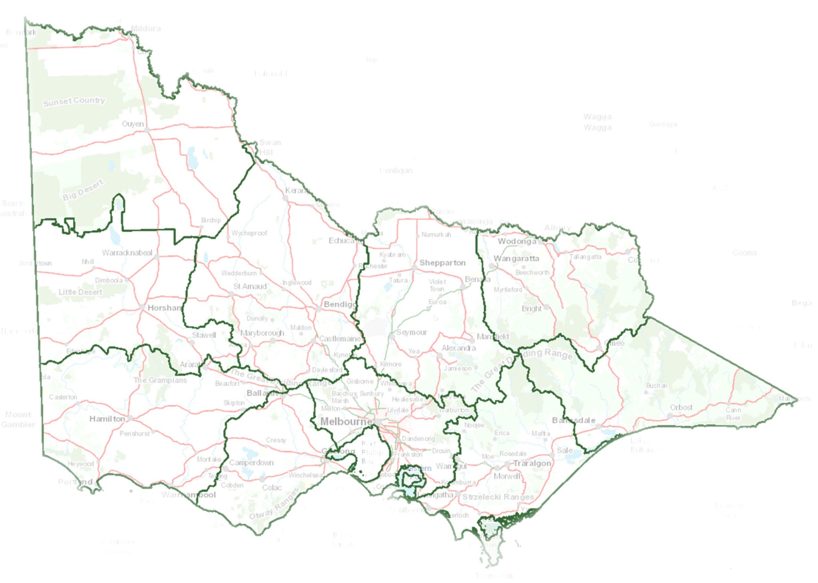
Wimmera
The Wimmera CMA region, located in western Victoria, encompasses an area of 2.3 million hectares and includes Horsham Rural City Council and Hindmarsh, West Wimmera, Yarriambiack and the Northern Grampians Shire Councils. Eighty percent of land in the Wimmera CMA region is used for agriculture.
Dryland livestock and cropping are the main agricultural activities in the Wimmera region. Wheat, canola, legumes and pulses are the main crops, and sheep are raised for both wool and meat production. A vibrant viticulture industry has been established in the upper Wimmera. There is significant irrigation in the West Wimmera supplied by groundwater (Murray Group Limestone Aquifer), supporting small seed (white clover), lucerne and vegetable production.
The Wimmera region is not connected by surface water processes to the River Murray; however, it is included as part of the Murray-Darling Basin and the BSM2030 reporting due to its groundwater connection. The Wimmera region is an important recharge area for the Parilla Sands aquifer which ultimately discharges to the River Murray. However, the ability of recharge management (or other salinity management activities) in the Wimmera to impact on the salinity levels in the River Murray is considered insignificant in terms of generally accepted timeframes for salinity control. Nevertheless, the salinisation of land and water resources is an issue in part of the Wimmera region itself.
North East
The North East CMA region covers an area of 1.98 million hectares, or approximately nine per cent of the area of Victoria. The major catchments within the North East region are the Ovens, Kiewa, and Upper Murray catchments. Landforms vary across the region from the Victorian Alps in the Great Dividing Range, to the Riverine Plains in the lower catchments. Despite making up such a small geographic area the North East region plays an integral role in providing water resources for south-eastern Australia, contributing 38% of the total water in the Murray-Darling Basin system.
Approximately 55 per cent of the North East region consists of public land including National Parks, State Forests, wilderness areas, nature reserves, plantations, and plantation forests (on long-term lease for softwood production), crown land and Alpine resorts. The remaining land is largely privately owned, much of which is cleared of native vegetation and used for farmland.
North Central
The North Central CMA region covers almost three million hectares and includes the Campaspe, Loddon, Avoca and Avon-Richardson River catchments. The area is dominated by agricultural landscapes which sustain the region’s economic and social prosperity.
The region’s waterways, which encompass more than 100,000 km of streams and 1,600 wetlands, have significant economic, environmental, cultural, and social values. The region is home to two internationally recognised Ramsar wetlands, Gunbower Forest, and Kerang Wetlands, which support many migratory waterbirds.
Salinity risks are observed throughout the north central region. In a few places it is natural, meaning it was there prior to colonisation, for example the salt lakes to the west of Donald. However, in most instances it is the result of changes in the hydrology of the land that can be attributed to the adoption of European agricultural practices.
Salinity is not restricted to agricultural land; it is also a substantive issue in terms of the water quality of the region’s rivers and streams. Salt loads within the Axe Creek catchment southeast of Bendigo, for example, range from 5,000 tonnes per annum to more than 10,000 tonnes depending on seasonal climatic conditions. Salinity is also an issue in urban areas where it typically referred to as ‘urban salinity’.
Goulburn Broken
Covering 2.4 million hectares, or about eleven percent of Victoria, the Goulburn-Broken CMA region is home to approximately 1 million hectares of dryland agriculture and 270,000 hectares of highly productive irrigated agriculture in the Shepparton Irrigation Region (SIR).
The SIR supports industries including dairy, horticulture and cropping and a large food processing sector with recent major investment in on-farm and off-farm irrigation infrastructure.
Mallee
The Mallee region covers almost four million ha, around one-fifth of Victoria and is the largest catchment area in the State. It extends along the Murray River from Nyah to the South Australian Border and south through vast dryland cropping areas and public reserves.
Despite the semi-arid nature of the Mallee region, the predominance of effective winter rainfall and access to reliable water from the Murray River allows the Mallee region to be an agriculturally diverse and productive region. About 62% of the region’s land area has been modified for agricultural production, of which dryland farming covers an area of 2.4 million ha (Mallee CMA 2013). In contrast, the irrigation area encompasses 88,125 ha or just over 2% of the arable land within the region.
The gross value of irrigated horticultural production accounts for approximately 33% of the gross value of irrigated horticultural production in Victoria in 2020-21 (ABS 2022). Of the 88,125 ha of irrigable land along Murray River, a majority (71%) are permanent horticultural plantings (Mallee CMA 2022) with irrigation water sourced from the Murray River.

3. Salinity Accountability Framework

3.1 Register Position

3.1.1 Victorian Statement of Compliance
Under Schedule B of the Murray-Darling Basin Agreement, Victoria is accountable for actions that will change salinity in the River Murray, specifically actions that result in a modelled change in salinity at Morgan in South Australia of plus or minus 0.1EC must be reviewed and entered on the MDBA managed salinity registers. Actions such as irrigation development, which increase river salinity, result in a debit on the Salinity Register, whereas actions such as salt interception and improved irrigation efficiency, which decrease salinity impacts, result in credits on the Salinity Register.
Victoria remains compliant with Schedule B of the Murray-Darling Basin Agreement (Schedule 1 to the Commonwealth Water Act 2007).

3.1.2 Credits
Based on the 2022 MDBA Register A (November 2022) Victoria’s salinity credits equalled a salinity effect of -46.6 EC, and a salinity cost effect of $10.066million/yr.
Based on the 2023 MDBA Register A (September 2023, subject to change) Victoria’s salinity credits are –45.3 EC or a salinity cost effect of $9.879 million/yr (Table 1).
Since the 2022 Register was finalised in November 2022, there was a net 1.3 EC change in the salinity credits for Victoria, this consists of our share of the Joint Component of Murtho SIS following 2023 review completed (0.9 EC), Changed MDBC River Operations 2000 to 2002 (0.3 EC), and minor shifts in the interpolated impacts of several accountable actions.

3.1.3 Debits
Based on the 2022 MDBA Register A (November 2022) Victoria’s debits equalled a salinity effect of 22.6 EC (including 3.6 EC as GMW Connections debit), and a salinity cost effect of -$5.569 million/yr.
Based on the 2023 MDBA Register A (September 2023) Victoria’s salinity debits are 22.6 EC or a salinity cost effect of -$5.113 million/yr (Table 1).
No changes in Victoria’s debits 2023 were reported compared with Victoria’s debits 2022.

3.1.4 Net Balance
The balance of Victoria’s salinity registers as September 2023 is -22.7 EC or $4.766 million/yr.
Table 1: Victoria's Register A balance sheet summary
 | Balance in November 2022 |  | Change in 2022/23 Reporting Period |  | Balance on September 2023
 | Salinity Effect (EC at Morgan) | Salinity Cost Effect ($/yr) | Salinity Effect (EC at Morgan) | Salinity Cost Effect ($/yr) | Salinity Effect (EC at Morgan) | Salinity Cost Effect ($/yr)
Credit | -46.6 | 10,066,000 | 1.3 | 187,000 | -45.3 | 9,879,000
Debit | 22.6 | -5,569,000 | - | -456,000 | 22.6 | -5,113,000
Total | -24.0 | 4,497,000 | 1.3 | -269,000 | -22.7 | 4,766,000

Table 2: Victoria's Credit Balance Sheet based on the 2023 MDBA Salinity Register (as of September 2023)
Register A Entry | Physical Impact  (EC) | Salinity Cost Effect  ($/yr)
Joint Works and Measures
Salinity and Drainage Strategy
Woolpunda Salt Interception Scheme (SIS) | -8.5 | 766,000
Improved Buronga and Mildura/Merbein SIS | -0.8 | 185,000
New Operating Rules for Barr Creek Pumps | -0.9 | 225,000
Waikerie SIS | -2.6 | 235,000
Changed MDBC River Operations 1988 to 2000 | -0.3 | 150,000
Mallee Cliffs SIS | -0.9 | 276,000
Waikerie SIS Phase 2A | -0.6 | 55,000
Changed MDBC River Operations 2000 to 2002 | -0.0 | -134,000
Sub-Total Basin Salinity Management Strategy | -14.7 | 1,758,000
Basin Salinity Management Strategy
Changed MDBC River Operations after 2002 | 0.0 | 23,000
Pyramid Creek SIS | -0.6 | 135,000
Bookpurnong Joint SIS | -0.8 | 94,000
Improved Buronga SIS | -0.1 | 26,000
Loxton SIS | -1.1 | 132,000
Waikerie Lock 2 SIS | -1.0 | 68,000
Upper Darling SIS | -0.6 | 200,000
Joint Component of Murtho SIS | -0.6 | 108,000
Sub-Total Basin Salinity Management Strategy | -4.9 | 786,000
Shared Schemes
Permanent Trade Accounting Adjustment - NSW to Victoria | -0.1 | 5,000
Barmah-Millewa Forest Operating Rules | -1.0 | 185,000
Sub-Total Shared Schemes | -1.10 | 190,000
Victorian Measures
Barr Creek Catchment Strategy | -7.7 | 1,963,000
Psyche Bend | -2.1 | 237,000
Permanent Trade Accounting Adjustment - Victoria to SA | -0.8 | 182,000
Sunraysia Drains Drying up | -2.2 | 591,000
Lamberts Swamp | -2.7 | 526,000
Church's Cut Decommissioning | -0.3 | 47,000
Mallee Drainage Bore Decommissioning | -0.3 | 67,000
MM SIS Refurbishment 2015 | -0.5 | 109,000
Reduced Irrigation Salinity Impact Victoria | -8.1 | 1,823,000
Victorian S&DS Commitment Adjustment | 0.0 | 1,600,000
Sub-Total Victorian Measures | -24.7 | 7,145,000
TOTAL CREDITS | -45.3 | 9,879,000

Table 3: Victoria's Debit Balance Sheet based on MDBA Salinity Register (as of September 2023)
Register A Entry | Physical Impact (EC) | Salinity Cost Effect ($/yr)
Joint Works and Measures
Salinity and Drainage Strategy
Changed Operation of Menindee and Lower Darling | 0.2 | -146,000
Basin Salinity Management Strategy
None
Sub-Total Joint Works and Measures | 0.2 | -146,000
Shared Schemes
None
Sub-Total Shared Schemes | 0.0 | 0
Victorian Measures
Tragowel Plains Drains at 2002 level | 0.9 | -132,000
Shepparton SMP | 5.5 | -1,076,000
Nangiloc-Colignan SMP | 0.4 | -102,000
Nyah to SA Border SMP - Irrigation Development | 13.3 | -3,057,000
Kerang Lakes/Swan Hill SMP | 1.5 | -347,000
Campaspe West SMP | 0.0 | -18,000
Woorinen Irrigation District Excision | 0.8 | -235,000
Sub-Total Victorian Measures | 22.4 | -4,967,000
TOTAL DEBITS | 22.6 | -5,113,000

3.2 Regional Salinity Registers
Victoria manages its obligation to keep the total of salinity credits in excess of, or equal to, the total of any salinity debits attributed to it in Register A (Clause 16(1) (a) Schedule B) by allocating Victorian salinity credits to the CMAs. It is then the responsibility of the CMAs to ensure that the salinity debits in their region do not exceed their salinity credit allocation.
No additional salinity credits have been allocated to any of the five CMAs within the Victorian Murray-Darling Basin during 2022/23. The salinity credit allocations to Victorian CMAs for accountable actions on the MDBA Register A are provided in Table 4.
Victoria has allocated -42.2 EC to three CMAs, of which -16.7 EC is allocated to the CMA’s but are unused. There are currently -3.1 EC salinity credits unallocated (* The Mallee regional debits are estimates performed by the Mallee CMA annually. They do not align with MDBA Register A as the corresponding entries on Register A will not be confirmed and updated until they are next reviewed (in 2025).

Table 5). Salinity credits have not been allocated to Wimmera or North East CMA as they do not have any Register A accountable actions. North East CMA has two Legacy of History register items, however offsetting credits for legacy of history items are managed through State credits held by DEECA.
Table 4: Victorian Register A salinity credit allocation and salinity debits for CMA’s
 | Government allocation of salinity credits (EC) | Salinity debits by region in 2022 MDBA Register (EC) | Salinity debit change over 2022/23 reporting period (EC) | Salinity debits by region in 2022/23 (EC) | Allocated salinity credit balance for 2023 (EC)
Goulburn Broken | -8.9 | 6.0 | 0 | 6.0 | -2.9
North Central | - 10.1 | 2.6 | 0 | 2.6 | -4.9
Mallee* | -23.2 | 13.9 | 0.4 | 14.3 | -8.9
Total | -42.2 | 22.5 | 0.4 | 22.9 | -16.7
* The Mallee regional debits are estimates performed by the Mallee CMA annually. They do not align with MDBA Register A as the corresponding entries on Register A will not be confirmed and updated until they are next reviewed (in 2025).

Table 5: Summary of Register A salinity credits for Victoria as at September 2023
Credits | Physical EC
Total Available (Table 1) | -45.3
Total Allocated (Table 4) | -42.2
Unallocated salinity credits | -3.1

3.3 New Accountable Actions
In 2021/22 and 2022/23, Victoria has been progressing work on the assessment of potential new actions for the Victorian Mid Murray Storages Review. The assessment is expected to be completed in 2024.

DEECA is currently working with the MDBA to identify a process to combine the Psyche Bend Lagoon and Sunraysia Drying of the Drains accountable actions to better reflect on ground salinity management and improve efficiency in reporting and reviews

Victoria (DEECA, CMAs and GMW) is supporting an MDBA-led project which proposes a revised Registers Review Plan schedule. This will align accountable action reviews, reduce reporting, and will allow for more appropriate review frequencies.

3.4 Salinity Accountability for Environmental Water
CMAs undertook environmental watering activities in accordance with their EWMPs, which consider and manage the potential salinity impacts of proposed watering actions. A summary of current and potential future environmental water accountable actions is provided below.

3.4.1 Environmental Watering of the Gunbower Forested Floodplain
Investigations supported by both the Living Murray Program (TLM) and the Victorian Murray Floodplain Restoration Project (VMFRP) over the past two years have explored the potential for environmental watering of the Gunbower Forested floodplain to generate salt loads that might call for consideration of an accountable action. Preliminary findings appear to confirm groundwater within the floodplain is not responsive to inundation. Groundwater hydrographs established through data from electronic loggers show no response during either the October 2022 floods or environmental watering. The presence of high shrink-swell clays and actively transpiring native vegetation eliminate deep percolation and groundwater recharge to underlying aquifers. The watertable remains deep within the forested floodplain and the data captured to date suggests this is unlikely to change, affording little opportunity for the discharge of saline groundwater to the land surface. Data collection continues through electronic monitoring of groundwater behaviour and a report documenting the results is to be prepared in early 2024.

3.4.2 Victorian Murray Floodplain Restoration Project
Nine Victorian Sustainable Diversion Limit Adjustment Mechanism (SDLAM) projects were proposed as part of the package of 37 SDLAM measures agreed to by the Murray Darling Basin Ministerial Council in June 2017. The nine projects progressed are:
- Belsar-Yungera Floodplains Management Project
- Burra Creek Floodplain Management Project
- Hattah Lakes North Floodplain Management Project
- Lindsay Island (Stage 2) Floodplain Management Project
- Nyah Floodplain Management Project
- Vinifera Floodplain Management Project
- Wallpolla Island Floodplain Management Project
- Gunbower National Park Floodplain Management Project
- Guttrum and Benwell Forests Floodplain Management Project

In 2021, an assessment of the current data and knowledge status for the nine VMFRP sites to inform Victoria’s future work to meet obligations under Schedule B to the Murray Darling Basin Agreement and the guiding principles of the BSM2030 strategy (RMCG, 2021).

The assessment indicated three of the VMFRP projects will likely require detailed salinity assessments for consideration as new accountable actions. These projects are undergoing both Victorian and Commonwealth regulatory approvals processes. More detailed evaluation and modelling of long-term salinity impacts as managed under BSM2030 will become possible after approvals, design, construction and operation details are confirmed.
Despite timing and funding constraints including impacts from the COVID-19 pandemic and flooding, Victoria remains committed to delivering the VMFRP.

4. Management of Salt Interception Schemes
Salt Interception Schemes (SIS) reduce base salt loads in the river and reduce the magnitude and duration of episodic salinity peaks. SIS are managed through the Joint Programs, which comprise 14 sites in the Basin and three in Victoria. The three SIS sites are the Pyramid Creek Groundwater Interception Scheme, Barr Creek Drainage Diversion Scheme and Mildura-Merbein SIS.
In 2022/23 the Victorian SIS sites were operated in accordance with the agreed operating rules. Under BSM2030 Basin Governments have agreed to continue a trial of responsive management of SIS operations. Under the trial opportunities to reduce operations and therefore operating costs during periods of low in-river salinity are taken when forecast river flow and salinity conditions allow. The trial is conducted to ensure no adverse environmental impacts are caused from reducing site operations.

4.1 Salt Interception Scheme Operations
Pyramid Creek Groundwater Interception Scheme
The SIS intercepts saline groundwater that would have otherwise discharged to the Pyramid Creek. Previously this salt caused significant negative impacts upon the Torrumbarry Irrigation Area’s agricultural production, the environmental attributes of the Ramsar listed Kerang Lakes, and downstream River Murray water users. A total of 212 ML of groundwater with an average salinity of 42,920 EC was intercepted in 2022/23. These flows, with a corresponding salt load of 5,463 tonnes, were diverted to constructed drainage basins from which salt is harvested by a private operator. These figures were much lower than previous years as a major flooding event in October 2022 caused significant damage to the SIS. The SIS requires major refurbishment, but a small section of pumps has been operational since late January to meet minimal requirements of the salt harvester.
Barr Creek Drainage Diversion Scheme
The Barr Creek Drainage Diversion Scheme has once again been effective in reducing base salt loads in the River Murray by diverting drainage flows and intercepted saline groundwater from the Barr Creek catchment to the Tutchewop Disposal Lakes. The 2022/23 period has seen the SIS largely operate according to the agreed rules, diverting 665 ML of drainage water at an average salinity of 3,892 EC. Approximately 3,902 tonnes of salt were diverted to the disposal lakes.

The diverted flows were lower than previous years due to the major flooding event in October 2022 impacted normal operation of the SIS. The prolonged nature of the flooding event, with flood water taking a long time to recede, prevented inspection of damage until early 2023. Although the SIS only suffered minor damage from the floods, changes in electrical regulations deemed the ageing switchboard unsafe to have power restored. Temporary diesel-powered pumps have been installed whilst the new switchboard is being replaced. Although the SIS remained un-operational for several months, the operating rules dictated that the pumps did not need to run for most of the time since the flood event. This was mainly due to the high, fresh flows in the River Murray, and despite the damage, the SIS has largely complied with the pumping rules for 100% of the time.
Mildura-Merbein Salt Interception Scheme
The refurbished Mildura-Merbein SIS was commissioned and commenced operation in 2014/15. In 2022/23, the SIS pumped 791 ML of groundwater (at an average salinity of 84,000 EC) with a corresponding salt load of 45,151 tonnes. The diversions were lower than previous years for two reasons:
- the major flooding event in October 2022 caused the SIS to shut down and remain off until February 2023.
- parts of the SIS were shut down at times whilst the additional works were completed between July and September 2022. The floods prevented the testing and commissioning of the works, which were not fully operational until May 2023.
Two of the pumps (Pumps MM8 and MM9) operated at a reduced level all year as part of the responsive management trials. These have been turned off since the beginning of April 2021 and only operate for 3 hours per week for pump protection, and to enable chlorination. Due to all the above - mentioned reasons, the SIS did not operate at 100% capability.
Table 6: Summary of Victorian Salt Interception Scheme Operations 2021/22 and 2022/23
Salt Interception Scheme | 2021/22 |  |  | 2022/23
 | Volume Pumped (ML) | Salt Load Diverted (Tonnes) | Average Salinity (EC) | Volume Pumped (ML) | Salt Load Diverted (Tonnes) | Average Salinity (EC)
Pyramid Creek | 1,024 | 26,745 | 43,000 | 212 | 5,463 | 42,920
Barr Creek | 2,272 | 4,055 | 5,298 | 665 | 3,902 | 3,892
Mildura-Merbein | 1,316 | 77,672 | 80,799 | 791 | 45,151 | 84,000
Total |  | 108,472 |  |  | 54,516

4.2 Salt Interception Scheme Support and Maintenance activities
Pyramid Creek Groundwater Interception Scheme
During October 2022, the Scheme experienced inundation similar to the 2011 flood event. Due to the very slow nature of the 2022 flood, the floodwaters in the Pyramid Creek remained elevated for a significant period, and inspections were only able to commence in January 2023. Completed inspections (by March 2023) showed that 92% of the pumps were affected, and 80% of the electrical cabinets.

Some of the electrical cabinets, and associated pumps, that were above the flood waters were able to be reinstated in mid-January. This was vital for both supply of salt to the salt harvester, and protection of the storage ponds (by not allowing them to dry out).

The statutory review of the SIS was completed and endorsed by the Victorian Salt Disposal Working Group, Salt Interception Technical Working Group and BSMAP. In addition to reviewing the Scheme’s asset management, maintenance, operations and performance, the work included the Register Entry Review of both the Scheme and Church’s Cut. The Kerang Lakes REALM model inputs remained unchanged from the previous review, and the MDBA advised that the current Register Entry for both components can be carried forward. Investigations into the replacement of the electrical cluster cabinets has commenced, with the plan to install these above the flood water level. Replacement of all cluster cabinets is expected to take approximately one year to complete.
Barr Creek Drainage Diversion Scheme
During October 2022, the Scheme experienced inundation similar to the 2011 flood event. Permission was obtained from the MDBA to use Lake Tutchewop for flood refuge (as was the case in 2011). The use of Lake Tutchewop had a major impact in preventing Kangaroo Lake and Lake Boga from overtopping, which averted extensive damage to local infrastructure. However, the volume of water that has been added to the lake means that the operations of the Barr Creek Scheme will be modified over the next two years.

Slow flood recession, restricted access to the pump station until February 2023. Due to changes in Victorian electrical legislation, the pump station was not allowed to have power reconnected. A low voltage power supply has been installed that allows the site to remain controlled via the existing Supervisory Control and Data Acquisition system.

A works program has been undertaken which involved the replacement or refurbishment of major structures such as bridges and regulators along the diversion channel. This program has been ongoing for the last five years and is now complete. The remaining bridge (occupation crossing on private land) was planned to be refurbished in October 2022 but was delayed due to the floods. These works were rescheduled and completed in May 2023.

Work commenced on the design for the new Barr Creek electrical switchboard. It is planned as an extra structure adjacent to the current pump station building with controls remaining within the existing building. Until this is completed, diesel-powered pumps have been borrowed from SA Water to allow pumping to occur when required. Although slightly lower in pumping capacity, it is anticipated that the Scheme will remain close to 100% of its capacity.
Mildura-Merbein Salt Interception Scheme
Planned acid-dosing of the bores (by SA Water) was deferred over the last two years due to COVID-19 restrictions in both States. The October 2022 flood event further delayed both the commissioning of these works and the bore acid-dosing. Due to the slow flood recession in the Murray at Mildura, the works were commissioned in April 2023, with the acid-dosing being undertaken in May/June 2023.

Pumps MM8 and MM9 remained operating at a reduced level all year as part of the responsive management trials. The Ranfurly West pump failed due to it only operating on a sporadic basis and remaining submerged in stagnant water. A business case is being prepared to replace this pump with a submersible drainage pump.

The additional works to improve the operational efficiency of the Mildura-Merbein SIS were completed in April 2023. These works remove the operational difficulties with the SIS and it is now able to operate at 100% of its design criteria. The improved operational efficiency of the scheme is expected to deliver the full 0.7 EC credit for this accountable action for Victoria.

5. Salinity Management

5.1 Victorian Salinity Management
DEECA is the delegated agency of the Victorian Government responsible for overseeing the implementation of salinity policy and accounting for Victoria’s obligations under BSM2030. Although DEECA coordinates the State’s implementation of BSM2030, the CMAs manage salinity impacts and most of the accountable action management activities as part of the implementation of their LWMPs, through the Catchment and Land Protection Act (1994).
Victoria’s approach to meeting its Murray-Darling Basin salinity management obligations in partnership with CMAs and Water Corporations is set out in the Manual for Victoria’s Salinity Accountability in the Murray-Darling Basin (DELWP, 2021). The manual was updated in 2021 to reflect contemporary policy.
Several state and interjurisdictional groups support and inform salinity management activity in Victoria, and these include the following:
- Basin Salinity Management Advisory Panel
- Salt Interception Technical Working Group.
- Technical Working Group for Salinity Modelling.
- Victorian Salt Disposal Working Group and
- Various Project Steering Committees.

5.1.1 State-wide policies and actions
Water for Victoria
Water for Victoria (DELWP, 2016) is the state’s strategic plan for managing water resources, presenting the plan for a future with less water as it responds to the impact of climate change and a growing population. The actions set out in the plan support a healthy environment, a prosperous economy with growing agricultural production, and thriving communities.
Through Water for Victoria, Victoria reconfirmed its commitment to salinity management in the Murray-Darling Basin through two key actions relating to salinity including:
- to manage salinity, water logging and water quality, including compliance with BSM2030; and
- to improve salinity management in the Mallee region, specifically in relation to irrigation development which represents Victoria’s largest salinity risk.
Sustainable Irrigation Program
Third-party impacts arising from irrigation including salinity impacts are managed through a well-established and evolving Sustainable Irrigation Program (SIP) delivered jointly by DEECA and CMAs. The SIP has driven Basin salinity outcomes in Victoria by:
- Providing extension services to irrigators to encourage irrigation practices that reduce rootzone drainage or runoff;
- Providing incentives to maintain or upgrade irrigators’ on-farm irrigation systems to reduce rootzone drainage or runoff;
- Developing and coordinating Irrigation Development Guidelines processes to advise licensing authorities on matters relating to the Water-Use Objectives, including minimising salinity impacts, when considering irrigation development proposals.
- Monitoring surface water and groundwater in the BSC Network; and
- Undertaking activities to ensure Victoria meets the Schedule B of the Murray Darling Basin Agreement, such as by completing accountable action reviews.
The program has been supported by 4-year funding cycles that ensure stability of resourcing and enable better strategic planning, especially for projects that require multiple years to complete.
Flow Based Management and Environmental Water
Management of environmental water in Victoria is undertaken through a partnership between the Victorian Environmental Water Holder (VEWH), CMAs, DEECA, land managers including Parks Victoria and local councils, water corporations, Traditional Owner groups, and interjurisdictional agencies including the Commonwealth Environmental Water Holder and the MDBA.
CMAs across Victoria, in collaboration with communities and agencies, have developed long-term Environmental Water Management Plans (EWMPs) and Icon Site Operating Plans to guide environmental watering activities at rivers, wetlands and floodplains. These plans outline the values, objectives, watering requirements of the sites and operating strategies. They also summarise key risks that may impact on the ability to achieve objectives, including risks to water quality.
EWMPs feed into long term watering plans for Northern Victoria, the Victorian Murray and the Wimmera-Mallee which inform annual VEWH Seasonal Watering Plans.
Dryland Salinity Management
Services addressing salinity on dryland farms across Victoria continue to be delivered by AgVic’s Climate Resilience & Recovery Program (Agriculture Services). The Climate Resilience & Recovery Program delivers planning and ongoing management and mitigation advice through existing land management extension services such as farm planning courses with an emphasis on dryland farms that have salinity risks.
AgVic continues to engage with Landcare groups to educate them about dryland salinity management and other groundwater issues. This includes providing advice on groundwater level monitoring and dryland salinisation in their areas. Upon request from the public, AgVic also tests the salinity levels of farmers bore water to evaluate suitability for stock and domestic use.

5.2 Regional Salinity Management
This section describes the plans and strategies within each of Victoria’s northern catchments to address the management of land and water salinity issues and risks, as well as the actions taken to address them during the reporting period.
Integrated catchment management underpins the sustainable management of land and water resources in Victoria. The Victorian Government and its partners seek to achieve sustainability and ensure the long-term viability of the natural resource systems, and to meet human needs for both current and future generations with this approach.
Victoria’s framework is established under the Catchment and Land Protection Act 1994 (the CaLP Act). CMAs are responsible for the integrated planning and coordination of land, water and biodiversity management in each catchment and land protection regions. This includes specific obligations with respect to salinity management and irrigation drainage.
In Victoria’s major irrigation districts, CMAs prepare and implement regional LWMPs to reduce the environmental and third-party impacts of irrigation and improve farm water use efficiency. Victorian LWMPs have evolved from Salinity Management Plans (SMP) developed in the late 1980s and 1990s to mitigate the impacts of salinity on agriculture, environments, and communities. Many of the objectives and tools implemented in the original SMPs are preserved in current LWMPs.

5.2.1 North East
Flow-Based Salinity Management
The North East CMA manages an environmental water entitlement in the Ovens River. However, this entitlement is only 123 ML and has no discernible salinity impact.
Land-Based Salinity Management
The farm works undertaken in the North East region during the 2022/23 year are summarised in Table 7.

Table 7: The farm works undertaken in the North East region during the 2022/23 year
Item | Irrigation - Works carried out
Whole Farm Plans | - 6.5 ha irrigation survey and design.  - 21 irrigation planning and advice cases covering 713ha estimated to save 535 ML from improved irrigation practices
Irrigation system upgrades | - 5 new irrigation development cases covering 108 ha  - 25ha open channel irrigation system converted to pipe and riser estimated to save 20 ML.
Education/extension activities | - Soil samples taken at a vineyard with suspected saline soil issues used to verify cause and future management options.
Other Achievements | - 7 irrigation systems checked (three centre pivot systems, two pipe and riser systems, one travelling gun system and one micro sprinkler system) completed and systems calibrated to run more efficiently and save 68 ML  - Soil moisture probes were installed on nine farms covering 323 ha estimated to save 242 ML. There were three provided with advice on interpreting data covering 22ha estimated to save 17 ML (total 12 properties)  - 35 irrigators and irrigation advisers receiving weekly evapotranspiration rate email to help with irrigation scheduling.

5.2.2 Goulburn Broken
Flow-Based Salinity Management
In 2022/23, the Goulburn Broken CMA prepared six seasonal watering proposals covering major environmental watering sites including Goulburn River, Broken River, Broken Creek, Barmah-Millewa Forest, Gaynor Swamp, Kanyapella Basin, Kinnairds Wetland, Black Swamp, Moodie Swamp, Doctors Swamp, Reedy Swamp, Loch Garry, and Horseshoe Lagoon waterways. Salinity was not identified as a risk to be managed by or due to the environmental watering events.

The Shepparton Irrigation Region (SIR) Sustainable Irrigation Program has undertaken research on the groundwater and salinity impacts from environmental watering at Gaynor’s Swamp. Please refer to the ‘Strategic Knowledge Improvement’ section of this report.
Land-Based Salinity Management
Farm works undertaken in the Goulburn Broken region during the 2022/23 year are summarised in Error! Reference source not found.
Table 8: Summary of farm works undertaken in the Goulburn Broken region during the 2022/23 year
Item | Dryland - Works carried out | Irrigation - Works carried out  (Please note some activities are delivered by AgVic)
Whole Farm Plans | - | Whole farm plans for 39 properties covering a total of 2,906ha were completed
Land forming | - | An estimated area of 1,453ha has been laser levelled
Irrigation system upgrades | Irrigation works in dryland zones: -Irrigation Development Referral over 81 ha. | 1,453 ha of irrigation systems were improved through laser grading and soil moisture monitoring.
Educational activities |  | 4 SIR Drainage Working Group Meetings, 2 community workshops to inform the update of the SIR LWMP, 688 visits to the Goulburn Broken CMA Salinity Watch Website, 3 GMID Drainage Management Strategy Coordinating Group Meetings, DCD engagement (3 on-farm visits with and 9 follow-up calls with 4 landholders), Surface Drainage Floor Recovery engagement (16 on-farm visits and 16 follow-up calls with 8 landholders), 4 gatherings of the Community Reference Group for the Girgarre Evaporation Basin Future Management Options Study, 5 presentations in Conference and VIDP, 2 Shepparton Irrigation Region Water table Study Maps.
Other Achievements | - | 48 km of Drainage Course Declaration gazetted, servicing an area of 10,570 ha.

5.2.3 North Central
In 2021/2022, a revised Loddon-Campaspe Irrigation Region Land and Water Management Plan 2020- 2030 and a 2021-2027 Regional Catchment Strategy were developed and/or delivered by the North Central CMA. Both strategic documents continue the strong regional salinity management programs already in place and are being actively implemented.
Flow-Based Salinity Management
A draft guideline for salinity risk assessment has been developed and piloted by North Central CMA for consideration in the environmental watering of wetlands in the region, and for the rehabilitation of wetlands. The guideline is scheduled to be completed in 2023/2024.
Historical assessments of environmental watering of the Gunbower, Benwell, and Guttrum forests on the Murray River floodplain indicate a very low salinity risk. The Gunbower Forest continues to be watered under the Living Murray program with potential for expansion (subject to approvals) under the Murray River Floodplain Restoration program. A similar environmental watering program has been proposed for the Benwell-Guttrum Forest (also subject to approvals). Investigations conducted over the past eighteen months have focussed on collecting groundwater information through the deployment of digital data-logging technology. The data collected to date confirms a very low risk from either environmental watering or significant overbank flooding.
No Basin plan flow management reporting relevant to salinity management occurred within the North Central CMA region during 2022/2023.
Land-Based Salinity Management
The farm works undertaken in the North Central region during the 2022/23 year are summarised in Error! Reference source not found.Error! Reference source not found..
Table 99: Summary of farm works undertaken the North Central region during the 2022/23 year
Item | Irrigation - Works carried out
Whole Farm Plans | 15 Surveys and 17 Designs covering 5352 Ha completed
Soil Salinity Surveys | 2 Surveys covering 233 hectares
Irrigation system upgrades | Three Irrigation system efficiency checks. one Centre Pivot, one Pump system, one Sub surface drip system.
Education activities | Development of Online Irrigation Selection Tool.  34 weekly Irrigation Requirements updates to more than 650 subscribers.  10 articles published on ExtensionAus platform.  228 attendees across the three webinars: Understanding water supply and demand in the southern Murray- Darling Basin
Other Achievements | Developments of soil moisture monitoring and scheduling tools.

5.2.4 Mallee
Flow-Based Salinity Management
As part of the Seasonal Water Proposal (SWP) development for 2022-23, risk assessments were undertaken as part of the EWMPs and a workshop was facilitated by the VEWH. SWPs for Hattah, Lindsay-Mulcra-Wallpolla, Murray Wetlands and Wimmera Mallee Pipeline were prepared. Brickworks Billabong, Koorlong Lakes, and Lake Hawthorn have been identified with a potential salinity risk resulting from environmental watering, but no salinity risk was identified for other environmental watering sites. Risks were re-assessed again during the development of the Delivery Plan and are an ongoing consideration during delivery. Active management strategies were implemented to mitigate the potential impacts of salinity.
During the 2022-23 River Murray high flow event, almost all wetlands on the River Murray floodplain in the Victorian Mallee were inundated. Flooding, high localised rainfall, runoff and the residual effects of the spring and summer fluvial flooding resulted in most of the scheduled spring and autumn watering for the Murray floodplains being called off.
High flows (exceeding 35,000 ML/day at Colignan) triggered Psyche Bend Lagoon flushing events, from 6 September 2022 to 27 January 2023. The natural flushing event discharged an estimated 7,100 tonnes of salt to the River Murray. Over the last ten years flushing of Psyche Bend Lagoon discharged an average of 520 tonnes/year of salt to the River Murray.
Land-Based Salinity Management
The farm works undertaken in the Mallee region during the 2022/23 year are summarised in Table 1010.
Table 1010: Summary of farm works undertaken the Mallee region during the 2022/23 year
Item | Dryland - Works carried out | Irrigation - Works carried out
Whole Farm Plans |  | 2.25 ha Irrigation Development Management Plan
Irrigation system upgrades |  | 104.25 ha for scheduling equipment  2.25 ha irrigation infrastructure upgrade
Education activities | Workshops, field days, forums (22) and publications (23) delivered to facilitate the development of skills/knowledge required for implementation of improved and/or alternative land use options with salinity benefits (primarily secondary benefits such as increased groundcover).
Other Achievements |  | 28 ha systems check

In 2022-23, the establishment of 166 ha of native (indigenous) vegetation was completed using a combination of high-density seedling plantings and direct seeding. A further 382 ha of previously revegetated areas was also maintained through supplementary (low density) planting to provide for seedling mortalities. Long-term salinity benefits will be achieved through reduced groundwater recharge under established native vegetation. A further 50 ha of revegetation works are currently scheduled to be undertaken in 2023-24.

5.2.5 Wimmera
Flow-Based Salinity Management
Environmental watering in the Wimmera region occurs under the Wimmera Waterway Strategy 2014-2022 (WWS) and an EWMP for the Wimmera River System. The EWMP considers the salinity impact of any potential watering actions. The Wimmera River System is not directly connected with the River Murray by surface water processes. The Wimmera River flows into a system of terminal lakes including Lake Hindmarsh.
Land-Based Salinity Management
The farm works undertaken in the Wimmera region during the 2022/23 year are summarised in table 11.
Table 11: The farm works undertaken in the Wimmera region during the 2022/23 year
Item | Dryland - works carried out
Education activities | A total of 354 participants engaged in soils management training and awareness activities, either in person or online, as part of the Wimmera CMA Building Carbon and Capacity Project, including discussions related to salinity.  The Regional Agriculture Landcare Facilitator supported installation of 72 soil moisture probes, designed to increase the agriculture sector's resilience to climate variability by providing a networked, catchment-wide soil moisture probe network.  Perennial Pasture Systems continued to conduct perennial pasture research and provide information to its members in the upper Wimmera catchment, engaging over 470 people.

5.3 End of Valley Target Outcomes

5.3.1 End of Valley Target Site Flow & Salinity Data Evaluation
End of Valley Target (EoVT) sites were introduced under the Basin Salinity Management Strategy (2001– 2015) to serve as indicators of catchment health, and to help assess and manage the impacts of salt exports from catchments to the shared water resources.
Under the current BSM2030 strategy, the role of EoVTs in supporting long-term salinity management across the Basin has been adjusted to better reflect new knowledge. EoVTs now play an important role in building an understanding of salinity trends and risks to the shared water resource arising from tributary catchments through monitoring and reporting under the BSM2030 strategy.
The methodology set for EoVT site reporting within the BSM Procedure requires the preparation of five-year rolling salinity and salt load exceedance curves using continuous flow and salinity monitoring data, for comparison against an estimate of baseline conditions
Monitoring and reporting data cover the two-year period since the last comprehensive report. Reporting data generates a single exceedance curve for each of salinity and salt load frequency outcomes for the five-year period preceding the reporting year (e.g. reporting year R2022 and R2023 corresponds to the five-year period Jul 2017- Jun 2022 and Jul 2018-Jun 2023, respectively). Error! Reference source not found. shows the location of Victoria’s EoVT sites.

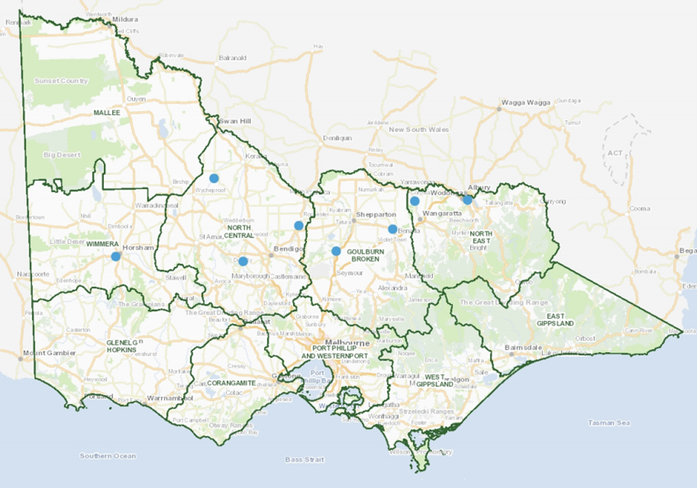
Figure 1: Victoria’s End-of-Valley Target sites.

Salinity across the eight Victorian EoVT monitoring sites remained relatively consistent with the previous reporting period, however an increase in salt load (tonnes per day) was seen across a number of sites. This is likely due to higher than average flows across the reporting period, driven in part by significant flooding in late 2022. -In 2022, total spring rainfall was double the 1961–1990 average across the Murray Darling Basin, and more than 3 times above average for much of north-west Victoria. The flooding which followed was more significant, in terms of extent, severity and duration, than any other flooding in the region since 2009–10, with some gauges exceeding their historical flood peaks in the north of the state.

Extreme high flows and post flood salt mobilisation processes are known to increase instream salt loads within the River Murray system, which was seen in the period following the 2022 flood event.

Salinity and salt loads remained below the benchmark period for the majority Victoria’s EoVT sites. Upper and lower bound exceedance curves were determined by selecting the highest and lowest salinity and salt load values occurring at the 80th percentile over the benchmark period envelope (based on 1 July 1975 to 30 June 2000). The 80th percentile was selected to align with the salinity peak percentiles for reporting against the majority of EoVT target sites specified in Schedule B. This provides a measure that captures the majority of events, whilst recognising the relatively small percentage of more extreme, or exceedance events in the system. The benchmark period envelope is shown as a grey band in each of the exceedance curve charts.

Ovens at Peechelba-East (403241) EoVT site
Figure 2 and increased Figure 3 show the salinity exceedance curve and salt load exceedance curve for the Ovens at Peechelba-East EoVT site, respectively. Based on these figures, there are no signs of increasing salinity at this site. However, the salt load for the reporting period R2023 (Jul 2018-Jun 2023) had increased compared to previous years, it remained close to the lower band of the baseline exceedance curve. This is likely to be a result of increased rainfall as the Residual Mass Rainfall chart (Figure 4) shows that the rainfall over the reporting periods is above average (the slope over this period is positive).

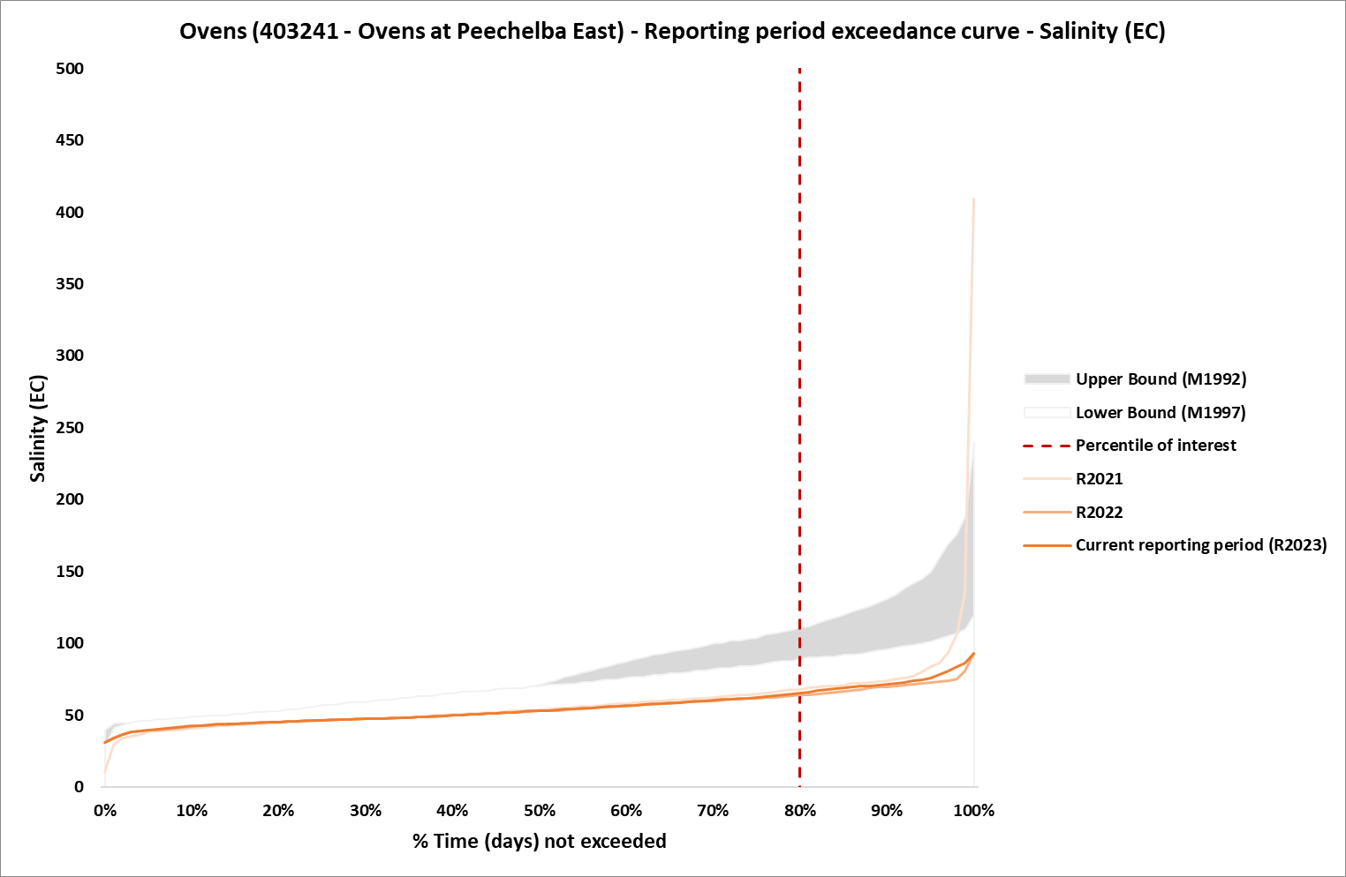
Figure 2: Salinity exceedance curve with Benchmark Period envelope and reporting years, R2022 and R2023 corresponds to the five-year period Jul 2017- Jun 2022 and Jul 2018-Jun 2023, respectively, at Ovens EoVT site
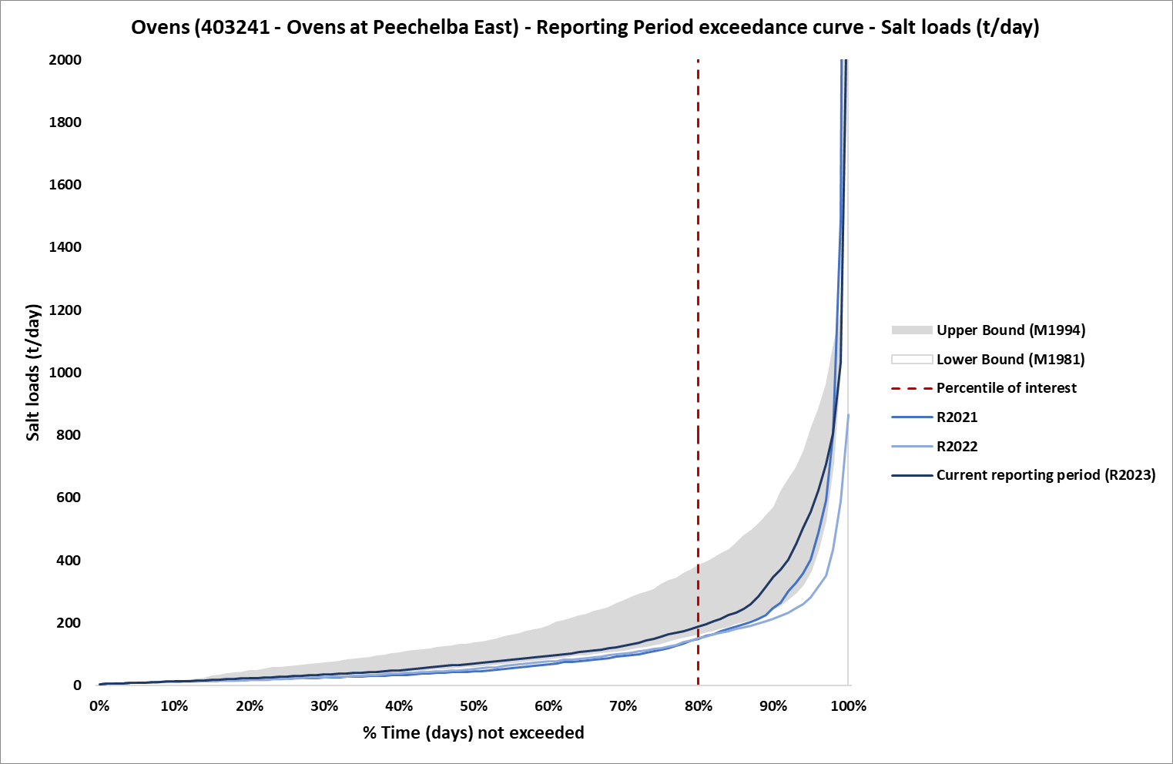
Figure 3: Salt load exceedance curve with Benchmark Period envelope and reporting years, R2022 and R2023 corresponds to the five-year period Jul 2017- Jun 2022 and Jul 2018-Jun 2023, respectively, at Ovens EoVT site

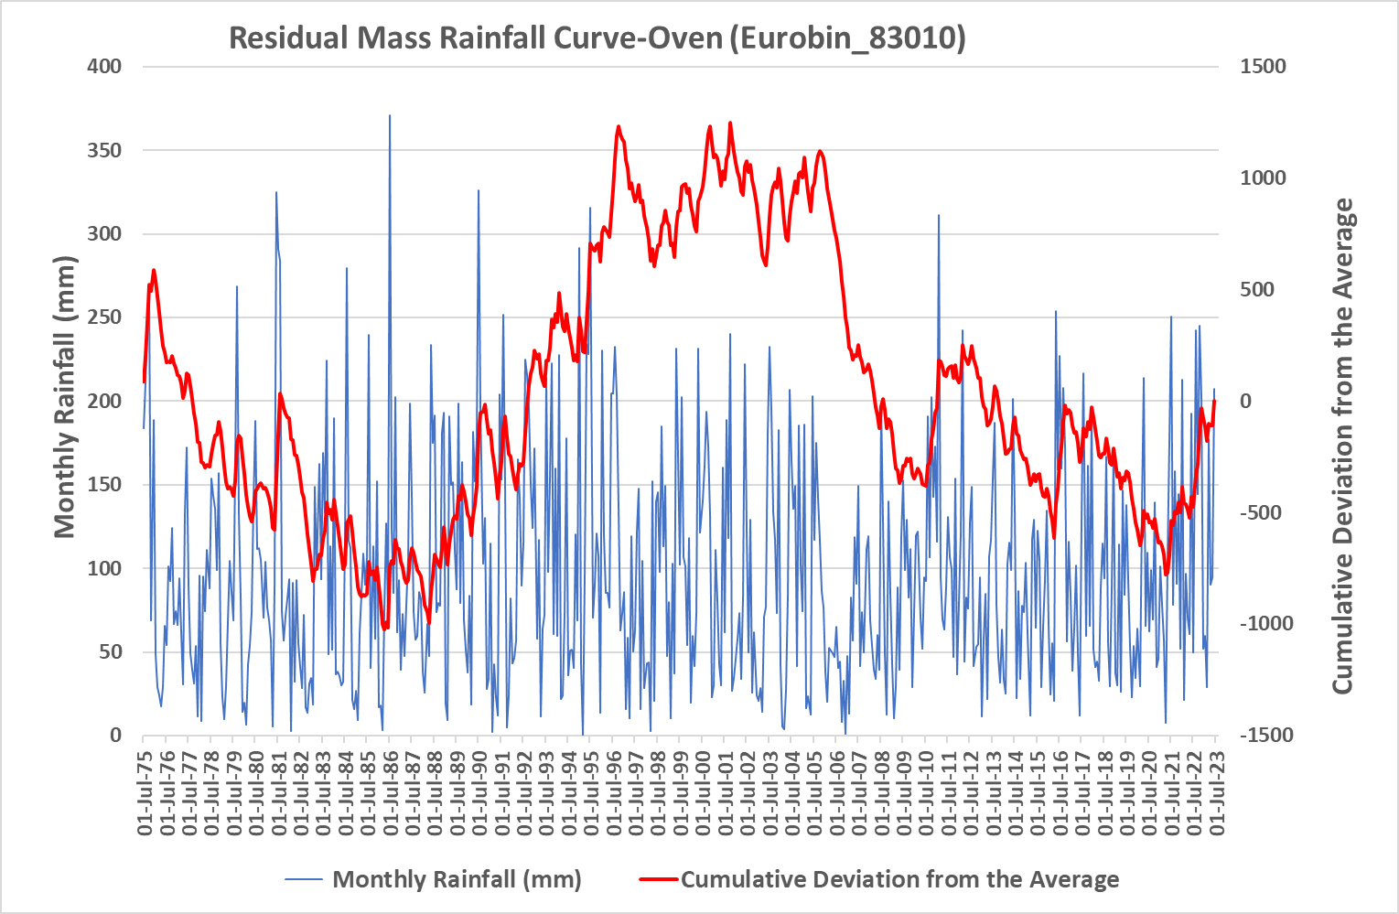
Figure 4: Residual mass rainfall curve for Eurobin (83010) 1975-2023

Kiewa at Bandiana (402205) EoVT site
Figure 5 and Figure 6 show the salinity exceedance curve and salt load exceedance curve for the Ovens at Kiewa at Bandiana EoVT site, respectively. This shows an increase for salinity at the site, but it remains lower than the Benchmark Period. The salt load for the reporting period R2023 (Jul 2018-Jun 2023) has also increased compared to previous years. This is likely to be a result of increased rainfall as the Residual Mass Rainfall chart (Figure 7) shows that the rainfall over the reporting periods is above average (the slope is positive).
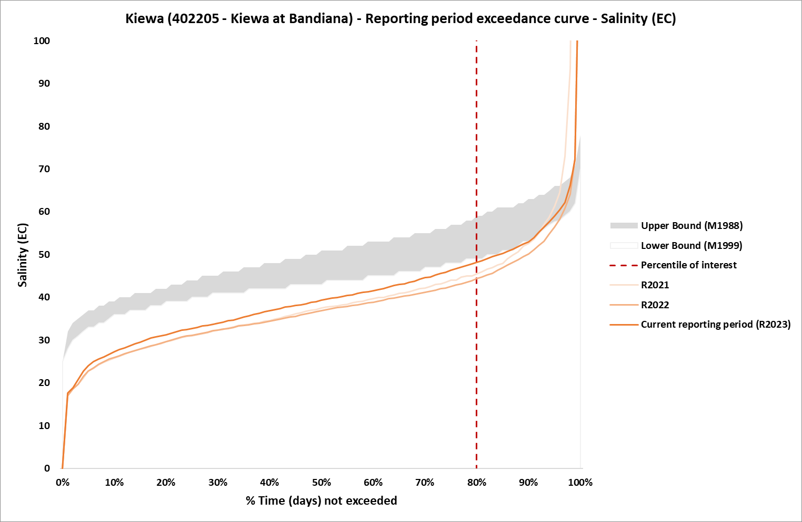
Figure 5: Salinity exceedance curve with Benchmark Period envelope for reporting years, R2022 and R2023 corresponds to the five-year period Jul 2017- Jun 2022 and Jul 2018-Jun 2023, respectively, at Kiewa EoVT site

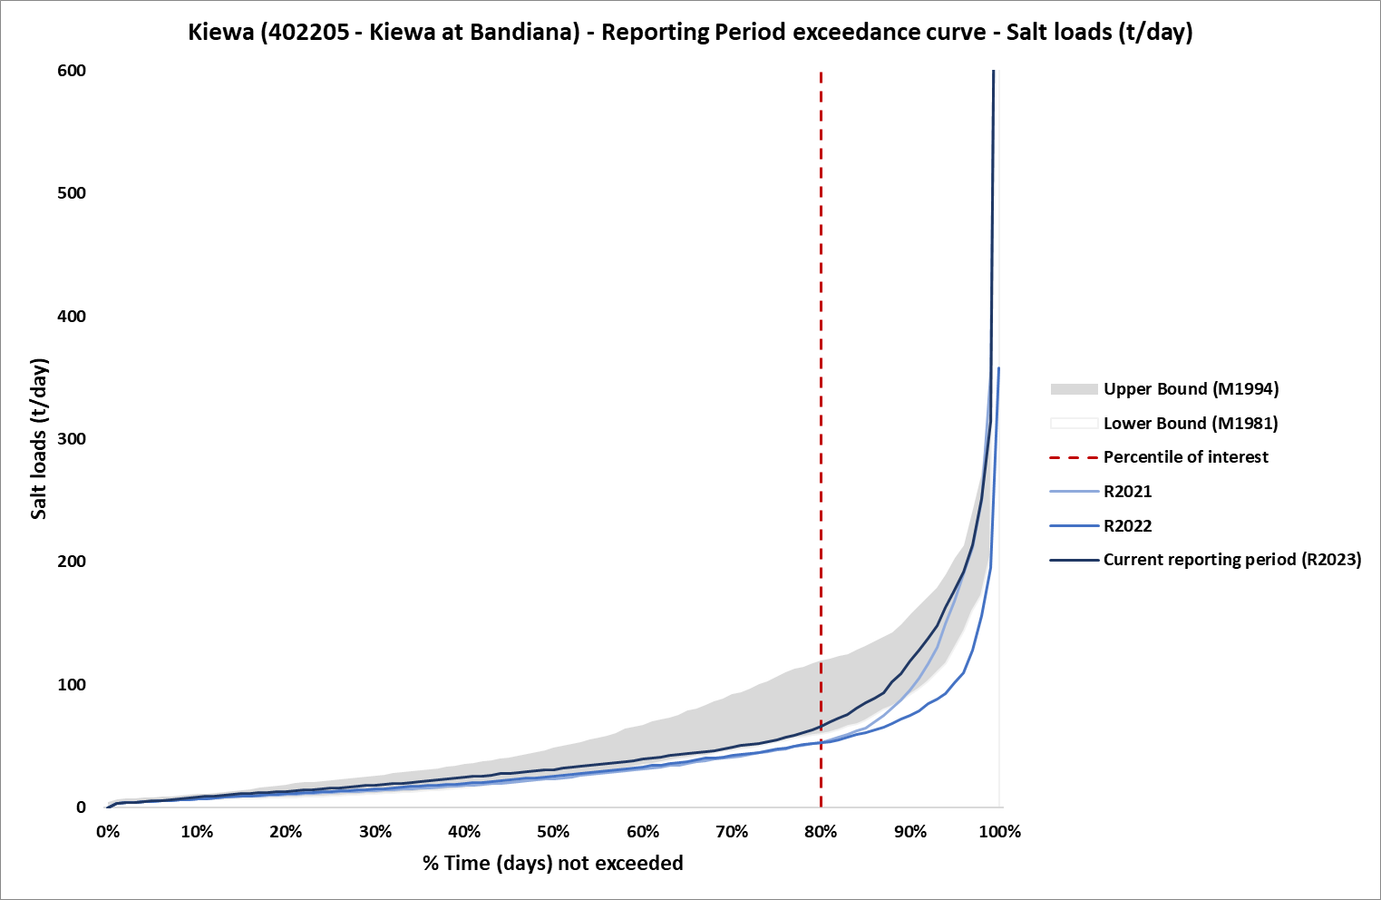
Figure 6: Salt load exceedance curve with Benchmark Period envelope for reporting years, R2022 and R2023 corresponds to the five-year period Jul 2017- Jun 2022 and Jul 2018-Jun 2023, respectively, at Kiewa EoVT site

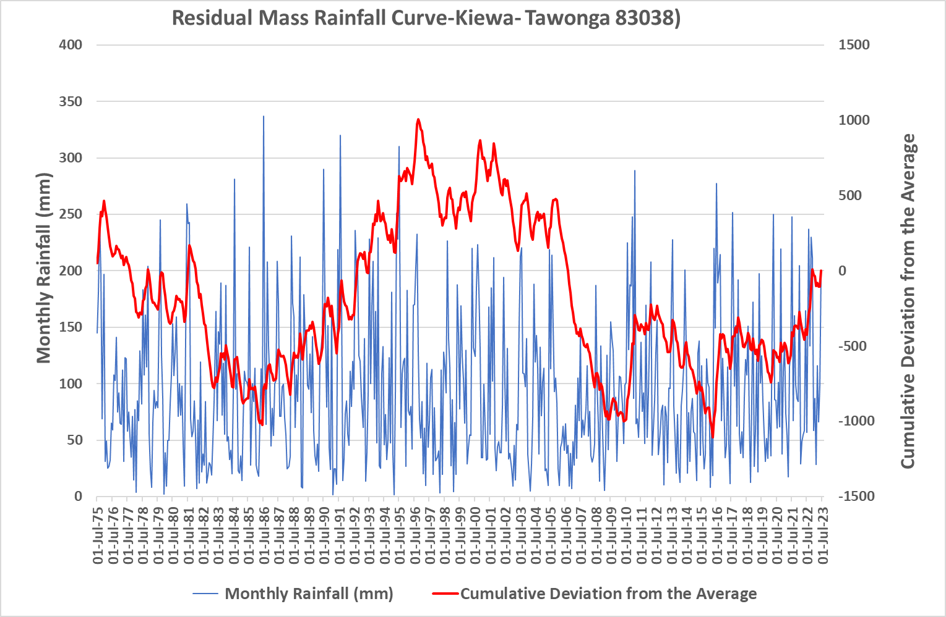
Figure 7: Residual mass rainfall curve for Tawonga (83038) 1975-2023

Goulburn at Goulburn Weir (405259) EoVT site
Figure 8Figure 5 and Figure 9 show the salinity exceedance curve and salt load exceedance curve for Goulburn at Goulburn Weir EoVT site, respectively. Based on these figures, there is no significant change for salinity at the site. However, the salt load for the reporting period R2023 (Jul 2018-Jun 2023) has increased marginally compared to previous years, and it remained close to the lower band of the baseline exceedance curve. This is likely to be a result of increased rainfall as the Residual Mass Rainfall chart (Figure 10) shows that the rainfall over the reporting periods is above average (the slope is positive).

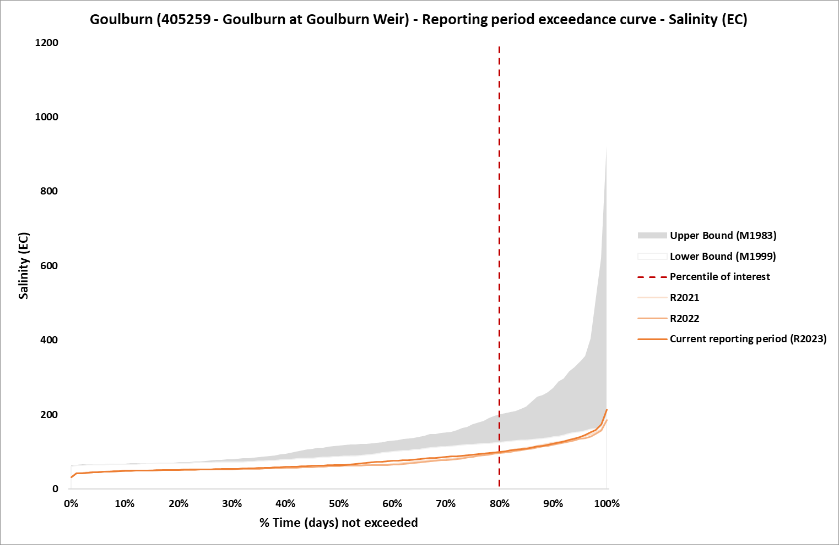
Figure 8: Salinity exceedance curve with Benchmark Period envelope for reporting years, R2022 and R2023 corresponds to the five-year period Jul 2017- Jun 2022 and Jul 2018-Jun 2023, respectively, at Goulburn EoVT site

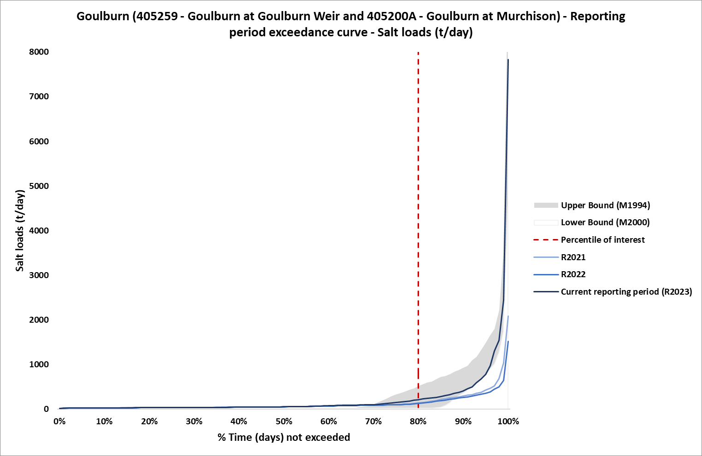
Figure 9: Salt load exceedance curve with Benchmark Period envelope for reporting years, R2022 and R2023 corresponds to the five-year period Jul 2017- Jun 2022 and Jul 2018-Jun 2023, respectively, at Goulburn EoVT site
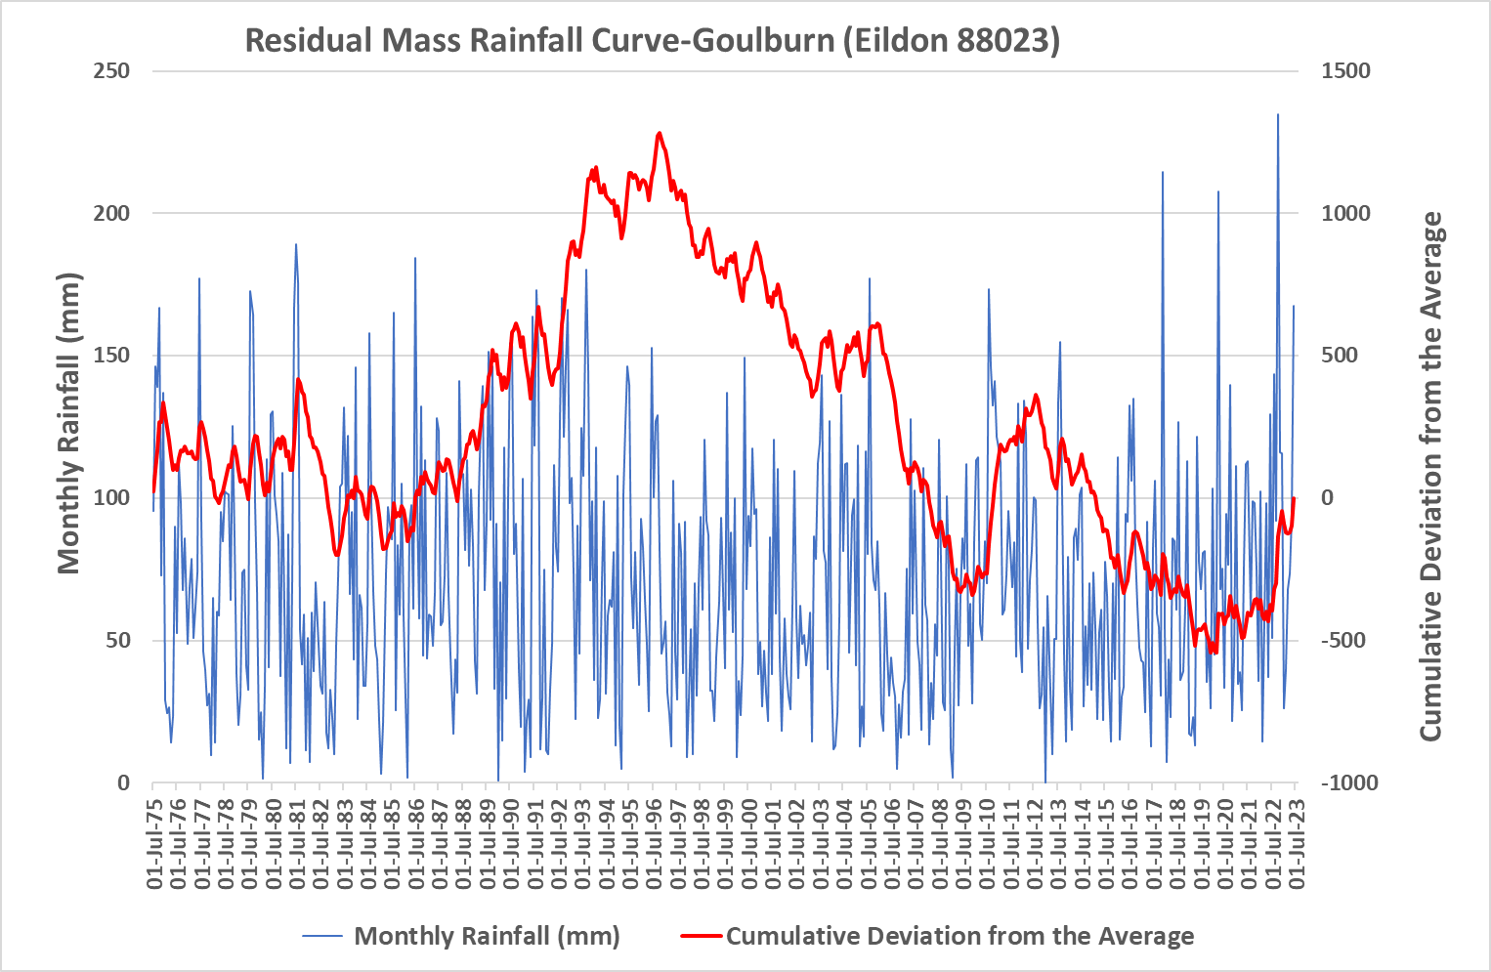
Figure 10: Residual mass rainfall curve for Eildon (88023) 1975-2023

Broken River at Casey's Weir (404217) EoVT site
Figure 11 and Figure 12 show the salinity exceedance curve and salt load exceedance curve for Broken River at Casey's Weir EoVT site, respectively. While no changes in salinity were reported during the reporting period, the salinity is above the benchmark period salinity. There is an increase in the salt load for the reporting period (which is also above the benchmark period salt load), which can be explained in part by the decommissioning of Lake Mokoan in 2009 and Legacy of History Impacts. It should also be noted that the Broken River generally contributes relatively low salt loads to shared water resources in comparison to other Victorian catchments. This is due to much of the catchment upstream of the EoVT being moderately afforested highland areas with comparatively low flows (Goulburn Broken Catchment Management Authority (GBCMA), 2002).
The Residual Mass Rainfall chart (Figure 13) shows that the rainfall over the reporting periods is above average (the slope is positive).

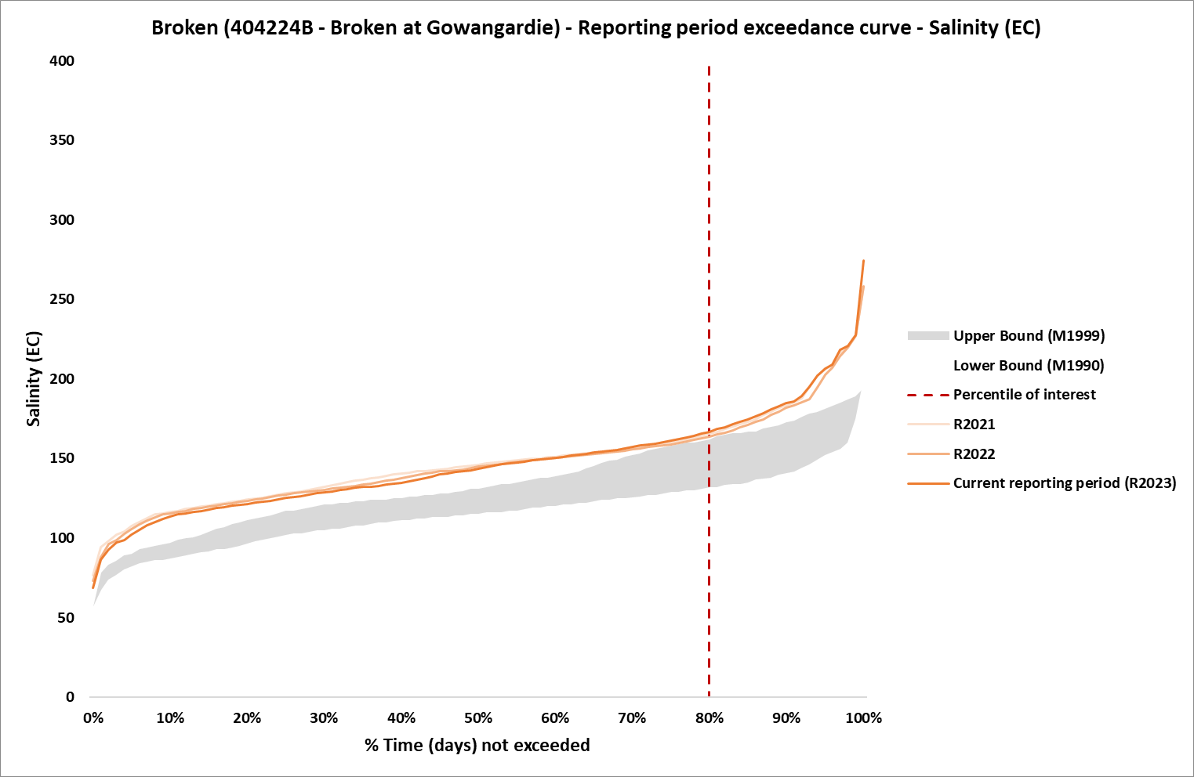
Figure 11: Salinity exceedance curve with Benchmark Period envelope for reporting years, R2022 and R2023 corresponds to the five-year period Jul 2017- Jun 2022 and Jul 2018-Jun 2023, respectively, at Broken EoVT site

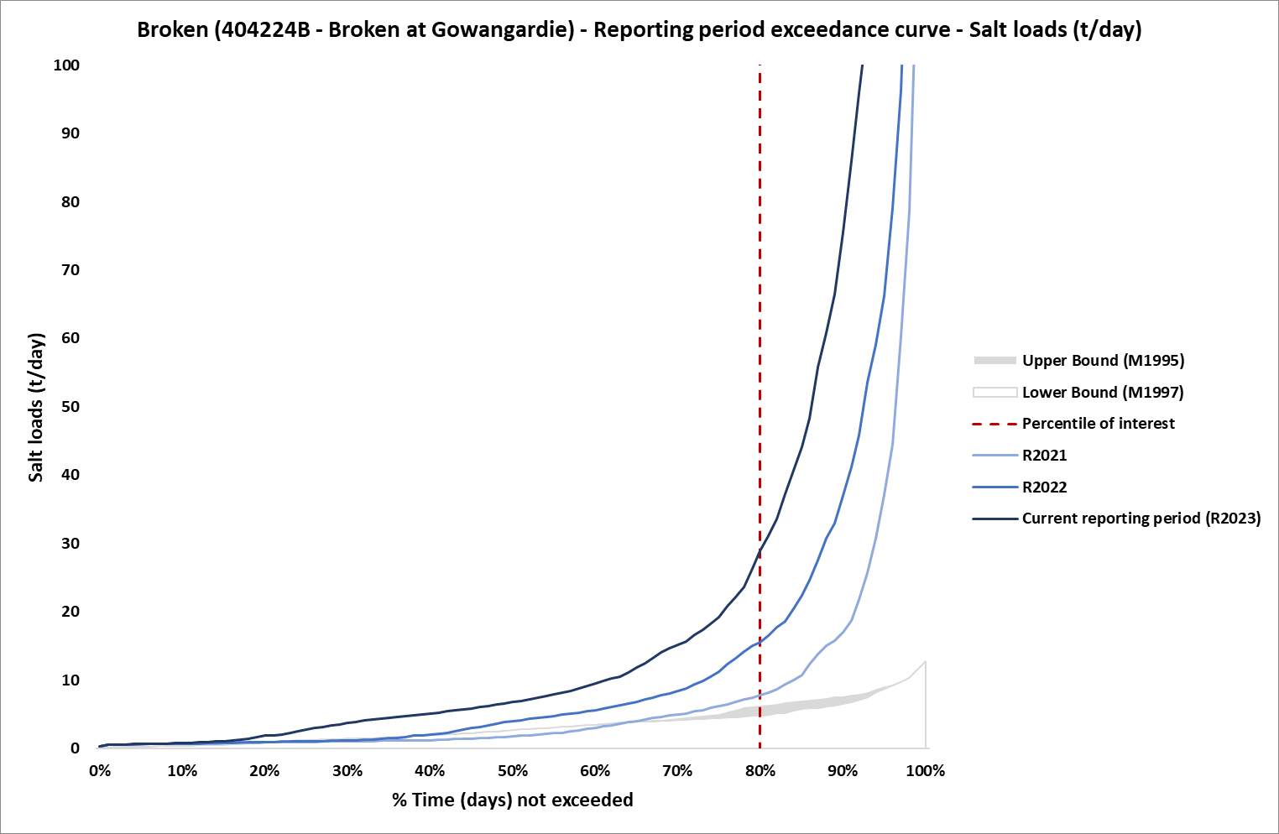
Figure 12: Salt load exceedance curve with Benchmark Period envelope for reporting years, R2022 and R2023 corresponds to the five-year period Jul 2017- Jun 2022 and Jul 2018-Jun 2023, respectively, at Broken EoVT site
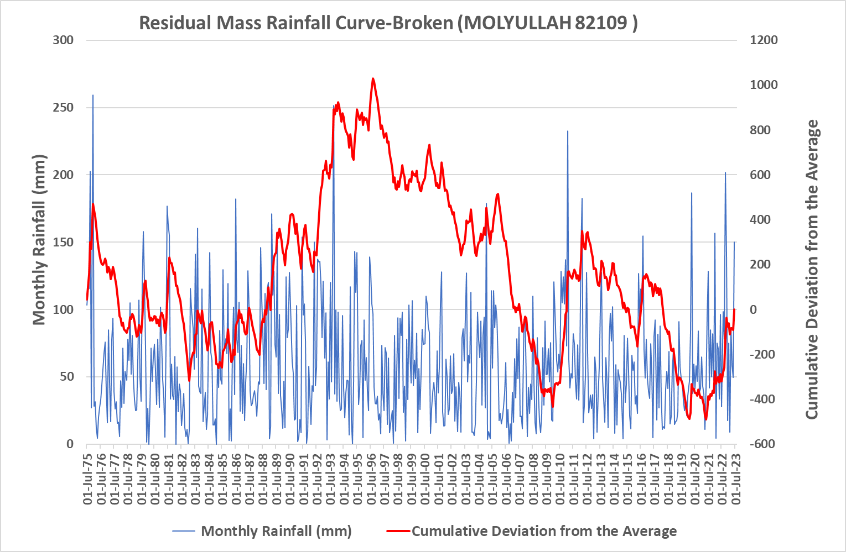
Figure 13: Residual mass rainfall curve for Molyullah (82109) 1975-2023

Avoca at Quambatook (408203) EoVT site
Figure 14 and Figure 15 show the salinity exceedance curve and salt load exceedance curve for the Avoca at Quambatook EoVT site, respectively. In comparison with R2021, the salinity decreased for the reporting period. However, there is an increase of salt load for reporting period R2023 (Jul 2018-Jun 2023) compared with previous years. This is likely to be a result of increased rainfall and significant flooding in 2022. The Residual Mass Rainfall chart (Figure 16) shows that the rainfall over the reporting periods is above average (the slope is positive).

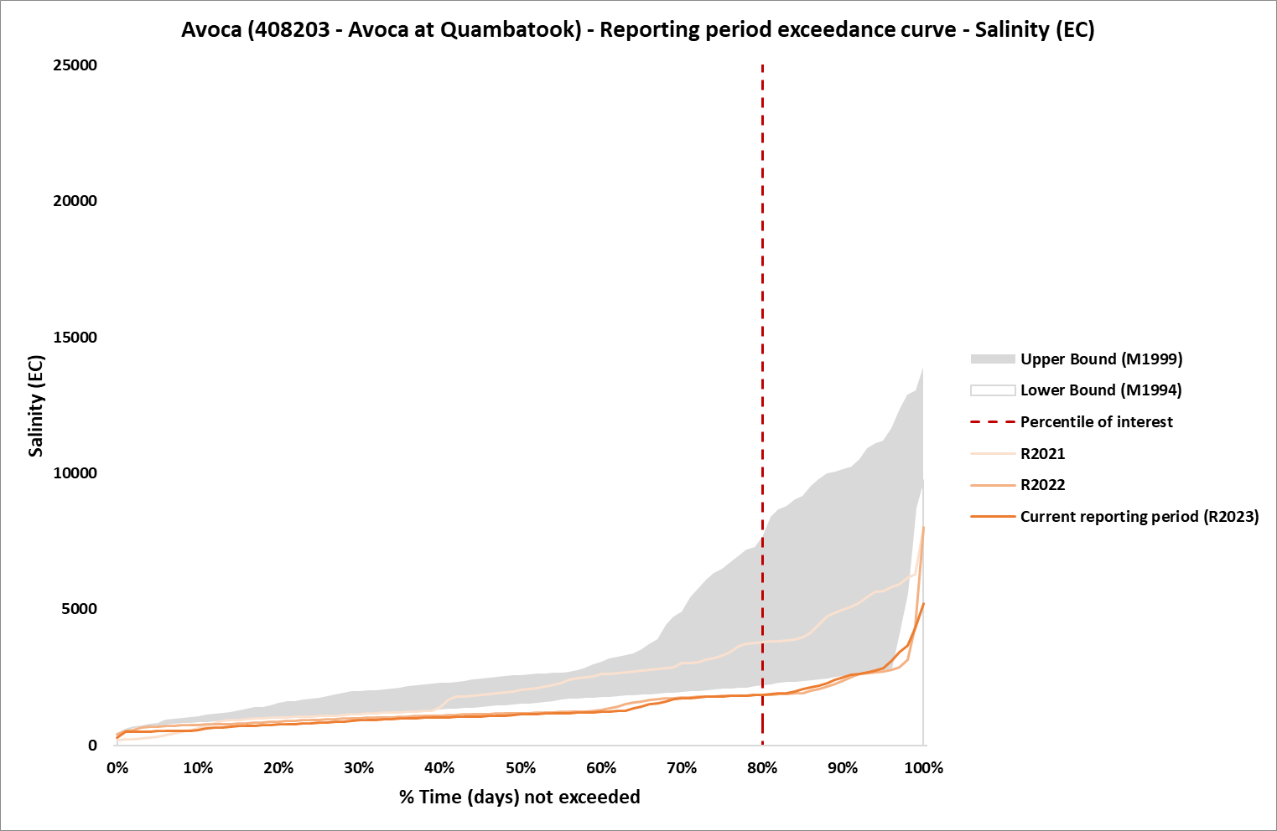
Figure 14: Salinity exceedance curve with Benchmark Period envelope for reporting years, R2022 and R2023 corresponds to the five-year period Jul 2017- Jun 2022 and Jul 2018-Jun 2023, respectively, at Avoca EoVT site
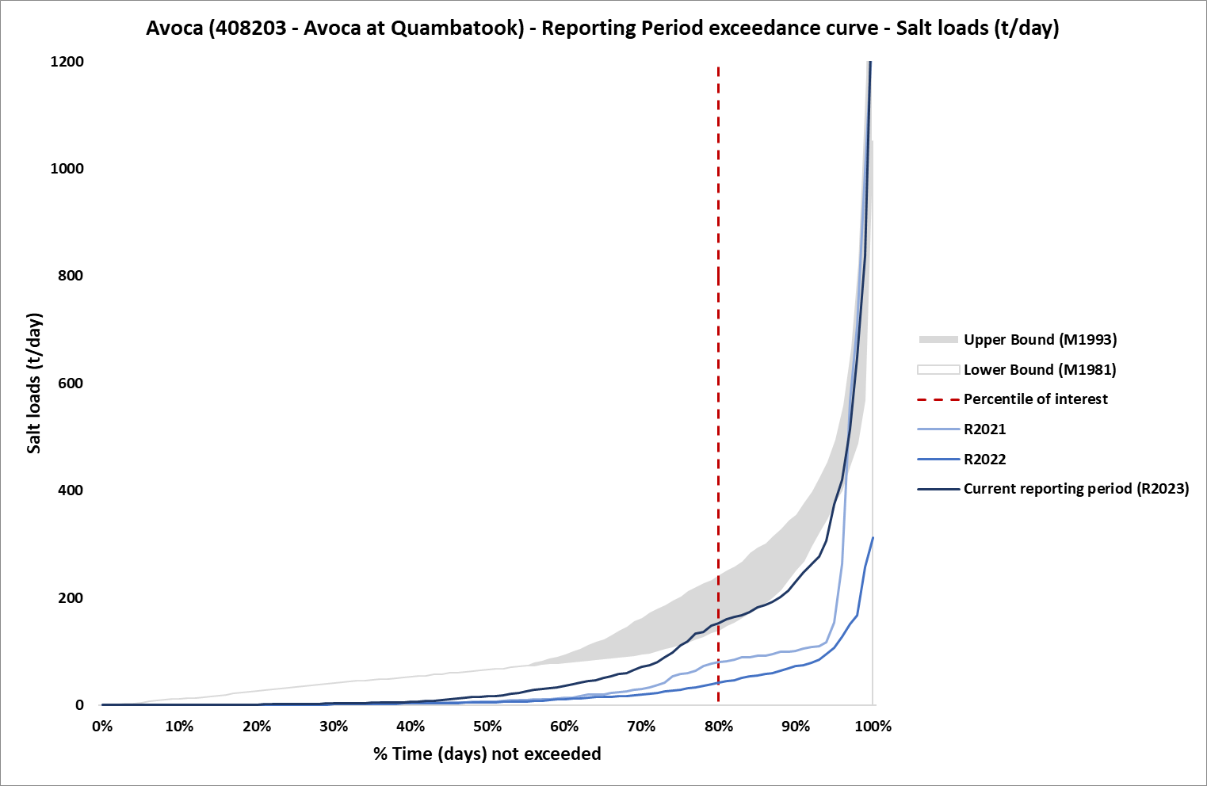
Figure 15: Salt load exceedance curve with Benchmark Period envelope for reporting years, R2022 and R2023 corresponds to the five-year period Jul 2017- Jun 2022 and Jul 2018-Jun 2023, respectively, at Avoca EoVT site
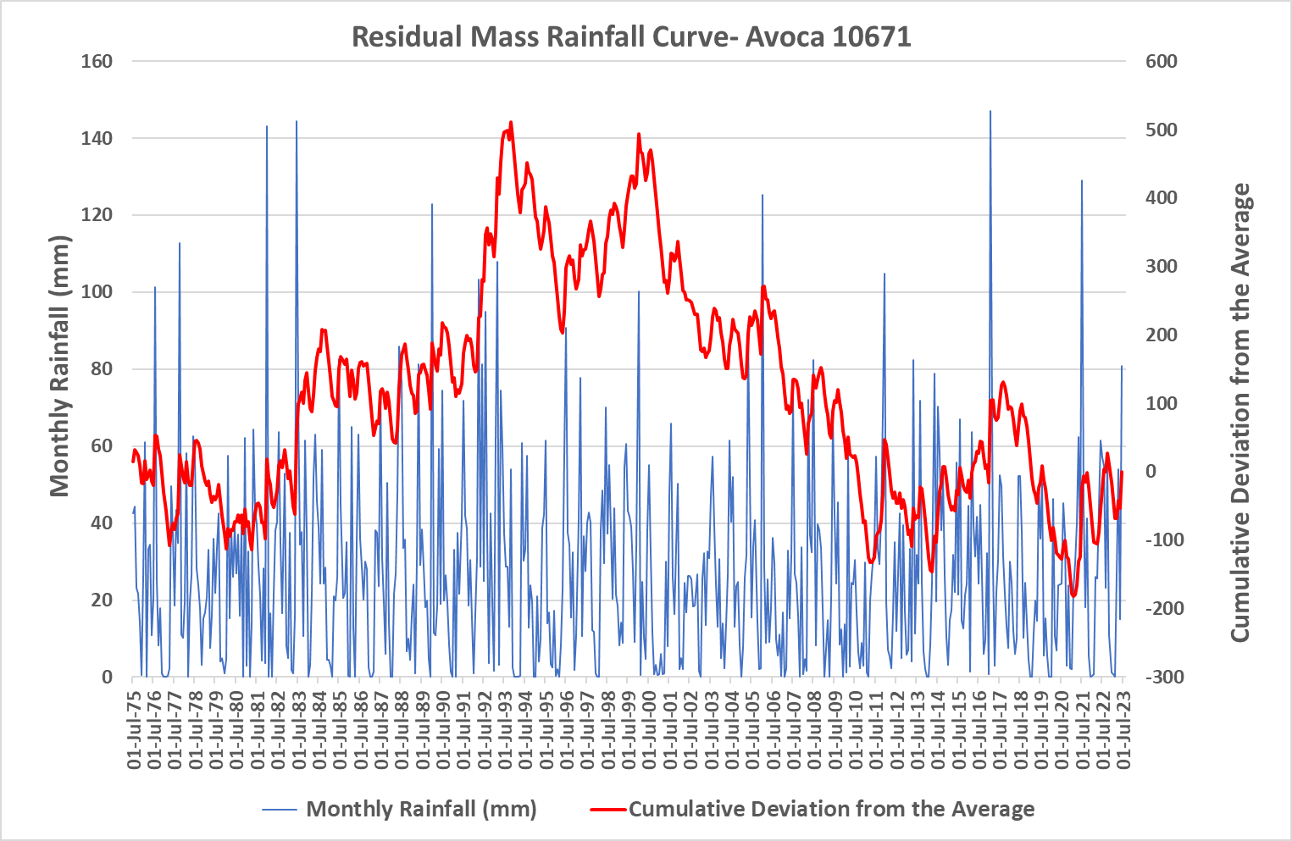
Figure 16: Residual mass rainfall curve for Avoca (10671) 1975-2023

Loddon at Laanecoorie (407203) EoVT site
Figure 17 and Figure 18 show the salinity exceedance curve and salt load exceedance curve for the Loddon at Laanecoorie site, respectively. Based on these figures, there is no sign of increase salinity at the site. However, the salt load for the reporting period R2023 (Jul 2018-Jun 2023) increased marginally compared to previous years, it remains lower than benchmark period envelope. The Residual Mass Rainfall chart (Figure 19) shows that the rainfall over the reporting periods is above average (the slope is positive).

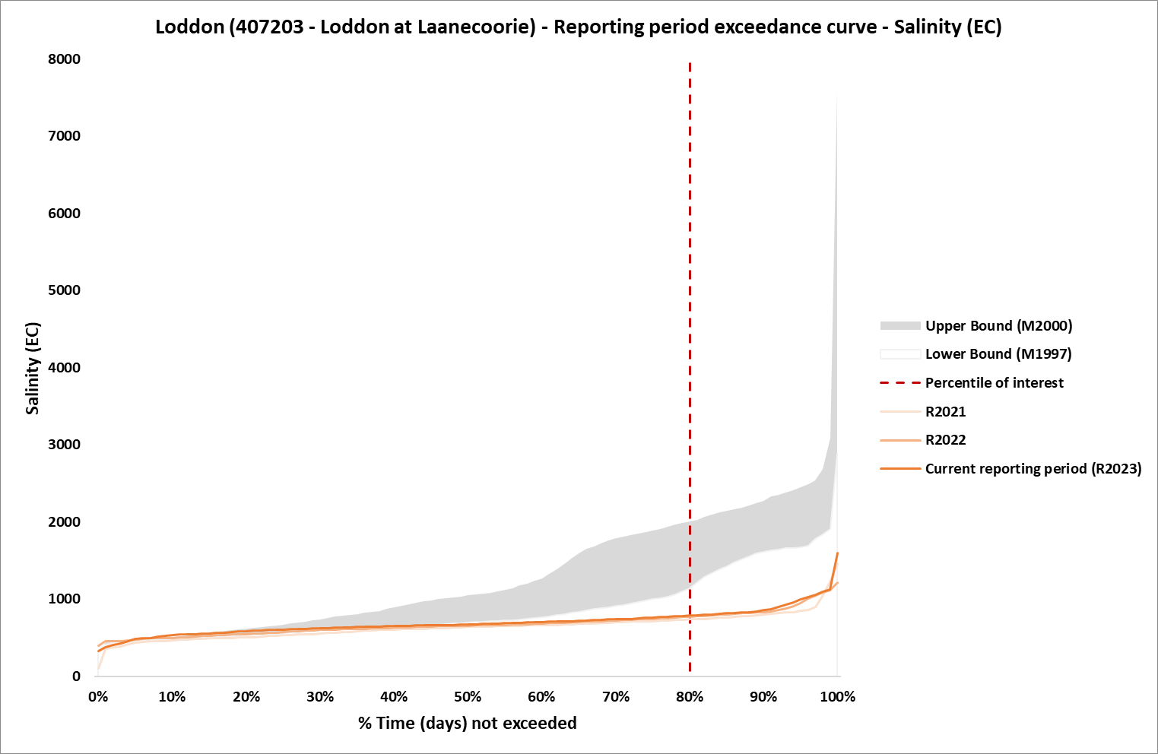
Figure 17: Salinity exceedance curve with Benchmark Period envelope for reporting years, R2022 and R2023 corresponds to the five-year period Jul 2017- Jun 2022 and Jul 2018-Jun 2023, respectively, at Loddon EoVT site
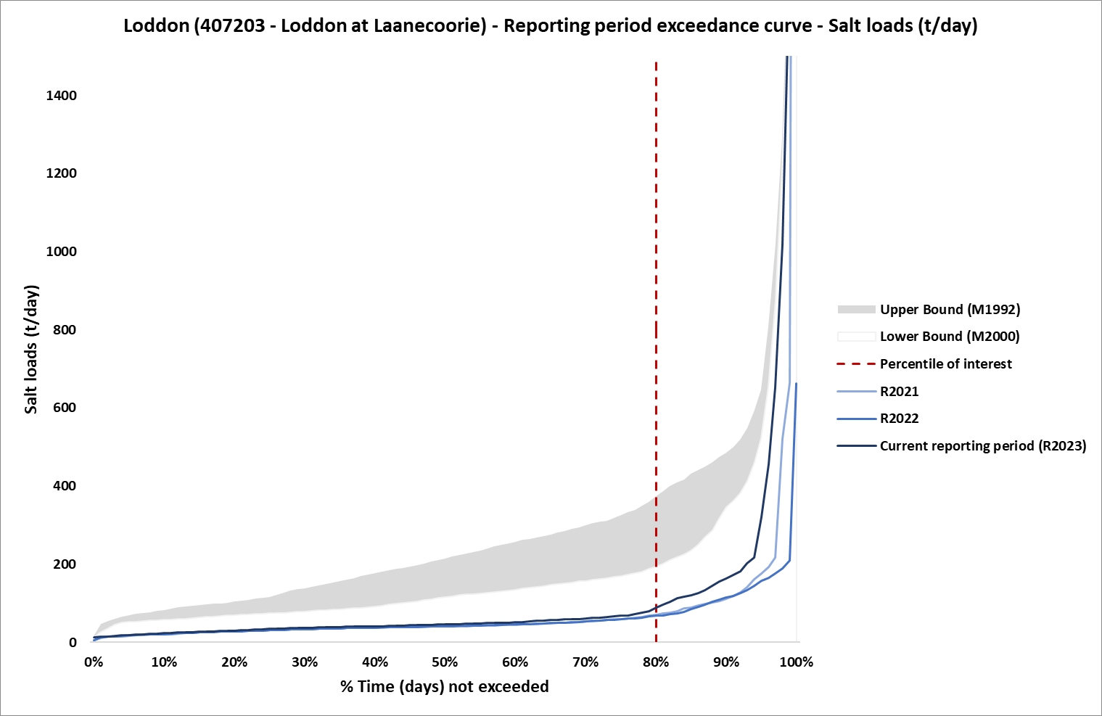
Figure 18: Salt load exceedance curve with Benchmark Period envelope for reporting years, R2022 and R2023 corresponds to the five-year period Jul 2017- Jun 2022 and Jul 2018-Jun 2023, respectively, at Loddon EoVT site
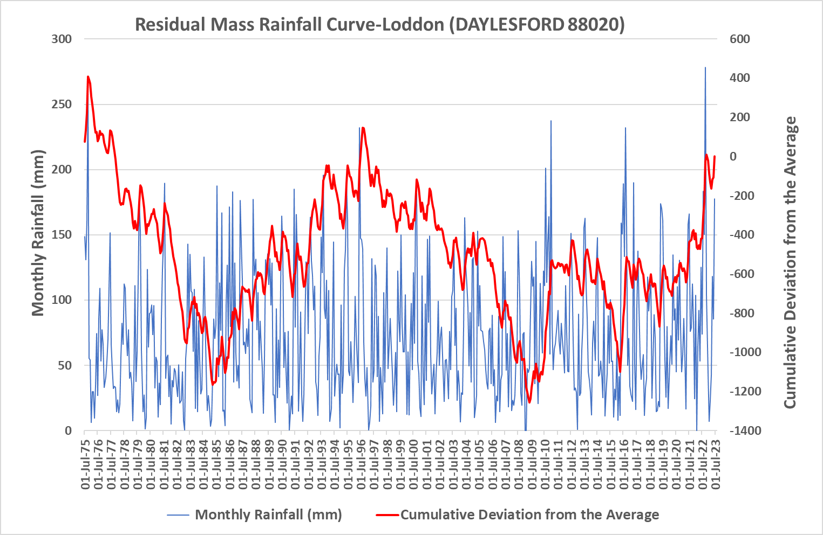
Figure 19: Residual mass rainfall curve for Daylesford (88020) 1975-2023

Campaspe at Campaspe Weir (406218) EoVT site
Figure 20 and Figure 21 show the salinity exceedance curve and salt load exceedance curve for the Campaspe at Campaspe Weir site, respectively. During the reporting years, salinity increased slightly. The salt load for the reporting period R2023 (Jul 2018-Jun 2023) increased marginally compared to previous years, although it remained lower than t salt load of benchmark period. The Residual Mass Rainfall chart (Figure 22) shows that the rainfall over the reporting periods is above average (the slope is positive)."

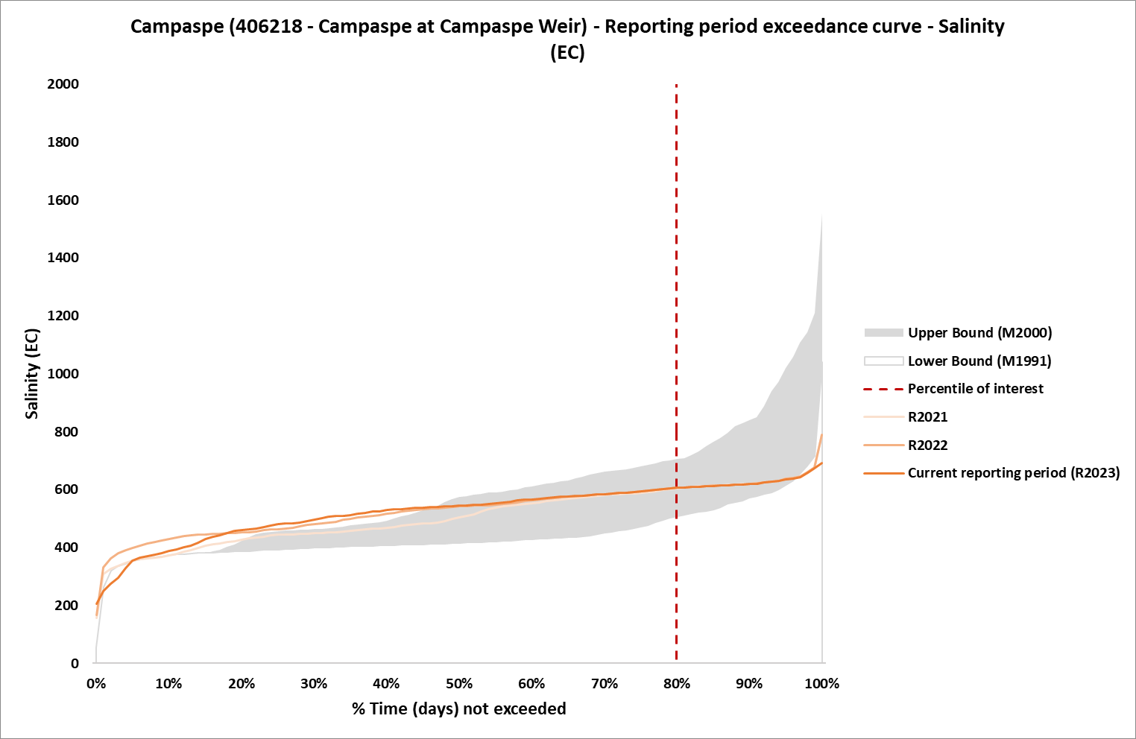
Figure 20: Salinity exceedance curve with Benchmark Period envelope for reporting years, R2022 and R2023 corresponds to the five-year period Jul 2017- Jun 2022 and Jul 2018-Jun 2023, respectively, at Loddon EoVT site
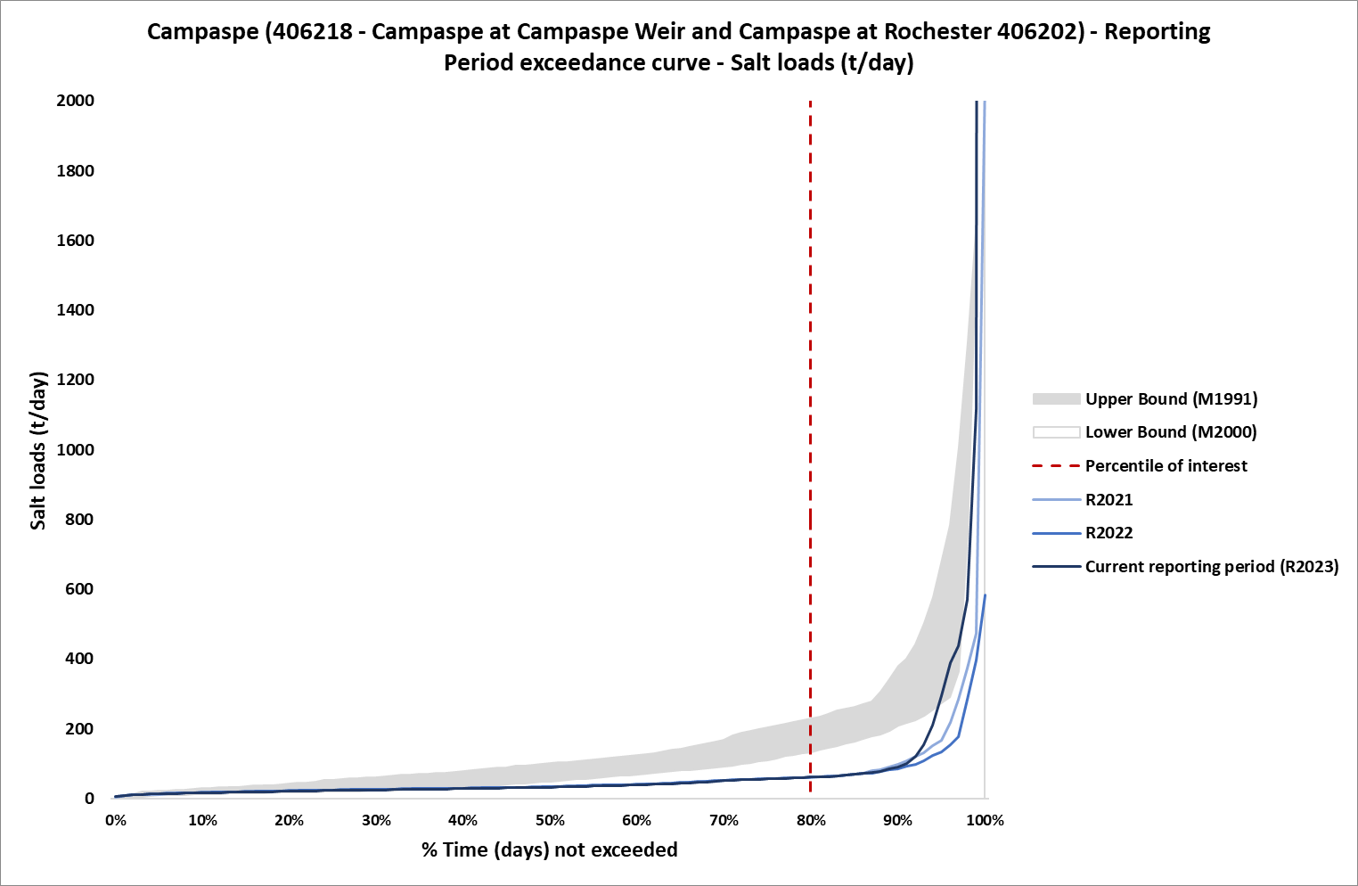
Figure 21:Salt load exceedance curve with Benchmark Period envelope for reporting years, R2022 and R2023 corresponds to the five-year period Jul 2017- Jun 2022 and Jul 2018-Jun 2023, respectively, at Campaspe EoVT site
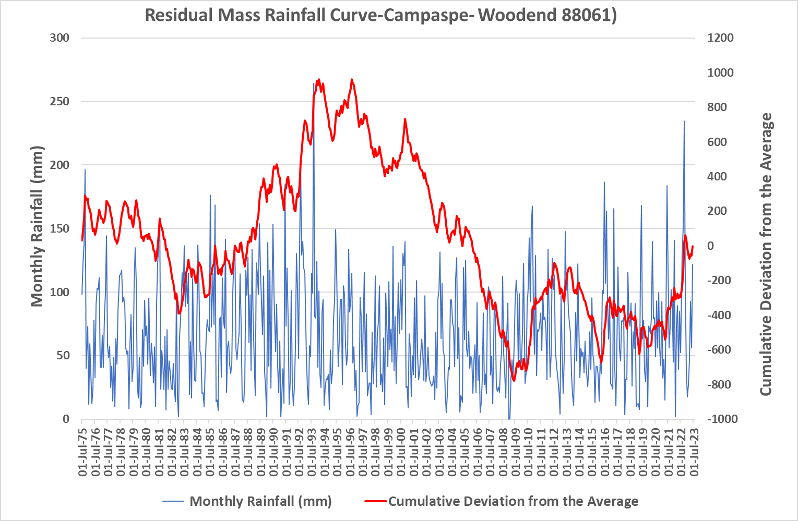
Figure 22: Residual mass rainfall curve for Woodend (88061) 1975-2023

Wimmera at Horsham Weir (415200) EoVT site
Figure 23 and Figure 24 show the salinity exceedance curve and salt load exceedance curve for Wimmera at Horsham Weir EoVT site, respectively. There is no modelled benchmark period data for this site as it is a terminal system. Based on these figures, there is no change for salinity at this site. However, the salt load for the reporting period R2023 (Jul 2018-Jun 2023) shows a moderate increase compared to previous years. This is likely to be a result of increased rainfall and the 2022 flood. The Residual Mass Rainfall chart (Figure 25) shows that the rainfall over the reporting periods is above average (the slope is positive).

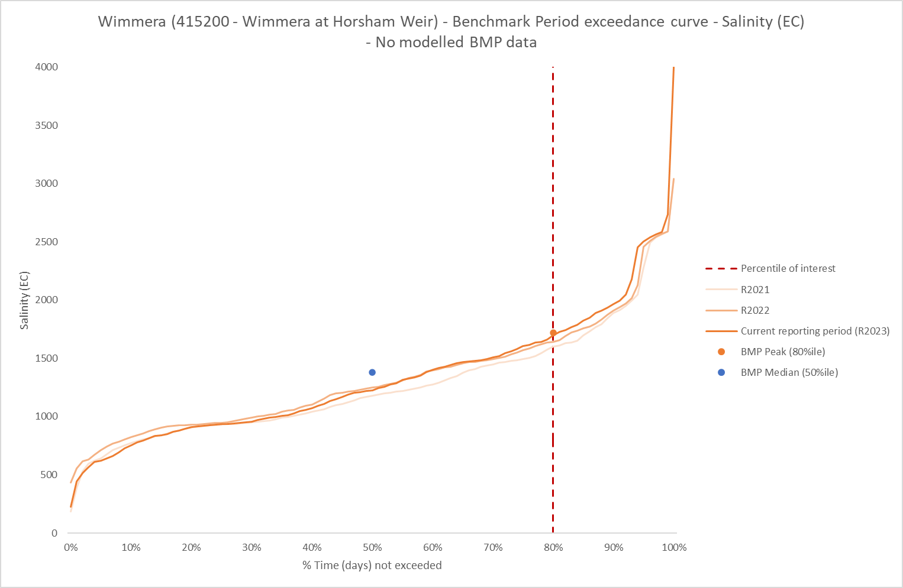
Figure 23: Salinity exceedance curve with benchmark period peak and median for reporting years, R2022 and R2023 corresponds to the five-year period Jul 2017- Jun 2022 and Jul 2018-Jun 2023, respectively, at Wimmera EoVT site
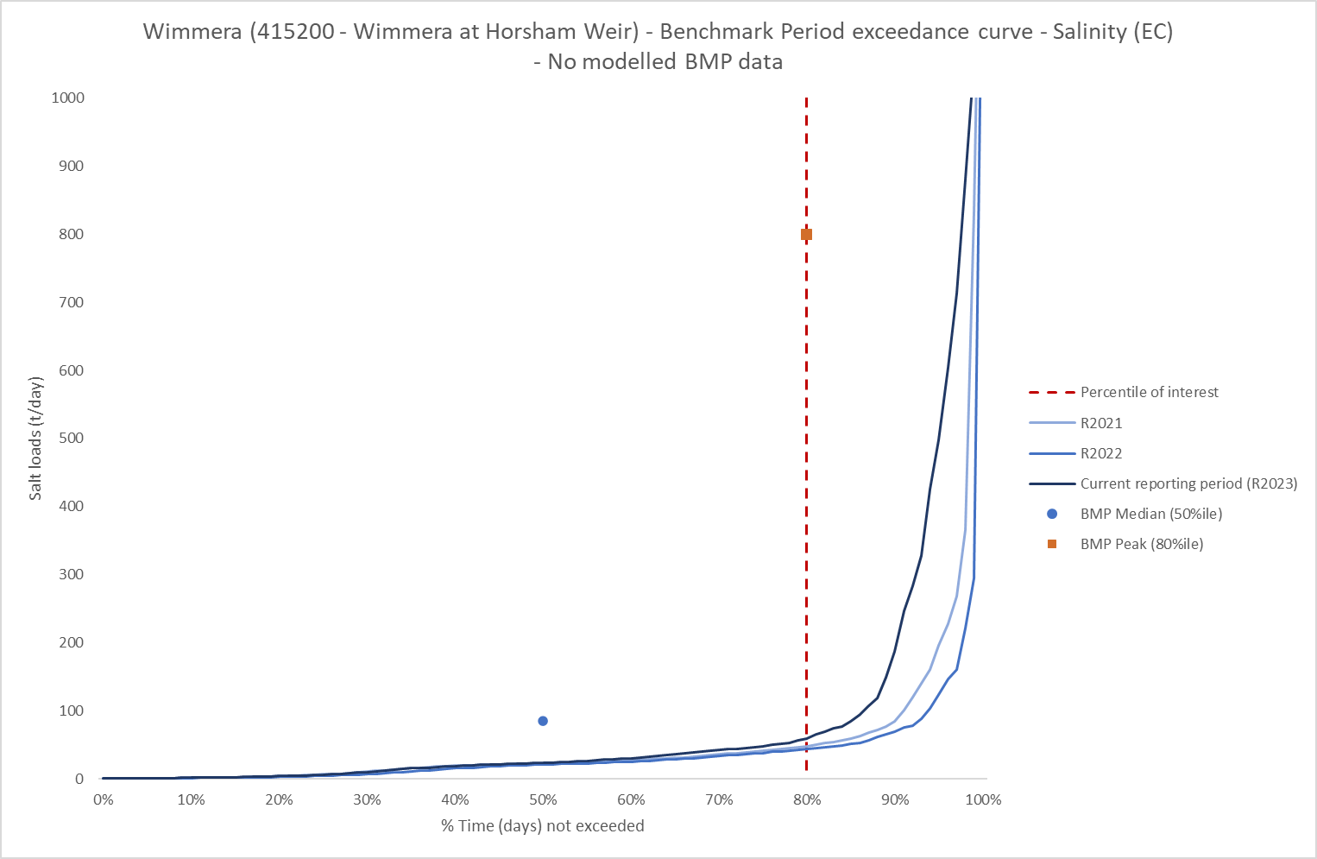
Figure 24: Salt load exceedance curve with benchmark period peak and median for reporting years reporting years, R2022 and R2023 corresponds to the five-year period Jul 2017- Jun 2022 and Jul 2018-Jun 2023, respectively, at Wimmera EoVT site
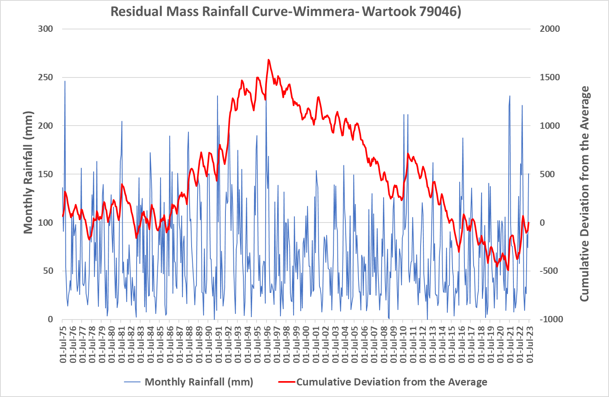
Figure 25: Residual mass rainfall curve for Wartook Reservoir (79046) 1975-2023

6. Efficient Governance
The following section details arrangements and actions by Victoria to support efficient Basin-wide governance of BSM2030 and Victoria’s Salinity Register through monitoring which helps to support the assessment of salinity impacts and periodic reviews of accountable actions. Victoria also actively participates in the audit process which tracks the performance of partner governments and the MDBA in implementing BSM2030 and identifies areas of improvement.
Victoria has a cross-borders approach to salinity management, with a strong focus on collaboration with inter-jurisdictional and regional partners. Basin CMAs, AgVic and Water Corporations play a strong role in regional leadership and implementation of key salinity management actions including accountable action monitoring and reviews.
To align with contemporary policy and procedures DEECA released an update of the Manual for Victoria’s Salinity Accountability in the Murray-Darling Basin 2021. The manual guides Victoria’s salinity and water managers in salinity policy, practices, and procedures to continue managing the threat of salinity in our landscape

6.1 BSM2030 Basin-wide Core Salinity Monitoring Network
During 2022/23 DEECA, working with regional partners including Basin CMAs and AgVic, finalised the details of Victorian monitoring sites in the BCS Monitoring Network in line with BSM2030. Victoria has shared details of the network with the MDBA.
The BCS Monitoring Network will be reviewed on a regular basis, with proposed changes to core sites to be submitted by relevant agencies through the annual status reports and comprehensive reports required under BSM2030.
The groundwater bore monitoring network established by Victoria in the mid-1980s continues to be an important source of long-term groundwater data for the region and is used to inform policy and program development. For example, DEECA integrates the data into landholder extension packages delivered across the catchment.
Strategic reviews of monitoring networks by CMAs have helped to inform the extent and number of monitoring sites within the network. This has ensured that funding is being directed to sites with the greatest benefit for the State’s monitoring objectives.

6.1.1 Dryland Salinity Bore Monitoring
Agriculture Victoria Research (AVR) continues to oversee the monitoring of the suite of dryland salinity observation bores within the North Central CMA, Goulburn Broken CMA and North East CMA regions as part of Victoria’s “watch in brief” on dryland salinity and saline groundwater trends in northern Victoria. This information is also used to determine any likely emerging impact of dryland salinity on key environmental and productive assets.
AVR is currently undertaking a review of the dryland salinity bore information provided by AVR to the Victorian Water Measurement Information System (WMIS) to identify any gaps in relevant WMIS records or areas where the records are not up to date. Once identified, AVR will then ensure this information is migrated to WMIS. Dryland salinity groundwater records are also provided to BOM, and on request to Landcare groups, local government and landholders. AVR is also in the initial stages of identifying any dryland bores within the BCS Monitoring Network where they can no longer gain access on to the private properties to undertake the monitoring. Once identified, DEECA, in consultation with the relevant Catchment Management Authority will determine the most appropriate action to propose.

6.1.2 North East
Groundwater monitoring for salinity management continues to be collected from a set of 64 observation bores throughout the Ovens (52 bores) and Kiewa (12 bores) catchments (Ovens and Kiewa GW trend 2017 report: modified August 2019). Thirty two of these bores are managed under an AgVic project, and 32 are part of the water resource focussed bores in the State Observation Bore Network managed by DEECA. These provide an important source of long-term groundwater trend data for north-east Victoria which is used to ascertain change in the salinity status of these two catchments, part of Victoria's obligations under BSM2030. The data is also used for landholder extension packages delivered across the catchment and to inform policy and program development. To ensure appropriate data set is available for future analysis and reviews, existing stream flow and bore monitoring must be maintained.

6.1.3 Goulburn Broken
Surface water and groundwater monitoring has been undertaken as per the Goulburn Broken CMA’s component of the Basin-wide Core Salinity Monitoring requirements. There has been no change to the regions network in 2022/23.
Monthly monitoring of shallow observation bores enables the region to monitor for change and identify salinisation risks. It is also used to produce community engagement tools such as groundwater level maps and salinity threat maps, it provides the data for the Goulburn Broken CMA’s Salinity Watch website, and also dictates the operation of GMW’s Public Groundwater Pump Network.
Monitoring of the Goulburn Broken regional surface drains and rivers are equally important as this data enables the CMA to identify changes in water quality such as salt loads, ensuring that new and emerging risks are being identified and input to BSM2030 Legacy of History and Accountable action reviews. Surface water monitoring also provides data to inform the annual SIR Surface Drain Water Quality Annual report.

6.1.4 North Central
Under a service level agreement with AgVic, 355 bores were monitored across the Riverine Plains in northern Victoria. Two thirds of the bore network was monitored before the October 22 floods and one third after the floods. Twenty surface water stations were monitored under the Victorian Regional Water Monitoring Program.

6.1.5 Mallee
Flow and water quality of the River Murray and irrigation drainage were monitored during 2022-23 to provide data and information for BSM2030 implementation.
Twenty-nine drainage outfall sites were monitored for flow and salinity during 2022-23. The data collected from the drainage network were useful for the Psyche Bend Lagoon and Sunraysia Drying of Drains Accountable Action reviews and the Sunraysia Model Upgrade project for assessing the salinity impact of RISI VIC accountable action. In total, 436 groundwater bores were monitored for depth and salinity.

6.1.6 Wimmera
Monitoring data is collected monthly at 22 surface water sites throughout the Wimmera catchment. These sites are located on the major rivers and creeks. The field sampling is conducted by Wimmera CMA staff. Continuous water quality and flow data are also collected at permanent water monitoring stations, as part of the DEECA managed regional water monitoring partnership. The cumulative impacts of the various threats facing the Wimmera River are most keenly felt as the river winds its way to its terminal lakes, Hindmarsh and Albacutya. Complementing Wimmera CMA monitoring, Jeparit Waterwatch has been in existence for more than 25 years and the long record of water quality monitoring tells a story of significant challenges in terms of the dire water quality readings measured during the drought, where salinity levels were talked about in terms of multiples of seawater salinity.
Groundwater Bore Improvement Program
Improvement and maintenance activities undertaken in 2021/22 and 2022/23 included the continuation of a maintenance program for the bore network. Changes to the Core Salinity Monitoring Network during 2021/22 were summarized in Table 12. In 2021/22, Mallee CMA has notified DEECA that one bore is to be removed from the Core Monitoring Network. The bore was damaged but adequate coverage is provided by neighbouring bore 7786 which is already nominated in the MDBA Core Salinity Network.
Mallee and Goulburn Broken CMAs have notified DEECA that three groundwater monitoring bores (listed in Table 12) are to be removed from the BCS Network. Seven additional bores are required to be installed to replace the removed bores and be part of the monthly monitoring network.

Table 12: Changes to Core Salinity Monitoring Network
Bore ID or Gauge Number | Region | What did it monitor? | Supporting which register entry or model? | Reason for change | Proposed action?
130547 | Mallee  CMA | Groundwater levels and salinity | RISI | Bore destroyed by farming activities | Remove from network
Bore 1131 | Goulburn Broken CMA | Groundwater levels | SIR Groundwater Trends to support Shepparton SMP Register A entry | Blocked and parted casing | Remove from network
Bore 44443 | Goulburn Broken CMA | Groundwater levels | SIR Groundwater Trends to support Shepparton SMP Register A entry | Health and safety access issues | Remove from network
Bore 1431 | Goulburn Broken CMA | Groundwater levels | SIR Groundwater Trends to support Shepparton SMP Register A entry | Replacing bore 1131 | Add to network
Bore 44449 | Goulburn Broken CMA | Groundwater levels | SIR Groundwater Trends to support Shepparton SMP Register A entry | Replacing bore 44443 | Add to network
Bore 114572 | Goulburn Broken CMA | Groundwater levels | SIR Groundwater Trends to support Shepparton SMP Register A entry | Additional bore for Public Groundwater Pumps T8 | Add to network
Bore 110066 | Goulburn Broken CMA | Groundwater levels | SIR Groundwater Trends to support Shepparton SMP Register A entry and Gaynor Swamp Watertable Impact Investigation | Additional boundary shallow observation bore for the Gaynor Swamp Watertable Impact Investigation | Add to network
Bore 4908 | Goulburn Broken CMA | Groundwater levels | SIR Groundwater Trends to support Shepparton SMP Register A entry and Gaynor Swamp Watertable Impact Investigation | Additional boundary shallow observation bore for the Gaynor Swamp Watertable Impact Investigation | Add to network
Bore 44968 | Goulburn Broken CMA | Groundwater levels | SIR Groundwater Trends to support Shepparton SMP Register A entry and Gaynor Swamp Watertable Impact Investigation | Additional boundary shallow observation bore for the Gaynor Swamp Watertable Impact Investigation | Add to network
Bore 110068 | Goulburn Broken CMA | Groundwater levels | SIR Groundwater Trends to support Shepparton SMP Register A entry and Gaynor Swamp Watertable Impact Investigation | Additional boundary shallow observation bore for the Gaynor Swamp Watertable Impact Investigation | Add to network

6.2 Register Reviews of Victorian Accountable Actions

6.2.1 Summary
During 2021/22 and 2022/23 a range of projects were commenced or completed to either review Victorian Accountable Actions or follow up recommendations from previous reviews which will inform scheduled reviews over the next few years. These projects contributed to the management of seven Victorian Register A accountable actions have been listed in 1313.
1313: Status of Victorian BSM2030 Accountable Action reviews in 2021/22 and 2022/23 (Registers A)
In progress | Completed
Kerang Lakes/Swan Hill Salinity Management Plan*** | Pyramid Creek GIS
Woorinen Irrigation District Excision*** | Church's Cut decommissioning
Victorian Mid Murray Storages (VMMS) | RISI Stage 1*
Shepparton Irrigation Region (SIR) Land and Water Management Plan (LWMP) | RISI Stage 2*
New Integrated Accountable Action Model (IAAM) for the Tragowel Plains and Barr Creek Catchment | Psyche Bend Lagoon
 | Sunraysia Drying of the Drains
*Linked to the MDBA lead Sunraysia Model Upgrade (SMU) project.
**The Model Refinement Project developed the method for assessing the Nyah to SA Border SMP accountable action.
***These will be considered alongside the assessment of the new Victorian Mid-Murray Storages Register A entry.

6.2.2 Goulburn Murray Water
Pyramid Creek and Church’s Cut
The Pyramid Creek Salt Interception Scheme (PCSIS) and Church’s Cut are works targeting the reduction of saline groundwater accessions to Pyramid Creek between Kow Swamp and Flannery’s Bridge in Northern Victoria. Church’s Cut was infilled in 2003. The PCSIS was subsequently constructed in 3 stages commencing in July 2004, with the final stage operating by May 2009. The scheme is operated to intercept saline groundwater thereby reducing salt accessions to the River Murray. The third review of Pyramid Creek SIS (PCSIS) and Church’s Cut was completed in 2023. This review covers the period from 1 July 2015 to 30 June 2021. As there were no changes to the input data for the modelling, the last review EC impacts was adopted (the EC impact will not change).

6.2.3 Goulburn Broken
Shepparton Irrigation Region Land and Water Management Plan
The Shepparton Irrigation Region Land and Water Management Plan (SIR LWMP) Register Entry Review project started in 2020/21. The initial concept proposed reviewing the risk of the register entry in line with the steps set out in the Jacobs and RMCG (2020) Irrigation Assessment Framework and approaching the review with the BSM2030 Guiding Principle of ‘effort commensurate with risk’.
In providing this oversight, the project steering committee in consultation with the VSDWG have determined that whilst the current SIR LWMP Register Entry value is a relatively high debit, this current register value reflects an accounting risk rather than a biophysical risk, and so should not be construed as meaning that a complex modelling approach is required. DEECA shared this decision with the Basin Salinity Management Advisory Panel (BSMAP), with members supportive of viewing the register entry as low risk based on current catchment observations.
Based on the low-risk nature of the action, a simple modelling approach is therefore required. Whilst likely to need to be applied at the drainage catchment scale, it will seek to use only readily available data, and to address gaps by using judgements by specialists with a high-level understanding of the landscape. To ensure that future updates are simple and cost efficient and cost effective, the model will also seek to be primarily informed by routine Victorian agency monitoring and reporting data sets, and triggered through the use of clear indicators.
A staged approach to the review has been prepared and endorsed by the project steering committee. Briefs have been prepared for the first two stages of the project. The next step for the project is to undertake consultant procurement for Stage 1 of the project in early 2023/24.

6.2.4 North Central
New Integrated Accountable Action Model for the Tragowel Plains and Barr Creek Catchment
The new Integrated Accountable Action Model (IAAM) for the Tragowel Plains and Barr Creek Catchment Management Strategies is largely complete. The model deploys the Victorian Catchment Assessment Tool for simulating the hydrological impacts of land use. The tool feeds recharge to a fully distributed three-dimensional groundwater model. IAAM features post processing algorithms that predict salinity, flows, and salt loads. It was proposed to combine accountable actions for the Tragowel Plains and the Barr Creek, however, advice from DEECA in late 2022 suggested submitting each catchment separately. The 2023 Barr Creek Catchment Salinity Report (BCCS) report will be submitted first, whilst further work will be required to complete the Tragowel Plains assessment. The BSM2030 scenario requirements are currently being evaluated. This requires consideration of sequencing issues given the presence of the Barr Creek Diversions Strategy in the lower catchment below the BCCS. Pending some additional work, it is anticipated the 2023 review of Barr Creek will be complete in October-November 2023.
Victorian Mid Murray Storages
In early 2010, the VMMS was formed by combining four separate storages in the Kerang Lakes system to harvest and store a portion of the increased unregulated Victorian tributary to the River Murray, resulting from the decommissioning of Lake Mokoan in the Broken River system. The objective was to capture, store and release water for the benefit of Victorian Murray System users, with water harvested into the VMMS being able to be returned to the River Murray to supplement flows. The project was driven by the need to achieve water savings to be returned to the environment.
A preliminary assessment undertaken in 2015 showed that the operation of the VMMS had a significant salinity impact on the River Murray and must be accounted for in the Salinity Register. The VMMS salinity impact assessment commenced in 2022 and is expected to be completed by May 2024.
Kerang Lakes Swan Hill Salinity Management Plan
Victoria is only accountable for the salinity impact of the Lake Charm Flushing component of the Kerang Lakes Swan Hill Salinity Management Plan. In 1997, the Lake Charm Outfall Channel works were commissioned to allow flushing of the lake to move the accumulated salinity from the lake into the River Murray.
As Lake Charm is one of the storages that make up the VMMS, the Lake Charm Outfall Channel operating rules became superseded when the VMMS was formed, in 2010. The Kerang Lakes Swan Hill Salinity Management Plan accountable action review is underway as part of the VMMs salinity impact assessment to assess if any residual salinity impact remains.
Woorinen Irrigation District Excision
In 2003/04, part of the open channel system supplying the Woorinen Irrigation District was replaced with a piped system. This change resulted in a large portion of the irrigation district becoming supplied directly from the River Murray and a reduction in the volume of water supplied by the Torrumbarry Irrigation Area’s Channel No. 9, which in turn reduced the flows through Kerang Lakes. To protect the water quality of the Kerang Lakes, a throughflow requirement passing through the Kerang Lakes into the River Murray was added, which added a salt load to the River Murray.
The Kerang Lakes throughflow requirement became superseded when the VMMS was formed in 2010. The review of the Woorinen Irrigation District Excision accountable action review is underway as part of the VMMS salinity impact assessment to assess if any residual salinity impact remains.

6.2.5 Mallee
Psyche Bend Lagoon
Psyche Bend Lagoon is a natural discharge area of highly saline groundwater. Historically, irrigation drainage water would pass through the lagoon on its way to the River Murray. A diversion pipeline and a regulator gate were installed by 1996 that diverted irrigation drainage water away from Psyche Bend Lagoon and Psyche Bend Lagoon from discharging into the River Murray under most circumstances. This reduced the salt load in the River Murray.
The review of the Psyche Bend Lagoon accountable action was completed in April 2023, which found that the irrigation drainage flows that would have been diverted by the Psyche Bend Lagoon diversion pipeline had dried up due to improvements in irrigation efficiency. The salinity impact for the accountable action remains unchanged from the previous review as a -2.1 EC credit.
Sunraysia Drying of the Drains
The Sunraysia Drying of Drains accountable action accounts for the reduction in drainage volume and salt loads discharged into the River Murray from sub-surface drainage catchments in the Mallee, Red Cliffs and Merbein Irrigation Districts as a result of improvements in irrigation efficiency.
The Sunraysia Drying of the Drains accountable action review was completed in April 2023. The salinity impact for the accountable action remains unchanged from the previous review as a -2.2 EC credit.
RISI VIC (Sunraysia Model Upgrade)
The Reduced Irrigation Salinity Impact (RISI) Stage 1 and Stage 2 accountable actions account for reduced salt inputs into the River Murray from the pre-1988 irrigated areas due to improvements in irrigation efficiency both on-farm and in distribution systems. Stage 1 covered the area along the River Murray from Red Cliffs to Wentworth, while Stage 2 covered the area along the River Murray from Mallee Cliffs to Red Cliffs. Victoria was accountable for the RISI areas in the Victorian Mallee.
Owing to interactions with the corresponding RISI accountable actions in NSW and other accountable actions, the Sunraysia Model Upgrade project was undertaken by MDBA and focused on the refinement and upgrade of the EM2.5 numerical groundwater model to EM2.6. The resultant model was used to review RISI 1 and RISI 2 accountable actions, which was completed in March 2022. The model upgrade project and attached accountable action review resulted in RISI 1 and RISI 2 becoming combined, and the Victorian portion is now recorded as a single accountable action RISI VIC on the Salinity Register. The review found the salinity impact for the accountable action is to be a -8.1 EC credit.

6.3 Victorian response to IAG-Salinity audit recommendations 2019-2021
Table 14: Victoria’s progress against the 2017-2021 IAG-Salinity’s Recommendations
RECOMMENDATIONS from the 2019-2021 Audit, in the order presented in the executive summary of the report | Victoria’s response (2021) | Progress notes as of September 2023
Recommendation 1:
The IAG-Salinity recommends that work be accelerated to:
- update the workplans to include provisional entries for SDLAM projects by the end of 2024. | Victoria supports this recommendation and notes this will provide confidence in credit balance of the Register. | Victoria continues to support the inclusion of provisional entries of SDLAM projects, when there is confidence projects can be implemented (e.g. after planning, environmental, cultural heritage and similar approvals are obtained and design and operational rules are confirmed).  Victoria has briefed internal SDLAM project leads on salinity assessment requirements and resources and has supported regional partner agencies to undertake projects to prepare for the assessment of the SDLAM program.  Report cards have been prepared for each Victorian SDLAM project site to provide an overview of the knowledge status of each site which includes:  - high level guidance on the conceptualisation including the spatial distribution of the  - monitoring network,  - the most likely salt mobilisation processes,  - the current best estimate of the salinity effect,  - and issues for consideration in developing the base case against which the incremental impact of the SDLAM site assessment should be compared.
- review the provisional entries for the TLM works and measures | Victoria supports this recommendation and will work with Basin Salinity Management Advisory Panel (BSMAP) to confirm the approach to progress this. | Accounting of TLM projects depend on the completion of the Source transition.  Victoria will need to coordinate with MDBA when it happens and is supporting BSMAP to plan for reviews prior to the 2026 BSM2030 mid-term review.  Victoria undertakes assessment and monitoring of the environmental outcomes arising from TLM activities, which include salinity impacts.
- clarify whether the salinity effects of SDLAM projects are to be a single entry or separate entries for each site | Victoria supports this recommendation and notes clear directions from BSMAP will need to be provided to guide this recommendation. | Accounting of SDLAM projects depend on both the completion of the Source transition and confidence the various SDLAM will be completed.  Victoria continues to support the grouping of SDLAM projects where it is logical and efficient to do so.  No current action from Victoria.
Recommendation 1 (continued):
The IAG-Salinity recommends that work be accelerated to:
- ensure there is a line of sight between the salinity effects of individual actions and the cumulative effects of the TLM and SDLAM programs | Victoria supports this recommendation. | Accounting of SDLAM and TLM projects depend on both the completion of the Source transition and confidence SDLAM will be completed.  Victoria is conscious of the potential complexity of salinity accounting at sites that are both TLM and SDLAM. BSMAP will is considering this in preparing for TLM review. No current action from Victoria.
Recommendation 2:
The IAG-Salinity recommends that:
- the draft procedures be finalised by the end of 2022 | Victoria supports this recommendation. | Endorsed by BSMAP (Feb 2023) and BOCA (May 2023) and expected be published on the MDBA website in 2023.  Victoria is utilising the procedures and providing continuous improvement feedback to BSMAP as appropriate.
- the review clause in the BSM Procedures be updated by the end of 2022 to require annual endorsement by BSMAP of the BSM Procedures and reviews after experience in applying the BSM Procedure indicates that significant changes are needed | Victoria supports this recommendation to ensure that the Procedures are reviewed and continuous improvements are made. | Completed – Victoria is utilising the procedures and providing continuous improvement feedback to BSMAP as appropriate.
- the BSM Procedure “Developing the Review Plan” be updated by the end of 2022 to ensure that authorised works or measures that are within the baseline are included within the Review Plan | Victoria notes the relevance of this recommendation to the Rufus River Scheme and supports this recommendation. | A proposed revised BSM procedure for updating the review plan was discussed at BMSAP meeting 60 – May 2023 (Agenda Item 7, BSM Procedures), which Victoria provided comments to.  Victoria understands that subsequently the Developing the Review Plan procedure has been further updated and a new Review Plan is also being drafted. Victoria is keen to further review the procedure and new Review Plan given issues identified by Victoria.
- BSMAP and/or the relevant Contracting Governments certify that the BSM Procedures have been followed when new entries to the Register are made and when reviews are undertaken. | Victoria supports this recommendation and notes the importance of following the BSM Procedures for endorsement by BSMAP. | May require update of BSM procedures (for Conducting Reviews and Assessments). Victoria will continue to discuss with BSMAP.  Victoria has commenced internal processes to enable assurance is given to BSMAP for all reviews, etc undertaken by Victoria.
Recommendation 3:
The IAG-Salinity recommends that:
- A Basin salinity management risk management Procedure be developed when the draft risk management framework is finalised. | Victoria supports this recommendation. | Complete – Endorsed by BSMAP in Feb 2023.
Recommendation 4:
The IAG-Salinity recommends that:
- direct KPIs (e.g. groundwater levels at designated monitoring sites) should be consistently prepared and applied for all schemes that both align with Register entries and provide operators with the flexibility to optimise operations | Victoria supports this recommendation and notes that hydrogeological characteristics of the relevant salt interception scheme sites need to be considered in determining the appropriate KPIs. | In Progress (BAU) - All three Victorian schemes have direct KPIs in place.  The Pyramid Creek and Mildura-Merbein schemes have specified performance bores that are used to report on the Scheme’s effectiveness. The Barr Creek Drainage Diversion Scheme has specified pumping rules (the 1999 Rules) that dictate whether the pumps are run or not.
- State Constructing Authorities include the SISs in modern asset management systems and that budgets with five-year expenditure outlooks be developed by the next audit | Victoria supports this recommendation and advises that the Victorian SISs are incorporated into Goulburn Murray Water’s asset management system. | In progress - GMW (as the State Constructing Authority for Victoria) undertook an asset management and operations review, with recommendations to align maintenance strategy with asset management system documentation, improve collection of asset condition data, and improve useability of asset registers, etc.  An Asset Management Plan has been developed for the Salt Interception Schemes that align with GMW’s Asset Management System. There will be continual improvements made to this Plan.
- MDBA work with the South Australian State Constructing Authority to review the Rufus River SIS by 2025 and with BSMAP to consider implications for the Register in advance of the BSM2030 review | Victoria notes this recommendation. | South Australia action, but Victoria will consider implications as member of BSMAP as appropriate.
- MDBA RMO provide an annual briefing to BSMAP about the performance of the SISs. | Victoria notes this recommendation. | GMW provided a summary performance table to the MDBA in August. GMW are preparing to submit the Annual Reports for each scheme to the MDBA, that will support the annual briefing to BSMAP.
Recommendation 5:
The IAG-Salinity recommends the MDBA:
- use MSM BigMod to prepare the 2022 Salinity Registers | Victoria supports this recommendation. | Complete – 2022 salinity registers endorsed in October 2022.
- progress the salinity functionality of Source so that it can produce “shadow” Register entries for 2022 to enable policy issues to be identified and resolved | Victoria supports this recommendation and notes that this will help to manage disruptions to Accountable Action reviews. Victoria also notes a clear communication plan about the transition from MSM BigMod to Source will be important to ensure the recommended deadline can be met. | Delayed- Victoria supports progress on the Source model development and the transition process and updated work plan for the transition to the Source model.  To support TWGSM, Victoria provided input data requirements from Victoria on the Kerang Lakes model for various salinity register items. Victoria supports a special audit to be convened to compare the salinity registers prepared in both the MSM-Bigmod and Source.
- reactivate the TWGSM with surface water modelling experts from the States as a matter of priority to build confidence in the Source model | Victoria supports this recommendation and notes that communication of progress and issues encountered between TWGSM and BSMAP will be important in the process to transition to Source. | Complete - The reactivation of the TWGSM is supporting the transition to Source. The ability to discuss the progress and issues with the transition to Source directly with modellers has improved Victoria’s ability to plan activities to meet BSM2030 obligations and prepare for the BSM2030 strategic review.
- adopt Source outputs for the 2023 Registers. | Victoria supports this subject to appropriate accreditation of the model for salinity purposes, and endorsement of model adoption by BSMAP. Victoria notes that there will need to be clear communication or guidance on how to minimise disruptions to Accountable Action reviews. | Delayed – Source is now expected to be adopted for 2024. Victoria notes several Victorian accountable action reviews and a salinity impact assessment for a new register entry in 2023 and 2024 may need to be modelled by BIGMOD at least initially.
Recommendation 6:
The IAG-Salinity recommends that:
- the Source model be functional by 2022 to support reviews of register entries relating to river operations and environmental water | Victoria notes this recommendation. | Delayed – Source is now expected to be adopted for 2024.
- the MDBA and Contracting Governments ensure adequate resources are available to complete all scheduled reviews by 2025 in advance of the BSM2030 strategic review | Victoria supports this recommendation. | Victoria has a stable 4-yearly funding program that supported resourcing for BSM2030 related activities from 2020-2024. Victoria will explore portions for funding beyond 2024 shortly.  Victoria notes adequate resourcing across all agencies and jurisdictions will be required to ensure program effectiveness and compliance.
- BSMAP review opportunities to amalgamate entries by the end of 2022 and amalgamated entries are included in the 2023 Register | Victoria supports in principle, but notes: clear directions need to be provided by BSMAP on how to amalgamate Register entries; and there may be implications between amalgamating Register entries and the transition to Source. | Victoria is working to explore the amalgamation of register entries, where appropriate. The recent Psyche Bend Lagoon and Sunraysia Drying of the Drains accountable actions confirmed the potential to amalgamate entries. This is now been worked through with BSMAP.
- BSMAP ensure that the methods used to undertake reviews are proportionate to the risks. | Victoria supports this recommendation. | In progress - Victoria has advanced discussion on the effort-commensurate-with-risk principle at BSMAP and BSMAP has endorsed the methodology for the Shepparton Irrigation Region LWMP accountable action following this principle. The consideration of effort commensurate with risk when determining review methods have become BAU.  Victoria has undertaken further issues identification and strategic planning in 2023 between the Victorian Salt Disposal Working Group to identify implications of this principle to the BSM2030 review and opportunities to better apply this principle.
Recommendation 7:
The IAG-Salinity recommends that:
- BOC consider including a specific objective in the “Objectives and Outcomes for river operations in the River Murray System” that describes the coordination arrangements for managing short term events including salinity spikes. | Victoria supports this recommendation. | Victoria has supported the MDBA on this recommendation. if required.
Recommendation 8:
The IAG-Salinity recommends that:
- progress in implementing IAG-Salinity recommendations continue to be reviewed in future audits | Victoria supports this recommendation and will provide updated responses regarding the implementation of IAG-Salinity recommendations in future audits. | Victoria has reported on outstanding IAG-Salinity recommendations in this report.
- where possible, future IAG-Salinity recommendations include a suggested date for the recommendation to be implemented. | Victoria supports this recommendation. | Victoria notes MDBA has added timeframes for the IAG-Salinity recommendations to be implemented in a BSMAP IAG-Salinity recommendations tracking document. Victoria will continue to support the completion of recommendations as appropriate.

7. Strategic Knowledge Improvement

7.1 State-wide Projects
Over the last two years DEECA has progressed a range of work in partnership with CMAs, GMW, AgVic, other Basin States and MDBA in relation to salinity management.

7.1.1 Contemporary Salinity Risks of Victoria
In conjunction with CMAs and water corporations, DEECA completed an issues paper mapping out key governance, financial and physical risks faced by the salinity management program in Victoria, with a focus on Victoria’s part in salinity management in the Murray-Darling Basin. As part of the issues paper, a work plan was prepared to coordinate joint actions required by DEECA, CMAs and water corporations to prepare for the BSM2030 Strategic Review.

7.1.2 Preparing Contextual Narratives of Salinity Risk for End-of-Valley Target sites
In 2023, DEECA commenced developing a set of contextual narratives for Victorian EoVT sites. The contextual narratives will concisely capture key salinity processes, landscape characteristics, climate drivers and risks unique to each catchment in Victoria. The narratives will:
- Provide guidance for future BSM reporting and to support reporting teams to interpret the latest reporting data (Part A); and
- Provide information to assist the Basin Salinity Management Advisory Panel (BSMAP) determine which EoVT sites require further investigation of salinity trends, predictions, and risks (Part B)
The draft reporting narratives (Part A) were submitted to DEECA to review in September 2023.

7.2 Regional Projects

7.2.1 Goulburn Broken
Gaynor Swamp Groundwater Impact Assessment of Filling Events
A project has been undertaken to identify the groundwater impacts of filling events (such as environmental waterings) at Gaynor Swamp. This is an area where shallow groundwater levels and salinity threats have remained high while groundwater levels across a majority of the SIR have largely fallen.
An initial investigation of water table level data in 2018/19, before, during and after an April/May 2018 environmental watering event at Gaynor Swamp, was not able to identify a groundwater response to the event. This investigation identified a lack of observation bores in close proximity to the swamp and recommended the installation of additional bores at the site and ongoing monitoring to observe any impacts of watering events.
The 2021/22 Environmental Watering event at Gaynor Swamp occurred during April and May 2022, and delivering a total of 920 ML to the site. The investigation was complicated by vandalism to a control structure at the site in July 2022, releasing a large amount of water from the swamp and into Lake Cooper. The investigation was further complicated by the regional flooding event of October 2022, which filled the swamp with natural inflows.
Data collected during the project allowed for the conclusion that shallow groundwater is impacted by surface water within the swamp; however this impact is predominantly confined to the swamp area and no impacts were observed on the regional shallow groundwater levels. Unfortunately, flooding of the site prevented monitoring the swamp for its full wetting and drying cycle. Doing this would provide data on how long elevated shallow groundwater levels persist at the site following a filling event.
Girgarre Evaporation Basin Future Management Options Study
Girgarre Evaporation Basin Future Management Options Study is a study to identify possible future management options for the Girgarre Evaporation Basin (GEB). The GEB is a 30 ha groundwater disposal basin North-West of Stanhope in northern Victoria, built in 1987 and designed to receive in around 400 ML of saline (22,000 EC) groundwater from Public Groundwater Pump T101. Sediment build-up within the bay floors has reduced the capacity. A review in 2019 established new operating levels for the basin. The future management of the GEB has reasonably strong and diverse community interest, with several of social, economic and environmental values being considered as viable future management options for the site.
In May 2023, a community reference group meeting and an agency tour were held to seek feedback. Consideration of feedback and analysis of the options resulted in the preferred option being to retain the site operating in its current manner, and work on the integration of environmental and community partnerships.
This option ensures the asset is available for future salinity mitigation when required, and will otherwise help to maintain the current value of the aquatic environment at the site. This option has progressed to further development during 2023/24.
Integrated Management System
GMW has established a Business Intelligence Tool which acts as a decision support system for the operation of Public Groundwater Pump Network. This new system, the Public Groundwater Pump Network Integrated Management System, exports data from the GMW corporate data storage system Aquarius to produce a series of dashboards (inclusive of both groundwater and receiving water trigger dashboards). These aid GMW in decision-making around the scheduling of public groundwater pump operations and allows for the assessment of potential receiving water impacts.

7.2.2 North Central
North Central CMA prepared a draft guideline for assessing risks of salt mobilisation for proposals to water wetland and for the rehabilitation of wetlands. The guideline is expected to be completed in 2023/24. The Guideline may inform salinity impact assessments or proposals for environmental watering activities. The Guidelines are currently being piloted.
The most significant increase in knowledge arises from the hydrogeological assessments completed through the application of electronic groundwater monitoring of groundwater within the Gunbower Forested Floodplain. This has been described in section 3.4.1 in this report.

7.2.3 Mallee
Nangiloc-Colignan Hydrogeological Review for Threat Assessment
A hydrogeological review was undertaken to identify the nature and degree of threat to the Hattah-Kulkyne floodplain environment by expansion of irrigation in Nangiloc Colignan area in Mallee region.
The possible threats to the floodplain environment at Hattah-Kulkyne from further growth in irrigation development at Nangiloc Colignan showed that conversion of dryland agriculture to irrigation may
- increase recharge to the regional saline aquifer (Channel Sands) leading to water table to rise, waterlogging and salinisation, and;
- lead to formation and lateral expansion of perched water table leading to water logging and salinisation.
This may negatively affect the floodplain wetlands and black box woodlands. The review also identified options to mitigate the threats posed to Hattah-Kulkyne national park by irrigation expansion in the district.
Mallee Bore Management Strategy
The Mallee Bore Management Strategy sought to review and optimise the groundwater monitoring network to ensure that the bore network is fit for purpose. As part of the strategy, a bore assessment framework was developed and trialled for bores located at Red Cliffs, and subsequently applied to the entire Mallee CMA monitoring network. The assessment framework provides a systematic decision-making process to assess the suitability of individual monitoring bores for inclusion in the Mallee CMA monitoring network and establishes linkages between monitoring activities and objectives to justify the monitoring effort at each bore.

Acid Sulfate Soil Hazard Assessment and Strategic Management
The Mallee CMA completed a study to assist environmental managers to identify and manage acid sulfate soil hazards, which are associated with saline environments, in 17 wetlands in the Victorian Mallee and River Murray Floodplains. The findings and conclusions of the report provide a strong basis for understanding the nature and distribution of acid sulfate soil materials and their associated acidification and de-oxygenation hazards for each of the studied wetlands on acidification and de-oxygenation hazards. Management recommendations were provided for each of the hazard categories.

7.2.4 Wimmera
Groundwork to inform the development of a new WWS continues, to replace the WWS 2014-2022. The WWS is a regional planning document for managing rivers, streams, wetlands, and lakes in the Wimmera CMA region.

8. Community Engagement and Communication
Community engagement, education and communication are central to the implementation of Victorian CMAs’ Regional Catchment Strategies, and subordinate strategies and plans including their LWMPs and Waterway Strategies. Many CMA boards use community-based advisory groups to gain community and expert input into projects and strategies, and to help inform communities, agencies, and land managers about natural resource management in the region. These groups are central to effective management of salinity in Victoria, particularly in irrigation areas, and have a long history of ownership and involvement in development and implementation of SMPs and LWMPs.

8.1 Community engagement and education activities

8.1.1 Dryland Salinity Management
AgVic Services’ Climate Resilience & Recovery Program delivers planning, management and mitigation advice in dryland areas that have a salinity risk through existing on-farm land management services such as farm business planning courses, workshops and on-farm field days.
AgVic engages with Landcare groups to educate them about dryland salinity management and other groundwater issues. Advice is provided on groundwater level monitoring and dryland salinisation. Upon request from the public, AgVic test the salinity levels of farmers’ bore water to evaluate suitability for stock and domestic use.

8.1.2 North East
Activities to improve irrigation water use efficiency in the Northeast vary from group on farm activities to encouraging the uptake of soil moisture probes and other irrigation scheduling tools. Irrigation performance checks are undertaken to ensure irrigation systems are performing as originally designed, along with individual general irrigation extension.

8.1.3 Goulburn Broken
The Goulburn Broken CMA engages with local communities through SIR Drainage Working Group meetings, SIR People & Planning Integration Committee meetings SIR LWMP community workshops and the Community Reference Group for the Girgarre Evaporation Basin Future Management Options Study. The establishment of Drainage Course Declarations for the Murray Valley West Catchment and the Waranga Drainage Project, and the SIP Drainage Program Flood Recovery works such as catchment obstruction review modification and removal of obstructions involved direct landholder engagement Communication tools including:
- SIR Water table Study Maps,
- the SIR Water table Study Groundwater Segment Chart,
- SIR salinity monitoring Bores Groundwater Level Frequency Curves, and
- updated groundwater levels and the Salinity Threat Map on the Goulburn Broken CMA Salinity Watch Website (https://salinitywatch.gbcma.vic.gov.au/) were developed.

8.1.4 North Central
Presentations were made to the newly formed community-based Enhanced Northern Victorian Waterways Advisory Committee to communicate complex technical understanding of salinity processes within the Riverine Plains. Proving to be useful, similar presentations made to the North Central CMA Community Leaders Group and to Irrigation Steering Committees focused on understanding the hydrogeological regimes in Northern Victoria, appreciating the impact of flooding and environmental water on groundwater within the River Murray floodplain, and establishing electronic groundwater monitoring to assess the impact of the October 2022 flooding of Lake Tutchewop on groundwater within the lake hinterlands.

8.1.5 Mallee
A range of activities and material related to Regional Capacity Development were completed during the reporting period including:
Regional Capacity Development
In 2021/22, the Mallee CMA upgraded and converted its Water Watch trailer into a Salinity Trailer, which was used in Mildura Irrigation Field Days to engage participants at Mildura Irrigation Field Days about salinity.
In 2022/23, the Mallee CMA commissioned the internal reference document “The Murray River and the People of the Victorian Mallee” to be used to facilitate knowledge exchange with Traditional Owners and, over time, the broader community. The document summarises how and why river flows have changed over the last 100 years through river regulation and provides contemporary information about salinity management and environmental water practices along the River Murray.
Mildura Field Days
The activities in agriculture, water management and salinity were displayed and explained to the community during the Mildura Field Days held between 19 and 20 May 2023. 750 people visited the Mallee CMA stall to interact with the catchment model.
Irrigators Shed Meetings
Sixty-five irrigators and 14 agency partners discussed challenges and opportunities for irrigation in meetings held in five locations (Koorlong, Nangiloc, Boundary Bend, Lindsay Point and Robinvale). Information on irrigation water delivery risks and shortfalls during the growing season were discussed in addition to salinity incentive grants available from Mallee CMA and the Victorian Government.

8.1.6 Wimmera
Wimmera CMA’s Building Carbon and Capacity Project engaged partners and supported farmers to capture and retain soil carbon. Actions were delivered in partnership with AgVic, Birchip Cropping Group, Perennial Pasture Systems, Barengi Gadjin Land Council, Partners in AgVic, and Landcare. The project involved disseminating information to farmers via workshops, paddock walks, Perennial Pasture Systems’ Annual Conference, fact sheets, podcasts, and media campaigns. Strategic soil sampling of agricultural land was undertaken and surveys were conducted with rural landholders to increase understanding of land-management practices, challenges, concerns and demographics.
Wimmera CMA’s Regional Agriculture Landcare Facilitator supported the adoption and awareness of sustainable agriculture through developing a soil moisture monitoring network on Wimmera farms, building partnerships, including cross-regional partnerships and the Wimmera Partnership Group involving agriculture stakeholders and supporting activities associated with the Wimmera's National Landcare Program and Future Drought Fund projects.

9. Priorities for Future Work
Victoria’s process for prioritising work is directed by the BSM2030 guiding principles of:
- accountability and transparency;
- cost-efficient and cost-effective management;
- risk-based approach; and
- adaptive management.
This results in investment of time and effort in projects which strategically improve and streamline our accountability processes Victoria is focussing on the areas where the real risk of salinity impact lies within the catchment, to ensure that the future risk to the River Murray, and catchment is minimised.
In no particular order, some of Victoria’s priorities over the next two years are summarised below:
- completing scheduled accountable action reviews and salinity impact assessments;
- completing a five-year review of the Tragowel Plains through application of the IAAM;
- applying the completed IAAM to the Barr Creek/Tragowel Plains Accountable Action Reviews;
- Salinity Impact Charges Review;
- airborne Electro Magnetic Survey in the Victorian Mallee;
- run of River Survey for salinity (upstream of Mallee Cliffs);
- further understanding the salinity risks of SDLAM Projects and GMW Water Efficiency Projects
- FARM projects to improve the ability to mitigate salinity impact of irrigation;
- engagement with Traditional Owners and Aboriginal Victorians on salinity issues with a focus on with two-way communications and supporting Aboriginal self-determination;
- preparing for the 2026 review of BSM2030;
- preparing contextual narratives of salinity risk for End-of-Valley Target sites;
- renewal of the Shepparton Irrigation Region Land and Water Management Plan;
- continue work on developing the preferred option for the future management of the Girgarre Evaporation Basin;
- delivering of SIP Drainage Program Flood Recovery projects and catchment reporting for future priorities;
- continuing work on the current review of the SIR L&WMP Register Entry;
- restructuring the groundwater observation network to monitor salinity and ground water issues more effectively and efficiently in northern Victoria;
- reporting on the impacts of extreme flooding of Lake Tutchewop on watertable elevation and salinity in the hinterlands adjacent to the lake;
- repairing the bore network damaged by flooding on the northern plains;
- establishing at least twenty electronic loggers in bores throughout northern Victoria to record seasonal response to climate and land use; and
- further investigations on the impact of environmental watering on flood plain assets in northern Victoria (rivers, waterways, and wetlands).

10. References
ABS (2022). Value of Agricultural Commodities Produced, Australia and state/territory (https://www.abs.gov.au/statistics/industry/agriculture/value-agricultural-commodities-produced-australia/2020-21), July 2022.
DELWP (2021). Manual for Victoria’s Salinity Accountability in the Murray-Darling Basin
DELWP (2016), Water for Victoria. Victorian Government, Department of Environment, Land, Water and Planning, Melbourne.
Goulburn Broken Catchment Management Authority (GBCMA), 2002, Draft Goulburn Broken Dryland Salinity Management Plan: 1995-2001 Review: Second Generation Salinity Management Plan. GBCMA. Shepparton, Victoria.
Jacobs and RMCG (2020). Salinity accountability in the Victorian Riverine Plains. Jacobs, June 2020
Mallee CMA (2013). Mallee Regional Catchment Strategy 2013-19. Mallee CMA, Mildura.
Mallee CMA (2022). Mallee Horticulture Crop Report. Mallee CMA, February 2022.
RMCG (2021). Salinity effects of Victorian Murray Floodplain Restoration Projects Scoping Paper - Final Department of Environment Land Water & Planning

Based on the 2023 Salinity Registers dated 28 September 2023 and endorsed by BSMAP members for meeting number 63 on 28 September 2023

