Integrated water management

Progress Report – March 2022

Integrated water management, a new way of working

Water for Victoria committed to implementing integrated water management planning across Melbourne and regional Victoria

In 2017 the Victorian Government released the Integrated Water Management (IWM) Framework for Victoria. This is the first time that a systematic application of collaborative IWM has been designed and promoted at a state-wide scale in Australia.
IWM considers how the delivery of water, wastewater and stormwater services can contribute to water security, public and environmental health and urban amenity. It fundamentally shifts the way water, land use planning and urban development opportunities are understood and undertaken in Victoria.
Since its release, DELWP, has made significant progress toward making the IWM Framework a reality for Victoria in collaboration with key partners
- Enabling 18.3 billion litres of recycled water for high value agriculture through IWM Forum planning
- Saving around 1 billion litres of drinking water a year through IWM program capital funding
- Bringing together over 100 organisations
- Establishment of 15 IWM Forums across Victoria
- IWM Forum planning has attracted $60.2 million in Commonwealth funding for IWM projects. This includes capital funding to produce 18.3 billion litres to support high value agriculture in Balliang and Bellarine
- Grant capital funding toward 15 stormwater and recycled water projects that will create an additional 1.4 billion litres of stormwater and recycled water and save around 1 billion litres of drinking water every year. These projects will supply alternative water to important green spaces across Victoria including:
  - 15 sporting ovals
  - 3 golf courses
  - 21 parks & open public spaces
  - 9 schools and colleges
  - Conservation parklands
  - Werribee Open Range Zoo
- Construction of two new wetlands and the enhancement and extension of four existing wetlands to improve stormwater management
- The ecological restoration of over 2.8kms of creekline and the revegetation of over 30 hectares of natural landscapes to revitalise our waterways
- Funding 106 strategic and capital water projects throughout the state, totalling $22.4 million in investment from DELWP to support more resilient cities and towns
- Funding of 68 technical studies to help inform place-based planning and assess the viability of IWM opportunities throughout the state

What is integrated water management?

Integrated Water Management considers all parts of the water cycle as an integrated system to optimise the environmental, cultural, social and economic outcomes for our communities.

In Victoria, water is managed by a network of government agencies, working in partnership with the Traditional Owners. This includes water corporations, local governments, catchment management authorities, the Victorian Planning Authority and the Department of Environment, Land, Water and Planning.
These organisations are responsible for the supply of clean water to our homes and businesses, treatment and removal wastewater, reducing our flood risks, maintaining the health of our streams, rivers and bays, planning for our communities, caring for our parks and gardens, and long-term planning to ensure Victoria’s water supply remains secure and healthy.
Although co-ordination of all these responsibilities can be complex, the best community outcomes occur when these organisations effectively collaborate to plan and manage our water infrastructure. Working together to identify priorities, risks and opportunities puts us in a stronger position to deliver a range of environmental, economic, cultural and social benefits.
This collaborative approach is called integrated water management.
IWM considers all parts of the water cycle as an integrated system to optimise the environmental, social and economic outcomes for our communities. IWM occurs at all scales, from large-scale catchment areas, through to smaller suburbs and towns and even down to individual streets and houses. IWM solutions match water sources to needs so that potable (drinking) water is only used where it’s really needed. By using recycled water where we can (e.g. maintaining parks or washing clothes), we protect our supply of drinking water and strengthen our resilience to drought and climate change impacts. In addition to this, IWM solutions deliver other benefits such as healthier rivers and wetlands; cooler, greener cities and towns; reduced urban flood risks; and new opportunities for community spaces and/or economic development.
"It is imperative that we manage this fundamental but finite resource in a holistic way and shift to sources of water that are climate resilient. With less water and more people, Integrated Water Management has never been more vital to our region’s ongoing health and prosperity." - Seamus Butcher, Chair Barwon Region Integrated Water Management Forum
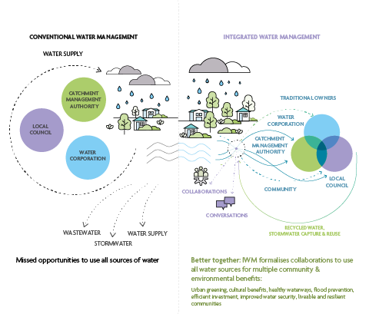
Figure 1: How does IWM work? Conventional water management saw a more siloed approach to water management, with a single supply source and two discharge systems to move stormwater and wastewater away as quickly as possible, resulting in missed opportunities to use all sources of water. The IWM approach brings water managers together to plan and deliver new opportunities to provide broader benefits to the community. Listening to and consulting with Victorian communities about how they want water managed is critical to informing IWM decision making. Communities are directly consulted on IWM Plans and through existing Catchment Management Authority, Water Corporation and Local Government strategies.

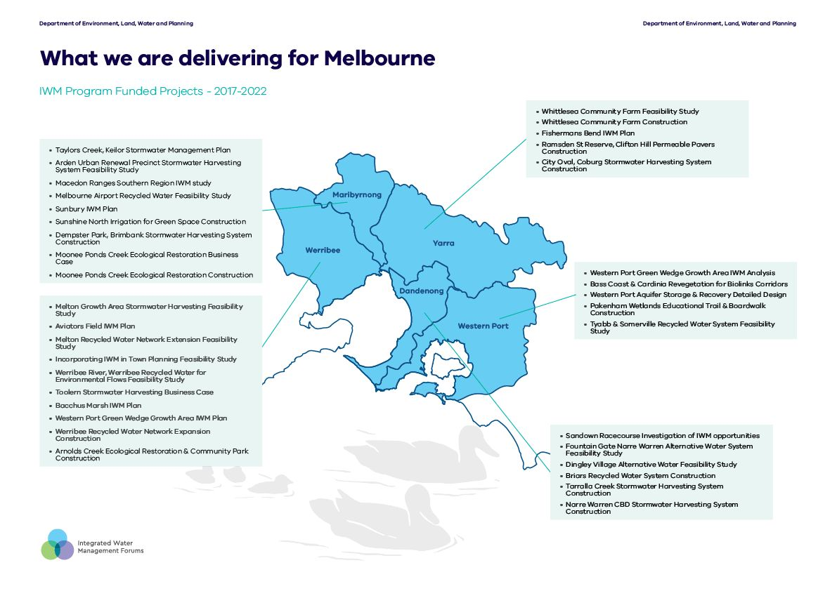

What we are delivering for Melbourne

IWM Program Funded Projects - 2017-2022

Werribee IWM Forum area
- Taylors Creek, Keilor Stormwater Management Plan
- Arden Urban Renewal Precinct Stormwater Harvesting System Feasibility Study
- Macedon Ranges Southern Region IWM study
- Melbourne Airport Recycled Water Feasibility Study
- Sunbury IWM Plan
- Sunshine North Irrigation for Green Space Construction
- Dempster Park, Brimbank Stormwater Harvesting System Construction
- Moonee Ponds Creek Ecological Restoration Business Case
- Moonee Ponds Creek Ecological Restoration Construction

Maribyrnong IWM Forum area
- Melton Growth Area Stormwater Harvesting Feasibility Study
- Aviators Field IWM Plan
- Melton Recycled Water Network Extension Feasibility Study
- Incorporating IWM in Town Planning Feasibility Study
- Werribee River, Werribee Recycled Water for Environmental Flows Feasibility Study
- Toolern Stormwater Harvesting Business Case
- Bacchus Marsh IWM Plan
- Western Port Green Wedge Growth Area IWM Plan
- Werribee Recycled Water Network Expansion Construction
- Arnolds Creek Ecological Restoration & Community Park Construction

Yarra IWM Forum area
- Whittlesea Community Farm Feasibility Study
- Whittlesea Community Farm Construction
- Fishermans Bend IWM Plan
- Ramsden St Reserve, Clifton Hill Permeable Pavers Construction
- City Oval, Coburg Stormwater Harvesting System Construction

Western Port IWM Forum area
- Western Port Green Wedge Growth Area IWM Analysis
- Bass Coast & Cardinia Revegetation for Biolinks Corridors
- Western Port Aquifer Storage & Recovery Detailed Design
- Pakenham Wetlands Educational Trail & Boardwalk Construction
- Tyabb & Somerville Recycled Water System Feasibility Study

Dandenong IWM Forum area
- Sandown Racecourse Investigation of IWM opportunities
- Fountain Gate Narre Warren Alternative Water System Feasibility Study
- Dingley Village Alternative Water Feasibility Study
- Briars Recycled Water System Construction
- Tarralla Creek Stormwater Harvesting System Construction
- Narre Warren CBD Stormwater Harvesting System Construction

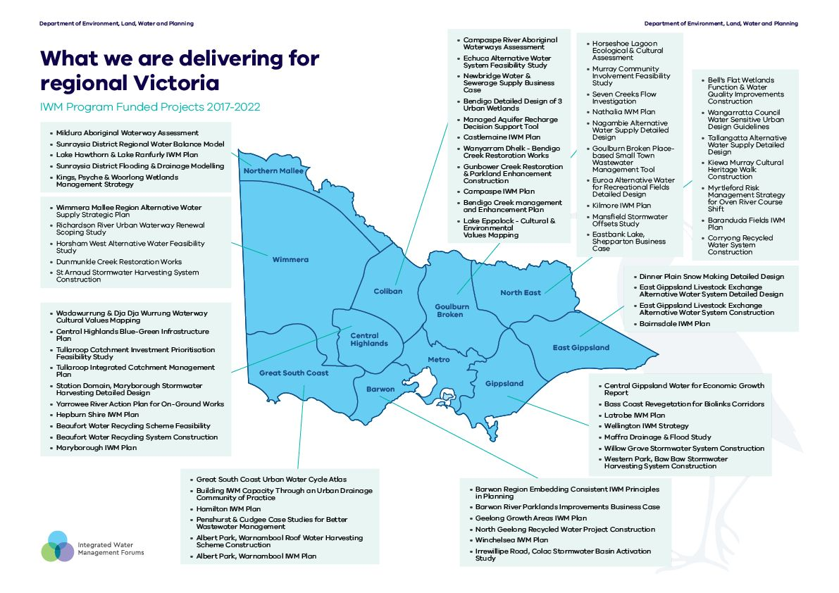

What we are delivering for Regional Victoria

IWM Program Funded Projects - 2017-2022

Northern Mallee IWM Forum area
- Mildura Aboriginal Waterway Assessment
- Sunraysia District Regional Water Balance Model
- Lake Hawthorn & Lake Ranfurly IWM Plan
- Sunraysia District Flooding & Drainage Modelling
- Kings, Psyche & Woorlong Wetlands Management Strategy

Wimmera IWM Forum area
- Wadawurrung & Dja Dja Wurrung Waterway Cultural Values Mapping
- Central Highlands Blue-Green Infrastructure Plan
- Tullaroop Catchment Investment Prioritisation Feasibility Study
- Tullaroop Integrated Catchment Management Plan
- Station Domain, Maryborough Stormwater Harvesting Detailed Design
- Yarrowee River Action Plan for On-Ground Works
- Hepburn Shire IWM Plan
- Beaufort Water Recycling Scheme Feasibility
- Beaufort Water Recycling System Construction
- Maryborough IWM Plan

Great South Coast IWM Forum area
- Great South Coast Urban Water Cycle Atlas
- Building IWM Capacity Through an Urban Drainage Community of Practice
- Hamilton IWM Plan
- Penshurst & Cudgee Case Studies for Better Wastewater Management
- Albert Park, Warnambool Roof Water Harvesting Scheme Construction
- Albert Park, Warnambool IWM Plan

Coliban IWM Forum area
- Campaspe River Aboriginal Waterways Assessment
- Echuca Alternative Water System Feasibility Study
- Newbridge Water & Sewerage Supply Business Case
- Bendigo Detailed Design of 3 Urban Wetlands
- Managed Aquifer Recharge Decision Support Tool
- Castlemaine IWM Plan
- Wanyarram Dhelk - Bendigo Creek Restoration Works
- Gunbower Creek Restoration & Parkland Enhancement Construction
- Campaspe IWM Plan
- Bendigo Creek management and Enhancement Plan
- Lake Eppalock - Cultural & Environmental Values Mapping

Goulburn Broken IWM Forum area
- Horseshoe Lagoon Ecological & Cultural Assessment
- Murray Community Involvement Feasibility Study
- Seven Creeks Flow Investigation
- Nathalia IWM Plan
- Nagambie Alternative Water Supply Detailed Design
- Goulburn Broken Place-based Small Town Wastewater Management Tool
- Euroa Alternative Water for Recreational Fields Detailed Design
- Kilmore IWM Plan
- Mansfield Stormwater Offsets Study
- Eastbank Lake, Shepparton Business Case

North East IWM Forum area
- Horseshoe Lagoon Ecological & Cultural Assessment
- Murray Community Involvement Feasibility Study
- Seven Creeks Flow Investigation
- Nathalia IWM Plan
- Nagambie Alternative Water Supply Detailed Design
- Goulburn Broken Place-based Small Town Wastewater Management Tool
- Euroa Alternative Water for Recreational Fields Detailed Design
- Kilmore IWM Plan
- Mansfield Stormwater Offsets Study
- Eastbank Lake, Shepparton Business Case

East Gippsland IWM Forum area
- Dinner Plain Snow Making Detailed Design
- East Gippsland Livestock Exchange Alternative Water System Detailed Design
- East Gippsland Livestock Exchange Alternative Water System Construction
- Bairnsdale IWM Plan

Gippsland IWM Forum area
- Dinner Plain Snow Making Detailed Design
- East Gippsland Livestock Exchange Alternative Water System Detailed Design
- East Gippsland Livestock Exchange Alternative Water System Construction
- Bairnsdale IWM Plan

Barwon IWM Forum area
- Dinner Plain Snow Making Detailed Design
- East Gippsland Livestock Exchange Alternative Water System Detailed Design
- East Gippsland Livestock Exchange Alternative Water System Construction
- Bairnsdale IWM Plan

What we are delivering - planning and policy

Enabling collaboration
The Victorian Government, in collaboration with Traditional Owners, water corporations, catchment management authorities and local government has established 15 IWM forums across Victoria. This brings over 100 organisations together to identify, prioritise and oversee the implementation of local and regional collaborative water opportunities.
250 IWM opportunities have been identified and Strategic Direction Statements have been developed by the IWM Forums.

Updating policy to make IWM easier
IWM is a relatively new concept, and many existing policies and frameworks – which were developed over time to support conventional water management approaches - need adapting. We have made progress on removing barriers to IWM, including:
- in October 2018 reforms to the Victoria Planning Provisions expanded stormwater management to commercial subdivisions and developments, industrial subdivisions and developments, public use developments and residential multi-dwelling developments; in addition, a new IWM clause was added to the Planning Policy Framework to embed IWM objectives and strategies into urban land-use planning
- in 2021 we streamlined and clarified the EPA guidance for recycled water use
- in 2020 we reviewed the economic regulatory framework and the role of pricing in enabling recycled water schemes
- in 2021 we incorporated an IWM approach into precinct planning for new developments and strategic planning for strategic agricultural land in peri-urban areas.
"The wealth of knowledge and experience that our Forum Partners bring to water planning and management will ensure that our catchment is protected and enhanced for future generations to succeed and thrive as we have.” - Shaun Cox, Chair Dandenong Region Integrated Water Management Forum

Supporting regional planning for a local context
The first step to successful and sustainable change is a good plan. Since Victorian communities vary greatly in their needs, resources and opportunities, there is no ‘one-size-fits-all’ IWM Plan. Solutions need be tailored to local contexts. As such, we’ve funded 68 place-based feasibility studies that identify and assess the viability of IWM opportunities throughout the state including:

Assessing City-Wide Alternative Water Network Opportunities (ACAWN)
explored and assessed the high-level economic feasibility of strategic options for large scale supply networks to expand the use of stormwater and recycled water across the Greater Melbourne region over the next 50 years.

Catchment Scale IWM Plans
these plans align with the 5 major water catchments of Metropolitan Melbourne and reflect rigorous technical analysis to determine performance targets for IWM Forum Partners to adopt at their organisations. The plans will guide organisational decision-making and enable the Forums to assess their joint progress towards the vision for each Catchment, and to demonstrate measurable progress towards liveability, resilience and related IWM outcomes to their communities.

Strategic Direction Statements
capture the regional context, shared vision and water-related outcomes for each of the Forum areas across regional Victoria. Each Strategic Directions Statement includes a list of integrated water management opportunities collaboratively developed by the Forum to bring local community views, values and priorities into practice through integrated water management.

Port Phillip Bay and Western Port (PPB-WP) Source Catchment Model
simulated the flow of water and loads of nitrogen, phosphorous and sediment exported from the Port Phillip Bay and Western Port catchments, an area that spans 13,000 square kilometres across the Greater Metropolitan Melbourne region. It enables us to investigate the impact that climate change and population growth has on Port Phillip Bay, Western Port and the waterways within these catchments, and allows us to assess the effectiveness of current water and land management policies and interventions and better target integrated water management projects.

Regional Urban Water Balance Project
20 representative towns across regional Victoria have calculated current annual volumes of rainfall, evapotranspiration, drinking water use, stormwater and recycled water generated, as well as waterway pollutants, and forecast these out to 2050. This has created a better understanding of stormwater’s contribution to the overall water resource and pollutant balances of catchments that are predominantly rural. This work will help us understand integrated water management opportunities, and plan for fit-for-purpose use of stormwater in regional urban centres.
"You’ve suddenly got access to a whole network of programs and projects. These are on the ground, these are projects for communities and can quite often be retrofitted to other municipalities and other towns." - Lyall Bond, Manager Environment & Emergency Corangamite Shire, Great South Coast Region Integrated Water Management Forum Member

What we are delivering - investment, tools and resources

Contributing investment & support
The Victorian Government has provided $22.4 million in funding for 106 priority projects across the state (see pages 6-9), including for strategic planning (e.g. investigations, business cases, and detailed design) and for construction. This includes funding in 2020 from the Victorian Government’s Building Works Stimulus Package. Nine IWM projects are being delivered as part of the state’s economic recovery plan, providing jobs and growth as well as community and environmental outcomes.
In addition, the IWM Program has attracted $60.3 million in Commonwealth investment for planning and construction of IWM projects in Victoria.
This is combined with more than $19.7 million in investment from IWM forum member organisations.

Developing tools and resources
We have worked with experts and industry bodies to produce and share numerous guidelines, tools and other resources for upskilling organisations to plan and deliver IWM. Some examples include:

Preliminary Project Assessment Method
guides the shortlisting IWM project opportunities, brings together lessons and data from previous IWM strategies, and provides a methodology framework to aid shortlisting in a time-effective yet robust manner.

Cost Allocation Framework
guides the cost allocation of projects through provision of principles to enable decisionmaking on funding arrangements for projects that deliver multiple benefits and have multiple beneficiaries.

Small Town Wastewater Management Tool
enables quick and efficient identification of preferred wastewater management solutions (including technical and funding solutions) to assist towns in managing the impacts of on-site ownermanaged septic tank systems and implementing alternative domestic wastewater management schemes.

The Knowledge Hub
facilitates fast and effective sharing of information and ideas by regional IWM partners via an online platform. This contributes to building and maintaining regional IWM expertise.
"It is clear that 5 years on DELWP’s IWM program is much more than a program or series of projects, it is an innovation that has transformed the way we collaborate across organisational boundaries to deliver IWM outcomes for communities." - Gillian Sparkes, AM, Commissioner for Environmental Sustainability Victoria, Western Port IWM Forum Chair

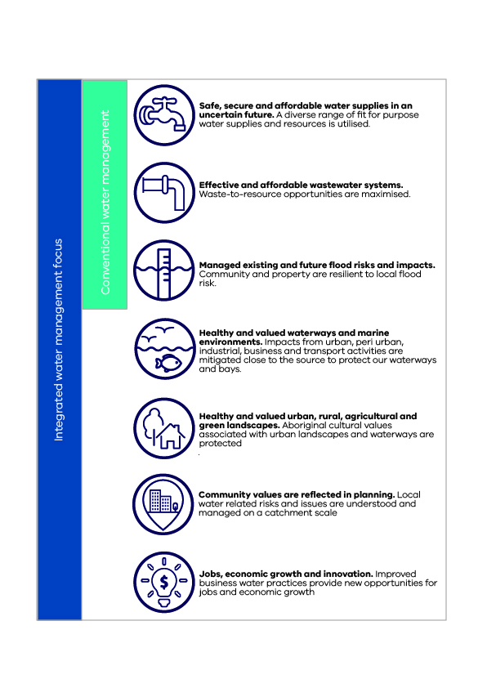
Figure 2 the seven areas of focus of Integrated Water Management

What we are delivering – construction

Since 2018 the IWM grant program has launched more than 27 construction projects state-wide that will improve our water security, enhance waterway and landscape health and build greater community connections to the environment

Finding alternative water sources & increasing our drought tolerance
Construction is underway for 15 alternative water projects across the state. Each project has been designed to fit its unique geological context, using available local resources to meet the needs of local communities. This includes:
- 6 stormwater harvesting schemes that will generate an estimated 106 million litres of alternative water every year
- Expanding a roof water harvesting scheme in Albert Park, Warnambool that will capture rainwater from the roofs of major buildings in the precinct for treatment and reuse
- 8 recycled water schemes that will keep our urban spaces green and healthy

Protecting and enhancing our native habitats

IWM projects are revegetating, re-naturalising and enhancing waterways in cities and towns throughout Victoria. These works include the ecological restoration and revegetation of over 2.8kms of creekline, the ecological restoration of wetlands in Croydon and Yackandandah, the creation of new wetlands in Narre Warren and Gunbower, and the extension of biolink corridors throughout Cardinia through the revegetation of over 23-hectares of land. These works not only provide important habitat to native flora and fauna, but also improve water quality and open up green spaces for urban communities to enjoy.

Greening and cooling our cities and towns

Gardens, parks and wetlands play a vital role in reducing the urban heat island effect and keeping our urban spaces cool. In Sunshine, a traditionally hot area of Melbourne, IWM projects are extending Dempster park with a 450sqm rain garden and creating a 5-hectare irrigated ‘cool zone’ in the open space adjoining Upper Stony Creek Reserve.

Creating spaces for community to connect and learn

Community is at the heart of IWM. IWM projects reflect community values because they are designed by stakeholders within the local community and in consideration of the local communities needs and resources.
In Gunbower, the Campaspe Shire Council are leading a project to upgrade Gunbower Lions Park. In addition to ecological restoration works along Gunbower Creek, they’re installing a natural playpark, a footpath network and a canoe launching pad.
In Pakenham, the ‘Wetland Wonders’ IWM project installed three educational boardwalk trails through the Deep Creek Wetlands.
In Whittlesea, a demonstration community farm will provide training opportunities in sustainable farming practices. The produce will be donated to the local emergency relief network for distribution to vulnerable communities.

"We all know that water is an essential ingredient for developing resilient and liveable suburbs in the face of climate change, but the optimum mix of water system solutions involves a range of projects at different scales with different water sources. This is the responsibility of many players including state agencies, local government, water corporations, Traditional Owners, the broader community and the private sector. The IWM Forums are seeing these various players collaborating and co-designing sustainable solutions to these challenges - it is a genuinely transformational process which would not be possible without DELWP's support at both a policy and operational level." - Rob Skinner AM, Convenor of Integrated Water Management Forum Chairs, Chair Werribee Region Integrated Water Management Forum

Case Studies

Reimagining Arnolds Creek, Melton West
Many of Melbourne's creeks pose significant environmental and safety risks due to regular flooding events. These risks have traditionally been managed with concrete drainage channels. This project 'reimagined' a bland concrete corridor of Arnolds Creek, in Melton West, as a space that could provide multiple environmental and community benefits whilst continuing to meet vital drainage requirements.
The project has collaboratively planned and delivered an open space that has been designed by the community, for the community. Major changes to the area included:
Removing 1.4 km of concrete channel and replacing it with more natural materials
Planting extensive trees, grasses and other native plants to provide habitat and wildlife corridors
Placing stepping stones, benches, tables and an arbour to allow the community to gather, enjoy the space and reconnect with nature
Together with a broader program of creek reimagining projects led by Melbourne Water, this project was the winner of the 2021 Australian Institute of Landscape Architects Victoria Award of Excellence for Infrastructure. The Arnolds Creek also a finalist for the Infrastructure Innovation Award (metro) in the Australian Water Association’s Victorian Water Awards (final winner yet to be confirmed). The space is now open to the public and providing multiple social and environmental benefits.
This project was funded by Melbourne Water ($7,300,000), Victorian Government's IWM Program ($500,000) & Melton Council ($420,000).

Greening Sporting Reserves in Baw Baw
Located in Warragul, the Western Park Ovals are an important sporting events venue for the Baw Baw shire. The ovals were irrigated with 600,000 litres of drinking water every week, and this was expected to increase to 900,000 litres as our climate becomes dryer and hotter. This placed a strain on the Shire’s water supply, which is largely drawn from the Tarago river. In the event of drought, the community may have had to make the tough decision to cease maintaining the ovals in order to conserve their water supplies.
In discussing this issue, Baw Baw Shire Council, Gippsland CMA and Gippsland Water identified a potential new solution to meet the water demands at the Western Park Ovals. Adjacent to the ovals is a 2.5-hectare wetland that captures and treats stormwater runoff from upstream residential developments before discharging it to Hazel Creek.
The group developed a plan to divert a portion of this stormwater toward irrigating the sporting oval. The project involves the installation of an offtake pump station, an inline sediment filter, a UV filtration system, and a 600,000 litres underground storage tank.
Once complete, the project will save 20 million litres of drinking water every year (that's about half a million four-minute showers!), decrease pollution of Hazel Creek by reducing stormwater input and drought-proof a valuable community space.
Funded by the Victorian Government's IWM Program ($425,000), Baw Baw Shire ($195,000) & Gippsland Water ($10,090).

Whittlesea Community Farm
The Whittlesea Community Farm is an innovative project that will use recycled water to grow food and native plants and provide education and training opportunities on the northern outskirts of Melbourne.
The collaborative project, undertaken by Yarra Valley Water (YVW), the City of Whittlesea, local not-for-profit group Whittlesea Community Connections and Melbourne Polytechnic, involves establishing a demonstration farming enterprise around YVW’s Aurora recycled water treatment plant. The farm will use recycled water for a wide range of farming activities at the site, including greenhouse plant nurseries for native plants and vegetable seedlings, in-ground horticulture, native grassland seed production, cattle grazing, crop trials and beekeeping.
Some of these activities will generate income for the farm, while others will serve predominantly as demonstration activities for educational purposes in the short term, and may be expanded to commercial scale at a later stage. The farm will provide education and training for the agriculture and horticulture industry in Melbourne, as well as local employment. Food from the farm will also be distributed into the local emergency relief network via the Whittlesea Food Collective.
Design of the facility has been developed in consultation with representatives from Wurundjeri Woi wurrung, the Traditional Custodians of the land, to ensure that culturally sensitive and biologically significant areas will be protected and enhanced. The project vision is of a vibrant food hub that provides a place for the community to connect, learn and prosper.
This project is funded by the Victorian Government's IWM Program ($1,500,000), Yarra Valley Water, City of Whittlesea, Melbourne Polytechnic and Whittlsea Community Connections ($900,000). In addition, key consultants, contractors and suppliers are providing discounted services to support the project.

Wanyarram Dhelk, Bendigo Creek Restoration
‘Wanyarram Dhelk’ means ‘Good Waterhole’ in Djaara language. Led by the Djandak (Dja Dja Wurrung Enterprise), the Wanyarram Dhelk project was a collaborative effort to improve the health of Bendigo Creek. Djandak used traditional ecological knowledge, combined with contemporary design and technology, to restore a section of the creek to what it would have been prior to European intervention.
A series of ponds were constructed along a section of the creek, weeds and invasive plant species were removed and native vegetation was re-introduced. The layout was carefully designed so that stormwater runoff was channelled through the ponds and plant life, which acted as a filtering system for the water, removing nutrients and sediments. In addition to improving the water quality, this project had a number of other environmental & social benefits:
Improved habitat for birds, frogs and the insects they feed on
The reintroduction of culturally significant food and fibre plants back on to Country and the use of stormwater to grow these plants
A cooling effect on the immediate surrounds, and a high-quality natural environment for the community to enjoy
Increased community awareness of Dja Dja Wurrung knowledge and culture
Increased capacity of the Dja Dja Wurrung people to lead environmental protection and enhancement activities on Country.
This project was funded by the Victorian Government through both the IWM and Waterway Health Programs ($500,000).

Central Highlands Green-Blue Infrastructure Plan
In 2019 the Golden Plains Shire Council, in partnership with three other local councils (Pyrenees, Moorabool and Central Goldfields) and Central Highlands Water, led a project to develop the Central Highlands Green-Blue Infrastructure Plan.
Green-blue infrastructure (GBI) are the built and natural assets of an urban environment that use and manage water (e.g. nature strips, trees, stormwater drains). GBI can help urban environments make the most of stormwater. Although regional councils across Victoria recognise the importance of GBI in an increasingly dry climate, they often face resource constraints that make it difficult to access the knowledge and skills required to incorporate GBI into town planning.
The Central Highlands GBI Plan helps to address this issue in the region. Developed through a series of engagement-based workshops, the plan contains three key elements:
A guide for Council staff to help consider GBI principles in the planning, design and delivery of new, modified or renovated urban infrastructure
A catalogue of references, guides, tools and websites to help improve awareness, knowledge and skills in GBI across Councils
A set of recommended next steps including the identification of specific GBI project opportunities in the region.
Utilising this tool, the Central Highlands IWM Forum are now working to implement some of these recommendations.
This project was funded by the Victorian Government's IWM Program ($20,000), & the shire councils of Golden Plains, Moorabool, Central Goldfields & Pyrenees ($22,500)

Recycled Water for the Bellarine Peninsula
Recycled Water for Bellarine will deliver certainty for local farmers and businesses, with a guaranteed high-quality water supply irrespective of seasonal conditions.
The innovative project involves the installation of an ultra-filtration and reverse osmosis plant to produce fit-for-purpose recycled water at a significantly lower salinity than the existing high salinity Class C water. This will improve water quality, allowing it to be used for a wider range of agricultural purposes.
Ultimately the upgrade will supply 450 million litres of recycled water per year to new and existing agricultural and horticultural customers, nearly doubling the amount of recycled water used on the Bellarine.
The project will secure the future of key local industries and create dozens of local jobs, while preserving Bellarine Peninsula’s unique landscape and reduce reliance on drinking water for agriculture.
The upgrade will save more drinking water for Barwon Water customers and allow the Portarlington Plant to reuse 100 per cent of its recycled water and presents opportunities for more farms and businesses to connect to this valuable resource.
This project is funded by the Commonwealth’s National Water Grid Fund ($5.53 million), Barwon Water ($3.56 million) & DELWP ($1.97 million).

Western Irrigation Network
The Western Irrigation Network (WIN) is a $116 million project jointly funded by the Commonwealth’s National Water Grid Fund, Western Water and the private agribusinesses who will become the network’s foundation customers.
The network will connect dryland farmers in the Parwan-Balliang area, near Bacchus Marsh, with a guaranteed supply of Class C recycled water suitable for irrigation farming by mid-2022. Although this region is rich in high quality soils, the productive potential of the land has not been realised due to the lack of reliable rainwater. This problem is predicted to worsen with climate change. Supplying the region with a reliable source of water for irrigation will enable farmers to increase both the variety and quantity of food grown.
The project involves the construction of 59kms of pipeline, three high-capacity pump stations and 3.3 GL of storage tanks. The scheme will initially supply 1.7 billion litres per year, increasing as irrigators expand and adapt. By 2050 the scheme could supply up to 18.3 billion litres each year and irrigate up to 4,500 hectares of high-quality land.
In addition to sustainably increasing the growing capacity of Victoria's agricultural land, the project will also help to manage the increasing volumes of wastewater — particularly in the Melton, Sunbury and Bacchus Marsh areas — and reduce discharges into the environment. At the same time, WIN has potential to transform farms currently dependent on unreliable rainfall by connecting them to a year-round guaranteed water supply.
This project is funded by the Victorian Government ($65.6 million), the Commonwealth's National Water Grid Fund ($48.1 million) and other project partners ($2.6 million), and is delivered in partnership with Greater Western Water and local farmers.

Drought proofing Cranbourne Royal Botanic Gardens
This IWM project has supplied high-quality recycled water to the Royal Botanic Gardens Cranbourne to irrigate the award-winning Australian garden and plant nursery.
This project delivers water from Melbourne’s Eastern Treatment Plant via a 1-kilometre pipeline to a new water treatment plant at Royal Botanic Gardens Cranbourne, which further cleans the water of salts and nutrients to make it suitable for long-term irrigation of Australian plants.
This pipeline will save 35 million litres − or the equivalent of 14 Olympic-sized swimming pools − of potable water per year. The completed works allow Royal Botanic Gardens Cranbourne to adopt sustainable water management practices to better respond to climate-change-related rainfall and temperature changes.

The project began delivering recycled water to the Australian Garden in February 2022 and is now helping to grow more than 100,000 plants representing 1900 different species, including 400 rare or threatened species and those from the Victorian bushfire recovery programme.
Royal Botanic Gardens Cranbourne is one of Victoria’s premier eco-tourism destinations attracting interstate and overseas visitors, with more than 1.5 million people visiting the gardens last year. The Victorian Government funded the $3.25 million project in addition to IWM Program funding. It demonstrates how the IWM approach to make use of all sources of water is now being adopted more broadly in Victoria.
This project was funded by DELWP ($3.25 million).

Recent Progress
Water is central to every community, powering our industries and economy, improving our quality of life, and nurturing our natural environment.
Over the long term, climate change will mean more extreme climatic events, less rainfall, and potentially 50 per cent reduction in streamflow by 2065. Victoria’s population will almost double by 2051 placing further demand on scarce water resources. Our challenge is to do more with less water. Integrated water management will help us meet our water needs and build cooler, greener and more liveable communities.
Developing the Catchment Scale IWM Action Plans - the Metropolitan IWM Forums are developing an agreed list of priority actions that will help each Forum progress towards their catchment scale IWM targets and support Forum organisations to target their resources to where it can have the greatest impact.
Delivery of a $14.1 million grant program – This grant program is well underway and will support the co-delivery of additional IWM projects throughout the state. In a first for the IWM program, a dedicated Traditional Owner funding stream is on offer to support self-determination and ensure that Traditional Owner values and aspirations are represented in water management.
Funding regional IWM Officers - The Victorian Government is co-funding regional IWM Officers to overcome resourcing constraints and support the implementation of IWM practices and projects in the regions. The purpose of these regional IWM officers will be to facilitate collaboration between Forum organisations and help identify place-based opportunities to implement and embed IWM in their regions.
Implementing agreed actions from the audit of recycled water policy and programs – In 2021 the Victorian Auditor General's Office examined if efforts to increase recycled water use have been effective and if barriers to increasing recycled water use have been identified and addressed, with a focus on the Barwon region. It found that the IWM Forums have improved understanding of the barriers that influence recycled water use across Victoria, and the audited organisations are actively engaging with the community to understand risks and opportunities for recycled water and also working together to identify and deliver water recycling projects. Agreed actions to better share knowledge and educate the community on recycled water and the outcomes of the IWM program will be implemented in 2022-23.
Central and Gippsland Region Sustainable Water Strategy - The Victorian Government is working closely with the water sector, Traditional Owner groups and the community to create a long-term plan that meets and balances the water needs of the Central and Gippsland Region. The IWM program will support delivery of policy commitments in the final Strategy (due in 2022). The program will play a key role in making better use of all sources of water by increasing the use of recycled water, stormwater, rainwater captured in tanks, to reduce reliance on river water and groundwater. In the Metro region alone, the IWM Forums are seeking to deliver recycled water, stormwater and rainwater projects that save the use of up to 200 billion litres of drinking water per year by 2070. Further opportunities to supply peri-urban agriculture with climate resilient alternative water sources are also being investigated.

Acknowledgement
We acknowledge and respect Victorian Traditional Owners as the original custodians of Victoria's land and waters, their unique ability to care for Country and deep spiritual connection to it.
We honour Elders past and present whose knowledge and wisdom has ensured the continuation of culture and traditional practices.
We are committed to genuinely partner, and meaningfully engage, with Victoria's Traditional Owners and Aboriginal communities to support the protection of Country, the maintenance of spiritual and cultural practices and their broader aspirations in the 21st century and beyond.

© The State of Victoria Department of Environment, Land, Water and Planning 2022
This work is licensed under a Creative Commons Attribution 4.0 International licence. You are free to re-use the work under that licence, on the condition that you credit the State of Victoria as author. The licence does not apply to any images, photographs or branding, including the Victorian Coat of Arms, the Victorian Government logo and the Department of Environment, Land, Water and Planning (DELWP) logo. To view a copy of this licence, visit creativecommons.org/licenses/by/4.0/
ISBN 978-1-76105-908-7

Disclaimer
This publication may be of assistance to you but the State of Victoria and its employees do not guarantee that the publication is without flaw of any kind or is wholly appropriate for your particular purposes and therefore disclaims all liability for any error, loss or other consequence which may arise from you relying on any information in this publication.

Accessibility
If you would like to receive this publication in an alternative format, please telephone the DELWP Customer Service Centre on 136 186, or email customer.service@delwp.vic.gov.au, or via the National Relay Service on 133 677, www.relayservice.com.au. This document is also available on the internet at www.delwp.vic.gov.au

