Guidelines for assessing the impact of climate change on water availability in Victoria
  - 2025
Supplementary Materials

Acknowledgements
DEECA acknowledges the contributions of a range of researchers and water industry participants, including:
- Water sector representatives who participated in the workshops that informed the development of the guidelines and provided valuable feedback on the draft version.
- Climate and hydrology researchers from the Bureau of Meteorology, Monash University and the University of Melbourne, who contributed a range of background material for the guidelines.
- Researchers from CSIRO, particularly Anjana Devanand and Zaved Khan, for developing the hydroclimate projections.
- Consultants from Hydrology and Risk Consulting, Streamology, and Patrick Russell, who contributed to the drafting of the guidelines.
- Various reviewers who provided valuable comments and suggestions for different components of the guidelines, including the Water Resilience and Science Team at Hunter Water, Francis Chiew from CSIRO, Murray Peel and Keirnan Fowler from the University of Melbourne.
Any questions on these guidelines should be directed to the Hydrology, Climate and Energy team, Water Resource Assessment Branch, Water Resource Division, Water & Catchments Group, Victorian Department of Energy, Environment and Climate Action. Email the Hydrology, Climate and Energy team at HCS.team@deeca.vic.gov.au
Acknowledgement to Country
We acknowledge and respect Victorian Traditional Owners as the original custodians of Victoria’s land and waters, their unique ability to care for Country and deep spiritual connection to it.
We honour Elders past and present whose knowledge and wisdom has ensured the continuation of culture and traditional practices.
DEECA is committed to genuinely partnering with Victorian Traditional Owners and Victoria’s Aboriginal community to progress their aspirations.
Copyright notice
© The State of Victoria Department of Energy, Environment and Climate Action, 2025.
Creative Commons
This work is licensed under a Creative Commons Attribution 4.0 International licence, visit the Creative Commons website (http://creativecommons.org/licenses/by/4.0/).
You are free to re-use the work under that licence, on the condition that you credit the State of Victoria as author. The licence does not apply to any images, photographs or branding, including the Victorian Coat of Arms, and the Victorian Government and Department logos.
ISBN 978-1-76176-666-4 (pdf/word/online)
Disclaimer
This publication may be of assistance to you but the State of Victoria and its employees do not guarantee that the publication is without flaw of any kind or is wholly appropriate for your particular purposes and therefore disclaims all liability for any error, loss or other consequence which may arise from you relying on any information in this publication.
Accessibility
To receive this document in an alternative format, phone the Customer Service Centre on 136 186, email customer.service@delwp.vic.gov.au, or contact National Relay Service on 133 677. An accessible version is available at Water availability climate change guidelines (https://www.water.vic.gov.au/our-programs/climate-change-and-victorias-water-sector/climate-change-water-resources/water-availability-climate-change-guidelines).

Contents
1 Introduction 2
2 Hydroclimate projections for Victoria 2
2.1 Method used to develop hydroclimate projections 2
2.1.1 Estimating change signal in climate variables 3
2.1.2 Developing future daily climate series for rainfall‒runoff modelling 4
2.1.3 Rainfall‒runoff modelling to simulate historical and future runoff 4
2.2 Future hydroclimate projections 6
2.2.1 Hydroclimate projection dataset 6
2.2.2 Summary of hydroclimate projections 6
2.3 Robustness of the hydroclimate projections and limitations of the method used to develop the projections 9
2.3.1 The pattern scaling method used to estimate the change signal in climate variables 9
2.3.2 Uncertainty in hydroclimate projections 9
2.3.3 Hydrological non-stationarity 9
2.3.4 Hydrological impact modelling method 10
2.3.5 Interpretation of modelled historical and future runoff 10
2.4 Summary 10
3 Additional techniques for assessing climate change impact on water availability 12
3.1 Paleoclimate rainfall and streamflow reconstructions 14
3.2 Covariate analysis 15
3.3 Sensitivity testing and stress testing 16
3.4 Vulnerability assessment with decision scaling 17
3.5 Climate analogues 19
3.6 Storylines 20
3.7 Simpler water resource models for climate change impact assessments 21
4 Additional approaches to support adaptive planning and management 23
4.1 Pareto-front optimisation 24
4.2 Dynamic adaptive policy pathways 25
4.3 Adaptive planning and management 26
4.4 Real options and investing to reduce uncertainty 27
References 29

Introduction
This document provides supporting technical information for the Guidelines for Assessing Climate Change Impact on Water Availability in Victoria 2025 (the guidelines). It covers how hydroclimate projections for Victoria have been developed by the Commonwealth Scientific and Industrial Research Organisation (CSIRO), additional techniques for assessing climate change impact and approaches to support adaptive planning. A summary and attributes of the additional techniques and approaches have been provided to help practitioners consider their applications. The guidance provided here is general and may not be applicable in other contexts. Practitioners are encouraged to consider the basic principles of climate change impact assessment as outlined in the guidelines.

Hydroclimate projections for Victoria
Global average surface air temperature is projected to increase under different emissions scenarios (Figure 1). As a result of higher temperature, potential evapotranspiration (PET) will increase. Very heavy rainfall will become more intense because of the increase in moisture-holding capacity in a warmer atmosphere. There is large uncertainty in the change in future regional rainfall. For Victoria, and southern Australia generally, there are multiple lines of evidence indicating that cool-season rainfall will likely decline under climate change. These include observed trends in the past several decades, climate science understanding of changes in atmospheric and oceanic circulation patterns causing cool-season rainfall to decline in southern Australia, and very strong consensus between climate models projecting a drier cool season in southern Australia under climate change. The projected decline in cool-season rainfall (when most of the runoff in Victoria occurs) and projected increase in PET will lead to a decline in future runoff and water availability and more frequent and severe hydrological drought in Victoria (DEECA, 2025a).
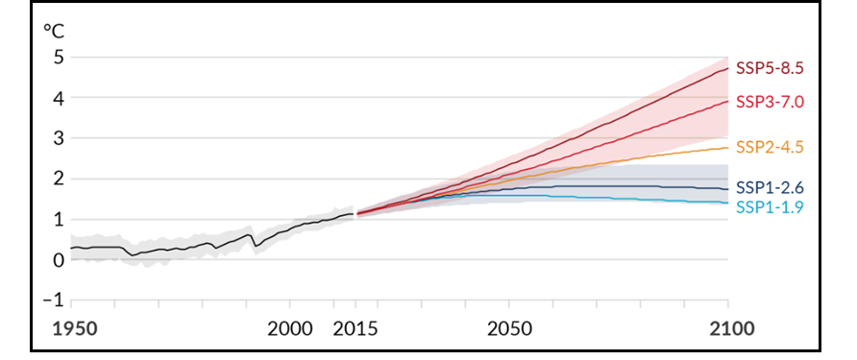
Figure 1: Projected increase in global average surface air temperature relative to 1850–1900 pre-industrial period for different shared socioeconomic pathways (SSPs) of emissions scenarios (adapted from IPCC, 2021). (SSP2-4.5 is a medium emissions scenario, SSP3-7.0 is a medium-high emissions scenario, SSP5-8.5 is a high emissions scenario.)

This chapter describes the method used to develop the hydroclimate projections and presents the projections for Victoria. The method used here is similar to that used in the Murray‒Darling Basin Sustainable Yields (MDBSY) project, which is described in detail in Chiew et al. (2025), including the merits and limitations of the method. The projections are developed for each of the ~10,000 0.05° (~5 km) grid cells across Victoria.

Method used to develop hydroclimate projections
There are three steps in the method to develop hydroclimate projections:
- estimating change signal in climate variables
- developing future daily climate time series for rainfall‒runoff modelling
- rainfall‒runoff modelling to simulate historical and future runoff.

Estimating change signal in climate variables
The raw climate projections data come from the Coupled Model Intercomparison Project phase 6 (CMIP6) global climate models (GCMs) (Eyring et al., 2016) used in the Intergovernmental Panel on Climate Change (IPCC) Sixth Assessment Report (IPCC, 2021). The first runs from all available CMIP6 GCMs for SSP2-4.5, SSP3-7.0 and SSP5-8.5 are used for the analysis here. The spatial resolutions of the different GCMs are different (generally more than 100 km) and their grids do not necessarily align, and for the analysis here, the GCM simulations are mapped across Victoria and analysed at 0.05° (~ 5 km) grid cells. Altogether 120 GCM simulations (41 from SSP-2.45, 37 from SSP-3.70 and 42 from SSP-5.85) are analysed.
The ‘pattern scaling’ method is used to estimate the change in the climate variable per degree of global average warming from 1990. This is illustrated in Figure 2 for an example 0.05° grid cell for annual rainfall from one of the 120 GCM simulations. The top panel shows the GCM simulation of annual rainfall. The middle panel shows the GCM simulation of global temperature. The annual values are plotted as the change or difference relative to the average value over 1976‒2005 (30-year period centred on 1990). The pattern scaling method is illustrated in the bottom panel, where the simulated/projected annual rainfall is plotted against the simulated/projected global temperature, and the linear slope (orange line) passing through the origin at 1990 is the estimated/projected change in mean annual rainfall per degree of global warming since 1990 from that GCM simulation for that grid cell.
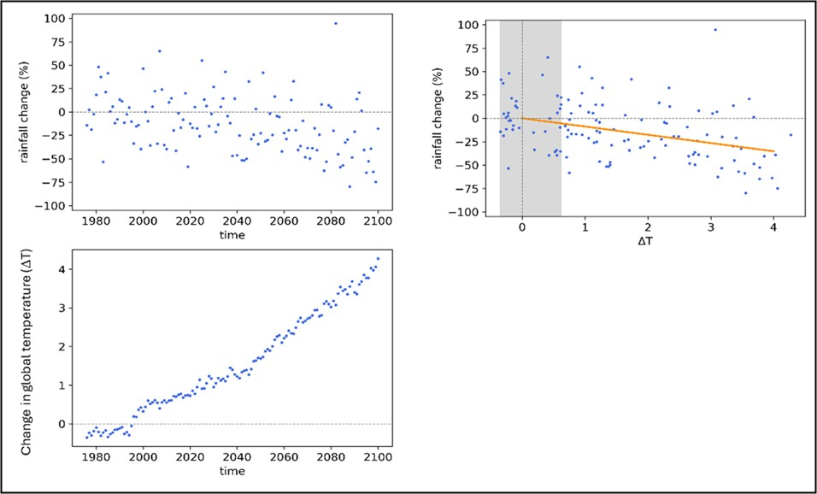
Figure 2: Illustration of the pattern scaling method for one GCM simulation for a 0.05° grid cell, with the slope of the orange line in the right panel indicating the percentage change in mean annual rainfall per degree of global average warming since 1990.

Analyses in MDBSY (Chiew et al., 2025; Devanand et al., 2025) indicate that projections from all the 120 simulations from the different SSPs, expressed as change in the climate variable per degree of global warming since 1990, can be considered together to provide 120 estimates of projected change in the climate variable. This results in 120 plausible projections for the climate variables analysed, expressed as change in the climate variable per degree of global warming, for each of the ~10,000 0.05° (~5 km) grid cells across Victoria.
The hydroclimate projections were developed to consider changes in the climate reference period from the year 1990 as adopted for the projections developed for the Murray‒Darling Basin Sustainable Yields (MDBSY) project. As the pattern scaling method uses more than 100 years of climate model data to develop the climate change signal, projections developed using the year 1990 or the year 2000 as the starting point would produce similar results. Changes relative to global warming level from the year 2000 have been adopted in the guidelines so they can be readily applied to the post-1975 climate reference period.
The climate variables analysed, and therefore the projections, are developed for the following:
- mean annual temperature, PET and rainfall
- mean cool-season (May–Oct) and warm-season (Nov–Apr) temperature, PET and rainfall
- mean summer (DJF), autumn (MAM), winter (JJA) and spring (SON) temperature, PET and rainfall
- very heavy daily rainfall (>P_{99.5} daily rainfall, i.e. daily rainfall that is exceeded 0.5% of the time or on average 1.8 times per year).
The pattern scaling expresses the change in the climate variable per degree of global warming since 1990. This can be scaled to provide projections for any global warming level associated with any emissions scenario and future time period (Figure 1). For the purpose of presentation throughout this chapter and the development of future climate and runoff, the projections are expressed as a change in the climate signal for 1.5°C global warming since 1990 (or ~2050 relative to 1990, see Figure 1).

Developing future daily climate series for rainfall‒runoff modelling
The rainfall‒runoff modelling is carried out using daily rainfall and PET data from 1975 to 2023. The post-1975 period has been recommended to be used as the climate reference period in the guidelines. The daily rainfall series for each of the ~10,000 0.05° (~5 km) grid cells across Victoria come from the SILO gridded daily climate series (SILO, 2024). Daily PET is calculated using Morton’s wet environmental evapotranspiration algorithm (Morton, 1983; Chiew & McMahon, 1991) and FAO24 net radiation algorithm (Allen et al., 1998), using the SILO daily data for temperature, relative humidity and solar radiation.
To reflect a future climate, daily climate data from the climate reference period (1975–2023) are scaled by the climate change signal developed as described in Chapter 2.1.1. There are 120 future daily climate series (corresponding to the projections from the 120 GCM simulations) for each of the ~10,000 0.05° grid cells across Victoria.
There are two steps in the scaling of rainfall. In the first step, all the daily rainfalls above P_{99.5} (rainfall that is exceeded 0.5% of the time, or on average 1.8 times per year) are scaled by the change signal in very heavy rainfall. In the second step, all other daily rainfalls are then scaled by seasonal factors such that the future rainfall series reflect the seasonal rainfall change signals. The PET series are scaled by the seasonal PET change signals. The method scales the data from the climate reference period to obtain a future daily climate timeseries that reflects the projected changes in seasonal rainfall and PET, and in very heavy daily rainfall.
Note temperature, PET or daily rainfall are not always available for each GCM simulation. When they are not available, the projected change from another GCM simulation with the closest projected change in temperature averaged across Victoria is used for PET. For very heavy daily rainfall above P_{99.5}, the projected change from another GCM with the closest projected change in annual rainfall averaged across Victoria is used.

Rainfall‒runoff modelling to simulate historical and future runoff
Daily runoff is modelled for each of the ~10,000 0.05° (~5 km) grid cells across Victoria, using the GR4J conceptual daily rainfall‒runoff model (Perrin et al., 2003). A regional calibration is used to determine the four parameter values in GR4J for each of the four regions across Victoria (Figure 3). The single set of parameter values (for each region) is then used to model historical and future runoff for all the 0.05° grid cells in each of the regions. The four regions are arbitrarily defined guided by cluster analysis of observed annual streamflow series, mean annual streamflow, and runoff coefficient in 127 catchments across Victoria.
The GR4J model is calibrated against 1997–2023 observed daily streamflow data from 127 catchments (39 in north-west Victoria, 15 in south-west Victoria, 37 in north-east Victoria, 36 in south-east Victoria; see Figure 3). The streamflow data come from the Bureau of Meteorology’s Hydrologic Reference Stations (HRS) (Zhang et al., 2016) and represent high-quality streamflow data from largely unregulated and unimpaired catchments.
In the regional calibration, a single set of parameter values is used to model runoff across each of the four regions, with the model calibrated to maximise the sum of NSE-bias (Viney et al., 2009) in all the catchments in each of the four regions. The Nash-Sutcliffe Efficiency (NSE) (Nash & Sutcliffe, 1970) minimises the sum of squares of the difference between modelled and observed daily streamflows, and the bias ensures that the difference between total modelled and observed streamflow is small. In the regional calibration, where the NSE-bias in a catchment is less than 0.2, it is set to 0.2. This is to avoid the regional calibration attempting to simulate streamflow in a couple of very poor-performing catchments (with very low or meaningless negative NSE values) at the expense of the large majority of the other catchments. In these poor-performing catchments, there may be issues with the climate inputs or streamflow data or the rainfall‒runoff model simply not being able to reproduce the observed streamflow.
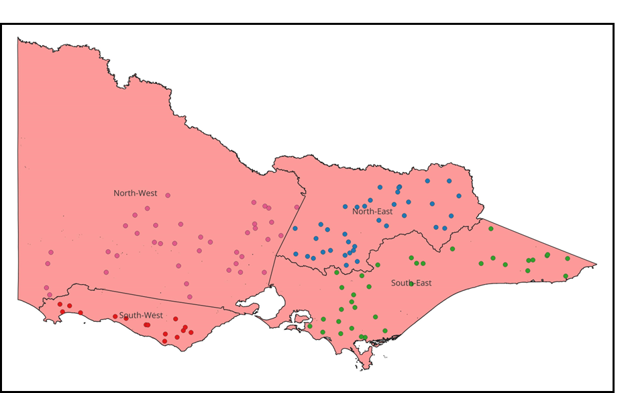
Figure 3: Location of the 127 HRS catchments and four hydrological modelling regions in Victoria.

The use of the same parameter values to model runoff across large regions with similar hydroclimates can potentially provide a more robust estimation of changes in future runoff across the region. Other methods that are commonly used to predict runoff in ungauged catchments, such as using parameter values from the nearest calibration catchment or from physically similar catchments, have also been explored (Zhang & Chiew, 2009; Bloschl et al., 2013), with the regional calibration showing similar or better calibration results.
The historical runoff is modelled using observed daily rainfall and PET from the post-1975 period. The future runoff is modelled using future rainfall and PET series as described in Chapter 2.1.2. These are modelled using the same GR4J parameter values calibrated against streamflow data from 1997–2023. The modelling therefore simulates runoff for the 1975–2023 climate reference period for catchment conditions over 1997–2023, and the future runoff from the scaled 1975–2023 climate data that reflect a future climate series (Chapter 2.1.2). A comparison between the modelled post-1975 period against modelled future period provides projected change in mean runoff or any runoff metric under a future climate relative to 1990.

Future hydroclimate projections

Hydroclimate projection dataset
The analysis of projections from the 120 CMIP6 GCM simulations and rainfall‒runoff modelling described in Chapter 2.1 produces change factors of hydroclimate variables under climate change for each of the ~10,000 0.05° (~5 km) grid cells across Victoria. The projected changes in hydroclimate data are relative to 1990, corresponding to the global average warming level since 1990. The hydroclimate projection datasets are available in the CSIRO Data Access Portal for the following:
- mean annual temperature, PET, rainfall and runoff
- mean cool-season (May–Oct) and warm-season (Nov–Apr) temperature, PET, rainfall and runoff
- mean summer (DJF), autumn (MAM), winter (JJA) and spring (SON) temperature, PET, rainfall and runoff
- very heavy daily rainfall (>P99.5 daily rainfall, i.e. daily rainfall that is exceeded 0.5% of the time or on average 1.8 times per year).
The changes in these variables in the dataset are provided for 1.5°C global average warming (~2050 relative to 1990). As described earlier, these change factors can be linearly scaled to reflect changes for any global warming level.
The data access portal provides the change factors informed by the 120 GCM simulations for the ~10,000 0.05° grid cells as well as for aggregations over the 29 river basins across Victoria. The median value and the 10th and 90th percentile values informed by the 120 GCM simulations/projections are also summarised in the data portal. The spatial aggregations are based on the volumetric values (i.e. rainfall or runoff volume across the river basin).
Note that the aggregation of the 10th or 90th percentile projections from smaller temporal scales (e.g. 10th percentile projections from each of the four seasons) will be more extreme than the direct 10th or 90th percentile projections at the annual scale. Likewise, the aggregation of the 10th and 90th percentile projections from all the grid cells within a river basin will be more extreme than the direct 10th or 90th percentile volumetric projections for the river basin.

Summary of hydroclimate projections
Projected changes in PET, rainfall and runoff across Victoria for 1.5°C increase in global warming relative to 1990 around 2050 are shown in Figure 4, Figure 5 and Figure 6, respectively. The range of projections is represented by the 10th, median and 90th percentile output from the 120 GCM simulations. Projections are derived for mean annual, cool-season and warm-season values.
There is strong agreement in PET projections across the 120 GCM simulations, with the 10th to 90th percentile projected increase in PET ranging from 3.5% to 6.0%. PET projections for the different seasons and across Victoria are relatively similar (Figure 4).
The GCM simulations indicate that very heavy rainfall will become more intense, with a median projection of daily rainfall above P99.5 (daily rainfall that is exceeded 0.5% of the time, or on average 1.8 days per year) increasing by about 5% and ranging (10th to 90th percentile) from 0 to 10% (not shown here).
The large majority of GCM simulations indicate that cool-season rainfall will decrease, with a median projection of a 4.6% decrease averaged across Victoria under 1.5°C global warming, with the 10th to 90th percentile projection ranging from +0.2% to -9.5% (middle row of Figure 5). There is less agreement in the projection of warm-season rainfall, with the 10th to 90th percentile projection ranging from +5.7% to -8.9% (bottom row of Figure 5). The spatial differences in the projections across Victoria are relatively small.
Runoff across Victoria is projected to decrease, driven by the reduction in cool-season rainfall (when most of the runoff in Victoria occurs) and increase in PET (Figure 6). Averaged across Victoria, the median projection is for mean annual runoff (or water availability) to decrease by 14% under 1.5°C global warming, with the 10th to 90th percentile projection ranging from a decrease of 4% to a decrease of 26%. The range in the projection is slightly greater for the drier region in north-west Victoria.
The future and historical daily runoff series modelled by the rainfall‒runoff model can be analysed to estimate changes in any runoff characteristic (e.g. hydrological drought, low flow important for connectivity, high flow or inundation flow). For example, Figure 7 shows that under 1.5°C global average warming, a 3-year hydrological drought occurring on average once every 20 years in the climate reference period would now occur once every 16 years in the median projection and once every 12 years in the 90th percentile projection.
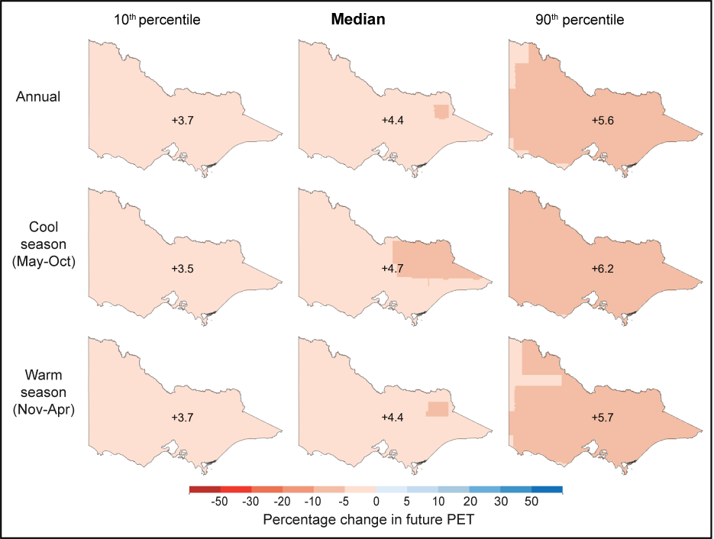
Figure 4: Projected change in mean annual, cool-season and warm-season PET across Victoria under 1.5°C global average warming (~2050 relative to 1990).

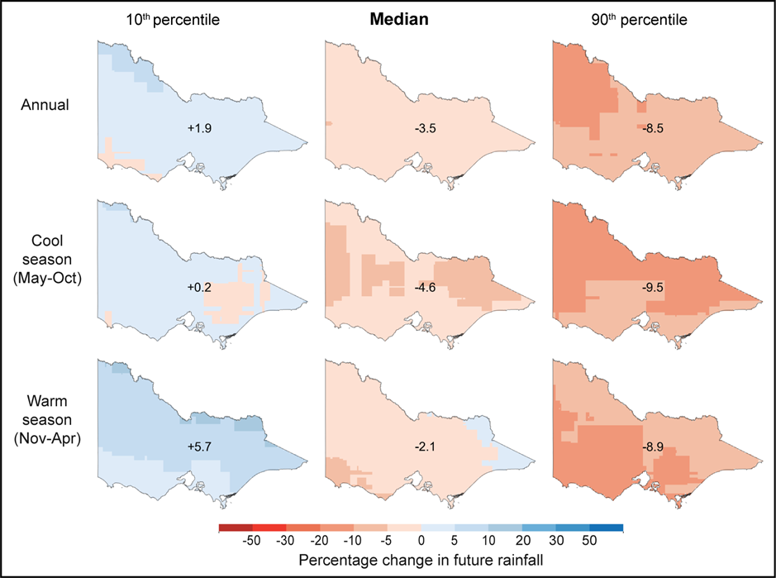
Figure 5: Projected change in mean annual, cool-season and warm-season rainfall across Victoria under 1.5°C global average warming (~2050 relative to 1990).

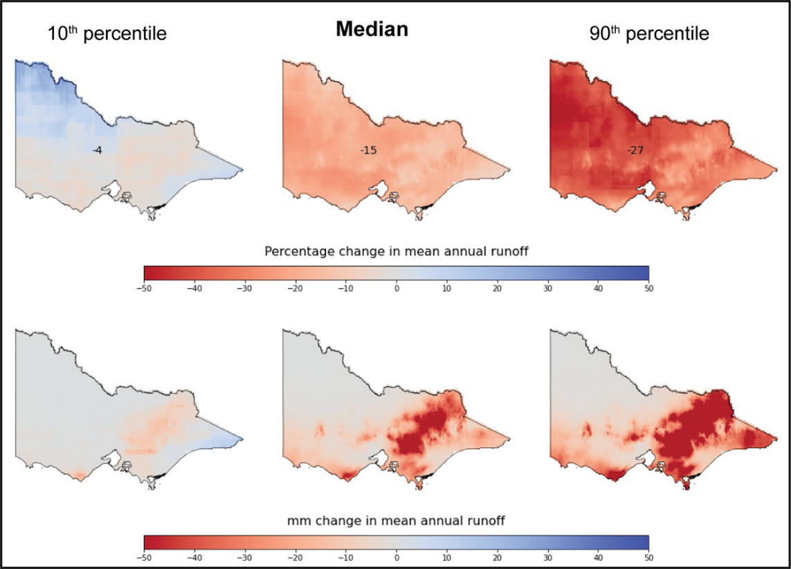
Figure 6: Projected change in mean annual runoff across Victoria under 1.5°C global average warming (~2050 relative to 1990).

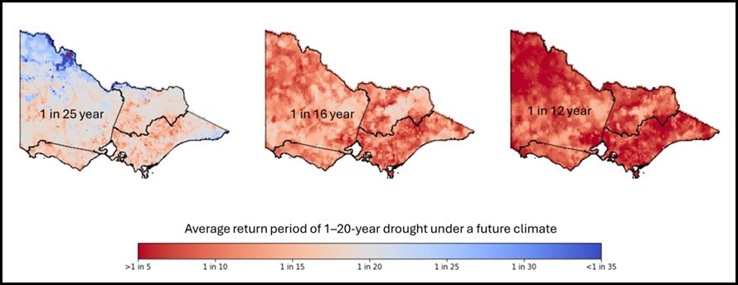
Figure 7: Projected frequency of a 1 in 20-year 3-year hydrological drought under 1.5°C global average warming (~2050 relative to 1990).

Robustness of the hydroclimate projections and limitations of the method used to develop the projections

The pattern scaling method used to estimate the change signal in climate variables
There are several appealing features in the pattern scaling method used to estimate the change signal in the climate variables. The pattern scaling method considers the trend in the climate variable (e.g. rainfall) over more than 100 years, rather than the traditional time slice method, which compares the rainfall over a future time window versus a historical period (e.g. Zheng et al., 2024). Any method used will reflect both the uncertainty in the climate change signal simulated by the different climate models and the internal climate variability or stochasticity arising from initial conditions in the climate models. By considering the rainfall trend over 100+ years, the pattern scaling method more robustly captures the range in the climate change signal compared with the time slice method, which inevitably also accounts for a large proportion of the internal climate variability, more so when a shorter time slice or window is used (Devanand et al., 2025). As a result, the range in the climate projections developed using the pattern scaling method is smaller than the range in the climate projections in the 2020 Victorian water availability guidelines (DEECA, 2020), which were developed using a time slice method.
The pattern scaling method easily enables the climate projections to be expressed as a change per degree of global warming. The analysis in MDBSY (Chiew et al., 2025; Devanand et al., 2025) indicates that the change signal per degree of global warming can then be linearly scaled to obtain projections for any global warming level. The analysis also shows that GCM simulations for the different emissions scenarios can be pooled together (120 GCM simulations are considered here) to estimate the distribution (median and range) in the future climate projections. The analysis also indicates that the runoff projections per degree of global warming can generally be linearly scaled to estimate the change in runoff for global warming levels up to 2.5°C since 1990.

Uncertainty in hydroclimate projections
The largest uncertainty in the runoff projection comes from the uncertainty in the rainfall projection. The differences in the runoff projections developed using different rainfall‒runoff models for changes in the climate inputs ‒ as also explored here with four rainfall‒runoff models (Chiew et al., 2025) and reported in many studies (e.g. Teng et al., 2012; Joseph et al., 2018; Hatterman et al., 2018) ‒ are relatively smaller compared with the range in the rainfall projections from the different GCMs.
The use of climate projections from a sub-set of ‘better performing’ GCMs, as well as from four higher-resolution dynamical downscaling or regional climate model (RCM) products in the Coordinated Regional Downscaling Experiment (CORDEX) (Grose et al., 2023), were also investigated. The results show that the median and range of projections for these are similar to those developed from the 120 GCM simulations in Chapter 2.2 (Chiew et al., 2025).

Hydrological non-stationarity
A major limitation in hydrological impact modelling is the use of the same model parameter values obtained through model calibration against historical data to model the future under climate change. The modelling therefore considers the changes in the climate inputs (climate non-stationarity) but not the potential changes in the climate‒runoff relationship or dominant hydrological processes (hydrological non-stationarity).
Practically all the catchments in Victoria exhibit non-stationarity in the rainfall‒runoff relationship, where less annual streamflow was generated during the 1997–2009 Millennium Drought for the same amount of rainfall compared with pre-drought conditions (Saft et al., 2015; DEECA, 2025a). The shift in hydrological response and recovery following the drought can be different in different catchments, and many catchments in Victoria, particularly in western Victoria, have not fully recovered from the Millennium Drought (Peterson et al., 2021).
There have been extensive studies in the Victorian Water and Climate Initiative (VicWaCI) and elsewhere attempting to understand the causality and to adapt models to account for hydrological non-stationarity (DEECA, 2025; Fowler et al. 2022b). However, this is a complex problem that has been identified as one of the 23 key research challenges by the international hydrological community (Bloschl et al., 2020), and research in this area continues. Existing modelling approaches, like the modelling adopted in these guidelines, tend to overestimate runoff during dry periods, and this will tend to lead to an underestimation of the reduction in future runoff under a drying climate (DEECA, 2025a). The use of the post-1997 period to calibrate the rainfall‒runoff model partly overcomes this problem.
By using the same parameter values to model runoff for both the climate reference period and the future, the model is also being extrapolated to predict a future under conditions not seen in the past, such as higher temperature, PET and atmospheric CO₂ concentration. There are conflicting views on how vegetation will respond to these changes, but their net impact on runoff in water-limited areas such as Victoria is likely to be relatively small (compared with uncertainty in future rainfall projections) and cannot yet be observed in global streamflow data (Wei et al., 2024).
Also not modelled in the guidelines are potential changes in future catchment conditions, such as the impact of farm dams (the reduction in total runoff volume may increase by up to 10%; Robertson et al., 2023), fires (the net impact on total runoff is likely to be relatively small; Lane et al., 2023; Robertson et al., 2024) and snow hydrology (higher temperature will impact the seasonality of alpine runoff but has relatively smaller impact on total runoff volume, particularly when aggregated over a large area).

Hydrological impact modelling method
The empirical scaling method used here (Section 2.1.2) assumes that the future daily rainfall sequence is the same (but with different daily values) as the historical rainfall sequence. Methods such as direct bias correction of climate model simulations can overcome this limitation but are likely to also introduce more uncertainties (Potter et al., 2020; Charles et al., 2020; Addor & Siebert, 2014). The empirical scaling method was adopted because (1) it is fit-for-purpose to assess climate change impact on runoff, (2) it provides consistent projections that are relatively easy to interpret and communicate, (3) it is simple and can be applied with future projections from all available and appropriate climate models to reflect a fuller range of uncertainty, and (4) it is commonly used for climate change impact assessment globally and is similar to methods used in previous and recent studies in this region (Chiew et al., 2009; Zheng et al., 2024).
Nevertheless, Chiew et al. (2022) compared runoff projections developed for south-east Australia using different hydrological impact modelling methods (different methods used to generate future climate series, different rainfall‒runoff models and model calibration) and climate projection data sources (Chapter 2.3.1) and concluded that they all indicate a hotter and drier future in south-east Australia with similar values and range in the runoff projections.

Interpretation of modelled historical and future runoff
Modelling experiments were carried out for calibration against post-1975 streamflow, as well as using a longer 1895–2023 climate reference period. It is interesting to note that the mean annual and seasonal runoff (and most other runoff characteristics) averaged over post-1975 are relatively similar to (or very slightly lower than) the averages over the longer 1895–2023 period. Modelling with parameter values from post-1997 calibration produced considerably lower runoff in north-west Victoria compared to modelling with post-1975 calibration (by less than 70%), and to a lesser extent in south-west Victoria (10‒20% lower), because catchments here have not fully recovered from the Millennium Drought. In eastern Victoria, modelling with post-1997 and post-1975 calibrated parameters produced similar results.
The change in runoff is relatively similar for both the post-1997 and post-1975 calibrations. This is due to modelled historical and future runoff produced with post-1997calibration were consistently lower than those produced with post-1975 calibration.

Summary
The hydroclimate projections developed here use a consistent hydrological impact modelling method informed by the latest projections from climate models. Victoria will become hotter and is likely to become drier in the future, and this will be amplified by the reduction in water availability, with more frequent and severe hydrological droughts. The effect of climate change on water availability is very significant, even under the median projection.
Further research in VicWaCI and elsewhere is continuing to enhance knowledge about climate change science and hydrological impact modelling in the region. This will further improve hydroclimate projections for Victoria, but the uncertainty or range in the projections is likely to remain large. Water resource management will therefore need to acknowledge this uncertainty in planning for a hotter and drier future. Management and planning will need to consider the risk versus reward of adaptation options under this uncertainty.
To better inform water resources planning, the top-down modelling projections here could be complemented with bottom-up sensitivity modelling or thinking (John et al., 2021; Robertson et al., 2025). This includes identifying and quantifying the threshold and resilience of water resources systems and attributes important to the basin (e.g. environment, communities, irrigation), identifying adaptation or policy options that can be realistically implemented and assessing these in a risk assessment framework. Stochastic modelling can also be useful in assessing impact under different climate change scenarios and the efficacy and timing of water augmentation options (Gao et al., 2025; Chiew et al., 2024).

Additional techniques for assessing climate change impact on water availability
This chapter describes various techniques that can be used to support the assessment of climate change impact on water availability. These techniques can add value or complement scenario-based modelling (top-down approaches) described in the guidelines.
Each topic is presented in individual sub-sections and includes a short ‘at a glance’ overview and key benefits and limitations when applying the related technique. This is followed by a summary of where the technique lies in its phase of development, the extent of application to date, and any prerequisite material or knowledge required to apply the technique (Table 1).
When considering the added value offered by these techniques, other attributes that should also be considered relative to the specific context and objective of the assessment are:
- the ‘skill’ of the technique, in relation to its accuracy and reliability; and,
- the level of effort and cost required to apply the technique.
The level of effort and cost for applying a technique/approach should consider the time required, the cost of resources, the availability of assessment tools, and whether specialist knowledge or bespoke solutions are needed.
There can be large variations in how some techniques are defined and applied (for examples, sensitivity assessments, stress tests, and storylines) which can also influence the added value that they offer.
The summary of these techniques and their attributes has been compiled only within the context of water availability impact assessments, and is based on publicly available material. As techniques and applications change over time, it is likely that the benefits, limitations and attributes described in this document would also change. The guidance provided here is general in nature and may not be fully applicable in all contexts, assessments or applications.
Table 1: Summary of attributes for additional water availability impact assessment techniques.
Attributes | Description
Phase of development
Research | Research is ongoing or has been completed but without practical testing or application in Victoria.
Investigation | Research has been completed and is starting to be applied by water industry practitioners to case studies in Victoria, but those investigations are inconclusive, incomplete or have not yet led to broader uptake of the technique.
Application | Technique has been practically applied to real-world water systems in Victoria.
Applications in other jurisdictions
No | No known applications in other jurisdictions of Australia.
Emerging | Currently being investigated in other jurisdictions of Australia, but no practical applications yet.
Yes | Has been applied in at least one other jurisdiction of Australia.
Prerequisites
Listing of any prerequisites that should be considered, such as being dependent on research outcomes, software or regulatory/legal hurdles.

Paleoclimate rainfall and streamflow reconstructions
At a glance
Paleoclimate reconstructions use old growth coral, tree rings, ice cores, stalagmites, stalactites, lake sediments and/or marine sediments as an indicator of climate variability over past centuries, prior to when formal climate observations became available.
Key benefits
Provides insights into climate variability beyond that available from the ~130 years of instrumental records.
Identifies very rare or extreme events (e.g. low likelihood with high impact) that have occurred in the past.
Key limitations
High-skill paleoclimate reconstructions suitable for direct use in water sector applications are not currently available for Victoria.
Future climate variability under anthropogenic climate change may differ from distant past variability.
Development phase: | Research | Applications in other jurisdictions: | Yes
Prerequisites: High-skill paleoclimate reconstruction of Victoria’s climate or streamflow.

Instrumental records for rainfall are typically only available from the late 19th century onwards in Victoria, with almost all streamflow records not starting until the 20th century. Paleoclimate proxy records are indicators of past climate that can provide information about natural climate variability prior to the start of available instrumental records. Paleoclimate proxy records can date back hundreds to thousands of years and are derived from a range of sources including corals, tree rings, ice cores, cave speleothems, and lake and marine sediments.
Paleoclimate proxy records are sometimes used to extend a climate reference period prior to undertaking a climate change impact assessment (e.g. Verdon-Kidd et al., 2019). Paleoclimate rainfall reconstructions can show climate variability outside that observed in the instrumental record, with more extreme dry and wet epochs than observed in the instrumental record (Ho et al., 2015). Being much longer than the instrumental record, paleoclimate data can provide a more robust estimate of the likelihood and sequencing of those epochs.
In northern and central NSW, information derived from paleoclimate proxy records about the persistence of dry and wet epochs was used to adjust a stochastic model of rainfall for regional water planning (DPE, 2023). These adjustments were not applied to southern NSW due to the poor relationships between the multi-decadal climate indicator of dry and wet epochs (the IPO) used in that work and local rainfall.
The Victorian Drought Inference Project collated all published, high-resolution (at least annual) publicly available paleoclimate records for the Australasian region that met the requirements of the study. The collation process highlighted the temporal and spatial limitations of paleoclimate records suitable for high-skill hydroclimate reconstructions for Victoria (DEECA, 2025a). The closest suitable multi-century published records were found to be based on tree rings from Tasmania and New Zealand. The project concluded that high-skill paleoclimate reconstructions, likely based on new local proxy records, would need to be developed before they could be directly used in water industry applications in Victoria.
Notwithstanding these shortcomings, paleoclimate proxy records developed to date in other parts of Australia have reinforced that the instrumental climate record is only a small snapshot of possible climate variability.

Covariate analysis
At a glance
Covariate analysis develops a relationship between annual air temperature and annual runoff, and the global warming projections from climate models, to generate runoff under climate change. This technique does not require rainfall projections from climate models, or the use of daily or monthly time-step rainfall‒runoff models.
Key benefit
Uses a climate variable (i.e. air temperature) that is generated with high confidence for a given emissions scenario.
Key limitations
Dependent on the strength of the relationship between historical annual average air temperature and annual runoff, which is lower than the relationship between rainfall and runoff.
Less suitable for long-term assessment, as extrapolation of the temperature–runoff relationship will be required when the future temperature exceeds its historical range.
Development phase: | Investigation | Applications in other jurisdictions: | Emerging
Prerequisites: None. Case studies are under investigation in Victoria.

Kiem et al. (2020) presented a method to use surface air temperature as a covariate to describe streamflow variance attributable to global warming. They applied it to generate stochastic hydroclimate data to assess future water supply risks for three of Sydney’s water catchments. This approach can be useful for de-trending historical streamflow (or rainfall) data that are affected by global warming, thus allowing a stationary climate reference period with a larger range of climate variability to be developed. It can also be used to project streamflow based only on projected air temperature (which is available from GCMs with high confidence) rather than projected rainfall (which is available from GCMs with much lower confidence). Projecting streamflow based on temperature avoids the need to use rainfall‒runoff models, which introduce a further source of uncertainty. The approach is attractive because of its simplicity when accounting for both historical and future changes in runoff.
The robustness of the projected streamflow is highly dependent on the goodness-of-fit of the relationship between historical temperature and streamflow. It also assumes that this relationship will remain stable in the future. Under a warming climate, future temperatures are likely to exceed the highest historical annual average temperature. This method is more suited for near to medium term (up to 20 years) applications when the projected increase in temperature is likely be within 1‒2°C of the historical average to avoid extrapolating the relationship (Kiem et al, 2020).

Sensitivity testing and stress testing
At a glance
Sensitivity testing assesses the degree of change in water system outputs (e.g. change in system performance) to an incremental change in inputs (e.g. 10% or 20% lower rainfall).
Stress testing involves applying sensitivity testing or other scenarios to change one or more system inputs until unsatisfactory performance in the water system occurs (i.e. the system becomes stressed).
Key benefit
Can test water system performance without precise knowledge of future climate conditions, particularly for aspects of future climate that are modelled with lower confidence by climate models.
Key limitation
The likelihood of the failure threshold may not be known.
Development phase: | Application | Applications in other jurisdictions: | Yes
Prerequisites: None for simple testing (e.g. incremental input changes, reordering of sequences). Stress testing to assess future change in climate variance is an area of investigation.

Sensitivity testing involves identifying the water system response to discretised changes in input conditions, such as a change in system performance in response to, say, a +10% or +20% change in input climate conditions. Stress testing differs subtly from sensitivity testing in that rather than testing a consistent, discretised change in inputs (e.g. +10%, +20%), stress testing only involves scenarios that are considered likely to cause stress, including scenarios that breach performance objectives, and these scenarios need not be discretised changes.
Sensitivity test perturbations and stress test scenarios need not always be plausible, as understanding that a highly unlikely or implausible change is required to create stress can also be a useful modelling outcome to inform water resources planning. DEECA’s Uniform Stress Test for urban water corporations is an example of a simple stress test, where the sequencing of years over the Millennium Drought is reordered to generate more severe multi-year drought sequences than occurred historically.
- Sensitivity test: Testing the sensitivity of a water system output to an incremental change in an input variable. For example, environmental flow compliance in a given water system may be reduced by 5‒10% for a reduction of 10‒20% in annual rainfall. The change in input variable may or may not result in an outcome that causes stress to the water system. The emphasis on interpretation for a sensitivity test is usually the relative sensitivity of outputs to changing different inputs (e.g. whether environmental flow compliance is more or less sensitive to changes in input rainfall than evaporation) and the degree of linearity in the change (i.e. is the change in output directly proportional to the change in input or is it amplified or muted?).
- Stress test: Changing one or more input variables until unsatisfactory performance in the water system occurs. The change in input variable can be an incremental change (as per a sensitivity test) or a different input scenario (e.g. changing the sequencing of a water system input, such as a reordering of years in the Millennium Drought to group the driest years together). The emphasis on interpretation for a stress test is the degree to which the change in input variable causes stress.
Sensitivity testing and stress testing can be used for water systems where available input scenarios do not adequately represent potential changes to threats and opportunities. An example of this would be for run-of-river supply systems with little storage capacity relative to inflows and demand. For this type of system, stress could occur due to changes in low flow duration over time frames of a few days to a few weeks. Climate change projections are currently unable to reliably identify future changes in the number of rain days, particularly at local scales. They might therefore not be able to reliably inform whether low-flow conditions at a location of interest might change. Under this circumstance, it could be more informative to sensitivity test or stress test the system, to identify by how much cease-to-flow conditions would need to change before supply system performance would be compromised. Possible response options for that scenario (which is an output of the water system stress testing) could then be considered and assessed. The level of effort to address this potential risk would still need to be weighed up against its likelihood, which may not be known.
Sensitivity tests and stress tests can also be used for assessing how much the integrity of a supply system could be compromised (e.g. due to disasters or other supply system shocks) without compromising performance relative to objectives.
A vulnerability assessment with decision scaling is an extension of climate stress testing that incorporates results from sensitivity testing, described in chapter 3.4 below.

Vulnerability assessment with decision scaling
At a glance
Decision scaling is an extension of climate stress testing, where projected changes to climate input from climate models are overlaid over a water system performance matrix resulting from incremental changes to climate input.
Key benefits
Can be used to readily assess robustness to many climate change scenarios, rather than assessing robustness to a few representative climate change scenarios only.
Identifies the range of changes to climate input when system performance is no longer acceptable. This can be useful when system performance responds non-linearly to changes in climate.
Key limitations
Requires significant modelling resources.
Requires greater effort to analyse, interpret and communicate the results to decision makers.
Development phase: | Investigation | Applications in other jurisdictions: | Yes (mostly in academic literature)
Prerequisites: Requires mapping of individual climate model projections and co-design of stress test approach with stakeholders.

A decision scaling (decision centred) approach has potential advantages for supply systems with many input scenarios and few response options. Decision scaling is a ‘scenario neutral’ planning approach that makes no explicit assumptions about future conditions. It involves testing the sensitivity of a supply system under a hypothetical range of climate, population growth or other uncertainties. This is used to better understand the system’s vulnerability and robustness to changing conditions for a given supply system configuration and operation. After this sensitivity testing has been undertaken to generate performance metrics for a given range of input variables (e.g. for an X%, Y% and Z% change in rainfall, temperature and/or or population), the projected changes to input variables for any climate scenario can readily be plotted onto those sensitivity test results.
For example, rather than modelling supply system performance under projected climate change for different time horizons and emissions scenarios (as would be done for a scenario-based or top-down approach), projected changes to climate variables under those scenarios are simply plotted onto the sensitivity test results. This illustrates how well the supply system would perform under those climate scenarios.
This can be repeated for an infinite number of input climate and population growth scenarios, with each new scenario simply being a new point mapped onto the sensitivity test outcomes. Decision scaling works very well when there are many potential scenarios, rather than focusing of one or only a few scenarios, which has led to its appeal for climate change applications (Figure 8). See Henley et al. (2019) for an application of decision scaling applied to an urban water supply system, and John et al. (2024) for an application to environmental water planning.
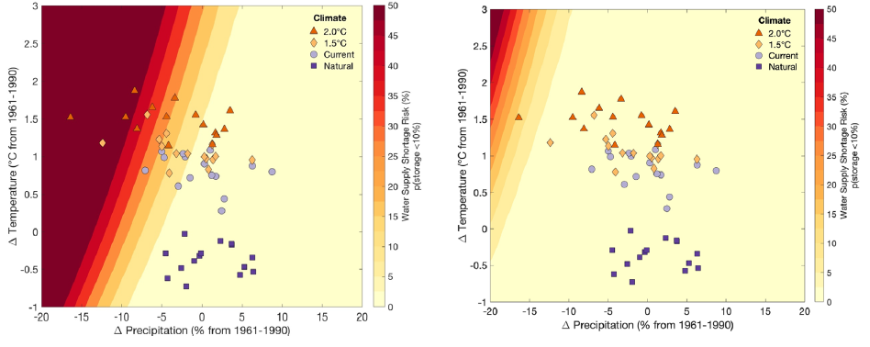
Figure 8: An example of decision scaling applied to average changes in air temperature and precipitation when assessing system performance for a supply system without (left) and with (right) a supply augmentation option. Source: Henley et al. (2019).

The key features to look for when interpreting sensitivity test results used for stress testing purposes are:
- the rate of change of system performance across the tested space ‒ where contours are close together, this indicates rapid change in system performance for a given input change in climate; for example, in the left-hand panel of Figure 8, with zero assumed temperature change, the system performance is maintained for small changes (<5%) in rainfall, but deteriorates rapidly when rainfall declines by 5‒15%
- the slope of the contours ‒ the near-vertical contours in Figure 8 suggest that performance is much more sensitive to changes in rainfall than it is to changes in temperature; horizontal contours (not shown) would indicate greater sensitivity of performance to changes in temperature than rainfall
- hotspots ‒ stress tests can sometimes identify hotspots of poor performance, high performance, an improvement in performance or a deterioration in performance, associated with rapid change in performance with changing climate inputs
- stress test outcomes relative to plausible climate change projections ‒ in the right-hand panel of Figure 8, performance is poor in the top-left corner of the stress test results, but there are no plausible projections in this area for 1.5° and 2.0°C of global warming (i.e. for the two global warming scenarios considered in that example); the stress test results in the top-left corner provide useful information about potential system response if climate change were to be more severe than the two global warming scenarios considered, but if designing the system specifically for up to 2.0°C of global warming, then this region of the stress test outcomes will be less relevant to decision makers
- shifts in stress test outcomes under different water system configurations or operation ‒ this is seen in Figure 8 as the improvement in performance between the left-hand panel (without augmentation) and the right-hand panel (with augmentation).

Decision scaling has the following benefits:
- It enables assessment of system performance independent of climate change projections. The results from the sensitivity test are not influenced by the uncertainties associated with global climate models and remain valid even if global climate models are subsequently updated.
- By allowing decision makers to see the performance outcomes of all climate scenarios simultaneously, it directs decision makers to give greater weight to system robustness and adaptability to future uncertainty, rather than its optimal performance under a limited number of scenarios.
However, decision scaling has the following limitations:
- It can significantly increase water supply system modelling effort, particularly for perturbations of multiple variables.
- Outcomes become more complex to present and interpret when there are more than two variables being perturbed at any one time. Results of sensitivity testing for a single performance measure with two input variables, such as annual rainfall and population growth, can be presented in a two-dimensional plot. Sensitivity testing for more than one performance measure, or for more than two variables, results in outcomes in a multi-dimensional space. This becomes much more difficult to communicate and interpret. Outcomes need to be duplicated for each supply system configuration and operation, and for each point in time over the planning horizon for which outcomes are required.
- It may, without careful consideration of the covariance of different variables, generate unrealistic combinations of input variables, which can distract decision making.
- It may require climate response functions or models to be created for supply system inputs that are not modelled (e.g. where inflows are used directly, rather than climate inputs to a rainfall‒runoff model).

Climate analogues
At a glance
Climate analogues are a simple storytelling technique that relates the future (changed) climate of one location to the historical climate of a different location.
Key benefit
Improves understanding of the implications of projected climate change to a non-technical audience.
Key limitations
Comparisons across locations are coarse and require knowledge and understanding of the historical climate in other locations.
Does not take account of physical processes that influence local rainfall patterns and catchment responses to rainfall, which determine changes to future streamflow.
Development phase: | Application | Applications in other jurisdictions: | Yes
Prerequisites: Identification of an analogue location, which can be done using the Climate Analogues Explorer.

Climate analogues involve selecting historical climate data from another climate station in the region to represent the anticipated climate behaviour at the location of interest under a future climate change condition. For example, if a location is expected to become drier, then a rainfall station in a drier climate could be selected to illustrate what that location’s future climate might be like. It is a simple method to visualise and communicate the impact of climate change.
Climate analogues are presented on climate change in Australia using the Climate Analogues Explorer, with case studies for Victoria presented in Grose et al. (2015) and Timbal et al. (2015). The tool matches the site of interest to other locations using the average annual rainfall and the maximum temperature (within set tolerances) (CSIRO & Bureau of Meteorology, 2015). It can also be used to refine the search using measures of rainfall seasonality (the proportion of rainfall that falls in summer) and temperature seasonality (expressed as the difference between summer and winter temperatures), as well as average seasonal rainfall and temperature for individual seasons.
Climate analogues do not take account of how different weather systems and large climate drivers influence patterns or variability in local climate. For example, Melbourne’s projected average annual rainfall is analogous to Bathurst’s average annual rainfall. However, the eastern seaboard has different patterns of rainfall variability and relationships with climate drivers, including influences from east coast lows, than other regions in south-east Australia (Pepler et al., 2020). Hence, rainfall variability in Bathurst may not reflect future variability in Melbourne.
Although climate analogues can be useful to communicate climate information, they may not be suitable for drawing reliable inferences on climate change impact on water availability.

Storylines
At a glance
A storylines approach creates a set of physically consistent climate scenarios over a planning horizon that are expected to have a meaningful impact on the performance of a local water system.
Key benefit
Promotes a narrative of alternative plausible climate futures that can help decision makers to avoid assigning a ‘most likely’ scenario and focus more on water system robustness.
Key limitation
Is bespoke for each application, with a high level of effort to identify the storylines, because the climate model results must be linked to the specific performance measures of interest to local stakeholders and decision makers.
Development phase: | Research | Applications in other jurisdictions: | Yes
Prerequisites: May require unique interrogation of climate model outputs. Requires a clear understanding of performance measures of interest to stakeholders for the specific water system being assessed.

The storylines approach to climate change impact assessment involves analysing discrete model scenarios used to represent past events or plausible future events or pathways (Shepherd et al., 2018). An advantage of adopting discrete scenarios is that they are physically self-contained, meaning that model outputs such as temperature and rainfall come from the same set of model results, rather than using an aggregation of outputs from multiple models, which can weaken the ability to make statements, including those relating to impacts of remote drivers of regional change (Caviedes-Voullieme & Shepherd, 2023).
Storylines are not predictions (Shepherd et al., 2018); they are not intended to identify a more likely climate future. They can be used as a qualitative tool to test theories about the interactions of climate processes (Shepherd et al., 2018). The approach often involves selecting, or adapting, particular global or regional climate models that simulate the plausible future scenarios of concern. Normally, multiple storylines are generated for comparison. Zappa & Shepherd (2017), for example, adopted a storyline approach to model the potential impact of future warming in Europe on patterns of atmospheric circulation change, defined by the responses for three remote climate drivers.
In Western Australia, the storylines approach was adopted to explore the range of future water availability (DWER, 2024) following a case study of the western Pilbara region (Narsey et al., 2023). The case study explored storylines that account for much wetter, little change and much drier future climates based on plausible changes to climate drivers that affect the region. Two of the storylines were matched against projections from GCMs, while the third storyline was approximated using a dynamically downscaled climate model. The impact of the climate storylines on runoff was modelled using a water balance model (AWRA-L).
The Murray‒Darling Basin Sustainable Yields project (Chiew et al., 2025) used storylines to illustrate climate sequences that may be experienced under a selection of climate scenarios between 2025 and 2050. Two of the storylines represent climate sequences from the edges of the plausible range of climate futures, with projected future changes being drawn from two climate models that correspond to the 10th and 90th percentile range of all GCMs. The third model represents an extended drought sequence under a hotter and drier climate scenario.
These examples illustrate how storylines can be developed for different purposes. For this reason, the range of futures contained in storylines can be highly subjective and specific to the assessment context.

Simpler water resource models for climate change impact assessments
At a glance
This technique involves developing, verifying and applying a simple water resource model to explore many climate change input scenarios or response options. In these models, representations of input, output or operating rules may be simplified (relative to more complex models) to reduce modelling run time.
Key benefit
Can significantly reduce analysis time for rapid exploration of a wide range of input scenarios, such as modelling stochastic input data with many climate change scenarios and response options.
Key limitation
Can perform poorly in some water systems, introducing additional bias or uncertainty into the analysis.
Development phase: | Application | Applications in other jurisdictions: | Yes
Prerequisites: Need to develop and verify a simplified model of the water system.

High-resolution, fine-scale, complex water resource models or related response models (e.g. ecological response models) have often been adopted in water resources planning for their precision in representing legal entitlements to water, water system operating rules, and system dynamics. These types of models provide a level of certainty for stakeholders on some aspects of system behaviour, and are well suited to running a small to moderate number of input scenarios quickly, but can be time-consuming to run in the context of a high number of potential future scenarios.
The guidelines provide three representative climate change projections that cover warmer and wetter, warmer and drier, and warmer and much drier possibilities, spanning the 10th to 90th percentile range of GCM projections, for one or two emissions scenarios. Such an approach typically reduces total run time for scenarios to a manageable level, such that it does not adversely delay decision making, even when using complex models.
For climate change impact assessments that involve many response options over different planning horizons, running the 10th, 50th and 90th percentile GCM projections for one or two emissions scenarios can result in many scenarios needing to be run, particularly if any form of optimisation of system levers needs to be tested. Similarly for bottom-up impact assessments such as stress testing, or for stochastic modelling, or for independent assessments using the full suite of available GCM and RCM projections, complex water resource models can be poorly suited to quickly exploring the range of outcomes with these numerous and often widely different inputs and model configurations.
In such a situation, simpler models can potentially be used to explore many scenarios quickly, giving decision makers access to a wider range of potential outcomes, including finer detail about incremental system responses and sensitivity to specific climate change thresholds. Simpler models could include modelling on a longer time step (e.g. monthly instead of daily), using models with reduced complexity (e.g. grouping catchments or demands) or using emulators that mimic system responses using simple relationships between variables. These options are discussed in Fowler et al. (2022a). The performance of any simplified model would need to be verified as being fit-for-purpose.
Once the range of scenarios has been quickly explored, a small number of representative input scenarios and favourable response options can then be identified for assessment using the complex model.
Running simpler models is not the only solution to this problem. Processing time when running many scenarios on complex models can sometimes also be improved by accessing more computing resources, such as running scenarios on different processors in parallel locally or in the cloud.

Additional approaches to support adaptive planning and management
WSAA (2024) provides guidance on the advantages and disadvantages of adopting different types of climate change impact assessment techniques for different types of assessment problem. This guidance has been informed by Victoria’s 2020 guidelines (DELWP, 2020). The default approach typically used across Victoria, and adopted in the urban water strategy guidelines (DEECA, 2025b), is a scenario planning approach with adaptive management. Dewar (2006), as reported in Marchau et al. (2019), concluded that scenario planning can effectively be applied regardless of future uncertainties, but was less preferable when system complexity was high and when there were many implementation options available. Defining and communicating scenarios, and assessing potential actions under those scenarios, becomes more difficult under these circumstances. This is when other planning approaches can potentially be considered, as represented visually in Figure 9 and outlined below. Approaches other than scenario planning can potentially be more useful for decision making when:
  - there are many input scenarios that are irreducible
  - there are many response options to consider
  - the available input scenarios do not adequately represent potential risks
  - there is insufficient information to make an informed decision.

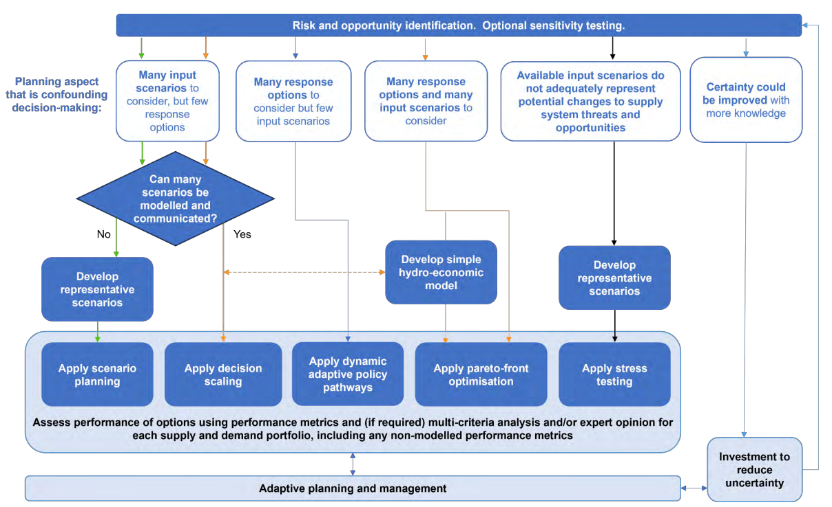
Figure 9: Planning approaches for managing future uncertainty when decision making using scenario planning is being confounded. Source: WSAA (2024)

Each topic is presented in individual sub-chapters, with a short overview and key benefits and limitations when applying the technique. Similar to Chapter 3, a summary of where the technique lies in its phase of development, the extent of application to date, and any prerequisite material or knowledge required to apply the technique have been provided (Table 1). Practitioners are also encouraged to consider the skill of the technique for the application and the level of effort and cost. The information provided here has been compiled only within the context of water availability impact assessment. The guidance provided here is general in nature and may not be fully applicable in all contexts, assessments or applications.

Pareto-front optimisation
At a glance
Pareto-front optimisation is an analytical approach that allows direct trade-offs between different objectives to be assessed when evaluating actions for a water system under projected climate change.
Key benefit
Can assist decision making where there are many potential response options to many possible (climate change) input scenarios.
Key limitation
Need to convert measures of performance into common quantifiable metrics, such as financial cost. Not all performance measures lend themselves to accurate quantification using a common metric.
Development phase: | Investigation | Applications in other jurisdictions: | Yes
Prerequisites: Need to convert measures of performance into common quantifiable metrics, such as financial cost.

Pareto-front optimisation is a modelling technique that can be used to support decision making that is well suited to supply systems with many potential input scenarios and many potential response options. It involves modelling all of these scenarios and options, typically with a hydro-economic model, to identify a subset of solutions with high performance and low regret under the range of scenarios tested. Once the subset of more attractive solutions has been identified, other decision-making techniques such as expert opinion or multi-criteria analysis can be applied to select a preferred solution.
Given the extensive modelling effort that is often involved, the representation of the supply system in these hydro-economic models has sometimes been simplified. Refer to Cui and Kuczera (2010) or Purves et al. (2015) for examples of pareto-front optimisation applied to urban water supply systems. In Figure 10, seven representative supply configurations are identified along the pareto-front, ranging from higher cost but lower regret options to lower cost and higher regret options. These seven configurations could then be assessed in more detail and presented to decision makers to assess their risk appetite and willingness to invest.
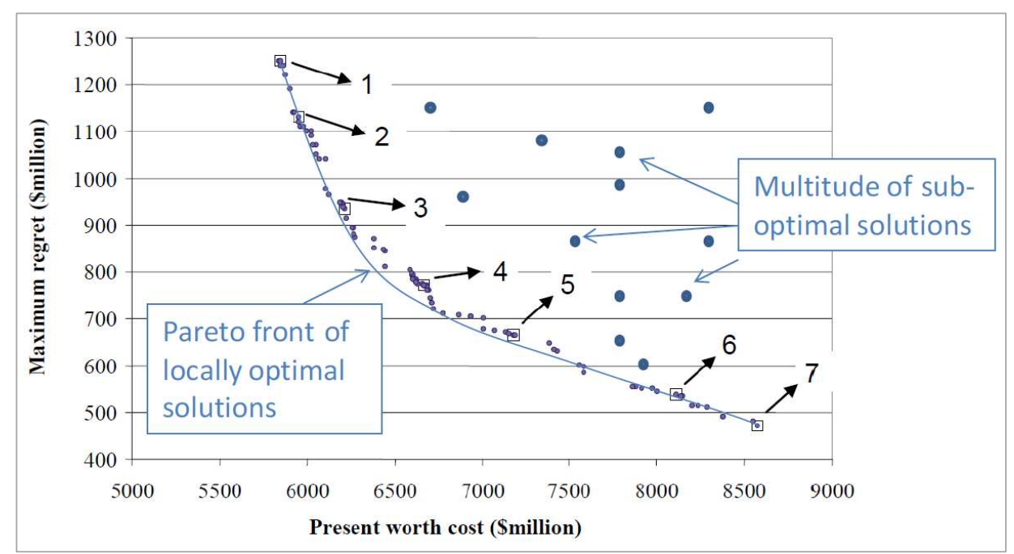
Figure 10: Example two-dimensional pareto-front. Source: Adapted from Cui & Kuczera (2010).

Dynamic adaptive policy pathways
At a glance
Adaptive pathways are an analytical approach that visually represents the sequences of actions for maintaining system performance under projected climate change over a planning horizon. The preferred pathway can be planned to be modified as more information (e.g. on climate conditions) emerges.
Key benefit
Through visualisation of pathways, can assist decision-making when there are many options to respond to climate change, and some of those options would either prevent or promote subsequent adaptability if implemented.
Key limitation
Can become difficult to represent multiple input scenarios on the pathway diagrams.
Development phase: | Application | Applications in other jurisdictions: | Yes
Prerequisites: Often applied using off-the-shelf commercial software.

In the dynamic adaptive policy pathways approach presented by Deltares (2025), adaptation pathways are visualised (Figure 11), with each potential pathway assessed against a simple scoring system. Each pathway includes a trigger point (or transfer station), a lead time to the implementation point, and a threshold (or tipping point) for adopting an alternative pathway under changing conditions. Implicit in this approach is that designated performance objectives are maintained along each pathway. Decisions are then made by consensus, informed by the costs and benefits of each pathway. A more practical discussion of this approach for a water service provider can be found in Maynard et al. (undated). Victoria’s Resilient Coast framework and guidelines (DEECA, 2023) recommend an adaptive pathway approach, including further discussion and illustration of the approach for practitioners.
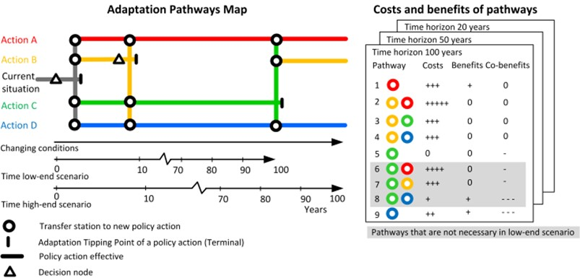
Figure 11: An example of an adaptation pathways map (left) and scorecard (right). Source: Deltares (2025).

Such an approach is best suited to supply systems where the options available are well understood, but their preferred sequencing is not, or where there is a risk that near-term decisions could result in maladaptation because they exclude the potential for the adaptation that could be needed under some climate futures. It also has the advantages that:
- it is visual in nature; for example, highlighting option dependencies, sequencing, and the design life of options
- it can allow enabling actions for future pathways to be reserved (e.g. setting aside land for infrastructure that is likely to be needed in future decades under the preferred pathway).
It has the disadvantage that:
- there is limited ability to represent multiple input scenarios.

Adaptive planning and management
At a glance
Adaptive planning and management is a planning approach that involves establishing triggers to adjust actions, and then monitoring against those triggers to take action as climate variability and climate change unfold.
Key benefit
Already an embedded Victorian government process that promotes adaptability, such as in the annual water outlooks and drought preparedness plans for Victoria’s water corporations.
Key limitation
Requires the development of meaningful triggers that are able to be monitored effectively in real time, with enough lead time available to implement the planned response.
Development phase: | Application | Applications in other jurisdictions: | Yes
Prerequisites: Actions with a short enough lead time to change system performance when implemented. High-quality, real-time monitoring of trigger variables.

Adaptive planning and management involves establishing triggers to adjust actions in response to changing conditions. All approaches to adaptive planning and management involve (1) defining the problem, (2) specifying options for addressing the problem and their constraints, (3) identifying a promising initial plan using a simple planning technique (e.g. multi-criteria analysis or the outcomes of scenario planning as described above), (4) identifying and assessing vulnerabilities, and (5) designing a monitoring system with triggers for action.
In the more formal adaptive management approach adopted in Kwakkel et al. (2010), actions are described as mitigating (to address likely vulnerabilities), hedging (to cater for uncertain vulnerabilities) or seizing (to take advantage of likely opportunities). Monitoring is used to trigger actions that are classified as defensive actions, corrective actions, reassessments or capitalising actions. In water resources planning, adaptive planning typically occurs in the context of drought. During drought, current or near-term projected conditions can be used not only to trigger short-term contingency measures, but also to bring forward or defer planned actions identified in long-term water resources strategies. Adaptive planning triggers can also be related to population growth, community consultation outcomes or regulatory approvals.
An example of adaptive planning is the preparation of an annual water outlook by water service providers in Victoria (DEECA, 2025b). The outlooks confirm whether any adjustment is required to actions from a water service provider’s long-term water resources strategy as a result of current and forecast conditions over the next 12 months. Such a process is illustrated in Figure 12 and includes:
- A strategy that identifies actions to be implemented prior to the next strategy review (in ~5 years’ time) and in the long-term (from 5 to 50 years) ‒ this can include specific triggers developed for option readiness (i.e. evaluating options to an extent that enables their selection), selection and implementation.
- An annual review (every year from years 1 to 5) of the water system status and the status of potential threats to water system performance ‒ this can be used to trigger changes to the timing or nature of planned actions without revisiting the whole strategy.
- An emergency response plan that identifies emergency response options in real time for known stressors (e.g. drought), as agreed during the planning process, or if conditions rapidly change such that long-term planning actions are unable to be implemented to avoid an emergency response.

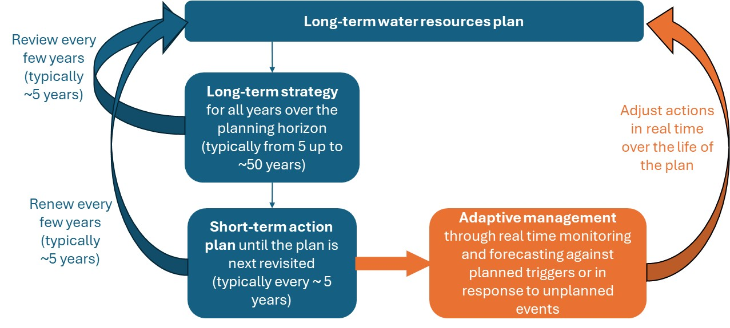
Figure 12: Adaptive management over the life of a long-term water resources plan.

Real options and investing to reduce uncertainty
At a glance
Real options is a financial analysis technique that can be used to inform the level of effort to apply to further develop different climate change response options for a water system, when those response options are not all developed to the same level of certainty.
Key benefit
Promotes consideration of actions to progressively invest in options that improve information or reduce the lead time for implementation, which could lead to better response options than those currently available.
Key limitation
Requires likelihoods to be assigned to input scenarios, which can be difficult for climate change scenarios.
Development phase: | Investigation | Applications in other jurisdictions: | No
Prerequisites: Likelihoods must be able to be assigned to climate change scenarios.

Real options is a technique developed in the finance industry for the progressive investment in a portfolio of financial assets. The potential application of a real options approach to urban water resources planning was presented in Borinson et al. (2008). The mechanics of a formal real options approach for application in water resources planning has not been implemented successfully in Australia to date. This is because it relies on being able to assign likelihoods to future scenarios, which in water resources planning are usually unknown.
Nevertheless, a core concept from a real options approach is useful for water resources planning. This is that there can be benefits from incremental investment in multiple response options to either reduce the uncertainty associated with those options (so as to be able to make decisions with higher confidence in the future), or to reduce the lead time associated with them. If a water manager has a fixed capital budget available to spend, it must decide where best to invest those funds. This could include investing in monitoring, community consultation, modelling, or research and development.

References
Addor, N., & Siebert, J. (2014). Bias correction for hydrological impact studies – Beyond the daily perspective. Hydrological Processes, 28(17), 4823–4828. https://doi.org/10.1002/hyp.10238
Allen, R.G., Pereira, L.S., Raes, D., & Smith, M. (1998). Crop evapotranspiration – guidelines for computing crop water requirements. FAO irrigation and drainage paper 56. Food and Agriculture Organization of the United Nations. https://www.fao.org/4/x0490e/x0490e00.htm
Blöschl, G., Bierkens, M. F. P., Chambel, A., Cudennec, C., Destouni, G., et al. (2020). Twenty-three unsolved problems in hydrology (UPH) – A community perspective. Hydrological Sciences Journal, 64(10), 1141–1158. https://doi.org/10.1080/02626667.2019.1620507
Blöschl, G., Sivapalan, M., Wagener, T., Viglione, A., & Savenije, H. (2013). Prediction in ungauged basins: Synthesis across processes, places and scales. Cambridge University Press.
Borinson, A., Hamm, G., Farrier, S., & Swier, G. (2008). Real options and urban water resource planning in Australia (WSAA Occasional Paper No. 20). Water Services Association of Australia. https://water360.com.au/wp-content/uploads/2022/02/2008073.pdf
Caviedes-Voullième, D., & Shepherd, T. G. (2023). Climate storylines as a way of bridging the gap between information and decision-making in hydrological risk. PLOS Clim, 2(8): e0000270. https://doi.org/10.1371/journal.pclm.0000270
Charles, S. P., Chiew, F. H. S., Potter, N. J., Zheng, H., Fu, G., & Zhang, L. (2020). Impact of dynamically downscaled rainfall biases on projected runoff changes. Hydrology and Earth System Sciences, 24(6), 2981–2997. https://doi.org/10.5194/hess-24-2981-2020
Chiew, F. H. S., & McMahon, T. A. (1991). The applicability of Morton’s and Penman’s evapotranspiration estimates in rainfall-runoff modelling. Water Resources Bulletin, 27(3), 505–522. https://doi.org/10.1111/j.1752-1688.1991.tb01462.x
Chiew, F. H. S., Devanand, A., Khan, Z., Zheng, H., Potter, N. J., et al. (2025). Hydroclimate projections for the Murray-Darling Basin. (Module 1 of the MDB Sustainable Yields Project). CSIRO. https://researchdata.edu.au/hydroclimate-projections-murray-darling-basin/3655930
Chiew, F. H. S., Robertson, D. E., Potter, N. J., Post, D. A., Devanand, A., et al. (2024). Climate variability, climate change and baselines: Considerations for water resources management and planning. In Hydrology and Water Resources Symposium (pp. 1199–1208). Engineers Australia. http://hdl.handle.net/102.100.100/706496?index=1
Chiew, F. H. S., Teng, J., Vaze, J., Post, D. A., Perraud, J.-M., Kirono, D. G. C., & Viney, N. R. (2009). Estimating climate change impact on runoff across south-east Australia: Method, results and implications of modelling method. Water Resources Research, 45(10), W10414. https://doi.org/10.1029/2008WR007338
Chiew, F. H. S., Zheng, H., Potter, N. J., Charles, S. P., Thatcher, M., et al. (2022). Different hydroclimate modelling approaches can lead to a large range of streamflow projections under climate change: Implications for water resources management. Water, 14(17), 2730. https://doi.org/10.3390/w14172730
CSIRO, & Bureau of Meteorology. (2015). Climate change in Australia: Information for Australia’s natural resource management regions – Technical report. https://www.climatechangeinaustralia.gov.au/media/ccia/2.2/cms_page_media/168/CCIA_2015_NRM_TechnicalReport_WEB.pdf
Cui, L., & Kuczera, G. (2010). Coping with climate change uncertainty using robust multi-objective optimization: Application to urban water supply systems. In Climate Change 2010: Practical Responses to Climate Change. Engineers Australia. https://search.informit.org/doi/abs/10.3316/INFORMIT.769494055789234
DEECA. (2020). Guidelines for assessing the impact of climate change on water availability in Victoria. https://www.water.vic.gov.au/__data/assets/pdf_file/0027/663327/guidelines-for-assessing-the-impact-of-climate-change-on-water-availability-in-victoria-2020-edition.pdf
DEECA. (2023). Victoria’s resilient coast: Adapting for 2100+ – Framework and guidelines. https://www.marineandcoasts.vic.gov.au/marine-coastal-management/victorias-resilient-coast-adapting-for-2100
DEECA. (2025a). Victoria’s water resources under a changing climate: Insights from Phase 2 of the Victorian Water and Climate Initiative. https://www.water.vic.gov.au/__data/assets/pdf_file/0037/729928/Victorias-water-resources-under-a-changing-climate.pdf
DEECA. (2025b). Guidelines for the development of Urban Water Strategies & Drought Preparedness Plans.
DELWP. (2020). Guidelines for assessing the impact of climate change on water availability in Victoria: Final (November 2020). https://www.water.vic.gov.au/__data/assets/pdf_file/0017/664001/guidelines-for-assessing-the-impact-of-climate-change-on-water-availability-in-victoria-2020-edition.pdf
Deltares. (2025). Dynamic adaptive policy pathways. https://www.deltares.nl/en/expertise/areas-of-expertise/sea-level-rise/dynamic-adaptive-policy-pathways
Devanand, A., Chiew, F. H. S., Post, D. A., Robertson, D. E., Grose, M. G. R., et al. (2025). Partitioning uncertainty in climate projections in the Murray-Darling Basin. Submitted journal paper under review.
DPE. (2023). Water modelling – Stochastic climate data. https://datasets.seed.nsw.gov.au/dataset/water-modelling-stochastic-climate-data
DWER. (2024). Guide to future climate projections for water management in Western Australia. https://www.wa.gov.au/government/publications/guide-future-climate-projections-water-management-western-australia
Eyring, V., Bony, S., Meehl, G. A., Senior, C. A., Stevens, B., et al. (2016). Overview of the Coupled Model Intercomparison Project Phase 6 (CMIP6) experimental design and organization. Geoscientific Model Development, 9(5), 1937–1958. https://doi.org/10.5194/gmd-9-1937-2016
Fowler, K., Horne, A., Ballis, N., & John, A. (2022a). Integrated framework for rapid climate stress testing on a monthly time step. Environmental Modelling & Software, 150, 105339. https://doi.org/10.1016/j.envsoft.2022.105339
Fowler, K. J. A., Peel, M. C., Saft, M., Peterson, T. J., Western, A., et al. (2022b). Explaining changes in rainfall-runoff relationships during and after Australia’s Millennium Drought: A community perspective. Hydrology and Earth System Sciences, 26(22), 6073–6120. https://doi.org/10.5194/hess-26-6073-2022
Gao, Z., Robertson, D. W., Ng, T. L., Russell, P., Chiew, F. H. S., & Frdelja, J. (2025). Stochastic rainfall and runoff generation to evaluate the effects of changing climate on water supply systems. Submitted journal paper under review.
Grose, M., et al. (2015). Southern Slopes Cluster Report. In M. Ekström et al. (Eds.), Climate change in Australia projections for Australia’s natural resource management regions: Cluster reports. https://www.climatechangeinaustralia.gov.au/media/ccia/2.2/cms_page_media/168/SOUTHERN_SLOPES_CLUSTER_REPORT_1.pdf
Grose, M. R., Narsey, S., Trancoso, R., Mackallah, C., Delage, F., et al. (2023). A CMIP6-based multi-model downscaling ensemble to underpin climate change services in Australia. Climate Services, 30, 100368. https://doi.org/10.1016/j.cliser.2023.100368
Hattermann, F. F., Vetter, T., Breuer, L., Su, B., Daggupati, P., et al. (2018). Sources of uncertainty in hydrological impact assessment in a cross-scale study. Environmental Research Letters, 13(1), 015006. https://doi.org/10.1088/1748-9326/aa9938
Henley, B. J., Peel, M. C., Nathan, R., King, A. D., Ukkola, A. M., Karoly, D., & Tan, K. S. (2019). Amplification of risks to water supply at 1.5°C and 2°C in drying climates: A case study for Melbourne, Australia. Environmental Research Letters, 14(8), 084028. https://iopscience.iop.org/article/10.1088/1748-9326/ab26ef
Ho, M., Kiem, A. S., & Verdon-Kidd, D. C. (2015). A paleoclimate rainfall reconstruction in the Murray–Darling Basin (MDB), Australia: 2. Assessing hydroclimate risk using paleoclimate records of wet and dry epochs. Water Resources Research, 51(10), 8380–8396. https://doi.org/10.1002/2015WR017059
IPCC. (2021). Summary for policymakers. In V. Masson-Delmotte et al. (Eds.), Climate change 2021: The physical science basis (pp. 3–32). Cambridge University Press. https://doi.org/10.1017/9781009157896.001
John, A., Horne, A., Nathan, R., Fowler, K., Webb, J. A., & Stewardson, M. (2021). Robust climate change adaptation for environmental flows in the Goulburn River, Australia. Frontiers in Environmental Science, 9, 789206. https://doi.org/10.3389/fenvs.2021.789206
John, A., Horne, A., Nathan, R., & Lang, S. (2024). High flow management as climate change adaptation for freshwater ecosystems in regulated rivers. Australasian Journal of Water Resources, 28(2), 240–254. https://doi.org/10.1080/13241583.2024.2392322
Joseph, J., Ghosh, S., Pathak, A., & Sahai, A. K. (2018). Hydrologic impacts of climate change: Comparisons between hydrological parameter uncertainty and climate model uncertainty. Journal of Hydrology, 566, 1–22. https://doi.org/10.1016/j.jhydrol.2018.08.080
Kiem, A. S., Kuczera, G., Kozarovski, P., Zhang, L., & Willgoose, G. (2020). Stochastic generation of future hydroclimate using temperature as a climate change covariate. Water Resources Research, 57(2), e2019WR025992. https://doi.org/10.1029/2020WR027331
Kwakkel, J., Walker, W., & Marchau, V. (2010). Adaptive airport strategic planning. European Journal of Transport and Infrastructure Research, 10(3), 249–273. https://doi.org/10.18757/ejtir.2010.10.3.2891
Lane, P. N. J., Benyon, R. G., Nolan, R. H., Keenan, R. J., & Zhang, L. (2023). Forests, fire and vegetation change impacts on Murray-Darling Basin water resources. Australian Journal of Water Resources, 27(1), 68–84. https://doi.org/10.1080/13241583.2023.2179555
Marchau, V. A. W. J., Walker, W. E., Bloemen, P. J. T. M., & Popper, S. W. (Eds.). (2019). Decision making under deep uncertainty: From theory to practice. Springer. https://doi.org/10.1007/978-3-030-05252-2
Morton, F. I. (1983). Operational estimates of areal evapotranspiration and their significance to the science and practice of hydrology. Journal of Hydrology, 66(1–4), 1–76. https://doi.org/10.1016/0022-1694(83)90177-4
Maynard, D., Boyle-Gotla, A. & Ho, I. (undated). Dynamic adaptive pathway planning – adding flexibility in an uncertain future. Water New Zealand. https://www.waternz.org.nz/Attachment?Action=Download&Attachment_id=5197
Narsey, S., Kociuba, G., Peter, J., Schopf, J., Bellhouse, J., Bende-Michl, U., Grose, M., Barnes, K., & Srikanthan, S. (2023). Storylines of the Pilbara’s future climate: A case study on constructing storylines of future water availability for western Pilbara aquifers in a warmer climate. Climate Systems Hub, National Environmental Science Program. https://nesp2climate.com.au/wp-content/uploads/2023/08/Storylines-of-the-Pilbara.pdf
Nash, J. E., & Sutcliffe, J. V. (1970). River flow forecasting through conceptual models Part I – A discussion of principles. Journal of Hydrology, 10(3), 282–290. https://doi.org/10.1016/0022-1694(70)90255-6
Perrin, C., Michel, C., & Andréassian, V. (2003). Improvement of a parsimonious model for streamflow simulations. Journal of Hydrology, 279(1–4), 275–289. https://doi.org/10.1016/S0022-1694(03)00225-7
Pepler, A. S., Dowdy, A. J., van Rensch, P., et al. (2020). The contributions of fronts, lows and thunderstorms to southern Australian rainfall. Climate Dynamics, 55, 1489–1505. https://doi.org/10.1007/s00382-020-05338-8
Peterson, T. J., Saft, M., Peel, M. C., & John, A. (2021). Watersheds may not recover from drought. Science, 372(6542), 745–749. https://www.science.org/doi/10.1126/science.abd5085
Potter, N. J., Chiew, F. H. S., Charles, S. P., Fu, G., Zheng, H., & Zhang, L. (2020). Bias in downscaled rainfall characteristics. Hydrology and Earth System Sciences, 24(6), 2963–2979. https://doi.org/10.5194/hess-24-2963-2020
Purves, T., Larkings, K., & Salma, S. (2015). The trade-off between water security and cost. In Ozwater 2015 Conference Proceedings. Australian Water Association.
Robertson, D. E., Chiew, F. H. S., Zheng, H., Peña-Arancibia, J. L., Shrestha, D. L., & Post, D. A. (2024). How do hydrological non-stationarities impact future runoff projections. In Hydrology and Water Resources Symposium (pp. 1209–1218). Engineers Australia. https://search.informit.org/doi/abs/10.3316/informit.T2025050600026800139050769
Robertson, D. E., Peña-Arancibia, J., Kim, S., Shokri, A., Montazeri, M., et al. (2025). Assessing different approaches for generating future projections of river system outcomes. (Report from Module 1 of MDBA Sustainable Yields Project.) CSIRO.
Robertson, D. E., Zheng, H., Peña-Arancibia, J. L., Chiew, F. H. S., Aryal, S., et al. (2023). How sensitive are catchment runoff estimates to on-farm storages under current and future climates. Journal of Hydrology, 626, 130185. https://doi.org/10.1016/j.jhydrol.2023.130185
Saft, M., Western, A. W., Zhang, L., Peel, M. C., & Potter, N. J. (2015). The influence of multiyear drought on the annual rainfall-runoff relationship: An Australian perspective. Water Resources Research, 51(4), 2444–2463. https://doi.org/10.1002/2014WR015348
Shepherd, T., Boyd, E., Calel, R., Chapman, S., Dessai, S., et al. (2018). Storylines: An alternative approach to representing uncertainty in physical aspects of climate change. Climatic Change, 151(3), 555–571. https://doi.org/10.1007/s10584-018-2317-9
SILO. (2024). SILO gridded climate data. https://longpaddock.qld.gov.au/silo/gridded-data/
Teng, J., Vaze, J., Chiew, F. H. S., Wang, B., & Perraud, J.-M. (2012). Estimating the relative uncertainties sourced from GCMs and hydrological models in modelling climate change impact on runoff. Journal of Hydrometeorology, 13(1), 122–139. https://doi.org/10.1175/JHM-D-11-058.1
Timbal, B., Ekström, M., & Grose, M. (2015). Murray Basin Cluster Report. In M. Ekström et al. (Eds.), Climate change in Australia projections for Australia’s natural resource management regions: Cluster reports. CSIRO & Bureau of Meteorology. https://www.climatechangeinaustralia.gov.au/media/ccia/2.2/cms_page_media/168/MURRAY_BASIN_CLUSTER_REPORT_1.pdf
Verdon-Kidd, D., Beatty, R., & Allen, K. (2019). Planning urban water system responses to megadrought: How looking back can help us look forward. Water e-Journal, 4(3). https://doi.org/10.21139/wej.2019.020
Viney, N. R., Perraud, J., Vaze, J., Chiew, F. H. S., Post, D. A., & Yang, A. (2009). The usefulness of bias constraints in model calibration for regionalisation to ungauged catchments. In MODSIM 2009 (pp. 3421–3427). https://mssanz.org.au/modsim09/I7/viney_I7a.pdf
Wei, H., Zhang, Y., Huang, Q., Chiew, F. H. S., Luan, J., et al. (2024). Vegetation responses to recent CO₂ rise exert limited impacts on global streamflow. Nature Communications, 15, 9423. https://doi.org/10.1038/s41467-024-53879-x
WSAA. (2024). Urban water resources planning framework: Guideline (March 2024). https://wsaa.asn.au/Common/Uploaded files/library/resource/Urban_ Water_ Resources_ Planning_ Framework_ March_202024.pdf
Zappa G., & Shepherd, T. G. (2017) Storylines of atmospheric circulation change for European regional climate impact assessment. Journal of Climate, 30 (16), 6561–6577. https://doi.org/10.1175/JCLI-D-16-0807.1
Zhang, Y., & Chiew, F. H. S. (2009). Relative merits of different methods for runoff predictions in ungauged catchments. Water Resources Research, 45(7), W07412. https://doi.org/10.1029/2008WR007504
Zhang XS, Amirthanathan GE, Bari MA, Laugesen RM, Shin D, et al. (2016) How streamflow has changed across Australia since the 1950s: evidence from the network of hydrologic reference stations. Hydrology and Earth System Sciences, 20, 3947–3965. https://hess.copernicus.org/articles/20/3947/2016/hess-20-3947-2016.html
Zheng, H., Chiew, F. H. S., Post, D. A., Robertson, D. E., Charles, S. P., et al. (2024). Projections of future streamflow for Australia informed by CMIP6 and previous generations of global climate models. Journal of Hydrology, 636, 131286. https://doi.org/10.1016/j.jhydrol.2024.131286

