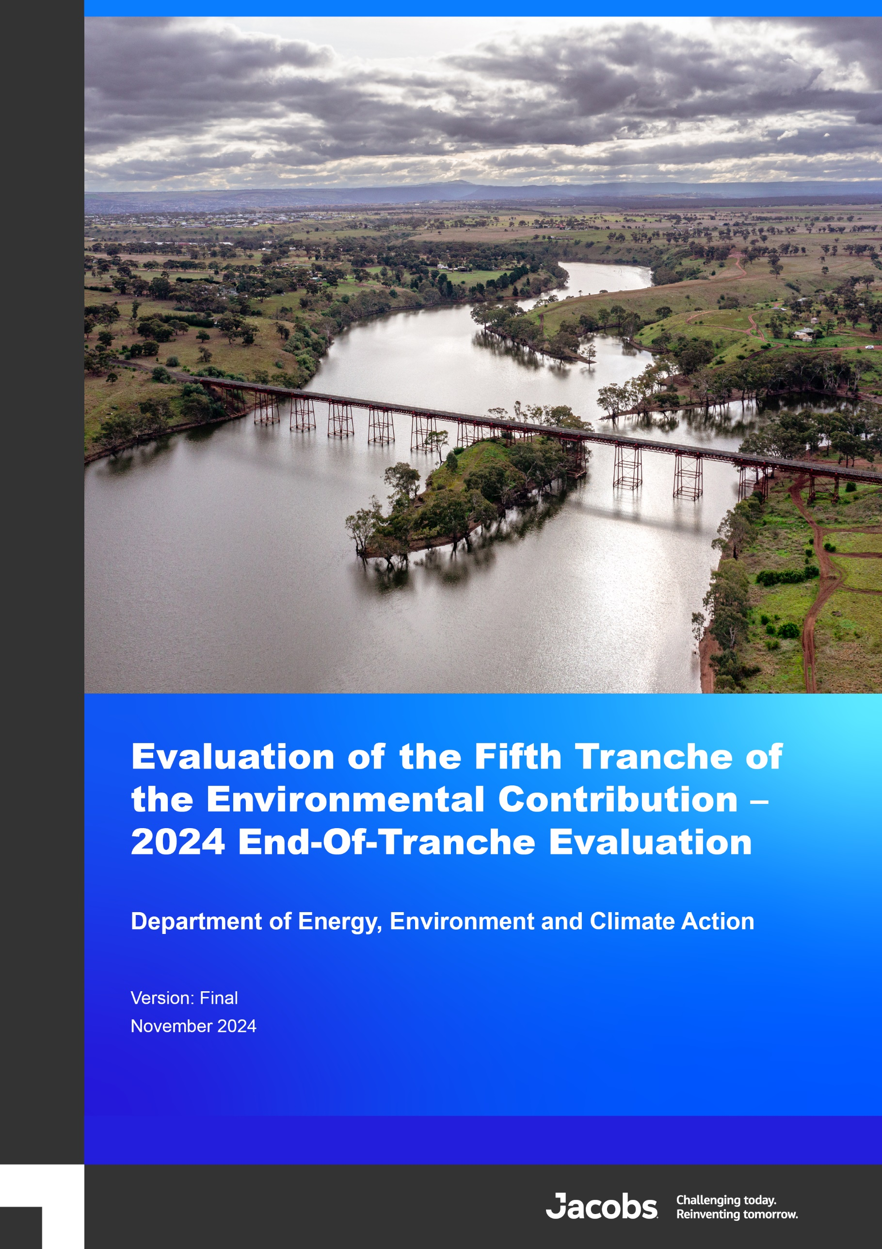
Version:
Department of Energy, Environment and Climate Action

Evaluation of the Fifth Tranche of the Environmental Contribution

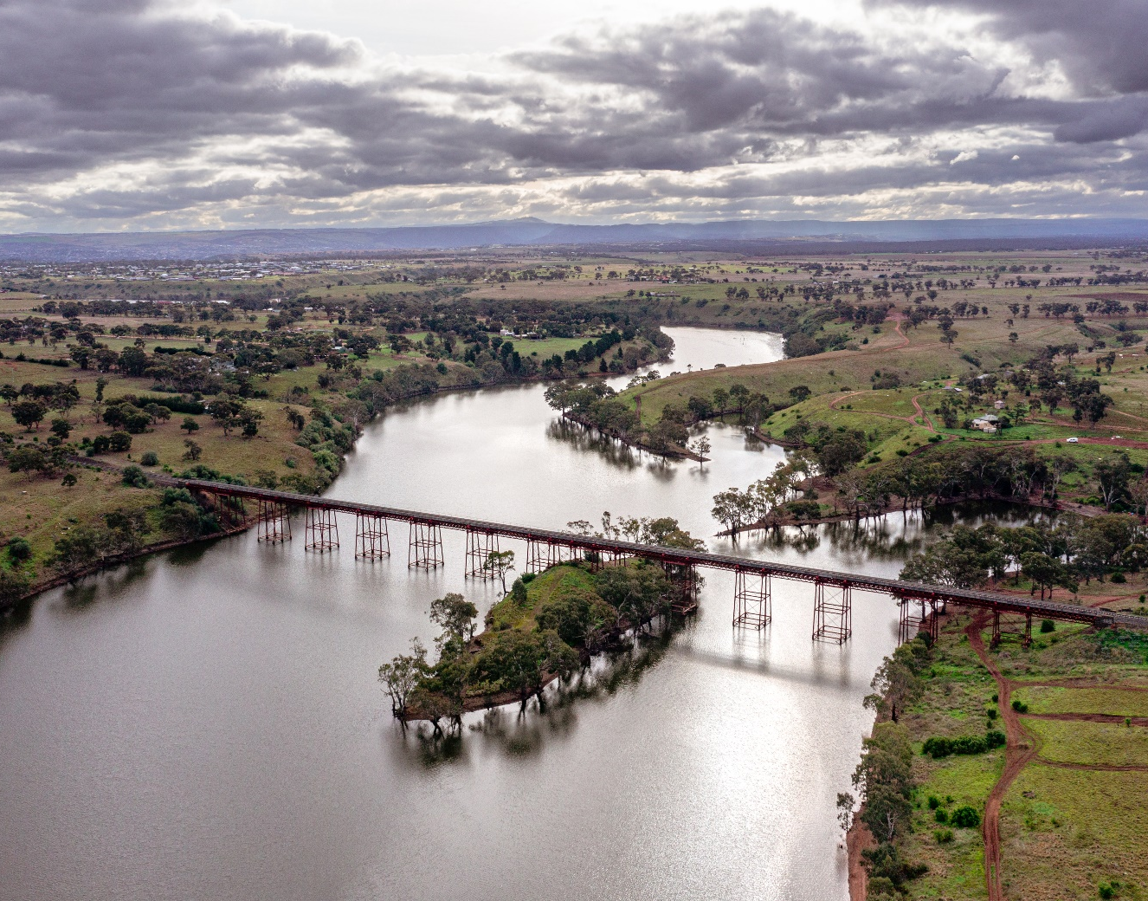 |  | <Drafting Note: Final report to include graphical cover page and section divider pages>

Evaluation of the Fifth Tranche of the Environmental Contribution – 2024 End-Of-Tranche Evaluation
Client name: | Department of Energy, Environment and Climate Action
Project name: | Evaluation of the Fifth Tranche of the Environmental Contribution
Version: | Final | Prepared by: | B Coff
Date: | 29 November 2024
Document status: | Final
Document history and status
Version | Date | Description | Author | Checked | Reviewed | Approved
V1 | 07/10/24 | Draft V1 | BC | ES | ES | ES
V2 | 11/10/24 | Draft V2 | BC & CL | BC & ES | ES | ES
Final | 29/11/24 | Final | BC & CL | BC & ES | ES | ES
Distribution of copies
Version | Issue approved | Date issued | Issued to | Comments
V1 | Draft | 07/10/24 | DEECA | For review
V2 | Draft | 11/10/24 | DEECA | For EC PCB Review
Final | Final | 29/11/24 | DEECA | Incorporated updates from EC PCB review
Jacobs Group Australia
Copyright Jacobs Group Australia © 2024
All rights reserved. The concepts and information contained in this document are the property of the Jacobs group of companies (‘Jacobs Group’). Use or copying of this document in whole or in part without the written permission of Jacobs Group constitutes an infringement of copyright. Jacobs, the Jacobs logo, and all other Jacobs Group trademarks are the property of Jacobs Group.
NOTICE: This document has been prepared exclusively for the use and benefit of Jacobs Group client. Jacobs Group accepts no liability or responsibility for any use or reliance upon this document by any third party.

Executive summary
Background to the Environmental Contribution
The Environmental Contribution (EC) is a key mechanism for the Victorian Government and the broader community to deliver outcomes for the public good that promote the sustainable management of water and address adverse water-related environmental impacts. The EC is funded through contributions from Victoria’s 18 water corporations under an Order made by the Minister for Water.
The fifth 4-year tranche (EC5) commenced on 1 July 2020 and raised $693.9 million to fund initiatives aligned with the delivery of the Victorian Government’s overarching water plan released in 2016 – Water for Victoria. EC5 has also been aligned with Victorian water policies and strategies that have been developed since Water for Victoria, including Water is Life: Traditional Owner Access to Water Roadmap (2022), and the Central and Gippsland Region Sustainable Water Strategy 2022 (CGRSWS). EC5 comprises 14 initiatives, delivered as 38 projects. Many of the initiatives build on work completed in earlier EC tranches.
Evaluation purpose and approach
The purpose and approach for the two-phased EC5 evaluation is summarised in Figure E1. The End-Of-Tranche evaluation (this report) details the achievements and lessons from the 4 years of the EC5 initiatives (and constituting projects), fulfilling the requirement of Section 196 of the Water Industry Act 1994 and EC governance requirements. This evaluation is focused on the dual purposes of accountability and continual improvement. This report documents and reflects on the achievements, challenges, and lessons from delivery of EC5 through analysis of the impacts, effectiveness, efficiency, appropriateness, and legacy of EC5. It also documents key lessons, opportunities, and future priorities for the EC.
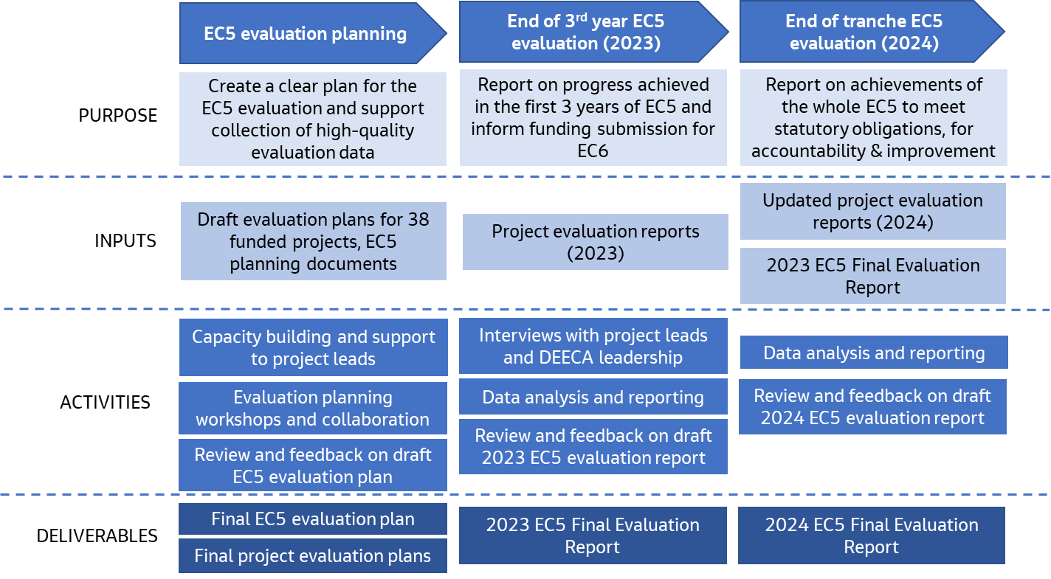
Figure E 1.Summary of the EC5 evaluation purpose and approach
Summary of evaluation findings
Over the 4 years of EC5, a broad range of positive outcomes for the environment, communities, and industries throughout Victoria have been achieved. A key driver of these achievements was the way in which EC5 initiatives either built on or extended work started in EC4 or earlier tranches. Key findings against the evaluation domains are summarised in Table E1.
Table E 1.Summary findings against each evaluation domain
Evaluation Domain | Findings summary
Impact   | Key findings for each of the EC5 long-term outcomes are:  - Water Security: The development of the CGRSWS and associated implementation was a key achievement of EC5. By taking a 50-year view of the water needs of urban users, rural users, Traditional Owners, and the environment, the CGRSWS provided a balanced approach to increasing water supply and sharing water resources into the future that has been integral in minimising conflicts between affected parties while achieving beneficial outcomes for climate change and population growth. A range of on-ground works, designs, and planning for uptake of manufactured water supplies through an Integrated Water Management (IWM) approach were delivered, representing a shift from primarily policy and planning (in EC4) toward implementation. A suite of reviews, planning processes, reform and technology improvement activities has supported progress toward reducing pressure on the water grid, improving functioning of water markets, and enhancing the water entitlement framework.  - Water Efficiency: Water efficiency outcomes were delivered to multiple facets of the Victorian community, including schools, urban households, irrigators, and regional communities. The Community Rebate Program (CRP) and Community Housing Retrofit Program (CHRP) saved 0.298 GL/yr in households and emergency community housing properties. The Schools Water Efficiency Program (SWEP) saved 1.9 GL over the investment period. Investments in residential behaviour change initiatives contributed to the Smart Water Advice portal, providing water saving tips to households and businesses, updating Target 155 to Target 150, and Victoria’s contribution to the Commonwealth’s Water Efficiency Labelling Standards (WELS) scheme, which resulted in 4 GL of water savings over the period. Irrigators are more prepared for a future with reduced water availability, and irrigation losses are on track to be reduced by up to10.3 GL annually under the Macalister Irrigation District Modernisation Phase 2 Project (upon project completion in EC6). A modern risk-based compliance and enforcement framework was implemented to manage unauthorised take of water.  - Waterway and Catchment Health: Strong progress was made in improving the health of waterways and catchments throughout Victoria, with the continuation and extension of several long-term projects. EC5 enabled a suite of 52 IWM projects, including stormwater harvesting, recycled water and rainwater harvesting projects which – when completed – will result in significant stormwater pollution reduction. Over 46,764 ha of place-based on-ground catchment stewardship projects were delivered, along with 35,465 ha of waterway vegetation improvement works across priority sites, continuation and expansion of the Flagship Waterway projects, the Jan Juc daylighting project, and commitment to deliver 88 projects from Burndap Birrarung burndap umarkoo, the Yarra Strategic Plan (YSP), focused on protecting and enhancing Birrarung (the Yarra River) and its parklands. Over 3,212 GL of water for the environment was delivered to 161 rivers and wetlands sites in 2023-24, 154 sites in 2022-23, 170 sites in 2021-22, and 225 sites in 2020-21. While environmental outcomes generally take time to accrue following investment in waterway health projects, monitoring programs are beginning to show long-term positive environmental changes associated with works from EC5 and earlier tranches, building a strong evidence base.  - Traditional Owner Priorities: Over EC5, frameworks and strategies have been delivered to help account for and include Traditional Owners’ priorities in water resource management. The publication of both ‘Water is Life’: Traditional Owner Access to Water Roadmap and the CGRSWS in 2022 were key achievements of EC5; they represent a policy shift that provides new guidance and policy direction for the inclusion of Traditional Owners in the management of Victoria’s water resources. However, there remains significant work to be done to successfully implement the actions from Water is Life and the CGRSWS, and meaningfully embed Traditional Owner involvement, values, and principles of self-determination throughout EC projects and the broader Victorian Water sector.  - Inclusive Management: The EC5 projects were inclusive of social and community values, with 87% of the projects reporting that they are increasing community participation and inclusion of community values in water management. New technology platforms and communications products were developed for improved community and sector access to information. Some priorities shifted throughout EC5 due to COVID-19 disruption and flood recovery works.  - Water Governance: Many of the projects contributed to meeting the needs of customers and the community, through improved water planning, access to information and inclusion in water planning and decision-making. Flood risks were reduced, as well as the risks posed by the three highest-risk local government authority owned small dams. Climate change was embedded into water sector planning and decision-making through the development of Guidelines for Assessing the Impact of Climate Change on Water Availability in Victoria, which have been widely adopted across the Victorian water sector.  Ongoing Foundational Work: Ongoing surface water and groundwater monitoring and modelling projects continued to build the foundational knowledge base of continuous and comprehensive water monitoring data and information which is used for planning and decision-making across the Victorian water sector. Many of the other EC5 projects noted the use of the EC to fund business-as-usual works that were critical to the project teams achieving their standard objectives and ongoing obligations. Along with benefits of EC funding supporting a range of short and long-term projects, several emerging risks associated with the EC increasingly funding ongoing, business-as-usual activities were noted.  Unintended Outcomes: Unintended outcomes were observed by 67% of projects. All unintended outcomes reported were positive and included unexpected benefits of building relationships with organisations and groups outside DEECA, deeper partnerships and collaboration with Traditional Owners, and unintended benefits resulting from flexibility and changing policy directions.
Effectiveness   | Delivery Effectiveness: The EC is well-designed and well-run, with supportive governance structures and appropriate accountability and reporting requirements. Four-year funding cycles and flexibility in funding at the project level enabled teams to respond to changing contexts and shift priorities as needed. However, there are opportunities for embedding further flexibility and arrangements to promote planning of long-term projects and better support Traditional Owners. There were complexities associated with aligning the timing and reporting requirements of multiple funding sources, and delivery challenges associated with team capacity and staff turnover.  Adapting to Changing Contexts: EC5 showed a high level of adaptability and flexibility to manage the effects of external influences, including the COVID-19 pandemic, flood and bushfire events.  While some delays and changes to workplans were required, the projects were able to adapt. There is a need to ensure that knowledge is retained and lessons learned are actioned from previous events to enable preparedness for future unexpected / emergency events.  Partnerships and Collaboration: The EC5 projects were highly collaborative and recognised the importance of partnerships in effective delivery. Over 1,300 partnerships were fostered throughout the 38 EC5 projects, with a broad range of stakeholders. These were valuable in achieving the project outcomes, as reported by 95% of projects.
Appropriateness   | Alignment with the Legislated Objectives and Key Water Management Strategies: EC5 projects showed clear alignment with the legislated objectives with all EC5 projects reporting contributions to one or both legislated objectives of the EC. The projects were guided by key State Government strategies including Water for Victoria (2016), Water is Life: Traditional Owner Access to Water Roadmap (2022), and the CGRSWS (2022). Many of the projects adapted as new State Government strategies were published, to ensure continued alignment with key strategic directions.  Monitoring, Evaluation and Improvement: These actions were integrated throughout EC5 to promote delivery effectiveness. Almost all (92%) projects reported that learning and improvement were effectively incorporated into the project to foster a culture of continual improvement. Some projects reported using independent evaluations, stakeholder feedback, and sharing of lessons to support improvement. The broader EC tranche governance also supported continuous learning through the requirement for each project to develop an evaluation plan and evaluation report, which is used for whole-of-tranche evaluations, and to foster learning for future tranches. Investment in capacity building sessions for the EC5 project teams as part of the EC5 evaluation process has fostered improvement in the effectiveness of the evaluation plans and reports from EC4 to EC5.
Efficiency   | Efficiency through Delivery: Many of the projects delivered their work programs on budget and on time, and where there were variances these were justified in project reporting. Reasons for variation from original work plans included escalating prices due to supply chain issues, lack of staff availability and staff turnover, delays due to COVID-19 restrictions, disruptions from the flood and bushfire events, and higher resource requirements for project elements than was initially planned.  Working with Others to Achieve Better Outcomes: Almost all (89%) of the project teams agreed that efficiencies were gained through working together with other project teams, and many reported this as a key enabler of successful delivery. The main ways that efficiencies were gained was through knowledge sharing between groups, cost sharing, partnerships and workload sharing and distribution.  Leveraging Additional Funding Sources: The EC5 $693.85 million investment was augmented by significant co-investment over the tranche. Investment programs were co-funded by a total reported amount of $347.9 million. This represents $0.50 in co-investment for every dollar of investment from the EC. This is considered a conservative estimate, with many areas also reporting co-investment of funding and other resources that were not quantified in the project evaluations.  Options Assessments: Undertaking options assessment and/or cost-benefit analyses to support project decision-making was reported by 79% of projects. These approaches supported efficient delivery through using structured processes to make investment decisions. Examples of analytical approaches that were used include options papers, cost-benefit tools, best cost options analyses, value for money assessments.
Legacy   | Projects promoted sustained impact through investments in capacity building, long-term partnerships and collaborations, enduring reforms and policy changes, new technology and reporting platforms, and the delivery of on-ground projects focused on creating long-term benefits.
Conclusions and recommendations
Delivery of EC5 strongly aligned with, and made considerable progress towards, the legislated objectives of the EC and key Victorian Government policies and strategies, including Water for Victoria, Water is Life and the CGRSWS. As with previous tranches of the EC, EC5 provided critical funding that has driven innovation and best practice in water management, enabled planning and delivery of strategic, long-term projects, and delivered ongoing foundational services to meet the needs of the Victorian water sector, communities, and industries.
The findings from the EC5 End-Of-Tranche evaluation point to the need for future EC tranches to respond to current and emerging challenges associated with sustainable water management and protection of environmental values, and to realise the full benefits of EC5 investments and those in earlier tranches. Recommendations have also been developed to support continuous improvement for the EC into the future and have been framed to be relatively discrete actions to provide flexibility around how and when they are implemented based on available funding and resourcing.
Table E 2. Recommendations for continuous improvement of future tranches
Recommendation | Rationale and details
- Continue EC funding into a 6th tranche. Prioritise future investment to build resilience to existing and emerging challenges, and to support benefits realisation from work started in EC5 or earlier tranches. | Continued investment is required in many areas to maintain the gains made by EC5 and previous tranches of the EC, and to achieve the objectives of Water for Victoria, Water is Life, the CGRSWS and other key state strategies (for example, the Water Cycle Adaptation Action Plan). Future investment should be directed toward:  - Building water security and resilience in the Victorian water sector, communities, and environments to existing and emerging challenges: Key themes for increased focus in EC6 include security of supply and demand management, climate change adaptation, supporting the energy transition, environmental stewardship and values, supporting Traditional Owner self-determination, collaboration and relationships, and the integration of new technologies with water planning and decision-making.  - Continuing ongoing projects to support benefits realisation from work started in EC5 or earlier tranches: Many of the EC5 projects are not discrete four-year investments but require funding over longer periods of time to deliver the EC long-term outcomes. This includes long or medium-term projects that are expected to realise benefits over two or more EC tranches and ongoing business-as-usual work that is foundational to the functioning of the Victorian water sector.  Priorities for future funding are outlined in Table E3 below.
- Continue to support the EC’s adaptability to changing conditions and priorities | It is recognised that changing conditions and priorities will emerge throughout each tranche, which can affect the relevance and ability to deliver commitments designed at the funding submission stage. The evaluation found that EC5 projects adapted well to unexpected disruptions (such as the COVID-19 pandemic and extreme weather events), and flexibility in delivery was supported by the EC Project Control Board. New priorities that emerge are managed through maintaining a buffer of unallocated funds that can be directed to these emerging issues. These mechanisms should continue to be supported to provide flexibility in future tranches.
- Investigate ways to better align multiple funding sources | Many projects utilised co-funding from other sources. However, there were challenges with aligning the timing and reporting requirements of multiple funding sources. While the EC is already aligned with other Victorian budget processes, and there is limited opportunity to modify Commonwealth funding processes, there may be other opportunities for the delivery of EC projects to align with other funding sources. Any alignment between funding sources could support delivery and reporting efficiencies. Therefore, where possible, potential co-funding opportunities should be identified as early as possible.
- Investigate options for streamlining reporting processes | While the existing governance and reporting structures are functioning well to support effective EC delivery, it would be beneficial to investigate options to reduce duplication and administrative workload through creating more efficient links between regular reporting and evaluation reporting. Opportunities for streamlining reporting between DEECA and partner agencies where there is collaborative work should also be explored.
- Build in appropriate governance and funding structures to support Traditional Owner involvement | Partnerships with Traditional Owners are of critical importance to the management of Victoria’s water resources. Developing these arrangements will help to support Traditional Owner self-determination. Where they currently exist, such as the CGRSWS Traditional Owner Partnership, they will need to be properly resourced and supported. Governance and funding structures will need to be designed in collaboration with Traditional Owner organisations so they can balance the increased demand for engagement and partnership on a wide range of water-related and other matters. Streamlining funding arrangements, supporting capacity building, and ensuring there is oversight of broader engagement with Traditional Owners should be key priorities.
- Consider economic and social value analyses and /or benefits assessment | There are challenges with articulating the benefits of some projects and the collective benefits of the EC, particularly for ongoing business-as-usual work, maintenance works, and broad policy or planning projects. There is an opportunity to better articulate the benefits of the EC through economic and social values analyses, and/or narratives around how the benefits of delivered projects are realised by Victorian communities, environments, and industries.
- Consider the opportunities and potential risks associated with EC funding being used for ongoing business-as-usual activities, and build in mitigation measures to future tranches | It is acknowledged that there are a range of opportunities and benefits of EC funding supporting both short- and long-term projects. There is a need to reflect on potential risks that could emerge if the EC is increasingly used for ongoing, business-as-usual activities, such as:  - Potential for reduced ability to innovate and implement new projects in response to changing demand and priorities.  - Risks to the delivery of critical business-as-usual DEECA activities if funding pool from EC were to decrease.  - Difficulty in providing immediate visible project outcomes and benefits of ongoing business-as-usual work, which could lead to poor community perception.  Design of future EC tranches should consider these potential risks, along with the opportunities, and build in mitigation measures if required.
Priorities for investment in EC6 and into the future
Continued investment is required to respond to existing and emerging challenges and to maintain and build upon the significant progress made toward improving water security, water efficiency, waterway and catchment health, inclusion of Traditional Owner priorities, inclusive management, and water governance throughout Victoria. Key priorities are summarised in Table E3 and have been categorised into:
- Response to existing and emerging challenges: Increased investment in projects to respond and build resilience in the Victorian water sector, communities, and environments to existing and emerging challenges.
- Realising the full benefits from current and prior investment: Continuation of ongoing projects to support benefits realisation from work started in EC5 or earlier tranches.
Table E 3. Summary of priority areas for future investment
Category | Priority areas for future investment
Response to existing and emerging challenges | - Adapting to climate change: There is a need to increasingly integrate adaptive planning into water sector decision-making to support resilience to future weather conditions (for example, floods, fires, and droughts). There is also the need to continue to develop better understanding of how to meet Victoria’s water sector objectives in a drying climate, integrate the latest knowledge into water resource plans and strategies, and build capacity in climate change adaptation and mitigation principles.  - Building resilience: There needs to be an increased focus on proactive resilience to identify emerging trends as they arise, and act quickly.  - Supporting the energy transition: Water access is pivotal to Victoria’s energy transition to net zero emissions as emerging energy technologies, including large-scale hydrogen and pumped hydro projects, require water to operate. Investment is required to support decision-makers, investors, secure the upstream supply chain and contribute towards Victoria meeting its net zero targets.  - Supporting Traditional Owner self-determination and access to water: Investment in implementation of the actions from Water is Life is required to increase Traditional Owner roles and resources in water and waterway management and improve Traditional Owner access to water for self-determined purposes. Considerable effort is still required to address barriers, change legislative and regulatory settings, and achieve a step-change in the return of water to Traditional Owners.  - Delivering the Long-Term Water Resource Assessment: The Long-Term Water Resource Assessment for Northern Victoria is due to commence in 2025 building on lessons learnt in the Southern Victorian assessment.  - Integrating new technology solutions: Increased investment in new technologies and platforms to provide opportunities for distribution of information and data informed decision-making. In part, this will involve continuation of new technology platforms delivered in EC5, as well as investigation of emerging applications. There is also an increasing need to manage associated cyber security risks and threats.  - Securing Water Supplies: Building on the achievements in EC5, look to build secure water supplies into the future by providing opportunities to continue to improve water efficiency, transition to a greater use of manufactured water, reduce reliance on river water and plan and implement augmentations to meet water needs as the population grows and the climate changes. In the future, planning approaches that focus on readiness planning to reduce pressure on the water grid will be key to securing water for all our needs.
Realising the full benefits from existing investment | Medium- and long-term projects that depend on funding over two or more EC tranches:  - Water reforms: Continued work on the suite of water market reforms and improvements to frameworks and policies for water sharing, management, accountability, and transparency.  - Water Resources Planning and delivery of actions: Continued implementation of water portfolio priorities YSP, the Waterways of the West and Rivers of the Barwon (Barre Warre Yulluk) Action Plans and development of new SWS in the Western and Northern Regions.  - Waterway health: Long-term investment is required to protect Victoria’s waterways and deliver long-term environmental outcomes. Stable, ongoing funding allows for projects to be planned for the timelines necessary to implement meaningful change for waterway health, such as the 10-year flagships program.  - Collaboration and partnerships: Continuing and building upon existing work to foster a collaborative approach to water management, including strengthening partnerships across water sector agencies, Traditional Owners and between the water sector and Victoria’s communities to ensure water security is achieved.  - Traditional Owner priorities: Continued investment into the Aboriginal Water Program is necessary to maintain employment of Aboriginal Water Officers and enable continuity of long-term Traditional Owner-led water-related projects and priorities. The continuation of the Aboriginal Water Program is a key enabler and foundation for Water is Life implementation.  - Water efficiency: Continued focus on reducing irrigation losses and improving irrigation efficiency through infrastructure investments and extension support to irrigators. Continuation of community, school and household water efficiency projects and behaviour change and education initiatives.  - Integrated water management: Continuation of mainstreaming the integrated water management approach through the IWM Forums, policy work and supporting grant programs. Future investment in this program builds industry capacity to better adapt to climate change, build resilience, secure water supplies, support the housing development government priority while managing impacts on waterway health.  Ongoing foundational, business-as-usual projects:  - Ongoing operations of the Victorian Water Register.  - Ongoing water compliance activities, management of entitlements, water trading and accounting.  - Continuation of long-term surface water monitoring and modelling activities, maintenance of monitoring infrastructure, and provision of foundational water information to the water sector and communities.

Contents
Executive summary i
Appendices x
Tables x
Figures x
Acronyms and abbreviations xi
Key terms – EC5 hierarchy xii
1. Introduction 1
1.1 Context 1
1.2 Purpose and scope 2
1.3 Structure of the report 3
2. EC background and summary 5
2.1 Policy alignment 5
2.2 Revenue collected 5
2.3 Summary of EC5 investment 6
2.4 Summary of key outputs of EC5 investment 8
3. Evaluation framework 13
3.1 Overview 13
3.2 Methods and approach 13
3.3 Program logic 14
3.4 Evaluation domains and key evaluation questions (KEQs) 16
3.5 Performance assessment scale 17
4. Evaluation of impact 20
4.1 Overview 24
4.2 What progress has been made toward secure and resilient water systems? 24
4.3 What progress has been made toward efficient water use? 27
4.4 How have risks to priority waterways and catchment health been reduced? 29
4.5 To what extent were Traditional Owner priorities furthered? 34
4.6 To what extent were social and community values incorporated into water management? 40
4.7 To what extent was the effectiveness of water governance improved? 42
4.8 To what extent has ongoing, foundational work, supported other programs and improved data availability and decision-making? 44
4.9 Unintended outcomes 46
5. Evaluation of effectiveness 49
5.1 Overview 49
5.2 What worked well and did not work well about the way EC5 was delivered? 50
6. Evaluation of appropriateness 58
6.1 Overview 58
6.2 To what extent was funding allocated in line with the legislated objectives of the EC and guided by key water management strategies? 58
6.3 To what extent did EC funded programs use monitoring and evaluation data to improve management (adaptive management)? 61
7. Evaluation of efficiency 63
7.1 Overview 63
7.2 How has EC5 demonstrated efficiency through delivery? 64
7.3 To what extent were efficiencies gained through working together with others to achieve better outcomes? 64
7.4 Have projects leveraged additional funding sources and in what way was this leverage applied? 65
7.5 What evidence is there of projects undertaking options assessment and/or cost-benefit analysis of approaches? 66
8. Evaluation of legacy 68
8.1 Overview 68
8.2 To what extent are EC5 tranche impacts expected to be sustained over time? 68
9. Conclusions and recommendations 70
9.1 Conclusions and recommendations 70
9.2 Priorities for investment in EC6 and into the future 72

Appendices
Appendix A: Summaries of project evaluations 74
Appendix B: Impact domain: Examples of project contributions to end of tranche outcomes 75
Appendix C: Graphical summary of short-answer questions from the project evaluation reports 77

Tables
Table 1. Definitions of the EC objectives 1
Table 2. Focus of the evaluations 2
Table 3. Contributions to EC from revenue of Victorian water corporations 5
Table 4. EC5 expenditure by project (approximate) 6
Table 5. Examples of key outputs from the EC5 investment 8
Table 6. Program logic hierarchy of terms and descriptions 14
Table 7. KEQs and associated sub-questions 16
Table 8. Summary of what worked well and key areas for improvement for delivery of EC5 50
Table 9. Impacts and adaptive responses from unexpected events 53
Table 10. Alignment of EC5 with Key State Government Water Strategies 59
Table 11. Co-investment for EC5 projects 65
Table 12. Recommendations for continuous improvement of future tranches 70
Table 13. Summary of priority areas for future investment 72

Figures
Figure 1. Process for the EC5 evaluation 14
Figure 2. Program logic for EC5 Evaluation 15
Figure 3. Performance assessment scales 17
Figure 4. Numbers of partnerships developed with various stakeholders throughout the EC5 54

Acronyms and abbreviations
Acronym | Definition
CGRSWS | Central and Gippsland Region Sustainable Water Strategy
CHRP | Community Housing Retrofit Program
CMA | Catchment Management Authority
CRP | Community Retrofit Program
CWCT | Catchments, Waterways, Cities and Towns (a division in Water and Catchments group within DEECA)
DEECA | Department of Energy, Environment and Climate Action (Victorian Government)
EC | Environmental Contribution
EC4 | The fourth tranche of the Environmental Contribution (2016-2020)
EC5 | The fifth tranche of the Environmental Contribution (2020-2024)
EC6 | The sixth tranche of the Environmental Contribution (2024-2028)
GL | Gigalitre (one billion litres)
GM2030 | Groundwater Management 2030
ICM | Integrated Catchment Management
IWM | Integrated Water Management
KEQ | Key Evaluation Question
MDB | Murray-Darling Basin
MERI | Monitoring, Evaluation, Reporting and Improvement
OCOC | Our Catchments Our Communities Program
PSP | Partnerships and Sector Performance (a division in Water and Catchments group within DEECA)
SIRS | Statewide Infrastructure and Rural Strategy (a division in Water and Catchments group within DEECA)
SWEP | Schools Water Efficiency Program
WRS | Water Resource Strategy (a division in Water and Catchments group within DEECA)
WELS | Water Efficiency Labelling Standards
YSP | Burndap Birrarung burndap umarkoo, the Yarra Strategic Plan

Key terms – EC5 hierarchy
Term | Definition
Environmental Contribution (EC) | The EC was announced as part of the Victorian Government’s 2004 Our Water Our Future white paper and was legislated in 2004 through an amendment to the Water Industry Act 1994 (the Act). The EC is funded through collection of a contribution from Victoria’s 18 water corporations, delivering outcomes focused on promoting the sustainable management of water and addressing adverse water-related environmental impacts.
Tranche | The EC is funded and delivered via four-year ‘Tranches’. Four complete tranches were delivered between 2004 – 2020.
EC5 | The Fifth Tranche of the Environmental Contribution, which invested $693.9 million between July 2020 – June 2024.
Initiative | EC5 has delivered a total of 14 initiatives, which are groups of projects, to make progress toward the EC objectives.
Project | The 14 initiatives delivered under EC5 are made up of 38 discrete projects. An evaluation plan and report were developed for each project, for input to the EC5 evaluation.

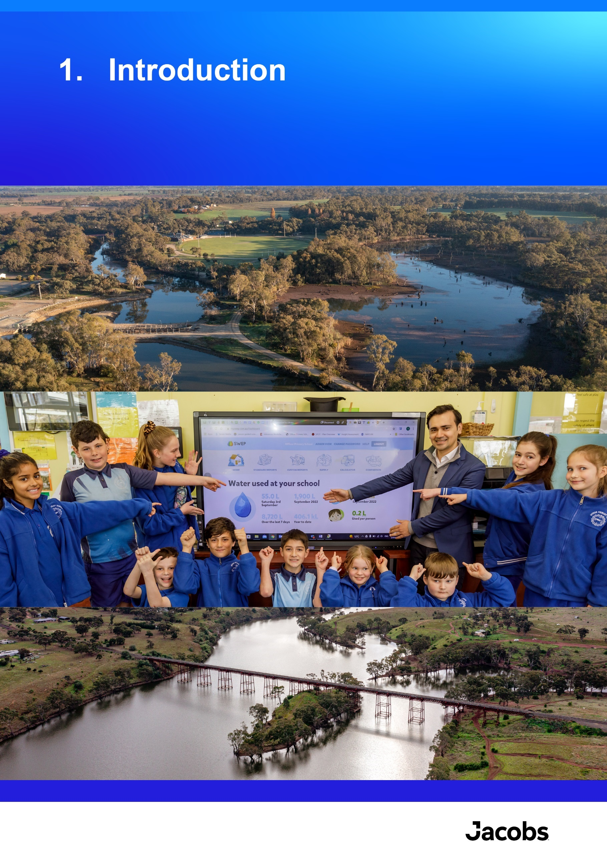

Introduction

Context
The Environmental Contribution (EC) was announced as part of the Victorian Government’s 2004 Our Water Our Future white paper and was legislated in 2004 through an amendment to the Water Industry Act 1994 (the Act). Funded through collection of a contribution from Victoria’s 18 water corporations, the EC is a key mechanism for the Victorian Government to deliver outcomes for the public good through promotion of, and actions to achieve, sustainable water management.
The revenue collected via the EC is held by the Department of Treasury and Finance and allocated to the Department of Energy, Environment and Climate Action (DEECA) as part of the annual state budget approval process. DEECA is responsible for managing the delivery of the EC, as well as annually reporting EC expenditure and undertaking a review of the EC at the end of each tranche of funding.
Table 1 provides definitions of the objectives of the EC as established in Part 9 of the Act.
Table 1. Definitions of the EC objectives
Legislated objectives | DEECA Approved definitions
Promote the sustainable management of water | To promote:  - Effective management of Victoria’s water systems for the present and future, or  - Efficient and effective use of Victoria’s water systems to better manage within the known limits of the resources, or  - The long-term resilience and security of Victoria’s water systems
Address adverse water-related environmental impacts | To prevent, remediate, mitigate, or offset:  - Adverse impacts on water-related environments arising from water extraction and associated infrastructure, or  - Processes that adversely impact on the health of water-related environments
The EC initiatives, which comprise multiple projects, are aimed at achieving the legislative purpose mentioned above and are guided by Victorian Government water management strategies. The first 3 of the 4-year ‘tranches’ of the EC funded most of the actions required to achieve the objectives of the 2004 Our Water Our Future strategy, and the fourth tranche was focused on delivery of the 2016 Water for Victoria strategy.
The collections for the first four tranches were as follows:
- tranche 1 (2004 to 2008) collected $226.5 million
- tranche 2 (2008 to 2012) collected $277.6 million
- tranche 3 (2012 to 2016) collected $405.3 million
- tranche 4 (2016 to 2020) collected $537 million.
The fifth 4-year tranche (EC5) commenced on 1 July 2020, with funding of $693.9 million. To guide investment decisions, DEECA undertook a strategic planning process, including identification of performance measures for EC5, investment priorities, and a strategic framework for the tranche. The resulting 14 initiatives were delivered through 38 projects, covering a range of water management priorities including:
- water security
- water efficiency
- waterway and catchment health
- Traditional Owner priorities
- inclusive management
- water governance.

Purpose and scope
Section 196 of the Act requires that a review of the operation of each tranche of the EC is conducted and that its conclusions are reported to the Minister. A phased approach was taken to evaluate EC5 as follows:
- End-of-third year EC5 evaluation (up to 30 June 2023) – previous report
- End-of-Tranche EC5 evaluation (up to 30 June 2024) – this report.
Table 2 sets out the objectives, evaluation domains and audience for each phase, showing that while the key evaluation domains are the same, each phase has separate objectives and audiences. The focus and key dimensions of the evaluation were discussed and developed as part of an Evaluation Plan prepared by Jacobs in early 2023. They align with common program evaluation domains outlined in the Commonwealth Evaluation Policy.
Table 2. Focus of the evaluations
 | Objectives and evaluation domains | Audiences
End-of-third year EC5 evaluation | To inform EC6 investment decisions through an understanding of:  - Progress made by projects to date towards achieving identified outcomes (Impact)  - Appropriateness, efficiency, effectiveness and legacy of project delivery  - Key lessons and opportunities from implementation to date | - Minister for Water  - Cabinet (evaluation findings will inform DEECA’s Cabinet submission for EC6)  - Central agencies – Department of Treasury and Finance and Department of Premier and Cabinet  - DEECA Secretary, Water and Catchments Deputy Secretary and executive leadership team, EC6 business case authors, EC5 initiative leads and policy/program teams.
End-of-Tranche EC5 evaluation | To provide accountability and transparency of investment and support continuous improvement through an understanding of:  - What has and has not worked across projects, and as a tranche of funding?  - Impact and achievement of outcomes  - Lessons and opportunities for the future | In addition to the audiences above, the End-Of-Tranche evaluation will be made publicly available, as part of DEECA's commitment to improve public reporting on the EC.  Delivery partners and other stakeholders, including CMAs, Traditional Owner groups, local councils, water corporations, Agriculture Victoria.

Structure of the report
This report is structured as follows:
- Section 2 explains the collection of EC5 funds and their allocation across initiatives and projects.
- Section 3 describes the evaluation approach and defines evaluation domains.
- Section 4 presents the findings on the progress of EC5 in achieving the intended outcomes (impact).
- Section 5 presents the findings on the extent to which projects were designed and delivered effectively (effectiveness).
- Section 6 presents the findings on the degree to which investments were appropriate and aligned with the legislated objectives (appropriateness).
- Section 7 presents the findings on how well delivery of EC5 has demonstrated efficient delivery and value for money (efficiency).
- Section 8 presents the findings on the extent to which EC5 impacts are expected to be sustained over time (legacy).
- Section 9 presents the conclusions and recommendations.
Appendix A contains summaries of the evaluation reports prepared by DEECA for the 38 projects and key aspects that are pertinent to the EC5 evaluation.
Appendix B supports Section 4 (impact domain) by summarising project level contributions to each of the EC5 outcomes.
Appendix C provides a graphical summary of the short answer questions from project evaluation reports
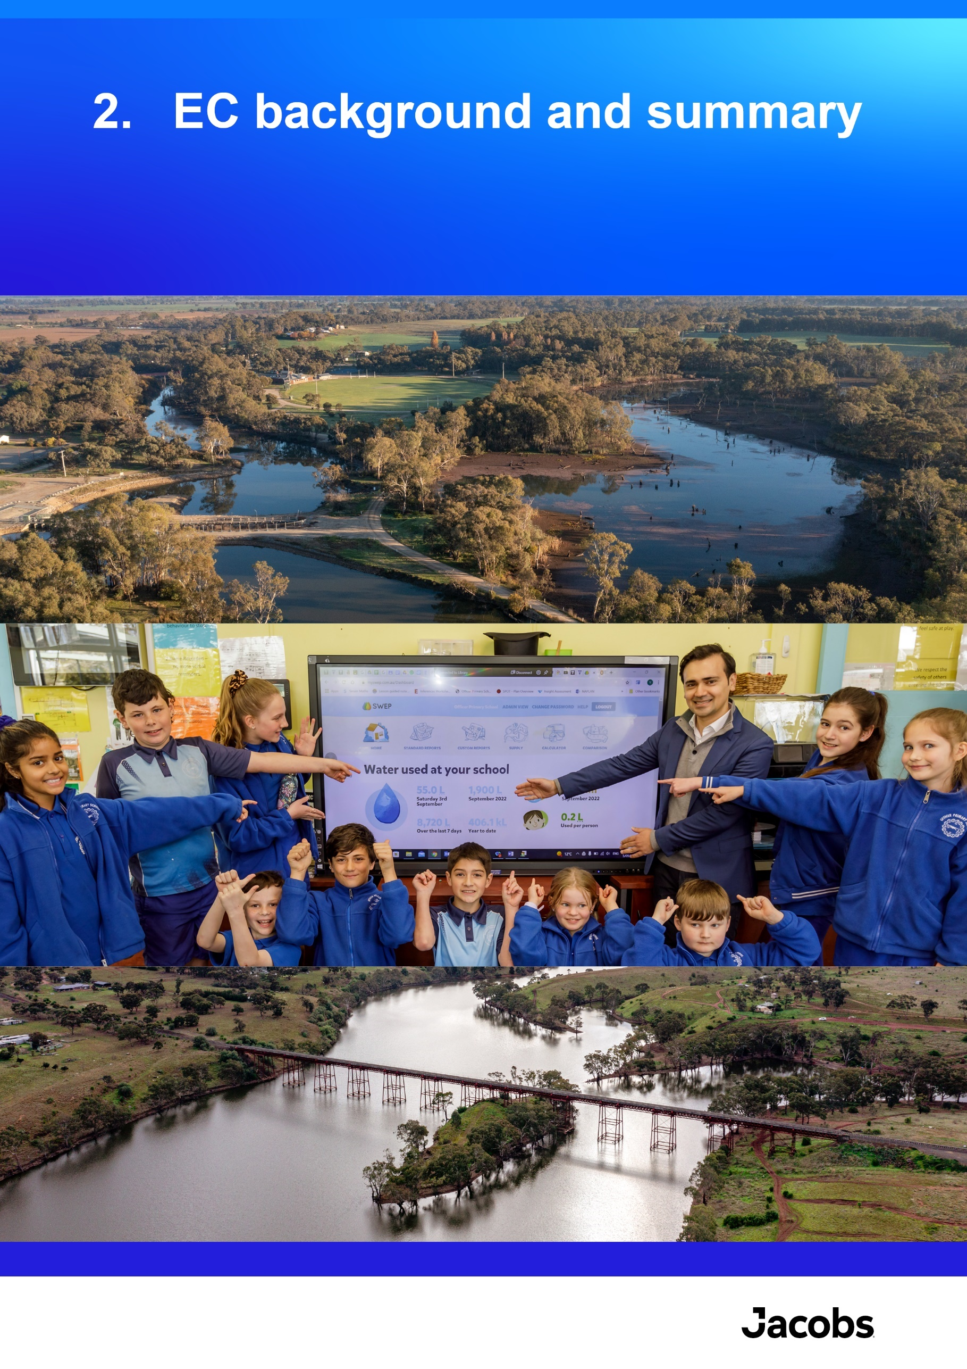

EC background and summary

Policy alignment
Funding allocated through the EC aligns with key Victorian water legislation and policies and the intended outcomes. The following legislation, policies and guidance documents guide investment decisions across the range of initiatives and projects that are funded under the EC, and which outcomes they are intended to contribute toward in the long-term:
- Water Industry Act 1994
- Water for Victoria (2016)
- Central and Gippsland Region Sustainable Water Strategy 2022 (CGRSWS)
- Water is Life: Traditional Owner Access to Water Roadmap (2022)
- DEECA portfolio priorities
- EC5 strategic plan/framework
- EC investment criteria.

Revenue collected
The EC is collected from water corporations based on their revenue. The amount of EC to be collected for each tranche is determined by a rate applied to each water corporation’s revenue in a specified base year. EC5 continued the historical rates of 2% of revenue for rural and 5% for urban water corporations, indexed to 2018-19 financial year audited revenue figures. This rate of 2% and 5% collected from rural and urban water corporations respectively has been applied for all EC tranches so far since the establishment in 2004.
The contributions to EC from each of the Victorian water corporations are presented in Table 3.
Table 3. Contributions to EC from revenue of Victorian water corporations
Water corporation | Contribution to the EC ($ million)
Water corporation | 2020/21 | 2021/22 | 2022/23 | 2023/24 | Total
Metropolitan Melbourne water corporations
Greater Western Water (formerly City West Water) | 29.843 | 33.912 | 33.912 | 33.912 | 135.647
Western Water* | 4.069
South East Water | 43.461 | 43.461 | 43.461 | 43.461 | 173.843
Yarra Valley Water | 47.430 | 47.430 | 47.430 | 47.430 | 189.720
Melbourne Water | 0.947 | 0.947 | 0.947 | 0.947 | 3.790
SUB-TOTAL | 125.750 | 125.750 | 125.750 | 125.750 | 503.000
Regional urban water corporations
Barwon Water | 9.598 | 9.598 | 9.598 | 9.598 | 38.393
Central Highlands Water | 4.472 | 4.472 | 4.472 | 4.472 | 17.889
Coliban Water | 5.734 | 5.734 | 5.734 | 5.734 | 22.937
East Gippsland Water | 1.654 | 1.654 | 1.654 | 1.654 | 6.614
Gippsland Water | 5.953 | 5.953 | 5.953 | 5.953 | 23.810
Goulburn Valley Water | 3.750 | 3.750 | 3.750 | 3.750 | 15.000
North East Water | 2.998 | 2.998 | 2.998 | 2.998 | 11.992
South Gippsland Water | 1.369 | 1.369 | 1.369 | 1.369 | 5.475
Wannon Water | 3.167 | 3.167 | 3.167 | 3.167 | 12.668
Westernport Water | 1.075 | 1.075 | 1.075 | 1.075 | 4.302
SUB-TOTAL | 39.770 | 39.770 | 39.770 | 39.770 | 159.080
Rural water corporations
Grampians Wimmera Mallee Water | 2.601 | 2.601 | 2.601 | 2.601 | 10.405
Goulburn-Murray Water | 2.577 | 2.577 | 2.577 | 2.577 | 10.309
Lower Murray Water | 2.251 | 2.251 | 2.251 | 2.251 | 9.005
Southern Rural Water | 0.530 | 0.530 | 0.530 | 0.530 | 2.121
SUB-TOTAL | 7.960 | 7.960 | 7.960 | 7.960 | 31.840
TOTAL ALL | 173.480 | 173.480 | 173.480 | 173.480 | 693.921
Source: DEECA
*Note: In mid-2021, Western Water and City West Water merged, forming a new entity named Greater Western Water.

Summary of EC5 investment
Table 4 shows the distribution of expenditure of the EC5 investment against the 14 initiatives and 38 projects to 30 June 2024. Note that some projects received funding from other fund sources, and a small proportion of initiative funding was appropriated for EC administrative costs.
Table 4. EC5 expenditure by project (approximate)
EC5 initiatives | Projects | EC5 Funding
- Enhancing urban water security, iconic urban waterways and recreational water | CWCT01: Integrated Water Management  (includes both Regional and Metro) | $28, 217,000
 | CWCT02: Iconic Urban Waterways Program | $17,128,000
 | CWCT03: Recreational Values Program | $5,840,000
 | CWCT04: Recycled Water, Stormwater and Onsite Wastewater Policy | $9,000,000
- Strong foundations for Victoria's water: compliance, markets, water entitlements and oversight of the water grid. Compliance and interceptions: protect reliability of water entitlements and maximise water resources for regional business and communities  (Water Compliance Project only) | WRS1: Retail Entitlements and Markets | $7,215,000
 | WRS2: Water Grid Oversight | $1,688,000
 | WRS3: Water Market Reform | $2,700,000
 | WRS4: Water Market Transparency | $448,453
 | WRS5: Managing Victoria’s Water Sharing Framework | $7,442,567
 | WRS6: Licensing framework groundwater and unregulated systems | $6,144,000
 | WRS7: Water Compliance Reform | $2,351,959
 | WRS8: Accounting for Water Recovery | $2,500,000
- Sustaining a Resilient and Secure Water Register for Victoria | WRS9: Water Register Operations and Improvements | $35,920,000
- The evidence base for Victorian water: availability and knowledge | WRS10: Understand and Apply Climate Science to Water | $5,280,000
 | WRS11: Surface Water Assessment and Modelling | $4,075,000
 | WRS12: Long-Term Water Resource Assessment | $2,355,000
 | WRS13: Groundwater Assessment and Modelling | $8,285,000
 | WRS14: Surface Water and Ground Water Monitoring | $26,631,000
 | WRS15: Water Accounting and Reporting | $2,332,053
 | WRS16: Knowledge and Insights | $703,000
- Making Victorians Water Wise | CWCT05: Water Efficiency Program | $11,140,000
- Water Wise Rural Communities: Rural-Infrastructure and Sustainable Irrigation Streams | SIRS1: Rural Water Infrastructure Project Oversight and Governance | $9,501,000
 | SIRS2: Sustainable Irrigation Program Implementation | $49,000,000
- Improving recognition and management of water by Traditional Owners and Aboriginal Victorians | CWCT06: Aboriginal Water Program | $24,373,000
- Building a Sustainable Water Sector | PSP1: Long-term Water Security | $7,103,000
- Building a Sustainable Water Sector | PSP2: Sustainable Water Strategies | $7,660,000
- Building a Sustainable Water Sector | PSP3: Mitigating the risks of small dams | $3,000,000
- Phase One Implementation of the Central and Gippsland Region Sustainable Water Strategy | CWCT07: CGRSWS Funding Stream 2 Diversify Water Sources and Increase Water Efficiency | $39,029,000
 | CWCT08: CGRSWS Funding Stream 3 Waterway Health Complementary Measures and Catchment Management Improvement | $9,975,000
 | PSP4: CGRSWS - Funding Stream 4 Enable Adaptation to a Variable Climate | $5,987,000
- Building flood resilience in Victoria | SIRS3: Building Flood Resilience in Victoria | $26,700,000
- Bendigo Groundwater Management | SIRS4: Central Bendigo Mine Rehabilitation Project - Groundwater | $4,353,000
- Improving the health of Victoria’s waterways and catchments in the face of escalating impacts of climate change  Supporting regional communities and economic recovery through healthy waterways | CWCT09: Waterway Health | $125,980,000
 | CWCT10: Environmental Water | $67,194,000
 | SIRS6: Murray Programs | $7,000,000
 | CWCT11: Our Catchments Our Communities Program | $21,750,000
- Macalister Irrigation District Modernisation Project - Phase 2 | SIRS5: Macalister Irrigation District (MID) Modernisation Project - Phase 2 | $10,930,000
- Resilient Water Markets, Regional Communities, and Infrastructure | WRS19: Resilient Water Markets, Regional Communities, and Infrastructure (Stream 1 and 2) | $5,589,000
Source: DEECA

Summary of key outputs of EC5 investment
A summary of some of the key outputs for each initiative is provided in Table 5. More detailed descriptions of the outputs are presented in the project evaluation summaries in Appendix A.
Table 5. Examples of key outputs from the EC5 investment
EC5 projects | Examples of key outputs
CWCT01: Integrated Water Management | Facilitation of 15 Integrated Water Management (IWM) Forums, policy reforms, capacity building, co-investment program for project implementation, Collaborative IWM Forum strategic plans, including Strategic Direction Statement refreshes in regional Victoria and the Catchment Scale IWM Plans and Action Plans in Metro Melbourne, construction and improvement of wetlands and ecological restoration works.
CWCT02: Iconic Urban Waterways Program | Burndap Birrarung burndap umarkoo – the Yarra Strategic Plan (YSP), Action Plans - Waterways of the West and Rivers of the Barwon (Barre Warre Yulluk), delivery of priority projects, annual reporting, policy development to recognise iconic waterways as living entities and Traditional Owners as their voice, Green Links Grants Program (Round 1).
CWCT03: Recreational Values Program | Management of COVID-19 response across 40 recreational areas, policy work for recreation at storages, grants program, progressed opening Tarago Reservoir to on-water recreation, development of new Recreational Area (Water) Regulations 2023, Greens Lake Action Plan, Flagship Water Wannon, and better linkages between DEECA, the water sector, Traditional Owners and relative government portfolios for collaboration.
CWCT04: Recycled water, stormwater and onsite wastewater policy | Update of regulatory guidelines and frameworks, guidance to partner agencies regarding recycled, stormwater and wastewater management.
WRS1:  Retail Entitlements and Markets | Market monitoring and information, governance, entitlements and legislation to support reform including place of take framework.
WRS2: Water Grid Oversight | Delivery of the forward review of resources and the Water Grid Biennial Statement. Undertook stress testing of the Water Grid as part of the Water Sector Climate Change Adaptation Action Plan and Urban Water Strategies.
WRS3: Water Market Reform | Reform options for improving water sharing arrangements in South-Central Victoria, new Ministerial Trading Rules for unregulated systems, removal of ‘20% rule’ for downstream trades in unregulated systems
WRS4: Water Market Transparency | Published water market information while protecting privacy, working with other jurisdictions and the Commonwealth to facilitate trade, provided feedback on the Water Act 2007 (Cth) amendments and Water Amendment (Restoring our Rivers) Act 2003, social research project into barriers to trade in the South West Limestone Aquifer Groundwater Management Area.
WRS5: Managing Victoria’s Water Sharing Framework | Delivery of adaptive and contemporary bulk entitlement and environmental entitlement framework within regulatory guidelines.
WRS6: Licensing framework groundwater and unregulated systems | Maintenance of management and licensing framework for groundwater and unregulated systems, publication of Groundwater Management 2030 (GM2030), licensing review and reform.
WRS7: Water compliance reform | Creation of a statewide regulatory regime to reduce unauthorised take and allow for improved compliance and enforcement, embedded key performance indicators for rural water corporations, telemetry installations and meter upgrades.
WRS8: Accounting for Water Recovery | Independent audit and reviews of water recovery projects, translating the water recovery into water entitlement volumes and reliabilities, creation, and distribution of water shares.
WRS9: Water Register Operations and Improvements | Transition of the Victorian Water Register to a new technology platform and delivering operational requirements.
WRS10: Understand and Apply Climate Science to Water | Guidelines for Assessing the Impact of Climate Change on Water Availability in Victoria, communications products, engagement.
WRS11: Surface Water Assessment and Modelling | Transitioning models to a new platform and updating capabilities to meet the needs of Victoria.
WRS12: Long-Term Water Resource Assessment and Addressing the impacts of mining and extractive industries | Inclusion of actions within the SWS that address findings of Long-Term Water Resource Assessment, preliminary method for the Long-Term Water Resource Assessment for northern Victoria, 2023 Latrobe Valley Regional Rehabilitation Strategy (LVRRS) Amendment review and supporting outputs.
WRS13: Groundwater assessment and modelling | State-wide review of sustainable yields for groundwater systems and assessment of sustainable use, refurbishment and construction of bores, provision of specialist advice.
WRS14: Surface Water and Ground Water Monitoring | Operation and maintenance of 1015 surface water and 1400 groundwater sites, site upgrades, upgrades to water monitoring information systems, Regional Water Monitoring Partnership program, new contracts, delivery of five-yearly analysis of Victoria’s surface water.
WRS15: Water Accounting and Reporting | Upgrade of the Victorian Water Account Platform, business-as-usual functions.
WRS16: Knowledge and insights | Water Market Watch app, video content, curriculum-aligned educational content, Building a Better Victorian Water Register Website, enhanced Victorian trade communications to water market participants
CWCT05: Water Efficiency Program | Water efficiency support (water use monitoring, leak alert service, data visualisation) and education materials to schools, delivery of water efficiency rebates to customers in vulnerable and hardship situation and not-for-profit emergency housing organisations, Smart Water Advice portal, updating and promoting Target 155 to Target 150 and Victoria’s contribution to the Commonwealth’s Water Efficiency Labelling Standards (WELS) scheme.
SIRS1: Rural water infrastructure project oversight and governance | Secured funding for strategic rural water infrastructure projects across 33 projects totalling approximately $996 million.
SIRS2: Sustainable Irrigation Program Implementation | Irrigation frameworks, Wise Water Use and Best Practice, irrigation drainage and management, salinity compliance with Murray Darling Basin Agreement, Murray Darling Basin Plan water recovery program implementation and monitoring, evaluation and reporting, rural water policy reforms.
CWCT06: Aboriginal Water Program | Facilitation of Aboriginal Water Officer Network, delivery of Water is Life: Traditional Owner Access to Water Roadmap, employment of 24 Aboriginal Water Officers, partnerships with Traditional Owner organisations.
PSP1: Long-term Water Security | Updated Urban Water Strategy Guidelines and oversaw the 2022-2027 Urban Water Strategy updates, commenced review of urban water planning arrangements, Water Sector Circular Economy Action Plan, research projects, global collaboration.
PSP2: Sustainable Water Strategies | Delivery of the CGRSWS, the implementation plan, and a monitoring, evaluation and reporting framework.
PSP3: Mitigating the risks of small dams | Designs and on-ground works to rehabilitate Goldfields dam, Baxter Park dam and the large dam at Traralgon Railway Reservoir Conservation Reserve; upgrades to dam safety portal.
CWCT07: CGRSWS - S2 Diversify water sources and increase water efficiency | Investment in 17 IWM projects, delivery of WaterSmart across all 10 CGRSWS urban water corporations, Victorian urban water efficiency behaviour change initiatives.
CWCT08: CGRSWS - S3 Waterway Health complementary measures and catchment management improvement | Planning and governance of Lower Latrobe Wetlands, Maffra Weir Fishway, Moorabool channel lining and Werribee diversion weir activities, implementation of regional catchment strategy including capacity building works and contribution to CMA priority activities.
PSP4: CGRSWS - S4 Enable adaptation to a variable climate | Trial framework to understand algal risks, trial to calculate benefits of efficient showerheads, progress towards Water Cycle Adaption Action Plan term.
SIRS3: Building Flood Resilience in Victoria | Building Flood Resilience in Victoria program, Victorian Floodplain Management Strategy Implementation, 24/7 activation of FloodZoom in response to flood events.
SIRS4: Central Bendigo Mine Rehabilitation Project - Groundwater | Delivery of long-term solution to prevent mine-impacted groundwater discharges in Central Bendigo, secured funding for solution implementation.
CWCT09: Waterway Health | Delivery of 459 waterway structures, 331.5 km of fencing, 35,465 ha of vegetation and weed control, and 482 management agreements between CMAs and landholders, processing of >30,000 waterway licenses/permits, flagship waterway projects, citizen science programs, monitoring programs and waterway management policies.
CWCT10: Environmental Water | Over 3,212 GL of water for the environment delivered to priority rivers and wetland sites throughout the state: 161 sites in 2023-24, 154 sites in 2022-23, 170 sites in 2021-22, and 225 sites in 2020-21.
SIRS6: Murray programs | Traditional Owner partnerships, 48 Aboriginal waterways assessments, development of monitoring, evaluation, reporting and improvement plans and ecological data base.
CWCT11: Our Catchments Our Communities Program | Renewal of regional catchment strategies, on-ground stewardship programs, engagement events, planning and regulation.
SIRS5: Macalister Irrigation District Modernisation Project - Phase 2 | Treatment of approximately 80 km of leaky channels, construction of 34 km of pipeline and decommissioning of 50 km of old channels resulting in water savings used for agriculture and the environment.
WRS19: Resilient Water Markets, Regional Communities and Infrastructure (Stream 1 and 2) | Victorian implementation of an interstate broker regulation scheme that delivers an agreed interstate standard of conduct, conduction of environmental cultural and recreational assessments.

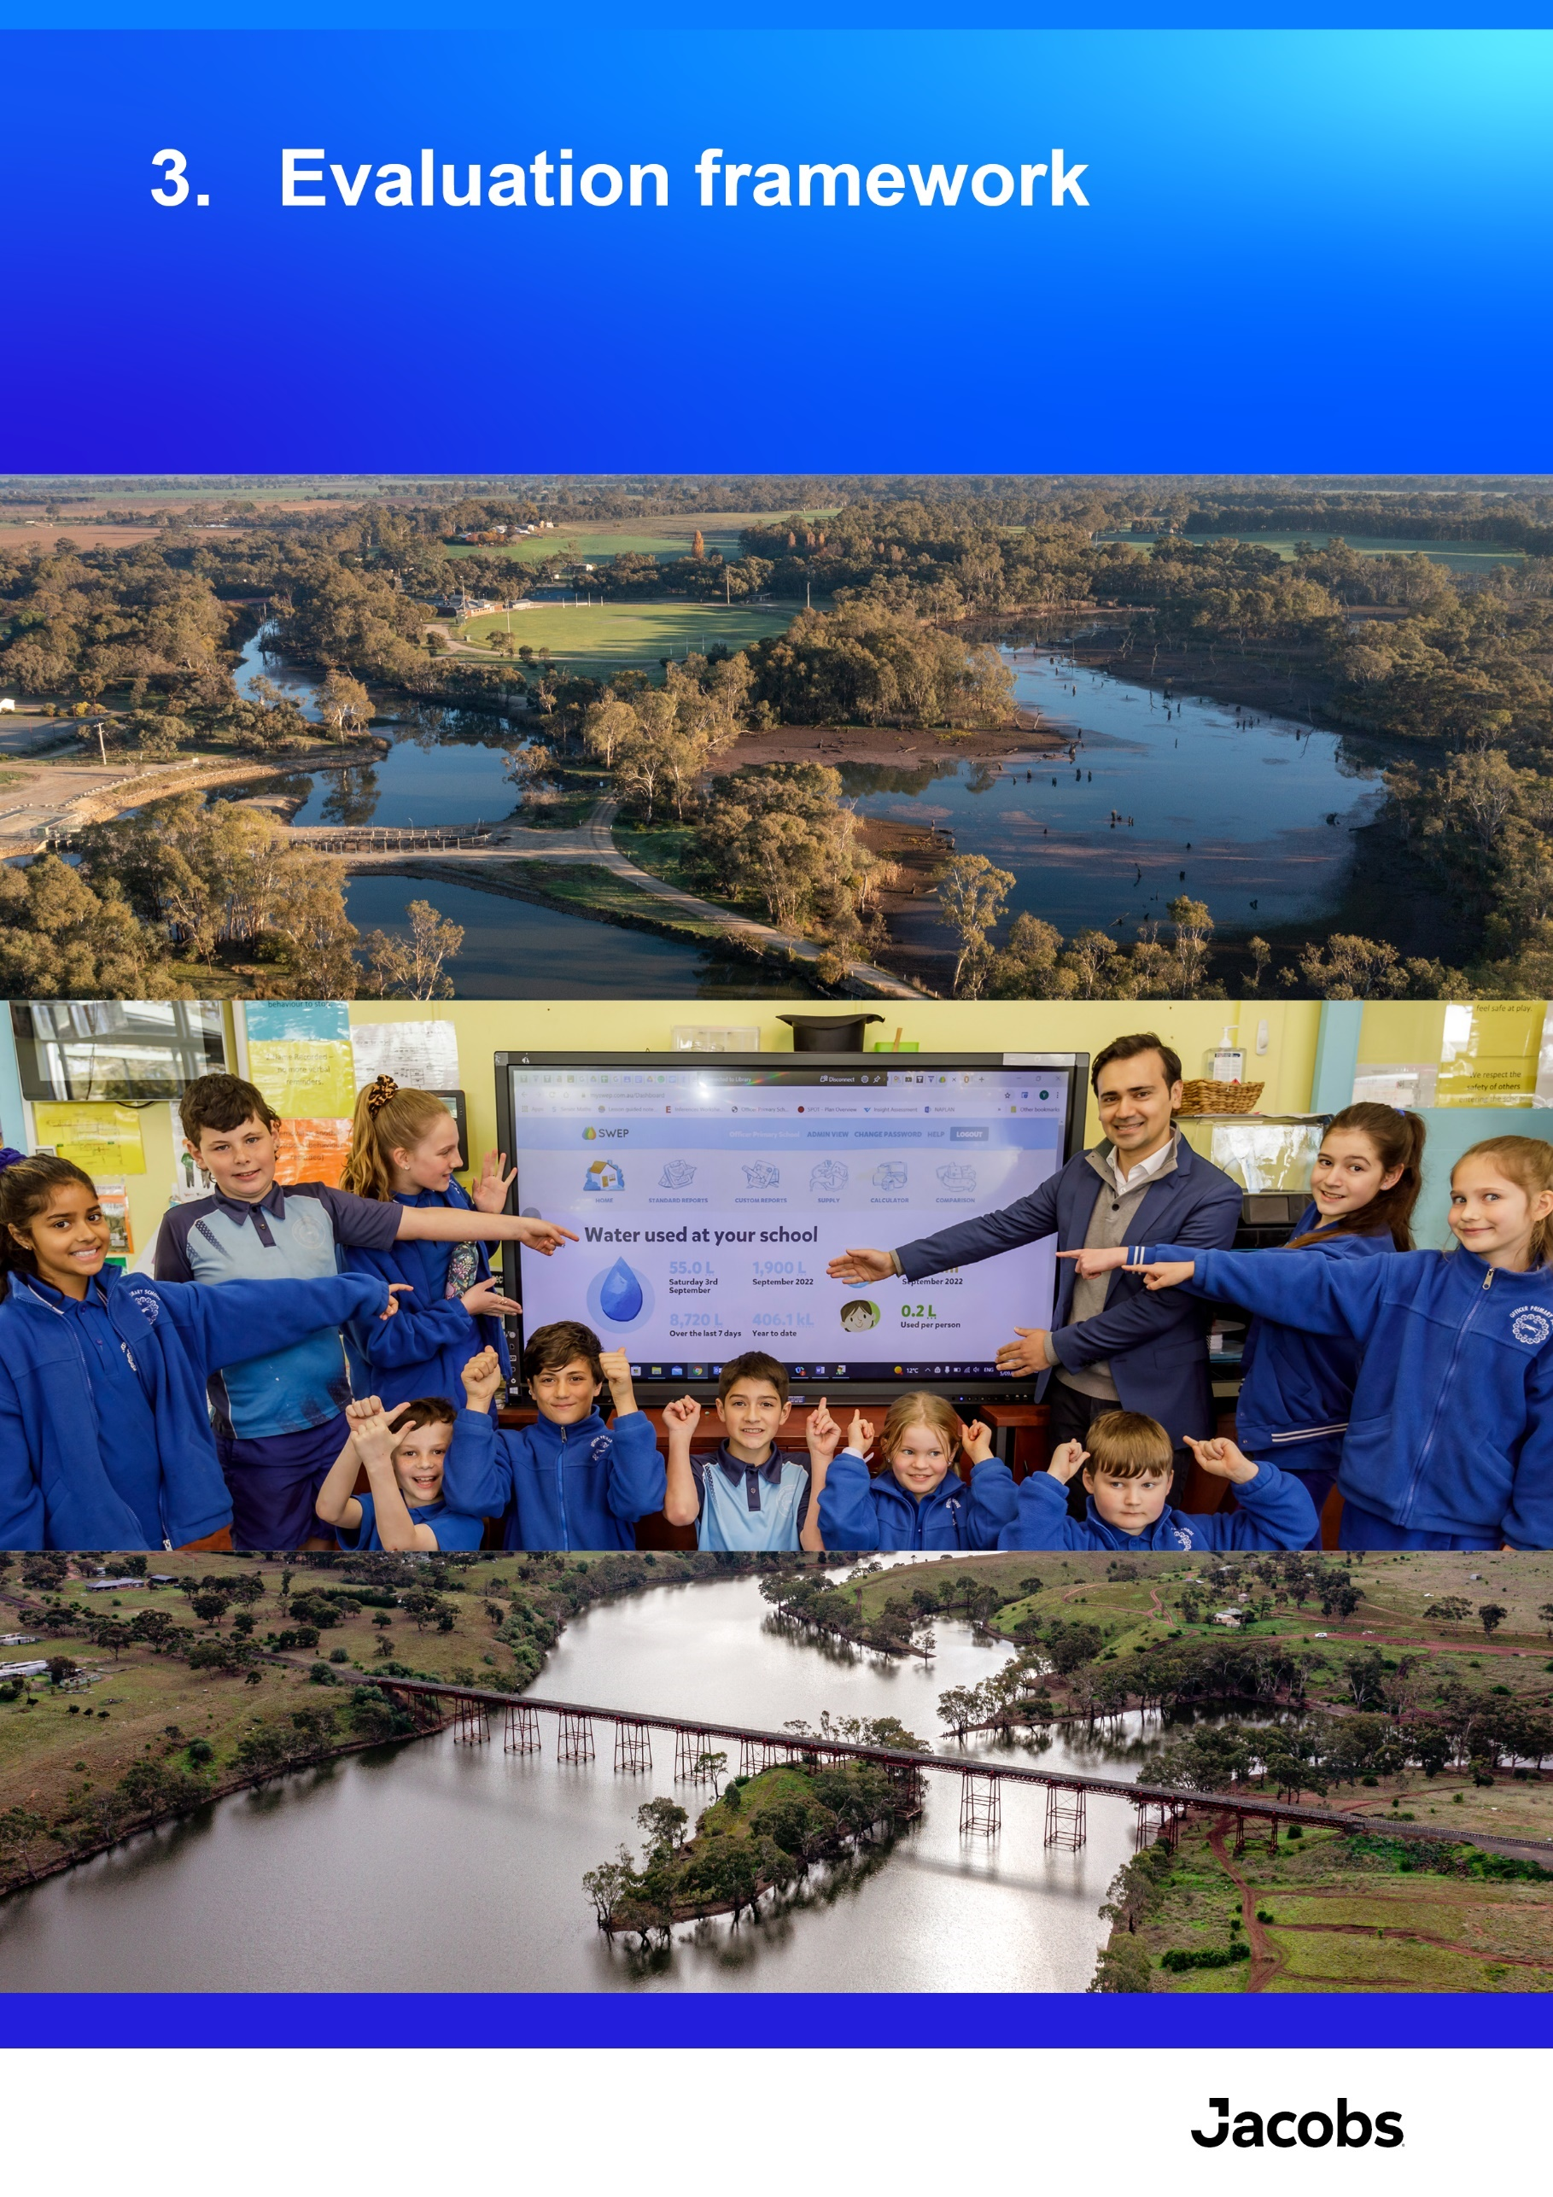

Evaluation framework

Overview
The framework adopted for this evaluation provides a consistent and systematic approach for evaluating the EC at both the project level and for the whole of EC5. The framework embeds common evaluation concepts into each EC funded project from its commencement. It ensures that all projects have an evaluation plan (based on an evaluation plan template and guidelines) and program logic in place, which is reported against annually, and provides a work plan for evaluation of the EC at the end of project funding.
As explained in Section 1.2, the EC5 evaluation comprised 2 phases:
- An evaluation of the progress made by each project up until end of June 2023 (previous report) primarily focused on informing the investment strategy and Cabinet submission to endorse the establishment of EC6.
- An end of program evaluation (this report), which builds on the findings presented in the previous report and fulfills the requirement of Section 196 of the Act and the EC5 governance requirements.

Methods and approach
A plan for evaluation of the tranche (the ‘EC5 evaluation plan’) was developed by the Jacobs’ evaluation team, with input from DEECA and endorsement by the EC5 Project Control Board. Project teams developed evaluation plans for the 38 projects invested in over the tranche (initially for the third year evaluation, then updated for the End-of-Tranche evaluation). These plans included program logics and specific Key Evaluation Questions (KEQs), with evaluation reporting provided by project delivery teams. As part of evaluation planning for the EC5 evaluation, the Jacobs’ project team held an evaluation knowledge sharing session focused on explaining and clarifying key evaluation concepts, and small group sessions were offered to all project leads to assist with consistent and high-quality project level evaluation and reporting.
The project evaluation reports were complemented by interviews with key project leads and DEECA leadership. Both data sources were used in the EC5 evaluation. The evaluation addressed KEQs described in the EC5 evaluation plan, supported by responses to KEQs provided at the project level. This approach was undertaken by DEECA to ensure that all components of each of the 38 projects were captured in the most logical way to enable effective evaluation across EC5.
The EC evaluation framework treats the project evaluation plans and EC5 evaluation plan as separate but interrelated components. The EC5 evaluation assesses the aggregated achievements of the funded projects, capturing the integrated nature of the projects in collectively meeting the EC objectives. These interrelationships are represented in the EC5 program logic. This integration is required because the functions of the individual projects are not discrete; many inform one another or go on to provide support or foundational components for the broader water sector in Victoria. The EC5 evaluation plan acknowledges and, in part, describes these complexities and interrelationships.
The process for the EC5 evaluation is summarised in Figure 1.

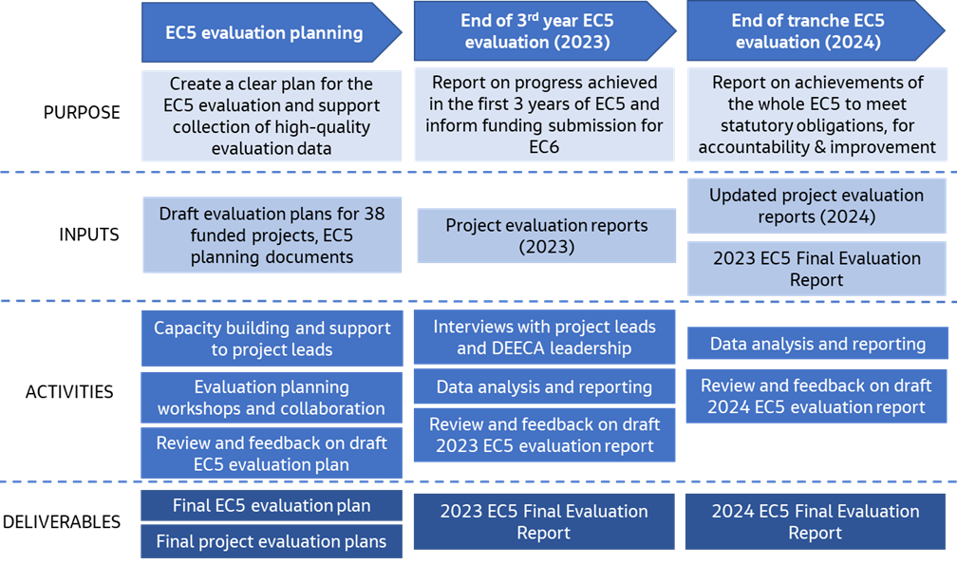
Figure 1. Process for the EC5 evaluation

Program logic
The program logic summarises the ‘theory of change’ for EC5 and provides a visual guide to tell the story of how EC5 funded projects collectively contribute to the statutory, long-term objectives.
This program logic is specific to EC5, with outcomes focused on the changes expected by the end of the tranche, based on the planned progress of the projects. It forms a basis for evaluation of the EC5 by setting the scene for EC5’s contribution to longer term outcomes. The program logic is shown in Figure 2, and Table 6 provides a description of the program logic hierarchy components.
Table 6. Program logic hierarchy of terms and descriptions
Program logic element | Description
Long-term outcomes | Bigger picture goals the EC outcomes contribute to as specified in the Act
Outcomes: End-of-Tranche 5 | Intended effects or changes resulting from EC5, expected by the end of the 4-year tranche 5 funding
Outputs | Products or deliverables that result from project activities. These can be biophysical (such as on-ground works or assets), or non-biophysical (social, institutional, cultural, or economic changes)
Activities | Actions, events, and processes undertaken

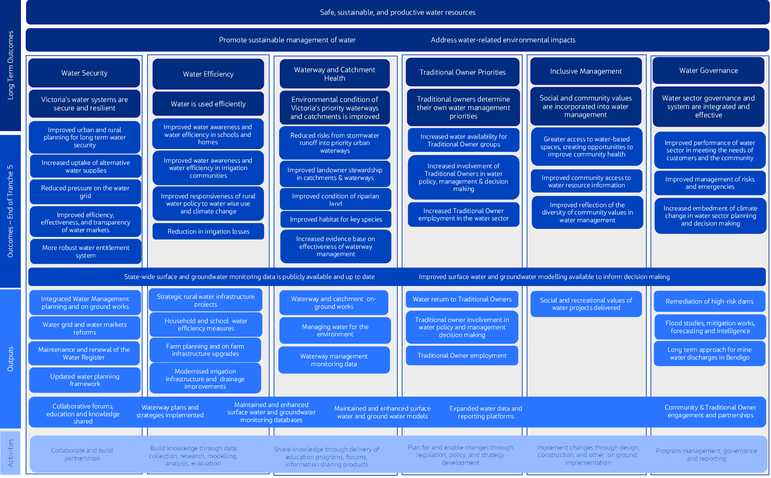
Figure 2. Program logic for EC5 Evaluation

Evaluation domains and key evaluation questions (KEQs)
Five evaluation domains were used to meet the evaluation objectives. The key questions and sub-key questions for each of the evaluation domains are presented in Table 7.
Table 7. KEQs and associated sub-questions
Domains and KEQs | Sub-questions
Impact
To what extent did EC5 achieve the desired outcomes? | - Water security: What progress has been made toward secure and resilient water systems?  - Water efficiency: What progress has been made toward efficient water use?  - Waterway and catchment health: How have risks to priority waterways and catchment health been reduced?  - Traditional Owner priorities: To what extent were Traditional Owner priorities furthered?  - Inclusive management: To what extent were social and community values incorporated into water management?  - Water governance: To what extent was the effectiveness of water governance improved?  - To what extent has ongoing, foundational work, supported other programs and improved data availability and decision-making?  - What unintended outcomes (positive or negative) have arisen?
Effectiveness
To what extent was EC5 designed and delivered effectively? | - What worked well and did not work well about the way EC5 was delivered?  - To what extent did funding support the adaptation of projects in response to changing contexts? (For example, COVID-19 pandemic, floods, bushfire)  - To what extent did projects develop and work in partnership with other parts of government, other organisations, and community?
Appropriateness
How suitable were the EC5 investments given the intended objectives? | - To what extent was funding allocated in line with the legislated objectives of the EC and guided by key water management strategies?  - To what extent did EC funded projects use monitoring and evaluation data to improve management (adaptive management)?
Efficiency
To what extent has EC5 demonstrated efficiency and value for money? | - How has EC5 demonstrated efficiency through delivery?  - To what extent were efficiencies gained through working together with others to achieve better outcomes?  - Have initiatives leveraged additional funding sources and in what way was this leverage applied?  - What evidence is there of initiatives undertaking options assessment and/or cost-benefit analysis of approaches?
Legacy
- To what extent are impacts expected to be sustained over time?

Performance assessment scale
Figure 3 shows the performance assessment scale used for evaluating the impact domain. The performance assessment scale provides a qualitative assessment of how EC5 has performed against the intended outcomes. The intended outcomes for EC5, and over the long-term, are shown in the EC5 program logic (presented in Section 3.3) and are the benchmark for the assessment.
The purpose of the performance assessment scale is to support the accompanying evaluation narratives, enable findings to be concisely summarised, and communicate clearly where there are areas for improvement.
The EC investment is complex, spanning a broad range of priorities and involves initiatives and projects that are operating at a range of maturity levels, which are influenced by the EC priorities and progress made in past tranches. To address this complexity, two metrics have been used to distinguish between:
- The extent to which the end-of-EC5 outcomes were achieved (from the beginning of EC5 tranche period to the End-Of-Tranche)
- The overall level of progress toward achieving the long-term outcomes (through EC5 and earlier EC tranches).
Rating | Extent to which end-of-EC5 outcomes were achieved |  |  |  |  | Overall progress toward long-term outcomes
Rating | Very low | Low | Medium | High | Very high | Very low | Low | Medium | High | Very high
Figure 3. Performance assessment scales

Limitations of the analysis
Limitations on the evaluation included:
- There are complex interdependencies across EC tranches and the broader context in which EC investment occurs: Each subsequent tranche will support the achievement of benefits from previous tranches. That is:
  - works undertaken in subsequent tranches help preserve the benefits achieved in earlier tranches; and
  - the works and benefits from subsequent tranches are dependent on the works and benefits achieved in earlier tranches.
Also, there are multiple drivers for the outcomes that the EC is contributing toward. These include influences and achievements from other programs, changes to policies and government priorities, and other externalities not funded under the EC. Quantitative assessment of these interdependencies is complex and beyond the scope of the evaluation.
- An economic assessment was beyond the scope of this evaluation: While this evaluation reported on efficiency, the scope did not include an economic assessment. This means evaluation of efficiency and value for money is qualitative only and does not quantitatively compare the value of investment to the benefits achieved. However, some of the projects undertook economic assessments as part of the investment cycle and the outcomes of these were reviewed as part of the project evaluations. Monetisation of many of the values the EC supports have traditionally been complex (such as environmental and social values), although new methods and techniques are increasingly being used to analyse these.
- Relying on qualitative data: The main source of information used for this evaluation was project evaluation reports developed by DEECA project leads. These were comprehensive and have undergone internal reviews within DEECA prior to their use in the evaluation; however they were of variable quality, with some reports reflecting the purposes of the evaluation better than others. Improvements were made in the reporting process that was used for the third year evaluation, to improve the efficiency and reliability of information provided for the End-Of-Tranche evaluation. Many project evaluation reports used quantitative evidence, where possible, to demonstrate achievements, however there was still significant reliance on qualitative information where quantitative evidence did not exist.

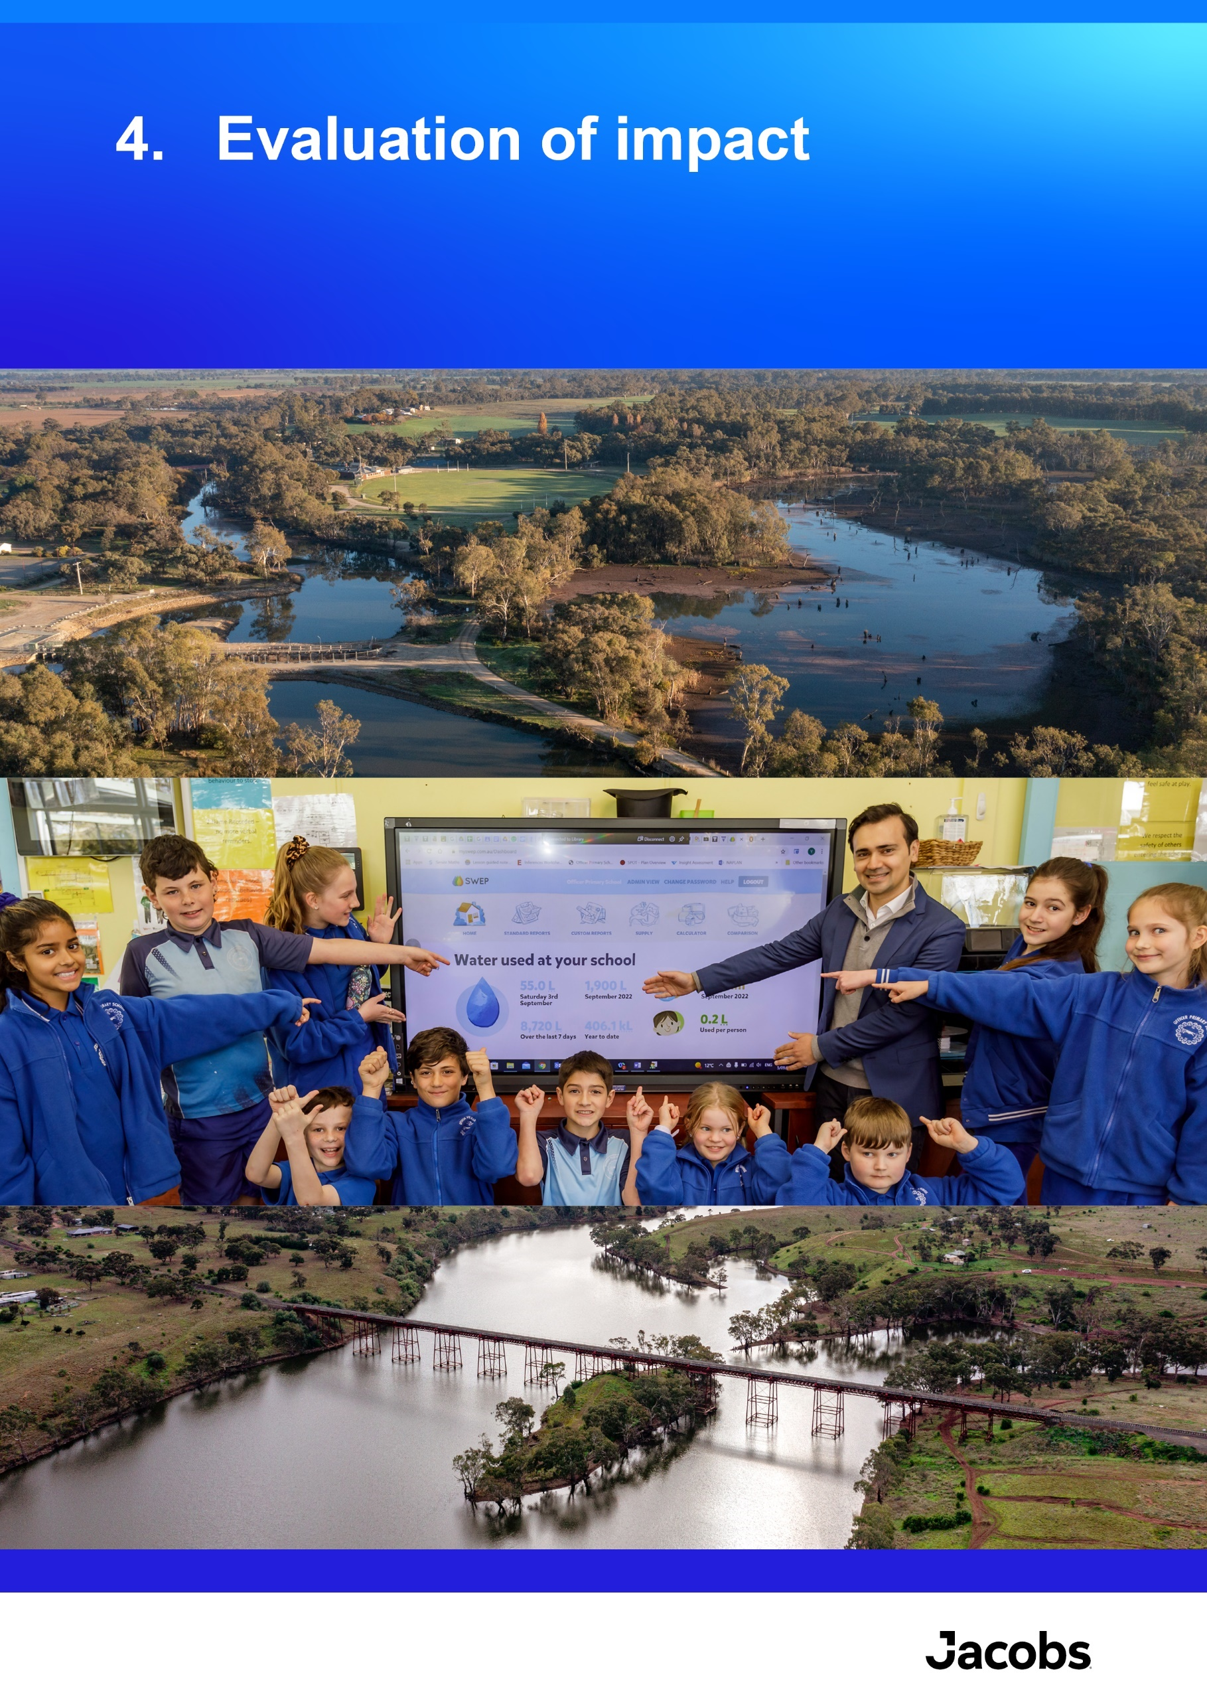

Evaluation of impact
Key findings
- Overall achievements: Over the 4 years of EC5, a broad range of positive outcomes for the environment, communities, and industries throughout Victoria have been achieved. A key driver of these achievements was the way in which EC5 initiatives either built on or extended work started in EC4 or earlier tranches. This is supported by evidence of completion of the planned works and outcomes assessments in the detailed project evaluation reports prepared by DEECA project teams. Several projects had to adapt the planned activities throughout the tranche due to changes in sector priorities, delays or to accommodate impacts from unforeseen events (such as COVID-19, floods, bushfires), or project complexities and resourcing issues. These changes were acknowledged and described in the project evaluation reports and were part of the expected evolution of project delivery over the four-year timeframe.
- Water security: EC5 delivered a suite of projects to improve Victoria’s ability to plan for long-term water security. The development of the CGRSWS, and associated implementation works, were key achievements of EC5. The CGRSWS identified the opportunity for the region to shift away from reliance on river water and move towards climate-resilient, manufactured water to augment the region’s water supplies. Options included fit-for-purpose recycled water, treated stormwater and desalinated water. A range of on-ground works, designs, and planning for uptake of diverse water supplies were delivered, representing a shift from primarily policy and planning (in EC4) toward increasing implementation to achieve water security. A suite of reviews, planning processes, reform and technology improvement works were implemented to reduce pressure on the water grid, improve functioning of water markets, and enhance Victoria’s water entitlement framework. A summary of the performance assessment for this outcome is shown below:
Rating type | Rating | Rationale
Extent to which end-of-EC5 outcomes were achieved | Medium | Publication of the CGRSWS and associated implementation works, and a suite of reform works represent key achievements against the end-of-EC5 outcomes. Some aspects experienced changes in approach which resulted in delays to achievement of planned outcomes for EC5 and will flow through into EC6. For example, the development of a renewed Victorian Water Register platform will be part of EC6.
Overall progress toward long-term outcomes | Medium | Investment through previous EC tranches and other programs has maintained or increased water security in many systems throughout Victoria. Continued work is needed to maintain current water security and build resilience in the face of multiple stressors, such as population growth and a variable and changing climate.
- Water efficiency: Water efficiency outcomes were delivered in multiple Victorian communities, including schools, urban households, irrigators and regional communities. Several water efficiency programs have provided significant water savings, water awareness, and cost-saving benefits with 0.298 GL of water saved in households and community housing properties through the Community Retrofit Program (CRP) and Community Housing Retrofit Program (CHRP), and 1.9 GL saved in schools through the Schools Water Efficiency Program (SWEP) over the investment period. Smart Water Advice portal provided water saving tips to households and businesses and Target 155 was reinvigorated to Target 150. Victoria’s contribution to the Commonwealth’s WELS scheme resulted in 4 GL of water savings. Irrigators are more prepared for a future with reduced water availability through the provision of educational tools, knowledge, and farm planning support. Irrigation losses are on track to be reduced by up to 10.3 GL annually, through modernisation of over 80 km of irrigation in the Macalister Irrigation District (upon project completion in EC6). A modern risk-based compliance and enforcement framework was implemented to manage unauthorised take of water. A summary of the performance assessment for this outcome is provided shown below.
Rating type | Rating | Rationale
Extent to which end-of-EC5 outcomes were achieved | High | EC5 continued a range of initiatives focused on improving water efficiency in schools, homes, rural communities and irrigation districts, for which water savings were monitored and quantified. Work to improve regulation of water use compliance was a key achievement of EC5.
Overall progress toward long-term outcomes | Medium | Prior investment in rural water infrastructure has created the gains in improved irrigation efficiency. However, continued investment and ongoing work is needed to realise the remaining opportunities. Urban water efficiency varies due to multiple factors and there is more work needed to achieve Melbourne’s per capita water use targets.
- Waterway and catchment health: Strong progress was made in improving the health of waterways and catchments throughout Victoria, with the continuation and extension of several long-term projects. EC5 enabled a suite of 52 IWM projects, including stormwater harvesting, recycled water and rainwater harvesting projects which – when completed – will result in significant stormwater pollution reduction. Over 46,764 ha of place-based, on-ground catchment stewardship projects were delivered, along with 35,465 ha of waterway vegetation improvement works across priority sites. The Flagship Waterway projects were also continued and expanded such as with the Jan Juc daylighting project and a commitment to deliver 88 projects from the YSP, focused on protecting and enhancing Birrarung (Yarra River) and its parklands. Over 3,212 GL of water for the environment was delivered to 161 rivers and wetlands sites in 2023-24, 154 sites in 2022-23, 170 sites in 2021-22, and 225 sites in 2020-21. While environmental outcomes generally take time to accrue following investment in waterway health projects, monitoring programs are beginning to show long-term positive environmental changes associated with works from EC5 and earlier tranches, building a strong evidence base. This includes the recording of significant colonial waterbird breeding at sites that received water for the environment and natural flooding. A summary of the performance assessment for this outcome is shown below.
Rating type | Rating | Rationale
Extent to which end-of-EC5 outcomes were achieved | Very High | The health of waterways and catchments throughout Victoria were improved, with the continuation and extension of several long-term projects. Increased implementation of IWM initiatives, delivery of a large volume of vegetation and habitat improvement works, environmental water delivery, and delivery of actions from the YSP were strengths of EC5. An increased evidence base was also developed for ecological improvements resulting from waterway management works.
Overall progress toward long term outcomes | Medium | Prior EC tranches have invested significantly in waterway and catchment health, and while environmental outcomes generally take time to accrue following investment, there is emerging and strengthening evidence of environmental benefits from EC investments. Ongoing investment is required to continue to address significant remaining environmental degradation amid continued stressors.
- Traditional Owner priorities: Over EC5,frameworks and strategies have increasingly considered and included Traditional Owner priorities and support Traditional Owner participation. The publication of Water is Life: Traditional Owner Access to Water Roadmap and the CGRSWS in 2022 were key achievements of EC5. Both documents include standalone Traditional Owner contributions (27 Traditional Owner Nation Statements in Water is Life, and Chapter 6 of the CGRSWS) and represent a policy shift that provides new guidance and policy direction for the inclusion of Traditional Owners in the management of Victoria’s water resources. Continuation and modest growth in the Aboriginal Water Program means there are now 24 Aboriginal Water Officers, plus dedicated funding for Traditional Owner-led water-related projects across 18 Traditional Owner groups (including the all Registered Aboriginal Parties) and 4 CMAs, to strengthen Traditional Owner capacity and enable greater consideration of Traditional Owner priorities and involvement in the way water is managed and delivered in Victoria. Continued investment is needed into EC6 to successfully implement the actions from Water is Life and CGRSWS, and meaningfully embed Traditional Owner involvement, values and principles of self-determination throughout EC projects and the broader Victorian water sector. A summary of the performance assessment for this outcome is shown below.
Rating type | Rating | Rationale
Extent to which end-of-EC5 outcomes were achieved | Very High | The publication of Water is Life in 2022 was a key achievement of the EC5 tranche, representing a policy shift that provides new guidance and policy direction for the inclusion of Traditional Owners which has the potential to deliver tangible outcomes and staged systemic change. Within EC5, the inclusion of Traditional Owners was increasingly integrated into project frameworks and strategies. With increased responsibilities and obligations to include Traditional Owners in water management, new challenges are emerging relating to resourcing and the availability for Traditional Owner organisations to balance and engage with competing priorities, and to exercise self-determination in water management.
Overall progress toward long-term outcomes | Low | There remains significant work to be done to successfully implement the actions from Water is Life, and meaningfully integrate Traditional Owner involvement, values and principles of self-determination throughout EC projects and the broader Victorian water sector. While important progress has been made through EC5, there is still a large gap between the current level of Traditional Ownership self-determined participation and the long-term outcome.
- Inclusive management: The EC5 projects were inclusive of social and community values, with 87% of the projects reporting that they are increasing community participation and inclusion of community values in water management. New Recreational Area (Water) Regulations 2023 were developed to manage recreation at storages, recreational values will be embedded in the new Victorian Waterway Management Strategy, and $2.89 million of grants funds were distributed to support 19 projects focused on improving recreational outcomes. New technology platforms and communications products were developed for improved community and sector access to information. A summary of the performance assessment for this outcome is shown below.

Rating type | Rating | Rationale
Extent to which end-of-EC5 outcomes were achieved | High | The EC5 projects continued being inclusive of social and community values. Key features of EC5 were a focus on managing recreation at Victoria’s water storages, projects focused on improved recreational values and new technology platforms for improved access to information. Some priorities shifted throughout EC5 due to COVID-19 disruption and flood recovery works.
Overall progress toward long term outcomes | High | Community participation and inclusion of community values were strongly integrated throughout the EC5 initiatives, indicating a high level of inclusive management throughout the Victorian water sector. Significant opportunities remain to improve high value recreation opportunities.
- Water governance: Many of the projects contributed to meeting the needs of customers and the community, through improved water planning, access to information and inclusion in water planning and decision-making. Flood risks were reduced, as well as the risks posed by the three highest-risk local government authority owned small dams. Climate change was embedded into water sector planning and decision-making through the development of Guidelines for Assessing the Impact of Climate Change on Water Availability in Victoria, which have been widely adopted across the Victorian water sector. A summary of the performance assessment for this outcome is shown below.
Rating type | Rating | Rationale
Extent to which end-of-EC5 outcomes were achieved | High | Many of the EC5 projects contributed to meeting the needs of customers and the community, through improved water planning, access to information and broad community / stakeholder inclusion in water planning and decision-making.
Overall progress toward long-term outcomes | Very High | The Victorian water sector enjoys a high level of strong governance integration and effectiveness. Ongoing work, such as that provided in EC5, is needed to maintain and further improve as existing and new challenges emerge, and new technologies present opportunities.
- Ongoing foundational work: Ongoing surface water and groundwater monitoring and modelling projects continued to build the foundational knowledge base of continuous and comprehensive water monitoring data and information which is used for planning and decision-making across the Victorian water sector. Many of the other EC5 projects noted the use of the EC to fund business-as-usual works that was critical to the project teams achieving their standard objectives and ongoing obligations. Overall, 81% of the projects reported having a degree of ongoing work (which started prior to EC5 and/or will continue post EC5). Along with benefits of EC funding supporting a range of short and long-term projects, several emerging risks associated with the EC increasingly funding ongoing, business-as-usual activities were noted.

Overview
The impact of EC5 was assessed through analysis of the extent to which the projects have collectively achieved, or made progress toward achieving, the 6 overarching EC5 investment objectives, and the 26 End-of-Tranche outcomes articulated in the EC5 program logic (refer section 3.3). The 7 key evaluation questions used to assess impact were:
- What progress has been made toward secure and resilient water systems?
- What progress has been made toward efficient water use?
- How have risks to priority waterways and catchment health been reduced?
- To what extent were Traditional Owner priorities furthered?
- To what extent were social and community values incorporated into water management?
- To what extent was the effectiveness of water governance improved?
- To what extent has ongoing, foundational work, supported other programs and improved data availability and decision-making?
The findings for each of these are discussed in the sections below. The key sources of information used in this analysis were the project evaluation reports prepared by the DEECA project teams, which were reviewed to understand the progress against each outcome over the 4 years of the EC5 (to 30 June 2024). Interviews with selected project teams and DEECA leadership provided further insights.

What progress has been made toward secure and resilient water systems?
The overall performance assessment for this KEQ is:
Outcome theme | Rating type | Rating | Rationale
Water Security | Extent to which end-of-EC5 outcomes were achieved | Medium | Publication of the CGRSWS and associated implementation works, and a suite of reform works represent key achievements against the end-of-EC5 outcomes. Some aspects experienced changes in approach which resulted in delays to achievement of planned outcomes for EC5 and will flow through into EC6. For example, the development of a renewed Victorian Water Register platform will be part of EC6.
Water Security | Overall progress toward long-term outcomes | Medium | Investment through previous EC tranches and other programs has maintained or increased water security in many systems throughout Victoria. Continued work is needed to maintain current water security and build resilience in the face of multiple stressors, such as population growth and a variable and changing climate.
This KEQ evaluates progress made toward the Water Security objective of the EC5. The program logic diagram (see Section 3.3) includes the long-term outcome ‘Victoria’s water systems are secure and resilient’ supported by the following End-of-Tranche outcomes:
- improved urban and rural planning for long-term water security
- increased uptake of manufactured water supplies
- reduced pressure on the water grid
- improved efficiency, effectiveness, and transparency of water markets
- more robust water entitlement system
A summary of the achievements made by EC5 projects to these outcomes is provided below. This is supported by examples of some of the main ways that individual projects have contributed to each outcome area, provided in Appendix B.

Improved urban and rural planning for long-term water security
EC5 delivered a suite of projects to improve Victoria’s ability to plan for long-term water security. The development of the CGRSWS, and associated implementation works, was a key achievement of the tranche. Other planning-based projects provided improved coordination of planning approaches, collaboration, and planning for adaptation to climate change. These include:
- review and update of the Urban Water Strategy Guidelines and assessment of the broader water planning framework
- developing a response to the findings of the Long-Term Water Resource Assessment for Southern Victoria, by developing a set of actions in the CGRSWS targeted toward sustainable solutions to addressing decline in water availability
- publication of the first full Water Cycle Adaptation Action Plan, focused on ensuring the water sector can continue to provide safe, secure, and reliable water services under a changing climate
- facilitation of the 15 IWM Forums and development of action plans for each Forum supporting the shift towards IWM as business-as-usual water management in Victoria
- transitioning all major Victorian surface water resource systems models from REALM (Resource Allocation Model) to the Source platform, for improved consistency and ability to support policy, planning and management decisions
- a state-wide review of caps for all groundwater systems and statewide assessment of sustainable use of these systems, along with analysis of risks associated with the entitlement framework.
Case Study 1 outlines ways in which the CGRSWS is promoting long-term water security by enabling a shift away from reliance on river water towards climate-resilient manufactured water to augment our water supplies.

Increased uptake of manufactured water supplies
EC5 projects funded the delivery of a range of on-ground works, designs, and planning for uptake of recycled water, stormwater and rainwater supplies. Throughout EC5 there was a shift from primarily policy and planning (in EC4) toward increasing implementation of manufactured water projects. Projects delivered in EC5 will generate around 3.0 GL/yr of manufactured water, and planning and design has commenced for future implementation. This includes 52 projects associated with the IWM Forums, supported by a grants program, and 17 IWM projects in the Central and Gippsland region as part of the CGRSWS implementation.
An enabling environment was also created to increase the uptake of recycled water, rainwater, and stormwater through updating regulatory guidelines, developing risk frameworks, cost-benefit analysis and regulatory impact statements, guidance and capacity building activities for water corporations, local government, CMAs and Traditional Owners, planning system users, government and practitioners.

Reduced pressure on the water grid
Foundational activities were implemented that will help reduce pressure on the water grid in the future, such as establishment of an Executive Advisory Committee to provide oversight and guidance on urban water security.

Improved efficiency, effectiveness, and transparency of water markets
EC5 funded a suite of reform, review, communications, technology improvement and solution implementation works to improve the functioning of water markets. Together, these projects have improved the way Victorian water markets operate, report, and share information.
Some examples include:
- addressing water and cost sharing problems in South-Central Victoria through design of a water sharing framework
- improving water market transparency by publishing information on entities owning > 2% of water entitlements within a system.
- completing the Goulburn to Murray trade rule review and introducing a new place of take approvals framework through legislative changes to the Victorian Water Act 1989 to support the integrity of the retail entitlement and market framework
- upgrading the Victorian Water Accounts platform
- participating in the Australian Competition and Consumer Commission (ACCC) Inquiry Roadmap
- reviewing and reporting on the effectiveness of water markets across Victoria, with work programs that commit to improvements over time.
Progress was also made toward developing a new technology platform to support the Victorian Water Register. While the original project planned to complete this within the EC5, it was found to be unfeasible based on forecast costs to complete the project and for ongoing operations of the new platform. Following termination of the original project, a new project was established to develop an alternative approach to delivering a Victorian Water Register platform that maximises reuse of the investment made to date, while delivering a value for money outcome.

More robust water entitlement system
The robustness of the Victorian water entitlement system was improved through enhancing entitlement frameworks (bulk, environmental, groundwater, unregulated systems), reducing risks and barriers to users, and improving compliance. This involved:
- 96 changes to bulk and environmental entitlements with 36 of the changes made to realise water recovery from irrigation modernisation projects in northern Victoria.
- setting clear direction for improved groundwater management through development of GM2030; it provides a clear statement of 13 priorities for the next 6 years, protecting the integrity of retail entitlement and market framework through the Goulburn to Murray trade review and Regulatory Impact Assessment, as well as development and implementation of a Victorian Shortfall Response Plan and place of take framework.
- enabling audited long-term water recovery from water savings projects to be converted into water entitlement volumes and reliabilities.
Work that was planned on a licensing review for groundwater and unregulated systems experienced delays due to unanticipated lead times, resourcing and the significant level of consultation required to create legislative instruments.
Case Study 1: Central and Gippsland Region Sustainable Water Strategy (CGRSWS) 2022- A move toward manufactured water
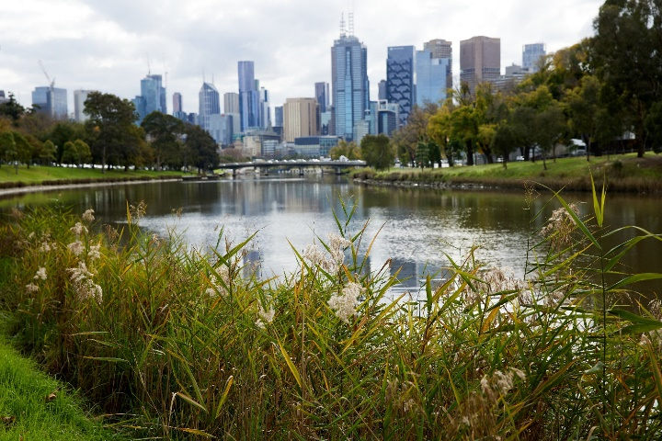  Banks of the Birrarung (Yarra River) looking on towards Melbourne city | The role of the CGRSWS is to set policy directions and outline actions for securing the region’s long-term water supplies to protect the jobs, farms, ecosystems, communities and Traditional Owners that rely on them. It focuses on the current and emerging water challenges over the next 50 years, during which time the region’s population is expected to grow to over 10 million and variability in water availability are projected due to climate change. It contributes to multiple outcomes of the EC including water security, water efficiency, waterway and catchment health, Traditional Owner priorities and inclusive management.
The CGRSWS 2022 covers an area that 6 million Victorians rely on for work and recreation. It also provides drinking water for 90% of Victorians. Hence, adapting to the impacts of climate change and managing associated water security risks is critical to build resilience in communities and to secure a healthy future for all Victorians. Modelling shows that the Central and Gippsland Region is likely to need additional water supplies within the next 10 years and that water supply may need to double over the next 50 years to meet demand. A loss of access to water may lead to lost economic opportunity, loss of recreation, environmental and cultural values, and cost burdens on water customers.
The CGRSWS identifies the opportunity for the region to shift away from reliance on river water and move towards climate-resilient, manufactured water to augment our water supplies. This includes fit-for-purpose recycled water, treated stormwater and desalinated water.
DEECA, the water sector and Traditional Owners will progress regionally significant urban water projects. Investments in new water supplies will aim to balance the region’s growing water demands with affordability of supply. Additionally, the use of manufactured water will lead to river water becoming available for other uses, including returning water to Traditional Owners and the environment.

What progress has been made toward efficient water use?
The overall performance assessment for this KEQ is:
Outcome theme | Rating type | Rating | Rationale
Water Efficiency | Extent to which end-of-EC5 outcomes were achieved | High |  | EC5 continued a range of initiatives focused on improving water efficiency in schools, homes, rural communities and irrigation districts, for which water savings were monitored and quantified. Work to improve regulation of water use compliance was a key achievement of EC5.
Water Efficiency | Overall progress toward long-term outcomes | Medium |  | Prior investment in rural water infrastructure have created the gains in improved irrigation efficiency. However, continued investment and ongoing work is needed to realise the remaining opportunities. Urban water efficiency varies due to multiple factors and there is more work needed to achieve Melbourne’s per capita water use targets.
This KEQ evaluates the extent to which the Water Efficiency objectives of the EC5 were achieved. The program logic (see Section 3.3) includes the long-term outcome ‘Water is used efficiently’ supported by the following End-of-Tranche outcomes:
- improved water awareness and water efficiency in schools and homes
- improved water awareness and water efficiency in irrigation communities
- improved responsiveness of rural water policy to water wise use and climate change
- reduction in irrigation losses
- improved regulation of water user compliance.
A summary of the achievements made by EC5 projects to these outcomes is provided below. This is supported by examples of some of the main ways that individual projects have contributed to each outcome area, provided in Appendix B.

Improved water awareness and water efficiency in schools and homes
Water efficiency programs have provided significant water savings, water awareness, and cost-saving benefits, with:
- 0.298 GL/yr saved in households and community housing properties through CRP and CHRP through water audits and water efficiency works in 6,035 properties (exceeding the target of 5,275 by 15%), and resulting in average water and wastewater charges of $124/year per customer assisted
- 1.9 GL was saved through leak detection in 905 schools as part of SWEP over EC
- 4 GL has also been saved through Victoria’s contribution to the Australian Government’s WELS scheme
- Investments in residential behaviour change initiatives contributed to the Smart Water Advice portal, providing water saving tips to households and businesses and reinvigoration of the Target 155 to Target 150 (T150) water conservation behavioural program.
While more work is still needed to reduce Melbourne’s average per capita daily water consumption to achieve 150 litres per person per day, T150 is an aspirational target, not a mandatory target / performance outcome.

Improved water awareness and water efficiency in irrigation communities
This outcome was driven through the continued implementation of the Sustainable Irrigation Program, which provides extension support and capacity building to irrigators to assist them with decision-making and future irrigation planning. The irrigation extension program resulted in the development of 86 whole farm plans, for on-farm operational capacity, efficiency, and preparedness for a future with reduced water availability. EC5 also supported DEECA in providing governance and oversight of major water efficiency infrastructure projects in irrigation communities, and to secure funding for 33 new strategic projects ($996 million). Modernisation works in the Macalister Irrigation District were complemented by whole farm planning and on-farm efficiency incentives to landholders to maximise the benefits of both modernisation and on-farm programs.

Improved responsiveness of rural water policy to water wise use and climate change
Chapter 7 of the CGRSWS commits to actions that work with farmers to encourage more efficient use of water and best-practice irrigation, as well as Policy 7-1 that commits to maximising water efficiency in agriculture. During EC5, the Social and economic impacts of Basin Plan water recovery in Victoria, and Water supply and horticultural demand in the southern Murray-Darling Basin were published, which report on future changes and implications for irrigated agriculture and communities under a changing climate. The findings from these reports are being integrated into rural water policy.

Reduction in irrigation losses
The Macalister Irrigation District Modernisation Project – Phase 2 is on track to deliver up to 10.3 GL of water recovery and has modernised just over 80 km of irrigation network. The final project achievements and audited water savings will be reported following practical completion in late 2024, and will be reported in the next reporting period.

Improved regulation of water user compliance
An independent review of Victoria’s progress during EC5 with implementing a modern risk-based compliance and enforcement framework to manage unauthorised take of water reported very good progress and significant reductions in unauthorised take.

How have risks to priority waterways and catchment health been reduced?
The overall performance assessment for this KEQ is:
Outcome theme | Rating type | Rating | Rationale
Waterway and Catchment Health | Extent to which end-of-EC5 outcomes were achieved | Very High | The health of waterways and catchments throughout Victoria were improved, with the continuation and extension of several long-term projects. Increased implementation of IWM initiatives, delivery of a large volume of vegetation and habitat improvement works, environmental water delivery, and delivery of actions from the YSP were features of EC5. An increased evidence base was also developed for ecological improvements resulting from waterway management works.
Waterway and Catchment Health | Overall progress toward long-term outcomes | Medium | Prior EC tranches have invested significantly in waterway and catchment health, and while environmental outcomes generally take time to accrue following investment, there is emerging and strengthening evidence of environmental benefits from multi-year EC investments. Ongoing investment is required to continue to address significant remaining environmental degradation amid continued stressors.
This KEQ evaluates progress made toward the Waterway and Catchment Health objective of the EC5. The program logic (see Section 3.3) includes the long-term outcome ‘Environmental condition of Victoria’s priority waterways and catchments is improved’ supported by the following End-of-Tranche outcomes:
- reduced risks from stormwater runoff into priority urban waterways
- Improved landowner stewardship in catchments and waterways.
- Improved condition of riparian land.
- Improved habitat for key species.
- Increased evidence base on effectiveness of waterway management.
A summary of the achievements made by EC5 projects to these outcomes is provided below. This is supported by examples of some of the main ways that individual projects have contributed to each outcome, provided in Appendix B.

Reduced risks from stormwater runoff into priority urban waterways
The IWM project supported a suite of 52 IWM projects including stormwater harvesting, recycled water and rainwater harvesting projects which are expected to result in significant stormwater pollution reduction (prevention of 8,407 kg of nitrogen, 2,299 kg of phosphorus and 258 tonnes of total suspended solids from entering our waterways every year).
A stormwater offset framework and compliance tool was developed with input from industry and councils; four councils have implemented schemes and another four are considering offset schemes within their municipalities. 58 of 65 eligible councils were provided with grants to make data improvements, update onsite wastewater management projects or to undertake risk reducing activities.
Additionally, CGRSWS has funded capital and design works for several stormwater harvesting projects, including the Jan Juc daylighting project, the stormwater harvesting concept design for the Northern and Western Geelong Growth Areas, and the Werribee Reconfiguration project.

Improved stewardship in catchments and waterways
Our Catchments, Our Communities (OCOC) delivered Integrated Catchment Management (ICM) that is strongly community based, regionally focused and collaborative. This resulted in 46,764 ha of place-based, on-ground catchment stewardship projects in EC5. The Waterway Health program also supported CMAs to process approximately 30,000 waterway licenses and permits, floodplain and planning referrals and advice for local councils and the general community providing a critical business-as-usual function focused on catchment stewardship. The Waterway Health program also funded a range of projects focused on increased community and landholder involvement in stewardship activities. One example of this is the Caring for the Campaspe project, which supported landholders to fence and revegetate the river to protect its important environmental and community values, delivering 90 km of fencing, over 270 ha revegetated with native plants and over 400 ha where weed control was undertaken, involving 150 landholders.

Improved condition of riparian land and habitat for key species
Several EC5 projects delivered vegetation and habitat improvement works, including:
- Waterway Health: Delivery of 459 waterway structures (rock chutes, fish “hotels”, large wood, erosion control structures, flow regulators, removal of fish barriers), 331.5 km of fencing used to protect areas alongside waterways, 35,465 ha of vegetation and weed control, and 482 management agreements between CMAs and landholders, to ensure works areas are maintained in good quality for at least 10 years. As a result of these works, 386 river reaches and wetlands in Victoria are maintained or improved every year, with over 366 ha of waterway vegetation improvement works across priority sites. The Flagship Waterway projects also continued and expanded during EC5. Several activities were completed related to improving state policy and regional planning for wetland and catchment health improvements, including characterising wetland hydrologic stress across Victoria, developing habitat distribution models for wetland-dependent species and undertaking analysis to understand current and likely flow alteration under a range of climate change scenarios for unregulated rivers.
- Environmental Water: Delivery of environmental water to 161 rivers and wetlands sites throughout the state in 2023-24, 154 sites in 2022-23, 170 sites in 2021-22, and 225 sites in 2020-21, fully or partially achieving a total of 934 watering actions. Water delivery equated to over 3,212 GL of water for the environment to rivers and wetlands.
- CGRSWS Funding Stream 2 Diversify Water Sources and Increase Water Efficiency: The Jan Juc daylighting project, which is returning the highly disturbed urban waterway to a more natural state through recreating habitat, biodiversity and amenity values as well as delivering significant stormwater quality objectives.
- CGRSWS Funding Stream 3 Waterway Health Complementary Measures and Catchment Management Improvement: Design works for Lower Latrobe Wetlands, Maffra Weir Fishway, Moorabool channel lining and Werribee diversion weir activities
- Progressing 88 projects from the YSP, focused on protecting and enhancing the river and its parklands.
- Our Catchments Our Communities: CMAs delivered 46,764 ha of land under active catchment stewardship, including environment works, management services, management agreements, assessments and plans.

Increased evidence based on effectiveness of waterway management
- Waterway Health: The evidence base was increased through the Stream Change assessment: Riparian Woody Vegetation, 2021 Great Australian Platypus Search using eDNA, VEFMAP and WetMAP to evaluate ecological responses to environmental water management, Riparian Intervention Monitoring Program, and Victoria’s first index of estuary condition. Some outcomes of these activities include:
  - The Stream Change Assessment Project compared the condition of woody riparian vegetation in 3,400 km of stream length between 2018-2020 and 2010. It found that statewide changes were small, however largest changes occurred where substantial or sustained riparian management had been undertaken.
  - The VEFMAP fish theme completed the most comprehensive assessment to date of long-term trends in Victorian native fish populations, which showed that most examined species declined during the Millenium Drought (2000-2010), but population trends have increased subsequently. VEFMAP fish monitoring also demonstrated strong influences of hydrology (including environmental water), on key processes such as movement, dispersal and recruitment.
  - Riparian Intervention Monitoring Program: found that after three years of interventions such as weed control, revegetation and livestock exclusion, there is positive changes such as increased density of native woody recruits and native taxa. Monitoring of Riparian Intervention Monitoring Program sites for responses to widespread and significant flooding in late 2022 showed that most sites (both intervention and control sites) had some degree of scour and/or mass failure in response to flooding. However, results indicated that the severity and/or frequency of scour and mass failure was less at intervention sites than control sites.
  - DEECA and other organisations partnered with the Odonata Foundation to undertake a state-wide investigation into platypus populations using environmental DNA as part of the Great Australian Platypus Search. Samples were collected from close to 2,000 sites across Victoria with the data improving our understanding of platypus populations across the state.
- Environmental Water: In 2022-23, significant colonial waterbird breeding was recorded at sites that received water for the environment, including:
  - 2,000 nests of Australian White Ibis and Straw-necked Ibis in Barmah Forest
  - 10 species of colonial nesting waterbirds across the Hattah Lakes using 7,000 nests for over 25,500 chicks, with a further 18 waterbird species detected breeding with an additional 1,700 chicks recorded
  - over 15,000 birds from 21 species recorded at Gunbower Forest and the Kerang Ramsar wetlands during 69 surveys over spring 2022 and autumn 2023.
- Environmental Water: Increases in waterbird numbers, including several threatened species, were evident in a field survey at Moodie Swamp after environmental watering. Due to the significant number of threatened waterbirds recorded at the wetland Goulburn Broken CMA successfully advocated for the wetland’s closure to duck hunting in 2024.
The field survey found:
  - over 130 Eastern Great Egret (vulnerable per the Victorian Flora and Fauna Guarantee Act 1988) and 100 Plumed Egret (critically endangered per the Victorian Flora and Fauna Guarantee Act 1988), marking the largest Victorian Plumed Egret count in 23 years
  - 14 endangered Brolga, the highest number ever recorded at the wetland.
Case Study 2 provides an example of improved catchment health in irrigation areas of the Goulburn Broken Region, delivered through drainage course declarations which represent a new approach to drainage management. Case Study 3 provides an example of how citizen science is being used to increase community involvement in waterway health and catchment stewardship.

Case Study 2: Victorian Irrigation Drainage program- Goulburn Broken Region
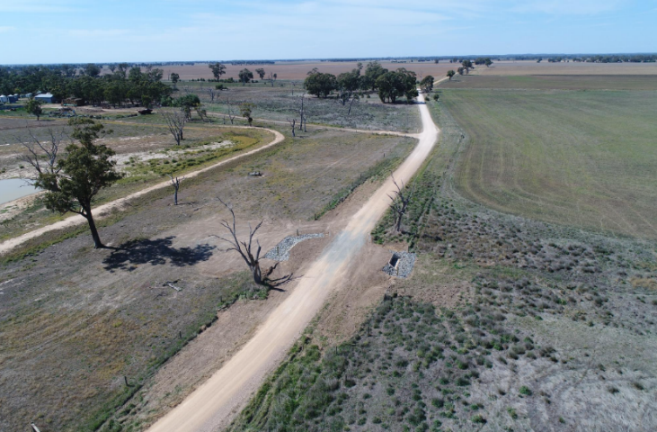  An undersized and partially blocked box culvert has been replaced with two 1200 mm x 450 mm box culverts. | Drainage course declarations (DCDs) have been implemented across the Goulburn Broken Region as part of EC5’s funding of the Victorian Irrigation Drainage Program. This project contributes to the EC waterway and catchment health outcomes.  The DCDs provide a mechanism to reconnect natural drainage lines, reflecting a change in attitude to how Victoria manages drainage in irrigated landscapes. This process reduces the risks of waterlogging and salinity to agricultural productivity infrastructure and terrestrial and wetland ecosystems, as well as provides opportunities to restore natural wetland wetting regimes. DCDs are around a quarter of the cost to
implement compared to traditional constructed primary drains and enable works to be undertaken to remove artificial obstructions in natural drainage lines.
One example of this is in the Cornella Creek sub-catchment, an actively irrigated catchment covering 270 km². This project included extensive community and stakeholder engagement, in conjunction with a range of drainage investigation activities that included detailed conceptual design, modelling, surveys, infield assessment and on-farm consultation. Works have been completed with regional input by the Goulburn Broken CMA, Goulburn-Murray Water and community including the drainage working group. The Cornella Creek Catchment was declared in August 2019, comprising a total of 17 km of the Cornella Creek Anabranch and Ryan’s Floodway. The works ranged from lowering embankments, installing enlarged road culverts, and remediating existing farm drainage structures. At completion this project underwent an independent assessment of costs and benefits that found the project to be highly beneficial to the region’s economy.

Case Study 3: Citizen Science- WaterWatch and EstuaryWatch
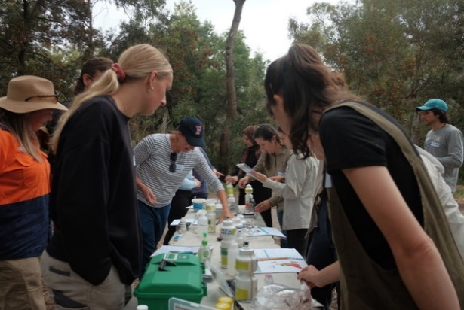  Volunteers undertaking water testing | Citizen science programs are a valuable way for DEECA to support community members to become actively involved in local waterway monitoring and on-ground activities. WaterWatch Victoria and EstuaryWatch Victoria focus on waterway health with over 1,404 active WaterWatch sites and 137 active EstuaryWatch sites across the state. This project is fully funded through the EC5 ‘Improving Waterways and Catchments’ initiative, in partnership with related DEECA and Australian Government initiatives. It contributes to the EC waterway and catchment health and inclusive management outcomes.
Established in 1993, WaterWatch Victoria is the longest running citizen science program in Australia. In March 2023, CMAs came together to celebrate 30 years of Waterway Citizen Science and to recognise volunteers for their commitment and contribution to our region’s waterways. In May 2023, audiences joined an online panel compiled of longstanding volunteers, coordinators, and researchers to reflect on the past 30 years of waterway citizen science and imagine what the future 30 years may bring. One of the longest serving volunteers is Rob Loats, who has been part of WaterWatch since 1996. Rob now monitors three sites on the Little Murray River near where he lives in Swan Hill, after relocating from Donald and monitoring the Richardson River for many years.
WaterWatch and EstuaryWatch provide important pathways to connect communities to their local environment, build the capacity of communities and create change. Throughout these programs, citizen scientists contributed a total of 65,722 hours to care for Victoria’s waterways, equivalent to 8,763 volunteer days in 2021-22. The estimated economic value of volunteer contribution in 2021-22 was $2,743,236. More information on the program’s achievements in 2021-22 can be found in the WaterWatch and EstuaryWatch Annual Report.

To what extent were Traditional Owner priorities furthered?
The overall performance assessment for this KEQ is:
Outcome theme | Rating type | Rating | Rationale
Traditional Owner Priorities | Extent to which end-of-EC5 outcomes were achieved | Very High | The publication of Water is Life in 2022 was a key achievement of the EC5 tranche, representing a policy shift that provides new guidance and policy direction for the inclusion of Traditional Owners which has the potential to deliver tangible outcomes and staged systemic change. Within EC5, the inclusion of Traditional Owners was increasingly integrated into project frameworks and strategies. With increased responsibilities and obligations to include Traditional Owners in water management, new challenges are emerging relating to resourcing and the availability for Traditional Owner organisations to balance and engage with competing priorities, and to exercise self-determination in water management.
Traditional Owner Priorities | Overall progress toward long-term outcomes | Low | There remains significant work to be done to successfully implement the actions from Water is Life, and meaningfully integrate Traditional Owner involvement, values and principles of self-determination throughout EC projects and the broader Victorian water sector. While important progress has been made through EC5, there is still a large gap between the current level of Traditional Ownership self-determined participation and the long-term outcome.
This KEQ evaluates progress made toward the Traditional Owner objective of the EC5. The program logic (see Section 3.3.) includes the long-term outcome ‘Traditional owners determine their own water management priorities’ supported by the following End-of-Tranche outcomes:
- increased involvement of Traditional Owners in water policy, management and decision - making
- increased water availability for Traditional Owner groups
- increased Traditional Owner employment in the water sector.
A summary of the achievements made by EC5 projects to these outcomes is provided below. This is supported by examples of some of the main ways that individual projects have contributed to each outcome area, provided in Appendix B.

Increased involvement of Traditional Owners in water policy, management, and decision-making
Over EC5, critical foundations were established that support Traditional Owner involvement, self-determination, objectives, and aspirations. The publication of Water is Life and CGRSWS in 2022 were key achievements of the EC5, representing a policy shift which provides new guidance and policy direction for the inclusion of Traditional Owners in water management and decision making.
- Water is Life is a nation-leading multi-lingual policy that places the Victorian Government’s policy position and Traditional Owner voices side-by-side. The development and final publication of Water is Life prioritises collaboration and partnership with Traditional Owners to further enable self-determination. A total of 61 Traditional Owner Nation-level, regional and statewide workshops were held with Traditional Owners throughout the development of Water is Life, and 27 Traditional Owner Nation Statements were published alongside the government’s policy commitments in the final Water is Life document. Water is Life establishes pathways to increase Traditional Owner roles and resources in water and waterway management across Victoria and has the potential to deliver tangible outcomes and staged systemic change, if implemented fully.
- The CGRSWS is the first of its kind to be developed through a genuine partnership with Traditional Owners. Representatives of the Traditional Owners in the region sat alongside decision-makers from the government and the water sector and guided the development of the CGRSWS. Traditional Owners developed their own stand-alone chapter, Healthy Country, Healthy Mob which sets out their expectations. Chapter 6: Water justice for Traditional Owners sets the policies and actions that are the next step for water justice for Traditional Owner groups in the region.
These publications have changed how the Victorian Government partners with Traditional Owners and sharpened the focus on working towards Treaty. Many project evaluation reports acknowledged this important shift and provided examples of how inclusion of Traditional Owners has been considered and integrated into project frameworks and strategies.
Other highlights of EC5 related to increasing involvement of Traditional Owners in water policy, management and decision-making include:
- A Traditional Owner stream in the IWM grants program, piloting of Traditional Owner IWM officers, and supporting 14 Traditional Owner led IWM projects. However, Traditional Owner groups and the project team have indicated that dedicated funding support is needed to enable them to develop the skills and capacity to effectively participate in the program and help to generate meaningful contributions from these groups Another area for improvement was identified in regard to ensuring culturally safe and inclusive spaces within IWM Forum meetings to facilitate meaningful participation by Traditional Owner representatives.
- The development of the draft Greens Lake Action Plan represented a new way of working collaboratively with water corporations, Traditional Owners and the recreation community to generate shared outcomes.
- The Traditional Owner Partnership developed by the CGRSWS to support self-determined outcomes for Traditional Owners in the region, including identifying opportunities to return water now and in the future, the development of the Cultural Benefits Framework and commitments to resources Traditional Owners in the region to partner during the implementation of the CGRSWS. Feedback from Traditional Owners is that the strategy building process is to be used as an example for other strategy building processes across the Victorian Government.
- Delivery of the Cultural Water for Cultural Economies project and 10 Traditional Owner-led pilot projects focused on access to water for economic development (2019-21), provided foundational information used to inform the government's drafting on Water is Life. The Cultural Water for Cultural Economies project included over 40 meetings and workshops with representatives from 20 Traditional Owner groups.
- Traditional Owner groups were key participants in the catchment stewardship projects as part of the OCOC project, including 12 formal partnerships with Traditional Owner groups and 22 with Aboriginal Victorians.
- Strengthened relationships with the Yorta Yorta Nation Aboriginal Corporation during the development of Black Swamp Environmental Water Management Plan which enabled sharing and learning with Goulburn Broken CMA on culturally sensitive language and improved context for the Moodie Swamp and Lower Broken Creek Environmental Water Management Plans.
However, there is more work to do to meaningfully include and support Traditional Owners in water sector management and decision-making across Victoria. Continued investment is needed into EC6 to successfully implement the full suite of actions included in Water is Life and the CGRSWS, and meaningfully embed Traditional Owner involvement, values and principles of self-determination throughout the EC5 projects and the broader Victorian water sector. A little over half (58%) of the project evaluations indicated that the project supported Traditional Owner self-determination objectives and aspirations. Recognising that many of the projects were historically developed with little or no Traditional Owner involvement, this indicates that Traditional Owner inclusion is increasingly being integrated into the EC and water sector and momentum is building in the right direction.
While the development of Water is Life, the CGRSWS and Aboriginal Water Program funding have all contributed significantly to elevating Traditional Owner voices and enabling Traditional Owner self-determination of water management priorities, there is work to be done to create an enabling environment for partnerships with Traditional Owners. Since the beginning of EC5, the Victorian Government and the water sector have increased responsibilities and obligations to include Traditional Owners in the way water is managed in Victoria. However, Traditional Owner organisations report being over-stretched and describe the ongoing challenge of balancing and engaging with multiple and competing priorities. These priorities often suit the needs of Government and/or the water sector, rather than those of Traditional Owners, and therefore reduce Traditional Owners’ ability to exercise self-determination in water management.
For Traditional Owners to partner with government and contribute to government processes from an informed position, they must be able to determine and articulate their water priorities, be adequately resourced, and be included as early as possible in the development and delivery of projects. Business case development and program planning must consider the resources necessary to enable Traditional Owners to participate fully in EC projects.
Traditional Owner groups have indicated that more funding support is needed to enable them to develop the skills and capacity to effectively participate in EC projects, and several project evaluations reported on challenges in aligning project work plans with Traditional Owner timeframes and priorities. Future governance and funding structures will need to be designed in collaboration with Traditional Owner organisations to account for the increased demand for engagement and partnership on a wide range of matters across water resource management.
Some relevant strategies suggested by EC5 project teams to support Traditional Owner self-determination and effective partnerships include:
- Having key relationship managers assigned to Traditional Owner partnerships across the EC.
- Increased focus on creating culturally safe and inclusive environments for Elders and other Traditional Owners in collaborative forums / meetings.
- Streamlining funding arrangements and ensuring there is oversight of broader engagement across the EC investment spectrum to avoid burdening Traditional Owner partners.
- Consideration of the ability to carry over Traditional Owner funding between tranches, account for the transitional period (gap) between when one EC tranche and the next, and combine funding streams to minimise administrative burden on Traditional Owner groups.
- Increase flexibility in funding agreements and project plans for Traditional Owner partners, to cater for dynamic and changing priorities and act as an enabler for self-determined priorities.

Increased water availability for Traditional Owner Groups
The Victorian Government recognises First Nations’ and Traditional Owners’ rights and connection to water through Water for Victoria (2016) and is committed to increasing the water available to Traditional Owners to use for self-determined purposes. Water is Life and the CGRSWS establish pathways to increase water return to Traditional Owner Groups, which forms an important foundational basis for progress toward this outcome.
Delivery of the Cultural Water for Cultural Economies project and 10 Traditional Owner-led pilot projects (2019-21) also focused on understanding the current barriers to Traditional Owners' accessing, using and managing water. These activities provided foundational information used to inform the pathways to increase water returns outlined in Water is Life.
During EC5, the Victorian Government returned water to Traditional Owners through a range of projects including:
- 2 GL section 51 licence on the Mitchell River returned to Gunaikurnai Land and Waters Aboriginal Corporation in south-eastern Victoria.
- 2.5 GL section 51 licence on the Fitzroy River system returned to Gunditj Mirring Traditional Owners Aboriginal Corporation in south-western Victoria.
- two licences for cultural water use (0.200 GL at Buchan Munji and 0.500 GL on the Tambo River) issued to Gunaikurnai Land and Waters Aboriginal Corporation.
- A number of water returns in progress at the time of this End-Of-Tranche evaluation.
- In March 2022, Victoria reported for the National Agreement on Closing the Gap (Inland Waters Target) that Traditional Owners and Aboriginal Victorians held 4.298 GL of water entitlements. As of 30 June 2024, this figure has increased to 9.228 GL.
Other examples of how projects are considering ways to work toward this outcome include:
- The Licensing Framework Groundwater and Unregulated Systems project identified ways to reduce obstacles for Traditional Owners applying for section 51 licences and established an authorisation process allowing Traditional Owner Groups to nominate crown land parcels for a section 51 licence application, where the Traditional Owner group does not own or occupy land.
- Through delivery of water for the environment in partnership with Traditional Owner organisations, and in support of cultural values, such as:
  - Delivering water for the environment to Annulus Billabong in the Yarra system, for the first time - in partnership with Wurundjeri Woi Wurrung Cultural Heritage Aboriginal Corporation in spring 2020 and 2021. These events supported cultural values identified by Traditional Owners, as well as environmental objectives including vegetation growth, habitat and feeding conditions for waterbirds.
  - Supporting the First People of the Millewa Mallee Aboriginal Corporation's restoration and protection of a site of high cultural significance at Robertson Creek in the lower Mallee in spring 2020 with the environmental flows.
  - For the first time in August 2022, 1.913 GL of water for the environment was delivered to partially fill Lake Boort in partnership with Dja Dja Wurrung Aboriginal Clans Corporation, North Central CMA, the VEWH, Goulburn Murray Water and Parks Victoria. The Lake Boort partial fill aimed to support river red gums that were planted in 2017 and culturally important vegetation, such as spiny flat sedge.
- Identification in the CGRSWS of where there is unallocated water on relevant Country and where there are other opportunities to return water to Traditional Owners in the region.
These types of foundational activities can ‘set the scene’ for future projects to increase water availability, hence they represent interim progress toward the outcome.

Increased Traditional Owner employment in the water sector
All the projects supporting increased involvement by Traditional Owners in water policy, planning and decision-making have supported Traditional Owner groups and/or individuals financially, leading to increased employment in the water sector. This has included:
- Continuation of the Aboriginal Water Program (established in 2016) during EC5 has funded Traditional Owners through the Water, Country and Community Program grants (stages 1 and 2). This program has supported 24 full-time equivalent Aboriginal Water Officer roles and a range of Traditional Owner-led water-related projects across 18 Traditional Owner groups (including all Registered Aboriginal Parties) and 4 CMAs, that have strengthened Traditional Owner capacity and enabled greater involvement in the way water is managed and delivered in Victoria.
- Total funding (through CMAs) to 30 projects for Traditional Owners and Aboriginal Businesses of $883,802.
- The Traditional Owner Partnership (founded from the CGRSWS development process) continues. Funding for RAP groups to participate in decision making in the water sector as well as ensuring implementation of the CGRSWS is ongoing for EC5 and will be required post EC5.
Case Study 4 provides an example of how the Aboriginal Water Officer Network is facilitating increased employment of Traditional Owners in the water sector, and supporting inclusion of Traditional Owner values into water management.

Case Study 4: Aboriginal Water Officer Network
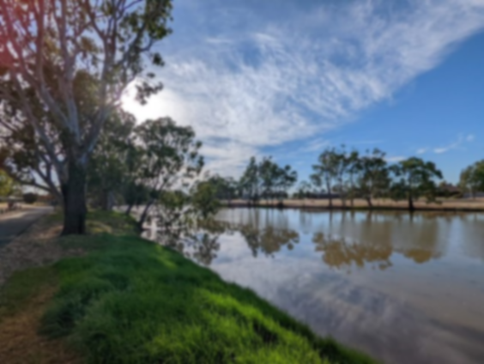  The banks of the Wimmera River during the AWON's visit to Ranch Billabong (Credit: Brodey Hamilton, February 2022) | The Aboriginal Water Officer Network (AWON) is a space for Aboriginal Water Officers (AWOs) to come together to share and discuss knowledge, information and experiences working in the water sector and undertaking projects. It is an opportunity for AWOs to yarn about self-determination, water management practices, cultural knowledge, government processes and policies, among other topics. AWON Meetings are held quarterly, hosted by the AWON and supported by DEECA. They are held on Country by nominated hosts within the AWON and include one full day in a meeting-like format, and one full day undertaking on-Country activities.
Some benefits of the AWON are:
- It provides a safe space for Traditional Owners in the water sector to connect and share cultural and governmental knowledge.
- It provides AWOs with an opportunity to speak with DEECA face-to-face about their priorities for water and any obstacles to self-determination that they face.
- It allows AWOs from all around Victoria to meet in-person, have a yarn and get out on Country together.
The AWO positions provide dedicated resources to support the delivery of Traditional Owner self-determined water priorities, directly contributing to the Traditional Owner priority EC outcomes. The program has initiated funding for 24 full-time equivalent Aboriginal Water Officer positions. AWOs work on Traditional Owner-determined water projects and programs. Partnerships have been fostered between Traditional Owner Corporations, Aboriginal communities, CMAs, and water corporations.
The Aboriginal Water Officer Network (AWON) on Wotjobaluk Country
The year of 2022 was a year of firsts for the AWON. On 24 and 25 February, the AWON held its first network meeting of the year, which was also the first in-person meeting in almost 12 months, and the first hybrid meeting ever.
- The COVID-safe event was hosted by Wimmera CMA and Barengi Gadjin Land Council on Wotjobaluk Country.
- An even split of attendees from all around the state dialled in virtually or attended in person for the first day of the meeting.
The AWON kicked off with a warm Welcome to Country by Uncle Ron Marks and a Smoking Ceremony by
Lachie Marks near the banks of the Wimmera River. Day 1 provided an opportunity for members to connect and yarn about current projects and priorities. It also involved robust discussions and knowledge sharing around Aboriginal water assessments, strategic planning, relationship building, and learning and
development opportunities. Day 2 started with a presentation from Ben Muir on the Ranch Billabong project being undertaken by Barengi Gadjin Land Council and Wimmera CMA, and ended with a deadly trip to and tour of the Ranch itself.

To what extent were social and community values incorporated into water management?
The overall performance assessment for this KEQ is:
Outcome theme | Rating type | Rating | Rationale
Inclusive Management | Extent to which end-of-EC5 outcomes were achieved | High | The EC5 projects continued being inclusive of social and community values. Key features of EC5 were a focus on managing recreation at Victoria’s water storages, projects focused on improved recreational values and new technology platforms for improved access to information. Some priorities shifted throughout EC5 due to COVID-19 disruption and flood recovery works.
Inclusive Management | Overall progress toward long-term outcomes | High | Community participation and inclusion of community values were strongly integrated throughout the EC5 initiatives, indicating a high level of inclusive management throughout the Victorian water sector. Significant opportunities remain to improve high value recreation opportunities.
This KEQ evaluates progress made toward the Inclusive Management objective of the EC5 tranche. The program logic (see Section 3.3) includes the long-term outcome ‘Social and community values are incorporated into water management’ supported by the following End-of-Tranche outcomes:
- greater access to water-based spaces, creating opportunities to improve community health
- improved community access to water resource information
- improved reflection of the diversity of community values in water management.
The EC5 projects were inclusive of social and community values, with 87% of the projects reporting that they are increasing community participation and inclusion of community values in water management. Project evaluation reports provided examples of community engagement, capacity building and knowledge sharing activities that supported project outcomes.
A summary of the achievements made by EC5 projects to these outcomes is provided below. This is supported by examples of some of the main ways that individual projects have contributed to each outcome area, provided in Appendix B.

Greater access to water-based spaces, creating opportunities to improve community health
The Recreational Values project completed a range of policy and planning projects focused on improved access for community enjoyment of waterways including development of new Recreational Area (Water) Regulations 2023 to manage recreation at storages and embedding recreational values in the next Victorian Waterway Management Strategy. It also distributed $2.89 million of grants funds to support 19 projects and 11 organisations focused on improving recreational outcomes, including consideration of recreational access to drinking water storages, a policy statement in the CGRSWS and collaboration with Melbourne Water to consider access to Tarago Reservoir. It progressed the flagship Water Wannon project, explored new ways to facilitate recreation using water corporation assets, and delivered four planning and community engagement projects.
One example of an impactful grant contribution leading to improved community outcomes is the Trawool Walking Track project. A $250,000 investment from the Recreational Values project was pivotal in getting the project off the ground, which facilitated an excellent partnership between Goulburn Valley Water and Taungurung Land and Waters Council, among others. Goulburn Valley Water is a small water corporation, whose focus on recreation to date has been minimal. Through the inclusion of recreational values in their operations, they have been able to deliver on multiple projects to open disused assets for recreational use by communities.
The Recreational Values project also responded to unforeseen events during EC5, with the implementation (and then controlled easing) of COVID-19 restrictions across 40 recreational areas, in collaboration with water corporations and DEECA’s emergency management and public land teams. They were also involved in flood recovery works to repair recreation infrastructure following the October 2022 floods.

Improved community access to water resource information
Several projects developed new technology platforms and communications products for improved community and sector access to information, including:
- redevelopment of the Water Management Information System (WIMS) and upgrading the WMIS website
- development of the Water Education Portal (aimed at resources for students and teachers)
- launch of the Water Market Watch iOS app to provide real-time water market information
- upgrade of the Victorian Water Accounts platform to provide a new interactive website to improve the ability of users to engage with the water accounts and download the data for use
- production of photography and video assets to assist in community engagement including social media
Project teams acknowledged that there is a lot of water resources data, analysis, knowledge and insights that is of value to the community. Embracing new and evolving ways of communicating this information should be a high priority to increase community understanding and improve access to it.

Improved reflection of the diversity of community values in water management
Many projects reported working extensively and collaboratively with communities as part of planning and delivery of projects. The My Victorian Water Survey ran for five weeks in March/April 2022 and generated a total of 6,240 online survey responses, gathering a wealth of information about current waterway usage, attitudes and understandings about waterway health, current knowledge and language used by the community, and aspirations for the future.
From the results, almost all respondents said that waterways nurture their wellbeing (94%), and that healthy waterways are important for continued community needs (84%) and for future generations (83%), demonstrating that there will likely continue to be strong community support for initiatives that improve the health, accessibility and amenity of urban waterways. The information collected will help shape water-sector policy, guide investments and inform waterway programs and community engagement.
The development of the YSP was informed by the 50-year Community Vision prepared by a community assembly, and an engagement program that reached 120,000 people. Case Study 5 outlines the collaborative development of the YSP, involving Melbourne Water, Wurundjeri-Woi wurrung Cultural Heritage Aboriginal Corporation, a range of state and local government entities, Yarra Collaboration Committee, Yarra River Community Assembly, and the wider community.
Case Study 5: Development of Burndap Birrarung burndap umarkoo, the Yarra Strategic Plan (YSP)
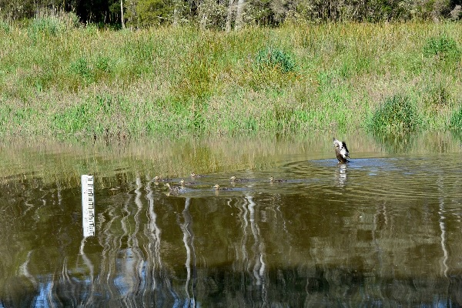  Annulus Billabong Pacific Black Ducks, VEWH | Burndap Birrarung burndap umarkoo, the Yarra Strategic Plan (YSP) is the first 10-year plan for the Yarra River Corridor to protect and enhance the Birrarung (Yarra River) and its parklands as one living and integrated natural entity. The YSP was developed by Melbourne Water as the lead agency, in collaboration with the Wurundjeri Woi wurrung Cultural Heritage Aboriginal Corporation and state and local government entities with decision-making and land management responsibilities in the Birrarung corridor and on Yarra River Land (responsible public entities). The YSP aligns with the 50-year Community Vision for the Birrarung and regional Healthy
Waterways Strategy, as well as supports both the Wurundjeri Woi-wurrung and Bunurong Traditional Owners to increase their participation in the management of land on their respective Country. It contributes to the EC outcomes of water security, waterway and catchment health, Traditional Owner priorities, and inclusive management.,
An important feature of the YSP is the shared commitment to transparent and coordinated decision-making by responsible public entities that enables diverse values to be reflected in the Birrarung’s management. This decision-making framework embeds the role of Traditional Owners as custodians of the Birrarung through partnership, representation and involvement in planning and decision-making. The framework enables the development and prioritisation of projects that lead to lasting change in the river’s values.
A priority project under the YSP, the Annulus Billabong (Yarra Flats) project has received funds to support identification and implementation of a permanent watering solution. This aims to improve the wetland’s water regime to meet ecological watering objectives, improving ecosystem services, cultural and social values. This has led to improvements in managing the billabong, with native wetland cover increasing from ~5% to ~28% in the Annulus Billabong between 2019–22, following successive waterings (Greet et al. 2022).

To what extent was the effectiveness of water governance improved?
The overall performance assessment for this KEQ is:
Outcome theme | Rating type | Rating | Rationale
Inclusive Management | Extent to which end-of-EC5 outcomes were achieved | High | Many of the EC5 projects contributed to meeting the needs of customers and the community, through improved water planning, access to information and broad community / stakeholder inclusion in water planning and decision-making.
Inclusive Management | Overall progress toward long-term outcomes | Very High | The Victorian water sector enjoys a high level of strong governance integration and effectiveness. Ongoing work, such as that provided in EC5, is needed to maintain and further improve as existing and new challenges emerge, and new technologies present opportunities.
This KEQ evaluates progress made toward the Water Governance objective of the EC5. The program logic (see Section 3.3.) includes the long-term outcome ‘Water sector governance and system are integrated and effective’ supported by the following End-of-Tranche outcomes:
- improved performance of water sector in meeting the needs of customers and the community
- improved management of risks and emergencies
- increased embedment of climate change in water sector planning and decision-making.
A summary of the achievements made by EC5 projects to these outcomes is provided. This is supported by examples of some of the main ways that individual projects have contributed to each outcome area, provided in Appendix B.

Improved performance of water sector in meeting the needs of customers and the community
The Central Bendigo Mine Rehabilitation Project (Groundwater) met customer and community expectations regarding prevention of mine impacted groundwater discharges to Central Bendigo through an interim solution, enabled Central Deborah Gold Mine to continue to offer underground tours, and developed and secured funding for implementation of a long-term management solution.
The level of achievement toward inclusive water management outlined in section 4.6 is also relevant to this outcome, as customer and community needs are closely linked with community access to water information and inclusion in water planning and decision-making.

Improved management of risks and emergencies
Flood risks were better understood and managed through completion of 23 flood studies, 8 planning scheme amendments, 11 flood mitigation infrastructure projects, 23 projects to develop or upgrade flood warning services, and completion of all 56 actions from the Victorian floodplain management strategy. The FloodZoom platform was improved to create a ‘one stop shop’ experience for flood responders and analysts. Maps from 100% of completed flood studies stored by FloodZoom are now publicly available due to collaboration with the Victorian Government’s Digital Twin platform.
The 3 local government authority owned small dams at highest risk of failure have been rehabilitated and preparedness works undertaken, as well as upgrades to the Dam Safety Portal to include local government dams.

Increased embedment of climate change in water sector planning and decision-making
A key achievement of EC5 for this outcome was development of Guidelines for Assessing the Impact of Climate Change on Water Availability in Victoria (the Guidelines). Stakeholders rely on this guidance as part of their climate change risk assessments, particularly for water availability for consumptive use, water supply for cities, towns, irrigators and industry as well as for environmental and Traditional Owner outcomes. Ensuring these products remain up-to-date is an important part of enabling the sector to respond to the challenge of climate change. An independent survey conducted to understand the usefulness of The Guidelines to the water sector found:
- ‘The Guidelines appear to be universally used by urban water corporations for their Urban Water Strategies and associated water resource planning’.
- ‘The consultants interviewed used the guidelines for urban water strategies, but also for environmental type studies and investigations in the rural water area. DEECA teams use the Guidelines in strategic areas such as Sustainable Water Strategies, Long-Term Water Resource Assessment as well as Urban Water Strategies, and modelling of the northern Victorian regulated systems’.
- ‘Almost all participants commented on the high value of the guidelines, that they provide consistent and dependable advice, that they are of high quality and well researched and that they are a “point of truth” for the industry’.
The CGRSWS Funding Stream 4 Water Cycle Climate Change Adaptation Action Plan project improved understanding of climate risks by providing feedback to the water sector on their Corporate Plans and Annual Reports to build capacity to better address the climate change risks. This project also involved in-depth consultation with the water sector on their understanding and management of climate risks, resulting in the establishment of partnerships with CMAs (through a grants program) and water corporations (by agreement with VicWater) to build their climate risk management capacity.

To what extent has ongoing, foundational work, supported other programs and improved data availability and decision-making?
This KEQ does not link to a specific long-term outcome from the program logic (see Section 3.3). However, this KEQ recognises the importance of ongoing foundational work undertaken throughout EC5 in supporting the End-Of-Tranche outcomes. In particular, the ongoing surface water and groundwater monitoring and modelling projects provided continued development of a detailed knowledge base of continuous and comprehensive water monitoring data and information which is used for planning and decision-making throughout the Victorian water sector.
In addition to the surface water and groundwater monitoring and modelling, many of the other EC5 projects noted the use of the EC to fund business-as-usual works that was critical to the groups achieving their standard objectives and ongoing obligations. Overall, 81% of the projects reported having a degree of ongoing work (which started prior to EC5 and/or will continue post EC5). Project evaluation reports noted the need for long-term, reliable funding to drive important outcomes and create long-term changes in how water resources are managed in Victoria, and that the EC (over several tranches) has been successful in progressing long-term direction and policy work.
It is acknowledged that there are a range of opportunities and benefits of EC funding supporting both short and long-term projects. There is a need to reflect on potential risks that could emerge if the EC is increasingly used for ongoing, business-as-usual activities, such as:
- potential for reduced ability to innovate and implement new projects in response to changing demand and priorities
- risks to the delivery of critical business-as-usual DEECA activities if funding pool from EC were to decrease
- difficulty in providing immediate visible project outcomes and benefits of ongoing business-as-usual work, leading to poor community perception of the EC.
Some examples of ongoing work (in addition to the surface water and groundwater monitoring and modelling outlined above) include:
- The Retail Entitlements and Markets project is part of a broader policy and program development, underpinned by protecting the integrity of, and continually improving, the retail entitlement and water trading framework. The work is ongoing in that policy needs to continue to evolve and adapt to achieve positive and holistic benefits for Victoria as conditions change and new challenges emerge.
- The Managing Victoria’s Water Sharing Framework project supported the ongoing administration of bulk entitlements, environmental entitlements and management of large, regulated systems including the support for the Minister for Water in fulfilling their statutory obligations. This work is fundamental to the implementation of most policies relating to water sharing arrangements and recovery of water for the environment, irrigators and Traditional Owners. It is also fundamental in ensuring that water corporations can successfully continue to carry out their primary function of supplying water to their customers and ensuring that environmental water managers can deliver water for the environment.
- For Water Compliance Reform, ongoing work by DEECA is required to ensure water corporations continue to improve their compliance performance and deliver consistent, cost-effective and best-practice compliance outcomes across different water systems into the future.
- The rural water infrastructure project oversight and governance project funding is required to ensure the appropriate expenditure of public money on major water infrastructure projects. This includes seeking public good outcomes and benefits from Government investment, both State and Commonwealth, in water infrastructure projects through the monitoring of performance and compliance of the projects being delivered.
- The Sustainable Irrigation Program involves ongoing activities including Basin Salinity Management 2030 compliance, maintaining Land and Water Management Plans and Irrigation Development Guidelines, optimising irrigation drainage, and irrigation extension.
- There is a legislative requirement for Sustainable Water Strategies (SWS), including to implement existing Strategies and to monitor, report, and review them. The prior EC4 tranche resulted in the review of the Central Region SWS, and midterm review of both the Western and Northern Region SWS. The EC5 led to the development of the 2022 CGRSWS and ongoing monitoring of other SWSs. In future, (EC6 and beyond) there is a need to maintain a core team to monitor, report, evaluate and review SWSs across the state.
- The IWM Program is about mainstreaming a transformative approach to water management. The scale of the change in terms of the number of organisations involved, the community value to be delivered and the policy changes required mean that this change is ongoing.
- For the Waterway Health program, the long-term/ongoing nature of the program is not only beneficial but necessary to meet the project’s aims of improving the health of Victoria’s waterways. A long-term commitment is required to achieve complex waterway health outcomes (e.g. to complete project planning, on-ground works and follow up monitoring and maintenance to ensure outcomes are being achieved) and the necessity to provide funding over multi-tranche timescales. Stable, ongoing funding allows for CMAs as organisations to continue their program work, and also to continue to build their capacity and knowledge as organisations, and to serve Victoria’s regional communities. The ongoing nature also allows for projects to be planned on the timelines necessary to implement meaningful change for waterway health, such as the 10-year flagships program. For example, the Werribee fishway design and Moorabool investigation activities are well underway, but funding will be required for construction to deliver on-ground outcomes for fish passage and waterway improvement.
Case Study 6 demonstrates how the ongoing Regional Water Monitoring Partnership supports the availability of long-term information on Victoria’s water resources, informing planning, policy and decision-making.
Case Study 6: Victorian Regional Water Monitoring Partnership
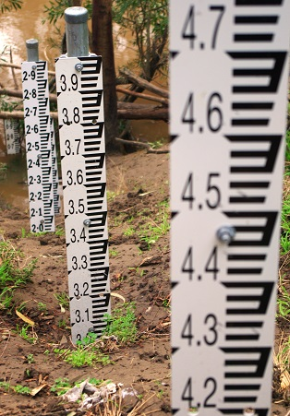 | Victoria’s Regional Water Monitoring Partnerships supports effective management of water through the provision of accurate, timely and consistent data on both the quality and quantity of Victorian water resources. This ongoing monitoring data from Victoria’s key gauging stations and groundwater observation bores provide vital input into a range of uses, including operational decisions by water corporations, compliance, and for the modelling and analysis that is required to develop an understanding of trends and water availability in Victoria’s water resources, providing the information to make informed water management decisions. It contributes to decision making throughout the Victorian water sector and the EC outcomes of water security, water efficiency, waterway and catchment health, inclusive management and water governance.  EC5 has funded DEECA’s contribution to operating and maintaining 950 surface water and 1,400 groundwater stations across Victoria. As part of the Regional Water Monitoring Partnership, DEECA pays approximately 30% of the costs for the surface water sites and
approximately 80% for the groundwater sites. All remaining costs are shared by 55 partner agencies including the Bureau of Meteorology, Murray-Darling Basin Authority, water corporations, catchment management authorities and local government associations. DEECA manages monitoring on behalf of the partners to ensure that data collected is both consistent and high quality. This data is curated and published via the publicly available Water Measurement Information System and to any other related back-end data systems.
Made possible by the tranches of EC funding, 248 surface water sites and 382 groundwater sites have accrued sufficient data to be classified as long-term sites. This critical information allows DEECA to measure long-term trends, including the impacts of climate change, changing demand, and increasing population.

Unintended outcomes
Many of the projects (67%) reported that unintended outcomes had arisen during EC5. The unintended outcomes were overwhelmingly positive, and the following key themes emerged from the responses:
- unexpected benefits of building relationships with organisations and groups outside DEECA
- deeper partnerships and collaboration with Traditional Owners
- unintended benefits resulting from flexibility and changing policy directions
Each of these is expanded on below.
Benefits of building relationships with organisations and groups outside DEECA
Eleven projects pointed to unexpected outcomes regarding strengthened relationships with other groups, including other management authorities at Commonwealth and Regional levels, other jurisdictions, Traditional Owners and the community. For example:
- The Water Market Transparency project reported a positive unintended outcome of strengthening relationships between the Market Reform and Transparency team and water corporations and other government agencies including with the Commonwealth Department of Climate Change, Energy, the Environment and Water.
- The Understand and Apply Climate Science to Water project reported much broader and deeper connections with scientific and stakeholder communities than anticipated, resulting in research being used and built upon by others, such as the Murray-Darling Basin Authority’s Water and Environment Research Program.
- The Resilient Water Markets, Regional Communities and Infrastructure project reported that the development of relationships and connections with stakeholders across Victoria has established a foundation for future work across a range of program areas, particularly with Traditional Owner groups that will serve future collaboration and co-design well.
Deeper partnerships and collaboration with Traditional Owners
Several projects reported unintended benefits resulting from involvement and partnerships with Traditional Owner groups, including:
- For the Recreational Values program, the Greens Lake Action Plan development process represented a significant shift in how we can genuinely partner with Traditional Owners and others to understand shared objectives and establish new and effective ways of working together. The process of developing the draft Greens Lake Action Plan was initiated in response to community concern about lost recreation opportunities, but has led into much broader work, self-determined to achieve lasting change for the wider Corop Wetlands Cultural Landscape.
- The Traditional Owner Partnership, which was established to support the development of the CGRSWS, have requested to continue through the implementation phase of the project, to support self-determination and address collective issues in a culturally safe way, indicating the broader usefulness and benefit of this group outside its originally intended purpose. Traditional Owner Partnership members see this forum as a keyway to put forward a collective position, coordinate implementation and keep government accountable.
Unintended benefits resulting from flexibility and changing external environment
There were several unintended benefits identified which were generated through projects taking a flexible approach and making changes based on new policy directions or stakeholder or community values. Examples of these include:
- The development of new software, models, and capability through the surface water modelling and assessment project resulted in readiness to support unplanned complex water management activities including undertaking water recovery projects including Goulburn-Murray Water Connections Project and scenario modelling to support the Murray Darling Basin Plan Implementation.
- As part of CGRSWS Funding Stream 3 Waterway Health Complementary Measures and Catchment Management Improvement – an opportunity to re-design a traditional concrete vertical-slot fishway as a natural-style rock channel was taken, realizing reduced construction costs, providing fish-passage over a greater ranger of flows and requiring less maintenance.
- The Recreational Values Program reported that the establishment of the Water Safety Taskforce, which was a follow on from COVID-19, has been hugely valuable in bringing together agencies involved in water safety to develop relationship and share strategies to tackle the ongoing challenge of balancing the benefits of water recreation with safety.
- Under the Surface Water and Groundwater Monitoring project, the extensive and persistent floods of 2022-23 allowed a large number of surface water gauging sites to have measurements undertaken at the high end of the rating table, improving the accuracy at the high end of the rating tables.

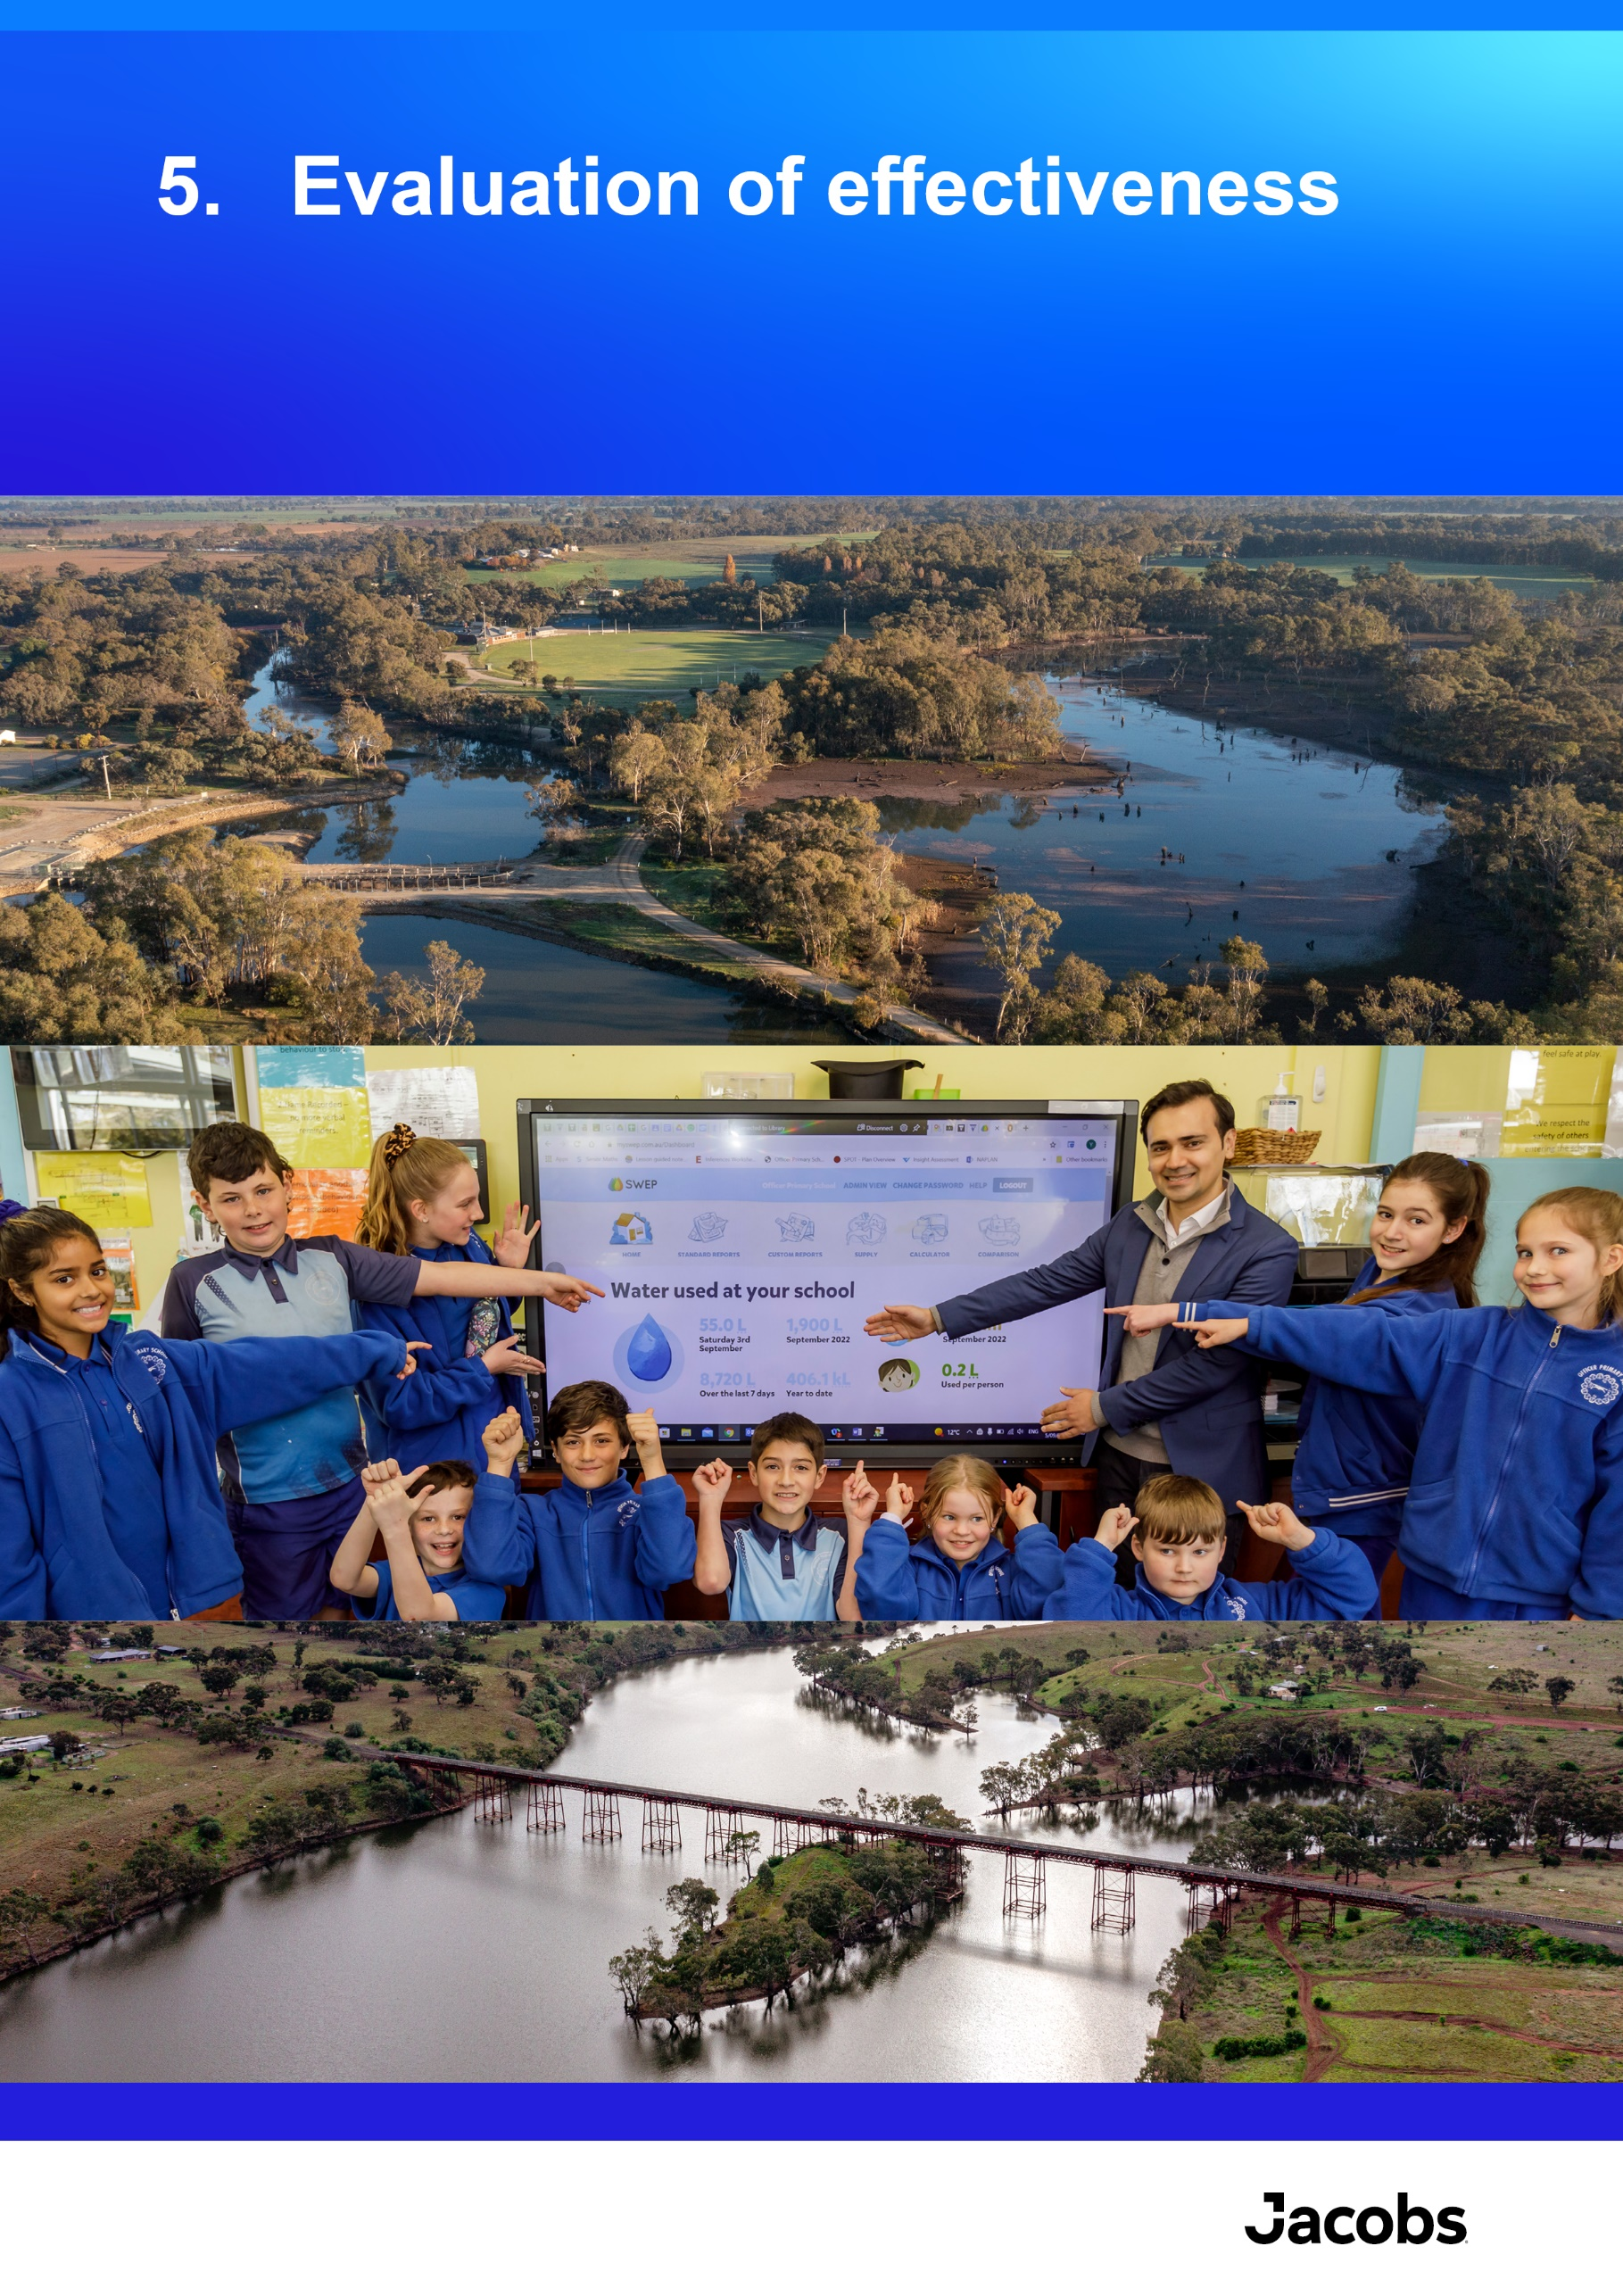

Evaluation of effectiveness
Key findings
- Delivery effectiveness: The EC has been designed effectively, with supportive governance structures and appropriate accountability and reporting requirements. Four-year funding cycles and flexibility in funding at the project level enabled teams to respond to changing contexts and to shift priorities as needed, however there are opportunities for embedding further flexibility and arrangements to promote planning of long-term projects with funding assurance. Complexities with aligning the timing and reporting requirements of multiple funding sources were discussed, and a need was identified to align the EC funding with other funding sources to assist in delivery efficiency and in best utilisation of sources outside EC funding. Many project evaluation reports described challenges with retaining key capabilities and staff turnover, and the need to ensure that corporate knowledge is retained throughout EC tranches, and that teams are supported. There is an opportunity to better articulate the benefits of the EC through economic and social values analyses, and/or narratives around how the benefits of delivered projects are passed on to Victorian communities, environments and industries.
- Adapting to changing contexts: EC5 delivery demonstrated a high level of adaptability and flexibility to manage the effects of external influences, including the COVID-19 pandemic and extreme weather events, specifically flooding and bushfires. While some delays occurred due to the weather events and the COVID-19 pandemic (which particularly affected on-ground works), the department and delivery partners were able to adapt to work with changes. DEECA leadership outlined that support for flexible work throughout EC5 – as a response to the COVID-19 pandemic and other emergencies - was good and should be continued in EC6. DEECA leaders also noted the opportunity to ensure that knowledge is retained and lessons learned are actioned from previous events, to enable preparedness for future unexpected / emergency events.
- Partnerships and collaboration: EC5 projects were highly collaborative and recognised the importance of partnerships in effective delivery. Almost all (95%) of the projects reported that partnerships that were developed throughout tranche 5 were valuable in achieving the project outcomes. Project teams reported that over 1,300 partnerships were fostered throughout the 38 EC5 projects, with a broad range of stakeholders. The highest numbers of partnerships with local governments, Traditional Owners, and community organisations

Overview
The effectiveness of EC5 implementation to the End-of-Tranche was assessed through the following KEQs:
- What worked well and did not work well about the way EC5 was delivered?
- To what extent did funding support the adaptation of projects in response to changing contexts / circumstances? (for example, COVID-19 pandemic, floods, bushfire)
- To what extent did projects develop and work in partnership with other parts of government, other organisations, and community?
The findings for each of these are discussed in the sections below. The key sources of information in this analysis were the project evaluation reports, in which project leads reported on effectiveness of their projects. Interviews with selected project teams and DEECA leadership provided further insights.

What worked well and did not work well about the way EC5 was delivered?
The DEECA leadership and project leads reported that EC5 projects were delivered effectively. Almost all (89%) of project evaluations reported that the project management and delivery arrangements supported effective and efficient delivery. Key themes are summarised in Table 8.
Table 8. Summary of what worked well and key areas for improvement for delivery of EC5
Key theme | What worked well | Areas for improvement
Reporting and governance arrangements | - Projects consistently included the establishment of working groups, steering committees, communities of practice and forums which provided systematic and inclusive project management. In many cases these arrangements were codesigned with DEECA and partners and these worked well to streamline administrative requirements.  - The annual work program process and a high level of accountability to the EC Project Control Board and to the Minister supported appropriate planning, reporting, transparency and change management. | DEECA leadership discussed the potential to further streamline the EC bid process, reporting frameworks, and evaluation process, through:  - better links between regular reporting and evaluation reporting, to reduce overall level of effort required, and to enable teams to spend a higher proportion of time on delivery  - streamlining reporting between DEECA and delivery partners to avoid additional workload  - ensuring there are strong procedures and processes around programs, especially where money is granted to third parties. While this is already working well for some projects, there is the opportunity to further develop inclusive governance models that actively engage Traditional Owners, local governments, community representatives, and other sectors, to strengthen trust and build long-term buy-in.
Delivery and administration | - Some projects outlined that a flexible approach which enabled priorities to shift as changes occurred throughout the EC benefited delivery and the ability for the EC to address community needs.  - Project community of practices/reference groups were highly effective in driving improvement and identifying risks/solutions at the project level.  - Online delivery (e.g., webinars, video meetings), in addition to in-person interactions, has increased the reach and efficiency of projects. | - Teams reported that there is a high administrative burden associated with tracking multiple milestones across multiple projects, and a need to balance the requirement for milestones/progress reports with delivery. Opportunities to streamline reporting and administration aspects should be considered.  - Internal procurement processes are complex to navigate and would benefit from streamlining and support.
Funding | Adequate flexibility in funding at the project level enabled project teams to respond to changing contexts and to shift priorities as needed, particularly in response to unexpected disruptions from COVID-19 and extreme weather (e.g., floods and bushfires). Examples included:  - The EC Project Control Board was able to realign funding throughout the tranche as needed to ensure the program was kept accountable to agreed objectives and also flexible to emerging needs.  - At the start of EC5, a portion of funding was withheld to support new and emerging programs. This was beneficial as it allowed for teams to drive innovation, and to respond to emerging needs and changing priorities throughout the tranche.  - The four-year funding cycle allowed for funding of longer and larger projects with less administrative hurdles, as compared to annual funding.  - The ability for the EC to provide funding for partners (such as CMAs and water corporations) to enable them to overcome resourcing challenges was crucial in achieving timely project outcomes. | - Some funding was delivered in increments throughout the tranche, impeding the ability of DEECA to make long-term strategic decisions due to funding uncertainty. This also created pressure to deliver projects quickly to utilise funds for a given financial year. This means that projects were often delivered based on funding availability when a stronger focus on needs and planning was preferred.  - While the EC has become a major funding source for water programs, it is not able to fund the full implementation of large infrastructure programs. For EC funded strategies, plans and policies, alternative funding sources may be needed to implement long-term solutions, including climate adaptation and mitigation work.  - Many projects utilised co-funding from other sources. Complexities with aligning the timing and reporting requirements of multiple funding sources were discussed, and a need was identified to align the EC funding with other funding sources to assist in delivery efficiency and in best utilisation of sources outside EC funding.  - Even a four-year funding cycle is difficult for Traditional Owner organisations with complex organisational operations, barriers and resourcing constraints. The ability to carryover Traditional Owner funding between tranches should be considered.  - Several grant projects encountered unforeseen challenges that affected timelines and budgets. Future grant programs could require a more structured approach to risk management during the application process, ensuring that applicants have identified common potential risks and developed mitigation strategies embedded within project submitted.
Team capability and capacity, and partnerships | - Strong partnerships and consistent collaboration drove effective implementation. Fostering collaborative structures should remain a priority for future tranches. | - There were challenges with retaining key capabilities due to staff turnover, and the need to ensure that corporate knowledge is retained throughout EC tranches.  - This included the risk of over-committing to projects without the team capacity and capability to deliver, and ensuring that expectations are aligned with what can feasibly be delivered.  - Lack of a clear line of sight to the work of other teams, creating challenges in understanding the interactions between projects. This can also lead to duplicated efforts and inefficient use of resources.
Articulating the impacts and benefits of the EC | Monitoring and evaluation processes for continual improvement were embedded in the EC5 projects as discussed in section 6.3. | - The EC relies on contributions raised from Victorian water corporations, and there is a need to articulate the multiple environmental, social, economic and public benefits. DEECA leaders described challenges with articulating the benefits of some projects, particularly for ongoing business-as-usual work, maintenance works, and broad policy or planning projects.  - There is an opportunity for the EC projects to improve their visibility and understanding within broader community contexts. Increasing community awareness of water management challenges and the benefits of EC initiatives will enhance community literacy and support.

To what extent did funding support the adaptation of projects in response to changing contexts/circumstances? (e.g. COVID-19 pandemic, floods, bushfire)
Almost all (95%) of the project teams agreed that the effects of unexpected events were managed adequately to reduce their impact on project outcomes. This shows a high level of adaptability and flexibility to manage the effects of external influences throughout the tranche. The key unexpected events that occurred during EC5 were the COVID-19 pandemic and associated social/working shifts and extreme weather events, specifically flooding and bushfires. One project evaluation report described:
‘The combined impacts of COVID-19, extreme weather emergencies, supply chain uncertainties and inflationary pressures have made it complex and difficult to consistently plan and deliver multiple elements of the [project]. Project managers and stakeholders were faced with multiple reschedules of timelines, and a great deal of adaptive management was necessary’.
Adapting to changing contexts/circumstances throughout EC5 was also a strong theme that emerged from interviews with DEECA leadership. They emphasised that while some delays occurred due to the extreme weather events and COVID-19 (which particularly affected on-ground works), the EC was able to adapt to these changing circumstances. DEECA leadership outlined that support for flexible work throughout EC5 as a response to the COVID-19 pandemic was positive and should be continued in EC6. DEECA leaders also noted the opportunity to ensure that knowledge is retained, and lessons learned are actioned, from previous events, to enable preparedness for future unexpected / emergency events.
However, project teams noted a need to reduce administrative processes to adapt their projects as changes occured, noting that when there were changes to do with personnel, policy direction and team structure that affected project direction and outcomes, there was a significant amount of work required to update EC5 budgets and reporting to reflect the changes. A summary of the types and impacts from changing contexts/circumstances and adaptive responses is provided in Table 9.
Table 9. Impacts and adaptive responses from unexpected events
Unexpected event | Key impacts and management / adaptation responses
COVID-19 pandemic | COVID-19 primarily affected the projects through disruption to in person engagement and travel to attend work sites. DEECA managed to pivot engagement and meetings to hybrid on many occasions for both staff and community events. Where work needed to be re-prioritised, this was undertaken actively in consultation with the Executive and to ensure that time-critical outcomes were still achieved. Projects reported that the presence of existing working groups and steering committees enabled agile problem solving to mitigate project risks.  Three examples of adaptive responses include:  - Onsite wastewater management systems (OWMS): Local councils that were impacted by floods and COVID-19 were offered a second grants program and additional time to apply for funding. This increased the uptake from 57% to 83% of councils undertaking OWMS related projects.  - The State Observation Bore Network site works required re-prioritising as COVID-19 affected the scheduling of works, and regional flooding affected site access.  - IWM Forums: Online meetings and digital platforms, while not perfect, were essential in maintaining momentum and should be considered as integral parts of future program delivery.
Flooding | In spring 2022, major flooding occurred in northern Victoria, causing significant damage to many of Victoria’s rivers, infrastructure in towns, and other natural assets. The floods had a significant impact on the capacity of key delivery partners and stakeholders, including rural water corporations/licensing authorities, which resulted in changes to timelines, especially where grants were provided, and to project approaches. Resources from DEECA and partner organisations were diverted from planned EC5 projects to focus on flood response priorities, affecting delivery timeframes. Access to work sites was also restricted for long periods due to dangerous conditions.  Flooding events spotlighted the capacity of existing DEECA systems to respond. New systems were implemented in response, diverting resources to emergency management.  The DEECA Bulk Entitlements and Systems (BES) team has contributed to the government’s response to increased public scrutiny on storage manager functions following the October 2022 floods, and has contributed to reviews into storage operations and infrastructure and inquiries into Victoria’s preparedness for the 2022 flood event. This has resulted in impacts on the remainder of the work program due to the need to reallocate resources for these functions. Some lessons from this experience include:  - the need to build time into work plans to respond to unforeseen events such as those resulting from extreme weather events  - in response to the floods, the BES team were asked to respond to community enquiries, which required a specialised skill set outside of BES team’s prior experience. This highlighted the importance of recognising when unforeseen events lead to roles outside a team’s scope of experience, which require new training or involving appropriate specialists.
Bushfire | Major bushfires occurred in Victoria in 2019–20 causing major damage to the Victorian landscape and having significant impacts on access to communities in rural and regional areas.

To what extent did projects develop and work in partnership with other parts of government, other organisations, and community?
The EC5 projects were highly collaborative and recognised the importance of partnerships in effective delivery. Partnerships were valuable, with 95% of the projects reported that partnerships developed during EC5 were valuable in achieving project outcomes. Project teams reported that over 1,300 partnerships were fostered throughout the 38 EC5 projects, with a broad range of stakeholders. The highest numbers of partnerships were with local government, Traditional Owners, and community organisations, as shown in Figure 4.
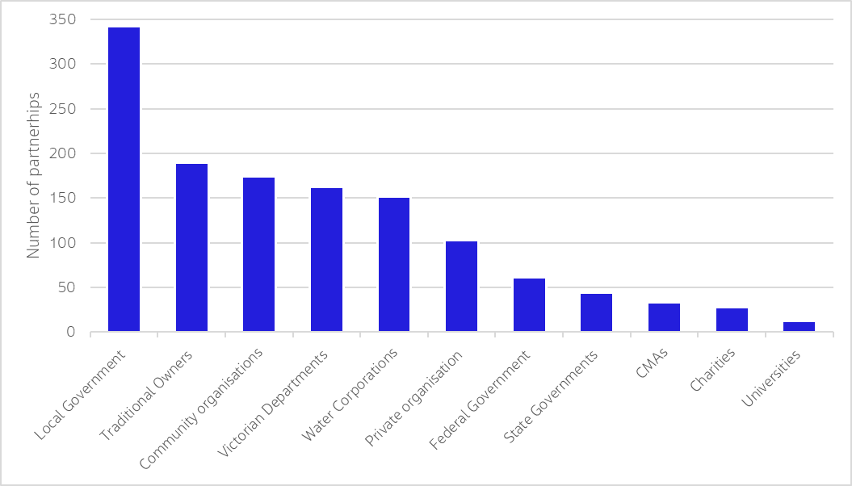
Figure 4. Numbers of partnerships developed with various stakeholders throughout the EC5
Some examples of the value that partnership approaches provided to the projects include:
- The development and implementation of the Lower Werribee Waterway Amenity Action Plan (LWWAAP) and Kitjarra-dja-bul bullarto langi-ut (formerly Barwon River Parklands Masterplan). This approach supported planning for and managing waterways as connected and living entities across land tenures and agency responsibilities, with buy-in from a range of stakeholders at both a development and delivery level. In bringing together state government departments and statutory agencies, local government, Traditional Owners and community groups from the start of the process, a plan was developed that represented diverse values and outcomes.
- The partnership between DEECA and the Department of Education in SWEP proved to be extremely valuable when a single email from the Department of Education resulted in the same number of new registrations as 600 direct calls to schools over a 4-week period from the SWEP team.
- In the Waterway Health project, early engagement and a partnership approach with stakeholders enabled risks to be identified and mitigated, as well as provided opportunities for increasing project efficiency. For example, for the Lower Werribee Diversion Weir fish project, DEECA regularly met with Melbourne Water and Southern Rural Water. During this process, the possibility of working with the proposed Werribee Regional Park was identified, and subsequent discussions with Parks Victoria have resulted in adding a cheaper, more effective option for the design phase.
Project reports also highlighted that where sub-projects were designed and delivered in partnership with other organisations, strong project management practices/contract management is required to ensure outputs are delivered on time/budget.
Although EC5 has been characterised by a high degree of collaboration, DEECA leaders discussed the opportunities for more collaboration with partners to jointly manage resources at every level of governance. This could include better integrated governance when working with CMAs and other regional bodies, as well as building and strengthening existing forums such as the Victorian Waterways Managers Forum, IWM Forums and the Regional Investment Coordinator Forum.
DEECA leaders also emphasised the need to create structures that support self-determination and collaboration with Traditional Owner groups. Case Study 7 below provides an example of collaboration and partnership as a foundation for building capability and capacity in IWM, and to drive implementation. The IWM Forums project team reported that strong relationships and consistent collaboration between stakeholders was vital to the success of the forums, emphasising the importance of networking and sharing knowledge, in driving more effective implementation. They also discussed the need for inclusive decision-making that incorporates diverse perspectives to drive more equitable and sustainable outcomes.

Case Study 7: Integrated Water Management (IWM) Forums
IWM Forums act as a collaborative platform to facilitate the identification, assessment, and implementation of IWM solutions. They directly address water cycle management challenges presented by climate change and urban development in a place-based way. There are currently 15 established IWM Forums that create collaboration across all stages of the water cycle with over 125 partner organisations, including local governments, Traditional Owners, water corporations, CMAs, and the State Government. This program represents the first time that a systematic application of IWM has been designed and implemented at a state-wide scale in Australia.
Each IWM Forum has identified a priority list of actions to address seven key broad strategic outcomes (below) included in the respective Forum Strategic Direction Statement. The IWM Forums have been responsible for identifying and accelerating many projects and policy developments across the water cycle. This includes opportunity identification, plan development, project design and project delivery. Between 2021 and 2024, the IWM Forums stimulated the progression of more than 68 IWM projects. Projects vary in scale and scope, addressing different combinations of the strategic outcomes. Focus areas include water supply and waterway health, healthy urban landscapes and opportunities for economic development. This includes capital works for stormwater harvesting systems, recycled water schemes and rainwater harvesting systems, naturalisation of waterways and place-based plans and designs as well as Traditional Owner led projects.
The IWM Forums represent a change management program that aims to mainstream IWM thinking and approaches for water management across the state, permeating through State Government and partner organisations. This is aligned with broader water industry changes that prioritise and outcomes-based approach and community focus. This project is moving from establishment to acceleration phase, with larger results to be delivered throughout the next tranche of the EC.
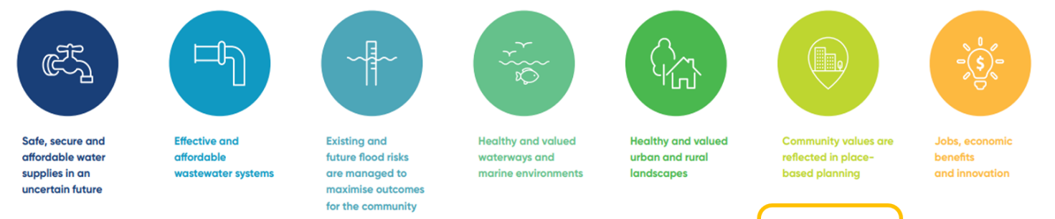
Seven broad strategic outcomes each IWM Forum is seeking to achieve

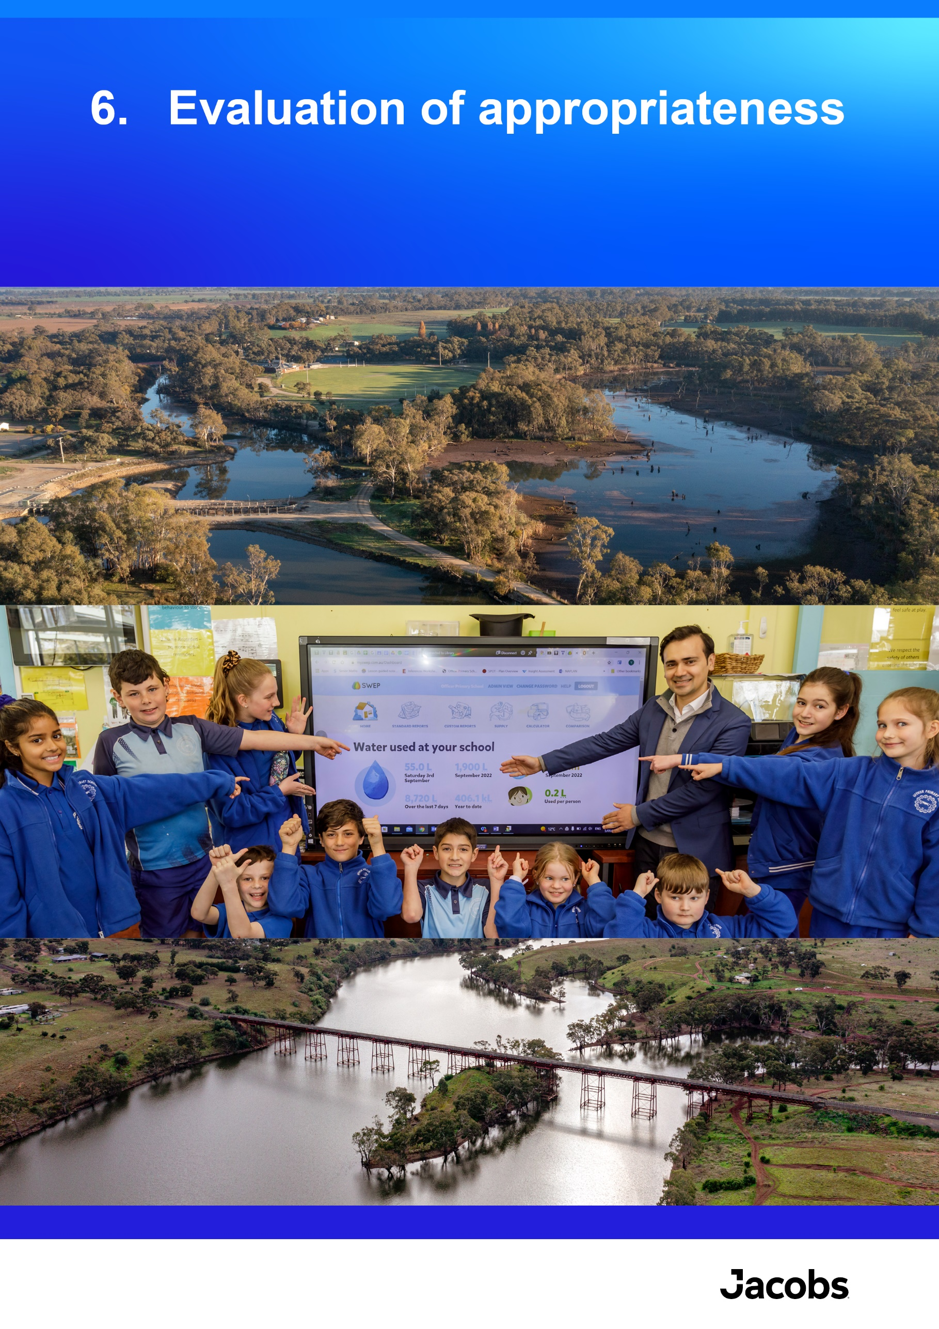

Evaluation of appropriateness
Key findings
- Alignment with the legislated objectives and key water management strategies: EC5 projects showed clear alignment with the legislated objectives with all EC5 projects reporting contributions to one or both legislated objectives of the EC. The projects were guided by key State Government strategies including Water for Victoria (2016), Water is Life: Traditional Owner Access to Water Roadmap (2022), and the CGRSWS (2022). Many of the projects adapted as new State Government strategies were published, to ensure continued alignment with key strategic directions.
- Monitoring, evaluation and improvement: These actions were integrated throughout EC5 to promote delivery effectiveness. Learning and improvement were effectively incorporated into the project to foster a culture of continual improvement, as reported by 92% of the projects. Some projects reported using independent evaluations, stakeholder feedback, and sharing of lessons to improve. The broader EC tranche governance also supported continuous learning through the requirement for each project to develop an evaluation plan and evaluation report, which is used for whole-of-tranche evaluations, and to foster learning for future tranches. Investment in capacity building sessions for the EC5 project teams as part of the EC5 evaluation process has fostered improvement in the effectiveness of the evaluation plans and reports from EC4 to EC5.

Overview
The appropriateness of EC5 implementation to the End-Of-Tranche was assessed through the following KEQs:
- To what extent was funding allocated in line with the legislated objectives of the EC and guided by key water management strategies?
- To what extent did EC funded programs use monitoring and evaluation data to improve management (adaptive management)?
The findings for each of these are discussed in the sections below. The key sources of information used in this analysis were the project evaluation reports, in which project leads reported the appropriateness of their projects. Additionally, interviews with selected project teams and DEECA leadership provided relevant insights.

To what extent was funding allocated in line with the legislated objectives of the EC and guided by key water management strategies?
As discussed in Section 1.1, the objectives of the EC are legislated in Part 9 of the Act. The projects showed clear alignment with the legislated objectives, with all EC5 projects reporting contributions to one or both legislated objectives:
- Contributing to the promotion of sustainable management of water (97%)
- Addressing water-related environmental impacts (86%)
The projects were guided by the following key State Government water management strategies:
- Water for Victoria (2016)
- Water is Life: Traditional Owner Access to Water Roadmap (2022)
- CGRSWS (2022).
An analysis of alignment of the EC5 projects with each of the actions specified in each of these strategies is provided in Table 10, as reported in the project evaluation reports. Many of the projects also reported contributing to other State or Commonwealth strategies (see Appendix A for further information in the individual project summaries).
Table 10. Alignment of EC5 with Key State Government Water Strategies
EC5 Projects | Water for Victoria (2016) | Water is Life (2022) | CGRSWS (2022)
CWCT01: Integrated Water Management | ✓ A5.8 | ✓ | ✓
CWCT02: Iconic Urban Waterways Program | ✓ | ✓ | ✓
CWCT03: Recreational Values Program | ✓ A7.1, 7.2, 7.3 | − | −
CWCT04: Recycled Water, Stormwater and Onsite Wastewater Policy | ✓ | ✓ | ✓
WRS1: Retail Entitlements and Markets | ✓ A9.3, A9.4, A9.6 | − | −
WRS2: Water Grid Oversight | ✓ A9.1, A9.2 | − | ✓
WRS3: Water Market Reform | ✓ A9.5, A9.7 | − | ✓
WRS4: Water Market Transparency | ✓ A9.3, A9.4 | − | ✓
WRS5: Managing Victoria’s Water Sharing Framework | ✓ A8.1, A8.9 | ✓ O7 | ✓ A4-5, A4-4. A4-8,A4-10, A4-11, A9-3
WRS6: Licensing Framework Groundwater and Unregulated Systems | ✓ delivered A8.2, A8.3, A8.4, supported A10.1, A10.8, A10.6 | ✓ O7,O8,O11 | ✓ A4-4,A4-9,A4-12,A4-13,A4-16,A6-4,A6-5,A6-8,A6-15
WRS7: Water Compliance Reform | ✓ A8.5 | − | −
WRS8: Accounting for Water Recovery | ✓A4.5 | ✓O7 | -
WRS9: Water Register Operations and Improvements | ✓ | - | -
WRS10: Understand and Apply Climate Science to Water | ✓A2.2 | - | ✓
WRS11: Surface Water Assessment and Modelling | ✓ A8.11, A3.3,A8.4,A8.6 | ✓ | ✓
WRS12: Long-Term Water Resource Assessment and Addressing the Impacts of Mining and Extractive Industries | ✓ A8.8 | - | ✓A9-6,
WRS13: Groundwater Assessment and Modelling | ✓ A2.2, A8.10, A8.11 | ✓ | ✓
WRS14: Surface Water and Ground Water Monitoring | ✓ A8.10, A8.11 | - | -
WRS15: Water Accounting and Reporting | ✓A8.10 | - | -
WRS16: Knowledge and Insights | ✓ A8.10, A3.9, A8.11, A7.2 | - | -
CWCT05: Water Efficiency Program | ✓ Ch5.3 | − | ✓ Ch 2: 2-1, 2-3, 2-5, 2-6
SIRS1: Rural Water Infrastructure Project Oversight and Governance | ✓ | ✓ | ✓
SIRS2: Sustainable Irrigation Program Implementation | ✓ A4.6 | - | ✓
CWCT06: Aboriginal Water Program | ✓ A6.1-6.4, 10.4, 10.8, 10.9 | ✓ | ✓
PSP1: Long-term Water Security | ✓ A5.3,A5.4,A5.7 | - | ✓ A9-5
PSP2: Sustainable Water Strategies | ✓ | ✓ | ✓
PSP3: Mitigating the Risks of Small Dams | ✓ A10.12 | - | -
CWCT07: CGRSWS Funding Stream 2 Diversify Water Sources and Increase Water Efficiency | ✓ | − | ✓ A3-4, 3-5, 3-8, 4-10, 2-1, 2-7, 3-8
CWCT08: CGRSWS Funding Stream 3 Waterway Health Complementary Measures and Catchment Management Improvement | ✓ | ✓ | ✓
PSP4: CGRSWS Funding Stream 4 Enable Adaptation to a Variable Climate | ✓ A2.1, A2.3, A5.4, A9.2, A10.12, A10.3 | - | ✓
SIRS3: Building Flood Resilience in Victoria | ✓ A10.5, A10.12 | ✓ O2 | ✓
SIRS4: Central Bendigo Mine Rehabilitation Project - Groundwater | ✓ | - | -
CWCT09: Waterway Health | ✓ A3.4 | - | -
CWCT10: Environmental Water | ✓ | - | -
SIRS6: Murray Programs | ✓ A4.11 | ✓ | -
CWCT11: Our Catchments Our Communities Program | ✓ A3.3 | - | -
SIRS5: Macalister Irrigation District Modernisation Project - Phase 2 | ✓ | - | ✓A7-1
WRS19: Resilient Water Markets, Regional Communities and Infrastructure (Stream 1 and 2) | ✓ A9.3, A9.4, A9.6 | - | -
Note: A (Action), O (Objective), Ch (Chapter)

To what extent did EC funded programs use monitoring and evaluation data to improve management (adaptive management)?
Monitoring, evaluation and improvement were integrated throughout EC5 to promote delivery effectiveness. Learning and improvement were effectively incorporated into the project to foster a culture of continual improvement, as reported by 92% of projects.
Some projects reported using independent evaluations, stakeholder feedback, and sharing of lessons learned to improve such as:
- The IWM Program, which engaged independent development of an evaluation framework in 2019 and a 2-phase project evaluation (2020 and 2023). The project also collaboratively developed a MERI Plan for the Catchment Scale IWM Plans across metropolitan Melbourne, and has a MERI pilot underway.
- For development of the Water Education Portal, feedback from phase 1 of DEECA’s collaboration with the Geography Teachers’ Association of Victoria was integrated into phase 2.
- A review was undertaken into Victoria’s progress implementing a modern risk-based compliance and enforcement framework to manage unauthorised take of water, reporting very good progress and significant reductions in unauthorised take.
- An independent survey was conducted to gather feedback and understand the usefulness of the newly published Guidelines for Assessing the Impact of Climate Change on Water Availability in Victoria to the water sector.
- An independent evaluation of the community water efficiency rebates programs (CRP and CHRP) was conducted during the EC5 period, with findings used to understand the program impacts, and potential for improvements.
- The Aboriginal Water Program utilised feedback from partners from phase 1(EC4) to Phase 2 (EC5) to improve program reporting, with changes made to templates and reporting lines that better suit Traditional Owner partners. For example, partners can provide verbal reporting (yarn updates) rather than written reporting.
- As part of the Waterway Health project, the CMAs completed evaluations of the implementation of the 9 Flagship Waterway projects that commenced in EC4. The evaluations were rich with information and learning and have provided a great insight into these significant projects. The collective evaluations helped DEECA understand common issues and opportunities and identify how we can work with CMAs to maximise the value of future evaluations and streamline effort required for CMAs and DEECA, in EC6 and beyond.
The broader EC governance also supported continuous learning through the requirement for each project to develop an evaluation plan and evaluation report in each EC tranche, which is used for whole of tranche evaluations, and to foster learning for future tranches. Investment in capability building sessions for the EC5 project teams as part of the EC5 evaluation process has fostered improvement in the effectiveness of the evaluation plans and reports from EC4 to EC5.

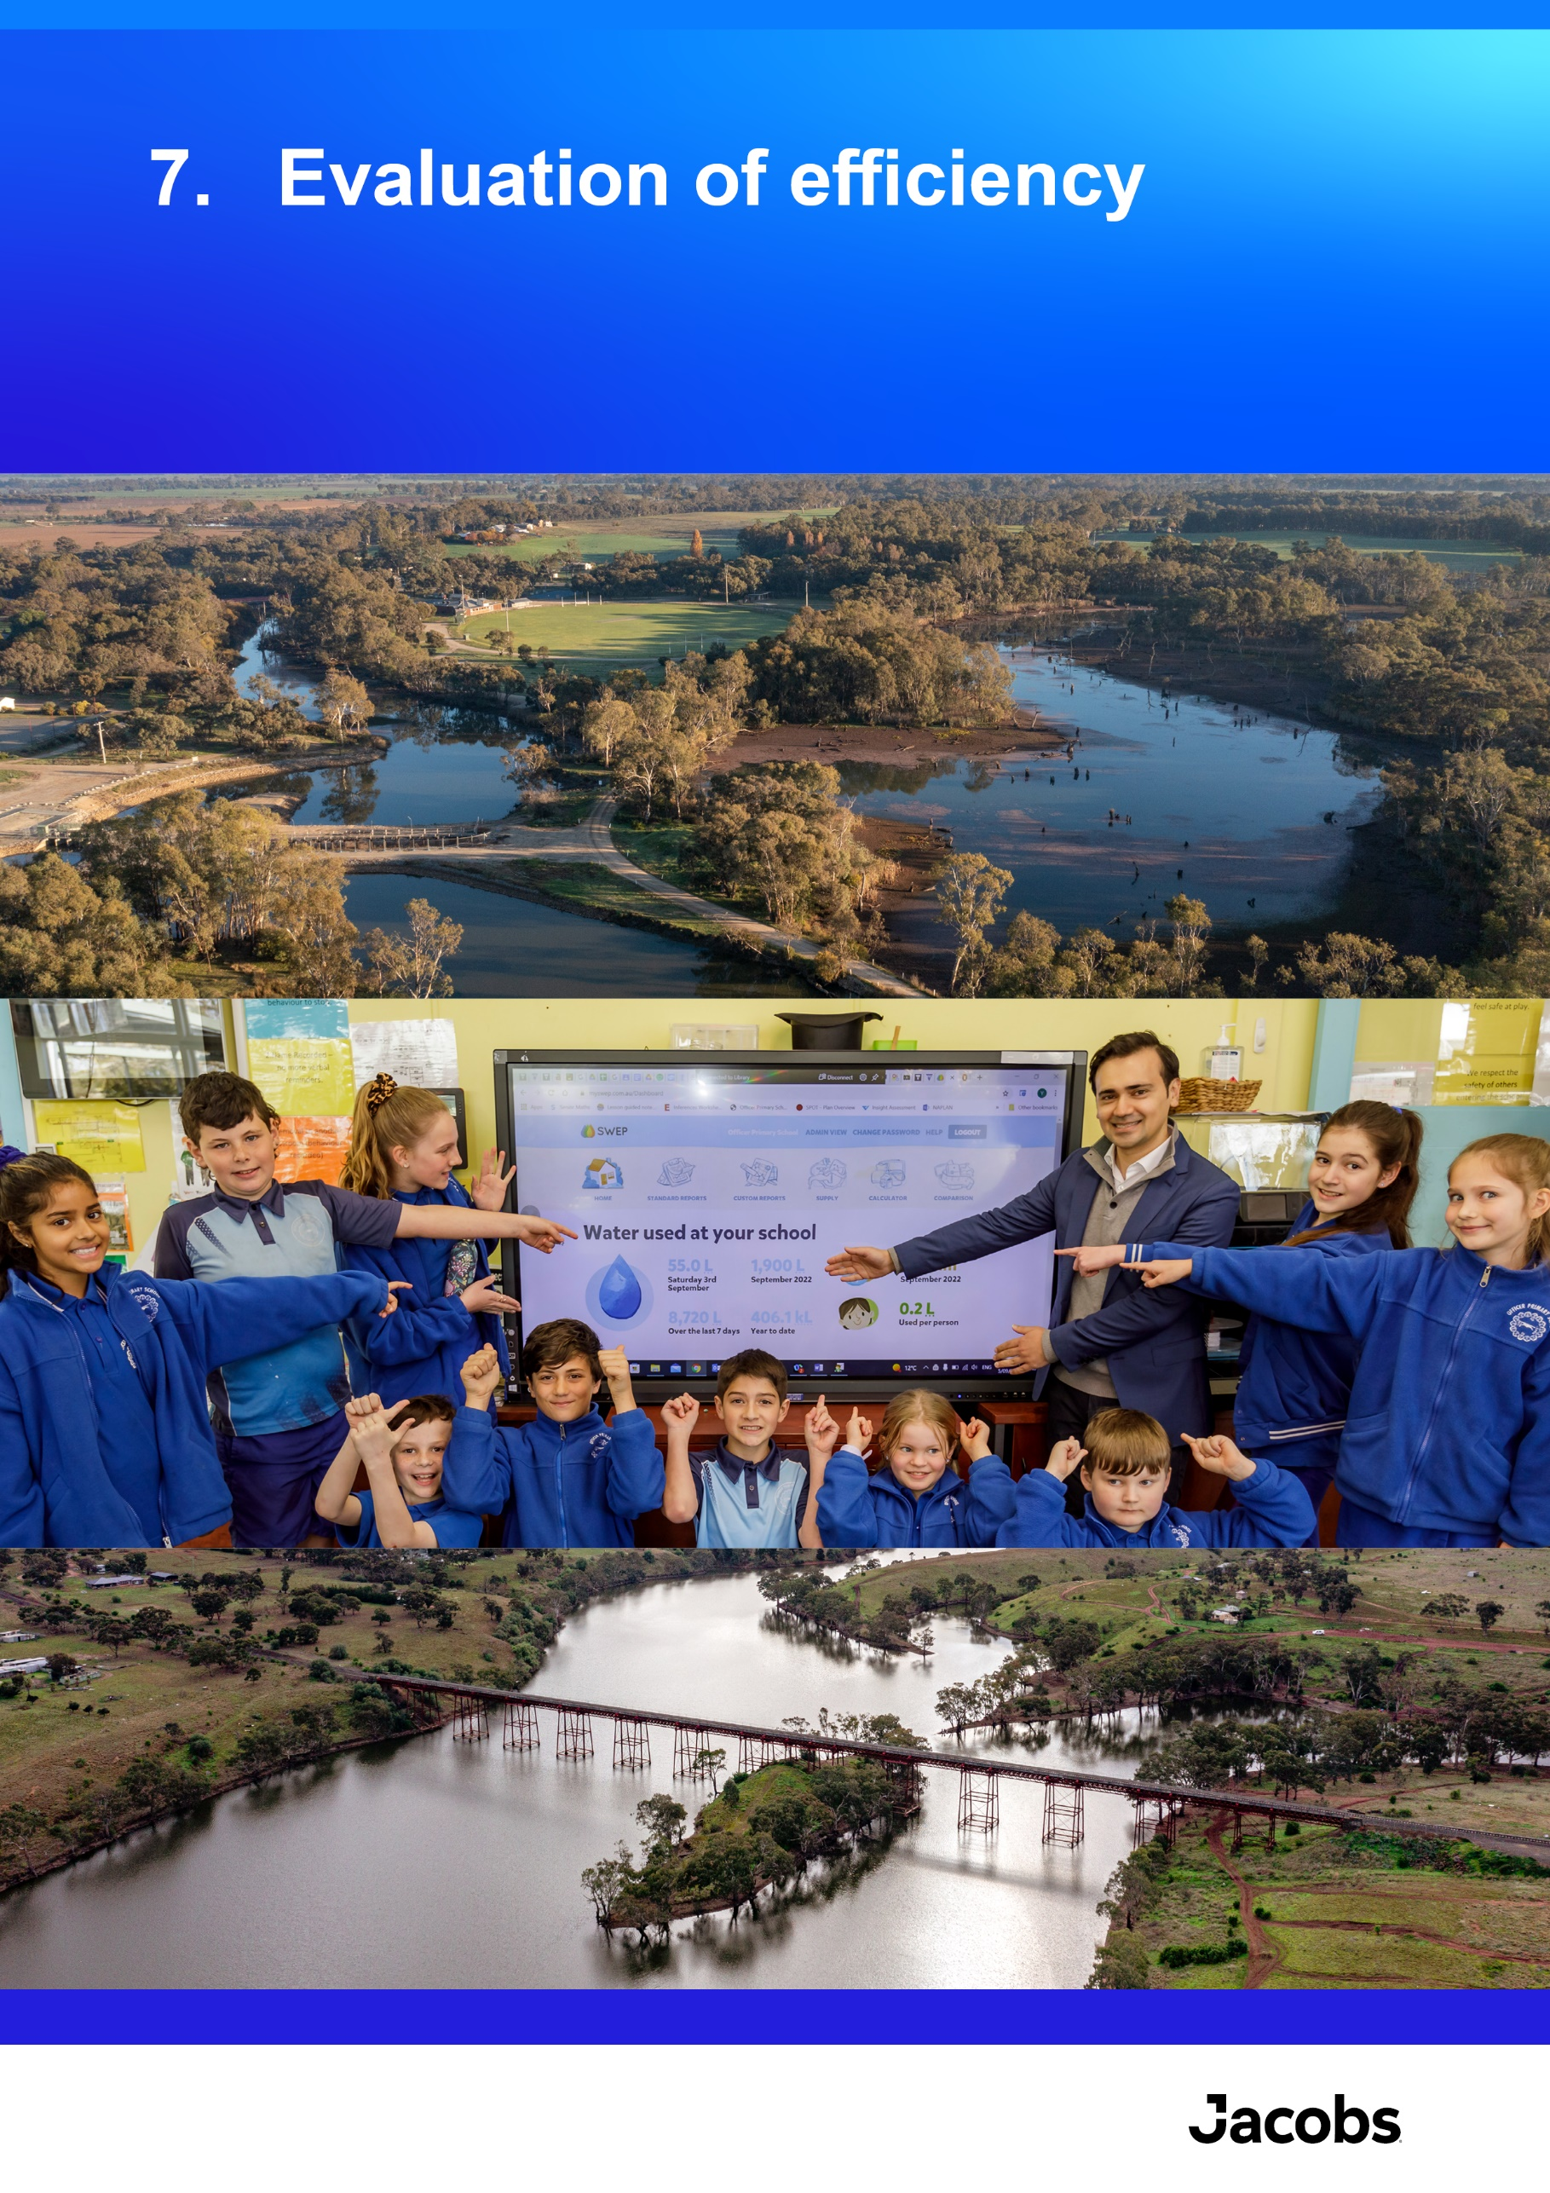

Evaluation of efficiency
Key findings
- Efficiency through delivery: Many of the projects delivered their work programs on budget and on time, and where there were variances these were justified in project reporting. Reasons for variation from original work plans included escalating prices due to supply chain issues, lack of staff availability and staff turnover, delays due to COVID-19 restrictions, disruptions from the flood and bushfire events, and higher resource requirements for project elements than was initially planned.
- Working with others to achieve better outcomes: Almost all (89%) of the project teams agreed that efficiencies were gained through working together with other project teams, and many reported this as a key enabler of successful delivery. The main ways that efficiencies were gained was through knowledge sharing between groups, cost sharing, partnerships and workload sharing and distribution.
- Leveraging additional funding sources: The EC5 $693.85 million investment was augmented by significant co-investment over the tranche. Investment programs were co-funded by a total reported amount of $347.9 million. This represents $0.50 in co-investment for every dollar of investment from the EC. This is considered a conservative estimate, with many areas also reporting co-investment of funding and other resources that were not quantified in the project evaluations.
- Options assessments: Options assessment and/or cost-benefit analyses were undertaken by 79% of projects to support project decision-making. These approaches supported efficient delivery through using structured processes to make investment decisions. Examples of analytical approaches that were used included: options papers, cost-benefit tools, best cost options analyses, value for money assessments.

Overview
The efficiency and value for money of EC5 implementation to the End-of-Tranche was assessed through the following KEQs:
- How has EC5 demonstrated efficiency through delivery?
- To what extent were efficiencies gained through working together with others to achieve better outcomes?
- Have projects leveraged additional funding sources and in what way was this leverage applied?
- What evidence is there of projects undertaking options assessment and/or cost-benefit analysis of approaches?
The key sources of information used in this analysis were the project evaluation reports, in which project leads reported on efficiency and value for money for their projects. Interviews with select project teams and DEECA leadership provided further insights.
An overall economic / quantitative assessment was the beyond the scope of the EC5 Evaluation. This means that the findings reported below are based on qualitative information and analysis only.

How has EC5 demonstrated efficiency through delivery?
Efficiency through delivery was demonstrated by:
- Delivery of investment programs within the budget specified.
- Delivery of budgets within specified timeframes.
All initatives reported their progress in comparison to budget and original schedule to the End-of-Tranche, with key findings including:
- Most projects reported that the budget was fully expended each financial year of the EC5 project. Some exceptions included:
  - Escalating prices due to supply chain issues meant that some budget items had to be rescoped or abandoned to keep within overall project budgets.
  - Issues with staff turnover, short-staffing, and lack of the required expertise to deliver were commonly cited as reasons for unexpended budgets (and timeframe delays).
  - The Goulburn to Murray Regulatory Impact Statement took longer and required more resources than expected. The additional cost and staffing to deliver the project were supported by $4.907 million of co-funding from a Federal Funding Agreement for delivery of Murray-Darling Basin projects.
- For some projects, consultation and generating buy-in from stakeholders and decision-makers took longer and required more resources than planned. This was the case for the development and consultation of the Goulburn to Murray Trade Rule review, due to the complex nature of the trade and delivery of water, evolving demands and pressures on our river systems, and increasing understanding of cultural values.
- Many projects reported that they delivered the EC5 outcomes in line with the planned timeframes; however, several reported delays to timeframes due to unexpected events including COVID-19, flooding and bushfires. Refer section 5.2 for details.
Due to complexities with how budget reporting was completed at the project level, reliable data was not able to be sourced on expenditure vs budget for each project throughout EC5. Improved budget reporting for future tranches may enable this analysis as part of future evaluations.

To what extent were efficiencies gained through working together with others to achieve better outcomes?
Almost all (89%) of the projects agreed that efficiencies were gained through working together with other project teams. The main ways that efficiencies were gained was through knowledge sharing between groups, cost sharing, and workload sharing and distribution. Some examples include:
- Collaboration to generate efficiencies is the fundamental basis for the IWM Forums, which are collaborative platforms that enable different organisations responsible for different parts of the water cycle to identify where collaborative investment and effort could deliver community outcomes more efficiently and effectively. An example includes an analysis to deliver manufactured water opportunities that was undertaken working together with IWM Forum partners and the water industry urban water strategy working groups. Policy reform opportunities were delivered in partnership by working with other projects.
- The Water Knowledge and Insights project reported that working together with other teams within DEECA, our water sector partners, and the general public improved the efficiency of their projects particularly through discovery and scoping phases. This meant they were producing work that was guided by stakeholders to best address their needs.
- For the Water Efficiency Project, delivery efficiencies were gained within water corporations delivering the CRP and CHRP via either their customer and hardship/and or sustainability teams. This allowed the programs to be better targeted and reach more customers through existing water corporation networks (i.e., with community groups).
- The Surface Water Assessment and Modelling project outlined the importance of technical cooperation in achieving objectives efficiently and effectively. The project used model calibration tools from Queensland, noted that urban water corporations used a hydroclimate data transformation tool and seasonal determination approaches, plus cooperation with South Australia on Model Management Systems.

Have projects leveraged additional funding sources and in what way was this leverage applied?
The EC5 $693.85 million investment was augmented by significant co-investment over the tranche. Projects were co-funded by a total reported amount of $347.9 million. This represents $0.50 in co-investment for every dollar of investment from the EC. This is considered a conservative estimate, with many projects also reporting co-investment of funding and other resources that were not quantified in the project evaluation reports, for example the value of in-kind, volunteer contributions for waterway health and catchment initiatives are often underestimated
While projects reported benefits of co-funding and diversity in funding sources, some challenges reported include:
- complexity in administration and reporting to multiple funders
- the need to manage for program continuation, and potential increase in EC funding when alternative sources are finished.
A breakdown of reported co-funding amounts and co-investors for each project is provided in Table 11. Further detail on co-funding for individual investment programs can be found in Appendix A.
Table 11. Co-investment for EC5 projects
EC5 projects | EC5 funding | Co-investment | Co-investors
CWCT01: Integrated Water Management | $59,788,302 | $34,719,781 | IWM Forum partners, federal government
CWCT02: Iconic Urban Waterways Program | $16,151,969 | $1,883,047 | Delivery partners
CWCT04: Recycled water, stormwater and onsite wastewater policy | $10,634,038, | $1,488,000 | Dept of Health, water corporations, EPA, Melbourne Water, Councils
WRS1: Retail Entitlements and Markets | $7,215,000 | $4,907,000 | Federal Funding Agreement for delivery of Murray-Darling Basin projects
WRS10: Understand and Apply Climate Science to Water | $7,092,000 | $2,642,000 | Bureau of Meteorology and CSIRO
CWCT07: CGRSWS Funding Stream 2 Diversify water sources and increase water efficiency | $39,029,000 | $83,571,900 | Water corporations and local government authorities
SIRS4: Central Bendigo Mine Rehabilitation Project - Groundwater | $12,030,000 | $99,000 | Trust funds
CWCT09: Waterway Health | $125,980,000 | $15,985,600* | Sector partners, community and Traditional Owners
SIRS6: Murray programs | $7,000,000 | $7,080,000* | Relief and Early Recovery Treasurer’s Advance 2022-23
SIRS5: Macalister Irrigation District Modernisation Project - Phase 2 | $10,930,000 | $52,170,000 | Southern Rural Water, Commonwealth National Water Infrastructure Development Fund
WRS14: Surface Water and Ground Water Monitoring | $26,631,000 | Partners pay 70% of costs for surface water sites and 20% of the costs for groundwater sites | 55 partner agencies including the Bureau of Meteorology, Murray-Darling Basin Authority, water corporations, catchment management authorities and local government associations
*co-funding amount estimates at the end of the third year of EC5 (June 30 2023)

What evidence is there of projects undertaking options assessment and/or cost-benefit analysis of approaches?
Options assessment and/or cost-benefit analyses were undertaken by 79% of projects to support project decision-making. This supports efficient delivery through using structured processes to make investment decisions. Examples of analytical approaches that were used included options papers, cost-benefit tools, best cost options analyses, and value for money assessments. Many of the projects that did not report using these approaches were policy or planning type projects with already defined investment pathways.

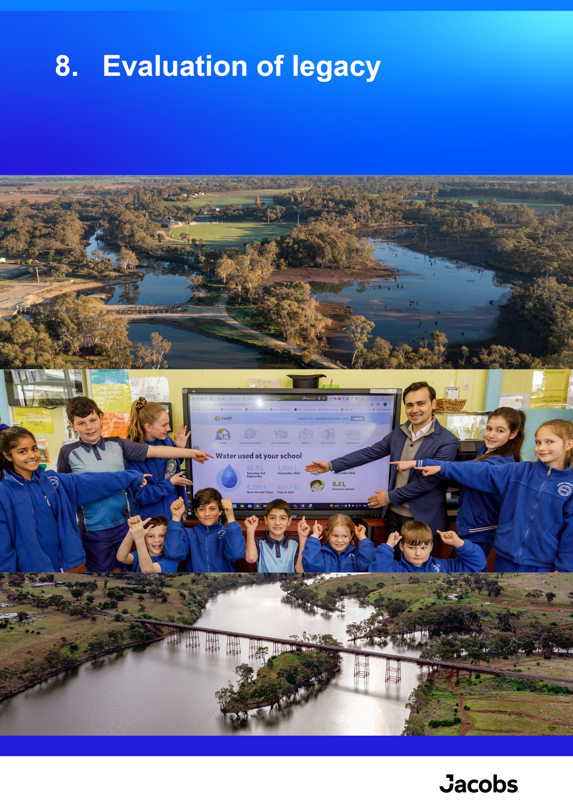

Evaluation of legacy
Key findings
- Significant efforts were made in project planning and design to encourage impacts and benefits to endure into the future. The main ways in which projects promoted sustained impacts included:
  - focusing on capacity building
  - fostering long-term partnerships and collaborations
  - implementing enduring reforms and policy changes
  - use of new technology and reporting platforms
  - the delivery of on-ground projects focused on creation of long-term benefits.

Overview
The legacy of EC5 implementation to the End-of-Tranche was assessed through the following KEQ:
- To what extent are EC5 tranche impacts expected to be sustained over time?
The key sources of information used in this analysis were the project evaluation reports, in which project leads reported on legacy aspects of their project. Additionally, interviews with select project teams and DEECA leadership provided relevant insights.

To what extent are EC5 tranche impacts expected to be sustained over time?
Significant efforts were made in project planning and design to encourage impacts and benefits to endure into the future. The main ways in which projects promoted sustained impacts include:
- Focus on capacity building (of communities and the water sector personnel), ownership and long-term behaviour change through collaboration, delivery of education programs, information products, and significant engagement.
- Fostering long-term partnerships and collaborations across a wide range of groups in the water sector and the community for development of strategies, planning, design and on-ground delivery.
- Reforms and policy changes, strategies and legislation that create long-term, enduring changes to the functioning of the Victorian water sector. For example, work on developing a new Victorian Waterway Management Strategy, development of Water (Recreational Area) Regulations, continued grid planning, Water market reforms, water compliance reforms, Birrarung (Yarra River) governance, publication of Water is Life and the CGRSWS.
- Improving the availability and quality of information through new technology and reporting platforms, which will be operational into the future. Examples include redevelopment of the Water Monitoring Information System, development of the Water Education Portal (aimed at resources for students and teachers), launching the Water Market Watch iOS app to provide real-time water market information, and upgrade of the Victorian Water Accounts platform.
- Delivery and contribution to on-ground projects that will provide long-term benefits to waterway health, water security, water quality, and climate change resilience.
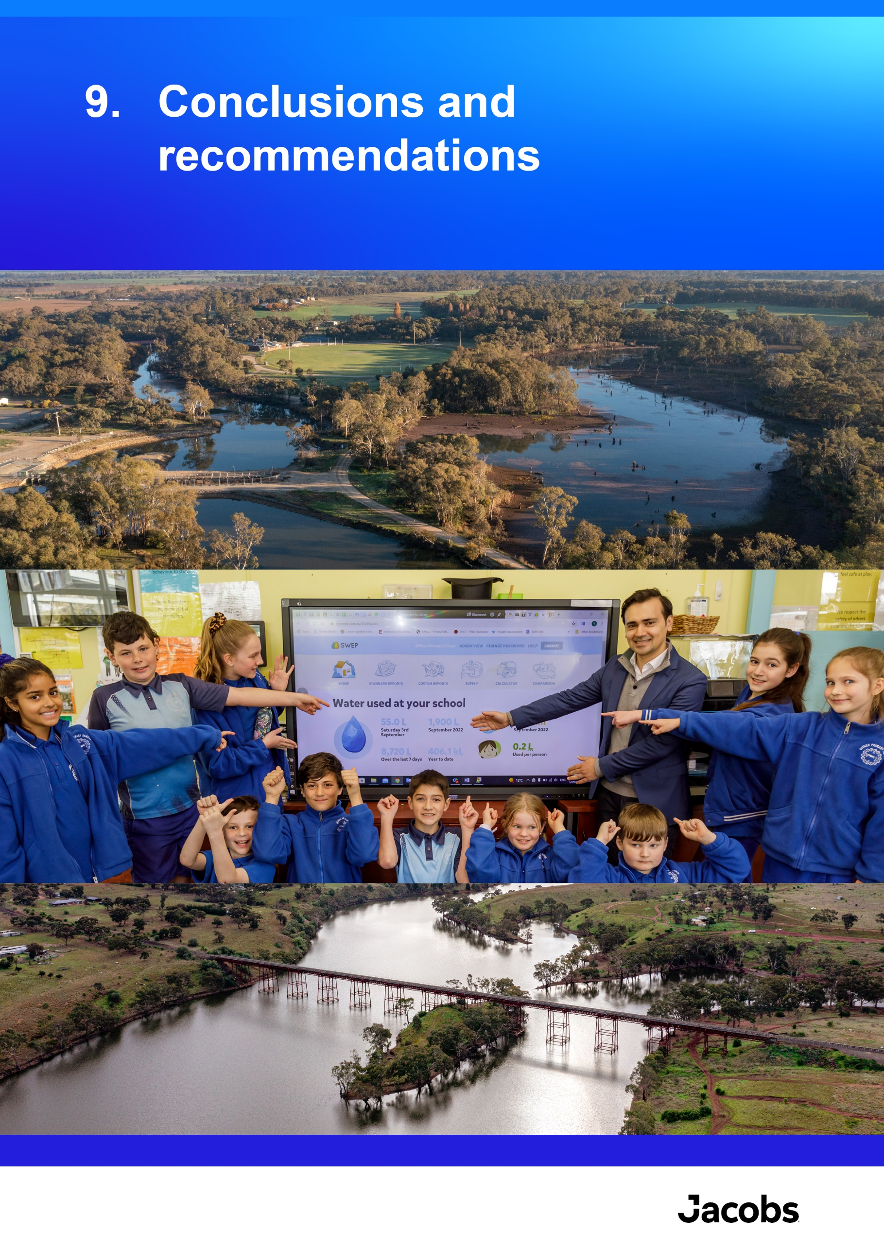

Conclusions and recommendations

Conclusions and recommendations
Delivery of EC5 strongly aligned with, and made considerable progress towards the legislated objectives of the EC, and key Victorian Government policies and strategies, including Water for Victoria, Water is Life and the CGRSWS. As with previous tranches of the EC, EC5 provided critical funding that has driven innovation and best practice in water management, enabled planning and delivery of strategic, long-term projects, and delivered ongoing foundational services to meet the needs of the Victorian water sector, communities and industries.
The findings from the EC5 End-Of-Tranche evaluation point to the need for future EC tranches to respond to current and emerging challenges associated with sustainable water management and protection of environmental values, and to realise the full benefits of EC5 investments and those in earlier tranches.
Recommendations have also been developed to support continuous improvement for the EC into the future and have been framed to be relatively discrete actions to provide flexibility around how and when they are implemented based on available funding and resourcing.
Table 12. Recommendations for continuous improvement of future tranches
Recommendation | Rationale and details
- Continue EC funding into a sixth tranche. Prioritise future investment to build resilience to existing and emerging challenges, and to support benefits realisation from work started in EC5 or earlier tranches. | Continued investment is required in many areas to maintain the gains made by EC5 and previous tranches of the EC, and to achieve the objectives of Water for Victoria, Water is Life, the CGRSWS and other key state strategies (for example, the Water Cycle Adaptation Action Plan). Future investment should be directed toward:  - Building water security and resilience in the Victorian water sector, communities, and environments to existing and emerging challenges: Key themes for increased focus in EC6 include security of supply and demand management, climate change adaptation, supporting the energy transition, environmental stewardship and values, supporting Traditional Owner self-determination, collaboration and relationships, and the integration of new technologies with water planning and decision-making.  - Continuing ongoing projects to support benefits realisation from work started in EC5 or earlier tranches: Many of the EC5 projects are not discrete 4-year investments, but require funding over longer periods of time to deliver the EC long-term outcomes. This includes long or medium-term projects that are expected to realise benefits over two or more EC tranches and ongoing business-as-usual work that is foundational to the functioning of the Victorian water sector.  Priorities for future funding are outlined in Table 13 below.
- Continue to support the EC’s adaptability to changing conditions and priorities | It is recognised that changing conditions and priorities will emerge throughout each tranche, which can affect the relevance and ability to deliver commitments designed at the funding submission stage. The evaluation found that EC5 projects adapted well to unexpected disruptions (such as the COVID-19 pandemic and extreme weather events), and flexibility in delivery was supported by the EC Project Control Board. New priorities that emerge are managed through maintaining a buffer of unallocated funds that can be directed to these emerging issues. These mechanisms should continue to be supported to provide flexibility in future tranches.
- Investigate ways to better align multiple funding sources | Many projects utilised co-funding from other sources. However, there were challenges with aligning the timing and reporting requirements of multiple funding sources. While the EC is already aligned with other Victorian budget processes, and there is limited opportunity to modify Commonwealth funding processes, there may be other opportunities for the delivery of EC projects to align with other funding sources. Any alignment between funding sources could support delivery and reporting efficiencies. Therefore, where possible, potential co-funding opportunities should be identified as early as possible.
- Investigate options for streamlining reporting processes | While the existing governance and reporting structures are functioning well to support effective EC delivery, it would be beneficial to investigate options to reduce duplication and administrative workload through creating more efficient links between regular reporting and evaluation reporting. Opportunities for streamlining reporting between DEECA and partner agencies where there is collaborative work should also be explored.
- Build in appropriate governance and funding structures to support Traditional Owner involvement | Partnerships with Traditional Owners are of critical importance to the management of Victoria’s water resources. Developing these arrangements will help to support Traditional Owner self-determination. Where they currently exist, such as the CGRSWS Traditional Owner Partnership, they will need to be properly resourced and supported. Governance and funding structures will need to be designed in collaboration with Traditional Owner organisations so they can balance the increased demand for engagement and partnership on a wide range of water-related and other matters. Streamlining funding arrangements, supporting capacity building and ensuring there is oversight of broader engagement with Traditional Owners should be key priorities.
- Consider economic and social value analyses and /or benefits assessment | There are challenges with articulating the benefits of some projects and the collective benefits of the EC, particularly for ongoing business-as-usual work, maintenance works, and broad policy or planning projects. There is an opportunity to better articulate the benefits of the EC through economic and social values analyses, and/or narratives around how the benefits of delivered projects are realised by Victorian communities, environments and industries.
- Consider the opportunities and potential risks associated with EC funding being used for ongoing business-as-usual activities, and build in mitigation measures to future tranches | It is acknowledged that there are a range of opportunities and benefits of EC funding supporting both short- and long-term projects. There is a need to reflect on potential risks that could emerge if the EC is increasingly used for ongoing, business-as-usual activities, such as:  - potential for reduced ability to innovate and implement new projects in response to changing demand and priorities  - risks to the delivery of critical business-as-usual DEECA activities if funding pool from EC were to decrease  - difficulty in providing immediate visible project outcomes and benefits of ongoing business-as-usual work, which could lead to poor community perception.  Design of future EC tranches should consider these potential risks, along with the opportunities, and build in mitigation measures if required.

Priorities for investment in EC6 and into the future
Continued investment is required to respond to existing and emerging challenges and to maintain and build upon the significant progress made toward improving water security, water efficiency, waterway and catchment health, inclusion of Traditional Owner priorities, inclusive management, and water governance throughout Victoria. Key priorities are summarised in Table 13 and have been categorised into:
- Response to existing and emerging challenges: Increased investment in projects to respond and build resilience in the Victorian water sector, communities, and environments to existing and emerging challenges.
- Realising the full benefits from current and prior investment: Continuation of ongoing projects to support benefits realisation from work started in EC5 or earlier tranches.
Table 13. Summary of priority areas for future investment
Category | Priority areas for future investment
Response to existing and emerging challenges | - Adapting to climate change: There is a need to increasingly integrate adaptive planning into water sector decision-making to support resilience to future weather conditions (for example, floods, fires and droughts). There is also the need to continue to develop better understanding of how to meet Victoria’s water sector objectives in a drying climate, integrate the latest knowledge into water resource plans and strategies, and build capacity in climate change adaptation and mitigation principles.  - Building resilience: There needs to be an increased focus on proactive resilience to identify emerging trends as they arise, and act quickly.  - Supporting the energy transition: Water access is pivotal to Victoria’s energy transition to net zero emissions as emerging energy technologies, including large-scale hydrogen and pumped hydro projects, require water to operate. Investment is required to support decision-makers, investors, secure the upstream supply chain and contribute towards Victoria meeting its net zero targets.  - Supporting Traditional Owner self-determination and access to water: Investment in implementation of the actions from Water is Life is required to increase Traditional Owner roles and resources in water and waterway management, and improve Traditional Owner access to water for self-determined purposes. Considerable effort is still required to address barriers, change legislative and regulatory settings, and achieve a step-change in the return of water to Traditional Owners.  - Delivering the Long-Term Water Resource Assessment: The Long-Term Water Resource Assessment for Northern Victoria is due to commence in 2025 building on lessons learnt in the Southern Victorian assessment.  - Integrating new technology solutions: Increased investment in new technologies and platforms to provide opportunities for distribution of information and data informed decision-making. In part, this will involve continuation of new technology platforms delivered in EC5, as well as investigation of emerging applications. There is also an increasing need to manage associated cyber security risks and threats.  - Securing water supplies: Building on the achievements in EC5, look to build secure water supplies into the future by providing opportunities to transition to water efficiency and manufactured water, reduce reliance on river water and plan and implement augmentations to meet water needs as the population grows and the climate changes. In the future, planning approaches that focus on readiness planning to reduce pressure on the water grid will be key to securing water for all our needs.
Realising the full benefits from existing investment | Medium- and long-term projects that depend on funding over two or more EC tranches:  - Water reforms: Continued work on the suite of water market reforms and improvements to frameworks and policies for water sharing, management, accountability and transparency.  - Water resources planning and delivery of actions: Continued implementation of water portfolio priorities YSP, the Waterways of the West and Rivers of the Barwon (Barre Warre Yulluk) Action Plans and development of new SWS in the Western and Northern Regions.  - Waterway health: Long-term investment is required across the state to protect Victoria’s waterways and deliver long-term environmental outcomes. Stable, ongoing funding allows for projects to be planned on the timelines necessary to implement meaningful change for waterway health, such as the 10-year flagships program.  - Collaboration and partnerships: Continuing and building upon existing work to foster a collaborative approach to water management, including strengthening partnerships across water sector agencies, Traditional Owners and between the water sector and Victoria’s communities to ensure water security is achieved.  - Traditional Owner priorities: Continued investment into the Aboriginal Water Program is necessary to maintain employment of Aboriginal Water Officers and enable continuity of long-term Traditional Owner-led water-related projects and priorities. The continuation of the Aboriginal Water Program is a key enabler and foundation for Water is Life implementation.  - Water efficiency: Continued focus on reducing irrigation losses and improving irrigation efficiency through infrastructure investments and extension support to irrigators. Continuation of community, school and household water efficiency projects and behaviour change and education initiatives.  - Integrated water management: Continuation of mainstreaming the integrated water management approach through the IWM Forums, policy work and supporting grant programs. Future investment in this program builds industry capacity to better adapt to climate change, build resilience, secure water supplies, support the housing development government priority while managing impacts on waterway health.  Ongoing foundational, business-as-usual projects:  - operation of the Victorian Water Register  - water compliance activities, management of entitlements, water trading and accounting  - continuation of long-term surface water monitoring and modelling activities, maintenance of monitoring infrastructure, and provision of foundational water information to the water sector and communities.

Appendix A: Summaries of project evaluations

Appendix B: Impact domain: Examples of project contributions to end of tranche outcomes

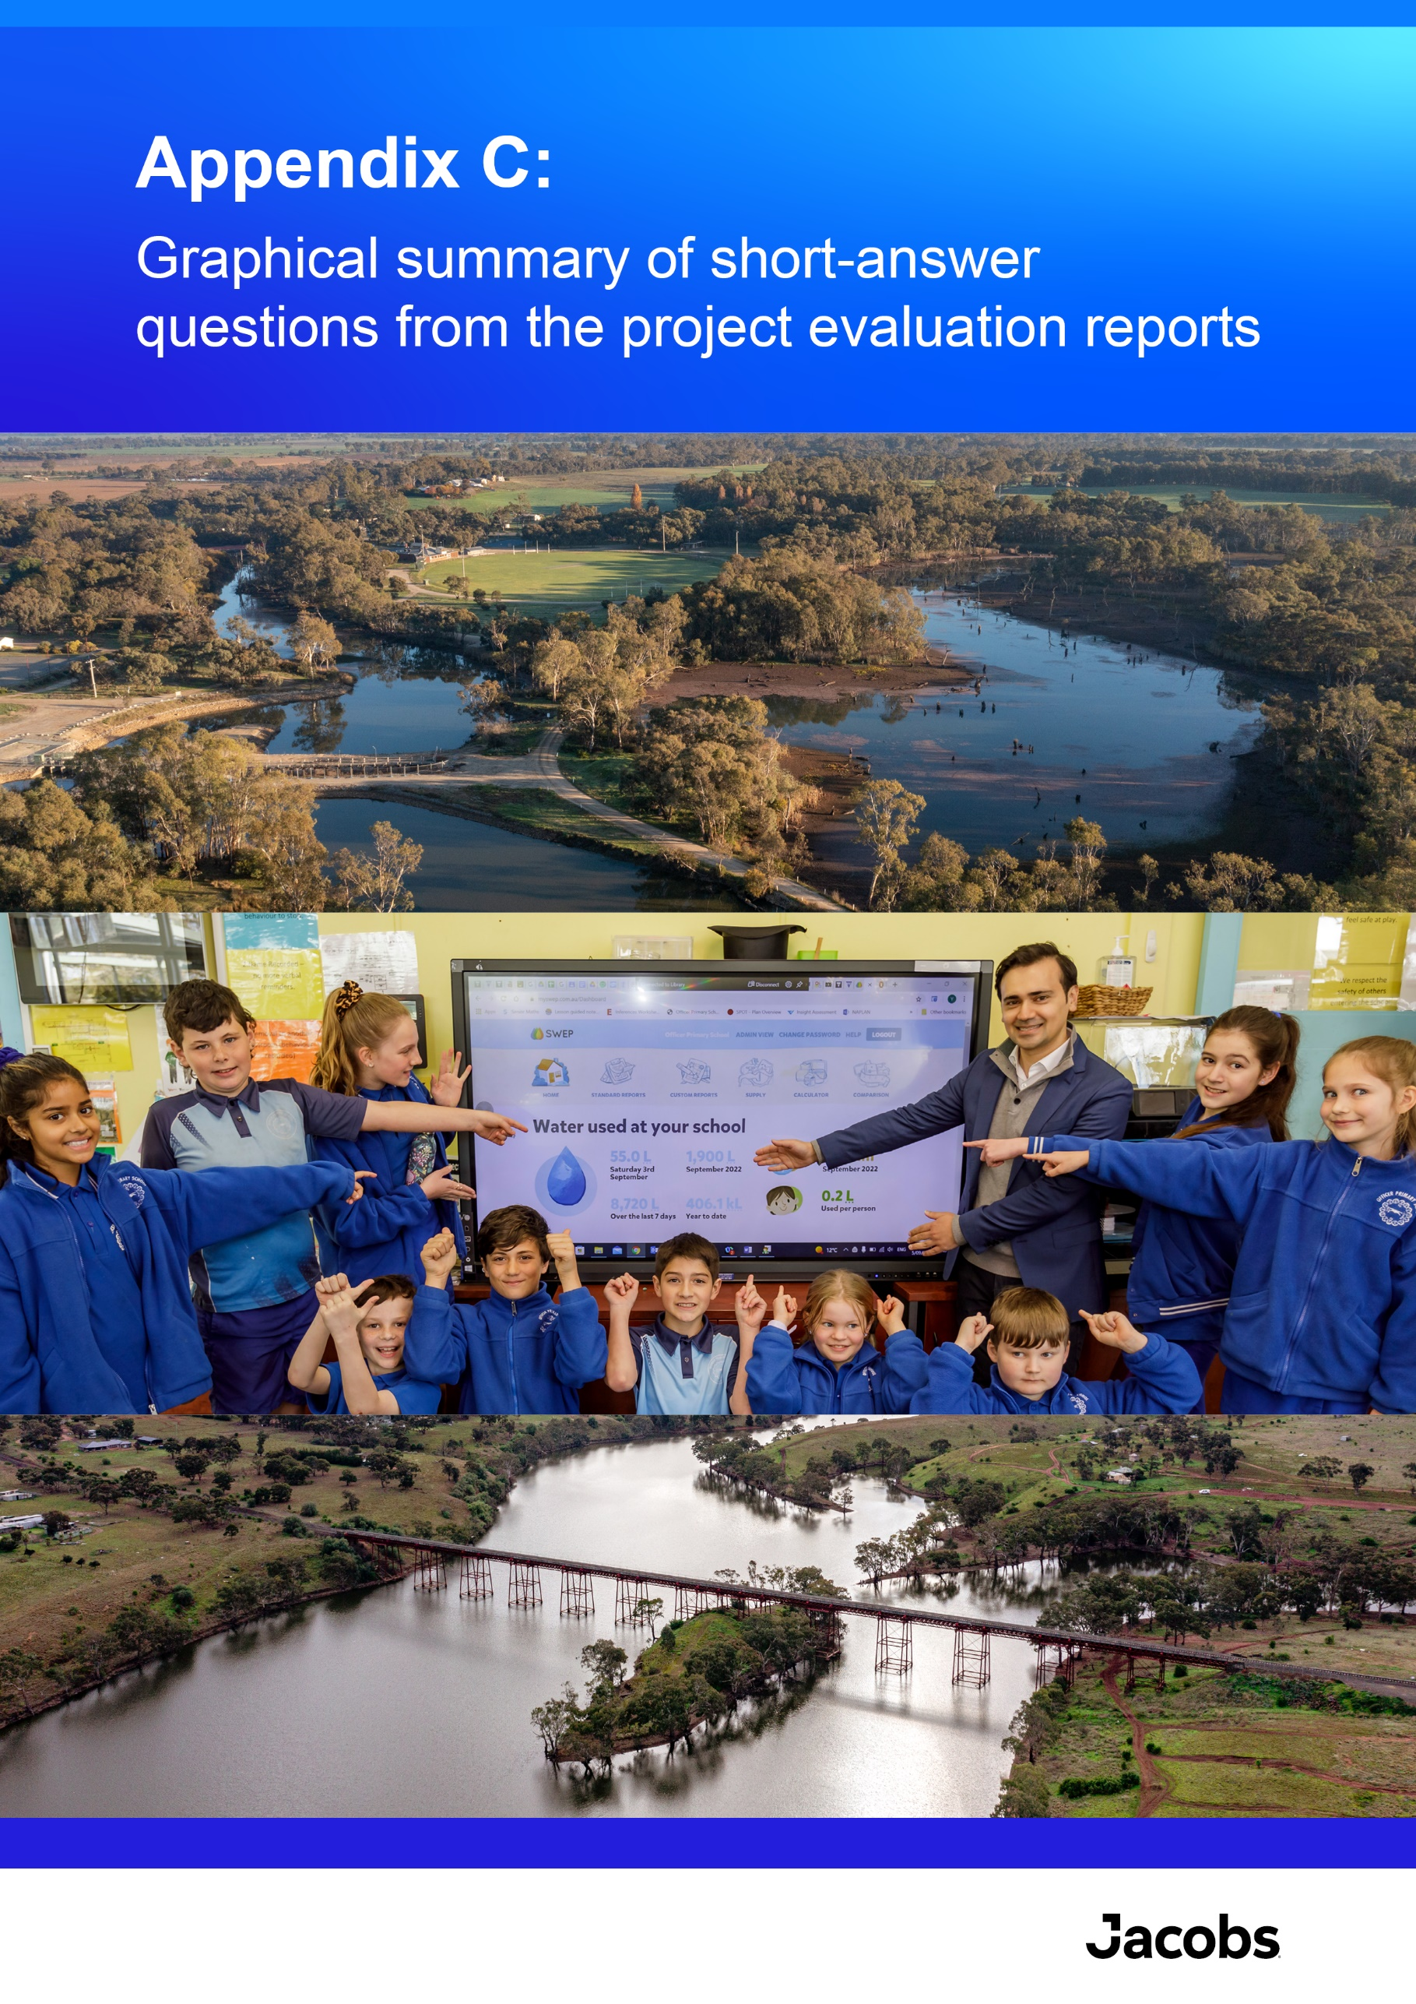

Appendix C: Graphical summary of short-answer questions from the project evaluation reports
Section 6 of the 2023 EC5 project evaluation reports contained a series of short answer questions which have been referred to throughout this evaluation report. The responses were not updated for the End-of-Tranche evaluation. This Appendix provides a graphical summary of the responses.
To what extent do you agree or disagree with the following statements?
6.1 The effects of unexpected events (such as floods, droughts, covid) and other challenges were managed adequately to reduce their impact on initiative outcomes
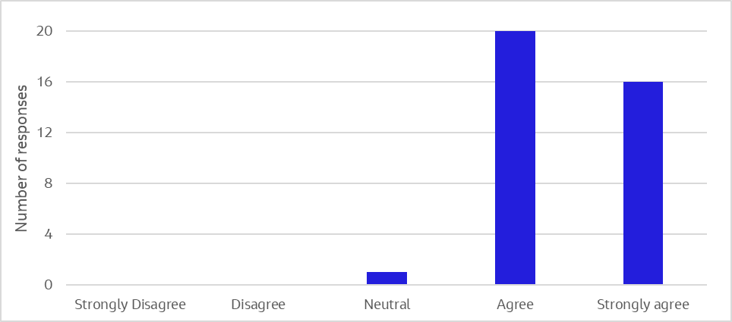
6.2 The initiative is on track to deliver the full set of outputs (products or deliverables) as intended
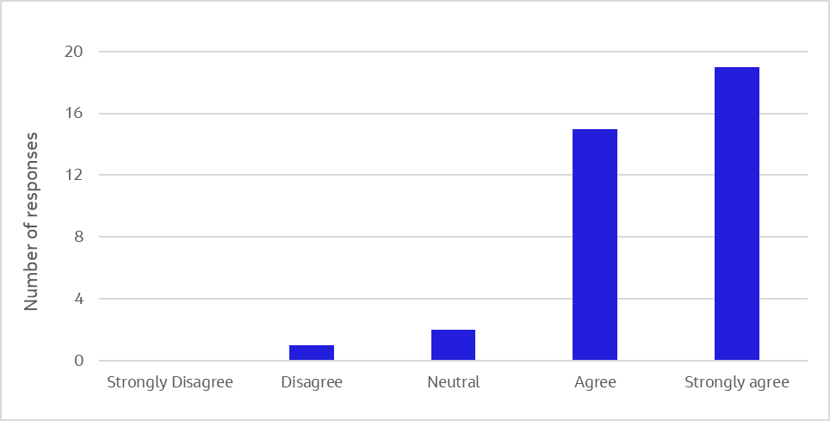
6.3 The initiative is on track to deliver the full set of outcomes (intended effects or changes from tranche ) as intended
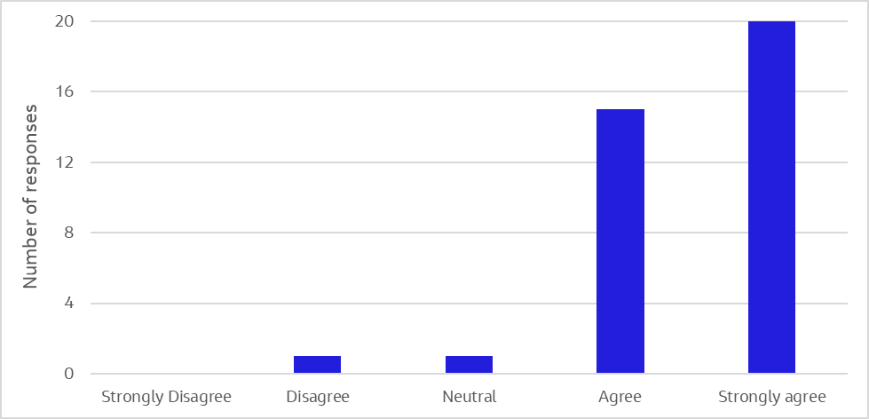
6.4 Initiative management and delivery arrangements supported the effective and efficient delivery of the initiative
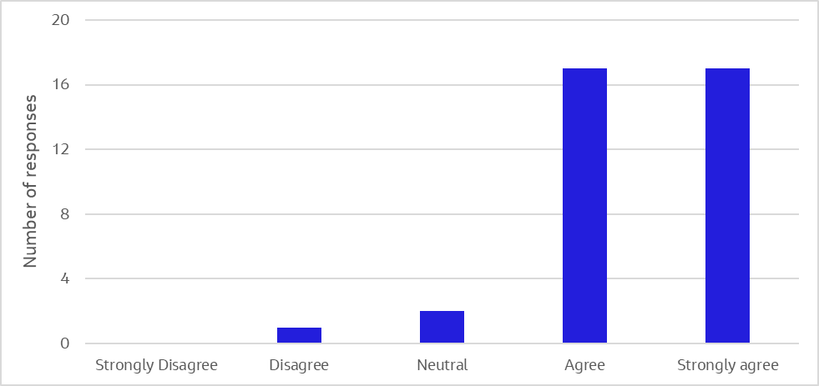
6.5 Options assessment and / or cost-benefit analyses were used effectively to support initiative decision making
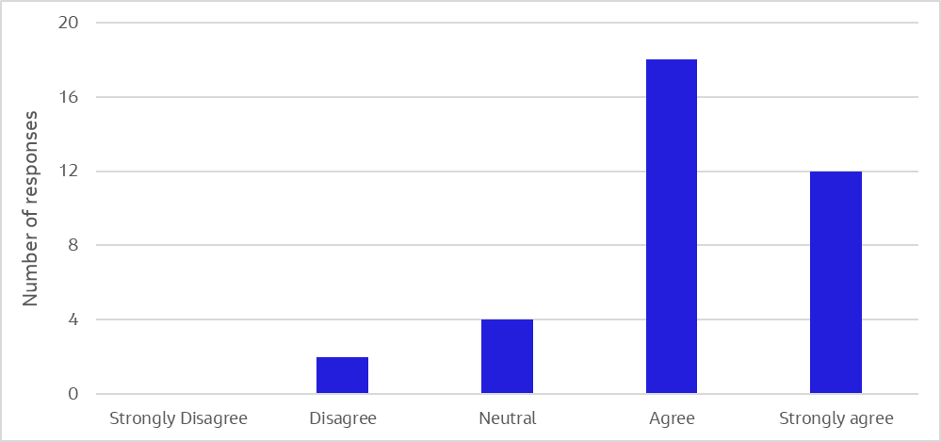
6.6 The initiative enabled Traditional Owner Self-determination objectives and aspirations
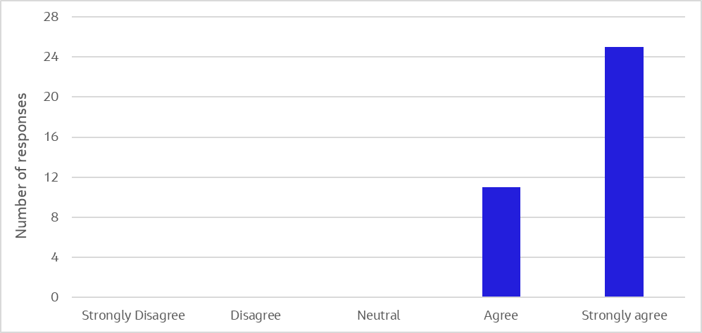
6.7 Learning and improvement were effectively incorporated into the initiative, to foster a culture of continual improvement
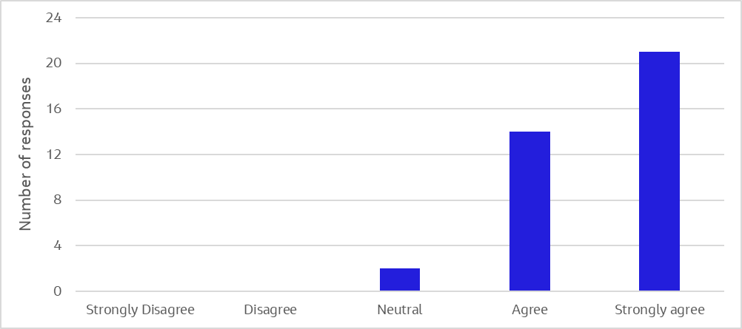
6.8 Partnerships that were developed throughout tranche 5 were valuable in achieving initiative outcomes
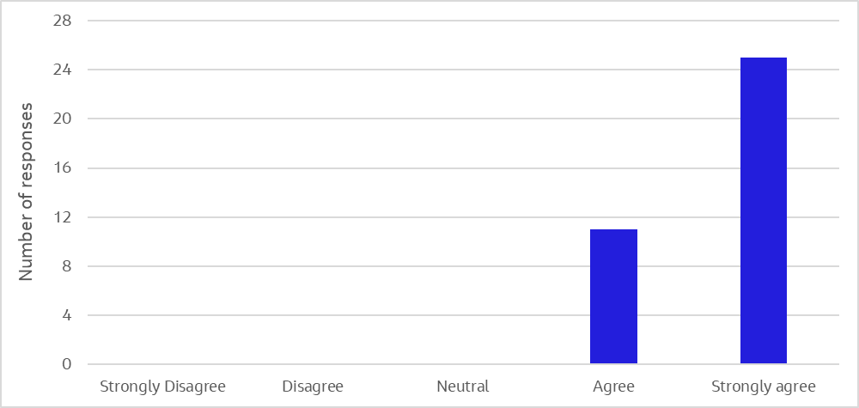
6.9 Efficiencies were gained through working together with other initiatives to achieve better outcomes.
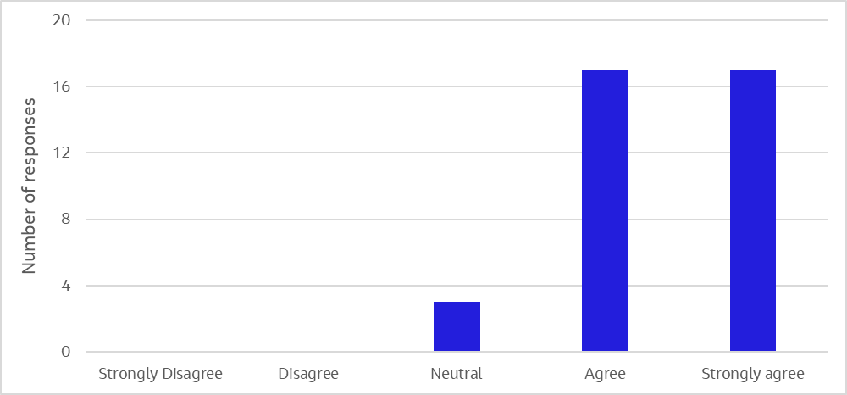
6.10 The initiative is increasing community participation and inclusion of community values in water management
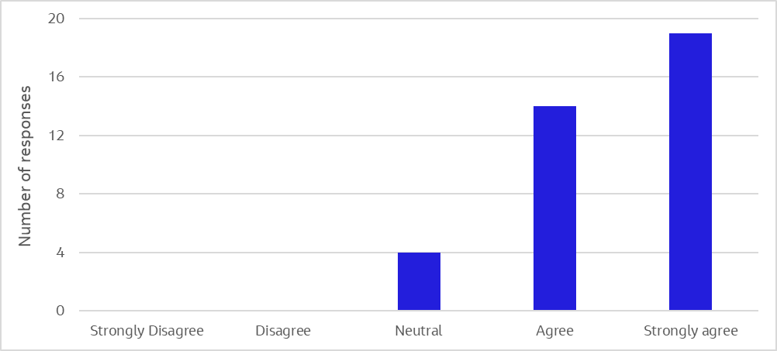
6.11 Did the initiative foster partnerships with others?
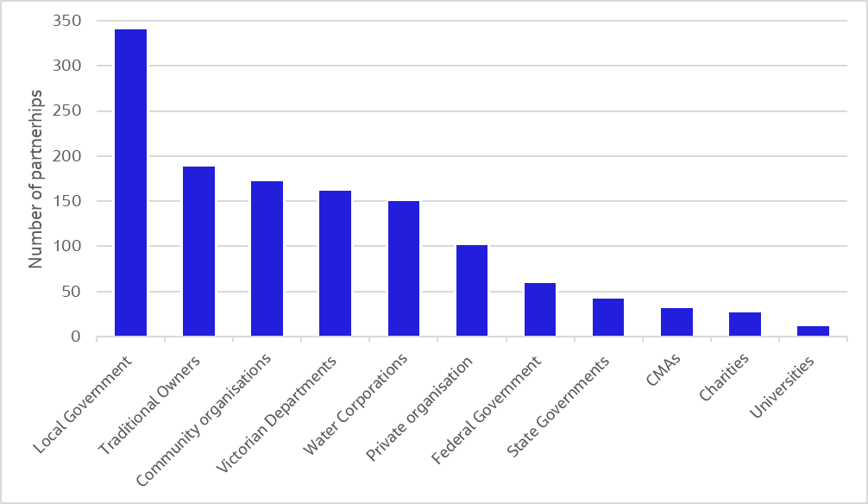
6.12 Is the initiative contributing to the promotion of sustainable management of water?
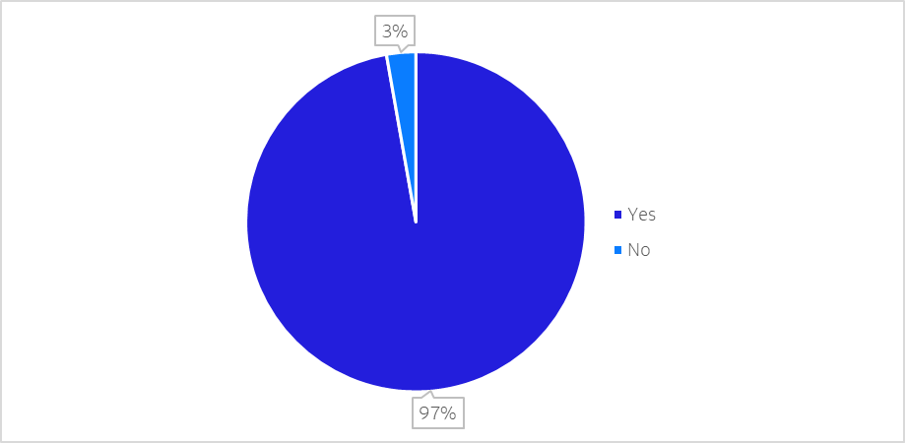
6.12 Is the initiative addressing adverse water-related environmental impacts?
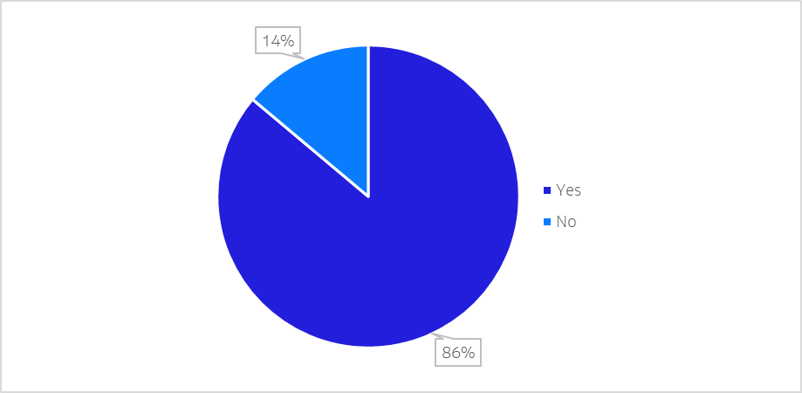
7.3 Does the initiative include work that is of an ‘ongoing’ nature (i.e. was part of prior EC tranches, and will continue on into future tranches indefinitely)?
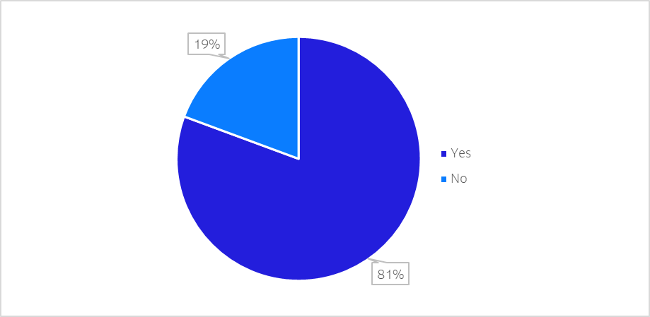

Australian Government Dept of Finance (2023) Commonwealth Evaluation Policy and Toolkit, https://www.finance.gov.au/about-us/news/2021/commonwealth-evaluation-policy-and-toolkit
Jacobs (2023) Environmental Contribution Tranche 5 Evaluation Plan, Final 15 March 2023
Victorian Environmental Flows Monitoring and Assessment Program
Wetland Monitoring and Assessment Program

