Victoria’s water in a changing climate
  - Insights from the Victorian Water and Climate Initiative: Amended Feb 2021
Cover Image: Kings Billabong. Photo credit: Emma Coats, VEWH
This version of Victoria’s Water in a Changing Climate has been created using best possible accessibility practices. Given the size and scope of this document, if you would like assistance on how to best navigate this document and its findings, we recommend you contact the Hydrology and Climate Science team of the Water and Catchments Group of the Victorian Government Department of Environment, Land and Planning. Their contact is HCS.Team@delwp.vic.gov.au.

Acknowledgements
We acknowledge and respect Victorian Traditional Owners as the original custodians of Victoria’s land and waters, their unique ability to care for Country and deep spiritual connection to it. We honour Elders past and present whose knowledge and wisdom has ensured the continuation of culture and traditional practices.
We are committed to genuinely partner, and meaningfully engage, with Victoria’s Traditional Owners and Aboriginal communities to support the protection of Country, the maintenance of spiritual and cultural practices and their broader aspirations in the 21st century and beyond.
This project has been funded by the Victorian Government Department of Environment, Land, Water and Planning (DELWP), with financial contributions from the Bureau of Meteorology and the CSIRO. The authors wish to acknowledge the input from water sector stakeholders and scientists in the development of the Victorian Water and Climate Initiative research program. We wish to thank various internal and external reviewers for providing valuable feedback that has improved this report as well as Hydrology and Risk Consulting (HARC) for contributing to the development of Figure 3.13. We also acknowledge the in-kind contribution of Monash University.
This report was amended in February 2021 to correct a plotting position error in Figure 2.1. Data for 2020 was also added to Figure 2.1

Contributors:
Project leaders: Pandora Hope (Bureau of Meteorology), Murray Peel (The University of Melbourne), Francis Chiew (CSIRO), Geoffrey Steendam (DELWP).

Project teams:
Bureau of Meteorology: Linden Ashcroft*, Ghyslaine Boschat, Andrew Dowdy, Sonya Fiddes*, Chris Lucas, Roseanna McKay, Sugata Narsey, Luke Osburn, Acacia Pepler, Scott Power*, Surendra Rauniyar, Irina Rudeva, Bertrand Timbal, Margot Turner, Peter van Rensch*, Guomin Wang.
* Denotes a researcher who is no longer with BoM. VicWaCI thanks their new organisation for allowing them to continue with this important work.
The University of Melbourne: Margarita Saft, Chinchu Mohan.
CSIRO Land and Water: Steve Charles, Guobin Fu, Michelle Ho, Nick Potter, Lu Zhang, Hongxing Zheng.
Monash University: Tim Peterson.
DELWP (Hydrology and Climate Science team): Rachel Brown, Sandra Dharmadi, Glenn Dunks, Jasmine Errey, Marty Gent*, Thomas Jenkins*, Rebecca Lett, Lisa Lowe*, Robert Morden*.
* Denotes a former member of the Hydrology and Climate Science team.
Editorial support: Karen Pearce
Design and layout: Green Scribble
© The State of Victoria Department of Environment, Land, Water and Planning 2020
This work is licensed under a Creative Commons Attribution 4.0 International licence. You are free to re-use the work under that licence, on the condition that you credit the State of Victoria as author. The licence does not apply to any images, photographs or branding, including the Victorian Coat of Arms, the Victorian Government logo and the Department of Environment, Land, Water and Planning (DELWP) logo. To view a copy of this licence, visit creativecommons.org/licenses/by/4.0/
ISBN 978-1-76105-348-1 (Print)
ISBN 978-1-76105-349-8 (pdf/online/MS word)
This report should be cited as: Department of Environment, Land, Water and Planning; Bureau of Meteorology; Commonwealth Scientific and Industrial Research Organisation; The University of Melbourne (2020), Victoria’s Water in a Changing Climate.

Disclaimer
This publication may be of assistance to you but the State of Victoria and its employees do not guarantee that the publication is without flaw of any kind or is wholly appropriate for your particular purposes and therefore disclaims all liability for any error, loss or other consequence which may arise from you relying on any information in this publication.

Accessibility
If you would like to receive this publication in an alternative format, please telephone the DELWP Customer Service Centre on 136 186, or email customer.service@delwp.vic.gov.au, or via the National Relay Service on 133 677, www.relayservice.com.au. This document is also available on the internet at www.delwp.vic.gov.au

Contents
Executive summary 5
Water in Victoria 5
Victoria’s changing climate 5
Implications for the water sector 5
Victoria’s changing hydrology 6
Implications for the water sector 6
Victoria’s water future 6
Implications for the water industry 7
Research application 7
New research findings 7
1. Water in Victoria 7
Water in Victoria: at a glance 7
1.1 Science to support water management in Victoria 8
1.2 Victoria’s water resources 8
1.3 Victoria’s variable and changing climate and water 10
1.4 Implications for the water sector 11
2. Victoria’s changing climate 11
Victoria’s changing climate: at a glance 12
Implications for the water sector 12
2.1 Victoria’s climate 12
2.2 Recent rainfall decline 15
2.3 Simulated and projected rainfall changes 17
2.4 Changes in global circulation influencing Victoria’s rainfall 20
2.5 Variability drivers – from the tropics and mid-latitudes 21
2.6 Weather systems influencing Victorian rainfall 22
VicWaCI considered three types of weather systems. 22
2.7 Extreme rainfall events 24
3. Victoria’s changing hydrology 27
Victoria’s changing hydrology: at a glance 27
Implications for the water sector 28
3.1 Victoria’s hydrology 28
3.2 Pre-drought, drought and post-drought runoff generation 32
3.3 How have rainfall–runoff relationships changed? 32
3.3.1 Annual changes 33
3.3.2 Seasonal changes 35
3.3.3 Types of catchment drought response and recovery 36
3.4 Why have rainfall–runoff relationships changed? 37
3.4.1 Key catchment and drought characteristics 38
3.4.3 Groundwater–surface water connectivity 39
3.4.4 Catchment wetness and drought recovery 40
3.5 Magnitude of observed shift in rainfall–runoff relationship during the Millennium Drought 41
3.6 Implications for hydrology modelling 42
4. Victoria’s water future 43
Victoria’s water future: at a glance 43
Implications for the water industry 44
4.1 Projections of water futures 44
4.2 Understanding uncertainty 46
4.2.1 Uncertainty in future rainfall projections 47
4.2.3 Range of uncertainty in rainfall and runoff projections for Victoria 49
4.2.4 Uncertainty in hydrological modelling 51
4.3 Using projections to inform planning, management and adaptation decisions 51
Climate reference period 52
5. Research application 52
Sources of additional information include: 53
Glossary 53
References 54

Executive summary
The Victorian Water and Climate Initiative (VicWaCI) is a partnership between the Victorian Department of Environment Land, Water and Planning (DELWP), the Bureau of Meteorology, The University of Melbourne and the Commonwealth Scientific and Industrial Research Organisation (CSIRO). VicWaCI is managed by the Hydrology and Climate Science team of DELWP’s Water and Catchments Group who worked closely with researchers and water sector stakeholders to design the program.
VicWaCI sought to answer questions and better understand our climate and water resource situation. The findings from the initiative are presented in this report, with some of the new findings highlighted on page 7. This initiative continues on from earlier work by the South Eastern Australian Climate Initiative and the Victorian Climate Initiative.

Water in Victoria
Findings from VicWaCI are helping to better understand how the climate has and will continue to change and the impacts on Victoria’s water resources, allowing better preparation for the future.
Victoria’s water resources are under pressure from increasing demand and decreasing supply.
Victoria’s already highly variable rainfall and streamflow are now occurring against a backdrop of climate change, with the drying trend of recent decades projected to continue into the future.
The water sector, including water-dependent industries and water entitlement holders, need to continue managing and planning for large variability along with increasingly hotter and drier conditions.

Victoria’s changing climate
Victoria’s climate is highly variable; however, the trend in recent decades is towards warmer and drier conditions.
The decline in cool-season rainfall in recent decades is unlikely to have been as large without the influence from increasing levels of atmospheric greenhouse gases.
The majority of climate models project a drier climate future for Victoria, particularly later this century under a high emissions scenario.
Most global climate models underestimate the magnitude of the observed decline in rainfall. This lowers confidence in projections based on the same models.
Changes in the global circulation are associated with an increased frequency of high-pressure systems and reduced frequency of low-pressure systems across Victoria.
Large-scale climate drivers, such as El Niño and the Indian Ocean Dipole, that are largely responsible for Victoria’s climate variability are themselves subject to climate change, with consequent effects on rainfall.
Rainfall from cold fronts and low-pressure systems in the cooler half of the year has declined across Victoria, while thunderstorm-related rainfall has increased in northern Victoria in the warmer half of the year.
Extreme, short-duration rainfall events are generally becoming more intense in Victoria, a trend that is expected to continue into the future.

Implications for the water sector
Most of the rainfall and runoff in Victoria occurs during the cooler half of the year. The reductions in rainfall during this part of the year have a disproportionately large impact on water availability because this is the time of year when a larger proportion of rainfall becomes runoff.
From a runoff perspective, possible increases in rainfall during the warmer months are unlikely to offset the impact of rainfall declines during the cooler time of the year.
A significant reduction in the number of very wet months since 1997, particularly during the cooler time of the year, has also reduced water availability. The wetter catchment conditions during these very wet months generally result in a larger proportion of rainfall becoming runoff and provide improved resilience for water users or environmental systems to cope during any subsequent dry periods. Changes in rural hydrology and rural flooding will depend on the conditions in any given catchment.
The intensity of short-duration (hour-long) rainfall events is increasing in some places but is not expected to offset the water availability impact of overall declines in rainfall. However, it is likely to have implications for urban hydrology and urban flooding, depending on the influence of overall drier catchment conditions and other factors, including the capacity of drainage systems to accommodate these short-duration rainfall events.

Victoria’s changing hydrology
Average runoff has declined over recent times, largely due to rainfall declines.
Runoff reductions in some catchments are larger than expected from reduced rainfall.
There was a downward shift in the rainfall–runoff relationship in many Victorian catchments in the Millennium Drought.
Catchments can respond to and recover from drought in distinctly different ways.
The shifts in the rainfall–runoff relationships were largely governed by catchment resilience or vulnerability to drought, rather than differences in drought severity.
Changes in weather systems may be less important in determining if a catchment is more likely to experience a shift in rainfall–runoff relationship compared to internal catchment characteristics, such as catchment mean slope.
Groundwater–surface water disconnection is an important feature of catchments with shifted rainfall–runoff relationship during the drought.
The rainfall–runoff relationship in some catchments can recover even if they don’t receive all of the ‘missing’ rainfall that they went without in the drought years.
During the Millennium Drought, more than half of the Victorian catchments analysed experienced an extra 20–40% decline in their annual streamflow due to the shift in rainfall–runoff relationships.
The current generation of hydrologic models do not replicate well the observed changes in the rainfall–runoff relationship during and after extended drought.

Implications for the water sector
The low-runoff conditions experienced in many catchments during and after the Millennium Drought need to be factored into water resource planning decisions.
Until there are improvements in the ability of hydrological models to represent the impact of multi-year drought and shifting rainfall–runoff relationships, selection of calibration periods will be important to ensure that model results account for shifts in rainfall–runoff relationships.

Victoria’s water future
Future runoff in Victoria is likely to be lower because of the projected decline in cool-season rainfall and higher potential evapotranspiration. Variability will remain high, with wet and dry years on a background of a drying trend.
The runoff projections developed through the Victorian Climate Initiative continue to be the most appropriate for the water sector in Victoria and can be considered as projected change relative to post-1975 averages.
There is considerable uncertainty in future water availability projections, largely due to the uncertainty in future rainfall projections.
Finer-scale dynamic downscaled projections (like the Victorian Climate Projections 2019) can potentially add value, particularly for local scale assessments.
Although dynamic downscaling is improving, there is significant bias in the downscaled rainfall that needs to be robustly bias corrected for hydrological application.
Projection products from different selections of global climate models and dynamic downscaled products do not necessarily converge to a narrower range of change.
Hydrological models developed and calibrated against past observations may not robustly predict the future under hotter conditions, enhanced atmospheric carbon dioxide concentration and longer dry spells not seen in the past.
Assessments focused on a systems approach that characterise resilience to climate variability and climate change can provide insights and a foundation for considering the risk versus reward of adaptation options.

Implications for the water industry
Given the large range of plausible climate futures, water resource planning should consider a wide range of possible futures.
In addition to considering hydroclimate projections, approaches that consider how vulnerable a water system is to change can also be used to inform climate change adaptation. The Guidelines for Assessing the Impact of Climate Change on Water Availability in Victoria (DELWP 2020) have been developed to provide tailored guidance on how to apply hydroclimate science for water resource planning applications and to promote a consistent approach to climate change impact assessment across the water industry.

Research application
The findings that have emerged from VicWaCI have implications for many different parts of the Victorian water sector, particularly flooding, drainage, urban runoff, water supply and demand, water availability, infrastructure investment and water resource policy.
The Guidelines for Assessing the Impact of Climate Change on Water Availability in Victoria (DELWP 2020) draw on the science from VicWaCI in the selection of a climate reference period, in defining the range of recommended hydroclimate change projections and in recommending approaches to sensitivity and stress testing of water resources systems.

New research findings
The four-year investment in the Victorian Water and Climate Initiative has continued to build on the scientific knowledge base formed since the publication of the Victorian Climate Initiative’s findings in 2017. The initiative focused on partnering with Victorian water sector stakeholders to share the knowledge for application across the sector.
VicWaCI research has:
- identified the roles of natural variability and climate change in cool-season rainfall reductions experienced since 1997, and the prospects for future cool-season rainfall (Section 2.2)
- improved our understanding of how changes in global circulation have increased the frequency of high-pressure systems and reduced the frequency of low-pressure systems across Victoria (Section 2.4 and Section 2.5)
- identified the contribution of different weather systems to the amount of rainfall received across Victoria, how this changes seasonally and observed trends in these weather systems over time (Section 2.6)
- quantified how much sub-daily rainfall intensities have increased across some parts of Victoria (Section 2.7)
- identified the catchments across Victoria where a significant shift in the runoff response to rainfall was observed during the Millennium Drought, and catchments where these reductions have continued since the end of the drought (Section 3.3)
- classified catchment response to droughts, based on timing of the change in runoff response and recovery, which may be useful to predict future runoff response (Section 3.3.3)
- assessed the possible causes of the change in runoff response to rainfall (Section 3.4) and the magnitude of reductions in runoff response during the Millennium Drought (Section 3.5)
- identified that catchment runoff response can recover after drought prior to the cumulative rainfall deficit fully recovering (Section 3.4.4)
- used high-resolution rainfall projections to project runoff, which highlighted the challenges in robustly bias correcting dynamically downscaled rainfall for hydrological application (Section 4.2.1 and Section 4.2.2)
- improved understanding of how different climate and runoff projections compare, and methods for developing improved runoff projections (Section 4.2.3).

Water in Victoria

Water in Victoria: at a glance
- Findings from the Victorian Water and Climate Initiative are helping to better understand how the climate has and will continue to change and the impacts on Victoria’s water resources, allowing better preparation for the future.
- Victoria’s water resources are under pressure from increasing demand and decreasing supply.
- Victoria’s already highly variable rainfall and streamflow are now occurring against a backdrop of climate change, with the drying trend of recent decades projected to continue into the future.
- The water sector, including water-dependent industries and water entitlement holders, need to understand the nature of Victoria’s variable and changing water supply to effectively manage this critical resource.

1.1 Science to support water management in Victoria
Findings from the Victorian Water and Climate Initiative are helping to better understand how the climate has and will continue to change and the impacts on Victoria’s water resources, allowing better preparation for the future.
The Victorian Water and Climate Initiative (VicWaCI) forms part of the Victorian Government’s plan for management of our water resources as laid out in the framework document Water for Victoria (DELWP 2016). In particular, the work of the initiative is a response to the specific action around the understanding and application of climate science to water management in order to better meet the requirements of the water sector and the community.
While the whole climate system influences the hydrological cycle, understanding rainfall is particularly important because:
- It is the primary climate variable driving water availability.
- Projections of rainfall have larger uncertainty than projections of temperature due to variability in time and space.
- Rainfall declines over the past two decades have generally been much greater than the change simulated by most climate models. This raises important questions for the water sector about how much of the recent experience is natural variability and how much is a permanent shift due to the changing climate.
With greater understanding of the underlying physical processes for the changes observed, we are better able to interpret observed changes and identify and disentangle the influences of natural climate variability and climate change. This provides greater confidence for decision-making.
Similarly, understanding past runoff changes and future water projections allows us to better understand streamflow and other hydrology trends we are currently experiencing in Victoria and how these may change in the future.
Our understanding of these physical processes and of recent climate change and its impact on water was improved by research carried out in the South Eastern Australian Climate Initiative (SEACI) and the Victorian Climate Initiative (VicCI). However, many questions remained.
Building on these earlier research programs, VicWaCI was developed in consultation with stakeholders in the water sector to address some of these remaining questions, in particular:
- How much is climate change already impacting Victorian rainfall?
- Where is runoff declining and why?
- Can we improve projections of future water availability in Victoria?
VicWaCI sought to answer these questions by looking at the past to see what trends we have experienced so that we can better understand our climate and water resource situation today, as well as looking at the future so we can have as much knowledge as possible about where things are heading. The findings from the initiative are presented in this report, along with examples of how this information can support planning and decision-making.
The initiative was managed by the Hydrology and Climate Science team of the Victorian Department of Environment, Land, Water and Planning’s Water and Catchments Group. The team worked closely with researchers and water sector stakeholders to design the program. Research was delivered by the Bureau of Meteorology, The University of Melbourne and CSIRO.

1.2 Victoria’s water resources
Victoria’s water resources are under pressure from increasing demand and decreasing supply.
Water is critical to Victoria’s economy, environment and communities. A healthy environment and safe, affordable and reliable water services are essential for people, jobs and a thriving economy.
As of November 2020, Victoria’s water resources are managed by 19 water corporations constituted under the Water Act 1989 (Vic) (Figure 1.1). Rural water corporations are commonly required to provide irrigation, drainage and storage services. These services are critical for agricultural water users and underpin on-farm investment decisions. They are also responsible for administering the diversion of water from waterways and the extraction of groundwater on behalf of the Victorian Minister for Water.
Urban and regional water corporations manage water resources and deliver water supply and wastewater services within cities and towns. The forecast growth in urban population will increase pressure on existing water systems, placing a growing demand on current assets, infrastructure, water supply and wastewater services.
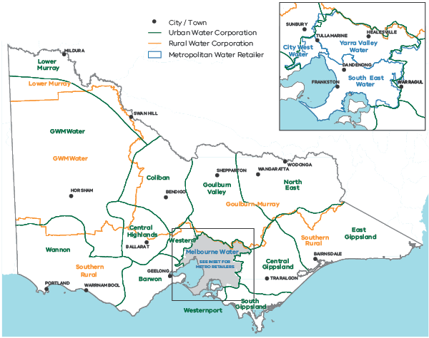
Figure 1.1: Jurisdictions of Victoria’s water corporations (Source: DELWP).
*In November 2020, the Victorian Government announced that metropolitan water retailer City West Water and urban water corporation Western Water would merge to form one larger, integrated entity called Greater Western Water that would commence on 1 July 2021.
Melbourne storages by the numbers:
1913 to 1996 historic average is 615 gigalitres.
1997 to 2019 average is 418 gigalitres.
2015 to 2019 average is 404 gigalitres.
1997 to 2009 average (millennium drought) is 376 gigalitres.
The 2019 inflow into Melbourne storages was 463 gigalitres. This was 25% below the historic 1913 to 1996 average.
Melbourne storages have received below historic average inflows in 18 out of the last 20 years.
Figure 1.2 Declining inflows to Melbourne's water storages (Source: DELWP).
The two greatest pressures on Victoria’s water resources are population growth and climate change.
In 2015, Victoria became the fastest growing state in Australia. Victoria’s population is projected to reach 10.1 million people by 2051 — almost double what it is today (DELWP 2016). Melbourne and the major regional centres Ballarat, Bendigo and Geelong are expected to almost double their population. The western suburbs of Melbourne will have an extra one million people. This population growth increases the demand for water, and rapid urbanisation increases stormwater, which can adversely impact waterways.
While demand for water is growing, supply is decreasing, with recent years seeing significant reductions in the amount of water flowing into Victoria’s water storages (Figure 1.2). Understanding the role that climate change is playing in Victoria’s water supply and how it will impact future supply is critical for ensuring Victoria’s water sector can continue to meet the state’s water supply needs.

1.3 Victoria’s variable and changing climate and water
Victoria’s already highly variable rainfall and streamflow are now occurring against a backdrop of climate change, with the drying trend of recent decades projected to continue into the future.
Victoria’s rainfall varies considerably from year to year (Figure 1.3) and also across the state. The annual average rainfall varies from less than 300 mm per year in parts of the north-west to over 1500 mm in parts of the Alps, while the wettest years can have more than twice as much rainfall as the driest years.
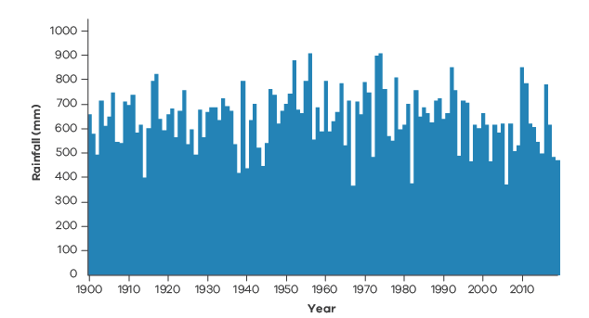
Figure 1.3 Total annual rainfall in Victoria from 1900 to 2019 showing high year-to-year variability (Source: BoM).
Rainfall variability is amplified in Victoria’s streamflow, which varies from year to year and between catchments. Longer-term changes in rainfall and streamflow are occurring against the backdrop of this high variability.
Over the past few decades, Victoria has experienced its warmest period on record, as well as declining cool-season (April to October) rainfall (Hope et al. 2017). This decline is associated with an increase in the number of high-pressure systems over southern Australia (Pepler et al. 2019) and a decrease in rainfall from fronts and low-pressure systems (Pepler et al. 2020b). A majority of global climate models (GCMs) indicate that climate change has contributed to the rainfall decline (Rauniyar and Power 2020). While rainfall will continue to vary from year to year, the underlying downward trend in cool-season rainfall due to climate change is projected to intensify, unless global greenhouse gas emissions are markedly reduced.
Streamflows over the past decades have also been the lowest on record, with many catchments experiencing significantly greater declines than expected based on past rainfall–runoff relationships. Streamflow is likely to continue to decline over coming decades (Potter et al. 2016). This is driven mostly by declines in future cool-season rainfall, along with increasing temperatures and potential for evapotranspiration (the transfer of water vapour to the air directly from the soil, from open water or through plants). While future declines in rainfall and streamflow are expected, there is a wide range of uncertainty about the speed and magnitude of the reductions.
Increases in thunderstorm activity have been observed in recent decades, particularly in eastern Victoria (Dowdy 2020), which can increase warm-season rainfall. However, future trends in warm-season rainfall are less clear than for the cool season. There are large uncertainties around projected future changes in thunderstorm activity in general for Australia. Even if there is an increase in warm-season rainfall, it is unlikely to offset the impact of reduced cool-season rainfall on total annual rainfall, or the impact on total annual runoff. Although some projections have suggested increased flooding due to increases in the intensity of rainfall events, recent research suggests that extreme rainfall at higher temperatures only results in increases in streamflow in the most extreme rainfall events in smaller catchments (Wasko and Sharma 2017).
When rain falls, it does not all end up in our waterways: some rainfall infiltrates into the soil, some is captured in surface depressions, some evaporates away from the surface and a large amount of rainfall transpires back to the atmosphere via plants. The hotter and drier the conditions before a rainfall event, the more water is lost before it can contribute to streamflow and flooding.

1.4 Implications for the water sector
The water sector, including water-dependent industries and water entitlement holders, need to continue managing and planning for large variability along with increasingly hotter and drier conditions.
We can expect the large variability in rainfall and streamflow that we currently experience to continue into the future, and we can expect some aspects of the variability (e.g. rainfall extremes and drought periods) to increase. It is important that the water sector continues to manage for this large variability, along with the underlying changes over time.
An increasingly hotter and drier climate is expected to significantly reduce inflows to storages. Due to the interaction between rainfall and catchment runoff generation, streamflow is projected to decrease by a greater proportion than the percentage decrease in rainfall. Climate models indicate the largest reductions are expected in Victoria’s south-west. Projected changes in runoff under the medium climate change scenario suggest a possible average annual streamflow reduction of up to 50% in some catchments by 2065 (Potter et al. 2016). Reductions of this scale could have serious future consequences for water availability across Victorian catchments.
Climate change and streamflow reduction also pose risks to water quality (DELWP 2016). Higher air temperatures increase evapotranspiration rates, while reduced streamflow and more extreme events such as heatwaves and bushfires could have short- and longer-term impacts on water temperature, turbidity and the frequency and severity of algal blooms. Ecological impacts are also likely (DELWP 2016). The species that live in and around our waterways rely on well-established flow patterns for successful feeding, breeding and movement throughout the landscape. Changes in climate and streamflow will disrupt these patterns, not only affecting ecosystems but also with knock-on effects for the health of waterways.
Warmer and drier conditions will also result in increasing frequency and intensity of bushfire (Dowdy et al. 2019; Harris and Lucas 2019). Bushfires can affect the quantity and quality of water flowing in our rivers and streams and into our storages for many years after they occur (DELWP 2016).
Warming temperatures increase the potential for greater specific humidity and storm intensity (Wasko et al. 2018). Flash floods caused by heavy, short-duration rainfalls may impact urban areas and infrastructure and disrupt essential water and wastewater services. In coastal areas rising sea levels and increases in storm surges may damage or limit the function of water infrastructure.
Climate change will also impact water demands and water use in catchments. A hotter, drier climate will threaten communities as less water and more extreme events may compromise the liveability of cities and towns. Increased temperatures and less water flowing in our waterways may also cause an increase in harmful algal blooms. This could affect the safety of our water supplies for drinking, supporting stock and recreation.

Victoria’s changing climate
How much is climate change already impacting Victorian rainfall?
Understanding Victoria’s variable climate, along with the impact of climate change, is important to ensure informed decision-making across the Victorian water sector. Victoria’s climate has already changed, and the majority of global climate model projections indicate a likely warmer and drier future for Victoria. This means that a significant challenge for water sector planners and decision-makers is understanding how much the climate now differs from past decades and the timing and severity of future rainfall changes. What rainfall patterns can we expect with our current climate, and how might these change into the future?

Victoria’s changing climate: at a glance
Victoria’s climate is highly variable; however, the trend in recent decades is towards warmer and drier conditions.
- The decline in cool-season rainfall in recent decades is unlikely to have been as large without the influence from increasing levels of atmospheric greenhouse gases.
- The majority of climate models project a drier climate future for Victoria, particularly later this century under a high emissions scenario.
- Most global climate models underestimate the magnitude of the observed decline in rainfall. This lowers confidence in projections based on the same models.
- Changes in the global circulation are associated with an increased frequency of high-pressure systems and reduced frequency of low-pressure systems across Victoria.
- Large-scale climate drivers, such as El Niño and the Indian Ocean Dipole, that are largely responsible for Victoria’s climate variability are themselves subject to climate change, with consequent effects on rainfall.
- Rainfall from cold fronts and low-pressure systems in the cooler half of the year has declined across Victoria, while thunderstorm-related rainfall has increased in northern Victoria in the warmer half of the year.
- Extreme, short-duration rainfall events are generally becoming more intense in Victoria, a trend that is expected to continue into the future.

Implications for the water sector
- Most of the rainfall and runoff in Victoria occurs during the cooler half of the year. The reductions in rainfall during this part of the year have a disproportionately large impact on water availability, because this is the time of year when a larger proportion of rainfall becomes runoff.
- From a runoff perspective, possible increases in rainfall during the warmer months are unlikely to offset the impact of rainfall declines during the cooler time of the year.
- A significant reduction in the number of very wet months since 1997, particularly during the cooler time of the year, has also reduced water availability. The wetter catchment conditions during these very wet months generally result in a larger proportion of rainfall becoming runoff and provide improved resilience for water users or environmental systems to cope during any subsequent dry periods. Changes in rural hydrology and rural flooding will depend on the conditions in any given catchment.
- The intensity of short-duration (hour-long) rainfall events is increasing in some places but is not expected to offset the water availability impact of overall declines in rainfall. However, it is likely to have implications for urban hydrology and urban flooding, depending on the influence of overall drier catchment conditions and capacity of the urban form and drainage systems to accommodate these short-duration rainfall events.

2.1 Victoria’s climate
Victoria’s climate is highly variable; however, the trend in recent decades is towards warmer and drier conditions.
In line with Australian and global warming, Victoria’s average annual temperature has risen by around 1.2°C from 1910 to 2018 (Clarke et al. 2019). Since 1970, Victoria has only experienced 12 cooler than average years, the most recent in 1996 (Figure 2.1).
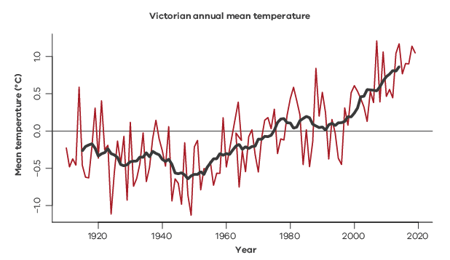
Figure 2.1 Annual average temperature anomaly for the whole of Victoria. The average (1961–1990) is 14.1°C. The dark line shows the 11-year moving average.
Victoria’s rainfall is highly variable (Figure 2.2), as it is influenced by large-scale climate drivers (see Section 2.5) and a range of weather systems over different timescales (Hope et al. 2017). The variability and timing of extremes differ by season. Around two-thirds of Victoria’s total annual rain falls during the cool season (April to October). This rainfall is important for many crops and for replenishing reservoirs (Delage and Power 2020; Rauniyar and Power 2020). With lower temperatures and less radiation at this time of year, proportionally less of this rainfall is lost to evaporation and transpiration from catchments, and more rainfall is converted into runoff.
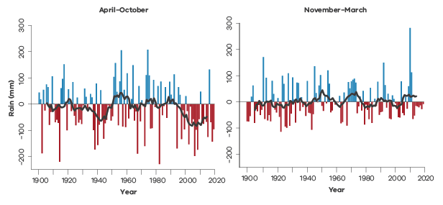
Figure 2.2: Victorian average rainfall anomaly in April–October (left) and November–March (right). The averages (1961–1990) are 448.2 mm and 212.9 mm. The dark line shows the 11-year moving average.
Rainfall and temperature are intimately linked across Victoria, with rainfall linked to cooler daytime conditions in all seasons (Hope and Watterson 2018). Those cooler conditions can persist for several months following very wet months, and result in relatively cooler annual temperatures, such as in 2010–2011. The reason for this is that additional rainfall causes higher soil moisture, resulting in increased evaporation that keeps surface temperatures lower. However, minimum temperatures (usually night-time) are initially warmer during wet conditions, as additional cloud cover keeps surfaces warmer. The converse is likely to be the case during dry conditions, with more frequent and severe heatwaves during periods of drought (Perkins et al. 2015) and an increased chance of frost (Crimp et al. 2016). Although the variability of rainfall drives some variability in temperature, there is still an underlying upward trend in temperature (Figure 2.1).
Measures of actual and potential evapotranspiration provide indicators of water availability. Potential evapotranspiration is the estimated evapotranspiration that would occur if there was no limit to the surface water available to evaporate (Figure 2.3). Potential evapotranspiration has a strong seasonal cycle in Victoria, peaking in January and with a minimum in June (in line with sunlight hours). Actual evapotranspiration only occurs when water is available to evaporate and has a more variable seasonal cycle, generally peaking in spring.
Potential evapotranspiration gives an indication of how much extra moisture the air can hold. For example, in 2010, which had a very wet summer, there was plenty of surface water to evaporate, so actual evapotranspiration was high. However, the air was already very moist, and could not accept more moisture, so potential evapotranspiration was low (Figure 2.3).
The actual evapotranspiration is far lower than the potential evaporation, highlighting that Victoria is a generally water-limited environment and the actual evapotranspiration tends to follow the surface water availability. The data in Figure 2.3 is from the Australian Water Resource Assessment Landscape (AWRA-L) model, which uses satellite-based radiation data that starts in 1990. Since 1990 there has been a downward shift in the cool-season actual evapotranspiration and an upward trend in potential evapotranspiration (Figure 2.3).
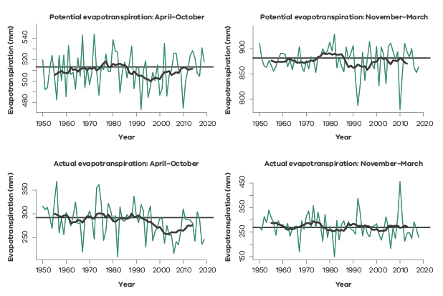
Figure 2.3: Victorian average potential (top) and actual (bottom) evapotranspiration drawn from the AWRA-L model for April–October (left) and November–March (right). The dark line shows the 11-year moving average and the horizontal black line shows the 1961–1990 average. Note the different scales on the vertical axes.

2.2 Recent rainfall decline
The decline in cool-season rainfall in recent decades is unlikely to have been as large without the influence from increasing levels of atmospheric greenhouse gases.
Cool-season rainfall was the lowest on record when averaged across the state during the Millennium Drought (1997–2009; Figure 2.4, top middle). It has continued to be low across the state (Figure 2.4, top right) and, for many locations, the 23 years since 1997 have had the lowest cool-season rainfall compared to any other 23-year period (Figure 2.4, top left). Averaged over the state, cool-season rainfall since the beginning of the Millennium Drought in 1997 through to the end of 2018 was approximately 12% below the 1900–1959 average (Rauniyar and Power 2020). This early climate reference period serves as a reference for recent observed change (see the box on climate reference period in Section 4). The majority of Global Climate Models (GCMs) estimate that the decline in cool-season rainfall in recent decades would not have been as large without the influence from increasing levels of atmospheric greenhouse gases (Rauniyar and Power 2020).
The warm season (November to March) also saw low rainfall totals across the south and east of the state during the Millennium Drought (Figure 2.4, bottom middle). Since the end of the drought in 2010, there has been more warm-season rainfall than average in the north of the state and through the southern Murray Darling Basin (Figure 2.4, bottom right), particularly due to heavy rains in 2010–2011 and 2016. Over the whole 22 years since the start of the Millennium Drought, the pattern of generally lower than normal warm-season rainfall in the south and higher than normal warm-season rainfall in the north of the state is amplified (Figure 2.4, bottom left).
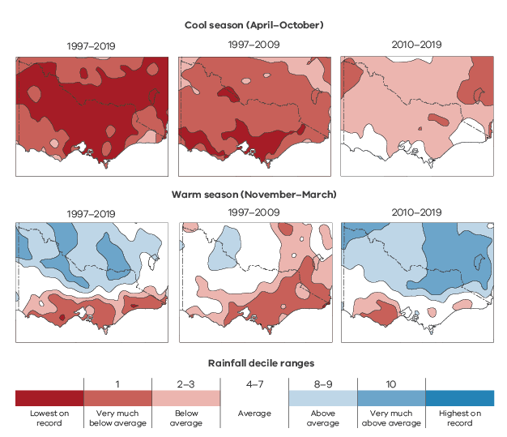
Figure 2.4 Rainfall decile maps for the cool season (April–October, top row) and warm season (November–March, bottom row). For the full period since the start of the Millennium Drought in 1997 (left column: 1997–2019), relative to all other 23-year periods; the Millennium Drought years (middle column: 1997–2009), relative to all other 13-year periods; and the years following the Millennium Drought (right column: 2010–2019), relative to all other 10-year periods. Data: Australian Gridded Climate Data (Evans et al. 2020).
While the past 23 years have seen less than average rainfall across Victoria, it is particularly the lack of very wet months that made the Millennium Drought and following years so unusual in the record (Figure 2.5), except for 2010 which had five consecutive wet months between October 2010 and February 2011. This suggests a possible change in the distribution of monthly rainfall.
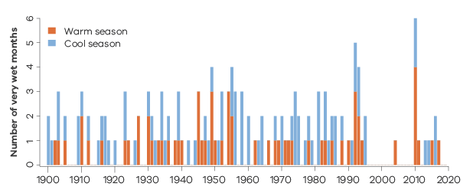
Figure 2.5 Number of very wet months for Victoria in each year from April 1900 to March 2020, where ‘very wet’ is defined as being above the 90th percentile of rainfall. By chance, one would expect one or two of these in every year. Cool-season months (April–October) are marked in blue and the following warm-season months (November–March) are marked in red, together making up each ‘year’.
Modelling suggests that the likelihood of dry conditions has increased due to increasing levels of atmospheric greenhouse gases (Rauniyar and Power 2020). See Section 2.5 for more about drivers of variability.

2.3 Simulated and projected rainfall changes
The majority of climate models project a drier climate future for Victoria, particularly later this century under a high emissions scenario.
Cool-season rainfall declines are projected to continue (on average) into the future by global climate models (GCMs) (Figure 2.6).
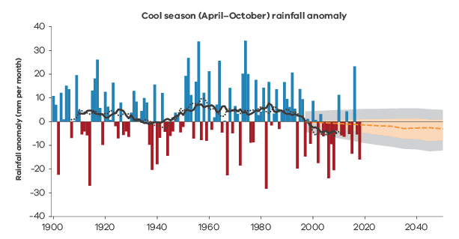
Figure 2.6: Observed cool-season rainfall anomalies from the 1976–2018 climate period serves as a reference for Victoria in mm per month (in bars). The solid and dashed lines through the observations are 20-year and 15-year running averages respectively. The coloured wedge represents the projected rainfall across 40 GCMs (CMIP5) by scaling the observation for the 1975–2018 period with the model-based mid-decile scaling factors derived by comparing the modelled future period with the modelled 1975–2018 period for different 30-year future periods centered at 2020, 2025 and every decade afterwards to 2050. The dashed black line is the middle of the range across the 40 models and the pink shaded area shows the 10th to 90th percentiles range of the 40 models. In grey, the observed 1900–2018 decadal variability is added.
Teasing out the influence of internal climate variability (e.g. La Niña) from the effect of climate change (particularly greenhouse gas increases) on recent decades with low rainfall is important. This is because the part of any trend attributed to increasing levels of greenhouse gases is likely to continue into the future, while changes due to internal climate variability might shift back to rainfall totals seen prior to the dry decades. Over any particular decade, internal variability might either temporarily enhance or lessen the drying trend due to climate change.
Global ocean-atmosphere climate models and earth system models from the Coupled Model Intercomparison Project Phase 5 (CMIP5) forced by the observed changes in the concentration of atmospheric greenhouse gases and other factors each simulate their own representation of the Earth’s weather and climate. Of the 42 models in CMIP5, 13 have provided two extra sets of results forced with only greenhouse gas forcing or ‘natural’ forcing (solar variability and volcanoes). Averaging the results from many GCMs reveals the signal above the natural variability. More than two-thirds of the climate model simulations show that rainfall in Victoria in the past two decades is below the pre-industrial average in response to increases in greenhouse gases (Rauniyar and Power 2020). The implication is that, even though internally generated rainfall variability (e.g. in response to El Niño) is an important part of our climate, most of the climate models are indicating that the likelihood of drier conditions is higher now than it was early last century.
The influence of climate change becomes clear from 2010–2029, when more than 90% of models show increased drying. While the impact of global warming on Victorian rainfall tends to increase as the 21st century unfolds, large internal variability will continue to occur. In some years and decades this might tend to either offset or exacerbate the underlying drying (Figure 2.7). The combined impact of the anthropogenic forcing and natural variability in coming years and decades is unknown. Climate models suggest that for 2018–2037 there is a small chance (12%) that internal rainfall variability will completely offset drying due to climate change under all emissions scenarios (Rauniyar and Power 2020).
We do know, however, that dry conditions become increasingly likely as the century unfolds, especially if international efforts do not have a major impact on reducing global greenhouse gas emissions.
Up to 2060, climate models project similar drying in Victoria for low, medium and high emissions scenarios (Rauniyar and Power 2020). After this, the degree of drying is related to emissions, with the least drying (6.5% compared to the period 1900–1959) under a low scenario and the most (16%) under a high scenario. Like the historical change signal, the average over 24 models will smooth out variations due to El Niño (for example) and reveal the climate change signal.
For finer detail, such as catchment features, results from downscaling should be considered, such as presented in the Victorian Climate Projections 2019 (VCP19). VCP19 has results from an atmosphere-only climate model with much finer resolution over Victoria, with forcing from six of the 42 CMIP5 GCM results. The set of six GCMs were chosen to be representative of the range of results from all GCMs. The use of only six models and a single downscaling model mean these results are not a comprehensive set of projections in isolation. However, when taken alongside other modelling and lines of evidence, there are several notable insights that can be gained. For example, there is very likely to be effects from topography on the projected change in rainfall that are not adequately captured by GCMs. This includes an enhanced drying on the windward slopes of the Alps in the cooler seasons, and possibly an enhanced precipitation increase on the peaks of the Alps in summer (Clarke et al. 2019; Grose et al. 2019).
Most global climate models underestimate the magnitude of the observed decline in rainfall. This lowers confidence in projections based on the same models.
The modelled drying during all periods from 1900–2050 is smaller in magnitude than the drying that was observed during the Millennium Drought. This suggests that the observed extreme conditions in the Millennium Drought were affected by variability above and beyond the variability represented by models, or that they were enhanced by climate change beyond the modelled response, or that there are some processes that climate models do not simulate adequately, which should be explored further.
Global warming will significantly increase the risk of decadal droughts in the cool season that are more severe than the World War 2 Drought and the drying observed over 1997–2018, particularly towards the end of 21st century under high emissions (Figure 2.7). Under mid-level future emissions cool-season drying is projected to be less than under high emissions, but the drying at the end of the century could still be similar in magnitude to the World War 2 Drought (1935–1945). Furthermore, the risk of experiencing droughts more extreme than those that occurred during the historical period is also increased (Delage and Power 2020).
Note that confidence in estimates of the contribution of anthropogenic forcing to past rainfall declines and estimates of future rainfall is lowered because the models have difficulty simulating rainfall declines as large as those that have been observed. The reasons for this are not fully understood, although several factors have been identified. These include the underestimation of multidecadal rainfall variability (Rauniyar and Power 2020) and the differences between the model and real-world representations of key features of the atmospheric circulation and modes of climate variability (e.g. subtropical ridge, Southern Annular Mode) and their relationship with Victorian rainfall (Grose et al. 2015, 2017; Hope et al. 2017; Lim and Hendon 2015; Timbal et al. 2015; Timbal et al. 2016). It should also be noted that the figures quoted above are based on results obtained using rainfall averaged across the entire state. The impact of anthropogenic forcing on Victorian rainfall is expected to be different between the north and south of Victoria and also in the mountains (e.g. Grose et al. 2019). Further work examining these regions separately will likely provide better estimates with higher confidence.
Taking both global warming (under a high emissions scenario, RCP8.5) and variability into account, most models project drying in Victoria towards the end of the century (2080–2100) that is greater than the drying experienced during the World War 2 Drought (Figure 2.7). Approximately 40% of models exhibit conditions during 2080–2100 under RCP8.5 which are drier than those experienced during the Millennium Drought. Major reductions in global greenhouse gas emissions result in much less drying towards the end of the century. Internal climate variability can enhance or reduce any drying signal in any given decade.
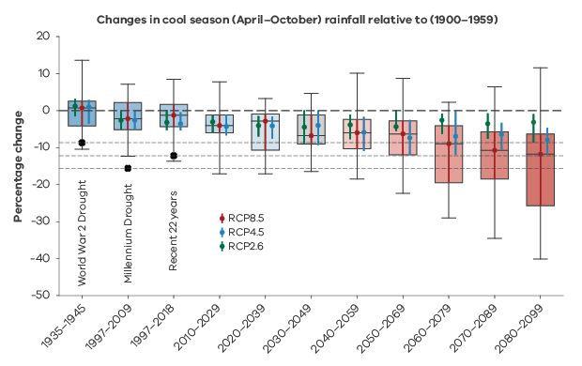
Figure 2.7: Simulated % changes in cool-season rainfall compared with observed changes during the World War 2 (WW2) and Millennium Droughts, and 1997–2018, all relative to 1900–1959. The distribution of changes in 24 models under high emissions (RCP8.5) are represented as box plots for each 20-year period. The horizontal line in the box indicates the median, the shaded box represents the inter-quartile range (IQR: 25th and 75th percentiles) and the whiskers indicate the minimum and the maximum values based on 24 CMIP5 models. The median values for medium (RCP4.5) and low (RCP2.6) emissions scenarios are overlaid on the box plots as blue and green circles, with corresponding IQRs represented by the blue and green vertical lines, respectively. The black dots and three horizontal dotted lines show the observed anomalies of rainfall during 1935–1945 (WW2 Drought), the last 22 years (1997–2018) and 1997–2009 (Millennium drought) Source: Rauniyar and Power (2020).

2.4 Changes in global circulation influencing Victoria’s rainfall
Changes in the global circulation are associated with an increased frequency of high-pressure systems and reduced frequency of low-pressure systems across Victoria.
The changes in Victorian climate are influenced by the global climate. Understanding how the global changes connect with the weather across Victoria will help us understand why Victoria’s climate is changing, and which changes are here to stay.
The atmospheric circulation plays an important role in determining the nature of the hydrological cycle. The mean atmospheric circulation (described in Hope et al. 2017) and weather-scale eddies work together to move water vapour from the tropics and supply it to middle and high (polar) latitudes (Hartmann 2016). Victoria’s rainfall is influenced by mid-latitude weather systems from the south or west as well as tropical systems from the north.
The tropical north-south circulation is generally dominated by the overturning Hadley cell (Figure 2.8), formed by the air moving upward in the Inter-Tropical Convergence Zone (ITCZ), then poleward and downward in Victorian latitudes, forming a belt of high pressure at the surface that is often referred to as the subtropical ridge. This circulation shifts seasonally: both upward and downward branches shift northward in summer and southward in winter. This means that Victoria is located within the subtropical ridge in summer, and to the south of it in winter (Rudeva et al. 2019). The Hadley cell can also be altered (in position and strength) by natural variability or global changes in the climate.
There has been an observed trend towards a widening of the Hadley cell, otherwise described as an expansion of the tropics (see CSIRO 2012; Hope et al. 2017; Lucas et al. 2014; Seidel et al. 2008). The expansion has been linked to enhanced summer rainfall across northern Victoria.
A new way of describing the global circulation allows the investigation of the circulation on weather timescales, providing a clearer understanding of weather changes to Australia’s south (Lucas et al. 2020). These ‘weather-generated’ aspects of the circulation are shown in Figure 2.8 as the ‘transient updraft’ and ‘downdraft’.
As well as confirming tropical expansion and intensification of the Hadley cell subsidence over Victoria’s latitudes, this new approach shows that circulation in the mid-latitudes (~30°S to 60°S) has weakened, reducing the instability and ‘uplift’ required for storm generation. Together, these changes are linked to an upward trend in pressure and fewer low-pressure systems across Victoria.
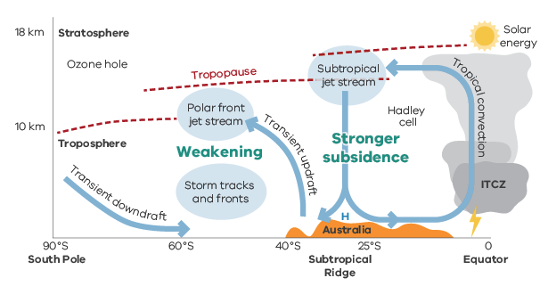
Figure 2.8: Averaged (around a latitude circle) cross-section of the atmospheric circulation from the tropics to the pole. Generally, rainfall is associated with strong upward motion. The descending arm of the Hadley cell is over the sub-tropics, and its subsidence has been strengthening. The circulation associated with weather systems south of Australia has been weakening, also reducing the uplift over Victoria.
Changes in the global circulation affect the location and strength of the subtropical ridge. A strong subtropical ridge is generally associated with higher pressure and a decrease in rainfall across Victoria in autumn, winter and spring. A poleward displacement of the subtropical ridge is also associated with reduced rainfall during winter (CSIRO 2012; Timbal and Drosdowsky 2013). This relationship was neatly illustrated in winter 2017, when the subtropical ridge was both stronger and further south than usual for this time of year, resulting in Victoria recording its driest June in 120 years of records (BoM 2017c).
The intensification of the subtropical ridge can partly explain observed declines in Victorian cool-season rainfall during the Millennium Drought (CSIRO 2012). The subtropical ridge is also intimately linked to the synoptic systems that cross Victoria, with a strong subtropical ridge associated with an increase in dry weather and high-pressure systems and a decrease in the fronts and lows that cause Victorian cool-season rainfall.
The subtropical ridge also influences both mean and extreme temperatures in Victoria (Pepler et al. 2018), with higher average maximum temperatures and an increased likelihood of very hot days when the subtropical ridge is more intense or further south than normal. During late autumn and early winter, a strong subtropical ridge is also associated with an increased likelihood of very cold nights in northern Victoria. This means that an intensifying subtropical ridge may be contributing to both an increase in heat extremes across the state, as well as contributing to the observed weak upward trends in frost nights in some parts of northern Victoria.
The averaged north-south global circulation can reveal a great deal about the observed global changes; however, it averages out information over all the land, mountains and ocean along each latitude circle. To fully understand Victoria’s changing climate will also require information about the large-scale drivers of variability (like La Niña) and regional weather systems and how they interact with the land, sea and mountains.
The drying effect is not only seen in Australia. There has been extreme drought at similar latitudes in southern Africa and South America. The alignment of drought conditions at similar latitudes around the Southern Hemisphere suggests that there has been a large-scale shift in the global circulation. Understanding the global circulation can provide clues as to the causes of the changes, and what that means for the weather and climate of Victoria.

2.5 Variability drivers – from the tropics and mid-latitudes
Large-scale climate drivers, such as El Niño and the Indian Ocean Dipole, that are largely responsible for Victoria’s climate variability are themselves subject to climate change, with consequent effects on rainfall.
Year-to-year variations in the atmospheric circulation are linked with changes in large-scale modes of variability, such as the El Niño Southern Oscillation (ENSO: El Niño and La Niña), Indian Ocean Dipole (IOD), Southern Annular Mode (SAM) and Interdecadal Pacific Oscillation (IPO). These changes in turn influence rainfall in Victoria.
Historically, during El Niño events the eastern Pacific is warmer than normal, the ITCZ intensifies, and rainfall shifts away from Australia, bringing dry conditions to Victoria. In contrast, during La Niña years oceans are cooler than normal in the eastern Pacific and warmer to the north of Australia, bringing more tropical moisture and rainfall to the south-east (Clarke et al. 2019; Hope et al. 2017). The IOD acts similarly, with a negative IOD associated with warmer water to the north-west of Australia and an increase in rainfall in the south-east during winter and spring, while a positive IOD brings drier conditions.
GCMs can be used to investigate how the large-scale drivers might be expected to change under a changing global climate. However, the interactions under the ocean surface and between the ocean and atmosphere are all extremely important to simulating these features well, and small biases in their representation can add up to a misrepresentation of their future state, resulting in considerable uncertainty in future changes (CSIRO and BoM 2015). The Indian Ocean is particularly difficult to simulate, possibly due to a lack of long records for verifying and testing models (compared to the Pacific Ocean). While some studies indicate future increases in extreme El Niños and positive IOD events (e.g. Cai et al. 2014a,b) these results are sensitive to the definitions and models used (Marjani et al. 2019; Wang et al. 2017), making this an area of active research. Palaeoclimate archives have extended the observed record, providing another indication that the large-scale drivers are changing over time: Abram et al. (2019) found a trend to more positive IOD events (with dry conditions over Victoria, like in spring 2012 and 2019) and Freund et al. (2019) found a trend towards a type of El Niño event that is located closer to Australia (‘central Pacific’ El Niño) becoming more common, likely linked to enhanced impacts. Observed changes in the last two decades match these trends towards more positive IOD events and more ‘central Pacific’ El Niño events.
The SAM can interact with the large-scale tropical drivers to enhance or reduce their influence. SAM weakens the westerlies in Victorian latitudes during its positive phase, often causing drier than normal conditions in winter, and strengthens them in its negative phase, often resulting in wetter than normal winter conditions (Hendon et al. 2007; Marshall 2003). In contrast, during late spring and summer positive SAM allows more moisture into Victoria from the north, increasing rainfall. The SAM is projected to shift more towards the positive phase under climate change (e.g. Cai et al. 2011a).
The IPO (Power et al. 1999) has a similar ocean surface pattern to ENSO but is broader north and south. It is believed to vary on a timescale of decades, but it is unclear if it is a mode in its own right or is the consequence of the variability of ENSO. It is currently not possible to forecast the IPO: it is only able to be calculated in hindsight. The shift in the state of the IPO – to a La Niña-like pattern – was considered an important driver of tropical expansion in the Australian region, and it was suggested that the expansion might reduce in coming decades (Hope et al. 2017). However, recent research suggests that the observed tropical ocean trends are partly driven by human-induced climate change, and the aspects of the current state of the IPO will persist (Lim et al. 2019).
Simulations performed with the POAMA model (Hudson et al. 2013) extending the observed trend into the future show only weak changes to the subtropical ridge globally during the Southern Hemisphere spring. However, an increase in mean sea-level pressure south-east of Australia is suggestive of a poleward shift of the subtropical ridge near Victoria. The simulations show a weakening of the relationship of El Niño and the development of negative SAM which means that SAM will be less predictable during El Niño events (Lim et al. 2019).
Over recent decades the extended periods of dry years, interspersed with extremely wet years (2010–2011, 2016), indicate that there might have been a shift in both how the very extreme rainfall forms and how dry years might persist. The changing nature of the large-scale drivers themselves, the moisture in the atmosphere and land–atmosphere interactions all contribute to change in Victoria’s pattern of rainfall through a decade. There is still a great deal more to learn about these facets of the climate.

2.6 Weather systems influencing Victorian rainfall
Rainfall from cold fronts and low-pressure systems in the cooler half of the year has declined across Victoria, while thunderstorm-related rainfall has increased in northern Victoria in the warmer half of the year.
Cold fronts, surface low-pressure systems and thunderstorms are, together, responsible for 89% of Victoria’s rainfall each year. There are other types of weather that are linked to rainfall on other days such as weather activity higher in the atmosphere, which will be explored in further research. Sometimes one of these weather events happens on its own, but often multiple types of weather event occur on the same day, and these combined events are more likely to cause heavy rain (Dowdy and Catto 2017). The interaction of a low-pressure system with a thunderstorm is particularly important for extreme rainfall in Victoria.
Different types of weather systems can have different rainfall characteristics; for instance, lows and fronts tend to be longer-lived and more widespread, while thunderstorm rain can be very heavy but short-lived and spatially variable (including localised intense rainfall). They also have different seasonal characteristics, with lows and fronts particularly important for rainfall during the cooler months of the year and thunderstorms more important during the warmer months of the year (Dowdy 2020; Pepler et al. 2020a). This means that changes in the dominant weather systems may also influence the relationship between rainfall and runoff in a given location (see Section 3.4).

VicWaCI considered three types of weather systems.
Cold fronts are fast-moving weather systems where cold air hits an area of warmer air. The passage of a cold front brings a shift from warm, northerly winds to cool, south-westerly winds and is often associated with widespread moderate rainfall.
Low-pressure systems are areas where the pressure is lower than the surrounding environment. In the Southern Hemisphere, winds rotate clockwise around the centre of the low. Lows can cause widespread and/or heavy rainfall and can also cause large waves and erosion along the coastline.
Thunderstorms are common during the warm months, and severe thunderstorms can cause heavy rain, lightning, hail and even tornadoes. Individual storms can be small and short-lived, but when atmospheric conditions are favourable, multiple storms can develop over large parts of the state.
Combinations of all three weather types were also analysed (e.g. lows and thunderstorms, fronts and thunderstorms or all three together).
Different regions of Victoria are dominated by different weather systems (Figure 2.9). The rainfall from different weather types has been used to distinguish different seasons and regions across Victoria (Fiddes et al. 2020). Thunderstorms are more important for rainfall in the north of the state, particularly during the warm season, while increased rainfall from lows and fronts contributes to higher rainfall totals during the cool season, particularly in the south. The combination of a low/front with a thunderstorm is an important source of rainfall throughout the year but particularly during the warm season, with these systems explaining a large proportion of heavy rain events.
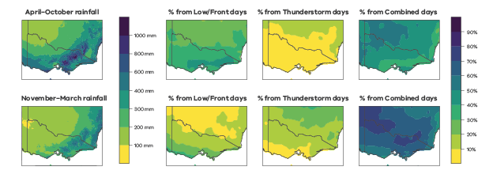
Figure 2.9: (left) Average seasonal rainfall across Victoria between 1979 and 2015, and the proportion of rainfall that is due to (centre-left) lows and/or fronts, (centre-right), thunderstorms and (right) the combination of a low and/or front with a thunderstorm. Figures are shown separately for the cool season (top) and warm season (bottom).
There has been a decrease in the frequency of lows in Victoria, particularly during the winter months, over the period 1979–2015 (Pepler et al. 2020b). The likelihood that a low or front will produce rainfall has also decreased, as has the average rainfall per system. This trend has led to a large decline in the total rainfall from lows and fronts during the cooler half of the year, particularly in southern and eastern Victoria (Figure 2.10). There has also been an increase in the frequency of high-pressure systems in Victoria, which are associated with dry weather (Pepler et al. 2019).
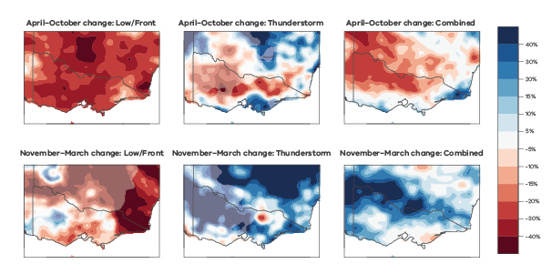
Figure 2.10: Spatial plot showing the percentage change in seasonal average rainfall from lows/fronts (left), thunderstorms (middle) and combined events (right) between 1979–1996 and 1997–2015 in April–October (top) and November–March (bottom). Red shading means less rainfall in recent years. Plots are faded where the weather system contributes less than 25 mm on average per season.
At the same time, there are more thunderstorm days in some regions, especially in the east (Dowdy 2020). Some of these extra thunderstorms produce rainfall, contributing to increased rainfall in parts of southern and eastern Victoria during the summer months. Thunderstorm environments are identified by the lightning associated with them. However, there is also an increase in eastern Victoria in the number of days indicated as having lightning but little or no rainfall (known as ‘dry-lightning’), which can ignite fires and contribute to an increasing bushfire hazard.
While both El Niño Southern Oscillation (ENSO) and the Indian Ocean Dipole (IOD) influence rainfall from low-pressure systems and thunderstorms during the cool half of the year, during spring the IOD is particularly important for rain from fronts. ENSO also continues to influence thunderstorm rainfall into the warm season when the influence of the IOD on rainfall is minimal. This is consistent with research that shows that the IOD exerts its influence on south-eastern Australian rainfall in spring via changes to the mid-latitude westerlies (Cai et al. 2011b). El Niño years are also associated with an increase in the frequency of high-pressure systems during the warm half of the year, while both El Niño and positive IOD are associated with an increase in the strength of high-pressure systems during the cooler months, contributing to drier conditions in Victoria (Pepler et al. 2019).

2.7 Extreme rainfall events
Extreme, short-duration rainfall events are generally becoming more intense in Victoria, a trend that is expected to continue into the future.
Extreme rainfall events are periods of very heavy rainfall generally described in terms of the rainfall intensity (how much rain falls during a period of time), the rainfall duration (over what time period the rain falls) and the frequency (how often you would expect to see an event of a given magnitude). The intensity of extreme, short-duration (around an hour) rainfall events is changing. These events have implications for urban infrastructure and design, emergency management (e.g. flash flooding) and natural resource management (e.g. increased erosion).
Analysis of the data from Australian Gridded Climate Data (AGCD) show the maximum daily precipitation per year has increased across large parts of Victoria since 1958 (Figure 2.11). Larger increases in extreme precipitation have been widely reported to occur on shorter timescales (Jakob et al. 2011; Jakob et al. 2020).
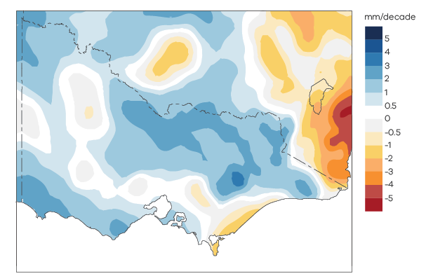
Figure 2.11: Trends in the annual maximum daily precipitation across Victoria using data from Australian Gridded Climate Data from 1958–2014. Note: this ends in 2014 to align with the extremes results below that is limited by data availability.
The number of hourly extreme rainfall events that exceed 12 and 18 mm/hr, which roughly correspond to return periods of one and two years respectively, has increased on average by 26% and 89% respectively from 1958–1985 to 1987–2014 at the eight weather stations in Victoria with the most robust and concurrent data record (Figure 2.12; Osburn et al. 2020).
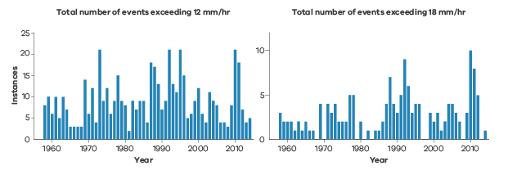
Figure 2.12: Number of events per year exceeding 12 mm/hr (left) and 18 mm/hr (right) from the eight stations (total events from the eight stations) from 1958 to 2014. For the thresholds of 12 mm/hr (left) and 18 mm/hr (right), the number of events in the latter half of the time period (1987–2014) increased by 60 and 47 respectively relative to the earlier periods (1958–1985) and increased proportionately by 26% and 89% respectively. Note different scales on the vertical axes.
Extreme rainfall events are becoming more intense, and more so for the shorter duration and more extreme rainfalls, with larger increases during the warm season when thunderstorm rainfall is increasing (Figure 2.10). The average increase in intensity of the 20 most extreme events during the warm season was 3.5 mm/hr and 0.9 mm/hr during the cool season. There has also been an observable shift in the distribution of the most extreme events towards a greater intensity (Figure 2.13; Osburn et al. 2020).
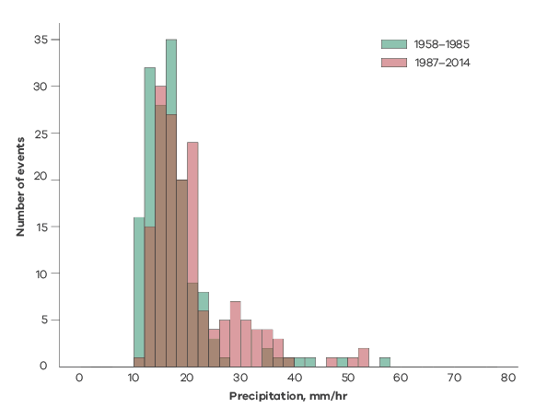
Figure 2.13: Histograms of the 20 most extreme events from the eight stations for the time periods of 1958–1985 (green) and 1987–2014 (red) for the warm season.
The proportion of total annual precipitation that can be attributed to precipitation events greater than 8, 12 and 18 mm/hr during the warm season has been steadily increasing since the 1990s, while total annual precipitation has been decreasing. Before the 1990s, the proportion of precipitation that could be attributed to these extreme events was relatively stable.
Statistical techniques (after Coles et al. 2001) were used to estimate the intensity of the 100-year return period hourly rainfall for two periods (1958–1985 and 1987–2014). The largest changes were at Mildura and the Lauriston Reservoir. Smaller increases were estimated in the south-east of the state, while little to no changes were estimated for the more central stations of Mt St Leonard and Lake Eildon (Figure 2.14; Osburn et al. 2020).
These findings highlight a general trend towards a greater proportion of total rainfall coming from the more intense events, given the decrease in the mean annual rainfall combined with an increase in the intensity of the more extreme events.
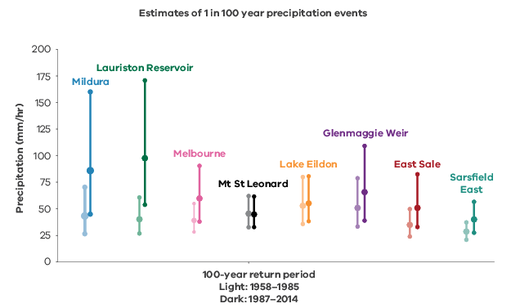
Figure 2.14: Estimations of hourly precipitation intensity with 90% confidence intervals for the 100-year return periods for the eight stations in Victoria, calculated based on the periods 1958–1985 (light shading) and 1987–2014 (dark shading). The stations are plotted in order from west to east.
More intense extreme rainfall is expected in the future with high confidence (Jakob et al. 2020). It is well understood that water vapour content can increase by ~7% for every additional degree of warming which is the basis for projections of more intense rainfall events in the future. However, there is growing evidence from around the world that extreme precipitation can scale at around twice this rate under certain conditions (Berg et al. 2013; Busuioc et al. 2016; Dowdy 2020; Lenderink and Van Meijgaard 2008, 2010; Lenderink et al. 2011; Mishra et al. 2012; Park and Min 2017). The exact mechanisms are not fully understood but are likely associated with enhanced uplift in storms, given that increased moisture in the air due to global warming can provide additional energy for convection as the energy source for thunderstorms and increased rainfall intensity (Dowdy 2020). More intense extreme rainfall has important implications for planning; that is, that the possibility of heavier extremes needs to be considered along with the implications for flood risk.

3. Victoria’s changing hydrology
Where is runoff declining and why?
Recent research has shown that for many catchments in Victoria and south-east Australia, the runoff response to rainfall has declined, particularly during the Millennium Drought. This means that for a given amount of rainfall we get less streamflow than we did in past decades. Since the Millennium Drought, some catchments have recovered while others have not. The reduction in runoff response is particularly concerning for future water availability and flow-dependent ecosystems. The reduction in runoff is in addition to the impact expected from future declines in rainfall due to climate change – so is likely to have significant consequences for our environment and our communities.

Victoria’s changing hydrology: at a glance
- Average runoff has declined over recent times, largely due to rainfall declines.
- Runoff reductions in some catchments are larger than expected from reduced rainfall.
- A significant shift in the runoff response to rainfall was observed in many Victorian catchments during the Millennium Drought.
- Catchments can respond to and recover from drought in distinctly different ways.
- The shifts in the rainfall–runoff relationships were largely governed by catchment resilience or vulnerability to drought, rather than differences in drought severity.
- Changes in weather systems may be less important in determining if a catchment is more likely to experience a shift in rainfall–runoff relationship compared to internal catchment characteristics, such as catchment mean slope.
- Groundwater–surface water disconnection is an important feature of catchments with shifted rainfall–runoff relationship during the drought.
- The rainfall–runoff relationship in some catchments can recover even if they don’t receive all of the ‘missing’ rainfall that they went without in the drought years.
- During the Millennium Drought, more than half of the Victorian catchments analysed experienced an extra 20–40% decline in their annual streamflow due to the shift in rainfall–runoff relationships.
- The current generation of hydrologic models do not replicate well the observed changes in the rainfall–runoff relationship during and after extended drought.

Implications for the water sector
- The low-runoff conditions experienced in many catchments during and after the Millennium Drought need to be factored into water resource planning decisions.
- Until there are improvements in the ability of hydrological models to represent the impact of multi-year drought and shifting rainfall–runoff relationships, selection of calibration periods will be important to ensure that model results account for shifts in rainfall–runoff relationships.

3.1 Victoria’s hydrology
Annual average runoff has declined over recent times, largely due to rainfall declines.
Catchments in Victoria experience a wide range of rainfall and streamflow conditions, with wetter catchments in the mountainous regions and drier catchments in the central west. Across the state, 156 study catchments were selected to further investigate rainfall–runoff behaviour, in areas largely unaffected by significant water use development. In these catchments it can be seen that rainfall varies considerably from year to year (Figure 3.1) and varies considerably between the catchments in any given year (shaded area in Figure 3.1). Since 1957 there have been some very dry years (1967, 1982 and 2006), and some very wet years (1992 and 2010). Streamflow also shows considerable variability between years and between catchments within years (Figure 3.1). The impact of the Millennium Drought on streamflow is clearly evident, with below-average river flows in most of the study catchments every year from 1997–2009 inclusive (Figure 3.1).
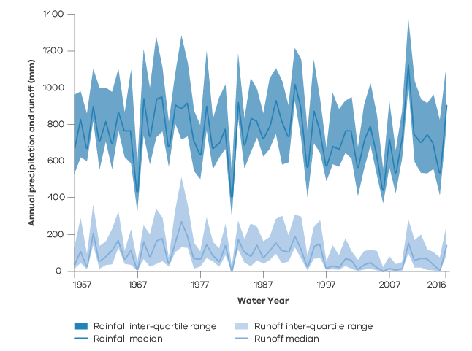
Figure 3.1: Annual rainfall and runoff for the period 1957–2016 across 156 study catchments. Solid lines indicate the median across the catchments with 25th to 75th percentile range shown. The inter-quartile range indicates the range of variability in annual precipitation and runoff each year across the study catchments.
The recent drying across Victoria (see Section 2.2) has impacted streamflow as shown in Figure 3.2. Reductions in streamflow since 1997 are widespread with greater reductions seen in the central west than the wetter mountainous regions.
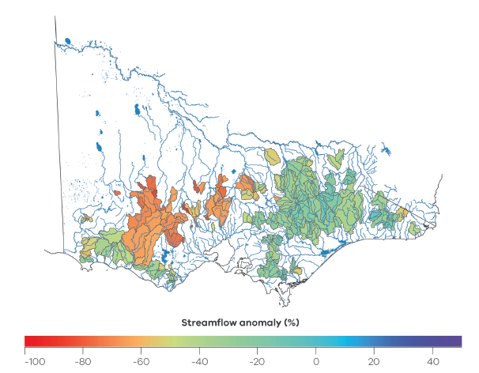
Figure 3.2: Percentage reduction in mean annual streamflow from 1997–2016 relative to pre-1997 across Victoria.
Typically, a 10% reduction in rainfall might lead to a 20–30% reduction in streamflow (Chiew 2006) due to streamflow being sensitive to changes in rainfall. The sensitive response of streamflow to a change in rainfall is known as ‘elasticity’. For example, the Wonnangatta River (Figure 3.3a) experienced a 10% reduction in average annual rainfall since 1997, which translated into an expected 25% reduction in average annual streamflow over that period. In contrast, an upstream tributary of the Loddon River (Figure 3.3b) experienced an 11% reduction in average annual rainfall since 1997, which translated into an unexpectedly large 55% reduction in average annual streamflow over that period. The unexpectedly large reduction in streamflow since 1997 in the upstream tributary of the Loddon River and some of the large reductions shown in Figure 3.2, relative to the rainfall reductions experienced, suggest that streamflow has not responded as expected (based on past rainfall–runoff relationships) in some regions of Victoria.
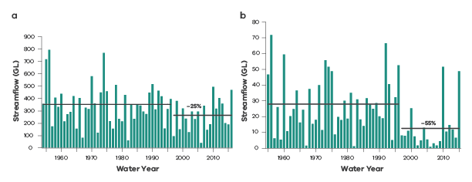
Figure 3.3: Annual streamflow for two catchments: (a) Wonnangatta River at Crooked River and (b) an upstream tributary of the Loddon River at Yandoit. The percentage decrease in mean annual streamflow during and after the drought relative to pre-drought is also shown.
The impact of rainfall changes on streamflow shown in Figure 3.2 and Figure 3.3 are a combination of the impacts during and after the Millennium Drought. Figure 3.4 shows the separate impacts of rainfall changes on streamflow during (Figure 3.4a) and after (Figure 3.4b) the drought relative to pre-drought conditions. The greatest reductions in streamflow during the Millennium Drought were in western central Victoria (Figure 3.4a). While the decline in rainfall is likely to be the main reason for the decline in streamflow, some of the streamflow declines are larger than expected.
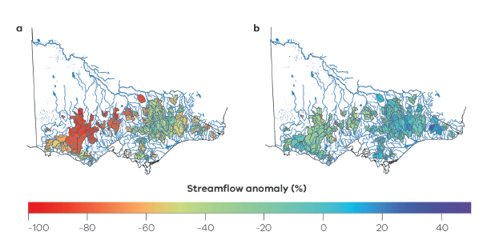
Figure 3.4: Percentage reduction in mean annual streamflow (relative to average pre-drought streamflow) during (a) and after (b) the Millennium Drought across the study catchments.
Since the end of the drought, the streamflow response to more average rainfall conditions has been mixed, ranging from a reduction of 80% in some western and central Victorian catchments to an increase of 40% in the east (Figure 3.4). In western central Victoria, some catchments are still producing much less streamflow than expected historically for a given annual rainfall, particularly given that the drought has ended.

3.2 Pre-drought, drought and post-drought runoff generation
Runoff reductions in some catchments are larger than expected from reduced rainfall.
How catchments respond to and recover from droughts has substantial implications for current and future water resource planning.
It has generally been assumed that streamflow declines during drought because of less rainfall, but otherwise the catchment behaves like it did under pre-drought conditions. However, analysis of annual streamflow and rainfall data from south-eastern Australia (Saft et al. 2015) showed that catchment runoff processes can change during droughts, with less rainfall going to streamflow than occurred prior to the drought, even when those rainfall amounts are the same.
Similarly, it has been assumed that after the drought the catchment will always return to pre-drought conditions; that is, that catchments are infinitely resilient to climatic disturbances (Peterson et al. 2009, 2012, 2014; Peterson and Western 2014). However, the substantial reductions in streamflow in the Victorian catchments during the drought, and the non-recovery of streamflow following the drought (Figure 3.4 and Table 3.1) indicates that during and after the drought the proportion of rainfall that becomes streamflow has reduced in some catchments and still not recovered.
Table 1: Catchment average annual rainfall and runoff pre-drought (up to 1996), Millennium Drought (1997–2009) and post drought (from 2010 onwards) averaged across 156 catchments.
 | Pre-drought | Drought | Post-drought
Average rainfall (mm/year) | 977 | 820 | 978
Average runoff (mm/year) | 246 | 123 | 201
Runoff ratio | 0.21 | 0.12 | 0.17

3.3 How have rainfall–runoff relationships changed?
A significant shift in the runoff response to rainfall was observed in many Victorian catchments during the Millennium Drought
A rainfall–runoff relationship provides an expectation of how much streamflow will occur for a given amount of rainfall, with dry years at the bottom-left of this relationship, and wet years at the upper-right. An example is given in Figure 3.5 where for the upstream tributary of the Loddon River, years with rainfall around 450 mm produce negligible streamflow, but as annual rainfall increases, the proportion of rainfall that becomes streamflow increases. The line between wet and dry years describes the expected annual runoff for a given annual rainfall.
The upstream tributary of the Loddon River shown in Figure 3.3 and Figure 3.5 had a 55% reduction in streamflow for an 11% reduction in rainfall since 1997. This unexpectedly large reduction in streamflow can be seen in Figure 3.5, where the same annual rainfall during and after the drought produces less streamflow than prior to the drought. These changes in the rainfall–runoff relationship indicate a change in how the catchment responds to rainfall. Shifts in the rainfall–runoff relationship are indicative of changes in the internal functioning of the catchment system (Saft et al. 2015; 2016b).
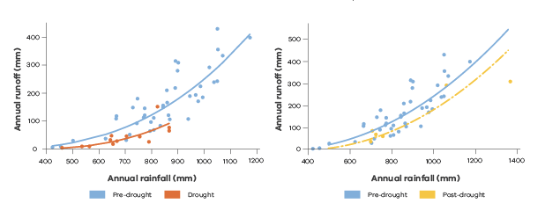
Figure 3.5: Comparison of annual rainfall–runoff relationship between pre-drought and during the drought (left) and pre-drought and post-drought for an example catchment (gauge 407221).

3.3.1 Annual changes
Historically, the amount of runoff produced during dry years would follow the annual rainfall–runoff relationship. However, there was a systematic downward shift in the annual rainfall–runoff relationship in many Victorian catchments during the Millennium Drought (Figure 3.6, shifted, recovered). Although all catchments experiencing drought produced less streamflow than before the drought, about two-thirds of them produced disproportionally less streamflow than expected (Figure 3.6 and Figure 3.7).
The response to drought varied from catchment to catchment (Figure 3.6) and over time within catchments (Figure 3.7). The rainfall–runoff relationships in the wetter catchments on the Great Dividing Range in eastern Victoria did not shift significantly; the large reductions in streamflow were in line with expectations based on previous similarly dry years. In western Victoria, most study catchments experienced a shift in relationship during the drought.
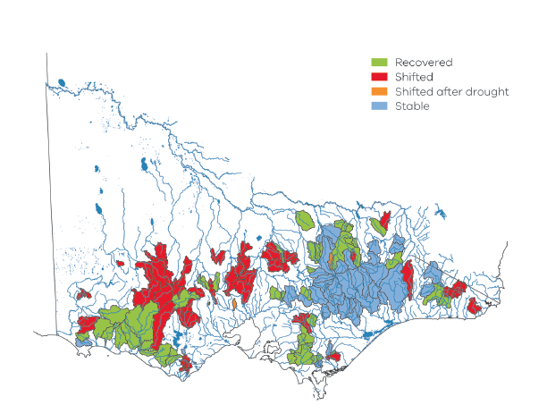
Figure 3.6: Shift in catchments’ hydrological response and recovery across Victorian catchments during and after the Millennium Drought. Results show which catchments did not shift relationship during or after the drought (blue), shifted relationship during the drought and have not recovered yet (red), shifted relationship during the drought and recovered after the drought (green) and did not shift relationship during the drought but shifted after the drought (orange).
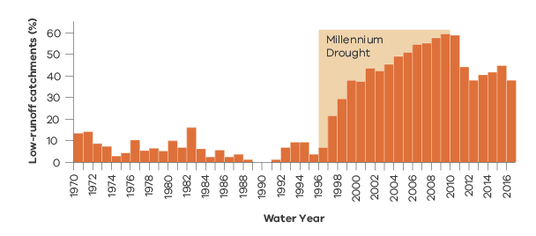
Figure 3.7: Percentage of catchments generating less streamflow than expected (low-runoff state). Note: a normal runoff state was defined as the runoff occurring for a given rainfall in 1990 (see Peterson et al. 2020 for details). By the end of the 2016 water year, 38% of catchments remained within a low-runoff generation state. From the end of the Millennium Drought to 2016 the number of catchments that have not recovered is not declining. (Source: adapted from Peterson et al. 2020).
Once the Millennium Drought broke, the expectation was that runoff generation would follow the pre-drought relationship. However, about one-third of study catchments have not recovered since the Millennium Drought (Figure 3.7).
The floods of 2010 and 2011 prompted about a third of the study catchments that had changed during the drought to switch back to their pre-drought rainfall–runoff relationship (Figure 3.7). Since 2011, rainfall has been average or below in some catchments. Around a third of catchments continue to behave as if the drought has not ceased (Figure 3.6 and Figure 3.7). Interestingly, this fraction appears to be constant post-2010 (Figure 3.7), which suggests current rainfall conditions have not been sufficient to trigger recovery of these catchments. It should be noted that the last year in this analysis is the water year starting in March 2016, so statements about non-recovery hold up to that year. On-going monitoring of the runoff state of catchments on an annual basis could be of particular benefit to water resource management, such as for annual water supply system outlooks, as changes in state would allow water managers to plan for more or less runoff for a given climate outlook.

3.3.2 Seasonal changes
Annual totals can mask changes between seasons. For example, a reduction in winter rainfall could be offset by an increase in summer rainfall with little change in annual total. The runoff in winter would reduce while the runoff in summer would increase, but not to the same extent, as usually the proportion of rainfall that becomes runoff is greater in winter than summer. Therefore, a seasonal redistribution of rainfall could appear as a shift in the annual rainfall–runoff relationship.
Cool-season patterns of rainfall–runoff change (Figure 3.8) are similar to the annual changes (Figure 3.6). During the cool season, the period of highest runoff production, many of the wettest catchments on the Great Dividing Range in eastern Victoria either did not shift their behaviour significantly or have recovered after the drought. Catchments of western Victoria had a higher tendency to exhibit shifts in cool-season rainfall–runoff relationships, which is in line with the annual results.
Warm-season shifts in hydrologic behaviour were considerably less frequent during the drought, but more frequent after the drought. That is, some catchments shifted their warm-season hydrologic behaviour downward only around the end of the drought. The warm season is a period of lower runoff generation, typically dominated by sub-surface drainage, and the shifts do not show any clear spatial pattern either during or after the drought. Furthermore, shifts after the drought are based on short record lengths (2010–2016) and should be treated with some caution.
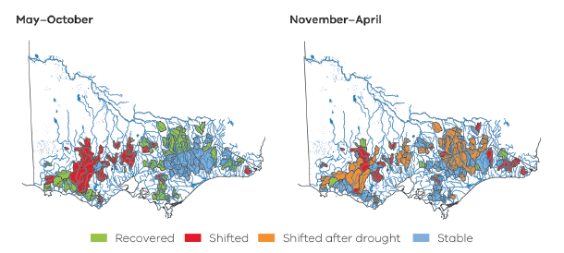
Figure 3.8: Cool (May–October, left) and warm (November–April, right) season shifts in runoff. Results show which catchments experienced no shift in runoff during and after the drought (blue), a shift in runoff during and after the drought (red), a shift occurring at the end of the drought (orange) and a shift in runoff only during the drought (green).
The similarity of the annual and seasonal results indicates that the changes in rainfall–runoff relationship are not due to redistribution of rainfall within the year, but due to other factors that impact the catchment all through the year.
The lack of decline in the number of catchments in a seasonally low runoff state (Figure 3.9) suggests that recovery is not simply dependent upon the number of years since the drought broke and that we should not expect these catchments to recover soon. Importantly, there is also no seasonal cycle in the number of catchments in a low-flow state. This suggests that the switch to a low-flow state persists for years, rather than only for a subset of seasons.
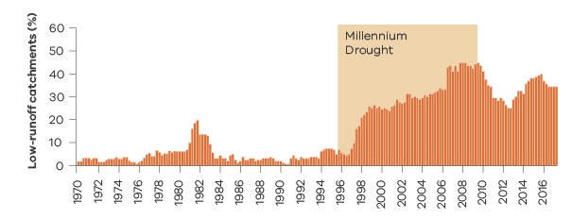
Figure 3.9: Percentage of catchments generating less streamflow than expected (low-flow runoff). Note: a normal runoff state was defined as the runoff occurring for a given rainfall in 1990 (see Peterson et al. 2020 for details). By autumn 2017, 38% of catchments remained within a low-runoff generation state.

3.3.3 Types of catchment drought response and recovery
Catchments can respond to and recover from drought in distinctly different ways.
A wide diversity of catchment dynamics was observed among the study catchments, ranging from those that experienced a significant shift to a low-runoff state at the start of the Millennium Drought and have yet to recover, through to those that experienced no shift in runoff state.
For analysing catchment dynamics before, during and after the Millennium Drought, six distinct clusters of runoff state/recovery dynamics were identified (Figure 3.10), based on if and when they shifted to a low-runoff state and the rate of their recovery. These clusters applied to both the 1982–1983 drought and the Millennium Drought and they were reasonably consistent across Victoria. The timing of the change in runoff response and recovery was the most distinguishing factor for each cluster, while the magnitude of the change in runoff did not appear to be a clear factor.
These clusters of similar catchment response and recovery show it may be possible to develop predictive tools to inform likely future runoff response to drought. For example, catchments that did not shift would not be expected to respond to a drought of a similar magnitude. The late shift, quick recovery catchments might not respond to a less severe drought. The other catchments would be expected to shift near the beginning of a similarly severe drought and have varying recovery/non-recovery rates.
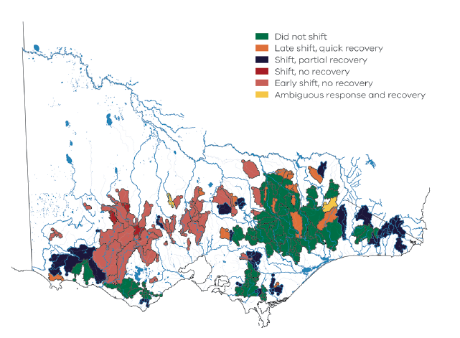
Figure 3.10: Catchment clusters derived from the runoff changes during and after the Millennium Drought using hierarchical clustering with six clusters – which was determined to be the optimal number of clusters.

3.4 Why have rainfall–runoff relationships changed?
Changes in rainfall–runoff relationships during and after the Millennium Drought resulted in less runoff than expected for a given rainfall in many regions, particularly in the drier parts of the state. This reduction in expected runoff means less flow in rivers and streams for affected catchments. For catchments that have recovered since the drought, this period of reduced runoff has ceased. However, for catchments that have not recovered, this period of reduced runoff is on-going.
Water resource planning that is based on the assumption that rainfall–runoff relationships are stable are likely to overestimate future runoff if rainfall–runoff relationships change to a low-flow state in the future, so it is important to understand why rainfall–runoff relationships can change during prolonged dry periods and why they recover.

3.4.1 Key catchment and drought characteristics
Shifts in the rainfall–runoff relationships were largely governed by catchment resilience or vulnerability to drought, rather than differences in drought severity.
Over 50 potentially influential factors representing both catchment and drought features were simultaneously analysed (following the methodology of Saft et al., 2016b) to detect which factors were most informative in explaining percentage reduction in drought runoff (streamflow anomaly), where larger anomalies are associated with rainfall–runoff relationship shifts. Four broad groups of factors were considered: (1) catchment properties (e.g. catchment area, slope, elevation, vegetation); (2) historical pre-drought climate (e.g. humidity index, temperature, rainfall patterns); (3) streamflow and groundwater signatures (e.g. mean and low-flow condition metrics, unconfined aquifer thickness, groundwater depth); and (4) drought characteristics (e.g. rainfall reductions, temperature changes).
The key factors explaining drought streamflow anomaly were related to catchment storage, relief and pre-drought climate. Drier and flatter catchments were found to be more vulnerable to large drought streamflow anomalies. Additionally, larger soil storage (deeper soil with higher available water-holding capacity) was linked to larger magnitudes of shift. In contrast, ample groundwater storage protected catchments from shifts in hydrologic response. Another important factor ensuring high catchment resilience was high altitudes, especially the area above the snow line (~1400 m). Slope and humidity index explain 75% of the variance in total streamflow anomaly during the drought. Including unconfined aquifer thickness increases the explained variance to 81%.
Regarding drought characteristics, the rainfall anomaly explained 23% of the drought streamflow anomalies, while changes in annual rainfall variability were important (larger streamflow anomalies were related to lower interannual variability of rainfall during the drought) along with increased potential evapotranspiration (larger streamflow anomalies were related to higher potential evapotranspiration). Temperature anomalies and changes in seasonality were not related to the shifts in the rainfall–runoff relationships.
Post-drought streamflow anomaly could not be predicted well without knowing the streamflow anomaly during the drought, which is additional evidence that hydrological shifts during the drought are key to understanding post-drought catchment hydrological behaviour.
3.4.2 Weather changes
Changes in weather systems may be less important in determining if a catchment is more likely to experience a shift in rainfall–runoff relationship compared to internal catchment characteristics, such as catchment mean slope.
Changes in the weather systems delivering rainfall to shifted catchments may provide a mechanism for explaining the change in rainfall–runoff relationship. For example, if a given annual rainfall was delivered via a series of more or less intense rainfall events, then runoff generation would be expected to differ as a result. In this analysis the shift is represented by the streamflow anomaly in excess of the elasticity reduction, which is a sub-component of the total streamflow anomaly presented in Section 3.4.1.
Up to 43% of the shift in rainfall–runoff relationships observed in many Victorian catchments during the Millennium Drought can be explained by changes in rainfall from weather systems, with some weather systems having a larger influence than others. Catchments with a shifted rainfall–runoff relationship during the drought tend to receive a lower proportion of their rainfall from fronts during this time than catchments that did not shift. Although there was an overall reduction in total rainfall in all catchments, a greater proportion of rainfall in shifted catchments was received from events that were a combination of thunderstorms, low-pressure systems and fronts compared to the rainfall from low-pressure systems or cold fronts alone.
Changes in weather systems are less important in determining if a catchment is more likely to experience a shift in rainfall–runoff relationship compared to a selection of internal catchment characteristics, such as catchment mean slope. However, this result is confounded due to the high spatial correlation between mean slope and changes in the proportion of rainfall from front-only systems during the drought. There is little change in the proportion of rainfall from fronts in catchments with a steeper slope, suggesting orography may inhibit the further reduction in rainfall from fronts seen in flatter catchments, and makes the importance of weather systems on the rainfall–runoff relationship shift difficult to resolve.
Analysis of post-drought weather systems was hampered by the limited years for which runoff data was available, increasing the uncertainty in results. The limited data indicates that catchments experiencing a rainfall–runoff shift post-drought also received a lower proportion of rainfall from fronts than catchments that did not shift during this time, similarly for low-pressure systems. There was also less increase in proportion of rainfall from front-thunderstorm systems in shifted catchments than stable catchments.
There is a statistically significant difference in the magnitude of rainfall–runoff shifts between eastern and western Victoria, indicative of contrasting catchment processes in those regions. However, to assess the impact of a change in dominant weather types on rainfall–runoff shifts, there needs to be further investigation into how this relationship changes between regions of similar dominant weather types clusters (e.g. Figure 2.8), catchment processes and seasonal variability of the rainfall–runoff relationship (e.g. Figure 3.8). This will help to identify how long-term changes in weather patterns will impact long-term streamflow availability across different catchments in Victoria.

3.4.3 Groundwater–surface water connectivity
Groundwater–surface water disconnection is an important feature of catchments with shifted rainfall–runoff relationship during the drought.
Changes in groundwater–surface water connectivity could account for some of the change in the rainfall–runoff relationship. Analysis of cease-to-flow conditions — which provide a useful indicator of the disconnection between a stream and any sub-surface water — shows that many streams experienced a prominent increase in the proportion of cease-to-flow conditions during and after the Millennium Drought (Figure 3.11). Prior to the drought, catchments that shifted rainfall–runoff relationship during the drought (Shifted and Recovered) have higher average percentage of cease-to-flow days (i.e. days in which streamflow falls to zero) than catchments that did not shift relationship (Stable and Shifted after drought). During the drought, the percentage of cease-to-flow days increased for Shifted and Recovered catchments, which indicates these catchments became more intermittent or even ephemeral during the drought. The fact that average cease-to-flow days remain elevated in many catchments years after the Millennium Drought broke confirms that groundwater storages have not been refilled enough by post-drought floods or average rainfall conditions since the drought to lower the proportion of cease-to-flow conditions to pre-drought levels. Figure 3.11 shows that groundwater–surface water disconnection is an important feature of catchments with shifted rainfall–runoff relationship during the drought, but the driver of this disconnection remains to be identified.
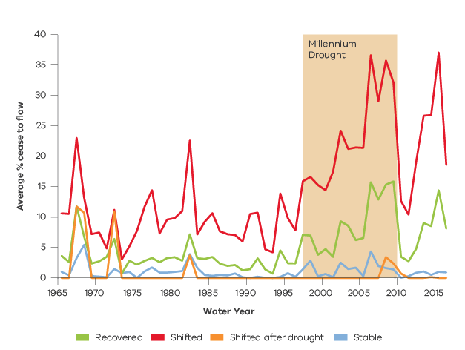
Figure 3.11: Average percentage of days in cease-to-flow condition per year for Stable, Shifted, Recovered and Shifted after drought catchments. The analysis is restricted to 1965–2016 when each year has > 80 catchments with data.

3.4.4 Catchment wetness and drought recovery
The rainfall–runoff relationship in some catchments can recover even if they don’t receive all of the ‘missing’ rainfall that they went without in the drought years.
One possible driver of recovery is that the cumulating rainfall deficit during the drought needs to be offset by drought-breaking rainfall. So far, in about 75% of catchments that have recovered, the catchment was drier at recovery than when it shifted into a low-runoff state (Peterson et al. 2020). This suggests that the rainfall–runoff relationship recovery does not require the cumulative rainfall deficit from the drought to be offset by drought-breaking rainfall before recovery can occur. That is, the catchments often appear drier based on cumulative rainfall anomaly when they recover than when they shifted into a low-runoff state, which indicates potential non-linearity, hysteresis and/or threshold behaviour in the associated processes.
The rainfall–runoff relationship in one-third of catchments in this study has not recovered since the Millennium Drought. Of the catchments that have recovered since the drought broke, about 80% showed an indication of recovery during the three years prior to recovering (Peterson et al. 2020). However, the catchments that have not yet recovered do not display this indication.
Most of the catchments that have not recovered show no evidence within their last three years of record of recovering soon and appear to be persisting within the low-runoff state (Peterson et al. 2020). The catchments that have not recovered appear likely to remain within a low-runoff state into the near future. Considering that many catchments shifted to a low-runoff state during the 1983 drought and did recover, future recovery of these one-third of catchments appears possible but the drivers for such recovery remains an open question.

3.5 Magnitude of observed shift in rainfall–runoff relationship during the Millennium Drought
During the Millennium Drought, more than half of the Victorian catchments analysed experienced an extra
20–40% decline in their annual streamflow due to the shift in rainfall–runoff relationships.
The earlier sections described where significant changes in rainfall–runoff relationships have been observed, over what timescales and potential drivers of the shift. Knowing the magnitude of the observed changes due to the shift also helps us to understand the significance of the issue in the different catchments across Victoria.
Comparing the rainfall and runoff observed during the Millennium Drought with what would have been expected based on the pre-drought rainfall–runoff relationship provides a way to calculate the quantity of runoff that is ‘missing’, or that is not explained by the decline in annual rainfall alone. Figure 3.12 shows the percentage decline in runoff for the study catchments during the Millennium Drought that is in excess of the expected runoff decline from the pre-drought rainfall–runoff relationship. Comparing Figure 3.12 with the total observed percentage decline in runoff during the Millennium Drought (Figure 3.4a) shows that the shift in rainfall–runoff response accounts for a significant proportion of the observed runoff decline.
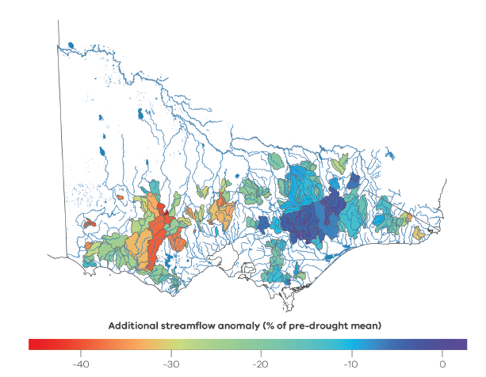
Figure 3.12: Percentage reduction in runoff during the Millennium Drought across the study catchments that is in excess of the expected runoff decline from the pre-drought rainfall–runoff relationship. The percentage decline is relative to the pre-drought average runoff.
Drawing on the understanding of potential drivers of the changes in rainfall–runoff relationship (described in Section 3.4), a regression equation explaining 71% of the variance in observed shifts was developed using catchment and drought characteristics. The regression was used to predict the magnitude of declines across other catchment areas of Victoria outside of the study catchments (Figure 3.13). Data smoothing techniques were used to combine the magnitude information calculated within the study catchments with the outputs of the prediction equation.
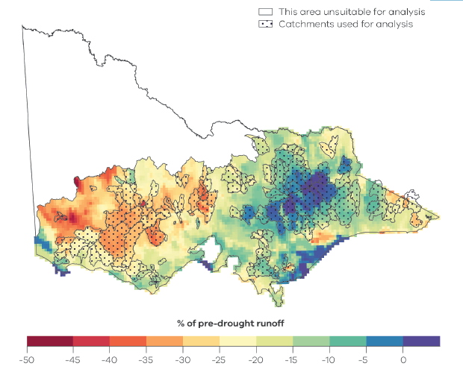
Figure 3.13: Estimated reduction in runoff during the Millennium Drought that is in excess of the expected runoff decline from the pre-drought rainfall–runoff relationship. The percentage decline in runoff is relative to pre-drought average runoff.

3.6 Implications for hydrology modelling
The current generation of hydrologic models do not replicate well the observed changes in the rainfall–runoff relationship during and after extended drought.
Current rainfall–runoff models perform poorly when applied to conditions different to those used to calibrate the model. The structure of hydrologic models often presumes stable rainfall–runoff relationships and that catchments always recover from droughts (Peterson et al. 2009; Peterson and Western 2014; Peterson et al. 2014). However, as we see in Victoria, these relationships can change over time. Generally, rainfall–runoff models overestimate runoff under drier conditions (Saft et al. 2016a) and underestimate runoff under wetter conditions (Coron et al. 2012).
In a changing climate, as future conditions diverge from those observed in the past, we can expect our model performance in predicting future runoff will degrade without on-going re-calibration. If there is also a future change in rainfall–runoff relationship, then the degradation of model performance will possibly be amplified. This model performance degradation is further complicated by the variable timing of rainfall–runoff relationship change and recovery observed in this study. At present our conceptual rainfall–runoff models do not reproduce observed changes in rainfall–runoff relationship arising from extended drought. Developing models that can do this at one catchment poses a future research challenge. Developing models that can do this across many catchments that exhibit variable response — including no change, early change, late change, early recovery, late recovery and no recovery — is also a significant future research challenge. The Millennium Drought provides a useful test bed for improving and testing our rainfall–runoff models for changing conditions. Where rainfall–runoff relationships have previously changed, then calibration strategies that use pre-drought and drought runoff may address some of these future challenges.
Fowler et al. (2020) explored the ability of five commonly used conceptual rainfall–runoff models to reproduce multi-year trends, similar to those observed during the Millennium Drought, in runoff or model internal stores and fluxes. They found that the current structure of all these models constrained their ability to reproduce multi-year trends observed within catchments. Hence, these models in their current form will not be able to reproduce the observed runoff characteristics during the Millennium Drought with a single robust parameter set identified by calibration during pre-drought conditions.
Research is active and on-going to diagnose and rectify model structural inadequacies to increase the number of robust parameter sets within a model and improve calibration techniques to identify those robust parameter sets without knowing the future change conditions. The framework of Fowler et al. (2018) for model testing and improvement can guide modellers to diagnose whether to modify the calibration methodology or seek to modify the model structure.
A warmer future is likely to increase evaporative demand for water from the landscape. The impact of changed evaporative demand can be incorporated into our models via future projections of potential evaporation, which are used as a model input. In water-limited regions of Victoria, future changes in evaporative demand are much less likely to alter projected streamflow than projected changes in rainfall, as streamflow in these regions is strongly responsive to rainfall. In contrast, in more energy-limited mountainous regions, projected changes in evaporative demand could combine with changes in rainfall to influence streamflow.
Another aspect of projected climate change that could influence future catchment response is how vegetation responds to increasing concentrations of atmospheric carbon dioxide, warmer temperatures, changing fire regime, predation, species dynamics and rainfall (see Brodribb et al. 2020; Peel 2009). The net effect on runoff of future changes in vegetation-related evapotranspiration due to the complex interaction of these factors remains unknown. How to incorporate the net effect of vegetation responses into our hydrologic model is an area of active research.

4. Victoria’s water future
Can we improve projections of future water availability in Victoria?
Projections of future climate have a level of uncertainty, so they are presented as a range of possible future scenarios. Water resource planners need to be confident that the range of scenarios are robust and encompass the breadth of what we may experience in the future.
The range of future hydrological scenarios can be different depending on the approach taken to generate the projections. Improved projections will provide greater confidence that the future scenarios used for planning represent a plausible range of possible futures.

Victoria’s water future: at a glance
- Future runoff in Victoria is likely to be lower, because of the projected decline in cool-season rainfall and higher potential evapotranspiration. Variability will remain high, with wet and dry years on a background of a drying trend.
- The runoff projections developed through the Victorian Climate Initiative (VicCI) continue to be the most appropriate for the water sector in Victoria and can be considered as projected change relative to post-1975 averages.
- There is considerable uncertainty in future water availability projections, largely due to the uncertainty in future rainfall projections. However, understanding of the state’s water future is becoming clearer due to initiatives like VicWaCI.
- Finer-scale dynamic downscaled projections (like the Victorian Climate Projections 2019) can potentially add value, particularly for local scale assessments.
- Although dynamic downscaling is improving, there is significant bias in the downscaled rainfall that needs to be robustly bias corrected for hydrological application.
- Projection products from different selections of global climate models and dynamic downscaled products do not necessarily converge to a narrower range of change.
- Hydrological models developed and calibrated against past observations may not robustly predict the future under hotter conditions, enhanced atmospheric carbon dioxide concentration and longer dry spells not seen in the past.
- Assessments focused on a systems approach that characterise resilience to climate variability and climate change can provide insights and a foundation for considering the risk versus reward of adaptation options.

Implications for the water industry
- Given the large range of plausible climate futures, water resource planning should consider a wide range of possible futures.
- The climate and water availability conditions experienced over recent periods, like the period since 1997, should be assessed as a scenario for predictive purposes to account for the possibility that climate change may have occurred more rapidly than projected by most global climate models.
- In addition to considering hydroclimate projections, approaches that consider how vulnerable a water system is to change can also be used to inform climate change adaptation.
- The Guidelines for Assessing the Impact of Climate Change on Water Availability in Victoria (DELWP 2020) have been developed to provide tailored guidance on how to apply hydroclimate science for water resource planning applications and to promote a consistent approach to climate change impact assessment across the water industry.

4.1 Projections of water futures
Future runoff in Victoria is likely to be lower, because of the projected decline in cool-season rainfall, and higher potential evapotranspiration. Variability will remain high, with wet and dry years on a background of a drying trend.
There is high confidence that Victoria’s long-term water future will be drier, given the high confidence in projected reductions in cool-season rainfall (as projected by the large majority of global climate models (GCMs), and consistent with the physical drivers of rainfall change in south-eastern Australia in a warmer world; see Section 2) together with higher temperatures and potential evapotranspiration. A changing rainfall–runoff relationship, with lower runoff for the same rainfall during long dry spells, also corresponds to a drier water future (see Section 3).
The runoff projections developed through the Victorian Climate Initiative continue to be the most appropriate for the water sector in Victoria and can be considered as projected change relative to post-1975 averages.
The VicCI hydroclimate projections (Potter et al. 2016; Figure 4.1 to Figure 4.3) continue to be the most appropriate projections currently available for the water sector in Victoria. There is considerable uncertainty in the future water projections, largely due to the uncertainty in future rainfall projections. The VicCI projections were developed using a hydrological model informed by the climate change signal from the 42 CMIP5 GCMs. Therefore, Figure 4.1 reflects the range of rainfall projections from the 42 GCMs, amplified in the runoff.
The percentage change in mean annual rainfall in Victoria is typically amplified as a two to three times larger percentage change in the mean annual runoff (Chiew 2006). The increase in temperature and potential evapotranspiration will further accentuate the decline in runoff. The higher temperature will also increase water demand and therefore increase the gap between future water supply and demand (Chiew and Prosser 2011).
Extreme rainfall events are projected to become more intense in a warmer world (VicWaCI 2019; see also Section 2.7), increasing flood hazard and flood risk in urban areas and small catchments. However, the impact on medium and large catchments in Victoria is less certain because of the compensating influence of higher extreme rainfall intensity and drier antecedent catchment conditions (Jacobs 2020; Pedruco et al. 2018).
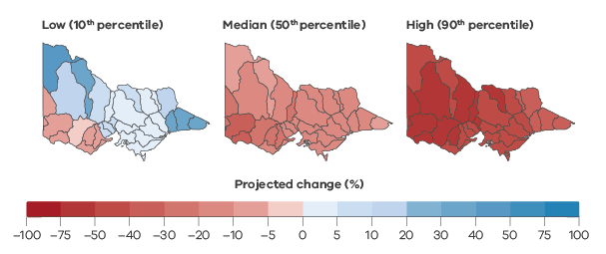
Figure 4.1: Median and range of projected percentage changes to basin mean annual runoff centred on 2065 relative to post-1975 average for a high emissions scenario (RCP8.5). (Source: Potter et al. 2016).
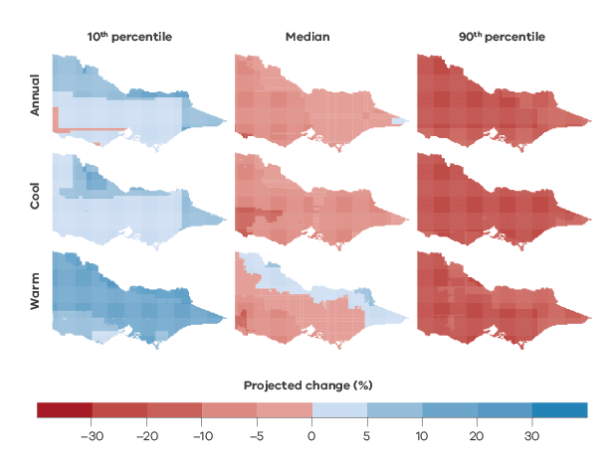
Figure 4.2: Median and range of projected percentage changes to mean annual rainfall, cool-season rainfall (April–October) and warm-season rainfall (November–March) centred on 2065 relative to post-1975 averages for a high emissions scenario (RCP8.5).
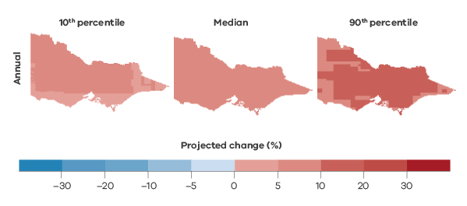
Figure 4.3: Median and range of projected percentage changes to mean annual potential evapotranspiration centred on 2065 relative to post-1975 average for a high emissions scenario (RCP8.5).
Potential evapotranspiration will increase under higher temperatures because of the higher amount of energy available for evapotranspiration. In potential evapotranspiration formulations, the increase in potential evapotranspiration largely comes from the increase in vapour pressure deficit driven by higher temperature.
Despite increases in temperature, decreases in pan evaporation (used to measure potential evapotranspiration) have been reported around the world (commonly referred to as the ‘pan evaporation paradox’), and this was attributed to reductions in wind speed and solar radiation. Stephens et al. (2018) examined pan evaporation trends across Australia using more recent data and confirmed the decline in pan evaporation over 1975–1994, but noted that this trend has plateaued or reversed in recent decades. Increasing vapour pressure deficit has become more dominant, resulting in an increasing pan evaporation trend over 1994–2016.
Climate projections science is an active area of research with new climate projections datasets being developed. This includes the CMIP6 projections from many more GCMs that will become available in 2021, and more dynamic downscaling experiments under a coordinated regional climate modelling program. Currently, the Potter et al. (2016) projections remain the recommended projections to use, with possible supplementation with dynamic downscaling as outlined in the new Guidelines for Assessing the Impact of Climate Change on Water Availability in Victoria (DELWP 2020). There is also research underway to improve hydrological models and to develop more robust calibration approaches for hydrological prediction under climate change. These will inform the development of the next-generation hydroclimate projections for Victoria in several years’ time.

4.2 Understanding uncertainty
There is considerable uncertainty in future water availability projections, largely due to the uncertainty in future rainfall projections. However, understanding of the state’s water future is becoming clearer due to initiatives like VicWaCI.
Despite improvements in the climate projections and hydrological impact modelling sciences, the range (or uncertainty) in the projected hydroclimate is likely to remain large. Each step in the development of hydrological projections (Figure 4.4) has its own inherent uncertainty, which is compounded at each step of the process: (1) choice of greenhouse gas emission scenarios; (2) selection of GCMs; (3) downscaling of GCM outputs to catchment scale climate variables (including robust bias correction); and (4) hydrological modelling (see Chiew et al. 2017; Ekstrom et al. 2016). Understanding this uncertainty will inform the most appropriate use of projections from multiple sources and indicate how best to use the available hydroclimate scenarios for Victorian water management and planning.
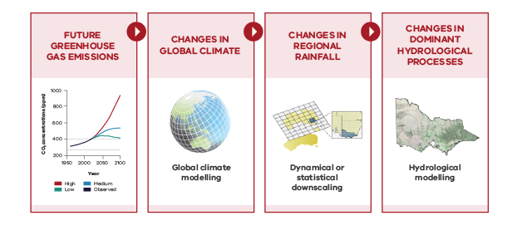
Figure 4.4: Modelling components and uncertainty in projecting water futures.

4.2.1 Uncertainty in future rainfall projections
Finer-scale dynamic downscaled projections (like the Victorian Climate Projections 2019; VCP19) can potentially add value, particularly for local scale assessments.
There is a large range of plausible change in the current Victorian runoff projections (Figure 4.1) arising mainly from the rainfall change signal of the CMIP5 GCMs (corresponding to the Intergovernmental Panel on Climate Change [IPCC] Fifth Assessment Report). The IPCC Sixth Assessment Report that will become available from 2021 will draw on projections from many more GCMs from CMIP6. Nevertheless, despite improvements in climate change science, the range in the projections is likely to remain large. Therefore, water resource planning should take a precautionary approach of assessing vulnerabilities and risk from a wide range of projected changes together with value judgements as to how risk adverse the resulting adaptation decisions need to be.
Finer-scale dynamic downscaled projections, like the VCP19 can add value to the GCM-scale projections, particularly in coastal areas and across mountain ranges. For example, the VCP19 projections show enhanced drying on the westward slopes of the Victorian Alps, consistent with other dynamic downscaling studies, physical theory and past trends (Grose et al. 2019), and appearing as ‘realised added value’ in analysis of CORDEX simulations (Di Virgilio et al. 2020).
The VCP19 projections come from the Conformal Cubic Atmospheric Model (CCAM) dynamic downscaling model (Clarke et al. 2019) conditioned on six host GCMs chosen based on their skill in reproducing observed large-scale drivers of Australian climate as well as representing the range of projected future climates. The VCP19 projections are generally drier than the CMIP5 GCM projections (see Section 4.2.3, Figure 4.7). A major challenge in interpreting and using dynamic downscaled data is the lack of agreement in the rainfall projections from the different downscaling methods (Potter et al. 2018; Ekstrom et al. 2015; Figure 4.7).
As noted by Clarke et al. (2019), there are advantages and limitations in the different approaches, and the CCAM downscaling in VCP19 is intended to enhance the amount of climate modelling data available to increase the robustness of climate change adaptation and planning. For example, the drier VCP19 results can be considered in water resource planning as plausible ‘worst case’ scenarios to assess the risk of more extreme drying on the water resources. The global community is progressing towards coordinated downscaling experiments (e.g. CORDEX) that will allow the consistent and robust analysis of regional modelling and its ‘added value’.
4.2.2 Use of downscaled rainfall in hydrological modelling
Although dynamic downscaling is improving, there is significant bias in the downscaled rainfall that needs to be robustly bias corrected for hydrological application.
There is considerable bias in the dynamic downscaled (as well as GCM) rainfall, where the difference between the downscaled and observed rainfall is often larger than the climate change signal itself (see Figure 4.5). Therefore, the raw downscaled rainfall needs to be bias corrected to utilise its value for hydrological applications.
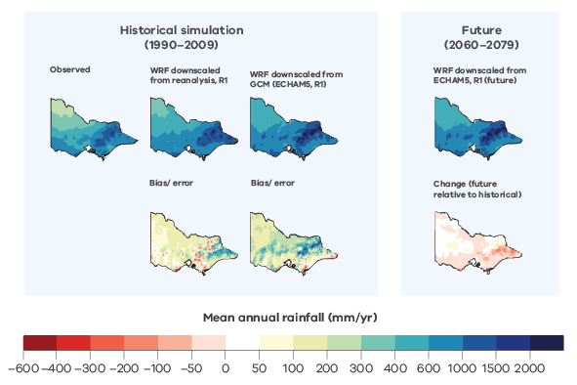
Figure 4.5: Mean annual rainfall simulated by Water Research and Forecasting (WRF) regional climate (or dynamic downscaling) model compared to observed rainfall (1990–2009) (left panel) and future WRF rainfall (2060–2079) relative to historical WRF rainfall (1900–2009) (right panel). (Analysis using CCAM, as well as other host GCMs, show similar results).
The runoff projections in Figure 4.1 are modelled using future daily rainfall series generated by empirically scaling the historical daily rainfall series by the annual, seasonal and daily (at the different daily rainfall percentiles) change signal in the GCMs (Chiew et al. 2009; Potter et al. 2016). With this method, the future daily rainfall sequence is the same as the historical daily rainfall sequence. The empirical scaling method can also be used with dynamic downscaled data. To better utilise the dynamic downscaled rainfall directly (i.e. rather than scaling the historical series), a bias correction method is generally used by relating the daily distribution of the raw downscaled rainfall to that of the observed rainfall (a quantile-quantile mapping method is used here) and then using this relationship to convert the future raw dynamic downscaled rainfall to the grid or catchment rainfall. Unlike the empirical scaling method, the bias correction method and hydrological application considers potential changes in the rainfall sequencing and variability over different temporal scales.
Analysis of the bias-corrected daily rainfall data (Potter et al. 2020) found biases remained in a number of metrics. As multi-day rainfall totals or events contribute significantly to runoff generation, underestimation of this metric leads to an underestimation of runoff (Charles et al. 2020). Bias correction at independent grid cells also does not correct for underestimation of the spatial correlation of rainfall that is another significant driver of catchment runoff, leading to a further underestimation of runoff (Charles et al. 2020).
The bias correction of daily rainfall also leads to monthly, seasonal and annual change signals that are different to the change signals in the raw downscaled data (Charles et al. 2020). This raises the question of whether the bias-corrected data should be rescaled to match the seasonal and/or annual change in the raw downscaled data, and how to interpret and communicate this difference.
To overcome these limitations in using dynamic downscaled data for hydrological applications, further research is needed to: (1) reduce the bias in the daily, seasonal and annual downscaled rainfall; (2) understand the different change signals from different downscaling products; (3) better understand the mechanisms leading to change signal that is different from the host GCMs; and (4) develop more robust bias correction methods specifically tailored for hydrological modelling.

4.2.3 Range of uncertainty in rainfall and runoff projections for Victoria
Projection products from different selections of global climate models (and dynamic downscaled products) do not necessarily converge to a narrower range of change.
Figure 4.6 compares modelled changes in future mean annual runoff using a range of different climate inputs: (a) empirically scaled rainfall changes from the six GCMs used in VCP19 to drive CCAM; (b) empirically scaled rainfall changes from CCAM; (c) bias-corrected rainfall from CCAM; (d) empirically scaled rainfall changes from the four New South Wales and Australian Capital Territory Regional Climate Modelling (NARCliM) Water Research and Forecasting model (WRF) (Evans et al. 2014); and (e) bias-corrected rainfall from WRF. This highlights the major differences in change signal from GCMs and the dynamically downscaled products (Figure 4.6a and Figure 4.6b) and the corresponding bias-corrected rainfall (Figure 4.6b versus Figure 4.6c and Figure 4.6d versus Figure 4.6e). These results highlight both the advantages of dynamic downscaling (finer spatial scale particularly over orography) and challenges in interpreting the differences between GCM results and between CCAM and WRF empirically scaled and bias-corrected results.
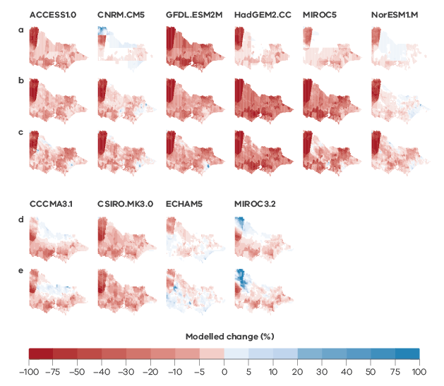
Figure 4.6: Modelled changes in mean annual runoff (%) from different future rainfall inputs: (a) empirically scaled rainfall changes from the six host GCMs; (b) empirically scaled rainfall changes from CCAM; (c) bias-corrected rainfall changes from CCAM; (d) empirically scaled rainfall changes from the four NARCliM WRF; and (e) bias-corrected rainfall changes from WRF. For (a) to (c), change is for a period centred on 2065 relative to 1986–2005 for a high emissions scenario (RCP8.5); for (d) and (e) change is for a period centred on 2070 relative to 1990–2009 for a high emissions scenario (SRES A2).
Similarly, at the basin scale, Figure 4.7 shows the relative changes across the different projection products, in this case for the Goulburn Basin (Basin ID 405) as an example. The CCAM rainfall changes are generally drier than that of the host GCMs. Five of the six CCAM projections are drier than the median scenario of the 42 GCMs. The WRF results are noticeably wetter (or less dry), with only one of the four projections drier than the median of the 42 GCMs (noting that WRF uses CMIP3 GCMs so it is not a direct comparison, but the tendency for a wetter signal is of note). The daily bias correction can also modify the mean annual change signal, more so in CCAM than in WRF.
The corresponding runoff changes are, overall, consistent with the rainfall changes, with the percentage changes in rainfall amplified in the runoff. Of particular note are the two driest CCAM runoff projections and the relative positions of the runoff changes from empirically scaled versus bias-corrected rainfall. Whereas the bias-corrected CCAM rainfall is drier than the empirically scaled rainfall, in contrast the resultant runoff changes from the empirically scaled rainfall are drier than those from the bias-corrected rainfall. This could be due to both differences in future sequencing as well as biases in multi-day rainfall totals and spatial correlation that have been found to result in the underestimation of observed runoff (Charles et al. 2020).
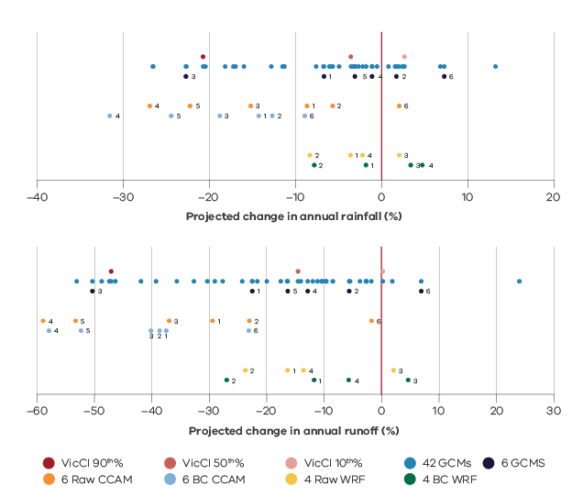
Figure 4.7: Comparison of the range of basin-scale projected changes from different sources – 42 GCMs; 6 CCAM and 4 WRF (top) rainfall and (bottom) runoff for the Goulburn Basin. “VicCI” refers to the VicCI projections.

4.2.4 Uncertainty in hydrological modelling
Hydrological models developed and calibrated against past observations may not robustly predict the future under hotter conditions, enhanced atmospheric carbon dioxide concentration and longer dry spells not seen in the past.
Most studies show that the differences in the modelled change in long-term average runoff from different rainfall–runoff models are relatively small, and much smaller compared to the uncertainty in the future rainfall projections (e.g. Chiew et al. 2018; Teng et al. 2012). However, different rainfall–runoff models and different calibration approaches can give significantly different projections of climate change impact on streamflow characteristics beyond the long-term averages, particularly the low-flow characteristics (Chiew et al. 2018). Estimating the hydrological impact from climate change therefore requires careful modelling consideration and calibration against appropriate criteria that specifically target the streamflow characteristic that is being assessed.
Practically all studies assessing climate change impact on runoff simulate future runoff using the same model parameter values obtained from model calibration against historical data. The approach therefore assesses changes in runoff due to changes in the input climate data, assuming that the calibration against past observations adequately represents the future catchment characteristics. This assumption is likely to fail as hydrological models are extrapolated to predict a future under hotter conditions, higher atmospheric carbon dioxide concentration, and longer dry spells not seen in the past.
Several studies have now shown that traditional calibration of hydrological models will tend to underestimate the range in the projected hydrological impact. That is, it will underestimate the decline in runoff where a runoff decrease is projected, and underestimate the increase in runoff where a runoff increase is projected (Chiew et al. 2014; Saft et al. 2016a; Vaze et al. 2010). Research in VicWaCI has shown that robust calibration based on multiple objectives to produce good calibration of dry periods as well as wet periods (at the expense of the traditional ‘best’ simulation over the entire period of record), can reduce but not eliminate the modelling limitation of underestimating the projected range in future runoff. This is because of the need to consider trade-offs between the calibration consideration (particularly in simulating the dry periods) versus enhanced bias that result from the consideration. Hydrological models will therefore also need to be adapted to reflect the non-stationary nature of catchment responses in a changing climate, and this is the subject of active research.

4.3 Using projections to inform planning, management and adaptation decisions
Assessments focused on a systems approach that characterise resilience to climate variability and climate change can provide insights and a foundation for considering the risk versus reward of adaptation options.
The Guidelines for Assessing the Impact of Climate Change on Water Availability in Victoria (DELWP 2020) recommend that water resources planning should use the projected changes in Potter et al. (2016) relative to post-1975 averages. It may be prudent to also consider a post-1997 hydroclimate reference period in recognition of the fact that climate change may have occurred more rapidly than projected by most GCMs.
There is considerable uncertainty in the future rainfall (and therefore also runoff) projections. The uncertainty is likely to remain large even with more robust next-generation hydroclimate projections. End users will therefore always need to:
- identify the assets and operations in their system that are influenced by climate
- be able to define how the performance of the system is measured
- be able to identify climate-related risks to their assets and adaptations that are possible under different broad changes in the climate.
This bottom-up systems approach will allow testing of assumptions used in quantifying climate impacts on the system providing a pathway towards incorporating climate uncertainties into the model. This systems approach to understanding climate risks also has the potential to guide the development of more appropriate climate scenarios or knowledge from climate science, to explore system limits and breaking points, and to guide the development of adaptation strategies.
Most climate change impact studies consider potential changes in a future period relative to the historical period (e.g. hydroclimate centred around 2065 relative to 1975–2019 hydroclimate, as in Figure 4.1 to Figure 4.3). An alternative is to consider transient projections or trajectories from the present into the future. This is particularly suited to models and applications that lend themselves to exploring many simulations or realisations, where stochastic data that represent both climate variability and climate change can be used as inputs to the model. In the short term, natural variability will dominate and as such the choice of hydroclimate reference period is important (see the box on climate reference period), while the impact of climate change becomes more important for medium- and long-term planning.

Climate reference period
As noted in Rauniyar et al. (2019) climate reference period (or baseline) can be used as a:
- reference against which recent observations are compared (e.g. pre-industrial)
- benchmark for predictive purposes, as an indicator of the conditions likely to be experienced in a given location (as close to current as possible)
- benchmark to evaluate the future changes in climate for planning and management (close to current but limited by climate model forcing and run-time).
The Intergovernmental Panel on Climate Change (IPCC) defines a pre-industrial climate reference period preferably prior to 1900, but as early in the modern observational record as possible (Point 1 in list above). For Australia, the modern meteorological record began around 1900, so Rauniyar and Power (2020) use a 1900–1959 climate reference period against which to reference observed change. The climate reference period should ideally be long enough to capture the range of natural variability like El Niño and La Niña.
The World Meteorological Organization recommends using a period of at least 30 years (e.g. 1981–2010) as a reference climate period representative of the current climate (Point 2), but are always keen to use the most recent 30 years. The IPCC has used the 1986–2005 period as a reference climate period (IPCC 2014) to compare future projections against (Point 3). However, hydrological planning generally requires much more than 30 years of data to adequately represent the range of rainfall and runoff variability over different timescales.
The choice of a suitable reference climate period in Victoria is compounded by the fact that the post-1997 climate (particularly cool-season rainfall) is significantly drier than in the past, and drier than the near-future rainfall projections from most GCMs. The persistent dry conditions have been amplified in the runoff decline, in many places more than could be expected from past rainfall–runoff relationships. Nevertheless, 1997–2019 is a relatively short period and Rauniyar and Power (2020), through analysis of GCM simulations, concluded that about 20% of this decline could be attributed to anthropogenic climate change.
The Guidelines for Assessing the Impact of Climate Change on Water Availability in Victoria recommends using a post-1975 historical climate reference period from which to generate a range of current and future hydroclimate projections (DELWP 2020). Similarly, some agencies (e.g. energy industries) use the start of the Millennium Drought as a reference climate period (1997–present). This is a conservative approach as the post-1997 climate is a very dry period and using the relatively short post-1997 period alone (i.e. without applying data extension techniques) could omit important aspects of the climate variability experienced in the longer past.

5. Research application
How can this information be used in different decision-making contexts?
The findings that have emerged from the Victorian Water and Climate Initiative have implications for many different parts of the Victorian water sector.
A better understanding of past, current and future climate and water resources helps the water sector and communities to make more-informed planning, management and policy decisions. Some of the parts of the water sector for which the Initiative’s research findings are particularly relevant include flooding, drainage, urban runoff, water supply and demand, water availability, infrastructure investment and water resource policy.
The findings from VicWaCI's research provides a knowledge base that underpins many of the water resource planning and policy activities across Victoria. Application of the findings from earlier research programs, like the Victorian Climate Initiative, highlights the range of application, which include:
- providing a foundation for regional water policy development, for example through regional sustainable water studies
- informing decisions about urban water supply security through Water Corporation urban water strategies
- assisting environmental water managers to assess the impacts of climate change to inform environmental water planning decisions
- providing a foundation for statewide water resource policy and planning, for example through the Government’s water plan, Water for Victoria, the Pilot Water Sector Climate Change Adaptation Action Plan, the Victorian Rural Drainage Strategy and the Victorian Floodplain Management Strategy.
One of the ways that DELWP is supporting the water sector to apply some of the research findings specifically to water availability planning is through the development of Guidelines for Assessing the Impact of Climate Change on Water Availability in Victoria (DELWP 2020). The guidelines set out climate change scenarios for temperature, potential evapotranspiration, rainfall, runoff and groundwater recharge to be used across Victoria for assessing the impact of climate change on water availability, supply and demand. The guidelines also include information on changes to climate variability associated with climate change.
The guidelines serve a range of purposes.
- They provide tailored guidance on how to apply the climate science for water resource planning applications. Applying the science can be complex, and the guidelines describe how to do this in a manner consistent with current research findings.
- They promote a consistent approach to climate change impact assessment for water supplies. This enables comparisons of current and future water availability and use for shared water resources across Victoria. This will be particularly important for regional planning processes such as the development of sustainable water strategies.
- They enable more efficient climate change impact assessment by pre-generating a standard set of climate change information, thereby removing the burden for individual water corporations or other users to generate their own climate change projections in an area of complex science.
The guidelines are used by water corporations for the development of urban water strategies and will be used by government in the development of the Central and Gippsland Sustainable Water Strategy. The guidelines can also be used to assess the impacts of climate change on water availability for the provision of environmental flows.
The guidelines draw on the science of the Victorian Water and Climate Initiative in the selection of a climate reference period, in defining the range of recommended climate change projections and in recommending approaches to sensitivity and stress testing.

Sources of additional information include:
- The Victorian Water and Climate Initiative
- Victoria’s Climate Science Report 2019
- Hydroclimate projections for Victoria at 2040 and 2065 (Potter et al. 2016)
- Climate change and the Victorian water sector
- The Victorian Climate Projections 2019 (Clarke et al. 2019)
- The Climate Change in Australia website
- The Pilot Water Sector Climate Change Adaptation Action Plan (DELWP 2018)

Glossary
AGCD: Australian Gridded Climate Data – the Australian Bureau of Meteorology’s official dataset for monthly gridded rainfall analysis
AWAP: Australian Bureau of Meteorology 0.05o gridded daily climate product (from the Australian Water Availability Project), replaced in September 2020 by AGCD
CCAM: Conformal Cubic Atmospheric Model – a dynamic downscaling model developed by CSIRO
CMIP: Coupled Model Intercomparison Project – global climate models in the fifth phase of the project, CMIP5, were used to inform the IPCC Fifth Assessment Report; the sixth phase, CMIP6, is currently underway and will inform the IPCC Sixth Assessment Report
cool season: April to October
CORDEX: Coordinated Climate Downscaling Regional Experiment
ENSO: El Niño Southern Oscillation
Evapotranspiration: the transfer of water vapour to the air directly from the soil or through plants – actual evapotranspiration (AET) is the evapotranspiration that occurred while potential evapotranspiration (PET) is the evapotranspiration that would occur from a fully saturated surface
GCM: global climate model
IPCC: Intergovernmental Panel on Climate Change
IPO: Interdecadal Pacific Oscillation
ITCZ: Inter-Topical Convergence Zone
RCM: Regional climate model – a dynamic downscaling model
NARCliM: New South Wales and Australian Capital Territory Regional Climate Modelling
RCP: representative concentration pathway
SAM: Southern Annular Mode
SEACI: South Eastern Australian Climate Initiative
VCP19: Victorian Climate Projections 2019
VicCI: Victorian Climate Initiative
VicWaCI: Victorian Water and Climate Initiative
warm season: November to March
WRF: Water Research and Forecasting model – one of the most commonly used regional climate model or dynamic downscaling models

References
Abram NJ, Hargreaves JA, Wright NM, Thirumalai K, Ummenhofer CC and England MH (2020) Palaeoclimate perspectives on the Indian Ocean Dipole. Quaternary Science Reviews, 237. doi:10.1016/j.quascirev.2020.106302.
Berg P, Mosele, C and Haerter JO (2013) Strong increase in convective precipitation in response to higher temperatures. Nature Geoscience, 6(3), 181–185.
BoM (Bureau of Meteorology) (2017c) Subtropical ridge leaves us high and dry this June. July 2017 Climate Update. Available at <http://www.bom.gov.au/climate/updates/articles/a025.shtml>.
Brodribb TJ, Powers J, Cochard H and Choat B (2020) Hanging by a thread? Forests and drought. Science, 368, 261–266.
Busuioc A, Birsan MV, Carbunaru D, Baciu M and Orzan A (2016) Changes in the large-scale thermodynamic instability and connection with rain shower frequency over Romania: verification of the Clausius–Clapeyron scaling. International Journal of Climatology, 36(4), 2015–2034.
Cai W, Borlace S, Lengaigne M, van Rensch P, Collins M, Vecchi G, Timmermann A, Santoso A, McPhaden MJ, Wu L, England MH, Wang G, Guilyardi E and Jin FF (2014b) Increasing frequency of extreme El Niño events due to greenhouse warming. Nature Climate Change, 4, 111–116. doi:10.1038/nclimate2100.
Cai W, Santoso A, Wang G, Weller E, Wu L, Ashok K, Masumoto Y and Yamagata T (2014a) Increased frequency of extreme Indian ocean dipole events due to greenhouse warming. Nature, 510, 254–258. doi:10.1038/nature13327.
Cai W, Sullivan A and Cowan T (2011a) Interactions of ENSO, the IOD, and the SAM in CMIP3 Models. Journal of Climate, 24, 1688–1704. doi:10.1175/2010JCLI3744.1.
Cai W, van Rensch P, Borlace S and Cowan T (2011b) Does the Southern Annular Mode contribute to the persistence of the multidecade-long drought over southwest Western Australia? Geophysical Research Letters, 38, L14712, doi:10.1029/2011GL047943.
Charles SP, Chiew FHS, Potter NJ, Zheng H, Fu G and Zhang L (2020) Impact of downscaled rainfall biases on projected runoff changes. Hydrology and Earth Systems Science, 24, 2981–2997, doi:10.5194/hess-24-2981-2020.
Chiew F and Prosser I (2011) Water and climate. In: Water – Science and Solutions for Australia (Ed: I Prosser), CSIRO Publishing, pp 29–46. Available at: <http://www.csiro.au/en/Research/Environment/Water/Water-Book>.
Chiew FHS (2006) Estimation of rainfall elasticity of streamflow in Australia. Hydrological Sciences Journal, 51, 613–625.
Chiew FHS, Potter NJ, Vaze J, Petheram C, Zhang L, Teng J and Post DA (2014) Observed hydrologic non-stationarity in far south-eastern Australia: implications and future modelling predictions. Stochastic Environmental Research and Risk Assessment, 28, 3–15.
Chiew FHS, Teng J, Vaze J, Post DA, Perraud JM, Kirono DGC and Viney NR (2009) Estimating climate change impact on runoff across south-east Australia: method, results and implications of modelling method. Water Resources Research, 45, W10414.
Chiew FHS, Zheng H and Potter NJ (2018) Rainfall–runoff modelling considerations to predict streamflow characteristics in ungauged catchments and under climate change. Water, 10, 1319.
Chiew FHS, Zheng H, Potter NJ, Ekstrom M, Grose MR, Kirono DGC, Zhang L and Vaze J (2017) Future runoff projections for Australia and science challenges in producing next generation projections. Proceedings of the 22nd International Congress on Modelling and Simulation, Hobart, December 2017, pp 1745–1751. doi:10.36334/modsim.2017.L16.chiew.
Clarke J, Grose M, Thatcher M, Hernaman V, Heady C, Round V, Rafter T, Trenham C and Wilson L (2019) Victorian Climate Projections 2019 (VCP19), Technical Report, CSIRO. Available at: <https://www.climatechangeinaustralia.gov.au/media/ccia/2.1.6/cms_page_media/508/Vic%20Climate%20Projections%202019%20Technical%20Report.pdf>.
Coles S, Bawa J, Trenner L and Dorazio P (2001) An introduction to statistical modeling of extreme values, Vol. 208. Springer.
Coron L, Andréassian V, Perrin C, Lerat J, Vaze J, Bourqui M and Hendrickx F (2012) Crash testing hydrological models in contrasting climate conditions: an experiment on 216 Australian catchments. Water Resources Research, 48, W05552.
Crimp SJ, Gobbett D, Kokic P, Nidumolu U, Howden M and Nicholls N (2016) Recent seasonal and long-term changes in southern Australian frost occurrence. Climatic Change, 139, 115–128. doi:10.1007/s10584-016-1763-5.
CSIRO (2012) Climate and water availability in south-eastern Australia: a synthesis of findings from Phase 2 of the South Eastern Australian Climate Initiative (SEACI), CSIRO, Australia, September 2012, 41 pp.
CSIRO and BoM (Bureau of Meteorology) (2015) Climate Change in Australia. Information for Australia’s Natural Resource Management Regions: Technical Report, CSIRO and Bureau of Meteorology, Australia. Available at <https://www.climatechangeinaustralia.gov.au/media/ccia/2.1.6/cms_page_media/168/CCIA_2015_NRM_TechnicalReport_WEB.pdf>.
Delage FPD and Power SB (2020) The impact of global warming and the El Niño-Southern Oscillation on seasonal precipitation extremes in Australia. Climate Dynamics, 54, 4367-4377.
DELWP (Department of Environment, Land, Water and Planning) (2016) Water for Victoria. DELWP, Melbourne.
DELWP (Department of Environment, Land, Water and Planning) (2020) Guidelines for Assessing the Impact of Climate Change on Water Availability in Victoria. DELWP, Melbourne.
Di Virgilio G, Evans JP, Di Luca A, Grose MR, Round V and Thatcher M (2020) Realised added value in dynamical downscaling of Australian climate change. Climate Dynamics, 54, 4675–4692.
Dowdy AJ (2020) Climatology of thunderstorms, convective rainfall and dry lightning environments in Australia. Climate Dynamics, 54(5), 3041–3052.
Dowdy AJ and Catto JL (2017) Extreme weather caused by concurrent cyclone, front and thunderstorm occurrences. Scientific Reports, 7, 40359.
Dowdy AJ, Ye H, Pepler A, Thatcher M, Osbrough SL, Evans JP, Di Virgilio G and McCarthy N (2019) Future changes in extreme weather and pyroconvection risk factors for Australian wildfires. Scientific Reports, 9, 10073. doi:10.1038/s41598-019-46362-x.
Ekstrom M, Grose MR and Whetton PH (2015) An appraisal of downscaling methods used in climate change research. WIREs Climate Change, doi:10.1002/wcc.339.
Ekstrom M, Grose M, Heady C, Turner S and Teng J (2016) The method of producing climate change datasets impacts the resulting policy guidance and chance of maladaptation. Climate Services, 4, 13–29.
Evans JP, Ji F, Lee C, Smith P, Argueso D and Fita L (2014) Design of a regional climate modelling projection ensemble experiment – NARCliM. Geoscientific Modelling Development, 7, 621–629.
Evans A, Jones D, Smalley R and Lellyett S (2020) An enhanced gridded rainfall analysis scheme for Australia Bureau Research Report – BRR041, 39 pp.
Fiddes S, Pepler A, Saunders K, Hope P (2020) Redefining southern Australia’s climatic regions and seasons. Journal of Southern Hemisphere Earth System Science, accepted.
Fowler K, Coxon G, Freer J, Peel MC, Wagener T, Western R, Woods R and Zhang L (2018) Simulating runoff under changing conditions: a framework for model improvement. Water Resources Research, 54, 9812–9832.
Fowler K, Knoben W, Peel MC, Peterson T, Ryu D, Saft M, Seo K-W, Western A (2020) Many commonly used rainfall–runoff models lack long, slow dynamics: implications for runoff projections. Water Resources Research, 56, e2019WR025286. doi:10.1029/2019WR025286.
Fowler K, Peel M, Western A and Zhang L (2018) Improved rainfall–runoff calibration for drying climate: choice of objective function. Water Resources Research, 54, 3392–3408.
Freund MB, Henley BJ, Karoly DJ, McGregor HV, Abram NJ and Dommenget D (2019) Higher frequency of Central Pacific El Niño events in recent decades relative to past centuries. Nature Geoscience, 12, 450–455. doi:10.1038/s41561-019-0353-3.
Grose M, Timbal B, Wilson L, Bathols J and Kent D (2015) The subtropical ridge in CMIP5 models, and implications for projections of rainfall in southeast Australia. Australian Meteorological and Oceanographic Journal, 65, 90–106. doi:10.22499/2.6501.007.
Grose MR, Risbey JS, Moise AF, Osbrough S, Heady C, Wilson L and Erwin T (2017) Constraints on Southern Australian Rainfall Change Based on Atmospheric Circulation in CMIP5 Simulations. Journal of Climate, 30, 225–242. doi:10.1175/JCLI-D-16-0142.1.
Grose MR, Syktus J, Thatcher M, Evans JP, Ji F, Rafter T and Remenyi T (2019) The role of topography on projected rainfall change in mid-latitude mountain regions. Climate Dynamics, 53, 3675–3690. doi:10.1007/s00382-019-04736-x
Harris S and Lucas C (2019) Understanding the variability of Australian fire weather between 1973 and 2017. PLoS ONE, 14(9): e0222328. doi:10.1371/journal.pone.0222328.
Hartman DL (2016) Global physical climatology. Elsevier Science, 498 pp. doi:10.1016/C2009-0-00030-0.
Hendon HH, Thompson DWJ and Wheeler MC (2007) Australian Rainfall and Surface Temperature Variations Associated with the Southern Hemisphere Annular Mode. Journal of Climate, 20, 2452–2467. doi:10.1175/JCLI4134.1.
Hope P, Timbal B, Hendon HH, Ekström M, Potter NJ (2017) A synthesis of findings from the Victorian Climate Initiative (VicCI). Bureau of Meteorology, Melbourne, Australia. 56 pp.
Hope PK and Watterson IG (2018) Persistence of cool conditions after heavy rain in Australia. Journal of Southern Hemisphere Earth Systems Science, 68, doi:10.22499/3.6801.004.
Hudson D, Marshall AG, Yin Y, Alves O and Hendon HH (2013) Improving intraseasonal prediction with a new ensemble generation strategy. Monthly Weather Review, 141, 4429–4449.
IPCC (Intergovernmental Panel on Climate Change) (2014) Climate Change 2014: Synthesis Report. Contribution of Working Groups I, II and III to the Fifth Assessment Report of the Intergovernmental Panel on Climate Change. IPCC, Geneva, Switzerland, 151 pp.
Jacobs (2020) Rainfall intensities in Victoria under climate change. Consultancy report for Victorian Department of Environment, Land and Water Planning.
Jakob D, Osburn L, Hope, P, Smith L (2020)
Short duration, heavy rainfall is intensifying, but not everywhere, and not all the time -
A literature review. Bureau of Meteorology Research Report, accepted.
Jakob D, Karoly DJ and Seed A (2011) Non-stationarity in daily and sub-daily intense rainfall–Part 2: Regional assessment for sites in south-east Australia. Natural Hazards and Earth System Sciences, 11(8), 2273–2284. doi:10.5194/nhess-11-2273-2011.
Lenderink G and Van Meijgaard E (2008) Increase in hourly precipitation extremes beyond expectations from temperature changes. Nature Geoscience, 1(8), 511–514.
Lenderink G and Van Meijgaard E (2010) Linking increases in hourly precipitation extremes to atmospheric temperature and moisture changes. Environmental Research Letters, 5(2), 025208.
Lenderink G, Mok HY, Lee TC and van Oldenborgh GJ (2011) Scaling and trends of hourly precipitation extremes in two different climate zones–Hong Kong and the Netherlands. Hydrology and Earth System Sciences, 15, 3033–3041.
Lim E and Hendon HH (2015) Understanding and predicting the strong Southern Annular Mode and its impact on the record wet east Australian spring 2010. Climate Dynamics, 44, 2807–2824. doi:10.1007/s00382-014-2400-5.
Lim EP, Hendon HH, Hope P, Chung C, Delage F and McPhaden MJ (2019) Continuation of tropical Pacific Ocean temperature trend may weaken extreme El Niño and its linkage to the Southern Annular Mode. Scientific Reports, 9, 17044.
Lucas C, Rudeva I, Nguyen H, Ashcroft L, Hope P and Boschat G (2020) Variability and changes of the zonal mean meridional circulation in isentropic coordinates, in preparation
Lucas C, Timbal B and Nguyen H (2014) The expanding tropics: a critical assessment of the observational and modeling studies. WIREs Climate Change, 5, 89–112. doi:10.1002/wcc.251.
Marjani S, Alizadeh-Choobari O and Irannejad P (2019) Frequency of extreme El Niño and La Niña events under global warming. Climate Dynamics, 53, 5799–5813. doi:10.1007/s00382-019-04902-1.
Marshall GJ (2003) Trends in the Southern Annular Mode from observations and reanalyses. Journal of Climate, 16, 4134–4143. doi:10.1175/1520-0442(2003)016<4134:TITSAM>2.0.CO;2.
Mishra V, Wallace JM and Lettenmaier DP (2012) Relationship between hourly extreme precipitation and local air temperature in the United States. Geophysical Research Letters, 39(16).
Osburn L, Hope P and Dowdy A (2020) Changes in Hourly Extreme Precipitation in Victoria, Australia, from the Observational Record. Weather and Climate Extremes, accepted.
Park IH and Min SK (2017) Role of convective precipitation in the relationship between subdaily extreme precipitation and temperature. Journal of Climate, 30(23), 9527–9537.
Pedruco P, Szemis JM, Brown R, Lett R, Ladson AR, Kiem AS and Chiew FHS (2018) Assessing climate change impacts on rural flooding in Victoria. In: Hydrology and Water Resources Symposium (HWRS2018): Water and Communities, Engineers Australia, Melbourne, December 2018, pp. 645–648.
Peel MC (2009) Hydrology: catchment vegetation and runoff. Progress in Physical Geography, 33(6), 837–844.
Pepler A, Ashcroft L and Trewin B (2018) The relationship between the subtropical ridge and Australian temperatures. Journal of Southern Hemisphere Earth System Science, 68, 201–214. doi:10.22499/3.6801.011.
Pepler A, Dowdy A, van Rensch P, Rudeva I, Catto J and Hope P (2020a) The contributions of fronts, lows and thunderstorms to southern Australian rainfall. Climate Dynamics, doi:10.1007/s00382-020-05338-8.
Pepler A, Dowdy A and Hope P (2020b) The role of weather systems in southern Australian rainfall changes. Climate Dynamics, under review
Pepler A, Hope P and Dowdy A (2019) Long-term changes in southern Australian anticyclones and their impacts. Climate Dynamics, 53, 4701–4714. doi:10.1007/s00382-019-04819-9.
Perkins SE, Argüeso D and White CJ (2015) Relationships between climate variability, soil moisture, and Australian heatwaves. Journal of Geophysical Research: Atmospheres, 120, 2015JD023592. doi:10.1002/2015JD023592.
Peterson TJ, Argent RM, Western AW and Chiew FHS (2009) Multiple stable states in hydrological models: an ecohydrological investigation. Water Resources Research, 45, W03406, doi:10.1029/2008WR006886.
Peterson TJ, Saft M, Peel MC and John A (2020) Watersheds may not recover from droughts. Science, under review
Peterson TJ and Western AW (2014) Multiple hydrological attractors under stochastic daily forcing: 1. Can multiple attractors exist? Water Resources Research, 50, 2993–3009, doi:10.1002/2012WR013003.
Peterson TJ, Western AW and Argent RM (2012) Analytical methods for ecosystem resilience: a hydrological investigation. Water Resources Research, 48, W10531, doi:10.1029/2012WR012150.
Peterson TJ, Western AW and Argent RM (2014) Multiple hydrological attractors under stochastic daily forcing: 2. Can multiple attractors emerge? Water Resources Research, 50, 3010–3029. doi:10.1002/2012WR013004.
Potter NJ, Chiew FHS, Charles SP, Fu G, Zheng H and Zhang L (2020) Bias in downscaled rainfall characteristics. Hydrology and Earth Systems Science, 24, 2963–2979, doi:10.5194/hess-24-2963-2020.
Potter NJ, Chiew FHS, Zheng H, Ekstrom M and Zhang L (2016) Hydroclimate projections for Victoria at 2040 and 2065. CSIRO. Available at <https://publications.csiro.au/rpr/download?pid=csiro:EP161427&dsid=DS2>.
Potter NJ, Ekstrom M, Chiew FHS, Zhang L and Fu G (2018) Change-signal impacts in downscaled data and its influence on hydroclimate projections, Journal of Hydrology, 564, 12–25.
Power S, Casey T, Folland C, Colman A and Mehta V (1999) Inter-decadal modulation of the impact of ENSO on Australia. Climate Dynamics, 15, 319–324. doi:10.1007/s003820050284.
Rauniyar SP, Power SB and Hope P (2019) A literature review of past and projected changes in Victorian rainfall and their causes, and climate baselines. Bureau Research Report 037. Bureau of Meteorology, Melbourne. 40 pp. Available at <http://www.bom.gov.au/research/publications/researchreports/BRR-037.pdf>
Rauniyar SP and Power SB (2020) The impact of anthropogenic forcing and natural processes on past, present and future rainfall over Victoria, Australia. Journal of Climate, doi:10.1175/JCLI-D-19-0759.1.
Rudeva I, Simmonds I, Crock D and Boschat G (2019) Midlatitude fronts and variability in the Southern Hemisphere tropical width. Journal of Climate, 32, 8243–8260. doi:10.1175/JCLI-D-18-0782.1.
Saft M, Peel MC, Western AW, Perraud KM and Zhang L (2016a) Bias in streamflow projections due to climate-induced shift in catchment response. Geophysical Research Letters, 43, 1574–1581.
Saft M, Peel MC, Western AW and Zhang L (2016b) Predicting shifts in rainfall-runoff partitioning during multiyear drought: roles of dry period and catchment characteristics. Water Resources Research, 52, 9290–9305.
Saft M, Western AW, Zhang L, Peel MC, Potter NJ (2015) The influence of multiyear drought on the annual rainfall–runoff relationship: an Australian perspective. Water Resources Research, 51, 2444–2463.
Seidel D, Fu Q, Randel W and Reichler TJ (2008) Widening of the tropical belt in a changing climate. Nature Geoscience, 1, 21–24. doi:10.1038/ngeo.2007.38.
Stephens CM, McVicar TR, Johnson FM and Marshall LA (2018) Revisiting pan evaporation trends in Australia a decade on. Geophysical Research Letters, 45, 11164–11172. doi:10.1029/2018GL079332.
Teng J, Vaze J, Chiew FHS, Wang B and Perraud J-M (2012) Estimating the relative uncertainties sourced from GCMs and hydrological models in modelling climate change impact on runoff. Journal of Hydrometeorology, 13, 122–139.
Timbal B and Drosdowsky W (2013) The relationship between the decline of Southeastern Australian rainfall and the strengthening of the subtropical ridge. International Journal of Climatology, 33, 1021–1034. doi:10.1002/joc.3492.
Timbal B, Ekström M, Fiddes S, Grose M, Kirono D, Lim E, Lucas C and Wilson L (2016) Climate change science and Victoria. Bureau of Meteorology, Melbourne.
Timbal B, Griffiths M and Tan KS (2015) Rainfall and streamflows in the Greater Melbourne catchment area: variability and recent anomalies. Climate Research, 63, 215–232. doi:10.3354/cr01296.
Vaze J, Post DA, Chiew FHS, Perraud J-M, Viney NR, Teng J (2010) Climate non-stationarity – Validity of calibrated rainfall–runoff models for use in climate change studies, Journal of Hydrology, 394(3–4), 447–457.
VicWaCI (Victorian Water and Climate Initiative) (2019) “Rainfall extremes are getting more extreme” – are they? VicWaCI factsheet. Available at <https://www.water.vic.gov.au/__data/assets/pdf_file/0021/437241/VicWaCI-Fact-Sheet-Extreme-Rainfall.pdf>.
Wasko C and Sharma A (2017) Global assessment of flood and storm extremes with increased temperatures. Nature, doi:10.1038/s41598-017-08481-1.
Wasko C, Lu WT and Mehrotra R (2018). Relationship of extreme precipitation, dry-bulb temperature, and dew point temperature across Australia. Environmental Research Letters, 13(7), 074031.
Wang G, Cai W and Santoso A (2017) Assessing the impact of model biases on the projected increase in frequency of extreme positive Indian Ocean Dipole events. Journal of Climate, 30, 2757–2767. doi:10.1175/JCLI-D-16-0509.1.

