**Implementation Snapshot**

**2016 - 2022 Six Years of Delivery**

# The Victorian Floodplain Management Strategy

Victorian Floodplain Management Strategy (VFMS) was released in April 2016 and sets the direction for floodplain management in Victoria. It builds on the technical basis of the Victoria Flood Management Strategy 1998.

The strategy aligns with the Victorian Government’s responses to the Victorian Floods Review and the parliamentary inquiry into flood mitigation infrastructure. It also aligns with the broader emergency management framework set out in the Emergency Management Act 2013.

The objective of the VFMS is to ensure that Victorian communities, businesses and government agencies are aware of flooding and are actively taking measures to manage their flood risks to minimise the consequences to life, property, community wellbeing and the economy.

## Funding

In July 2016, the Victorian government allocated $21 million to implement the VFMS over four years. An additional $26.7 million was allocated in July 2021 to complete the strategy’s remaining actions and support implementation of the communities’ priority actions identified in the Regional Floodplain Management Strategies (RFMS).

This snapshot highlights what has been achieved with these funds.

Key projects funded include the development of nine RFMSs flood studies, flood mitigation infrastructure and early warning systems for local communities together with an intelligence platform to support emergency management.

## Auditing our Progress

In September 2020 an audit of the strategy’s implementation was conducted by Ernst and Young.

The audit determined that clear governance structures had been established by DELWP to engage with key delivery partners to oversee the implementation of the strategy.

The audit also found that DELWP had put in place effective processes to monitor and report on the delivery of the strategy actions. This included providing evidence of work carried out.

## Implementation progress

All 56 VFMS actions have been completed or embedded as part of business-as-usual practice.

The strategy will continue to inform consistent decisions and actions for management of flood-related issues over its ten-year term from 2016.

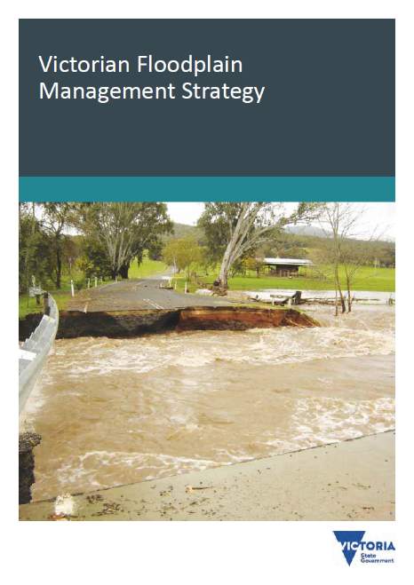

* The VFMS includes 56 actions, all of which are complete and/or embedded as part of agencies’ business as usual practice.
* Major bodies of work include nine Regional Floodplain Management Strategies, flood studies and the planning and construction of mitigation works and early warning systems.
* The strategy makes 57 statements of policy to guide decision making and 47 statements to clarify accountability for leadership and the ongoing maintenance of assets and systems. A facilitated review into agency understanding of these policies and accountabilities found a high level of awareness and understanding.
* An audit of the strategy’s implementation confirms significant progress across the sector.

# Regional Floodplain Management Strategies

The VFMS commits to the development of nine Catchment Management Authority (CMA) led Regional Floodplain Management Strategies (RFMS) in partnership with local government, VICSES and local communities. The intent of each RFMS is to facilitate local implementation of the VFMS including locally prioritised actions.

## RFMS implementation

CMAs lead their region’s strategy development including establishing local implementation committees. Membership of these committees comprised of local government, VICSES and water authorities.

In 2018, implementation committees rolled out the RFMSs in each region.

The role of the implementation committees is now to implement the priority actions for each region.

The strategies are used by state and local government as a guide to ensure available funding is allocated to priority projects. The Risk and Resilience Grants Program (RRGP – formerly the Natural Disaster Resilience Grants Scheme) will continue to be the primary avenue for accessing both state and federal government funding contributions to local priority projects via a single application process.

## RFMS mid-term review

As we approach five years into the regional strategies’ term, CMAs will lead a process with their implementation committees to conduct a mid-term review.

The mid-term review is intended to celebrate achievements and update priority actions for each region for the first five years.

* The regional strategies provide the CMAs and LGAs with the opportunity to involve communities directly in identifying flood mitigation measures they want implemented and can afford to maintain.
* The RFMS process has also enabled local governments to align their priorities with other agencies to allocate local funding to implement those measures and to seek state and federal government contributions.
* Applications for funding for flood mitigation actions identified in RFMSs are prioritised for funding through the Risk and Resilience Grants Program (RRGP). The grants program provides communities the opportunity to triple their local investment.

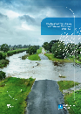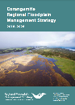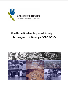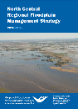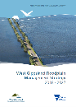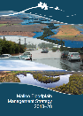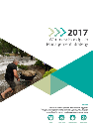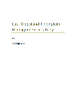

## Risk and Resilience Grants Program

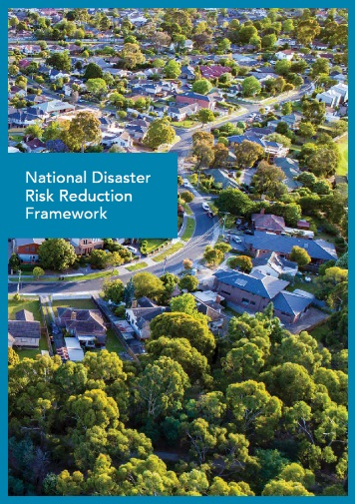

The Risk and Resilience Grants Program (RRGP) is co-funded by the Federal Attorney General’s department through the National Partnership Agreement on Disaster Risk Reduction 2020-2024 (NPA). The Victorian government matches the Commonwealth contribution and typically adds additional funds to increase the value of the program.

The NPA was agreed and endorsed by the Honourable Daniel Andrews MLA on 13 March 2020. The RRGP provides flood mitigation project managers with access to both Federal and State Government funding with a single funding proposal. Grant applicants include a local contribution, which must be equivalent to at least one third of total project costs. The funding model, a third from each tier of government, leverages the maximum value from investment in Victoria’s flood resilience.

Proposals seeking funding through the RRGP are required to align with one or more of four priorities and associated five-year outcomes in the National Disaster Risk Reduction Framework (2018). Due to work already completed to develop RFMSs, including locally agreed priorities, the Victorian floodplain management sector will continue to be well positioned to take advantage of the program.

# Local Flood Studies

The VFMS identifies flood mapping as a key activity to understand and evaluate risk to local communities. When complete, flood study data is loaded into FloodZoom and is available to emergency and incident control staff during a flood event. Local councils adopt flood maps in to their planning schemes to ensure planning decisions are made based on correct flood information.

A key task of a detailed flood study is to examine whether existing planning schemes, flood mitigation infrastructure, municipal flood emergency plans and total flood warning systems match local flood risks. LGAs have accountability for implementation and maintenance of these measures. Many local flood studies have been prioritised for funding through RFMSs.

## The flood study process

The flood study process includes modelling the hydrologic inputs (such as rainfall and runoff) and the calibration of these models against historic floods. The hydraulic behaviour of floods (such as flood heights, extents and velocities) is then also modelled and again calibrated against historic floods. Finally, an assessment is made of the likely consequences of floods of different sizes at particular locations.

## Products

A flood study typically includes the following outputs:

* spatial flood data for import into the emergency management tool FloodZoom, including extent, velocity, depth and hazard data
* mapping to support CMAs’ roles in responding to planning referrals and flood advice requests
* mapping to support draft Planning Scheme Amendments
* relevant components of the Municipal Flood Emergency Plan (MFEP)
* preferred local elements of a Total Flood Warning System
* preferred options for flood mitigation measures.

Since July 2016, the Victorian Government has invested in 59 flood studies and data collection projects across Victoria. The flood studies have produced high quality flood mapping, covering a range of flood magnitudes.

## Future investment

At the local level, flood studies are a key tool for identifying priority areas and the most appropriate and cost-effective form of flood mitigation. Local knowledge and ownership of flood studies is critical to ensure appropriate prioritisation of future actions.

The next tranche of government investment will focus on the delivery of priority flood studies identified in each RFMS and progression of planning scheme amendments in locations where flood studies were completed in the last round of funding.

* DELWP has prepared the Victorian Flood Data and Mapping Guidelines to guide flood mapping, and flood data collection activities and ensure a consistent approach to preparing flood studies that help communities consider their options for flood management.
* From July 2016 to June 2022, 59 local and regional flood studies and data collection projects were funded and are delivered or underway.

## Case Study: Birregurra Flood Study and Planning Scheme Amendment

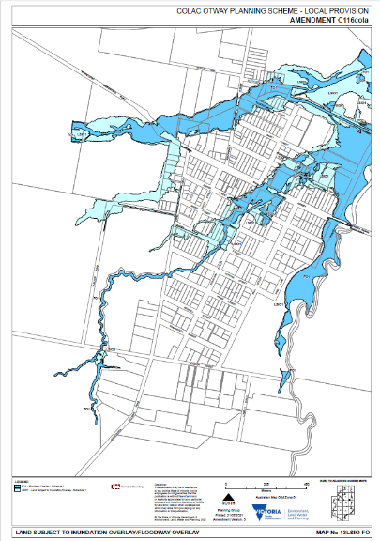

Colac Otway Shire Council has adopted changes to its planning scheme in line with recommendations from the Birregurra Flood and Drainage Strategy completed in 2019.

The amendment changes the mapping of flood-based overlays at Birregurra, so they match with updated mapping of flood-prone land in the Birregurra Flood and Drainage Strategy. The amendment was placed on public exhibition in September 2021, with submissions considered by an independent panel in May 2022.

The Birregurra Flood and Drainage Strategy was co-funded by the Commonwealth and State Governments through the Natural Disaster Resilience Grants Scheme (NDRGS) in 2019.

The State Government then supported Council with additional funding in 2021 to prepare the amendment. Total State Government investment in this body of work has been $124,000.

“Council is pleased to be in the final stage of the process, which commenced in 2019 with the Birregurra Flood and Drainage Study,” the council’s development general manager Ian Seuren said. “The amendment responds to local flood events and ongoing pressure for development in Birregurra.”1

1Colac Otway Shire Council (30 June 2022) Birregurra Flood Study adopted [media release], Colac Otway Shire Council website, accessed 20 July 2022.

# Flood Mitigation Works and Warning Systems

Each RFMS has facilitated the community’s identification of priority mitigation works and warning systems.

Flood mitigation works are structural measures used to mitigate the effects of flooding such as levees, floodways and retention basins.

Flood warning systems provide communities and emergency management agencies with information about when flooding may occur, its likely severity and what to do to minimise consequences.

Sound flood mitigation works and well-designed warning systems empower communities to manage their risk and to be prepared.

Co-funding local councils to deliver flood mitigation measures on behalf of their communities ensures local ownership in decision making and is the most effective way of achieving Government’s commitment to better prepare Victorians for future floods.

## Impacts of the 2019-20 summer East Gippsland and North East Fires

The East Gippsland and North East Victoria regions are serviced by a network of approximately 130 automated river and rain monitoring gauges. Around 70 of these are relied on to support flood warning and forecasting services across the regions. A significant percentage of flood warning gauges access a single form of telemetry or communication stream, for example the Next G cellular data network.

Assessment of performance of the network during the 2020 fires has shown that where dual telemetry is installed at a gauge, that gauge is more likely to continue to deliver real time river or rain data, even if suspected of being impacted by fire.

With technical support and recommendations from the Bureau of Meteorology DELWP will work with local councils to identify flood warning gauges with limited or no telemetry service and add either radio or satellite-based telemetry. This will build redundancy into the network, ensuring real time river level and rainfall data continues to be available to BoM and residents even when the network is being impacted by fire or flood.

* 74 Flood Mitigation Works and Warning System projects have commenced or been completed across the state since July 2016.
* Construction is complete or underway on levee banks in Boort, Carisbrook, Castlemaine, Donald, Euroa, Numurkah, Pyramid Hill, Quambatook, Robinvale, Seaspray, Warracknabeal and Wodonga.
* Significant investment in design and engagement with local communities has meant key projects were shovel ready when Commonwealth funding became available. Victoria has recently been successful in securing the following:
  + $1.2M Carisbrook levee 20/21
  + $2.2M Castlemaine levee 20/21
  + $3.5M Wangaratta levee 20/21
  + $2.38M Numurkah levee 21/22
  + $1.06M Seaspray levee 21/22

## Case Study: Robinvale Levee

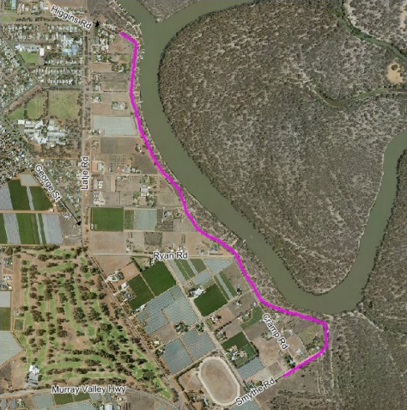

Reconstruction of the Robinvale township levee to upgrade its flood protection to the one percent Annual Exceedance Probability flood level was completed in November 2021.

Construction of the levee has resulted in an increased resilience to the impacts of floods for the Robinvale community and a reduced risk of financial losses due to property damage from floods.

The upgraded levee has opened opportunities for further development of the township by enabling future subdivisions and new developments (including construction of new tourism orientated facilities).

Newly constructed road crossings across the levee have significantly improved the ability to safely access the riverbank area, including for emergency purposes.

Further development of the clay material borrow pit into a constructed wetland will have significant environmental benefits including provision of new habitat for the local wildlife species and reduction of pollutants in the drainage water prior to it entering the Murray River.

The project began in 2017 and has cost a total of $1.78M including a $980,000 contribution from the State Government.

# Flood Intelligence Platform (FloodZoom)

A key element of the VFMS is to build, maintain and support a flood intelligence platform (FloodZoom) that is capable of providing a central source of all Victorian flood behaviour data and intelligence for agencies to access when preparing for and responding to flood events.

## Emergency Response

FloodZoom is the authoritative source of flood behaviour data and intelligence for emergency agencies when responding to and monitoring flood events. The platform greatly improves responder agencies’ capacity to predict the potential consequence of a flood at particular locations.

FloodZoom is a web-based application for collating data and sharing flood intelligence products between agencies during an incident. FloodZoom brings together:

* flood related behaviour information, such as recent and historic modelled flood extents, depths, flood levels, study reports and observed flood impacts;
* real time and historical rain and streamflow records; and
* flood forecasts, flood mapping and property data such as floor heights.

## FloodZoom as a Planning tool

The Flood Intelligence Platform is also a dedicated business as usual tool used by CMAs to assess and streamline land use planning proposals for locations subject to flood inundation.

This Planning System module, used daily by CMAs, ensures for emergency purposes that FloodZoom maintains current and accurate data and confidence in modelling products for planning, preparing and responding to flood events. The transition from the previous desktop capabilities to the web-based application has realised significant benefits for organisation business continuity during the COVID restrictions in 2020. The wide range of users from the VICSES, CMAs and water corporations have been able to continue to undertake their necessary activities seamlessly and without interruption from remote locations.

* FloodZoom facilitates more accurate and timely advice and warnings specific to local communities, enabling improved preparedness and response together with informed planning decisions.
* FloodZoom contains detailed information from the flood studies which can be used to inform emergency management and the community in the event of a flood.
* The incorporation of these elements into the platform enables it to be the single source of truth for flood-related emergencies.
* The planning module is being continually improved in areas including reporting and auditing using feedback from users to facilitate well-informed decision making by CMAs and local government.

## Case Study: FloodZoom Dashboard

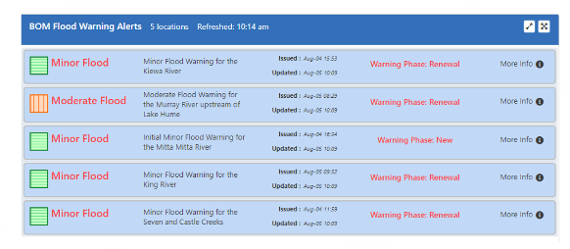

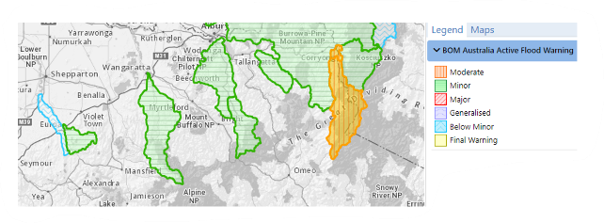

FloodZoom users logging into the platform in March 2022 saw an important new dashboard feature for the first time, with flood warnings added to the Current Situation list.

The ‘current activity’ panel of the dashboard had previously displayed a summary of river gauges where flood class levels have been triggered. The addition of current warnings to the dashboard means that with a single click, flood analysts can now quickly assess the status of any current flood warning. While these warnings can also be accessed from Vic Emergency and the Bureau’s own web pages, placing all current river height and warning status data on one page at the analysts’ fingertips is efficient and a timesaver.

DELWP and industry flood analysts raised the idea with the FloodZoom Emergency Management Focus Group as a potentially valuable tool for flood analysts in supporting VICSES to prepare for and respond to a developing flood.

The focus group which includes representation from CMAs, VICSES and DELWP agreed. With assistance from Bureau and VICSES our developers worked through how to receive the warnings live into FloodZoom, and how the information is presented in the platform map.

# Summary of Action by Chapter

## Chapter 4: The strategic approach

|  |  |  |
| --- | --- | --- |
| **Action** | **Status** | **Highlight** |
| Action 4a: DELWP will refine a rapid and robust methodology for establishing regional floodplain management priorities in ways that allow statewide floodplain management priorities to be established. | Complete | A statewide methodology was consistently applied to assess flood risks across all regions in the development of Regional Floodplain Management Strategies (RFMSs). |

## Chapter 12: Sharing flood risk information

|  |  |  |
| --- | --- | --- |
| **Action** | **Status** | **Highlight** |
| Action 12a(1): DELWP will develop guidelines to encourage consistent standards and planning arrangements for post-flood data collection. | Complete | The Victorian Flood Data and Mapping Guidelines were published in 2016 and are available to stakeholders and the public on the DELWP website. |
| Action 12a(2): CMAs and Melbourne Water will use these guidelines to update their protocols and standards for data collection. | Complete and now business as usual | The Guidelines were used to maintain best practice during the 2016 floods. |
| Action 12b: DELWP and Melbourne Water will integrate the two existing databases to provide Victorians with a single point of entry to readily accessible and authoritative records of flood data in Victoria. | Complete | DELWP Flood Intelligence Platform (FloodZoom) is fully operational and maintained with most current Melbourne Water data. |
| Action 12c: DELWP, in consultation with Melbourne Water, CMAs, LGAs and the VICSES, will ensure the information in Victoria’s flood intelligence platform remains current. | Complete and now business as usual | DELWP employs tools to ensure uploaded data from new flood studies is accessible in FloodZoom as soon as available. |

## Chapter 13: Avoiding or minimising flood risks through the planning and building systems

|  |  |  |
| --- | --- | --- |
| **Action** | **Status** | **Highlight** |
| Action 13a: DELWP, in consultation with LGAs, CMAs and Melbourne Water, will update the State Planning Policy Framework’s floodplain management policy to use the 1% Annual Exceedance Probability flood as the terminology for the design flood event to replace the current reference to the 1-in-100-year design flood event. | Complete and now business as usual | Changes in the flood controls through the gazettal of planning scheme amendment VC171 occurred on 6 September 2021:   * 13.03-1S (Floodplain Management). There is now reference to both 1 in 100 and 1% AEP. Coastal inundation, riverine, overland flows and wetlands are recognised. |
| Action 13b: The CMAs and Melbourne Water will work with LGAs to ensure that Planning Schemes use the planning controls that align with their flood risks. | Complete and now business as usual | Regional Floodplain Management Strategies (RFMSs) include a prioritised rolling program of flood studies and planning scheme amendments (PSAs). |
| Action 13c: DELWP will periodically review the treatment of flood-related referral advice from CMAs to LGAs. This review will examine the trends and the particular circumstances where the CMAs’ advice is not being followed by LGAs. | Complete and now business as usual | FloodZoom includes capability to track and report land use planning matters, including conflicting decisions between councils and CMAs. CMAs capture incidents of Council rejection of CMA planning advice in the Planning System module and flag those incidents in their bi-annual Outcomes Reporting to DELWP. |
| Action 13d(1): DELWP will work with key stakeholders to understand significant constraints to implementing appropriate Municipal Planning Scheme amendments. | Complete and now business as usual | The RFMSs have each identified local/regional constraints to implementing Planning Scheme amendments. |
| Action 13d (2): DELWP will work with LGAs to streamline the process of converting flood study outputs into Planning Scheme amendments, e.g. by exploring opportunities to use the processes prescribed for amendments to consult with local communities during the flood study. | Complete and now business as usual | Grants of (typically) $30,000 have been made available to Local Government to progress flood study outputs into Planning Scheme Amendments. Funding will continue to be available through competitive applications to the Risk and Resilience Grants Program. |
| Action 13d (3): The CMAs and Melbourne Water will develop implementation plans for their regional floodplain management strategies that will seek to either:   * help convert existing flood study data into Planning Scheme amendments; or * conduct new flood studies to provide draft Planning Scheme amendments. | Complete | All RFMSs are completed and contain prioritised actions for implementing these measures. |
| Action 13e: DELWP in consultation with LGAs, CMAs and Melbourne Water will prepare state-wide Floodplain Development Guidelines. | Complete | The guidelines were developed in close collaboration with LGAs, CMAs and Melbourne Water. They are published on DELWP’s website. |
| Action 13f: DELWP in consultation with LGAs, CMAs and Melbourne Water will regularly review and, if necessary, revise the Victorian Planning Provisions to ensure they support this strategy’s objectives and policies. | Complete and now business as usual | Planning Scheme amendments VC142 and VC148 introduced significant changes to the Victoria Planning Provisions, including flood related provisions. |
| Action 13g: DELWP and the Victorian Building Authority will work together to improve the effectiveness of the flooding provisions of the Building Code of Australia. | Complete and now business as usual | DELWP, VicSES and the Victorian Building Authority are represented on the National Flood Risk Advisory Group, which is used to raise and resolve these issues. |

## Chapter 14: Managing stormwater and urban flooding

|  |  |  |
| --- | --- | --- |
| **Action** | **Status** | **Highlight** |
| Action 14a: DELWP, in consultation with Melbourne Water and metropolitan LGAs, will review the institutional arrangements governing the accountabilities for urban stormwater flood risk management for the Port Phillip and Westernport region. | Complete | A review has been completed. Follow up work is foreshadowed in Melbourne Water’s Flood Management Strategy currently being refreshed. |
| Action 14b(1): Melbourne Water will work with LGAs to:   * identify areas of stormwater and urban flooding in Melbourne in the implementation of its Regional Floodplain Management Strategy. * assess and quantify different types (scales and frequencies) of stormwater flooding across Melbourne and refine the process for identifying and prioritising areas subject to stormwater and urban flooding. * evaluate the treatment options. * discuss and seek agreement from beneficiaries for the treatment option that best manages the flood risk and provides other benefits. | Complete and now business as usual | Melbourne Water, together with councils, VICSES and DELWP, has developed a prioritisation method and tool which is now available for use across Metropolitan Melbourne. |
| Action 14b(2): CMAs, in developing their regional floodplain management strategies, will work with LGAs to identify areas with a history of stormwater and urban flooding in regional centres. | Complete | These areas have been identified and documented during the development of the RFMSs. |
| Action 14c: DELWP will lead a review of how the Victorian Planning Provisions, and in particular clause 56, could better manage the potential urban stormwater flood impacts from infill development, urban renewal and non-residential development within established areas. | Complete | The final report of the Improving Stormwater Management Advisory Committee (Sept 2018) recommended substantial changes to the Victorian Planning Provisions, which were implemented through Planning Scheme amendment VC154. |

## Chapter 15: Managing coastal flooding

|  |  |  |
| --- | --- | --- |
| **Action** | **Status** | **Highlight** |
| Action 15a(1): DELWP will expand the standards for flood mapping to include coastal flooding. | Complete | The Victorian Flood Data and Mapping Guidelines include coastal flooding considerations and are available to stakeholders and public on the DELWP webpage. |
| Action 15a(2): DELWP will support LGAs in preparing coastal flood studies for the priority areas identified through coastal hazard assessments and regional floodplain management strategies. | Complete and now business as usual | RFMSs for coastal regions have been completed including identifying priorities for further flood studies. |
| Action 15b: DELWP will review the flood-related overlays to determine the most appropriate planning tools in relation to coastal flooding. | Complete | The Marine and Coastal Act (MACA) Transition Plan was released and includes a goal to deliver clear planning and controls about access, use and development in the marine and coastal environment. The Marine and Coastal Strategy 2022 foreshadows actions for implementation. |
| Action 15c(1): The CMAs and Melbourne Water will document, in regional floodplain management strategies or implementation plans, areas with identified coastal flood risks. This will inform priorities for future coastal hazard assessments and provide an input into flood risk assessments along the coast. | Complete | RFMSs for coastal regions have been completed including identifying coastal flood risks. |
| Action 15c(2): DELWP will work with the CMAs, Melbourne Water and LGAs to:   * support the implementation of Regional Coastal Plans by developing a systematic approach to prioritising areas for detailed coastal hazard assessments including flooding. * develop a strategic and consistent approach to assessing risks to regionally significant coastal public assets from coastal hazards, including flooding. | Complete | The *DELWP Coastal Climate Change Risk Assessments* (2015) has been developed to enable decision makers to strategically identify and manage current and future risks on the coast and implement a method to prepare Coastal Climate Change Risk Assessments for each coastal region. |
| Action 15d: DELWP will support local government responses by:   * working with LGAs to develop adaptation responses from the hazard assessment pilot projects. * identifying other areas where this process can be used through the implementation of Regional Coastal Plans. * undertaking coastal hazard assessment to the standard of the pilot projects for new priority locations identified through the Regional Coastal plans. * continuing to work in partnership with LGAs, CMAs land managers and communities to support adaptation planning. | Complete and now business as usual | DELWP has contributed funds to support LGAs on the following projects:   * Port Phillip Bay coastal planning: land use adaptation project. * Bellarine Peninsula-Corio Bay CHA: Greater Geelong and Queenscliffe Planning Schemes Implementation. * Lakes Entrance Growth and Adaptation Strategy. * Port Fairy Coastal and Structure Plan. * Port Phillip Bay CHA and Barwon South West CHA. * Climate change and land-use planning review consultation plan. |

## Chapter 16: Flood warnings

|  |  |  |
| --- | --- | --- |
| **Action** | **Status** | **Highlight** |
| Action 16a: DELWP will:   * establish a framework to assess Total Flood Warning System (TFWS) services in the context of the relevant community’s identified flood risks. * prepare a rolling three-year State TFWS services development plan informed by the implementation plans coming out of regional floodplain management strategies and the outputs of local flood studies. | Complete | The TFWS assessment framework is in place and rolling out across each RFMS region. |
| Action 16b(1): DELWP will work with the Emergency Management Commissioner to evaluate the potential to disseminate generalised district-scale flash flood warning services based around BoM’s existing severe weather warning services, using similar dissemination approaches employed for bushfires. | Complete and now business as usual | District scale flash-flood warning services can now be disseminated through the Emergency Vic App and website. DELWP is working with BoM and EMV to put this into practice for local communities. |
| Action 16b(2): DELWP will work with BoM, the Emergency Management Commissioner and VICSES to evaluate the potential to provide localised neighbourhood-scale flash flood warning services where there is a history of flash flooding. | Complete and now business as usual | DELWP is working with BoM, EMV and Melbourne Water to build on an existing trial within the metropolitan area and extend based on technological opportunities and prioritised communities. |

## Chapter 17: Flood mitigation infrastructure

|  |  |  |
| --- | --- | --- |
| **Action** | **Status** | **Highlight** |
| Action 17a(1): DELWP will provide guidelines and assistance to LGAs and other authorities to help them develop and implement Water Management Schemes. | Complete | The framework and guidance notes have been finalised in consultation with the CMAs and are available on the DELWP website. |
| Action 17a(2): DELWP will provide guidance for LGAs on seeking the relevant skills and expertise for the design, construction and management of any infrastructure implemented under a Water Management Scheme. | Complete and now business as usual | The framework and guidance notes have been finalised in consultation with the CMAs and are available on the DELWP website. |
| Action 17a(3): DELWP will maintain a management framework for flood mitigation infrastructure. | Complete and now business as usual | The framework and guidance notes have been finalised in consultation with the CMAs and are available on the DELWP website. |
| Action 17b: DELWP will prepare, for government consideration, a proposal to amend the Water Act 1989, to clarify and simplify the liability and assurance arrangements for LGAs when they construct or maintain flood mitigation infrastructure through the implementation of Water Management Schemes. | Complete | A case for a legislative amendment has been prepared for consideration and has been prioritised for inclusion with the next suite of changes to the Water Act. |
| Action 17c: DEWLP will provide:   * guidance on the positioning of new flood mitigation infrastructure in accordance with the Victorian Waterway Management Strategy 2013, which is to avoid high-energy flows. * guidance on developing levee management and maintenance arrangements. * guidance on inspection and auditing requirements and provision for third party inspections. | Complete and now business as usual | The framework and guidance notes have been finalised in consultation with the CMAs and is available on the DELWP website. |
| Action 17d(1): DELWP will consult and collaborate with relevant LGAs to develop a process to convert existing flood mitigation infrastructure to Water Management Schemes. That process will:   * begin with an assessment of the condition of the infrastructure and its standard of protection, based on the best available information derived from flood studies. * consider options to upgrade the infrastructure to contemporary design standards. * identify, in consultation with the benefitting community, the most cost-effective option in keeping with community's willingness and ability to pay for ongoing management and maintenance. * establish ongoing management arrangements. | Complete and now business as usual | The framework and guidance notes have been finalised in consultation with the CMAs and are available on the DELWP website. |
| Action 17d(2): DELWP will develop principles to guide LGAs on the option to leave existing infrastructure unmanaged and unmaintained or only maintained to a low standard. | Complete | The framework and guidance notes have been finalised in consultation with the CMAs and are available on the DELWP website. |
| Action 17e: DELWP will prepare guidance material, including an Application Kit, on how to apply for a permit to maintain levees on Crown land. This will include practical advice on how to meet their obligations to protect environmental values. CMAs will make these guidelines available at their offices and on their websites. | Complete | An Application Kit has been prepared and is available on the DELWP website.  CMAs are required to make the Application Kit available on their websites. |
| Action 17f(1): DELWP will approach the NSW Government with a view to establishing formal arrangements for:   * constructing and managing new flood mitigation infrastructure. * sharing information. * improving floodplain management planning processes. * considering joint studies and strategies. * considering whether the MDBA or some other group could act as a sounding board for major initiatives or issues. * coordinating floodplain management. | Complete and now business as usual | Current project management and associated processes ensure Victorian floodplain managers actively engage with cross border partners. Three flood studies on the Murray River - Swan Hill and District, Echuca and District and Murray River Downstream of Nyah are being delivered by multi agency steering committees with representation from both Victorian and NSW Government. All future projects will follow this model. |
| Action 17f(2): DELWP’s guidelines will require regional floodplain management strategies to take account of cross-border issues and actively seek participation from NSW counterparts. | Complete | RFMSs acknowledge cross border issues and include participation with NSW counterparts in future actions. |
| Action 17f(3): DELWP will work with NSW agencies to review the need for flood warning upgrades along the River Murray. | Complete | DELWP is actively engaged with BoM and NSW counterparts on flood warning upgrades to the Murray River system. |
| Action 17f(4): Municipal Flood Emergency Plans will include cross-border issues. | Complete and now business as usual | VICSES has revised Municipal Flood Emergency Plan (MFEP) template to ensure consideration of cross-border issues (updated every 3 years). |

## Chapter 18: Flood mitigation activities on waterways

|  |  |  |
| --- | --- | --- |
| **Action** | **Status** | **Highlight** |
| Action 18a(1): DELWP will prepare guidelines on how to apply to a CMA or Melbourne Water for authorisation to carry out works on waterways. These guidelines will include practical advice on how to meet Aboriginal and cultural heritage protection requirements. They will also include practical advice on how to meet environmental protection requirements. | Complete | DELWP has prepared, in consultation with CMAs, four fact sheets and the ‘Assessment of flood risk posed by vegetation and large wood in and around waterways: Guidelines for Waterway Managers’. |
| Action 18a(2): CMAs and Melbourne Water will make these guidelines are available at their offices and on their websites. | Complete | All CMAs and Melbourne Water make their guidelines available at their offices and on their websites. |

## Chapter 19: Risk management planning for critical infrastructure

|  |  |  |
| --- | --- | --- |
| **Action** | **Status** | **Highlight** |
| Action 19a: DELWP in consultation with the CMAs and Melbourne Water and representative asset owners will develop principles for managing serious risks to critical infrastructure from waterway processes (see Victorian Waterway Management Strategy [2013] Action 4.2), in accordance with the principles and obligations outlined in the Victorian Critical Infrastructure Resilience Strategy and any relevant legislation. | Complete and now business as usual | DELWP worked with EMV to implement the Emergency Management Amendment (Critical Infrastructure Resilience) Act 2014 including obligations on infrastructure operators and departments to annually attest, prioritise and undertake mitigation planning. |

## Chapter 20: Flood insurance

|  |  |  |
| --- | --- | --- |
| **Action** | **Status** | **Highlight** |
| Action 20a(1): DELWP will seek ongoing access to the National Flood Information Database, used by most insurers as a core input when assessing flood risk at the address level across Victoria. | Complete and now business as usual | Insurance Council of Australia has provided DELWP, CMAs and Melbourne Water with access to the National Flood Information Database. |
| Action 20a(2): DELWP will work with the insurance industry to ensure that insurance premiums take into account the benefits of formally managed flood mitigation infrastructure as well as the mapped flood risk profiles for individual properties. | Complete and now business as usual | DELWP and Melbourne Water have provided flood study data to the Insurance Council of Australia (ICA) with ongoing updates provided as required. |
| Action 20a(3): DELWP will approach the Insurance Council of Australia with a view to developing a code-of-practice that recognises the benefits of flood mitigation infrastructure when determining premiums. | Complete and now business as usual | Based on consultation with Insurance Council of Australia, current arrangements (sharing of up-to-date data) are considered adequate. |

## Chapter 21: Disclosing flood risk information

|  |  |  |
| --- | --- | --- |
| **Action** | **Status** | **Highlight** |
| Action 21a: DELWP will consult with Consumer Affairs Victoria to review the application of the Due Diligence Checklist. The aim will be to determine the administrative and legislative issues involved in including flood risk information on vendor disclosure statements. | Complete | Based on consultation with Consumer Affairs, current arrangements are considered adequate to address flood risk. |

## Chapter 22: Integrated flood emergency management

|  |  |  |
| --- | --- | --- |
| **Action** | **Status** | **Highlight** |
| Action 22a(1): LGAs will work with VICSES to ensure that Municipal Flood Emergency Plans include the best available information about the condition of flood mitigation infrastructure, including levees. | Complete and now business as usual | VICSES has revised the MFEP template to include additional information on flood mitigation infrastructure (updated every 3 years). |
| Action 22a(2): LGAs will provide VICSES with the outputs of flood studies, the management arrangements for Water Management Schemes and the condition assessments for flood mitigation infrastructure. | Complete and now business as usual | All flood studies are available on FloodZoom for all users including VICSES. Increasingly FloodZoom will hold or provide links to all relevant data including the condition of flood mitigation infrastructure and arrangements for Water Management Schemes. |
| Action 22a(3): Flood emergency plans will make reference to the overtopping or failure of flood levees and their possible consequences. | Complete and now business as usual | VICSES has revised the MFEP template to include more information on flood mitigation infrastructure (updated every 3 years). |
| Action 22a(4): Incident Controllers will determine how best to deal with the issue of a levee overtopping or failing. | Complete | VICSES Standard Operating Procedure (SOP) 036 details the process for Incident Controllers with additional guidance materials being developed. |
| Action 22a(5): DELWP, CMAs and Melbourne Water will provide technical advice to assist Incident Controllers in planning around levee failure, including overtopping. | Complete and now business as usual | VICSES maintains a technical specialist panel to source this expertise detailed in SOP061. |

## Chapter 23: Incident control

|  |  |  |
| --- | --- | --- |
| **Action** | **Status** | **Highlight** |
| Action 23a: DELWP will work with the Emergency Management Commissioner and the Office of Aboriginal Affairs Victoria to develop a process for the involvement of Traditional Owner representatives during the management of flood emergencies to consider risks to Aboriginal cultural heritage. | Complete | The Emergency Management Cultural Heritage Working Group was established by Emergency Management Victoria (EMV) in 2016 and has established the role of Aboriginal Cultural Heritage Advisor during emergencies. |
| Action 23b: VICSES will develop a process to enable the evaluation and authorisation of emergency works for flood response. | Complete | The Victorian State Emergency Service Act 2005 has been amended to include the right to enter land without landowner’s consent. SOPs have been updated accordingly. |

## Chapter 25: Delivering the strategy

|  |  |  |
| --- | --- | --- |
| **Action** | **Status** | **Highlight** |
| Action 25a: DELWP will establish a committee to prepare an implementation plan and support implementation of the VFMS. | Complete and now business as usual | The VFMS Implementation Reference Committee met periodically to initiate the implementation of the VFMS. RFMS committees are now driving local implementation. |

## Chapter 26: Regional floodplain management strategies

|  |  |  |
| --- | --- | --- |
| **Action** | **Status** | **Highlight** |
| Action 26a(1): DELWP will develop guidelines to enable the preparation and review of regional floodplain management strategies. | Complete | Guidelines and associated guidance notes were developed for use by CMAs in the development of their region's RFMS. |
| Action 26a(2): The CMAs and Melbourne Water will each prepare regional floodplain management strategies for their regions. | Complete | All 9 RFMSs have been completed. Melbourne Water is currently refreshing their strategy. |