Guidance Note: Flood risk ratings

(October 2026)









deeca.vic.gov.au

This guidance note explains flood risk ratings, why flood maps are updated, and how flood risk information may inform planning and building decisions in Victoria.
It is intended to help communities, landowners, developers and industry understand flood risk management in Victoria.

Key messages
- Flood maps show where flooding may occur
- Maps are updated as information becomes available
- Flood risk may change over time
- Planning responses reflect the assessed risk
- Mitigation may reduce but not remove risk

What are flood maps

Flood maps show where flooding may occur and help communities understand flood risk. They support emergency planning and response, consideration of mitigation measures, and planning and building assessments. They are based on available flood studies, modelling and other relevant information.

Why do flood maps change?
Flood maps are regularly reviewed and updated to reflect new information and changing conditions.
Flood behaviour and risk may change because:
- new flood studies are completed
- significant flood events provide new information
- improved flood modelling methods become available
- changes in land use and development alter runoff
- projected changes in rainfall intensity and weather patterns are identified
- updated sea level projections become available
As flood mapping is reviewed and updated, future-condition mapping may indicate a different level of risk under specified scenarios.
Flood maps do not create flood risk. They help communities, government and industry better understand, communicate and manage flood risk.
Understanding flood risk
Updated flood mapping may identify a higher or lower level of flood risk than previously mapped.
Future-condition mapping may also indicate how risk could change under specified rainfall, sea level and weather scenarios.
Figure 1: Flood risk
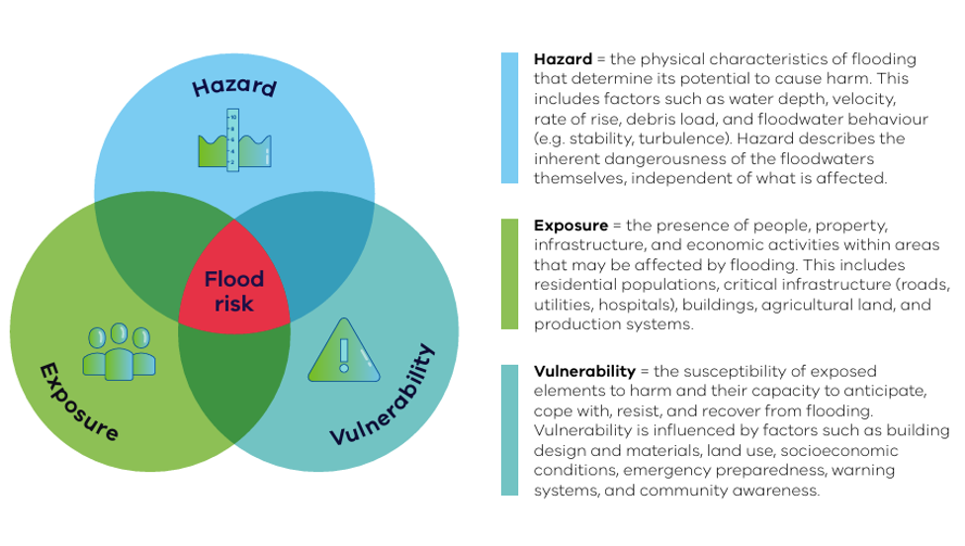

Figure 2: Flood risk ratings
Risk management responses
Some locations simply aren’t suitable for more homes.
Active consideration of risk responses is essential to reduce flood risk to an acceptable level including managing residual risk in existing communities.
Flood risk responses may include:
- emergency management arrangements
- land use and development controls
- community education and preparedness
- flood mitigation infrastructure (e.g. levees)
The most effective approach often involves a combination of responses. This can help reduce flood risks, improve community safety and resilience, and support appropriate development.

Flood risk ratings
Floodplain management authorities (including regional Catchment Management Authorities and Melbourne Water) prepare flood risk ratings as part of new flood mapping.
Flood ratings categorise risk from low to extreme based on the potential consequences of an event on people, property and infrastructure.
Each rating considers flood hazard, exposure of people and assets, vulnerability to flooding and potential consequences of flooding.
Clear and consistent flood information helps support safer planning outcomes and improves community understanding of potential impacts.

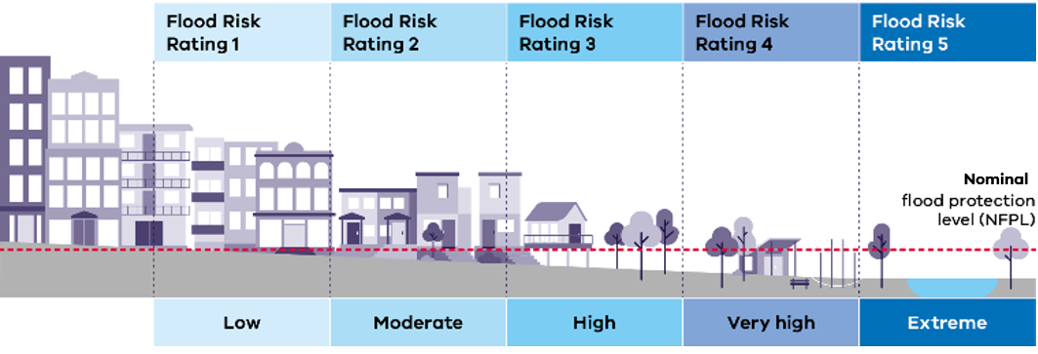
Typical flood depth (metres) | 0 - 0.15 | 0.15 - 0.5 | 0.5 - 1.2 | 1.2 - 2.0 | 2.0 +
Typical hazard description | Shallow and slow-moving | Unsafe for small vehicles | Unsafe for children and the elderly, and all vehicles | Unsafe for all people and all vehicles | All buildings vulnerable to damage or failure
Development response | Manage through minimum construction standards | Protect through design and safety measures | Assess development carefully with additional safety measures | Avoid use and development | Prohibit use and development
Accessible description: A figure and table showing five flood risk levels from low to extreme. The figure uses a streetscape illustration to show increasing flood severity, with water depth rising from right to left. The table below outlines each risk level, including typical flood depths, descriptions, and development responses.

Land use and development controls
Flood information helps inform strategic planning and the assessment of proposed land use and development. The applicable response will depend on the assessed risk, site-specific information and relevant planning provisions.
Planning and building decisions must consider the applicable flood standard and relevant future conditions in accordance with Victorian planning and building requirements. A one per cent annual exceedance probability flood has a one per cent chance of occurring in any given year.

Building system
Land affected by the one per cent (1%) AEP flood may be designated as flood-prone land under the building system. Where the designation applies, building requirements may include minimum floor levels and other construction standards intended to reduce flood impacts.

Planning system
The planning control applying to land will depend on its assessed flood risk and the relevant provisions of the planning scheme. The planning outcome for a particular proposal will depend on the applicable planning scheme provisions, site-specific information and assessment by the responsible authority.
Table 1: Planning controls
Flood risk rating | Planning control | Purpose of the control | Key requirements and protection measures
Low | No planning control |  | No flood-specific planning requirements. Standard building regulations apply.
Moderate | Clause 44.09 Flood Management Overlay  Schedule 1 | Support development while ensuring moderate flood risks are appropriately managed. | Development generally supported. Buildings and works must incorporate basic flood protection measures including flood-resilient design and construction.
High | Clause 44.09  Flood Management Overlay  Schedule 2 | Ensure development only occurs where high flood risks can be demonstrated to be safely managed. | Detailed flood assessment required. Development must demonstrate risks to occupants can be managed through siting, design, access, evacuation arrangements and flood-resilient construction. Additional permit requirements and restrictions apply.
Very High | Clause 44.09  Flood Management Overlay  Schedule 3 | Discourage development in areas where flood risks to life, access or emergency response are significant. | Development is generally discouraged. Any permitted development must satisfy stringent local controls, including higher flood protection standards, safe access and evacuation requirements, and limitations on vulnerable land uses.
Extreme | Clause 37.11  Flood Management Zone | Protect floodways and areas critical to floodplain function while avoiding unacceptable risk to human life. | Development is limited to compatible uses such as agriculture, open space and recreation. Buildings and works must not obstruct flood flows or reduce flood storage.

Further guidance
This guidance does not provide property-specific planning or building advice. Current planning scheme provisions and advice from the relevant responsible authority should be considered before making land use, development or building decisions. Other related guidance on the changes including guidelines for development and flood mapping are currently being prepared to support implementation of the flood risk ratings and new planning controls.

Figure 3: Flood risk map
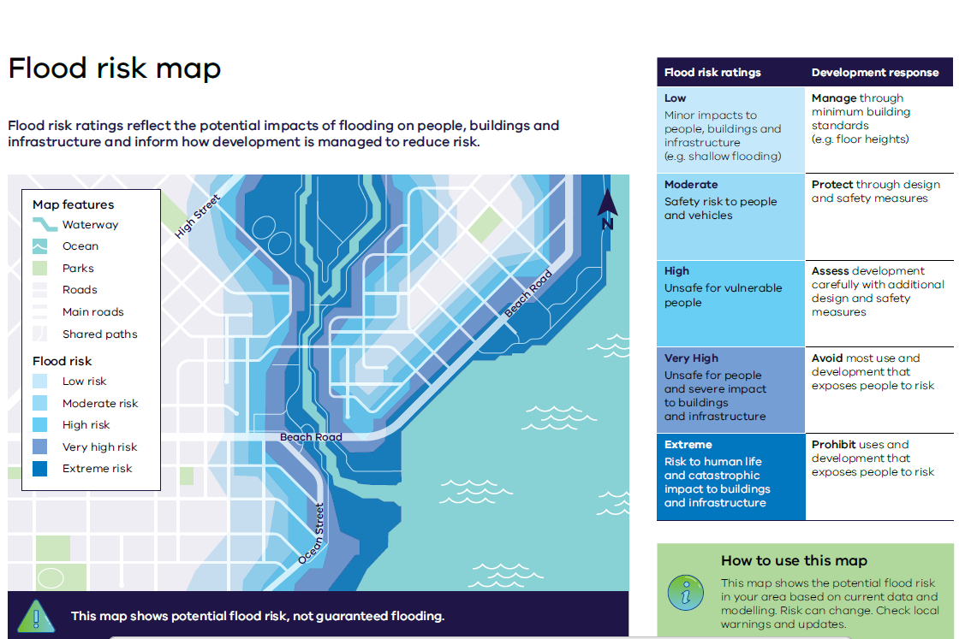
Accessible description: Map of an urban area with a river running through the centre and a coastline on the right. Flood risk is shown using shades of blue, with darker colours indicating higher risk. The highest risk areas are concentrated along the river and near the coast, with risk decreasing further away. A legend shows risk ratings, from low to extreme risk.

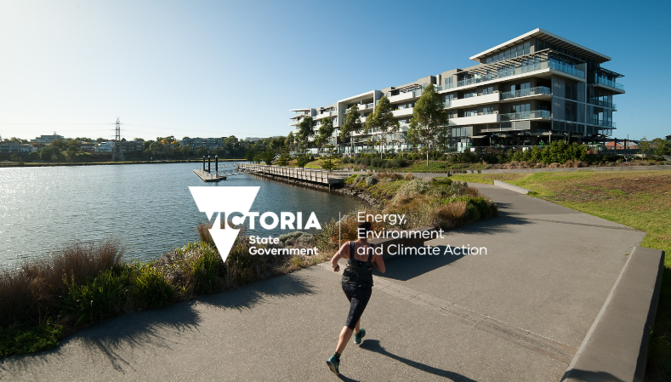
Image: Maribyrnong River Bike path

© The State of Victoria Department of Energy, Environment and Climate Action October 2026 Creative Commons This work is licensed under a Creative Commons Attribution 4.0 International licence, visit the Creative Commons website (http://creativecommons.org/ licenses/by/4.0/). You are free to re-use the work under that licence, on the condition that you credit the State of Victoria as author. The licence does not apply to any images, photographs or branding, including the Victorian Coat of Arms, and the Victorian Government and Department logos.
ISBN 978-1-86520-052-1 (pdf/online/MS word)
Disclaimer ISBN to be provided This publication may be of assistance to you but the State of Victoria and its employees do not guarantee that the publication is without flaw of any kind or is wholly appropriate for your particular purposes and therefore disclaims all liability for any error, loss or other consequence which may arise from you relying on any information in this publication.
Accessibility To receive this document in an alternative format, phone the Customer Contact Centre on 136 186, email customer.service@deeca.vic.gov.au, or contact National Relay Service (www.accesshub.gov.au/) on 133 677. Available at DEECA website (www.deeca.vic.gov.au)

