
Rivers of the Barwon (Barre Warre Yuluk) Action Plan
  - Annual Report 2025






deeca.vic.gov.au


We acknowledge and respect Victorian Traditional Owners as the original custodians of Victoria’s land and waters, their unique ability to care for Country and deep spiritual connection to it.
We honour Elders past and present whose knowledge and wisdom
has ensured the continuation of culture and traditional practices.
DEECA is committed to genuinely partnering with Victorian Traditional Owners and Victoria’s Aboriginal community to progress their aspirations.
© The State of Victoria Department of Energy, Environment and Climate Action September 2026
Creative Commons
This work is licensed under a Creative Commons Attribution 4.0 International licence, visit the Creative Commons website (http://creativecommons.org/licenses/by/4.0/).
You are free to re-use the work under that licence, on the condition that you credit the State of Victoria as author. The licence does not apply to any images, photographs or branding, including the Victorian Coat of Arms, and the Victorian Government and Department logos.
ISSN 2653-7478 - Online (pdf/word)
Disclaimer
This publication may be of assistance to you but the State of Victoria and its employees do not guarantee that the publication is without flaw of any kind or is wholly appropriate for your particular purposes and therefore disclaims all liability for any error, loss or other consequence which may arise from you relying on any information in this publication.
Accessibility
To receive this document in an alternative format, phone the Customer Service Centre on 136 186, email customer.service@delwp.vic.gov.au, or contact National Relay Service on 133 677. Available at Water website (www.water.vic.gov.au).

Contents
Context 2
Overview of progress in 2025 3
Looking ahead 4
Action plan implementation case studies 5
Reviewing stormwater management in the Lower Barwon 5
Barwon River and Moorabool River fishways 5
Action tracker 7

Context
The Victorian Government released the Rivers of the Barwon (Barre Warre Yulluk) Action Plan in late 2021, setting out a plan for this iconic catchment to remain healthy, resilient and valued by the community into the future.
The Rivers of the Barwon (Barre Warre Yulluk) annual reports provide updates on progress towards delivering the Action Plan’s 7 directions and 30 actions. This report highlights key progress in 2025, outlines the status of actions, and supports the Victorian Government’s commitment to update the community annually on implementation of the 5-year Action Plan.
The Eastern Maar and Wadawurrung peoples have cared for this Country and its waterways for millennia. The Action Plan recognises the waterways as living and integrated natural entities, and acknowledges the unique role of Traditional Owners as knowledge holders, custodians and voices of these living entities.
The Action Plan is informed by a 50-year Community Vision. The vision encourages agencies and communities to work in partnership with the Traditional Owners of Barre Warre Yulluk.
Through collaboration across the region, partners are progressing the community vision and delivering improved outcomes for waterway health, culture and community wellbeing.
How the 5-year Action Plan builds on the vision for the Rivers of the Barwon (Barre Warre Yulluk)
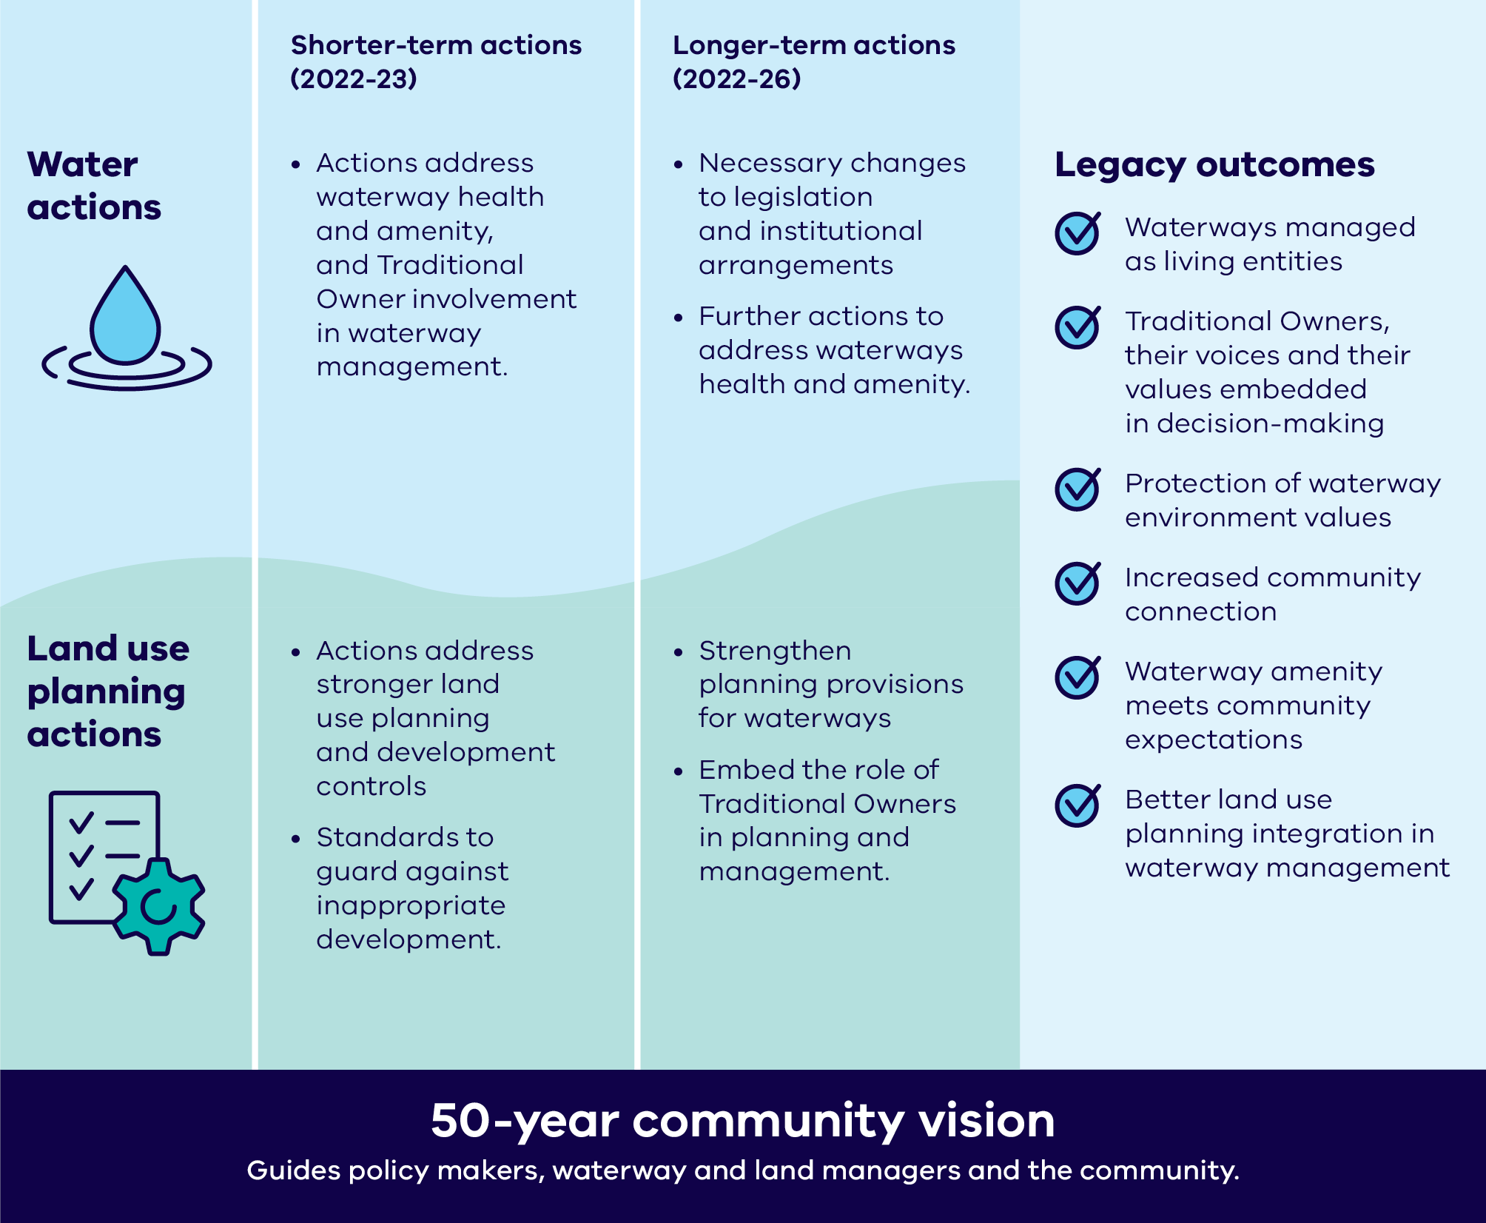
Figure 1: Rivers of the Barwon (Barre Warre Yulluk) implementation framework

Overview of progress in 2025
Highlights of 2025 include:
- During 2025 DEECA undertook engagement with Traditional Owner groups across Victoria on Outcome 1 of Water is Life, Traditional Owner Access to Water Roadmap, seeking input into the development of a law proposal to recognise all Victorian waterways as living. A 'What We Heard' Report summarising the findings of the 2025 engagement was provided to participating Traditional Owner groups in December 2025.
- Following review and consultation, the Government approved and formally implemented planning scheme amendment VC278 in late 2025. This amendment makes existing planning controls for the Rivers of the Barwon (Barre Warre Yulluk) permanent. See Direction 3.
- Three high-priority projects identified in the Kitjarra-dja-bul Bullarto langi-ut Masterplan continued to progress in 2025. Project partners continue to identify funding opportunities for the remaining Tranche 1 projects. Wadawurrung Traditional Owners Aboriginal Corporation (WTOAC) provided important cultural input to a number of priority Masterplan projects. See Action 4.5.
- The City of Greater Geelong (CoGG) has developed a draft stormwater offsets scheme, in accordance with the stormwater offsets framework developed by DEECA in 2021. Further consultation on pricing is now required, with the outcome to go to Council for consideration. See Action 6.2.
- Coordinated advocacy by partner organisations, led by Golden Plains Shire, has increased stormwater management standards in the draft Bannockburn South East Precinct Structure Plan (PSP), which is awaiting approval. See Action 6.3.
For more detailed information on delivery of actions in the Rivers of the Barwon (Barre Warre Yulluk) Action Plan, please see the Action tracker section of the report.

Table 1: Status of actions across Action Plan directions
Direction | Number of actions | Delivered/ Superseded | Ongoing | In progress | Planning
Direction 1: Recognise the Rivers of the Barwon (Barre Warre Yulluk) as a living and integrated natural entity and the Traditional Owners as the ‘voice of this living entity’ | 6 | 5* | 1 | 0 | 0
Direction 2: Embed Traditional Owners’ values in planning and decision-making for waterways | 5 | 2 | 1 | 1 | 1
Direction 3: Strengthen planning policy and controls for waterways | 6 | 6 | 0 | 0 | 0
Direction 4: Improve waterway amenity to meet community expectations | 6 | 4 | 1 | 1 | 0
Direction 5: Identify opportunities to meet environmental and cultural water needs | 2 | 1 | 0 | 1 | 0
Direction 6: Strengthen stormwater management to build resilience | 3 | 1 | 2 | 0 | 0
Direction 7: Ensure accountability and transparency for Action Plan delivery | 2 | 0 | 1 | 1 | 0
Total | 30 | 19 | 6 | 4 | 1
*Includes items that have been superseded, as they are considered to have been delivered.

Looking ahead
In 2026, the Rivers of the Barwon (Barre Warre Yulluk) Action Plan enters the final year of its 5-year implementation timeframe. Key priorities for 2026 include:
- Following public consultation, DEECA will continue work to finalise the Third Victorian Waterway Management Strategy. The strategy includes an increased focus on urban waterways and their importance to communities, including amenity, health and environmental outcomes (Action 4.6).
- Corangamite Catchment Management Authority (CMA) will publish a draft of its new Regional Waterway Strategy and seek stakeholder and community feedback. The strategy has been guided by Eastern Maar and Wadawurrung Traditional Owners and their priorities for the waterways as a living entity (Action 2.5).
- Corangamite CMA and partners will finalise designs for the fishways on the Parwan/Barwon River at Buckley Falls and Moorabool Yaluk/Moorabool River at Batesford Weir, subject to the outcomes of hydraulic, heritage and cultural assessments (Action 4.5).
- Project partners will complete plantings and works funded through the Green Links grants program. This includes the Bunanyung Landscape Alliance project, Urban Ripple: Restoring our Yarrowee Rivers and its little creek, and a 69-hectare project in the Barwon River region being delivered by Corangamite CMA, the CoGG, Deakin University, Barwon Water and Wadawurrung Traditional Owners Aboriginal Corporation.
- With additional funding to support its coordination role, Corangamite CMA will commence new priority projects in collaboration with partners to implement Kitjarra-dja-bul Bullarto langi-ut. Wadawurrung Traditional Owners Aboriginal Corporation has also been funded to continue engaging in the Masterplan’s delivery.
- Ongoing statewide engagement with Traditional Owners to develop and test legislative and policy approaches to recognise waterways as ‘living entities’ and their Traditional Owners as a unique ‘voice’ of those entities (Direction 1).

Action plan implementation case studies

Reviewing stormwater management in the Lower Barwon
Action 6.3 Central and Gippsland Region Sustainable Water Strategy (CGRSWS) stormwater investigations

DEECA, the City of Greater Geelong and Barwon Water established a collaborative project to review stormwater management arrangements in the Lower Barwon region.
The project aimed to:
- understand current stormwater management arrangements across the region
- identify gaps and areas of uncertainty in roles and responsibilities
- assess alternative stormwater management models used elsewhere in Australia and identify options for further consideration.
The final report will identify practical options and further actions to improve stormwater management arrangements in the Lower Barwon.
In addition to this review, partners are prioritising funding, delivery and clear responsibilities for short-term stormwater volume management solutions in the Geelong and Bannockburn growth areas.
This work supports delivery of Action 3-14 of the Central Gippsland Sustainable Water Strategy.

Barwon River and Moorabool River fishways
Action 4.5 Support for Kitjarra-dja-bul Bullarto langi-ut priority projects

Corangamite Catchment Management Authority (CMA) is planning, designing and constructing fishways on the Moorabool and Barwon rivers to address barriers to fish migration.
The project received $1.67 million through the Australian Government’s Urban Rivers and Catchments Program to support the design and construction of fishways at Buckley Falls (Figure 1) and at a downstream rock pool on the Lower Barwon River. The funding will also support removal of the Batesford Weir on the Lower Moorabool River and the design of a further fishway at Baum’s Weir on the Barwon River.
The project will improve passage for migratory fish species, benefiting aquatic health, habitat and food chains. Restoring fish passage at these barriers is expected to benefit at least 15 native fish species, including the vulnerable Australian Grayling (Prototroctes maraena).
The Corangamite CMA is also collaborating with Wadawurrung Traditional Owners to progress storytelling, interpretive signage, cultural aquaculture and site renaming, supporting cultural, community and environmental outcomes.
Progress to date
Corangamite CMA has developed a conceptual design for the Buckley Falls fishways (Figure 2). In early 2026, further refinement is expected following cultural and heritage assessments, hydraulic modelling and any additional feedback. This is likely to result in construction of two fish ladders at Buckley Falls. Project partners will also expand river monitoring at Batesford Weir to support its removal.
Corangamite CMA is investigating fish passage options at Baum’s Weir. This work will identify and evaluate options, benefits, and risks, providing a recommendation on the most feasible solution at this site.
Project partners continue to engage stakeholders, including Wadawurrung Traditional Owners Aboriginal Corporation, Heritage Victoria, Southern Rural Water and local community groups such as the Highton Rotary Club, Geelong Historical Society, Geelong District Anglers Association, Friends of the Barwon and Friends of Buckley Falls.
The project is expected to be completed in April 2028.

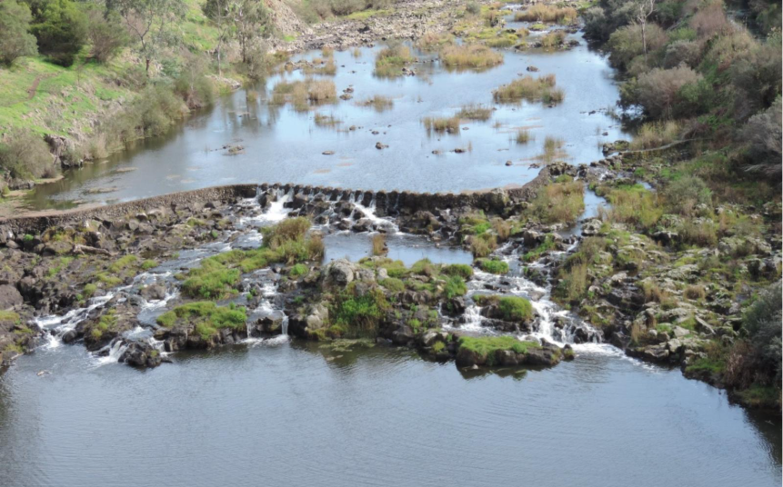
Figure 1: Buckley Falls fish barrier (supplied by CCMA)

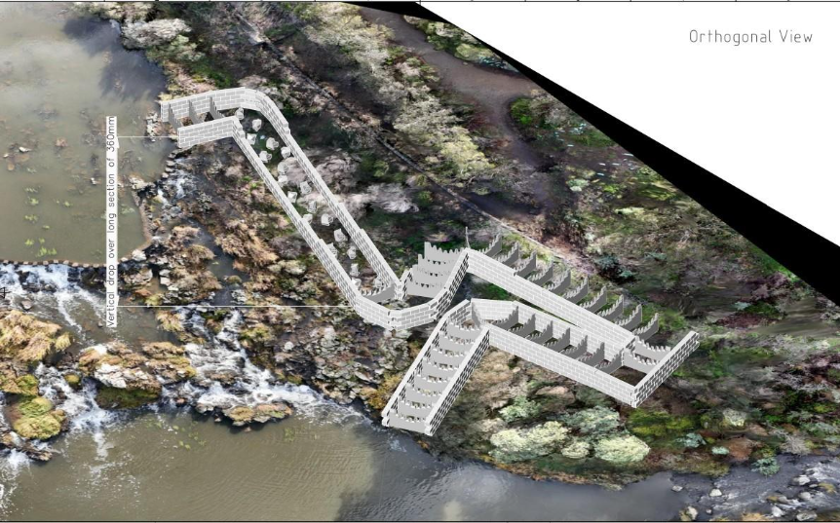
Figure 2: conceptual design of the fish ladder at Buckley Falls (supplied by CCMA)

Action tracker
The Action Plan outlines 7 directions and 30 actions to be delivered over a 5-year period. All short-term actions have now been completed, with most outcomes reported in the 2022, 2023 and 2024 annual reports.
The majority of long-term actions are expected to be delivered by the end of 2026, where they are not ongoing in nature, or have not been superseded by related policy or program delivery. The 2025 Action Tracker below provides point-in-time summary of action progress and implementation status during the reporting year (to December 2025), including ongoing actions that have no fixed delivery date.
While each action below lists a responsible lead organisation, delivery of the Action Plan relies on extensive collaboration across agencies and organisations. This is most apparent in work to deliver ‘living entity’ and ‘voice’ outcomes, which will involve partnerships with Traditional Owners and other agencies.
A full explanation of all deliverables and actions, including background, can be found in the Rivers of the Barwon (Barre Warre Yulluk) Action Plan.

Action | Status at Dec 2025 | Timeframe | Lead agency | Comment
Direction 1: Recognise the Rivers of the Barwon (Barre Warre Yulluk) as a living and integrated natural entity and the Traditional Owners as the ‘voice of this living entity’
1.1 ‘Living entity’ and ‘voice’ for Regional Catchment Strategy (RCS) | Delivered | Short-term | Corangamite Catchment Management Authority (CMA) | Delivered in 2022 – further information is available in the Rivers of the Barwon (Barre Warre Yulluk) Action Plan Annual Report 2022
1.2 Eastern Maar and Wadawurrung aspirations in Corangamite RCS planning | Delivered | Short-term | Corangamite CMA | Delivered in 2022 – further information is available in the Rivers of the Barwon (Barre Warre Yulluk) Action Plan Annual Report 2022
1.3 Support for Eastern Maar and Wadawurrung to express ‘voice of living entities’ | Ongoing | Short-term | Department of Energy, Environment and Climate Action (DEECA) | Continuing support of Eastern Maar and Wadawurrung Traditional Owners to explore what being 'the voice of the living entities' could mean through policy and legislation. This includes work on living entity policy to input into the draft Third Victorian Waterway Management Strategy (VWMS), as well as work to progress Outcome 1 of Water is Life, Traditional Owner Access to Water Roadmap.
1.4 Wider engagement with Traditional Owners about ‘living entity’ and ‘voice’ | Superseded | Long-term | DEECA | Actions 1.4-1.6 are now being delivered through Outcome 1 of Water is Life,  Water is Life: Traditional Owner Access to Water Roadmap.  The Victorian Government is working with Traditional Owners to increase their access to water and their involvement in water management. Outcome 1 in Water is Life commits DEECA to working with Traditional Owners across Victoria to develop a law proposal to recognise all waterways as living entities and Traditional Owners as having a unique voice to speak for those living entities.  Extensive work was undertaken during 2025 to develop the proposal and undertake consultation with Traditional Owners across Victoria to input into this law proposal. While Outcome 1 was originally expected to be completed by the end of 2025, the timeline has been extended to enable further engagement and ensure meaningful, ongoing collaboration with Traditional Owners.  To support this next phase of work, DEECA is offering grants of up to $20,000 (excluding GST) to interested Traditional Owner groups for Outcome 1 engagement activities and collaboration with DEECA. Several Learning by Doing projects will commence in August 2026, supporting Traditional Owners to develop their positions on Outcome 1. The outcomes of these projects will help inform any future law reform proposals and related policy development.  Water is Life Progress reporting is published annually
1.5 Investigate legislation for ‘living entity’ and ‘voice’ concepts | Superseded | Long-term | DEECA
1.6 Traditional Owner preamble for possible legislation | Superseded | Long-term | DEECA
Direction 2: Embed Traditional Owners’ values in planning and decision-making for waterways
2.1 Embed connections to Country in Corangamite RCS | Delivered | Short-term | Corangamite CMA | Delivered in 2022 – further information is available in the Rivers of the Barwon (Barre Warre Yulluk) Action Plan Annual Report 2022
2.2 Partnerships to implement ‘voice’ on Country | Delivered | Short-term | Corangamite CMA | Delivered in 2022 – further information is available in the Rivers of the Barwon (Barre Warre Yulluk) Action Plan Annual Report 2022
2.3 Traditional Owner values and knowledge in land use planning | Ongoing | Long-term | Department of Transport and Planning (DTP) & DEECA | In 2025, DTP progressed updates to the Planning and Environment Act, which were passed by Parliament and received Royal Assent in February 2026. Although not specifically focused on Traditional Owner-related amendments, the work provided an opportunity to strengthen the recognition of Traditional Owner values and act on recommendations made in the Yoorrook Justice Commission's report, Yoorrook Truth be Told. Including ensuring that Registered Aboriginal Parties are invited to participate in strategic planning on Country and are given early notification of proposed development on land that has been prescribed to be culturally sensitive.  The Planning Controls for Waterways Program within DTP is also exploring how planning schemes can better reflect these values.
2.4 RCS reporting Traditional Owner aspirations | Planned | Long-term | Corangamite CMA | In 2025 CCMA engagement with Traditional Owners was focused on the renewal of the Regional Waterway Strategy rather than on a Traditional Owner assessment of RCS activities, or feedback into the RCS mid-term review which was completed by CCMA in 2025.  CCMA work with Wadawurrung and Eastern Maar Traditional Owners prioritised on-ground activities such as estuary management and grassland rehabilitation.
2.5 Eastern Maar and Wadawurrung regional waterway strategy partnership | In progress | Long-term | Corangamite CMA | Eastern Maar and Wadawurrung Traditional Owners have been engaged early and regularly in the development of the new Regional Waterway Strategy. Their input means the region-wide vision centres on waterways as living entities. The future strategy, including its 20-year outcomes, will be structured at the highest level around Traditional Owner priorities for Country. Corangamite CMA will continue providing Traditional Owners with opportunities to review and contribute to draft outcomes, priorities and targets relating to their Country.
Direction 3: Strengthen planning policy and controls for waterways
3.1 Stronger planning policy and guidance | Delivered | Short-term | DTP | Delivered in 2022 – further information is available in the Rivers of the Barwon (Barre Warre Yulluk) Action Plan Annual Report 2022
3.2 Interim landscape and environmental controls for key waterways | Delivered | Short-term | DTP | Delivered in 2022 – further information is available in the Rivers of the Barwon (Barre Warre Yulluk) Action Plan Annual Report 2022
3.3 Interim built-form controls for key waterways | Delivered | Long-term | DTP | In 2025 landscape controls were expanded, and made permanent, for key waterways in urban areas via Planning Scheme Amendment VC278. VC278 allows for better management of the interface and amenity between private land holdings with waterways.  Practice Notes 97 and 98 outline how to identify, plan for and consider planning applications to protect the values of waterways.
3.4 Integrated regional strategic land use plan for Rivers of the Barwon (Barre Warre Yulluk) | Delivered (in part) | Long-term | DTP | In 2022, regional policy was introduced into relevant planning schemes to protect and elevate the significance of the Rivers of the Barwon (Barre Warre Yulluk) via planning scheme amendment VC201.  The policy provides strategies to protect and enhance the environmental qualities and landscape values of waterways, wetlands and significant waterbodies across the catchment.  The project has not yet secured additional funding for a more detailed framework plan.
3.5 Structure plan to integrate Geelong’s centre with Parwan/ Barwon River | Superseded | Long-term | DTP | New projects being investigated as part of delivery of the Kitjarra-dja-bul Bullarto langi-ut Masterplan will improve links between parklands in the Barwon corridor and Geelong. It is necessary to complete this work before progressing Central Geelong Framework Plan implementation.
3.6 Review of interim planning controls | Delivered | Long-term | DTP | In late 2025, the Government approved planning scheme amendment VC278, making existing planning controls for the Rivers of the Barwon (Barre Warre Yulluk) permanent.
Direction 4: Improve waterway amenity to meet community expectations
4.1 Waterway amenity values in RCS | Delivered | Short-term | Corangamite CMA | Delivered in 2022 – further information is available in the Rivers of the Barwon (Barre Warre Yulluk) Action Plan Annual Report 2022
4.2 Barwon and Moorabool flagship programs | Delivered | Short-term | Corangamite CMA | Delivered in 2022 – further information is available in the Rivers of the Barwon (Barre Warre Yulluk) Action Plan Annual Report 2022
4.3 Develop Kitjarra-dja-bul Bullarto langi-ut/ Barwon Rivers Parklands Masterplan | Delivered | Short-term | Corangamite CMA | Delivered in 2023 – further information is available in the Rivers of the Barwon (Barre Warre Yulluk) Action Plan Annual Report 2023
4.4 Funding for Yarrowee Masterplan parkland priority projects | Delivered | Short-term | DEECA | Delivered in 2023 – further information is available in the Rivers of the Barwon (Barre Warre Yulluk) Action Plan Annual Report 2023
4.5 Support for Kitjarra-dja-bul Bullarto langi-ut priority projects | Ongoing | Long-term | Corangamite CMA | Kitjarra-dja-bul Bullarto langi-ut continues to support the implementation of high-priority projects identified in the Masterplan and associated business case. During 2025, conceptual designs were progressed for two priority projects: the City of Greater Geelong’s (CoGG) Barwon River Loop Trail project and the Golden Plains Shire Council Moorabool River Reserve project. Detailed design is expected to be completed in 2026.  Funding received by Barwon Coast Committee of Management contributed to the design of four amenity blocks, sewerage upgrades and a refreshed community hub as part of upgrades to camping and recreation facilities at Bukareeyoo.  DEECA is funding Corangamite CMA to oversee the implementation and governance of the Masterplan, as well as funding for the Wadawurrung Traditional Owners Aboriginal Corporation to provide advice that supports delivery by the wider collaboration.
4.6 Victorian Waterway Management Strategy – urban waterway values | In progress | Long-term | DEECA | An Urban Waterways chapter has been drafted for the Third Victorian Waterway Management Strategy, and work to finalise the strategy will continue in 2026.
Direction 5: Identify opportunities to meet environmental and cultural water needs
5.1 Funding for Traditional Owner cultural water assessment priorities | Delivered | Short-term | DEECA | Delivered in 2022 – further information is available in the Rivers of the Barwon (Barre Warre Yulluk) Action Plan Annual Report 2022
5.2 Central and Gippsland Region Sustainable Water Strategy (CGRSWS) water options for environment and culture | In progress | Long-term | DEECA | The CGRSWS (2022) includes policies to return up to 6,500 megalitres to Moorabool Yaluk/Moorabool River west branch and 700 megalitres to the river’s east branch over the next 10 years. Action 4-3 and 4-4 of the CGRSWS will contribute to this commitment through returning 3,000 megalitres to the Moorabool Yaluk/Moorabool River west branch and 700 megalitres to the east branch.  DEECA and partners are progressing implementation by assessing entitlement options, determining how water will be shared between WTOAC and the environment (Action 4-4), undertaking water resource modelling, and supporting a WTOAC-led water delivery trial.
Direction 6: Strengthen stormwater management to build resilience
6.1 Framework for stormwater infrastructure collaboration | Delivered | Short-term | City of Greater Geelong (CoGG) | Delivered in 2022 – further information is available in the Rivers of the Barwon (Barre Warre Yulluk) Action Plan Annual Report 2022
6.2 Support for a pilot Geelong stormwater offsets program | Ongoing | Long-term | DEECA | The CoGG has developed a draft stormwater offsets scheme, in accordance with the stormwater offsets framework developed by DEECA in 2021. Further consultation on pricing is now required, with the outcome to go to Council for consideration.
6.3 Central and Gippsland Region Sustainable Water Strategy (CGRSWS) stormwater investigations | Ongoing | Long-term | DEECA | DEECA continues to progress stormwater investigations, with several projects supporting delivery of this action directly and indirectly. Barwon Water received $190,000 to investigate short- to medium-term stormwater harvesting opportunities in the Northern and Western Geelong Growth Areas and Bannockburn, which will support the implementation of Integrated Water Management Plans. DEECA also provided funding to Corangamite CMA to improve understanding of any environmental impacts of increased stormwater runoff from new development areas.  DEECA progressed CGSWS Action 3-16 by exploring the feasibility of mandating flow reduction targets in regulations, including through case studies with the CoGG. DEECA is now preparing a planning scheme amendment to implement Action 3-16.  In collaboration with CoGG and DEECA, Barwon Water is investigating opportunities to take a stronger institutional role in stormwater management, supporting Action 3-14 of CGRSWS.  Finally, coordinated advocacy by organisations, led by Golden Plains Shire, has increased stormwater management standards in the draft Bannockburn South East Precinct Structure Plan (PSP). The Victorian Planning Authority and the Department of Transport and Planning are finalising the plan for Ministerial approval.
Direction 7: Ensure accountability and transparency for Action Plan delivery
7.1 Annual implementation report | Ongoing | Short-term | DEECA | This report marks the fourth year of annual reporting on the Action Plan.
7.2 Final review of implementation | In progress | Long-term | DEECA | A review has commenced that will inform the final delivery and future reviews of the Action Plan.

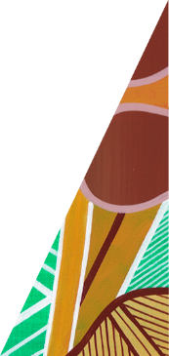






deeca.vic.gov.au

