Achievement of environmental outcomes in Victoria’s Murray-Darling Basin waterways

  - Summary report to the Murray-Darling Basin Authority to meet Basin Plan Schedule 12
Matter 8 obligations
deeca.vic.gov.au

Table of Contents
Acknowledgements 5
Synopsis 6
Key findings 6
Evaluation: How has the Basin Plan affected environmental outcomes? 8
Working together for a better Basin 11
Overview 14
About the Basin Plan 14
What is the Basin Plan? 14
Basin Plan implementation in Victoria 14
Valuing waterways of the Murray-Darling Basin 17
Traditional Owners 17
Priority Environmental Assets 19
Influences on environmental outcomes and attribution to the Basin Plan 20
Matter 8 reporting – Victorian purpose and approach 22
Victoria’s framework to deliver Basin Plan objectives 24
Selection of priority environmental assets for monitoring 28
Waterway health indicators 29
Assessing environmental outcomes and the achievement of Basin Plan objectives – Victoria’s approach to compiling this report 30
Approach to reporting on environmental outcomes and Chapter 8 objectives 33
Results – Achievement of environmental outcomes and Basin Plan objectives 36
Part 1: Achievement of environmental outcomes at Victorian Priority Environmental Assets 36
Northern Victoria 36
Broken System 38
Broken River 38
Broken Creek 40
Moodie Swamp 43
Campaspe System 46
Campaspe River 46
Goulburn System 49
Lower Goulburn River 49
Doctors Swamp 53
Gaynor Swamp 55
Horseshoe Lagoon 58
Loch Garry 60
Reedy Swamp 62
Loddon System 65
Loddon River 65
Twelve Mile Creek 68
Pyramid Creek 70
The Boort Wetlands 72
Central Murray wetlands 78
Kunat Kunat (Round Lake) 78
Ovens System 81
Ovens River 81
Victorian Murray 84
Barmah Forest 86
Broken System 91
Black Swamp 91
Kinnairds Wetland 94
Gunbower Forest and Gunbower Creek 97
Central Murray wetlands 101
Hird Swamp 101
Johnson Swamp 104
Lake Cullen 106
Lake Elizabeth 109
Lake Murphy 112
McDonalds Swamp 115
Richardson’s Lagoon 118
Wirra-lo Wetland 121
Hattah Lakes 123
Lower Murray wetlands 126
Brickworks Billabong 126
Cowanna Billabong 128
Koorlong Lake 130
Heywood Lakes 132
Neds Corner 135
Vinifera Floodplain 138
Lindsay, Mulcra and Wallpolla Islands 140
Wimmera-Mallee 143
Wimmera River System 145
Wimmera River 145
Mount William Creek 148
Burnt Creek & MacKenzie River 151
Wimmera-Mallee Pipeline wetlands 155
Carapugna Wetland 155
Crow Swamp 156
Carapugna Wetland 157
Crow Swamp 157
Part 2: Achievement of Basin Plan objectives at Victorian Priority Environmental Assets 159
Case studies 211
1. Native fish in the Goulburn and Campaspe rivers – Improving understanding of the benefits of environmental water with modelling 211
The Goulburn River 212
The Campaspe River 215
2. Managing Moira grass in Barmah Forest using environmental water and grazer exclusion 218
3. Lake Kramen – waterbird breeding 223
4. Wimmera waterholes 225
5. Minimising the effects of blackwater in the Goulburn-Broken region 228
6. Tracking turtles in Barmah Forest 232
7. Management of water for the environment in conjunction with natural inflows to meet river red gum and waterbird requirements at Gunbower Forest 234
References 238
Appendix A – Alignment of Basin Plan Chapter 5 and 8 objectives and outcomes 241
Appendix B – Alignment between Chapter 8 objectives and waterway health indicators monitored at relevant priority environmental assets 244
Appendix C – Scientific and common names for species listed in this report 247

Acknowledgements
© The State of Victoria Department of Energy, Environment and Climate Action 2024
This work is licensed under a Creative Commons Attribution 4.0 International licence, visit the Creative Commons website (http://creativecommons.org/licenses/by/4.0/). You are free to re-use the work under that licence, on the condition that you credit the State of Victoria as author. The licence does not apply to any images, photographs or branding, including the Victorian Coat of Arms, and the Victorian Government and Department logos.
ISBN: 978-1-76136-751-9 (pdf/online/MS word)

Disclaimer
This publication may be of assistance to you but the State of Victoria and its employees do not guarantee that the publication is without flaw of any kind or is wholly appropriate for your particular purposes and therefore disclaims all liability for any error, loss or other consequence which may arise from you relying on any information in this publication.

Accessibility
To receive this document in an alternative format, phone the Customer Service Centre on 136 186, email customer.service@delwp.vic.gov.au, or contact National Relay Service on 133 677. Available at DEECA website (www.deeca.vic.gov.au).

Synopsis
This report presents an assessment of change since 2012 in the status of waterway health indicators at 54 waterways in the Victorian Murray-Darling Basin (Basin) where water for the environment is delivered and monitoring has occurred. The assessment was based on the opinion of scientists and waterway managers, backed by empirical data.

Key findings
Since implementation of the Murray-Darling Basin Plan (Basin Plan) began in 2012, the protection and restoration (For this report the terms ‘protect and restore’ are used in line with Basin Plan Chapter 5 and 8 objectives) of environmental outcomes - in line with Basin Plan objectives - has, for the most part, been observed. This is evident in this report through the improvement or maintenance in the status of fish, vegetation, waterbirds, and frogs at monitored waterways that have been actively managed under Basin Plan, including through the delivery of water for the environment. It will take time to realise the full environmental benefits of these efforts.
Victoria’s 2024 Matter 8 assessment shows:
- Victoria’s Basin Ramsar sites (including Hattah Lakes, Barmah Forest, Gunbower Forest) are being protected and restored; The level of restoration experienced by other water-dependent ecosystems such as Hird Swamp and Johnson Swamp in the Kerang Wetlands Ramsar site that support species listed under international protections for migratory birds is unclear, with most of these showing a maintenance in abundance for relevant waterbird species rather than an increase.
- The presence and abundance of threatened species has improved in approximately half of Victoria’s monitored Basin assets. Examples include, recruitment of Murray cod, trout cod and Murray-Darling rainbowfish occurring annually at Barmah forest, an improvement in native riparian vegetation species evident in the Campaspe river system and new records of EPBC-listed Australasian bittern recorded at Wirra-lo wetland complex. Approximately half the monitored waterways showed a maintenance of their status (e.g., poor to poor, average to average) for fish and waterbirds. There were some exceptions to this trend - abundances of threatened fish species declined in the Broken Creek due to a fish death event associated with low dissolved oxygen levels in spring 2022. Numbers of threatened waterbird species at Kunat Kunat and Lake Murphy have also declined since 2012. In Kunat Kunat, the decline in abundance of the FFG-listed blue-billed duck is notable because numbers were previously high. Waterbird numbers in Lake Murphy have declined generally, with a number of EPBC and state-listed waterbird species absent in recent years. The cause of these declines is unknown but could be due to changes in habitat (including availability of more suitable habitat elsewhere), or the difficulty of detecting cryptic species such as Australasian bittern.
- At most of Victorian monitored Basin assets, results suggest ‘representative’ species, populations, and communities (i.e. all non-threatened species, populations and communities) of native biota (per Basin Plan objective 8.05 (3)(b)) have been protected and/or restored, which contributes to strengthening resilience to climate change. This is particularly true for fish in rivers, and for waterbirds and tree condition (river red gum and black box) in wetlands. Monitoring in the Campaspe River indicated that restoration and protection of riparian vegetation over the period 2007-2024 due to environmental watering in combination with revegetation and protection works, has supported resilience of riparian vegetation to recent flood events (2022 and 2024), particularly for upper bank vegetation. For waterbirds, the restoration of wetlands such as Gaynor Swamp, Johnson Swamp and Moodie Swamp have resulted in relatively high diversity and abundance in recent surveys, despite wide availability of alternative habitat nearby from recent floods.
- Longitudinal connectivity in Victoria’s main river systems (represented by fish movement and distribution) has largely been protected and restored.
- The protection and restoration of ecosystem functions that maintain populations (as per Basin Plan objective 8.06 (6)(a)(b)) has varied. Fish recruitment and dispersal have improved in approximately half of the monitored assets, vegetation recruitment has been maintained at most riverine assets (and improved in the Campaspe River), and waterbird breeding has mostly been maintained, although improvements in breeding have been observed in Barmah Forest and Hattah Lakes, as well as Gaynor Swamp in the Goulburn-Broken catchment management region, and Lake Yando, McDonalds Swamp, Richardsons Lagoon and Wirra-lo Wetlands in the North Central region.

Evaluation: How has the Basin Plan affected environmental outcomes?
The Victorian Basin has undergone over a century of degradation due to colonisation and associated impacts from population growth, river regulation, change in land use practices, the introduction of invasive species, and now climate change. The Basin Plan has been a significant step towards protecting and restoring waterways, with Victoria securing 826.5 GL of its water recovery target. The extent of ecological degradation and the ongoing impacts on Basin ecosystems of river regulation and floodplain development, means environmental recovery following Basin Plan commencement in 2012 requires a long-term commitment coordinated between government agencies, Traditional Owners and the community. Waterway management in highly modified catchments is complex and requires active and adaptive management that considers short, medium and long-term outcomes. The results presented in this Matter 8 assessment indicate a general pattern of restoration and protection through the improvement or maintenance in the status of fish, vegetation, waterbirds, and frogs at monitored waterways that have been actively managed under Basin Plan, including through the delivery of water for the environment. These are referred to in this report as ‘priority environmental assets’, consistent with the Basin Plan.
These positive outcomes likely reflect the evolution of waterway management in Victoria since the first Victoria River Health Strategy in 2002, including the establishment of environmental water entitlements through the Victorian Water Act (2005 amendment), establishment of the Victorian Environmental Water Holder (VEWH) in 2011, commencement of the Basin Plan in 2012, and significant statewide investment in complementary waterway and catchment health measures.
It must be noted that highly modified natural systems coupled with the impacts of climate change means that environmental watering under Basin Plan is only one of several contributing factors that leads to the protection and restoration of environmental objectives. To protect and restore ecosystem functions over the long-term, realistic environmental objectives must be set, and environmental water actively managed with an adaptive approach that tests and improves understanding of how watering contributes to achieving the objectives. Victoria has a mature and seasonally adaptive approach to environmental water management that combines with complementary waterway health actions and more broadly, integrated catchment management.
Water recovery under the Basin Plan is supporting the protection and restoration of many Ramsar sites, threatened species and water-dependent ecosystems at local scales, however, complementary measures are also essential to meet Basin Plan objectives. In Victoria these include activities such as building fishways on instream barriers like dams and weirs; addressing water quality issues; reinstating in-channel habitat such as snags, pools or vegetation; controlling invasive plants and animals; stocking native fish; and supporting sustainable irrigation programs.
The results in this Matter 8 assessment are achieved through integration of environmental water with complementary measures such as Regional Riparian Action Plans (2015, 2021), establishment of large scale long-term investment in integrated waterway management under the Victorian Flagship Waterway Program (2016), and increased investment in maintaining ecological character at Ramsar listed wetlands. As one example, the importance of complementary measures to achieve outcomes is illustrated for Moira grass in Barmah Forest below (case study 2).
The results of this assessment will also reflect recent weather conditions and the wide-scale flooding and floodplain inundation experienced in Victoria’s north in 2011 (breaking the Millenium Drought), 2016, 2022-23 and 2023-24. Victoria implements a seasonally adaptive approach to waterway management that takes into account recent climate history, climate outlook and available environmental water. This means that in wet periods, environmental watering focusses on providing a water regime that can support values which are not maintained in drier periods, such as large-scale bird breeding events, managing water quality (see below case study 5 on blackwater in the Goulburn-Broken), or extending critical floodplain inundation periods for vegetation (see below case study 7 on river red gums in Gunbower Forest). Flooding offers opportunities to better understand the Basin system, with both positive and negative environmental impacts observed.
It will take time to realise the full environmental benefits from Basin Plan-related water recovery efforts. Continued protection and restoration of the environment requires ongoing investment in environmental works and rule changes that enable the efficient and effective delivery of water for the environment, along with complementary measures, and active, integrated and adaptive management approaches. These approaches are critical to optimise the benefits from environmental water and improve environmental outcomes in Victoria’s waterways.

Working together for a better Basin
Victoria’s waterway management is guided by a series of foundational strategic documents, including the Victorian Waterway Management Strategy and Regional Waterway Strategies. A new 10-year Victorian statewide strategy is being developed for release in 2025 and new regional strategies will be prepared by 2027. These updated documents will specifically address climate change and other ongoing pressures that challenge our ability to care for waterways.
The policies and range of management actions outlined in these documents will underpin the state’s continued commitment to environmental outcomes driven through regional objective setting, adaptive management supported by best available scientific evidence, and investment in environmental works and complementary measures. Operational experience and hydrological modelling show that water recovery can provide freshes and low flows that support drought refuges for aquatic species, improve water quality, and enable some ecosystem resilience – but these environmental outcomes are mostly limited to within the river channel and during dry to average climatic conditions. This is not enough to achieve Basin Plan environmental objectives to protect and restore waterways in Victoria. Environmental works in combination with active management of water to support river connectivity to floodplain ecosystems is also vital. Some of this work is being progressed through Sustainable Diversion Limit Adjustment Mechanism (SDLAM) projects such as the Victorian Murray Floodplain Restoration Project, and Constraints Feasability Study. Consistent modelling of climate change impacts in the Basin at catchment scale is required to inform water recovery efforts and future work programs.
Victoria also supports a coordinated, multijurisdictional approach to water management. The Enhanced Environmental Water Delivery (EEWD) project, jointly delivered by Victoria, South Australia and New South Wales, is improving the efficiency of environmental water delivery by developing new forecasting and planning tools and streamlined processes for coordinated system-wide river operations in the Southern Connected Basin. These approaches will maximise system-wide connectivity and enhance environmental outcomes to make best use of water for the environment particularly in average to wet conditions to support ecosystem restoration, and resilience for drier conditions. This is particularly critical in the context of climate change.
The Murray-Darling Basin Authority’s (MDBA) Basin Plan Review Early Insights Paper (June 2024) noted that the Basin Plan Evaluation, to be released mid-2025, will provide a thorough assessment of Basin Plan implementation, its impact and its effectiveness to date. This will form the basis for the 2026 Basin Plan Review, which will recommend changes for adaptive management of the Basin’s water resources. Victoria strongly supports the MDBA’s insights that the Basin Plan Review needs to recognise the importance of an integrated approach to water management. This should include consideration of critical factors to achieving environmental outcomes, such as water quality, riparian and floodplain management, pest control, instream habitat, river operations, removing constraints and other on-ground works. The 2026 Basin Plan Review will also need to recognise the importance of planning over meaningful spatial and temporal scales for future outcomes in the Basin, particularly in the context of climate change.
Victoria supports the MDBA’s proposal to evaluate the effectiveness of Sustainable Diversion Limits (SDLs) including potential benefits from changes in river operations to jointly benefit the environment, irrigators and the community. Water recovery under the Basin Plan is supporting the protection and restoration of threatened species and priority water-dependent ecosystems, including five northern Victorian Ramsar sites. Victoria’s priority for implementing the Basin Plan has always been achieving its environmental objectives by meeting the SDLs while balancing environmental, community, socio-economic and cultural considerations. Any further water recovery in Victoria should be targeted towards the approach set out in Planning Our Basin Future Together prospectus, which seeks to achieve enhanced environmental outcomes without causing perverse outcomes for tributaries throughout the Basin, while minimising socioeconomic impact, and placing communities at the centre of decision-making.
Victoria looks forward to working with the MDBA and other Basin states to support development of the 2025 Basin Plan Evaluation (initially through this Matter 8 report) and collaborating on the 2026 Basin Plan Review.

Overview

About the Basin Plan

What is the Basin Plan?
Spanning four states and one territory in Australia’s southeast, the Murray-Darling Basin (Basin) supports a unique environment of interconnected rivers, wetlands, and floodplains, as well as significant social, economic, and cultural values.
The Murray-Darling Basin Plan (Basin Plan) was established in 2012 to improve the health of the Basin and address decades of overuse of water and the impacts of drought. The Basin Plan aims to improve water security and establish a sustainable and long-term adaptive management framework for Basin water resources. The Basin Plan limits the amount of water that can be used for irrigation, industry, towns, or other consumptive purposes, through Sustainable Diversion Limits (SDLs), which came into effect in mid-2019. The water remaining in the system is intended to benefit fish, birds, frogs, vegetation, and other aspects of the Basin’s environment.

Basin Plan implementation in Victoria
Victoria is successfully implementing the Basin Plan in a way that secures environmental outcomes and minimises socio-economic impacts. The Murray River system and its tributaries (see Figure 1 below) are highly regulated and modified; waterways are still facing multiple threats and climate change represents an additional pressure. Securing environmental outcomes in these waterways requires an integrated, pragmatic and evidence-based approach. In Victoria that includes recovering and delivering water for the environment to meet ecological objectives; implementing the seasonally adaptive approach for drought, dry, average and wet years; using environmental infrastructure to actively manage watering to restore high-value ecological systems; using complementary management actions to enhance outcomes and manage threats; and where feasible, removing constraints to re-connect rivers to their floodplains.
Victoria’s progress towards implementing the Basin Plan includes:
- maintaining Victoria’s Water Resource Plans, which have been accredited and are operational.
- developing the long-term watering plans required for each of Victoria’s water resource plan areas (Wimmera-Mallee, Northern Victoria, and the Victorian Murray; Figure 1). These long-term plans are periodically refined and updated to reflect new knowledge and information, with the most recent updates completed in 2021.
- recovering over 826 gigalitres of Victoria’s 1,075 GL long-term water recovery target, with the remainder to be offset through environmental projects that deliver equivalent benefits.
- delivering major environmental works under The Living Murray that now provides water to 12,000 hectares (ha) of high value Murray River floodplain in Victoria, effectively protecting these areas during dry times.
- constructing regulators at Catfish Billabong (near Mildura) and Kynmer Creek (Barmah Forest) restoring more natural hydrological regimes, and installing a pipeline to Kinnairds Wetland (GBCMA region) improving the efficiency and flexibility of environmental water deliveries.
- advancing the planning and development of eight more major environmental works projects that will enable watering of an additional 14,000 ha of Murray River floodplain to restore these areas and protect them from future drought and climate change impacts.
- completing a feasibility study examining benefits and risks of lifting constraints to floodplain inundation along the Goulburn and Murray rivers.
- delivering more than 8,500 GL of environmental water since 2013 to over 120 priority waterways in northern Victoria, to benefit fish, waterbirds, vegetation, frogs, turtles, platypus, water quality, and many other aspects of the environment.
- Monitoring 54 waterways where water for the environment is being delivered and managed, to build knowledge and guide adaptive management for improved environmental water outcomes.
Figure 1: Victoria’s three surface water resource plan areas (WRP areas) and their location within the broader Murray-Darling Basin
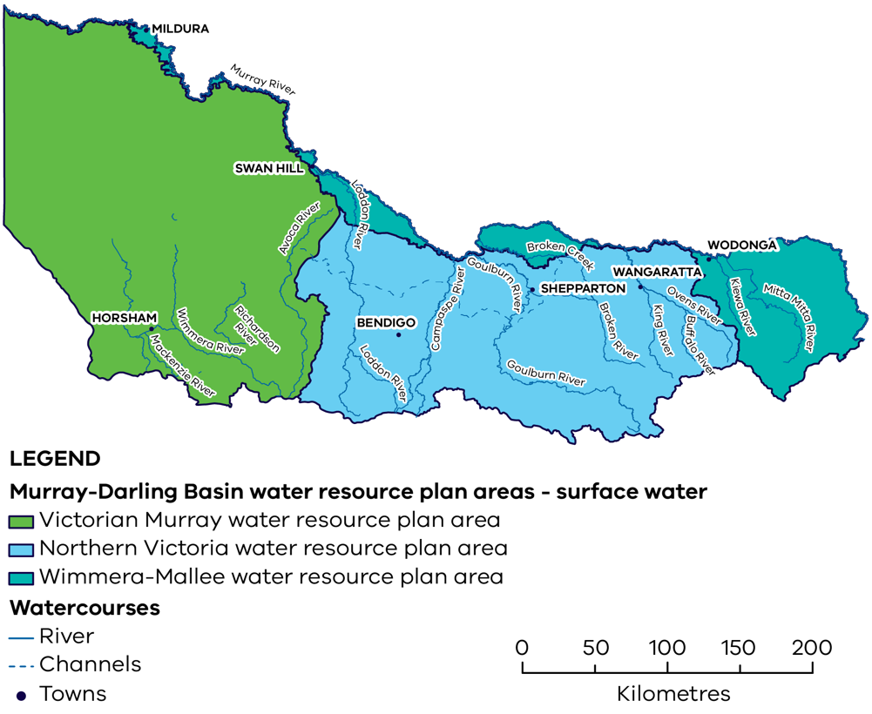
Victoria is also investing in complementary measures to address threats such as barriers to movement, pest plants and animals, instream habitat loss, and livestock impacts. This has been occurring since establishment of catchment management authorities in the 1990s. Management actions are guided by Regional Waterway Strategies and are set out to align with policies and directions set out in the statewide strategy in place. The first state-wide strategy was the Victorian River Health Strategy (2002). An update of the current Victorian Waterway Health Strategy (2013) will be released in 2025.
As an indication of the degree of works, the following have been completed across northern Victorian waterways since 2016:
- pest plant and animals controlled in over 233,700 ha
- revegetation of more than 4815 ha
- fishways built on key barriers (e.g., Koondrook Weir, Tea Garden Weir, Taylors Creek Weir, Cudgewa Creek)
- more than 1000 snags returned to support native fish
- over 945 km of riparian fencing
- managing livestock grazing over more than 4622 ha.

Valuing waterways of the Murray-Darling Basin

Traditional Owners
The Victorian Government acknowledges Aboriginal people as Australia’s first people, and as the Traditional Owners and custodians of the land on which we work and live. The Victorian Government recognise that Traditional Owners have never surrendered rights to Country.
In 2022 the Victorian Government released Water Is Life – Traditional Owner Access to Water Roadmap https://www.water.vic.gov.au/our-programs/aboriginal-water-program/water-is-life-roadmap. Water is Life commits to meaningful outcomes and actions around water and waterway management, led by and in partnership with Traditional Owners. This includes outcomes and actions in the Murray-Darling Basin.
In compiling this report, DEECA acknowledges the Traditional Owners and First Nations peoples of northern Victoria, including the Murray River system and the Wimmera-Mallee region. The Traditional Owner groups in and around the Victorian Murray-Darling Basin are presented below.
Table 1: Traditional Owner groups and First Nations peoples of northern Victoria
First Peoples of the Millewa-Mallee Aboriginal Corporation | Baraparapa Traditional Owners | Dja Dja Wurrung Clans Aboriginal Corporation | Bangerang Aboriginal Corporation
Latji Latji Mumthelang Aboriginal Corporation | Barapa Land and Waters | Barengi Gadjin Land Council Aboriginal Corporation | Dhudhuroa Waywurru Nations Aboriginal Corporation
Nyeri Nyeri Traditional  Owners | Wadi Wadi Land and Water Indigenous Corporation | Taungurung Land and Waters Council | Dalka Warra Mittung Aboriginal Corporation
Tati Tati Kaiejin | Wiran Aboriginal Corporation  - (Wamba Wemba) | Yorta Yorta Nation Aboriginal Corporation | Duduroa Dhargal Aboriginal Corporation
Tati Tati Land and Water Indigenous Corporation | Wamba Wemba Aboriginal Corporation | Ngurai Illum Wurrung | Jaithmathang Traditional Ancestral Bloodline Original Owners First Nation Aboriginal Corporation
Weki Weki Traditional Owners | Waddi Waddi | Waywurru Traditional Owners | Konermar Buller Jaithmatang

Priority Environmental Assets
Priority environmental assets are defined in the Basin Plan as the rivers, wetlands, and floodplains able to be managed with environmental water. The Victorian Murray-Darling Basin has a diverse spectrum of priority environmental assets, ranging from permanent lowland rivers and lakes to river red gum forests, lignum shrublands and temporary wetlands, which vary considerably in size, degree of permanency, location in the catchment, values and threats, and adjacent land-use.
Based on the Australian National Aquatic Ecosystems (ANAE) classification framework, Victoria’s priority environmental assets represent 41 of the 53 ANAE waterway types. Some types are well represented, in particular temporary river red gum swamp and black box woodland riparian zone, while others including clay pan and river red gum woodland riparian zone are rarer.
Victoria’s priority environmental assets provide habitat for a broad range of native species, including many protected under international treaties and/or listed as threatened under the Commonwealth’s Environment Protection and Biodiversity Conservation Act 1999 (EPBC Act) or Victoria’s Flora and Fauna Guarantee Act 1988 (FFG Act). Important life processes (e.g. feeding, nesting, reproduction, roosting) are also supported.

Influences on environmental outcomes and attribution to the Basin Plan
Although historical events and recurrent water quality issues through the twentieth century showed too much water was being extracted for consumptive use from Basin systems, it was the Millennium Drought and the risk of irreversible environmental damage that provided the political will for water recovery from overallocated systems. Water recovery under the Basin Plan led to setting of limits on the amount of water that could be taken, and recovery of volumes of water across the Basin that are protected and managed for environmental purposes. Under the Basin Plan, Victoria has recovered over 826 gigalitres of our 1,075 GL long-term water recovery target. As Victoria has already bridged the gap it is focused on completing as many SDLAM projects as possible ahead of reconciliation at December 2026, and finding a pathway for viable projects that will deliver real environmental outcomes to be completed beyond that date.
Today, large reservoirs across many major rivers regulate their flow. As a result of this, affected waterways experience a reversed flow regime, with high flows in summer to deliver irrigation water and low flows in winter when dams are being filled for the next irrigation season. Water that is held for the environment is used to actively deliver flow components to meet specific environmental needs and restore some seasonal fluctuation. These environmental flows prevent cease-to-flow events and stagnating water, maintain low flows and habitat refuges, deliver spring and autumn pulses that trigger life cycle cues in native flora and fauna, flush sediment and nutrients, and provide other hydrological events that otherwise would not occur, or would occur much less frequently, including extended duration of flood events, benefitting targeted wetland flora and fauna.
Without water recovery and actively managing waterways for environmental outcomes, many Basin systems would operate as consumptive water delivery channels. The Basin Plan has been key to enabling critical flow components that support native flora and fauna.
Environmental outcomes in waterways are influenced by a multitude of factors, not just the ability to deliver and manage environmental water. It is important to acknowledge this, and to contextualise results from asset-based monitoring and research relative to the range of conditions experienced at the asset and across the landscape more generally.
Before the Basin Plan commenced in 2012, the Murray-Darling Basin had endured over a decade of intense drought, starting in 1997 and ending in 2010 (the Millenium Drought). Since 2011, the Victorian Murray-Darling Basin environment has experienced recurrent flooding (in 2011, 2016-17, 2022-23, 2023-24), interspersed with the hottest, driest period ever recorded in the Murray-Darling Basin (2017-2019) (NWA 2020: Murray–Darling Basin: Climate and water (bom.gov.au)).
These extreme fluctuations in climate have strongly influenced environmental conditions. Indeed, studies indicate that hydrological recovery from the Millenium Drought has been slow and is still occurring in some regions (Peterson et al. 2021). Add to this the effects on environmental condition of land use change and development around waterways, livestock grazing, predators, and invasive species, and it is not surprising that the ability to directly attribute environmental outcomes to the Basin Plan is limited 12 years after its commencement, and five years after its sustainable diversion limits came into effect. Against the backdrop of over a century of degradation that continues to this day, the ability to detect and directly attribute environmental change to specific management actions (e.g. environmental watering) is limited particularly given the relatively short timeframe since the Basin Plan commenced.

Matter 8 reporting – Victorian purpose and approach
Schedule 12, Matter 8 of the Murray-Darling Basin Plan requires Basin states (Queensland, New South Wales, Victoria, South Australia, and the ACT) to conduct 5-yearly reporting on the ‘Achievement of environmental outcomes at an asset scale’.
Based on reporting guidelines provided by the Murray-Darling Basin Authority (MDBA) in 2023, Victoria’s approach to Matter 8 reporting in 2024 includes three forms of information:
- This Summary Report to the MDBA reports on the asset-scale achievement of environmental outcomes in the context of environmental objectives presented in Chapter 5 and Chapter 8 of the Basin Plan. The achievement of environmental outcomes and objectives has been assessed since Basin Plan implementation began in 2012 (although data collection may not have commenced at that time).
To help inform the MDBA’s 2025 Basin Plan Evaluation, the report also includes a series of case studies to highlight the different contexts in which environmental water is delivered in Victoria’s Murray-Darling Basin waterways and demonstrate learnings and successes from these efforts.
Victoria’s Matter 8 Summary Report:
- describes the environmental outcomes that have been achieved in the Victorian Murray-Darling Basin since 2012.
- contextualises the results relative to flow and non-flow factors (where possible).
- builds on the information presented in Victoria’s 2020 Matter 8 report.
- lays the foundation for future outcomes-based reporting for the Basin Plan.
The report does not attempt to attribute environmental outcomes to specific factors unless supported by sufficient scientific evidence. Instead, it provides key, relevant information to assist the MDBA’s interpretation of results.
Additionally, Part 2 of this report provides an expert-opinion based summary of the achievement of Basin Plan objectives at Victoria’s priority environmental assets. This information is provided to the MDBA to help inform the 2025 Basin Plan Evaluation; the information should not be interpreted as a conclusive statement of the extent to which Basin Plan objectives have been met in Victorian assets.
- Several technical reports prepared for the monitoring and research programs conducted in Victorian waterways since 2012, to support the Summary Report. These include reports for:
- The Living Murray program (The Living Murray | Murray–Darling Basin Authority (mdba.gov.au)).
- Victoria’s environmental flows monitoring and assessment programs (VEFMAP for rivers, WetMAP for wetlands – Assessing benefits of water for the environment (ari.vic.gov.au)).
- the Native Fish Report Card (a program jointly funded by the Department of Energy, Environment and Climate Action (DEECA) and the Victorian Fisheries Authority; Native Fish Report Card Program (ari.vic.gov.au)).
- the Commonwealth Environmental Water Holder’s (CEWH) Goulburn River Flow-MER and Long-Term Intervention Monitoring Program (LTIM) (Monitoring Evaluation and Research Program (Flow-MER) - DCCEEW).
- additional projects conducted by Victorian Catchment Management Authorities (CMAs).
- An Environmental Outcomes Communications Brochure has also been developed to summarise the detailed outcomes for a broader audience of stakeholders and community.

Victoria’s framework to deliver Basin Plan objectives
The overarching objectives and outcomes for the waterways and water-dependent ecosystems of the Basin are listed in Chapter 5 of the Basin Plan. The objectives with most direct relevance to Matter 8 reporting include:
- give effect to relevant international agreements through the integrated management of Basin water resources (BP objective 5.02 (1)(a)).
- promote healthy and resilient ecosystems with rivers and creeks regularly connected to their floodplains (BP objective 5.02 (2)(c)).
- protect and restore water-dependent ecosystems of the Murray-Darling Basin (BP objective 5.03 (1)(a)).
- protect and restore the ecosystem functions of water-dependent ecosystems (BP objective 5.03 (1)(b)).
- ensure that water-dependent ecosystems are resilient to climate change and other risks and threats (BP objective 5.03 (1)(c)).
Sitting below these objectives, the Basin-wide environmental watering strategy (BEWS, MDBA 2019) sets measurable medium-term outcomes for river flows and connectivity, vegetation, waterbirds, and fish at a whole-of-Basin scale. The BEWS references long-term planning for environmental water at the State scale by acknowledging state WRP areas and Long-Term Watering Plans (LTWP) for surface water, and the catchment areas within.
As noted above, Victoria has three WRP areas and three corresponding surface water LTWPs – one each for the Victorian Murray, Northern Victoria, Wimmera-Mallee (Figure 1). Nested below each LTWP, Victoria’s CMAs hold a set of Environmental Water Management Plans (EWMPs), which the CMAs develop for all priority environmental assets in their region (noting EWMPs are still to be developed for some waterways). The objectives and targets listed in Victoria’s EWMPs form the basis of Victoria’s LTWP objectives and targets.
The Victorian Environmental Water Holder (VEWH) prepares an annual Seasonal Watering Plan (SWP), based on annual proposals for environmental watering, which are prepared by the CMAs based on the objectives and targets presented in their EWMPs. The VEWH, CEWH, CMAs, and water corporations are responsible for delivery of held environmental water entitlements, taking into consideration prevailing conditions and seasonally adaptive objectives set by CMAs for their waterways.
Figure 2: Victoria’s planning approach for the delivery of environmental water
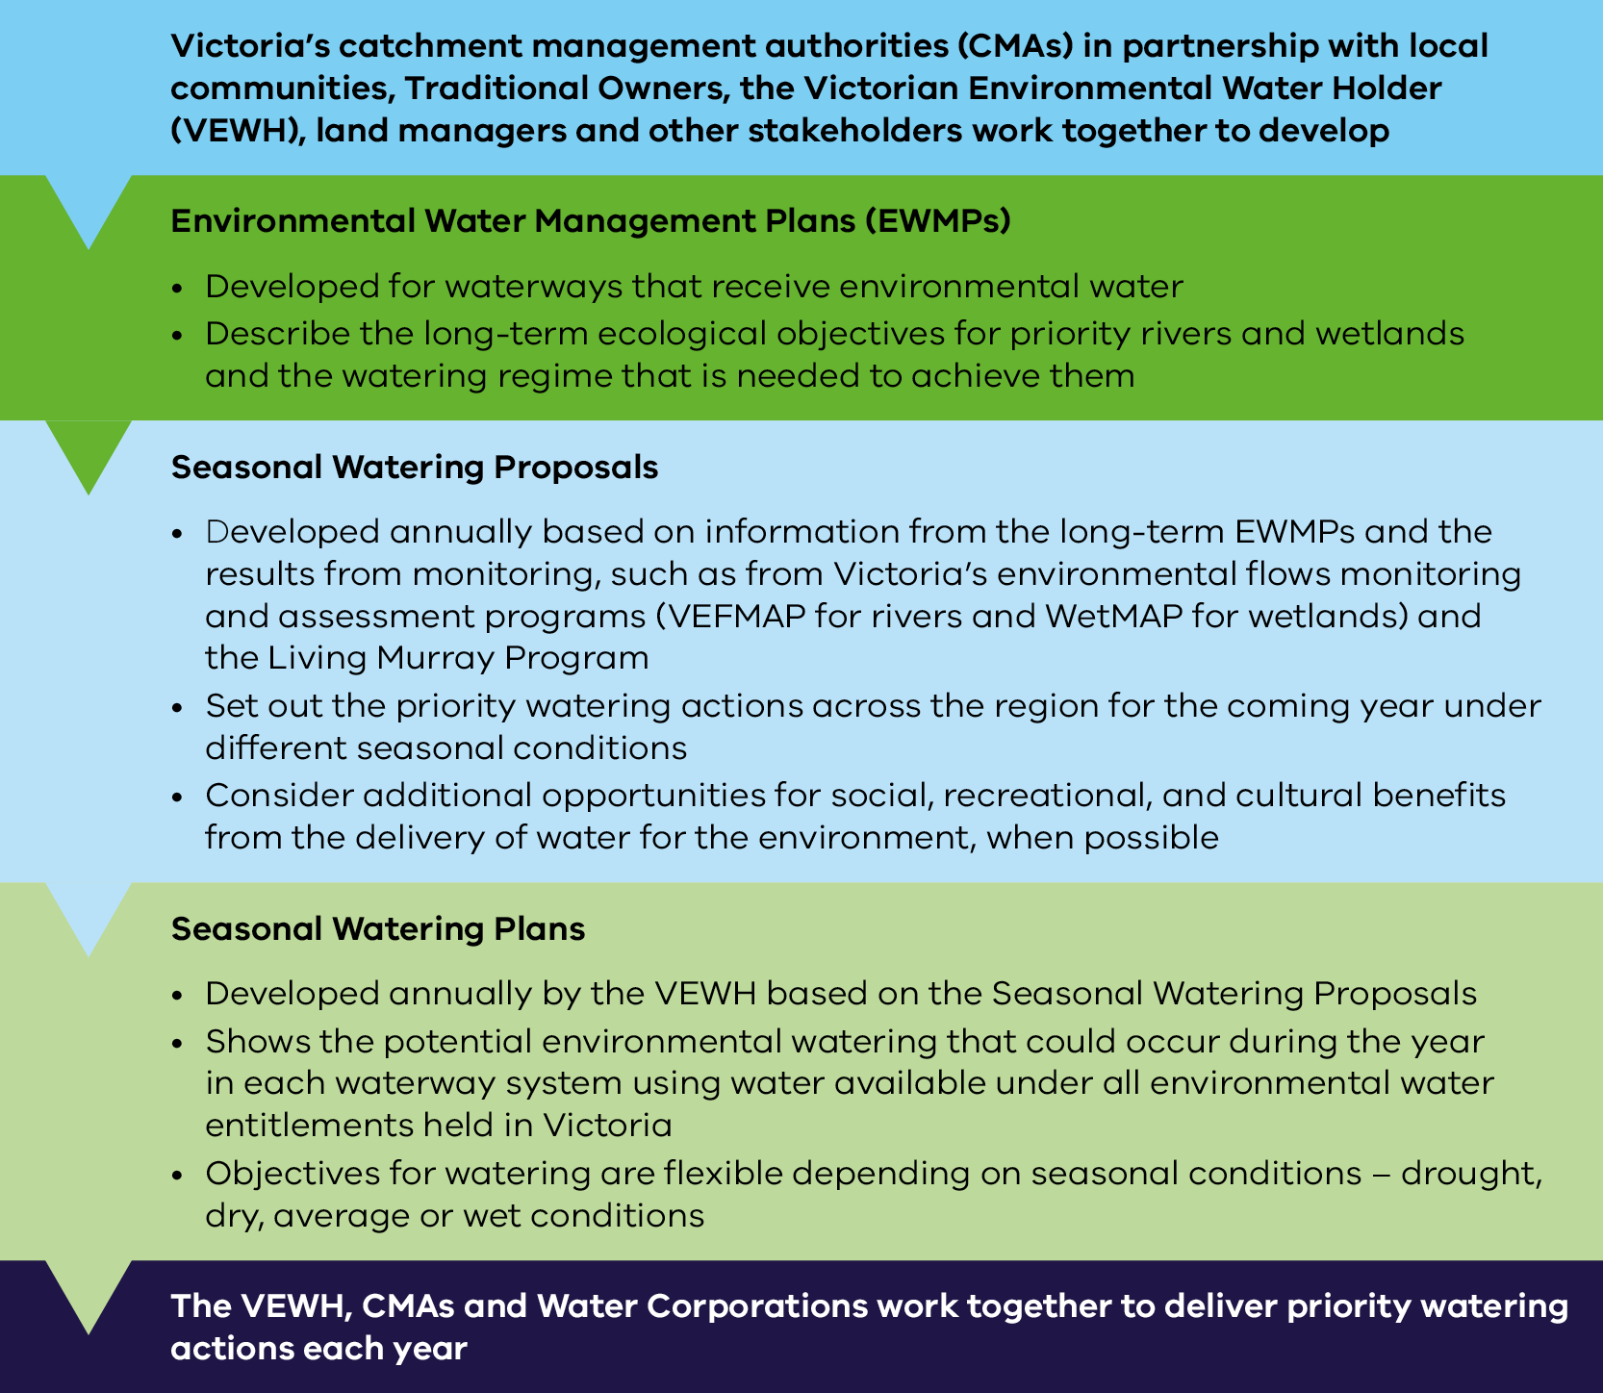
Victoria’s framework to deliver Basin Plan environmental objectives is outlined in Figure 3. This shows the relationship between:
- legislation and planning documents (the Basin Plan, BEWS, and the State’s WRPs, LTWPs, EWMPs and SWPs)
- implementation and delivery
- monitoring and evaluation
- reporting, and
- improvement to support legislative and adaptive management needs.
Figure 3: Victorian framework to deliver Basin Plan objectives.
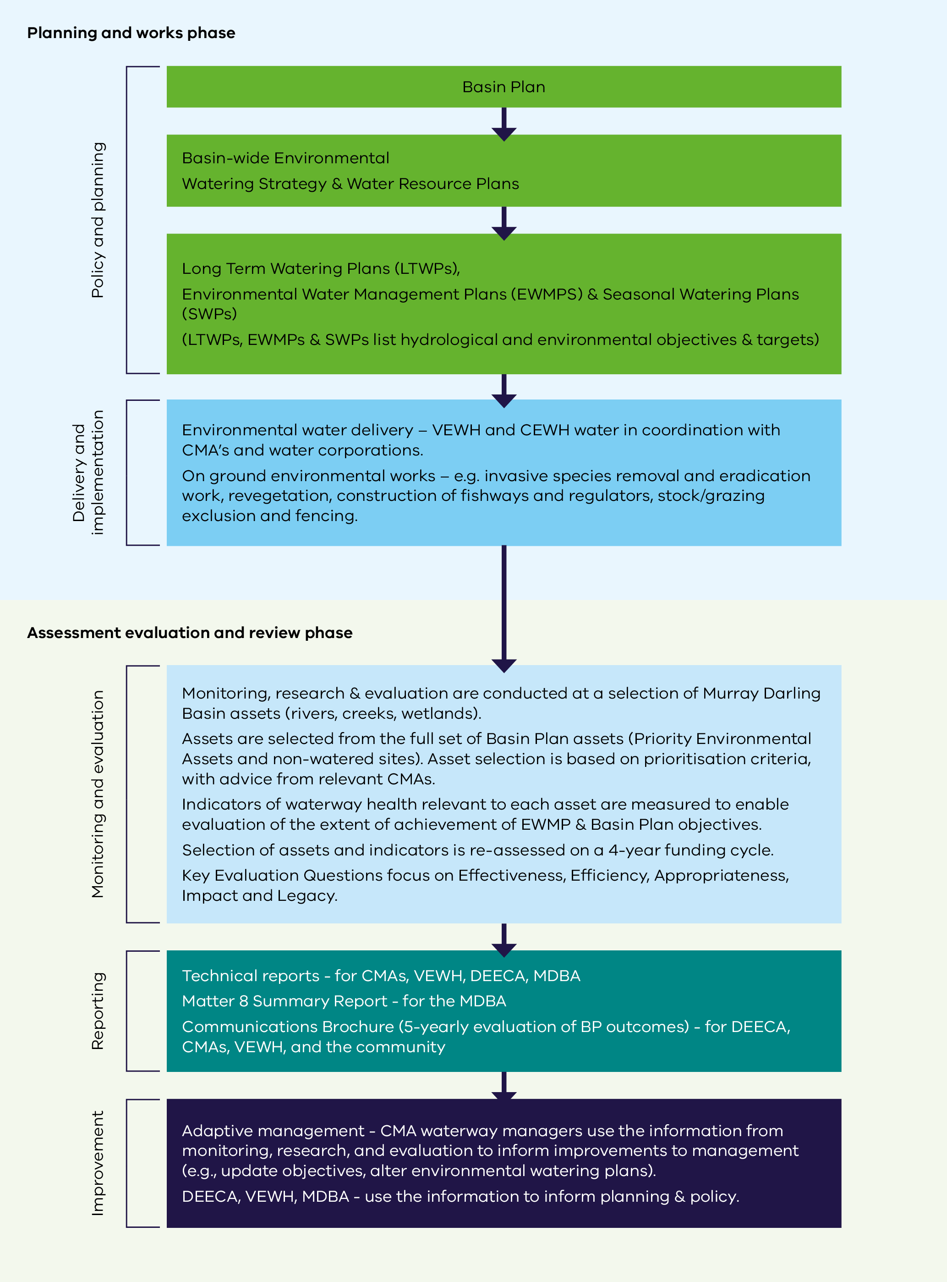
At its core, Victoria’s Basin Plan monitoring, evaluation, and reporting (MER) program is guided by the following questions.
- To what extent have EWMP and related Basin Plan outcomes and objectives been achieved at Victorian assets?
- If environmental objectives were not met, why not?
- To what extent did flow management contribute to environmental outcomes and the achievement of the environmental objectives?
- To what extent did non-flow factors affect environmental outcomes and the achievement of environmental objectives?
- To what extent did the Basin Plan contribute to achieving the environmental outcomes and objectives?
As noted, assessing the relative contribution of flow management to the achievement of environmental outcomes in the Basin (question (iii), above) is challenging.
To the extent possible, high-level answers to these questions have been provided within the Synopsis of this Summary Report. For a more detailed and comprehensive assessment and explanation of Victoria’s approach to Basin Plan MER, please refer to the technical reports noted in the section above.

Selection of priority environmental assets for monitoring
This report focuses on 54 priority environmental assets (rivers, creeks, floodplains, and wetlands identified in Victoria’s LTWPs) where environmental water can be delivered, and monitoring data is available. These assets are monitored because of their ecological importance, role in maintaining biological diversity, regional significance, and, for some assets, recognition under the International Convention on Wetlands (Ramsar, 1971, original_1971_convention_e.pdf (ramsar.org)).
Victoria’s priority environmental assets vary considerably from one another both in space and time with respect to size, degree of permanency, location in the catchment, values and threats, and adjacent land-use. This variation is also represented in the subset of assets that are monitored and thus the relative ecological importance of reported assets varies too.

Waterway health indicators
Victoria selects waterway health indicators for Basin environmental water monitoring and assessment programs based on LTWP and EWMP objectives and targets. Indicators are prioritised for investigation according to their fundamental importance to ecology, management significance, and alignment with the ecological components (themes) presented in the BEWS (MDBA 2019) and Basin Plan Schedule 7. These themes include:
- river flows and connectivity
- native vegetation
- waterbirds
- native fish.
Specific indicators are selected based on ecological significance for each theme - for example, native fish spawning, recruitment and abundance, waterbird breeding and abundance, native vegetation species richness, cover, and extent.
A variety of other ecological components are included in EWMP objectives across northern Victoria (e.g.,
platypus, rakali, macroinvertebrates), depending on regional values and priorities, and key processes and functions at each asset. Monitoring of these components is relatively limited; however, additional evidence is collected where this is deemed appropriate (e.g., for frog monitoring at selected assets).
Each of the ecological components (themes) and their respective waterway health indicators are not monitored at every priority environmental asset featured in this report. The significance of this point is expanded upon below.
Finally, monitoring conducted in the Goulburn River for the CEWH’s Flow-MER program addresses the four BEWS themes as well as a series of waterway health indicators related to riverbank erosion and deposition, metabolism, and food webs.

Assessing environmental outcomes and the achievement of Basin Plan objectives – Victoria’s approach to compiling this report
The assessment of environmental outcomes and objectives presented in this report was based on expert opinion, backed by empirical data. Assessments were conducted by the scientists who deliver the monitoring programs, and the results were checked and confirmed by the relevant environmental water managers for each priority environmental asset. Assessments were based on the change in condition status of waterway health indicators in the context of the Basin Plan Chapter 5 and 8 objectives. An assessment of current environmental condition was not conducted for this report.
Scientists first:
- assessed the change in status of each indicator for each asset, relative to the relevant Basin Plan chapter 5 and 8 objectives, using the categories described below
- assessed the Data Quality that each assessment was based on (criteria listed below)
- provided contextual information on flow and non-flow factors (where available) that may have influenced the results.
These assessments were then reviewed by the relevant CMA environmental water managers, who provided additional contextual information where needed and where available.
When assessing and reviewing the environmental outcomes for each indicator and asset, scientists and environmental water managers considered results relative to levels of natural variation and expected outcomes for the different assets, given prevailing conditions. An assessment of Red, for example, indicates decline beyond the acceptable level of natural variation expected given the environmental conditions experienced at the asset since commencement of the Basin Plan.
Table 2: The status of environmental outcomes and Basin Plan objectives is represented by four categories:
Category | Explanation of Category
 | There is evidence that the status of the asset has improved, or a ‘good condition’ status has been maintained since 2012 = There is evidence the Basin Plan objective (‘to protect and restore’) is being met
 | The asset status/condition has been maintained (e.g., as ‘average to average’ or ‘poor to poor’) = The extent to which the Basin Plan objective has been achieved is unclear – there is no evidence of restoration (improvement), but some degree of protection (maintenance) is apparent
 | There is evidence that the status of the asset has declined since 2012 = Basin Plan objective (‘to protect and restore’) is not being achieved
? | No trend identifiable
Data Quality reflects the type and adequacy of available data:
- not enough data available to make an assessment (indictors have not been reported where this is the case)
- limited evidence and expert opinion-based assessments
- adequate data to make a qualitative assessment
- high-quality data that would support a quantitative assessment.
Assessors were asked to decide (i) if the status of the indicator had improved, been maintained, or declined, and (ii) if the status was maintained, was the status of the indicator considered ‘good’. When the later was the case, assessors assigned the environmental outcome a ‘green status’ because the asset has been protected and is adequately restored, according to Basin Plan objectives and Schedule 7 targets. In this case, there is sufficient evidence that the Basin Plan objective has been achieved for the indicator/asset pairing, which aligns with a ‘green status’ assessment.
The decision not to conduct an explicit assessment of environmental condition was made for two reasons:
- defining a baseline environmental condition from which to measure a ‘good, average, poor’ condition (or any alternative descriptors for condition) is subjective and influenced by personal bias and experiences, and
- Victoria’s baseline and definition of ‘good, average, poor’ (or alternatives) might differ from those used by the other Basin states. Therefore, reporting could inadvertently and inaccurately suggest better or worse environmental outcomes in Victoria, relative to other parts of the Murray-Darling Basin.

Approach to reporting on environmental outcomes and Chapter 8 objectives
The results section of this report is presented in two parts.
Part 1 provides high-level information for each priority environmental asset on environmental outcomes (change in condition status over time), waterway location and characteristics, key environmental values, years of data collection, and potential flow and non-flow influences (where available) on environmental outcomes. It also reports on the Data Quality for the asset assessment.
To help contextualise results, the report provides outputs from the VEWH’s eFlow Projector tool (eFlow Projector – Assess the performance of environmental watering objectives), which includes a summary of the achievement of potential watering actions for each asset, annually since 2019-20 (when the tool was created). In this context, a ‘potential watering action’ refers to the different flow types required by assets to achieve environmental objectives outlined in EWMPs and SWPs (e.g., spring or autumn freshes, winter or summer low flows, partial or full fills for wetlands). Importantly, these flow types do not include overbank flows, they only include actions that can be delivered using available holdings, within system constraints. Notably, the total number of potential watering actions per asset (‘n’) over the last four years is variable, with ‘n’ depending on the flow requirements for each asset (outlined in EWMPs). For example, while many of the rivers have 10 or more potential watering actions across the four years, some wetlands have only one potential watering action, because the hydrological needs of the asset will be met through watering once every four (or more) years. Further, potential watering actions can be achieved through both environmental water deliveries and natural flows, so the number of watering actions achieved per asset may be greater than the number of years when environmental water was delivered (displayed for each asset), due to the occurrence of natural flooding in intervening years (also displayed).
Part 2 of this report presents a summary of the achievement of Basin Plan objectives for each environmental theme at each asset; this is presented on an objective-by-objective basis. No comments have been made on the overall achievement of each Basin Plan objective at each asset.
The objectives assessed in Part 2 were drawn from Basin Plan Chapter 8 (as well as Chapter 5) because these objectives provide a more detailed explanation of the intended environmental outcomes from management in the Basin. For reference, Appendix A describes Victoria’s approach to aligning the objectives in Chapter 5 and Chapter 8.
As noted above, each of the ecological themes and their respective waterway health indicators is not monitored at every priority environmental asset featured in this report. Consequently, the achievement of all Chapter 8 outcomes and objectives is not reported for all assets. Instead, the achievement of Basin Plan objectives is only reported for the assets where relevant monitoring took place and/or for which the objective is relevant (e.g., the extent of achievement of objective 8.05 (2)(a) Ramsar wetlands maintain their ecological character is only reported for Ramsar sites).

Figure 4: Environmental outcome indicators monitored for each environmental theme reported in Part 1 of this report.
Theme | Indicators
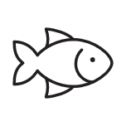 | - Fish – recruitment, spawning  - Fish – species richness, diversity &/or relative abundance  - Fish – Movement (migration & dispersal), distribution  - Murray hardyhead presence  - Fish – Proportion of native species
 | - Understorey vegetation – cover, extent, species richness (native species)  - Understorey vegetation – cover, extent, species richness (invasive species)  - Understorey vegetation – recruitment
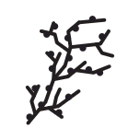 | Lignum condition
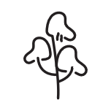 | Tree condition
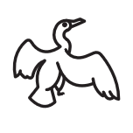 | - Waterbird – breeding  - Waterbird – species richness, diversity &/or abundance
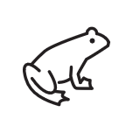 | Frogs – species richness
 | Bank stability – erosion, deposition
 | Primary production and respiration

Results – Achievement of environmental outcomes and Basin Plan objectives

Part 1: Achievement of environmental outcomes at Victorian Priority Environmental Assets
This section of the report is divided into the three Victorian WRP areas, with asset descriptions grouped by river system and wetland complex. Throughout this section of the report common names are used to denote species (see Appendix C for scientific names). Outcomes for international migratory bird species have only been reported at assets with suitable habitat to support them (determined by the relevant waterbird monitoring leads and CMA waterway managers for each asset). The achievement of environmental outcomes represents the change in condition status for each reported indicator since 2012.

Northern Victoria
The Northern Victoria WRP area (Figure 5) is dominated by northerly flowing river systems connected to the Murray River downstream of the junction with the Kiewa River. It includes the Ovens, Goulburn, Broken, Campaspe and Loddon Rivers, and associated wetlands. Note that nearby wetlands associated with the Murray River (e.g., Barmah Forest) lie in the Victorian Murray WRP area immediately to the north.

Figure 5: Priority environmental assets within the Northern Victorian WRP area (not all assets are monitored or assessed in this report).
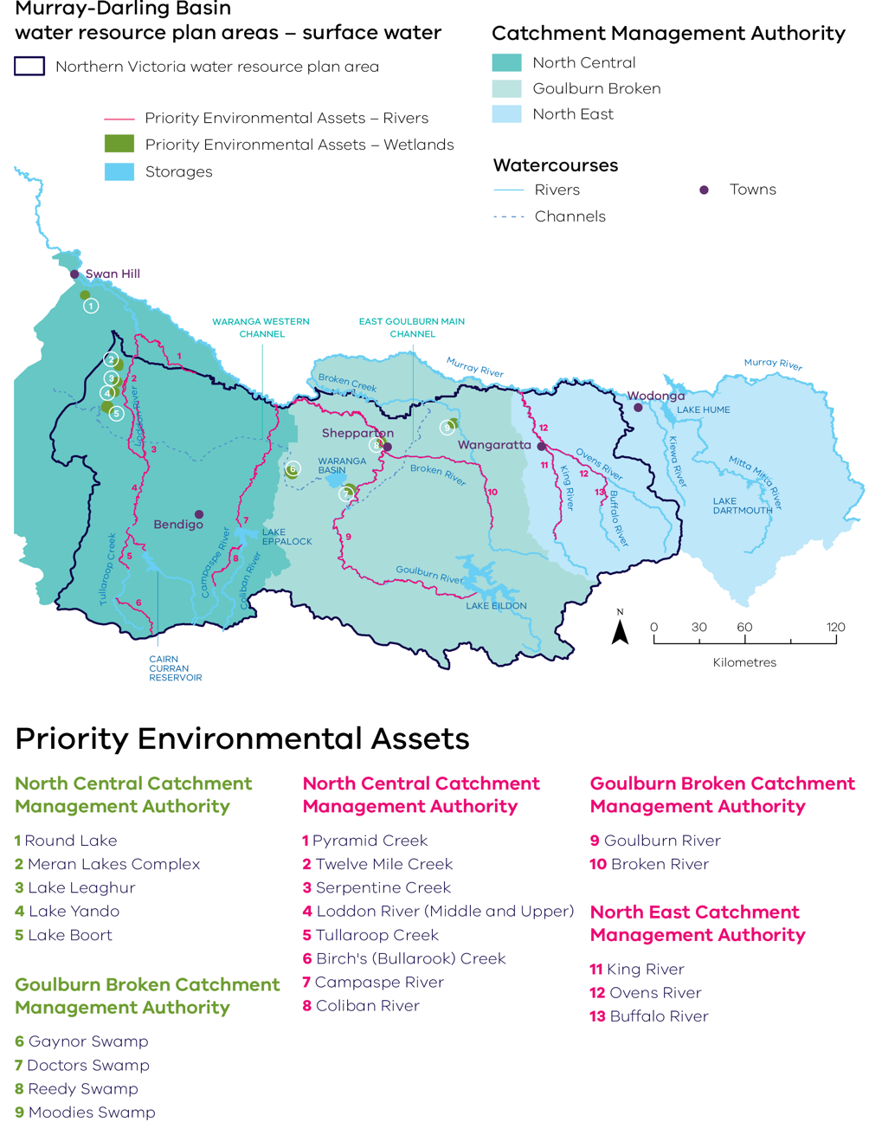

Broken System

Broken River
Richness, diversity, abundance  (non-threatened spp.) | Richness, diversity, abundance  (threatened spp.) | Movement,  distribution | Recruitment, spawning
Improving trend &/or good condition maintained  DATA QUALITY = 4 | Improving trend &/or good condition maintained  DATA QUALITY = 4 | Average or poor status has been maintained  DATA QUALITY = 2 | Average or poor status has been maintained  DATA QUALITY = 3
Note: Data collection period – Fish – 2007-24.
 | 2022-23 | 2021-22 | 2020-21 | 2019-20 | 2018-19 | 2017-18 | 2016-17 | 2015-16 | 2014-15 | 2013-14
Flooding | F | - | - | - | - | - | F | - | - | -
*E-water | 2,502 | 510 | - | - | 250 | 1,000 | - | - | - | -
Flood occurrence was based on the Bureau of Meteorology (BOM) flood classification and includes minor, moderate & major floods at Caseys Weir flow gauge.
*Volumes of environmental water (megalitres, ML) delivered in the Broken River since 2017.
Chart 1: Achievement of planned watering actions, 2019–2023
(Total actions = 12)
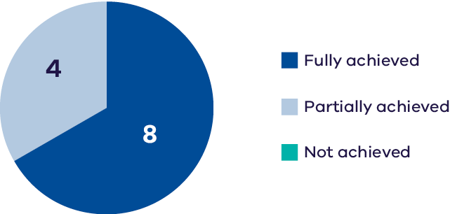
The Broken River is a tributary of the Goulburn River that flows through Taungurung and Yorta Yorta Country, rising in the highlands and flowing in a north-easterly direction to join the Goulburn River near Shepparton. The Lower Broken River retains healthy in-stream vegetation, with a diversity of submerged and aquatic plant species. This vegetation provides habitat for a range of native fish species including Murray cod (EPBC-listed), silver perch, southern pygmy perch, golden perch, Macquarie perch, mountain galaxias and Murray-Darling rainbowfish.
The highest priority for environmental watering in the Broken River, under all climatic conditions, is to maintain spring and summer baseflows. Spring and summer are the most important periods for instream production and native fish, macroinvertebrate and platypus movement and reproduction. Summer low flows also help to maintain water quality, which is often at greatest risk at this time of the year due to high ambient temperatures. The next priority is to provide autumn low flows, which is an important time for dispersal of juvenile platypus.
Outcomes from monitoring and research in the Broken River include:
- evidence of increasing populations of several fish species (e.g., Murray cod, river blackfish (restricted distributions), golden perch and Macquarie perch (restricted distributions)) since 2012, and maintenance of species composition.
- frequent recruitment for several species (e.g., Murray cod, Murray-Darling rainbowfish) and population recovery, which highlights the resilience of system however in-frequent recruitment for several other species (e.g. trout cod, golden perch, Macquarie perch) with no change since 2012.
several physical barriers (e.g., Gowangardie Weir and Casey’s Weir) are preventing migration of threatened species from the Goulburn River and limiting longitudinal connectivity.
Based on the available data and indicators measured, six Basin Plan Chapter 8 objectives were assessed for the Broken River. A measure of the extent to which these objectives have been achieved is provided in Part 2.

Broken Creek
Richness, diversity, abundance  (non-threatened spp.) | Richness, diversity, abundance  (threatened spp.) | Movement,  distribution | Recruitment,  spawning
Average or  poor status has been maintained  DATA QUALITY = 4 | Declining  trend  DATA QUALITY = 4 | Improving trend &/or good condition maintained  DATA QUALITY = 3 | Average or  poor status has been maintained  DATA QUALITY = 4
Extent, cover,  richness – native species | Extent, cover,  richness – invasive species | Recruitment
Average or  poor status has been maintained  DATA QUALITY = 3 | Average or  poor status has been maintained  DATA QUALITY = 3 | Average or  poor status has been maintained  DATA QUALITY = 3
Note: Data collection period – Fish –2005-24; Understorey vegetation – 2022-24.
 | 2022-23 | 2021-22 | 2020-21 | 2019-20 | 2018-19 | 2017-18 | 2016-17 | 2015-16 | 2014-15 | 2013-14
Flooding | F | - | - | - | - | - | - | - | - | -
*E-water | 48,574 | 71,163 | 34,890 | 36,350 | 33,847 | 41,408 | 36,364 | 30,320 | 34,693 | 38,594
Flood occurrence was based on the BOM flood classification and includes minor, moderate & major floods at Nathalia flow gauge.
*Volumes of environmental water (megalitres, ML) delivered in the Broken Creek since 2013.
Chart 2: Achievement of planned watering actions, 2019–2023
(Total actions = 17)
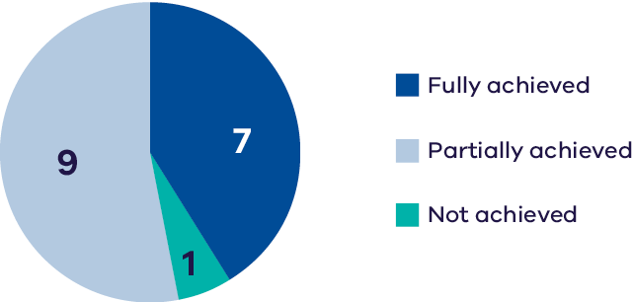
Broken Creek is a distributary channel of the Broken River on Yorta Yorta Country, which flows from the river near Winton and discharges to the Murray River near Barmah Forest. The upper reaches are dominated by grey box riparian vegetation and the waterway provides habitat for platypus and eastern long-necked turtles. Broken Creek supports a diverse and abundant native fish community including Murray cod and critically endangered silver perch, as well as small-bodied species such as FFG-listed Murray-Darling rainbowfish. Upper Broken Creek, together with the Broken River are listed in the Directory of Important Wetlands in Australia.
The Upper Broken Creek has a perennial water regime, due to ongoing diversions to supply irrigators between Casey’s Weir and Waggarandall Weir. There is a small environmental water allocation that is mainly used to maintain baseflows, especially during spring and summer, which is the most important time for instream production as well as native fish, macroinvertebrate, and platypus movement and reproduction. Summer environmental flows also help to maintain water quality, which is often at greatest risk at this time of the year due to high ambient temperatures (Goulburn Broken CMA 2024).
Lower Broken Creek is a heavily modified system with a highly regulated flow regime. Significant past disturbances have impacted the creek, including channelisation, livestock grazing, land clearing, alien species and altered hydrology. Riparian plant species cover, extent and diversity are all limited by the constrained hydrological regime, and the narrow riparian zone is dominated by few competitive species.
Outcomes from monitoring and research in the Lower Broken Creek indicated:
- flow management was effective in improving native fish diversity and abundance for both threatened and non-threatened species from 2012 to 2022. However, a significant fish death event in late spring 2022 severely impacted the community and population numbers are still below those recorded pre-Basin Plan (2012).
- two threatened fish species (trout cod and river blackfish) have not been detected in the system since the 2022 event; Murray cod numbers were also seriously affected.
the extent, cover, species richness and recruitment of riparian plant species has been maintained with no change since 2012 due to a lack of natural variability in the flow regime.
Based on the available data and indicators measured, six Basin Plan Chapter 8 objectives were assessed for Broken Creek. A measure of the extent to which these objectives have been achieved is provided in Part 2.

Moodie Swamp
Extent, cover, richness – native species | Extent, cover, richness – invasive species | Black box &/or river red gum condition | Abundance, species richness  (non-threatened & migratory spp.)
No trend  identifiable  DATA QUALITY = 2 | No trend  identifiable  DATA QUALITY = 2 | Improving trend &/or good condition maintained  DATA QUALITY = 3 | Improving trend &/or good condition maintained  DATA QUALITY = 3
Abundance, species richness  (threatened spp.) | Breeding | Species richness  (non-threatened spp.)
Improving trend &/or good condition maintained  DATA QUALITY = 3 | Average or  poor status has been maintained  DATA QUALITY = 2 | Improving trend &/or good condition maintained  DATA QUALITY = 3
Note: Data collection period – Wetland understorey vegetation – 2014-24; Trees – 2014-24; Birds – 2014-24; Frogs – 2018-24.
 | 2022-23 | 2021-22 | 2020-21 | 2019-20 | 2018-19 | 2017-18 | 2016-17 | 2015-16 | 2014-15 | 2013-14
Flooding | F | F | - | - | - | F | F | - | - | F
*E-water | - | 1,006 | - | - | - | 500 | - | 500 | 500 | 121
Flood occurrence is indicated by an ‘F’ when the wetland filled from natural catchment runoff or inflows.
*Volumes of environmental water (megalitres, ML) delivered in Moodie Swamp since 2013.
Chart 3: Achievement of planned watering actions, 2019–2023
(Total actions = 3)
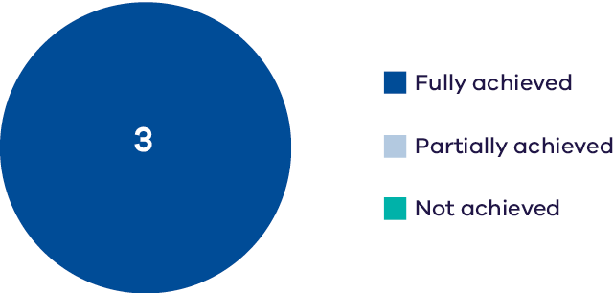
Moodie Swamp is a 180 ha southern cane grass wetland located on Yorta Yorta Country. It is managed by Parks Victoria and is part of the Moodie Swamp Wildlife Reserve. It is located on the floodplain of the upper Broken Creek approximately 40
km north of Benalla and is listed as a wetland of national importance as part of the Broken Creek system. Moodie Swamp provides important brolga breeding habitat and habitat for other wetland dependent fauna species. Since monitoring of the waterway began in 2008, 65 species of wetland dependent fauna and 42 species of wetland dependent flora have been recorded at the asset. The latter includes the EPBC-listed rigid water-milfoil.
Optimal watering conditions for the swamp include a six-month duration of inundation in five out of 10 years, allowing for essential dry periods. Water for the environment is critical to maintaining ecological objectives, as the swamp would otherwise only receive water in times of high flows or flooding in the Broken Creek; in a drying climate this has the potential to significantly impact ecological values.
On-ground works to improve the efficiency and effectiveness of environmental water deliveries to Moodie Swamp are currently underway and expected to be completed by 2025. These works will reduce delivery losses and increase the delivery capacity from less than 10 ML/day to 20 ML/day.
Monitoring indicated:
- relatively high species richness of frogs.
- continued high tree stand condition since 2014.
- uncertainty related to wetland understorey vegetation, with more monitoring needed to be confident about its condition.
- high waterbird diversity and abundance in recent surveys, despite wide availability of alternative waterbird habitat at the time due to flood conditions. Serval observations of breeding by Brolgas in 2023, however there have been no confirmed waterbird breeding events during monitoring surveys at this waterway.
occurrence of waterbird species listed as threatened in Victoria, including plumed egrets and brolga.
Based on the indicators measured, five Basin Plan Chapter 8 objectives were assessed for Moodie Swamp. A measure of the extent to which these objectives have been achieved is provided in Part 2 of this report.

Campaspe System

Campaspe River
Species richness, diversity, abundance  (non-threatened spp.) | Species richness, diversity, abundance  (threatened spp.) | Movement, distribution | Recruitment, spawning
Improving trend &/or good condition maintained  DATA QUALITY = 4 | Average or  poor status has been maintained  DATA QUALITY = 4 | Average or  poor status has been maintained  DATA QUALITY = 4 | Improving trend &/or good condition maintained  DATA QUALITY = 4
Extent, cover, richness – native species | Extent, cover, richness – invasive species | Recruitment
Improving trend &/or good condition maintained  DATA QUALITY = 4 | Improving trend &/or good condition maintained  DATA QUALITY = 4 | Improving trend &/or good condition maintained  DATA QUALITY = 4
Note: Data collection period – Fish – 2007-24; Understorey vegetation – 2016-24.
 | 2022-23 | 2021-22 | 2020-21 | 2019-20 | 2018-19 | 2017-18 | 2016-17 | 2015-16 | 2014-15 | 2013-14
Flooding | F | - | - | - | - | - | F | - | - | -
*E-water | 13,856 | 25,822 | 25,030 | 20,438 | 23,356 | 29,584 | 5,551 | 13,658 | 30,729 | 14,565
Flood occurrence was based on the BOM flood classification and includes minor, moderate & major floods at Rochester siphon flow gauge.
*Volumes of environmental water (megalitres, ML) delivered in the Campaspe River since 2013.
Chart 4: Achievement of planned watering actions, 2019–2023
(Total actions = 16)
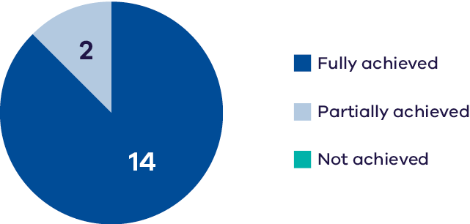
The Campaspe River flows through Dja Dja Wurrung, Taungurung and Yorta Yorta
Country rising in the central highlands of the Great Dividing Range, before flowing into the major storage at Lake Eppalock. The river then continues from Lake Eppalock in a northerly direction to discharge into the Murray River at Echuca. The river has a narrow riparian zone dominated by large river red gums. It supports important native fish species such as Murray cod, silver perch, Murray-Darling rainbowfish and golden perch, as well as platypus, rakali, turtles and frogs.
Water for the environment is primarily used in the Campaspe River (downstream of Lake Eppalock) to improve the magnitude and variability of flow during winter and spring, but it is also used to deliver critical flow in summer and autumn that is not met by operational deliveries. The Campaspe is subject to inter-valley transfers that deliver consumptive water from Lake Eppalock and the Western Waranga Channel (at Rochester) to the Murray River (or downstream). This can result in high flows in summer and autumn when the Campaspe River would naturally have low flow, which can have negative effects on juvenile fish and streamside vegetation. As part of water management for environmental outcomes, storage managers and the North Central CMA have been working cooperatively to better align flows with environmental recommendations.
Monitoring indicates:
- improvements in riparian vegetation over the period 2007-2024. On the lower banks, environmental water is the primary driver for suppressing terrestrial vegetation encroachment and promoting native riparian species. Responses to recent flood events (2022 and 2024) indicate resilience to periodic extreme climate events, particularly for upper bank vegetation.
- increased recruitment frequency of Murray cod and Murray-Darling rainbowfish.
- increasing abundance of Murray cod, golden perch, silver perch and Murray-Darling rainbowfish, however little change in the diversity of threatened fish species since 2012, noting several threatened species that were historically present remain absent from the system.
- an increase in alien fish species (especially carp) in high rainfall years.
the system is still impacted negatively by intervalley transfers, and two major structural barriers (Campaspe Weir and the Campaspe Syphon) significantly impact the movement and dispersal of native fish.
Based on the indicators measured, six Basin Plan Chapter 8 objectives were assessed for the Campaspe River. A measure of the extent to which these objectives have been achieved is provided in Part 2 of this report.

Goulburn System

Lower Goulburn River
Species richness, diversity, abundance  (non-threatened spp.) | Species richness, diversity, abundance (threatened spp.) | Movement,  distribution | Recruitment,  spawning
Improving trend &/or good condition maintained  DATA QUALITY = 4 | Average or poor  status has been maintained  DATA QUALITY = 4 | Improving trend &/or good condition maintained  DATA QUALITY = 3 | Improving trend  &/or good condition maintained  DATA QUALITY = 4

Extent, cover, richness – native species | Extent, cover, richness –  invasive species | Recruitment | Bank stability – erosion,  deposition | Primary  production & respiration
Average or poor status has been maintained  DATA QUALITY  = 4 | Average or poor status has been maintained  DATA QUALITY  = 3 | Average or poor status has been maintained  DATA QUALITY  = 3 | Improving trend &/or good  condition maintained  DATA QUALITY  = 4 | Improving trend &/or good  condition maintained  DATA QUALITY  = 4
Note: Data collection period – all themes – 2014-2024.
 | 2022-23 | 2021-22 | 2020-21 | 2019-20 | 2018-19 | 2017-18 | 2016-17 | 2015-16 | 2014-15 | 2013-14
Flooding | F | - | - | - | - | - | F | - | - | -
*E-water | 220,946 | 447,372 | 238,932 | 401,881 | 225,580 | 354,832 | 229,753 | 228,243 | 309,371 | 312,349
Flood occurrence was based on the BOM flood classification and includes minor, moderate & major floods at McCoys Bridge flow gauge.
*Volumes of environmental water (megalitres, ML) delivered in the Goulburn River since 2013.
Chart 5: Achievement of planned watering actions, 2019–2023
(Total actions = 14)
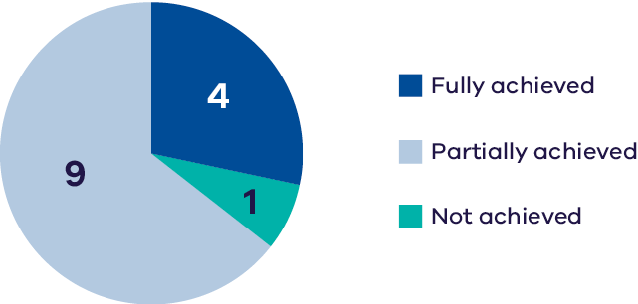
The Goulburn River rises on Taungurung Country in the Great Dividing Range upstream of Woods Point and flows through to Yorta Yorta Country, meeting the Murray River east of Echuca. Downstream of Lake Eildon, the Goulburn is a declared Victorian Heritage River in recognition of its important ecological and social values. The waterway is lined with river red gums and supports a variety of native fish species including Murray cod, golden perch, trout cod, freshwater catfish and silver perch.
The Lower Goulburn River comprises the reaches downstream of Goulburn Weir and is characterised by the Lower Goulburn National Park, which includes the riparian and floodplain forests from Shepparton to the confluence with the Murray River. Citizen science monitoring programs indicate the mid-Goulburn River supports a strong population of platypus, which are now classified as vulnerable in Victoria.
The construction and operation of Lake Eildon and Goulburn Weir have significantly altered the natural flow regime of the Goulburn River. Water harvesting during wet periods, and releases to meet irrigation and other consumptive demands during dry periods, mean that flow below these structures is typically low in winter/spring and high in summer/autumn – the reverse of the natural seasonal flow pattern. Using environmental water to maintain year-round baseflows (particularly in winter and spring) is a priority in the Lower Goulburn River (environmental water is also used to provide spring and autumn freshes).
The achievement of environmental outcomes in the Goulburn River since 2012 has not been limited by availability of water for the environment, but by operational constraints limiting the ability to inundate the floodplain. This continues to impede the benefits associated with environmental flows. A high demand for inter-valley transfers (IVT) of consumptive water from the Goulburn to the River Murray during summer/autumn has also affected environmental condition over the past 12 years. New operating rules for the Goulburn River have been in place since July 2022; these will prevent sustained, extremely high flows occurring in summer/autumn, which should reduce the risk to the environment.
Monitoring indicates:
- environmental water is resulting in positive outcomes for riverbank condition. Spring freshes followed by low summer flows (recent high natural flows have reduced the need for IVT flows during summer), allowed the banks to recover from past erosive damage (caused by high IVT-demand). This is evident from the deposition of sediment and seeds and colonisation of new vegetation. A positive feedback loop exists between vegetation presence and bank resilience, with more stable banks allowing for the expansion of vegetation cover, which in turn consolidates sediment and encourages deposition through increased roughness, thereby increasing bank stability further.
- environmental water was also linked to favourable outcomes for in-channel productivity demonstrated by the amount of organic carbon created via gross primary production and the mass of organic carbon consumed each day via ecosystem respiration. These processes are critical for the maintenance of riverine food webs.
- overall increases in abundance of common native fish species since 2012 (e.g., Australian smelt, carp gudgeon).
- minimal change in the abundance of threatened fish species (e.g., Murray cod, trout cod, river blackfish) over the long-term with slight declines in recent years for several species (e.g. silver perch, Murray-Darling Rainbowfish.
- increased spawning of golden perch (which has been directly linked to environmental water deliveries), strong annual recruitment of Murray cod, trout cod and Murray-Darling rainbowfish, and episodic recruitment of golden perch and silver perch.
- an increase in alien fish species (especially carp) in high rainfall years.
riparian and instream vegetation has been positively influenced by environmental water, with an increase in native species cover at some waterways; however, the negative impacts of high summer IVT flows in 2016-17 and 2017-18 are still being observed.
Based on the indicators measured, eight Basin Plan Chapter 8 objectives were assessed for the Lower Goulburn River. A measure of the extent to which these objectives have been achieved is provided in Part 2 of this report.

Doctors Swamp
Extent, cover, richness –  native species | Extent, cover, richness – invasive species | Species richness  (non-threatened spp.)
Improving trend &/or good condition maintained  DATA QUALITY = 3 | Improving trend &/or good condition maintained  DATA QUALITY = 3 | Average or poor status  has been maintained  DATA QUALITY = 3
Note: Data collection period – Wetland understorey vegetation – 2015-23; Frogs – 2018-24.
 | 2022-23 | 2021-22 | 2020-21 | 2019-20 | 2018-19 | 2017-18 | 2016-17 | 2015-16 | 2014-15 | 2013-14
Flooding | F | - | F | - | - | F | F | - | F | F
*E-water | - | 427 | - | 67 | - | - | - | 594 | - | -
Flood occurrence is indicated by an ‘F’ when the wetland filled from natural catchment runoff or inflows.
*Volumes of environmental water (megalitres, ML) delivered in Doctors Swamp since 2015.
Chart 6: Achievement of planned watering actions, 2019–2023
(total actions = 3)
Doctors Swamp is a 200-ha red gum swamp located on Yorta Yorta Country, is managed by Parks Victoria and is part of the Doctors Swamp Wildlife Reserve. It is considered one of the most intact red gum swamps in Victoria, supporting over 80 wetland plant species, including riverine bittercress and open marshwort both listed as endangered in Victoria. There are also records of the nationally endangered Sloane’s froglet from this wetland.
The surrounding catchment of Doctors Swamp is largely unmodified, and the wetland receives a near natural water regime. Therefore, the wetland only requires environmental water during dry periods where the optimal drying regime of six months has been exceeded, or to enhance natural inundation events to ensure the success of bird breeding events or provide optimal growth conditions for water-dependent vegetation.
Monitoring indicates:
- a moderate species richness of frogs has been maintained including the endangered Sloane’s froglet.
high variability in vegetation condition, but native wetland plant cover has increased since 2022 and richness remained stable. The condition of vegetation has been influenced by both environmental water as well as natural floods.
Based on the indicators measured, three Basin Plan Chapter 8 objectives were assessed for Doctors Swamp. A measure of the extent to which these objectives have been achieved is provided in Part 2 of this report.

Gaynor Swamp
Extent, cover, richness – native species | Extent, cover, richness – invasive species | Black box &/or  river red gum condition | Abundance, species richness  (non-threatened & migratory spp.)
Average or poor status has been maintained  DATA QUALITY = 3 | Average or poor status has been maintained  DATA QUALITY = 3 | Improving trend &/or good condition maintained  DATA QUALITY = 3 | Improving trend &/or good condition maintained  DATA QUALITY = 3
Abundance, species richness  (threatened spp.) | Abundance, species richness (international migratory species) | Breeding | Species richness  (non-threatened spp.)
Improving trend &/or good condition maintained  DATA QUALITY = 2 | Average or poor status has been maintained  DATA QUALITY = 3 | Improving trend &/or good condition maintained  DATA QUALITY = 3 | Average or poor status has been maintained  DATA QUALITY = 2
Note: Data collection period – Wetland understorey vegetation – 2016-24; Trees – 2014-24; Birds – 2012-24; Frogs – 2018-24.
 | 2022-23 | 2021-22 | 2020-21 | 2019-20 | 2018-19 | 2017-18 | 2016-17 | 2015-16 | 2014-15 | 2013-14
Flooding | F | - | F | - | - | - | F | - | - | -
*E-water | - | 901 | 993 | - | 601 | 500 | - | - | - | -
Flood occurrence is indicated by an ‘F’ when the wetland filled from natural catchment runoff or inflows.
*Volumes of environmental water (megalitres, ML) delivered in Gaynor Swamp since 2017.
Chart 7: Achievement of planned watering actions, 2019–2023
(Total actions = 3)
Gaynor Swamp is a southern cane grass wetland located on Taungurung Country that supports large numbers of waterbirds when inundated. It is an important breeding site for brolga. When water levels recede, large numbers of shorebirds such as red-necked avocet forage in the shallow waters. The waterway provides habitat for a wide variety of water dependent and terrestrial fauna species, with over 110 species recorded within the wetland.
The hydrology of Gaynor Swamp changed during the 1940s and 1950s when irrigation was introduced to the area and the swamp was used for disposal of irrigation drainage. This resulted in prolonged inundation causing the death of southern cane grass and river red gums in the deepest part of the wetland.
Environmental water is used to provide optimum wetting and drying regimes to maintain wetland condition. The regulating structure at the south end of the wetland that controls flow from the Cornella Creek is being redesigned and is expected by be completed in 2025. This will assist the management of water levels for environmental outcomes, including maintaining vegetation extent, diversity and condition to provide nesting and feeding materials for waterbirds, especially brolga.
Monitoring indicates:
- tree stand condition has remained high over the past decade.
- understorey wetland plant condition is highly variable spatially and temporally.
- the wetland supports a high diversity and abundance of waterbirds, including hundreds of pied stilt
- international migrant waterbird species of sharp-tailed sandpiper and one white-winged black tern were recorded in 2018 however wet conditions at the wetland in recent years has potentially limited further occurrences.
after extended natural flood conditions, five EPBC-listed Australasian bittern were recorded in spring 2023, and painted snipe have also been sighted.
Based on the indicators measured, six Basin Plan Chapter 8 objectives were assessed for Gaynor Swamp. A measure of the extent to which these objectives have been achieved is provided in Part 2 of this report.

Horseshoe Lagoon
Extent, cover, richness  – native species | Extent, cover, richness – invasive species | Species richness  (non-threatened spp.)
Average or poor status  has been maintained  DATA QUALITY = 3 | Average or poor status  has been maintained  DATA QUALITY = 3 | Average or poor status  has been maintained  DATA QUALITY = 2
Note: Data collection period – Wetland understorey vegetation – 2012-21; Frogs – 2018-24.
 | 2022-23 | 2021-22 | 2020-21 | 2019-20 | 2018-19 | 2017-18 | 2016-17 | 2015-16 | 2014-15 | 2013-14
Flooding | F | - | F | F | F | F | F | F | F | F
*E-water | 70 | 52 | 17 | 121 | - | - | - | - | - | -
Flood occurrence is indicated by an ‘F’ when the wetland filled from natural catchment runoff or inflows.
*Volumes of environmental water (megalitres, ML) delivered in Horseshoe Lagoon since 2019.
Chart 8: Achievement of planned watering actions, 2019–2023
(Total actions = 4)
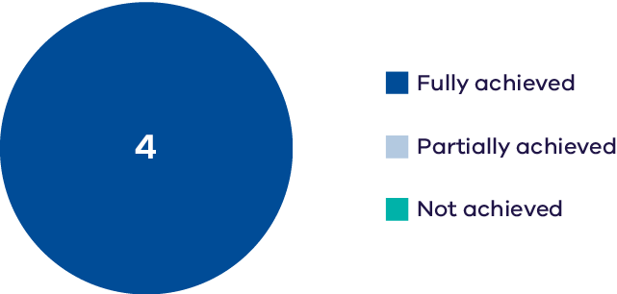
Horseshoe Lagoon is a former channel of the Goulburn River and is located on Taungurung Country between Kerrisdale and Trawool, approximately 15 km south-east of Seymour. The 20 ha lagoon lies largely within the Horseshoe Lagoon Flora and Fauna Reserve, managed by Parks Victoria. The nationally vulnerable river swamp wallaby-grass has been recorded in the wetland.
Monitoring indicates:
- the cover and species richness of both native and invasive understorey vegetation species has varied considerably since 2012.
a moderate species richness of frogs has been maintained.
It is also worth noting that carp invaded the wetland following flooding in 2022-23. This is expected to have a negative impact on wetland vegetation growth and habitat for aquatic fauna.
Based on the indicators measured, three Basin Plan Chapter 8 objectives were assessed for Horseshoe Lagoon. A measure of the extent to which these objectives have been achieved is provided in Part 2 of this report.

Loch Garry
Extent, cover, richness – native species | Extent, cover, richness – invasive species | Species richness  (non-threatened spp.)
Average or poor status has been maintained  DATA QUALITY = 3 | Declining trend  DATA QUALITY = 3 | Average or poor status has  been maintained  DATA QUALITY = 2
Note: Data collection period – Wetland understorey vegetation – 2012-21; Frogs – 2018-24.
 | 2022-23 | 2021-22 | 2020-21 | 2019-20 | 2018-19 | 2017-18 | 2016-17 | 2015-16 | 2014-15 | 2013-14
Flooding | F | - | F | - | F | F | F | - | F | F
*E-water | - | 980 | - | 500 | - | - | - | - | - | -
Flood occurrence is indicated by an ‘F’ when the wetland filled from natural catchment runoff or inflows.
*Volumes of environmental water (megalitres, ML) delivered in Loch Garry since 2019.
Chart 9: Achievement of planned watering actions, 2019–2023
(Total actions = 2)
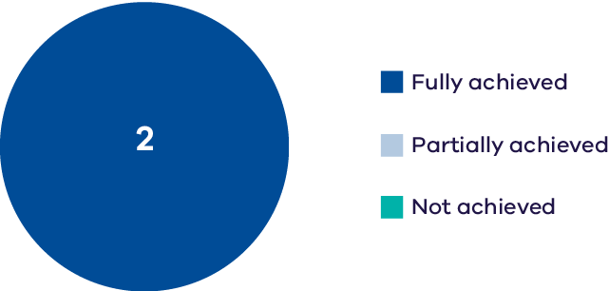
Loch Garry is a 680 ha paleochannel of the Goulburn River located on Yorta Yorta Country that provides deep, open-water habitat. The channel is surrounded by shallow, vegetated wetland depressions, red gum forest, and sand ridges. It is an important waterway for waterbird feeding and roosting, and it is a drought refuge for eastern great egrets, musk ducks, nankeen night herons, and royal spoonbills.
Monitoring indicates:
- the cover and species richness of native understorey vegetation has varied considerably since 2012.
- the cover and species richness of invasive understorey vegetation has increased over time.
a moderate species richness of frogs has been maintained.
Based on the indicators measured, three Basin Plan Chapter 8 objectives were assessed for Loch Garry. A measure of the extent to which these objectives have been achieved is provided in Part 2 of this report.

Reedy Swamp
Extent, cover, richness – native species | Extent, cover, richness – invasive species | Abundance, species richness  (non-threatened & migratory spp.) | Abundance, species richness  (threatened spp.)
Average or  poor status has been maintained  DATA QUALITY = 2 | Average or  poor status has been maintained  DATA QUALITY = 2 | Improving trend &/or good condition maintained  DATA QUALITY = 3 | Average or  poor status has been maintained  DATA QUALITY = 2
Abundance, species richness  (international migratory species) | Breeding | Species richness  (non-threatened spp.)
No trend  identifiable  DATA QUALITY = 2 | Average or  poor status has been maintained  DATA QUALITY = 2 | Improving trend &/or good condition maintained  DATA QUALITY = 2
Note: Data collection period – Wetland understorey vegetation – 2014-20; Birds – 2018-24; Frogs – 2018-24.
 | 2022-23 | 2021-22 | 2020-21 | 2019-20 | 2018-19 | 2017-18 | 2016-17 | 2015-16 | 2014-15 | 2013-14
Flooding | F | F | F | F | - | F | F | F | F | F
*E-water | - | - | - | 500 | 500 | - | - | 356 | - | -
Flood occurrence is indicated by an ‘F’ when the wetland filled from natural catchment runoff or inflows.
*Volumes of environmental water (megalitres, ML) delivered in Reedy Swamp since 2015.
Chart 10: Achievement of planned watering actions, 2019–2023
(Total actions = 2)
Reedy Swamp is a 130 ha wetland located on Yorta Yorta Country on the outskirts of Shepparton, on the floodplain of the Goulburn River. The waterway supports areas of open water and emergent marsh, dominated by giant rush. It provides important foraging and breeding habitat for waterbirds.
Environmental water management at Reedy Swamp is used to manage optimum wetting and drying regimes to maintain wetland condition. It is also used to provide resources and conditions for successful waterbird breeding and to maintain frog populations.
Monitoring indicates:
- no clear trend in wetland vegetation species richness or cover.
- the swamp regularly supports over 1,000 individuals of around 30 waterbird species when inundated during spring and summer, associated with its mosaic of wetland habitats. This often includes species that are relatively uncommon in Victoria such as plumed whistling-duck and glossy ibis.
- intermittent waterbird breeding has been recorded in some years,
- occasional records of the EPBC-listed Latham’s snipe, although not since 2020 however this could potentially be due to flooding in the area providing alternate habitat.
an increase from three to five common frog species recorded.
Based on the indicators measured, six Basin Plan Chapter 8 objectives were assessed for Reedy Swamp. A measure of the extent to which these objectives have been achieved is provided in Part 2 of this report.

Loddon System

Loddon River
Species richness, diversity, abundance  (non-threatened spp.) | Species richness, diversity, abundance  (non-threatened spp.) | Movement, distribution | Recruitment, spawning
Average or  poor status has been maintained  DATA QUALITY = 3 | Average or  poor status has been maintained  DATA QUALITY = 3 | Improving trend &/or good condition maintained  DATA QUALITY = 2 | Average or  poor status has been maintained  DATA QUALITY = 3
Extent, cover, richness – native species | Extent, cover, richness – invasive species | Recruitment
Average or  poor status has been maintained  DATA QUALITY = 3 | Improving trend &/or good condition maintained  DATA QUALITY = 3 | Average or  poor status has been maintained  DATA QUALITY = 3
Note: Data collection period – Fish –2007-24 (Movement, distribution – 2016-20); Understorey vegetation – 2017-24.
 | 2022-23 | 2021-22 | 2020-21 | 2019-20 | 2018-19 | 2017-18 | 2016-17 | 2015-16 | 2014-15 | 2013-14
Flooding | F | - | - | - | - | - | F | - | - | -
*E-water | 10,838 | 14,747 | 15,806 | 13,702 | 15,598 | 17,205 | 13,840 | 6,712 | 11,870 | 9,368
Flood occurrence was based on the BOM flood classification and includes minor, moderate & major floods at Loddon weir flow gauge.
*Volumes of environmental water (megalitres, ML) delivered in the Loddon River since 2013.
Chart 11: Achievement of planned watering actions, 2019–2023
(Total actions = 26) [– includes Tullaroop Creek and Twelve Mile Creek]
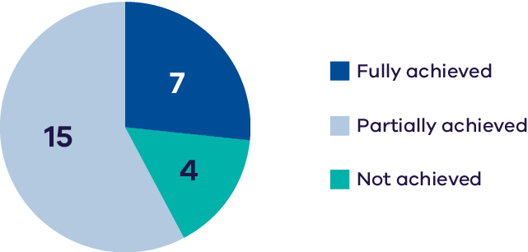
The Loddon River is Victoria’s second longest river flowing north for approximately 430 km from its headwaters in Wombat State Forest in the Great Dividing Range, near Daylesford, towards the Murray. The Registered Aboriginal Party (RAP) in the region is the Dja Dja Wurrung Clans Aboriginal Corporation and the Wamba Wemba Aboriginal Corporation. It has high ecological value due to its wide variety of water dependent flora and fauna including 26
waterbird species and the EPBC-listed silver perch and vulnerable growling grass frog. The local communities particularly value the native fish and platypus populations, as well as the aesthetic and recreational values of the river.
The highly regulated nature of the Loddon system provides challenges and opportunities for the effective management of water for the environment. The ability to manipulate the timing of releases at multiple locations can help achieve environmental outcomes at discrete locations. However, coordinating environmental and consumptive flows is difficult through the irrigation season, especially when irrigation demand is high or flow in the river is highly variable. These issues can constrain the timing and delivery of water for the environment or lead to a flow that exceeds the recommended flow rates above Loddon Weir. The structures used for managing irrigation water also form barriers in the waterway that restrict native fish movement throughout the river and make it difficult to meet ecological objectives.
Monitoring indicates:
- positive outcomes with respect to fish dispersal (small- and large-bodied species) and maintaining water quality for native fish, due to environmental water deliveries in autumn and spring.
- hydrological conditions outside autumn and spring environmental flows are not meeting other needs of native fish and consequently there have been consistently low relative abundance, reporting rates, and species diversity of native fish species. However, there has been a slight increase or stable trend in abundance and reporting rates for Murray cod, golden perch, and Murray-Darling rainbowfish since 2012.
- the frequency of recruitment for Murray cod, golden perch, bony herring and Murray-Darling rainbowfish has been consistently low.
- an increase in alien fish species (especially carp) in high rainfall years.
riparian vegetation is largely dominated by native emergent species and few, if any, herbaceous species are present. Cover, extent and species richness are limited, with both instream aquatic species and riparian species dominated by only a few native species. Relatively few exotic plant species have been recorded, with limited cover and extent.
Based on the indicators measured, six Basin Plan Chapter 8 objectives were assessed for the Loddon River. A measure of the extent to which these objectives have been achieved is provided in Part 2 of this report.

Twelve Mile Creek
Extent, cover, richness – native species | Extent, cover, richness – invasive species | Recruitment
Average or poor status has been maintained  DATA QUALITY = 3 | Improving trend &/or good condition maintained  DATA QUALITY = 3 | Average or poor status has  been maintained  DATA QUALITY = 3
Note: Data collection period – Understorey vegetation – 2017-24.
Chart 12: Achievement of planned watering actions, 2019–2023
(Total actions = 19)
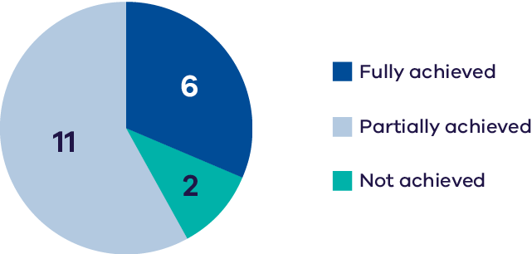
Twelve Mile Creek is a northerly flowing anabranch of the Loddon River that forms the eastern boundary of Canary Island. The waterway supports quality habitat for a range of aquatic biota including native fish and platypus. Environmental flows in Twelve Mile Creek aim to provide longitudinal connectivity and passage for native fish as well as to improve streamside vegetation condition.
Monitoring has indicated that environmental water management has helped to improve the growth of native vegetation species and minimise invasive species cover at some locations. Non-flow factors, however, have limited the effectiveness of environmental water, with the waterway subject to grazing having higher weed cover and lower canopy condition.
Based on the indicators measured, four Basin Plan Chapter 8 objectives were assessed for Twelve Mile Creek. A measure of the extent to which these objectives have been achieved is provided in Part 2 of this report.

Pyramid Creek
Species richness, diversity, abundance  (non-threatened spp.) | Species richness, diversity, abundance (threatened spp.) | Movement,  distribution | Recruitment,  spawning
Average or poor  status has been maintained  DATA QUALITY = 3 | Average or poor  status has been maintained  DATA QUALITY = 3 | Improving trend &/or good condition maintained  DATA QUALITY = 3 | Average or poor  status has been maintained  DATA QUALITY = 3
Note: Data collection period – Fish –2007-24 (Movement, distribution – 2016-20).
 | 2022-23 | 2021-22 | 2020-21 | 2019-20 | 2018-19 | 2017-18 | 2016-17 | 2015-16 | 2014-15 | 2013-14
Flooding | F | - | - | - | - | - | F | - | - | -
*E-water | 65 | 968 | 620 | 123 | 1,042 | 861 | 924 | - | - | -
Flood occurrence was based on the BOM flood classification and includes minor, moderate & major floods at Flannery’s bridge flow gauge.
*Volumes of environmental water (megalitres, ML) delivered in Pyramid Creek since 2016.
Chart 13: Achievement of planned watering actions, 2019–2023
(Total actions = 6)
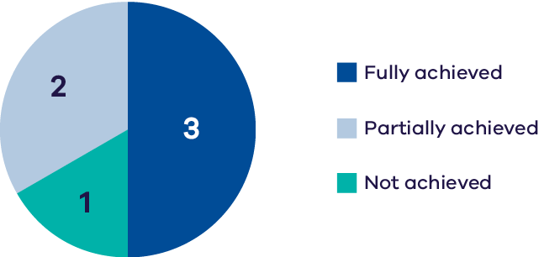
Pyramid Creek begins at Ghow Swamp and joins the Loddon River at Kerang Weir. In the 1960s it was dredged to create more efficient delivery of irrigation water, removing the large woody debris and creating steep, narrow banks; this reduced habitat values, particularly for native fish. Recent restoration efforts (adding large woody debris and re-establishing native vegetation) have been undertaken to improve habitat conditions for native fish. Although the link between fish occurrence and the recent restoration efforts is still unclear, Pyramid Creek currently supports populations of several large-bodied native fish species including Murray cod, silver perch and golden perch.
Water for the environment is used to facilitate fish passage, improve productivity and provide habitat for aquatic fauna. Supporting re-vegetation efforts are also important uses of environmental water at this asset.
Monitoring indicates:
- environmental flows delivered as freshes and baseflows have had positive effects on native fish dispersal and distribution.
- the system is characterised by infrequent fish recruitment, relatively low abundance, and the absence of many small-bodied native fish species.
- variable trends in relative abundance of priority fish species, with no evidence of any overall improvements since 2012.
an increase in alien fish species (especially carp) in high rainfall years.
Based on the indicators measured, six Basin Plan Chapter 8 objectives were assessed for Pyramid Creek. A measure of the extent to which these objectives have been achieved is provided in Part 2 of this report.

The Boort Wetlands

Lake Boort
Abundance, species richness  (non-threatened & migratory spp.) | Abundance, species richness  (threatened spp.) | Abundance, species richness (international migratory species)
Improving trend &/or good condition maintained  DATA QUALITY = 2 | Average or poor status has been maintained  DATA QUALITY = 2 | Average or poor status has been maintained  DATA QUALITY = 2
Note: Data collection period – Birds – 2012-24.

Lake Leaghur
Abundance, species richness  (non-threatened & migratory spp.) | Abundance, species richness  (threatened spp.)
Average or poor status has been maintained  DATA QUALITY = 2 | Average or poor status has been maintained  DATA QUALITY = 2
Note: Data collection period – Birds – 2012-24.

Little Lake Meran
Abundance, species richness  (non-threatened & migratory spp.) | Abundance, species richness  (threatened spp.) | Breeding | Species richness
Average or poor status has been maintained  DATA QUALITY = 3 | Average or poor status has been maintained  DATA QUALITY = 2 | Average or poor status has been maintained  DATA QUALITY = 2 | Average or poor status has been maintained  DATA QUALITY = 2
Note: Data collection period – Birds – 2018-24.

Lake Meran
Abundance, species richness  (non-threatened & migratory spp.) | Abundance, species richness  (threatened spp.) | Breeding
Improving trend &/or good condition maintained  DATA QUALITY = 2 | Improving trend &/or good condition maintained  DATA QUALITY = 2 | Average or poor status has been maintained  DATA QUALITY = 2
Note: Data collection period – Birds – 2018-24.

Lake Yando
Black box &/or  river red gum condition | Abundance, species richness  (non-threatened & migratory spp.) | Abundance, species richness  (threatened spp.) | Breeding
Improving trend &/or good condition maintained  DATA QUALITY = 3 | Improving trend &/or good condition maintained  DATA QUALITY = 2 | Average or poor status has been maintained  DATA QUALITY = 2 | Improving trend &/or good condition maintained  DATA QUALITY = 2
Note: Data collection period – Trees – 2017-24; Birds – 2012-24.
Flooding | 2022-23 | 2021-22 | 2020-21 | 2019-20 | 2018-19 | 2017-18 | 2016-17 | 2015-16 | 2014-15 | 2013-14
Lake Boort | F | - | - | - | - | F | - | - | - | -
*E-water | 1,913 | 770 | - | - | - | - | - | - | - | -
Lake Leaghur | F | - | - | - | - | F | - | - | - | -
*E-water | - | - | 805 | - | - | - | - | - | - | -
Meran Lakes  Complex | F | - | - | - | - | F | - | - | - | -
*E-water | 884 | 7,714 | 1,353 | 1,612 | 510 | 498 | - | 2,000 | 2,000 | 1,849
Lake Yando | F | - | - | - | - | F | - | - | - | -
*E-water | - | - | 1,011 | - | - | - | - | - | 558 | 151
Flood occurrence is indicated by an ‘F’ when the wetland filled from natural catchment runoff or inflows.
*Volumes of environmental water (megalitres, ML) delivered since 2013.
Chart 14: Achievement of planned watering actions, 2019–2023
(Total actions = 15)
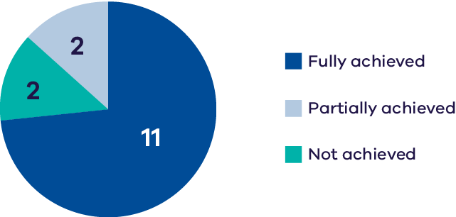
The Boort wetlands are on the floodplain west of the Loddon River, below Loddon Weir. They consist of temporary and permanent freshwater lakes and swamps: Lake Boort, Lake Leaghur, Lake Yando, Little Lake Meran and Lake Meran. Together, the Boort wetlands cover over 800 ha and provide habitat for a range of plant and animal species.
Lake Boort is a shallow freshwater marsh located on Dja Dja Wurrung Country that, due to its use as a water storage in the past, has many standing dead river red gums. The fringing river red gum woodland, however, remains intact and there are areas of tangled lignum and southern cane grass. Lake Boort is considered to be of bioregional importance due to its high habitat value and diversity. Lake Boort supports several threatened and vulnerable species, including ducks, large-bodied waders, and white-bellied sea-eagle.
Lake Leaghur, similar to other wetlands in the Boort complex, was a shallow freshwater marsh prior to its use as a water storage in the 1920s and 30s, when it became permanently inundated. This resulted in the death of several river red gums across the lakebed, which remain as standing dead trees. Recent restoration of a wet and dry cycle has improved habitat values, and the waterway supports a high diversity and abundance of waterbirds.
Little Lake Meran is part of the Meran Lakes Complex. This temporary freshwater lake provides open water habitat during its wet phase, which supports deep-water foraging waterbirds. As the wetland dries, the deepest sections of the wetland bed provide mudflat habitat for wading birds, including threatened and migratory species. Little Lake Meran supports a mix-aged canopy of black box woodland higher on the wetland margins, and river red gum woodland along the lake edge.
Lake Meran is a permanent freshwater wetland that supports migratory waterbirds and Murray River turtle populations.
Lake Yando is an intermittent wetland on the floodplain of the Loddon River. It is surrounded by river red gum woodland and when inundated supports emergent reed beds and a number of rare or threatened wetland plant species including the EPBC-listed rigid water-milfoil and river swamp wallaby-grass. The waterway supports a diversity of waterbirds and frogs in the wet phase.
Environmental water management at the Boort Wetlands aims to return more natural hydrological regimes of wet and dry cycles. Water is also used to improve vegetation communities and to facilitate successful waterbird breeding. The exception is Lake Meran, which is managed to maintain a core area of permanent wetland to support Murray River turtles.
Monitoring in the Boort Wetlands indicates:
- low species richness of frogs at Little Lake Meran.
- an increase in tree-stand condition at Lake Yando, possibly reflecting environmental watering and the natural spring 2022 floods.
- good waterbird breeding responses (2021-24) at Lake Yando with no clear trend at Lake Meran and Little Lake Meran.
- high waterbird abundance and species richness at lakes Boort, Meran and Yando, with less abundance in recent years at lakes Leaghur and Little Lake Meran, however this is potentially due to more favourable habitat elsewhere in the region.
improvements in waterbird abundance and species richness at Lake Meran, including for threatened species, with the wetland regularly supporting a pair of white-bellied sea-eagles, however infrequent abundance of threatened species has been recorded at the other lakes within the Boort wetlands.
Based on the indicators measured, six Basin Plan Chapter 8 objectives were assessed for various wetlands in the Boort complex. A measure of the extent to which these objectives have been achieved is provided in Part 2 of this report.

Central Murray wetlands

Kunat Kunat (Round Lake)
Murray hardyhead presence | Abundance, species richness  (non-threatened & migratory spp.) | Abundance, species richness  (threatened spp.) | Abundance, species richness  (international migratory species) | Breeding
Improving trend &/or good condition maintained  DATA QUALITY = 3 | Average  or poor status has been maintained  DATA QUALITY = 2 | Declining  trend  DATA QUALITY = 2 | Average  or poor status has been maintained  DATA QUALITY = 2 | Average  or poor status has been maintained  DATA QUALITY = 2
Note: Data collection period – Fish – 2015-24; Birds – 2013-23.
 | 2022-23 | 2021-22 | 2020-21 | 2019-20 | 2018-19 | 2017-18 | 2016-17 | 2015-16 | 2014-15 | 2013-14
Flooding | - | - | - | - | - | - | - | - | - | -
*E-water | 250 | 409 | 370 | 300 | 461 | 422 | 350 | 576 | 556 | 509
Flood occurrence is indicated by an ‘F’ when the wetland filled from natural catchment runoff or inflows.
*Volumes of environmental water (megalitres, ML) delivered in Kunat Kunat (Round Lake) since 2013.
Chart 15: Achievement of planned watering actions, 2019–2023
(Total actions = 4)
Kunat Kunat is a saline wetland located on Wamba Wemba Country on the outskirts of the town of Lake Boga, on the floodplain of the Avoca River. The system supports submerged large-fruit sea tassel and a variety of charophytes, which are important habitat for the EPBC-listed Murray hardyhead. The wetland is also important for supporting a diversity of waterbirds, particularly small wading species, including international migrants.
Environmental water management at Kunat Kunat aims to:
- maintain water depth, and salinity within 15,000-80,000 EC, to support suitable habitat and breeding conditions for Murray hardyhead.
- restore and maintain submerged aquatic plants.
maintain water depth to provide permanent feeding, foraging and refuge habitat for waterbirds.
Monitoring indicates:
- persistent Murray hardyhead populations, with evidence of multiple successful spawning events in a season.
- high waterbird abundance and species richness recorded early in the reporting period with some declines in recent years, however a particular decline in abundances of the blue-billed duck, listed as vulnerable in Victoria.
infrequent waterbird breeding with a single pied stilt nest with eggs in 2024.
Based on the indicators measured, six Basin Plan Chapter 8 objectives were assessed for Kunat Kunat. A measure of the extent to which these objectives have been achieved is provided in Part 2 of this report.

Ovens System

Ovens River
Species richness, diversity, abundance  (non-threatened spp.) | Species richness, diversity, abundance (threatened spp.) | Movement,  distribution | Recruitment,  spawning
Improving trend &/or good condition maintained  DATA QUALITY = 4 | Improving trend &/or good condition maintained  DATA QUALITY = 4 | Improving trend &/or good condition maintained  DATA QUALITY = 4 | Improving trend &/or good condition maintained  DATA QUALITY = 3
Note: Data collection period – Fish –2003-24.
 | 2022-23 | 2021-22 | 2020-21 | 2019-20 | 2018-19 | 2017-18 | 2016-17 | 2015-16 | 2014-15 | 2013-14
Flooding | F | F | F | F | - | F | F | - | F | F
*E-water | 215 | 215 | 159 | 142 | 162 | 123 | 70 | 70 | 70 | 70
Flood occurrence was based on the BOM flood classification and includes minor, moderate & major floods at Wangaratta flow gauge.
*Volumes of environmental water (megalitres, ML) delivered in the Ovens System since 2013. Environmental water is delivered to the Ovens System through King River and Buffalo River
Chart 16: Achievement of planned watering actions, 2019–2023
(Total actions = 4)
The Ovens River rises in the Great Dividing Range near Mt Hotham and discharges to the Murray River at Lake Mulwala. The RAP in the region is the Taungurung Land and Waters Council Aboriginal Corporation and the Yorta Yorta Nation Aboriginal Corporation. From Killawarra to Lake Mulwala the river is a declared Victorian Heritage River in recognition of its outstanding ecological values. The river red gum dominated riparian vegetation is of exceptional quality and the waterway supports a wide range of fish species including Murray cod, trout cod and Macquarie perch. The lower reaches support a complex wetland system, listed as nationally important, which supports a high diversity of flora and fauna including several threatened species such as the growling grass frog. There is some evidence that the lower Ovens complex also supports periodic colonial nesting waterbirds.
Environmental water holdings in the Ovens system are relatively small (123 ML) which limits what can be achieved. In recent years, private landowners have donated some of their annual water allocations to the VEWH to use in the King River. The Taungurung Land and Waters Council has also transferred some of their annual allocation to the VEWH to be delivered to the King River to heal Country.
Monitoring indicates:
- improved recruitment frequency of Murray cod, trout cod, Macquarie perch and river blackfish.
a diverse fish assemblage, with stable or increasing reporting rates and relative abundance of Macquarie perch, Murray cod, trout cod and golden perch (noting that the monitoring period encompassed extreme low and high flow periods with stable and/or increasing trends, which indicates a resilient system).
These results are likely to reflect the natural flow regime and almost annual flooding experienced by the river since 2012.
Based on the indicators measured, six Basin Plan Chapter 8 objectives were assessed for the Ovens River. A measure of the extent to which these objectives have been achieved is provided in Part 2 of this report.
Victorian Murray
The Victorian Murray WRP area is shown in Figure 6; it extends from Omeo in the far east of Victoria to the South Australian border in the northwest of the state. The Victorian Murray WRP area comprises the Victorian tributaries of the Murray River upstream of Albury/Wodonga, as well as the lower reaches of tributaries from the Northern Victoria WRP area (the lower Loddon River and Broken Creek) and the anabranches and floodplain wetlands along the length of the Murray River.
Figure 6: Priority environmental assets within the Victorian Murray WRP area (not all assets are monitored or reported on in this report).
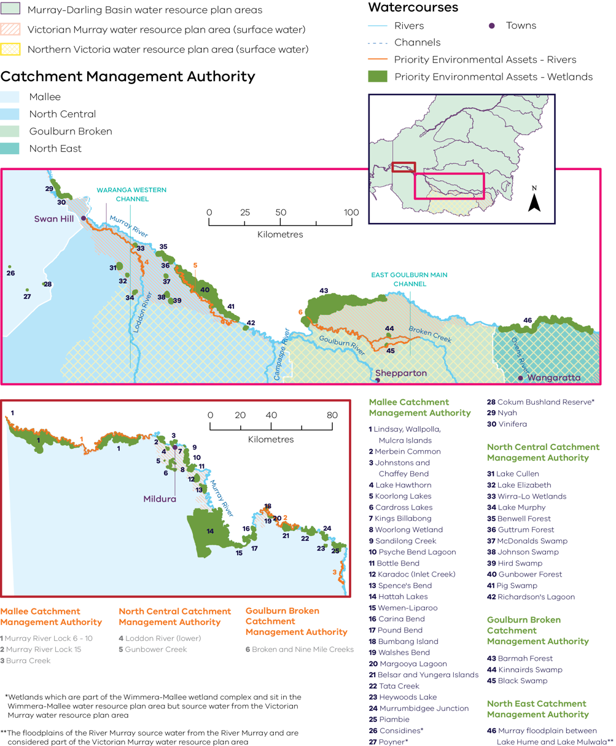

Barmah Forest
Species richness, diversity, abundance  (non-threatened spp.) | Species richness, diversity, abundance (threatened spp.) | Proportion of native species | Recruitment, spawning | Extent, cover, richness – native species
Average  or poor status has been maintained  DATA QUALITY = 4 | Improving trend &/or good condition maintained  DATA QUALITY = 4 | Improving trend &/or good condition maintained  DATA QUALITY = 4 | Improving trend &/or good condition maintained  DATA QUALITY = 4 | Improving trend &/or good condition maintained  DATA QUALITY = 3
Extent, cover, richness – invasive species | Abundance, species richness  (non-threatened & migratory spp.) | Abundance, species richness  (threatened spp.) | Breeding | Species richness  (non-threatened spp.)
Improving trend &/or good condition maintained  DATA QUALITY = 4 | Improving trend &/or good condition maintained  DATA QUALITY = 3 | Improving trend &/or good condition maintained  DATA QUALITY = 4 | Improving trend &/or good condition maintained  DATA QUALITY = 4 | Improving trend &/or good condition maintained  DATA QUALITY = 4

Below: Specific outcomes related to Ramsar ecological characteristics and limits of acceptable change
Species richness,  diversity, abundance  (non-threatened spp.) | Species richness,  diversity, abundance  (threatened spp.) | Extent, cover, richness – native species Ramsar ecological character
Improving trend &/or good condition maintained  DATA QUALITY = 4 | Improving trend &/or good condition maintained  DATA QUALITY = 4 | Declining  trend  DATA QUALITY = 4
Abundance, species richness  (non-threatened  & migratory spp.) | Abundance, species richness  (threatened spp.) | Breeding
Improving trend &/or good condition maintained  DATA QUALITY = 3 | Improving trend &/or good condition maintained  DATA QUALITY = 4 | Improving trend &/or good condition maintained  DATA QUALITY = 3
Note: Data collection period – Fish – 2007-24; Wetland understorey vegetation – 2015-24; Birds – 2011-24; Frogs – 2018-24.
 | 2022-23 | 2021-22 | 2020-21 | 2019-20 | 2018-19 | 2017-18 | 2016-17 | 2015-16 | 2014-15 | 2013-14
Flooding | F | - | - | - | - | - | F | - | - | F
*E-water | 102,251 | 205,313 | 204,516 | 230,668 | 74,636 | 201,232 | 111,505 | 403,294 | - | 355,400
Flood occurrence is indicated by an ‘F’ when the wetland filled from natural catchment runoff or inflows.
*Volumes of environmental water (megalitres, ML) delivered in Barmah Forest since 2013.
Chart 17: Achievement of planned watering actions, 2019–2023
(Total actions = 22)
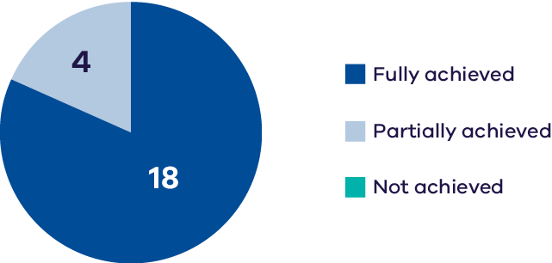
Barmah Forest is designated as a wetland of international importance under the Ramsar Convention and, together with the Millewa Forest in NSW, is the largest river red gum forest in Australia. The Yorta Yorta Nation Aboriginal Corporation is the Registered Aboriginal Corporation, and jointly manage the Barmah National Park with the Victorian state government.
In addition to the extensive forests and woodlands, Barmah Forest supports important open marsh vegetation, including the iconic Moira grass plains. The waterway is important for colonial nesting waterbirds and native fish and supports a significant proportion of the southeastern Australian population of the endangered Australasian bittern.
Water management at Barmah-Millewa Forest seeks to build on natural flow and the delivery of consumptive and operational water en route, to optimise environmental outcomes when possible. As Barmah-Millewa Forest is located towards the upper reaches of the regulated portion of the Murray River, water for the environment that passes through the forest and returns to the river can often be used at other waterways further downstream as part of multi-waterway watering events.
Environmental water has been delivered to Barmah Forest in most years since the Basin Plan commenced in 2012. There is a wide body of evidence indicating that this, combined with natural flooding, has contributed to improved outcomes for vegetation, waterbird, fish, frog and turtle populations as well as maintaining the ecological character of the Barmah Forest Ramsar Site.
Monitoring indicates:
- the extent of Moira grass has declined significantly due to a combination of factors including a seasonal inundation (during summer and autumn) as well as introduced grazers (feral horses). The management of grazers and water management improvements has led to increases in the cover of Moira grass from less than 10% of its extent in 2015. It is still below the level considered acceptable to meet the ecological character objectives of the Ramsar site. Waterway managers anticipate further mapping in the forest will reveal continuing increases in Moira grass cover (see Case Studies, below).
- although the catch per unit effort for native fish species has remained relatively low, the overall fish community assessment score, which captures both flowing and wetland waterways, has improved since 2012, along with three of the six nativeness indices.
- spawning of golden perch and silver perch, and recruitment of Murray cod, trout cod and Murray-Darling rainbowfish occurs annually.
- the status of the frog community is stable or improving.
- both terrestrial and aquatic weeds have been observed in low amounts, with water regimes a contributing factor to the low amount of terrestrial weed species.
- breeding of colonial nesting species continues to be supported, particularly during high rainfall years. Environmental water contributed to the duration of inundation at breeding locations.
- waterbird species richness and abundance have been maintained, with between 32 and 49 species recorded annually, and thousands of birds were recorded in five years out of ten (2010-11; 2011-12; 2014-15; 2016-17; 2021-22).
the nationally endangered Australasian bittern continues to be supported.
Targeted fish monitoring at a number of wetlands in the forest has indicated:
- high percentage of native fish at Cucumber Gully, but a decline in richness of native species.
- high abundance of native and exotic species at Hut Lake.
a decline in fish species at Tarma Lagoon and increases in exotic species such as gambusia and goldfish.
Based on the available data and indicators measured, six Basin Plan Chapter 8 objectives were assessed for Barmah Forest. A measure of the extent to which these objectives have been achieved is provided in Part 2 of this report.

Broken System

Black Swamp
Extent, cover, richness – native species | Extent, cover, richness – invasive species | Black box  &/or river red gum condition | Abundance,  species richness  (non-threatened & migratory spp.)
Average  or poor status has been maintained  DATA QUALITY = 3 | Average  or poor status has been maintained  DATA QUALITY = 3 | Improving trend &/or good condition maintained  DATA QUALITY = 3 | Improving trend &/or good condition maintained  DATA QUALITY = 2
Abundance,  species richness  (threatened spp.) | Breeding | Species richness  (non-threatened & migratory spp.)
Improving trend &/or good condition maintained  DATA QUALITY = 2 | Average  or poor status has been maintained  DATA QUALITY = 2 | Average  or poor status has been maintained  DATA QUALITY = 3
Note: Data collection period – Wetland understorey vegetation – 2014-24; Trees – 2014-24; Birds – 2014-24; Frogs – 2018-24.
 | 2022-23 | 2021-22 | 2020-21 | 2019-20 | 2018-19 | 2017-18 | 2016-17 | 2015-16 | 2014-15 | 2013-14
Flooding | F | - | - | - | - | F | F | - | - | F
*E-water | - | 80 | - | 65 | 80 | - | - | 80 | - | 50
Flood occurrence is indicated by an ‘F’ when the wetland filled from natural catchment runoff or inflows.
*Volumes of environmental water (megalitres, ML) delivered in Black Swamp since 2013.
Chart 18: Achievement of planned watering actions, 2019–2023
(Total actions = 2)
Black Swamp is a 16 ha intermittent river red gum swamp located on Yorta Yorta Country on the floodplain of Nine Mile Creek east of Wunghnu and 27
km north of Shepparton. Historical water management resulted in prolonged inundation and the death of many of the mature river red gums. These standing dead trees along with the emergent wetland vegetation provide habitat for foraging and roosting waterbirds. The wetland also contains a significant population of the EPBC-listed river swamp wallaby-grass.
Environmental flows can only be delivered to the swamp when flows in the Nine Mile Creek exceed 100 ML/day, which occurs during periods of high rainfall and during the irrigation season (August to May).
Due to river regulation Black Swamp only receives water naturally during high unregulated flow events. As a result, environmental water needs to be delivered during dry periods (approximately every 2 years) to ensure the success of bird breeding events or to provide optimal growth conditions for water dependent vegetation. Monitoring indicates:
- frog species diversity has largely remained unchanged since 2018, but there was a new detection of the threatened species Sloane’s froglet in 2023-24.
- there is evidence that environmental water has contributed to improved tree condition.
- further monitoring is required to understand trends in understorey vegetation and the influence of different drivers of change.
there have been increases in waterbird diversity and abundance, despite (or perhaps because of) wide-spread availability of alternative waterbird habitat at the time due to flood conditions. The EPBC-listed Australasian bittern has been recorded at Black Swamp occasionally at the wetland throughout the monitoring period
Based on the indicators measured, five Basin Plan Chapter 8 objectives were assessed for Black Swamp. A measure of the extent to which these objectives have been achieved is provided in Part 2 of this report.
Kinnairds Wetland
Extent, cover, richness – native species | Extent, cover, richness – invasive species | Species richness  (non-threatened spp.)
Improving trend &/or good condition maintained  DATA QUALITY = 3 | Average or poor status has been maintained  DATA QUALITY = 3 | Improving trend &/or good condition maintained  DATA QUALITY = 2
Note: Data collection period – Wetland understorey vegetation – 2014-24; Frogs – 2018-24.
 | 2022-23 | 2021-22 | 2020-21 | 2019-20 | 2018-19 | 2017-18 | 2016-17 | 2015-16 | 2014-15 | 2013-14
Flooding | F | - | - | - | - | F | F | - | - | F
*E-water | - | 195 | - | 259 | 384 | - | - | 689 | - | 180
Flood occurrence is indicated by an ‘F’ when the wetland filled from natural catchment runoff or inflows.
*Volumes of environmental water (megalitres, ML) delivered in Kinnairds Wetland since 2013.
Chart 19: Achievement of planned watering actions, 2019–2023
(Total actions = 2)
Kinnairds Wetland is a 94 ha temporary freshwater swamp that occurs in a natural depression near the Broken Creek on Yorta Yorta Country. Vegetation is dominated by a mosaic of river red gum swamp and plains grassy wetland communities with small areas of emergent marsh and open water. It supports a high diversity of wetland fauna including breeding colonies of royal spoonbill and a number of EPBC-listed wetland-dependent species including ridged water milfoil, river swamp wallaby-grass, Australasian bittern and Latham’s snipe.
The frequency, duration and depth of natural flood events at Kinnairds Wetland have been reduced by river regulation, drainage and modifications to the landscape. To help reinstate a more natural flooding regime, environmental water has been delivered to the wetland on a regular basis since 2008. The optimum wetting regime for Kinnairds Wetland is inundation for 6-8 months over the autumn-spring period.
The construction of an underground pipeline was completed in early 2024 connecting the wetland to an adjacent irrigation channel. The pipeline will allow water to be delivered adaptively and improve the efficiency and effectiveness of environmental water delivery by reducing the travel time of water deliveries.
Monitoring indicates:
- cover and richness of native wetland plant species has remained consistently high since the commencement of monitoring in 2014. Recent surveys showed a particularly high cover of native plants in some parts of the wetland, possibly due to two natural floods in a row.
- introduced plant species cover was consistent over time, with the highest cover occurring in areas that cannot receive environmental water.
- the waterway supports an abundance of common frog species, which have been maintained over time.
the threatened species Sloan’s froglet was detected for the first time in 2023-24.
Based on the indicators measured, three Basin Plan Chapter 8 objectives were assessed for Kinnairds Wetland. A measure of the extent to which these objectives have been achieved is provided in Part 2 of this report.

Gunbower Forest and Gunbower Creek
Species richness, diversity, abundance  (non-threatened spp.) | Species richness, diversity, abundance  (threatened spp.) | Proportion  of native species | Recruitment, spawning
Average  or poor status has been maintained  DATA QUALITY = 4 | Improving trend &/or good condition maintained  DATA QUALITY = 4 | Average  or poor status has been maintained  DATA QUALITY = 4 | Improving trend &/or good condition maintained  DATA QUALITY = 4
Extent, cover, richness – native species | Black box  &/or river red gum condition | Species richness  (non-threatened spp.)
Average  or poor status has been maintained  DATA QUALITY = 4 | Improving trend &/or good condition maintained  DATA QUALITY = 4 | Improving trend &/or good condition maintained  DATA QUALITY = 4

Below: Specific outcomes related to Ramsar ecological characteristics and limits of acceptable change
Species richness, diversity, abundance  (non-threatened spp.) | Species richness, diversity, abundance  (threatened spp.) | Abundance, species richness  (non-threatened & migratory spp.)
Improving trend &/or good condition maintained  DATA QUALITY = 4 | Improving trend &/or good condition maintained  DATA QUALITY = 4 | Improving trend &/or good condition maintained  DATA QUALITY = 3

Note: Data collection period – Fish – 2007-24; Wetland understorey vegetation – 2015-24; Trees – 2005-22; Birds – 2011-24; Frogs – 2018-24.
 | 2022-23 | 2021-22 | 2020-21 | 2019-20 | 2018-19 | 2017-18 | 2016-17 | 2015-16 | 2014-15 | 2013-14
Flooding | F | - | - | - | - | - | F | - | - | -
*E-water | 54,905 | 30,302 | 12,901 | 26,140 | 60,205 | 30,662 | 26,653 | 44,989 | 38,256 | 38,833
Flood occurrence was based on the BOM flood classification and includes minor, moderate & major floods at Murray River downstream of Torrumbarry Weir flow gauge.
*Volumes of environmental water (megalitres, ML) delivered in Gunbower Forest and Gunbower Creek since 2013.
Chart 20: Achievement of planned watering actions, 2019–2023
(Total actions = 1)
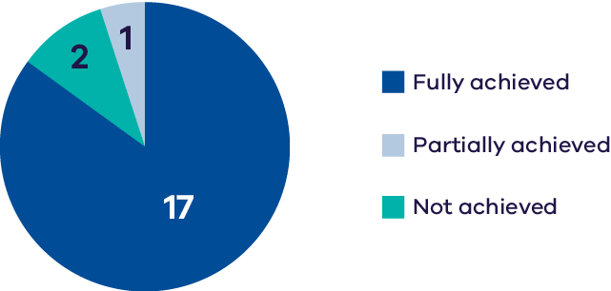
Gunbower Forest comprises approximately 20,000 ha of floodplain between the Murray River and Gunbower Creek. Yorta Yorta Nation Aboriginal Corporation is the RAP in the region It is designated a wetland of international importance under the Ramsar Convention and is a Living Murray program icon site. Gunbower Forest is predominantly river red gum forest and woodland, with smaller areas of black box and grey box woodland. The forest also features a variety of permanent and temporary wetlands, including lakes, swamps, and lagoons. These support wetland vegetation communities and provide habitat for several waterbird species, many of which breed within the waterway. The asset includes Gunbower National Park, Gunbower State Forest, and a portion of the Murray River Park.
Gunbower Creek is a natural creek that has been modified to supply irrigation water from the Murray River to the Torrumbarry Irrigation Area. There are 12 lagoons, largely located in the upper reaches of the creek system, that are permanently or seasonally connected to Gunbower Creek. Water for the environment is used in Gunbower Creek to improve habitat for native fish, especially Murray cod.
The Living Murray environmental works program in the middle and lower forest was completed in 2014. The works allow up to 4,500 ha of the wetlands and floodplain to be watered with considerably less water than would be required if the watering infrastructure was not in place. The works enable efficient watering through Gunbower Creek and the forest to maintain the wetland and floodplain condition and provide connectivity between the creek, forest floodplain, and the Murray River.
There is a large body of evidence that suggests environmental water has contributed to maintaining and improving the ecological character of this Ramsar site since 2012.
Monitoring indicates:
- significant improvements in fish populations, particularly in Gunbower Creek, where environmental water management has focussed on restoring the flow regime for Murray cod populations. Since 2012, there has been a slight decline in Murray-Darling rainbowfish abundance and increases in the abundances of golden perch, Murray cod, unspecked hardyhead, silver perch and trout cod. This demonstrates a resilience to recent hypoxic events.
- an increase in alien fish species in high rainfall years.
- overall maintenance of wetland understorey vegetation extent, cover and species richness due to increases at some wetlands (attributed to environmental water management) and decreases at other waterways (attributed to carp).
- tree condition has improved since 2012.
- there is evidence of a decline in black box condition outside the environmental watering footprint.
colonial nesting species have been recorded breeding in the waterway in at least seven of the past ten years (2012-13, 2014-15, 2015-16, 2016-17, 2018-19, 2021-2022, 2022-23).
Based on the available data and indicators measured, six Basin Plan Chapter 8 objectives were assessed for Gunbower Forest. A measure of the extent to which these objectives have been achieved is provided in Part 2.of this report.

Central Murray wetlands

Hird Swamp
Extent, cover, richness – native species | Extent, cover, richness – invasive species | Black box  &/or river red gum condition | Abundance,  species richness  (non-threatened & migratory spp.)
No trend  identifiable  DATA QUALITY = 2 | No trend  identifiable  DATA QUALITY = 2 | Improving trend &/or good condition maintained  DATA QUALITY = 3 | Average  or poor status has been maintained  DATA QUALITY = 2
Abundance,  species richness  (international migratory species) | Abundance,  species richness  (international migratory species) | Breeding
Average  or poor status has been maintained  DATA QUALITY = 2 | Average  or poor status has been maintained  DATA QUALITY = 2 | No trend  identifiable  DATA QUALITY = 2
Note: Data collection period – Wetland understorey vegetation – 2017-23; Trees – 2014-24; Birds – 2013-23.
 | 2022-23 | 2021-22 | 2020-21 | 2019-20 | 2018-19 | 2017-18 | 2016-17 | 2015-16 | 2014-15 | 2013-14
Flooding | F | - | - | - | - | - | - | - | - | -
*E-water | - | - | 2,901 | - | - | 2,220 | 1,370 | - | 945 | 3,343
Flood occurrence is indicated by an ‘F’ when the wetland filled from natural catchment runoff or inflows.
*Volumes of environmental water (megalitres, ML) delivered in Hird Swamp since 2013.
Chart 21: Achievement of planned watering actions, 2019–2023
(Total actions = 1)
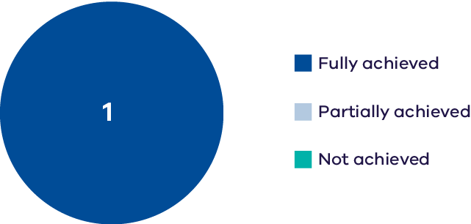
Hird Swamp is a 344 ha deep freshwater marsh located within the Kerang Wetlands Ramsar Site. The wetland provides a variety of habitats including emergent marshes dominated by cumbungi and common reed, large areas of dense tangled lignum, with a sparse overstorey including patches of river red gums. The waterway supports a diversity and abundance of waterbirds including the EPBC-listed Australasian bittern and eastern great egret, listed as vulnerable in Victoria.
Environmental water management at Hird Lake aims to:
- drown terrestrial weeds to reduce their extent.
- promote the germination and establishment of aquatic vegetation.
inundate the wetland fringe to provide habitat for waterbirds, frogs and turtles and provide conditions suitable for macroinvertebrates that are food for waterbirds.
Monitoring indicates:
- an increase in tree-stand condition.
- variable cover and species richness of understorey vegetation (linked to prolonged inundation due to large natural floods); monitoring since 2022 showed approximately half of the survey plots had near 100% native plant cover, with species richness highly variable (hence the status assessment of ‘unknown’).
a decline in waterbird abundance in recent surveys, linked to large natural floods (potentially due to high availability of habitat regionally).
Based on the indicators measured, six Basin Plan Chapter 8 objectives were assessed for Hird Swamp. A measure of the extent to which these objectives have been achieved is provided in Part 2 of this report.

Johnson Swamp
Abundance, species richness  (non-threatened & migratory spp.) | Abundance, species richness  (threatened spp.) | Abundance, species richness  (international migratory species) | Breeding
Improving trend &/or good condition maintained  DATA QUALITY = 3 | Improving trend &/or good condition maintained  DATA QUALITY = 2 | Declining  trend  DATA QUALITY = 2 | Average  or poor status has been maintained  DATA QUALITY = 2
Note: Data collection period – Birds – 2015-23.
 | 2022-23 | 2021-22 | 2020-21 | 2019-20 | 2018-19 | 2017-18 | 2016-17 | 2015-16 | 2014-15 | 2013-14
Flooding | F | - | - | - | - | - | - | - | - | -
*E-water | 1,148 | 1,500 | - | 3,240 | 1,500 | - | - | 2,890 | 1,500 | -
Flood occurrence is indicated by an ‘F’ when the wetland filled from natural catchment runoff or inflows.
*Volumes of environmental water (megalitres, ML) delivered in Johnson Swamp since 2014.
Chart 22: Achievement of planned watering actions, 2019–2023
(Total actions = 4)
Johnson Swamp is a 340 ha deep freshwater marsh located within the Kerang Wetlands Ramsar Site. The wetland includes emergent marsh, dense tangled lignum, and chenopod shrublands, which provide high-quality habitat for waterbirds. Accordingly, the waterway supports a high diversity and abundance of waterbirds including the EPBC-listed Australasian bittern as well as large numbers of ibis and waterfowl.
Environmental water is used to manage habitat for turtles, frogs, and waterbirds by preventing encroachment of lignum and tall marshy reeds into open water habitats, and promoting the growth of submerged vegetation. Water is also used to extend inundation periods during waterbird breeding events, to facilitate successful fledging.
Monitoring indicates:
- a high abundance and diversity of waterbirds, with several thousand individuals from over 30 species recorded regularly.
- EPBC-listed Australasian bittern recorded in most seasons and several Victorian-listed species recorded in moderate abundances.
- few waterbird breeding records in recent years, potentially due to prolonged inundation from flooding and decreased submerged aquatic vegetation.
occasional records of international migratory species, but prolonged inundation limits suitable feeding habitat.
Based on the indicators measured, six Basin Plan Chapter 8 objectives were assessed for Johnson Swamp. A measure of the extent to which these objectives have been achieved is provided in Part 2 of this report.

Lake Cullen
Abundance, species richness  (non-threatened & migratory spp.) | Abundance, species richness  (threatened spp.) | Abundance, species richness  (international  migratory species) | Breeding
Improving trend &/or good condition maintained  DATA QUALITY = 3 | Average or  poor status has been maintained  DATA QUALITY = 2 | Average or  poor status has been maintained  DATA QUALITY = 3 | Average or  poor status has been maintained  DATA QUALITY = 3
Note: Data collection period – Birds – 2012-23.
 | 2022-23 | 2021-22 | 2020-21 | 2019-20 | 2018-19 | 2017-18 | 2016-17 | 2015-16 | 2014-15 | 2013-14
Flooding | - | - | - | - | - | - | - | - | - | -
*E-water | 5,000 | - | - | 6,385 | 7,790 | - | 17,180 | - | - | -
Flood occurrence is indicated by an ‘F’ when the wetland filled from natural catchment runoff or inflows.
*Volumes of environmental water (megalitres, ML) delivered in Lake Cullen since 2016.
Chart 23: Achievement of planned watering actions, 2019–2023
(Total actions = 2)
Lake Cullen is a large saline wetland in the Kerang Wetlands Ramsar site, covering approximately 630 ha. Although it provides predominantly open water and mudflat habitat, the wetland also supports low saltmarsh shrublands dominated by glasswort, as well as areas of emergent marsh comprising cumbungi and common reed. Lake Cullen supports very large numbers of waterbirds with >30,000 individuals recorded regularly. The range of diverse habitat types supports a high diversity of waterbird species including ducks, fish-eating species, and waders, some of which are listed under international migratory bird agreements.
Environmental water deliveries at Lake Cullen aim to provide feeding, breeding, and refuge habitat for waterbirds; water delivery is designed to promote increased cover and extent of submerged plants and support a high diversity and abundance of macroinvertebrates.
Monitoring indicates:
- outstanding abundance and species richness of waterbirds, with over 30,000 birds recorded regularly, including >
- 1% of the population of Eurasian coots in December 2023.
- EPBC-listed Australasian bittern regularly up to 2020, but no recent records.
- few breeding records, which is likely to be due to the high salinity of the wetland and a lack of suitable cover.
a recent decline in the abundance of migratory shorebirds due to increased water levels from natural floods, which has reduced suitable feeding habitat at the waterway, but provided alternative habitat elsewhere.
Based on the indicators measured, six Basin Plan Chapter 8 objectives were assessed for Lake Cullen. A measure of the extent to which these objectives have been achieved is provided in Part 2 of this report.

Lake Elizabeth
Murray  hardyhead presence | Abundance, species richness  (non-threatened & migratory spp.) | Abundance, species richness  (threatened spp.) | Abundance, species richness  (international migratory species) | Breeding
Improving trend &/or good  condition maintained  DATA QUALITY  = 3 | Improving trend &/or good  condition maintained  DATA QUALITY  = 3 | Average  or poor status  has been maintained  DATA QUALITY  = 3 | Average  or poor status  has been maintained  DATA QUALITY  = 3 | Average  or poor status  has been maintained  DATA QUALITY  = 3
Note: Data collection period – Fish – 2018-24; Birds – 2012-24.
 | 2022-23 | 2021-22 | 2020-21 | 2019-20 | 2018-19 | 2017-18 | 2016-17 | 2015-16 | 2014-15 | 2013-14
Flooding | F | - | - | - | - | - | - | - | - | -
*E-water | 646 | 824 | 714 | 960 | 1,080 | 530 | 750 | 1,070 | 675 | 1,455
Flood occurrence is indicated by an ‘F’ when the wetland filled from natural catchment runoff or inflows.
*Volumes of environmental water (megalitres, ML) delivered in Lake Elizabeth since 2013.
Chart 24: Achievement of planned watering actions, 2019–2023
(Total actions = 4)
Lake Elizabeth is a 94 ha deep permanent saline lake located within the Wandella Creek sub catchment of the Loddon River basin. The wetland is fringed by low saltmarsh shrubland dominated by glasswort and supports submerged vegetation comprising sea tassel and fox-tail stonewort. The waterway supports a population of the EPBC-listed Murray hardyhead as well as a high diversity and abundance of waterbirds.
Environmental water management at Lake Elizabeth aims to:
- maintain salinity below 12.5 ppt in spring and above 30 ppt during summer/autumn, to support suitable habitat and breeding conditions for Murray hardyhead.
- restore and maintain submerged aquatic plants.
maintain water depth to provide permanent feeding, foraging and refuge habitat for waterbirds.
Monitoring indicates:
- persistent Murray hardyhead populations, with evidence of multiple successful spawning events in a season.
- high abundance of several common waterbird species including black swan, Eurasian coot, grey teal, and hoary-headed grebe.
- small numbers of Victorian-listed threatened waterbird species including musk duck, blue-billed duck, and Australasian shoveler, likely due to alternative habitat being available elsewhere.
- few waterbird breeding records, which is likely to be due to the high salinity of the wetland.
smaller numbers of migratory shorebirds (e.g., sharp-tailed sandpiper and common greenshank) in recent surveys, which is likely to be due to increased water levels following natural floods, but which has provided alternative habitat elsewhere.
Based on the indicators measured, six Basin Plan Chapter 8 objectives were assessed for Lake Elizabeth. A measure of the extent to which these objectives have been achieved is provided in Part 2 of this report.

Lake Murphy
Black box &/or river red gum condition | Abundance,  species richness  (non-threatened &  migratory spp.) | Abundance, species richness  (threatened spp.)
Improving trend &/or good condition maintained  DATA QUALITY = 3 | Declining trend  DATA QUALITY = 2 | Declining trend  DATA QUALITY = 2
Abundance,  species richness  (international migratory species) | Breeding | Species richness  (non-threatened spp.)
Improving trend &/or good condition maintained  DATA QUALITY = 2 | Average or poor status has been maintained  DATA QUALITY = 3 | Average or poor status has been maintained  DATA QUALITY = 2
Note: Data collection period – Trees – 2014-24; Birds – 2012-23; Frogs – 2018-24.
 | 2022-23 | 2021-22 | 2020-21 | 2019-20 | 2018-19 | 2017-18 | 2016-17 | 2015-16 | 2014-15 | 2013-14
Flooding | F | - | - | - | - | - | - | - | - | -
*E-water | - | 3,306 | - | - | 2,550 | 580 | - | - | 2,983 | -
Flood occurrence is indicated by an ‘F’ when the wetland filled from natural catchment runoff or inflows.
*Volumes of environmental water (megalitres, ML) delivered in Lake Murphy since 2014.
Chart 25: Achievement of planned watering actions, 2019–2023
(Total actions = 1)
Lake Murphy is a 172 ha intermittent and variably saline wetland situated approximately 8 km south-west of Kerang. It is surrounded by an open woodland of black box with patches of dense tangled lignum, and it periodically supports a diversity and abundance of waterbirds.
Environmental water management is aimed at restoring natural cycles of wetting and drying to support a diversity of wetland vegetation types and provide high-quality feeding and breeding habitat for waterbirds and frogs.
Monitoring indicates:
- a potential decline in frog species richness in recent years, possibly due to poor water quality and high carp numbers following natural floods.
- an increase in tree-stand condition, which has been linked to environmental watering and recent natural flooding.
- regular breeding by waterbird species.
- increased numbers of international migratory species such as sharp-tailed sandpiper at times when water levels have been suitable (this has not occurred during recent flood years when water levels may have been too deep).
- regular recording of several thousand waterbirds at a time, up to 2020. However, since 2020, surveys have typically recorded a few hundred individuals. This may be partially explained by good conditions elsewhere, although it represents a greater difference than seen at other wetlands and requires further investigation.
a similar absence of EPBC and state-listed waterbird species in recent years.
Based on the indicators measured, six Basin Plan Chapter 8 objectives were assessed for Lake Murphy. A measure of the extent to which these objectives have been achieved is provided in Part 2 of this report.

McDonalds Swamp
Black box &/or river red gum condition | Abundance,  species richness  (non-threatened &  migratory spp.) | Abundance, species richness  (threatened spp.)
Improving trend &/or good condition maintained  DATA QUALITY = 3 | Improving trend &/or good condition maintained  DATA QUALITY = 3 | Improving trend &/or good condition maintained  DATA QUALITY = 2
Abundance,  species richness  (international migratory species) | Breeding | Species richness  (non-threatened spp.)
Average or poor status has been maintained  DATA QUALITY = 2 | Improving trend &/or good condition maintained  DATA QUALITY = 2 | Average or poor status has been maintained  DATA QUALITY = 2
Note: Data collection period – Trees – 2014-24; Birds – 2012-23; Frogs – 2018-24.
 | 2022-23 | 2021-22 | 2020-21 | 2019-20 | 2018-19 | 2017-18 | 2016-17 | 2015-16 | 2014-15 | 2013-14
Flooding | F | - | - | - | - | - | F | - | - | -
*E-water | 402 | 350 | 280 | 293 | 230 | 350 | 750 | - | 904 | 1,240
Flood occurrence is indicated by an ‘F’ when the wetland filled from natural catchment runoff or inflows.
*Volumes of environmental water (megalitres, ML) delivered in McDonalds Swamp since 2013.
Chart 26: Achievement of planned watering actions, 2019–2023
(Total actions = 4)
McDonalds Swamp is a 164 ha wetland on the floodplain between the Loddon and the Murray Rivers. This former river red gum swamp is now dominated by open water, emergent reeds and standing dead trees because of historical water management. The waterway supports a high diversity of waterbirds including ducks, large-bodied waders and, as water levels recede, small waders. The wetland also supports waterfowl breeding including black swan and pink-eared ducks.
Environmental water management aims to maintain McDonalds Swamp as a temporary freshwater marsh with a diversity of aquatic vegetation and habitat types to support feeding and breeding requirements for a range of native waterbirds (including colonial nesting and migratory species), frogs and turtles.
Monitoring indicates:
- higher frog abundance and diversity during wet phases.
- an increase in tree stand condition.
- an outstanding waterbird breeding response to floods in 2022-23, after the wetland had been primed with environmental water in autumn 2022. Species that bred successfully included Victorian-listed magpie goose and blue-billed duck and a small colony of Australian white ibis.
- recent declines in international migratory species, most likely due to widespread habitat availability elsewhere following natural floods.
continued high diversity and abundance of waterbirds and the presence of the EPBC-listed Australasian bittern.
Based on the indicators measured, six Basin Plan Chapter 8 objectives were assessed for McDonalds Swamp. A measure of the extent to which these objectives have been achieved is provided in Part 2 of this report.

Richardson’s Lagoon
Black box &/or river red gum condition | Abundance,  species richness  (non-threatened &  migratory spp.) | Abundance, species richness  (threatened spp.)
Improving trend &/or good condition maintained  DATA QUALITY = 3 | Improving trend &/or good condition maintained  DATA QUALITY = 3 | Average or poor status has been maintained  DATA QUALITY = 2
Abundance,  species richness  (international migratory species) | Breeding | Species richness  (non-threatened spp.)
Average or poor status has been maintained  DATA QUALITY = 3 | Improving trend &/or good condition maintained  DATA QUALITY = 2 | Average or poor status has been maintained  DATA QUALITY = 2
Note: Data collection period – Trees – 2014-24; Birds – 2012-24; Frogs – 2018-24.
 | 2022-23 | 2021-22 | 2020-21 | 2019-20 | 2018-19 | 2017-18 | 2016-17 | 2015-16 | 2014-15 | 2013-14
Flooding | F | - | - | - | - | - | - | - | - | -
*E-water | - | 1,392 | 1,461 | - | - | 458 | 568 | 1,309 | - | -
Flood occurrence is indicated by an ‘F’ when the wetland filled from natural catchment runoff or inflows.
*Volumes of environmental water (megalitres, ML) delivered in Richardson’s Lagoon since 2015.
Chart 27: Achievement of planned watering actions, 2019–2023
(Total actions = 3)
Richardson’s Lagoon (also known as Baillieu’s Lagoon) is a 120 ha wetland located on Yorta Yorta Country on the Murray River floodplain near Echuca. It provides a range of habitats, including open water and reed beds, as well as shallower habitat through river red gum and black box dominated flats. Richardson’s Lagoon provides significant waterbird habitat, with abundant breeding and roosting waterway.
The lagoon can receive water from the Murray River during very high natural flooding, but such occasions are rare, because it was disconnected from the river by levees. As a result, water for the environment (provided by a fixed pontoon pump directly from the Murray River) is the only reliable way Richardson’s Lagoon can be inundated. Water management aims to provide a wet and dry cycle to maintain the condition of vegetation, prevent algal blooms, and provide habitat for waterbirds.
Monitoring indicates:
- stable species richness of frogs however further monitoring would be required to confirm any changes in trend.
- maintenance of good tree-stand condition.
- good waterbird breeding responses during recent surveys, especially in 2021-22 and 2022-23.
- an increase in waterbird species richness, and likely maintenance of modest abundance with no clear trend across threatened species or international migratory species.
records of Victorian-listed threatened waterbird species (e.g., eastern great egret and white-bellied sea-eagle).
Based on the indicators measured, six Basin Plan Chapter 8 objectives were assessed for Richardson’s Lagoon. A measure of the extent to which these objectives have been achieved is provided in Part 2 of this report.

Wirra-lo Wetland
Abundance,  species richness  (non-threatened & migratory spp.) | Abundance,  species richness  (threatened spp.) | Breeding | Species richness  (non-threatened spp.)
Improving trend &/or good condition maintained  DATA QUALITY = 2 | Improving trend &/or good condition maintained  DATA QUALITY = 3 | Improving trend &/or good condition maintained  DATA QUALITY = 2 | Average or  poor status has been maintained  DATA QUALITY = 3
Note: Data collection period – Birds – 2017-24; Frogs – 2018-24.
 | 2022-23 | 2021-22 | 2020-21 | 2019-20 | 2018-19 | 2017-18 | 2016-17 | 2015-16 | 2014-15 | 2013-14
Flooding | F | - | - | - | - | - | - | - | - | -
*E-water | 29 | 111 | 97 | 245 | 92 | 80 | 165 | 369 | 140 | -
Flood occurrence is indicated by an ‘F’ when the wetland filled from natural catchment runoff or inflows.
*Volumes of environmental water (megalitres, ML) delivered in Wirra-lo Complex since 2014.
Chart 28: Achievement of planned watering actions, 2019–2023
(Total actions = 18)
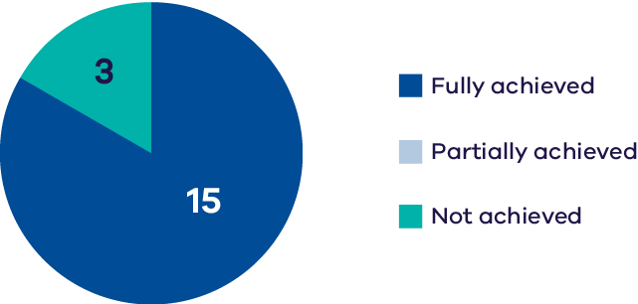
The Wirra-lo Wetland Complex covers 70 ha and is comprised of a series of swamps, creeks and depressions located at the junction of Barr Creek and the Loddon River. The complex is ecologically significant due to the variety of habitat types that can support a high diversity of waterbirds, frogs (including the threatened growling grass frog), mammals, reptiles, and macroinvertebrates.
Environmental water management aims to maintain the diversity of habitats in the complex. This includes objectives to:
- provide feeding and breeding opportunities for frogs, waterbirds, and turtles.
- promote the germination and growth of aquatic vegetation.
- maintain open-water and associated mudflat habitats for waterbirds to feed and breed.
create feeding and nesting habitat for Australasian bittern.
Monitoring indicates:
- a slight increase in detection of EPBC-listed frog species with both growling grass frog and Sloane’s froglet recorded using acoustic sensors.
- outstanding breeding responses for waterbirds, including rare Victorian breeding records of Victorian-listed magpie goose and freckled duck in the summer of 2023.
- increases in waterbird abundance and species richness in response to inundation and ongoing restoration.
new records of EPBC-listed Australasian bittern and increased detection of Victorian-listed waterbird species.
Based on the indicators measured, five Basin Plan Chapter 8 objectives were assessed for Wirra-lo Complex. A measure of the extent to which these objectives have been achieved is provided in Part 2 of this report.

Hattah Lakes
Species richness, diversity, abundance  (non-threatened spp.) | Recruitment, spawning | Extent, cover, richness – invasive species | Lignum  condition
Average  or poor status has been maintained  DATA QUALITY = 3 | Improving trend &/or good condition maintained  DATA QUALITY = 4 | Average  or poor status has been maintained  DATA QUALITY = 4 | Improving trend  &/or good  condition  maintained
Black box  &/or river red gum condition | Abundance,  species richness  (non-threatened & migratory spp.) | Breeding
Improving trend  &/or good  condition maintained | Improving trend  &/or good  condition maintained | Improving trend  &/or good  condition maintained
Below: Specific outcomes related to Ramsar ecological characteristics and limits of acceptable change
Species richness, diversity, abundance  (non-threatened spp.) | Abundance,  species richness  (non-threatened & migratory spp.)
Improving trend &/or good condition maintained  DATA QUALITY = 4 | Improving trend &/or good condition maintained  DATA QUALITY = 2
Note: Data collection period – Fish – 2010-22; Wetland understorey vegetation – 2015-24; Lignum condition – 2017-22; Trees – 2008-22; Birds – 2019-22.
 | 2022-23 | 2021-22 | 2020-21 | 2019-20 | 2018-19 | 2017-18 | 2016-17 | 2015-16 | 2014-15 | 2013-14
Flooding | F | - | - | - | - | - | F | - | - | -
*E-water | 29,312 | 46,139 | 27,200 | 12,702 | 281 | 111,932 | 31,847 | 6,840 | 76,196 | 97,288
Flood occurrence is indicated by an ‘F’ when the wetland filled from natural catchment runoff or inflows.
*Volumes of environmental water (megalitres, ML) delivered in Hattah Lakes since 2013.
Chart 29: Achievement of planned watering actions, 2019–2023
(Total actions = 5)
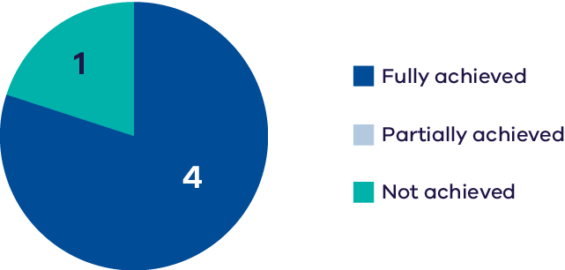
The Hattah Lakes is an extensive complex of lakes and floodplain set within the Hattah–Kulkyne National Park and the Murray–Kulkyne Regional Park. Twelve of the lakes are part of the Hattah–Kulkyne Lakes Ramsar Site, listed primarily for their value as waterbird habitat and importance in maintaining regional biodiversity. The area is also one of The Living Murray’s six icon sites.
The lakes support breeding of colonial nesting waterbirds, primarily fish-eating species such as cormorants, and provide occasional nursery habitat for native fish. There are extensive areas of river red gum and black box woodland on the floodplain surrounding the lakes, which support a diversity of waterbirds and woodland birds including the EPBC-listed regent parrot. Through The Living Murray program, environmental watering infrastructure was completed in 2014 that enables watering of 6,000 ha of lakes and floodplain, including all 12 Ramsar-listed lakes.
Monitoring indicates:
- the ecological character of the Ramsar site is being maintained.
- improvements in diversity and biomass of native fish species in riverine waterways, with periodic declines at wetlands due to managed drawdown of wetlands for maintaining other ecological values.
- the condition of river red gum and black box trees has increased since 2012.
- population structure for both river red gum and black box has improved since the implementation of the Basin Plan in 2012.
- native species richness of wetland understorey vegetation has been maintained with recent vegetation surveys recording similar species richness to that of 2012.
- lignum health in 2021-22 was the highest it has been since the new monitoring method was instigated in 2017. The health of lignum was statistically correlated with inundation metrics.
the relatively high abundance and species richness of waterbirds is being maintained.
Based on the indicators measured, five Basin Plan Chapter 8 objectives were assessed for Hattah Lakes. A measure of the extent to which these objectives have been achieved is provided in Part 2 of this report.

Lower Murray wetlands

Brickworks Billabong
Murray
hardyhead
presence
Average or
poor status has
been maintained
DATA QUALITY = 2
Note: Data collection period – Fish – 2014-24.
 | 2022-23 | 2021-22 | 2020-21 | 2019-20 | 2018-19 | 2017-18 | 2016-17 | 2015-16 | 2014-15 | 2013-14
Flooding | F | F | - | - | - | - | F | - | - | -
*E-water | - | 199 | 248 | 320 | 251 | 250 | - | 400 | 200 | 348
Flood occurrence is indicated by an ‘F’ when the wetland filled from natural catchment runoff or inflows.
*Volumes of environmental water (megalitres, ML) delivered in Brickworks Billabong since 2013.
Chart 30: Achievement of planned watering actions, 2019–2023
(Total actions = 4)
Brickworks Billabong is a permanent saline wetland within Merbein Common on the Murray River Floodplain north of Mildura. First Peoples of the Millewa Mallee Aboriginal Corporations is the RAP in the region. The billabong contains small areas of emergent macrophytes (common reed and cumbungi) and dense submerged beds of sea tassel. The wetland once supported a translocated population of the EPBC-listed Murray hardyhead, however the species has not been recorded at the waterway since 2019. There is limited evidence for a decline or maintenance of the species over the reporting period.
Based on the indicators measured, one Basin Plan Chapter 8 objective was assessed for Brickworks Billabong. A measure of the extent to which this objective has been achieved is provided in Part 2 of this report.

Cowanna Billabong
Species richness
(non-threatened spp.)
Average or
poor status has
been maintained
DATA QUALITY = 3
Note: Data collection period – Frogs – 2018-24.
 | 2022-23 | 2021-22 | 2020-21 | 2019-20 | 2018-19 | 2017-18 | 2016-17 | 2015-16 | 2014-15 | 2013-14
Flooding | F | F | F | F | F | F | F | - | - | -
*E-water | - | - | - | - | - | - | - | 250 | - | -
Flood occurrence is indicated by an ‘F’ when the wetland filled from natural catchment runoff or inflows.
*Volumes of environmental water (megalitres, ML) delivered in Cowanna Billabong since 2015.
Cowanna Billabong is located within the Merbein Common on First Peoples of the Millewa Mallee Country on the floodplain of the Murray River downstream of Mildura. Since 2014-15, it has been managed through a regulator connected to the Murray River to ensure there is an annual filling and drying phase without the need for additional environmental water deliveries. Cowanna Billabong can periodically support a high diversity of small- and large-bodied native fish. It also provides habitat for a high diversity of waterbirds including several fish-eating species, diving ducks and deep-water foragers due to its open water habitat. Monitoring indicates variability between years in frog species.
Based on the indicators measured, two Basin Plan Chapter 8 objectives were assessed for Cowanna Billabong. A measure of the extent to which this objective has been achieved is provided in Part 2 of this report.

Koorlong Lake
Murray
hardyhead
presence
Improving trend
&/or good condition maintained
DATA QUALITY = 3
Note: Data collection period – Fish – 2009-24.
 | 2022-23 | 2021-22 | 2020-21 | 2019-20 | 2018-19 | 2017-18 | 2016-17 | 2015-16 | 2014-15 | 2013-14
Flooding | F | F | - | - | - | F | F | F | F | F
*E-water | - | - | 62 | 148 | 57 | - | - | - | - | -
Flood occurrence is indicated by an ‘F’ when the wetland filled from natural catchment runoff or inflows.
*Volumes of environmental water (megalitres, ML) delivered in Koorlong Lake since 2018.
Chart 31: Achievement of planned watering actions, 2019–2023
(Total actions = 4)
Koorlong Lake is located near Lake Cardross on the Murray River floodplain south-west of Mildura on First People of the Millewa Mallee Country. It is an artificial evaporation basin that has received irrigation drainage since the 1930s. The lake provides predominantly open-water habitat and contains beds of the submerged aquatic sea tassel. A population of the EPBC-listed Murray hardyhead was established in Lake Koorlong through a series of translocations from 2009 to 2013.
Environmental water deliveries at Koorlong Lake aim to maintain water levels to support the growth of saline aquatic vegetation, including sea tassel, to provide nursery habitat for Murray hardyhead and feeding resources for shorebirds. Monitoring indicates persistence of Murray hardyhead at the waterway.
Based on the indicators measured, one Basin Plan Chapter 8 objective was assessed for Koorlong Lake. A measure of the extent to which this objective has been achieved is provided in Part 2 of this report.

Heywood Lakes

Lake Heywood
Abundance,  species richness  (non-threatened & migratory spp.) | Abundance,  species richness  (threatened spp.) | Abundance,  species richness  (international  migratory species) | Breeding
Average or  poor status has  been maintained  DATA QUALITY = 2 | Average or  poor status has  been maintained  DATA QUALITY = 2 | Average or  poor status has  been maintained  DATA QUALITY = 2 | Average or  poor status has  been maintained  DATA QUALITY = 2
Note: Data collection period – Birds – 2017-23.

Little Lake Heywood
Black box
&/or river red gum condition
Improving trend
&/or good condition maintained
DATA QUALITY = 3
Note: Data collection period – Trees – 2014-24.
 | 2022-23 | 2021-22 | 2020-21 | 2019-20 | 2018-19 | 2017-18 | 2016-17 | 2015-16 | 2014-15 | 2013-14
Flooding | F | - | - | - | - | - | F | - | - | -
*E-water | - | - | - | - | - | 512 | 3,000 | - | - | 5,000
Flood occurrence is indicated by an ‘F’ when the wetland filled from natural catchment runoff or inflows.
*Volumes of environmental water (megalitres, ML) delivered in the Heywood Lakes since 2013.
Chart 32: Achievement of planned watering actions, 2019–2023
(Total actions = 1)
Heywood Lakes are situated on the River Murray floodplain between Swan Hill and Robinvale, southeast of Boundary Bend. The waterway includes three wetlands, covering approximately 1600 ha: Lake Heywood and Little Lake Heywood, located to the south of the Murray Valley Highway, and one small unnamed wetland to the north of the highway. Lake Heywood and Little Lake Heywood are ephemeral deflation basins that fluctuate between terrestrial and aquatic states. The wetlands fill naturally during very high floods of the Murray River and, after filling, Lake Heywood retains water for several years.
The waterway supports a diversity of wetland flora and fauna when inundated, including more than 30 waterbird species, some of which are listed as under the FFG Act (blue-billed duck, eastern great egret, freckled duck and white-bellied sea eagle). The EPBC-listed growling grass frog and regent parrot have also been recorded at this waterway.
Environmental water management aims to maintain wet and dry cycles at the lakes to sustain resident aquatic fauna during periods of natural inundation and support breeding waterbirds. Monitoring indicates:
- an increase in tree stand condition in Little Lake Heywood, albeit with a high degree of interannual variability.
- a high degree of variability in waterbird abundance and species richness between years.
- a decline in recent years in migratory shorebirds, linked to increased water levels following natural floods, which has reduced suitable feeding habitat and provided alternative habitat elsewhere.
- low frequency of waterbird breeding which was only recorded during summer 2023 following recent natural flooding.
Based on the indicators measured, six Basin Plan Chapter 8 objectives were assessed for the Heywood Lakes. A measure of the extent to which these objectives have been achieved is provided in Part 2 of this report.

Neds Corner

Neds Corner East
Species richness
(non-threatened spp.)
Average or
poor status has
been maintained
DATA QUALITY = 2
Note: Data collection period – Frogs – 2018-24.

Neds Corner Central
Extent, cover, richness – native species | Extent, cover, richness – invasive species | Black box  &/or river red gum condition
Improving trend &/or good condition maintained  DATA QUALITY = 3 | Improving trend &/or good condition maintained  DATA QUALITY = 3 | Improving trend &/or good condition maintained  DATA QUALITY = 3
Note: Data collection period – Understorey vegetation – 2017-24; Trees – 2014-24.

Neds Corner Woolshed
Species richness
(non-threatened spp.)
Improving trend
&/or good condition maintained
DATA QUALITY = 3
Note: Data collection period – Frogs – 2018-24.
 | 2022-23 | 2021-22 | 2020-21 | 2019-20 | 2018-19 | 2017-18 | 2016-17 | 2015-16 | 2014-15 | 2013-14
Flooding | F | - | - | - | - | - | F | - | - | -
*E-water | - | - | 53 | 268 | - | 104 | - | 250 | 212 | -
Flood occurrence is indicated by an ‘F’ when the wetland filled from natural catchment runoff or inflows.
*Volumes of environmental water (megalitres, ML) delivered in Neds Corner since 2014.
Chart 33: Achievement of planned watering actions, 2019–2023
(Total actions = 4)
Neds Corner is a series of Murray River floodplain wetlands within Neds Corner Station located on the Country of the First People of the Millewa Mallee. Neds Corner is the largest freehold property in Victoria and the biggest private conservation reserve in the state, located around 60 km west of Mildura. The wetlands are surrounded by river red gum and black box woodland and support a diversity of frogs and waterbirds.
Environmental water management at Neds Corner aims to provide a mosaic of intermittent wetlands that provide waterbird breeding and feeding habitat within a productive floodplain system. Recent monitoring indicates:
- consistently high tree-stand condition at Neds Corner Central.
- improvements in native wetland vegetation condition at Neds Corner Central following the 2022 floods, with a corresponding drop in introduced species cover and richness.
- an overall maintenance in detection of frog species at Neds Corner East, with declines possibly due to monitoring occurring during seasonal periods of low inundation.
a slight increase in frog species richness at Neds Corner Woolshed.
Based on the indicators measured, three Basin Plan Chapter 8 objectives were assessed for Neds Corner. A measure of the extent to which these objectives have been achieved is provided in Part 2 of this report.

Vinifera Floodplain
Abundance,  species richness  (non-threatened & migratory spp.) | Abundance,  species richness  (threatened spp.) | Breeding
Average or  poor status has  been maintained  DATA QUALITY = 2 | Improving trend  &/or good condition maintained  DATA QUALITY = 2 | Average or  poor status has  been maintained  DATA QUALITY = 2
Note: Data collection period – Birds – 2018-23.
 | 2022-23 | 2021-22 | 2020-21 | 2019-20 | 2018-19 | 2017-18 | 2016-17 | 2015-16 | 2014-15 | 2013-14
Flooding | F | F | - | - | - | F | F | - | - | -
*E-water | - | - | - | - | 665 | 925 | - | 400 | 500 | -
Flood occurrence is indicated by an ‘F’ when the wetland filled from natural catchment runoff or inflows.
*Volumes of environmental water (megalitres, ML) delivered in Vinifera Floodplain since 2014.
Chart 34: Achievement of planned watering actions, 2019–2023
(Total actions = 1)
The Vinifera Floodplain comprises around 640 ha of wetlands, creeks, river red gum forest and black box woodland on the Murray River in northern Victoria. When inundated, the waterway supports a diversity of species, including several EPBC-listed species (growling grass frog, Murray cod, silver perch).
Environmental water management at the waterway aims to improve the condition of vegetation communities to provide a range of habitats and feeding and breeding resources for waterbirds and frogs.
Recent monitoring indicates:
- consistent abundance and species richness of waterbirds, with assemblages dominated by ducks and herons.
- low detection of international migratory species, potentially due to habitat being dominated by river red gum, while these species prefer open environments.
- regular detections of the Victorian-listed eastern great egret and recent records of Australasian shoveller.
low incidence of waterbird breeding, which is most likely to be a result of limited spatial monitoring (many more breeding attempts are likely to have been made given the ideal flood conditions).
Based on the indicators measured, five Basin Plan Chapter 8 objectives were assessed for Vinifera Floodplain. A measure of the extent to which these objectives have been achieved is provided in Part 2 of this report.

Lindsay, Mulcra and Wallpolla Islands
Species richness,  diversity, abundance  (non-threatened spp.) | Species richness,  diversity, abundance  (threatened spp.) | Recruitment, spawning
Improving trend &/or good condition maintained  DATA QUALITY = 4 | Improving trend &/or good condition maintained  DATA QUALITY = 4 | Average or poor status has been maintained  DATA QUALITY = 4
Movement | Extent, cover,  richness – native species | Extent, cover,  richness – invasive species
Average or poor status has been maintained  DATA QUALITY = 4 | Improving trend &/or good condition maintained  DATA QUALITY = 4 | Average or poor status has been maintained  DATA QUALITY = 4
Lignum condition | Black box &/or  river red gum condition | Abundance,  species richness  (non-threatened  & migratory spp.)
Average or poor status has been maintained  DATA QUALITY = 4 | Improving trend &/or good condition maintained  DATA QUALITY = 4 | Improving trend &/or good condition maintained  DATA QUALITY = 3
Note: Data collection period – Fish – 2006-23; Wetland understorey vegetation – 2007-23; Lignum condition – 2016-23; Trees – 2007-23; Birds – 2019-23.
 | 2022-23 | 2021-22 | 2020-21 | 2019-20 | 2018-19 | 2017-18 | 2016-17 | 2015-16 | 2014-15 | 2013-14
Flooding | F | F | - | - | - | - | F | - | - | -
*E-water | - | up to 4094.5 | 2,179 | 1,783 | - | 3,200 | 457 | 11,339 | 6,677 | 3,745
Flood occurrence is indicated by an ‘F’ when the wetland filled from natural catchment runoff or inflows.
*Volumes of environmental water (megalitres, ML) delivered in Lyndsay, Mulcra and Walpolla islands since 2013.
Chart 35: Achievement of planned watering actions, 2019–2023
(Total actions = 17)
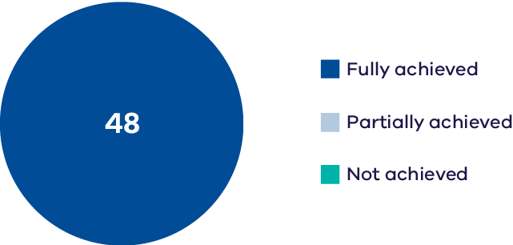
Lindsay, Mulcra and Wallpolla Islands are part of the cross-border Chowilla–Lindsay–Wallpolla Icon Site under The Living Murray program, which has components in South Australia, New South Wales, and Victoria. The RAP in the region is the First Peoples of the Millewa Mallee Aboriginal Corporation. The islands are formed by a series of anabranches of the Murray River, covering 26,156 ha. The waterways, wetlands and broader floodplain have high ecological significance. When inundated, these areas provide refuges and resources for a range of flora and fauna, including threatened species; they also provide important waterbird breeding habitat. As at other Living Murray sites, works under this program have increased the ability to manage and deliver water. Only 1,500 ha can be watered with existing works, although there is also greatly increased control over frequency and duration of wetland and floodplain inundation in these areas.
Monitoring indicates:
- increased native fish movement throughout the anabranch network in response to environmental water delivery, indicating the effectiveness of the recommended Mullaroo Creek flows.
- abundances of Australian smelt, carp gudgeon, Murray-Darling rainbowfish and unspecked hardyhead have all increased considerably over the 2016–2023 period compared with the 2010–2014 period.
- abundances of threatened fish species (Murray cod and silver perch) have also increased.
- evidence of improved wetland understorey species richness.
- an overall average maintenance of lignum condition with improvements at some locations (e.g. Lignum Woodland) but not others (e.g. Lignum Shrubland and Lignum Swamp).
- improved condition and population structure for river red gum and black box, with black box exceeding the desired condition target for the first time in 2023.
improved waterbird abundance and species richness.
Based on the indicators measured, six Basin Plan Chapter 8 objectives were assessed for Lindsay, Mulcra and Wallpolla Islands. A measure of the extent to which these objectives have been achieved is provided in Part 2 of this report.

Wimmera-Mallee
Figure 7: Priority environmental assets within the Wimmera-Mallee WRP area ( not all assets are monitored or reported on in this report).
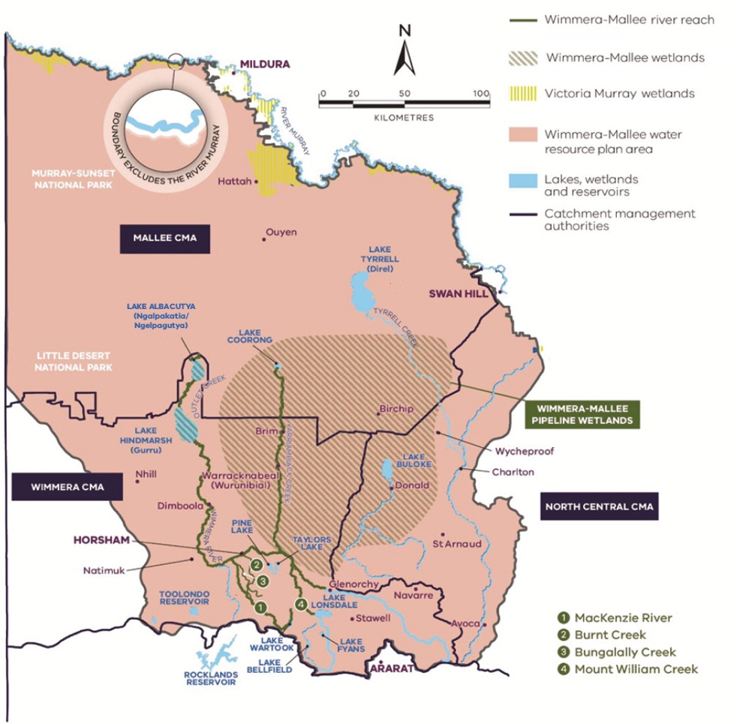
The Wimmera-Mallee WRP area (Figure 7) is located in north-west Victoria. It extends from the Grampians (Gariwerd) and the Pyrenees Ranges in the south, to Ouyen and Kerang in the north, and it extends west to the South Australian border and east to meet the Northern Victoria WRP area. The Wimmera-Mallee WRP area is dominated by the Wimmera, Avon-Richardson and Avoca River systems. The three waterway systems flow inland to the north, terminating in large lake systems. Major wetlands in the Wimmera-Mallee WRP area include Lake Albacutya and Lake Hindmarsh (terminal lakes of the Wimmera system), and the Wimmera Mallee Pipeline wetlands – a large collection of wetlands located east of the terminal lakes. Only a few waterways in the region can receive water for the environment.

Wimmera River System

Wimmera River
Species richness, diversity, abundance  (non-threatened spp.) | Species richness, diversity, abundance  (threatened spp.) | Movement, distribution | Recruitment, spawning
Improving trend  &/or good condition maintained  DATA QUALITY = 4 | Improving trend  &/or good condition maintained  DATA QUALITY = 4 | Improving trend  &/or good condition maintained | Average  or poor status has  been maintained  DATA QUALITY = 3
Extent, cover, richness – native species | Extent, cover, richness – invasive species | Recruitment
Average  or poor status has  been maintained  DATA QUALITY = 3 | Average  or poor status has  been maintained  DATA QUALITY = 3 | Average  or poor status has  been maintained  DATA QUALITY = 3
Note: Data collection period – Fish –2010-24; Understorey vegetation – 2022-24.
 | 2022-23 | 2021-22 | 2020-21 | 2019-20 | 2018-19 | 2017-18 | 2016-17 | 2015-16 | 2014-15 | 2013-14
Flooding | F | F | F | - | - | F | F | - | - | -
*E-water | 3,683 | 8,869 | 4,281 | 7,692 | 10,171 | 8,641 | 7,116 | 3,890 | 12,137 | 19,532
Flood occurrence was based on the BOM flood classification and includes minor, moderate & major floods at Horsham flow gauge.
*Volumes of environmental water (megalitres, ML) delivered in the Wimmera River since 2013.
Chart 36: Achievement of planned watering actions, 2019–2023
(Total actions = 18)
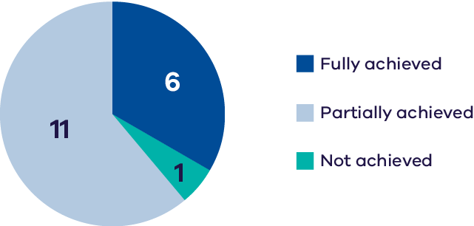
The Wimmera River is an inland intermittent river rising in the Pyrenees on Eastern Maar Country, on the northern slopes of the Great Dividing Range, and flows generally north west and drains into Lake Hindmarsh on Barengi Gadjin Country. The waterway supports abundant native fish populations, including one of Victoria’s few self-sustaining populations of freshwater catfish. The Wimmera River also supports native waterbird, turtle, frog, and rakali (water rat) populations.
Environmental water deliveries aim to increase water depth to provide a stimulus for fish movement, provide flow variability to maintain water quality and diversity of fish habitats, and wet lower benches to support native streamside vegetation, entrain organic debris and maintain habitat for macroinvertebrates and fish.
Monitoring indicates:
- increasing abundance of golden perch, freshwater catfish, and silver perch.
- infrequent recruitment for all native fish species, unchanged since 2012.
- native emergent and herbaceous riparian species are present at all waterways on the river margins; however, the cover, extent and species richness are limited, with riparian species dominated by a few native emergent species.
limited recruitment of native plant species in riparian zones, with recruitment dominated by exotic species.
Based on the indicators measured, six Basin Plan Chapter 8 objectives were assessed for the Wimmera River. A measure of the extent to which these objectives have been achieved is provided in Part 2 of this report.

Mount William Creek
Species richness, diversity, abundance  (non-threatened spp.) | Species richness, diversity, abundance  (threatened spp.) | Movement, distribution | Recruitment, spawning
Average  or poor status has  been maintained  DATA QUALITY = 2 | Average  or poor status has  been maintained  DATA QUALITY = 2 | Average  or poor status has  been maintained  DATA QUALITY = 2 | Average  or poor status has  been maintained  DATA QUALITY = 2
Extent, cover, richness – native species | Extent, cover, richness – invasive species | Recruitment
Average  or poor status has  been maintained  DATA QUALITY = 2 | Average  or poor status has  been maintained  DATA QUALITY = 2 | Average  or poor status has  been maintained  DATA QUALITY = 2
Note: Data collection period – Fish –2013-23; Understorey vegetation – 2017-24.
 | 2022-23 | 2021-22 | 2020-21 | 2019-20 | 2018-19 | 2017-18 | 2016-17 | 2015-16 | 2014-15 | 2013-14
Flooding | F | F | - | - | - | F | F | - | - | -
*E-water | 1,361 | 135 | - | 1,966 | 1,660 | 764 | 155 | 100 | 1,149 | -
Flood occurrence was based on the BOM flood classification and includes minor, moderate & major floods at Lake Lonsdale flow gauge.
*Volumes of environmental water (megalitres, ML) delivered in Mt William Creek since 2014.
Chart 37: Achievement of planned watering actions, 2019–2023
(Total actions = 7)
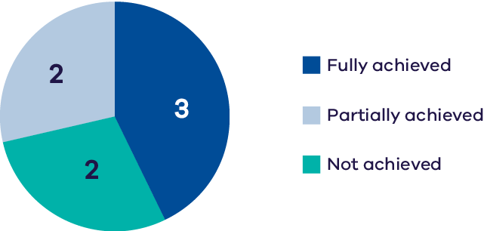
Mount William Creek is a major tributary of the Wimmera River, rising on the slopes of Mount William in the Grampians and discharging to the Wimmera River near Taylor’s Lake. The RAP in the region is the Barengi Gadjin Land Council Aboriginal Corporation. Mount William Creek supports regionally important populations of river blackfish, southern pygmy perch, and the western swamp crayfish.
Environmental water deliveries aim to:
- maintain edge habitats and shallow-water habitat for macroinvertebrates and endemic fish.
- inundate the streamside zone to maintain its condition and facilitate the recruitment of streamside vegetation communities.
- prevent a decline in water quality by flushing pools during low flow.
- provide a variable flow and allow the movement of fish and macroinvertebrates throughout the reach during the low-flow season.
Monitoring indicates:
- enhancement of connectivity and water quality in the upper reaches, resulting in a maintenance of native fish abundance, distribution and recruitment. The lower reach, however, remains in poor condition.
recent spatially limited native vegetation monitoring suggests highly degraded riparian zones, however further monitoring is required to determine any changes in trend.
Based on the indicators measured, six Basin Plan Chapter 8 objectives were assessed for Mount William Creek. A measure of the extent to which these objectives have been achieved is provided in Part 2 of this report.

Burnt Creek & MacKenzie River

Burnt Creek
Species richness, diversity, abundance  (non-threatened spp.) | Species richness, diversity, abundance  (threatened spp.) | Movement, distribution | Recruitment, spawning
Improving trend  &/or good condition maintained  DATA QUALITY = 2-3 | Average  or poor status has  been maintained  DATA QUALITY = 2 | Improving trend  &/or good condition maintained  DATA QUALITY = 2 | Improving trend  &/or good condition maintained  DATA QUALITY = 3
Extent, cover, richness – native species | Extent, cover, richness – invasive species | Recruitment
Average  or poor status has  been maintained  DATA QUALITY = 3 | Average  or poor status has  been maintained  DATA QUALITY = 3 | Average  or poor status has  been maintained  DATA QUALITY = 3
Note: Data collection period – Fish – 2013-23; Understorey vegetation – 2017-24.

MacKenzie River
Species richness, diversity, abundance  (non-threatened spp.) | Species richness, diversity, abundance  (threatened spp.) | Movement, distribution | Recruitment, spawning
Improving trend  &/or good condition maintained  DATA QUALITY = 3 | Average  or poor status has  been maintained  DATA QUALITY = 3 | Improving trend  &/or good condition maintained  DATA QUALITY = 4 | Improving trend  &/or good condition maintained  DATA QUALITY = 3
Extent, cover, richness – native species | Extent, cover, richness – invasive species | Recruitment
Average  or poor status has  been maintained  DATA QUALITY = 4 | Average  or poor status has  been maintained  DATA QUALITY = 4 | Average  or poor status has  been maintained  DATA QUALITY = 3
Note: Data collection period – Fish –2013-24; Understorey vegetation – 2017-24.
 | 2022-23 | 2021-22 | 2020-21 | 2019-20 | 2018-19 | 2017-18 | 2016-17 | 2015-16 | 2014-15 | 2013-14
Flooding | F | - | - | - | - | F | F | - | - | -
*E-water | 3,862 | 2,995 | 2,333 | 2,603 | 3,388 | 6,403 | 3,429 | 1,010 | 4,873 | -
Flood occurrence was based on the BOM flood classification and includes minor, moderate & major floods at Wonwondah East flow gauge for Burnt Creek and McKenzie Creek flow gauge for McKenzie River.
*Volumes of environmental water (megalitres, ML) delivered in the MacKenzie River, Burnt Creek (and Bungalally Creek) since 2014.
Chart 38: Achievement of planned watering actions, 2019–2023
(Total actions = 26)
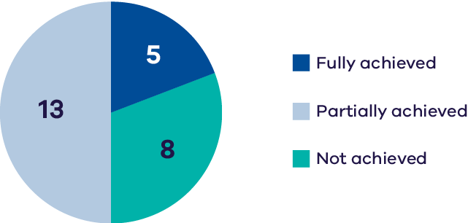
Burnt Creek is a distributary of the MacKenzie River in western Victoria,located on Barengi Gadjin Country. The riparian zone is lined with river red gum and melaleuca. The waterway is a key location for the breeding of southern pygmy perch and obscure galaxias. Upper Burnt Creek supports a threatened western swamp crayfish population, which is also becoming established in lower Burnt Creek.
Environmental water management in Burnt Creek aims to maintain connectivity for fish movement, maintain pool habitat for fish and crayfish, prevent the growth of terrestrial vegetation in channel, maintain streamside native vegetation and flush sediments to increase biofilm production.
Monitoring indicates:
- improved abundance and distribution of native fish in upper Burnt Creek, including southern pygmy perch and obscure galaxias, however abundance and distribution is poor in lower Burnt Creek, which receives no or very little environmental water..
- cover, extent and species richness of native vegetation are limited, with instream aquatic species and riparian species dominated by only a few native species.
recruitment in streamside vegetation is generally low and limited to invasive species.
The MacKenzie River contains the only confirmed remaining platypus population in the Wimmera system and supports locally important populations of native fish, including river blackfish and southern pygmy perch. It also supports populations of threatened Glenelg spiny crayfish, western swamp crayfish, and turtles, as well as the critically endangered Wimmera bottlebrush. Barengi Gadjin are the RAP in the region. Managed releases from Lake Wartook for urban supplies and environmental flows maintain regular flow in the middle and upper reaches of the MacKenzie River and provide important refuges for these regionally important populations during dry periods.
Environmental water management in the MacKenzie River aims to maintain connectivity for fish movement, maintain pool habitat for fish, crayfish, and platypus, prevent the growth of terrestrial vegetation in channel, maintain streamside native vegetation and flush sediments to increase biofilm production.
Monitoring indicates:
- high and increasing abundance and distribution of native fish species, including southern pygmy perch, obscure galaxiids and gudgeons. Environmental water deliveries since 2012 have enhanced connectivity and water quality to recover these species however there has been no change in the abundance of river blackfish.
- improved cover, extent, and plant species richness of native streamside vegetation.
recruitment in streamside vegetation has been limited to non-herbaceous and non-woody species.
Based on the indicators measured, six Basin Plan Chapter 8 objectives were assessed for each of the MacKenzie River and Burnt Creek. A measure of the extent to which these objectives have been achieved is provided in Part 2 of this report.

Wimmera-Mallee Pipeline wetlands

Carapugna Wetland
Extent, cover, richness – native species | Extent, cover, richness – invasive species | Black box  &/or river red gum condition | Abundance,  species richness  (non-threatened & migratory spp.)
Improving trend  &/or good condition maintained  DATA QUALITY = 3 | Average  or poor status has  been maintained  DATA QUALITY = 3 | Improving trend  &/or good condition maintained  DATA QUALITY = 3 | Average  or poor status has  been maintained  DATA QUALITY = 2
Abundance,  species richness  (threatened spp.) | Breeding | Species richness  (non-threatened spp.)
Average  or poor status has  been maintained  DATA QUALITY = 2 | Average  or poor status has  been maintained  DATA QUALITY = 2 | Average  or poor status has  been maintained  DATA QUALITY = 2-3
Note: Data collection period – Wetland understorey vegetation – 2017-24; Trees – 2014-24; Birds – 2017-24; Frogs – 2018-24.

Crow Swamp
Extent, cover, richness – native species | Extent, cover, richness – invasive species | Abundance,  species richness  (non-threatened & migratory spp.) | Species richness  (non-threatened spp.)
Average or  poor status has  been maintained  DATA QUALITY = 3 | Average or  poor status has  been maintained  DATA QUALITY = 3 | Average or  poor status has  been maintained  DATA QUALITY = 2 | Average or  poor status has  been maintained  DATA QUALITY = 2
Note: Data collection period – Wetland understorey vegetation – 2017-24; Birds – 2017-22; Frogs – 2018-24.
 | 2022-23 | 2021-22 | 2020-21 | 2019-20 | 2018-19 | 2017-18 | 2016-17 | 2015-16 | 2014-15 | 2013-14
Flooding | F | - | - | - | - | ^F | F | - | - | -
*E-water | 116 | 115 | 124 | 88 | 151 | 284 | 119 | 158 | 112 | 281
Flood occurrence is indicated by an ‘F’ when the wetland filled from natural catchment runoff or inflows.
^ Flooding only in Carapugna Wetland, not Crow Swamp.
*Volumes of environmental water (megalitres, ML) delivered in the # Wimmera-Mallee Pipeline wetlands since 2013.
# This table shows the total volume of water delivered to the 52 wetlands and dams distributed throughout Wimmer, Mallee and North Central CMA regions that are supplied by the pipeline. Carapugna Wetland and Crow Swamp receive only a portion of the share of environmental water each year.
Chart 39: Achievement of planned watering actions, 2019–2023
(Total actions = 8)
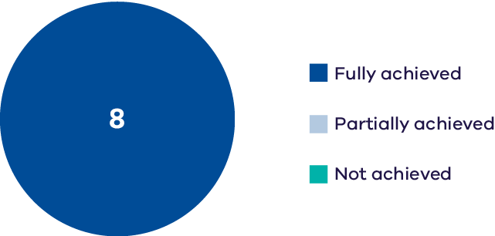
The Wimmera-Mallee wetlands include 52 wetlands and dams on public and private land spread across north-west Victoria. They were previously filled annually from open irrigation channels associated with the Wimmera Mallee Domestic and Stock Channel System. The construction of the Wimmera-Mallee Pipeline in 2010 replaced stock and domestic supply dams with tanks, and the open-channel distribution system with pipelines; these changes were made to improve water efficiency. A portion of the water savings was converted to an environmental entitlement that is used to maintain the aquatic values of the Wimmera-Mallee wetlands.

Carapugna Wetland
Carapugna Wetland is an intermittent wetland located on Barengi Gadjin Country, comprising black box open woodland and areas of freshwater meadow. When inundated it supports a high diversity of aquatic wetland species including the EPBC-listed ridged water-milfoil. The wetland supports a variety of waterbird species including ducks and large-bodied waders, with breeding observed for Australasian grebes.

Crow Swamp
Crow Swamp is a shallow freshwater marsh located on Barengi Gadjin Country, comprising river red gum woodland and areas of freshwater meadow. The wetland supports a community of rare spiny lignum and a variety of waterbirds and frog species when inundated.
Monitoring at Carapugna and Crow wetlands indicates:
- general maintenance of frog species richness with more monitoring required to determine any changes in trend.
- consistently good tree-stand condition at Carapugna Wetland.
- a slight increase in wetland plant cover and richness at Carapugna. Decreases in introduced vegetation species have been recorded at Crow Swamp, however overall cover of introduced species remains high.
- species richness of wetland vegetation remains poor at Crow Swamp.
neither wetland supported notable abundances or species richness of waterbirds; a single sighting of the threatened Latham’s snipe was recorded at Carapugna Wetland in 2019.
Based on the indicators measured, five Basin Plan Chapter 8 objectives were assessed for Carapugna Wetland and three Chapter 8 objectives were assessed for Crow Swamp. A measure of the extent to which these objectives have been achieved is provided in Part 2 of this report.

Part 2: Achievement of Basin Plan objectives at Victorian Priority Environmental Assets
As noted previously, this report presents an assessment of change since 2012 in the status of waterway health indicators at priority environmental assets where monitoring has occurred in the Victorian Murray-Darling Basin. The assessment has been based on the opinion of scientists and waterway managers, backed by empirical data.
DEECA cannot comment definitively on the extent to which Basin Plan objectives have been met at priority environmental assets to date; this will require more data over a longer time period. However, a preliminary assessment based on expert opinion has been provided here, to assist the MDBA with their evaluation of the effectiveness of the Basin Plan.
This section of the report presents outcomes for each Basin Plan Chapter 8 objective on an asset by theme basis. The report does not comment on the overall achievement of each Basin Plan objective at each asset, or more broadly.
Table 3: The extent to which Basin Plan objectives have been achieved is represented by four categories
Category | Description
Improving trend  &/or good condition maintained | There is evidence the Basin Plan objective (‘to protect and restore’) is being met
Average or poor status has been maintained | The extent to which the Basin Plan objective has been achieved is unclear – there is no evidence of restoration (improvement), but some degree of protection (maintenance) is apparent
Declining trend | Basin Plan objective (‘to protect and restore’) is not being achieved
No trend identifiable | Monitoring data has not be able to identify a trend
Data Quality is also reported on and reflects the type and adequacy of available data:
- Not enough data available to make an assessment (indicators have not been reported where this is the case)
- Limited evidence and expert opinion-based assessments
- Adequate data to make a qualitative assessment
- High-quality data that would support a quantitative assessment.
Data Quality is represented for each asset by the number 2 to 4 within each cell.
As noted in the introduction, Table 1 provides a summary of the environmental themes relevant to each Chapter 8 objective and the number of assets reported on per objective. Appendix B shows how the specific waterway health indicators monitored at Victoria’s priority environmental assets have been aligned with the Chapter 8 objectives to support the development of this report; to assist interpretation, this information also accompanies each Chapter 8 objective table, below. As noted for Part 1, throughout this section of the report common names are used to denote species (see Appendix C for scientific names)
Table 1. Environmental themes relevant to each Basin Plan Chapter 8 objective
Basin Plan Chapter 8 objectives | Environmental themes | No. assets reported on
8.05 (2)(a) Ramsar wetlands maintain their ecological character |  | 3
8.05 (2)(b) Protect and restore water-dependent ecosystems that support JAMBA, CAMBA, ROKAMBA, Bonn Convention-listed species. |  | 12
8.05 (3)(a) Protect & restore Basin assets that support threatened or endangered species or ecological communities (listed or treated so in State law) * |  | 37
8.05 (3)(b) Ensure representative populations and communities of native biota are protected and restored |  | 52
8.06 (3)(a) To protect and restore the diversity and dynamics of geomorphic structures, habitats, species and genes | bank stability – erosion, deposition | 1
8.06 (3)(b)(i) Protect and restore ecological processes dependent on longitudinal connectivity |  | 11
8.06 (6)(a)(b) Protect and restore water-dependent ecosystem functions (a)  by ensuring flow sequences, and inundation and recession events, meet ecological requirements and (b) by maintaining habitat diversity, extent, condition and connectivity |  | 35
8.06 (7) Protect and restore ecological community structure, species interactions, carbon and nutrient dynamics, primary production and respiration |  | 1
8.07 (2) Ensure water-dependent ecosystems are resilient to climate change, climate variability and disturbances |  | 52
8.07 (5) Mitigate human-induced threats |  | 29
* Note: Frogs are not reported for objective 8.05 (3)(a) because the monitoring methods used were not targeted towards these often-cryptic species.

Due to insufficient data the following Basin Plan Chapter 8 objectives are not addressed specifically in this report:
8.05 (2)(c) To protect and restore water-dependent ecosystems able to support episodically high ecological productivity and its ecological dispersal.
Objective 8.06 (3)(b)(ii) To protect and restore connectivity within and between water-dependent ecosystems by ensuring that ecological processes dependent on hydrologic connectivity laterally between watercourses and their floodplains (and associated wetlands) are protected and restored.
8.06 (3)(b)(iii) To protect and restore connectivity within and between water-dependent ecosystems by ensuring that ecological process dependent on hydrologic connectivity vertically between the surface and subsurface are protected and restored.
8.06 (4) To protect and restore natural in-stream and floodplain processes that shape landforms (for example, the formation and maintenance of soils).
8.07 (4) To provide wetting and drying cycles and inundation intervals that do not exceed the tolerance of ecosystem resilience or the threshold of irreversible change.
8.07 (3) To protect refugia in order to support the long-term survival and resilience of water-dependent populations of native flora and fauna, including during drought to allow for subsequent re-colonisation beyond the refugia.
Basin Plan objective 8.06 (2) The water quality of Basin water resources does not adversely affect water-dependent ecosystems and is consistent with the water quality and salinity management plan is not addressed here because the Victorian Water Quality Analysis 2022 Time Series Report (Victorian Water Quality Analysis 2022 Time Series Report - Part 1) provides sufficient coverage of outcomes relevant to this objective.
Objective 8.05 (2)(a) To ensure that declared Ramsar wetlands that depend on Basin water resources maintain their ecological character
5.02 (1)(a) to give effect to relevant international agreements through the integrated management of Basin water resources.
Table 4: Relevant monitoring indicators (for Objective 8.05 (2)(a))
Indicators
Fish – recruitment, spawning; species richness, diversity &/or relative abundance (threatened species and non-threatened species)
Vegetation (understorey) – native species cover, extent, species richness
Waterbirds – breeding; species richness, diversity &/or abundance (threatened species, non-threatened and migratory species)

Asset | Fish  (non-threatened) | Fish  (threatened) | Vegetation | Waterbirds  (non-threatened) & migratory | Waterbirds  (threatened) | Waterbirds  breeding
Barmah  Forest | Improving trend &/or good condition maintained  Data quality = 4 | Improving trend &/or good condition maintained  Data quality = 4 | Declining trend  Data quality = 4 | Improving trend &/or good condition maintained  Data quality = 4 | Improving trend &/or good condition maintained  Data quality = 4 | Improving trend &/or good condition maintained  Data quality = 3
Gunbower  Forest | Improving trend &/or good condition maintained  Data quality = 4 | Improving trend &/or good condition maintained  Data quality = 4 |  | Improving trend &/or good condition maintained  Data quality = 3
Hattah  Lakes | Improving trend &/or good condition maintained  Data quality = 4 |  |  | Improving trend &/or good condition maintained  Data quality = 2

Limits of Acceptable Change (LAC) have been met at all monitored Ramsar wetlands, for all components, processes and services that had adequate data for the assessment, with the exception of wetland vegetation at Barmah Forest. There has been a decline in Moira grass extent at this waterway spanning many years, attributed to a combination of feral animal (horse) grazing and unseasonal flooding due to river management (rather than environmental watering). In the past three years, efforts have been made to control herbivores and improve water regimes with evidence of an increase in Moira grass extent (see Case Studies, below). To date, this improvement has not resulted in a sufficient increase in the extent of Moira grass to within the LAC.
Note: The Kerang Wetlands Ramsar site is not listed against objective 8.05 (2)(a) because monitoring is only conducted at three of the 23 wetlands within the asset (Lake Cullen, Johnson Swamp and Hird Swamp). This means reporting cannot be presented at the whole-of-asset scale, which is the approach used for the other three Ramsar sites.
Objective 8.05 (2)(b) To protect and restore water-dependent ecosystems that support species listed under JAMBA, CAMBA, ROKAMBA, Bonn Convention
5.02 (1)(a) to give effect to relevant international agreements through the integrated management of Basin water resources.
Table 5: Relevant monitoring indicators (for Objective 8.05 (2)(b))
Indicator
Waterbirds – species richness, diversity &/or abundance (international migratory species)

Asset | Waterbirds
Gaynor Swamp | Average or poor status has been maintained  Data quality = 3
Hird Swamp | Average or poor status has been maintained  Data quality = 2
Johnson Swamp | Declining trend  Data quality = 2
Kunat-Kunat (Round Lake) | Average or poor status has been maintained  Data quality = 2
Lake Boort | Average or poor status has been maintained  Data quality = 2
Lake Cullen | Average or poor status has been maintained  Data quality = 3
Lake Elizabeth | Average or poor status has been maintained  Data quality = 3
Lake Heywood | Average or poor status has been maintained  Data quality = 2
Lake Murphy | Improving trend &/or good condition maintained  Data quality = 2
McDonalds Swamp | Average or poor status has been maintained  Data quality = 2
Reedy Swamp | No trend identifiable  Data quality = 2
Richardsons Lagoon | Average or poor status has been maintained  Data quality = 3
The majority of international migratory shorebirds that travel to Australia in spring and summer to forage are found in coastal habitats, although some species, such as snipes, prefer vegetated inland wetlands (Hansen et al. 2016). Several wetlands in the Victorian Murray-Darling Basin support shorebirds when conditions are suitable. In recent years, however, natural floods have resulted in deeper water in some wetlands, limiting shorebird foraging habitat. Flooding has also caused widespread shallow inundation of neighbouring floodplain areas, offering suitable habitat outside monitored wetlands. These factors, in combination, are likely to explain the generally stable numbers of international migratory shorebirds observed in monitored Victorian priority assets.
Objective 8.05 (3)(a) To protect and restore biodiversity that is dependent on Basin water resources by ensuring that water-dependent ecosystems that support the life cycles of a listed threatened species or listed threatened ecological community, or species treated as threatened or endangered (however described) in State law, are protected and, if necessary, restored so that they continue to support those life cycles
5.03 (1)(a), (2) To protect and restore water-dependent ecosystems of the Murray-Darling Basin with strengthened resilience to a changing climate.
Table 6: Relevant monitoring indicators (for Objective 8.05 (3)(a))
Indicators
Fish – species richness, diversity &/or relative abundance (threatened species)
Fish – Murray hardyhead presence
Waterbirds – species richness, diversity &/or abundance (threatened species)

Asset | Fish
Broken Creek | Declining trend  Data quality = 4
Broken River | Improving trend &/or good condition maintained  Data quality = 4
Campaspe River | Average or poor status has been maintained  Data quality = 4
Loddon River | Average or poor status has been maintained  Data quality = 3
Pyramid Creek | Average or poor status has been maintained  Data quality = 3
Lower Goulburn River | Average or poor status has been maintained  Data quality = 4
Ovens River | Improving trend &/or good condition maintained  Data quality = 4
Wimmera River | Improving trend &/or good condition maintained  Data quality = 4
Burnt Creek | Average or poor status has been maintained  Data quality = 2
Mackenzie River | Average or poor status has been maintained  Data quality = 3
Mt William Creek | Average or poor status has been maintained  Data quality = 2

Asset | Fish | Fish  (Murray hardyhead) | Waterbirds
Barmah Forest | Improving trend &/or good condition maintained  Data quality = 4 |  | Improving trend &/or good condition maintained  Data quality = 4
Black Swamp |  |  | Average or poor status  has been maintained  Data quality = 2
Brickworks Billabong |  | No trend identifiable  Data quality = 2
Carapugna wetland |  |  | Average or poor status has  been maintained  Data quality = 2
Gaynor Swamp |  |  | Improving trend &/or good condition maintained  Data quality = 2
Gunbower Forest | Improving trend &/or good condition maintained  Data quality = 4
Hird Swamp |  |  | Average or poor status  has been maintained  Data quality = 2
Johnson Swamp |  |  | Improving trend &/or good condition maintained  Data quality = 2
Kunat-Kunat  (Round Lake) |  | Improving trend &/or good condition maintained  Data quality = 3 | Declining trend  Data quality = 2
Lake Boort |  |  | Average or poor status  has been maintained  Data quality = 2
Lake Cullen |  |  | Average or poor status  has been maintained  Data quality = 2
Lake Elizabeth |  | Improving trend &/or good condition maintained  Data quality = 3 | Average or poor status  has been maintained  Data quality = 3
Lake Heywood |  |  | Average or poor status  has been maintained  Data quality = 2
Lake Koorlong |  | Improving trend &/or good condition maintained  Data quality = 3
Lake Leaghur |  |  | Average or poor status  has been maintained  Data quality = 2
Little Lake Meran |  |  | Average or poor status  has been maintained  Data quality = 2
Lake Meran |  |  | Improving trend &/or good condition maintained  Data quality = 2
Lake Murphy |  |  | Declining trend  Data quality = 2
Lake Yando |  |  | Average or poor status  has been maintained  Data quality = 2
Lindsay-Mulcra-Wallpolla | Improving trend &/or good condition maintained  Data quality = 4
McDonalds Swamp |  |  | Improving trend &/or good condition maintained  Data quality = 2
Moodie Swamp |  |  | Improving trend &/or good condition maintained  Data quality = 3
Reedy Swamp |  |  | Average or poor status  has been maintained  Data quality = 2
Richardsons Lagoon |  |  | Average or poor status  has been maintained  Data quality = 2
Vinifera floodplain |  |  | Improving trend &/or good condition maintained  Data quality = 2
Wirra-Lo |  |  | Improving trend &/or good condition maintained  Data quality = 2

Indicators used to assess change in richness and abundance of threatened species have improved or been maintained at the majority of monitored assets, although some have been maintained at a low base. Abundances of threatened fish species declined in the Broken Creek due to a fish death event associated with flooding in spring 2022; two threatened fish species (trout cod and river blackfish) have not been detected in the system since the 2022 flood event; Murray cod numbers were also seriously affected. Numbers of threatened waterbird species in Kunat Kunat and Lake Murphy have also declined since 2012. In Kunat Kunat, the decline in abundance of the Victorian-listed blue-billed duck is particularly significant, and waterbird numbers in Lake Murphy have declined generally, with a number of EPBC and Victorian-listed threatened waterbird species absent in recent years. Whether this is due to changes in habitat, or non-detection of cryptic species such as Australasian bittern, is not known.
Objective 8.05 (3)(b) To protect and restore biodiversity that is dependent on Basin water resources by ensuring that representative populations and communities of native biota are protected and, if necessary, restored
5.03 (1)(a), (2) To protect and restore water-dependent ecosystems of the Murray-Darling Basin with strengthened resilience to a changing climate.
Table 7: Relevant monitoring indicators (for Objective 8.05 (3)(b))
Indicators
Fish – species richness, diversity &/or relative abundance (non-threatened species)
Fish – Vegetation – native species cover, extent, species richness; tree condition;
Lignum condition
Waterbirds – species richness, diversity &/or abundance (non-threatened and migratory species)
Frogs – species richness (non-threatened species)

Asset | Fish | Vegetation
Broken Creek | Average or poor status has been maintained  Data quality = 4 | Average or poor status has been maintained  Data quality = 3
Broken River | Improving trend &/or good condition maintained  Data quality = 4
Campaspe River | Improving trend &/or good condition maintained  Data quality = 4 | Improving trend &/or good condition maintained  Data quality = 4
Loddon River | Average or poor status has been maintained  Data quality = 3 | Average or poor status has been maintained  Data quality = 3
12 Mile Creek |  | Average or poor status has been maintained  Data quality = 3
Pyramid Creek | Average or poor status has been maintained  Data quality = 3
Lower Goulburn River | Improving trend &/or good condition maintained  Data quality = 4 | Average or poor status has been maintained  Data quality = 4
Ovens River | Improving trend &/or good condition maintained  Data quality = 4
Wimmera River | Improving trend &/or good condition maintained  Data quality = 4 | Average or poor status has been maintained  Data quality = 3
Burnt Creek | Improving trend &/or good condition maintained  Data quality = 2 | Average or poor status has been maintained  Data quality = 3
Mackenzie River | Improving trend &/or good condition maintained  Data quality = 3 | Improving trend &/or good condition maintained  Data quality = 4
Mt William Creek | Average or poor status has been maintained  Data quality = 3 | Average or poor status has been maintained  Data quality = 2

Asset | Fish | Vegetation | Lignum | Trees | Waterbirds | Frogs
Barmah Forest | Average or poor status has been maintained  Data quality = 4 | Improving trend &/or good condition maintained  Data quality = 3 |  |  | Improving trend &/or good condition maintained  Data quality = 3 | Improving trend &/or good condition maintained  Data quality = 4
Bunyip Swamp | Average or poor status has been maintained  Data quality = 3
Cucumber Gully | Average or poor status has been maintained  Data quality = 2
Hut Lake | Improving trend &/or good condition maintained  Data quality = 2
Punt Paddock | Average or poor status has been maintained  Data quality = 3
Tarma Lagoon | Average or poor status has been maintained  Data quality = 3
Black Swamp |  | Average or poor status has been maintained  Data quality = 3 |  | Improving trend &/or good condition maintained  Data quality = 3 | Improving trend &/or good condition maintained  Data quality = 2 | Average or poor status has been maintained  Data quality = 3
Carapugna wetland |  | Improving trend &/or good condition maintained  Data quality = 3 |  | Improving trend &/or good condition maintained  Data quality = 3 | Average or poor status has been maintained  Data quality = 2 | Average or poor status has been maintained  Data quality = 3
Cowanna Billabong |  |  |  |  |  | Average or poor status has been maintained  Data quality = 3
Crow Swamp |  | Average or poor status has been maintained  Data quality =3 |  |  | Average or poor status has been maintained  Data quality = 2 | Average or poor status has been maintained  Data quality = 2
Doctors Swamp |  | Improving trend &/or good condition maintained  Data quality = 3 |  |  |  | Improving trend &/or good condition maintained  Data quality = 3
Gaynor Swamp |  | Average or poor status has been maintained  Data quality = 3 |  | Improving trend &/or good condition maintained  Data quality = 3 | Improving trend &/or good condition maintained  Data quality = 3 | Average or poor status has been maintained  Data quality = 2
Gunbower Forest | Average or poor status has been maintained  Data quality = 4 | Average or poor status has been maintained  Data quality = 4 |  | Improving trend &/or good condition maintained  Data quality = 4
Hattah Lakes | Average or poor status has been maintained  Data quality = 3 | Average or poor status has been maintained  Data quality = 4 | Improving trend &/or good condition maintained  Data quality = 4 | Average or poor status has been maintained  Data quality = 4 | Improving trend &/or good condition maintained  Data quality = 3
Hird Swamp |  | No trend identifiable  Data quality = 2 |  | Improving trend &/or good condition maintained  Data quality = 3 | Average or poor status has been maintained  Data quality = 2
Horseshoe Lagoon (Trawool) |  | Average or poor status has been maintained  Data quality = 3 |  |  |  | Average or poor status has been maintained  Data quality = 2
Johnson Swamp |  |  |  |  | Improving trend &/or good condition maintained  Data quality = 3
Kinnairds Wetland |  | Improving trend &/or good condition maintained  Data quality = 3 |  |  |  | Improving trend &/or good condition maintained  Data quality = 2
Kunat-Kunat (Round Lake) |  |  |  |  | Average or poor status has been maintained  Data quality = 2
Lake Boort |  |  |  |  | Improving trend &/or good condition maintained  Data quality = 2
Lake Cullen |  |  |  |  | Improving trend &/or good condition maintained  Data quality = 3
Lake Elizabeth |  |  |  |  | Improving trend &/or good condition maintained  Data quality = 3
Lake Heywood |  |  |  |  | Average or poor status has been maintained  Data quality = 2
Lake Leaghur |  |  |  |  | Average or poor status has been maintained  Data quality = 2
Little Lake Meran |  |  |  |  | Average or poor status has been maintained  Data quality = 3 | Average or poor status has been maintained  Data quality = 2
Lake Meran |  |  |  |  | Improving trend &/or good condition maintained  Data quality = 2
Lake Murphy |  |  |  | Improving trend &/or good condition maintained  Data quality = 3 | Declining trend  Data quality = 3 | Average or poor status has been maintained  Data quality = 2
Lake Yando |  |  |  | Improving trend &/or good condition maintained  Data quality = 3 | Improving trend &/or good condition maintained  Data quality = 2
Lindsay-Mulcra-Wallpolla | Improving trend &/or good condition maintained  Data quality = 4 | Improving trend &/or good condition maintained  Data quality = 4 | Average or poor status has been maintained  Data quality = 4 | Improving trend &/or good condition maintained  Data quality = 4 | Improving trend &/or good condition maintained  Data quality = 3
Little Lake Heywood |  |  |  | Improving trend &/or good condition maintained  Data quality = 3
Loch Garry |  | Average or poor status has been maintained  Data quality = 3 |  |  |  | Average or poor status has been maintained  Data quality = 2
McDonalds Swamp |  |  |  | Improving trend &/or good condition maintained  Data quality = 3 | Improving trend &/or good condition maintained  Data quality = 3 | Average or poor status has been maintained  Data quality = 2
Moodie Swamp |  | No trend identifiable2 |  | Improving trend &/or good condition maintained  Data quality = 3 | Improving trend &/or good condition maintained  Data quality = 2 | Improving trend &/or good condition maintained  Data quality = 2
Neds Corner Central |  | Improving trend &/or good condition maintained  Data quality = 3 |  | Improving trend &/or good condition maintained  Data quality = 3
Neds Corner East |  |  |  |  |  | Average or poor status has been maintained  Data quality = 2
Neds Corner Woolshed |  |  |  |  |  | Improving trend &/or good condition maintained  Data quality = 3
Reedy Swamp |  | Average or poor status has been maintained  Data quality = 2 |  |  | Improving trend &/or good condition maintained  Data quality = 3 | Improving trend &/or good condition maintained  Data quality = 3
Richardsons Lagoon |  |  |  | Improving trend &/or good condition maintained  Data quality = 3 | Improving trend &/or good condition maintained  Data quality = 3 | Average or poor status has been maintained  Data quality = 2
Vinifera floodplain |  |  |  |  | Average or poor status has been maintained  Data quality = 2
Wirra-Lo |  |  |  |  | Improving trend &/or good condition maintained  Data quality = 3 | Average or poor status has been maintained  Data quality = 3

Species richness and abundance of native fish and waterbirds have improved in many assets since the release of the Basin Plan. The condition of river red gum and black box has also improved in most wetland assets assessed. While the condition of wetland and streamside vegetation has improved at a small number of monitoring locations, for the majority of assets monitored, vegetation condition is impacted by historical conditions and ongoing impacts such as clearing and altered water regimes. There has been a decline in the abundance and diversity of waterbirds at Lake Murphy, the causes of which are still being investigated.
Objective 8.06 (3)(a) To protect and restore connectivity within and between water-dependent ecosystems by ensuring that the diversity and dynamics of geomorphic structures, habitats, species and genes are protected and restored
5.02 (2)(c) healthy and resilient ecosystems with rivers and creeks regularly connected to their floodplains.
In regard to connectivity, over the past 10 years flooding occurred in all Water Resource Plan areas due to natural high catchment runoff or inflows. Flooding per asset can be viewed in the results in Part 1 of this report. On occasions environmental water was used during the same year to supplement natural floods and protect and restore habitats at a particular asset. Flooding occurred across the Victorian Water Resource Plan areas every year (2013-14 to 2022-23) from between three assets (in 2015-16 and 2018-19) to 41 of the 43 assets (in 2022-23).
Table 8: Relevant monitoring indicators (for Objective 8.06 (3)(a))
Indicator
Bank stability – erosion, deposition
Asset | Bank stability
Lower Goulburn River | Improving trend &/or  good condition maintained  Data quality = 4
Bank stability has improved in the Lower Goulburn River as a result of new river operating and trade rules and delivery of water for the environment. The location, pattern and depth of erosion indicates that natural floods supplemented by deliveries of water for the environment are resulting in reestablishment of more stable channel form and banks, restoring geomorphic structures that were damaged by extremely high IVT-deliveries in 2018-19. Although geomorphological investigations have been conducted in other river systems in the Victorian Murray-Darling Basin, the Goulburn River is the only system with a dataset spanning an appropriate timeframe for reporting.
While water recovered through the Basin Plan is beneficial for restoring connectivity within and between water-dependent ecosystems, complementary measures such as building fishways and removing instream barriers like weirs and reinstating in-channel habitat such as snags, pools or vegetation is also vitally important.
Objective 8.06 (3)(b)(i) To protect and restore connectivity within and between water-dependent ecosystems by ensuring ecological processes dependent on hydrologic connectivity longitudinally along watercourses are protected and restored
5.02 (2)(c) healthy and resilient ecosystems with rivers and creeks regularly connected to their floodplains.
Table 9: Relevant monitoring indicators (for Objective 8.06 (3)(b)(i))
Indicator
Fish – movement (migration & dispersal), distribution

Asset | Fish
Broken Creek | Improving trend &/or good condition maintained  Data quality = 3
Broken River | Average or poor status has been maintained  Data quality = 2
Campaspe River | Average or poor status has been maintained  Data quality = 3
Loddon River | Improving trend &/or good condition maintained  Data quality = 2
Pyramid Creek | Improving trend &/or good condition maintained  Data quality = 3
Lower Goulburn River | Improving trend &/or good condition maintained  Data quality = 3
Ovens River | Improving trend &/or good condition maintained  Data quality = 4
Wimmera River | Improving trend &/or good condition maintained  Data quality = 4
Burnt Creek | Improving trend &/or good condition maintained  Data quality = 2
Mackenzie River | Improving trend &/or good condition maintained  Data quality = 4
Mt William Creek | Average or poor status has been maintained  Data quality = 2
In most systems monitored there have been positive responses in native fish movement and/or distribution that can be attributed to the delivery of environmental flows (mostly freshes) and improved connectivity. In Mount William Creek and the Campaspe and Broken rivers the distribution of fish has been maintained, rather than improved; this result is likely to reflect a number of factors, including the presence of physical barriers to fish movement, which is a known issue in many rivers across the Basin.
Objective 8.06 (6)(a)(b) To protect and restore ecosystem functions of water-dependent ecosystems that maintain populations (for example recruitment, regeneration, dispersal, immigration and emigration)
5.03 (1)(b), (2) To protect and restore the ecosystem functions of water-dependent ecosystems in the Murray-Darling Basin with strengthened resilience to a changing climate.
Table 10: Relevant monitoring indicators (for Objective 8.06 (6)(a)(b))
Indicators
Fish – recruitment, spawning
Vegetation – recruitment
Waterbirds – breeding

Asset | Fish | Vegetation
Broken Creek | Average or poor status has been maintained  Data quality = 4 | Average or poor status has been maintained  Data quality = 3
Broken River | Average or poor status has been maintained  Data quality = 3
Campaspe River | Improving trend &/or good condition maintained  Data quality = 4 | Improving trend &/or good condition maintained  Data quality = 4
Loddon River | Average or poor status has been maintained  Data quality = 3 | Average or poor status has been maintained  Data quality = 3
12 Mile Creek |  | Average or poor status has been maintained  Data quality = 3
Pyramid Creek | Average or poor status has been maintained  Data quality = 3
Lower Goulburn River | Improving trend &/or good condition maintained  Data quality = 4 | Average or poor status has been maintained  Data quality = 4
Ovens River | Improving trend &/or good condition maintained  Data quality = 3
Wimmera River | Average or poor status has been maintained  Data quality = 3 | Average or poor status has been maintained  Data quality = 3
Burnt Creek | Improving trend &/or good condition maintained  Data quality = 3 | Average or poor status has been maintained  Data quality = 3
Mackenzie River | Improving trend &/or good condition maintained  Data quality = 3 | Average or poor status has been maintained  Data quality = 3
Mt William Creek | Average or poor status has been maintained  Data quality = 2 | Average or poor status has been maintained  Data quality = 2
Asset | Fish | Trees | Waterbirds
Barmah Forest | Improving trend &/or good condition maintained  Data quality = 4 |  | Improving trend &/or good condition maintained  Data quality = 3
Black Swamp |  |  | Average or poor status has been maintained  Data quality = 2
Carapugna wetland |  |  | Average or poor status has been maintained  Data quality = 2
Gaynor Swamp |  |  | Improving trend &/or good condition maintained  Data quality = 3
Gunbower Forest | Improving trend &/or good condition maintained  Data quality = 4
Hattah Lakes | Improving trend &/or good condition maintained  Data quality = 4 | Improving trend &/or good condition maintained  Data quality = 4 | Improving trend &/or good condition maintained  Data quality = 3
Hird Swamp |  |  | No trend  identifiable  Data quality = 2
Johnson Swamp |  |  | Average or poor status has been maintained  Data quality = 2
Kunat-Kunat (Round Lake) |  |  | Average or poor status has been maintained  Data quality = 2
Lake Cullen |  |  | Average or poor status has been maintained  Data quality = 3
Lake Elizabeth |  |  | Average or poor status has been maintained  Data quality = 3
Lake Heywood |  |  | Average or poor status has been maintained  Data quality = 2
Little Lake Meran |  |  | Average or poor status has been maintained  Data quality = 2
Lake Meran |  |  | Average or poor status has been maintained  Data quality = 2
Lake Murphy |  |  | Average or poor status has been maintained  Data quality = 3
Lake Yando |  |  | Improving trend &/or good condition maintained  Data quality = 2
Lindsay-Mulcra-Wallpolla | Average or poor status has been maintained  Data quality = 4 | Improving trend &/or good condition maintained  Data quality = 4
McDonalds Swamp |  |  | Improving trend &/or good condition maintained  Data quality = 2
Moodie Swamp |  |  | Average or poor status has been maintained  Data quality = 2
Reedy Swamp |  |  | Average or poor status has been maintained  Data quality = 2
Richardsons Lagoon |  |  | Improving trend &/or good condition maintained  Data quality = 2
Vinifera floodplain |  |  | Average or poor status has been maintained  Data quality = 2
Wirra-Lo |  |  | Improving trend &/or good condition maintained  Data quality = 2
While there is clear evidence of increased recruitment of small- and large-bodied native fish, river red gum and waterbirds at several assets, recruitment indicators have remained stable at a moderate base at most assets monitored. Historical and ongoing impacts related to instream barriers, land clearing and altered water regimes have all played a role in influencing the achievement of this Basin Plan objective.
Objective 8.06 (7) To protect and restore ecological community structure, species interactions and food webs that sustain water-dependent ecosystems, including by protecting and restoring energy, carbon and nutrient dynamics, primary production and respiration
5.03 (1)(b), (2) To protect and restore the ecosystem functions of water-dependent ecosystems in the Murray-Darling Basin with strengthened resilience to a changing climate.
Table 11: Relevant monitoring indicators (for Objective 8.06 (7))
Indicator
Primary production and respiration
Asset | Primary production and respiration
Lower Goulburn River | Improving trend &/or  good condition maintained  Data quality = 4
Primary production and respiration have shown improvement in the Lower Goulburn River since 2012.
Objective 8.07 (2) That water-dependent ecosystems are resilient to climate change, climate variability and disturbances (for example, drought and fire)
5.03 (1)(c) To ensure that water-dependent ecosystems are resilient to climate change and other risks and threats.
Table 10: Relevant monitoring indicators (for Objective 8.06 (6)(a)(b))
Indicators
Fish – species richness, diversity &/or relative abundance (non-threatened species)
Vegetation – native species cover, extent, species richness; tree condition; lignum condition
Waterbirds – species richness, diversity &/or abundance (non-threatened and migratory species)
Frogs – species richness (non-threatened species)

Asset | Fish | Vegetation
Broken Creek | Average or  poor status has been maintained  Data quality = 4 | Average or  poor status has been maintained  Data quality = 3
Broken River | Improving trend &/or good condition maintained  Data quality = 4
Campaspe River | Improving trend &/or good condition maintained  Data quality = 4 | Improving trend &/or good condition maintained  Data quality = 4
Loddon River | Average or  poor status has been maintained  Data quality = 3 | Average or  poor status has been maintained  Data quality = 3
12 Mile Creek |  | Average or  poor status has been maintained  Data quality = 3
Pyramid Creek | Average or  poor status has been maintained  Data quality = 3
Lower Goulburn River | Improving trend &/or good condition maintained  Data quality = 4 | Average or  poor status has been maintained  Data quality = 3
Ovens River | Improving trend &/or good condition maintained  Data quality = 4
Wimmera River | Improving trend &/or good condition maintained  Data quality = 4 | Average or  poor status has been maintained  Data quality = 3
Burnt Creek | Improving trend &/or good condition maintained  Data quality = 3 | Average or  poor status has been maintained  Data quality = 3
Mackenzie River | Improving trend &/or good condition maintained  Data quality = 3 | Improving trend &/or good condition maintained  Data quality = 4
Mt William Creek | Average or  poor status has been maintained  Data quality = 3 | Average or  poor status has been maintained  Data quality = 2

Asset | Fish | Vegetation | Lignum | Trees | Waterbirds | Frogs
Barmah Forest | Improving trend &/or good condition maintained  Data quality = 3 | Improving trend &/or good condition maintained  Data quality = 3 |  |  | Improving trend &/or good condition maintained  Data quality = 3 | Improving trend &/or good condition maintained  Data quality = 3
Bunyip Swamp | Average or poor status has been maintained  Data quality = 3
Cucumber Gully | Average or poor status has been maintained  Data quality = 2
Hut Lake | Improving trend &/or good condition maintained  Data quality = 2
Punt Paddock | Improving trend &/or good condition maintained  Data quality = 3
Tarma Lagoon | Average or poor status has been maintained  Data quality = 3
Black Swamp |  | Average or poor status has been maintained  Data quality = 3 |  | Improving trend &/or good condition maintained  Data quality = 3 | Improving trend &/or good condition maintained  Data quality = 3 | Average or poor status has been maintained  Data quality = 3
Carapugna wetland |  | Improving trend &/or good condition maintained  Data quality = 3 |  | Improving trend &/or good condition maintained  Data quality = 3 | Average or poor status has been maintained  Data quality = 2 | Average or poor status has been maintained  Data quality = 2
Cowanna Billabong |  |  |  |  |  | Average or poor status has been maintained  Data quality = 3
Crow Swamp |  | Average or poor status has been maintained  Data quality = 3 |  |  | Average or poor status has been maintained  Data quality = 2 | Average or poor status has been maintained  Data quality = 2
Doctors Swamp |  | Improving trend &/or good condition maintained  Data quality = 3 |  |  |  | Improving trend &/or good condition maintained  Data quality = 3
Gaynor Swamp |  | Average or poor status has been maintained  Data quality = 3 |  | Improving trend &/or good condition maintained  Data quality = 3 | Improving trend &/or good condition maintained  Data quality = 3 | Average or poor status has been maintained  Data quality = 3
Gunbower Forest | Average or poor status has been maintained  Data quality = 3 | Average or poor status has been maintained  Data quality = 4 |  | Improving trend &/or good condition maintained  Data quality = 4
Hattah Lakes | Average or poor status has been maintained  Data quality = 3 |  | Improving trend &/or good condition maintained  Data quality = 4 | Average or poor status has been maintained  Data quality = 4 | Improving trend &/or good condition maintained  Data quality = 2
Hird Swamp |  | No trend identifiable  Data quality = 2 |  | Improving trend &/or good condition maintained  Data quality = 3 | Average or poor status has been maintained  Data quality = 2
Horseshoe Lagoon (Trawool) |  | Average or poor status has been maintained  Data quality = 3 |  |  |  | Average or poor status has been maintained  Data quality = 2
Johnson Swamp |  |  |  |  | Improving trend &/or good condition maintained  Data quality = 3
Kinnairds Wetland |  | Improving trend &/or good condition maintained  Data quality = 3 |  |  |  | Improving trend &/or good condition maintained  Data quality = 2
Kunat-Kunat (Round Lake) |  |  |  |  | Average or poor status has been maintained  Data quality = 2
Lake Boort |  |  |  |  | Improving trend &/or good condition maintained  Data quality = 2
Lake Cullen |  |  |  |  | Improving trend &/or good condition maintained  Data quality = 3
Lake Elizabeth |  |  |  |  | Improving trend &/or good condition maintained  Data quality = 3
Lake Heywood |  |  |  |  | Average or poor status has been maintained  Data quality = 2
Lake Leaghur |  |  |  |  | Average or poor status has been maintained  Data quality = 2
Little Lake Meran |  |  |  |  | Average or poor status has been maintained  Data quality = 3 | Average or poor status has been maintained  Data quality = 2
Lake Meran |  |  |  |  | Improving trend &/or good condition maintained  Data quality = 2
Lake Murphy |  |  |  | Improving trend &/or good condition maintained  Data quality = 3 | Declining trend  Data quality = 3 | Average or poor status has been maintained  Data quality = 2
Lake Yando |  |  |  | Improving trend &/or good condition maintained  Data quality = 3 | Improving trend &/or good condition maintained  Data quality = 2
Lindsay-Mulcra-Wallpolla | Improving trend &/or good condition maintained  Data quality = 3 | Improving trend &/or good condition maintained  Data quality = 4 | Average or poor status has been maintained  Data quality = 3 | Improving trend &/or good condition maintained  Data quality = 3 | Improving trend &/or good condition maintained  Data quality = 3
Little Lake Heywood |  |  |  | Improving trend &/or good condition maintained  Data quality = 3
Loch Garry |  | Average or poor status has been maintained  Data quality = 3 |  |  |  | Average or poor status has been maintained  Data quality = 2
McDonalds Swamp |  |  |  | Improving trend &/or good condition maintained  Data quality = 3 | Improving trend &/or good condition maintained  Data quality = 3 | Average or poor status has been maintained  Data quality = 2
Moodie Swamp |  | No trend identifiable  Data quality = 2 |  | Improving trend &/or good condition maintained  Data quality = 3 | Improving trend &/or good condition maintained  Data quality = 2 | Improving trend &/or good condition maintained  Data quality = 2
Neds Corner Central |  | Improving trend &/or good condition maintained  Data quality = 3 |  | Improving trend &/or good condition maintained  Data quality = 3
Neds Corner East |  |  |  |  |  | Average or poor status has been maintained  Data quality = 2
Neds Corner Woolshed |  |  |  |  |  | Improving trend &/or good condition maintained  Data quality = 3
Reedy Swamp |  | Average or poor status has been maintained  Data quality = 2 |  |  | Improving trend &/or good condition maintained  Data quality = 3 | Improving trend &/or good condition maintained  Data quality = 3
Richardsons Lagoon |  |  |  | Improving trend &/or good condition maintained  Data quality = 3 | Improving trend &/or good condition maintained  Data quality = 3 | Average or poor status has been maintained  Data quality = 2
Vinifera floodplain |  |  |  |  | Average or poor status has been maintained  Data quality = 2
Wirra-Lo |  |  |  |  | Improving trend &/or good condition maintained  Data quality = 3 | Average or poor status has been maintained  Data quality = 3

Maintaining and improving the ecological and environmental condition of rivers and wetlands provides increased resilience to disturbances, including those associated with climate change. There is clear evidence of improved condition of river red gum trees for most assets. Monitoring in the Campaspe River indicated that restoration and protection of riparian vegetation over the period 2007-2024 due to environmental watering in combination with revegetation and protection works, has supported resilience of riparian vegetation to recent flood events (2022 and 2024), particularly for upper bank vegetation. Monitored and improved fish condition indicators have been reported for most rivers. (The descriptions of outcomes for Objective 8.05 (3)(b) are also relevant here.)
Objective 8.07 (5) To mitigate human-induced threats (for example, the impact of alien species, water management activities and degraded water quality)
5.03 (1)(c) To ensure that water-dependent ecosystems are resilient to climate change and other risks and threats.
Table 13: Relevant monitoring indicators (for Objective 8.07 (2))
Indicators
Fish – proportion of native species
Vegetation – invasive species cover, extent, species richness

Asset | Vegetation
Broken Creek | Average or poor status has been maintained  Data quality = 3
Campaspe River | Improving trend &/or good condition maintained  Data quality = 4
Loddon River | Improving trend &/or good condition maintained  Data quality = 3
12 Mile Creek | Improving trend &/or good condition maintained  Data quality = 3
Lower Goulburn River | Average or poor status has been maintained  Data quality = 3
Wimmera River | Average or poor status has been maintained  Data quality = 3
Burnt Creek | Average or poor status has been maintained  Data quality = 3
Mackenzie River | Improving trend &/or good condition maintained  Data quality = 4
Mt William Creek | Average or poor status has been maintained  Data quality = 2

Asset | Fish | Vegetation
Barmah Forest | Improving trend &/or good condition maintained  Data quality =4 | Improving trend &/or good condition maintained  Data quality =4
Bunyip Swamp | Average or poor status has been maintained  Data quality =2
Cucumber Gully | Improving trend &/or good condition maintained  Data quality =3
Hut Lake | No trend identifiable  Data quality =2
Punt Paddock | Improving trend &/or good condition maintained  Data quality =3
Tarma Lagoon | Declining trend  Data quality =3
Black Swamp |  | Average or poor status has been maintained  Data quality =3
Carapugna wetland |  | Average or poor status has been maintained  Data quality =3
Crow Swamp |  | Average or poor status has been maintained  Data quality =3
Doctors Swamp |  | Improving trend &/or good condition maintained  Data quality =3
Gaynor Swamp |  | Average or poor status has been maintained  Data quality =3
Gunbower Forest | Average or poor status has been maintained  Data quality =4
Hird Swamp |  | No trend identifiable  Data quality =2
Horseshoe Lagoon |  | Average or poor status has been maintained  Data quality = 3
Kinnairds Wetland |  | Average or poor status has been maintained  Data quality = 3
Lindsay-Mulcra-Wallpolla |  | Average or poor status has been maintained  Data quality = 4
Loch Garry |  | Declining trend  Data quality = 3
Moodie Swamp |  | No trend identifiable  Data quality = 2
Neds Corner Central |  | Improving trend &/or good condition maintained  Data quality = 3
Reedy Swamp |  | Average or poor status has been maintained  Data quality = 2
Since 2012, the abundance of alien fish species declined or remained stable at the majority of assets monitored, whch is a positive outcome. The exception was Tarma Lagoon in Barmah Forest, where recruitment of small goldfish caused high levels of exotic species in 2023 and higher numbers of Gambusia were recorded in 2024. Similarly, the cover and richness of exotic plant species has improved or remained relatively stable at most assets monitored except at Loch Garry. There has been an increase in the cover of alien species at this wetland, the causes of which are still being investigated. (Note: The mitigation of human-induced threats though water management activities has not been reported specifically in Part 2 of this report; the inclusion of asset-based information on flooding and environmental water deliveries provided in Part 1 is considered sufficient to meet this purpose).

Case studies
The case studies presented in this report demonstrate some of the varied approaches to analysis and water management practices used in Victoria’s Murray-Darling Basin waterways. Only a small number of case studies has been provided; these offer an insight into the different contexts in which environmental water is delivered and demonstrate learnings and successes from these efforts. Case studies have been provided to assist the MDBA with their 2025 Evaluation; they do not represent a comprehensive summary of all water management approaches in the Victorian Murray-Darling Basin.
As for Part 1 and 2, throughout this section of the report common names are used to denote species (see Appendix C for scientific names).

1. Native fish in the Goulburn and Campaspe rivers – Improving understanding of the benefits of environmental water with modelling
A recent study by Tonkin et al. (2024) presents results of a state-wide assessment of riverine fish populations focused on mid-lowland river reaches across Victoria, including six systems in the Victorian Murray-Darling Basin (Broken, Campaspe, Goulburn, Loddon, Ovens, Wimmera). The report quantifies links between measures of fish population dynamics (relative abundance, distribution, and recruitment) and key aspects of river flow. An autoregressive, hierarchical Bayesian model was used to estimate trends in standardised fish catch (per unit effort) through time, while also examining how these trends were influenced by flow conditions. In addition, counterfactual modelling was used to show how environmental water has influenced the flow regime (for selected rivers only).
The following examples highlight how models can assist in understanding environmental outcomes sought through water management and the factors that affect them..

The Goulburn River
The Goulburn River system is Victoria’s largest river basin, covering over 1.6 million ha or 7.1 per cent of the state. The river and its tributaries support a high diversity of biota both instream and in the river red gum dominated riparian zones and floodplains. The Goulburn River is particularly important due to its range of native fish (including golden perch, silver perch, Murray cod, trout cod, Macquarie perch, and freshwater catfish). Monitoring of native fish has been ongoing in the lower Goulburn River (between Goulburn Weir and the Murray River) for 20 years.
Tonkin et al. (2024) used trends in flow metrics, complementary research and long-term fish population survey data to develop a qualitative understanding of the influence of flows on native fish populations in the Lower Goulburn River, including the likely effects of environmental water deliveries since 2010. Results show that sustained low flow conditions from 2000 to 2010 and extremes in flow variability are likely to be the key drivers of low abundances or declining trends of several fish species during this time. Conversely, since 2012, increases in natural flows and delivery of environmental water in the Goulburn River are likely to be the main drivers of increasing trends in abundance for several native fish species. This qualitative link is supported by research that indicates negative associations between fish abundance, spawning and recruitment, movement, and extreme low flows for a number of species.
Results of counterfactual modelling for the Goulburn River indicate that environmental water contributed substantially to increased average daily flows and reduced days of low flows following the Millennium Drought. Without environmental water, flow conditions (particularly low flows) would be expected to have resembled the latter half of the Millennium Drought for much of 2012–2023 (Figure 8).
Figure 9: Flow in the lower Goulburn River from 2000 to 2023 showing flow with environmental water (solid line) and without (dotted line) (Tonkin et al. 2024). Note: Q90 is the discharge level that is exceeded 90% of the time. Flows below this level represent the driest 10% of days (hence Q90 is used to represent low flow).
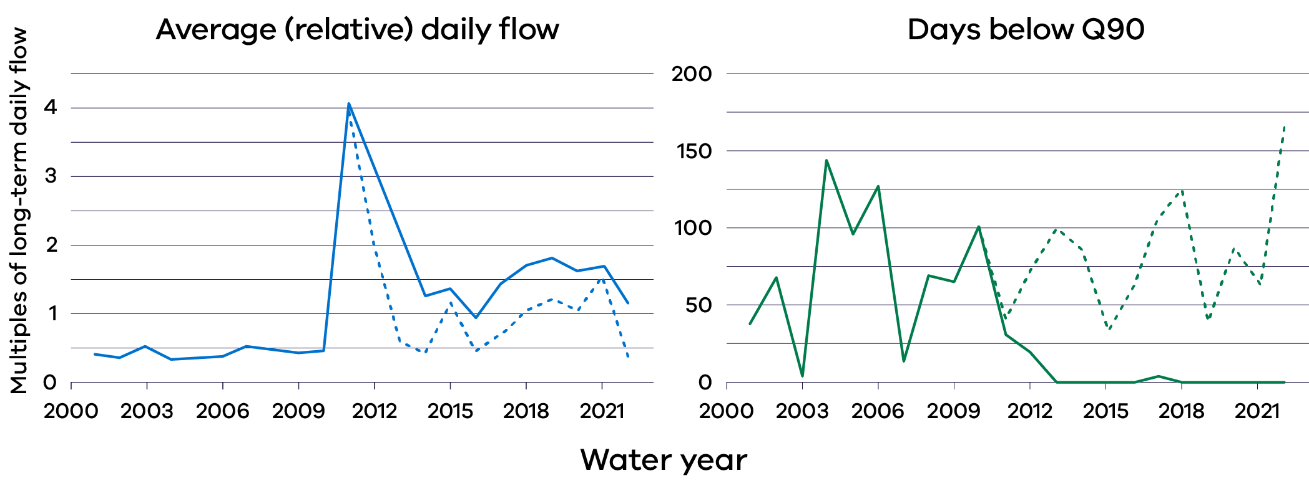
Populations of key native fish species declined in the period 2000 to 2010, with improvements in abundance of Murray cod, trout cod and golden perch post 2012. Modelling provided strong evidence that environmental water has provided substantial benefits to the native fish population of the Lower Goulburn River. This can be seen in Figure 9, which provides an example of Murray cod abundance, with and without environmental water.
Figure 10: Modelled Murray cod population abundances in the lower Goulburn River with environmental water and under a counterfactual scenario in which no environmental water was delivered. Points display median values and bars bound 90% credible intervals. All modelled values are subject to uncertainty (Tonkin et al. 2024).
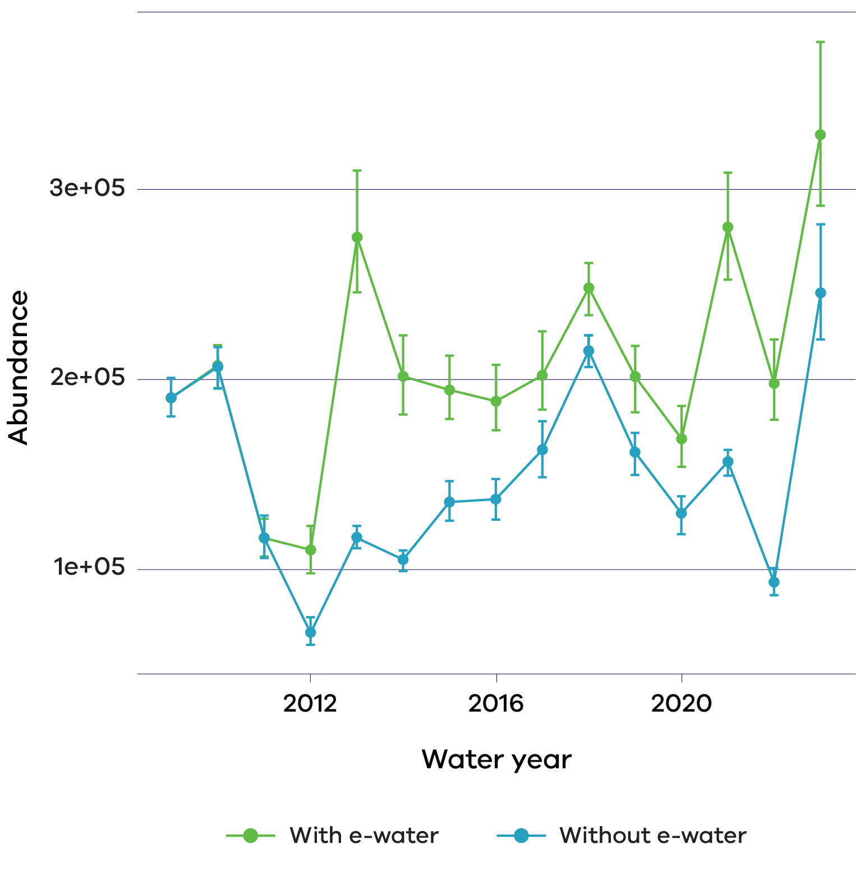

The Campaspe River
The Campaspe River rises in the central highlands of the Great Dividing Range, before flowing into the major storage at Lake Eppalock. The river then continues from Lake Eppalock in a northerly direction to discharge into the Murray River downstream of Echuca. The river has a narrow riparian zone dominated by large river red gums. It supports several large-bodied native fish such as Murray cod, silver perch and golden perch. Monitoring of native fish has been ongoing in the Campaspe River for 17 years (between 2007 and 2024).
As for the Goulburn River, trends in flow metrics, complementary research and long-term fish population trends were used to develop a qualitative understanding of the influence of flows on native fish populations in the Campaspe River, including the likely effects of environmental water deliveries since 2010 (Tonkin et al. 2024). A quantitative model for the fish species was also developed based on nine key predictor variables including flow metrics, temperature, invasive species and previous abundance. The model was built and validated using fish abundance data from 26 waterways across Victoria and was used for a more detailed analysis at six systems. Figure 11 shows a comparison of monitoring (observed) data against modelled outputs for three species in the Campaspe specifically, with reasonable agreement providing some confidence in interpretation of the impact of the predictor variables, including the flow metrics (further validation and analysis is available in Tonkin et al. 2024). In combination, results from these studies showed that sustained low flow conditions in the Campaspe from 2000 to 2010 and extremes in flow variability are likely to be the key drivers of low abundances or declining trends of many fish species during this time. Conversely, since 2012, increases in flows in the Campaspe River are likely to be the main drivers of increasing trends in abundance, reporting rates and recruitment of these fish species.
Based on their results, Tonkin et al. (2024) explain that although key attributes of the flow regime linked to native fish population dynamics have improved substantially since 2010, particularly the reduction in low flow days and decrease in extreme flow variability, the contribution of environmental water to these changes in flow conditions and therefore fish population recovery was less clear. Results from the counterfactual scenario suggested that without environmental water, the number of low flow days each year, flow variability, and average daily discharge from 2000 to 2023 would have been only slightly different had the water not been delivered (which differs considerably from the Goulburn River counterfactual; compare Figure 8 and Figure 10). Tonkin et al. (2024) note that this could be because the Campaspe’s environmental flow recommendations are frequently met using water that is not specifically assigned to the environmental water portfolio. For example, environmental water managers work closely with Goulburn Murray Water to influence the way inter-valley trade water is delivered to reduce ecological impacts and, where possible, meet flow recommendations.
Figure 11: Flow (left) and number of low flow days (right) in the Campaspe River 2000 to 2023 showing with environmental water (solid line) and without (dotted line) (Tonkin et al. 2024).
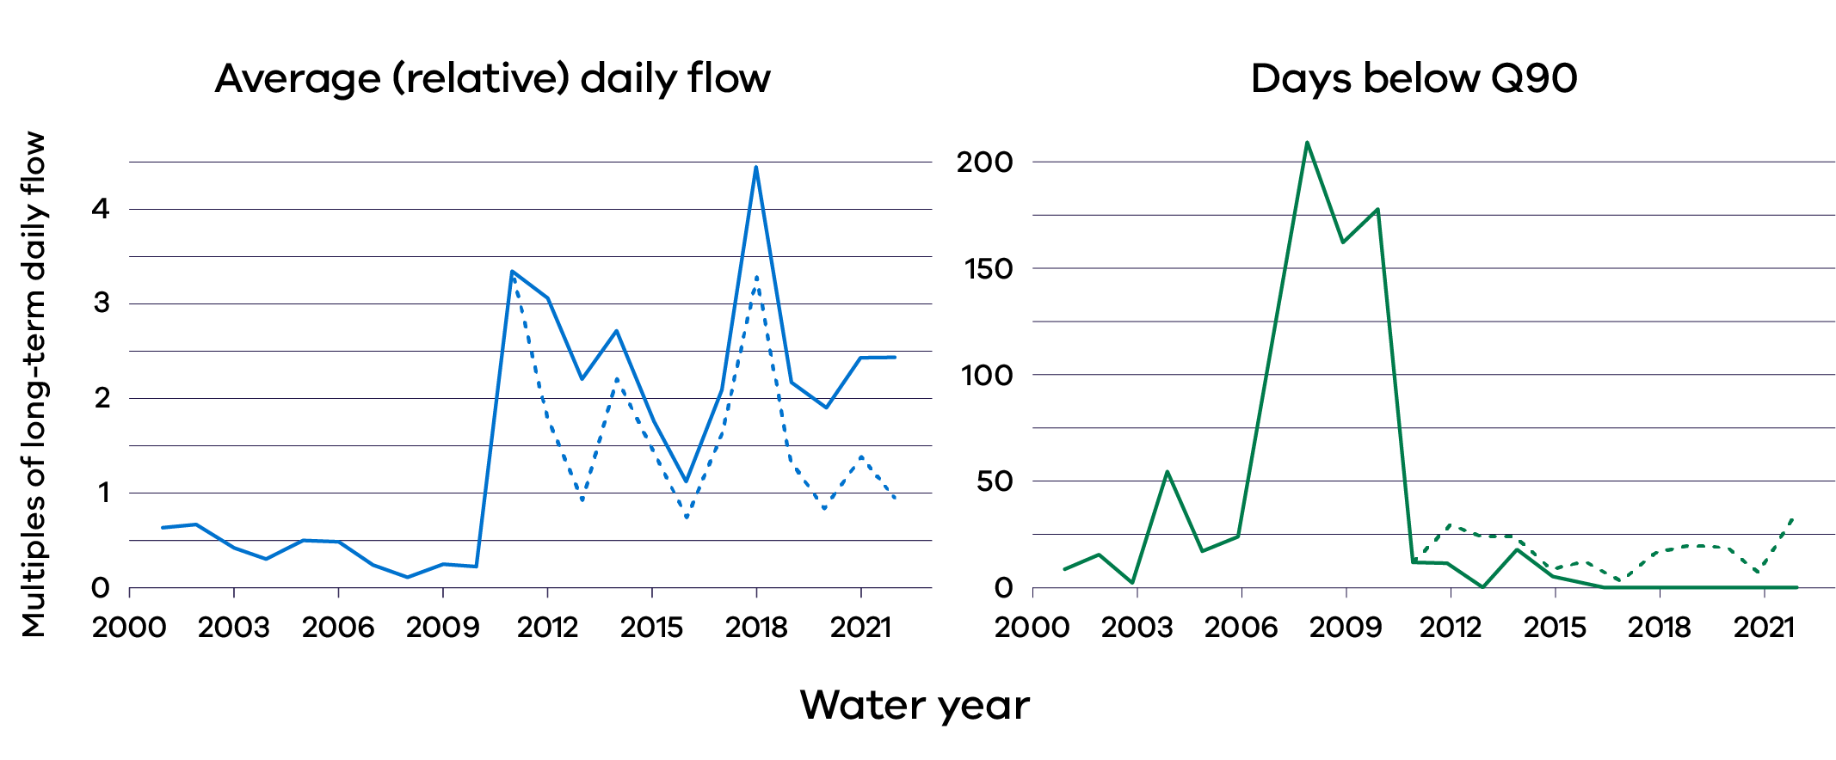
While further assessment is required, these results suggest that the management of environmental water in conjunction with natural flow events and flows to support other water delivery needs (i.e., irrigation) has led to significantly improved native fish populations in the Campaspe River (Figure 11).
A graph displaying observed (orange) and modelled (green) estimates of catch-per-unit-effort for three fish species in the Campaspe River (reaches 2-4) from 2008 to 2023. Points are median values and bars bound 10th and 90th percentiles (80% credible intervals). Both the observed and modelled estimates show a slight increase trend in Catch per unit effort over time
Figure 12: Observed (orange) and modelled (green) estimates of catch-per-unit-effort for three fish species in the Campaspe River (reaches 2-4) from 2008 to 2023. Points are median values and bars bound 10th and 90th percentiles (80% credible intervals) (Tonkin et al. 2024).
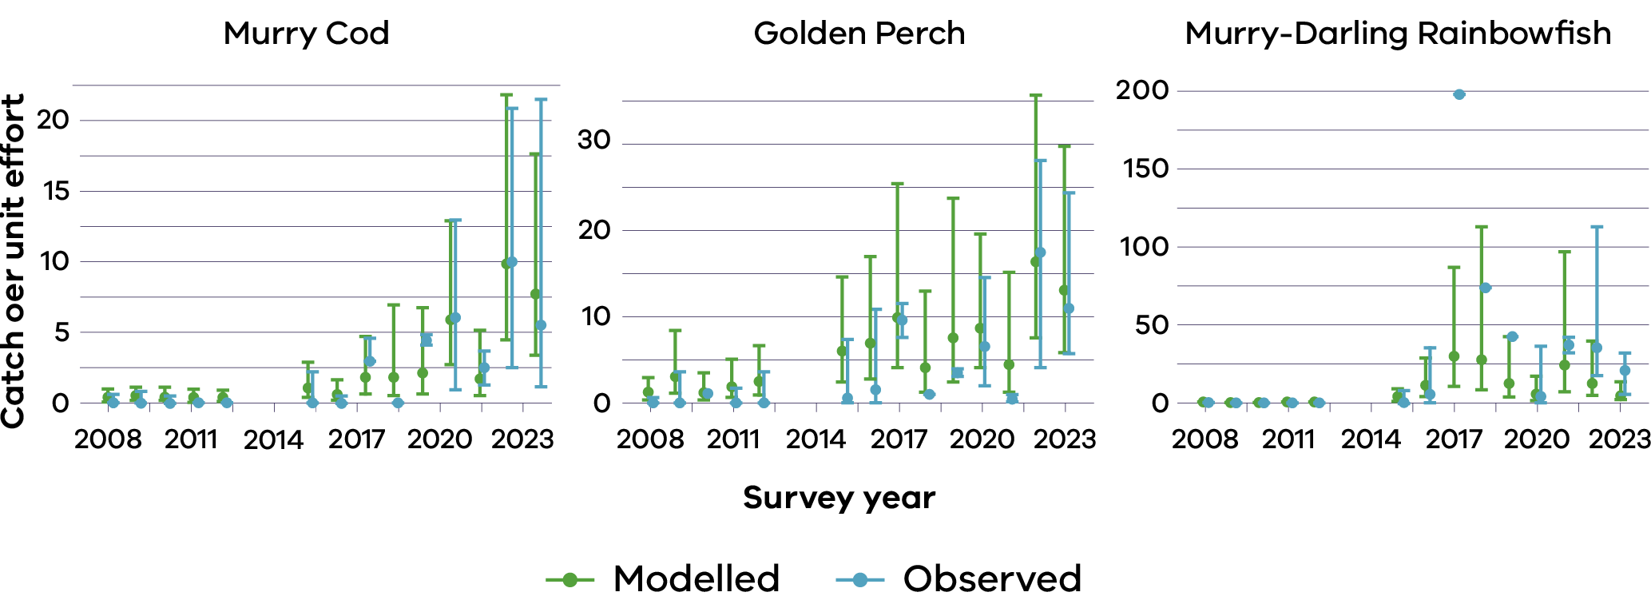

2. Managing Moira grass in Barmah Forest using environmental water and grazer exclusion
Barmah Forest is a Living Murray icon site and was listed as a wetland of international importance under the Ramsar Convention in 1982. Together with Millewa Forest in NSW, Barmah Forest forms the largest remaining expanse of river red gum forest and woodland in Australia. It is considered internationally important for its wetland vegetation communities and supports threatened and colonial nesting waterbird species. At the time the site was listed, Barmah Forest supported extensive areas of Moira grass, a wetland plant that not only has inherent values, but supports important ecological functions such as carbon and nutrient cycling and provision of habitat for frogs, fish, and waterbirds, including the nationally endangered Australasian bittern.
The extent of Moira grass at Barmah Forest has declined significantly since the 1930’s and the rate of loss has increased in the past two decades. There were an estimated 4000 hectares in the 1930s, 1650 hectares in 1979, and 947 hectares in 2007 (Colloff et al. 2014). By 2015 this number had dropped to less than 200 hectares, with only 50 hectares remaining of monospecific swards that were a historically important part of the floodplain (Vivian 2013, Vivian et al. 2015). This represents an exceedance of the Limits of Acceptable Change (LAC) for the Barmah Forest Ramsar site and a potential change in ecological character.
Reasons for the decline in Moira grass are complicated but related to two main drivers:
- a long history of changed water regimes, and
- grazing, particularly by feral horses and historically by cattle.
The optimal climatic conditions and water regime for aquatic grasslands, including Moira grass, have been described by Colloff et al (2014) generally as:
- hot summers with high evaporative demand,
- contrasting wet-dry periods on the floodplain,
- a predictable flood peak that arrives each spring, and
a flood peak that covers the floodplain by at least 1-2 metres for at least one month.
This is consistent with the “natural” flood regime of Barmah Forest prior to river regulation, where the Moira grass plains were inundated for an average of 7.4 months a year. Flows (inundation) were strongly seasonal and highest in September and lowest in March (Colloff et al. 2014).
Following the commissioning of the Hume Dam in 1936, there was a dramatic reduction in the moderate winter-spring flooding optimal for Moira grass wetlands. There has also been a corresponding increase in shallow, summer flooding of the system due to ‘rainfall rejection events’ (the rejection of previously ordered irrigation water following unexpected rainfall) (Abel et al. 2006). This altered water regime favours the growth of giant rush and river red gum, both of which have expanded at Barmah Forest, at the expense of Moira grass.
Grazing by cattle and feral horses is the other major factor that has contributed to the decline of Moira grass at Barmah Forest. While cattle have been removed from the waterway since 2007, feral horses have remained (see below for recent management actions).
Management at Barmah Forest aims to improve the extent and condition of Moira grass through a combination of water management (Goulburn Broken CMA 2023) and control of feral horses (Parks Victoria 2020). Unseasonal summer and autumn flooding due to rainfall rejection events is managed in two ways. Under a reciprocal arrangement with Millewa Forest, Barmah Forest receives water resulting from rainfall rejection events every other year. When the rainfall rejection flows are directed to Barmah Forest, Goulburn Broken CMA attempts to minimise their impact on Moira grass by diverting flood waters to giant rush dominated wetlands, where possible. These arrangements allow wetlands in both the Barmah and Millewa forests a better chance of drying every second summer, which, when combined with deliveries of water for the environment to provide winter/spring inundation, helps return them to a more natural wetting and drying regime (Brown and Tolsma 2021).
The Barmah Forest Strategic Action Plan developed by Parks Victoria in 2019-20 lists the removal of feral horses from the Barmah National Park as an immediate priority for action to fulfil commitments as a Ramsar wetland. It describes the first stage of control and removal of feral horses, bringing the total number down to a maximum of 100 in the first four years. The longer-term aim is total removal of feral horses from the Barmah National Park (Parks Victoria 2020). The Plan also included actions for a reduction in total grazing pressure exerted by other herbivorous grazers (feral sheep, goats, pigs and deer), as well as maintenance and improvement of water regimes, a reduction in the spread of native invasive species (giant rush and river red gum), and the reintroduction of Moira grass to some areas.
To explore the effects of excluding feral grazers (mostly horses, pigs and deer) on Moira grass in Barmah Forest, Goulburn Broken CMA constructed a series of grazing exclosures at Little Rushy Swamp in 2017 and 2019, and four other locations in 2020 (Hut Lake, Harbours Lake, Top Lake and Steamer Plain). Results of annual vegetation monitoring of the most recent four fenced areas from May 2020 to May 2024 indicated that the cover of Moira grass has increased markedly in the non-grazed quadrats and remained stable in the grazed quadrats over the study period ( Figure 12). These results are supported by the use of photo points which showed a substantial increase in plant biomass inside the exclosures compared with outside over the study (Figure 13).
The results of this 52-month study continue to show that grazing by feral animals reduces the cover of Moira grass, which clearly supports Parks Victoria’s objective to remove feral horses from the Barmah Forest in order to fulfil commitments as a Ramsar wetland (Water Technology 2024).
Figure 13: Summary of the change in cover of Moira grass inside and outside the grazing exclosures between May 2020 and May 2024 (Water Technology 2024).
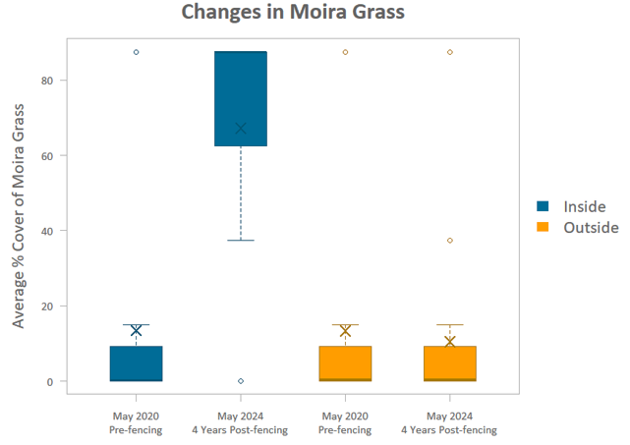
Figure 14: Photo-point monitoring at Harbours lake. Left of fence = grazing, right of fence = grazing excluded (Water Technology 2024).
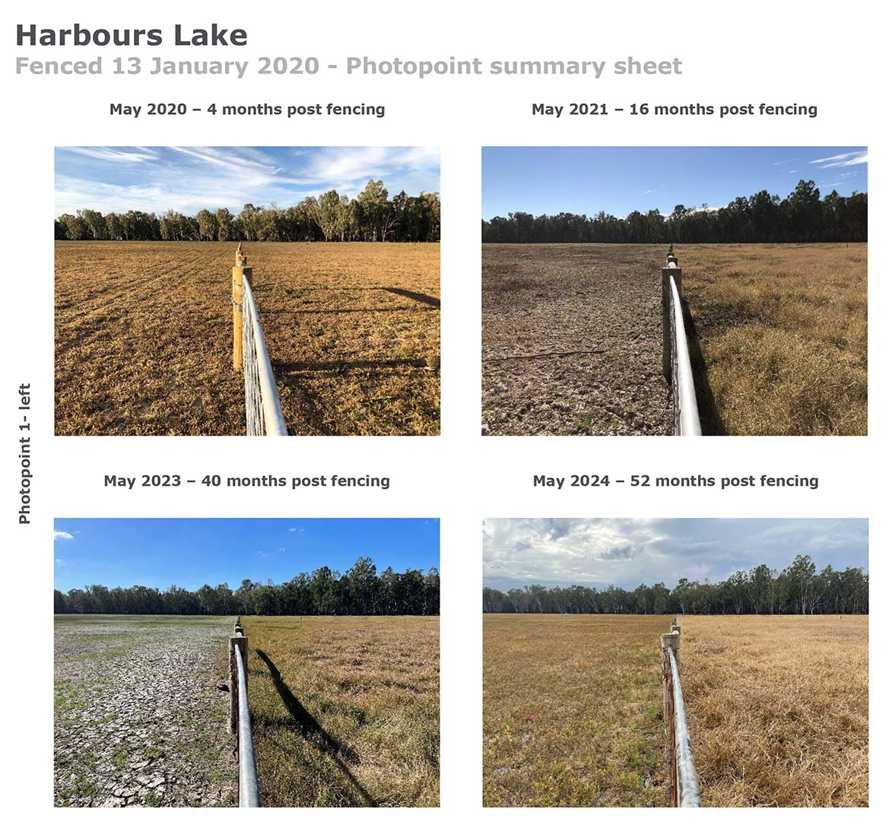

3. Lake Kramen – waterbird breeding
Lake Kramen is one of the 12 lakes that comprise the Hattah-Kulkyne Ramsar site located in the Hattah-Kulkyne National Park, between Ouyen and Mildura in far north-west Victoria. Naturally, Lake Kramen is an episodic wetland that would have filled during large flood events in the Murray River. River regulation has reduced the frequency and duration of flooding in the Hattah Lakes, and in 2011 Lake Kramen was described as having not filled naturally since it was designated as a wetland of international importance in 1982 (Butcher and Hale 2011).
Works commissioned under The Living Murray program were implemented to restore hydrological regimes and maintain the ecological character of the Hattah-Kulkyne Ramsar site. The system, including Lake Kramen, is now actively managed with environmental water for optimal wetting and drying cycles.
In spring 2019, approximately 13 gigalitres of environmental water was delivered to Lake Kramen. The objectives of the watering event were to provide a local refuge for aquatic fauna and to improve vegetation condition in and surrounding the lake. In line with expectations, as the water levels of the lake naturally drew down, vegetation condition improved and Lake Kramen provided ideal habitat for a range of waterbird species, including conditions appropriate for waterbird nesting. By 2020 and into 2021, Lake Kramen was the sole lake retaining environmental water within Hattah-Kulkyne National Park, and much of the surrounding landscape was also dry.
Monitoring following the spring 2019 environmental water delivery showed significant improvement in tree condition at Lake Kramen, as well as extensive use of the waterbody by waterbirds, frogs, and microbats (Bloink et al. 2020). Between September 2020 and February 2021, 54 bird species (including six threatened species) were observed using the lake, and six species were recorded breeding (GHD 2021).
In autumn 2021, Mallee CMA project officers observed black swans nesting at the lake and noted the aquatic vegetation present was providing abundant feeding habitat and nest-building materials (Figure 14). Monitoring in June 2021 indicated at least 45 active swan nests and over 2,200 birds were identified, with hatching in many nests commencing at that time (GHD 2021). Black swan fledging is known to take 150-170 days from hatching and it is vital that inundation is maintained to provide suitable foraging and predator-free habitat to support successful recruitment. Given this, Mallee CMA worked collaboratively with Parks Victoria and VEWH to monitor the situation and deliver water when required to maintain water depths at a minimum of 0.5-1.0 m in Lake Kramen to support fledging.
Most (around 100) cygnets had successfully fledged prior to the complete dry out of the lake in December 2021.
Figure 15: Black swans and swan nest with one cygnet at Lake Kramen in Hattah-Kulkyne National Park, 2021.
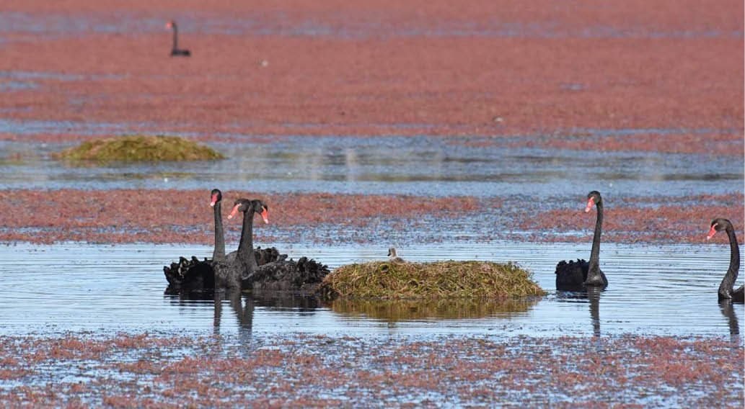

4. Wimmera waterholes
The Wimmera River (Barengi Gadjin) flows from its source in the Pyrenees Range and terminates at Lake Hindmarsh. During very large floods, Lake Hindmarsh may overflow through Outlet Creek into Lake Albacutya and eventually into Wyperfeld National Park (Bren and Sandell 2004). During drought periods, the lower Wimmera River frequently ceases to flow, and forms a series of disconnected pools (Figure 15).
Figure 16: Wimmera River (Barengi Gadjin) showing the location of major drought refuge waterholes in the lower reaches (Houghton et al. 2021).
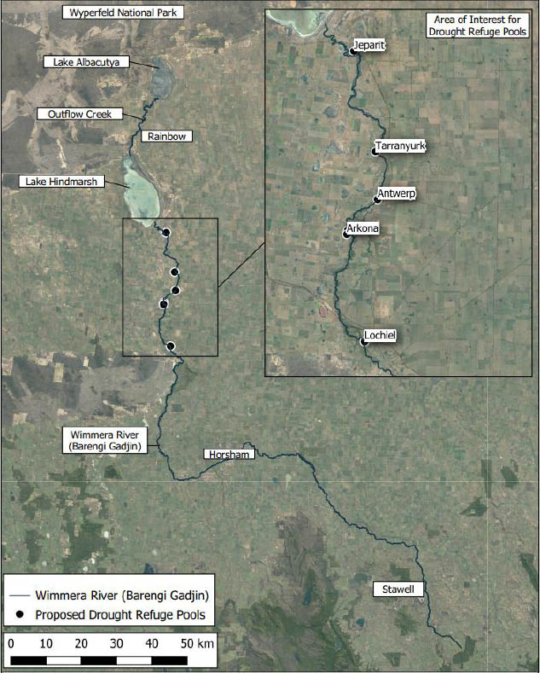
If appropriate water levels and quality can be maintained, these pools provide important drought refuges, offering essential habitat for obligate aquatic species such as fish, wetland plants, and macroinvertebrates, until wetter conditions return. Littoral and riparian vegetation surrounding the pools provides important shade and habitat for waterbirds, bush birds, and marsupials (Figure 16).
Except under conditions of very high flow, the lower Wimmera River is a “gaining” system with respect to groundwater. Saline groundwater entering the system forms a halocline (a layer of saline water at the bottom of the waterholes) that experiences little or no mixing with the surface water layer. The water below the halocline is not only highly saline, but also very low in dissolved oxygen. When the refuge pools are full, the surface layer is oxygenated and fresh, and supports aquatic biota. As the refuges dry, the residual pools become increasingly saline and less oxygenated. This favours common carp over native fish such as freshwater catfish. If dissolved oxygen levels drop below 2 mg/L, fish deaths can occur (Figure 16).
Importantly, the depth and water quality of the lower Wimmera River refuge pools can be maintained with environmental flows, although this requires large volumes of water (typically 2000-3000 ML per event). Accordingly, the Wimmera CMA commissioned development of a Wimmera River Drought Management Strategy (Alluvium 2018) and a Wimmera River Drought Refuge Management Plan (Houghton et al. 2021) to investigate alternative options for managing the refuge pools, including using water from the Wimmera-Mallee pipeline and revegetation to protect water-dependent fauna and flora during dry periods. Results from this work indicated a more efficient way to maintain water in the refuges is to pump environmental water directing into the waterholes from the Wimmera-Mallee pipeline. Four of the waterholes in the system have received approval for watering in this manner (Lochiel, Arkona, Antwerp and Tarranyurk).
When environmental water allocations and carry over volumes are insufficient to achieve environmental objectives in the lower Wimmera River, the provision of high-quality pipe water directly to drought refuge pools will sustain biodiversity through the extremes of drought and enable more rapid recolonisation of other parts of the river when wet conditions return.
Figure 17. Conceptual model of managed and unmanaged waterholes in the lower Wimmera River (Houghton etal. 2021).
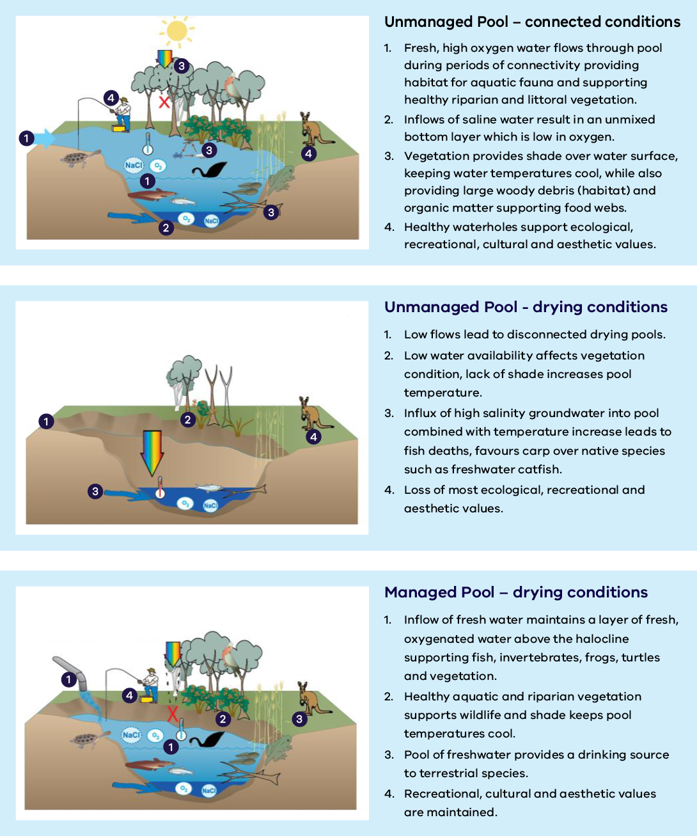

5. Minimising the effects of blackwater in the Goulburn-Broken region
Significant rainfall in the Goulburn Broken catchment in December 2023 and January 2024 led to mobilisation of organic matter from tributaries and floodplains into the lower Broken Creek and Lower Goulburn River. The movement of this carbon into river systems stimulates biological activity, which can rapidly deplete the water column of oxygen. This is often called a “blackwater event” due to the dark colour of the water (Figure 17). Dissolved oxygen concentrations have a marked impact on aquatic animals including invertebrates and fish. At lower levels, biota exhibit signs of stress and at very low levels (below 2 mg/L) death can occur (Figure 18).
Figure 18: Broken Creek at Larissa Road on 3 January 2024, with dissolved oxygen levels approximately 5 mg/L (left) and on 6 January 2024 with obvious blackwater and dissolved oxygen levels of 1.5 mg/L (right) (source GB CMA).
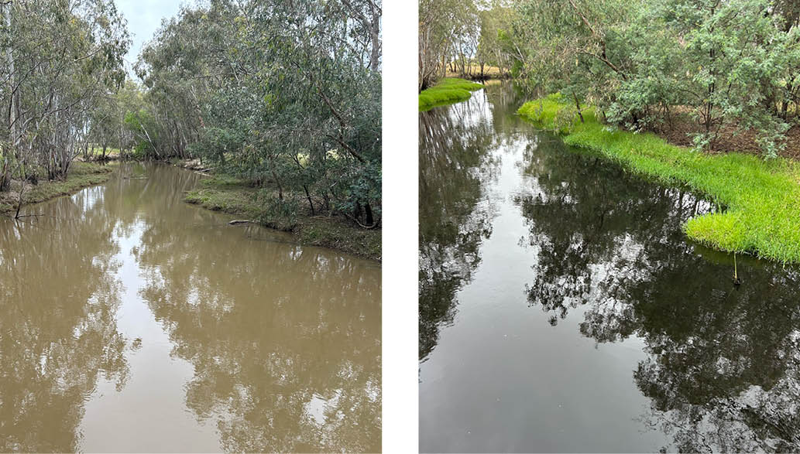
Figure 19: Visual representation of the effect of Dissolved Oxygen on aquatic animals. Water Quality and Dissolved Oxygen - GB CMA - Goulburn Broken CMA.
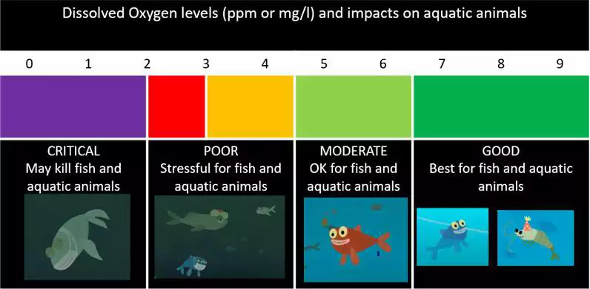
Frequent monitoring occurred throughout the high rainfall period (December 2023 and January 2024) and revealed extended periods of very low dissolved oxygen levels (1-2 mg/L for up to a week) at Murchison and downstream of Shepparton on the Lower Goulburn River and at Larissa Road (Figure 17) and Katandra Weir on the lower Broken Creek. During this time, reports were made to Goulburn Broken CMA of golden perch showing signs of stress near Katandra Weir and stressed shrimp and Murray spiny crayfish downstream of Bunbartha on the Lower Goulburn River. Small numbers of dead fish were located on the riverbanks around McCoys Bridge.
To ameliorate the effects of blackwater and minimise the time aquatic biota were exposed to low dissolved oxygen levels, water management partners Goulburn Broken CMA, the VEWH, and Goulburn Murray Water worked together to deliver water with higher dissolved oxygen concentrations from numerous outfalls in the irrigation network of both river systems (e.g., Figure 19), providing critical refuge areas. As flows were above operational levels (10,000 ML/day) water for the environment couldn’t be used until flows receded to within these levels. Deliveries in lower Broken Creek began on 12
January 2024 and continued for 3 weeks, and watering in the Goulburn River system commenced on 16
January. Once natural flows had receded to below 10,000 ML/day in the Lower Goulburn (25
January), water for the environment was delivered to slow the recession, protecting the banks from erosion and providing a prolonged period of good quality water to help aquatic biota.
Figure 20: Irrigation outfalls into Seven Creeks in water backed up from the Goulburn River at Shepparton on the 16 January 2024 (source GB CMA).
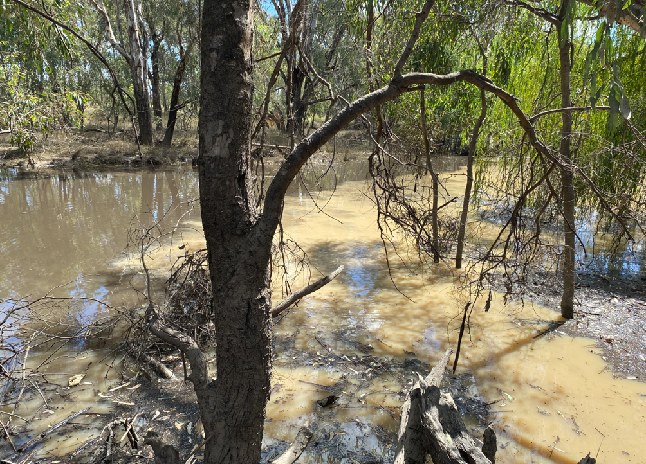

Based on historic evidence from similar events, a large number of fish and crustacean deaths would generally be expected from a summer event with prolonged very low dissolved oxygen levels. In this case, the absence of this negative response suggests that the provision of critical habitat using irrigation outlets and water from the Goulburn Water Quality Reserve (30 ML of water that can be released to meet water quality problems in the Goulburn river, subject to competing needs from the lower Broken Creek; available in any year.) helped support aquatic animal health. It is likely that this worked in combination with a range factors, including cooler weather (for summer) and good water quality in connected tributaries and the Murray, which fish could move to.

6. Tracking turtles in Barmah Forest
Freshwater turtles are declining along the Murray River and there is a paucity of long-term turtle research in this region. The Barmah-Millewa Forest is unique, being the largest river red gum floodplain system along the Murray River. It provides important permanent and floodplain habitat for three species of turtles including the broad-shelled turtle, eastern long-necked turtle, and the Murray River turtle. As well as playing important ecological roles, turtles are culturally significant species for the Yorta Yorta people, whose traditional lands encompass Barmah-Millewa Forest. In particular, the broad-shelled turtle, Bayadherra, is a totem species and integral to their creation stories as a protector, provider, and guide.
Barmah-Millewa Forest, with its extensive network of wetlands, creek lines and floodplain habitats, provides opportunities to investigate and understand how river regulation and water availability influence turtles. To track changes in turtle population condition over time, turtle condition and intervention monitoring programs were established through The Living Murray program in 2018-19 and 2020-21, respectively. These programs included (i) annual condition monitoring and (ii)
monitoring the movement of turtles in response to environmental flows and flood events, using acoustic technology.
The movement tracking program has shown that male Murray River turtles are highly mobile and capable of moving more than 100 kilometres per year. Their large home ranges incorporate the floodplain and when flow-regulating structures are open they also use regulated creek lines to travel through the forest. The condition monitoring program has generated multiple lines of evidence that landscape-scale flooding positively affects turtle body condition, recruitment, and population size. The body condition of all three species increases with flood extent, particularly the eastern long-necked turtle which is found in ephemeral and semi-permanent habitats. The recruitment of juvenile turtles and their survival to sub-adults is also positively influenced by the extent and frequency of flooding.
These important research programs are helping improve understanding of how water availability and water management influence the habitat use, condition, and survival of broad-shelled turtles, eastern long-necked turtles, and the Murray River turtle. Further research is underway and required, however results to date have provided important evidence that direct intervention using environmental water deliveries can impact both the movement and health of turtle populations.
Figure 21: Eastern long-necked turtles (photographer: Greg Clarke) (top left), Murray River turtle (photographer: Zak Atkins) (top right), broad-shelled turtle (photographer: Katie Howard) (bottom).
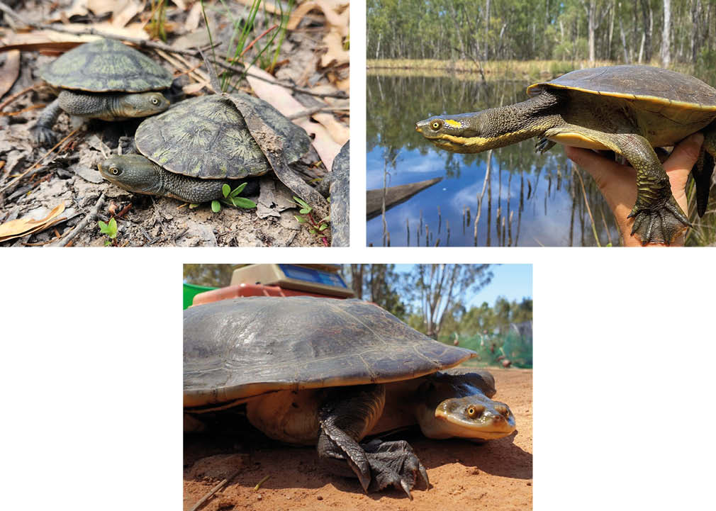

7. Management of water for the environment in conjunction with natural inflows to meet river red gum and waterbird requirements at Gunbower Forest
The Gunbower Forest is situated on the Murray River floodplain in northern Victoria between Torrumbarry and Koondrook. Covering 19,450 ha it is designated wetland of international importance under the Ramsar Convention and is a Living Murray program icon site.
Infrastructure constructed through The Living Murray program includes the Hipwell Road Channel and a series of smaller regulators, which enable effective and efficient environmental water delivery to 4,500 ha of the Gunbower Forest including 80% of the forest’s permanent and semi-permanent wetlands and 23% of the forest’s river red gums. In the last 20 years, the area of forest within the environmental water footprint has experienced only seven floods, three of which were created by operation of the Hipwell Road Channel. This is half the target flooding frequency (seven years in ten) required to support healthy river red gums with flood-dependent understorey vegetation (MDBA 2012).
Since the Millennium Drought broke in 2010-11, river red gums inside the Hipwell Road environmental water footprint had exhibited continual recovery, with the number of trees classed as healthy increasing from 30% in 2010 to 70% in 2019. Understorey vegetation had also shown a clear positive response to natural flooding and environmental watering, with both the cover and diversity of vegetation increasing.
However, by autumn 2022, Gunbower Forest had not received any widespread flooding in four years. Monitoring confirmed the health of the river red gums and understorey vegetation were beginning to decline. The significant Murray River flooding in spring 2022 inundated approximately 15,000 ha of the forest and provided much needed inundation for the floodplain vegetation.
The long duration of the spring flooding provided the understorey vegetation an opportunity to re-establish and put on new growth, while the river red gum canopies showed substantial increases in density. Nevertheless, without follow-up flooding, the gains made by understorey vegetation in 2022 were at risk, with the potential for plants to die back to limited or no above-ground live plant mass, leaving the soil exposed and susceptible to drying out.
To avoid this risk, water for environment was delivered to the forest in winter 2023, using the Hipwell Road Channel. Shortly after commencing water deliveries in June, the Murray River began to rise; inflows commenced via lower lying flood runners and overbank flooding occurred for more than a month. This provided significant inflows to Gunbower Forest, accelerating inundation within the Hipwell Road Channel environmental water footprint and inundating areas that cannot be targeted with environmental water deliveries.
Unfortunately, the duration of the natural flooding event (35 days) fell short of the duration needed by river red gums and understorey vegetation species for desired environmental outcomes (at least 3 months). Field observations identified that floodplain vegetation was beginning to respond positively to the watering, with early responders such as swamp wallaby grass and water ribbons becoming established. North Central CMA water managers determined further watering (beyond the 35 days) would ensure these, as well as other species such as swamp lily, would complete flowering and set seed.
Additionally, several waterbird species were nesting and other species with longer lag periods were beginning to display breeding behaviour. On this basis, water for environment delivery through the Hipwell Road Channel was restarted, to supplement the natural flooding and extend the duration of inundation across the floodplain. A further 17.4 GL of water for the environment was delivered to the Gunbower Forest in this way, extending the duration of inundation initiated by unregulated inflows by 60 days. In October 2023 further unregulated flows occurred in the Murray River so water for environment deliveries were stopped.
This combination of informed and responsive management of water for the environment and natural inflows allowed water requirements of the Gunbower Forest river red gums and understorey vegetation to be met (Figure 22 & 23). The extended flows also aided the development and retention of high-quality habitat for waterbirds and supported waterbird breeding success. Indeed, waterbird numbers peaked at over two thousand birds with breeding colonies of little black cormorant, Australasian darter and little pied cormorant establishing within the forest wetlands. A total of 92 eastern great egret were also observed with some in breeding plumage, however active breeding was not observed.
Figure 22: Flow rates at Hipwell Channel offtake compared with the Murray River at Torrumbarry Weir 2023-24. The dashed line denotes the approximate overbank threshold of 25,000 ML/d downstream of Torrumbarry Weir (Source: GMW 2024, MDBA 2024a)
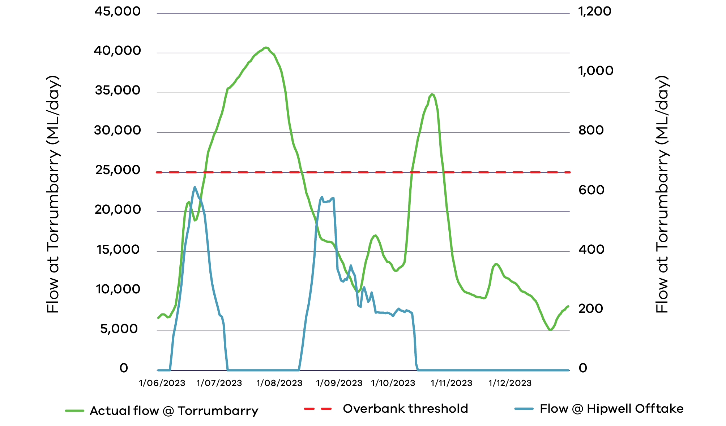
Figure 23: Vegetation response along Nursery Track in September 2023. Aquatics include water milfoil and starwort, with amphibious species such as swamp wallaby grass, blown grass and spike rush in shallower areas. (Photo NCCMA)
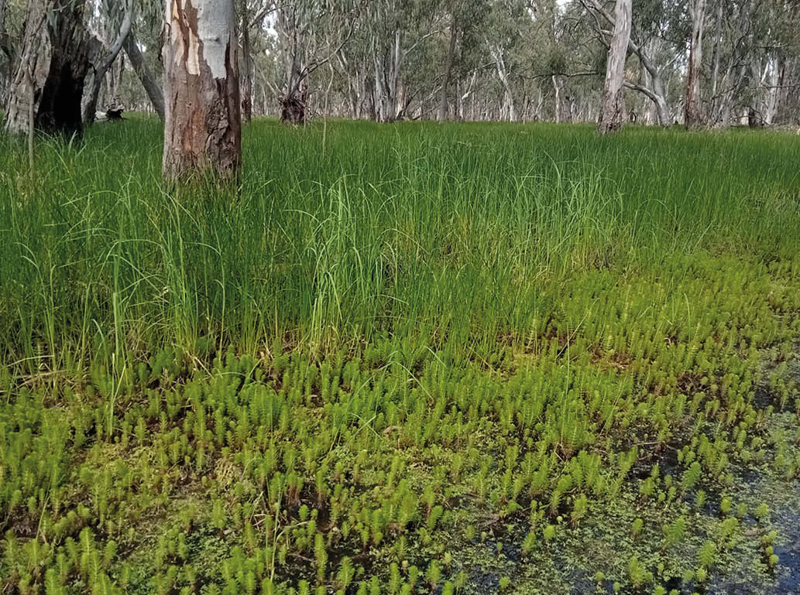
Figure 24: Canopy and understorey condition in Gunbower Forest in March 2022 (left) prior to the natural flooding showing minimal understorey and thinning red gum canopies compared to December 2023 (right) following two years of consecutive flooding created by both unregulated flows and water for the environment. (Photos: NCCMA).
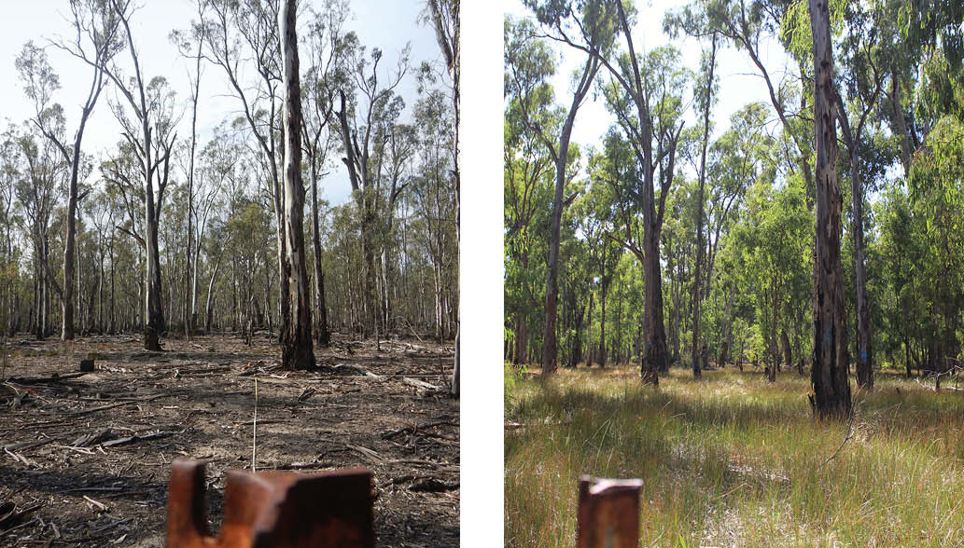

References
Abel, N., Roberts, J., Reid, J., Overton, I., O’Connell, D., Harvey, J., and Bickford, S. (2006). Barmah Forest: A Review of its Values, Management Objectives and Knowledge Base. CSIRO Sustainable Ecosystems.
Alluvium (2018). Wimmera River drought refuge management strategy. Prepared for the Wimmera Catchment Management Authority, October2018.
Bloink, C., Walker, Z., Sharp, J., and White, M. (2020). The Living Murray Condition Monitoring 2019-20 Hattah Lakes. Ecology Australia, Fairfield, Victoria.
Bren, L. and Sandell, P. (2004). Ecohydrology and Environmental Change to Lake Albacutya and Wyperfeld Park in North-Western Victoria, Australia. Australian Geographical Studies 42(3): 307–324.
Brown, G. and Tolsma, A. (2021). Mapping of River Red-gum and Giant Rush incursions into wetlands of the Barmah Forest Ramsar Site. Arthur Rylah Institute for Environmental Research, Heidelberg, Vic.
Butcher, R and Hale, J (2011). Ecological Character Description for Hattah-Kulkyne Lakes Ramsar Site. Report to the Department of Sustainability, Environment, Water, Population and Communities, Canberra.
Colloff M J, Ward K A and Roberts J. (2014) Ecology and conservation of grassy wetlands dominated by spiny mud grass Pseudoraphis spinescens in the southern Murray–Darling Basin, Australia. Aquatic Conservation: Marine and Freshwater Ecosystems, 24: 238–255.
Department of Environment, Land, Water and Planning (2021). Northern Victoria Long-term Watering Plan. Minor update, June 2021. Victoria.
Department of Environment, Land, Water and Planning (2021). Victorian Murray Long-term Watering Plan. Minor update, June 2021. Victoria.
Department of Environment, Land, Water and Planning (2020). Wimmera-Mallee Long-term Watering Plan. Minor update, September 2020. Victoria.
GHD 2021. Assessing nest sites of colonial nesting waterbirds – Hattah Kulkyne National Park. Report for Mallee CMA.
Goulburn Broken CMA (2023). Barmah-Millewa Forest Environmental Water Management Plan. Goulburn Broken CMA, Shepparton, Victoria.
Goulburn Broken CMA (2024). Broken River and Upper Broken Creek Seasonal Watering Proposal 2024-2025, Goulburn Broken CMA, Shepparton, Victoria.
Hansen, B., Fuller, R., Watkins, D., Rogers, D., Clemens, R., Newman, M., Woehler, E. and Weller, D., (2016). Revision of the East-Asian Australasian Flyway Population Estimates for 37 Listed Migratory Shorebird Species. BirdLife Australia.
Houghton, J., Crook, D., Boon, P., Iervasi, D., Davies, P., Hale, J., Arrowsmith, C., and Bond, N. (2021). Wimmera River (Barengi Gadjin) Drought Refuge Management Planning. Streamology Pty Ltd, Bright, Victoria.
Murray–Darling Basin Authority (2012). The Murray Darling Basin Plan, Murray–Darling Basin Authority, Canberra: Australian Government, Office of Parliamentary Counsel. Federal Register of Legislation - Basin Plan 2012.
Murray–Darling Basin Authority (2019). Basin-wide environmental watering strategy. Publication No 42/19. Second edition, 22 November 2019. Revised February 2020. Basin-wide environmental watering strategy | Murray–Darling Basin Authority (mdba.gov.au)
Parks Victoria (2020). Strategic Action Plan: Protection of Floodplain Marshes in Barmah National Park and Barmah Forest Ramsar Site. Parks Victoria: Melbourne, Australia
Peterson, T., Saft, M., Peel, M.C., and John, A. (2021). Watersheds may not recover from drought. Science 372 (6543), 745-749.
Tonkin, Z., Yen, J., Kitchingman, A., Amtstaetter, F., Hackett, G., Harris, A., Koster, W., Lieschke, J., Lyon, J., Pickworth, A., Raymond, S. (2024). Assessing long-term population trends for priority fish species across Victorian rivers. Arthur Rylah Institute for Environmental Research Unpublished Client Report for Department of Energy, Environment and Climate Action, Heidelberg, Victoria.
Vivian, L. (2013). Mapping the Moira Grass: the decline of Pseudoraphis spinescens grasslands at Barmah Forest. Canberra.
Vivian, L.M., Ward, K.A., Marshall, D.J., and Godfree, R.C. (2015). Pseudoraphis spinescens (Poaceae) grasslands at Barmah Forest, Victoria, Australia: current distribution and implications for floodplain conservation. Australian Journal of Botany 63(6): 526.
Water Technology (2024): Barmah Exclosure Monitoring – May 2024. Report prepared for the Goulburn-Broken Catchment Management Authority, Shepparton, Victoria.

Appendix A – Alignment of Basin Plan Chapter 5 and 8 objectives and outcomes
5.02 (1)(a) to give effect to relevant international agreements through the integrated management of Basin water resources
S8.05 Protection and restoration of water-dependent ecosystems
- 8.05 (2)(a) To ensure that declared Ramsar wetlands that depend on Basin water resources maintain their ecological character.
- 8.05 (2)(b) To protect and restore water-dependent ecosystems that support species listed under JAMBA, CAMBA, ROKAMBA, Bonn Convention.
5.02 (2)(c) healthy and resilient ecosystems with rivers and creeks regularly connected to their floodplains
S8.06 Protection and restoration of ecosystem functions of water-dependent ecosystems
- 8.06 (3)(a) To protect and restore connectivity within and between water-dependent ecosystems by ensuring that the diversity and dynamics of geomorphic structures, habitats, species and genes are protected and restored.
- 8.06 (3)(b)(i) To protect and restore connectivity within and between water-dependent ecosystems by ensuring that ecological process dependent on hydrologic connectivity longitudinally along watercourses are protected and restored.
- 8.06 (3)(b)(ii) To protect and restore connectivity within and between water-dependent ecosystems by ensuring that ecological process dependent on hydrologic connectivity laterally between watercourses and their floodplains (and associated wetlands) are protected and restored.
5.03 (1)(a), (2) To protect and restore water-dependent ecosystems of the Murray-Darling Basin with strengthened resilience to a changing climate
S8.05 Protection and restoration of water-dependent ecosystems
- 8.05 (3)(a) To protect and restore biodiversity that is dependent on Basin water resources by ensuring that water-dependent ecosystems that support the life cycles of a listed threatened species or listed threatened ecological community, or species treated as threatened or endangered (however described) in State law, are protected and, if necessary, restored so that they continue to support those life cycles.
- 8.05 (3)(b) To protect and restore biodiversity that is dependent on Basin water resources by ensuring that representative populations and communities of native biota are protected and, if necessary, restored.
5.03 (1)(b), (2) To protect and restore the ecosystem functions of water-dependent ecosystems in the Murray-Darling Basin with strengthened resilience to a changing climate
S8.06 Protection and restoration of ecosystem functions of water-dependent ecosystems
- 8.06 (2) The water quality of Basin water resources does not adversely affect water-dependent ecosystems and is consistent with the water quality and salinity management plan.
- 8.06 (4) To protect and restore natural in-stream and floodplain processes that shape landforms (for example, the formation and maintenance of soils).
- 8.06 (6)(a) To protect and restore ecosystem functions of water-dependent ecosystems that maintain populations (for example recruitment, regeneration, dispersal, immigration and emigration) including by ensuring that flow sequences, and inundation and recession events, meet ecological requirements (for example, cues for migration, germination and breeding).
- 8.06 (6)(b) To protect and restore ecosystem functions of water-dependent ecosystems that maintain populations (for example recruitment, regeneration, dispersal, immigration and emigration) including by ensuring that habitat diversity, extent, condition and connectivity that supports the life cycles of biota of water-dependent ecosystems (for example, habitats that protect juveniles from predation) is maintained.
- 8.06 (7) To protect and restore ecological community structure, species interactions and food webs that sustain water-dependent ecosystems, including by protecting and restoring energy, carbon and nutrient dynamics, primary production and respiration.
5.03 (1)(c) To ensure that water-dependent ecosystems are resilient to climate change and other risks and threats
S8.07 Ensuring water-dependent ecosystems are resilient to climate change and other risks and threats
- 8.07 (2) That water-dependent ecosystems are resilient to climate change, climate variability and disturbances (for example, drought and fire).
- 8.07 (5) To mitigate human-induced threats (for example, the impact of alien species, water management activities and degraded water quality).

Appendix B – Alignment between Chapter 8 objectives and waterway health indicators monitored at relevant priority environmental assets
Detailed BP objectives | Relevant monitoring indicators
8.05 (2)(a) Ramsar wetlands maintain their ecological character | Fish – recruitment, spawning; species richness, diversity &/or relative abundance (threatened species and non-threatened species)  Vegetation (wetland understorey) – native species cover, extent, species richness  Waterbirds – breeding; species richness, diversity &/or abundance (threatened species, non-threatened and migratory species)
8.05 (2)(b) Protect and restore water-dependent ecosystems that support JAMBA, CAMBA, ROKAMBA, Bonn Convention-listed species. | Waterbirds – species richness, diversity &/or abundance (international migratory species)
8.05 (3)(a) Protect & restore Basin assets that support threatened or endangered species or ecological communities (listed or treated so in State law) | Fish – species richness, diversity &/or relative abundance (threatened species)  Fish – Murray Hardyhead presence  Waterbirds – species richness, diversity &/or abundance (threatened species)
8.05 (3)(b) Ensure representative populations and communities of native biota are protected and restored | Fish – species richness, diversity &/or relative abundance (non-threatened species)  Vegetation – native species cover, extent, species richness; tree condition; lignum condition  Waterbirds – species richness, diversity &/or abundance (non-threatened and migratory species)  Frogs – species richness (non-threatened species)
8.06 (3)(a) To protect and restore the diversity and dynamics of geomorphic structures, habitats, species and genes | Bank stability – erosion, deposition
8.06 (3)(b)(i) Protect and restore ecological processes dependent on longitudinal connectivity | Fish – movement (migration & dispersal), distribution
8.06 (3)(b)(ii) Protect and restore ecological processes dependent on lateral connectivity | Fish – movement (migration & dispersal)
8.06 (6)(a)(b) Protect and restore water-dependent ecosystem functions (a) by ensuring flow sequences, and inundation and recession events, meet ecological requirements and (b) by maintaining habitat diversity, extent, condition and connectivity | Fish - recruitment, spawning  Vegetation – tree recruitment  Waterbirds - breeding
8.06 (7) Protect and restore ecological community structure, species interactions, carbon and nutrient dynamics, primary production and respiration | Primary production and respiration
8.07 (2) Ensure water-dependent ecosystems are resilient to climate change, climate variability and disturbances | Fish – species richness, diversity &/or relative abundance (non-threatened species)  Vegetation – native species cover, extent, species richness; tree condition; lignum condition  Waterbirds – species richness, diversity &/or abundance (non-threatened and migratory species)  Frogs – species richness (non-threatened species)
8.07 (5) Mitigate human-induced threats | Fish – proportion of native species  Vegetation: invasive species cover, extent, species richness

Appendix C – Scientific and common names for species listed in this report
Species Common Name | Species Scientific Name
Australasian bittern | Botaurus poiciloptilus
Australasian darter | Anhinga novaehollandiae
Australasian grebes | Tachybaptus novaehollandiae
Australasian shoveller | Anas rhynchotis
Australian smelt | Retropinna semoni
White ibis | Threskiornis moluccus
Barking marsh frog | Limnodynastes fletcheri
Black box | Eucalyptus largiflorens
Black cormorants | Phalacrocorax sulcirostris
Black swan | Cygnus atratus
Blue billed duck | Oxyura australis
Boney herring | Nematalosa erebi
Broad-shelled turtle | Chelodina expansa
Brolga | Grus rubicunda
Carp gudgeon | Hypseleotris klunzingeri
Common greenshank | Tringa nebularia
Common reed | Phragmites australis
Cumbungi | Typha spp.
Eastern great egrets | Ardea modesta
Eastern long-necked turtles | Chelodina longicollis
Eurasian coot | Fulica atra
European carp | Cyprinus  carpio
Fox-tail stonewort | Lamprothamneum compactum
Freckled duck | Stictonetta naevosa
Freshwater Catfish | Tandanus tandanus
Gambusia | Gambusia affinis
Giant rush | Juncus ingens
Glasswort | Tecticornia spp.
Glenelg spiny crayfish | Euastacus bispinosus
Glossy ibis | Plegadis falcinellus
Goldfish | Carassius auratus
Golden perch | Macquaria ambigua
Grey box | Eucalyptus microcarpa
Grey teal | Anas gracilis
Growling grass frog | Litoria raniformis
Hoary-headed grebe | Poliocephalus poliocephalus
Large fruit sea tassel | Ruppia megacarpa
Latham’s snipe | Gallinago hardwickii
Little pied cormorant | Microcarbo melanoleaucos
Macquarie perch | Macquaria australasica
Magpie goose | Anseranas semipalmata
Moira grass | Pseudoraphis spinescens
Mountain galaxias | Galaxias olidus
Murray cod | Maccullochella peelii
Murray-Darling rainbowfish | Melanotaenia fluviatilis
Murray hardyhead | Craterocephalus fluviatilis
Murray river turtle | Emydura macquarii
Murray spiny crayfish | Euastacus armatus
Musk duck | Biziura lobata
Nankeen night-herons | Nycticorax caledonicus
Obscure galaxias | Galaxias olidus
Open marshwort | Nymphoides geminata
Painted snipe | Rostratulidae
Pied stilt | Himantopus leucocephalus
Pink-eared ducks | Malacorhynchus membranaceus
Platypus | Ornithorhynchus anatinus
Plumed Egrets | Ardea intermedia
Plumed whistling-duck | Dendrocygna eytoni
Rakali | Hydromys chrysogaster
Red-necked avocet | Recurvirostra novaehollandiae
Regent parrot | Polytelis anthopeplus
Ridged water-milfoil | Myriophyllum porcatum
River blackfish | Gadopsis marmoratus
River red gum | Eucalyptus camaldulensis subsp. Camaldulensis
River swamp wallaby-grass | Amphibromus fluitans
Riverine bittercress | Cardamine hirsuta
Royal spoonbill | Platalea regia
Sea tassel | Ruppia megacarpa
Silver perch | Bidyanus bidyanus
Sharp-tailed sandpiper | Calidris acuminata
Sloane’s froglet | Crinia sloanei
Southern bullfrog | Limnodynastes dumerilii
Southern cane grass | Eragrostis infecunda
Southern pygmy perch | Nannoperca australis
Spiny lignum | Duma horrida subsp. horrida)
Swamp lily | Ottelia ovalifolia
Swamp wallaby grass | Amphibromus
Tangled lignum | Muehlenbeckia florulenta
Trout cod | Maccullochella macquariensis
Western swamp crayfish | Gramastacus insolitus
Whiskered tern | Chlidonias hybrida
White-bellied sea-eagle | Haliaeetus leucogaster
Wimmera bottlebrush | Callistemon wimmerensis
Unspecked hardyhead | Craterocephalus fulvus
End of document.

