|  |
| --- |
| Dams in Victoria  Safe and versatile infrastructure |

A dam is a wall that holds back water to form a basin, lake or reservoir. Dams are typically made of earth, rock or concrete.

Dams can be privately owned, owned by business or a Government agency. They can be used to store water for drinking, industry or farming, to protect property from flooding, or for recreation.

Dams in Victoria

Victoria has about 450,000 dams – this number shows how important dams are to the economy and our way of life. The sizes of our dams range from major storages such as Dartmouth dam (about 4,000,000 ML), Lake Eildon (about 3,300,000 ML) and the Thomson dam (about 1,070,000 ML) to small swimming pool-sized dams on farms or lifestyle properties. These smaller privately-owned dams are the most common type of dam in Victoria. Together, Victoria’s dams have a total storage capacity of about 13,400,000 ML.

How we use our dams

Dams have huge social, economic and environmental benefits. The vast majority of dams in Victoria have been built to store rainfall when it is plentiful for use in times when it is most needed. We depend on dams to supply water to our homes, businesses, industries, and farms. Some dams have multiple purposes. Some common uses of dams are:

**On farm**: these dams store water for domestic use, for stock or for irrigating crops and pasture.

**Urban and irrigation water supply**: these large dams or storages store and supply water for use in towns, cities, industry or large farming areas. These dams are managed by water corporations on behalf of the Government. The areas around some of these dams may be closed off from public use to protect the quality of the water.

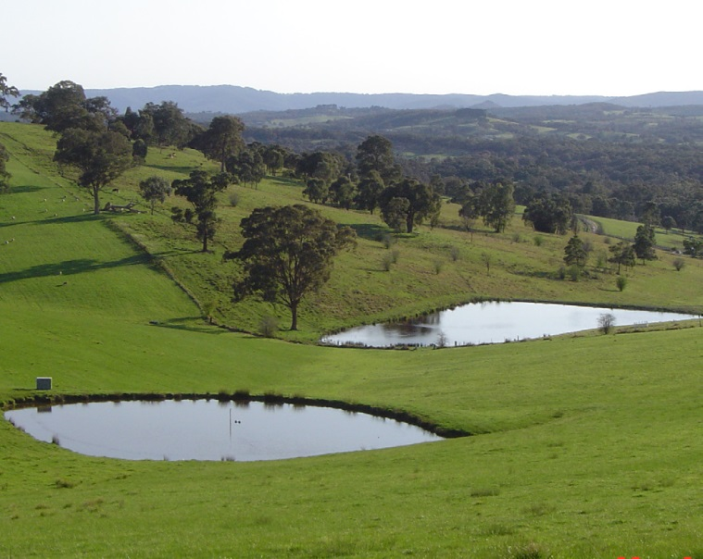

*Farm Dams*

**Generating power**: these large dams hold water for cooling coal or gas-fired power stations or to generate hydro-electric power.

**Recreation:** some of the lakes created by dams are used for recreational activities such as boating and fishing. These dams can be popular tourist destinations and the tourism generated by these dams can be important to the social and economic wellbeing of regional communities.

**Minimising flood damage:** these dams protect residential areas from flooding. Often quite small, they are built in urban areas and are commonly known as retarding basins. These basins are empty during dry periods and fill up with storm water when it rains. This water is then slowly released into the drainage system minimising flooding impacts from the storm. If more rain falls than the basin can hold, the additional water will spill and may cause flooding.

**Protecting the environment:** these dams hold liquid waste material from industrial and mining processes, allowing sediment to settle over time for later disposal. These dams are called tailings dams or mine tailings facilities and have an important job of protecting the environment.

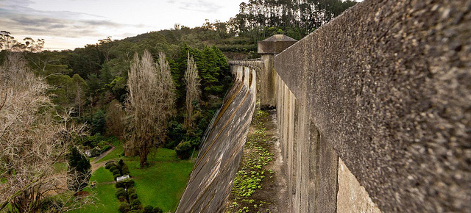

*Maroondah Dam*

Types of dam construction

There are many types of dams.

**Embankment dams** – are made of earth or a combination of earth and rock. Embankment dams are heavy enough to hold back the force of the water that builds up behind the wall and different types of earth are selected carefully to form a barrier that stops water flowing through the dam.

**Concrete gravity dams** – use large amounts of concrete to hold back the force of the water. Some of these dams are able to withstand a flood going right over the top of the whole structure, and may be tied to their foundation by large steel cables within them.

**Arch or buttress dams** - are special kinds of concrete dams that use their shape to transfer the force of the water to strong rocks around or under the dam. Arch dams use part of a circle or an ellipse to transfer the load of water to the sides (abutments), while buttress dams use their shape to transfer the load to the base (foundation) of the dam.

The vast majority of dams in Victoria have been built to store rainfall when it is plentiful, for use in times when it is most needed. We depend on dams to supply water to our homes, businesses, industries and farms.

How water can be released from dams

Dams are built with a way to get water from the dam and a way to let excess water out of the dam.

Outlet pipes are typically put through the bottom of the dam wall while it is being built. They are used to supply water from the dam and to empty the dam when needed.

Spillways are channels that are cut lower than the top of the dam. They are designed to allow water to flow out of a full dam in order to stop water from flowing over the top of the dam and causing damage. Small dams may have a simple depression on the ground or an overflow pipe to provide the function of a spillway. Spillways in larger dams are channels made of concrete. Some spillways have gates inside of them, although in Victoria many of these gates were included for the purpose of increasing the amount of water stored in the dam, not for controlling floods.

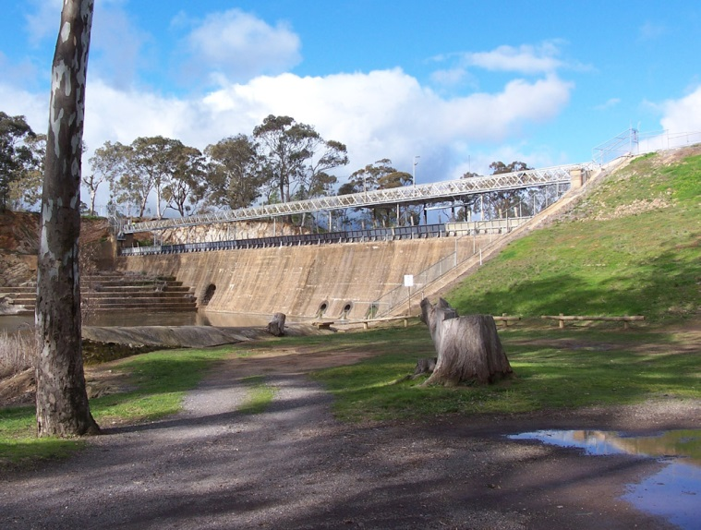

*Laanecoorie dam*

Although dams with spillway gates can make some difference to downstream flooding, dam owners operate their dam primarily to protect the safety of the dam and to conserve water for future use. They do this by closely watching weather forecasts, actual rainfall and river flows and adjusting their dam management strategies when required.

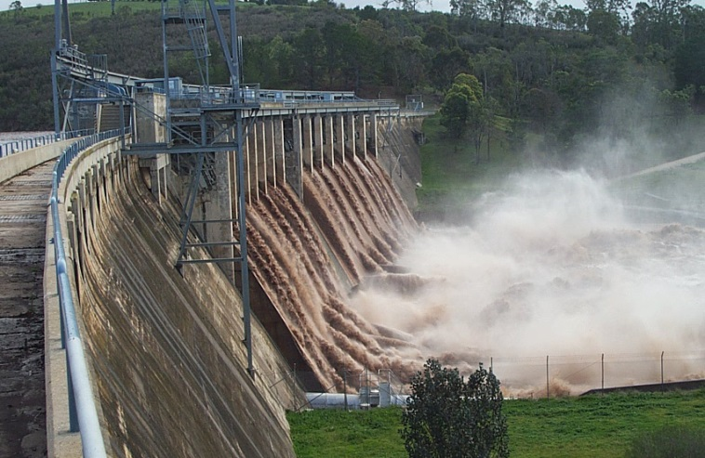

*Glenmaggie Weir under flood*

Keeping our dams safe

The Department of Environment, Land, Water and Planning (DELWP) provides policy, guidelines and oversight to dam owners for the safety of dams in Victoria.

Dam owners are responsible for the safety of their dams. They are required to implement certain controls, such as safety management programs, monitoring and operational measures. DEPI engages directly with water corporations regarding safety management of their dams.

Privately owned dams that have some risk if they fail must be licensed by one of five water corporations which are dam licensing authorities:

• Melbourne Water

• Goulburn-Murray Water

• Southern Rural Water

• Lower Murray Water

• Grampians Wimmera Mallee Water

How owners manage their dams

The greater the damage a dam could cause if it were to fail, the more effort a dam owner needs to put into monitoring it. Larger dams have safety programs which include regular inspections by experienced and qualified people and monitoring of instruments at dam sites. Information from these instruments is collected regularly and dam safety managers are continually looking for signs of change in their dams.

Dam owners also prepare operations and maintenance manuals with instructions on how to operate a dam under many different conditions, such as during a big flood.

Victoria has a good dam safety record but some dams were built as far back as the 1860s. These old dams were constructed to the best standards of the day. Design and construction standards have however changed over time with improvements in engineering methods and the understanding of natural events. As standards improve, dam owners assess their dams for risks and identify works that can improve safety. A list of some safety upgrades in Victoria can be found at www.depi.vic.gov.au/water/governing-water-resources/dam-safety-management.

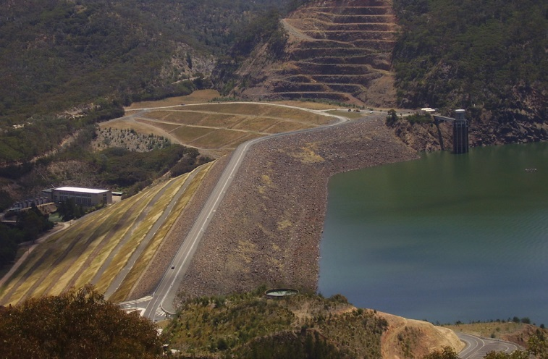

*Lake Eildon embankment dam*

Emergency Response

All large dams or dams which may cause significant damage if they fail need to have a Dam Safety Emergency Plan. This plan guides the dam owner’s response to an unwanted situation at the dam. Testing the plan with Emergency Service Organisations builds trust and an understanding of everyone’s responsibilities in the unlikely event of a dam safety emergency.

The Emergency Management Manual of Victoria assigns roles to Emergency Service Organisations and other agencies for types of incidents. In a dam safety emergency, the dam owner along with DELWP manages response activities to minimise the impact on the community and the environment from the incident. If warning or evacuation is needed, the State Emergency Service (VICSES) and Victoria Police are involved. Local councils provide emergency relief to the community.

How dams can fail

It is very unlikely that a well constructed and maintained dam would fail. A failure that causes serious damage to the structure is called a dam break. This extremely rare event can occur by:

Overtopping – During a flood, water that cannot be stored or controllably released, overtops the dam. Dams made of earth or rock can erode and fail quickly if overtopping continues to occur.

Structural failure. Causes of structural failure include:

• *Internal erosion* – water flowing through, or beneath, the dam washes out material from the dam wall and can lead to a collapse of the wall.

• *Earthquake* – shaking during strong earthquakes may make the material forming the dam wall settle and become lower (like shaking a sand castle on a tray). This may lead to overtopping. Strong earthquakes may cause a concrete wall to crack.

• *Mechanical failure* – the gates or outlet works may fail to work and prevent the dam operator from releasing water. This may lead to overtopping failure.

While the chance of a dam break happening is very low, flooding associated with such a situation would depend on the height of the dam wall, the amount of water in the dam and the shape of the valley below the dam.

Flood engineers make predictions on the paths and levels that water released from the dam would follow and plot these on maps known as inundation maps. Inundation maps are useful in planning for possible impacts of a dam break scenario. These maps are however based on assumptions of how the dam will fail which is difficult to predict. The path of water during the flood can also be difficult to predict as erosion or blockages by debris can change the course of the flood.

Find out more about dams in your area

Satellite images available on the internet are a good place to locate dams that are close to you. At www.depi.vic.gov.au/water/dams-map there is an interactive map and information on some of Victoria’s major dams.

If you live close to a large dam, it is likely that your local Water Corporation will know who owns it and can let you know who to speak to for more information. If you live near a private dam, the local water corporation who issues licences can provide some information about it.

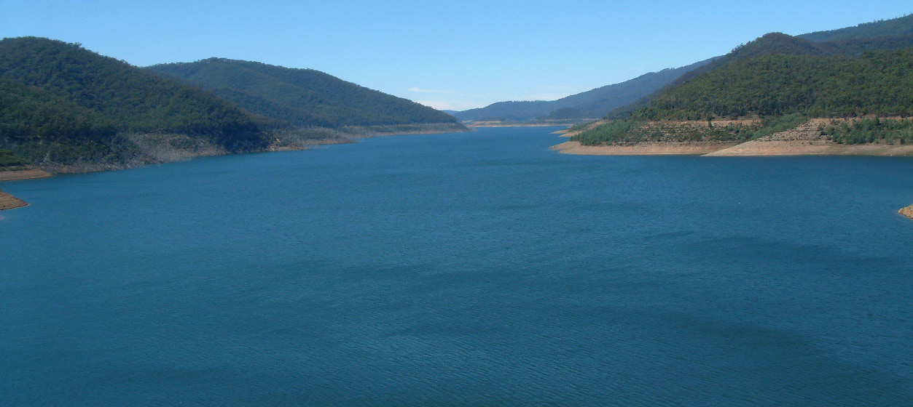

*Thomson dam catchment*

|  |  |
| --- | --- |
| © The State of Victoria Department of Environment, Land, Water and  Planning 2015  by  This work is licensed under a [Creative Commons Attribution 4.0 International licence](http://creativecommons.org/licenses/by/4.0/). You are free to re-use the work under that licence, on the condition that you credit the State of Victoria as author. The licence does not apply to any images, photographs or branding, including the Victorian Coat of Arms, the Victorian Government logo and the Department of Environment, Land, Water and Planning (DELWP) logo. To view a copy of this licence, visit <http://creativecommons.org/licenses/by/4.0/>  ISBN 978-1-74146-681-2 (Print)  ISBN 978-1-74146-682-9 (pdf)  **Disclaimer** This publication may be of assistance to you but the State of Victoria and its employees do not guarantee that the publication is without flaw of any kind or is wholly appropriate for your particular purposes and therefore disclaims all liability for any error, loss or other consequence which may arise from you relying on any information in this publication. | **Accessibility**  If you would like to receive this publication in an alternative format, please telephone DELWP Customer Service Centre 136 186, email [customer.service@delwp.vic.gov.au](mailto:customer.service@delwp.vic.gov.au) via the National Relay Service on 133 677 [www.relayservice.com.au](http://www.relayservice.com.au).  This document is also available on the internet at [www.delwp.vic.gov.au](http://www.delwp.vic.gov.au) |