VICTORIAN ACCOUNTABLE SALINITY IMPACTS
SUMMARY

FINAL 18 JULY 2020

Authors: Mark Wood and Campbell Fitzpatrick

TABLE OF CONTENTS
Acronyms ii
- Introduction 3
  - Purpose 3
  - Scope 3
  - Background 3
- Register A - Salt Interception Schemes 6
  - Improved Buronga and Mildura/Merbein IS (S&DS) 6
  - New Operating Rules for Barr Creek Pumps (S&DS) 9
  - Pyramid Creek SIS (BSMS) 13
- Register A - Shared Schemes 17
  - Permanent Trade Accounting Adjustment - NSW to Victoria 17
  - Barmah-Millewa Forest Operating Rules 19
- Register A - Salinity Credit Actions 21
  - Barr Creek Catchment Strategy (BCCS) 21
  - Psyche Bend 25
  - Permanent Trade Accounting Adjustment - Victoria to SA 29
  - Sunraysia Drains Drying up 32
  - Lambert Swamp 36
  - Church's Cut Decommissioning 40
  - Mallee Drainage Bore Decommissioning 43
  - Reduced Irrigation Salinity Impact (RISI) Stage 1 45
  - Reduced Irrigation Salinity Impact (RISI) Stage 2 50
  - Victorian S&DS Commitment Adjustment 53
- Register A - Salinity Debit Actions 55
  - Tragowel Plains Drains at 2002 level 55
  - Shepparton Salinity Management Plan 59
  - Nangiloc-Colignan SMP 63
  - Nyah to SA Border SMP - Irrigation Development 66
  - Kerang Lakes/Swan Hill Salinity Management Plan (SMP) 70
  - Campaspe West Salinity Management Plan 73
  - Woorinen Irrigation District Excision 76
- Register B Actions (Debits) 79
  - Campaspe Catchment Legacy of History 79
  - Goulburn Catchment Legacy of History 83
  - Loddon Catchment Legacy of History 87
  - Kiewa Catchment Legacy of History 91
  - Ovens Catchment Legacy of History 95
  - Victorian Mallee - dryland clearing 99
  - Victorian Mallee - Pre-88 Irrigation 104
References 110

Acronyms

BCCS | Barr Creek Catchment Strategy
BCDDS | Barr Creek Drainage Diversion Scheme
BSM2030 | Basin Salinity Management 2030
BSMS | Basin Salinity Management Strategy
CMA | Catchment Management Authority
DEDJTR | Department of Economic Development, Jobs, Transport and Resources
DELWP | Department of Environment, Land, Water and Planning
DJPR | Department of Jobs, Precincts and Regions
EC | Electrical Conductivity
EM2.3, 1.2 etc | Eastern Mallee model version 2.3 or Eastern Mallee model version 1.2 etc…
EPBC | Environment Protection and Biodiversity Conservation Act 1999
GMID | Goulburn-Murray Irrigation District
GMW | Goulburn-Murray Water
HIZ | High Impact Zone
IPR | Independent Peer Review
LIZ | Low Impact Zone
LMW | Lower Murray Water
LWMP | Land and Water Management Plan
MDBA | Murray-Darling Basin Authority
MMSIS | Mildura-Merbein Salt Interception Scheme
MSM-Bigmod | Monthly Simulation Model-Bigmod
N2B SMP | Nyah to South Australian Border Salinity Management Plan
RCS | Regional Catchment Strategy
REALM | REsource ALlocation Model
RISI | Reduced Irrigation Salinity Impact
S&DS | Salinity and Drainage Strategy 1988
SIR | Shepparton Irrigation Region
SIS | Salt Interception Scheme
SIZ | Salinity Impact Zones
SMP | Salinity Management Plan

Introduction

Purpose
To produce a document which will inform people with limited prior involvement in salinity management of the scope and nature of Victorian accountable actions on Basin Salinity Management 2030 (BSM2030) Registers A and B. The document should be easily understood and able to be updated easily for the extent of BSM2030.

Scope
To undertake a project to compile a suite of succinct summaries for 29 Victorian accountable actions which describe:
    - Overview
    - Background
    - Description
    - Models used
    - Reviews and studies
    - Related accountable actions
    - Possibilities for expansion of credits/debits
    - Issues, gaps and further work

Background
    - General
The Salinity and Drainage Strategy 1988 (S&DS) provided an interstate management framework to reduce river salinity and to protect irrigation land. It was a pollutant-trading framework that provided a system of salinity ‘credits’ and ‘debits’ resulting from works and measures that increase or decrease salinity in the Murray River.
The Strategy attached no blame to anything that happened before 1 January 1988. But each state (Victoria, NSW and South Australia) became fully accountable for anything it did to increase (or decrease) river salinity by 0.1 EC units at Morgan after that date. Queensland the ACT are accountable for actions after 1 January 2000.
The Strategy was based on economic principles that had similar characteristics to a cap and trade model. Salinity debits and credits were expressed as a:
      - Salinity Effect (in units of electrical conductivity (EC)) which is a measure of the physical effect of actions on the river
      - Salinity Cost Effect (in units of $ per year) which is a measure of the economic effect of river salinity on Murray River water users.
Basin governments are accountable for the Salinity Cost Effect, not EC at Morgan, i.e. the total economic benefits from accountable actions generating salinity credits must exceed the economic costs from accountable actions generating debits.
This meant that for the first time investment decisions to protect salinised land and water explicitly considered the salinity cost effects in the River.

The S&DS was formalised as a Schedule to the Murray-Darling Basin Agreement (Schedule C) which enabled the construction of salt interception schemes (SISs) and established an accountability regime based on a register of salinity credits and debits.
The Basin Salinity Management Strategy 2001-2015 (BSMS) added a second salinity Register, Register B, to account for the impacts of ‘Legacy of History’, or pre-1988 actions that have salinity impacts now and into the future.
BSM2030 updated the BSMS. BSM2030 maintained the fundamental accountability framework agreed to by all contracting governments for managing the salinity of the Murray River that is set out in Schedule B (previously Schedule C) and the associated BSMS Operational Protocols. Schedule B and the Operational Protocols have been revised to reflect changes adopted in BSM2030. The Operational Protocols are now called Operational Procedures.
    - Accounting method
Accountability requirements dictate that actions assessed to have a significant effect on river salinity (>0.1 EC change at Morgan) are deemed to be Accountable Actions and they are recorded on a salinity register.
The MDBA’s MSM-Bigmod is the model used to determine the Salinity Effect of each accountable action on Registers A and B. The Salinity Effect of each accountable action at Morgan is determined by comparing the modelled salinity at Morgan with and without an accountable action. The comparison is made using a common climate sequence – the Benchmark Period (1975 to 2000).
Register A records accountable actions that have occurred after the Baseline Date – in Victoria this is the 1st of January 1988.
Actions that occurred prior to 1st January 1988 that have been fully expressed in the river by the 1st January 2000 are considered as baseline. Register B records pre-1988 actions that have not been fully expressed in the river by 1st January 2000, e.g. it may take many decades for clearing of native vegetation many kilometres from the Murray River to result in an increase in salt in the river.
Each jurisdiction responsible for an accountable action must provide flow and salt loads entering the Murray River from the area of interest with and without the accountable action for the climate experienced over the Benchmark Period (1975 to 2000). These flow and salt load time series are entered into MSM-Bigmod. Flow and salt loads are generated using models developed as part of the initial assessments of accountable actions, or during subsequent 5-year reviews. New flow and salt load time series may be updated when a 5-year is conducted.
The models used to generate flow and salt load time series for input to MSM-Bigmod are discussed in the Models used section of each accountable action summary in sections 2 to 6.
Cost functions are used to convert the physical Salinity Effect of accountable actions into Salinity Cost Effect, the unit of accountability. The cost functions reflect the estimated economic effect of rising salinity levels in the basin. High salinity levels have the potential to reduce agricultural yields and impose additional costs to urban and industrial water users, e.g. increasing salinity on industry can reduce the reliability and lifespan of plant equipment, and impose additional processes and costs required to maintain product quality.
The salinity registers are updated as the salinity impacts from various accountable actions change over time and as available data sets and modelling techniques for assessing the impact of works and

measures improve. Schedule B and the BSM Operational Procedure – Conducting Reviews and Assessments, require that register items (that is, accountable actions) are reviewed periodically.

Register A - Salt Interception Schemes

Improved Buronga and Mildura/Merbein IS (S&DS)
    - Overview
The Murray-Darling Basin Authority (MDBA), on behalf of Basin governments, is responsible for this S&DS joint work Register A accountable action. The scheme is operated by Goulburn-Murray Water (GMW), the contracting authority appointed by the MDBA. Following the 2011-14 refurbishment the scheme is shared 50:50 by the Joint Venture and Victoria.
MDBA (2018) records the Improved Buronga and Mildura/Merbein IS accountable action as commencing in January 1991 (date deemed effective).
The current entry (2018) Salinity Effect of the entry is a -3.0 EC credit at Morgan on the Register A. The Salinity Effect is estimated to be a -3.0 EC credit in 2050 and 2100 (MDBA, 2018). There is medium confidence in the entry (MDBA (2017) and (2018)).
    - Background
The Buronga scheme is in NSW. The Mildura-Merbein Salt Interception Scheme (MMSIS) was designed to intercept groundwater discharge to the Murray River driven by local groundwater mounds that have developed as a result of irrigation practices and associated drainage water management practices.
The original Mildura-Merbein SIS consisted of 17 interception bores distributed over 7 kilometres between the Mildura weir and the Merbein pumping station. The saline groundwater is pumped to Lake Ranfurly East and West before being pumped to Wargan Basins. The Scheme was commissioned as a Victorian scheme in stages between 1979 and 1981 and was later upgraded through joint funding by MDBC in 1991. Only the upgrades of the Buronga and the Mildura Merbein schemes qualify for inclusion in the register as these occurred post 1988.
The original MMSIS is deemed a ‘Baseline Scheme’ and its performance in the four years up to 1988 is the basis for assessment of a ‘Baseline Obligation’ in relation to the Murray-Darling Basin salinity accountability framework.
For several years leading up to the refurbishment it became apparent the MMSIS was approaching the end of its serviceable life, and operational availability and overall effectiveness of the bore field was low.
    - Description
Jurisdictions are accountable for the decrease in flow and salt load to the Murray River resulting from enhancements made to the Buronga and Mildura Merbein SIS in 1991. Figure 1 shows the location of the scheme and associated groundwater bores.

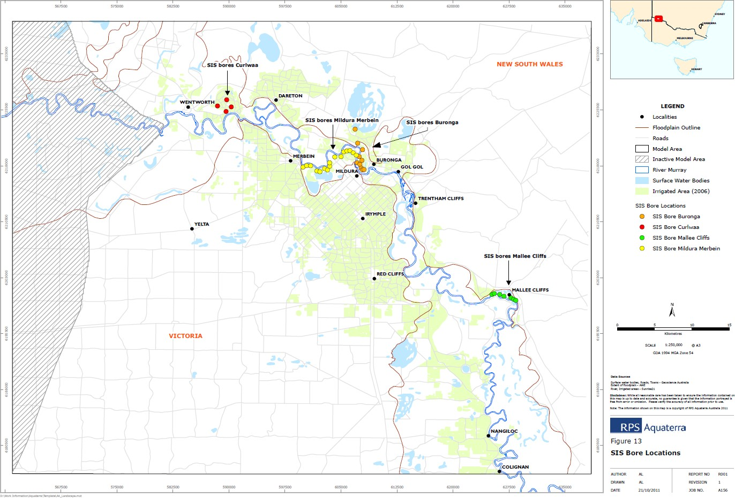

Figure 1 - Location of the Buronga and Mildura/Merbein SIS (Source: Figure 9 of MDBA (2017))

Refurbishment activities occurred between 2011 and 2014. Stage 1 borefield works included the construction of six new production bores, refurbishment of three existing production bores, new headworks for all nine bores and associated collection pipelines, and construction of 1.5 km of the main pipeline.
The modelled benefits of the Mildura-Merbein SIS Refurbishment are as follows:
- Victoria’s MMSIS baseline obligation is calculated to provide a salt load saving of 55.2 t/d at
2030
- the 1990 upgrade (existing Register A entry) is calculated to provide an additional salt load reduction of 8.9 t/d (2030)
- the 2014 refurbishment is calculated to provide a further additional salt load reduction of
6.5 t/d (2030) over and above Victoria’s baseline obligation
- the model results indicate that there is 16.0 t/d salt load still entering the River Murray in 2030 through the MMSIS reach.
The Scheme Performance Review report (AWE, 2017) demonstrates that the refurbished SIS has been highly effective at intercepting the in-river salt loads, and concludes that the design and implementation of the SIS refurbishment has resulted in a similar salinity benefit at a significant cost saving compared to the concept design for a replacement bore field of 22 bores.
    - Models used
What’s the model?
The assessment took the EM2.3.1 SURFACT model, and implemented it using MODFLOW 2000 (EM2.3.1MM MF2000) and with updated data sets to 2017 (AWE, 2018, p. 13).

Who owns the model?
The models are the property of the MDBA/Basin governments. Is the model accredited?
The EM2.3.1 model was peer reviewed and accredited as ‘fit–for–purpose’ for assessing salinity impacts of SISs (Mallee Cliffs, Buronga and rebuilt Mildura–Merbein) and Reduced Irrigation Salinity Impacts (RISI) of Victoria and NSW (MDBA, 2014). However, the MODFLOW version used in the assessment has not been accredited (section 2.1.8).
    - Reviews and studies
Table 1 lists reviews and studies related to the MMSIS Register A entry.
Table 1 – Reviews and studies related to the MMSIS Accountable Action Register A entry

Review No. | Review Type
Latest review | 5-year review by AWE (2017) and (2018)  Independent Peer Review by Jacobs (2017d)

    - Related accountable actions
The ‘Baseline’ and upgraded and refurbished components of the SIS are closely related. The MMSIS benefits are also tightly interwoven with the RISI accountable action (section 4.8) and the relationships could be further clarified in subsequent reviews (AWE, 2018, p. 23).
    - Possibilities for expansion of credits/debits
AWE (2018) indicated that the refurbishment of the scheme has prevented 15.4 tonnes of salt entering the River per day. There is a risk that the salinity credit will be reduced because of the deteriorating performance of the scheme. However, the risk of a material impact on Victoria’s overall register balance is relatively small given that the Salinity Effect in Register A is only a -3.0 EC credit.
    - Issues, gaps and further work
Jacobs (2017d) did not agree with the conclusions reached by AWE (2017) regarding double counting of the RISI claim, as the presentation of salt loads provided did not meet the requirements for a formal review of the register entry (because of: the MODLFOW version issue; the known issues of Buronga representation; and, the manner of dealing with river flows and scheme operations - specifically the shutdown). It was recommended that the results of the assessment not be used to update the salinity and drainage register.
Jacobs (2017d) listed several improvements to the modelling approach before the register entry could be updated. These included that the version of MODFLOW used would need to be specifically reviewed and accredited for use, which would include full analysis of calibration, sensitivity and model match to observed data.
The model outputs from the 5-year review have not been added to the Register. AWE (2018) subsequently stated that given the complexity of overlapping Register entries and differences arising from use of different model software, it is recommended that the results from the study not be included in the Register.

New Operating Rules for Barr Creek Pumps (S&DS)
    - Overview
The MDBA, on behalf of Basin governments, is responsible for this S&DS joint work Register A accountable action. The scheme is operated by GMW, the contracting authority appointed by the MDBA.
MDBA (2018) records the New Operating Rules for Barr Creek Pumps accountable action as commencing in July 1991 (date deemed effective) – the scheme began operating in 1968.
The current (2018) Salinity Effect of the entry is a -4.9 EC credit at Morgan on Register A. The Salinity Effect is estimated to be a -4.9 EC credit in 2050 and 2100 (MDBA, 2018). There is high confidence in the entry (MDBA (2017) and (2018)).
    - Background
Barr Creek, originally a natural water carrier, was remodelled as a drainage system with rudimentary surface drains first constructed in about 1914 and a more comprehensive system in the 1930s (GHD, 1985). The catchment is comprehensively covered by surface drains that range in depth from 1 to 4 metres (SKM, 2008). The catchment extends from the Murray Valley Highway area around Leitchville to where it discharges to the Loddon River just prior to the Loddon entering the Murray River (Figure 2).
Without salinity management actions Barr Creek would be the second highest point source of salt to the Murray River after the Darling River (MDBC, 2003). The high salinity of Barr Creek is mostly due to the creek and its surface drains intercepting the highly saline shallow water table.
From 1968, the flow in Barr Creek has been selectively diverted to evaporative disposal sites at Lakes Tutchewop, William, Little and Kelly, in order to minimise the outfall of salt to the Murray River. The basic components of the scheme are four diversion pumps, located on Barr Creek upstream of the confluence with the Loddon River, that pump saline water from Barr Creek to a disposal pipeline.
The disposal pipeline links to an open drain that conveys the saline drainage to the evaporation basins located approximately 10 km west of the pumping station (Figure 3). These evaporation basins are recognised under the Convention on Wetlands of International Importance (‘Ramsar Convention’). Given their Ramsar status, the basins are also recognised under the Environmental Protection and Biodiversity Conservation Act 1999.
As the scheme was implemented before 1 January 1988, the benefits of the original scheme do not qualify for inclusion in the BSM2030 Salinity registers. However, changes to pumping rules post 1988 which divert additional salt from the Murray River do (MDBA, 2017, p. 55).
The scheme was originally constructed as a Victorian Scheme but in 2000 the MDBC, now the MDBA, agreed to take responsibility for the Barr Creek Drainage Diversion Scheme in the light of its strategic importance as the most upstream of the SISs. It is now a joint scheme (SKM, 2011c, p. 3).
    - Description
Jurisdictions are accountable for the decrease in flow and salt load to the Murray River resulting from the change in pumping rules in 1999.
Initially the pump operating rules were aimed at controlling Murray River salinities during the irrigation season at Swan Hill and Sunraysia. However, the MDBC used its BigMod model in the

1990s to show that a greater overall benefit could be obtained for the River if pumping targeted the highest salinities in Barr Creek, regardless of the time of year.
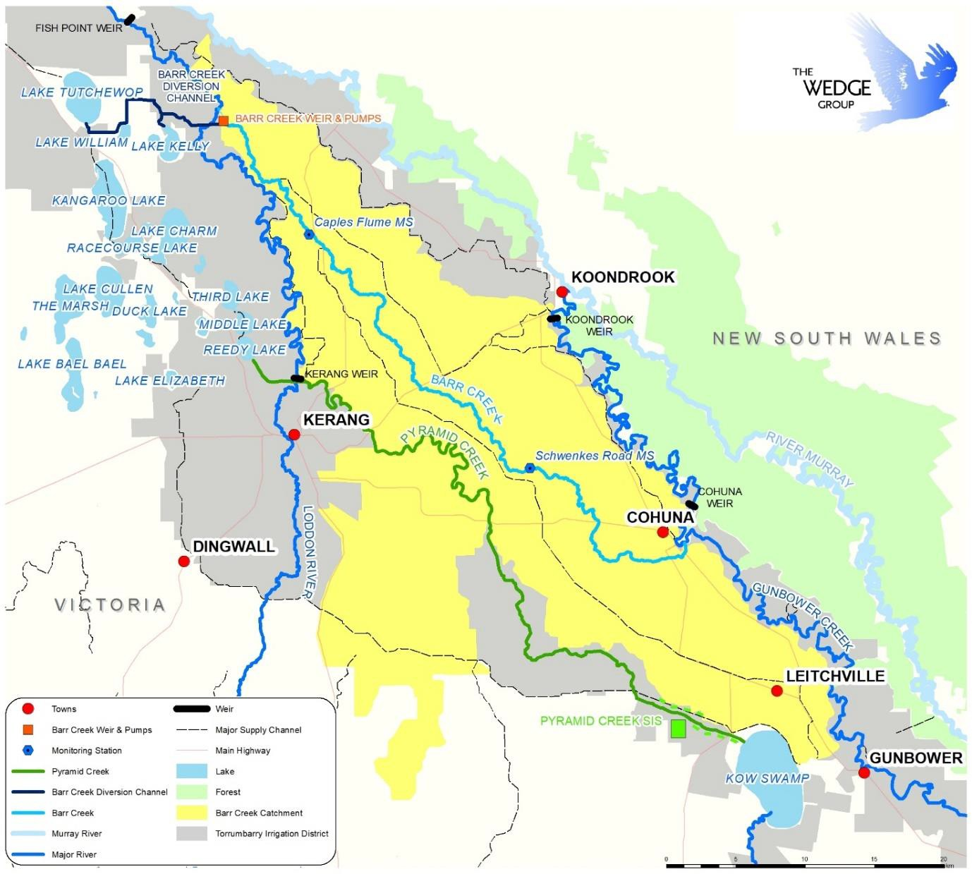
Figure 2 – Barr Creek catchment showing the weir, pumps and lakes associated with the drainage diversion scheme (top left) (Source: Figure 1 of NCCMA (2019))

The development of the 1999 Rules is detailed in MDBC (1999b). The key feature of the Rules is that by targeting the highest salinities in Barr Creek, regardless of the time of year, extra salt could be diverted to the disposal basins and extra Credits could be generated. The two other key rules relate to high flow rates in the Murray (> 20,000 ML/d at Torrumbarry) or Loddon (> 900 ML/d at Kerang Weir) or reduced air space in the disposal Lakes.
This resulted in the “1999 Rules” in which the diversion scheme pumps divert water from the Creek when flows reach a threshold salinity (this salinity threshold varies depending on the spare volume or ‘airspace’ in the Lakes). The pumps may be turned off during flood conditions in the Murray River and Loddon River.
To enable implementation of the ‘1999 Rules’ a regulator was constructed downstream of the pumps to replace the old low-level weir. The gates of the regulator were installed in July 2003. Prior to the regulator construction, the flow in Barr Creek was often diluted by back-up flow from the

Loddon and Little Murray Rivers. To maintain conservatism in the entry the full salinity benefits of the weir are not recognised in the existing -4.9 EC Register A entry (SKM, 2011c, p. 41).
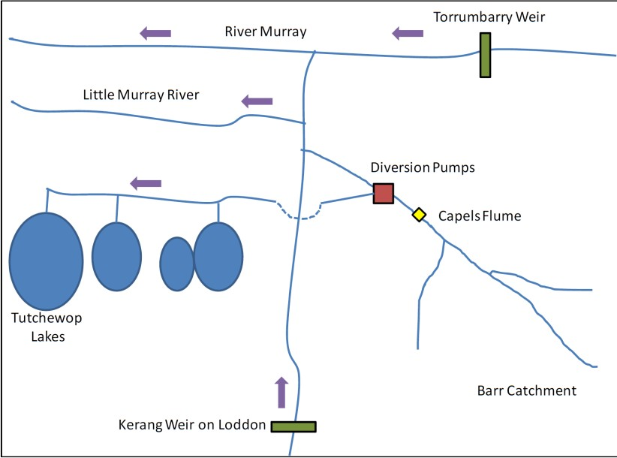
Figure 3 – Schematic of the Barr Creek Drainage Diversion Scheme (Source: Figure 1.1 of SKM (2011c))

    - Models used
What’s the model?
The model of the Drainage Diversion Scheme is incorporated within BigMod¹. The key input to the model is the daily flow and salinity at Capels Crossing. The dataset for Capels Crossing has not been altered from the dataset generated in the 2005 Barr Creek Catchment Strategy (BCCS) Review (SKM, 2011a, p. 42).
Who owns the model?
The model is owned and maintained by the MDBA. Is the model accredited?
Yes
    - Reviews and studies
Table 2 lists reviews and studies related to the Barr Creek Drainage Diversion Scheme Register A entry.

1 MSM-Bigmod is the main modelling suite used by the MDBA. MSM is a monthly simulation model that computes irrigation demands, resources assessment and water accounting. Bigmod is a daily flow and salinity routing model from Hume Dam to Lake Alexandrina (Ravalico, et al., 2007).

Table 2 – Reviews and studies related to the Barr Creek Drainage Diversion Scheme Accountable Action Register A entry

Review No. | Review Type
First review | 5-year review by SKM (2005e)  Independent Peer Review – not available
Second review | 5-year review by SKM (2011c)  Independent peer review – not available
Third review | 5-year review by Jacobs (2020)
Other | Development of the 1999 pumping rules – MDBC (1999b)

    - Related accountable actions
The BCCS accountable action is closely related as it determines the flow and salt load at Capels Crossing – the key modelling inputs for determining the Salinity Effect of the Barr Creek Drainage Diversion Scheme. However, the BCCS and the 1999 Rules are treated as separate entities on the Register and there is no overlap or duplication in their Credits (SKM, 2011c, p. 42).
    - Possibilities for expansion of credits/debits
MDBC (1999b) reported that an extra -0.74 EC Credit would result if a new regulator were built downstream of the diversion pumps, and the threshold for pumping were raised from 4,000 EC to 4,500 EC. The regulator was commissioned in August 2003 but the pumping threshold has not changed. However, the 2011 reviewer did not recommend this and preferred to maintain a more conservative entry (SKM, 2011c, p. 41).
    - Issues, gaps and further work
Some elements of the 1991/1999 rules are no longer relevant to contemporary management of the shared water resources. Furthermore, upstream catchment conditions have changed substantially since the rules were developed. In light of the above, the rules warrant review noting the importance of ensuring that any changes do not erode the current salinity benefits as recorded on the Register (Jacobs, 2020, p. 67).
Jacobs (2020, p. 67) also makes a series of additional recommendations for consideration by GMW and the MDBA were made across asset management, monitoring, public access, reporting, salinity register entry, records on pump operations and future pump operating rules.

Pyramid Creek SIS (BSMS)
    - Overview
The MDBA, on behalf of Basin governments, is responsible for this BSMS joint work Register A accountable action. The scheme is operated by GMW, the contracting authority appointed by the MDBA.
MDBA (2018) records the Pyramid Creek SIS accountable action as commencing in March 2006 (date deemed effective) – Stage 1 has been in operation since August 2004. The current (2018) Salinity Effect of the entry is a -3.5 EC credit at Morgan on Register A. The Salinity Effect is estimated to be a
-3.5 EC credit in 2050 and a -3.4 EC credit in 2100 (MDBA, 2018). There is high confidence in the entry (MDBA (2017) and (2018)).
    - Background
Pyramid Creek is a 60 km long modified natural stream in Northern Victoria (south of Barr Creek Catchment) that is used as the major irrigation carrier within the Torrumbarry Irrigation Area delivering water from Kow Swamp to the Kerang Lakes.
In 1968–69 the creek was remodelled and deepened for more efficient delivery of irrigation flows. This work resulted in highly saline ground water being discharged into the Creek. Approximately 50,000 tonnes of salt enters Pyramid Creek each year with about 50% entering the Creek in the first
  - Km downstream of Kow Swamp.
The salinity problem being caused by Pyramid Creek was identified by the Kerang Lakes Area Working Group in the late 1980’s. Following extensive investigations by the Victorian Authorities, a project proposal was presented to the Murray-Darling Basin Ministerial Council in 2001 (MDBA, Not dated).
    - Description
Basin Governments are accountable for the decrease in flow and salt load entering the Murray River as a result of the construction and operation of the SIS.
The $12.8 m SIS on the upper reaches of Pyramid Creek (first 12 km downstream of Kow Swamp) (Figure 5) lowers the groundwater table adjacent to the Creek preventing around 22,000 tonnes of salt from entering the Creek each year. This results in reduced salinity of downstream waterways including the Loddon River, the Ramsar listed Kerang Lakes and the River Murray.
The salt interception works comprises 87 production bores along a 12 km stretch of Pyramid Creek, each of which is equipped with an electrical submersible pump. An extensive network of monitoring bores is used to monitor the performance of the production bores and the salt harvesting pondage.
The scheme is constructed as a curtain of interception bores running alongside the Creek between Kow Swamp and Flannery’s Bridge. The scheme extracts groundwater from aquifers beneath the Creek, and by drawing down the pressures in the aquifer, induces a fall in the watertable in the overlying aquitard relative to the Creek operating level (Figure 4). The Creek is incised into the aquitard, so the fall in the watertable level is intended to reduce groundwater gradients into the Creek (Jacobs, 2016f, p. 22).

Figure 4 – Schematic of how groundwater pumps lower the watertable beneath Pyramid Creek which reduces the flow of salt water into the creek (Source: MDBA (Not dated))

A 3 km transfer pipeline is used to deliver saline groundwater from the production bores to the salt harvesting ponds. Pyramid Salt Pty Ltd operates and maintains a harvesting facility. Groundwater salinity along this section of Pyramid Creek is around 44,000 EC (MDBA, Not dated).
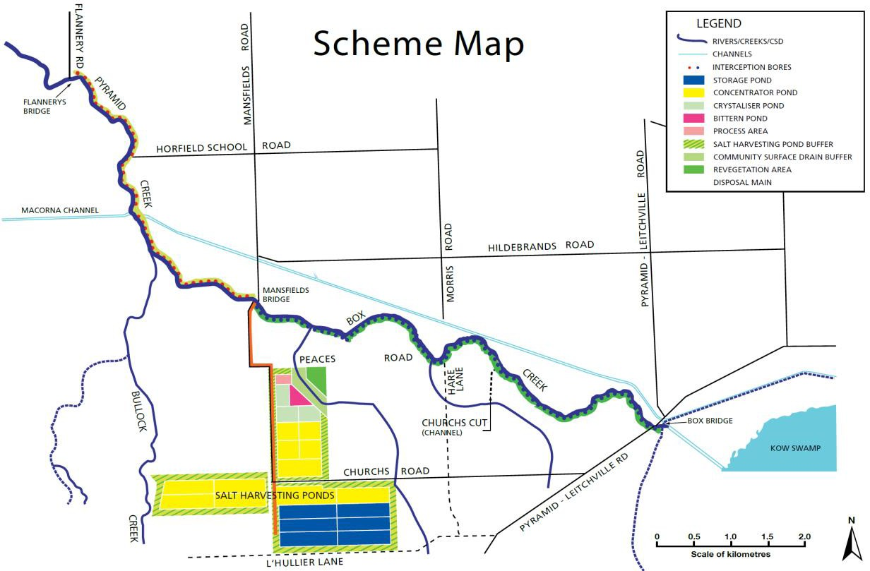
Figure 5 – Pyramid Creek Salt Interception Scheme (Source: MDBA (Not dated))

Jacobs (2016f, p. 86) conclude that the scheme is operating effectively with stream and groundwater monitoring data confirming that it is achieving full interception with evidence of salt intrusion along the target reach only during episodic (non-typical) extensive flooding events.
The 2016 5-year review provided new time series data for the entry for input to MSM-Bigmod. The
Salinity Effect decreased from a -5.1 EC to a -3.5 EC credit. The reduction reflects the revised (newly

accredited) Kerang Lakes REALM² model that routes flows and salinity along Pyramid Creek, to the Murray River, where MSM-Bigmod is used to estimate the salinity effect.
    - Models used
What’s the model?
Statistical methods (regression) are used to derive pre-intervention time series of daily salt loads over the Benchmark Period. These are converted to groundwater flow and salinity for input into the Kerang Lakes REALM model which estimates the final distribution of salt entering the Murray River.
Who owns the model?
The statistical methods are the property of the MDBA/Basin governments. The Department of Environment, Land, Water and Planning (DELWP) are custodians of the Kerang Lakes REALM model.
Is the model accredited?
The statistical methods are deemed as fit for purpose. The Kerang Lakes REALM model is accredited.
    - Reviews and studies
Table 11 lists reviews and studies related to the Pyramid Creek SIS Register A entry.
Table 3 – Reviews and studies related Pyramid Creek SIS Accountable Action Register A entry

Review No. | Review Type
First review | 5-year review – not available  Independent Peer Review – not available
Second review | 5-year review by Jacobs (2016f)  Independent peer review – not available
Other | Original Credit Claim – not available

    - Related accountable actions
The Pyramid Creek SIS accountable action is closely linked to Church’s Cut (section 4.6). The actions were effectively done at the same time – Church’s Cut was filled first because of the simplicity of the works, but apparently there was an understanding at the time that the SIS would precede Church’s Cut in MSM-Bigmod modelling. Both actions also involve works targeted at reducing groundwater accessions in the same sections of Pyramid Creek.
There was insufficient data to determine how to split reductions in salt load and flows between the two actions, although a 10% contribution from Church’s Cut was estimated. This led to a negotiated contribution from Church’s Cut of a -0.3 EC credit (Jacobs, 2016f, p. 26). Because of the connection between the two accountable actions they are reviewed together.
The Pyramid Creek SIS accountable action also interacts with the BCCS accountable action. SIS pumping may have contributed to a decrease in groundwater levels in the upper part of the Barr Creek catchment. This is managed by assuming all decreases in baseflows in Pyramid Creek are attributable to the Pyramid Creek SIS and ignoring the impacts of baseflow reductions in the Barr Creek catchment where other influences such as the BCCS and deep lead pumping effects interact

2 REsource ALlocation Model (REALM)

with the Pyramid Creek SIS effects. The result is less salt being exported to the Murray. This approach is appropriate, and indeed necessary, until a method is developed that can accurately differentiate between the two.
There are also several potential future accountable actions that may interact with the Pyramid Creek SIS accountable action. Changes to land and water management in the vicinity of Pyramid Creek
SIS/Church’s Cut are most likely to be considered by Victoria and the MDBA as requiring assessment as Accountable Actions relating to the modernisation of the irrigation system, and changes in irrigation footprint/intensity occurring across northern Victoria. These changes in irrigation footprint/intensity are arising from:
    - unbundling and the 80:20 sales deal package
    - on-farm irrigation efficiency program (funded by the Australian Government and individual irrigators)
    - water trade out of the Torrumbarry Irrigation Area
    - the Australian Government’s “buy-back” of entitlements.
Other potential drivers such as the development of the deep regional groundwater resource may also warrant consideration although it is important to recognise that the effects of such pumping apply at the Riverine Plains scale and hence is potentially an issue for other Accountable Actions across northern Victoria and southern NSW (Jacobs, 2016f, p. 32).
    - Possibilities for expansion of credits/debits
Refer to section 2.3.6.
    - Issues, gaps and further work
The last combined 5-year review of Church’s Cut and Pyramid Creek SIS discussed consideration of an alternative technical methodology for estimating salinity impacts, including use of a groundwater model (Jacobs, 2016f).
As with most accountable actions the 2016 5-year review proposes improvements to monitoring arrangements.

Register A - Shared Schemes

Permanent Trade Accounting Adjustment - NSW to Victoria
    - Overview
This is a shared entry with NSW (50/50). DELWP is responsible for this Victorian Register A accountable action.
MDBA (2017) records the Permanent Trade Accounting Adjustment – NSW to Victoria accountable action as commencing in June 2006 (date deemed effective). The current (2018) Salinity Effect of the entry is a -0.1 EC credit at Morgan on Register A. The Salinity Effect is estimated to be a -0.1 EC credit in 2050 and 2100 (MDBA, 2018).
There is high confidence in the entry (MDBA (2017) and (2018)).
    - Background and Description
This entry, first made in June 2006, represents the adjustments for the impact of changes in the dilution flows resulting from transferring irrigation water between NSW and Victoria as a result of entitlement trades (not allocation trades). These changes in flow affect the volume of water that is available to dilute salt that enters the Murray River.
Three adjustments have been made: one for trade up to January 2000, one up to June 2002 and one up to June 2006. MDBA (2018) records that it was last reviewed in 2006.
There is no allowance in this accountable action for the differences in likely salt accessions caused by applying the traded water. These impacts should be accounted for in Victorian or NSW irrigation development accountable actions.
    - Models used
What’s the model?
The transfer of water entitlements from NSW to Victoria were directly coded into MSM-Bigmod to increase entitlement flows to NSW.
The analysis has looked only at the dilution impacts of the changes to the accounts. It does not include any estimates of the salinity effect of reducing diversions in Victoria or increasing diversions in NSW. Therefore, the entry reflects changes to river operations (i.e. dilution flows) only.
Who owns the model?
The model is owned and maintained by the MDBA Is the model accredited?
Yes.
    - Reviews and studies
Table 4 lists reviews and studies related to the Permanent Trade Accounting Adjustment – NSW to Victoria Register A entry.

Table 4 – Reviews and studies related to the Permanent Trade Accounting Adjustment – NSW to Victoria Accountable Action Register A entry

Review No. | Review Type
Other | Cap model report by MDBA (2013)  Description of Register entries report by MDBA (2017)

    - Related accountable actions
There are several Register A accountable action entries for changes in dilution flow including:
- Permanent Trade adjustment Victoria to SA (section 4.3)
- Barmah-Millewa Forest Operating rules (section 3.2).
There are also Provisional Register A accountable action entries for changes in dilution flows:
- Barmah to Goolwa dilution flow
- The Living Murray – River Murray Increased Flows (TLM-RMIF) 570 GL.
    - Possibilities for expansion of credits/debits
The accountable action only deals with permanent water trades up to 2006. There is scope for including additional trades since then. The first step would be to determine the increase in the volume of entitlement trades. However, the unbundling of Victorian water entitlements in 2007 makes is difficult to track the destination of entitlement trades.
    - Issues, gaps and further work
No trade adjustment has been made since 2006. MDBA (2017) notes that no trade has occurred since 2006.
Over ten times as much water is traded on the temporary market as allocations than as entitlement trade. For example, in 2017-18 the trade of high reliability water shares in northern Victoria was 69 GL and 24 GL of low reliability water shares. This compares with 1,087 GL of commercial allocation trades (DELWP, 2018).
There are many actions that will change the flow regime of the Murray River compared by baseline conditions. Changes in the timing and location of demand is being caused by two types of actions:
      - commercial trading of allocations and entitlements (e.g. transfers from the GMID to the Mallee)
      - delivery of water to environmental sites.
Further work is needed to review the assessment framework for these types of actions and to consider when actions should be grouped.

Barmah-Millewa Forest Operating Rules
    - Overview
This is a shared entry with NSW (50/50). DELWP is responsible for this Victorian Register A accountable action.
MDBA (2017) records the Barmah-Millewa Forest Operating Rules accountable action as commencing in March 2002 (date deemed effective). The current (2018) Salinity Effect of the entry is a -2.0 EC credit at Morgan on Register A. The Salinity Effect is estimated to be a -1.9 EC credit in 2050 and a -2.3 EC credit in 2100 (MDBA, 2018).
There is high confidence in the entry (MDBA (2017) and (2018)).
    - Background
The Barmah-Millewa Forest is the largest river red gum forest in Australia covering 66,000 ha and is listed under the Ramsar International Convention on Wetlands as a significant breeding site for waterbirds. The Forest is one of The Living Murray icon sites and is managed by an Icon Site Coordinating Committee, on behalf of The Living Murray, with representatives from across jurisdictions.
    - Description
This entry accounts for the salinity effects (dilution benefits) of changes in Murray River flows caused by the introduction of rules for environmental watering of the Barmah-Millewa forest in 1993.
The Barmah–Millewa Environmental Water Allocation is a rule‑based allocation established in 1993. The Murray–Darling Basin Ministerial Council authorised a high‑security environmental water entitlement of 100 GL/y, to be drawn equally from Victoria and New South Wales, and a low‑security allocation of 50 GL (again to be contributed equally by the two states) to be provided in years when the Victorian irrigation allocation exceeds 130%.
The Ministerial Council endorsed revised operating rules for the Barmah–Millewa Environmental Water Allocation in May 2007 which describe the rules and triggers for use of the environmental water allocation (MDBA, 2012b, p. 27).
    - Models used
What’s the model?
The rule changes were directly coded into MSM-Bigmod. Who owns the model?
The model is owned and maintained by the MDBA. Is the model accredited?
Yes.
    - Reviews and studies
Table 5 lists reviews and studies related to the Barmah-Millewa Forest Operating Rules Register A entry.

Table 5 - Reviews and studies related to the Barmah-Millewa Forest Operating Rules Accountable Action Register A entry

Review No. | Review Type
Other | Cap model report by MDBA (2013)  Description of Register entries report by MDBA (2017)

    - Related accountable actions
The dilution benefits of the Barmah-Millewa Environmental Water Allocation are closely related to similar benefits from other environmental water allocations. These include the following Provisional Register A accountable action entries:
- Barmah to Goolwa dilution flow
- The Living Murray – River Murray Increased Flows (TLM-RMIF) 570 GL.
    - Possibilities for expansion of credits/debits
There is little scope for significant changes the credit under the current rules.
    - Issues, gaps and further work
The Salinity Effect of the Barmah-Millewa Forest Operating Rules will need to be updated following implementation of rule changes proposed under the Basin Plan’s Sustainable Diversion Limit Adjustment Mechanism. Victoria and NSW have put forward a joint Supply Measure to alter the rules (DELWP, 2015).

Register A - Salinity Credit Actions

Barr Creek Catchment Strategy (BCCS)
    - Overview
The North Central Catchment Management Authority (CMA) is responsible for this Victorian Register A accountable action.
MDBA (2017) records the BCCS accountable action as commencing in March 1991 (date deemed effective). The current (2018) Salinity Effect of the BCCS entry is a -7.7 EC credit at Morgan on Register A. The Salinity Effect is estimated to be a -7.7 EC credit in 2050 and 2100 (MDBA, 2018).
There is high confidence in the entry as a result of the completion of the 2011 5-year review (MDBA (2017) and (2018)).
    - Background
Barr Creek, originally a natural water carrier, was remodelled as a drainage system with rudimentary surface drains first constructed in about 1914 and a more comprehensive system in the 1930s (GHD, 1985). The catchment is comprehensively covered by surface drains that range in depth from 1 to 4 metres (SKM, 2008). The catchment extends from the Murray Valley Highway area around Leitchville to where it discharges to the Loddon River just prior to the Loddon entering the Murray River (Figure 6).
Without salinity management actions Barr Creek would be the second highest point source of salt to the Murray River after the Darling River (MDBC, 2003). The high salinity of Barr Creek is mostly due to the creek and its surface drains intercepting the highly saline shallow water table.
    - Description
Victoria is accountable for the decrease in Barr Creek flow and salt load resulting from implementation of the Strategy.
The BCCS was adopted in 1987 with the aim of reducing salinity in the Murray River at Morgan by at least 6.2 EC (SKM, 2005). The Strategy was largely completed by 2004-05.
The accountable activities in the Strategy that reduce flow and salt load are farm planning, farm re- use systems, and reductions in outfalls and leaks from channels. All the activities decrease leakage to groundwater and/or runoff to drains. The current rolling review of the BCCS is considering additional activities, not implemented as part of the Strategy, that have collectively dried the catchment and decreased Barr Creek flows and salt loads (see section 4.1.7).
The Strategy implemented actions upstream of the Barr Creek Drainage Diversion Scheme (BCDDS) to reduce the fresh water run-off component of inflows to Barr Creek, thereby concentrating the salinity of flows and enabling an increased diversion of salt to the Tutchewop Lakes system – the available storage and ability to evaporate water had been limiting the effectiveness of the scheme. Later work found that the major salinity benefits actually came from lowering watertables, which decreased salt water intrusion into drains and Barr Creek. A smaller proportion of the salinity benefits was attributable to improved effectiveness of the BCDDS (SKM, 2005).
    - Models used
What’s the model?

A statistical model (Multi-variate linear regression analysis) developed by SKM (2005) was used to assess salinity impacts of the major drivers of Barr Creek flow and salt load in the 2005 and 2011 5- year reviews.
Who owns the model?
It is owned and maintained by the North Central CMA. Is the model accredited?
Yes it was accredited by the MDBA for use in Barr Creek.

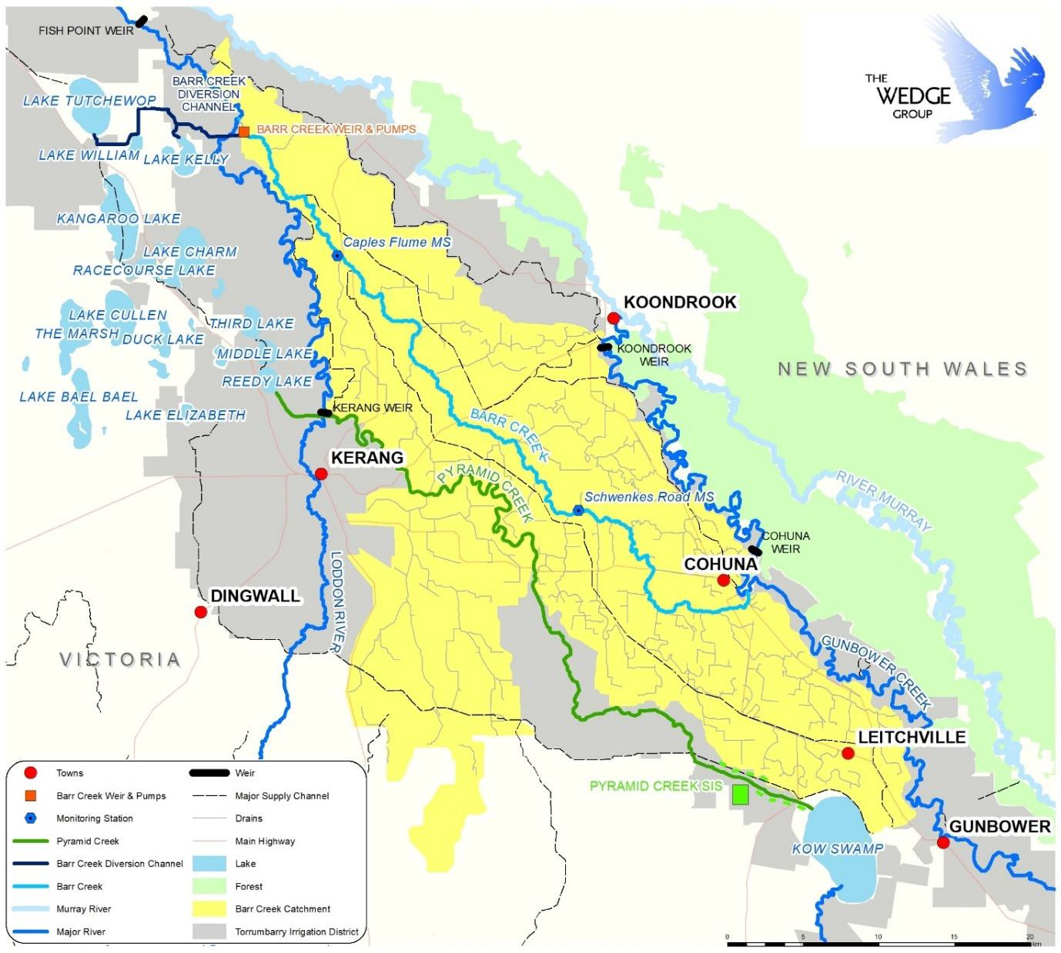
Figure 6 – Drains and drain monitoring stations in the Barr Creek Catchment (Source: Figure 3 of NCCMA (2019))

    - Reviews and studies
Table 6 lists reviews and studies related to the BCCS Register A entry.

Table 6 – Reviews and studies related to the BCCS Accountable Action Register A entry

Review No. | Review Type
First review | 5-year review by SKM (2005)  A review of the statistical methods used in the 2005 by Fox (2006) (not a formal Independent peer review)
Second review | 5-year review by SKM (2011a)  Independent peer review by Shepherd (2013)
Third review | The latest review of the action is in progress as of April 2019 – it is using a risked based approach for assessing salinity impacts instead of the statistical model developed in 2005.
Other | Jacobs (2017c) – reviewed and presented a contemporary understanding of how a wide range of policies, programs, actions, economic and climatic influences, have impacted Barr Creek salt loads and drainage flows since the original conceptualisation that underpinned the BCCS (in the mid-1980s).
    - Related accountable actions
The following accountable actions must be considered when reviewing the BCCS:
      - Barr Creek Drainage Diversion Scheme (BCDDS) (see section 2.2) – because it diverts flows from the end of Barr Creek away from the Murray River into Lake Tutchewop
      - Tragowel Plains Drains (see section 5.1) – because drainage from the Tragowel Plains flows into Barr Creek
      - Pyramid Creek Groundwater Interception Scheme (see section 2.3) – because groundwater pumping effects pressures beneath the Barr Creek Catchment.
The following potential future accountable actions are being considered in the current (2019) review because they have contributed to reduced flows in Barr Creek and decreased recharge to groundwater:
      - Goulburn-Murray Water Connections Project
      - Water trade, including Commonwealth Government buybacks.
    - Possibilities for expansion of credits/debits
A review of the BCCS is currently being undertaken (NCCMA, 2019). It is indicating that actions in the catchment post completion of the strategy (termed Phase II Catchment Actions), have the potential to increase the salinity credit by up to -25.6 EC. These land and water management outcomes arise from further improvements in:
      - on-farm efficiencies
      - reduced water use in the catchment arising from water recovery, trade and reduced allocations
      - distribution system modernisation
      - irrigator-initiated actions such as trade, self-funded irrigation efficiency improvements, and improved overall water management
      - groundwater pumping from deep aquifers to the east and north of the catchment

The cumulative effect of these activities is to decrease surface runoff and recharge to groundwater which in turn decreases the volume and salt concentration of Barr Creek flows.
    - Issues, gaps and further work
The large magnitude of the potential salinity credit claim means there will need to be high confidence in its assessment, i.e. effort commensurate with risk. Further work required includes upgrading the existing statistical model or developing a more sophisticated integrated groundwater surface water model. Use of either model will require improved monitoring and data collection, especially for the integrated model. If a decision was made to go with an integrated model, then several existing and possible new North Central CMA entries on Register A could be amalgamated into a single entry.

Psyche Bend
    - Overview
Victoria is only accountable for 50% of this Action. The remaining accountability lies with the Commonwealth. The Mallee CMA is responsible for the Victorian component of this Register A accountable action. The action is referred to as Psyche Bend on Register A but it is the entry for the Psyche Bend Lagoon Drainage Diversion Scheme.
The 2018 Register A (MDBA, 2018) records the Psyche Bend accountable action as commencing in February 1996 (date deemed effective). The current (2018) Salinity Effect of the entry is a -2.1 EC credit at Morgan on Register A. The Salinity Effect is estimated to be a -2.1 EC credit in 2050 and 2100 (MDBA, 2018).
There is medium confidence in the entry (MDBA (2017) and (2018)).
    - Background
Psyche Bend Lagoon is a billabong on the Murray River floodplain immediately south of Kings Billabong near Mildura (Figure 7). The lagoon received irrigation drainage water as well as being a natural groundwater discharge area, with this discharge being highly saline. Historically it was used to receive irrigation drainage water from the Red Cliffs irrigation area, which in turn displaced hyper saline groundwater from the lagoon into the Murray River.
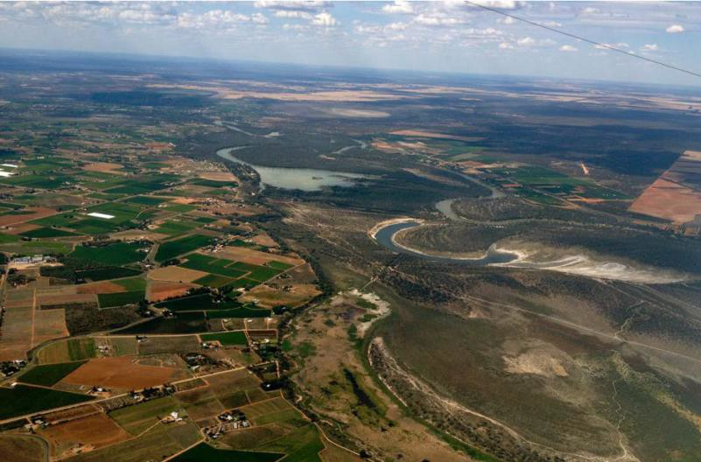
Basin 12
Psyche Bend Lagoon
Murray River
Kings Billabong
Figure 7 – Photographs of the floodplain east of Mildura and Red Cliffs irrigation district looking north. The floodplain contains Basin 12 in the foreground, Psyche Bend Lagoon (centre) and Kings Billabong to the north (Source: Cover photo of Jacobs (2016c)

    - Description
Victoria is accountable for the decrease in salt load reaching the Murray River from Psyche Bend Lagoon as a result of the three components of the action described below.
The Scheme (Figure 8) was established in 1996 and is located on the Murray River floodplain near the First Mildura Irrigation Trust pump station, south-east of Mildura. The two main objectives of the Scheme are:
- To divert drainage water away from the lagoon
- To control the flushing of salt from the lagoon to the Murray River during flood events (>35,000 ML/day flow).

The diversion works (Figure 8), consist of three components:
      - Diversion of drainage water in Red Cliffs No.1 drain to the inland Cardross Basins which are mostly located on Blanchetown Clay, resulting in minimal seepage to the groundwater – this reduces drainage flows into Basin 12 and, with component 2 in place, flows and salt load to the Murray River
      - The isolation of Psyche Bend Lagoon from the drainage system by diverting water from Basin 12 directly into the Murray River – this reduces flows from Basin 12 to Psyche Bend Lagoon and from Psyche Bend Lagoon to the Murray River. Previously Basin 12 flows of approximately 1,500 EC passed through the highly saline Psyche Bend Lagoon which increased the salt load of equivalent flow volumes leaving the Lagoon (Psyche Bend Lagoon had salinity levels of up to 50,000 EC)
      - Controlled flushing of the lagoon at appropriate times of high Murray River flow, i.e. above 35,000 ML/day – flushing at specified high flow rates rather than previously whenever Psyche Bend Lagoon spilled reduces the impact of salt loads in the river. Flushing is required to reduce the salinity impact on the floodplain and surrounding environment.
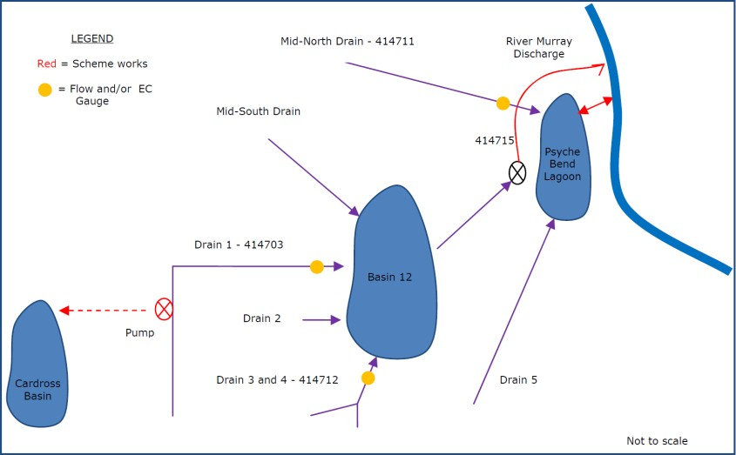
Figure 8 – Schematic of the Psyche Bend Drainage Diversion Scheme (Source: Figure 3.1a of Aquaterra (2010))

    - Models used
What’s the model?
The original assessment done was based on the Hydrotechnology water and salt balance models for Basin 12 and Psyche Bend Lagoon. Flow and salt load discharges to the Murray River were based on annual average flows and salt loads using available data from 1983 to 1994. These were disaggregated into constant daily values (Aquaterra, 2010). These data have not been revised since the original entry. Each 5-year review has completed water and salt balances to check that flows and salt loads during the review periods which remain below the original estimates.
Who owns the model?
Not applicable as it is a simple water balance model. Is the model accredited?
Not applicable as it is a simple water balance model.

    - Reviews and studies
Table 7 lists reviews and studies related to the Psyche Bend Register A entry.
Table 7 – Reviews and studies related to the Psyche Bend Accountable Action Register A entry

Review No. | Review Type
First review | Review by SKM (1998)
Second review | 5-year review by Aquaterra (2010)  Independent Peer Review reportedly done by John Shepherd in 2012 or 2013, but not sighted for this report
Third review | 5-year review by Jacobs (2016c)  Independent Peer Review by Hydrogeologic (2016) – not available for this report

    - Related accountable actions
The following accountable actions are closely related to, but separate from, the Psyche Bend accountable action (Jacobs , 2016c):
- Sunraysia Drains Drying Up (section 4.4) – The Psyche Bend claim (1996) predates the Sunraysia Drains Drying Up claim (2004) and so actions in Drying of the Drains claim do not degrade the earlier claim.
The works for Psyche Bend do not eliminate flows, they merely re-direct them around the Lagoon and directly to the river. Decreases in salt load resulting from the Sunraysia Drains Drying Up accountable action do decrease salt loads to the river. Thus the fundamental saving that accrues to Psyche Bend, which is the reduction in salt load displaced from Lagoon, is retained.
- Reduced Irrigation Salinity Impacts (RISI) (section 4.8 and 4.9) – The Psyche Bend accountable action was placed on the register before RISI and so any action claimed by RISI cannot degrade the saving created by the Psyche Bend accountable action.
Lower watertable. The amount of groundwater discharge to the river is expected to be lower due to a lower irrigation induced regional groundwater mound. This reduction is captured in the RISI register item.
The effect of lowering groundwater pressures may reduce the need for flushing under the protocols as the rate of salt accumulation may be reduced. In the future there may be an opportunity to reduce the debit associated with flushing in the Psyche Bend Lagoon action, or to increase the claim for RISI.
Controlled flushing of salt from Psyche Bend Lagoon now occurs as a result of two actions:
- In accordance with the Psyche Bend Lagoon Drainage Diversion Scheme Operating Procedures for Flushing of Lagoon – flushing is required to control the overall accumulation of salt in the Lagoon. These events were part of the original credit claim and are part of the accountable action. It was anticipated that flushing events would be triggered about twice every 10 years when river flows were above 35,000 ML/day.

- Planned environmental watering – these events have commenced since the accountable action was placed on the Register. They should be accounted for as part of environmental watering. Monitoring of flushing events provides for the impacts to be separately assessed.
    - Possibilities for expansion of credits/debits
There may be an opportunity to reduce the debit associated with flushing in the Psyche Bend accountable action, or to increase the credit claim for RISI as a result of lower groundwater levels beneath the Lagoon, i.e. improved irrigation efficiency has lowered groundwater levels which decreases saline groundwater flow into the Lagoon which reduces the need to flush the Lagoon (Jacobs , 2016c).
    - Issues, gaps and further work
Jacobs (2016c) comment that the credit claim could potentially be improved by separating the elements of Psyche Bend Lagoon flushing from the changes to drain flows. It would be pragmatic to include the benefit of the drain bypass of Psyche Bend Lagoon into the Sunraysia Drains Drying Up accountable action and within that action reconcile the overlapping effects of reduced drain flow on the river. The benefit of the bypass is captured if Basin 12 does not spill into Psyche Bend Lagoon.
The benefit of controlled flushing of Psyche Bend Lagoon compared with uncontrolled outfall could be kept as a separate register item, the effect of which would be confirmed by the operation in accordance with the Operational Procedures. Given the desire for enhanced environmental watering, there is merit in considering a re-configuration of the flushing procedures to meet environmental benefits and the credit could be used within the context of environmental watering impacts.

Permanent Trade Accounting Adjustment - Victoria to SA
    - Overview
DELWP is responsible for this Victorian Register A accountable action.
MDBA (2017) records the Permanent Trade Accounting Adjustment - Victoria to SA accountable action as commencing in June 2006 (date deemed effective). The current (2018) Salinity Effect of the entry is a -0.8 EC credit at Morgan on Register A. The Salinity Effect is estimated to be a -0.8 EC credit in 2050 and -1.0 EC credit in 2100 (MDBA, 2018).
There is high confidence in the entry (MDBA (2017) and (2018)).
    - Background and Description
This entry, first made in June 2006, represents the adjustments for the impact of changes in the dilution flows resulting from transferring irrigation water from Victoria to South Australia as a result of entitlement (water share) trades (not allocation trades). These changes in flow affect the volume of water that is available to dilute salt that enters the Murray River.
Three adjustments have been made: one for trade up to January 2000, one up to June 2002 and one up to June 2006. MDBA (2018) records that it was last reviewed in 2017 however no review report is available.
There is no allowance in this accountable action for the differences in likely salt accessions caused by applying the traded water in SA that will result from those transfers. These impacts should be accounted for in SA irrigation development accountable actions.
    - Models used
What’s the model?
The transfer of water entitlements from Victoria to SA were directly coded into MSM-Bigmod to increase entitlement flows into South Australia.
The analysis has looked only at the dilution impacts of the changes to the accounts (i.e. the change to the SA entitlement flow at the border). It does not include any estimates of the salinity effect of reducing diversions in Victoria or increasing diversions in SA. Therefore, the entry reflects changes to river operations (i.e. dilution flows) only.
Who owns the model?
The model is owned and maintained by the MDBA Is the model accredited?
Yes.
    - Reviews and studies
Table 8 lists reviews and studies related to the Permanent Trade Adjustment – Victoria to SA Register A entry.

Table 8 – Reviews and studies related to the Permanent Trade Accounting Adjustment - Victoria to SA Accountable Action Register A entry

Review No. | Review Type
Other | Cap model report by MDBA (2013)  Description of Register entries report by MDBA (2017)

    - Related accountable actions
There are several Register A accountable action entries for changes in dilution flow including:
- Permanent Trade adjustment NSW to Victoria (section 3.1)
- Barmah-Millewa Forest Operating rules (section 3.2).
There are also Provisional Register A accountable action entries for changes in dilution flows:
- Barmah to Goolwa dilution flow
- The Living Murray – River Murray Increased Flows (TLM-RMIF) 570 GL.
    - Possibilities for expansion of credits/debits
The accountable action only deals with permanent water trades up to 2006. There is scope for including additional trades since then. The first step would be to determine the increase in the volume of entitlement trades. However, the unbundling of Victorian water entitlements in 2007 makes is difficult to track the destination of entitlement trades.
    - Issues, gaps and further work
Register A 2018 (MDBA, 2018) records that the last review was completed in 2017 yet the review report is not available. It is not clear if this review was undertaken. No trade adjustment has been made since 2006 (MDBA, 2017).
Over ten times as much water is traded on the temporary market as allocations than as entitlement trade. For example, in 2017-18 the trade of high reliability water shares in northern Victoria was 69 GL and 24 GL of low reliability water shares. This compares with 1,087 GL of commercial allocation trades (DELWP, 2018).
From 1997 to 2018, the irrigable area in the Mallee catchment increased by 40,825 hectares, from 40,325 hectares to 81,150 hectares. The irrigable area includes permanent plantings, seasonal crops and vacant areas. Almond plantings have increased in the Mallee from 1,745 ha in 1997 to 24,485 ha in 2018 (MCMA, 2018). The increase in plantings are supported by a mix of permanent entitlement trades and temporary allocation trades.
In 2017-18 the amount of water supplied between Nyah and the SA Border was 456 GL (LMW, 2018). Much of this water was used to irrigate almonds which need 14-16 ML per hectare of water at maturity.
There is an opportunity to assess the salinity effects of entitlement and allocation trades to the Mallee from the riverine plains.
There are many actions that will change the flow regime of the Murray River compared to baseline conditions. Changes in the timing and location of demand is being caused by two types of actions:

      - commercial trading of allocations and entitlements (e.g. transfers from the GMID to the Mallee)
      - delivery of water to environmental sites.
Further work is needed to review the assessment framework for these types of actions and to consider when actions should be grouped.

Sunraysia Drains Drying up
    - Overview
The Mallee CMA is responsible for this Victorian Register A accountable action.
MDBA (2017) records the Sunraysia Drains Drying Up accountable action as commencing in June 2004 (date deemed effective). The current (2018) Salinity Effect of the entry is a -2.2 EC credit at Morgan on Register A. The Salinity Effect is estimated to be a -2.1 EC credit in 2050 and 2100 (MDBA, 2018).
There is medium confidence in the entry (MDBA (2017) and (2018)).
    - Background
Problems with waterlogging and salinisation emerged quickly in the irrigation districts around Mildura once irrigation commenced. This included the Mildura, Merbein and Red Cliffs districts. The problems were a result of a general rise in watertables throughout each district. In response, comprehensive, district-wide drainage schemes were constructed in the early 1930s as, unemployment relief projects during the Great Depression, for Nyah, Red Cliffs, Mildura and Merbein (Hallows & Thompson, 1995, p. 52).
The drainage schemes consisted of subsurface tile drains typically located 1.2 to 1.8 m below the soil surface, with the exact depth depending on the depth of the Blanchetown Clay layer which the drains sit above (SKM, 2003b, p. 10). They are spaced 13 to 40 m apart. Drainage water from the schemes discharged to the Murray River, floodplain or drainage disposal basins.
    - Description
Victoria is accountable for the reduction in drainage volume and salt loads discharged to the Murray River or floodplain from sub-surface drainage catchments in the Mildura, Red Cliffs and Merbein Irrigation Districts as a result of improvements in irrigation efficiency in the region (SKM, 2003b, p. 28).
The study area comprises three sub-surface drainage areas (each consisting of a number of sub- catchments) in the vicinity of Mildura that discharge to the Murray River either directly or via the floodplain (Figure 9). Areas draining to evaporation basins such as Lake Hawthorn or Cardross Basins are not part of the credit claim for this action.
The reduction in salt loads from irrigation drainage is thought to be due to declining perched watertable levels. In turn, the declining perched watertable is thought to be due to improved irrigation efficiencies, as the perched watertable has shown a steady decline since monitoring began in the mid-1980s - which pre-dates the recent spell of dry years (SKM, 2003b, p. 1).
Water use efficiency in the region was achieved by the following (SKM, 2003b, p. 28):
- Implementation of the Sunraysia Salinity Management Plan (SMP) involving -
  - Drainage, Water supply and Irrigation management programs
  - Environmental rehabilitation program
  - Community education, monitoring and other activities.
- Introduction of the Sunraysia SMP Irrigation Management Course and the Kickstart Sunraysia Rural Partnership Program
- Infrastructure changes, such as piped irrigation delivery and upgraded metering system

- Policy changes including the implementation of metering, user-pays and two-part tariff system and updated irrigation ordering
- Landuse change, such as urbanisation and industrialisation of irrigated land.
SKM (2003b, p. 28) found that drainage flows and salt loads to the Murray River from tile drainage beneath the specified irrigated areas of Merbein, Mildura and Red Cliffs districts had decreased by approximately 40% between 1988 and 2000, i.e. the difference between flows and salts loads at 1988 and 2000 levels of development over the Benchmark Period (1975 to 2000).
The most recent 5-year review examined the salt load and flows from relevant irrigation drains and compared them to those for the year 2000 conditions. It determined that for the review period (2010-15) less salt was discharged from the drains and the credit claim was valid (Jacobs, 2016d, p. 2). Flow and salt load time series used for MSM-Bigmod are those generated as part of the completing the original credit claim in 2004.
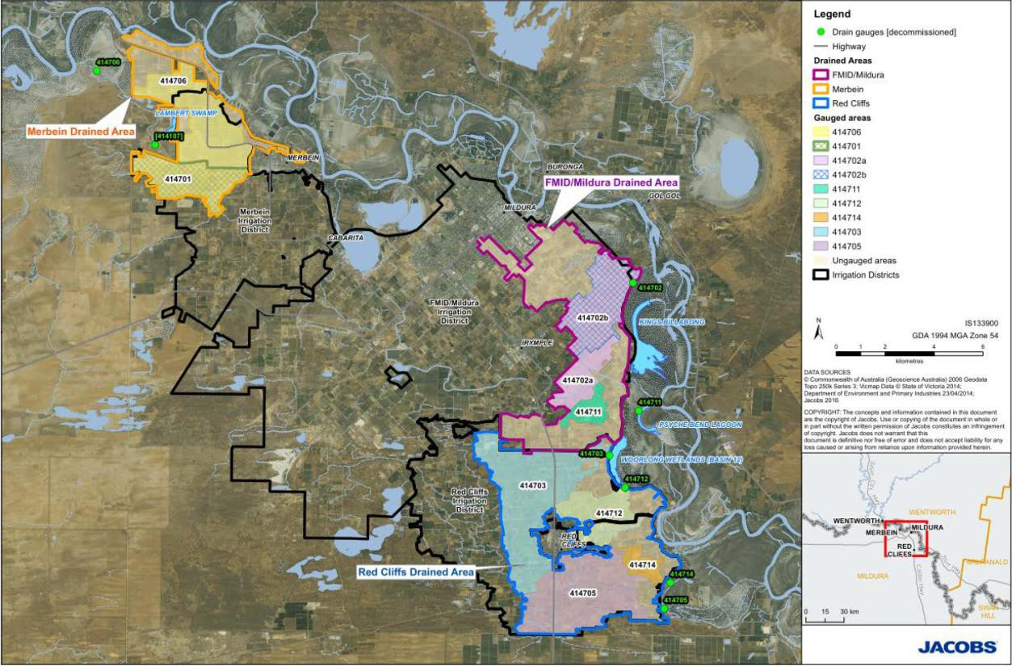
Figure 9 – Map of the Sunraysia Drying of the Drains area showing irrigation districts, drained areas, gauged catchments and location of gauges (Source: Figure 2.1 of Jacobs (2016d))

    - Models used
What’s the model?
The decrease in saline irrigation drainage inflows to the Murray River was analysed by undertaking a trend analysis of continuously monitored drains and applying the results to those areas within each irrigation district whose irrigation drainage outfalls to the River. This analysis was conducted using the Generalised Additive Model (GAM) over the period of record.
GAM is a windows-based program that fits a multi-parameter equation to time series data, allowing both drain flow and salinity to be simulated over the benchmark period from 1975 to 2000, at

drainage conditions equivalent to both 1988 and 2000 conditions. These time series were used to estimate drain salt loads under the two scenarios, which were then used to estimate the salinity change in the Murray River at Morgan due to the drying up of tile drainage from each district (SKM, 2003b, p. i).
Who owns the model?
The model is a general technique for analysing data. Is the model accredited?
It was deemed as fit for purpose.
    - Reviews and studies
Table 9 lists reviews and studies related to the Drains Drying Up Register A entry.
Table 9 – Reviews and studies related to the Sunraysia Drains Drying Up Accountable Action Register A entry

Review No. | Review Type
First review | 5-year review by Aquaterra (2010b)  Independent Peer Review by Shepherd (2012)
Second review | 5-year review by Jacobs (2016d)  Independent peer review – not available
Other | Original Credit Claim by SKM (2003b)

    - Related accountable actions
The following accountable actions are closely related to, but separate from, the Drying of the Drains accountable action (Jacobs, 2016d):
      - Lambert Swamp (section 4.5) – The current monitoring point for drain flows for the Lambert Swamp credit claim is gauge 414706. This site was also used in the review of Sunraysia Drying of the Drains. As both claims are on the salinity register with the same effective date, one does not take precedence over the other. Without adjusting the flow and salt load at site 414706 for the effect of Lambert Swamp accountable action, the potential exists that the Sunraysia Drying of the Drains claim could be over-stated for this monitoring point.
In the 5-year review and the companion assessment for Lambert Swamp (performed concurrently), the effect of the Lambert Swamp accountable action was removed from the Drying of the Drains data set, prior to the assessment being made. Thus, there is no overlap in practice.
      - Psyche Bend (section 4.2) – Salt load from three drains: 414711 in the FMID/Mildura irrigation area, 414703 from Red Cliffs and 414712 from Red Cliffs drain to either Basin 12 (Woorlong Wetlands) or to Psyche Bend. Diversion to Cardross Basins from Red Cliffs Drain No. 1 (gauge 414703) of 5 ML/d was provided for in the Psyche Bend Accountable Action.
The Psyche Bend claim (1996) predates the Sunraysia Drying of the Drains claim (2004) and so actions in Drying of the Drains do not degrade the earlier claim.

Also, the direct works for Psyche Bend do not eliminate drainage flows to the river, merely re-direct them around Psyche Bend and directly to the river. Therefore, any savings in salt load resulting from the Sunraysia Drying of the Drains accountable action still results in a saving to the river.
For most of the period since the Sunraysia Drying of the Drains claim, there has been no diversion to Cardross from Red Cliffs Drain number 1. The only exception was during the extreme flows of summer 2010/11. There is potential for double counting of the diversion flows. This was addressed by reducing the salt load target for this drain by the intended Psyche Bend diversion. Thus, there is no double counting in this analysis.
      - Reduced Irrigation Salinity Impacts (RISI) (section 4.8 and 4.9) – The source of salt in Sunraysia Drying of the Drains was a combination of irrigation drainage and groundwater inflow from the shallow and regional aquifers. The RISI accountable action covers reduction in salinity in the river as a result of reduced groundwater elevation. Lower elevation groundwater in the Sunraysia Drying of the Drains area will reduce the rate of salt ingress to irrigation drains and could reduce the theoretical need for disposal.
The Sunraysia Drying of the Drains accountable action was placed on the register before RISI and so any action claimed by RISI cannot degrade the saving created by Sunraysia Drying of the Drains accountable action. It is understood that the RISI claim has taken steps to avoid double counting of the Sunraysia Drying of the Drains accountable action in the method.
    - Possibilities for expansion of credits/debits
Jacobs (2016d, p. 32) suggest that for Red Cliffs and Mildura there could be additional salt load reductions that may be able to be claimed. To do this additional monitoring of all drains that discharge to the River or floodplain would be needed.
    - Issues, gaps and further work
Future monitoring to enable a revised claim for additional credits should monitor all drains for flow and salinity on a continuous basis. Future monitoring should identify areas of drained catchment that have been urbanised and exclude them from the analysis, ideally by monitoring drain flow from the urban areas and subtracting it from the total drain flow. Data should also be gathered on the likelihood of expansion of the irrigated area, based on likely water availability and trade (Jacobs, 2016d, p. 32).

Lambert Swamp
    - Overview
The Mallee CMA is responsible for this Victorian Register A accountable action.
MDBA (2018) records the Lambert Swamp accountable action as commencing in June 2004 (date deemed effective). The current (2018) Salinity Effect of the Lambert Swamp entry is a -3.0 EC credit at Morgan on Register A. The Salinity Effect is estimated to be a -3.0 EC credit in 2050 and 2100 (MDBA, 2018).
There is high confidence in the entry (MDBA (2017) and (2018)).
    - Background
Lambert Swamp is located adjacent to the Merbein Irrigation District and was originally established as a drainage disposal basin covering an area of 16ha (Figure 10). It received irrigation drainage water and stormwater from the surrounding catchment. However, due to the rise in regional groundwater levels, it also became a groundwater discharge area, and as a result the swamp has high salinity levels, often in excess of 100,000 EC. Pumping was used to control swamp water levels to prevent local flooding and associated inundation impacts. Pumped outfalls discharged directly to the Murray River resulting in significant salt load impacts.
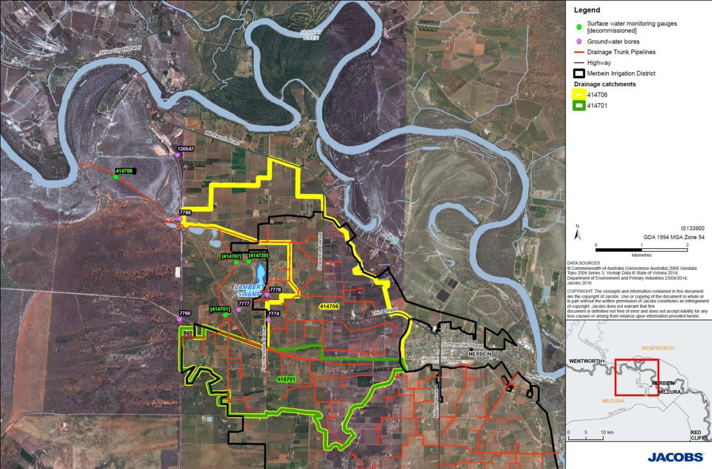
Figure 10 – Map of Merbein area showing the location of Lambert Swamp and drainage infrastructure (Source: Figure 2.2 of Jacobs (2016e))

In order to reduce the outfall of high salt loads to the Murray River, works were undertaken to reduce the inflows to Lamberts Swamp. Initially there was 52 ha of irrigated land draining to Lamberts Swamp, but this had reduced to approximately 20 ha in 2001. Works were then undertaken to redirect the remaining drainage water into the Merbein North West Drain, and as a result, since November 2003 Lamberts Swamp has received no irrigation drainage. In 2003/04 the Merbein West Drain was piped in the vicinity of Lamberts Swamp. Seepage from the drain had

resulted in a local groundwater mound, which increased groundwater inflows to Lamberts Swamp (MCMA, 2012, p. 47).
    - Description
Victoria is accountable for the decrease in flow and salt load from Lambert Swamp to the Murray River as a result of the works described below.
The works that are part of the accountable action and that practically eliminated flow and salt load to the Murray River from Lambert Swamp are (Jacobs, 2016e, p. 6) (Figure 11):
      - Reconfiguration of the subsurface drainage network and redirecting drainage water away from Lambert Swamp, including piping of a section of the channel, to avoid seepage losses to groundwater
      - Discontinuing the pumping of hypersaline water from Lambert Swamp into the drainage channel that connects to the river
      - Isolating Lambert Swamp to form an evaporation basin to store salt inland rather than to have it emptied into the river.
Jacobs (2016e) found that the scheme was operating as intended and that the magnitude of the entry on Register A should be retained. Flow and salt load time series used for MSM-Bigmod are those generated as part of completing the original credit claim in 2003.
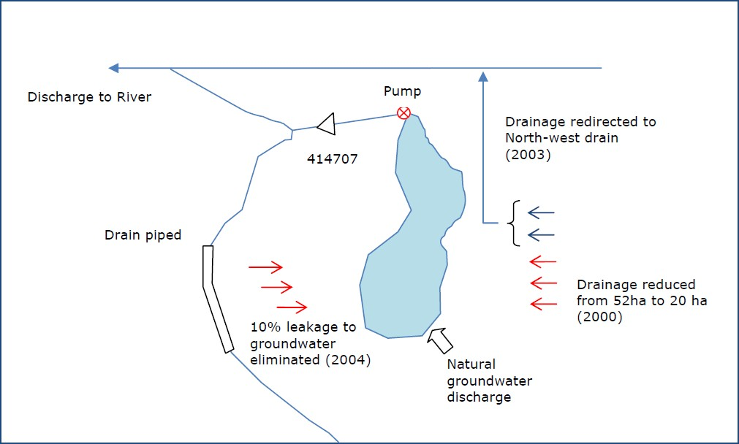

Figure 11 – Elements of the Lambert Swamp accountable action: i) cessation of pumping from the swamp to a drain and then the Murray River (pump was removed), ii) piping of a surface drain to eliminate seepage into Lambert Swamp, and iii) redirection of drainage water to the North-West Drain (Source: Figure 1.1 of Aquaterra (2010c))

    - Models used
What’s the model?
A surface water/groundwater salt and water balance spreadsheet model was used to assess salt load impacts to the Murray River.

Who owns the model?
The model is the property of the Mallee CMA. Is the model accredited?
It was deemed as fit for purpose.
    - Reviews and studies
Table 10 lists reviews and studies related to the Lambert Swamp Register A entry.
Table 10 – Reviews and studies related to the Lambert Swamp Accountable Action Register A entry

Review No. | Review Type
First review | 5-year review by Aquaterra (2010c)  Independent Peer Review by Shepherd (2012b)
Second review | 5-year review by Jacobs (2016e)  Independent peer review – not available
Other | Original Credit Claim by SKM (2003)

    - Related accountable actions
The following accountable actions are closely related to, but separate from, the Lambert Swamp accountable action (Jacobs, 2016e):
- Sunraysia Drying of the Drains (section 4.4) – The current monitoring point for drain flows for the drying of the drains is gauge 414706. This is the same site as was used for the original credit claim for Lambert Swamp. As both claims are on the salinity register with the same effective date, one does not take precedence over the other. Without adjusting the flow and salt load at site 414706 for the effect of Lambert Swamp accountable action, the potential exists that the Sunraysia Drying of the Drains claim could be over-stated for this monitoring point.
In the assessment for Sunraysia Drying of the Drains (performed concurrently with this study), the effect of the Lambert Swamp accountable action was removed from the drying of the drains data set, prior to the assessment being made. Thus, there is no overlap in practice.
- Reduced Irrigation Salinity Impacts (RISI) (section 4.8 and 4.9) – The source of salt in Lambert Swamp was a combination of irrigation drainage and groundwater inflow from the regional aquifer. The RISI accountable action (simplistically) covers reduction in salinity in the river as a result of reduced groundwater elevation that arises from improved irrigation efficiency. For the purposes of this review, lower elevation groundwater in the vicinity of Lambert Swamp will reduce the rate of salt ingress to the Swamp and could reduce the theoretical need for disposal.
The Lambert Swamp accountable action was placed on the register before RISI and so any action claimed by RISI cannot degrade the saving created by the Lambert Swamp accountable action. Thus, there is no adjustment required in the Lambert Swamp action.

    - Possibilities for expansion of credits/debits
Not applicable.
    - Issues, gaps and further work
The drainage disposal component to the credit claim could be moved to the Sunraysia Drying of the Drains accountable action, thus simplifying the Lambert Swamp accountable action.
The assessment of this action is primarily based on documenting that pumping from Lambert Swamp has not recommenced. This could readily be provided by a document or certificate from the system operators, Lower Murray Water, that such pumping has not occurred. Future reviews could be streamlined on this basis.

Church's Cut Decommissioning
    - Overview
The North Central CMA is responsible for this Victorian Register A accountable action.
MDBA (2018) records the Church’s Cut Decommissioning accountable action as commencing in March 2006 (date deemed effective) – works took place in July 2003. The current (2018) Salinity Effect of the entry is a -0.3 EC credit at Morgan on Register A. The Salinity Effect is estimated to be a
-0.2 EC credit in 2050 and 2100 (MDBA, 2018).
There is high confidence in the entry (MDBA (2017) and (2018)).
    - Background
Pyramid Creek is a modified natural stream in Northern Victoria (south of Barr Creek Catchment) that is used as the major irrigation carrier within the Torrumbarry Irrigation Area delivering water from Kow Swamp to the Kerang Lakes.
Saltload accessions to the Creek were historically sourced from Church’s Cut, a 550 m long cutting from Pyramid Creek, incised 2 to 3 metres into permeable sediments to supply the irrigation pump- site belonging to the Church family (Figure 12). During irrigation events, water drawn from Church’s Cut resulted in salt load accessions from groundwater being discharged to land, however during extended periods of no pumping (typically between each irrigation season) salt loads migrated to the Creek. Salt load accessions to the Cut were also problematic for early season irrigation of the Church property due to the concentration of salts during extended periods without throughflow, necessitating Creek regulation to induce flushing of the cutting at the commencement of each irrigation season. The confluence of the Cut with Pyramid Creek was approximately 2.8 km downstream of Kow Swamp and within the Stage 1 reach of the area targeted for the Pyramid Creek SIS (section 2.3) (Jacobs, 2016f, p. 3).
    - Description
Victoria is accountable for the decrease in flow and salt load to the Murray River resulting from
infilling of Church’s Cut.
To mitigate the downstream and local salinity impacts, the MDBA and Victoria worked co- operatively to fill Church’s Cut in July 2003 and construct a SIS along Pyramid Creek. Infilling of Church’s Cut effectively closed off a point source of salt to Pyramid Creek.
Prior to the infilling of Church’s Cut saline groundwater entered Church’s Cut and flowed into Pyramid Creek and either, spilled over Kerang Weir to reach the Murray River via the Loddon River, or continued westward into the Kerang Lakes and reached the Murray via several outfall points.
In conceptualising the benefits of closing the cut, it is necessary to recognise that had it not been filled, drawdown from implementation of the SIS (which runs perpendicular to the location of the now closed Cut) would have partly intercepted its’ salt contribution to the Creek.
The 2016 5-year review provided new time series data for the entry for input to MSM-Bigmod. The
Salinity Effect was unchanged.
    - Models used
What’s the model?

Statistical methods (regression) are used to derive pre-intervention time series of daily salt loads over the Benchmark Period. These are converted to groundwater flow and salinity for input into the Kerang Lakes REALM³ model which estimates the final distribution of salt entering the Murray River. These methods are the same as those used for the Pyramid Creek SIS.
The assessment of the modelled impact (benefit) for this Accountable Action is undertaken at the same time as the Pyramid Creek SIS and the total combined benefit is calculated. There is then an apportionment agreement between MDBA and Victoria on what is allocated to each Register Entry. There is no double accounting of benefits.
Who owns the model?
The statistical methods are the property of the scheme partners. DELWP is custodian of the Kerang Lakes REALM model.
Is the model accredited?
The statistical methods are deemed as fit for purpose. The Kerang Lakes REALM model is accredited.
Figure 12 – Pyramid Creek SIS and location of Churh’s Cut channel before it was infilled (Source: MDBA (Not dated))

    - Reviews and studies
Table 11 lists reviews and studies related to the Church’s Cut Register A entry.

3 REsource ALlocation Model (REALM)

Table 11 – Reviews and studies related to the Church’s Cut Accountable Action Register A entry

Review No. | Review Type
First review | 5-year review – not available  Independent Peer Review – not available
Second review | 5-year review by Jacobs (2016f)  Independent peer review – not available
Other | Original Credit Claim – not available

    - Related accountable actions
The Church’s Cut accountable action is closely linked to the Pyramid Creek SIS (section 2.3). The actions were effectively done at the same time – Church’s Cut was filled first because of the simplicity of the works, but apparently there was an understanding at the time that the SIS would precede Church’s Cut in MSM-Bigmod modelling. Both actions also involve works targeted at reducing groundwater accessions in the same sections of Pyramid Creek.
There was insufficient data to determine how to split reductions in salt load and flows between the two actions, although a 10% contribution from Church’s Cut was estimated. This led to a negotiated contribution from Church’s Cut of a -0.3 EC credit (Jacobs, 2016f, p. 26). Because of the connection between the two accountable actions they are reviewed together. There is no double counting of salinity credits.
    - Possibilities for expansion of credits/debits
Refer to the discussion in section 4.6.6 and 2.3.6.
    - Issues, gaps and further work
The last combined 5-year review of Church’s Cut and Pyramid Creek SIS discussed consideration of an alternative technical methodology for estimating salinity impacts, including use of a groundwater model (Jacobs, 2016f).

Mallee Drainage Bore Decommissioning
    - Overview
The Mallee CMA is responsible for this Victorian Register A accountable action.
MDBA (MDBA, 2018) records the Mallee Drainage Bore Decommissioning accountable action as commencing in June 2008 (date deemed effective). The current (2018) Salinity Effect of the BCCS entry is a -0.3 EC credit at Morgan on Register A. The Salinity Effect is estimated to be a -0.3 EC credit in 2050 and 2100 (MDBA, 2018).
There is low confidence in the entry (MDBA (2017), (2018) and Evans (2019)).
    - Background
The regions around Boundary Bend, Tol Tol and Bumbang were developed for irrigation during the 1950s-60s. Irrigation drainage problems became evident during the 1980s and it was around this time that drainage disposal bores were installed. These bores provided a means for irrigators to dispose of collected sub-surface irrigation drainage water directly to a local aquifer. The receiving aquifers were: Channel Sand Aquifer at Boundary Bend, the Parilla Sands Aquifer at Bumbang and the Blanchetown Clay at Tol Tol.
The Nyah to SA Border SMP Salinity Implementation Group were responsible for identifying alternatives to this direct aquifer disposal. Alternative options for disposal were identified in a 1996 investigation. These options involved alternate drainage disposal away from the bores. The drainage disposal bores were decommissioned in 2000 following the installation of a coordinated group drainage scheme in each of the three areas (MCMA, 2012, p. 49).
    - Description
Victoria is accountable for the decrease in flow and salt load from regional aquifers to the Murray River associated with the decommissioning of the drainage bores as well as small volumes of drainage water that was previously disposed of directly to the Murray River at Boundary Bend.
Direct disposal of drainage water to the aquifers from drainage bores resulted in an increase in recharge to the aquifers in this region which, in turn, contributed to the groundwater mound and increased salt loads to the Murray River, through hydraulic connection between the aquifers and the river.
The action is made up of the following:
      - Tol Tol – decommissioning of 8 drainage bores and subsequent disposal⁴ of drainage water (SKM, 2005b)
      - Bumbang – decommissioning of 16 drainage bores and subsequent disposal of drainage water to a reuse dam which discharges to the Murray River (SKM, 2005c)
      - Boundary Bend – decommissioning of 28 drainage bores and subsequent reuse of drainage water for irrigation. The original intent was to reuse other drainage water that was being disposed of to the Murray River for irrigation (SKM, 2005d); however this has not occurred.
There was provision for direct disposal to the Murray River in the case that the collected drainage volume exceeded the reuse capacity of the system (e.g. as would be the case during flood events).

4 The original intent was to reuse drainage water; however this has not occurred.

    - Models used
What’s the model?
Water and salinity balance calculations are used to derive the salinity flux. Who owns the model?
The model(s) are the property of the Mallee CMA. Is the model accredited?
The models were deemed as fit for purpose.
    - Reviews and studies
Table 12 lists reviews and studies related to the Mallee Drainage Bore Decommissioning Register A entry.
Table 12 – Reviews and studies related to the Mallee Drainage Bore Decommissioning Accountable Action Register A entry

Review No. | Review Type
First review | 5-year review by SKM (2013b)  Independent Peer Review by Shepherd (2013d)
Second review | 5-year review by Jacobs (2018) Independent Peer Review by Evans (2019)
Other | Original Credit Claim for:  - Tol Tol by SKM (2005b)  - Bumbang by SKM (2005c)  - Boundary Bend SKM (2005d)

    - Related accountable actions
None.
    - Possibilities for expansion of credits/debits
None.
    - Issues, gaps and further work
Evans (2019, p. 4) notes that re-use didn’t occur during the period 2013 to 2018 contrary to the recommendations of the previous review and its IPR report. Further, it is noted that Jacobs reports that re-use is unlikely to occur in the future. The importance of drainage water re-use to the operation of the drains and ultimately the relevance of drainage water re-use to the size of the Accountable Action is an issue that needs to be resolved by others. However, it is recommended that all future reviews of the Accountable Action assume that re-use does not occur.
Jacobs (2018, p. 2) concludes that future reviews of this Accountable Action should be commensurate with the risk to the Murray River (i.e. due to the relatively low magnitude of potential impacts, ten-year review intervals should be considered as per BSM2030).

Reduced Irrigation Salinity Impact (RISI) Stage 1
    - Overview
The Mallee CMA is responsible for this Victorian Register A accountable action.
MDBA (2018) records the RISI Stage 1 accountable action as commencing in June 2010 (date deemed effective). The current (2018) Salinity Effect of the entry is a -5.6 EC credit at Morgan on Register A. The Salinity Effect is estimated to be a -6.8 EC credit in 2050 and a -7.1 EC credit in 2100 (MDBA, 2018).
There is medium confidence in the entry (MDBA (2017) and (2018)).
    - Background
The Reduced Irrigation Salinity Impact (RISI) credit claim reflects improvements in irrigation efficiency (both farm and distribution system). These improvements have led to the recession of groundwater mounds underlying irrigated areas in the Sunraysia region and improvement in Murray River salinities due to reduced salt inputs.
    - Description
Victoria is accountable for the reduction in salt load to the Murray River associated with improved irrigation practices (both farm and distribution system) on the pre-1988 irrigated areas of the Victorian Mallee.
The RISI Stage 1 and Stage 2 (section 4.9) entries are for similar actions, however they are for different geographic areas within the Victorian Mallee. RISI Stage 1 covers the Murray River from Red Cliffs to Wentworth (Reaches E to L in Figure 15).
Since the mid-1980s, changes to irrigation practices in the Sunraysia region have resulted in the recession of groundwater mounds underlying irrigated areas. Mound recession has resulted in reduced groundwater fluxes to the River Murray, and hence reduced salt load forming the basis of the RISI credit claim.
The Sunraysia RISI is the decrease in salt load to the Murray River derived from improved irrigation practices and reduced leakage from supply infrastructure from irrigation areas already in place on 1 January 1988, assessed at 1 January 2007 for both Victoria and NSW. The benefit assessed for RISI excludes existing salinity credits and debits on the Salinity Registers, including those relating to drainage infrastructure, water trade and new irrigation development.
RISI occurs at locations where there is and where there isn’t SISs. Because SISs are not 100% efficient or effective at intercepting groundwater flowing into the Murray River, improvements in irrigation practices behind the schemes can still deliver salinity benefits, i.e. improvements decrease residual salt loads entering the Murray River. The unpacking (separation) of the RISI benefit at locations with and without SIS is illustrated in Figure 13 and Figure 14 (RPS Aquaterra, 2013).

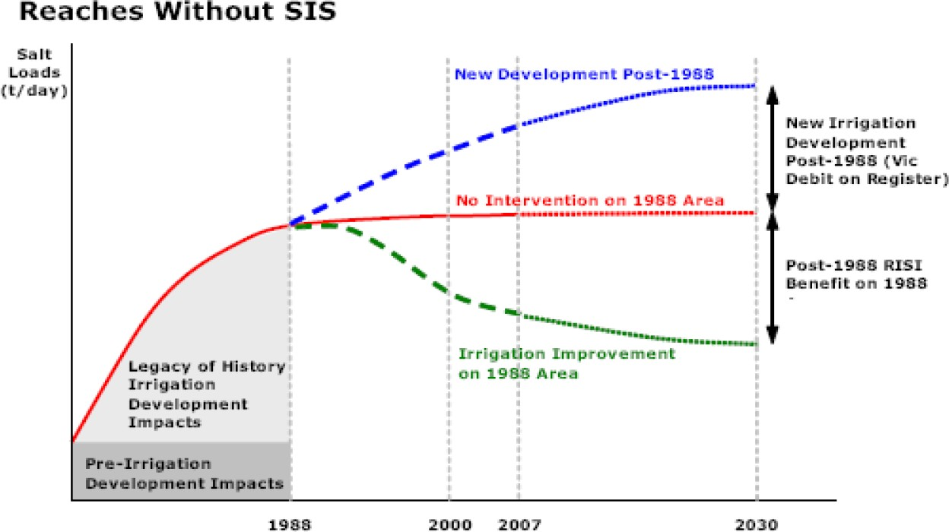

Figure 13 – Salinity benefits of improved irrigation practices without SISs (Source: Figure 14 of RPS Aquaterra (2013))

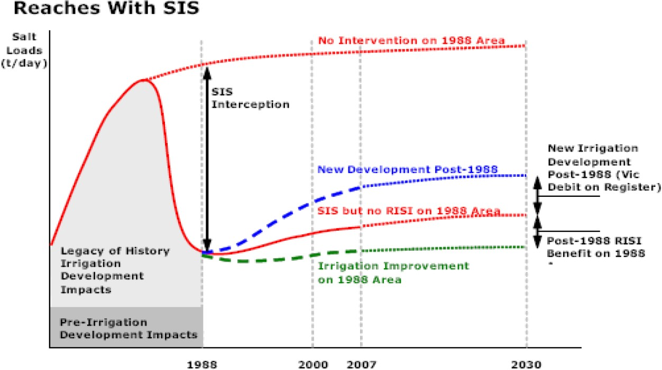

Figure 14 – Salinity benefits of improved irrigation practices with SISs (Source: Figure 14 of RPS Aquaterra (2013))

Figure 15 – River reaches used in the EM2 model (Source: Figure 14 of MDBA (2017))

    - Models used
What’s the model?
The EM2.4 model is the groundwater model used to model the RISI Stage 1 claim. The model has been built using the Modflow modelling platform.
In the EM model suite, recharge, aquifer throughflow, and discharge are all used as calibration parameters because data values or ranges are not well known. The primary calibration target, because it has the best data coverage, is groundwater heads. Recognising this, EM2.4 implemented a wider network of calibration bores than its predecessor (EM2.3.1), to better measure model performance throughout its domain.
EM2.4 contains changes to aquifer layering to make the model more consistent with the Victorian Aquifer Surfaces layers, which post‐date the development of EM2.3. Control on the elevation of the base of the Parilla Sand is poor in most areas of the model. During calibration, the transmissivity of the Parilla Sands was increased to be more consistent with measured data. Model heads are sensitive to these changes.
The rate of recharge to the regional groundwater mound drives the model’s water budget. Urban recharge rates have been increased in EM2.4 from 0.1 to 100 mm/year, to be consistent with published values, although with little impact on water budgets or heads. Recharge rates in Red Cliffs, Mildura and Merbein were reduced by 20%, and Nangiloc recharge rates were doubled. Recharge rates in NSW are around twice the rate in Victoria, which is assumed to reflect differences in crop type, irrigation efficiency and subsurface drainage.

Apparent errors in recharge rates at Karadoc and Monac remain in the model, as they don’t affect the RISI Stage 1 Entry. The model would benefit from a reformulation of the recharge rate calculation methodology to better constrain the recharge rates used in the model, noting that recharge is a calibration parameter in the model.
Evapotranspiration (ET) rates have been modified in EM2.4, particularly in reducing the extinction depth from 8m to 4m in the Nangiloc area and decreasing the spatial extent of where it applies. ET is a calibration parameter and is largely unconstrained by data. However, the model now has a smaller range of parameter values, which are more consistent with other River Murray floodplain model parameter sets.
Discharge of water and salt to the River Murray in Sunraysia is not well quantified, even though this is the key input to the Salinity Registers. During calibration, EM2.4 river conductances were reduced by an order of magnitude. The modelled salt load to river is based on modelled flux multiplied by the near‐river groundwater salinity distribution developed for EM2.3. The modelled salt load falls within the bounds of the Run‐of‐River salt loads. The salt load data is used to calibrate the model, and model calibration could be significantly improved by correcting errors in and analysing the available in‐river salinity data to produce a salt input history.
Who owns and model?
Who owns/maintains the EM2 models is not clear, both MDBA (through collective account), NSW and Victoria have contributed to the development of the various versions of the model.
Is the model accredited?
The model has been deemed as fit for purpose (Shepherd & Evans, 2016, p. 3).
    - Reviews and studies
Table 13 lists reviews and studies related to the RISI Stage 1 Register A entry.
Table 13 – Reviews and studies related to the RISI Stage 1 Accountable Action Register A entry

Review No. | Review Type
First review | 5-year review by AWE (2015) – not available  Independent Peer Review by Shepherd and Evans (2016)
Other | Modelling for the original salt credit claim by Aquaterra (2009)

    - Related accountable actions
The major challenges with the RISI Stage 1 credit claim, and all accountable actions in the Victorian Mallee is unpacking the influence of one action from another.
The RISI Stage 1 claim is structured to not undermine the Victorian ‘Sunraysia Drains Drying Up’ credit (section 4.4), thus avoiding double accounting. The influence of reduced drainage is removed during the development of district scale water balances in determining irrigation recharge, for districts within Victoria and NSW.
RISI Stage 1 also interacts with the Mildura-Merbein SIS (section 2.1) and with SISs in NSW. It is the task of model developers to separate the impacts of these accountable actions, often with limited data available.

    - Possibilities for expansion of credits/debits
Limited.
    - Issues, gaps and further work
Shepherd and Evans (2016, p. 3) recommend that EM2.4 should be used as the platform for the determination of new RISI Stage 1 Register A entries, subject to the resolution of the Register entry quantification methodology recommended by the RISI Stage 1 5 Year Review, recommendation 1. The IPRs also recommend that data collection and model development be undertaken to enable instream salt loads to be used as a calibration parameter for future groundwater salinity models.

Reduced Irrigation Salinity Impact (RISI) Stage 2
    - Overview
The Mallee CMA is responsible for this Victorian Register A accountable action.
MDBA (2018) records the RISI Stage 2 accountable action as commencing in June 2014 (date deemed effective). The current (2018) Salinity Effect of the entry is a -4.7 EC credit at Morgan on Register A. The Salinity Effect is estimated to be a -5.0 EC credit in 2050 and a -5.1 EC credit in 2100 (MDBA, 2018).
There is medium confidence in the entry (MDBA (2017) and (2018)).
    - Background
The Reduced Irrigation Salinity Impact (RISI) credit claim reflects improvements in irrigation efficiency (both farm and distribution system). These improvements have led to the recession of groundwater mounds underlying irrigated areas in the Sunraysia region and improvement in Murray River salinities due to reduced salt inputs.
    - Description
Victoria is accountable for the reduction in salt load to the Murray River associated with improved irrigation practices (both farm and distribution system) on the pre-1988 irrigated areas of the Victorian Mallee.
The RISI Stage 1 (section 4.8) and Stage 2 entries are for similar actions, however they are for different geographic areas within the Victorian Mallee. RISI Stage 1 covers the Murray River from Red Cliffs to Wentworth (Reaches E to L in Figure 15). RISI Stage 2 covers reaches from Mallee Cliffs to Red Cliffs (Reaches B, C and D in Figure 15) where there was low confidence in Stage 1 results (RPS Aquaterra, 2013, p. 85).
Since the mid-1980s, changes to irrigation practices in the Sunraysia region have resulted in the recession of groundwater mounds underlying irrigated areas. Mound recession has resulted in reduced groundwater fluxes to the River Murray, and hence reduced salt load forming the basis of the RISI credit claim.
The Sunraysia RISI is the decrease in salt load to the Murray River derived from improved irrigation practices and reduced leakage from supply infrastructure from irrigation areas already in place on 1 January 1988, assessed at 1 January 2007 for both Victoria and NSW. The benefit assessed for RISI excludes existing salinity credits and debits on the Salinity Registers, including those relating to drainage infrastructure, water trade and new irrigation development.
RISI occurs at locations where there is and where there is no Salt Interception Scheme (SIS). Because SIS are not 100% efficient or effective at intercepting groundwater flowing into the Murray River, improvements in irrigation practices behind the schemes can still deliver salinity benefits, i.e. improvements decrease residual salt loads entering the Murray River. The unpacking (separation) of the RISI benefit at locations with and without SIS is illustrated in Figure 13 and Figure 14 (RPS Aquaterra, 2013).
    - Models used
What’s the model?

The EM2.3.1 model is the groundwater model used to model the RISI Stage 2 claim. The model has been built using the Modflow modelling platform.
The EM2.3 model was developed from EM1 for the specific purposes of assessing the impacts of finer scale actions such as engineering salt interception schemes or the impacts of subtle changes within the irrigation regions. For this purpose the impacts of the dryland hinterland was less
important. Accordingly, the EM2.3 model is a “cookiecut” of the EM1 (the version of EM1 preceding EM1.2) model adopting boundary conditions as defined within the EM1 model but allowing for finer scale grid over key local regions adjacent to the river.
The upgrade of the EM2.3 model to address areas of previously low confidence was required for the RISI Stage 2 project, which lead to version EM2.3.1. The primary refinements from EM2.3 to EM2.3.1 include:
      - Improvements to the District–scale irrigation water balance for the Karadoc Irrigation Area (Vic) and the Monak and Paringi Irrigation Districts (NSW), based on additional data for diversions (Vic only) and drainage (NSW and Vic) data
      - Refined irrigation areas for the Karadoc Irrigation Area (Vic) and the Monak and Paringi Irrigation Districts (NSW) which were part of larger irrigation areas in EM2.3 (Vic private diverters and NSW private diverters respectively)
      - Inclusion of time lags on applied groundwater recharge where applicable.
Groundwater fluxes calculated using the EM2.3.1 model are converted to salt loads using assumptions of near river salinities.
Salt loads are then input to MSM-Bigmod, which is used to determine the impact of the scenario on Murray River salinities. Salt loads are expressed as extra groundwater salt load (t/day) entering the Murray River, in various river reaches (RPS Aquaterra, 2013, p. iv).
Who owns and model?
Who owns/maintains the EM2 models is not clear, both MDBA (through collective account), NSW and Victoria have contributed to the development of the various versions of the model.
Is the model accredited?
The model has been deemed as fit for purpose (RPS Aquaterra, 2013, p. iii).
    - Reviews and studies
Table 14 lists reviews and studies related to the RISI Stage 2 Register A entry.
Table 14 – Reviews and studies related to the RISI Stage 2 Accountable Action Register A entry

Review No. | Review Type
First review | The MDBA is currently (2020) undertaking a Sunraysia model review, the outcome of which will determine when and how the RISI Stage 2 review will be conducted. It is likely that RISI Stage 1 and 2 will be combined into the one Accountable Action.
Other | Modelling for the original salt credit claim by RPS Aquaterra (2013)  The Independent Peer Review of the original salt credit claim was not available

    - Related accountable actions
The major challenges with the RISI Stage 2 credit claim, and all accountable actions in the Victorian Mallee is unpacking the influence of one action from another. This includes interactions with the Sunraysia Drains Drying Up accountable action (section 4.4).
The reduction in drainage flow forms the basis of the Victorian ‘Sunraysia Drains Drying Up’ credit claim (SKM, 2003b). It should be noted that the detailed assessment of regional drainage flows, and the reduction thereof, undertaken in developing the ‘Sunraysia Drains Drying Up’ claim has been used as an input to the EM2.3 model and RISI assessment. As such the RISI claim does not double account for the credit associated with this entry on the Salinity Registers.
    - Possibilities for expansion of credits/debits
None.
    - Issues, gaps and further work
RPS Aquaterra (2013) notes that based on the sensitivity/uncertainty analysis undertaken for the original EM2.3 model, the key parameters that influence predictions of salt accessions to the river are irrigation recharge (and complexities related to the unsaturated zone), groundwater salinity and floodplain evapotranspiration. These parameters are also the most uncertain in terms of their measurement (although the AEM surveys have improved the spatial definition of near-river salinity) and are therefore the priority for future work. Testing of calibration sensitivity during the SIS model refinement process for the project identified that stream bed conductance is also a key parameter for model sensitivity.

Victorian S&DS Commitment Adjustment
    - Overview
The MDBA is responsible for this Victorian Register A accountable action.
Register A (MDBA, 2018) records the Victorian Salinity and Drainage Strategy (S&DS) Commitment Adjustment accountable action as commencing in November 2002 (date deemed effective). No Salinity Effect (physical EC) is recorded for the entry. The Salinity Cost Effect ($m/year), which is the measure that Victoria is accountable against, is a $1.6 million per year credit. The magnitude of the entry does not change from year to year.
No confidence rating is given for the accountable action entry.
    - Background
As part of the transition from the S&DS 1988 to the BSMS 2001-15, Register A was updated by extending the Benchmark Period from 10 to 25 years and applying new cost functions to determine Salinity Cost Effects ($m/year)⁵. The transition to the BSMS Register occurred in November 2002.
The changes to Register A affected all existing entries on the S&DS Register. Importantly it decreased credits available from some joint SISs and State credit accountable actions and increased debits for others. The effect on Victoria was particularly significant as it would have decreased the State’s ability to dispose of salt to the Murray River by 75%.
Prior to the transition from the S&DS Register to the BSMS Register the Murray-Darling Basin Commission (Meeting 52 on 14 September 1999) had agreed to a one off adjustment to account for any impact of changes to cost functions on each States’ ability to dispose of salt.
The Natural Resource Management Committee (Out of Session Meeting 7 on 1 September 2006) later agreed to make a one off adjustment to the BSMS Registers to maintain NSW’s and Victoria’s rights to dispose of salt that existed under the S&DS – this decision extended the earlier one to cover the change in the Benchmark Period.
    - Description
The $1.6 million per year credit (Salinity Cost Effect) was provided to Victoria as part of the transition from the S&DS Register to BSMS Registers. The transition involved extending the Benchmark Period and applying revised cost functions. The adjustment meant that Victoria could dispose of the same amount of salt into the Murray River before and after the register transition. The $1.6 million per year credit was a reallocation of credits that had previously been allocated to the Murray River, i.e. not set aside to offset salinity debits from State accountable actions such as irrigation development or construction of drains.
At 1 November 2002 Victoria had a credit balance in the S&DS Register of $1.64 million per year. The credit meant that Victoria could dispose an additional 83.9 tonnes per day of salt to the Murray River before debits and credits were in balance (this assumed that half the salt was added at Torrumbarry and half at Mildura).
Following transition to the BSMS Register A by updating the Benchmark Period and cost functions, if Victoria disposed of 83.9 tonnes per day of salt it would have been in debit by -$1.6 million per year.

5 A new Register B was also created but is not relevant to this accountable action.

Thus, Victoria received a $1.6 million per year credit in the one off adjustment which meant it could dispose of the same amount of salt as under the S&DS.
The Register transition also decreased the physical salinity credits available to Victoria by 2 EC (Physical Effect). However, the original decision by the Commission in 1999 referred solely to affects related to cost functions and no changes to physical salinity credits were made as part of the one off adjustment.
    - Models used
What’s the model?
MSM-Bigmod
Who owns the model? MDBA
Is the model accredited?
Yes.
    - Reviews and studies
The method used in the one off adjustment process is documented in MDBC (2006) Transition between the Salinity and Drainage Register and the Basin Salinity Management Strategy Register - Report on Methodology and Results, NRMC OOS Attachment A (MDBA Trim Ref D17/51734).
    - Related accountable actions
None.
    - Possibilities for expansion of credits/debits
None.
    - Issues, gaps and further work
None.

Register A - Salinity Debit Actions

Tragowel Plains Drains at 2002 level
    - Overview
The North Central CMA is responsible for this Victorian Register A accountable action.
MDBA (2017) records the Tragowel Plains Drains entry as commencing in March 1991 (date deemed effective). The current (2018) Salinity Effect of the Tragowel Plains Drains entry is 0.2 EC debit at Morgan on Register A. The Salinity Effect is estimated to be a 0.2 EC debit in 2050 and 0.2 EC debit in 2100 (MDBA, 2018).
Register A 2018 gives a confidence rating of high for the entry following completion of a rolling review in 2013⁶ (MDBA, 2018).
    - Background
The Tragowel Plains is a flat and saline irrigation area situated in north-central Victoria (Figure 16). In the late 1980s, a SMP was devised for the Tragowel Plains area to deal with issues of salinisation and dwindling productivity. The plains cover a total of 127,000 ha, of which 75,000 ha were irrigated in the late 1980s when the SMP was developed (Terry, et al., 1997). At the time of the development of the plan, there was a concern that the plan’s salinity and drainage strategy would result in a net increase in regional salt export to the Murray River.
Surface drains were installed as part of the SMP to help drain the flat plains area and reduce salinisation and increase productivity. The drains are generally shallow, 0.3 to 0.6 m deep, and don’t cut into the watertable like the deeper drains in the Shepparton Irrigation Region (SIR) and Barr Creek. Groundwater is thought to ‘weep’ into the drains when the watertable is around 0.5 m below the surface with salt getting to the fringes of drains by capillary action when it drops below 0.5 m (Jacobs, 2016b, p. 17). The drains generally flow into local waterways including Calivil, Nine Mile and Bullock Creeks (Figure 16).
Other elements of the Tragowel Plains SMP not specifically accounted for on Register A are soil salinity surveys, whole farm plans, landforming (no incentives provided), revegetation of C and D Class soils, on-farm drainage, structural adjustment, tree planting and research and monitoring.
    - Description
Change in salt export from the Tragowel Plains resulting from the installation of shallow surface drains, and permanent water trade out of the area since the drains were installed, are the accountable activities, so the driver of salinity impacts in the Murray River are flow and salt load from drains and creeks connected to the drains. The accountable activities are:
      - construction of 228 km of shallow drains between 1988 and 2002 (SKM, 2011b, p. 1) (1 EC debit). These were implemented as part of a broader works program through the Tragowel Plains SMP

6 The 5-year review report is dated 2011. Presumably the later date in Register A 2018 refers to when the peer review was completed.

      - permanent trade of water entitlements out of the area of 34,831 ML by 2004 (SKM, 2006c,
p. 54) (-0.8 EC credit).

The Tragowel Plains SMP was allocated 1.5 EC on the Salinity and Drainage Strategy Register (MDBC, 1999, p. 14). It was first listed on BSMS Register A as a 0.97 EC debit as the Tragowel Plains Drains at 2002 Levels in 2005. The entry was based on data from the Salinity and Drainage Strategy but modelled over the extended Benchmark Period. The current entry of 0.2 EC debit first appeared in 2007 following application of a multi-variate linear regression analysis that took account of permanent water trade out of the area.
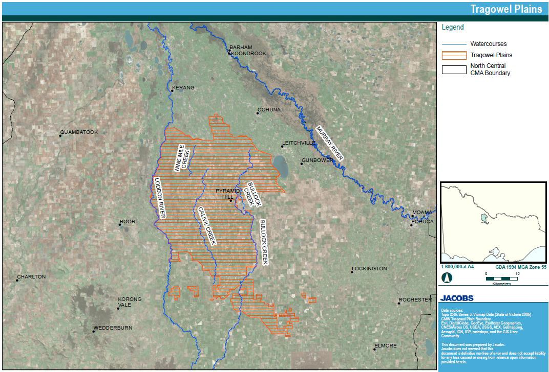The 2016 review modelled flow and salt loads based on water trade up to 2004 and drains at 2002 levels of development through the new Kerang Lakes REALM model to generate flow and salt load time series for input to BigMod. This modelling did not include any revisions associated with additional trade of water out of the area or improvements in farm and distribution system water use efficiency (Jacobs, 2016b).
Figure 16 – Map of the Tragowel Plains area (Source: Figure 1-1 Jacobs (2016b))

    - Models used
What’s the model?
A statistical model (Multi-variate linear regression analysis) developed by SKM (2006c) was used in the 2006 review to generate salt loads and flows from the area over the Benchmark Period. The model was not applied in the most recent 5-year review (Jacobs, 2016b). Instead a revised conceptualisation of the catchment and subsequent analysis was used to demonstrate that the

current 0.2 EC debit is conservative, i.e. salt loads in the drains are likely to be lower than those used to determine the current register entry.
The most recent version of the Kerang Lakes REALM model (Kerang_B226.sys) is the surface water model used to simulate the split between the different rivers, streams and irrigation channels downstream of the Tragowel Plains
Who owns the model?
DELWP is custodian of the Kerang Lakes REALM model. The statistical models are maintained by the North Central CMA.
Is the model accredited?
Yes. The statistical model was accredited by the MDBA for use in the Tragowel Plains.
Yes. The Kerang Lakes REALM model was accredited by the MDBA for use in the Tragowel Plains.
    - Reviews and studies
Table 6 lists reviews and studies related to the Tragowel Plains Register A entry.
Table 15 – Reviews and studies related to the Tragowel Plains Drains Accountable Action Register A entry

Review No. | Review Type
First review | 5-year review by SKM (2006c)  A review of the statistical methods used in the 5-year review by Fox (2006) (not a formal Independent peer review)
Second review | 5-year review by SKM (2011b)  Independent peer review by Shepherd (2013c)
Third review | 5-year review by Jacobs (2016b)  Independent Peer Review not available
Other | Kerang Lakes REALM Model Accreditation Submission Report (Jacobs, 2015)

    - Related accountable actions
Determination of the Tragowel Plains salinity effects at Morgan are not straight forward because the creeks in the area flow into other waterways before reaching the Murray River. Calivil and Nine Mile Creeks connect with Barr Creek, and hence changes in flow and salt load need to be run through BigMod (BigMod includes the Barr Creek and the Tutchewop Diversion Scheme). Bullock Creek connects to Pyramid Creek and then the Loddon River and Kerang Lakes, and changes in flow and salt load need to be run through the Kerang Lakes REALM model prior to their entry into BigMod⁷.
The following potential future accountable actions are likely to have decreased flow and salt load from the Tragowel Plains area. Their impacts are discussed further in the following section:
      - Goulburn-Murray Water Connections Project

7 Outflows from the Pyramid No. 1 and No. 2 drains and Bullock Creek flow to the Kerang Lakes during the irrigation season, but can enter the Loddon River directly at Kerang Weir and then the Murray River during outside the irrigation season. During extreme flood events flood water flows from the Loddon River, into Serpentine Creek and then into Nine Mile Creek (SKM, 2006c, p. 17).

      - Water trade, including Commonwealth Government buybacks
      - Farm irrigation efficiency projects.
    - Possibilities for expansion of credits/debits
The preliminary assessment undertaken as part of the most recent 5-year review (Jacobs, 2016b) proposed a potential reduction in impact of 0.81 EC as a result of: i) additional water trade out of the area (reduced irrigation deliveries), ii) modernisation of irrigation supply infrastructure (reduced channel leakage and outfalls), and iii) improved farm irrigation efficiency. Together these factors result in reduced accessions to the watertable, a lower watertable and reduced surface runoff.
However, the review noted that further detailed modelling would need to be undertaken to support a formal claim for the register entry and that the effort required was not commensurate with risk,
i.e. the resources required exceed the benefits of the changed entry.
    - Issues, gaps and further work
Revision of the register entry could be pursued as part of updating of other accountable actions if the North Central CMA and DELWP chose to develop a more sophisticated model for riverine plains accountable actions. The option of developing a more sophisticated model was raised as part of the most recent 5-year review of the Barr Creek Catchment Strategy accountable action (section 4.1).

5.2 Shepparton Salinity Management Plan⁸
5.2.1 Overview
The Goulburn Broken CMA is responsible for this Victorian Register A accountable action.
MDBA (2017) records the Shepparton Salinity Management Plan (SMP) as commencing in March 1991 (date deemed effective). The current (2018) Salinity Effect of the Shepparton SMP entry is a 5.4 EC debit at Morgan on Register A. The Salinity Effect is estimated to be a 5.9 EC debit in 2050 and a
7.8 EC debit in 2100 (MDBA, 2018).
Register A 2018 does not give a confidence rating for the entry. The Independent Peer Reviewer of the 2018 rolling review states that there is still low confidence in the entry because of large differences between observed and modelled flows and salt loads (Close, 2018).
    - Background
Irrigation in the SIR has a large impact on the region’s water balance. The application of irrigation water has contributed to drainage problems, increased watertable levels and increased recharge of groundwater. Surface and subsurface (groundwater pumps and tile drains) drainage systems have been constructed in response to these changes. This has increased surface water flows and salt loads from drains to the Murray River. In addition, the water diverted from the Murray and Goulburn water supply systems contains salt, a portion of which is being stored in the SIR.
Both processes are affected by the amount of irrigation that occurs in the region and therefore by how much water has been traded in or out of the area.
The SIR Land and Water SMP was a 30-year plan first prepared in 1989 to combat salinity problems. The current SIR Land and Water Management Plan (GBCMA, 2016) is the final update of the 30-year Plan.
The Register A entry includes activities in the original Shepparton Land and Water SMP 1989 (Shepparton SMP) and subsequent plans and irrigation modernisation actions. The Plan covers the area known as the Shepparton Irrigation Region (SIR) (Figure 17). This is why it is proposed that the entry be renamed as the Shepparton Irrigation Register A entry (Jabobs, 2018b).
The post 1988 downstream salinity impacts of land and water management activities are determined by the net change to the salt and water balance discharging from the regional surface drainage system. In addition to groundwater baseflows, this includes changes in the volume and salinity of run-off, changes to outfalls from the regulated channel system and diversion of flows from regional surface drains for farm irrigation (Jabobs, 2018b).

8 The Accountable Action title is the Shepparton Salinity Management Plan (SMP). However, the first version of the 30-year plan was called the SIR Land and Water SMP (1989). Subsequently it has also been titled the SIR Catchment Strategy (2003) and is currently called the SIR Land and Water Management Plan (2016).

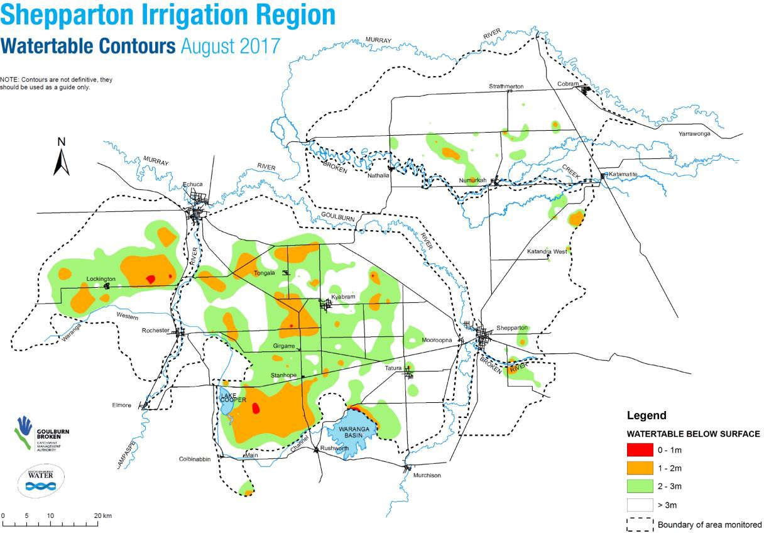

Figure 17 – Location, boundaries and watertable levels in the Shepparton Irrigation Region (Source: GBCMA (2018))

    - Description
Victoria is accountable for the increase in flow and salt load to the Murray River resulting from implementation of the Shepparton SMP.
The accountable activities implemented through the Plan which contribute to changed flow and salt load are construction of primary and community surface drains, public groundwater pumps⁹ which dispose to channels and drains and horticultural protection private groundwater pumps and tile drains.
The recent 5-year review (Jabobs, 2018b) included changes in a range of ‘additional’ activities that effect the flow and salt load in drains such as: changed land and water use (including their effect on decreases in tailwater runoff from farms), modernisation of farms and distribution systems (including their effect on decreasing distribution system channel outfalls to drains), increased deep groundwater pumping (including its effect on increased salinity of irrigation water) and decreased diversions of water from drains for farm irrigation. The most pronounced effect of these inclusions is to decrease dilution flows in drains and concentrate salinity of drainage flows which lead to an increased debit.

9 Private groundwater pumps, other than the horticultural ones, were originally an accountable activity but were removed following a decision by the SIR Implementation Committee in 2007 to cease winter disposal of groundwater from private pumps to surface drains (GMW, 2010). The impact of the pumps was removed from Register A in 2011 (MDBA, 2012).

    - Models used
Nearly all salt leaving the SIR is exported by surface drains and natural waterways – the constructed regional drainage system provides the primary conduit for downstream impacts of Accountable Actions. A conceptual model, that focused on the salt and water balance of the drainage network, was developed under previous 5-year reviews (SKM 2007a; 2009). The parameters considered were: irrigated and drained areas and drain length; groundwater inflow; river diversions (deliveries); irrigation volume; shallow groundwater pumping; deep aquifer pumping, channel outfalls; drainage diversions; tailwater runoff from farms; rainfall runoff and evapotranspiration.
What’s the model?
A simplified lumped parameter¹⁰ physical process model for the SIR based on the conceptual model was used to simulate the seasonal drainage responses in the catchment to climate and operational conditions. The model was fully calibrated to 2004 levels of development when it was developed. A lumped parameter model was again used for the 2018 assessment of salinity effects at 2015 levels of development (Jabobs, 2018b).
Who owns the model?
It is owned and maintained by the Goulburn Broken CMA. Is the model accredited?
Yes, it was accredited by the MDBA for use in the SIR.
    - Reviews and studies
Table 16 lists reviews and studies related to the Shepparton SMP Register A entry.
Table 16 – Reviews and studies related to the Shepparton SMP Accountable Action Register A entry

Review No. | Review Type
First review | 5-year review by SKM (2006a) and (2006b)  Independent Peer Review by Grayson (2007)
Second review | 5-year review by Jacobs (2018b)  Independent Peer Review by Close (2018)
Other | Reviews were also conducted by SKM (2007), SKM (2009) and RPS Aquaterra (2011) although these weren’t official 5-year reviews.

    - Related accountable actions
The following potential future accountable actions will interact with the Shepparton SMP action:
      - Goulburn-Murray Water Connections Project because it decreases recharge to groundwater and channel outfalls to surface drains
      - Farm modernisation Programs because they reduce recharge to groundwater and tailwater runoff from farms to surface drains

10 It treats drainage catchments as ‘lumped’ systems – apart from dividing catchments into four drainage types
it doesn’t represent spatial variability.

      - Water trade, including Commonwealth Government buybacks, because they reduce the irrigated area, volume of water applied and flow rates in surface drains.
    - Possibilities for expansion of credits/debits
There is significant uncertainty about the Shepparton SMP Register A entry. Consideration of several matters discussed in the following section could result in a substantial change to the entry.
    - Issues, gaps and further work
The most recent Independent Peer Review recommended that a new analysis should be done to:
      - include changes in SIR diversions from the rivers including from trade, environmental water recovery, improved irrigation efficiency, groundwater pumping and the reduction in channel outfalls
      - consider the impact of changed drainage outflows to the Goulburn on the operation of the Goulburn River model
      - better match modelled and observed drainage flows and salinities.

Nangiloc-Colignan SMP
    - Overview
The Mallee CMA is responsible for this Victorian Register A accountable action.
MDBA (2018) records the Nangiloc-Colignan accountable action as commencing in November 1991 (date deemed effective). The current (2018) Salinity Effect of the entry is a 0.4 EC debit at Morgan on Register A. The Salinity Effect is estimated to be a 0.4 EC credit in 2050 and 2100 (MDBA, 2018).
There is high confidence in the entry (MDBA (2017) and (2018)).
    - Background
The Nangiloc-Colignan SMP 1991 is one of three community driven and government endorsed SMPs developed in the Victoria Mallee in the early 1990s. The other two being the Sunraysia and Nyah to SA Border SMPs. The Mallee Land and Water Management Plan (LWMP) brought the three SMPs together (MCMA, 2011, p. 1).
The Nangiloc-Colignan Community Salinity Working Group was formed in July 1987 to tackle salinity problems in the Nangiloc-Colignan area. The Nangiloc-Colignan community had suffered from major salinity problems since rapid irrigation development in the 1960s. Throughout the district, rising watertables caused environmental damage and production losses. The Nangiloc-Colignan Draft SMP was completed in February 1991 and submitted to Government. The plan consisted of the following seven programs designed to address specific aspects of the SMP:
      - Irrigation Management Program
      - Co-ordinated Group Drainage Scheme
      - Community Education Program
      - Environmental Rehabilitation Program
      - Monitoring Program
      - Carwarp Domestic and Stock Pipeline
      - Implementation Program.
The Nangiloc-Colignan SMP resolved nearly three decade’s worth of community unrest about irrigation expansion, waterlogging, drainage disposal, wetland degradation and increased river salinity. The $5.5 million Nangiloc-Colignan Coordinated Group Drainage Scheme bolstered productivity on more than 6,000 hectares of prime horticultural land while also reducing the threats to significant wetlands. In doing all this, the plan returned harmony and cohesion to what had become a divided community (MCMA, 2011, p. 1).
    - Description
Victoria is accountable for the increase in flow and salt load to the Murray River from the Nangiloc- Colignan private diversion areas as a result of:
- Tile drainage systems disposing directly to the Murray River
- Tile drainage systems disposing to Karadoc Swamp from which salt is flushed when river levels reach 47,000 ML/day.
The Nangiloc-Colignan SMP centred upon the private diverter areas between Karadoc and Colignan and included the construction of subsurface drains collecting to pipelines to alleviate salinity problems associated with irrigation development. Pipelines discharge directly to the Murray River, to inland disposal basins and floodplain disposal basins Figure 18. Karadoc Swamp, a floodplain disposal

basin, is hydraulically connected to the river during times of flood when flows are greater than 47,000 ML/day. As the drainage water increases Murray River salinity, it is an accountable action (MCMA, 2012, p. 41).
The most recent 5-year review proposed providing revised salt load and flow time series for input to MSM-Bigmod (SKM, 2013c, p. 1). However, this is not recorded in MDBA (2017). It therefore appears that the salt load and flow time series for the entry are those derived during the 2008 5-year review by RMCG (2008).
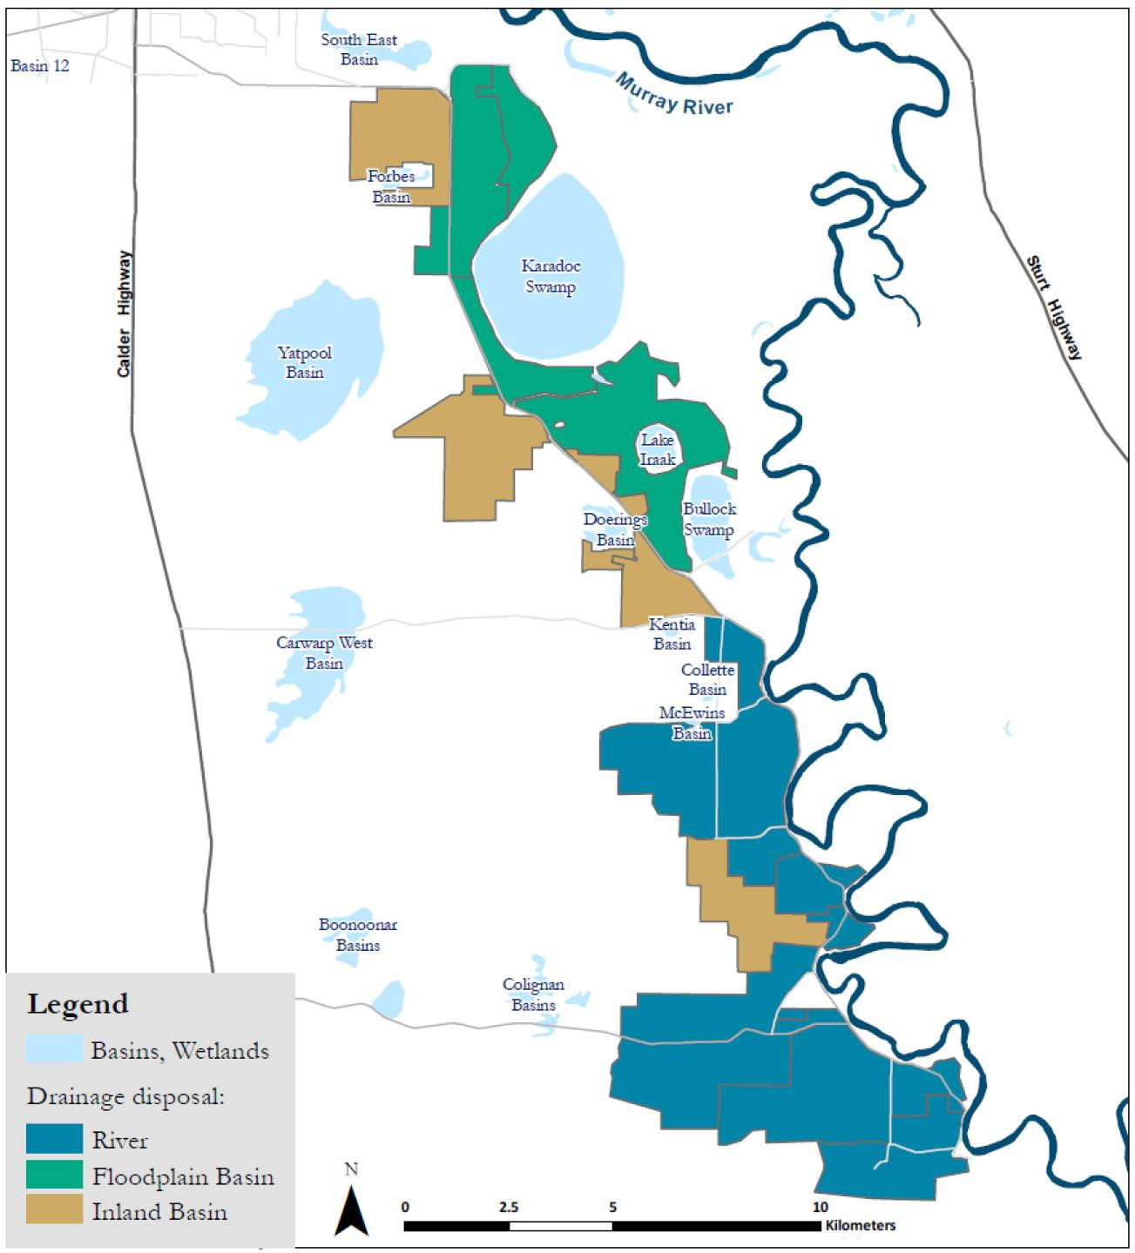

Figure 18 – Nangiloc-Colignan showing irrigation drainage disposal systems (Source: Figure 5 of Thompson et al. (2013))

    - Models used
What’s the model?
Statistical modelling tools are used to analyse drain flow and salt load data (groundwater models are not used) with the resulting time series data used as inputs to MSM-Bigmod.
Who owns the model?
The statistical model is the property of the Mallee CMA.

Is the model accredited?
The statistical models were deemed as fit for purpose.
    - Reviews and studies
Table 17 lists reviews and studies related to the Nangiloc-Colignan SMP Register A entry.
Table 17 – Reviews and studies related to the Nangiloc-Colignan SMP Accountable Action Register A entry

Review No. | Review Type
First review | 5-year review by RMCG (2008)  Independent Peer Review by Fox (2009)
Second review | 5-year review by SKM (2013c)  Independent peer review Shepherd (2013e)
Other | Original Credit Claim by

    - Related accountable actions
The impact of new irrigation development post-1988 on regional groundwater levels and subsequent groundwater flows to the Murray River are not part of this accountable action. They are considered are part of the Nyah to SA Border SMP – Irrigation Development (section 5.4).
    - Possibilities for expansion of credits/debits
None.
    - Issues, gaps and further work
None.

Nyah to SA Border SMP - Irrigation Development
    - Overview
The Mallee CMA is responsible for this Victorian Register A accountable action.
Register A 2018 (MDBA, 2018) records the Nyah to South Australian Border Salinity Management Plan (N2B SMP) as commencing in July 2003 (date deemed effective). The current (2018) Salinity Effect of the N2B SMP entry is a 17.3 EC debit at Morgan on Register A. The Salinity Effect is estimated to be a 17.3 EC debit in 2050 and a 17.4 EC debit in 2100 (MDBA, 2018).
Register A 2018 gives the entry a Medium confidence rating. However, there is a high confidence that the actual salinity impact of irrigation development in the region is less than 17.3 EC, i.e. the estimate is conservative.
    - Background
The entire Victorian Mallee ecosystem exists in an extremely fine fresh water/salt water balance with changes to hydrogeological processes (movement of groundwater) playing the most important role affecting this balance (MCMA, 2011, p. 13).
The Victorian Mallee is underlain by several aquifers including the Parilla Sands aquifer containing groundwater as salty as sea water. The aquifer is in direct connection to the Murray River and recharge to groundwater from irrigation has the potential to force salty groundwater sideways out of the aquifer and into the river (MCMA, 2011, p. 19). This aquifer is the major source of salt entering the Murray River.
Cummins and Thomson (2018) record that following the severe drought of 1966-67, which caused very high salinities in the Murray River, Victoria identified the Sunraysia area and the Barr Creek Catchment as the largest Victorian contributors to salinity in the Murray River (McCoy, 1988).
    - Description
Victoria is accountable for the increase in groundwater flow and salt load entering the Murray River as a result of post-1988 irrigation development in the area from Nyah to the South Australian Border (Figure 19).
The N2B SMP (N2B SMP (1992a), (1992b) and (1993)) is one of five salinity management plans for the Victorian Mallee developed in, and implemented from the early 1990s. It was primarily concerned with the management of water trade and irrigation development by private diverters to control the salinity impact caused by the action of root zone drainage recharging saline groundwater systems, and displacing groundwater-borne salt to the river (MCMA, 2011, p. 30).
The Plan provided for the activation of 44,000 ML of water (including the auction of 8,000 ML of new Dartmouth Dam water) to enable an additional 4,500 ha of irrigation. The centre piece of the Plan was to divide up the plan area into two zones based on the salinity impact of irrigation in each zone on the River – a High Impact Zone (HIZ) and a Low Impact Zone (LIZ). The Plan:
- encouraged water to be traded out of the HIZ by offering a $50 per ML incentive
- minimised increases in Murray River salinity (and the requirement for scarce salinity credits) by only allowing new water to be traded into the LIZ (Fitzpatrick & Wood, 2016, p. 3).
The 2008 five-year review of the N2B SMP accountable action advised that the accredited Salinity Impact Zoning Approach was acceptable if more detailed modelling was undertaken to verify salt

load estimates. In response, six numerical models covering the private diversion areas from Nyah to the SA border were developed¹¹. Although the Salinity Impact Zoning (SIZ) Approach is approved for use and is supported by the Water trade model suite, the model suite itself was not accredited.
The 2013 five-year review recommended a range of additional modelling tasks to confirm the acceptability of the existing suite of six numerical models (SKM 2013). It was also suggested, although not stated in the recommendations, that the Mallee CMA consider replacing use of the analytical model within the SIZ Approach with numerical models (Wood, 2015).
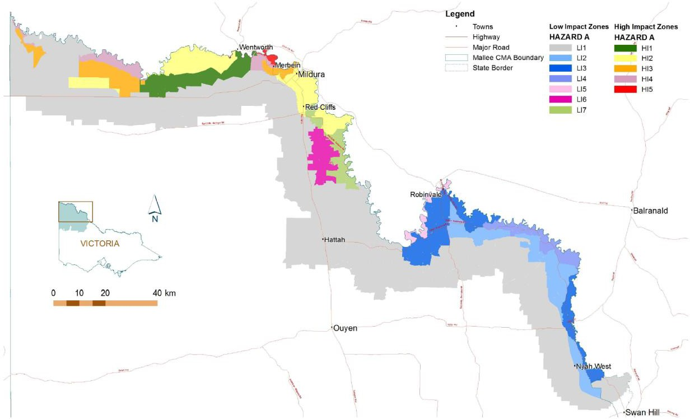
Figure 19 – Salinity Impact Zones in the Nyah to SA Border SMP area (Source: Figure 3-2 in SKM (2013))

    - Models used
What’s the model?
Initially a single LIZ and a single HIZ was mapped for the N2SAB SMP area. In 2001 these two impact zones were recognised as being too coarse for adequate accounting purposes and the SIZ Approach was updated. An analytical spread sheet model to estimate the increase in salt load to the River Murray caused by new irrigation development was developed and underpins the approach.
The analytical method used to calculate groundwater impacts of irrigation on the Murray River involved determining the impact on groundwater elevation of irrigation accessions and then, in turn, determining the likely change in salt load that will reach the Murray River after 50 years. In summary, the following steps were applied (SKM, 2013, p. 9):
      - Divide the Victorian Mallee into areas in which the geology and hydrogeology can assumed to be uniform for the purposes of making the assessment (Figure 19)

11 Models were developed for Piambie-Nyah, Robinvale-Piambie, Robinvale-Wemen, Nangiloc-Colignan, Red Cliffs-Yelta and Yelta-SA.

      - Assign hydrogeological parameters to each area
      - Assume that an irrigation development will occur at a given site
      - Using an analytical groundwater model predict how much additional groundwater flow would occur to the Murray River closest to the site in question after a period of 50 years
      - Convert the increased groundwater flow into a salt load using the salinity of the groundwater near the river
      - Convert the salt load to an equivalent EC at Morgan using relationships from the MDBC Murray Model
      - Repeat steps 3 to 6 at other sites within one hydrogeological area
      - Compare the results of step 7 and assign an impact that represents the EC impact after 50 years.
      - Map the areas in terms of their impact. Who owns the model?
The Analytical Model is owned and maintained by the Mallee CMA. Is the model accredited?
Yes. It was Peer Reviewed in 2003-04 and has been approved by the MDBC under the provision that further work be undertaken to validate model results (Murray Darling Basin Commission Record "Murray-Darling Basin Commission BSMS Implementation Working Group – Out-of-Session No.1 - Minutes" Paragraph 7).
A new numerical model suite is currently being developed for accreditation and use as part of the Salinity Model Refinement Project. The suite will replace the Analytical Model used as part of the SIZ Approach. It is anticipated that the numerical model suite will be used as part of the next rolling review, to be done in the second half of 2019, to update SIZ and salinity impact coefficients.
    - Reviews and studies
Table 18 lists reviews and studies related to the N2B SMP Register A entry.
Table 18 – Reviews and studies related to the N2B SMP Accountable Action Register A entry

Review No. | Review Type
First review | 5-year review by RMCG (2008)  Independent Peer Review – not available
Second review | 5-year review by SKM (2013)  Independent Peer Review by Shepherd (2013b)
Third review | The third rolling review, and the first under BSM2030, commenced in December 2019 and is scheduled for completion in June 2020. It will use the recently (June 2020) accredited numerical model suite to revise the estimates of salinity impact associated with new irrigation developments. It may also make recommendations to replace the existing SIZs and associated salinity impact coefficients with the accredited numerical models and update the register entry on review rather than biannually as is the current practice.
Other | Not applicable

    - Related accountable actions
There are complex interactions between the four accountable actions listed below in the Red Cliffs to Yelta reach of the Murray River (i.e. about 15 km southeast of Mildura to 15 km northwest of Mildura). The EM2.4 model, one of the models in the new numerical model suite, accounts for these interactions and separates the various salinity impacts of the actions on the Murray River, including new irrigation development under the N2B SMP (MCMA, 2017, p. 7).
      - RISI Stage 1 (see section 4.8)
      - RISI Stage 2 (see section 4.9)
      - Improved Buronga and Mildura/Merbein Interception Scheme (see section 2.1)
      - Victorian Mallee – Pre-88 Irrigation (see section 6.7).
    - Possibilities for expansion of credits/debits
The current (2019) Salinity Model Refinement Project has found that for many high impact zones on the floodplain the salinity impact in the Murray River is less than currently assigned:
- Major changes are in the zones west of Mildura, but most of the area is crown land or otherwise unlikely to be irrigated
- The Nangiloc-Colignan area is the one with the most significant potential change where there is widespread irrigation
- Within the Wemen to Nyah area, small downward shifts are likely (the majority are changes less than 0.1 EC/GL impact).
Preliminary analysis indicates that revised salinity impacts could decrease the existing debit entry by about 8 EC at 2018 levels of development.
    - Issues, gaps and further work
The Salinity Model Refinement Project has established that there are now two major areas of work to be done in relation to new irrigation developments:
      - Continuing to decrease the salt being mobilised to the Murray River (existing program)
      - Improving knowledge about salt in the landscape and how to manage it – this requires development of a new program of works.
For accountability purposes the major area of work is to complete the rolling review of the N2B SMP Accountable Action (commenced in December 2019) using the new numerical model suite.

Kerang Lakes/Swan Hill Salinity Management Plan (SMP)
    - Overview
The North Central CMA is responsible for this Victorian Register A accountable action.
MDBA (2018) records the Kerang Lakes/Swan Hill SMP entry as commencing in January 2000 (date deemed effective). The current (2018) Salinity Effect of the entry is a 1.6 EC debit at Morgan on Register A. The Salinity Effect is estimated to be a 1.1 EC debit in 2050 and 0.9 EC debit in 2100 (MDBA, 2018).
Register A 2018 gives a confidence rating of high for the entry (MDBA, 2018).
    - Background
The North Central CMA region includes the catchments of the Loddon, Campaspe, Avoca and Avon- Richardson rivers. Within the North Central CMA region, irrigation development is principally confined to the Loddon-Campaspe Irrigation Region.
Prior to 2002, five Salinity Management Plans (SMPs) and one regional development plan covered the Loddon Campaspe Irrigation Region. The six plans were known as:
- Kerang Lakes/Swan Hill SMP
- Tragowel Plains SMP
- Boort West of Loddon SMP
- Torrumbarry East of Loddon LWMP
- Campaspe West SMP
- Loddon Murray 2000+ regional development initiative.
The development of the Kerang Lakes/Swan Hill SMP began in 1986. The Kerang Lakes/Swan Hill SMP area covers all the irrigated land and interspersed dryland areas west of the Loddon River fed from the Torrumbarry Irrigation Supply System; an area of approximately 110,500 ha.
The Kerang Lakes/Swan Hill SMP consisted of eight programs: Farm, Water Quality, Environmental, Surface Drainage, Channel Seepage, Salt Disposal, Floodplain Management and Implementation, Extension and Education. The Water Quality Program included the only two activities within the SMP that have an impact above 0.1 EC and are therefore accountable actions – Lake Charm Flushing and Pyramid Creek SIS (section 2.3). Lake Charm Flushing is thus the sole component of the SMP that is assessed as part of 5-year reviews¹².
In 2002, the six plans of the Loddon-Campaspe Irrigation Region were combined into one integrated regional strategy - the Loddon-Murray Land and Water Management Strategy, which was superseded by the Loddon Campaspe Irrigation Region LWMP in 2007. These later plans built on the previous plans but progressively adopted a broader vision, moving from a focus on salinity to a broader range of issues facing sustainable land and water use in the region. The LWMP is currently being reviewed.

12 A component of permanently traded water entitlement in the SMP was added to the MDBA Register entry following investigations into the Woorinen Irrigation District Excision (pers. comm. Paul Saunders (attachment to email to Mark Potter sent on 16 June 2020). It was added to the MDBA Register outside of the Basin Salinity Management Strategy (BSMS) protocols¹³. It was not approved by North Central CMA or the VSDWG, nor is it a SMP activity. The 2010 5-year review deliberately did not address this component of Register entry and Victoria requested that the component be removed from the MDBA Register. It is yet to be removed.

Although the original six plans have been superseded, many of these plans, including the Kerang Lakes/Swan Hill SMP, are still listed as Accountable Actions on the Murray-Darling BSMS Register A (SKM, 2010b).
    - Description
Victoria is accountable for the increased flow and salt load entering the Murray River as a result of flushing flows being passed through Lake Charm.
Lake Charm is a natural lake that has been used as part of the Torrumbarry Irrigation System since the 1880. In 1969 a regulator was constructed at the inlet/outlet of the lake, restricting inflows and outflows to the lake to high rainfall periods. Due to high connectivity with saline groundwater in the area and due to irrigation operations within the region, salinity concentrations within the lake gradually rose over time to approximately 5,000 EC.
In February 1997, the Lake Charm Outfall Channel works were commissioned to allow flushing of the lake. The works comprise a 150 ML/d pumping station on the north shore of Lake Charm, and a 5 km channel to the Loddon River, which conveys flushed flows to the Murray (Figure 20). The Lake Charm Outfall Channel is operated according to a set of rules which restrict flushing under certain conditions, such as low flows in the Murray River. These rules aim to minimise the salinity impact on the Murray River. Flushing of the lake has reduced salinity levels in the lake.

Figure 20 – Torrumbarry Irrigation Area showing the location of Lake Charm and the Lake Charm Outfall Channel

The most recent 5-year review assessed historic pumping opportunities over the 5-year period from 2004 to 2009 (given the documented Lake Charm flushing rules) and compared it to actual pumping events. It found that during the review period, there were three periods where the Lake Charm Outfall Channel operating rules would allow an outfall event to take place, however the Lake Charm Outfall Channel was only operated once in this period. The review found that the intent of the rules was generally being followed.
The Lake Charm Outfall Channel ceased to exist (from a Register Entry perspective) when the Victorian Mid-Murray Storages came into effect. Until this point the storages (Lake Boga, Lake Charm, Kangaroo Lake and Kow Swamp) were part of the Torrumbarry Irrigation System. In 2010 these became the Mid-Murray storages and their operations were modified to enable them to be

filled from increases in Broken River flows resulting from decommissioning Lake Mokoan. Winter and spring flow from the Broken River are stored in the Mid-Murray storages for subsequent release to supply peak summer irrigation demand in the Mallee.
    - Models used
What’s the model?
Kerang Lakes REALM model. Who owns the model?
DELWP are custodians of the Kerang Lakes REALM model. Is the model accredited?
Several versions of the model have been accredited.
    - Reviews and studies
Table 19 lists reviews and studies related to the Kerang Lakes/ Swan Hill SMP Register A entry.
Table 19 – Reviews and studies related to the Kerang Lakes/ Swan Hill SMP accountable action Register A entry

Review No. | Review Type
First review | 5-year review by SKM (2010b)  Independent Peer Review – not available
Other | A review of operational management issues conducted by Hydro Environmental (2005)  Modelling done to improve register entries by SKM (2007b)  Recent modelling work on the impacts of the Mid-Murray Storages by Jacobs (2015b)

    - Related accountable actions
The Kerang Lakes/Swan Hill SMP is closely related to the Woorinen Irrigation District Excision accountable action (section 5.7). Both these actions are closely related to an imminent new accountable action, the Victorian Mid-Murray Storages.
    - Possibilities for expansion of credits/debits
Inclusion of the accountable action into a new Victorian Mid-Murray Storages entry will change the
Salinity Effect. Exactly how these changes will be accounted for is currently being considered.
    - Issues, gaps and further work
In 2016 an update of the Kerang Lakes REALM model was completed and the model accredited. A key aim of the project was to enable estimation of the Victorian Mid-Murray Storage for inclusion on the register as part of the collective The Living Murray (TLM) Works and Measures entry. Once completed the Victorian Mid-Murray Storages entry will supersede the Kerang Lakes/Swan Hill SMP and part of the Woorinen Irrigation District Excision accountable action (DELWP, 2018b, p. 16).

Campaspe West Salinity Management Plan
    - Overview
The North Central CMA is responsible for this Victorian Register A accountable action.
MDBA (2017) records the Campaspe West SMP as commencing in August 1993 (date deemed effective). The current (2018) Salinity Effect of the Campaspe West SMP entry is 0.0 EC at Morgan on Register A. The Salinity Effect is estimated to be a -0.1 EC credit in 2050 and 0.0 EC in 2100 (MDBA, 2018).
Register A 2018 gives a confidence rating of high for the entry following completion of a rolling review in 2018 (MDBA, 2018).
    - Background
The Campaspe West SMP area is that part of the Campaspe Irrigation District west of the Campaspe River and a small part of the Rochester Irrigation Area south of the Waranga Western Main Channel (Figure 21). It covers 5,700 ha of which 3,700 ha was irrigated when the 1992 Draft SMP was written.
The area was developed for intensive irrigated dairying after the completion of Lake Eppalock, with irrigation commencing in 1967-68. Despite the area being drained by surface drains, high watertables developed quickly with salinity problems emerging in the late 1970s. By 1992 watertables were within two metres of the surface in 60% of the SMP area with production estimated to be 85% of what it would have been without high watertables.
    - Description
Victoria is accountable for the increase in flow and salt load entering the Murray and Campaspe Rivers as a result of post-1988 installation of subsurface tile drains and private groundwater pumps as part of the SMP. Surface drains, three groundwater pumps and one tile drainage system installed prior to 1988 are not accountable activities.
The accountable activities are (RMCG, 2018):
- nine small capacity privately owned groundwater pumps
- five tile drainage installations servicing 161 ha (these were used where conditions were not suitable for groundwater pumping).
The groundwater collected was disposed of via the:
- Bamawn Drainage system, which outfalls to the Murray River via the Lockington Drain
- Campaspe Drains which outfall to the Campaspe River
- Waranga Western Channel – flows and salt loads aren’t part of the calculation of the accountable Salinity Effect as they are subsequently used for irrigation.
Developed between 1986 and 1989 and finalised in 1993 the major purpose of the private groundwater pumps and tile drains implemented was to lower watertables and reduce salinity. Implementation of accountable activities took place between 1988 and about 2004.

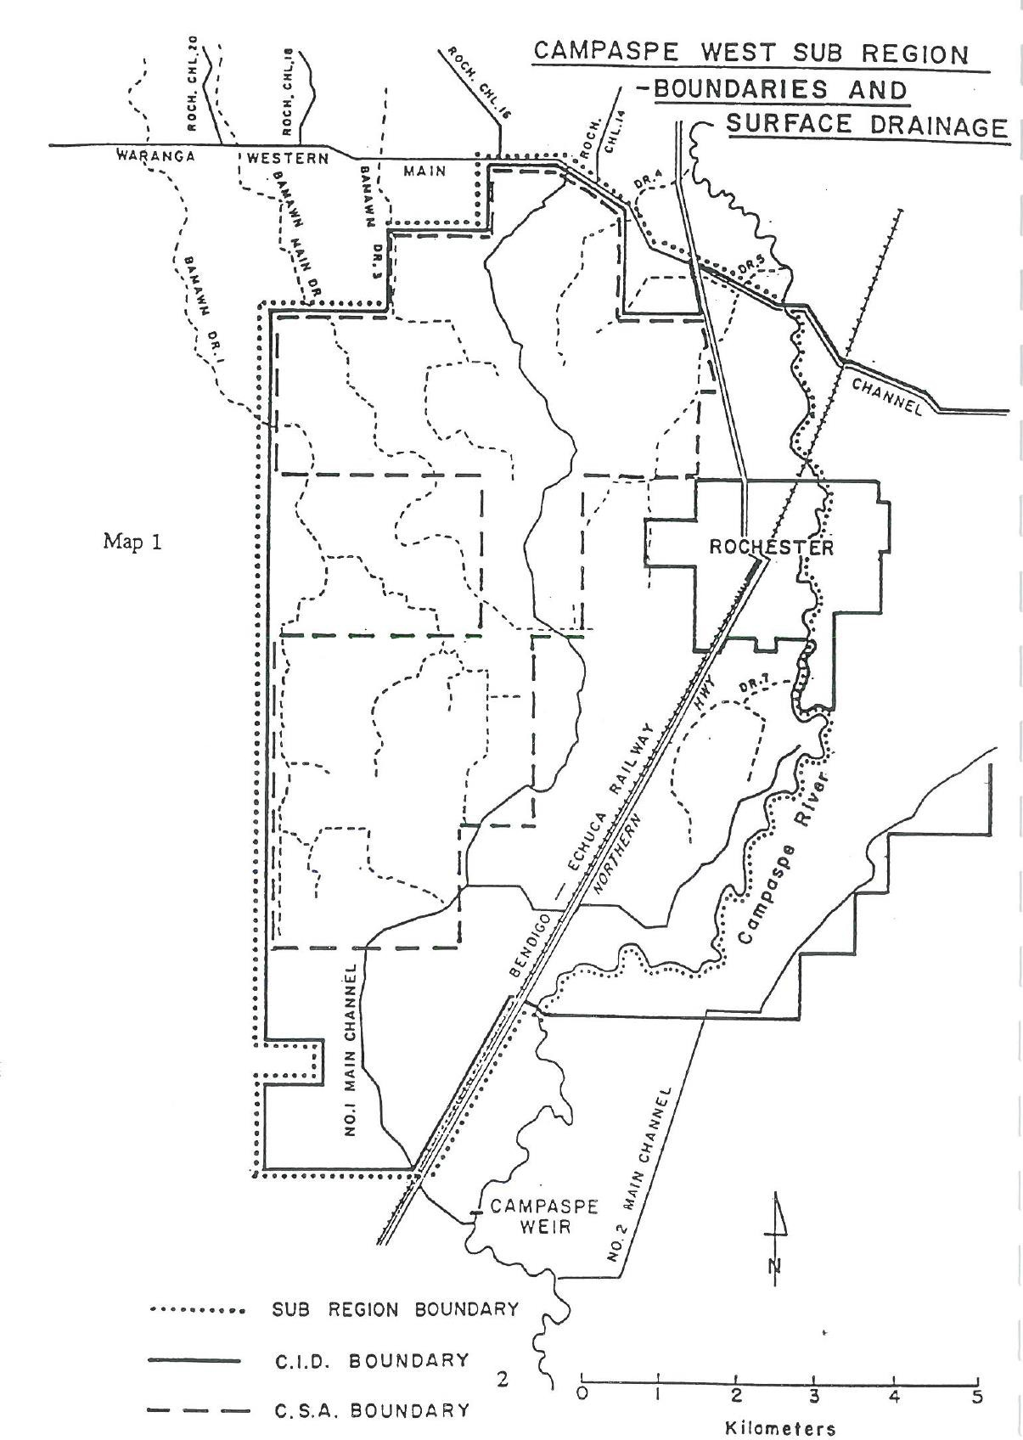
Campaspe West SMP area

Figure 21 – Map of the Campaspe West SMP area (Source: Map 1 CWSIG (1992))

The decommissioning of the CID in 2010 and associated transfer of water entitlements to the environment and additional water traded out of the CID has reduced the average annual surface water use by 95 per cent, from about 35 GL in the mid-1990s to 1.5 GL in recent years. Groundwater use in the Campaspe West area is estimated to be in the order of 6 GL per year (RMCG, 2018, p. 19). The dramatic decrease in irrigation resulted in very little flow from tile drains and groundwater pumps not operating and no flow or salt load reaching the Murray or Campaspe Rivers. Thus the 2018 rolling review recommended the Physical Effect for the entry be 0.0 EC (RMCG, 2018).

    - Models used
What’s the model?
There is no formal model for the entry.
The latest rolling review (RMCG, 2018) used field observations, interviews with landholders and monitoring data about flow from tile drains, operation of groundwater pumps and drain flows to conclude that no flows or salt was reaching the Murray or Campaspe Rivers as a result of accountable activities.
The 2010 5-year review used statistical analysis (regression techniques) to create drain flows based on long term expected irrigation allocations, rainfall and groundwater. Observed flows were not used because they were unrepresentative of climatic conditions over the Benchmark Period (1975- 2000), due to the millennium drought (RMCG, 2018).
    - Reviews and studies
Table 20 lists reviews and studies related to the Campaspe West SMP Register A entry.
Table 20 – Reviews and studies related to the Campaspe West SMP Accountable Action Register A entry

Review No. | Review Type
First review | Initial assessment of salinity impacts SKM (2001)
Second review | 5-year review by SKM (2010)  Independent Peer Review by RPS Aquaterra (2011b)
Third review | 5-year review by RMCG (2018) Independent Peer Review by Jacobs (2016)
Other | There are various studies listed in the References section of the 2010 5-year review (SKM, 2010)

    - Related accountable actions
None.
    - Possibilities for expansion of credits/debits
The risks of high watertables returning are low and decreasing. However, if water is traded back into the Campaspe West SMP area for irrigation, or deep lead groundwater pumping reduces, then flow and salt load from tile drains and shallow private groundwater pumps could increase and lead to a small salinity debit.
    - Issues, gaps and further work
The latest 5-year review recommends a range of monitoring to manage the risks of increased flow and salt load leading to an increased salinity impact in the Murray River.

Woorinen Irrigation District Excision
    - Overview
The North Central CMA is responsible for this Victorian Register A accountable action.
MDBA (2018) records the Woorinen Irrigation District Excision entry as commencing in September 2003 (date deemed effective). The current (2018) Salinity Effect of the entry is a 0.8 EC debit at Morgan on Register A. The Salinity Effect is estimated to be a 1.0 EC debit in 2050 and 1.2 EC debit in 2100 (MDBA, 2018).
Register A 2018 gives a confidence rating of high for the entry (MDBA, 2018).
    - Background
Historically, the Woorinen Irrigation District was supplied by Channel No.9, which originates at Little Murray Weir and is a part of the Torrumbarry Irrigation Area (Figure 22). Prior to pipelining, much of the Woorinen distribution system consisted of concrete lined channels with a few earthen channels. Most of the concrete channels were in poor condition.
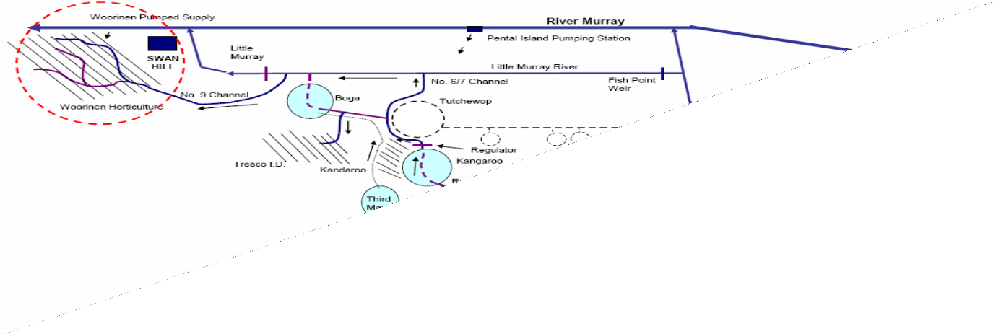
Figure 22 – Location of the Woorinen Irrigation District

    - Description
The Register Entry is composed of two components¹³:

13 Paul Saunders (pers comm.) notes that it could now be argued that the second component is fully replaced by Mid-Murray Storage operations that will effectively maintain/increase throughflow. Component 1 still causes a salinity impact (regardless of throughflow) with the different diversion point downstream in the Murray River. During a 2000 study it was realised that the Woorinen Excision was effectively a 10 GL water trade immediately downstream of the Torrumbarry Irrigation Area. This raised two questions that were pertinent at the time:
      - What is the potential impact of water trade from the Kerang Lakes area to Sunraysia that was starting to occur?
      - If GMW is responsible (under EPBC) for maintaining the throughflow in the Kerang Lakes for Woorinen, who is responsible for water trade? Without any approval from Victoria a water trade entry was subsequently added to the Kerang Lakes/Swan Hill SMP Register A entry.

- The excision of the irrigation district which resulted in water being supplied from further downstream in the Murray River (water is diverted at new pump site instead of being diverted from Torrumbarry Weir)
- The Environment Protection and Biodiversity Conservation Act (EPBC) requirement to maintain throughflow in the Kerang Lakes System.
Victoria is accountable for the increase in flow and salt load entering the River Murray as a result of both actions. The through flow exits the Kerang Lakes via the No. 6/7 Channel, into the Little Murray River, over the Little Murray Weir and into the Murray River.
In 2003/04, part of the existing open channel system supplying the Woorinen Irrigation District was replaced with a piped system. The pipelined area was approximately two-thirds of the total Woorinen horticultural area, which is now supplied via direct pumping from the River Murray downstream of Swan Hill. This has resulted in a reduction in the volume of water supplied by the Torrumbarry Irrigation Area’s Channel No.9 – demands off Channel No. 9 were estimated to decrease from 50 GL/year to 40 GL/year (SKM, 2008b).
Water from the Little Murray River that is diverted into Channel No. 9 is supplied from two sources, from the Kerang Lakes via the 6/7 Channel and direct from the Murray River via the Pental Island Pumps.
Before pipelining occurred, flows passing through the Kerang Lakes into the 6/7 Channel transported salt out of the Lakes and helped to maintain their water quality. This water was then applied to land in the Woorinen Irrigation District. Thus, it didn’t have a salinity impact on the Murray River.
From a water supply perspective, post pipelining the flows passing through the Kerang Lakes into the 6/7 Channel could have been reduced because the Woorinen Irrigation District demands decreased. However, a through flow volume was required to be maintained to ensure no decrease in water quality in the Kerang Lakes. This through now passes from the 6/7 Channel, into the Little Murray River, over the Little Murray Weir and into the Murray River, i.e. it is no longer diverted into Channel No. 9 and applied to land in the Woorinen Irrigation District. Thus, the salt load to the Murray River is increased. This increase in salt load is what Victoria is accountable for.
    - Models used
What’s the model?
Kerang Lakes REALM model (2004 version). Who owns the model?
DELWP are custodians of the model. Is the model accredited?
The model was accredited in 2004 (SKM, 2008b, p. 10).
    - Reviews and studies
Table 21 lists reviews and studies related to the Woorinen Irrigation District Excision Register A entry.

Table 21 – Review and studies related to the Woorinen Irrigation District Excision accountable action Register A entry

Review No. | Review Type
First review | 5-year review by RMCG (2008b) which used updated assumptions about the through flow flow patterns  Independent Peer Review – not available
Other | Original modelling to determine the Salinity Effect of the excision by SKM (2003c)  Revised modelling using an updated Kerang Lakes REALM model over the extended Benchmark Period (1975 to 2000) by SKM (2006d)

    - Related accountable actions
The Woorinen Irrigation District Excision is closely related to the Kerang Lakes/Swan Hill Salinity Management Plan accountable action (section 5.5). Both these actions are closely related to an imminent new accountable action, the Victorian Mid-Murray Storages.
    - Possibilities for expansion of credits/debits
Inclusion of the accountable action into a new Victorian Mid-Murray Storages entry will change the
Salinity Effect. Exactly how these changes will be accounted for is currently being considered.
    - Issues, gaps and further work
In 2016 an update of the Kerang Lakes REALM model was completed and the model accredited. A key aim of the project was to enable estimation of the Victorian Mid-Murray Storage for inclusion on the register as part of the collective The Living Murray (TLM) Works and Measures entry. Once completed the Victorian Mid-Murray Storages entry will supersede the Kerang/Swan Hill SMP and part of the Woorinen Irrigation District Excision accountable action (DELWP, 2018b, p. 16).

Register B Actions (Debits)

Campaspe Catchment Legacy of History
    - Overview
The North Central CMA is responsible for this Victorian Register B accountable action.
The current (2018) Salinity Effect of the entry is a 0.1 EC debit at Morgan on Register B. The Salinity Effect is estimated to be a 0.2 EC debit in 2050 and 0.3 EC debit in 2100 (MDBA, 2018).
Register B 2018 gives a confidence rating of medium for the entry (MDBA, 2018).
    - Background
The Register B entry covers the Campaspe catchment upstream of the Campaspe weir which is located just south of Rochester (Figure 23).
Approximately 80% of the Campaspe catchment has been cleared of deep-rooted vegetation for agriculture. Clearing of perennial natural vegetation cover and the introduction of grazing and annual crop-based farming led to an increase in groundwater recharge and decrease in evapotranspiration, causing the watertable to rise. The rising watertable brings salt to the surface initiating surface salt accumulation and causing dryland salinity.
There are more than 190 mapped saline groundwater discharge sites in the Campaspe catchment which cover an area of approximately 1,700 ha (Figure 23). Most of this land salinisation is associated with the Mount Camel Range to the east, and the sedimentary hill country across the centre of the catchment, e.g. Axe Creek, Knowsley and Tooborac areas.
Dryland salinity is identified as a threat to the community and environment by the North Central Reginal Catchment Strategy (RCS) (NCCMA, 2013). The RCS identifies a renewed focus on Landcare to reinvigorate local groups and provide the necessary support to groups to implement local sustainable agriculture projects generally. Improved dryland agricultural practices provide broad benefits including mitigating dryland salinity.
Runoff from about 60% of the catchment is regulated with flows controlled by storages such as Lake Eppalock and Malmsbury (DEDJTR, 2018a, p. 3).
    - Description
Victoria is accountable for the post 1 January 2000 increase in salt load to the Murray River resulting from pre-1988 actions in the Campaspe catchment (predominantly land clearing).
Register B entries are for Legacy of History delayed salinity impacts which have, or will have, an impact after 1 January 2000, but which are caused by an action taken or decision made before 1 January 1988 (the baseline date). The Campaspe catchment Register B salinity impact entry is attributed to dryland salinity associated with rising groundwater levels caused by land clearing post European settlement.
The negligible impacts reported demonstrate that Legacy of History actions pose a limited salinity risk to the downstream basin community.
Two initial studies by SKM ( (1999) and (2004)) to determine the Salinity Effect of the action used a very similar methodology, which comprised two main parts:

- groundwater projections
- surface water wash-off and quantity and quality routing.
The original analyses derived a relationship between groundwater salinity, the area of high watertable and stream salinity. Future trends in stream salinity and salt loads were then forecast from predicted future trends in groundwater levels.
The groundwater projections adopted in the two studies were almost identical. However, the surface water wash-off procedures were simplified in the later study (SKM, 2004) in order to improve the comparability of results between sub-catchments.
Overall SKM (2004) adopted a similar but more refined approach to SKM (1999). Predicted salt load increases were distributed according to the daily pattern of salt load by factoring up the daily time series of salinity in each sub-catchment until the average annual salt load over the benchmark period equalled the average annual salt load under year 2020, year 2050 and year 2100 conditions.
The approaches in both SKM studies were accredited by the MDBC for the Campaspe catchment Register B entry.
The following two 5-year reviews adopted a different approach.
A fit for purpose and low cost groundwater hydrograph analysis approach was used for the 2011 (Cheng, et al., 2012) and 2017 (DEDJTR, 2018a) 5-year year reviews because of the low downstream salinity impact, the minimal annual increase in downstream impacts and the minimal risk to downstream water users.
The trends of hydrographs of selected bores were reviewed and compared with trends forecast by the original analysis undertaken by SKM in 1999.
These 1999 and 2004 studies assumed a continuation of the historic rainfall patterns (particularly relatively wet conditions between the late 1980s and early 1990s) and an ever-increasing rise in groundwater levels. Reid et al. (2008) found that the drier than usual annual weather patterns in 2000s resulted in significant drops in groundwater levels across northern Victoria. In the 2011 review, Cheng et al. (2012) also demonstrated that long-term rising trends in groundwater level were considerably lower than those previously projected by SKM in 1999 and 2004.
The 2011 5-year Review (Cheng, et al., 2012) analysed groundwater trends and behaviour. The Hydrograph Analysis: Rainfall and Time Trends (HARTT) approach was used to differentiate between the effect of rainfall fluctuations and the underlying trend in groundwater level over time. Fifty-nine representative bores were selected for detailed groundwater hydrograph analysis.
The 2017 review (DEDJTR, 2018a) updated groundwater level trends at each representative bore, using data up to December 2016. These trends were compared with those forecast by the 1999 and the 2004 assessments used for the Register B entries. The review found that the Salinity Effects determined in 2011 review remain unchanged.

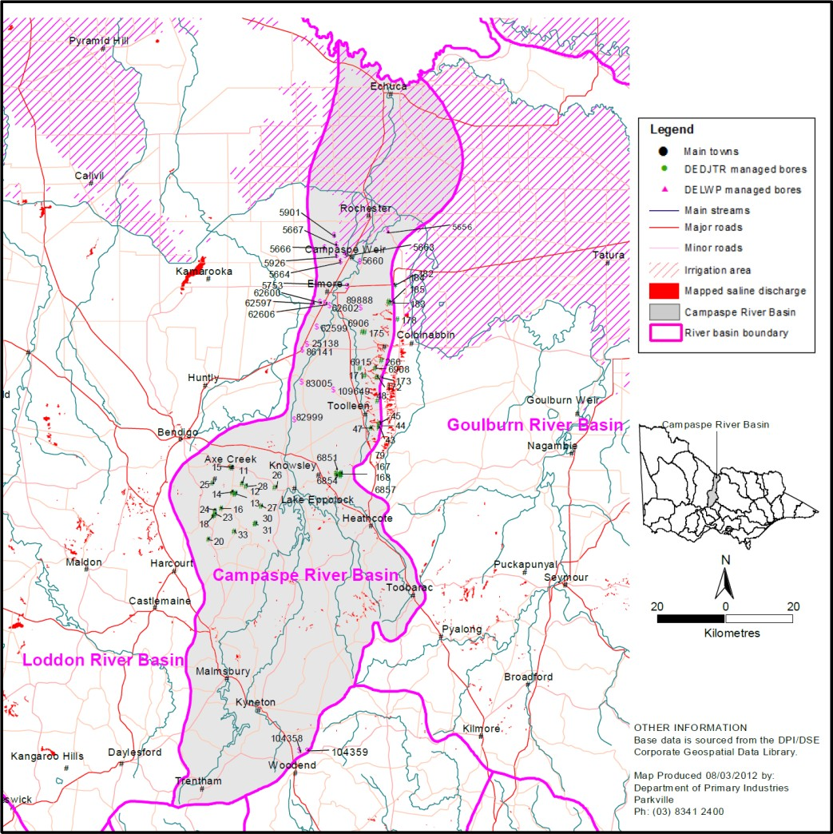

Figure 23 – Location of the Campaspe catchment including saline discharge sites and selected groundwater bores (Source: Figure 2 of DEDJTR (2018a))

    - Models used
What’s the model?
The Hydrograph Analysis: Rainfall and Time Trends (HARTT) approach was used to differentiate between the effect of rainfall fluctuations and the underlying trend in groundwater level over time.
Who owns the model?
The HARTT is a general approach for statistically estimating trends in groundwater levels. Is the model Accredited?
Suitability of the HARTT method for groundwater level trend analysis was addressed in the 2011 review (Cheng, et al., 2012). It was concluded that the method was suitable for the purpose of the bore trend analysis in the low risk catchments such as Ovens, although the independent peer reviewers were concerned that the uncertainty behind the explanation for the linear-trend component in the HARTT does not improve the reliability of the conclusions above that which has been obtained from the groundwater data itself.

    - Reviews and studies
Table 22 lists reviews and studies related to the Campaspe Catchment Legacy of History Register A entry.
Table 22 – Reviews and studies related to the Campaspe Catchment Legacy of History accountable Action Register B entry

Review No. | Review Type
First review | 5-year review by Cheng et al. (2012)  Independent Peer Review – not available
Second review | 5-year review by DEDJTR (2018a) Independent Peer Review – not available
Other | Original study to determine the Salinity Effect of the accountable action by SKM (1999)  Follow up study to determine the Salinity Effect of the accountable action by SKM (2004)

    - Related accountable actions
None.
    - Possibilities for expansion of credits/debits
None.
    - Issues, gaps and further work
None.

Goulburn Catchment Legacy of History
    - Overview
The Goulburn Broken CMA is responsible for this Victorian Register B accountable action.
The current (2018) Salinity Effect of the entry is a 0.6 EC debit at Morgan on Register B. The Salinity Effect is estimated to be a 1.1 EC debit in 2050 and 1.6 EC debit in 2100 (MDBA, 2018).
Register B 2018 gives a confidence rating of medium for the entry (MDBA, 2018).
    - Background
The Register B entry covers the Goulburn-Broken catchment upstream of McCoys Bridge (Figure 24).
Approximately 70% of the Goulburn-Broken catchment is assumed to be contributing to the recorded Register B Legacy of History Salinity Effect. The remaining area is within the Goulburn Murray Irrigation District (GMID).
Most of the catchment has been cleared for agriculture with intensive irrigation in the north and dryland farming enterprises in the south.
There are more than 600 mapped saline discharge sites with an approximate total area of 4,800 ha. Dryland salinity is widespread and threatens key assets in several sub-catchments, e.g. Kurkurac Creek, Dry Creek, Majors Creek, Whiteheads Creek, Sheep Pen Creek and Honeysuckle Creek. The catchment is an exporter of salt which contributes to water quality and stream degradation in the Murray River.
The first Goulburn-Broken Dryland SMP was endorsed by the Victorian government in 1990. The Plan was renewed in 1996 and again in 2002 at which time it was incorporated into the Dryland Landscape Strategy 2009-11 (GBCMA, 2013). The current strategy is called the Goulburn Broken Land Health Strategy 2017-2020 (GBCMA, 2017).
    - Description
Victoria is accountable for the post 1 January 2000 increase in salt load to the Murray River resulting from pre-1988 actions in the Goulburn Broken catchment (predominantly land clearing).
The first two assessments of the Salinity Effect of the Goulburn Catchment Legacy of History accountable action assumed a continuation of the historic rainfall patterns (the relatively wet conditions between the late 1980s and early 1990s) and an ever-increasing rise in groundwater levels SKM (1999) and (2004). This approach resulted in ever-increasing Legacy of History salinity impacts being accrued annually against the Register B entries in Victorian Northern Rivers Catchments East of Nyah (including the Goulburn-Broken dryland catchment).
Drier than usual annual weather patterns between 1997 and 2009 resulted in significant drops in groundwater levels across northern Victoria and challenged these previously held expectations (Reid, et al., 2008). In view of the relatively high downstream salinity impact, the significant annual increase in downstream impacts and the high risk to downstream water users and the State of Victoria, both a groundwater hydrograph analysis and comprehensive numerical catchment modelling were used for the subsequent Goulburn-Broken dryland catchment 5-year review (DPI, 2012, p. 2).
The latest 5-year review used a similar catchment modelling approach as for the 2012 review but did not undertake the groundwater hydrograph analysis because of the greater degree of detail

provided by the catchment modelling and comments from the previous Independent Peer Reviewer that the groundwater trend analysis did not provide additional insights in higher risk catchments (DEDJTR, 2019, p. 14).
Based on the comprehensive modelling approach adopted, DPI (2012, p. vi) concluded that:
      - the salinity impact from the Goulburn-Broken catchment will increase steadily at a reduced rate over the period from 2015 to 2100
      - the current entries recorded on Register B for the Legacy of History impact from Goulburn- Broken catchment are adequate overall
      - the short-term entries for 2015 estimated in the 2018 Review were very similar to the 2012 Review, while the long term entries for 2050 and 2100 were slightly lower
      - the Register B entry for 2015 impacts should be kept unchanged, while the 2018, 2030, 2050 and 2100 entries should be reduced slightly.
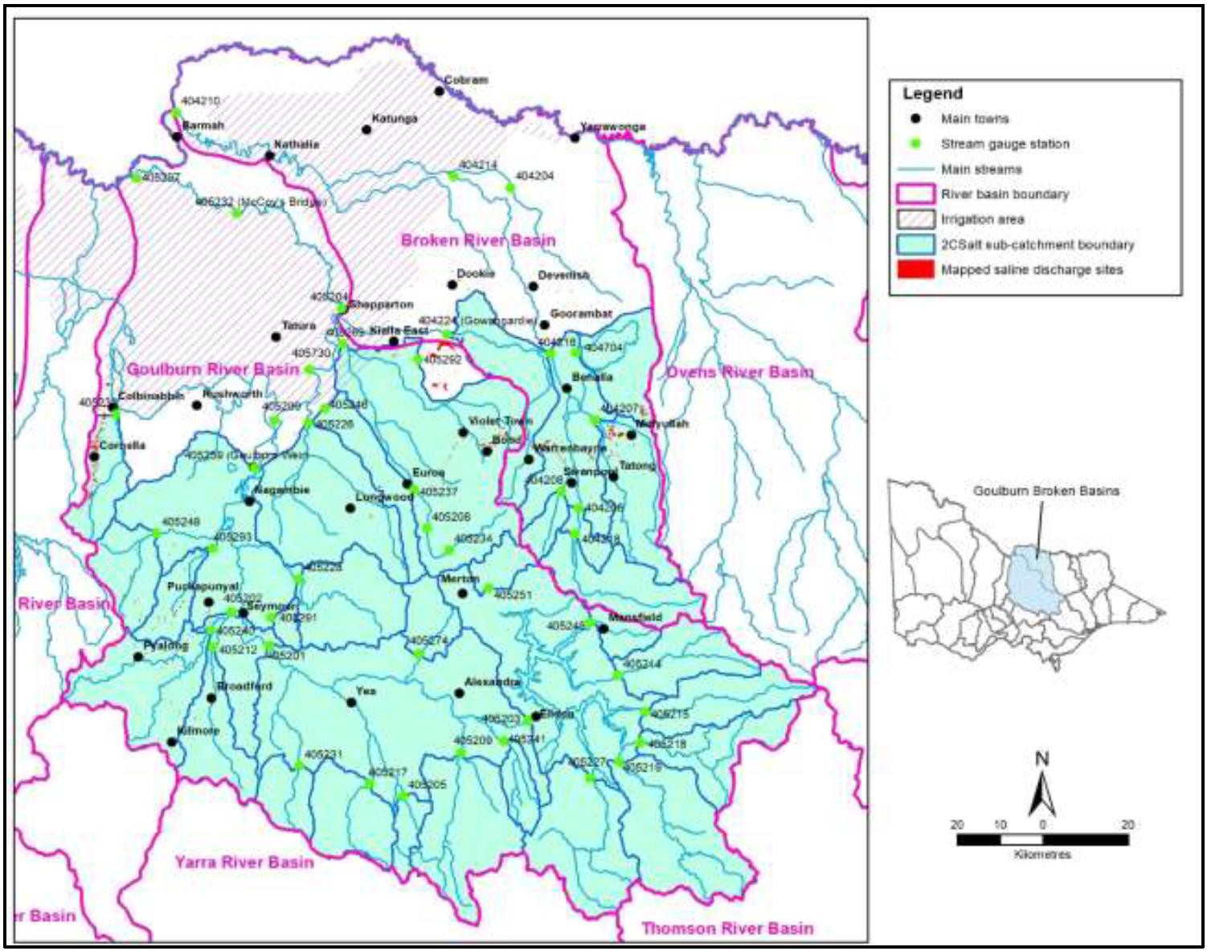

Figure 24 – Location of the Goulburn Broken catchment including the McCoy’s Bridge gauging station (Source: Figure 2 of DEDJTR (2019))

    - Models used
What’s the model?
Three models were used to estimate flow and salt load to the Murray River:
- Catchment Analysis Tool model (CAT) – this was used to establish the salt balance model for the unsaturated zones within the 34 selected sub-catchments. The following outputs were

generated for input to 2CSalt: evapotranspiration, runoff, subsurface lateral flow and deep drainage
- 2CSalt model - estimated monthly flow and salinity data sets (ratios relative to the baseline year months) for selected scenarios for each of 34 sub-catchments for input to REALM
- Goulburn Broken REALM model (2005 version) - generated flow and salt load data at McCoys Bridge for input into MSM-Bigmod.
Who owns the model?
The Department of Jobs, Precincts and Regions (DJPR) owns and maintains the CAT and 2CSalts models. DELWP owns and maintains the Goulburn Broken REALM model. The HARTT method is a general approach for statistically estimating trends in groundwater levels.
Is the model accredited?
The 2CSalt and Goulburn Broken REALM models are accredited for use.
    - Reviews and studies
Table 23 lists reviews and studies related to the Goulburn Catchment Legacy of History accountable action.
Table 23 – Reviews and studies related to the Goulburn Catchment Legacy of History accountable Action Register B entry

Review No. | Review Type
First review | 5-year review by DPI (2012)  Independent Peer Review – not available
Second review | 5-year review by DEDJTR (2019) Independent Peer Review – not available
Other | Original study to determine the Salinity Effect of the accountable action by SKM (1999)  Follow up study to determine the Salinity Effect of the accountable action by SKM (2004)

    - Related accountable actions
None.
    - Possibilities for expansion of credits/debits
DEDJTR (2019) recommended that, based on the results of MSM-Bigmod using updated data from the latest REALM modelling:
- the Register B entry should be kept unchanged for 2015
- Victoria prepare a formal submission to the MDBA for the 2018 Register B entry that reduces the 2050 Salinity Effect from a 1.1 EC to 0.7 EC debit and 2100 Salinity Effect from
1.6 EC to 1.1 EC.
The predicted Register B impacts should be slightly more robust. However, the improvement might not be sufficient to increase the confidence level entry beyond its current rating of medium.

    - Issues, gaps and further work
Victoria prepare a formal submission to the MDBA to amend the Register B entries for the Goulburn Legacy of History accountable action.

Loddon Catchment Legacy of History
    - Overview
The North Central CMA is responsible for this Victorian Register B accountable action.
The current (2018) Salinity Effect of the entry is a 1.0 EC debit at Morgan on Register B. The Salinity Effect is estimated to be a 1.5 EC debit in 2050 and 2.3 EC debit in 2100 (MDBA, 2018).
Register B 2018 gives a confidence rating of medium for the entry (MDBA, 2018).
    - Background
The Register B entry includes the Loddon catchment upstream of the following eight locations along the Loddon River which are input nodes for the MDBA’s MSM-Bigmod (Figure 25):
- Loddon River at Kerang Weir
- Sheepwash Creek
- Lake Charm Outfall
- Koondrook Spillway
- 6 on 7 Channel outfalls to Little Murray
- Lake Boga Outflows
- Lake Boga Inflows
- Channel 9 diversions.
Approximately 70% of the Loddon catchment is assumed to be contributing to the recorded Register B Legacy of History Salinity Effect. The remaining area is within the GMID.
Approximately 80% of the catchment has been cleared for agriculture with intensive irrigation in the north and dryland farming enterprises in the south.
Dryland salinity is one of the major natural resource management issues facing the Loddon catchment. There are more than 500 mapped saline discharge sites covering an approximate area of 5,300 ha. Dryland salinity is widespread and threatening key assets in the catchment.
The catchment is also an exporter of salt and a contributor to water quality and stream degradation in the Murray River.
The North Central RCS 2003-2007 identified dryland salinity as a major resource management issue but noted that water tables across much of the region were at their lowest levels since the mid- 1980s, largely due to dry conditions. The RCS included a package of measures to manage the impacts of dryland salinity by implementing actions in 10 ‘targeted project areas’, including locations in the upper and middle reaches of the Loddon, Avoca and Avon-Richardson catchments.
The North Central Dryland Region Management Plan 2007 replaced the earlier salinity management plan for the North Central region of Victoria. The Plan was needed because:
- the existing approach was not having the regional benefits anticipated (though it was still producing local benefits)
- there was a need to protect key threatened assets before they were lost, to provide the best public benefit from expenditure of public money
- there was a need for a broader mix of investment responses for salinity to be considered in the region.

The North Central RCS 2013-2019 continued the shift to a more comprehensive management focus on land and soils rather than a specific focus on dryland salinity.
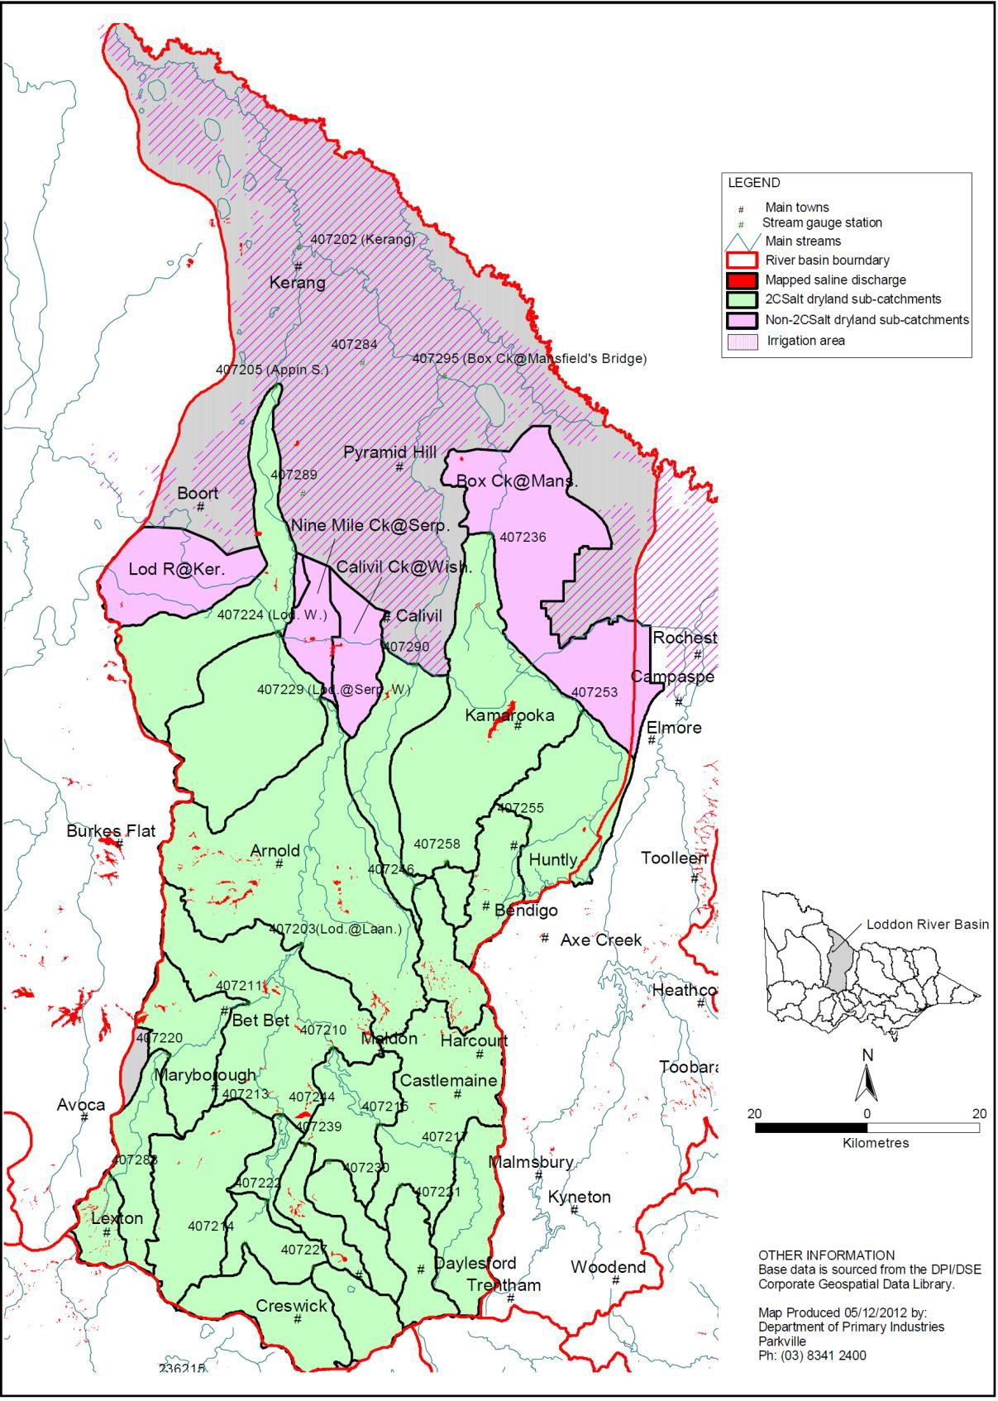
Figure 25 – Location of sub-catchments included in the 2011 5-year review of the Loddon catchment (Source: Figure ii of DPI (2013))

    - Description
Victoria is accountable for the post 1 January 2000 increase in salt load to the Murray River resulting from pre-1988 actions in the Loddon dryland catchment (predominantly land clearing).
The first two assessments of the Salinity Effect of the Loddon Catchment Legacy of History accountable action assumed a continuation of the historic rainfall patterns (the relatively wet conditions between the late 1980s and early 1990s) and an ever-increasing rise in groundwater levels SKM (1999) and (2004). This approach resulted in ever-increasing Legacy of History salinity impacts being accrued annually against the Register B entries in Victorian Northern Rivers Catchments East of Nyah (including the Loddon dryland catchment).
Drier than usual annual weather patterns between 1997 and 2009 resulted in significant drops in groundwater levels across northern Victoria and challenged these previously held expectations (Reid, et al., 2008). In view of the relatively high downstream salinity impact, the significant annual increase in downstream impacts and the high risk to downstream water users and the State of Victoria, both a groundwater hydrograph analysis and comprehensive numerical catchment modelling were used for the subsequent Loddon dryland catchment 5-year review (DPI, 2013, p. 14).
Based on the more comprehensive modelling approach adopted, DPI (2013, p. vi) concluded that:
      - there is no evidence to suggest a step increase in salinity impact from 2015 and 2100, as currently recorded on Register B for the Legacy of History impact from the Loddon catchment
      - the salinity impact from the Loddon catchment will increase steadily at a significantly reduced rate over the period from 2015 to 2100
      - the current long-term entries for 2050 and 2100 on Register B are overestimated, though the short-term entry for 2015 is slightly underestimated
      - the Register B entry for 2013 and 2015 impacts should be increased and the 2050 and 2100 entries should be significantly reduced.
The latest 5-year review was being considered for endorsement at the time of writing and was not available.
    - Models used
What’s the model?
Three models were used to estimate flow and salt load to the Murray River:
      - Catchment Analysis Tool model (CAT) – this was used to establish the salt balance model for the unsaturated zones within the 34 selected sub-catchments. The following outputs were generated for input to 2CSalt: evapotranspiration, runoff, subsurface lateral flow and deep drainage
      - 2CSalt model – estimated monthly flow and salinity data sets (ratios relative to the baseline year months) for selected scenarios for each of 24 sub-catchments for input to REALM
      - Loddon River REALM model (2005 version) – generated flow and salt load data at eight sites for input into MSM-Bigmod.
In addition, the Hydrograph Analysis: Rainfall and Time Trends (HARTT) approach was used to differentiate between the effect of rainfall fluctuations and the underlying trend in groundwater level over time.
Who owns the model?

DJPR owns and maintains the CAT and 2CSalts models. DELWP owns and maintains the Loddon REALM model.
Is the model accredited?
The 2CSalt and Loddon REALM models are accredited for use.
    - Reviews and studies
Table 24 lists reviews and studies related to the Loddon Catchment Legacy of History accountable action.
Table 24 – Reviews and studies related to the Loddon Catchment Legacy of History accountable Action Register B entry

Review No. | Review Type
First review | 5-year review by DPI (2013)  Independent Peer Review – not available
Second review | The 2018/19 5-year review was awaiting endorsement at the time of writing
Other | Original study to determine the Salinity Effect of the accountable action by SKM (1999)  Follow up study to determine the Salinity Effect of the accountable action by SKM (2004)

    - Related accountable actions
None.
    - Possibilities for expansion of credits/debits
Awaiting completion of the 2018/19 5-year review report.
    - Issues, gaps and further work
Awaiting completion of the 2018/19 5-year review report.

Kiewa Catchment Legacy of History
    - Overview
The North East Central CMA is responsible for this Victorian Register B accountable action.
The current (2018) Salinity Effect of the entry is a 0.1 EC debit at Morgan on Register B. The Salinity Effect is estimated to be a 0.0 EC debit in 2050 and 0.0 EC debit in 2100 (MDBA, 2018).
Register B 2018 gives a confidence rating of medium for the entry (MDBA, 2018).
    - Background
The Register B entry includes the Kiewa catchment upstream of Bandiana (10 km south east of Wodonga) (Figure 26).
There are a range of land uses within the catchment. Much of the upper reaches of the catchment are undisturbed and covered by forests. The lower reaches of the catchment are cleared for agricultural use.
Clearing of perennial natural vegetation cover and the introduction of grazing and annual crop-based farming led to an increase in groundwater recharge and decrease in evapotranspiration, causing the watertable to rise. The rising watertable brings salt to the surface initiating surface salt accumulation and causes dryland salinity.
Land salinisation is a relatively new phenomenon in the Kiewa catchment and only emerged as one of the natural resource management issues in recent years. There are a small number of mapped saline discharge sites with an approximate total area of 138 ha, which represents less than 0.1% of the Kiewa River Basin.
The mapped saline discharge sites mainly occur along drainage lines or low-lying areas in the lower part of the catchment and are generally small with low severity of salinisation (typically soil salinity of 300-600 us/cm). Water quality in the streams is good across the catchment, particularly in the upper reaches.
    - Description
Victoria is accountable for the post 1 January 2000 increase in salt load to the Murray River resulting from pre-1988 actions in the Kiewa dryland catchment (predominantly land clearing).
Register B entries are for Legacy of History delayed salinity impacts which have, or will have, an impact after 1 January 2000, but which are caused by an action taken or decision made before 1 January 1988 (the baseline date). The Kiewa catchment Register B salinity impact entry is attributed to dryland salinity associated with rising groundwater levels caused by land clearing post European settlement.
The negligible impacts reported demonstrate that Legacy of History actions pose a limited salinity risk to the downstream basin community.
Two initial studies by SKM (1999) and (2004)) to determine the Salinity Effect of the action used a very similar methodology, which comprised two main parts:
- groundwater projections
- surface water wash-off and quantity and quality routing.

The original analyses derived a relationship between groundwater salinity, the area of high watertable and stream salinity. Future trends in stream salinity and salt loads were then forecast from predicted future trends in groundwater levels.
The groundwater projections adopted in the two studies were almost identical. However, the surface water wash-off procedures were simplified in the later study (SKM, 2004) in order to improve the comparability of results between sub-catchments.
Overall SKM (2004) adopted a similar but more refined approach to SKM (1999). Predicted salt load increases were distributed according to the daily pattern of salt load by factoring up the daily time series of salinity in each sub-catchment until the average annual salt load over the benchmark period equalled the average annual salt load under year 2020, year 2050 and year 2100 conditions.
The approaches in both SKM studies were accredited by the MDBC for the Kiewa catchment Register B entry.
The following two 5-year reviews adopted a different approach.
A fit for purpose and low cost groundwater hydrograph analysis approach was used for the 2011 (DPI, 2012b) and 2017 (DEDJTR, 2018b) 5-year year reviews because of the low downstream salinity impact, the minimal annual increase in downstream impacts and the minimal risk to downstream water users.
The trends of hydrographs of selected bores were reviewed and compared with trends forecast by the original analysis undertaken by SKM in 1999.
These 1999 and 2004 studies assumed a continuation of the historic rainfall patterns (particularly relatively wet conditions between the late 1980s and early 1990s) and an ever-increasing rise in groundwater levels. Reid et al. (2008) found that the drier than usual annual weather patterns in 2000s resulted in significant drops in groundwater levels across northern Victoria. In the 2011 review, Cheng et al. (2012) also demonstrated that long-term rising trends in groundwater level were considerably lower than those previously projected by SKM in 1999 and 2004.
The 2011 5-year Review (DPI, 2012b) analysed groundwater trends and behaviour. The Hydrograph Analysis: Rainfall and Time Trends (HARTT) approach was used to differentiate between the effect of rainfall fluctuations and the underlying trend in groundwater level over time. The review used all 12 monitoring bores available in the Kiewa catchment.
The 2017 review (DEDJTR, 2018b) updated groundwater level trends at each bore, using data up to December 2016. These trends were compared with those forecast by the 1999 and the 2004 assessments used for the Register B entries.
DEDJTR (2018b) found that:
- rainfall was the primary factor influencing the fluctuation and trend of groundwater level. A linear rising trend was not found in any bore in the catchment. The previous assumption of continually rising groundwater levels (SKM (1999) and (2004)) was not evident in the catchment
- findings were broadly consistent with those in the 2011 review. Groundwater level trends determined in the 2011 and 2017 HARTT analyses were reasonably consistent. Both analyses showed that all bores used by SKM in 1999 had a falling trend except one bore which had a flat trend. The magnitude of falling trends in the 2017 analysis is slightly smaller at all landscapes.

- although groundwater behaviour is greatly influenced by rainfall variation, the magnitude of the influence varies depending on landscape position and groundwater flow system.
DEDJTR (2018b) recommended that:
- The Register B entry for the Kiewa Catchment Legacy of History remain with a confidence rating of Medium.
- To ensure a better data set is available for future Register B reviews, existing stream flow and bore monitoring continue.
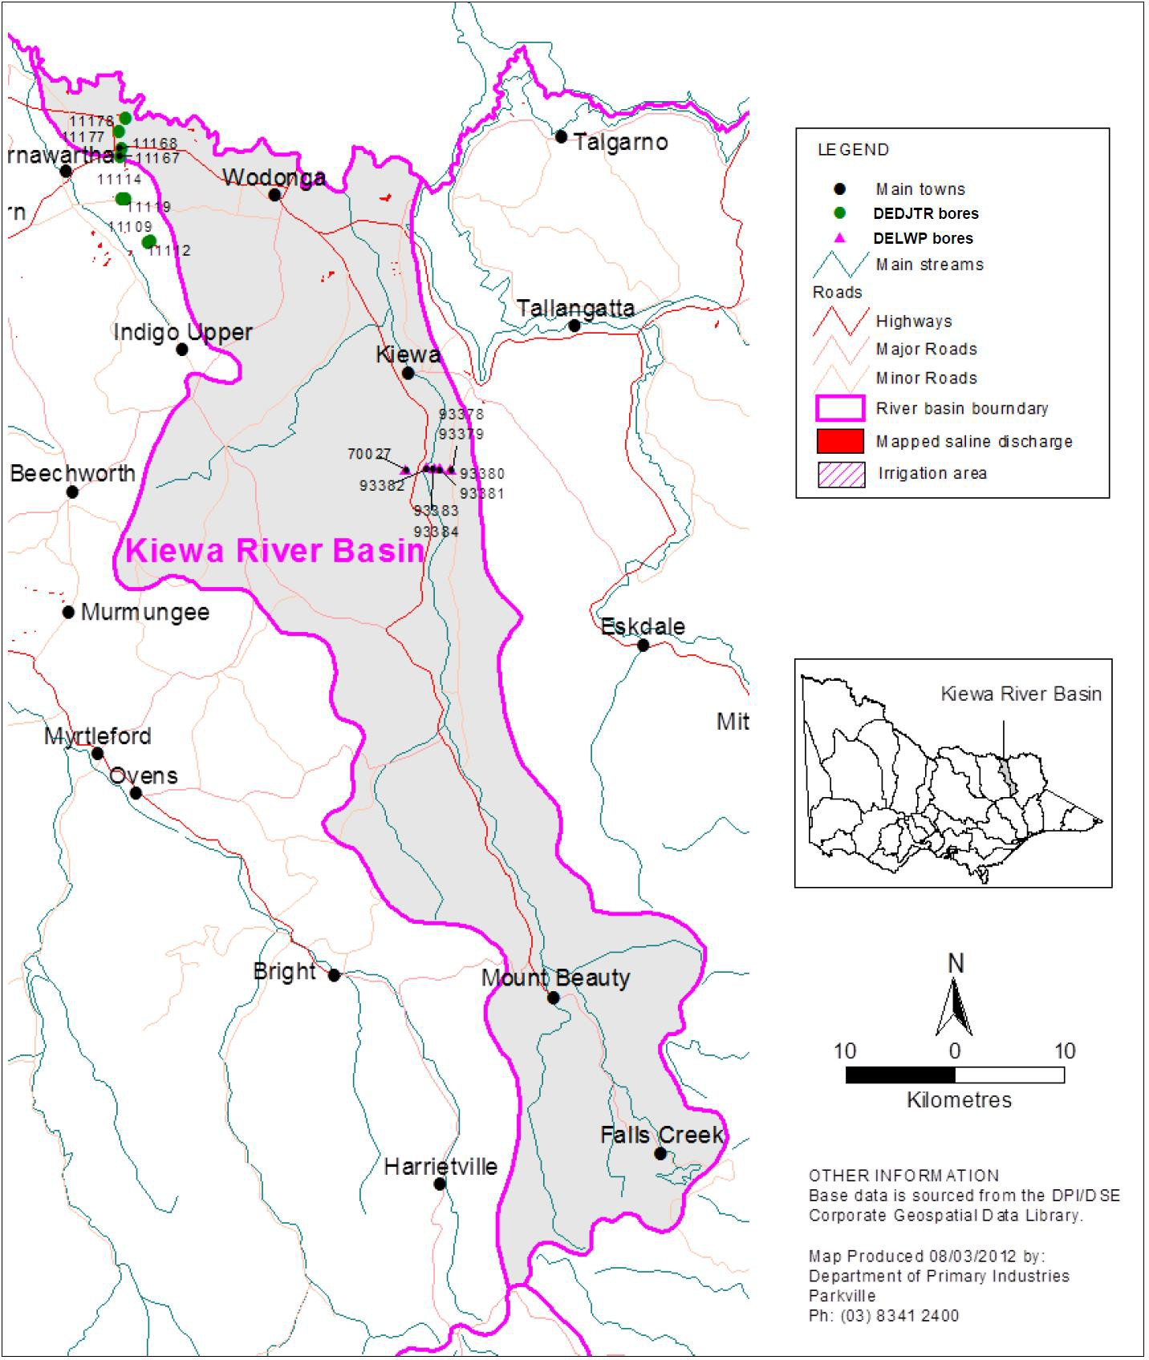
Figure 26 – Location of the Kiewa catchment, including saline discharge sites and selected groundwater bores (Source: Figure 2 of DEDJTR (2018b))

    - Models used
What’s the model?
The Hydrograph Analysis: Rainfall and Time Trends (HARTT) approach was used to differentiate between the effect of rainfall fluctuations and the underlying trend in groundwater level over time.
Who owns the model?
The HARTT is a general approach for statistically estimating trends in groundwater levels. Is the model Accredited?
Suitability of the HARTT method for groundwater level trend analysis was addressed in the 2011 review (DPI, 2012b). It was concluded that the method was suitable for the purpose of the bore trend analysis in the low risk catchments such as the Kiewa, although the independent peer reviewers were concerned that the uncertainty behind the explanation for the linear-trend component in the HARTT does not improve the reliability of the conclusions above that which has been obtained from the groundwater data itself.
    - Reviews and studies
Table 25 lists reviews and studies related to the Kiewa Catchment Legacy of History Register A entry.
Table 25 - Reviews and studies related to the Kiewa Catchment Legacy of History accountable Action Register B entry

Review No. | Review Type
First review | 5-year review by DPI (2012b)  Independent Peer Review – not available
Second review | 5-year review by DEDJTR (2018b) Independent Peer Review – not available
Other | Original study to determine the Salinity Effect of the accountable action by SKM (1999)  Follow up study to determine the Salinity Effect of the accountable action by SKM (2004)

    - Related accountable actions
None.
    - Possibilities for expansion of credits/debits
None.
    - Issues, gaps and further work
None.

Ovens Catchment Legacy of History
    - Overview
The North East Central CMA is responsible for this Victorian Register B accountable action.
The current (2018) Salinity Effect of the entry is a 0.0 EC debit at Morgan on Register B. The Salinity Effect is estimated to be a 0.6 EC debit in 2050 and 1.3 EC debit in 2100 (MDBA, 2018).
Register B 2018 gives a confidence rating of medium for the entry (MDBA, 2018).
    - Background
The Register B entry covers the Ovens catchment upstream of Peachelba (Figure 27).
There are a range of land uses within the catchment. While much of the upper reaches of the catchment remain undisturbed and are covered by forest, significant parts of the lower reaches have been cleared of deep rooted vegetation for agriculture. The current predominant agricultural land use is dryland pasture.
Clearing of perennial natural vegetation cover and the introduction of grazing and annual crop based farming led to an increase in groundwater recharge and decrease in evapotranspiration, causing the watertable to rise. The rising watertable brings salt to the surface initiating surface salt accumulation and causes dryland salinity.
Over 2,100 ha of salt-affected land has been mapped in the Ovens catchment, with widespread shallow watertables. Salinity problems have occurred in the north-western part of the catchment. Salinity discharges have been mapped along the lower Ovens and King rivers (lower floodplain terraces) on the plain, and at Springhurst, Rutherglen, Murmungee, Everton and Indigo Valley in the upland areas (DEDJTR, 2018c).
    - Description
Victoria is accountable for the post 1 January 2000 increase in salt load to the Murray River resulting from pre-1988 actions in the Ovens dryland catchment (predominantly land clearing in the lower catchment).
Register B entries are for Legacy of History delayed salinity impacts which have, or will have, an impact after 1 January 2000, but which are caused by an action taken or decision made before 1 January 1988 (the baseline date). The Ovens catchment Register B salinity impact entry is attributed to dryland salinity associated with rising groundwater levels caused by land clearing post European settlement.
The negligible impacts reported demonstrate that Legacy of History actions pose a limited salinity risk to the downstream basin community.
Two initial studies by SKM ( (1999) and (2004)) to determine the Salinity Effect of the action used a very similar methodology, which comprised two main parts:
- groundwater projections
- surface water wash-off and quantity and quality routing.
The original analyses derived a relationship between groundwater salinity, the area of high watertable and stream salinity. Future trends in stream salinity and salt loads were then forecast from predicted future trends in groundwater levels.

The groundwater projections adopted in the two studies were almost identical. However, the surface water wash-off procedures were simplified in the later study (SKM, 2004) in order to improve the comparability of results between sub-catchments.
Overall SKM (2004) adopted a similar but more refined approach to SKM (1999). Predicted salt load increases were distributed according to the daily pattern of salt load by factoring up the daily time series of salinity in each sub-catchment until the average annual salt load over the benchmark period equalled the average annual salt load under year 2020, year 2050 and year 2100 conditions.
The approaches in both SKM studies were accredited by the MDBC for the Ovens catchment Register B entry.
The following two 5-year reviews adopted a different approach.
A fit for purpose and low cost groundwater hydrograph analysis approach was used for the 2011 (DPI, 2012c) and 2017 (DEDJTR, 2018c) 5-year year reviews because of the low downstream salinity impact, the minimal annual increase in downstream impacts and the minimal risk to downstream water users.
The trends of hydrographs of selected bores were reviewed and compared with trends forecast by the original analysis undertaken by SKM in 1999.
These 1999 and 2004 studies assumed a continuation of the historic rainfall patterns (particularly relatively wet conditions between the late 1980s and early 1990s) and an ever-increasing rise in groundwater levels. Reid et al. (2008) found that the drier than usual annual weather patterns in 2000s resulted in significant drops in groundwater levels across northern Victoria. In the 2011 review, Cheng et al. (2012) also demonstrated that long-term rising trends in groundwater level were considerably lower than those previously projected by SKM in 1999 and 2004.
The 2011 5-year Review (DPI, 2012c) analysed groundwater trends and behaviour. The Hydrograph Analysis: Rainfall and Time Trends (HARTT) approach was used to differentiate between the effect of rainfall fluctuations and the underlying trend in groundwater level over time. The review used 52 ‘representative’ monitoring bores from 370 available in the Ovens catchment.
The 2017 review (DEDJTR, 2018c) updated groundwater level trends at each bore (20 bores were used in this review), using data up to December 2016. These trends were compared with those forecast by the 1999 and the 2004 assessments used for the Register B entries.
DEDJTR (2018c) found that:
- rainfall was the primary factor influencing the fluctuation and trend of groundwater level. A linear rising trend was only found in a small number of bores. This shows that the previous assumption of continually rising groundwater levels (SKM (1999) and (2004)) was not valid across most of the catchment
- the new revised trends are similar to those adopted in the 2011 review which are considerably lower than those adopted by SKM (1999, 2004), despite inclusion of the post Millennium Drought data (including the data collected in the 2010/2011 wet summer) in the analysis. This confirmed that the trends adopted in the 2011 review were conservatively high
- although groundwater behaviour is greatly influenced by rainfall variation, the magnitude of the influence varies depending on landscape position and groundwater flow system.
DEDJTR (2018c) recommended that:

- The Register B entry for the Ovens Catchment Legacy of History remain with a confidence rating of Medium.
- To ensure a better data set is available for future Register B reviews, existing stream flow and bore monitoring continue.
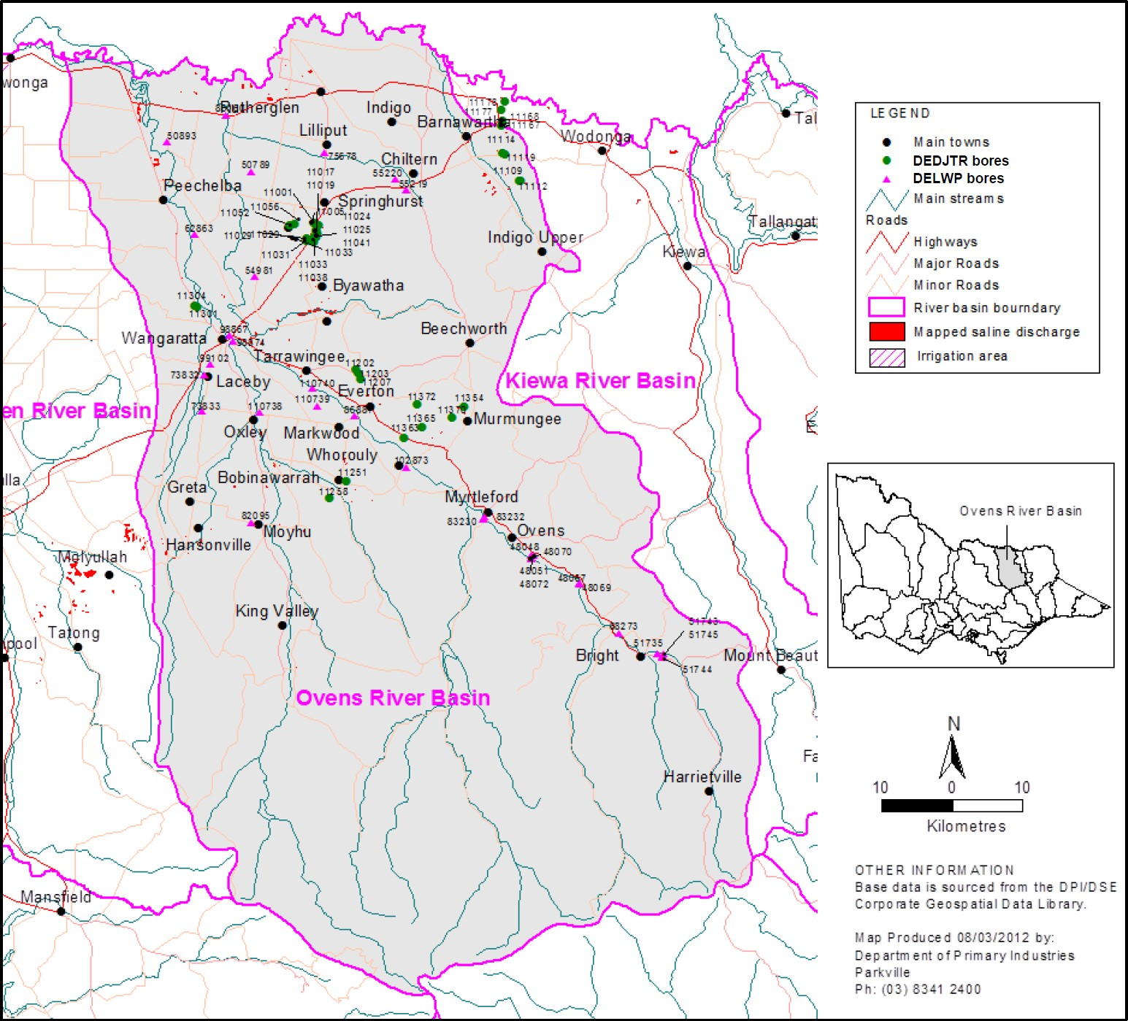
Figure 27 – Location of the Ovens catchment including saline discharge sites and selected bores (Source: Figure 2 of DEDJTR (2018c))

    - Models used
What’s the model?
The Hydrograph Analysis: Rainfall and Time Trends (HARTT) approach was used to differentiate between the effect of rainfall fluctuations and the underlying trend in groundwater level over time.
Who owns the model?
The HARTT is a general approach for statistically estimating trends in groundwater levels. Is the model Accredited?
Suitability of the HARTT method for groundwater level trend analysis was addressed in the 2011 review (DPI, 2012c). It was concluded that the method was suitable for the purpose of the bore

trend analysis in the low risk catchments such as the Ovens, although the independent peer reviewers were concerned that the uncertainty behind the explanation for the linear-trend component in the HARTT does not improve the reliability of the conclusions above that which has been obtained from the groundwater data itself.
    - Reviews and studies
Table 26 lists reviews and studies related to the Ovens Catchment Legacy of History Register A entry.
Table 26 – Reviews and studies related to the Ovens Catchment Legacy of History accountable Action Register B entry

Review No. | Review Type
First review | 5-year review by DPI (2012c)  Independent Peer Review – not available
Second review | 5-year review by DEDJTR (2018c) Independent Peer Review – not available
Other | Original study to determine the Salinity Effect of the accountable action by SKM (1999)  Follow up study to determine the Salinity Effect of the accountable action by SKM (2004)

    - Related accountable actions
None.
    - Possibilities for expansion of credits/debits
None.
    - Issues, gaps and further work
None.

Victorian Mallee - dryland clearing
    - Overview
The Mallee CMA is responsible for this Victorian Register B accountable action.
The current (2018) Salinity Effect of the entry is a 0.7 EC debit at Morgan on Register B. The Salinity Effect is estimated to be a 2.2 EC debit in 2050 and 5.9 EC debit in 2100 (MDBA, 2018).
Register B 2018 gives a confidence rating of low for the entry (MDBA, 2018).
    - Background
The study area used for modelling comprises an area of about 31,635 km² from Nyah West in the east to the South Australian Border in the west and from north of Lake Victoria to Ouyen in the south. This register B entry reflects the salinity impact due to land clearing for dryland agriculture in the Victorian part of the Mallee (MDBA, 2017)¹⁴. Figure 28 shows the areas of land that have been cleared for agriculture.
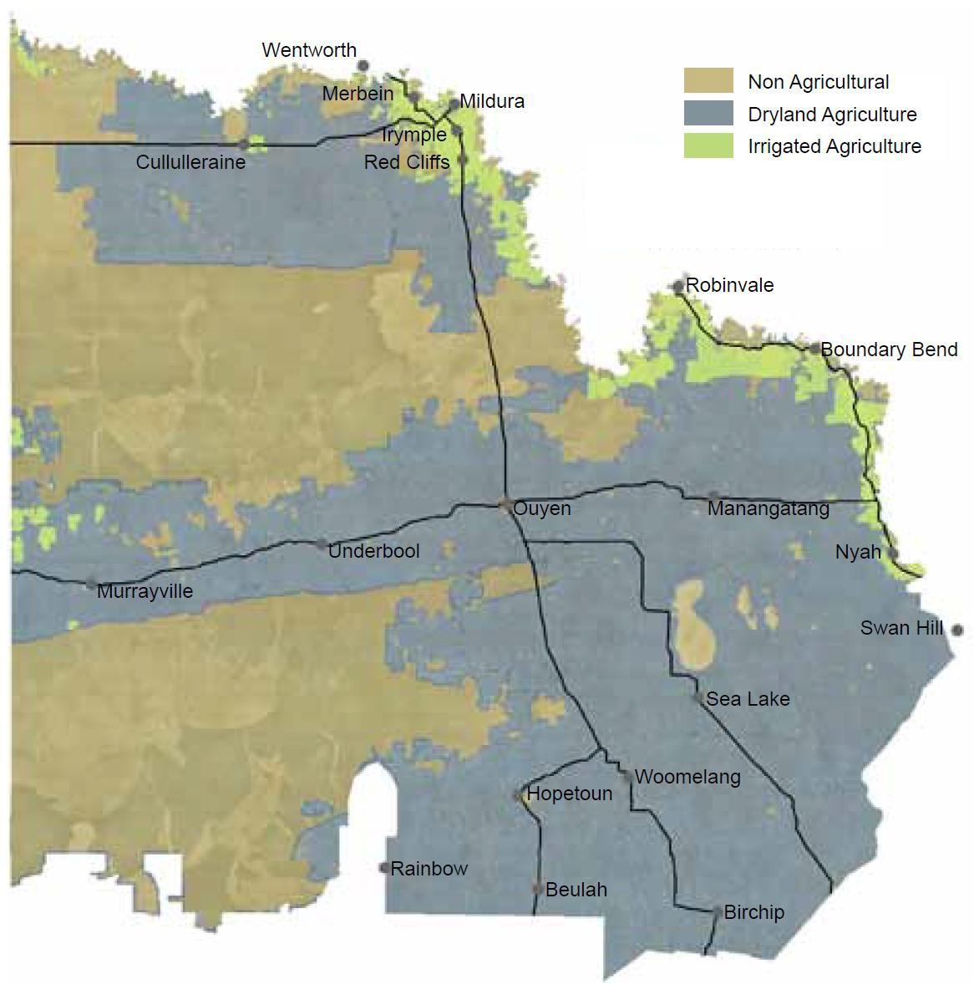

14 Victorian and NSW LoH reviews are done together, however modelling separates Victorian and NSW impacts into separate register entries.

Figure 28 – Distribution of dryland and irrigated agriculture in the Victorian Mallee (Source: Figure 18 of M CMA (2013))

There has been a major effort to control land clearing in the Mallee over the past three decades. The Mallee Area Review and Final Recommendations in 1989 permanently protected substantial areas of native vegetation on large blocks of public land mainly in the west of the region and many small reserves throughout the agricultural area (MCMA, 2008).
Native vegetation clearing controls on private land were introduced in 1989 as an amendment to the Planning and Environment Act 1987. These regulations were reviewed in 2016 and amended in December 2017. DELWP (2018c) reports on the operations of native vegetation removal regulations.
These major initiatives had prevented extensive land clearing in the Mallee by the year 2000.
The Mallee Native Vegetation Plan changed the focus to guiding regional native vegetation management activities to achieve a reversal of the long-term decline in the extent and quality of native vegetation and a ‘Net Gain’ (MCMA, 2008).
    - Description
Victoria is accountable for the post 1 January 2000 increase in salt load to the Murray River resulting from pre-1988 clearing of land for dryland agriculture in the Victorian Mallee.
The hypothesis supporting modelling assessments is that Mallee vegetation clearance and its replacement with shallow-rooted dryland farming systems results in enhanced root zone drainage and increased (but delayed) groundwater recharge that would drive more salt into the Murray River (Hydrogeologic, 2017, p. 2).
The entry requires increases in groundwater levels along the Murray River caused by clearing land for dryland agriculture to be estimated. The changes in groundwater levels are then used to estimate changes in salt loads to the River.
This is a complicated task because the effect of land clearing on groundwater levels needs to be separated out from the effect of irrigation along the River prior to 1988 and the effect of irrigation after 1988.
Cummins and Thomson (2005) reviewed the knowledge about the Mallee Register B entries at 2004. They found that prior to 2004 there was inconsistency in the use of predictive models to estimate Register B impacts. This is understandable, because at the time of the 1999 Audit there was no Register B. Most hydrogeology reports at the time lacked clarity about total salt loads and EC impacts for current and future conditions. Most did not separately identify Baseline, Register B or Register A components of those total loads.
Cummins and Thompson (2005) considered that since land clearing in South Australia, Victoria and New South Wales within 10 km of the River, occurred during early settlement, it is probable that the river salinity impact of this clearing has already been fully expressed. Therefore, there is not likely to be further significant change. Future salt loads from these zones are therefore likely to be lower than those previously predicted. Land clearing further away from the river, while not impacting on river salinity, does increase dryland recharge and the area of salt affected dryland discharge sites in the Mallee region.
    - Models used
What’s the model?

The EM1.2 model is the groundwater model which has been used to model the current ‘Victoria Mallee Legacy of History - Dryland’ and ‘Victoria Mallee Legacy of History - Irrigation’ Register B Accountable Actions. The EM1.2 model has been built using the Modflow modelling platform (MCMA, 2012, p. 52).
The Eastern Mallee 1.2 model (EM1.2) is a calibrated groundwater flow model which, when coupled with near river salinity assumptions, provides a representation of the historical salt loads to the river for the whole of the Mallee region over the period 1975 to 2005.
The model utilises several scenarios and post-processing of results to define the salt load impact of Accountable Actions. For example, dryland clearing (pre-1988) is assessed as the difference between a pre-development scenario and a dryland clearing scenario (with no irrigation or SIS), therefore only the impacts of the dryland clearing are observed and can be accounted for. Similar methods are applicable for actions such as pre 1988 irrigation development, irrigation contraction, irrigation improvements and salt interception schemes.
Groundwater fluxes calculated using the EM1.2 model are converted, using post processing, to salt loads using assumptions of near river salinities. Salt loads are then input to MSM-Bigmod, which is used to determine the impact of the scenario on Murray River salinities. Salt loads are expressed as extra groundwater salt load (t/day) entering the Murray River, in the following Mallee river reaches (MDBA, 2017, p. 210): Narrung towards Nyah; Lock 15 to Narrung; Colignan to Lock 15; Nangiloc- Colignan; Lock 11 to Nangiloc; Lock 10 to Lock 11; Lock 9 to Lock 10; Lock 8 to Lock 9; Lock 7 to Lock
8; and Lock 6 to Lock 7.
The current register entry is based on data provided as part of work by Aquaterra (2009). Who owns the model?
EM1.2 is owned and maintained by the Victoria and NSW (the initial model was probably funded from the joint account which is co-ordinated by MDBA). The current 2020 review is upgrading the model to EM1.3 which is jointly funded by Victoria and NSW. The MDBA is project managing the process, contributing in-kind, but model ownership will be shared b/w NSW and Vic.
Is the model accredited?
The model was accredited by the MDBA (Middlemis, 2013, p. 14), although its limitations are acknowledged (Aquaterra, 2009, p. 52), e.g. model predictions on salt loads are accurate to +/-25%. Prathapar’s (2010) independent review found the model was 'fit for purpose'.
    - Reviews and studies
Table 27 lists reviews and studies related to the Victorian Mallee – dryland clearing Legacy of History Register A entry.

Table 27 – Reviews and studies related to the Victoria Mallee – dryland clearing Legacy of History accountable Action Register B entry

Review No. | Review Type
First review | 5-year review by Aquaterra (2006)  Independent Peer Review – not available
Second review | 5-year review by Aquaterra (2009)  Independent Peer Review by Prathapar (2010b) and related reports all contained in MDBA (2010)
Other | Proposed 5-year review by Cummins and Thomson (2005) which became a gap analysis  A recent study done as part of the BSM2030 Knowledge Priorities on Mallee Legacy of History salinity impacts related to dryland vegetation clearance (Hydrogeologic, 2017)  A review of the Accountable Action commenced in 2019 and is expected to be finalised late 2020. An upgraded model will be developed as part of the process (EM1.3). As with past reviews the current review is being conducted jointly between NSW and Victoria.

    - Related accountable actions
The Victorian Mallee – dryland clearing legacy of history entry is closely related to the Victorian Mallee – Pre-1988 Irrigation legacy of history entry (section 6.7). The reviews are carried out together with the EM1.2 model used to separate the effects of the two accountable actions.
The NSW Mallee – dryland clearing and irrigation legacy of history entries are also closely related to the Victorian entries. Again, the reviews are conducted jointly with NSW and Victorian impacts accounted for separately.
    - Possibilities for expansion of credits/debits
Aquaterra (2009) did not recognise any opportunities. However, progressive reviews should be able to better define the scale of the debit as confidence improves due to model development, observed groundwater calibration and Murray River salinity.
    - Issues, gaps and further work
Aquaterra (2009) and Prathapar (2010) identify several modelling related issues to be considered in future reviews. These relate to:
- Recharge processes and lag times
- Floodplain salt accumulation, attenuation and discharge process
- The reliance of long-term (50-100 year) predictions on assumed future scenarios
- Management of the integrated EM1 modelling platforms.
The 2017 knowledge review (Hydrogeologic, 2017) addressed some of these issues and noted options for further work included:
- In relation to consistent modelling methodologies for vegetation clearance scenarios -
  - quantifying uncertainty: a pilot uncertainty assessment may be warranted for a representative regional groundwater model in each jurisdiction to quantify the

range of uncertainty applying to the best estimate (i.e. to objectively quantify the uncertainty applying to the Register entries)
Comprehensive uncertainty assessments of regional groundwater models are time consuming and expensive and are thus not warranted every time a salinity impact model is updated, hence the recommendation for a single (pilot) study.
  - Updating the Wang/SIMRAT dataset of mapped recharge and time lags, compare and contrast to new datasets (e.g. WAVES, BoM, CSIRO etc.) and use better data on land use changes (e.g. in south-western NSW)
  - consider alternative recharge datasets and advances in digital data availability.
- In relation to monitoring –
  - review the soil chloride profiles at the 14 sites within 20 km of the River in SA investigated by Cook et al. (2004), and confirm which sites may be worth re- surveying (high priority contemporary indicators of enhanced recharge due to clearing)
  - review the construction of the bores at the identified 18 priority sites (Middlemis and Knapton, 2015) to confirm their fitness for the purpose of annual monitoring of levels and salinity (lower priority trailing indicators of enhanced recharge due to clearing)
  - review gaps in the network (notably in Victoria where few priority sites have been identified) and consider the need for potential new monitoring bore and/or soil chloride profile sites, and the added value of obtaining soil chloride profiles at key/priority monitoring bore sites that are confirmed as fit for purpose.

Victorian Mallee - Pre-88 Irrigation
    - Overview
The Mallee CMA is responsible for this Victorian Register B accountable action.
The current (2018) Salinity Effect of the entry is a 1.6 EC debit at Morgan on Register B. The Salinity Effect is estimated to be a 4.7 EC debit in 2050 and 8.3 EC debit in 2100 (MDBA, 2018).
Register B 2018 gives a confidence rating of low for the entry (MDBA, 2018).
    - Background
The study area used for modelling Victorian and NSW dryland and irrigation impacts comprises an area of about 31,635 km² from Nyah West in the east to the South Australian Border in the west and from north of Lake Victoria to Ouyen in the south. This register B entry reflects the salinity impact of pre-1988 irrigation developments in the Victorian Mallee (MDBA, 2017). Figure 29 and Figure 30 show the irrigated areas in the Victorian Mallee within irrigation districts and private diversion areas in 1997.
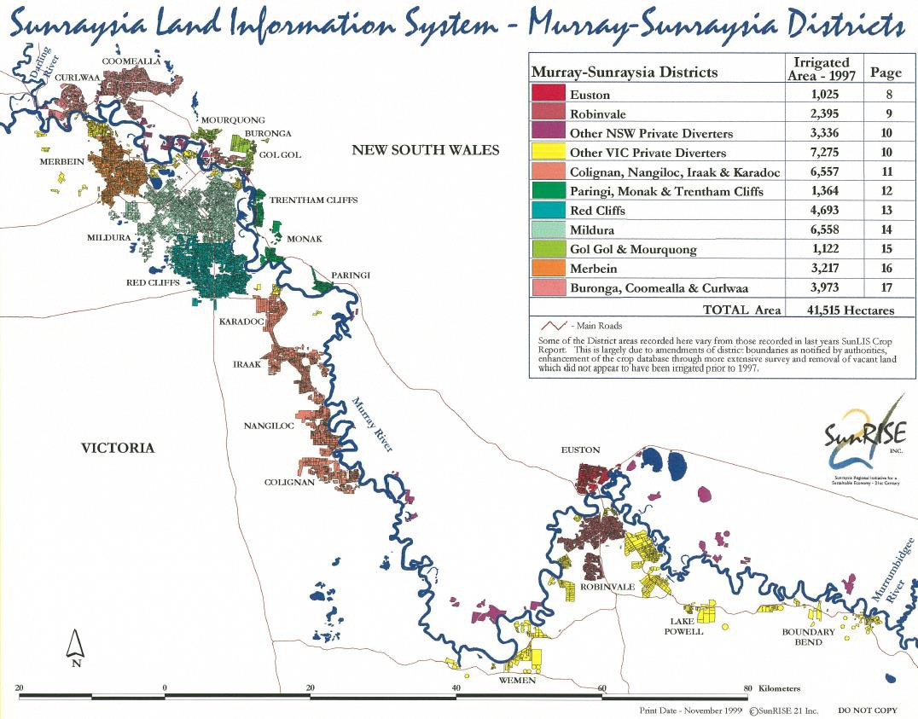
Figure 29 – Irrigated area in Victorian and NSW Mallee irrigation districts in 1997 (Source: Page 7 of SunRISE21 (1999))

    - Description
Victoria is accountable for the post 1 January 2000 increase in salt load to the Murray River resulting from pre-1988 irrigation developments in the Victorian Mallee.

The entry requires increases in groundwater levels along the Murray River caused by pre-1988 irrigation development to be estimated. The changes in groundwater levels are then used to estimate changes in salt loads to the River.
This is a complicated task because the effect of land clearing on groundwater levels needs to be separated out from the effect of irrigation along the River prior to 1988 and the effect of irrigation after 1988.
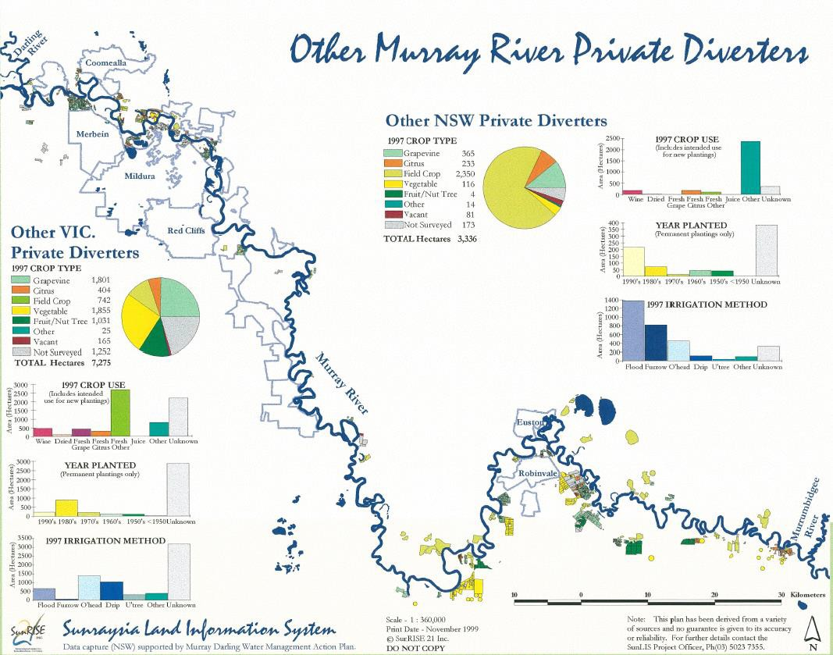

Figure 30 – Irrigated areas in the Victorian and NSW Mallee private diverter areas in 1997 (Source: Page 10 of SunRISE21 (1999))

Cummins and Thomson (2005) reviewed the knowledge about the Mallee Register B entries at 2004. They found that prior to 2004 there was inconsistency in the use of predictive models to estimate Register B impacts. This is understandable, because at the time of the 1999 Audit there was no Register B. Most hydrogeology reports at the time lacked clarity about total salt loads and EC impacts for current and future conditions. Most did not separately identify Baseline, Register B or Register A components of those total loads.
Aquaterra (2009) were tasked with addressing the shortcomings of earlier work. Their specific task was to devise a numerical groundwater flow model to provide robust estimates of salt loads to inform and update the B-Register (post-2000), by evaluating the salinity impact on the River Murray of pre-1988 actions relating to irrigation development and dryland clearing. The critical outcome of the work was a prediction of salt loads for the whole model domain (much of the Victorian and NSW Mallee) for post 2000 impacts of pre 1988 irrigation and dryland actions separated for Victoria and

NSW. An independent peer review of their work judged that they were successful and the revised EM1.2 model was judged as being fit for purpose (Prathapar, 2010).
Prior to the work by Aquaterra (2009) Victoria and NSW had a shared legacy of history entry for the Mallee with a combined Salinity Effect in 2015 of 58.4 EC (debit) and in 2100 of 201.7 EC (debit) (Table 28).
Table 28 – Estimated Salinity Effect of combined NSW and Victorian Mallee Legacy of History entries in the 2007-08 Salinity Register B (Source: Appendix II of MDBA (2009))

Salinity Effect (EC at Morgan)
Accountable Action | 2015 | 2050 | 2100
NSW-Vic Mallee Legacy of History – Dryland | 8.9 | 33.2 | 68.1
NSW-Vic Mallee Legacy of History – Irrigation | 49.5 | 119.6 | 133.6
TOTAL | 58.4 | 152.8 | 201.7

By addressing shortcomings in previous work Aquaterra reduced the combined Salinity Effects
dramatically to current estimates – a combined Salinity Effect in 2015 of 2.7 EC (debit) and in 2100 of
  - EC (debit) (Table 29). This was a ten-fold decrease in salinity impacts which had important ramifications for the health of the Murray River in the long-term, i.e. the approaching salinity disaster forecast by the 1999 Salinity Audit appeared to have abated.
Table 29 – Estimated Salinity Effect of combined NSW and Victorian Mallee Legacy of History entries in the 2018 Salinity Register B (Source: MDBA (2018))

Salinity Effect (EC at Morgan)
Accountable Action | 2015 | 2050 | 2100
NSW Mallee Legacy of History – Dryland | 0.3 | 1.3 | 3.6
NSW Mallee Legacy of History – Irrigation | 0.4 | 1.2 | 2.3
Vic Mallee Legacy of History – Dryland | 0.6 | 2.2 | 5.9
Vic Mallee Legacy of History – Irrigation | 1.4 | 4.7 | 8.3
TOTAL | 2.7 | 9.4 | 20.1

    - Models used
What’s the model?
The EM1.2 model is the groundwater model which has been used to model the current ‘Victoria Mallee Legacy of History - Dryland’ and ‘Victoria Mallee Legacy of History - Irrigation’ Register B Accountable Actions. The EM1.2 model has been built using the Modflow modelling platform (MCMA, 2012, p. 52).

The Eastern Mallee 1.2 model (EM1.2) is a calibrated groundwater flow model which, when coupled with near river salinity assumptions, provides a representation of the historical salt loads to the river for the whole of the Mallee region over the period 1975 to 2005.
The model utilises several scenarios and post-processing of results in order to define the salt load impact of Accountable Actions. For example, dryland clearing (pre-1988) is assessed as the difference between a pre-development scenario and a dryland clearing scenario (with no irrigation or SIS), therefore only the impacts of the dryland clearing are observed and can be accounted for. Similar methods are applicable for actions such as pre 1988 irrigation development, irrigation contraction, irrigation improvements and salt interception schemes.
Groundwater fluxes calculated using the EM1.2 model are converted, using post processing, to salt loads using assumptions of near river salinities. Salt loads are then input to MSM-Bigmod, which is used to determine the impact of the scenario on Murray River salinities. Salt loads are expressed as extra groundwater salt load (t/day) entering the Murray River, in the following Mallee river reaches (MDBA, 2017, p. 210): Narrung towards Nyah; Lock 15 to Narrung; Colignan to Lock 15; Nangiloc- Colignan; Lock 11 to Nangiloc; Lock 10 to Lock 11; Lock 9 to Lock 10; Lock 8 to Lock 9; Lock 7 to Lock
8; and Lock 6 to Lock 7.
The current register entry is based on data provided as part of work by Aquaterra (2009). Who owns the model?
EM1.2 is owned and maintained by the Victoria and NSW (the initial model was probably funded from the joint account which is co-ordinated by MDBA). The current 2020 review is upgrading the model to EM1.3 which is jointly funded by Victoria and NSW. The MDBA is project managing the process, contributing in-kind, but model ownership will be shared b/w NSW and Vic.
Is the model accredited?
The model was accredited by the MDBA (Middlemis, 2013, p. 14), although its limitations are acknowledged (Aquaterra, 2009, p. 52), e.g. model predictions on salt loads are accurate to +/-25%. Prathapar’s (2010) independent review found the model was 'fit for purpose'.
    - Reviews and studies
Table 30 lists reviews and studies related to the Victorian Mallee – Pre-1988 Legacy of History Register A entry.

Table 30 – Reviews and studies related to the Victorian Mallee – Pre-88 Irrigation Legacy of History accountable Action Register B entry

Review No. | Review Type
First review | 5-year review by Aquaterra (2006)  Independent Peer Review – not available
Second review | 5-year review by Aquaterra (2009)  Independent Peer Review by Prathapar (2010b) and related reports all contained in MDBA (2010)
Other | Proposed 5-year review by Cummins and Thomson (2005) which became a gap analysis  A recent study done as part of the BSM2030 Knowledge Priorities on Mallee Legacy of History salinity impacts related to pre-1988 irrigation (Hydrogeologic, 2017b)  A review of the Accountable Action commenced in 2019 and is expected to be finalised late 2020. An upgraded model will be developed as part of the process (EM1.3). As with past reviews the current review is being conducted jointly between NSW and Victoria.

    - Related accountable actions
The Victorian Mallee – Pre-1988 Irrigation legacy of history entry is closely related to the Victorian Mallee – dryland clearing legacy of history entry (section 6.6). The reviews are carried out together with the EM1.2 model used to separate the effects of the two accountable actions.
The NSW Mallee – dryland clearing and irrigation legacy of history entries are also closely related to the Victorian entries. Again, the reviews are conducted jointly with NSW and Victorian impacts accounted for separately.
    - Possibilities for expansion of credits/debits
Aquaterra (2009) did not recognise any opportunities. However, progressive reviews should be able to better define the scale of the debit as confidence improves due to model development, observed groundwater calibration and Murray River salinity.
    - Issues, gaps and further work
Aquaterra (2009) and Prathapar (2010) identify several modelling related issues to be considered in future reviews. These relate to:
    - Recharge processes and lag times
    - Floodplain salt accumulation, attenuation and discharge process
    - The reliance of long-term (50-100 year) predictions on assume future scenarios
    - Management of the integrated EM1 modelling platforms.
The 2017 knowledge review (Hydrogeologic, 2017b) addressed some of these issues and recommended the following to support the implementation of the whole-of-system modelling approach:
    - A review of the datasets that can be used to constrain the groundwater models

    - The investigation and development of a transfer function that connects irrigation accessions to groundwater recharge and is appropriate for situations where perching occurs or has occurred in the past
    - Studies to conceptualise and quantify the influence on the apportioning of salt loads to the river from regional drivers (e.g. from irrigation) to better understand and predict how a flux to the edge of the floodplain is routed through the floodplain to drive a change in river salinity
    - A pilot uncertainty analysis that takes a whole-of-system approach, covering the components of the district-scale water balance, recharge, groundwater flow and floodplain processes.

References
Aquaterra , 2010b. BSMS Five Year Review - Sunraysia Drying of Drains, Adelaide: Aquaterra .
Aquaterra, 2006. Mallee Zone 5-Year Rolling Salinity Review - Hydrogeological modelling for Victoria and NSW B Register 'Legacy of History' , Adelaide: Aquaterra Pty Ltd. Report prepared for the Murray-Darling Basin Authority (TRIM Ref 07/8288 and 07/8290 for Appendix A).
Aquaterra, 2009. Mallee Zone 5-Year Rolling Salinity Review - B-Register 'Legacy of History' Assessments - Eastern Mallee Model Version 1.2 (EM1.2), Adelaide: Aquaterra. Report prepared for the Murray-Darling Basin Authority.
Aquaterra, 2009. Sunraysia Sub-Regional Groundwater Flow Model (EM2.3) Final Report, Adelaide: Aquaterra Pty Ltd. Report prepared for Goulburn-Murray Water and the Murray-Darling Basin Authority.
Aquaterra, 2010. BSMS Five Year Review - Psyche Bend Lagoon Drainage Diversion Scheme. FInal ,
Adelaide: Aquaterra - report prepared for the Mallee CMA.
Aquaterra, 2010c. BSMS Five Year Review - Lamberts Swamp, Adelaide: Aquaterra (report prepared for the Mallee CMA).
AWE, 2015. RISI Stage 1 5 Year Review, s.l.: Australian Water Environments (AWE Refernce 15068). Prepared for the Mallee Catchment Management Authority.
AWE, 2017. Mildura SIS - Post Construction Register Entry Review, Salinity Impact Assessment, October 2017 Final Draft V 3.8. Eastwood South Australia, Australian Water Environments.
AWE, 2018. Mildura SIS - Post Construction Register Entry Review, Salinity Impact Assessment.
Eastwood South Australia, Australian Water Environments.
Cheng, X., Adelana, M. & Reid, M., 2012. Campaspe Catchment Legacy of History Salt Impacts, 2011 Register B – Five-year Review (Based on groundwater trend and behaviour analysis). Research Report., Melbourne: Victorian Government Department of Primary Industries.
Close, A., 2018. Peer Evaluation of the Five Year Review of the Shepparton Irrigation Region Salinity Register Entry, Final Report May 2018, s.l.: Report for the Murray-Darling Basin.
Cummins, T. & Thomson, C., 2005. Gap Analysis for the Mallee Zone Basin Salinity Management Strategy Five-Year Rolling Review, Lismore: Tim Cummins & Associates.
Cummins, T. & Thomson, C., 2018. A short history of irrigation development in the Victorian Mallee,
s.l.: s.n.
CWSIG, 1992. Salinity Management Plan Campaspe West Draft, November 1992, s.l.: Campaspe West Salinity Implementation Group .
DEDJTR, 2018a. 2017 Campapse Catchment Register B Five-year Review - Based on groundwater trend and behaviour analysis, Melbourne: Victorian Government Department of Economic Development, Jobs, Transport and Resources.
DEDJTR, 2018b. 2017 Kiewa Catchment Register B Five-Year Review. Based on groundwater trend and behaviour analysis, Melbourne : Victorian Government Department of Economic Development, Jobs, Transport and Resources.

DEDJTR, 2018c. 2017 Ovens Catchment Register B Five-year Review. Based on groundwater trend and behaviour analysis, Melbourne: Victorian Government Department of Economic Development, Jobs, Transport and Resources.
DEDJTR, 2019. Goulburn-Broken Catchment Legacy of History Salt Impacts - 2018 Register B Review. Melbourne, Victorian Government Department of Economic Development, Jobs, Transport and Resources.
DELWP, 2015. Business case for operating rule change to the use of the Barmah-Millewa Forest Environmental Water Allocation. A Sustainable Diversion Limit Adjustment Measure, Melbourne: Victorian Government Department of Environment, Land, Water and Planning .
DELWP, 2018b. Victoria's 2015/16 - 2016/17 Biennial Report, Basin Salinity Management 2030,
Melbourne: Victorian Government Department of Environment, Land, Water and Planning.
DELWP, 2018c. Annual Report 2017-18 - a report on the operations of the native vegetation removal regulations, Melbourne: Victorian Government Department of Environment, Land, Water and Planning.
DELWP, 2018. Victorian Water Trading 2017-18 Annual Report, Melbourne: Department of Environment, Land, Water and Planning.
DPI, 2012b. Kiewa Catchment Legacy of History Salt Impacts 2011 Register B - 5 year Review,
Melbourne: Victorian Government Department of Primary Industries.
DPI, 2012c. Ovens Catchment Legacy of History Salt Impacts 2011 Register B - 5 Year Review (Based on groundwater trend and behaviour analysis), Melbourne: Victorian Government Department of Primary Industries.
DPI, 2012. Goulburn-Broken Catchment Legacy of History Salt Impacts 2011 Register B - Five-year Review (Based on catchment modelling and groundwater trend & behaviour analysis), Melbourne: Victorian Government Department of Primary Industries.
DPI, 2013. Loddon Catchment Legacy of History Salt Impacts 2011 Register B - Five-year Review (Based on catchment modelling and groundwater trend & behaviour analysis), Melbourne: Victorian Government Department of Primary Industries.
Evans, R., 2019. Independent Peer Review of Victorian Mallee Drainage Bore Decommissioning. Findings Based on Final Report (22 November 2018). Draft: 29 March 2019, Canberra: Murray- Darling Basin Authority.
Fitzpatrick, C. & Wood, M., 2016. Scoping Study to Inform a Price Review of Mallee Salinity Offset Charges, Melbourne: Woodwater.
Fox, D., 2006. Review of Statistical Aspects of Methodology to Determine Tragowel Plains Impacts on Murray EC at Morgan, Canberra : Prepared for Mike Cuthbert at the Murray-Darling Basin Commission.
Fox, D. R., 2009. Review of Nangiloc-Colignan Salinity Management Plan Final Report, Melbourne: The Australian Centre for Environmetrics, University of Melbourne. Report prepared for the Murray- Darling Basin Authority.
GBCMA, 2013. Goulburn Broken Regional Catchment Strategy 2013-2019, Shepparton: Goulburn Broken Catchment Management Authority.

GBCMA, 2016. Shepparton Irrigation Region [Agricultural Floodplains] Land and Water Management Plan 2016-2020, Shepparton: Goulburn Broken Catchment Management Authority.
GBCMA, 2017. Goulburn Broken Land Health Strategy 2017-2020, Shepparton: Goulburn Broken Catchment Management Authority.
GBCMA, 2018. Shepparton Irrigation Region Watertable Contours August 2017, Shepparton: Goulburn Broken Catchment Management Authority.
GHD, 1985. Study of Future Management of Barr Creek and Catchment, s.l.: Rural Water Commission of Victoria.
GMW, 2010. Briefing Paper: Amending the Shepparton Salinity Management Plan Register A Entry to Reflect the Removal of Winter Disposal from Private Groundwater Pumps. Tatura: Goulburn-Murray Water (TATDOC-#2796737).
Grayson, R., 2007. Impartial Peer Review of the SIR Audit Report - Final Report August 2007, s.l.: Catchment to Sea.
Hallows, P. J. & Thompson, D. G., 1995. The History of Irrigation in Australia, Mildura : Australian National Committee on Irrigation and Drainage.
Hydro Environmental, 2005. Lake Charm Flushing Outfall Review of Operational Management Issues,
Melbourne: Hydro Environmental. Report prepared for Goulburn-Murray Water.
Hydrogeologic, 2016. Independent Peer Review of the BSMS 5-Year Review for the Victorian Accountable Action: Psyche Bend Lagoon Drainage Diversion Scheme, Highgate: Hydrogeologic, prepared for the Murray-Darling Basin Authority 13 December 2016.
Hydrogeologic, 2017b. BSM2030 Knowledge Priorities Mallee Legacy of History Salinity Impacts from Pre-1988 Irrigation, Adelaide: Hydrogeologic Pty Ltd. Report prepared for the Murray-Darling Basin Authority.
Hydrogeologic, 2017. BSM2030 Knowledge Priorities Mallee Legacy of History Salinity Impacts from Dryland Vegetation Clearance, Adelaide: Hydrogeologic Pty Ltd. Report prepared for the Murray- Darling Basin Authority.
Jabobs, 2018b. Shepparton Irrigation Region – salinity effect on the Murray River at 2015 levels of development Five-year review of the MDBA Salinity Register Entry, Canberra: Jacobs.
Jacobs , 2016c. BSMS Five Year Review of Accountable Action - Psyche Bend Lagoon Diversion Scheme. Final Report September 2016, Melbourne: Jacobs .
Jacobs, 2015b. Salinity Modelling Using the Updated Kerang Lakes REALM Model - Stage 2. Application of the Model to Simulate the Victorian Mid-Murray Storage, Final A, Melbourne: Jacobs. Report prepared for the North Central Catchment Management Authority.
Jacobs, 2015. Kerang Lakes REALM Model Accreditation Submission Report, Melbourne: Jacobs (report prepared for the North Central CMA).
Jacobs, 2016b. Tragowel Plains Salinity Management Plan, Tragowel Plains 5 Year Review to 2016 - Draft September 2016, Tatura: Jacobs.
Jacobs, 2016. Campaspe West Salinity Management Plan Five Year Register Entry Review - Independent Peer Review, Canberra: Jacobs for the Murray-Darling Basin Authority.

Jacobs, 2016d. BSMS Five Year Review of Accountable - Sunraysis Drying of the Drains, Melbourne: Jacobs .
Jacobs, 2016e. BSMS Five Year Review of Accountable Action - Lambert Swamp Final Report,
Melbourne: Jacobs.
Jacobs, 2016f. Pyramid Creek Salt Interception Scheme & Church's Cut - Five Year Review. Review of the MDBA salinity register entries and salt interception operations. Final Draft 2 November 2016, Canberra: Jacobs.
Jacobs, 2017c. Re-conceptualising of the Barr Creek Catchment, Melbourne: Jacobs.
Jacobs, 2017d. Mildura Merbein Salt Interception Scheme - Independent Peer Review of the five-year review of the register entry. Melbourne, Jacobs.
Jacobs, 2018. Mallee Drainage Bore Decommissioning Review of Accountable Action, Melbourne: Jacobs. Report prepared for the Mallee Catchment Management Authority, 22 November 2018.
Jacobs, 2020. Barr Creek Drainage Diversion Scheme Five-Yar Review of Operations, Maintenance and Salinity Register Entry, s.l.: Jacobs.
LMW, 2018. Annual Report Lower Murray Water 2017-18, Mildura: Lower Murray Urban and Rural Water Corporation.
McCoy, C., 1988. The supply of water for irrigation in Victoria from 1881 to 1981, Melbourne: Rural Water Commission of Victoria.
MCMA, 2008. Mallee Native Vegetation Plan, Mildura: Mallee Catchment Management Authority.
MCMA, 2011. Victorian Mallee Irrigation Region Land and Water Management Plan, Mildura: Mallee Catchment Management Authority.
MCMA, 2012. Victorian Mallee Irrigation Region Salt Procedures Manual, Mildura: Mallee CMA.
MCMA, 2013. Mallee Regional Catchment Strategy 2013-19, Mildura: Mallee Catchment Management Authority.
MCMA, 2017. Model Refinement to Estimate Salinity Impacts from Irrigation Development, Mildura: Mallee Catchment Management Authority.
MCMA, 2018. 2018 Mallee Horticulture Crop Report, Mildura: Mallee Catchment Management Authority.
MDBA, 2009. Murray-Darling Basin Authority Basin Salinity Management Strategy 2007-08 Annual Implementation Report, Canberra: Murray-Darling Basin Authority.
MDBA, 2010. Report of the Impartial Peer Review of Eastern Mallee Model Version 1.2 for accounting the salinity impacts of NSW and Victoria Mallee ‘legacy of history’ ‐ Dryland and Irrigation components in the 2010 Register B, Canberra: Murray-Darling Basin Authority (Basin Salinity Management Advisory Panel Meeting 6 - Agenda Item 5, 30 September 2010.
MDBA, 2012. Basin Salinity Management Strategy 2010-11 Annual Implementation Report, Canberra
: Murray-Darling Basin Authority.
MDBA, 2012b. Barmah-Millewa Forest Environmental Water Management Plan, Canberra: Murray- Darling Basin Authority.

MDBA, 2013. Updated Cap Model Report for the NSW Murray, Victorian Murray and Lower Darling Cap Valleys, (MDBA TRIM Ref Technical Report 2011/18 Version 1.1), Canberra: Murray-Darling Basin Authority.
MDBA, 2014. Basin Salinity Management Strategy 2012-13 Annual Implementation Report. MDBA Publication No 03/14. ISBN 978-1-922177-72-8. Canberra, Murray-Darling Basin Authority.
MDBA, 2017. BSM2030: Description of Salinity Entries 2017 Register, Technical Report No. 2017/13 (TRIM ref D17/49913), Canberra: Murray-Darling Basin Authority.
MDBA, 2018. Basin Salinity Management Strategy 2030 (Murray-Darling Basin Agreement Schedule
B) Salinity Registers "A" and "B" - Updated 14/09/2018, Canberra: Murray-Darling Basin Authority.
MDBA, Not dated. Pyramid Creek Salt Interception Scheme (Fact Sheet), Canberra: Murray-Darling Basin Authority.
MDBC, 1999b. Review of the Barr Creek Pumping Rules (MDBC Technical Report 99/5), Canberra: Murray-Darling Basin Commission.
MDBC, 1999. Salinity and Drainage Strategy Ten years on 1999, Canberra: Murray-Darling Basin Commission.
MDBC, 2003. Basin Salinity Management Strategy Morgan Exceedence Study, Canberra: Murray- Darling Basin Commission.
MDBC, 2006. Transition between the Salinity and Drainage Register and the Basin Salinity Management Strategy Register - Report on Methodology and Results, NRMC OOS7 Attachment A (MDBA Trim Ref D17/51734) , Canberra: Murray-Darling Basin Commission .
Middlemis, H., 2013. Mallee Salinity Workshop May 30, 2012. Chapter 7 - Key Tools (strengths and weaknesses), Mildura: Mallee Catchment Management Authority.
N2B SMP, 1992a. Draft Salinty Management Plan: From Nyah to the South Australian Border. From Nyah to the South Australian Border Community Salinity Group , s.l.: s.n.
N2B SMP, 1992b. Supplement. Draft Salinity Management Plans: From Nyah to the South Australian Border. From Nyah to the South Australian Border Community Salinity Group; December 1992, s.l.: Victorian Government.
N2B SMP, 1993. Victorian Government Support for Salinity Management Plans: Nyah to the South Australian Border, August 1993, Melbourne: Victorian Salinity Programme: Salt Action, Victoria. Government of Victoria.
NCCMA, 2013. North Central Regional Catchment Strategy 2013-2019, Huntly: North Central Catchment Management Authority.
NCCMA, 2019. Barr Creek Catchment Strategy 5 Year Review 2018, Huntly : North Central Catchment Management Authority.
Newman, B. C. D. E. R. &. A. T., 2009. Irrigated Agriculture in the Mallee: Estimating Root Zone Drainage . , Canberra: Murray-Darling Basin Authority.
Prathapar, S. A., 2010. Assessment of Aquaterra’s response (Document dated 2nd Sept 2010) to Impartial Peer review of Eastern Mallee Model Version 1.2 (NSP Pty Ltd, 2010), Canberra: Murray- Darling Basin Authority (TRIM: D10/28550).

Prathapar, S. A., 2010b. Eastern Mallee Model Version 1.2 Impartial Peer Review, Baulkham Hills, NSW 2153: S. A. Prathapar.
Ravalico, J. K., Dandy, G. C. & Maier, H. R., 2007. MORE Sensitivity Analysis of the MSM-BIGMOD River Murray Flow and Salinity Model. Christchurch, New Zealand, Modelling & Simulation Society of Australia & NZ, pp. 2754-2760.
Reid, M. et al., 2008. Overview of groundwater trends and dryland salinity status in Victoria.
Adelaide, s.n.
Reid, M. et al., 2008. Overview of Groundwater Trends and Dryland Salinity Status in Victoria.
Adelaide, s.n.
RMCG, 2008. Five Year Review of Accountable Actions Under the Nyah to South Australian Border and the Nangiloc Colignan Salinity Management Plans - Final April 2008, Bendigo: Mallee Catchment Management Authority.
RMCG, 2018. 5-Year Review Campaspe West Salinity Management Plan, Final with Independent Peer Review - updated April 2018, Bendigo: RMCG.
RPS Aquaterra, 2011b. Independent Peer Review of the Campaspe West Salinity Management Plan 5- Year Review Final, Canberra: Murray-Darling Basin Authority.
RPS Aquaterra, 2011. Independent Peer Review of the Salt Disposal Impact Assessment for the Shepparton Irrigation Region – 2007/08 Levels of Development. Project Report, 7 June 2011, Adelaide: RPS Aquaterra.
RPS Aquaterra, 2013. Sunraysia Eastern Mallee Model Project (SEMPP), Adelaide: RPS Aquaterra. Report prepared for the NSW Office of Water, Mallee Catchment Management Authority and Murray-Darling Basin Authority.
Shepherd, J., 2012b. Independent Peer Review of the BSMS 5 year review for the Victorian State Accountable Action: Lambert Swamp, s.l.: s.n.
Shepherd, J., 2012. Independent Peer Review of the BSMS 5 year review for the Victorian State Accountable Action: Sunraysia Drying of Drains, s.l.: s.n.
Shepherd, J., 2013b. Independent Peer Review of the BSMS five year review report of 2013 for the Victorian State Accountable Action: "Nyah to the South Australian Border Salinity Management Plan
- Irrigation Development" 16 December 2013 Final, Canberra: Murray-Darling Basin Authority.
Shepherd, J., 2013c. Independent Peer Review of the BSMS five year review report of 2011 for the Victorian State Accountable Action: Tragowel Plains Drains Salinity Mangement Plan. 10 April 2013 FINAL, Canberra: Murray-Darling Basin Authority.
Shepherd, J., 2013d. Independent Peer Review of the BSMS five year review report of 2013 for the Victorian State Accounable Action: Mallee Drainage Bore Decommissioning. Draft 3 June 2013, s.l.: s.n.
Shepherd, J., 2013e. Independent Peer Review of the BSMS five year review report of 2013 for the Victorian State Accountable Action: Nangiloc-Colignan Salinity Management Plan, s.l.: s.n.

Shepherd, J., 2013. Independent Peer Review of the BSMS five year review report of 2011 for the Victorian State Accountable Action Barr Creek Catchment Strategy, Draft3 April 2013, Canberra : Murray-Darling Basin Authority.
Shepherd, J. & Evans, R., 2016. Independent Peer Review of the BSMS five year review report "RISI Stage 1 Register Entries Five Year Review" December 2015, Canberra: Murray-Darling Basin Authority.
SKM, 1998. Review of Psyche Bend Lagoon Scheme Salinity Benefits, Psyche Bend Lagoon Diversion Scheme: Salinity Impact Review, s.l.: Sinclair Knight Merz.
SKM, 1999. Projections of the ultimate salt load from Victorian dryland catchments to the Murray River. Final Report: Summary of Method and Results, s.l.: Sinclair Knight Merz. Report prepared for the Victorian Government Department of Natural Resources and Environment.
SKM, 2001. Campaspe West Salinity Management Plan - Review of Salt Disposal Impacts: Final Report, s.l.: Sinclair Knight Merz for Goulburn-Murray Water (SKM Ref WT01447).
SKM, 2003b. Sunraysia Drying Up of Drains, Melbourne: Sinclair Knight Merz.
SKM, 2003c. Woorinen Pipeling, Downstream Salinity Impact, s.l.: Sinclair Knight Merz (Ref WC01488). Report prepared for Goulburn-Murray Water.
SKM, 2003. Lamberts Swamp EC Credit Claim and Future Management Scenarios., Melbourne: Sinclair Knight Merz. Report prepared for the Department of Sustainability and Environment.
SKM, 2004. No further intervention salt load projection, s.l.: Sinclair Knight Merz. A report prepared as part of the Murray-Darling Basin Salinity Management Strategy for the Murray-Darling Basin Commission.
SKM, 2005b. Claim for EC Credits Attributable to Improved Water Management. Groundwater Modelling of Impacts Associated with the Decommissioning of the Tol Tol Disposal Bores. Final October 2005, Melbourne: Sinclair Knight Merz. Report prepared for the Mallee CMA.
SKM, 2005c. Claim for EC Credits Attributable to Improved Water Management. Groundwater Modelling of Impacts Associated with the Decommissioning of the Bumbang Disposal Bores. Final September 2005, Melbourne: Sinclair Knight Merz. Report prepared for the Mallee CMA.
SKM, 2005d. Claim for EC Credits Attributable to Improved Water Management. Groundwater Modelling of Impacts Associated with the Decommissioning of the Bounday Bend Disposal Bores. Final September 2005, Melbourne: Sinclair Knight Merz. Report prepared for the Mallee CMA.
SKM, 2005e. Barr Creek Drainage Diversion Scheme Five Year Rolling Review July 1999 to June 2004 Final , Melbourne: Sinclair Knight Merz.
SKM, 2005. Rolling Five Year Review, Statistical Analysis of Barr Creek Flow and Salt Load (Advanced), Draft A, 3 October 2005, Melbourne: Sinclair Knight Merz.
SKM, 2006a. Shepparton Irrigation Region Salinity Audit - Modelling Outcomes, Draft Final 26 July 2006, Melbourne: Sinclair Knight Merz.
SKM, 2006b. Shepparton Irrigation Region Salinity Audit - Audit Report, Final 6 September 2006,
Melbourne: Sinclair Knight Merz.

SKM, 2006c. Rolling Five Year Review Tragowel Plains - Impact on Murray EC at Morgan, Final 10 March 2006, Melbourne: Sinclair Knight Merz.
SKM, 2006d. Kerang Lakes REALM Modelling for Refinement of the MDBC BSMS Register, Draft D,
s.l.: Sinclair Knight Merz (Ref WC03801). Report prepared for Goulburn-Murray Water.
SKM, 2007b. Kerang Lakes REALM Modelling for Refinement of the MDBC BSMS Register, Draft E,
Melbourne: Sinclair Knight Merz. Report prepared for Goulburn-Murray Water.
SKM, 2007. Shepparton Irrigation Region Catchment Strategy – Update of flow and salt load impacts to 2006/07, Melbourne: Sinclair Knight Merz.
SKM, 2008b. 5-Year Review of Woorinen Irrigation District Excision Accountable Action, Melbourne: Sinclair Knight Merz.
SKM, 2008. Market Based Instruments (MBI) for the Torrumbarry System. Salt export mechanisms from the Barr Creek Catchment, s.l.: Sinclair Knight Merz.
SKM, 2009. Salt Disposal Impact Assessment for the Shepparton Irrigation Region, 2007/08 Levels of Development, 17 December 2009, Melbourne: Sinclair Knight Merz.
SKM, 2010b. 5-Year Review of the Operation of the Lake Charm Outfall Channel, Melbourne: Sinclair Knight Merz.
SKM, 2010. Rolling 5-year Reviews of Accountable Actions under BSMS: Campaspe West Salinity Management Plan 5-Year Review, Final 10 March 2010, Melbourne: Sinclair Knight Merz.
SKM, 2011a. Barr Creek Catchment Strategy 5-Year Review, Final, 13 July 2011, Melbourne: Sinclair Knight Merz.
SKM, 2011b. Tragowel Plains SMP 5-Year Review to 2011, Final 14 July 2011, Melbourne: Sinclair Knight Merz.
SKM, 2011c. Barr Creek Drainage Diversion Scheme 5-Year Review 2011, Melbourne: Sinclair Knight Merz.
SKM, 2013b. Mallee Drainage Bore Decommissioning Accountable Action. Five Year Review Report. Draft 14 May 2013, Melbourne: Sinclair Knight Merz. Report prepared for the Mallee MCMA.
SKM, 2013c. Nangiloc-Colignan Salinity Management Plan Accountable Action Five Year Review Report. Draft 26 April 2013, Melbourne: Sinclair Knight Merz.
SKM, 2013. Nyah to the South Australian Border Salinity Management Plan - Irrigation Development Accountable Action Five Year Review Report, 4 September 2013, Melbourne: Sinclair Knight Merz.
SunRISE21, 1999. Sunraysia Land Information System, Horticulture of the Lower Murray Darling,
Mildura: Sunraysia Regional Initiative for a Sustainable Economy - 21st Century.
Terry, A., Heath, J., Bowman, R. & Oliver, H., 1997. Testing Key Assumptions of the Tragowel Plains Salinity Management Plan (NRMS Project I5008). Final Report for Stage 2: Soil Salt Transport, Tatura: Victorian Department of Natural Resources and Environment .
Thompson, C., Collett, K. & Cummins, T., 2013. 6. Drainage. In: D. Jaensch & J. Cooke, eds. Mallee Salinity Workshop, May 30 2012. Mildura: Mallee CMA.

Wood, M., 2015. Recommending a Salinity Modelling Approach for the Victorian Mallee, January 2015, Lismore: Tim Cummins & Associates .
Wood, M. & Fitzpatrick, C., 2018. Review of Victorian Salinity Metric for Water Use in the Goulburn- Murray Irrigation District, Melbourne: Woodwater .

Document History

Revision:

Revision no. | FINAL
Authors | Mark Wood and Campbell Fitzpatrick
Checked | Mark Wood
Approved | Mark Wood

Distribution:

Issue date | 18 July 2020
Issued to | Mark Potter

