Questions & Answers
Your property and flooding
1. Are you safe if your property has never flooded?
Floods bigger than those we have experienced are inevitable. We have less than 200 years of flood records in Australia. While there may be no memory or record of your property flooding it does not mean that the land has not flooded in past centuries or that it won’t flood in coming years. Extensive rainfall records for south east Australia, catchment topographic data and sophisticated computer models can now be used to accurately predict the possible extent of flooding for the full range of possible floods.
2. If your property is on a hill can it flood?
Hills are not always free of floods. This can happen in two ways:
- Creeks and rivers can raise several metres when they flood, so that land that was considered safe ends up well under water.
- When water is running down the hill to the creek or river it will find the easiest path to follow. When pipes or kerb and guttering cannot handle all the water in a severe storm, the water will find its own path, even when properties are located on hills.
3. Can properties flood if they are not near a creek or a river?
Yes, this can happen in two ways:
- When creeks and rivers burst their banks the water can spread several hundred metres (even kilometres).
- When water is running down the hill to the creek or river it will find the easiest path to follow. When pipes or kerb and guttering cannot handle all the water in a severe storm the water will find its own path, even when properties are located on hills.

4. Are properties that are above the flood level safe?
Floods can go higher than we plan for. In Victoria, the minimum floor level for buildings that are at risk of flooding are arbitrarily set at least 300 millimetres above the 100-year flood level. But floods can go higher than the 100-year flood level. To find out more about setting floor levels in known floodplain areas consult your Floodplain Management Authority – your local CMA or Melbourne Water.
5. Am I protected by levees?
Levees provide limited protection as it is not practical to build levees high enough to keep out all floods. Every levee has a chance of being overtopped by floodwaters. When a levee overtops the water rises very quickly in the areas that the levee was protecting.
Many have been built by individuals privately and may not be properly maintained. Failures of levees occur regularly and can worsen flooding in areas directly behind the failed levee than would occur naturally.

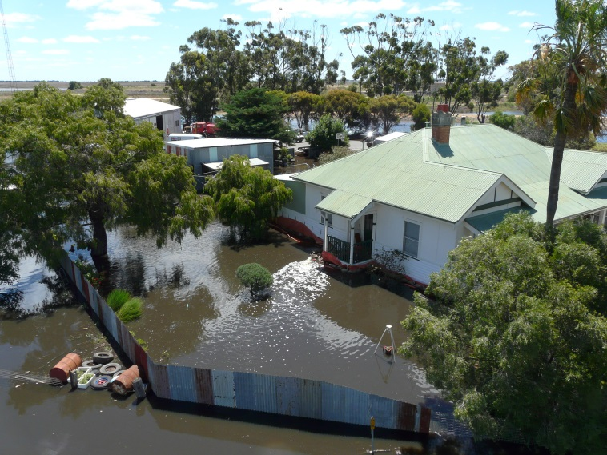
Flooding on property in Rupanyup, 2011

