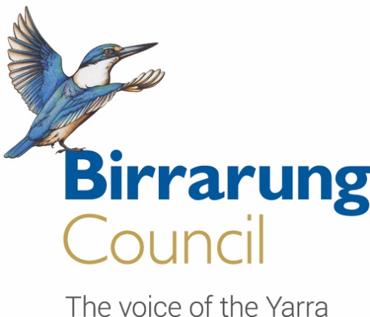

Reframing ‘environmental net gain’ for the Yarra Birrarung

Summary document

October 2021

This summary is based on a report prepared by Dr Bruce Lindsay and Associate Professor Bradley Moggridge for the Birrarung Council.

The Birrarung Council is a ministerial advisory committee, established under the Yarra River Protection (Willip-gin Birrarung murron) Act (2017), which serves as the voice of the Yarra River. It is both an advocate and a provider of high level, strategic advice to the Victorian Government on the health, wellbeing and future of the Yarra river, or Birrarung.

Table of Contents
Executive Summary 3
1 Introduction 5
1.1 What is meant by the term ‘net gain’? 5
1.2 The need to reframe the concept of ‘net gain’ 5
2 The role of net gain in achieving the aspirations for the River 6
2.1 Reframing net gain 7
2.2 Models of net gain for a progressive approach 7
2.2.1 Approach 1: Science and quantification of net gain 8
2.2.2 Approach 2: A restoration ecology approach 9
2.2.3 Approach 3: A cultural understanding of ‘gain’ 10
2.3 How to build a contemporary frame for net gain? 12
3 A multi-dimensional approach to net gain to meet current needs 12
3.1 A restoration ecology approach encompassing scientific inputs and methods 13
3.2 A restoration ecology approach as a vehicle for cultural gain and healing 13
4 Key steps in applying a mature net gain model 14
4.1 Prepare reference models to articulate the future state sought 14
4.2 Set targets 14
4.3 Manage barriers 14
4.4 Link others actions and policies to ‘gain’ through specific recovery plans 15
5 Conclusion 15

Executive Summary
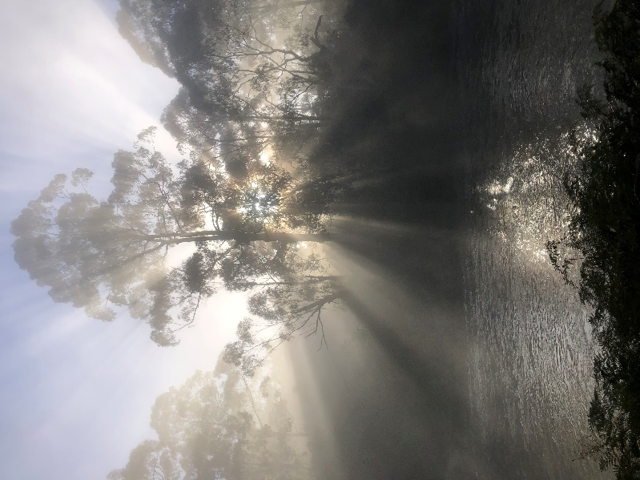
Net gain is an approach that seeks to leave the environment in a measurably better state than it is currently. For the Yarra River, or Birrarung, net gain provides an opportunity to address the multitude of incremental degrading effects over time.

The Birrarung Council, which has been established under the Yarra River Protection (Wilip-gin Birrarung murron) Act 2017, is seeking to stimulate discussion and understanding about the concept of net gain. The Council proposes an approach to achieving net gain which it believes is the best way forward to meet current challenges and expectations for the River.

The Council has undertaken this work for two reasons: Firstly net gain is a key term in the legislation which establishes new governance arrangements for the Yarra, yet the term is not defined and is not well understood. Secondly, the Council sees that net gain is a critical strategy for protecting the Yarra and its lands: the goals in the legislation and the community and Traditional Owner aspirations for the River can only be achieved if net gain principles are applied.
Warrandyte. Photo by: Kristin Olds

The legislation acknowledges the River as “one living and integrated natural entity”. Together with the community and Traditional Owner statements articulating their hopes for the River, it is clear that a net gain model must be one that is:

- future focused
- restorative
- based on the whole interconnected system
- based on a notion of landscape as being both the physical and the cultural landscape for which First Peoples are custodians, and
- comprised of social and cultural as well as physical landscape goals.

In this paper on net gain, the Council has sought to be very clear about what net gain is not. Notions of ‘net gain’ which merely provide some compensation for environmental harms fail to capture the real intent and potential of a true net gain approach. In situations where an environmental good is used reactively to cancel an environmental harm we see aspects of the environment taken out of context and reduced simplistically to commodities that can be traded in a transactional manner. The dynamic context, the complexities of the ecosystem, the chain reaction of any intervention, the cultural heritage of the land – all these intrinsic characteristics of our environment are not taken into account.

This means that felling 50 trees and replanting 100 young saplings is not a balanced equation. It is only by understanding the impact of tree loss on the complex environmental ecosystem and cultural landscape of traditional owners that a true response to such a loss can be devised. In addition such transactional approaches, which feature in both environmental offsetting and environmental economics, can have perverse consequences if they lead to actions which are not in the best interests of the landscape in the longer term or turn out to be detrimental. Transactional approaches can also serve as a conscience salve, giving implementers a sense that that an environmental problem has been adequately dealt with when the reality is quite different.
The Council sees this limited understanding of net gain as the definition being used all too often in our current policy settings.

In developing a proposed model of net gain for the River, the council has considered three main ways of approaching net gain:

- scientific and technical methods, typically using quantitative measures of ‘gain’
- models of ecological restoration which seek recovery of ecological systems, and use qualitative as well as quantitative measures of gain, and
- cultural understanding of ‘gain’, with measurable improvement in the ‘healing’ and proper ‘care’ of Country, under Traditional Owner auspices, as well as improved connection to Country.
The Council strongly believes that what is required is a more developed approach to net gain, which draws on all three approaches and grounded in the principles of restorative ecology. Such an approach must incorporate science for measurement and comparison, qualitative measures to capture important social goals and relationships, and be built on a concept of landscape which incorporates the physical as well as the cultural understanding of Traditional Owners.

In advocating for such an approach to net gain, the Council are envisaging a model which will:

- Have a clear articulation of what we are trying to achieve, in which the future state, or reference model, sets out in detail the vision of the restored environment. Our articulated goal will include dimensions of physical and cultural landscape as well as social factors which support them.
- Have a clear and detailed plan of how we get to our future state, complete with indicators targets, indicators and measures across scientific, social and cultural domains.
- Have a detailed programme of works to drive us along the trajectories of change leaving to that future state.
- Use physical and social sciences, and the laws, cultural protocols, and understanding of the Traditional Owners, to help progress to our goals.

The goal of a mature net gain approach is not to recreate an idealised past state but to generate ecosystem and cultural landscape health that is feasible and realistic.

At the current time there is a unique chance to positively affect the future health and wellbeing of the Birrarung, an agreed model of net gain can be used to deliver the best possible future for the River.

Introduction

What is meant by the term ‘net gain’?
Net gain is an approach that seeks to leave the natural environment in a measurably better state than it is currently. Net gain can be achieved as a by-product of major change or be a driver of change in its own right.

For the Yarra River, or Birrarung, net gain also provides an opportunity to address the multitude of incremental degrading effects over time. Many of these negative influences on the River have resulted in subtle and cumulative deterioration in environmental conditions whose effect can be hard to gauge at a single point in time. More discernible are the concentrated impacts of major planning decisions and infrastructure projects . Net gain approaches can mean making changes which create new positive benefits or address the impacts of past detrimental change.

But net gain can apply to more than just the physical landscape. This report explores how net gain can be used to apply to the cultural landscape as well, as understood by the Traditional Owners of the Yarra water and lands. The Yarra River Protection (Willip-gin Birrarung murron) Act (2017) recognises the intrinsic connection of the Traditional Owners to the Yarra River and their role as custodians of the Birrarung land and water. In this way the legislation acknowledges the cultural dimension of the landscape and it is therefore fitting that the concept and use of the term net gain includes both the cultural and physical dimensions of landscape.

The need to reframe the concept of ‘net gain’
The key driver of the task to reframe net gain is the Wilip-gin Birrarung murron Act. The Act sets out Yarra protection principles and establishes the Birrarung Council. The concept of net gain is contained in the legislation, which states that “There should be a net gain for the environment in the area of Yarra River land arising out of any individual action or policy that has an environmental impact on Yarra River land”.

The Birrarung Council considers that the concept of net gain has not been well understood or applied to date. When considered as a purely environmental concept, the term has typically been used to convey a process of neutralising harm. It has been used interchangeably with concepts of no net loss and of equivalence. There is a real risk going forward that decision makers will settle for providing environmental off sets, rather than true net gain actions, either because they mistake the former for the latter or because lack of clarity around the current understanding of net gain allows them to apply an inferior approach. An off setting approach to the environmental management of the Yarra would make for a bleak future, given that the experience shows the application of offsetting has actually allowed decline of the environment when viewed as a whole.

A contemporary reframing of net gain is needed, one which incorporates the cultural dimension of landscape which has not been well appreciated or acknowledged in the past.

An unclear or limited understanding of the net gain concept means that the unique opportunity presented by the current policy settings could well be wasted.

The role of net gain in achieving the aspirations for the River
The Wilip-gin Birrarung murron Act has the purpose of protecting the River as “one living and integrated natural entity”. To further articulate this long term vision for the Birrarung, the Act provides for a community vision to be developed which will guide strategic planning for the River. This vision was completed in 2018, after extensive public consultation, and sets out the community aspirations for the River. It includes the following aspiration for the River:
Its clean waters and connected network of thriving green spaces nurture biodiversity, and deepen relationships between people and nature.

(emphasis added)

Sitting alongside the Community Vision is Nhanbu narrun ba ngargunin twarn Birrrarung the Traditional Owners’ vision for the Yarra. This statement was developed in response to the Act and the Community Vision. It states:
We believe we need to see ….the complex, living system that is sensitive to its surrounds and a uniquely Victorian treasure. …we, together, are capable of turning around the damage of the past and acting to restore the river and its environment for the future use and enjoyment of all.

(emphasis added)

Together these statements articulate a future for the Birrarung where its health :
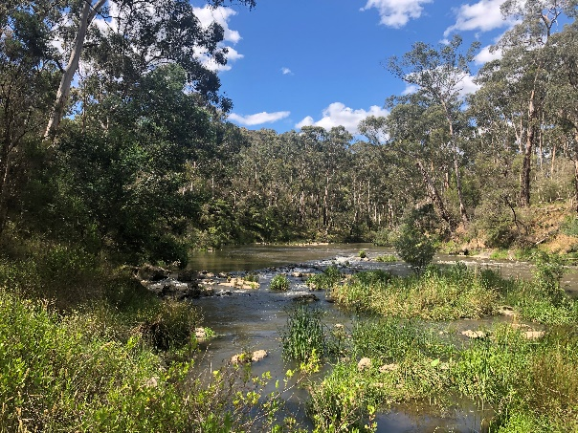
- is restorative
- is based on the whole interconnected ecosystem, and
- includes relationships and not just physical improvements.

The Yarra Protection Principles contained in the Act provide guidance on how actions, projects and policies can be shaped so as to meet aspirations and the central goal for the River. The requirement to achieve net gain is a key element of the environmental set of these Principles. Together with the other principles, the net gain concept is fundamental to achieving the community and Traditional Owner aspirations and shared goal for a River which is in a better physical state than currently and where the cultural landscape is nurtured. These relationships are set out in Figure 1 below.
Laughing Waters. Photo by Alexandra Lee

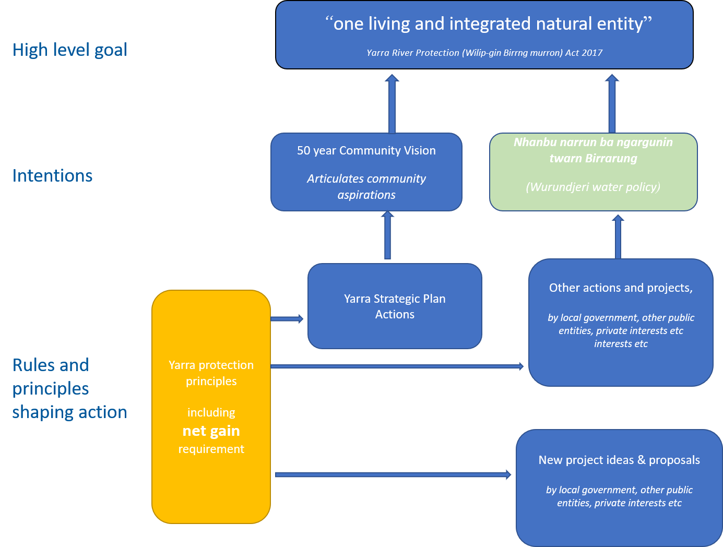
Figure 1: Goal, intentions, and rules and principles to shape action on the Birrarung/Yarra.

Reframing net gain
In this report, we conclude that the most effective way to achieve the Community Vision for the River is through an approach that centres on ecological restoration principles. There is a well-developed science and method in restoration ecology. It allies with other concepts and approaches, including with the cultural landscape (healthy Country), and other scientific disciplines.

Models of net gain for a progressive approach
This summary outlines three main ways of approaching net gain:
- scientific and technical methods, typically using quantitative measures of ‘gain’,
- models of ecological restoration which seek recovery of ecological systems, and use trajectories of change mapped out to guide progress to the goal of a restored or recovered future state. This approach draws on qualitative measures of ‘gain’ but also uses quantitative measures, and
- cultural understanding of ‘gain’, with measurable improvement in the ‘healing’ and proper ‘care’ of Country, under Traditional Owner auspices., as well as improved connection to Country.

Approach 1: Science and quantification of net gain
A well-established and conventional approach to conservation policy emphasizes quantification of environmental qualities, values and characteristics. This approach is influenced by the way metrics are used in economics, urban planning, and public administration to quantify factors in order to aid decision making.

Models using this approach would typically use indicators based on what can be measured as proxy measures for broader ecosystem function. Metrics used to reflect environmental condition can include measures of area, habitat quality, species diversity and populations, hydrology, ecological connection, or economic value.

Quantitative approaches are fundamental to environmental offsetting applications. Quantification allows the calculation of trade-offs between adverse impacts and compensatory actions in response. Quantification of environmental factors is also integral to concepts of ‘natural capital’ and to models of environmental accounting, which permeate international thinking and practice.

This approach, used in environmental ‘compensation’, offsetting or ‘compensation’ schemes, can also be integrated with wider conservation policies. Complex ecosystems can be represented by a set of quantified values for various aspects (for example, for terrestrial and/or in-stream habitat, water quality, flows, species assemblages or trophic complexity, and connectivity). These values can then be ‘bundled’ together to form a sophisticated model. This approach has been used in environmental ‘crediting’ schemes at the landscape scale.

In Australia, national and Victorian policy and reporting draw on quantified environmental factors. In Victoria, for example, the State of the Environment and State of the Yarra reports produced by the Commissioner for Environmental Sustainability use quantification techniques.

Quantitative approaches to measuring environmental impacts have an important place, for example, in considering development proposals. Scientific metrics and indicators provide insights into patterns of environmental change, and can be used to estimate the direction (trajectory) of overall environmental or ecosystem change. This includes whether the state of ecosystem health is improving, stagnating or declining.

Approach 2: A restoration ecology approach
The term ‘restoration ecology’ approach, as used in this paper, refers to intentional human activity directed to recovery of ecosystem health, integrity and sustainability . The goal of restoration is not to recreate an idealised past state but to generate ecosystem health that is feasible and realistic.

In essence, the restorative ecology model is a strategic approach, based on broadly defining what outcome is sought and designing the best way to get there. It contrasts with offsetting approaches which are more tactical in nature, seeking an immediate outcome in a present time setting. The distinctions between restorative ecology and offsetting are summarised in Figure 2 below.

A key feature of this approach is the need to articulate the future state, or reference model, sought.
Reference models can be constructed from actual ecosystems, or inferred ecological conditions, or a combination of both. Usually pre-existing ecologies are used in constructing reference models or states. Other sources of information are used too, such as historical records or analogous ecosystems. The intention is usually to re-establish broad ecosystem attributes, function and processes, however the task of designing a reference model must take into account the degree of degradation or impairment evident in the current ecosystem.

The standard of recovery, measured against reference models, may therefore be full recovery of an ecosystem or a ‘highest attainable level of recovery’. It will also include social outcomes.
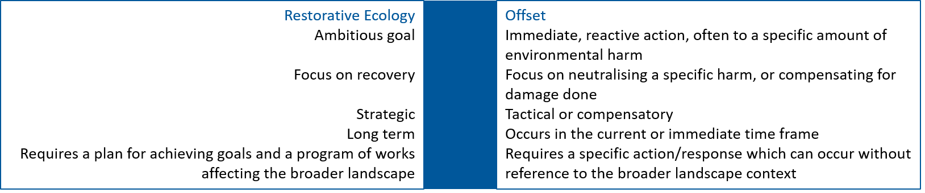
Figure 2: A comparison of restorative ecology and offset approaches

The importance of reference models or states is that they set out, with some degree of precision, what recovery, conservation or ‘gain’ is seeking to achieve. In aiming to respond to the questions ‘What are we trying to do here?’, or ‘What outcome are we seeking to achieve?’, the reference tool in restoration ecology allows net gain to be tied to tangible outcomes. Those outcomes ordinarily need to be debated, negotiated, collaborated on and informed by social and scientific inputs.

Under this model, both quantitative and qualitative outcomes are sought. In addition to the ecological goals, the social bases and relationships enabling restoration are of major importance, and must be not only included but also cultivated. This approach would typically use socio-cultural as well as ecological indicators of improvement.

Ecological restoration requires establishing planned pathways, or trajectories of change, to get to the goals sought. As following this trajectory will move us towards an intended system of socio-ecological health, progress can be measured in terms of movement along this trajectory of change.

Restoration and recovery can occur in widely varying time and spatial scales. Recovery of wetland function might occur in a period of a few years, whereas restoration of forest ecosystems can take centuries. Restoration projects can function at the scale of suburban gardens or continental landscapes. They can involve multiple scales at once.

Scientific methods and quantification remain crucial but, importantly, ecological restoration includes qualitative measures of positive ecological change / recovery. In contributing to the reframing exercise, restoration ecology includes categories of ecosystem health and recovery that can inform change and ‘gain’. These categories derive from ecological theory and restoration principles.

Using international literature on ecological restoration as a starting point , qualitative criteria can be developed for recovery of the river landscape. These could include:
- ongoing deterioration prevented
- critical habitats protected
- threats managed
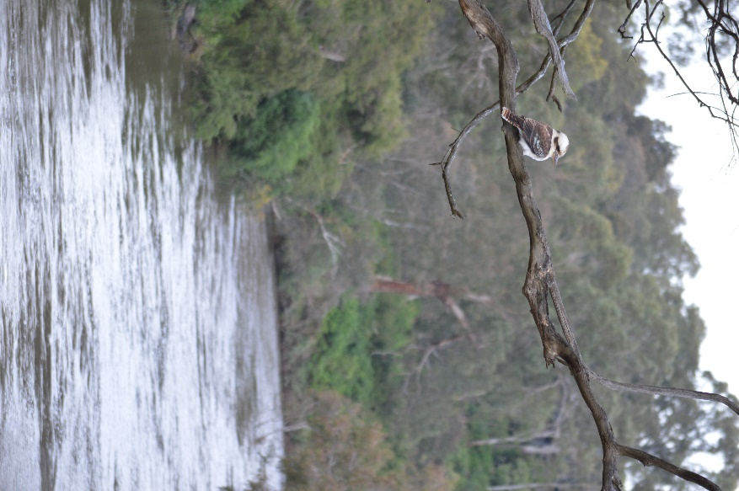
- an appropriate disturbance management regime
Fins Reserve. Photo by Alexandra Lee
- planning for recovery, including long-term management plans
- opportunities for recovery created
- characteristic biotic communities present
- species richness or diversity
- characteristic ecosystem functions present or restored
- biotic system, trophic and structural complexity
- improved connectivity, and/or
- high degree of resilience.

Ecological restoration is a rapidly emerging field of practice. There is a proliferation of practical examples, both within Australia and globally as well as international standards and principles to guide the restoration programs and models

Approach 3: A cultural understanding of ‘gain’
A third way of framing net gain for the Yarra relates to the cultural landscape and, specifically, the historic and ancient circumstances of the Birrarung as Wurundjeri Woi-wurrung Country.

The imperative for a cultural approach exists in the growing appreciation, from diverse sections of the community, of Traditional Owners’ connection with Country, and the justice in their being allowed to exercise sovereignty over Country.’ More formally, the imperative is clear in the Wilip-gin Birrarung murron Act:

This Act recognises the intrinsic connection of the traditional owners to the Yarra River and its Country and further recognises them as the custodians of the land and waterway which they call Birrarung.

The implication of statutory recognition is that Wurundjeri law of the River (First Law) is acknowledged in Parliamentary law. The subsequent implication for the model of net gain to be applied is that it must encompass a cultural dimension. This inclusion sits logically with environmental restoration objectives, given the weave between culture and Country. A model of net gain incorporating culture can include indicators of environmental condition consistent with restoration ecology. For example, work to achieve ‘clean’ waters and healthy populations of culturally significant species (such as eel or freshwater mussels).

The cultural approach to net gain can focus on the health of Country plus the health of connection to Country and health of those responsible for it. In other words, physical and relationship objectives are used, requiring both ecological and social indicators to be constructed to measure net gain. Ecological indicators can relate to places, species, or landscape features, or ecological processes. Social indicators can relate to cultural processes, such as those enabling connection to Country, revitalization of culture, and continued building of Wurundjeri status. Examples could include:
- access to Country
- re-establishing ceremony and education on Country
- cross-cultural connection to Country, under Wurundjeri auspices
- natural resource management on Country, such as cultural burning and cultural watering, and
- relevant rights to land and water.
These indicators can be given quantitative as well as qualitative expression.

Cultural measures of net gain may well overlap with or influence design and implementation of recovery trajectories and restoration.

Clearly a cultural approach to net gain can create synergies with other approaches. However there is another important aspect to the cultural and moral authority associated with Traditional Owners’ ‘custodianship’ which is raised by the net gain discussion, and this is about how net gain is designed rather than about just about what that design is. The custodial role of Wurundjeri, as recognised in the Wilip-gin Birrarung murron legislation, means they need to be central to governance and decision-making in relation to the Birrarung. In the context of efforts around net gain, this means the Wurundjeri need to be central participants in designing what we set out to achieve, as well as in assessing impacts on the health of the Birrarung.

How to build a contemporary frame for net gain?
Scientific /quantitative techniques, and the applications they support such as environmental compensation and environmental accounting , may have a role to play in achieving ‘net gain for the environment’ but there are real limitations if this is the only means we use to understand change in the complex environmental context.

Focusing solely on such a frame is likely to take us to a version of net gain whereby environmental characteristics are treated as equivalent and traded off one against the other, with a view to achieving overall, long-term improvements. The prevailing approach of conservation policy has understood environmental ‘net gain’ through the transactional device of offsetting. However there is no real evidence this device is effective in stopping degradation, let alone in reviving ecosystem health. Such an approach has been expressly criticised in the recent Independent Review of federal environmental law.

The metrics used to indicate whether we are making changes sought should not be confined solely to biophysical categories: quantitative measures of ‘gain’ should include social and cultural sciences. Further, the scientific /quantitative frame is not a natural vehicle to deliver on those cultural objectives which include connection to country and relationship elements. Cultural values do not lend themselves to a high degree of abstraction and equivalence, and are typically highly place-based.

A transactional approach will certainly fail to align with the legislated definition of the River as one integrated, living entity, and with the Community vision for a connected network, which will need wholistic understanding of the river’s ecology. It will also fall short on delivering the restoration aspiration of the Traditional Owners.

In short, quantitative techniques and metrics underlying scientific models are important ‘tools’ for planning and measuring change (or ‘gain’). But these tools have limitations: we need to know why we are measuring things in this way and keep a clear line of sight to how measured results link to high level goals.

The best way to use the scientific quantification approach is in conjunction with other ways of understanding change, as one part of a more holistic consideration of the environment and therefore of net gain.

A scientific approach and quantifiable metrics and measures should be one feature in a larger story which needs to be about recovery and restoration, with a robust cultural dimension. The cultural dimension to net gain is vital. The objects of the legislation, community vision and Traditional owner aspirations cannot be achieved without this component in a mature net gain approach. As with the scientific quantitative approach, it offers a vital component but not the complete model.

A multi-dimensional approach to net gain to meet current needs

The three broad approaches or ‘framing’ devices for net gain are not mutually exclusive approaches: there is considerable overlap. Models of ecological restoration and of cultural gain can include scientific and technical gains; and cultural gains can form part of ecological restoration.

The natural synergies between a cultural and scientific approach to net gain warrant special attention. Conventional science is increasingly working with Aboriginal knowledge systems to produce richer environmental knowledge and practice. This can include practical joint assessment and planning processes bringing together cultural and scientific models of environmental management.

This paper contends that most effective way to achieve the Community Vision for the River is through an approach that based on ecological restoration but which is broadened by including the cultural landscape perspective and strengthened by drawing on scientific disciplines. A combined approach needs to be more than just a compilation of the three approaches: it needs to harness the synergies that clearly exist between the three ways of considering net gain, and be led with an emphasis on restoration and cultural context.

In proposing this approach, the consultants have drawn on literature which provides leading contemporary thinking and experience in the area. There is a well-developed science and method in restoration ecology to use as a base.

Such an approach, though ambitious and challenging to design implement and monitor, offers the best way to achieve the legislative goal, and Community and Traditional Owner aspirations for the River.

A restoration ecology approach encompassing scientific inputs and methods
Scientific and technical inputs can play a major role in a restoration ecology approach to net gain by:
- guiding the development of models and concepts of natural systems, the big picture or wholistic view which is fundamental to restoration
- helping construct reference models (the future state we aspire to)
- informing recovery techniques
- planning of outputs and outcomes, goal-setting, target-setting and indicators of performance
- providing metrics to help determine base line conditions from which to gauge progress,
- assessment and analysis, and reporting on outcomes
- bringing cultural models into scientific thinking and practice
- engaging community and citizens in the scientific enterprise

A restoration ecology approach as a vehicle for cultural gain and healing
Just as ecosystem restoration can be guided and strengthened by science, so too can it be guided by cultural knowledge of Country. There are clear synergies between ecological sciences’ understanding of ecosystems as organisms and Aboriginal understanding of Country as a ‘living entity’. Incorporating a cultural dimension into an approach to net gain is about more than just enabling Wurundjeri custodianship as a moral or legislated issue. There is a practical imperative of strengthening restoration through incorporating the traditional Owners’ knowledge of the Birrarung as a living entity. Access to and management of Country for its health will achieve natural recovery and regeneration. In this way, restoration in cultural terms can also extend and deepen models of ‘gain’

Importantly, the cultural dimension of net gain will not just be about the Birrarung and its returning health: it must also include the connection ( and access to Country) by Traditional Owners. The notion of “recovery” in this sense seeks to address displacement caused by colonisation and needs to allow for Traditional Owner agency in determining and driving net gain objectives.

In create outcomes for Country, conventional planning tools and scientific techniques can be used. These include such tools as formal indicators and benchmarks, targets and assessments techniques applied to both physical and relationship goals.

Key steps in applying a mature net gain model

Prepare reference models to articulate the future state sought
For measuring landscape-scale ‘gain’ it is likely multiple reference models may be needed.. Reference models may be prepared at corridor and localised levels, with a view to their integration into a larger plan.

They could be coordinated with localised planning. An analogue is the requirement under anticipated UK environmental legislation for ‘local nature recovery strategies’. The concept of a series of nested reference models sits well with the approach taken by the Yarra Strategic plan, which considers the Birrarung as a series of reaches, with specific areas within each.

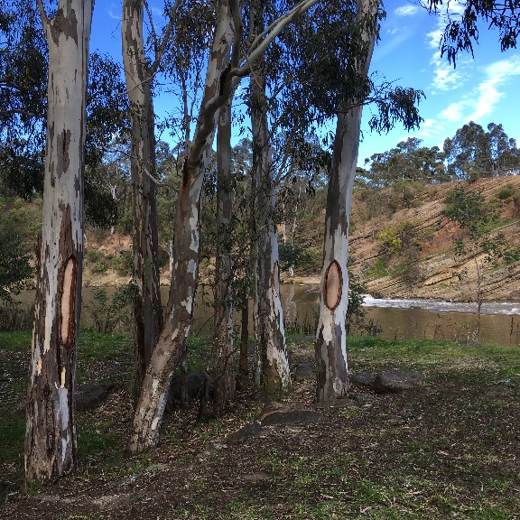
Reference models should expressly integrate cultural knowledge, practices and norms. For the Yarra Birrarung, this explicitly includes reference models for Country and prepared for the cultural landscape.
Scar Trees at Dights Falls. Photo by Alexandra Lee

Set targets
Target-setting should be driven by science and draw on cultural landscape influences and knowledge. For example, science-based targets for ‘net gain’ in the Yarra Birrarung could include targets for ecological connectivity or removal of degrading threats, alongside targets for reinstating cultural burning on Country with attendant ecological, cultural and social contributions to recovery.

Manage barriers
A wide range of existing rules, practices and decision-making frameworks may present potential (and perhaps unintended) barriers to restoration efforts. Delivering ‘net gain’, via restoration projects and actions, requires negotiating such barriers.
New regulations may be required in order to allow net gain plans to proceed. These could include regulation setting relating to the state’s Crown lands or public land management strategies. New agreements may be needed to allow works to be undertaken by nongovernmental organisations or Traditional Owners (such as burning on public land). Management plans, developed in the context of state legislation and relating to biodiversity or water management, may be necessary.

The River corridor takes in both public and private (freehold) estates. It may therefore be necessary to effect change in private landowner practices, through education and engagement, financial incentives or use of regulatory tools (such as planning rules).

Link others actions and policies to ‘gain’ through specific recovery plans
There are a broad range of actors and policy-makers whose work impacts on the Birrarung corridor.
A net gain approach, built on ecological recovery principles and incorporating quantitative, qualitative and cultural dimensions, could be strengthened by a requirement for the other actors, including local government and state actors, to have mandatory recovery plans which support agreed net gain goals.

Further, restoration projects are built from existing organisations, social and community actors, networks, collaborations and relationships. Success would see all key actors playing a role in an organised net gain effort, including private landowners, public land agencies, community organisations and NGOs, Aboriginal organisations, technical and scientific experts, in addition to statutory authorities and public entities who have a mandated role in care for the River. Such broad scale involvement requires appropriate structures to be in place to organise this diversity of effort so as to create collaborations and share authority and responsibility for restoration and recovery.

Conclusion
In light of past ambiguity in how the term ‘net gain’ has been understood and applied, it has conventionally been understood as a concept based in the present state of the environment, and concerned with responding to adverse environmental impacts such as those occurring through development, resource extraction or changed land uses. In this understanding, net gain has been used largely as a proposition of compensation, whereby an adverse impact can be offset by a positive environmental action in another or related area. Such a transactional approach misses real opportunities to positively and proactively affect the land scape in a way that sees its complexity as a series of complex interacting system.

At the current time there is a unique chance to positively affect the future health and wellbeing of the Birrarung. The imperatives for River protection and a bi-cultural approach are contained in the recent legislation and the Yarra Strategic Plan provides a vehicle for planning, organising and implementing a practical program for the next 10 years. With an agreed model of net gain for the River, which is at once ambitious and practical, the current opportunity can be used to deliver the best possible future for the River.

Yarra River Protection (Wilip-gin Birrarung murron) Act 2017, S. 9 (4)
https://imaginetheyarra.com.au/visions
Nhanbu narrun ba ngargunin twarn Birrarung ( Ancient Spirit and Lore of the Yarra), the Traditional Owners response to the Yarra River Protection (Wilip-gin Birrarung murron) Act 2017
See generally UN System of Environmental Economic Accounting 2012 – Central Framework (2014), https://seea.un.org/content/seea-central-framework; Millenium Ecosystem Assessment Ecosystems and Human Well-being: A Framework for Assessment (2005), https://www.millenniumassessment.org/en/Framework.html; The Economics of Ecosystems and Biodiversity (TEEB) Mainstreaming the Economics of Nature: A Synthesis of Approach, Conclusions and Recommendations of TEEB (2012), http://teebweb.org/publications/teeb-for/synthesis/
See Simmonds et al ‘Moving from biodiversity offsets to a target-based approach for ecological compensation’ (2020) Conservation Letters 13:e12695
See the example of ‘net gain’ under the proposed UK model for England: ‘”Net gain” example 2: The United Kingdom as a case study for managing net-gain and restoration: what does another jurisdiction tell us?’
See eg scheme for Willamette Basin in Oregon: Willamette Partnership Developing the Willamette Ecosystem Partnership (2008), https://willamettepartnership.org/wp-content/uploads/2014/09/Developing-the-Ecosystem-Credit-Accounting-System.pdf
Eg BoM Guide to Environmental Accounting in Australia (2013),
SER International Principles and Standards, 15-17
SERA National Standards for the Practice of Ecological Restoration in Australia (2018), Principle 4, 13-15
SER International Restoration Principles and Standards, 41, Table 3; see also Table 4, 42-43 for key attributes framing ecological indicators
See especially SER International Principles and Standards for the Practice of Ecological Restoration (2019), https://www.ser.org/page/SERStandards/International-Standards-for-the-Practice-of-Ecological-Restoration.htm
Yarra River Protection (Wilip-gin Birrarung murron) Act 2017, Preamble.
Wurundjeri Water Policy, 7
Freedman Bulleen-Banyule Flats Cultural Values Study, 239-240
As to indicators, see Bark et al ‘Operationalising the ecosystem services approach in water planning: a case of Indigenous cultural values from the Murray-Darling Basin, Australia’ (2015) 11 International Journal of Biodiversity Science, Ecosystem Services and Management 3 239
For example, the health of Bolin Bolin billabong and other wetlands: see Wurundjeri Water Policy, 7, 9; Wurundjeri Narrap team (pers comm, 2 October 2020)
For example, re-establishment of wildlife corridors and quoll habitat: Wurundjeri Narrap team (pers comm, 2 October 2020).
For example, reintroduction of cultural burning practices: Wurundjeri Narrap team (pers comm, 2 October 2020).
See eg Sangha and Russell-Smith ‘Towards an Indigenous ecosystem services valuation framework: A North Australian example’ (2017) 15 Conservation and Society 3 255
See eg Bulleen-Banyule Flats Cultural Values Study (2020), section 7, 238-253
Samuels Independent Review of the Environment Protection and Biodiversity Conservation Act 1999 (Cth), 138-139, https://epbcactreview.environment.gov.au/resources/final-report. The Independent Review supports a far more systematic and coherent approach to ecosystem restoration: see Ch 8 generally.
See ‘Review of literature 3: ‘Indigenous science’ and cultural knowledge’ below
See egg McKenzie et al Cultural Flows Field Studies: Final Report (MLDRIN, NBAN and NAILSMA, 2017), http://culturalflows.com.au/images/documents/Final%20report.pdf
Environment Bill 2019 (UK), cll 95-100
In relation to legal and regulatory schema applying to the Yarra Birrarung corridor, see Appendix of Bruce Lindsay report.
See Crown Land (Reserves) Act 1978 (Vic), s 13
See e.g. Parks Victoria Act 2018 (Vic), s 46
Nhanbu narrun ba ngargunin twarn Birrarung ( Ancient Spirit and Lore of the Yarra), the Traditional Owners response to the Yarra River Protection (Wilip-gin Birrarung murron) Act 2017

