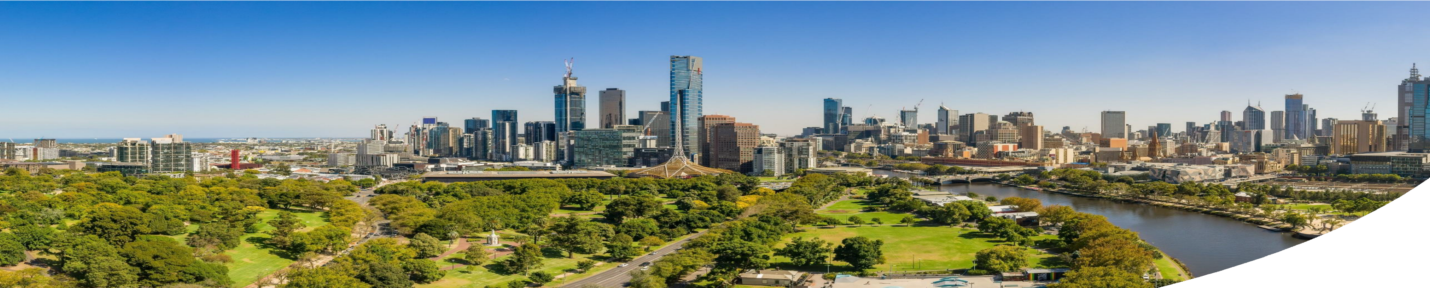
Why We Commit

OUR INTEGRATED WATER MANAGEMENT COMMITMENT
Water sustains our communities, our environment and our future. In the face of climate change, urban growth and increasing pressure on resources, we must act now. Integrated Water Management (IWM) is our pathway to creating thriving and resilient communities and shared prosperity. Together, we can create systems that protect ecosystems, enhance liveability and deliver lasting benefits across metropolitan Melbourne.
This Statement represents a collective commitment by the Department of Energy, Environment and Climate Action and the Department of Transport and Planning, Local Governments, Water Corporations and Traditional Owners to work collaboratively across boundaries, embed IWM early in planning and decision-making and align policy, investment and delivery. It recognises that no single organisation can address these challenges alone, and that lasting solutions depend on collaboration, shared responsibility and respect for diverse knowledge systems, including the enduring custodianship and wisdom of Traditional Owners.
Through this statement we affirm our commitment to the stewardship of water in all its forms delivering lasting
benefits for the well-being of current and future generations.

What We Stand For
We commit to:
- Value water in all its forms as essential to healthy Country.
- Collaborative planning to work across sectors and jurisdictions to align planning, design, and delivery of IWM solutions.
- Embed IWM early in urban land use planning to optimise outcomes for community and Country.
- Equity and Inclusion - make sure the benefits of IWM reach all communities, supporting healthier environments and better outcomes.

Call To Action

Together, we commit to build resilient, liveable and sustainable communities through Integrated Water Management.

How We Will Act
We commit to:
- Collaborate: Work across sectors, First Nations and communities to co-design place-based solutions that respond to local and regional needs and priorities.
- Innovate: Champion practices that drive water efficiency, reuse, and resilience and reflect Traditional knowledge.
- Act with Foresight: Make evidence-based decisions that prevent missed opportunities and safeguard options for future generations recognising the relationship between water, land and culture.
- Lead by Example: Embed IWM principles in planning, policy, and delivery.
- Monitor and Share: Track progress and share learnings to continuously improve and strengthen capacity.

Supported by

